To what extent is freedom of the press in Mexico affected by the violence against
journalists perpetrated by drug cartels in the country?
School of European Studies | The Hague University of Applied Sciences
Supervisor: Mr Rawal | May 21, 2012

05
20122
Freedom Of The Press In Mexico

Dissertation European Studies
Josca Blaak
08004390 - 4D

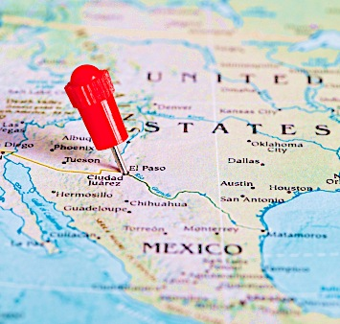

Executive Summary

It seems today that the streets in Mexico are littered with bodies of journalists. Since the ruling president, Felipe Calderón, declared war on drug cartels in December 2006, more than 30 journalists have been murdered or have gone missing. The escalating violence and attacks on Mexican media are emerging and have been the motivation for writing this dissertation.

Compliant with the Libertarian Theory of Siebert, Peterson and Schramm, the freedom of press is defined as follows in this research: 'the right for journalists to be able to do their work without being subject to intimidation or actual violence, and able to report freely without censorship.’ Under state rules Mexico's press is considered free, in Constitutional articles 6 and 7, but in practice this is not the case at all. Freedom House even declined Mexico's press from Partly Free (2010) to Not Free (2011), because of the escalating violent attacks on journalists caused by the drug war.

Aggressive media tactics have been designed by battling cartels throughout the entire country. To control the drug market, the cartels have to control (corrupt) journalists. Self-censorship is produced by bribery and extortion, and more importantly by death treats, violence and even killings of Mexican reporters (at times even their family members) and journalists. Media outlets can influence public opinion, expose locations or identities of the drug lords or members, or corrupt officials that are deployed by the cartels. Since the intensification of the drug war, there is an escalating range of violence against the Mexican press. Mexico is number eight on the list of most deadliest countries in the world for journalists, with 64 journalists killed since 1992. However, not only journalists face the consequences of reporting dangerous information. Social media users are brutally being murdered for 'snitching' on cartels on blogs, with notes left on their bodies 'justifying' their murders.

The large quantities of available information on the dramatic situation of Mexico lead to the central question of the dissertation: "to what extent is freedom of the press in Mexico affected by the violence against journalists perpetrated by drug cartels in the country?" Desk research has been conducted to answer this question. Qualitative research, in the form of an interview with Jan-Albert Hootsen, a Dutch correspondent who lives and works in Mexico, provides an inside scoop to the contemporary problems involving Mexican journalism.

In most of Mexico's states, rivaling drug cartels control the information agenda. It has come to a point where newspapers have printed texts on their front pages stating they do not cover the drug war to keep their employees safe. Which means that many shootouts in the streets of Mexico are ignored, and little to nothing on the drug war is being reported on.

The media in Mexico, and therefore the freedom of speech and press are extremely threatened by violent drug cartels. Journalists and even their family members are being killed, numerous are missing, media outlets are vandalised and even social media users are in danger. Drugs cartels are still extremely powerful, and control not only media outlets, but also bribe and pressure public employees, and are even infiltrated in Mexico's government and institutions. Mexico lives and breathes the drug war.

The violent drug cartels will continue to influence the security situation of Mexican society, particularly media workers, journalists and normal citizens, until a breakthrough will come in fighting them. There needs to be taken more action by Calderón and his government to defend and protect the media. The president and the government have a constitutional responsibility to guarantee free expression. Not only do journalists need to be able to do their jobs safely, safeguarding press freedom is a key factor in battling the cartels. The drug war cannot be won as long as the cartels maintain their power on the media. There should be reports of the corruption, the violence, and the government efforts to fight the cartels.

To conclude, Calderón and his government are not only being overshadowed in the drug war, but in the war of information as well. The media are extremely affected by the violent drug cartels. The free flow of information in Mexico has reached a crucial low, mainly because of the pressure and violence of cartels, and will not rise until the government takes drastic measures. Still then, it would take decades to defeat the powerful cartels. Until then, drug cartels remain in charge of what shows up on the front pages of Mexican dailies, and journalists are not able to practice their profession in safety.

Table of Contents
Introduction 6
Chapter 1: Mexico; an introduction 8
1.1 Country Profile 8
1.2 Political Situation 9
1.3 Drug Cartels 12
1.4 Media 14
Chapter 2: The importance of a free press 17
2.1 What is freedom of press 17
2.2 The fourth estate 18
2.3 Four theories of the press 18
2.3.1 Authoritarian Theory 18
2.3.2 Soviet-Totalitarian 19
2.3.3 Libertarian Theory 19
2.3.4 Social Responsibility 19
2.3 How free is the press in Mexico? 21
Chapter 3: Reporting on drug-related violence 23
3.1 Reporting in Mexico 23
3.2 Self imposed sensor ship 25
3.3 Journalism and Technology 27
Chapter 4: An overview of murdered Mexican journalists 29
4.1 Available facts on the killings of Mexican journalists 29
4.1.1 Maria Elizabeth Macias 31
4.1.2 Marco Antonio Avila Garcia 31
4.1.3 Norberto Miranda Madrid 31
4.1.4 Miguel Ángel López Velasco 32
4.1.5 Regina Martínez Pérez 32
4.2 Statistical Analysis 33
4.3 Most violent regions of Mexico 34
4.4 Investigations 34
Conclusions 36
References 38
Appendices 44
1. Interview Jan-Albert Hootsen 44

Introduction
This dissertation focuses on the influence drug cartels have on media in Mexico. Journalists working in Mexico face enormous personal and professional challenges. Press freedom took a dramatic slide in Mexico this year. Structural problems have contributed to its low rating but the intimidation and bribery of drug traffickers drove it downwards. More than 60 Mexican journalists have been killed in the past ten years, 10 of which in 2010. Mexican news outlets have been targeted with grenade attacks and are regularly being fired at. In 2010, the drug cartels intensified their methods. They use the media as a soapbox, and force them to print their views as if they were official news. Many newspapers are forced by the killings of their employees to stop writing about certain affairs.

The purpose of this dissertation is to describe and encounter the impact the violence, which comes with the drug war, has on Mexican media. The topic of press freedom is highly appealing because of its contemporary character. The research question underlying this is: 'to what extent is freedom of the press in Mexico affected by the violence against journalists perpetrated by drug cartels in the country?' In order to come to an answer to the central question, sub-questions have been researched.

The dissertation is organized as follows. To start researching, there first has to be a clear outline of the current problems that plague Mexico, which is sub-question number one. Chapter 1 consists of an extensive country profile, which is essential to gain understanding of the countries' current problems. Mexico's history, political situation and also a general media profile are described, which leads to sub-question two: 'what are the most important media in Mexico?'

Chapter 2 describes the definition and the importance of a free press. Four theories of the press are being discussed; with the Libertarian and Social Responsibility being the most relevant ones in relation tot the research and the current issues involving journalists in Mexico. Once press freedom is defined clearly, which is sub question three, press freedom in Mexico can be evaluated.

Following the chapter on press freedom, chapter 3 continues with an outline of reporting on drug-related violence in Mexico. One of the results of the violence for journalists is self-imposed censorship, which is elaborated on in subchapter 3.2. The upcoming important but dangerous role social media gets to play is discussed as well.

Chapter 4 consists of the analytical part of the research, with a more in-depth research on the violent attacks on Mexican journalists. A table of all murdered journalists in Mexico is retrieved from the CPJ website and demonstrated, with 5 of these murders highlighted and elaborated on to create a clear image of what exactly is happening to Mexican journalists that leads to a decrease of press freedom in Mexico. To end chapter 4, the investigations of the murders of Mexican journalists is being discussed. The final answer to the central question is found in the conclusion. The information given in chapter three and four provide an answer to both sub question four: 'How are Mexican journalists hampered in their work?' and five: 'Who is in control of the publishing of news in modern day Mexico?'

To be able to answer the research questions both qualitative and desk research have been conducted. The literature research has been conducted based on numerous articles, mostly found with the use of Google scholar. Many numbers, analysis and graphics are retrieved from the CPJ web page. The Committee to Protect Journalists (CPJ) is an independent, non-profit organization that promotes press freedom all over the world. They defend the rights of journalists in order for them to be able to report without fear of reprisals. Other important institutions from which I gathered data are: Country Watch, Central Intelligence Agency, Reuters, Bureau of Western Hemisphere Affairs and CNN. Newspapers such as 'The New York Times', 'The Guardian' (particularly helpful were articles of Professor Roy Greenslade) and the Dutch 'Volkskrant' have been proven useful on the topic as well. Helpful Mexican blogs that cover the drug war were Frontera al Rojo Vivo and Blog Del Narco.

To include qualitative research, there has been an interview with a Dutch correspondent, Jan-Albert Hootsen. Hootsen works and lives in Mexico and has provided an inside look to Mexico's media-related problems, with his knowledge and experiences. His comments have been referred to in various parts of the dissertation. I also made use of social networks such as Facebook and Twitter, to follow institutions as BorderlandBeat, Freedom House and Los Queremos Vivos. In fact, Twitter helped me to get in touch with Jan-Albert Hootsen, with which otherwise would not have happened.

Chapter 1: Mexico; an introduction

1.1 Country Profile
Mexico (The United Mexican States) is a federal democratic republic with great autonomy for separate states. The population consists of 113.7 million inhabitants (Fund For Peace, 2011). The capital is Mexico City, one of the world's largest and most populated cities. Mexico-City is by far the country's largest city, with a total of 20,450,000 inhabitants (World Atlas, 2010). Other states in Mexico with over a million inhabitants are Guadalajara, Monterrey, Puebla, Toluca, Tijuana, Leon, Ciudad Juarez, La Laguna and San Luis Potosi. A total of 76,5% of the population lives in cities or city areas. After Brazil, Mexico is the second most-populous country in Latin America. Of Spanish-speaking countries Mexico is the most populous country in the world. Before Mexico achieved independence in 1821, Mexico was a Spanish colony for 300 years (Country Watch, 2011).

With their major oil produce- and export business Mexico has the second-largest economy of Latin America. One-third of government revenue comes from this industry, although production has fallen over the last years. The socio-economic gap in Mexico is wide and prosperity remains a dream for most Mexicans. Shantytowns ring the cities and neglected rural areas are common. According to BBC (2011); "Many poor Mexicans try to cross the 3,000-km border with the US in search of a job, and more than a million are arrested every year."

Mexico is situated in Central America, bordering the Gulf of Mexico, the Caribbean Sea and the North Pacific Ocean. Their ethnic groups are: mestizo (Amerindian-Spanish) 60%, predominantly Amerindian 30%, white 9% and other 1%. Their national language is Spanish, which is spoken by 92.7% of the population. Indigenous languages are spoken by 5.7% of the population. The majority of the population is Roman Catholic (Central Intelligence Agency, 2011).

Key Data
Region | Middle America
Area Total | 1,972,550 km²
Area Land | 1,923,040 km²
Coast Line | 9,330 km
Capital | Mexico City
Climate | Varies from tropical to desert.
Languages | Spanish  Various Mayan dialects
Currency | 1 new Mexican peso (Mex$) = 100 centavos
(Country Watch, 2012)

1.2 Political Situation
Father Miguel Hidalgo proclaimed national independence from Spain on September 16, 1810. In Mexico this declaration ¨Viva Mexico!¨ is known as the ¨Grito de Dolores¨. This defining historic event was the start of a decade-long struggle for independence from Spain. In 1821, a treaty that recognized Mexico´s independence from Spain led to the creation of a republic, established in 1824. Federalists, liberals, conservatives and republicans debated throughout the 19th century among the shape of the government of Mexico. Economic and democratic reforms were made with during the presidential terms of Benito Juarez (1858-72). In 1862, the invasion of French forces interrupted Mexico´s first experience with democracy. Archduke Ferdinand Maximilian of Austria became Mexico´s emperor from 1864-67 and imposed a monarchy on the country. Following the overthrow of the Austrian emperor, Juarez returned to office in 1867 and remained president until his death in 1872. Authoritarian General Porfirio Diaz took office in 1877 after several weak governments, and ruled as president until 1911 (Bureau of Western Hemisphere Affairs, 2011).

A revolution (1919-1920) followed as a result to the several economic and social problems in Mexico. The 1917 constitution was created during this revolution. Emerging from the revolution the PRI (Institutional Revolutionary Party) was formed in 1929. It was initially created to keep peace in political competition. The Institutional Revolutionary Party controlled Mexico´s national government for 71 years. It continuously won every election until Vicente Fox´s defeated them in 2000. For the first time in 71 years the PAN (National Action Party) controlled the government. One of President Fox's most important reforms was the passage and implementation of freedom of information (FOIA) laws. President Fox also highlighted the need for modernization of Mexico's criminal justice system, including the introduction of oral trials. The elections of July 2000 were at the time seen as the fairest and freest elections in the history of Mexico.

With the inauguration of Vicente Fox on December 1, 2000, there were plans to strengthen the rule of law as well as democracy, and to fight crime and corruption involving the drug war. However, Mexico's economy contracted due to the United States' 9/11 attacks. Because of the economic contraction the government was forced to limit funding for promised education and health programs (Storrs, 2006). In the four years of Fox's presidency, the economy increased but Fox was not able to obtain approval of major legislation. Although Fox had plans to introduce judicial reforms that would make the criminal system more transparent and efficient, the Mexican Congress never completed action on his proposals. According to Storrs (2006); "In December 2004, he followed up with a series of proposed human rights reforms to discourage torture and to strengthen the rights of defendants in Mexico." President Fox, ruled as a president until December 1, 2006, where fellow PAN member Felipe Calderón took over (Bureau of Western Hemisphere Affairs, 2011).

The elections of 2006 resulted in a win for Felipe Calderón (PAN) over Andres Manuel Lopez Obrador (PRD) with a voting difference of less than 1%, which lead Lopez Obrador to claim fraud-allegations. Andrés Manuel López Obrador at the time did not recognize the election results and declared himself "legitimate president". Mexico´s Federal Electoral Tribunal, rejected Lopez Obradors´ accusations and upheld the victory of Felipe Calderón. The National Action Party (PAN) lost its majority in the Chamber of Deputies but was still the largest party in the Senate. The PRI holds a significant place in Mexican politics as it has recently been elected from 19 to 31 governorships. It also plays a large part in the coalition forming in Congress. In July 2012, the following national elections will take place (2011, Bureau of Western Hemisphere Affairs).

Calderón´s war on drugs has been one of the defining features of his presidency. According to the Central Intelligence Agency (2011): "since 2007, Mexico's powerful drug-trafficking organizations have engaged in bloody feuding, resulting in tens of thousands of drug-related homicides." Mexican newspaper La Reforma reported in January 2012 that 12,000 people were killed due to drug crime in 2011. Other media in the Latin America reported on more than 12,000 deaths last year by violence mainly caused by drug cartels are engaged. The violence is increasingly grim. In 2011, nearly 600 people were beheaded. There are also 1,000 recorded cases of torture.
In January 2012 the Mexican government updated the numbers of deaths due to the drug war, which is now set on 47,515 people. Experts believe a tracking system is needed for the Mexican government to follow criminal trends and improve security (New York Times, 2012). Eric Olsen, one of the security experts in the New York Times article says: “Our frustration is that they have some information and some numbers, something that would be valuable and they are not releasing them”.

(Drug) gangs in Mexico are fighting each other with brute force to hold the best smuggling routes to the USA. According to Mexican media more than 50,000 people died since the 2006 government of Calderón that started the battle against drug cartels (2012, Volkskrant). "If the government is unable to protect its citizens from the violence, it stands to lose much in the way of legitimacy. Corruption and lack of transparency remain rampant within the government, especially in local governments, the judiciary, and the police force. Serious reforms are needed to repair Mexico’s fragile institutions", state Fund For Peace in their latest country profile report on Mexico. The arrest and conviction of Mexico's drug enforcement chief, Gen. Jesús Gutiérrez Rebollo for having ties to organized crime in 1997, is one of the most spectacular corruption cases in Mexico.

According to Burtin Kirkwood (2011):
¨Since president Felipe Calderón was sworn into office in December 2006, Mexico had deployed more than 45,000 troops to various states and cities to try to stem the violence. Initial observation suggests that the military has not been as corrupted as some of the federal and state police, so the military may have a better chance at addressing the violence and corruption existing with the drug trade¨,

Mexico´s military totals approximately 225,000 personnel and is composed of a navy, air force and army. Roughly 0.9% of the annual budget is spent on the military, which is relatively low in comparison to other countries like the USA (4.7%) and China (2.2%). Mexico´s military´s most recent primary goal is to eliminate the drug trade and the violence that is associated with it (Burtin Kirkwood, 2011).

The militarization strategy of Calderón has led to an accusation of serious human rights abuses. The results of a Human Rights Watch report in November 2011 were not at all positive on Calderón’s approach. Instead of strengthening public Mexican security, the drug war has created a violence climate without laws, and fear rules all over the country. Five Mexican states were assessed in the report, which led to the documentation of hundreds of cases of torture, dozens of disappearances and over twenty extrajudicial killings (Council on Foreign Relations, 2011).

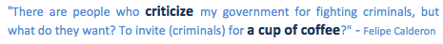

Mexican presidents are limited to a single term, which will bring the presidency of Calderón to an end in November 2012. In the eyes of many Mexicans, the government of Calderón has failed. Their strategy on fighting drug trafficking organizations has led to bloody massacres, decreased public security and escalating violence (New York Times, 2012).

In a YouTube video that went viral, children illustrate the modern day Mexican society and their main problems as poverty and drug-related violence. The point of the video is to present the challenges Mexican leaders will face (CNN, 2012). In the end of the video, a young girl makes a plea to the countries' presidential candidates:
"If this is the future awaiting us, I don't want it. Stop working for your party, and not for us. Stop trying to superficially fix the country. Mexico has touched the bottom. Are you only after the presidential chair, or do you really want to change the future of our country?"

One of Mexico's presidential front-runners is Enrique Pena Nieto. On Monday, April 9, 2012, he stated that might he win the elections, his priorities lie in ending violence over battling drug cartels. One of his future approaches would be the creation of a new police force consisting of former soldiers (Dave Graham, 2012).

1.3 Drug Cartels

As in most Latin-American countries, crime is one of the major concerns in Mexico. Mexico is one of the most important drug trafficking countries worldwide. The corruption and violence that come with drug trafficking provide large inconvenience. President Calderón declared war on drug cartels in 2006, which since then is being referred to as the Mexican drug war. This war costs more than 7000 lives a year and forms a threat to political stability in the country. Crime is a particular problem in the larger cities in the north and west. Although Mexico City is known internationally for its high crime, the bulk of crimes consist of robberies; the murder rate is relatively low for a metropolis like Mexico City. Extremely violent cities are Tijuana, Nuevo Laredo, Culiacán and Ciudad Juárez. The last one of these cities has been named the most murderous city of the world, with 1,037 deaths registered in only the first six months of 2011 (Manning, 2011).

According to government statistics, the most violent Mexican cities are Tamaulipas and Nuevo Leon. In the capital of Nuevo Leon, Monterrey, 400 people have been killed in 2011. These 400 killings were all connected to organized crime. In 2010 this number was three times lower (CNN, 2012). The seven principal DTOs (Drug Trafficking Organizations) in Mexico are Los Zetas, the Sinaloa Cartel, the Tijuana, the Juarez cartel, La Familia Michoacana, the Gulf cartel, and the Beltran-Leyva Organization. The cartels are all different based on the threat they pose to the government or public. They focus on different types of products and are not all equal in armed or financial strength (Murray & Jackson, 2011). The cartels operate in established and disputed territories, as is shown figure below.

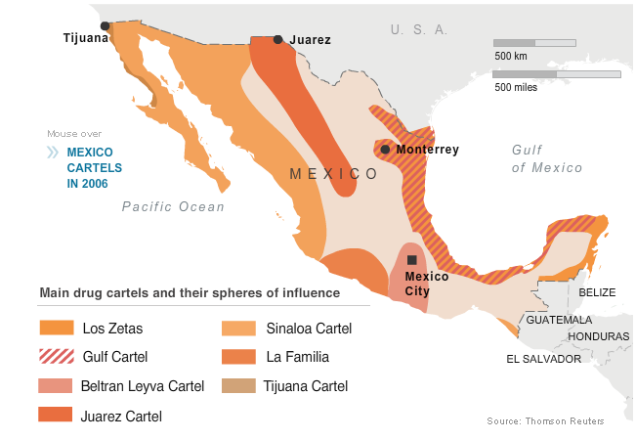
(Retrieved from Reuters Web Site, 2010)

Stratfor, Global Intelligence, produces an annual report on Mexico's drug cartels. In these reports, Stratfor assesses the most significant developments of the previous year and a forecast for the coming year. They also provide updated profiles of Mexico´s most powerful criminal cartels. This report covers their findings from Mexico Security Memo, quarterly updates and other analyses. According to their report of January 24, 2012, polarization is under way among Mexico´s cartels:
¨Most smaller groups (or remnants of groups) have been subsumed by the Sinaloa Federation, which controls much of western Mexico, and Los Zetas, who control much of eastern Mexico. While a great deal has been said about the fluidity of the Mexican cartel landscape, these two groups have solidified themselves as the country's predominant forces.¨

The trafficking of drugs from South America to the USA is controlled by the Mexican drug cartels. This business is estimated to be worth $13 billions a year. BBC (2012) states;
¨A US state department report estimated that as much as 90% of all cocaine consumed in the US comes via Mexico. Alliances shift between the main gangs as they vie for control of trafficking routes.¨
According to an August 2011 report by the US National Drug Intelligence Center, the Mexican side of the border remains the most dangerous place for drug-related violence.

Although La Familia and Los zetas set up most narco bloqueos (series of road blockages and vehicle fires) and show the largest activity in attacking government forces, the Sinaloa cartel is Mexico´s largest and most powerful drug cartel. Together with the Tijuana cartel they rule the major marijuana production areas in Mexico. The ¨Golden Triangle¨ region of Mexico is nearly exclusive controlled by these two cartels. This is a region where the mountainous areas of Durango, Chihuahua and Sinaloa states meet (The Borderland Beat, 2011).

In May 2012, a female member of the Los Zetas drug cartel was arrested for involvement with at least 20 murders. A spokesman for the prosecutor in the state of Nuevo Leon says the woman has confessed. The 26-year old Maria Jimenez would have been paid $ 1,700 per month to kill. She especially targeted rival drug dealers. She supposedly is responsible for the killing of a police officer as well. Jimenez is further charged with auto theft and kidnapping. Former Mexican soldiers founded Los Zetas. It is one of the most powerful gangs in the country (NU.nl, 2012).

Although the Sinaloa cartel does not often target civilians, it is the most violent DTO in terms of overall casualties and has targeted hundreds of police officers. It is generally thought that “El Chapo” Guzmán has caused a new outbreak of violence after breaking a truce with the other large criminal groups in the country (LA Times, 2010). The feud between the Sinaloa and Juarez organizations is the reason that Juarez is the most violent city in Mexico, and according to some accounts, the entire world. In 2010, 3,100 people were killed in Juarez, which is populated with more than a million. The Sinaloa cartel is constantly trying to expand its territory into that traditionally held by other cartels, particularly in Juarez, and this is a major cause of much of the violence (El Paso Times, 2011).
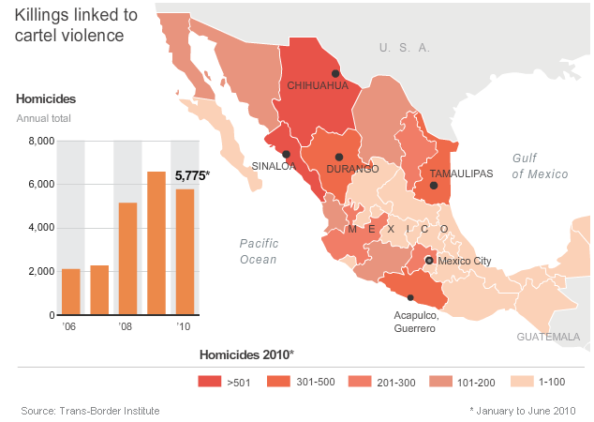
(Retrieved from Reuters Web Site, 2010)

In the ongoing drug war even Texas children are being recruited by Mexican drug cartels. Children are less likely suspected than adults, say law enforcement officers. In case of arrest the penalties are relatively low and they are easy manipulated for small sums of money by cartels (Reuters, 2011).

1.4 Media
There are many different types of media in Mexico, but in order to research the central question, the focus in this dissertation lies dominantly on Mexican Television and printed media.

Mexico is considered the media power centre of Latin America, based on the number of Spanish newspapers, publishers, radio stations, and television networks. Mexico's mainstream newspapers El Proceso (left-wing independent) and El Nacional (official government newspaper) differ in political preference and independence (Country Studies, 2010).

According to BBC News (2012); "Mexico's media were traditionally dominated by the Televisa group, which had firm links with the PRI. But the loosening of the PRI's hold led to greater editorial independence and the emergence of competitors." Once there was a virtual monopoly in Mexican TV, held by Televisa. Televisa was and still is a big global supplier of Spanish programmes. However, the Azteca group, Once TV, Television Metropolitana and other foreign satellite and cable operators have slightly reduced the media dominance of Televisa (BBC, 2012).

Televisa was founded in 1955 as Tele Sistema Mexicano. It is the largest Spanish-language media conglomerate in the world. The Azcarraga family owns the company. The current director is Emilio Azcarraga Jean. Televisa owns three Mexican television stations: Canal de las Estrellas, Canal 5 and Galavisión, and also several foreign television channels and several radio stations. Televisa is considered the most powerful media conglomerate in Mexico, and critics have expressed concerns about the great power of Televisa (Wikipedia, 2012).

Television
TV Azteca | Main competitor of Televisa, operates two networks and local stations
Televisa | Mexico's TV giant, operates four networks and has many local affiliates
Television Metropolitana | Canal 22 - government-owned cultural network
Once TV | Canal 11 - public, educational, cultural
(BBC, 2012)

Mexican newspapers reflect different political views; sensationalism characterises the biggest-selling dailies. According to Nation Master (2012), Mexico is third on a list of 'newspaper circulation', comparing media statistics of countries all over the world.

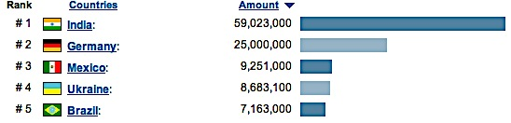
(Retrieved from Nation Master, 2012)

In Mexico City alone exist fifteen newspapers. Its dailies account for over 50 per cent of the national circulation. Excélsior is one of the most prestigious dailies newspapers in Latin America. It is best known for its analytical style, breadth of coverage, and relative independence. El Universal is the oldest traditional newspaper. It used to be closely associated with the government but is currently known for its independence in reporting. El Nacional is the official newspaper of the federal government (Country Studies, 2010).

Government tolerance of press freedom depends on the ruling president. The media tend to avoid direct criticism of the current president in office. The press provides minimal coverage on issues affecting the government. Among the many unwritten rules is one that says: "journalists are expected to respect the image of the president and other high-level government officials" (Mongabay, 2010). Since the 1980s a trend toward a more open political debate occurred. This trend led to a higher degree of tolerance of criticism in the media and supposedly increases public awareness of the need for changes within the Mexican political system (Country Studies, 2010).

An outline of the press is needed to define the most important and influential institutions of Mexican journalism. Televisa obviously dominates the television sector and the largest newspapers are El Proceso, Excelsior and El Nacional. To be able to analyse whether press freedom is in jeopardy, a clear-cut definition of press freedom in general, and in Mexico, is described in the following chapter.

Chapter 2: The importance of a free press

2.1 What is freedom of press

To highlight the importance of a free press, a clear definition of press freedom is needed. A definition found on the web page www.dictionary.com calls press freedom: 'the right to publish newspapers, magazines, and other printed matter without governmental restriction and subject only to the laws of libel, obscenity, sedition etc.' This is a basic and strict definition of a much broader and highly complicated term. Regarding to the problems affecting Mexican media in this research and compliant with the hereafter discussed Libertarian Theory, the freedom of press can be defined as follows: 'the right for journalists to be able to do their work without being subject to intimidation or actual violence, and able to report freely without censorship.’

Europeans sometimes tend to think that press freedom and freedom of speech is as obvious anywhere in the world, as it is in Europe. Journalists and human rights activists who have had experience in the international working field know that this is certainly not the case. Journalists worldwide are taking on the task to provide people of information in the most difficult conditions. However, many journalists are hampered daily in many ways while doing their work.

Press freedom allows sufficient reliable information to be published, to give people a complete picture of their country or situation. But while some journalists work on unravelling stories, others work on keeping the same stories quiet. Events are not reported, opinions are not shared, stories are not told. The situation in Mexico ensures that independent information is rare and that many stories remain untold. The image that exists of the Mexican situation is a puzzle with many pieces missing.

To continue to highlight the need for press freedom and keep as many people aware of the matter, the global and annual World Press Freedom Day is held on May 3. This year on this day, highly contrary events occurred. The bodies of three photojournalists were found dismembered in the violent state of Veracruz, Mexico. Their deaths followed the murder of another journalist there the week before (Freedom House, 2012).

Every year thousands of journalists get in trouble by their profession. Cameras and computers are destroyed to prevent news to break out to the world. Anonymous threatening phone calls, police raids and arrests are no exception. And it continues: from injury to murder.

2.2 The fourth estate

The press is sometimes referred to as the fourth estate, in addition to the judicial, legislative and executive power. To guarantee this important function, the government serves as the protector of freedom of the press as enshrined in legislation. The government, as a protector of the democratic principles, should guarantee the freedom the press needs to fulfil its function as a fourth power in a democracy. The fourth estate suggests an important, coherent and independent force in society. However, the press does not have the same responsible, legislative, executive or commercial goals as the government (The Guardian, 2011).

This lack of responsibility is one of the important respects in which the press is different. Although the press has a responsibility for standards and ethics, journalists are in fact without responsibility. They do not have to make compromises necessary in politics or provide answers to shareholders. Confidentiality agreements that bind others do not apply to them. Causing inconvenience and embarrassment is not something they should have to care and worry about, nor do they have to win votes. The situation they find themselves in, should be a privileged one, where issues on the economy or the environment can be discussed, in contrast to for example politicians (The Guardian, 2011).

This freedom of speech is fundamental. Many writers, jurists and political philosophers consider it the first and foremost of our freedoms. However, it is worth asking in this research, in a Mexican context, how "free" is the press?

2.3 Four theories of the press

Siebert, Peterson and Schramm give historical, philosophical and international perspective of the press in their book, Four Theories of the Press (1956). The most interested theories for this research are the libertarian theory and the social responsibility theory. They serve as a background for today's press in Mexico.

2.3.1 Authoritarian Theory
- Supports and advances the policies of the government in power
- Ownership can be either private or public
- In authoritarian regimes, there is no press freedom
- Usually, explicit censorship
- Not allowed to publish things that the regime does not approve
- Official propaganda forced to publish
- Control is based on the state
- Countries: Afghanistan, Saudi Arabia, Singapore

2.3.2 Soviet-Totalitarian
- Developed in the Soviet Union, although some of the same things were done by Nazis
- Purpose was to contribute to the success and continuance of the Soviet socialist system, and especially to the dictatorship of the party
- Ownership was public
- Countries: North Korea, China, Cuba and Vietnam

2.3.3 Libertarian Theory
- Adopted in England after 1688, and in the U.S., and is influential elsewhere in the world.
- Purpose is to inform, entertain, sell, as well as discover truth and check on government
- Ownership is chiefly private
- In this theory, the freedom of the press is central
- The press may not be subject to any restrictions
- The government can not control
- News gathering is legally protected
- Censorship is non-existent
- Countries: The Netherlands, some of the Scandinavian countries

Fred S. Siebert of Michigan State University developed the theory, first published in l956. The theory provides a philosophical basis for the on-going relationship between the news media, government and society in the United States. The theory seeks to maximize freedom of the press both for the news media and the public. Siebert (1956) wrote; "The underlying purpose of the media is to discover the truth, to assist in the process of solving political and social problems by presenting all manner of evidence and opinion as the basis for decisions."

2.3.4 Social Responsibility
- Practiced in the US in the 20th century
- Purpose is to inform, entertain, sell, but also to raise conflict to the plane of discussion
- Ownership is private
- The press is generally free
- But is deemed to take on a social role
- Do not disclose matters that are detrimental to society
- Damage can be caused to individuals, groups or institutions
- The press is considered to do self-regulation
- Countries: United States, Canada, Great Britain, France, Germany, Italy, Israel, Australia, New Zealand, Japan, the Philippines, India etc.
The social responsibility theory in fact is an outgrowth of the libertarian theory. However, social responsibility goes beyond "objective" reporting to "interpretive" reporting. A truthful, complete account of the news is not necessarily enough today, notes the Commission on the Freedom of the Press: "It is no longer enough to report the fact truthfully. It is now necessary to report the truth about the fact." As the Commission stated in 1940:
"Under the social responsibility theory, man is viewed not so much irrational as lethargic. He is capable of using his reason but he is loath to do so. If man is to remain free, he must live by reason instead of passively accepting what he sees, hears, and feels. Therefore, the more alert elements of the community must goad him into the exercise of his reason. Without such goading man is not likely to be moved to seek truth."

As a result one can say that it is the responsibility of the press to keep the public informed and to be more alert since an informed populace is the basic of any good democracy. Nevertheless in this new and always changing media environment, today’s large media conglomerates may have different ideas about which information or which persons are interesting enough for the public. In other words, the owners of the press decide what exactly reaches the public (Sue and Dean Barr).

Scholars Siebert, Peterson and Schramm also point out that the media cannot take their responsibility to inform the public lightly. The media must present all sides fairly, in order to inform the public as balanced as possible. Siebert, Peterson and Schramm even argue that if the media do take their responsibility too lightly, “it may be necessary for some other agency of the public to enforce it.” (Siebert, Peterson & Schramm, 1956)

They also emphasize the fact that freedom of expression is not an absolute right, like it is in most European countries. If held in the light of private rights of others or vital social interests, it must be balanced carefully since it is not always socially responsible to report on certain issues regarding drug cartels.

2.3 How free is the press in Mexico?

The Mexican Constitution guarantees the right to freedom of expression in Articles 6 and 7. Under state rules, this means there is freedom of press in Mexico. In practice this is not the case at all with the current self-imposed limitation of journalists. Freedom House declared Mexico's press Not Free in their 2011 Press Freedom Report.

The 2011 report on freedom of the press by Freedom House states the following;
"The Mexican media remains besieged by a mixture of drug violence, public corruption, systematic impunity, and broadcast media monopolies that severely limit the range and accuracy of information available to citizens. Conditions continue to deteriorate, with criminal defamation and insult laws in place and little reform to the broadcast sector, where ownership is monopolized by a few companies. These harsh conditions result from the convergence of elements such as the country’s prominent position in the international narcotics trade, the use of the military to combat feuding criminal groups in major cities, and an inability to enact state reforms to enhance government accountability and the rule of law following the 2000 presidential election."

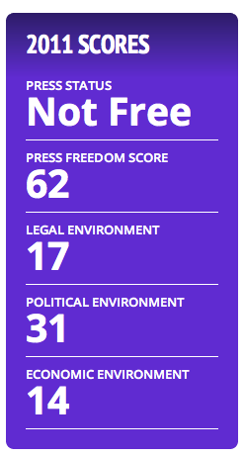
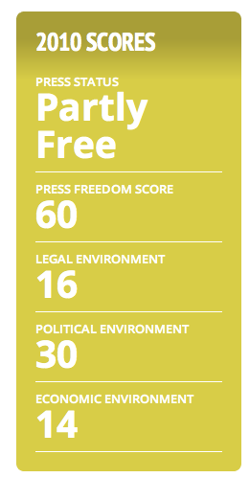
In 2010, Mexico was still declared Partly Free by Freedom House. The decline to Not Free is primarily due to the drug war, which has resulted in an increase of violence and intimidation towards journalists. Self-sensorship is practiced in a climate of impunity, where over 60 journalists were murdered over the past 10 years. The control of the drug cartels over Mexican media did not only lead to sensorship, the cartels also attempted to place their propaganda in certain media outlets. By threatening and bribing media workers, media outlets were forced to print the traffickers' press releases (Freedom House, 2011).

Together with just three other Latin American countries, Mexico has the distinction of being rated Not Free, in Freedom's House's 2012 press feedom survey. Being one of the deadliest countries in the world to be a journalist, with 67 journalists killed since 2000, leads director for Latin American programs at Freedom House, Viviana Giacaman (2012) to say; “As one of the region's largest democracies, Mexico must face this challenge head on to adequately protect journalists and restore confidence in its rule of law."

In Mexico, journalists are hardly able to do their work without being subject to intimidation or actual violence, and they certainly are not able to report freely without censorship. Having no freedom of press means that stories and events can not be told, opinions and information can not be shared. Under the constitutional rules of free press Mexico is free, but yet there is little reporting of the drug war.

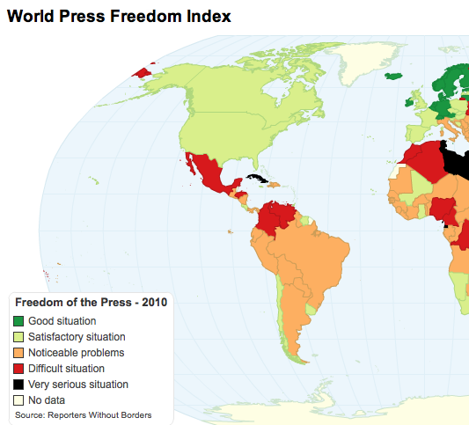
The Libertarian Theory of press is one that is practiced in very little countries, but has characteristics to which the press in each country should want to comply such as: the press may not be subject to any restriction, the government can not control, news gathering is legally protected and censorship is non-existent. These objectives clearly are nowhere close to the contemporary Mexican press.

Mexico's contemporary press corresponds most with the Social Responsibility Theory. The press is generally free but is deemed to take on a social role. The journalists try to take on this role, but are hampered severely while doing so. They do not disclose matters that are detrimental to society. Damage can and is being caused to individuals, groups or institutions to an extreme extent. The press is considered to do self-regulation, however, self-regulation in Mexican press is even expanding to self-censorship. The enormous challenges and risks Mexican journalists face while reporting on the drug war are being described in the following chapter.

Chapter 3: Reporting on drug-related violence

3.1 Reporting in Mexico

The influence of organized crime and drug gangs results in an unsafe environment for journalists in Mexico. In fact, it makes Mexico one of the least safe environments in the world for journalists. The killings and disappearances of journalists have intensified drastically since the PRI left office in 2000. Alongside the murders and threats of individuals, media outlets are being vandalized using car bombs, grenades and gunfires. These violent attacks are believed to be carried out by drug cartels, however it was more frequently reported that the state security forces were responsible for these acts. Alongside these forces, private security groups, sympathizers of political parties and and government officials are sources of threats and attacks toward Mexican media as well (Freedom House, 2011).

According to the CPJ (Committee to Protect Journalists), Mexico is number eight on the list of deadliest countries for reporters. Aimee Rawlins (2011) says;
"Traditional media outlets have come to fear reprisals for reporting drug-related crimes, which has led to an increased use of blogs and social media outlets, although these, too, have been increasingly targeted by the cartels.”
A climate of fear is created by the violence of the cartels against journalists, media-outlets, photographers and even civilians. This increase of fear leads to a decrease of freedom of speech and press freedom. Reporters Without Borders calls Mexico one of the most dangerous countries for media. Numerous journalists have been killed since 2000 (Reporters Without Borders, 2011).
The cartels have a strong impact on the Mexican society and media. The Fundación MEPI (MEPI Foundation) promotes investigative journalism, press freedom and the continuous preparation of journalists and future journalists, university students and graduates. They conducted a study among 11 drug-affected provinces, which makes up almost half of Mexico’s state territories. The report indicates that Mexican newspapers only report three out of ten drug-related news stories, if not fewer (Uncut, 2011).

Nowadays many reporters in big parts of the country are censoring their own coverage out of fear of consequences from violent drug gangs or corrupt policemen. Another fear is intimidation by military units, which are often deployed to fight drug gangs. According to the CPJ, attacks on reporters have intensified since 2006, when Calderón declared war on drug gangs. Over 40,000 people across Mexico lost their lives in the drug conflict (Reuters, 2011).

Jan-Albert Hootsen, a Dutch correspondent who lives and works in Mexico City says reporting on the drug war is particularly difficult, not only because of the violence and lack of transparency, but because most Western journalists look at it the wrong way. They focus purely on the criminal aspect and almost exclusively write horror stories about beheadings, etc. Journalists are ignoring the fact that the drug war is not an isolated phenomenon, but a phenomenon with which many factors in and outside Mexico are connected. Take for example the U.S. drug policy, the poverty factor, education and the transnational nature of drug trafficking. Most reports about the drug war look more like a strung group of incidents, rather than the context is being clearly described. As news consumers, we hear a lot of about organized crime in Mexico, but we know very little (Hootsen, 2012).

The raging drugs war along the U.S. border gets a lot of media attention. However, the fight between the Zetas and the Gulf cartel in Tamaulipas, is getting to the extreme point that media outlets have drastically decided to no longer cover crime in fear of reprisals (Dave Graham, 2011). According to Michael O'Connor, the CPJ's spokesman in Mexico: "The Zetas and Gulf cartel are the most important thing happening in Tamaulipas today, but (the media) don't touch it. Organized crime is in control of the state's politics, police and the justice system," he said, explaining the extremely far reach of the cartels.

Even when rival cartels fight each other in street battles in Tamaulipas, there hardly is local news coverage of the violence. According to local reporters, being intimidated in escalating ways by Calderón's soldiers is sometimes even worse than pressure from violent and highly dangerous gang leaders. Reporting in Tamaulipas becomes an increasingly impossible job. Reporters are not allowed to report on the capturing of drug suspects, but do rely on the gangs to alert them to spectacular killings. On the bodies of their victims are often found messages and threats for rival gangs, which journalists are pressured to transmit (Reuters, 2011).

Ismael Bojorquez is the director of the weekly Rio Doce, which is a newspaper in the northwestern state of Sinaloa. Sinaloa is the home of the equally named drugs cartel. In an interview with Reuters (2011), Ismael Bojorquez says; "We're doing survival journalism, walking a fine line". Bojorquez did not ask Reuters for anonymity, unlike many others. Many reporters are too afraid and do not consent to giver their names. Nowadays, cartels blackmail journalists to publish favourable stories for them or force them to be their eyes end ears among newsrooms. Experts believe the killing of journalists often comes from upsetting the cartels or local bosses (Dave Graham, 2011).

An anonymous reporter got a phone call of a gang member, after a news report came out on television in Monterrey. The report covered the capture of some members of the Zetas. The voice on the phone said;
"My job isn't to warn you, it's to kill you. If you carry on with this, we're going to run into each other." According to the reporter the man knew everything about him, where he lived, how many children he has and even their names (Dave Graham, 2011).

In a statement, a spokesperson of CDHDF said that these attacks on freedom of expression occur despite the legislative and public policy at the federal level, and that they intend to increase protections for journalists and human and combat impunity (Libertad Expresion, 2012).

Professor Roy Greenslade is one of Britain's foremost media teachers. He is a leading commentator and columnist on the media, and currently blogs for The Guardian. He writes extensively on the topic of Mexican media, and the dangers for journalists perpetrated by the drug cartels. In one of his articles he addressed a different kind of violence towards journalists, the violence coming from police officers. On February 3, 2012, an El Diario reporter named Joel González was beaten and arrested by police officers. González was attempting to report on the arrest of a citizen in front of El Diario's office. After the attack, González filed a complaint for abuse by authorities. In January, 2012, reporters of El Diario were attacked by police as well, for photographing and filming at the site of a drug-related arrest. Two journalists of the newspaper Norte were forced to delete their photos (Roy Greenslade, 2012).

Roy Greenslade wrote an article on March 26, 2012 about an upcoming exhibition dedicated to the killed Mexican journalists, staged at The Guardian's headquarters at May 3, 2012. A part of the article is quoted;
"Readers of this blog will be aware how often I write about the killing and intimidation of journalists in Mexico. The figures show that, since the start of this century, Mexico has been one of the world's most dangerous countries for journalists to operate. To highlight that fact, and to raise awareness of the problem of impunity, an exhibition is to be staged at The Guardian's headquarters from 3 May, world press freedom day. It is being mounted by the Catholic overseas development agency (CAFOD), a British-based charity. Organisers expect to show the photographs of the 67 journalists killed in Mexico since 2000 - a wall of silenced voices. This will be accompanied at the launch by the reading of extracts from their articles. "

3.2 Self imposed sensor ship

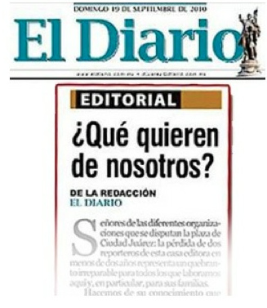
Reporters in many Mexican states have said they had to censor news about public corruption, the drug war and police or military action for several years out of fear for their and their families’ safety. In 2010, this shifted from self-censorship to direct engagement with victamizers. In September, 2010, the newspaper El Diario printed a front page editorial with a direct message to the leaders of the drug cartels. This editorial was the result of the killing of one of their employees, Luis Carlos Santiago. El Diario wrote directly to the cartels: 'Qué quieren de nosotros', which is translated as 'What Do You Want from Us?' The newspaper specifically asks what they can and can not publish, to avoid any more reprisals on journalists (LA Times, 2011).

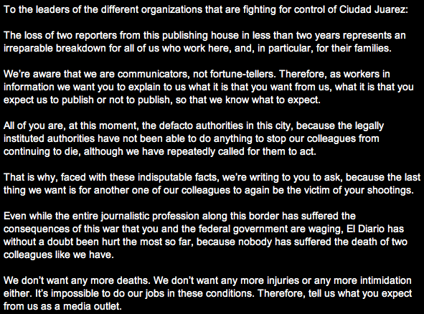
A translated part of the editorial of El Diario (NarcoNews.com)

Tracy Wilkinson, who works as a reporter for the Los Angeles Times, introduces a new journalistic expression: narco-censorship. This term refers specifically to the coverage of the drug war by Mexican media. Reporters and editors, are no longer in charge of deciding what to write or publish, but have two other options; write what drug lords demand or not write at all. Journalists in Mexico are being killed, kidnapped and intimidated for their writing (LA Times, 2010). Wilkinson writes:
"One of the devastating by-products of the carnage is the drug traffickers' chilling ability to co-opt underpaid and under-protected journalists — who are haunted by the knowledge that they are failing in their journalistic mission of informing society. "
She quotes an editor in Reynosa, in the border state of Tamaulipas, who tells her:
"You love journalism, you love the pursuit of truth, you love to perform a civic service and inform your community. But you love your life more... We don't like the silence. But it's survival."

As the attacks on the media spread, journalists in areas previously untouched by violence have begun changing their routines and censoring their own copy, a clear sign of shrinking press freedom. "You're watching out that nothing happens to you when you work," said a radio reporter based in Cuernavaca, a city south of Mexico City, who moved house after drug gangs kidnapped him and later ransomed for $10,000. "You make mention of a certain instance of violence, but without interpreting it or going into detail," he said (Reuters, 2011).

The first documented case of journalists held for ransom was in Durango. Where rival drug gangs demanded media coverage of their messages, either meant for their rivals or aimed at the state. However this is just one example of the limitations in media control. In another border city, Reynose, residents even had to turn to citizen journalists’ reports on sites like Twitter and YouTube, because of the growing influence of drug cartels on the traditional mass media. In Ciudad Victoria, Tamaulipas, a drug gang forced local press to publish fear-inducing propaganda intended to portray the army in a negative way. This propaganda was published as official news. The Committee to Protect Journalists spoke to 21 journalists In the border city Reynosa, who stated that the drug cartels ' had infiltrated the government and the press, using bribery and mutual benefit that was commonplace under the PRI and still exists in some parts of the country'. In this city, residents even had to turn to citizen journalists’ reports on sites like Twitter and YouTube, because of the growing influence of drug cartels on the traditional mass media (Freedom House, 2011).

3.3 Journalism and Technology

Journalism is closely associated with changing technology. Many important developments such as Twitter, tumblr, Facebook and blogs are traced to technical innovations. The interplay of journalism and technology has two important aspects. On the one hand technological innovations make possible the emergence of new media as carriers of journalism. On the other hand, technical developments in journalism have been adopted as a new means of communication, which have significant implications for the newsgathering of journalists (Ouwens Nagell, 2006).

Mexico is one of Latin America's biggest Internet markets. In the end of 2010 were nearly 35 million Internet users (Internetworldstats, N.A.). Facebook is the most popular social network. To stay informed of drug-related activities, journalists and citizens now turn to social media, but not without risks. Mexican social media users who search for up to date news about the drug war find themselves in a dangerous place. Reliable information is hard to find, to check and in some cases even deadly to pass along.

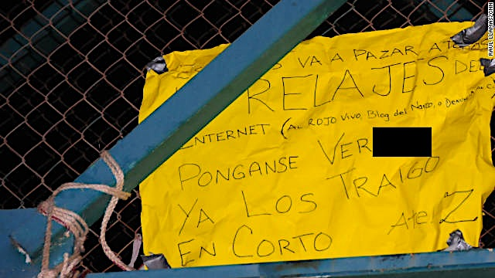
Borderland Beat, a blog that tracks the Mexican drug war, posted photos in September 2011 of two bodies as they appeared to motorists before being cut down by the authorities. According to CNN reports, the killings were reprisals for posting messages on Internet sites. Web sites like Frontera al Rojo Vivo and Blog Del Narco are one of the few platforms journalists and citizens can use to exchange information on drug-related crime (CNN, 2011). Two websites were specifically named in the notes that were found on the bodies. “This happened for snitching on Frontera Al Rojo Vivo,” read a note attached to the man’s leg. Another, on the overpass (see image below), said: "This will happen to all the Internet snitches. Be warned, we’ve got our eye on you. Signed, Z." The Z was a clear reference to the Zetas cartel.

(CNN, 2011)

Among the previously named blogs, Twitter and Facebook are being used for the same purposes. Many Mexicans turn to these platforms, which are becoming in important, but dangerous mechanism (New York Times, 2011). Gang members and bosses seem to closely check social Media, therefore twittering and face booking is not without risk. Jan-Albert Hootsen, who never writes anonymously, thinks this is hard to say:
"This theorem is generally assumed, but assumptions are not facts. The reality is that there are indications that organized crime use social media and sometimes even violent acts against social media users, but we do not know in practice how far that goes."

Social media has given people in Mexico chances to report, but the fear factor still rules. It is not likely to come to a revolution such as in Egypt, where social media has played a big role in the news about the revolt in 2011. Through platforms such as Twitter, Facebook and YouTube all kinds of material (news, photos, videos) were distributed all over the world. Twitter and Google gave people in Egypt the opportunity to publish their tweets via voicemail, after the regime had blocked access to the Internet. Social media still endeavour to provide their service despite all the obstacles (Pleijter, 2011). However, the social media revolutions in the Middle East would not have succeeded with external help from European countries and the USA. For Mexican (social) media to revolve, external help is needed as well.

The following chapter provides an in-depth research on the 64 murdered journalists in Mexico since 1992, and gives a closer look to five of these cases, the most violent states of Mexico, and the investigations on the murders.

Chapter 4: An overview of murdered Mexican journalists
According to the CPJ, at least 63 Mexican journalists have been murdered since 1992, of which 27 where motives have been confirmed and 36 with unconfirmed movies. These numbers make Mexico more deadly than Afghanistan, where a total of 24 journalists found their death since 1992 (Committee to Protect Journalists, 2012). CPJ even named Mexico the world’s deadliest country. There have always been attacks and threats against Mexican media; however, the strikes are currently spreading to new areas and are becoming more violent. Media killing have increased heavily since the drug war started in 2006 and fears are rising that press freedom is in jeopardy (Free Media, 2012).

4.1 Available facts on the killings of Mexican journalists

The web page of the Committee to Protect Journalists keeps track of all murdered journalists in Mexico. With the information available, a table has been created (see image on the following page) that contains an overview of all the killings from 1992 till present. The killings are ranged in time period, and divided in three categories: journalists killed; motive confirmed, media workers killed and journalists killed; motive unconfirmed. The table provides the names of the victims, where they worked, the date they were killed and the place they were found. Five of these cases are elaborated on in the following subchapters, to create a clearer image of the violent circumstances Mexican journalists constantly find themselves in, these names are highlighted in blue in the table.

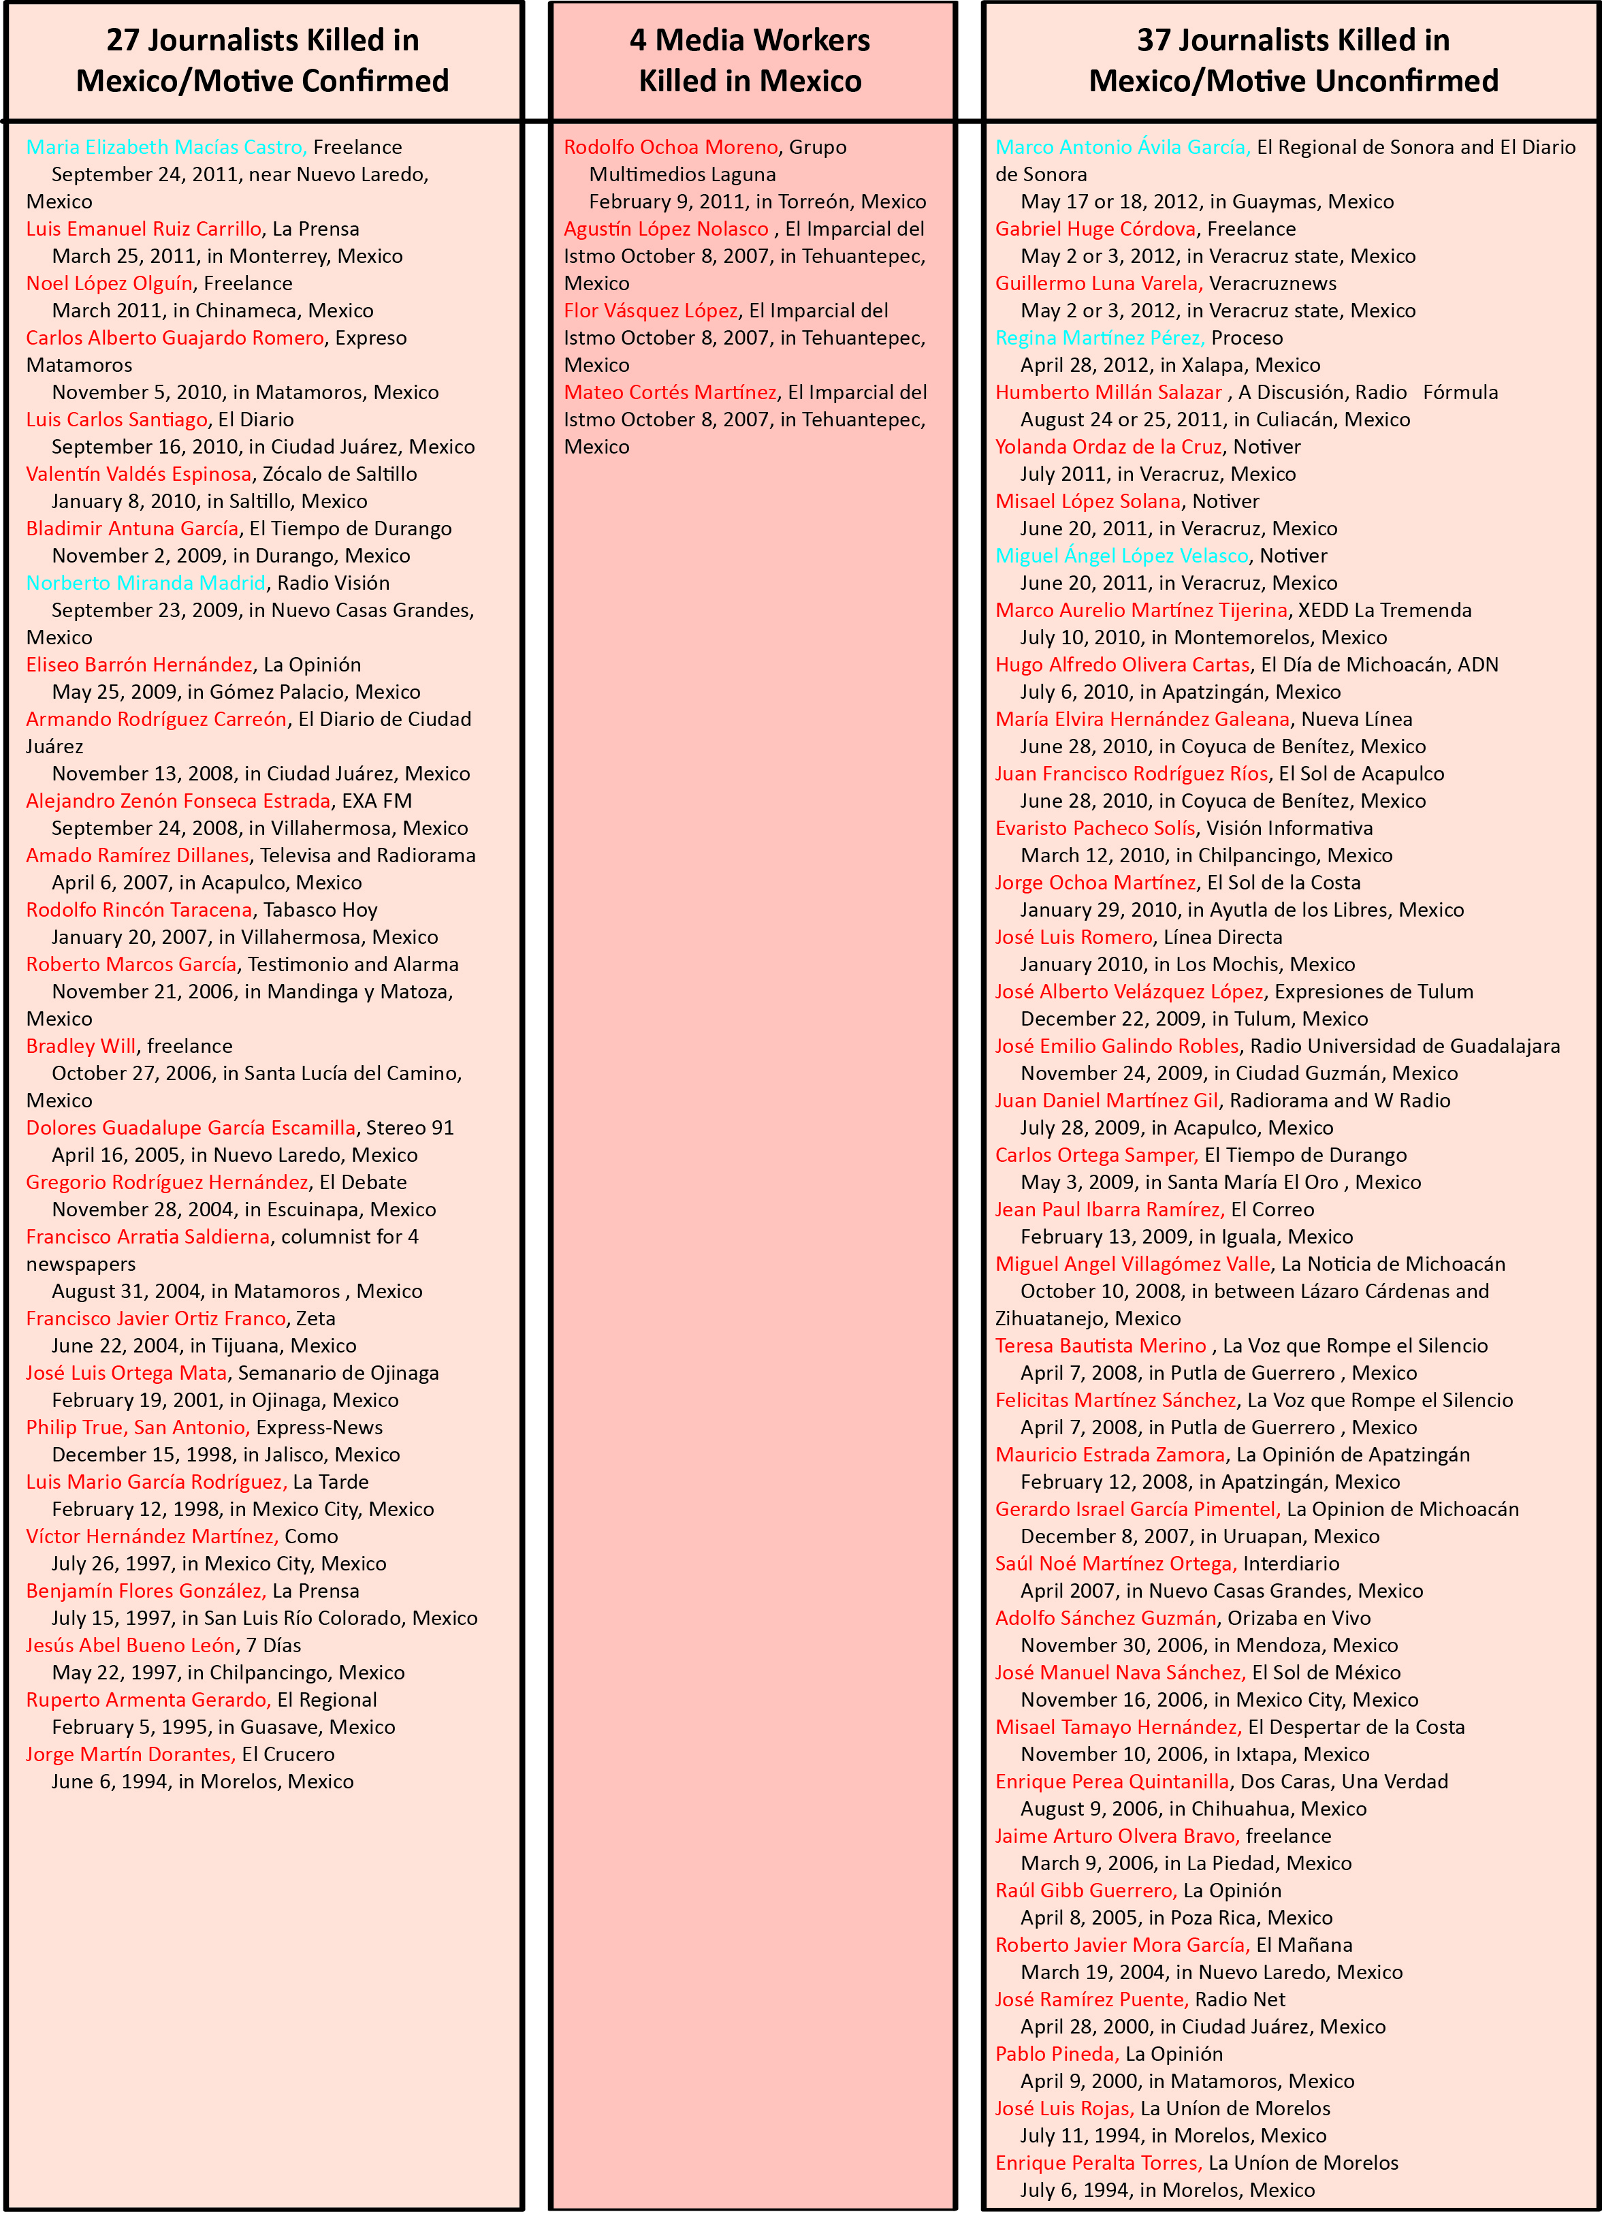

4.1.1 Maria Elizabeth Macias

One of the many media victims is Maria Elizabeth Macias, a freelance journalist who was brutally murdered because of her writing. The murder of Macias was the first case of a social media death. The remains of her body were found on September 24, 2011 on a road near Nuevo Laredo. Her head was placed in a pot together with computer components such as a mouse, keyboard, headphones and cables. Next to her mutilated remains was a note written by the Zetas cartel in which they wrote an explanation for her death. According to the cartel, Maria's “crime” was posting online critical articles that would help the Mexican citizens understand Mexico's organized crime (Maria Armoudian, 2011).

The death of Maria Elizabeth Macias was the first ever documented murder by CPJ in direct relation to social media journalism. According to sources of CPJ, Macias reported under the name La NenaDLaredo, which translates to the girl from Laredo, about criminal activities of drug cartels. She used platforms like Twitter and Nuevo Laredo en Vivo to post her stories. It remains unclear what particular report led to her murder, and how the killers discovered her identity.

4.1.2 Marco Antonio Avila Garcia

On May 18, 2012, the tortured body of Marco Antonio Ávila García was found in a plastic bag, in the state of Sonora, about 100km from the city Obregón where he was abducted on May 17. At the site, a note was found signed by a drug cartel. The Mexican journalist worked for the paper El Regional de Sonora and covered police and organised crime issues. These reports however had no investigative nature and there was never a mention of cartel names (Roy Greenslade, 2012). The executive director of IPI, Alision Bethel McKenzie, stated the following on the murder;
"Enough. Enough, enough, enough. When will this slaughter of journalists in Mexico end? It is no secret that Mexico is facing a major public safety crisis. But it should be no less obvious that journalists play an extremely critical role in Mexico by bringing the activities of drug cartels and of the corrupt politicians who support them to the public light. This valuable work is the reason that journalists are being silenced, and it is also the reason that - despite the difficulties involved - the federal government must step up and bring those responsible for crimes against the media to justice."

4.1.3 Norberto Miranda Madrid

On September 23, 2009, the 44-years old Norberto Miranda Madrid was shot to death in his radio station's newsroom. The radio host and web columnist worked for Radio Vision in Nuevo Casas Grandes, in the state of Chihuahua. He was repeatedly shot by two masked gunmen in the back of his neck, and died at the scene. Also present at the newsroom during the shooting was his brother, José, but he remained unharmed. Norberto wrote online columns and was a host for the online radio station. Known as The Tough Guy (El Gallito), he wrote critically on the lack of safety in Nuevo Casas Grandes and the areas surrounding this city. Norberto discussed twenty-five drug-related executions in his latest column, and referred to both the Sinaloa and Juarez cartel as main cause for the violence. Previous coverage of Norberto on an associated cartel (La Linea) had already resulted in threats from this particular cartel (Fighting for Press Freedom, 2009).

4.1.4 Miguel Ángel López Velasco

On June 20, 2011, Miguel Ángel López Velasco was shot to death with his wife Agustina and 21-years old son Misael. The murders occurred in his house in Veracruz, where gunmen had burst in the morning. The 55-years old Mexican journalist was an editor for the daily newspaper Notiver and covered issues as crime, political corruption and drug trade. Mexican authorities called the murders a cowardly attack, and could not determine a motive for the murders. After the murders of Velasco and his family members, the newspaper called for investigation to find those responsible for the killings (BBC, 2011).

4.1.5 Regina Martínez Pérez

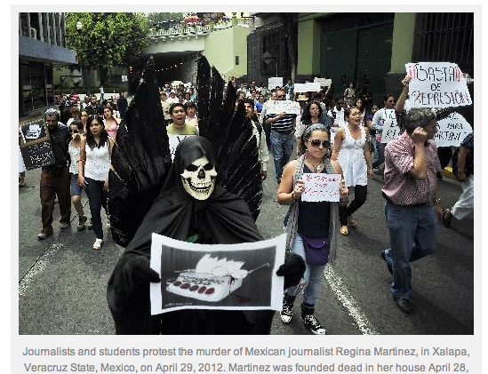
On April 28, 2012, the body of Regina Martinez Perez was found in the bathroom of her home in Xalapa, Veracruz. Martinez worked as a journalist and correspondent for the national newsmagazine Proceso, and covered drug trafficking in her stories. On her body traces of violence suggested a violent murder by strangulation. Martinez was a well-known journalist who wrote a lot about drug cartels for Proceso, which is one of Mexico's oldest and most respected research papers. The day before her death, Martinez had published an article about the arrest of nine local police officers, which were suspected of involvement with drug trafficking. This article was one in a series about the involvement of government officials. Javier Duarte, governor of Veracruz, promised a thorough investigation into the death of Martinez. Experience shows that many murders of journalists remain unsolved. In the days following the murder of Martinez, journalists took to the streets to protest against the increasing violence against (CPJ, 2012).

4.2 Statistical Analysis

On the web page of the Committee to Protect Journalists (CPJ) there are numerous statistical analysis available of killed journalists in Mexico. See the figures below for the most important ones.

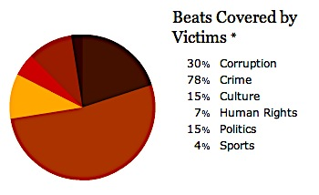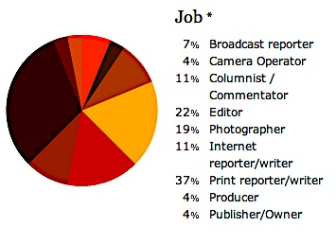
(CPJ, 2012)

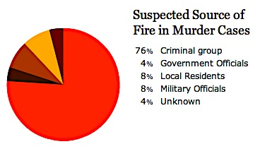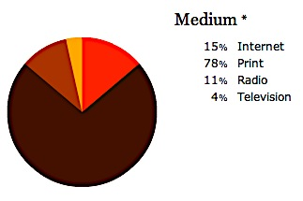
(CPJ, 2012)

March 2012 was considered a "violent" month by the Human Rights Commission of Ontario (CDHDF), by the number and type of attacks on freedom of expression. In this month the most violent acts were committed against media and journalists in the country, compared to previous months. Authorities called for implementation of the mechanism at the federal protection, to contribute effectively to exercise this right. Including one of these violent attacks in March is one where a grenade was thrown at Televisa facilities in the city of Matamoros, Tamaulipas. That same day was an attack against the Daily Express, in Ciudad Victoria, Tamaulipas, when a car bomb exploded outside their premises. Both attacks took a toll of property damage only (Libertad Expresion, 2012).

4.3 Most violent regions of Mexico

The massive increase in violence has been affecting several states in Mexico; especially states located in the Texas-Tamaulipas border region have been experiencing the negative outcomes. In this region the media has been silenced, which can be seen as a result of the power that criminal enterprises exert over border society. Drug organizations are also responsible for the “black news holes” in the northern regions of Mexico. This means that the media do not report on anything related to the drug war. Their power stretches to controlling editorial decisions, which are no longer merely based on news worthiness, but on instructions, threats, and fear of reprisals. The cartels have gained power of the media without any written or spoken agreements between traffickers, reporters, and editors. The violence in these regions also forms threats to tourists that visit Mexico (Correa-Cabrera & Nava, 2011).

The United States has increased a travel warning to 14 Mexican states, on February 10, 2012. The American government recommends the avoidance of travelling to all or parts of 14 of 31 Mexican states, which comes down to almost half of the country. Nonessential travelling to particularly Tamaulipas, Coahuila, Durango and Chihuahua is strongly discouraged (Huffington Post, 2012).

4.4 Investigations

Before Calderon took office in December 2006, the creation of the Special Prosecutor for the Attention of Crimes Against Journalists (FEADP) was approved. Following soon was the approval of the reclassification of murder as a federal crime if the victim was a journalist with unanimity by the House of Representatives. Reports of the FEADP stated that out of sixty cases only twenty-five had been filed. Also sixteen cases have been determined non-criminal and in fifteen cases sentence has not been dicted, which is remarkable considering the unanimous approval of the House of Representatives (Viridiana Rios, 2011). Viridinia Rios is a doctoral fellow in Inequality and Criminal Justice at Harvard's Kennedy School says;
"Mexico is silent and blind and our leaders do not seem to care. Our justice system is broken, it has no teeth. A Mexican journalist dies every ten days."

An article in The Guardian appeared on March 20, 2012 titled; 'PEN writers tell Mexican government to act against murderers of journalists'. The article describes the calling of PEN International (Promoting Literature, Defending Freedom of Expression) for immediate and definitive action to put a stop to the killings of Mexican journalists (Guardian, 2012). John Ralston Saul, president of PEN International said at a press conference in Mexico City to be "disappointed with the gap between rhetoric and action". PEN's message was supported by an open letter with the signing of 170 world's leading writers. This letter was printed as a full-page ad in El Universal and declared:
"We stand with you and all Mexican citizens who are calling out for the killing, the impunity, the intimidation to stop. You have an absolute right to life and a guaranteed right to practise your profession without fear."

The government plays a dual role in the violence against journalists. Sometimes she takes an active part in violence, often passive. Mexico suffers under a high degree of impunity, which is why most killings are not properly investigated and perpetrators are hardly ever caught. The authorities, in any case, certainly do not do enough to stop the violence against civilians and therefore journalists (Hootsen, 2012).

With the government lacking to prosecute, civilians are setting up websites and blogs to keep track of the drug-war victims. The website: http://losqueremosvivos.wordpress.com, which also has a Facebook account, is one of them. In the description of their Facebook account they say:
"Today we call on journalists, photographers, cameramen and workers in the media of the 31 states of the country and the City to analyse, discuss, diagnose and propose actions to respond to the question: HOW DO WE WANT TO LIVE?"
On their website, they keep lists of missing journalists, killed journalists, and missing media workers since January 2000. These lists are complete with dates, name and surname, and the latest information about each individual. According to Los Queremos Vivos (2012), 68 journalists have been killed and 14 journalists and 6 media workers are missing since January 2000, which are different numbers than the CPJ reports.

Paula Schriefer, director of advocacy at Freedom House says:
"When the threat of violence against journalists is so great that important issues become virtually untouchable, the implications for democracy are grave. The Mexican government must do more to address the rampant impunity, at every level of government, that serves to encourage criminals seeking to silence journalists through violence."
Clearly, Mexican media are severely hampered in their work. Fear, self-imposed censorship and in some cases even no reporting at all on certain events are results of the pressure of powerful drug cartels. Violent and sometimes even lethal reprisals of the drug cartels go without prosecution most times. The impunity level of the government and public employees and the increased threats posed by organized crime lead to a subsequent silencing of conventional media. Press freedom in Mexico these days is merely a text without meaning stated in the constitution, while the contemporary Mexican press is nowhere close to being ‘free’.

Conclusions

Mexico is plagued by problems such as poverty and an extremely high crime rate. Besides this, it is one of the most important drug trafficking countries worldwide. With the drug trafficking comes much violence and corruption, which provide large inconvenience to the country. Since the ruling president Felipe Calderón declared war on the drug cartels in 2006, the battle is being referred to as the Mexican drug war. The drug war costs more than 7000 lives a year and forms threats to political stability, the population, journalists and media outlets and even social media users. The violence is increasing, with 12,000 deaths, 600 beheadings and 1,000 cases of torture in 2011. Los Zetas and the Sinaloa Cartel are the country's predominant forces.

The three largest Mexican newspapers are El Proceso, Excelsior and El Nacional. Televisa is not only Mexico's largest TV institution, but also the largest Spanish-language media conglomerate in the world. The Azcarraga family owns it, with Emilio Azcarraga as current director. Televisa is considered the most powerful media conglomerate in Mexico, and critics have expressed concerns about the great power of Televisa.

Regarding to the problems affecting Mexican media in this research and compliant with the Libertarian Theory of Press, freedom of press can be defined as follows: 'the right for journalists to be able to do their work without being subject to intimidation or actual violence, and able to report freely without censorship.’ The Mexican Constitution guarantees the right to freedom of expression in Articles 6 and 7. Under state rules, there is freedom of press in Mexico, but in practice this is not the case at all. Freedom House declared Mexico's press Not Free in their 2011 Press Freedom Report.

Mexico is number eight on the list of deadliest countries for reporters. Not only the pressure from drug cartels limits reporters with doing their jobs, Calderón's soldiers and police officers intimidate them as well. It is obvious that Mexican journalists and reporters are severely hampered in their jobs, with 64 journalists killed since 1992. Journalists are beheaded, tortured, and killed in their own houses, in their own cars, and even at their work. Some of them are forced to flee with their families. Their limited freedom of speech shows off in fear and self-imposed censorship. In some cases they are forced to stop reporting at certain issues completely. The killing of newspaper employees have lead large Mexican dailies to directly address the cartels in their editorials, asking them in despair what they can and can not publish to ensure their employees' safety. The control of publishing news is completely handed over to the leaders of the drug cartels by these actions.

The reprisals of the drug cartels go without prosecution most times, in which the government plays a dual role. Mexico suffers under a high degree of impunity, which is why most killings are not properly investigated and perpetrators are hardly ever caught. The authorities do not do enough to stop the violence against civilians and therefore journalists.

As a result of the little information available on the drug war, citizens turn to informal media sources like Twitter, YouTube, and blogs to gather information. These platforms are used to fill the 'black holes' generated by the self-censorship of Mexican media. The rise of Social media has given Mexicans chances to report, but the fear factor still rules. With the killings of two young Mexicans who posted information about the drug war, a clear message was trespassed for users of blogs like Frontera Al Rojo Vivo and Borderland Beat. If you write about the drug war, you die. It is not likely that it will come to a revolution such as the one in Egypt, where social media has played a big role in the news about the revolt in 2011. Mexico's problems with drug cartels have not yet caused civil war, or affected other countries. The social media revolutions in the Middle East would not have succeeded with external help from European countries and the USA. For Mexican (social) media to revolve, external help is needed as well, but the Mexican drug trade is not only dangerous but also beneficial to the USA. Over time, the Internet might break, but it might just as well not.

The sub questions that were answered with the support of numerous articles, theories, interviews and a media comparison, lead tot the answer of the central question: " to what extent is freedom of the press in Mexico affected by the violence against journalists perpetrated by drug cartels in the country?" The answer is: to an extreme extent. Journalists are being killed, numerous are missing, media outlets are vandalised and even social media users are in danger. Drugs cartels are still extremely powerful, and control not only media outlets, but also bribe and pressure public employees, and are even infiltrated in Mexico's government and institutions. Mexico lives and breathes the drug war.

To conclude, the violent drug cartels will continue to influence the security situation of Mexican society, particularly media workers, journalists and normal citizens, until a breakthrough will come in fighting them. There needs to be taken more action by either Calderón and his government, or the future president, to defend and protect the media. The president and the government have a constitutional responsibility to guarantee free expression. Not only do journalists need to be able to do their jobs safely, safeguarding press freedom is a key factor in battling the cartels. The drug war cannot be won as long as the cartels maintain their power on the media. There should be reports of the corruption, the violence, and the government efforts to fight the cartels. Mexican journalists are not able to do their work without being subject to intimidation or actual violence, and are certainly not able to report freely without censorship, which is the complete contrary of a free press. Calderón and his government are not only being overshadowed in the drug war, but in the war of information as well. The free flow of information in Mexico has reached a crucial low, and will not rise until the government takes drastic measures. Till then, the drug cartels will continue to decide what appears on the front pages of Mexican dailies, and CPJ's list of killed Mexican journalists will continue to expand.

References

Aimee Rawlins. (2011, December 13). Mexico's Drug War. Retrieved on December 15th, 2011, from the Council on Foreign Relations Web site:
http://www.cfr.org/mexico/mexicos-drug-war/p13689

BBC. (2012, January 19). Mexico Country Profile. Retrieved on December 5th, 2011, from the BBC Web site:
http://news.bbc.co.uk/2/hi/americas/country_profiles/1205074.stm

BBC. (2012, January 25). Q&A: Mexico's drug-related violence. Retrieved on January 25th, 2012, from the BBC UK Web site:
http://www.bbc.co.uk/news/world-latin-america-10681249

BBC. (2011, June 11). Gunmen in Mexico kill crime journalist Lopez Velasco. Retrieved on May 30, 2012, from the Web page:
http://www.bbc.co.uk/news/world-latin-america-13853748

Borderland Beat. (2011, February 13). Badiraguato, Sinaloa: Birthplace of Narcos, Sinking in Poverty. Retrieved on January 28th, 2012, from the Borderland Beat Web site:
http://www.borderlandbeat.com/2011/02/badiraguato-sinaloa-birthplace-of.html

Bureau of Western Hemipshere Affairs. (2011, November 16). Background note: Mexico. Retrieved on December 6th, 2011, from the U.S. Government Web site:
http://www.state.gov/r/pa/ei/bgn/35749.htm

Burton Kirkwood. (2010). The History of Mexico: Second Edition. Santa Barbara California: Greenwood Press.

Central Intelligence Agency. (2012, April 13). The World Factbook, Mexico. Retrieved on December 6th, 2011, from the CIA Web site:
https://www.cia.gov/library/publications/the-world-factbook/geos/mx.html

Committee to Protect Journalists. (N.A.). 27 Journalists Killed in Mexico since 1992/Motive Confirmed. Retrieved on April 14, 2012, from the CPJ Web site:
http://cpj.org/killed/americas/mexico/

Committee to Protect Journalists. (2012, April 30). Regina Martínez Pérez.
Retrieved on May 30, 2012, from the CPJ Web site:http://cpj.org/tags/regina-mart%C3%ADnez-p%C3%A9rez

Country Studies. (N.A.). The Media. Retrieved on February 6th, 2012, from Country Studies Web site:
http://countrystudies.us/mexico/90.htm

Country Watch. (N.A.). Country Profile Mexico. Retrieved on December 5th, 2011, from the Country Watch Web site: http://www.countrywatch.com/country_profile.aspx?vcountry=114

Correa Cabrera & Nava. (2012, September 14). Drug Wars, Social Networks, and the Right to Information:
The Rise of Informal Media as the Freedom of Press’s Lifeline in Northern Mexico. Retrieved on May 30, 2012 from the Web page:
http://www.sergioaguayo.org/biblioteca2/Tuits_Ponencia_CorreaCabrera.pdf

CNN. (2012, May 14). 49 decapitated bodies found in Mexico. Retrieved on May 15, 2012 from the CNN Web site:
http://edition.cnn.com/2012/05/13/world/americas/mexico-remains/index.html

CNN Video. (2012, April 12). Plee against Mexican violence goes viral. Retrieved on May 15, 2012 from the CNN Web site:
http://edition.cnn.com/video/#/video/world/2012/04/12/pkg-romo-mexico-viral-video.cnn

Dave Graham (2012, April 9). Mexico's Pena Nieto plans new police to fight drug gangs. Retrieved on April 20, 2012, from Reuters Web site:
http://www.reuters.com/article/2012/04/09/us-mexico-drugs-penanieto-idUSBRE8380VG20120409?feedType=RSS&feedName=everything&virtualBrandChannel=11563

De Nieuwe Reporter. (2011, February 4). ‘Twitterrevolutie’ in Egypte, maar sociale media ontketenen geen revoluties. Retrieved on May 14, 2012, from the Web site:
http://www.denieuwereporter.nl/2011/02/twitterrevolutie-in-egypte-maar-sociale-media-ontketenen-geen-revoluties/

El Paso Times. (2010, July 6). Special report: 'Juárez deserves the title of most dangerous city in the world'. Retrieved on February 4th from El Paso Times Web site:
http://www.elpasotimes.com/juarez/ci_15241689

Esther Ouwens Nagell. (2006, September). Onderzoeken naar de praktijkervaringen van de Midden- Oostencorrespondent en redacteur. Retrieved on May 3, 2012, from the Miramedia Web site:
http://www.miramedia.nl/media/files/Thesis%20Midden-Oosten%20correspondent.pdf

Facebook, Los Queremos Vivos. (N.A.). Retrieved on May 8, 2012, from the Facebook page: http://www.facebook.com/pages/Los-Queremos-Vivos/101762773214618

Fighting For Press Freedom. (2009, September 23). Norberto Miranda Madrid. Retrieved on May 30, 2012, from the Web page: http://fightingforpressfreedom.com/2009/09/23/norberto-miranda-madrid/

Freedom House. (2009, September 10). Mexico's Media: Violence Not the Only Constraint. Retrieved on March 29, 2012 from the Freedom House Web site:
http://blog.freedomhouse.org/weblog/2009/09/mexicos-media-violence-not-the-only-constraint.html

Guardian. (2011, November 11). Anonymous acts are a key feature of Mexico's drug wars. Retrieved on March 28, 20120 from the Guardian Web site:
http://www.guardian.co.uk/commentisfree/2011/nov/01/anonymity-mexico-drug-wars?intcmp=239

Guardian. (2012, January 10). Another Mexican journalist shot dead. Retrieved on March 24, 2012, from the Guardian Web site:
http://www.guardian.co.uk/media/greenslade/2012/jan/10/journalist-safety-mexico

Guardian. (2012, January 31). PEN writers tell Mexican government to act against murderers of journalists. Retrieved on March 28, 2012 from the Guardian Web site:
http://www.guardian.co.uk/media/greenslade/2012/jan/31/journalist-safety-mexico

Guardian. (2011, October 6). The Importance of a Free Press. Retrieved on May 30, 2012, from the Guardian Web site:
http://www.guardian.co.uk/media/2011/oct/06/importance-free-press-alan-rusbridger

Huffington Post. (2012, Febrruary 12). Mexico Travel Warning: U.S. Increases Warning To 14 States.
Retrieved on May 30, 2012, from the Web site:
http://www.huffingtonpost.com/2012/02/12/mexico-travel-warning-us-_n_1272065.html

Libertad Expresion. (2012, April 9). Marzo, mes violento por ataques a prensa: CDHDF. Retrieved on May 5, 2012, from the Libertad Expresion Web site:
http://www.libertad-expresion.org.mx/noticias/marzo-mes-violento-por-ataques-a-prensa-cdhdf/

Los Angeles Times. (2010, September 7). A drug kingpin falls. Retrieved on February 4, 2012, from the LA Times Web site:
http://articles.latimes.com/2010/sep/07/opinion/la-ed-labarbie-20100907/2

LA Times. (2010, September 24). The Diario de Juarez editorial, in translation. Retrieved on May 30, 2012, from the LA Times Web site:
http://latimesblogs.latimes.com/laplaza/2010/09/diario-juarez-editorial-translated.html

Los Queremos Vivos. (N.A.). Periodistas Asesinados. Retrieved on May 8, 2012, from the Web site: http://losqueremosvivos.wordpress.com/periodistas-asesinados/

Maria Armoudian. (2011, October 17). Mexico Ranked Number Fifth Most Dangerous Country For Journalists. Retrieved on March 22, 2012, from the Web site:
http://www.mediafreedominternational.org/2011/11/21/mexico-ranked-number-fifth-most- dangerous-country-for-journalists/

Mexico Reporter. (2011, October 19). AFP: Journalists targeted by Mexican drug gangs. Retrieved on March 24, 2012, from the Mexico Reporter Web site:
http://www.mexicoreporter.com/2011/10/19/afp-journalists-targeted-by-mexican-drug-gangs/

Mongobay. (N.A.). Mexico - GOVERNMENT. Retrieved on February 6th, 2012, from the Mongobay Web site:
http://www.mongabay.com/reference/country_studies/mexico/GOVERNMENT.html

Narco News. (September 22, 2010). El Diario Writes to Narcos: What Do You Want from Us? Retrieved on May 30, 2012, from the Web site:
http://www.narconews.com/Issue67/article4209.html

Nation Master. (2012). Media Statistics > Newspaper circulation (most recent) by country. Retrieved on March 4, 2012, from the Nation Master Web site:
http://www.nationmaster.com/country/mx-mexico

New York Times. (2012, January 20). Mexican Drug Trafficking (Mexico's Drug War). Retrieved on January 25th, 2012, from the New York Times Web site:
http://topics.nytimes.com/top/news/international/countriesandterritories/mexico/drug_trafficking/index.html

New York Times. (2011, September 15). In Mexico, Social Media Become a Battleground in the Drug War. Retrieved on March 28, 2012, from New York Times Web site:
http://thelede.blogs.nytimes.com/2011/09/15/in-mexico-social-media-becomes-a-battleground-in-the-drug-war/

New York Times (2012, January 11). Mexico Updates Death Toll in Drug War to 47,515, but Critics Dispute the Data. Retrieved on February 15, 2012, from New York Times Web site:
http://www.nytimes.com/2012/01/12/world/americas/mexico-updates-drug-war-death-toll-but-critics-dispute-data.html

NU. (2012, May 8). Mexicaanse bekent twintig moorden. Retrieved on May 8, 2012, from the Web site: http://www.nu.nl/buitenland/2805184/mexicaanse-bekent-twintig-moorden.html

Pleijter. (2012, January 19). “Levensgevaarlijk land voor journalisten” Retrieved on March 5, 2012, from the Web site:
http://www.toekomstvandejournalistiek.nl/2010/01/levensgevaarlijk-land-voor-journalisten/

Reese. (N.A.). The Roots of a Sociology of News: Remembering Mr. Gates and Social Control in the Newsroom. Retrieved on April 7, 2012, from the Web site:
http://jmq.sagepub.com/content/78/4/641.short

Reporters Without Borders. (N.A.). Reporters without borders, for freedom of information. Retrieved on March 30, 2012, from the RSF Web site: http://en.rsf.org/

Reuters. (2011, October 17). Mexican drug cartels recruiting Texas children. Retrieved on February 4th from Reuters Web site:
http://www.reuters.com/article/2011/10/17/us-cartels-children-idUSTRE79G4UX20111017

Reuters. (2011, August 3). Under fire in drug war, Mexico's media falls silent. Retrieved on February 4th, 2012, from Reuters Web site:
http://www.reuters.com/article/interactive/idUSTRE7723V720110803?view=small&type=worldNew s

Roy Greenslade. (N.A.). Numerous articles retrieved on May 30, 2012, from the Guardian Web Page: http://www.guardian.co.uk/media/greenslade

Siebert, Peterson & Schramm. (1956). Four Theories Of The Press. Illinois, United States of America: The Board of Trustees

Singer. (2006, June 23). ONLINE JOURNALISTS: Foundations for Research into Their Changing Roles. Retrieved on May 4, 2012, from the Online Library Web site:
http://onlinelibrary.wiley.com/doi/10.1111/j.1083-6101.1998.tb00088.x/full

Steven M. Ellis. (2012, January 9). Mexican Journalist Murdered. Free Media. Retrieved on March 20, 2012, from the Free Media Web site:
http://www.freemedia.at/home/singleview/article/mexican-journalist-murdered.html

Stratfor. (2012, May 16). Mexico Security Memo: Zetas-Sinaloa Conflict Intensifies. Retrieved on May 18, 2012, from the Stratfor Web site: http://www.stratfor.com/sample/analysis/mexico-security-memo-zetas-sinaloa-conflict-intensifies

UNCUT, Free speech on the frontline. (2011, June 13). Drug wars threatening Mexican crime reporting. Retrieved on March 20th, 2012, from the Uncut Web site:
http://uncut.indexoncensorship.org/2011/06/drug-wars-mexico/

Virginia Rios (N.A.). More journalists killed in Mexico than in Iraq. Retrieved on May 5, 2012, from the Web site:
www.gov.harvard.edu/files/Rios-010210_EN.doc

Volkskrant. (2012, January 2). Mexicaanse drugsoorlog kostte afgelopen jaar aan 12.000 mensen het leven. Retrieved on January 20th, 2012, from the Volkskrant Web site:
http://www.volkskrant.nl/vk/nl/2668/Buitenland/article/detail/3102477/2012/01/02/Mexicaanse-drugsoorlog-kostte-afgelopen-jaar-aan-12-000-mensen-het-leven.dhtml

White, David Manning. (N.A.), In Chris Roberts. (2005, August). Gatekeeping theory: An evolution. Retrieved on April 28, 2012, from the Web site:
http://www.chrisrob.com/about/gatekeeping.pdf

Appendices

1. Interview Jan-Albert Hootsen
Dutch correspondent Latin America who works and lives in Mexico. He writes for e.g. 'de Telegraaf' and has his own website: www.elpincheholandes.nl.
Question 1: In jouw blog op de Nieuwe Reporter: Journalistiek en drugs: een hoofdpijndossier, schrijf je dat er veel mis is met de verslaggeving over drugshandel en georganiseerde misdaad in Mexico. Kan je dit kort toelichten en de belangrijkste oorzaken opnoemen?
Nog afgezien van het feit dat het geweld en het gebrek aan transparantie de drugsoorlog een bijzonder moeilijk onderwerp maken om verslag van te doen, kijken de meeste Westerse journalisten er op de verkeerde manier naar. Men richt zich puur op het criminele aspect, door bijna exclusief met horrorverhalen over onthoofdingen e.d. te schrijven. Daarmee gaan journalisten voorbij aan het feit dat de drugsoorlog geen op zichzelf staand fenomeen is, maar een verschijnsel dat aan heel veel factoren in binnen- en buitenland is verbonden. Neem bijvoorbeeld het Amerikaanse drugsbeleid in binnen- en buitenland, de armoedefactor, onderwijs, het transnationale karakter van de drugshandel, etc. De meeste berichtgeving over de drugsoorlog lijkt meer een aaneen geregen groep incidenten, dan dat de context helder beschreven wordt. We horen als nieuwsconsument heel veel over de georganiseerde misdaad in Mexico, maar we weten heel weinig.

Question 2: Wat zijn de belangrijkste verschillen in het werken als journalist in Europa en in Mexico?
Vooral de culturele verschillen maken het werk hier heel anders. Mexicanen zijn minder direct en zullen zelden een lastige vraag beantwoorden zonder eerst te pogen uit alle macht om de hete brij heen te draaien. De Mexicaanse samenleving is heel anders dan pakweg de Nederlandse: in plaats van koud en rationeel is Mexico een land waar veel mysterie onder de oppervlakte drijft. Heel veel fenomenen zijn daarom moeilijker te duiden. Het land lijkt oppervlakkig veel op Europa, maar is door o.a. haar indiaanse verleden heel anders. Daarbij is Mexico weliswaar een democratie, maar geen perfecte. Corruptie, machtsmisbruik en een samenleving die nog feodale kenmerken vertoont in sommige opzichten maken het minder transparant, en daardoor uitdagender.

Question 3: Denk je dat een Europees media-model zou kunnen werken in Mexico?
Ik weet niet zo goed wat ´het Europese media-model ´ betekent, maar in principe kan je in Mexico niet op dezelfde wijze werken als in Nederland, omdat bijvoorbeeld officiële informatie veel minder betrouwbaar is.

Question 4: Met het toenemende geweld naar journalisten toe, ben je niet angstig om te schrijven over de drugsoorlog? / Belemmert de huidige situatie jou in het doen van je werk?
Nee, eigenlijk niet. Mijn eigen werk is niet iets waar autoriteiten of georganiseerde misdaad van wakker liggen, omdat Nederlandse media hier uiteraard niet worden gelezen. Dit in tegenstelling tot mijn Mexicaanse collega´s.

Question 5: Speelt de overheid hier een positieve of negatieve rol in?
De overheid speelt een wat dubbele rol: soms neemt ze actief deel aan geweld, vaker passief. Mexico zucht op dit moment onder een hoge mate van straffeloosheid, waardoor bijv. moorden niet goed worden onderzocht en daders vrijwel niet worden gepakt. De autoriteiten doen in ieder geval zeker niet genoeg om het geweld tegen burgers, en dus ook journalisten, tegen te gaan.

Question 6: Schrijf je wel eens onder een andere naam?
Neen.

Question 7: Social Media wordt goed in de gaten gehouden door gangleden en -bazen, dus twitteren en facebooken is niet zonder risico, hoe zie jij dit?
Moeilijk te zeggen. De stelling zoals jij die brengt wordt algemeen aangenomen, maar aannames zijn geen feiten. De realiteit is dat er we aanwijzingen zijn dat de georganiseerde criminaliteit gebruik maakt van sociale media en ook soms gewelddadig optreedt tegen gebruikers van sociale media, maar we weten in de praktijk niet hoe ver dat gaat.

Question 8: Welke belangrijke journalistieke aspecten ontbreken in de lokale nieuwsvoorziening?
Feiten en goed onderzoek. In steden als Nuevo Lardo leggen journalisten zich zelfcensuur op uit angst voor geweld, waardoor er geen goed beeld ontstaat van wat er aan de hand is. Dat is het voornaamste probleem.

Question 9: Voel je, als correspondent Latijns-Amerika, een morele verantwoordelijkheid om verslag te doen van de drugsoorlog in Mexico, met (mogelijk) als doel een nieuwe aanpak te forceren?
Neen, hoewel dat ik den beginne wel heb gehad. Het zou kunnen dat ik wat ongevoeliger ben geworden, maar ik vind dat je als journalist moet informeren, niet ´forceren´. Als dat laatste je hoofddoel is, ben je een activist en geen journalist. Activisten maken deel uit van het verhaal en staan er niet buiten, waardoor ze de neutraliteit niet hebben om verhalen ook vanuit een tegenovergesteld standpunt te kunnen zien. Dat moet je als journalist niet willen!

