The Hague University of Applied Sciences
Faculty of Management & Organisation
European Studies

Purchase intention from a cultural perspective

Michella Vink
10008713
ES4-6

Dissertation supervisor: drs. van Weperen
Second marker: mr. van Leeuwen

March, 6th, 2017

Executive summary
Culture is one of the factors that determines the way of acting and thinking of a group of people and it is also one of the most influential factors for a consumer’s purchasing decision. This also applies to the Chinese population group in the Netherlands, which pertains to the fifth-largest minority group in the country. Hofstede’s cultural dimension theory reveals that the Chinese and Dutch cultures vary from each other. Namely, the Chinese culture is defined as a collectivistic and masculine society in which individuals are accustomed to keeping a high level of distance and more powerful people should always be respected. This contrasts with the Netherlands, where interdependence, equality and values of freedom are central. This insight informs the following research question: ‘What are the differences in purchase intentions between Chinese and Dutch customers in the Netherlands from the perspective of Hofstede’s cultural dimensions’ theory?’ The use of multiple research methods, including desk research and quantitative research, provides an answer to this question.

Preliminary research demonstrates that purchase intention refers to the plan to purchase a particular good or service in the future. It forms the main pillar for behaviour and intention is seen as the predictor of behaviour. There exist three factors that exert influences on purchase intention: namely, attitudes toward behaviour, subjective norms and perceived behavioural control. This factors include attitudes of an individual with respect to a specific product, opinions of others, the motivation to meet expectations of other people, and the extent to which an individual has the ability to do something in order to perform given behaviour. In order to research differences in purchase intention and the importance of certain cultural values, it was necessary to conduct a survey among individuals who were born in the Netherlands or China, with at least one parent of Dutch or Chinese origin. The survey questions were related to three stages of the consumer decision process and to cultural values. The results of the questionnaire showed that the Chinese respondents have a different mind-set when it comes to certain cultural values. Equality and interdependence are for example highly valued by Chinese respondents, as much as Dutch participants do. Furthermore, it became evident that the Chinese respondents base their trust on relationships with others derived from first-hand knowledge, while Dutch respondents make more use of testing a product or acquire information from a website. In addition, the opinion of friends is much appreciated for 23 Chinese and 25 Dutch respondents, and could exert influence a purchase decision.

Table of Contents

Executive summary 1
1. Introduction 7
1.1 Background 7
1.2 Problem definition 8
1.3 Objective 8
1.4 Central research question and sub questions 8
1.5 Research structure 9
2. Theoretical framework 9
2.1 Introduction 9
2.1.1 Consumer behaviour 9
2.1.2 Consumer decision process 10
2.1.3 Purchase intention 13
2.1.4 Intentions determine behaviour 13
2.1.5 Theory of reasoned action 13
2.1.6 Theory of planned behaviour 15
2.1.7 Relationship between attitude and purchase intention 15
2.1.8 Social status 16
2.2 Cultural differences 17
2.2.1 Culture 17
2.2.2 Chinese subculture in the Netherlands 18
2.2.3 Cultural dimensions of Hofstede 19
2.2.4 Power distance 20
2.2.5 Individualism versus collectivism 21
2.2.6 Masculinity versus femininity 22
2.2.7 Uncertainty avoidance 22
2.2.8 Long-term orientation versus short-term normative orientation 23
2.2.9 Analysis 24
3. Methodology 25
3.1 Introduction 25
3.2 Sub question 1 26
3.3 Sub question 2 26
3.4 Sub question 3 26
3.5 Sub question 4 27
3.6 Scope and limitations 28
4. Analysis 29
4.1 Cultural values 29
4.1.1 Introduction 29
4.1.2 Equality and interdependence 30
4.1.3 Confrontations 31
4.1.4 Mutual collaboration in domestic responsibilities 32
4.2 The Chinese and Dutch consumer 32
4.2.1 Where to buy a product 33
4.2.2 Online web shops 34
4.2.3 Physical stores 35
4.2.4 Gathering information 36
4.2.5 Choosing among different products 36
4.2.6 Purchase decision 38
4.2.7 Analysis 39
5. Conclusion 40
6. Recommendations 42
Appendix 46
I The questionnaire 46
II Student Ethics Form 58

1. Introduction

1.1 Background
People of various ethnicities purchase products and services in the Netherlands because the country's cultural diversity has made it a place where cultures from all over the world can come together. This includes the Chinese population group, which is the fifth-largest subculture in the Netherlands. Nowadays, there are over the 68.000 people with a Chinese background living in the Netherlands (CBS, 2016). These Chinese foreigners bring their cultural habits, beliefs and preferences with them when coming to the Netherlands. Culture is one of the most significant factors influencing consumer behaviour (Armstrong & Kotler, 2010, p. 165).

Customers choose a specific product that they expect will most effectively meet their requirements at the end of the consumer decision process. Customers may prefer one product for the reasonable price of that particular brand. This dissertation focuses on purchase intention, which refers to the plan to purchase a particular good or service in the future. The author researches differences and similarities in purchase intentions of individuals who were born in China or the Netherlands, and who have at least one parent of Dutch or Chinese origin. Their purchase intention is related to the cultural dimension theory of Hofstede, which forms the basis of this research.

1.2 Problem definition
The ways that consumers act are often taken for granted and largely consist of routine activities. It is often difficult for consumers to explain their daily activities, as culture is learned at an early age, has a powerful effect and is deeply internalised in individual psyches. According to Hofstede, Dutch and Chinese cultures are characterised in their own ways, which include cultural differences. Culture exerts influence on a customer’s interest in a product and the following steps of the consumer decision process. However, individuals in modern society are more internationally connected, which influences their purchase intentions (Schwartz, B. Unger, L, Zamboanga, & Szapocznik, 2013). This research aims to create better insight into purchase intentions of individuals with Dutch or Chinese origins.

1.3 Objective
The purpose of this dissertation is to analyse purchase intention between citizens in the Netherlands with a Dutch or Chinese background between 18 and 60 years of age. Prior to this, it is necessary to investigate cultural differences by using the cultural dimensions of Hofstede. Cultural characteristics that are described in literary sources are linked to three stages of the consumer decision process in order to research purchase intention of individuals with a Dutch or Chinese background who are living in the Netherlands. This paper intends to provide a clear explanation for these differences from a cultural perspective. Therefore, Hofstede’s cultural dimension theory is central to the report. In addition, researching cultural differences leads to a more accurate understanding of the interaction between culture and purchase intentions.

1.4 Central research question and sub questions
The purpose of this dissertation is to investigate differences in purchase intentions between customers of Dutch and Chinese backgrounds through a cultural lens. An emphasis on the influence of culture is key since this thesis involves individuals who have been instilled with values and beliefs of different cultures.

In order to conduct this research, a central research question has been formulated as follows:

What are the differences in purchase intentions between Chinese and Dutch customers in the Netherlands from the perspective of Hofstede’s cultural dimensions theory?

The main research question is answered through the following sub questions:
- Which factors influence purchase intention?
- What cultural differences exist between Dutch and Chinese culture, according to Hofstede?
- How are the cultural dimensions of Hofstede related to the purchase intentions of individuals from Dutch or Chinese cultural backgrounds?
- Is the importance of social status reflected in attitudes towards a status product?

1.5 Research structure
This report is composed of six chapters. Chapter 2 of the report discusses theories that are relevant to this research, such as the consumer decision process, the five cultural dimensions of Hofstede and the theory of planned behaviour. These models and theories are based on literary research. Afterwards, Chapter 3 explains the methodology applied in this research and clarifies reasons for the application of certain methods. Next, Chapter 4, examines and analyses the research findings that emerge from the various instruments. This chapter also outlines the data collection used in the main research, such as the questionnaire. Chapter 5 answers the research questions and presents a conclusion. Finally, Chapter 6 synthesises the research findings into a recommendation for further research on purchase intention of people in different age categories and different backgrounds.

2. Theoretical framework

2.1 Introduction
This chapter reviews preliminary research. First, it clarifies important concepts for this research and explains purchase intention with corresponding figures. Thereafter, it outlines Hofstede's cultural dimension theory and explains cultural differences.

2.1.1 Consumer behaviour
For decades, marketers, scientists and manufacturers have sought to understand the seemingly inscrutable behaviour of customers. This remains a challenge, since each individual has personal preferences and customers’ needs and desires change over time (Armstrong & Kotler, 2010, p. 165). In this context, ‘consumer behaviour is defined as the behaviour that consumers display in searching for, purchasing, using, evaluating, and disposing of products and services that they expect will satisfy their needs’ (Schiffman & Kanuk, 2007, p. 3). Hereby, the most important aspect is an understanding of why consumers make purchases and which factors influence these consumer purchases. The basic principles of consumer theory state that there are four main factors that exert influence on the behaviour of an individual: social factors, cultural factors, psychological factors and personal factors. Social and cultural factors are based on external influences, which originate from outside an individual. Social factors include groups and networks, family, roles and status. Cultural factors are grounded in culture, subcultures and social class. The other two factors are known as internal factors. Personal factors are formed by age and life-cycle stage, occupation, economic situation, lifestyle, personality and self-concept. Meanwhile, psychological factors include motivation, perception, learning, beliefs and attitudes (Armstrong & Kotler, 2010, p. 166).

Therefore, experts need to understand the activity within the human mind, which is better known as the ‘buyer’s black box’ (Armstrong & Kotler, 2010, p. 165). The contents of the black box consist of two parts – namely, buyer characteristics and the decision-making process. Several personal and psychological aspects, such as personality, knowledge, attitudes, motivations, lifestyle and perceptions, unite to comprise buyer characteristics. Marketers and individuals who are interested in stimulating buyer behaviour must understand the construction of the decision-making process of customers and which factors influence purchasing decisions (Armstrong & Kotler, 2010, p. 165).

2.1.2 Consumer decision process
The consumer decision process can be defined as a plan that represents the five different stages a consumer follows to arrive at a final purchase decision. This process allows marketers to understand how customers reach decisions when buying a product. Consumers make purchasing decisions based on the consumer decision process. Figure 1 depicts a model of the consumer decision process according to Philip Kotler.

The process starts before a consumer decides to purchase an actual product or service, because customers begin by searching for product information and performing price comparisons. Modern customers are inundated with product information through multiple communication channels, such as television, Internet, magazine and radio commercials, and even public transport vehicles labelled with advertisements (Armstrong & Kotler, 2010). Consumers must decide for themselves if messages are relevant to them and how they will react to that information. Not every step is taken into account during every purchase; rather, it depends on the type of product or service a customer wants to purchase. For instance, customers are more likely to buy products without informing themselves first when those particular products have been purchased before or have small personal, economic or social significance (Armstrong & Kotler, 2010).. Therefore, it is not necessary that each customer follows each stage of this process.

Need recognition

Post purchase behaviour behaBehaviour
Information Search

Evaluation of Alternatives
Purchase Decision

Figure 1. Consumer Decision Process (Armstrong & Kotler, Marketing an Introduction, 2010)
This research mainly focused on three stages of the decision-making process: information search, evaluation of alternatives and purchase decision. Namely, because the thesis focuses on purchase intention, which refers to the plan to purchase a particular good or service. The process begins with the recognition stage and progresses with the information stage. The last stage of this process is post-purchase behaviour.

The consumer decision process starts with the need recognition stage, which involves recognising a need and confronting a difference between an actual and desired state (Armstrong & Kotler, 2010, p. 180). When consumers become motivated to satisfy a need or want, they initiate a search for more information and reach the second step of the process, the information search. However, whether or not a customer searches for more information depends on the type of product. For instance, if a product is easily accessible and the customer’s drive is strong, that customer is likely to buy that product without searching for more information. Decisions to buy everyday products are especially less complicated compared to major purchases (Armstrong & Kotler, 2010, p. 180).

Many sources offer information, such as commercial sources, which include commercials, clothing stores, window displays and sales people. Moreover, customers can obtain information from personal sources, including friends, family and neighbours (Armstrong & Kotler, 2010, p. 180). A potential buyer also takes experiences with previous products into account when purchasing a new product, and applies brand knowledge when possible. In this way, different types of sources inform the customer. The influence of information from each source varies by customer and product. There are many sources available from which to derive information, but the most effective tend to be of a personal nature. In fact, through user-generated content, sources such as blogs, online review sites, forums and social networking sites tend to be the most influential. Commercial sources offer information, while personal sources offer evaluations (Ajzen, 2005). of products and services for customers (Armstrong & Kotler, 2010, p. 180).

The stage of evaluation of alternatives commences the moment a consumer becomes aware of the wide range of competing brands on the market that sell similar products. This stage concerns the ways in which customers use information acquired during the information search and how they choose certain products over alternative brands. In general, these are brands that are familiar for the customer. The evaluation purchase of alternatives depends on the product a customer would like to purchase, as well as the individual buyer (Armstrong & Kotler, 2015, p. 176).

Next, consumers are well informed about competing brands and products and are able to select products that seem most appropriate for addressing their needs. Two factors exert influence on the purchase decision: attitudes of others and unexpected situational factors. The first factor refers to the extent to which the attitude of another person influences a purchase decision and the importance of another person's opinion. The stronger the relationship between the two people, the greater the influence on the buying decision. Next, unexpected situational factors affect the purchase decision, such as dismissal, negative reviews or a more expensive price than anticipated. The purchase intention is based on factors such as expected price, expected income and expected product benefits. However, personal preferences and purchase intentions do not always result in obvious choices. Although they significantly impact buying behaviour, they do not completely determine a customer's final decision (Armstrong & Kotler, 2010, p. 181).

The last stage of the buyer decision process is the period after purchasing the product, called post-purchase behaviour. Customers are satisfied when a product meets their expectations. Otherwise, they are dissatisfied. Expectations are primarily based on the information the customer received in earlier stages. The fewer discrepancies there are between expectations and experiences of consumers, the stronger their satisfaction will be (Armstrong & Kotler, 2010, p. 181).

2.1.3 Purchase intention
Purchase intention refers to the plan to purchase a particular good or service in the future (Rizwan, Qayyum, Qadeer, & Javed, 2014). Customers can have purchase intentions to buy a specific product; however, this does not directly mean that they are actually going to buy that product online or in a physical store. The product specifications might not meet customers’ requirements, or the product’s appearance may not fulfil customers’ expectations during a sensory experience in a physical store. In other situations, it is possible that customers want to enjoy the shopping experience without intending to buy a specific product. In addition, special offers in physical stores can ensure that consumers make unplanned purchases.

A consumer’s intention is influenced by a negative or positive attitude towards a certain product or brand. A helpful definition to understand the meaning of attitudes is ‘a learned predisposition to behave in a consistently favourable or unfavourable way with respect to a given object’ (Schiffman & Kanuk, 2007, p. 238). It is generally agreed that attitudes are learned. Scientific literature suggests that purchase intention is part of the theory of reasoned action, which was formulated by Ajzen and Fishbein. This theory leads to clearer explanations and more accurate predictions of behaviour.

2.1.4 Intentions determine behaviour
In order to estimate discrepancies between attitude and behaviour, Azjen and Fishbein have formulated the theories of reasoned action (TRA) and planned behaviour (TPB). These comprehensive theories regard many behaviours and specify a limited number of psychological variables that may influence a person’s behaviour, such as an attitude toward the behaviour, an intention, a subjective norm, a perceived behavioural control, or behavioural, normative and control beliefs (The National Center for Biotechnology Information , 2001).
According to Azjen and Fishbein, intention is the main pillar for behaviour and is seen as a predictor of behaviour. This forms the starting point of both the TRA and TPB. The TPB complements the TRA. Both theories provide models to predict behaviour and explain which factors exert influence on an individual’s intention to act (University of Twente, 2002).

2.1.5 Theory of reasoned action
This theory is developed by Azjen and Fishbein, and asserts that behaviour is determined by intention to perform that behaviour. Three factors determine intention: attitudes toward behaviour, subjective norms and perceived behavioural control. The last factor is added in the TPB, which is further explained later in this paper. Figure 2 illustrates the TRA, which is coloured blue (Martens, 2010).

The behavioural component includes the attitude of an individual with respect to a specific object that can be a product or service of a certain brand. Personal views and beliefs for the positive or negative consequences of certain behaviour form this attitude. Personal evaluation is also part of the behavioural component, as each time an individual behaves in a specific manner, that behaviour is evaluated. Subjective norms are described as opinions and expectations of others and include approval or disapproval of a given behaviour. Opinions of family members, friends and co-workers can be of notable value for an individual when purchasing a product. Subjective norms consist of normative beliefs, which are based on a motivation to meet the expectations of these people. The degree to which another person's opinion is valued can influence the intention to purchase a product. The level of motivation to perform certain behaviours increases when a friend or family member provides positive feedback about acting in a certain manner. This behaviour then has a positive subjective norm. For instance, a relative may have encouraged an individual to buy a new pair of running shoes at a physical Adidas store because the store offers excellent service and a wide range of quality footwear. That family member's opinion is of significant value for the purchasing individual, and therefore positively influences the individual’s willingness to purchase a new pair of shoes in that Adidas store.
In other words, intentions to act in a certain manner exert influence on behaviour, and intentions are affected by attitudes towards behaviour, opinions of others, and the motivation to meet expectations of other individuals whose opinions are important.

Behavioural beliefs
Attitude toward behaviour

Outcomes Evaluation

Normative beliefs

Behaviour
Behavioural intention
Subjective norms
Motivation to comply

Control beliefs

Perceived behavioural control
Power of control

Figure 2. Model of planned behaviour (Sirgy, Rahtz, & Dias, 2016) that also includes the
Theory of reasoned action (Martens, 2010)

2.1.6 Theory of planned behaviour
The TRA provides an informative overview of volitional behaviours; however, it does not include a variable of behaviours that are not completely under volitional control. Therefore, Azjen and Fishbein have developed the TPB to adds another component to the model of the TRA that is called ‘perceived behavioural control’. Figure 2 also illustrates the TPB, since it is an extension of the TRA. In Figure 2, this last component is coloured green, but the whole model in Figure 2 refers to the TPB.

The new component includes control beliefs and power of control. Control beliefs refer to the extent to which an individual has the ability to do something in order to perform a given behaviour. Power of control concerns the extent to which an individual perceives that doing something will be helpful for engaging in the contemplated action (Sirgy, Rahtz, & Dias, 2016). This model assumes that perceived behavioural control is measured as a set of perceptions that an individual cannot perform the behaviour when desired, the behaviour depends on other circumstances, or performing the given behaviour might be considered possible or impossible. With the inclusion of this new component, the TPB proposes that behaviour can be directly influenced by perceived behavioural control.

2.1.7 Relationship between attitude and purchase intention
The model of the TPB is instrumental for understanding the means through which consumers form their attitudes and how this results in an intention to perform certain behaviours. The TPB assumes that individuals make rational decisions by consulting available information. In this way, individuals consider possible consequences before deciding to perform a particular behaviour. According to Ajzen, that behaviour is the result of behavioural intention, which refers to consciously planned behaviour that leads to a decision to behave in a certain manner. Behavioural intention can be considered a consequence when an individual determines his or her attitude towards a certain behaviour. Therefore, purchase intentions are situated between attitudes and final behaviour (Ajzen, 2005).

However, the TPB also focuses on attitudes toward a product, which is how it is researched in this paper. The TPB considers attitudes towards products to be external variables that do not exert immediate influence on an individual’s behaviour. However, Fazio has concluded that the attitude of an individual toward a certain object can be directly related to a behavioural attitude (Fazio, 1986). Behavioural intention is grounded in an attitude toward certain behaviour. This behavioural attitude is in turn the result of an attitude towards an object.
Performing in a certain manner is predictable on the basis of an attitude towards a certain action. According to Ajzen and Fishbein, that is only possible when a strong correlation exists between intention and behaviour. Essentially, an attitude towards an object has to conform to the attitude towards an action (Ajzen, 2005).

2.1.8 Social status
The TPB assumes that social pressure also exerts influence on purchase intentions besides attitudes. The opinions of others can be of immense importance; however, this depends on each individual. People can experience social pressure as a consequence of social standards, and the importance of embracing specific values (e.g. social concern) also plays a role in this process (Ajzen, 2005). Individuals who attach value to social status also experience a higher level of social pressure to meet certain expectations. Consumers who have goals seek products that they believe have the best chance to satisfy their needs. Attitude toward suitable products are positive since consumers intend to buy them. A positive attitude toward a product is formed when acting in a certain manner ensures that consumers will achieve their goals (Ajzen, 2005).

2.2 Cultural differences
This section explains this study's manner of interpreting culture and uses Hofstede's cultural dimensions theory to analyse cultural differences between the Dutch and Chinese context.

2.2.1 Culture
First of all, it is imperative to understand the meaning of culture, since each individual learns to think, feel and act in society based on the values, norms and traditions of a specific culture. In addition, culture is one of the most dominant factors that exert influence on the information processing and decision-making process of consumers. Culture constitutes the foundation of Hofstede's theory. Numerous definitions of culture are possible, as it is a complex whole and is applicable in various contexts. An insightful definition is 'culture represents the values, norms, and traditions that affect how individuals of a particular group perceive, think, interact, behave and make judgments about their world’ (Jacobs A. , 2012, p. 11). Values and norms are two critical elements of culture. Norms are ‘rules of behaviour held by a majority or at least a consensus of a group about how individuals should behave’ (Blackwell, Miniard, & Engel, 2006, p. 429). Meanwhile, values are beliefs or ideas shared by a culture that influence a person’s behaviour and attitude in various situations, such as at school, in business life, in private life and with regards to consumer behaviour. Values, norms and beliefs do not change quickly because they are established over centuries, and values are passed down from generation to generation (Hofstede & Hofstede, 2010, p. 27).

2.2.2 Chinese subculture in the Netherlands
In general, most cultures include groups of people who differ in some habit, custom or practice from the wider societal culture (Neuliep, Intercultural Communication: A Contextual Approach, 2009, p. 81). These groups are sometimes called subcultures, co-cultures or minorities, and are usually based on nationalities, religions, racial groups and geographic regions (Armstrong & Kotler, 2010, p. 166). The largest population groups in 2015 in the Netherlands were of Turkish, Moroccan or Surinamese nationality, or came from the Antilles or Aruba. The Chinese population in the Netherlands has increased, especially in the last 20 years. Currently, there are over 68.000 people with a Chinese background living in the Netherlands (CBS, 2016).

On January 1, 1997 there were 44.000 people living in the Netherlands who were born in China or Hong Kong or had a parent born there. This population group included approximately 25.000 people from Suriname, Indonesia, Malaysia or Singapore. In 1911, the number of people with a Chinese nationality in the Netherlands started to increase. These immigrants settled mostly in Amsterdam and Rotterdam in order to engage in strenuous and unhealthy work in the shipping industry. By the end of the Second World War in 1945, the Chinese population declined to only 1.500 (Harmsen, Chinezen in Nederland, 1998). However, after the Indonesian declaration of independence, there was again an increase in the Chinese population in the Netherlands. The number of Chinese immigrants has risen since the 1980s due to changing political circumstances that facilitated immigration. Asylum migration and family formation were notable reasons for these populations establishing residence in the Netherlands (Harmsen, Ruim 51 duizend Chinezen van de eerste generatie in Nederland , 2011). Three-quarters of the first Chinese generation that established itself during or prior to 1990 was born in Hong Kong or the adjacent province of Guandong. The remaining individuals of Chinese descent originated from the eastern coastal province of Zhejiang. Emigration was more difficult for individuals from other parts of China because of political circumstances (Harmsen, 2011).

The new generation of Chinese immigrants include more women and young people. In fact, 55% of this new generation is female, and over half is between the ages of 20 and 30 (Harmsen, Ruim 51 duizend Chinezen van de eerste generatie in Nederland , 2011). For this group, the primary motives for immigrating to the Netherlands were education and work possibilities. Therefore, a sizeable portion of the Chinese population group in the Netherlands live in densely populated cities, such as Amsterdam, Rotterdam and The Hague. Furthermore, Eindhoven, Wageningen, Groningen, Delft and Leeuwarden are also popular cities for receiving a strong education. Individuals in the second generation of Chinese immigrants have an average age of 24 on January 1, 2017 (Harmsen, Ruim 51 duizend Chinezen van de eerste generatie in Nederland , 2011). This group is performing as well as natives in school. Those in this group who have already joined the labour market have been less likely to choose a job in the hospitality industry compared to the first generation of Chinese immigrants. Instead, this second and newer generation of Chinese immigrants practice more professions in trade and business services (Harmsen, Ruim 51 duizend Chinezen van de eerste generatie in Nederland , 2011).

A remarkable finding is that since the arrival of Chinese people in the Netherlands, many Chinese restaurants have been established in the nation. Figures of Statistics Netherlands highlight that the first generation of Chinese immigrants were mainly focused on traditional restaurants. Moreover, in terms of culture, Chinese restaurants are mostly financed by family members. This contrasts with entrepreneurs of Dutch origin, who are more often financed by banks than by their families (Jacobs T. , 2011). Family is of vital importance in collectivistic societies, where people perceive themselves as interdependent with others, responsibility is collective and available resources should be shared with others (Neuliep, 2009, p. 41). This example reveals cultural values of the Dutch and Chinese that Hofstede has investigated. As a matter of fact, values and norms are transferable between people who originated in China and people who are now living in the Netherlands. However, it is important to take into account that Chinese who have resided in the Netherlands for years have also adopted Dutch cultural values and norms due to integration and adaption to Dutch culture (Schwartz, B. Unger, L, Zamboanga, & Szapocznik, 2013).

2.2.3 Cultural dimensions of Hofstede
Geert Hofstede has extensively researched how culture influences values in the workplace and the relation of these values to behaviour. Moreover, he has explained the interaction between organisational culture and national culture.
Hofstede is among the top-100 most-cited authors in the Social Science Citation Index. He included 40 countries in his study, which compares them to one another from the perspective of five cultural dimensions. However, his work also has its critics. Data that Hofstede has collected is approximately 30 years old and can be considered outdated information. Other critical points regarding Hofstede’s cultural dimension theory are national divisions, cultural homogeneity and the one-company approach. Despite this criticism, many researchers have concluded that Hofstede’s theory provides a valuable framework due to the slow change of culture. Hofstede's cultural dimensions are applicable for studying cultural influences and providing insights into the diversity of cultures and the implications of those differences for personality, education, family life and train of thought (Koning, 2013).

Hofstede's studies have indicated that individuals belong to certain categories of groups who share similar patterns of thinking, feeling and acting, who together form a culture. Each country has its own system of government that includes several institutions, laws, religious communities, family structures, school systems and businesses. Awareness within cultural anthropology arose with regards to the fact that all societies have been suffering from the same problems. These problem areas have thus been declared to be cultural dimensions. A dimension is an aspect of a culture that can be compared with other cultures. This has resulted in five cultural dimensions: power distance, individualism versus collectivism, masculinity versus femininity, uncertainty avoidance, and long-term orientation versus short-term normative orientation (Hofstede & Hofstede, 2010, p. 36). These cultural dimensions are discussed below and with a focus on Chinese and Dutch cultures. However, it is important to be aware that descriptions related to these dimensions are extreme scenarios. In other words, most countries are probably situated between the two extremes, and in reality, it can be different for each country.

2.2.4 Power distance
Power distance is the first cultural dimension this paper discusses and can be defined as ‘the extent to which less powerful member of a society accept and expect that power is distributed unequally’ (Mooij & Hofstede, 2011). Although all cultures contend with the issue of human inequality, many cultures declare and legislate equality for their members. Inequality can occur in many areas, such as human rights, power, wealth and prestige (Neuliep, 2009, p. 67). The power distance index in Hofstede’s second book indicates that China scores a high level of power distance. Individuals from large power distance cultures believe that inequalities amongst people are acceptable. In this situation, every person has a rightful place in society because society is hierarchically constructed. Status is meaningful in this kind of culture because status communicates power. More powerful individuals should always be respected, and less powerful people should be dependent on them. In contrast with large power distance societies, members of cultures with small power distance attempt to minimise inequality and promote interdependence between less and more powerful people. Those with less power are expected to contribute their best effort and become more successful in their work environment. In this way, different individuals change powerful roles more regularly

Since radiating power and prestige is a key value in large power distance societies, luxury status brands can presumably be used to ascertain people’s social statuses. In societies that reinforce each person's place within the social order, individuals might feel the need to prove themselves by purchasing luxury status brands.

2.2.5 Individualism versus collectivism
The second cultural dimension, which is perhaps the most studied dimension for comparing and contrasting cultures, is called individualism versus collectivism. This dimension refers to the ways in which individuals define themselves and their relationships with others. Individualistic (IND) societies feature strong feelings of self-awareness, and individual interests prevail over interests of the larger group. Additionally, personal independence is highly valued because it emphasises freedom of choice, personal responsibility and achieving self-fulfilment. In the Netherlands, individuals are conceived of as unique creatures and are taught to be independent. They are also encouraged to develop their talents and abilities (Neuliep, 2015). By doing so, they tend to define others through their success and accomplishments in life.

Dutch culture is an IND culture, and the Netherlands is among the top-five countries characterised by individualism. The Netherlands comes in fifth place, after the USA, Australia, Great Britain and Canada (Jandt, 2001, p. 200). In contrast with the Netherlands, China is characterised by collectivism (Jandt, 2001, p. 223). In collectivistic (COL) cultures, self-ambition and individual achievement are not valued within communities. The interest of the group prevails over personal interests, and other groups are taken into account when a person wants to set goals. Social position in COL societies is defined in terms of ‘we’, while individuals in IND societies are more ‘I’-conscious. It is important to live in harmony, express solidarity and be loyal to others within the community. Moreover, people from such cultures are less focused on offering their opinions, expressing their feelings or entering into a confrontation if doing so could disturb or harm positive relationships. This behaviour aims to preserve harmony and avoid ‘loss of face’, since identity is grounded in the group of which they are a part, including one's workplace, family and neighbourhood.

These behavioural differences affect consumer behaviour. Marketing specialist Marieke de Mooij’s comparison of 15 European countries has identified interesting correlations between individualism and consumer behaviour. People of IND cultures tend to read more books and attach less value to the opinions of members in their social network. In fact, television commercials are considered reliable sources of information in IND cultures, while COL cultures base trust on relationships with others that is derived from first-hand knowledge (Hofstede & Hofstede, 2010, p. 105). In addition, individuals from IND cultures notably opt to complete home repairs by themselves in order to maintain independence from the help of others.
The role of advertising in collectivistic and individualistic cultures reflect while Dutch respondents make more use of testing a product or obtaining information from a website. Building a relationship and trust between both parties is necessary during the sales process in a COL culture. On the contrary, IND cultures feature a more expedited process that seems to revolve mainly around persuasion, which is apparent in television commercials in the Netherlands. Commercials especially persuade women to purchase beauty products in order to optimise physical attractiveness. The idea of a desirable appearance has a positive effect on self-esteem. Individuals are particularly focused on themselves, while members of COL cultures relate self-esteem to relationships with others.

2.2.6 Masculinity versus femininity
The third dimension concerns the division of gender roles within a society and involves traits that are categorised as either masculine or feminine. According to Hofstede, the Netherlands scores a 14 on this dimension, and is therefore considered a feminine society. In contrast with the Netherlands, China scores a 66. On a 0 to 100 scale, lower scores suggest feminine societies, while higher scores imply masculine cultures.

Hofstede has defined Dutch culture as a feminine society, whereas Chinese culture is a masculine society. In masculine societies, dominant values include achievement, competition and success for men. There is a need for power, wealth and assertiveness. Businesses that are built on this type of culture believe that success equals money, and winning in the corporate world is therefore of great importance. Since performance and achievement are highly valued, they are demonstrated to others by using or wearing products that are associated with status. For instance, jewellery and other luxury goods are instrumental for conveying one’s success, and are thus related to masculinity. Hofstede has stated that cars are often seen as status symbols, and men therefore tend to have their own cars to communicate their success. Furthermore, women are expected to behave in a tender and modest manner, and their roles include nurturing others. This contrasts with feminine cultures, which divide gender roles more equally, as in Dutch culture. For instance, household chores are more evenly delegated between husband and wife since women expect men to collaborate in domestic responsibilities. Responsibility is meaningful for both parties, as well as decisiveness, ambition, nurturing and gentleness. Hofstede has also mentioned that people from feminine cultures are more focused on spending money on furnishing their residences, rather than on status products. Men and women tend to give greater attention to ‘do-it-yourself’ methods for building, modifying or repairing items without the direct aid of professionals. However, every society has its own determination of behavioural traits that are more appropriate for women or men. Such an interpretation of masculine and feminine traits varies by society.

2.2.7 Uncertainty avoidance
The fourth cultural dimension refers to the extent to which people feel threatened by uncertainty and attempt to avoid uncertain situations. According to Hofstede, China is a low uncertainty avoidance (UA) culture with a score of 30 out of 100. The Netherlands scores 53, and can therefore be defined as a low-UA culture as well. Chinese and Dutch cultures do not differ extensively in this area, since the Netherlands scores 23 points more than China (Hofstede & Hofstede, 2006, p. 174).

In general, individuals of low-UA cultures have a more active attitude toward life, consider uncertainty an ordinary aspect of life and tend to live from day to day. They are less concerned with their finances, and therefore feel more fortunate. They accept uncertain situations since they do not fear unknown risks. Conversely, individuals in strong-UA cultures largely avoid uncertainty. They do not appreciate this feeling because they fear unknown situations and find them a source of anxiety and stress. Individuals of low-UA cultures consider their health to be excellent. In fact, they are more involved in sports and sports services in their leisure time, as sports and physical activity provide a positive contribution to the wellbeing of people. Figures of Statistics Netherlands confirmed in 2014 that 54% of Dutch citizens participate in sports activities on a weekly basis. The majority of this group is teenagers and young people in their 20s (CBS, 2015).

Notably, UA impacts the relationship between culture and consumer behaviour. The results of comparisons by Marieke de Mooij have demonstrated that individuals in low-UA societies prefer nutritious convenience foods, whereas those in strong-UA cultures express a need for purity in their behaviour related to product categories. They also tend to be skeptial of new products and techniques, in contrast with individuals in low-UA cultures, who rapidly acknowledge new techniques and products.
The University of Wageningen has conducted a study that focused on the acceptance of new technologies in the Netherlands, which revealed that technology is mainly associated with usefulness and considered less risky. This is due to the development of many new technologies for a sustainable society. Purity and novelty contributes to a positive attitude towards new technologies. Nonetheless, consumers who contributed to this study preferred to see new technology applied to the process, rather than the product itself (Wageningen University & Research , 2014).

2.2.8 Long-term orientation versus short-term normative orientation
The last cultural dimension of differences of national societies that Hofstede has introduced is called long-term orientation versus short-term normative orientation. This dimension describes how societies prioritise these two existential goals differently. Hofstede has presented an index that mentions different countries, including the Netherlands and China, and characterises them by long-term orientation. China is at the top of the list, while the Netherlands is ranked at 13 (Hofstede & Hofstede, 2006, p. 212). Therefore, both cultures are oriented toward the long-term period.

In long-term oriented societies, individuals focus on preparing the future, and those who have this cultural perspective normally value perseverance, persistence, frugality and adaptability. Long-term orientation also correlates with certain business and economic values. For instance, spare time is not as important as in short-term orientated societies, and individuals place a high value on honesty, flexibility and discipline in their business environments. In comparison with long-term oriented societies, short-term oriented societies attach more value to freedom, rights, balanced work schedules and their own success. This is because they consider the present and past to be more important than the future. Moreover, people experience feelings of social pressure to spend money, and are often afraid to ‘lose face’. Given these characterisations, both China and the Netherlands maintain long-term orientations (Hofstede & Hofstede, 2006, p. 224).

2.2.9 Analysis
This chapter has presented the core definitions of theories and models in order to provide a more thorough understanding of cultural differences between Chinese and Dutch cultures. Culture is a complex concept with several possible interpretations. Although there may not be a universally accepted definition for it, norms, values, beliefs and religion are presumably important aspects that differentiate one culture from another. However, it is necessary to acknowledge that culture-bound norms and values may be diluted to a certain extent by integration and adaptation to Dutch culture. Thus, behavioural traits of individuals who have grown up within Chinese culture in the Netherlands will likely differ from those of Chinese people living in China. In particular, the second generation of Chinese immigrants in the Netherlands have matured in the country. Therefore, they do not have a direct connection with China that impacts their identity.

Furthermore, it is now clear which factors exert influence on purchase intention and how these factors persuade consumers to engage in certain behaviour. For example, social status is one factor due to the high value of status and prestige within Chinese culture. The importance of social status may explain certain customer attitudes, as it makes them see themselves as constrained to purchasing status luxury brands. The interconnection between culture and purchase intention may prove to be challenging, yet interesting, to research.

3. Methodology

3.1 Introduction
As Chapter 2 presented theories and models related to this research, Chapter 3 outlines the methods on which this dissertation is based. In order to address the research questions, it was necessary to perform the research in several steps.

First and foremost, it was important to gain information about the theories and models that serve as the basis of this research. Therefore, it was necessary to conduct desk research. In addition, quantitative research was used to measure purchase intention of Dutch and Chinese customers and develop insights into opinions of cultural values and their relations to the five cultural dimensions’ theory of Hofstede. These research methods ensure proper data collection and analysis and enable evaluation of the quality and validity of this research.

3.2 Sub question 1
In order to research the first sub question, ‘Which factors influence purchase intention?’, it was necessary to gather reliable information regarding consumer behaviour, purchase intention, and corresponding theories and models. Therefore, relevant information was obtained from academic sources and websites because information was available on the Internet and certain books presented a focused view on purchase intention. Desk research provides the advantages of clear explanations of information and stated definitions. It enabled clear explanations of important definitions and theories, such as the TPB and TRA, and provided a greater understanding of factors that exert influence on purchase intention. This is a central understanding, since purchase intention is the main pillar for behaviour and its predictor. Desk research yielded high credibility of information since it was based on facts from multiple sources.

3.3 Sub question 2
Finding an answer to the second sub question of this thesis, ‘What are cultural differences between the Dutch and Chinese culture according to Hofstede?’, required the collection of secondary data. Trustworthy documents and books were used to research Hofstede’s cultural dimension theory. Hofstede extensively researched culture differences and their relation to individuals' values concerning business lives, workplaces, social intercourse with others and private lives. He wrote several books about his theory and compared approximately 40 countries in his research, including the Netherlands and China, among others. This research consulted one of his books, which described the cultural dimension model in a proper way and facilitated the possibility of comparing norms and values that are central in Chinese and Dutch cultures.

3.4 Sub question 3
This thesis engaged with desk research and quantitative research to address the third sub question, ‘How are the cultural dimensions of Hofstede related to the purchase intention of individuals with a Dutch or Chinese cultural background?’ The choice of desk research was due to the legitimacy of available books from well-known authors and websites of reputable organisations. As mentioned, consulting books allowed for the collection of information regarding Hofstede’s cultural dimension theory and the consumer decision process. This information enabled a clear view of the meaning of these theories and an effective explanation of cultural differences.

Quantitative research has also been utilised, as it is an excellent way to reach large numbers of people with Chinese or Dutch backgrounds and make comparisons based on responses. In fact, a questionnaire offers the possibility to gather various customer opinions from multiple age categories, which is crucial for presenting representative results because the target group includes individuals between the ages of 18 and 60. Conducting a survey was necessary to gather opinions and gain insight into the importance of certain cultural values for the target group in order to compare them with Hofstede’s research findings and obtain information from respondents regarding their purchase intention.

The questionnaire was distributed through two channels. First, it was put online and linked to through social media, which was an easy way to distribute the survey and reach a vast audience. In the second place, the survey was conducted in person in public areas, such as in Chinatown in The Hague, The Hague University of Applied Sciences and De Chinese Brug. This facilitated connection with individuals of Chinese descent, since it was more difficult to reach this focus group on social media. De Chinese Brug is a foundation that represents the interests of the Chinese community in the Netherlands, particularly in The Hague. The author contacted this foundation to gather more respondents with a Chinese background for the survey. When the author got the opportunity to distribute the survey at De Chinese Brug, there were only a few persons present between the ages of 46 and 60 who could complete the survey. Although their English was in sufficient for understanding the survey, there was fortunately a woman who translated the survey into Chinese for them. In addition, many individuals between the ages of 36 and 45 who had been contacted in Chinatown belonged to the working class, and most of them were unable to fill out the questionnaire. For this reason, the major age category consisted of respondents between the ages of 18 and 25.

3.5 Sub question 4
Finally, a questionnaire has been used in the form of qualitative research in order to answer the fourth and final sub question: ‘Is the importance of social status reflected in the attitude towards a status product?’ This method offered an effective way to reach many people with Chinese or Dutch backgrounds and make comparisons based on the responses. In fact, a questionnaire offers the possibility to gather various consumer opinions from different age categories, which is of great importance for obtaining representative results since the target group included individuals between the ages of 18 and 60. Furthermore, the use of a questionnaire enabled the writer to imitate a sales scenario. This enabled the measurement of the importance of social status to the target group and the collection of personal opinions, feelings and attitudes of individuals with Chinese or Dutch backgrounds towards a status product. Also, conducting a questionnaire made it possible to determine if attitudes of respondents corresponded with their purchase intentions, since the probability of buying the watch is also measured.

3.6 Scope and limitations
In order to narrow the scope of this thesis, the research was based in the Netherlands. The target group includes customers between the ages of 18 and 60 years old with Chinese or Dutch backgrounds who are residing in the Netherlands. Individuals within this target group must have at least one parent of Dutch or Chinese origin and must have been born in China or the Netherlands. These parameters made it possible to measure the purchase intention of a broad age category to provide a representative outcome. However, readers of this paper should take into account that this research does not include people who extend beyond this category.

Furthermore, this dissertation applies a cultural lens to the cultural dimensions of Hofstede. Consequently, this research excludes other theories of national culture. The focus is based on Hofstede’s theory because the five cultural dimensions he has developed accurately represent five ongoing problem areas in each country. Hofstede did not only study how culture influences values in the workplace; he also researched the influence of culture in everyday life, such as its influence on consumer behaviour, school and family and other daily situations. Since the various areas include discussions of cultural differences, Hofstede’s theory was the most appropriate choice for this research. The theory of the five cultural dimensions was adapted in the survey and mainly focused on cultural values. The following chapter presents and analyses the results of the questionnaire through the use of graphics and explanations.

Moreover, some stages of the consumer decision process were excluded during the field research for this dissertation. This included the first and last stages of the consumer decision process. These were only described in Chapter 2 for the purpose of providing a clear overview of the consumer decision process as a whole. The focus was based on three stages: the information search, evaluation of alternatives and the purchase decision. This is because the thesis focuses on purchase intention, which refers to the plan to purchase a particular good or service. The desk research applied and analysed the three most important steps for this research.

4. Analysis

4.1 Cultural values
While Chapter 3 presented a description of the methods used for this research, this chapter analyses the results of the questionnaire in order to compare purchase intention and relate participants' responses to Hofstede's cultural dimensions.

4.1.1 Introduction
This fourth chapter presents the results gathered from the published questionnaire. The survey was published on social media pages, and the researcher went to several public places in order to obtain more respondents with a Chinese background. In total, 100 respondents completed the questionnaire, resulting in a validity of 98%. The analysis focuses on attitudes towards cultural values of individuals who are born in China or the Netherlands in connection with their purchase intention. Analysis of the purchase intention utilises the three stages of the consumer decision process. Important aspects of the results are weighed against each other to provide an insightful overview of differences and similarities between purchase intention and cultural values of respondents.

4.1.2 Equality and interdependence
Several questions in the survey aimed to gain insight into the importance of certain cultural values of respondents in relation to the five cultural dimensions of Hofstede. As Chapter 2 has indicated, the cultural dimension ‘power distance’ describes a significant difference between small and large power distance cultures. According to Hofstede, inequalities are accepted in large power distance societies, such as China.
The survey included a question regarding this aspect that sought to gain insight into respondents’ opinions of both groups. As Figure 3 demonstrates, the results of the questionnaire reveal that most participants – namely, 27 individuals born in China and 37 respondents born in the Netherlands - disagree or totally disagree with this statement.

Furthermore, Figure 4 illustrates that 32,7% of respondents who were born in China share the opinion that interdependence between less and more powerful people is important, which is almost 10% more than the amount of respondents who were born in the Netherlands. It is surprising that the majority of respondents who were born in China disagree with the statement about equality and agree with the statement about interdependence considering Hofstede’s explanation that inequalities amongst people are acceptable in large power distance cultures. Besides, the results of the questionnaire suggest that interdependence between less and more powerful people is even more important for the majority of Chinese respondents than it was for the Dutch ones.

Figure 3. Inequality amongst people is acceptable

Figure 4. Interdependence between less and more powerful people is important

4.1.3 Confrontations
Another evident cultural difference is related to the cultural dimension of individualism versus collectivism. According to Hofstede, individuals of COL cultures are less direct in their expression of opinions and feelings than individuals of IND societies because they prefer to live in harmony. Research related to this aspect acquired insight into the opinions of respondents who were born in China and the Netherlands. Surprisingly, there were more Chinese respondents than Dutch respondents who disagreed with the statement ‘I always give my opinion and express my feelings even though that could harm or disturb my relationship with others’. In fact, a total of 27 Chinese respondents disagreed with the statement, while only 8 agreed with it. Compared to the Chinese participants, 25 Dutch respondents agreed with the statement.

Considering the above information, respondents who were born in China were unlikely to fully express their thoughts when there is a chance that it could offend another person. Starting a confrontation with another person is considered disrespectful and undesirable, which is one of the reasons that Chinese respondents avoid confrontations. Instead of saying ‘no’ to someone, they prefer to say ‘I will take it into consideration’. On the other hand, individuals in IND cultures are encouraged to provide their opinion because doing so is considered sincere and honest. Of course, there are certain limits and it is appreciated to take the feelings of others into account. However, honesty is highly significant, and conflicts are considered normal components of family life (Hofstede & Hofstede, 2006, p. 97).

4.1.4 Mutual collaboration in domestic responsibilities
Another remarkable result was the answer to the question about collaboration in domestic responsibilities. Hofstede explained in one of his books that a difference remains in gender roles between feminine and masculine cultures. For instance, he stated that household chores are more equally divided in feminine cultures than in the masculine cultures because in the former, responsibility is important for both parties, not only women. However, the results of the survey demonstrated that no less than 35 respondents born in China agreed or totally agreed with the statement ‘Both men and women need to collaborate in domestic responsibilities’. This includes nearly every Chinese respondent older than 36 years of age, with the exception of three who expressed neutral opinions. The majority of participants born in the Netherlands also supported this statement - namely, 43 out of 56.

A comparison of the information provided in Hofstede’s book regarding collaboration in domestic responsibilities with the results of the survey has yielded no coincidence. The majority of Chinese respondents are in favour of mutual collaboration in household chores. Household responsibilities are often considered feminine responsibilities in masculine cultures. Since China is defined as a masculine culture, the author anticipated a different outcome, especially from male respondents born in China. This because women are still viewed as inferior to men in China and are under-represented in Chinese society (Lin, n.d.). It is possible that changes in opinions related to this aspect are due to acculturation, since 41 participants who were born in China have lived in the Netherlands for longer than one year. The word acculturation ‘refers to changes that place as a result of contact with culturally dissimilar people, groups, and social influences’ (Schwartz, B. Unger, L, Zamboanga, & Szapocznik, 2013). Adapting to another culture is a key part of integration, and during this process, individuals acquire practices, beliefs and values of their new homeland (Schwartz, B. Unger, L, Zamboanga, & Szapocznik, 2013). These changes may be a result of any intercultural contact, such as globalisation (Schwartz, B. Unger, L, Zamboanga, & Szapocznik, 2013).
Presumably, respondents of Chinese origin maintain a different view regarding this aspect since they have now been living in the Netherlands for at least a few years. Living in a feminine society that treats women as equal to men and being in contact with Dutch citizens could result in exposure to and development of new perspectives in a different environment than China.

4.2 The Chinese and Dutch consumer
After reviewing the most important results of the questionnaire regarding cultural values, the author decided to further analyse the purchase intention of respondents who were born in the Netherlands or China. As mentioned, the three most important stages of the consumer decision process are used and are linked to cultural dimension theory of Hofstede.

4.2.1 Where to buy a product
A large portion of the total number of participants of the survey preferred to buy their products in physical stores. While 61 respondents preferred physical stores, 37 preferred online shopping. The 61 respondents include 30 respondents who were born in China, and the other remaining participants were born in the Netherlands. The group of respondents between the ages of 18 and 25 was the largest age category of all, with a total of 38 individuals. In addition, the results of the questionnaire revealed that 21 out of 41 male respondents prefer online shopping. This contrasts with female respondents, of which 41 of the 57 prefer shopping in physical stores to online web shops.

It is not particularly surprising that male respondents prefer to purchase their goods online. Statistics Netherlands has concluded that male online shoppers more often use of online services and online web shops. Most of the time, they spend their money on hardware, software, electronics and financial products, whereas the average online shopper spends money on travelling, shoes and tickets for events (NOS, 2015).

4.2.2 Online web shops

Figure 5. Reasons to shop online

The following statistics in figure 5 demonstrate the various reasons that 37 respondents gave for purchasing their products at online web shops. A major reason that participants prefer to buy products online is convenience. This is one of the most obvious benefits of online shopping. Retailers accept orders 24 hours a day, which offers the ability to shop for products or services at a time that is convenient for the consumer. Besides, customers are no longer limited to products offered by local retailers since worldwide delivery is now available (Wolfinbarger & Gilly, n.d.). Other major reasons respondents prefer to purchase products online are that they attach importance to the reviews of other website users and they find that it saves time. Opinions of other consumers who already have experienced a product or service on a specific website may be a decisive factor for a consumer to purchase the product or service. These reasons were followed by money savings and the simple, safe and secure nature of online shopping.

Although there were 18 respondents who pointed out that online shopping is simple, safe and secure. Nowadays, customers across the world are increasingly taking advantage of the World Wide Web to purchase goods because they believe it is simple, safe and secure. Therefore, it is also necessary to keep risks in mind, such as those posed by cybercriminals who are keen to exploit customers benefitting from online shopping advantages (Welivesecurity, 2015). Of course, there are many secure payment methods, and it also depends on where a consumer purchases his product. However, it is surprising that this is a more significant reason for buying a product online than, for example, the availability of more discounts than in physical stores. Many stores organise several sale periods throughout the year, and most of the time, it is also possible to get online discounts. In that case, the product may still be in stock online and available in the correct size or colour, even if it is already sold out in the physical store. Of course, this also saves time.

4.2.3 Physical stores

Figure 6. Reason to shop in physical stores

As Figure 6 depicts, there are several major reasons why survey respondents preferred to buy products in physical stores. Surprisingly, of the 42 respondents born in China, 30 preferred physical stores over online shopping. This is approximately 71% of the total amount of Chinese participants. For them, the most notable reasons to shop in physical stores are product experience, trust and assurance, as well as the fact that it is simple, safe and secure. Moreover, the number of participants born in the Netherlands is nearly equal, at 31 respondents. They attached value to personal service and professional advice, and also believe that physical stores offer trust and assurance. Only a small number of respondents shared the opinion that shopping in physical stores saves money and time or expressed that they like the advantage of employees paying attention to complaints.

These are interesting results, as the Dutch company Statistics Netherlands has published an article that states that the number of people purchasing their goods online is growing every year. To be precise, the Netherlands is among the top-five of countries within the European Union whose citizens shop most online (CBS, 2016). The article of Statistic Netherlands also outlines that the average amount of money spent per purchase is between 100 to 500 Euros. Potentially, customers make larger purchases online after having experienced the product in a physical store, because some customers do not want the buy the product immediately but might consider it for a few days and decide to purchase the product online afterwards. Yet, product experience appears to be a major reason participants buy their goods in physical stores.

4.2.4 Gathering information
The second part of the survey incorporated a couple questions that were related to three stages of the consumer decision process. In this part, the results of the question related to the second stage of the process – namely, the information search.
Respondents of the questionnaire were requested to identify their personal preferences regarding how to inform themselves when they plan to purchase a product. A total of 27 respondents born in the Netherlands obtained product information on the website. Two other major reasons from participants with Dutch origins were opinions of friends, family and acquaintances, and testing or using the product. Surprisingly, both groups barely use sources such as television, radio, newspapers, blogs and discussion forums as information sources.

Correspondingly, the most common information source for Chinese respondents was opinions of friends, family and acquaintances. To be precise, 20 respondents valued opinions of other persons. This was followed by product information on the website and face-to-face conversations with people. This means of obtaining information can be related to the cultural dimensions of individualism versus collectivism. As Chapter 2 mentioned, individuals of COL cultures attach great value to their relationships with others, and methods of obtaining information are mostly derived from first-hand knowledge. Building a relationship and trust between both parties is necessary during the sales process. This cultural difference clarifies why face-to-face conversations with salespeople and opinions of others are a key reason why the majority of respondents with a Chinese background prefer to buy their goods in a physical store.

4.2.5 Choosing among different products
The information search is followed by the evaluation of alternatives. During this process, the consumer decides between product options. To gain insight into which product characteristics are important and which are not, it was necessary to ask respondents about their opinion when they choose a product instead of alternative brands. Respondents could indicate how important several characteristics were for them. The amount of respondents who were born in China and the Netherlands and chose the options ‘important’ and ‘very important’ was calculated.

Figure 7 displays the most important factors for both category groups, which include high quality, affordability and product features. This is actually quite surprising, since products of higher quality are typically less affordable than products of lower quality. In this context, product quality refers to the ability of a product to perform its functions, which is also known as performance quality (Armstrong & Kotler, 2011, p. 242). Respondents of Chinese and Dutch origins attached value to high quality, but at the same time, the product has to be affordable. Companies also take into account that not many customers can afford the highest performance quality. Therefore, they focus on a quality level that is consistent with the quality levels of competing products (Armstrong & Kotler, 2011, p. 242).

Equally surprising was the number of respondents who indicated that a designer brand was not important to them. There were 16 respondents out of the 42 born in China who indicated that a designer brand was important or very important for them. However, this number is slightly higher than the number of participants born in the Netherlands, which was 13 out of 56. This result was unexpected since the femininity versus masculinity dimension identifies a need for status products to symbolise status. Nevertheless, the majority of respondents born in China, do not attach importance to a product or designer brand, and it appears that it is not essential to purchase products of designer brands to demonstrate social status to others.

Figure 7. Most important factors when choosing among alternative brands

The result of survey question regarding social status appears in Figure 8. The majority of the survey responses indicate that it is not important to buy products of expensive brands. To be more precise, 31 participants born in the Netherlands and 13 respondents born in China did not attach value to buying products of expensive brands. As Figure 9 illustrates, 17 Chinese respondents did agree with the statement that social status is of great importance. This contrasts with 19 Dutch participants who had a neutral opinion and 19 who did not value the importance of social status. However, some participants also attach value to product of expensive brands, as evidenced by 10 Chinese respondents and 6 Dutch participants.

Figure 8. Importance of buying products of expensive Figure 9. Importance of social status
brands

4.2.6 Purchase decision
The last stage researched in the survey is the purchase decision. A review of the results of the survey produced the surprising finding that there were not remarkable results between both groups of respondents born in China or the Netherlands. Participants were asked to provide opinions about persons who could influence their choices when deciding to buy a new product. There were 31 Dutch and 32 Chinese participants who indicated that they would possibly take opinions of friends into account. Moreover, a partner’s opinion was also highly appreciated by 23 Chinese and 25 Dutch respondents. Parents and siblings were the next response, and no respondents indicated interest in the opinions of their family-in-law.

4.2.7 Analysis
To summarise, the results of the questionnaire indicate some obvious cultural differences between participants who were born in the Netherlands and China. First of all, results of some survey questions reveal that both cultural groups believe that equality is an important value in life. Even though China is described as a large power distance culture in Hofstede’s cultural dimension ‘power distance’, the majority of Chinese respondents who are now living in the Netherlands do not accept inequality. The importance of this value correlates with the importance of interdependence between less and more powerful people. Since equality is highly valued by Chinese and Dutch respondents, there is a need for pursuing interdependence, since both less and more powerful parties must co-operate with each other in order to minimise inequality. Equality is highly valued for participants; this outcome was strongly apparent in the survey. Results of the questionnaire demonstrate that there is more value attached to mutual collaboration for both feminine and male participants of Chinese descent than the author initially assumed from Hofstede’s conclusion that the Netherlands is a feminine society and China is a masculine culture.

Strikingly, both cultural groups preferred to purchase their goods and services in a physical store rather than online. However, male respondents preferred to spend their money at online web shops. Responses to the questionnaire indicated that the primary reason for purchasing products in physical stores for Chinese included product experience, trust and assurance. Dutch respondents also selected product experience, but cited professional service and advice as well. The most common information source during the information search for Chinese participants were opinions of others and face-to-face conversations with salespeople. Their means of obtaining information mostly derived from first-hand knowledge and building relationship and trust during the sales process. Therefore, their responses could be related to Hofstede’s findings regarding collectivism. Furthermore, the majority of Chinese participants did not attach value to a designer brand or express that they feel the need to buy products from more expensive brands to demonstrate their social status to others. This finding contradicted Hofstede’s findings about masculinity and its relation with social status.

5. Conclusion

The completion of conductive research in this dissertation enables a proper answer to the central question: ‘What are the differences in purchase intentions between Chinese and Dutch customers in The Netherlands as seen from the perspective of Hofstede’s cultural dimensions theory?’ This is accomplished by first answering the sub questions.

What factors influence purchase intention?
Intention is the main pillar for behaviour, and Azjen and Fishbein have considered it the predictor of behaviour. Intention is determined by three factors: attitudes toward behaviour, subjective norms and perceived behavioural control. These three components explain an individual’s intention to perform certain behaviour - in this case, the plan to purchase a product or service.

What are cultural differences between Dutch and Chinese culture according to Hofstede?
According to Hofstede, there are five problem areas in which all countries suffer, which are better known as the five cultural dimensions: power distance, individualism versus collectivism, masculinity versus femininity, uncertainty avoidance, and long-term orientation versus short-term normative orientation. To be brief, Hofstede has defined Chinese culture as a collectivistic, masculine society in which individuals are accustomed to maintaining a high level of distance. This contrasts with the Netherlands, where individuals tend to be more individualistic and less distant than the Chinese. However, both countries belong to the same category in the two last dimensions. The Netherlands and China are both described as low-UA cultures with long-term orientations.

How are the cultural dimensions of Hofstede related to the purchase intention of individuals with Dutch or Chinese cultural backgrounds?
The results of this research demonstrate that some findings were relatable to Hofstede's five cultural dimensions, while others did not coincide with Hofstede’s theory. For instance, equality and interdependence appear to be highly valued by Dutch and Chinese respondents who are living in the Netherlands. A total of 41 Chinese respondents have lived in the Netherlands for longer than one year, so there is a possibility that their opinions regarding certain values have changed as a result of contact with culturally dissimilar people and social influences. This factors exert influence into the process of globalisation, in which groups with different origins interchange ideas, world views and cultural aspects with one another. Furthermore, the author came to the conclusion that the way of obtaining information for respondents who were born in China, mostly derived from first-hand knowledge and face-to-face conversations with salespeople. In comparison with Dutch respondents, they have a tendency to first test the product, or to acquire product information from a website, prior to purchase a product. Furthermore, respondents of Chinese and Dutch origins attached value to high quality, but at the same time, the product has to be affordable. Affordability is very important for the majority of the respondents of both cultural groups compared to designer brands. There were 16 respondents out of the 42 born in China who indicated that a designer brand was important or very important for them. However, this number is slightly higher than the number of participants born in the Netherlands, which was 13 out of 56. This result was unexpected since the femininity versus masculinity dimension identifies a need for status products to symbolise status. Nevertheless, the majority of respondents born in China, do not attach importance to a product or designer brand, and it appears that it is not essential to purchase products of designer brands to demonstrate social status to others. In addition, the results showed that opinion of friends are much appreciated for 23 Chinese and 25 Dutch respondents, and could exert influence a purchase decision.

Is the importance of social status reflected in the attitude towards a status product?
Considering the findings of the questionnaire regarding this aspect, the importance of social status is not reflected in attitudes toward a status product. The majority of both groups who were born in China and the Netherlands were not concerned with their social status. The need for products of designer brands was not as high as anticipated, as this was strong in Hofstede’s findings with regards to the femininity versus masculinity dimension.

Given these points, this research concludes that not all the results are aligned with Hofstede’s theory of the five cultural dimensions with regards to Chinese respondents. Although Hofstede outlined that most countries are probably situated between the two extremes of cultural dimensions, he clearly stated in his books how Chinese individuals would act in various situations, for instance during the information search step of the decision-making process. The questionnaire respondents have resided in the Netherlands for at least one year, requiring them to integrate into a different country. Notably, Hofstede’s research was based on individuals living in China, and his research findings are now approximately 30 years old. Therefore, it is significant that Chinese respondents have experienced being abroad, including the adoption of new cultural perspectives and a more nuanced understanding of cultural differences than the Chinese population in China.

6. Recommendations
- To conduct further research on this topic, it is recommended to gather more participants of Chinese origin to gain a better insight about differences of cultural values. The author of this thesis has mainly gathered information of respondents who have lived in the Netherlands longer than one year, since it was required to narrow down the scope of this thesis. Presumably, respondents of Chinese origin maintain a different view regarding cultural values since they have now been living in the Netherlands for at least a few years. Living in a feminine society that treats women as equal to men and being in contact with Dutch citizens could result in exposure to, and development of new perspectives than individuals who are living in China. Therefore, it is advised to conduct field research in China instead of in the Netherlands.

- The target group includes customers between the ages of 18 and 60 years old with Chinese or Dutch backgrounds who are residing in the Netherlands. However, the author did not focus on differences in purchase intention between different age categories. It might be interesting to include this in further research to gain a better insight of differences in purchase intention amongst broad age categories.

References

Adjusting to Another Culture. (n.d.). Opgeroepen op February 10, 2017, van Office of International Education: http://www.colorado.edu/oie/cultural-resources/adjusting-another-culture
Ajzen, I. (2005). Attitudes, Personality, and Behavior . McGraw-Hill Education .
Armstrong, G., & Kotler, P. (2010). Marketing an introduction. United States: Pearson Education.
Armstrong, G., & Kotler, P. (2010). Marketing an introduction. United States: Pearson .
Armstrong, G., & Kotler, P. (2011). Marketing an introduction. New Jersey, United States: Pearson Education.
Blackwell, R. D., Miniard, P. W., & Engel, J. F. (2006). Consumer behavior. Mason.
CBS. (1998). Chinezen in Nederland.
CBS. (2015, July 24). Ruim 10 miljoen online shoppers. Opgeroepen op September 10, 2016, van CBS: https://www.cbs.nl/nl-nl/nieuws/2015/30/ruim-10-miljoen-online-shoppers
CBS. (2015, April 24). Ruim helft Nederlanders sport wekelijks. Opgeroepen op November 14, 2016, van CBS: https://www.cbs.nl/nl-nl/nieuws/2015/17/ruim-helft-nederlanders-sport-wekelijks
CBS. (2016, October 12). Bevolking; generatie, geslacht, leeftijd en herkomstgroepering, 1 januari. Opgeroepen op October 16, 2016, van CBS: http://statline.cbs.nl/Statweb/publication/?DM=SLNL&PA=37325&D1=a&D2=a&D3=0&D4=a&D5=46&D6=17-20&VW=T
CBS. (2016, June 14). Meer Nederlanders shoppen online. Opgeroepen op February 15, 2017, van CBS: https://www.cbs.nl/nl-nl/nieuws/2016/24/meer-nederlanders-shoppen-online
Eisinga, R., Scheepers, P., & Bles, P. (2012, November 8). Waardenverandering in Nederland: resultaten van de SOCON-enquête 1980-2011. Opgeroepen op November 1, 2016, van CBS: https://www.cbs.nl/nl-nl/achtergrond/2012/45/waardenverandering-in-nederland-resultaten-van-de-socon-enquete-1980-2011
Fazio, R. (1986). How do attitudes guide behavior? Handbook of motivation and cognition: Foundations of social behavior .
Geense, P. (1998). Opvoeding in Chinese gezinnen in Nederland: een praktische benadering . Van Gorcum.
Harmsen, C. (1998, July 13). Chinezen in Nederland. Opgeroepen op October 12, 2016, van CBS: https://www.cbs.nl/nl-nl/nieuws/1998/29/chinezen-in-nederland
Harmsen, C. (2011, April 28). Ruim 51 duizend Chinezen van de eerste generatie in Nederland . Opgeroepen op October 12, 2016, van CBS: https://www.cbs.nl/nl-nl/achtergrond/2011/17/ruim-51-duizend-chinezen-van-de-eerste-generatie-in-nederland
Hofstede, G., & Hofstede, G. (2006). Allemaal andersdenkenden. Amsterdam/Antwerpen: Contact.
Hofstede, G., & Hofstede, G. (2006). Allemaal andersdenkenden. Amsterdam/Antwerpen: Contact.
Hofstede, G., & Hofstede, G. (2006). Allemaal andersdenkenden . Amsterdam/Antwerpen: Contact.
Hofstede, G., & Hofstede, G. J. (2006). Allemaal andersdenkenden. Amsterdam/Antwerpen: Contact.
Hofstede, G., & Hofstede, G. J. (2010). Allemaal andersdenkenden . Amsterdam/Antwerpen: Uitgeverij Contact .
Hulst, A. v. (2016, September 2). Koetjes en kalfjes? Typisch Nederlands . Opgeroepen op November 8, 2016, van NRC: https://www.nrc.nl/nieuws/2016/09/02/koetjes-en-kalfjestypisch-nederlands-4086455-a1519531
ING Investment Office . (2016, July 8). Groei vertraagt in subsector luxegoederen . Opgeroepen op December 27, 2016, van ING : https://www.ing.nl/media/ING_sectorcommentaar-luxe-concumentengoederen-juli-2016_tcm162-106915.pdf
Jacobs, A. (2012). Cross-cultural communication. Noordhoff Uitgevers B.V.
Jacobs, T. (2011, May 6). Chinese machtsovername in horeca . Opgeroepen op October 13, 2016, van Hospitality management : http://www.hospitality-management.nl/chinese-machtsovername-in-de-horeca
Jandt, F. E. (2001). Intercultural Communication . Sage Publications .
KNAW. (n.d.). Koninklijke Nederlandse Academie van Wetenschappen. Opgeroepen op November 2016, 2016, van Hoe veranderen nationale culturele identiteiten in de tijd?: https://www.knaw.nl/nl/thematisch/de-nederlandse-wetenschapsagenda/cultuur-en-identiteit-in-heden-en-verleden/hoe-veranderen-nationale-culturele-identiteiten-in
Koning, J. d. (2013, August 11). How culture influences online purchase behaviour . Opgeroepen op November 1, 2016, van University of Amsterdam: http://dare.uva.nl/cgi/arno/show.cgi?fid=516801
Li, J. J., & Su, C. (2007). How face influence consumption: a comparative study of American and Chinese customers.
Lin, J. (n.d.). Chinese Women Under the Economic Reform. Opgeroepen op February 15, 2017, van Massachusetts Institute of Technology: MIT: http://web.mit.edu/lipoff/www/hapr/summer03_security/LIN.pdf
Martens, R. (2010, March 25). Online Koopgedrag van Mannen en Vrouwen. Opgeroepen op October 27, 2016, van Universiteit van Tilburg : http://arno.uvt.nl/show.cgi?fid=100344
Mooij, M. d., & Hofstede, G. (2011). Cross-Cultural Consumer Behavior: A Review of Research Findings. Opgeroepen op November 3, 2016, van Marieke de Mooij: http://www.mariekedemooij.com/articles/demooij_2011_int_journal_cons_marketing.pdf
Neuliep, J. W. (2009). Intercultural Communication: A Contextual Approach. Sage Publications.
Neuliep, J. W. (2009). Intercultural Communication: A contextual approach . Sage Publications .
Neuliep, J. W. (2015). Intercultural Communication: A contextual Approach.
NOS. (2015, December 22). Mannen shoppen meer online dan vrouwen. Opgeroepen op February 17, 2017, van NOS: http://nos.nl/artikel/2076676-mannen-shoppen-meer-online-dan-vrouwen.html
Rizwan, M., Qayyum, M., Qadeer, W., & Javed, M. (2014, July 2). The impact on branded product on consumer purchase intentions.
Schiffman, L. G., & Kanuk, L. L. (2007). Consumer bahavior. New Jersey, United States: Pearson Prentice Hall.
Schiffman, L. G., & Kanuk, L. L. (2007). Consumer Behavior . Pearson Prentice Hall.
Schmitz, L., & Weber, W. (n.d.). Are Hofstede's dimensions valid? A test for measurement invariance of Uncertainty Avoidance.
Schwartz, S. J., B. Unger, J., L, B., Zamboanga, L., & Szapocznik, J. (2013, July 3). Rethinking the Concept of Acculturation. Opgeroepen op February 17, 2017, van NCBI: https://www.ncbi.nlm.nih.gov/pmc/articles/PMC3700543/
Sirgy, M. J., Rahtz, D., & Dias, L. P. (2016). Consumer behaviour today. Opgeroepen op October 31, 2016, van Flat World Knowledge: http://catalog.flatworldknowledge.com/bookhub/reader/8111?e=sirgy_1_0-ch07_s03
The National Center for Biotechnology Information . (2001, January). Theories of Reasoned Action and Planned Behavior as Models of Condom Use: A Meta-Analysis. Opgeroepen op November 21, 2016, van The National Center for Biotechnology Information : https://www.ncbi.nlm.nih.gov/pmc/articles/PMC4780418/
University of Twente. (2002). Theory of Planned Behavior/Reasoned Action. Opgeroepen op October 27, 2016, van University of Twente: https://www.utwente.nl/cw/theorieenoverzicht/Theory%20Clusters/Health%20Communication/theory_planned_behavior/
University of Twente. (2002). Theory of Planned Behavior/Reasoned Action. Opgeroepen op October 27, 2016, van University of Twente: https://www.utwente.nl/cw/theorieenoverzicht/Theory%20Clusters/Health%20Communication/theory_planned_behavior/
Voogt, S. d. (2015, December 22). Steeds meer mensen doen online aankopen. (NRC) Opgeroepen op September 12, 2016, van NRC: https://www.nrc.nl/nieuws/2015/12/22/steeds-meer-mensen-doen-online-aankopen-a1410633
Vriesekoop, B. (2016, June 9). Moeizame vrouwenemancipatie in China: misogyn confucianisme. Opgeroepen op February 12, 2017, van The Post: http://politiek.tpo.nl/2016/06/09/moeizame-vrouwenemancipatie-in-china-misogyn-confucianisme/
Wageningen University & Research . (2014, February 12). Accepteert de consument uw nieuwe technologie? Opgeroepen op November 14, 2016, van Wageningen University & Research : http://www.wur.nl/nl/nieuws/Accepteert-de-consument-uw-nieuwe-technologie-1.htm
Welivesecurity. (2015, October 27). 5 top tips on buying online is a safe and secure way. Opgeroepen op February 20, 2017, van Welivesecurity: http://www.welivesecurity.com/2015/10/27/top-tips-on-buying-online-in-a-safe-and-secure-way/
Wolfinbarger, M., & Gilly, M. (n.d.). Consumer Motivations for Online Shopping. Opgeroepen op February 15, 2017, van Kettering University: https://paws.kettering.edu/~aborcher/articles/266.PDF

Appendix

I The questionnaire
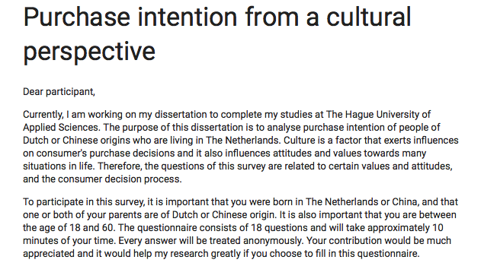

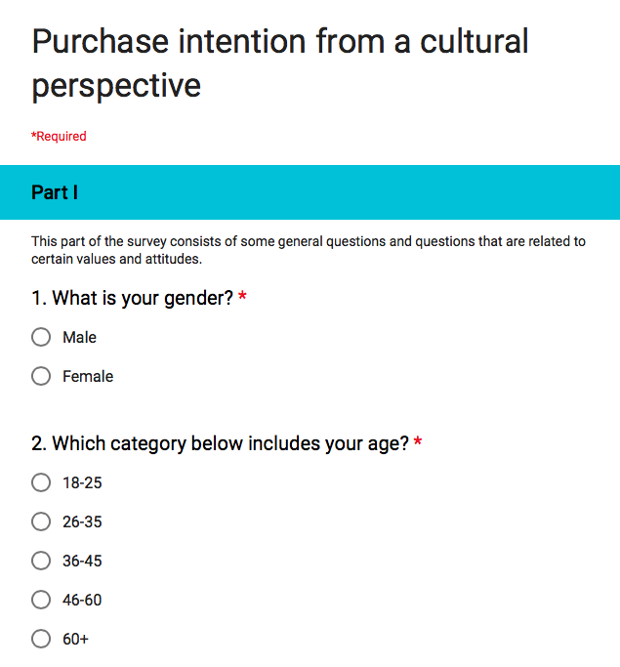

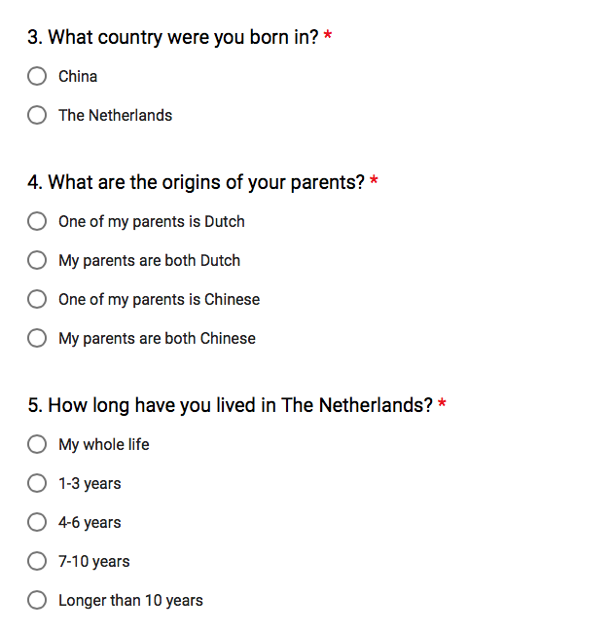
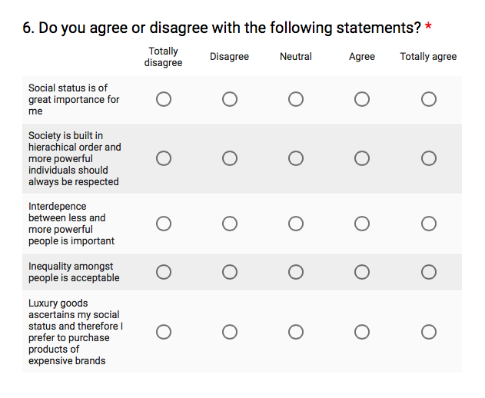

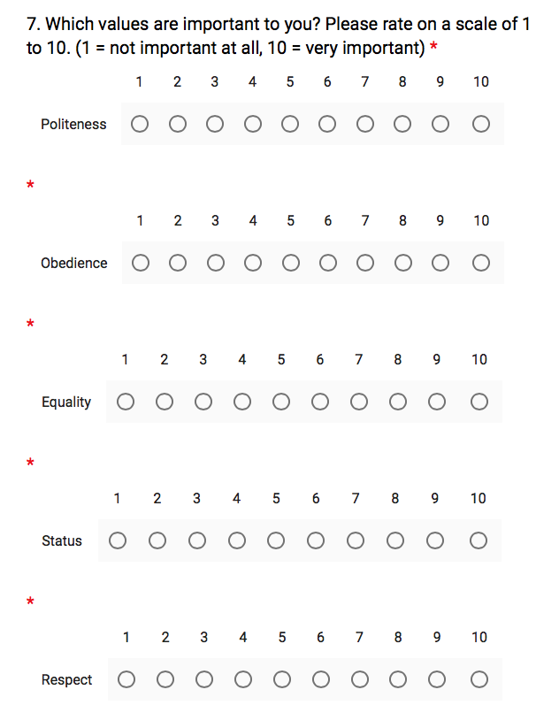

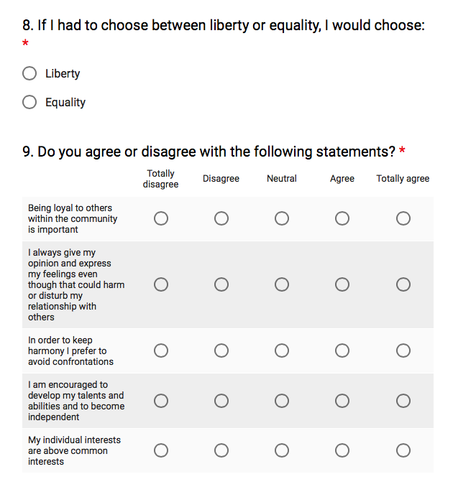
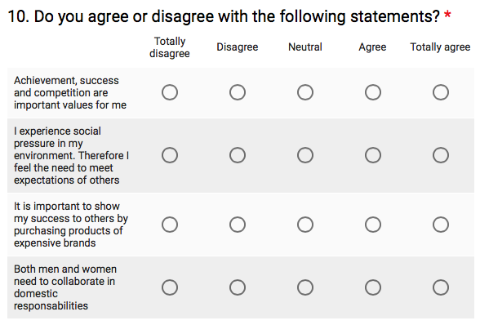

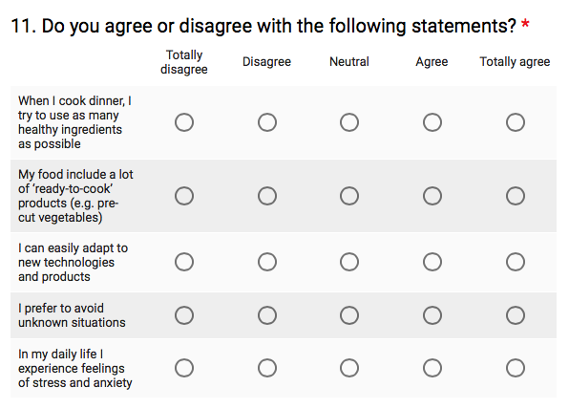

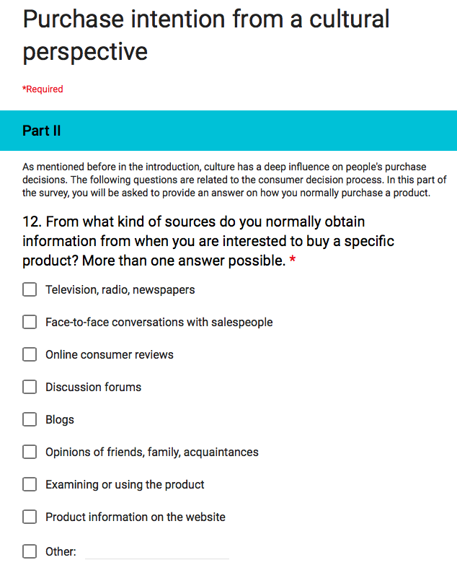

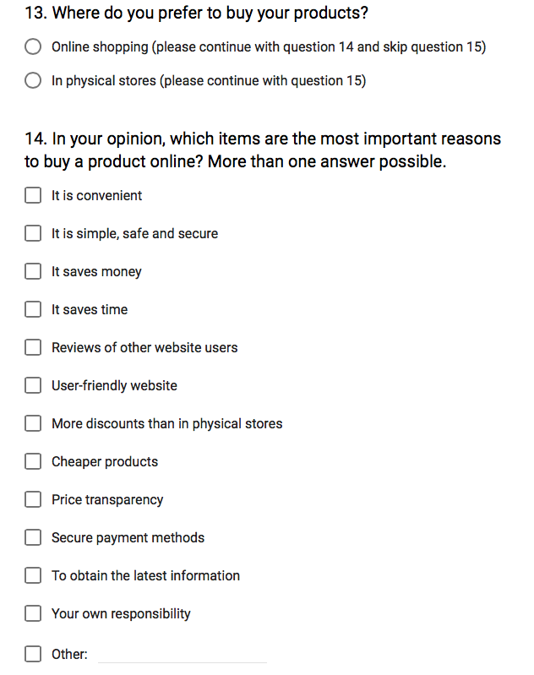
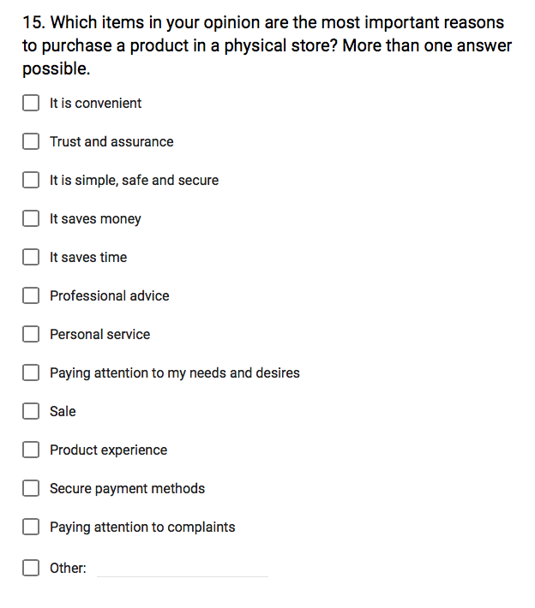
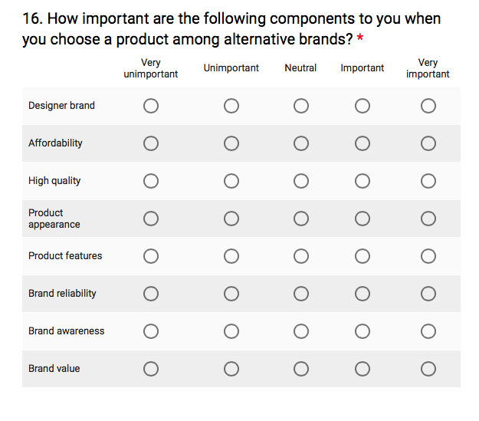
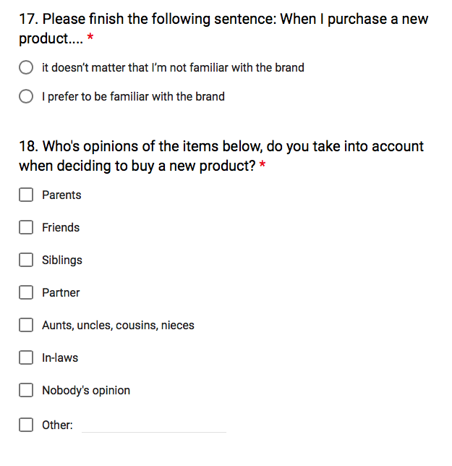

II Student Ethics Form

European Studies

Student Ethics Form

Your name: Michella Vink

Supervisor: Mr. van Weperen

Instructions/checklist
Before completing this form you should read the APA Ethics Code (http://www.apa.org/ethics/code/index.aspx). If you are planning research with human subjects you should also look at the sample consent form available in the Final Project and Dissertation Guide.

a. [ ] Read section 3 that your supervisor will have to sign. Make sure that you cover all these issues in section 1.
b. [ ] Complete sections 1 and, if you are using human subjects, section 2, of this form, and sign it.
c. [ ] Ask your project supervisor to read these sections (and the draft consent form if you have one) and sign the form.
d. [ ] Append this signed form as an appendix to your dissertation.

Section 1. Project Outline (to be completed by student)

- Title of Project:

Purchase intention from a cultural perspective

(ii) Aims of project:

The purpose of this dissertation is to analyse purchase intention between citizens in the Netherlands who are born in China or The Netherlands, who have at least one parent of Dutch or Chinese origin. With this research, a better insight in purchase intention will be created of individuals with Dutch or Chinese origins.

(iii) Will you involve other people in your project – e.g. via formal or informal interviews, group discussions, questionnaires, internet surveys etc. (Note: if you are using data that has already been collected by another researcher – e.g. recordings or transcripts of conversations given to you by your supervisor, you should answer ‘NO’ to this question.)

YES / N0

If no: you should now sign the statement below and return the form to your supervisor. You have completed this form.

This project is not designed to include research with human subjects . I understand that I do not have ethical clearance to interview people (formally or informally) about the topic of my research, to carry out internet research (e.g. on chat rooms or discussion boards) or in any other way to use people as subjects in my research.

Student’s signature ________________________________- date _____________________

If yes: you should complete the rest of this form.

Section 2 Complete this section only if you answered YES to question (iii) above.

(i) What will the participants have to do? (v. brief outline of procedure):

It is necessary that participants provide an answer on my survey questions.

(ii) What sort of people will the participants be and how will they be recruited?

The participants include individuals who were born in China or Holland and who are now living in the Netherlands. They will be recruited on social media en contacted in person in different public areas.

(iii) What sort stimuli or materials will your participants be exposed to, tick the appropriate boxes and then state what they are in the space below?

Questionnaires[ ]; Pictures[ ]; Sounds [ ]; Words[ ]; Other[ ].

The questionnaire can be found in the Appendix of this dissertation.

(iv) Consent: Informed consent must be obtained for all participants before they take part in your project. Either verbally or by means of an informed consent form you should state what participants will be doing, drawing attention to anything they could conceivably object to subsequently. You should also state how they can withdraw from the study at any time and the measures you are taking to ensure the confidentiality of data. A standard informed consent form is available in the Dissertation Manual.

(vi) What procedures will you follow in order to guarantee the confidentiality of participants' data? Personal data (name, addresses etc.) should not be stored in such a way that they can be associated with the participant's data.

All the responses of the questionnaire will be treated in the strictest confidence and will only be used in this dissertation. Besides, participants have filled out the survey questions anonymously and the author has not received any personal data about them.

Student’s signature: ................................................. date: .......................

Supervisor’s signature (if satisfied with the proposed procedures): ............. date: ..............

