MarketingPLAN

Name: Faraaz Abdoel
Student number: 10093400
Class: ES4-5
Final Project supervisor: Mr. L. Harris
Second marker: Mrs. N. Ariëns
Date of Completion: 22 June 2015
Academy of European Studies
The Hague University of Applied Sciences

Executive Summary
This document contains the marketing plan for HealthCity The Hague. HealthCity The Hague is a premium fitness club in The Hague that offers many extra facilities to its members, such as child care, personal training, a swimming pool, and sauna facilities.
The marketing plan is aimed at meeting the company’s objective for this year. The objective of HealthCity is to grow by four new members. This may look easy in the first place, but HealthCity needs to overcome some challenges in order to meet this objective.
Firstly, HealthCity is advised to retain the current customers. Many people cancel their membership because they feel that the price/quality relationship in not in balance. In order to expose the weak points of the health club, a survey was conducted among 100 members of HealthCity The Hague. The results of the survey indicate that HealthCity The Hague should pay more personal attention to its members. The fact that HealthCity The Hague does not pay enough personal attention to its members, is in contrast with the vision and mission statement of HealthCity. This requires improvement.
On the other hand, HealthCity is advised to target a specific target group. In order to determine which target group is most promising, different kinds of research methods were conducted.
Furthermore, the survey provided answers to which type of customers HealthCity should target. HealthCity is advised to target the so called ‘’Health Freakz’’. This type of customers is the group which is most loyal and visit HealthCity The Hague most frequently.
Secondly, desk research is conducted. Desk research revealed the trends that are currently taking place in the macro environment. Desk research of the macro environment showed the potential opportunities and threats which could affect the organisation. This marketing plan offers views on how HealthCity The Hague can adapt to current events in order to reduce potential threats. Examples of such threats are bootcamps and wearables.
On the other hand, opportunities were discovered from studying the macro environment. Major opportunities come from the political environment.
Finally, two interviews were conducted. The first interview provided answers to what HealthCity The Hague could learn from similar health clubs abroad. It is possible that health clubs abroad apply methods in order to meet their objectives, which HealthCity The Hague is not aware of.
The second interview was with Gary Barnes, a member of HealthCity The Hague, who belongs to the primary target group. The interview provided deeper insights into how HealthCity The Hague can improve the facility and services in order to meet the expectations of the primary target group.
Table of Contents
Executive Summary 2
Executive Summary Fout! Bladwijzer niet gedefinieerd.
Preface 5
1. Introduction 6
2. Methodology 8
3. Internal analysis 9
3.1 Mission 9
3.3 History 9
3.4 Business Definition 10
3.5 Customer Needs 12
3.6 Organisational Structure 14
4. Current marketing situation 16
4.1 DESTEP analysis 16
4.1.1 Demographic dimension 16
4.1.2. Economic Dimension 22
4.1.3. Social/Cultural Dimension 25
4.1.4 Technological dimension 27
4.1.5 Ecologic 28
4.1.6 Political 29
5. Meso environment 30
5.1. Competition analysis 31
5.2. Five Forces Of Porter 31
6. Swot Analysis 33
7. Confrontation Matrix 34
8. Goals and Objectives 35
9. Segmentation 36
10. Targeting 41
11. Positioning 44
12. Strategy 46
13. Marketing Mix 47
13.1 Product 48
13.2 Price 48
13.3 Promotion 48
13.4 Place 49
13.5 Personell 49
13.6 Presentation 49
14. International comparative examination with HealthCity Belgium 50
15. Recommendations 52
16. Conclusion 53
17. List of References 55
18. Appendices 57
18.1. Transcript interview 1 57
18.2. Transcript Interview 2 62
18.3. Questionnaire 63

Preface
For the purpose of this paper, a distinction is made between the main HealthCity organisation denoted by the name HeatlthCity, the HealthCity establishment in the centre of The Hague denoted by HealthCity The Hague, and the HealthCity subsidiary encompassing all HealthCity establishments in Belgium denoted by HealthCity Belgium.
HealthCity The Hague is the assignment provider for this marketing plan. HealthCity The Hague is a health club that consists of around 2100 members. HealthCity has 13 locations in The Netherlands and in total approximately 100 clubs across Europe. HealthCity is also parent company of the low budget facilities of Basic Fit.
HealthCity The Hague wants to increase membership sales. Because of both internal and external forces, HealthCity The Hague faces difficulty in increasing its membership sales.
The goal for this year is to increase the total number of members by four. It should be taken into account that about 70 members are leaving HealthCity monthly. The aim is to reduce the number of leavers and to attract new members as well.
Writing this marketing plan was a huge challenge. I really hope that this marketing plan will improve the HealthCity The Hague facility and that it will lead to a significant increase of membership sales.
Firstly, I would like to thank my beloved girlfriend Safira for all her patience during the writing of this marketing plan. She is my motivator.
I would also like to thank my parents. They provided me with all the love and comfort needed when this marketing plan was being written. I do hope I made you proud.
I would like to thank the department of European Studies for setting up this wonderful program. It has really helped me in growing as a person.
This document is dedicated to everyone who knows me.

Introduction

HealthCity is an exclusive health club that is located throughout the European continent. HealthCity is the parent company of the low budget facilities of Basic Fic and is market leader in the European continent. HealthCity has 13 health clubs in The Netherlands and several health clubs in Belgium, Germany, France, Italy, Spain and Luxembourg (Bloomberg, 2015).
The Dutch fitness market has become a displacement market (Driessen, 2014). The industry is affected by several societal changes.
Firstly, the economic recession has made consumers reluctant to commit to long term contracts.
Secondly, people’s loyalty towards health clubs has decreased.
These trends in combination with the saturated market cause difficulties for the fitness industry (Bouma, 2014).
HealthCity The Hague is also facing difficulties. Therefore, this marketing plan is designed. This paper aims at setting up strategies that can help the company survive the current economic recession and to come out stronger. In order to enable HealthCity The Hague to do so, research questions are formulated. The following research questions were assigned by the club manager of HealthCity The Hague. The research questions are formulated as following:
Central research question:
- How can HealthCity The Hague increase the membership sales?
In order to grow, HealthCity The Hague has to sell memberships. To be more specific, HealthCity The Hague has to bind more people than it loses. Because people unsubscribe on a monthly basis, HealthCity The Hague has to find a way to attract new customers on a monthly basis as well.
The following sub questions are designed to answer the central question.
Sub question 1:
- What are the target groups that HealthCity should focus on?
It is advisable to do research on which target group HealthCity should focus on. Targeting the wrong audience is a waste of time and money. HealthCity should target specific groups which provide the highest chances of success.

Sub question 2:
- How can HealthCity attract consumers from the target groups to subscribe?
Different target groups react differently to marketing, so it is of importance to use the right marketing tools for each target group in order to attract them.
Sub question 3:
- Why do most people unsubscribe from HealthCity?
By determining why members leave the company, it provides an indication on which aspects should be improved in order to retain these members. It will be in favour of the company when a minimum number of people unsubscribe. This will relieve the pressure on the sales department.
Sub question 4:
- What are external factors that could affect the joiner leaver rate at HealthCity?
This question requires analysis on what happens in the macro environment. By examining the macro environment, HealthCity will be better aware of opportunities and threats in the industry.
Sub question 5:
- How do comparable international health clubs abroad increase their membership sales and what could HealthCity The Hague learn from that?
This question is important because HealthCity is located in almost every country of Western- Europe.
It is possible that health clubs abroad are using methods which The Netherlands is not aware of.

Methodology

In order to meet the abovementioned objective, different kinds of research are required.
Firstly, desk research is necessary to study the macro environment. The model used for analyzing the macro environment is the DESTEP analysis.
The DESTEP analysis enables the examiner to find out trends that are taking place in the demographic, economic, social/cultural, technological, ecological and political fields of the society. Being aware of these dynamics will enable HealthCity to create and adapt strategies.
As the society is a dynamic force, it is advised to do the DESTEP analysis on an annual basis.
Desk research has also been conducted in order to analyse the meso environment. The meso environment is about the industry itself and includes factors such as competition and market growth. Analyzing the meso environment provides insights how the positioning strategy should be designed so HealthCity will be better aware of how it can distinguish itself from the competitors.
The main methodology used to do the internal analysis was field research. A survey was designed and distributed to 100 members of HealthCity. The responses were processed in Excel. The results of the survey are useful for doing analysis on the company’s strong and weak points and provides information about how HealthCity could improve the health club. This is expected to lead to fewer unsubscriptions. The survey also provides answers on who the average customer of HealthCity actually is, demographically as well as socially.
The third methodology used was interviewing. In order to attain information from international health clubs abroad, a telephonic interview was conducted with HealthCity Belgium. The interview was held with a sales employee of HealthCity Zuidpool Belgium. He was asked to describe his daily activities in order to determine what tips and tricks health clubs abroad apply to attract members. This could be useful for HealthCity the Hague, because health clubs abroad could apply methods which HealthCity The Hague is not aware of.

Internal analysis

HealthCity owns and operates sports and fitness clubs across Europe. The countries where they are located are The Netherlands, Belgium, France, Luxembourg, Germany, Spain, and Italy. HealthCity offers HealthCity clubs, Basic Fit, and HealthCity Premium. The company provides extra facilities, such as tennis and squash courts, swimming pools, sauna facilities and childcare. HealthCity’s head quarter is based in Hoofddorp, The Netherlands and was founded in 2000. HealthCity International B.V. operates as a subsidiary of Leisure Group Europe B.V. (Bloomberg, 2015).
3.1 Mission
‘’We are an integral part of our members’ lives. By our positive attitude, expertise, and appreciation for their efforts we motivate members to achieve an active lifestyle. We constantly strive for market leadership as best appreciated fitness partner’’ (HealthCity). This is described as the mission of HealthCity.
3.2 Vision
‘’HealthCity strives to be the best luxurious sports, fitness, and wellness chain of Europe. We do so by exciting and inspiring with innovative products and services, a capable staff and personal attention’’ (HealthCity). This is stated at the official website of HealthCity.
3.3 History
HealthCity is founded by René Moos, a former professional tennis player. After his career René Moos became a tennis instructor and owned a few tennis courts. Later on, he added some fitness and other sport facilities to it. About ten years later, he expanded from one accommodation, to eight sport clubs.
After a few years, investment group Waterland provided HealthCity with a financial injection. René Moos said that the advantages of increase of scale were a decisive factor for allowing Waterland to enter, especially for the purchase of fitness machines.
In 2006, HealthCity owned 26 fitness clubs. They took over Fitness First and Basic Fit in 2010. Fitness First became HealthCity and Basic Fit remained Basic Fit. Now René Moos is owner and CEO of a low budget fitness chain (Basic Fit) and a premium sports chain (HealthCity). (Groothengel, 2012).

3.4 Business Definition
A business definition will be given with the help of the Abell model. This model outlines the technologies that the company uses to meet the needs of several customer groups.
The Abell model gives a clear view on which customer groups are served, how they are served and based on which needs.
On the basis of this model, a description will be given about the customer groups, technologies and needs. In this internal analysis, only the information that is visible within the cube will be described. All the information outside of the cube will be described later on in this paper.
Figure 1. Abell
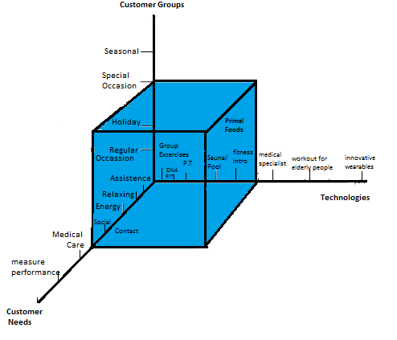

First, the technologies will be described.
HealthCity is a premium gym that offers additional facilities and products. Besides the usual strength and cardio machines, HealthCity offers group exercises, personal training, a swimming pool, sauna facilities, DNA FIT, fitness introduction, and Primal Foods.
Group exercises: HealthCity offers the Less Mills program. These consist of Xcore, Grit, Pilates, Body Attack, RPM, Indoor Cycling, Bodypump, Body Balance, Power Yoga and Zumba. Additionally, HealthCity also offers Boxercise, which is boxing training. These group workouts vary from high intensity training, to strength training, to flexibility training and cardio training. Additionally HealthCity also offers team workouts. These include Team Workout Core (Abs training), team workshop Freestyle (Small Group Training) and swim training. All group exercises are included in any kind of membership.
Personal Training: HealthCity offers 4 kinds of Personal Training Packages. The first one starts with four sessions (€260), secondly eight sessions (€480), thirdly 16 sessions (€720) and at last 48 sessions (€2400). HealthCity employs two personal trainers. In order to awaken the interest of the members, the personal trainers promote the packages by giving a single free coaching session. Also, with every new subscription, the new member can purchase a so called ‘’Personal Training Introduction’’ package, which consists of three personal training sessions. This package costs €30.
Sauna facilities / Pool:
HealthCity has one swimming pool of 20 metres long. This swimming pool can facilitate six people at a time. The swimming pool is accessible for both men and women. However, the sauna facilities are separate for men and women. HealthCity has a sauna and steam bath for women only and one for both genders. No clothes are allowed in these areas.
Fitness Introduction:
New members get a free Fitness Introduction. This introduction includes two sessions of each 45 minutes. The Fitness Introduction is, in contrast to the Personal Training Introduction, in groups of four people. During the Fitness Introduction, the new members are being introduced to the machines by the fitness instructor. Also, body weight and fat percentage are being measured during this introduction. Also, safety and fire exits are discussed. After the Fitness Introduction, members normally have to find their own way.
DNA FIT:
DNA FIT is a product HealthCity offers for people who want to gain insights in their own body. The DNA FIT is offered to both members and non-members. As non-member, the price is €219 and includes two months access to the HealthCity club. For members the price is €129.
DNA FIT is a program that gives insights into your genes. Genes contain information about personal strengths and weaknesses and nutrition intake. Saliva is taken from the mouth and being sent to the lab in London. After a couple of weeks, the results are being sent by e-mail to the participant, after which the participant is consulted by the personal trainer about the results.

Primal Foods:
Primal Foods takes place twice a week and is a workshop for people who like to improve their nutrition intake. The Primal Foods workshop teaches how to eat and drink healthy.

3.5 Customer Needs

In this paragraph, the customers’ needs will be discussed. HealthCity The Hague has designed its technologies based on what it thinks what the customers’ needs are. The needs are going to be described with the help of the Maslow hierarchy of needs.
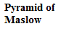
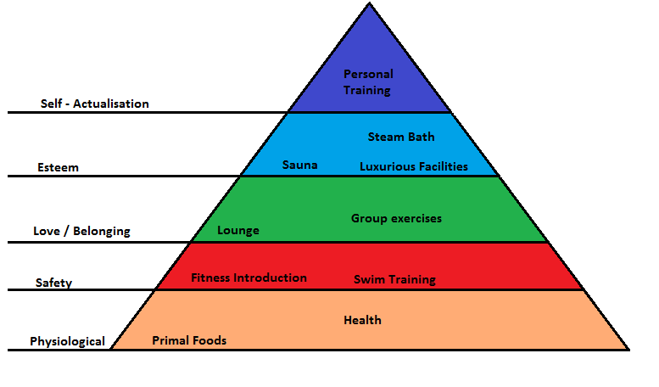

According to Maslow, every single person has the same needs (Muilwijk). Every need belongs to a certain layer. The first layer includes physiological needs. Physiological needs are the basic needs that a person has, like physical health and water. This is also applicable to HealthCity. HealthCity offers health. They do so by providing a location with facilities where people can work on their health, but also by providing, for example, workshops like Primal Foods. Primal Foods teaches the participant how to eat and drink healthy. After this need is fulfilled, the need upgrades to the second layer: safety needs.
The second layer includes safety needs. Also the safety needs can be applied to the products, services and facilities of HealthCity. HealthCity fulfils this need by providing swim classes and by providing the Fitness Introduction. During the Fitness Introduction, the instructor explains how the fitness machines should be used in a safe way. Also, emergency exits are being discussed during the Fitness Introduction.
When the second need is fulfilled, one will seek a feeling of love/belonging. HealthCity fulfils this need by facilitating an area where people can talk to each other while enjoying a cup of tea. This area is called the lounge. This need is also fulfilled during group exercises. Group exercises are often visited by the same people and given by the same instructor. Through this way, one meets new people, makes new friends and belongs to a community.
The fourth layer is about status and prestige. This is the need one will get after love/belonging is fulfilled. Because HealthCity is a premium gym with facilities that not every gym provides, for example a swimming pool, a sauna and a steam bath, it meets the need for status. The prices of HealthCity are above average. Through all these ways, HealthCity also fulfils the fourth layer of needs for status and prestige.
The last layer in the Maslow hierarchy is called Self - Actualisation. People who reach this need, have already fulfilled all the other needs. This need is about living up to your potential. HealthCity provides personal training to fulfil this need. During personal training, personal boundaries are extended. Personal training is aimed at improving yourself. That is what Self – Actualisation is about.
To conclude, a description of the target groups that are served will be provided. Two out of three factors of the Abell model are already discussed.
The distinction that is made for dividing the target groups is from the book ‘’Principles of Marketing. This book makes a behavioural distinction in how target groups can be segmented. The behavioural feature used in the Abell model is occasional. How these target groups are served with the products of HealthCity The Hague will be described as following:
HealthCity The Hague serves the members who fitness on a regular base (regular occasion) because HealthCity provides one year memberships (€79 a month) and two year memberships (€69 a month). Because these memberships cover a relatively long time, the people who train on regular occasion are served well.
Secondly, HealthCity also serves people who want to do fitness during their holiday. HealthCity has day cards (€17,50) and week cards (€35). These cards also provide full access to every facility of the gym. Even if someone is making a long trip to The Netherlands, HealthCity provides a monthly membership (€90). This membership can be cancelled monthly with one month time notice. This membership can perhaps also serve the people who want to train for a special occasion.

3.6 Organisational Structure
On the next page, the organisational structure of HealthCity The Hague Premium can be found.
On the top is the regional manager: Hank Roothuis. Hank is responsible for eight HealthCity clubs, under which the locations in Rotterdam, The Hague and Amsterdam.
Jamal Badre is the club general manager. He is in charge and is responsible for the club.
The third layer is the different departments. Reception, sales, fitness and group exercises.
Anita is assistant club manager and is responsible for the reception. She has a team of four other receptionists: Mireya, Jennifer, Nadia and Jeff.
The sales department consists of the employees: Michelle and Rabia. They are closely controlled by Jamal, the club general manager. Michelle and Rabia are responsible for meeting the sales target.
The fitness department consists of three people: Mohsen, Benjamin and Michael. They are supported by several interns. Mohsen is both fitness manager and personal trainer. He is also responsible for the targets regarding the sales of personal training packages. Benjamin is personal trainer and also has to meet his monthly target for the sales of personal training packages.
Michael is a fitness instructor. His job is to be on the floor, to clean if necessary, and to answer questions from members regarding the use of the machines. Michael also gives team workouts.
Judith is responsible for the schedule of the group exercises and the group instructors. If necessary, she also gives team workouts.

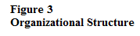
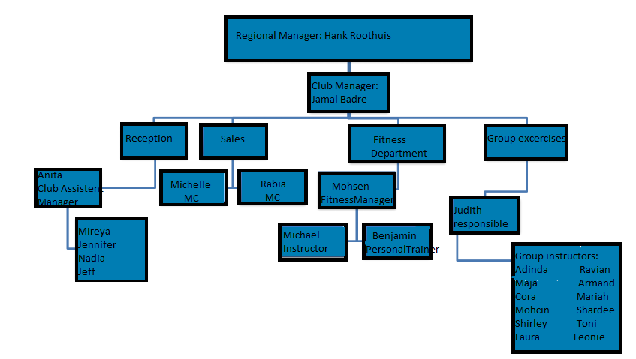

Current marketing situation

In this chapter, external factors that affect the organisation and its industry will be analysed. The model used for this analysis is called the ‘’DESTEP analysis’’. This model involves demographic, economic, social, technological, ecological and political factors. In order to retain a sustainable business, these factors are indispensable to be aware of before making any marketing decisions. This chapter will outline the most important external developments that affect the organization and its industry.

4.1 DESTEP analysis

4.1.1 Demographic dimension

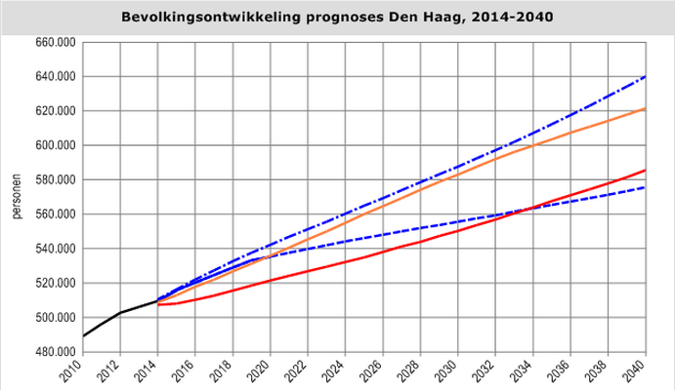
Demographic factors give a view on the population. The most important demographics will be described in this paragraph. It involves data, such as, gender, age, growth, aging population, density, life expectancy, immigration, education, occupation, and income.
The most important and most applicable demographics will be used. Because this is a marketing plan for HealthCity The Hague, demographics such as birth rate can be left out. HealthCity International has around 100 gyms throughout the European continent (The Netherlands, Belgium, Luxembourg, Germany, Italy and France) Because this marketingplan is especially designed for the location The Hague, demographics of The Hague will be applied.
Figure 4 shows how the municipality of The Hague predicts how the population of The Hague will increase until 2040. Currently, the population counts almost 520.000 people. This number is expected to double in 2040, according to research of the municipality of The Hague (Gemeente Den Haag, 2013). However, this graph shows the total population of The Hague. That means that children are also included. In order to a get clear vision of the most relevant ages and their geographical location, each quarter is going to be analysed apart from each other. Fitness is often a convenience facility which is located close to home.
Figure 5 represents the population of Centrum. The number of the total population of this quarter is 99.021 inhabitants and 66.264 of them have the age of 20-64.
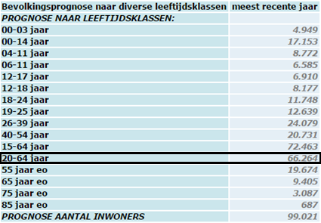

Figure 6 shows the population of Loosduinen. The number of the total population of this quarter is 45.722 and 25.889 of them have the age of 20-64
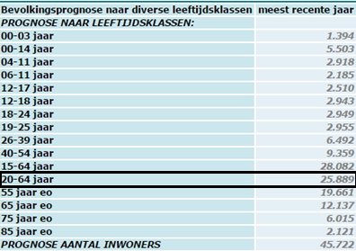

Figure 7 represents the quarter Escamp. The number of the total population is 118.916 and 74.192 have the age of 20-64
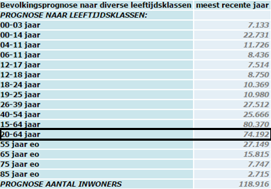

Figure 8 represents the quarter Segbroek. The number of the total population is 60.694 and 40.263 have the age of 20-64
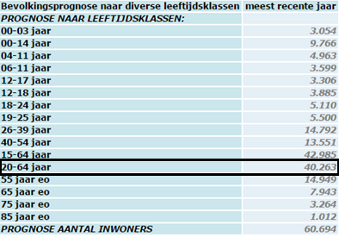

Figure 9 represents the quarter Scheveningen. The number of the total population is 54.119 and 33.010 have the age of 20-64
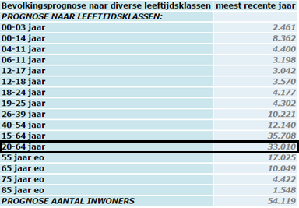

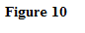
Figure 10 represents the quarter Laak. The number of the total population is 39.803 and 27.012 have the age of 20-64
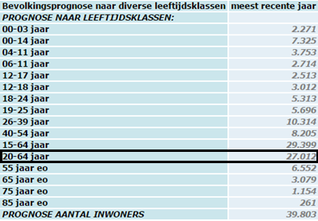

Figure 11 represents the quarter Haagse Hout. The number of the total population is 43.639 and 26.477 have the age of 20-64
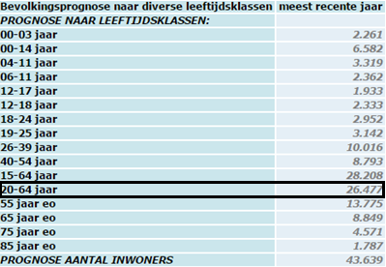

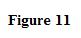

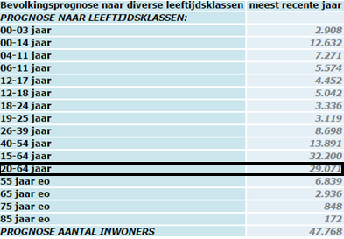
Figure 12 represents the quarter Leidschenveen - Ypenburg. The number of the total population is 47.768 and 29.071 have the age of 20-64

The figures show that The Hague consists of around 500.000 inhabitants, of which around 265.000 people are between the ages of 20-64. This is this potential primary target group. Currently, HealthCity consists of around 2000 members. The demographical study shows that HealthCity has many potential customers.

4.1.2. Economic Dimension

The next phase of the DESTEP analysis is the economic situation.
Figure 13 shows the working population of The Hague. As stated before in the demographic analysis, 265.000 people in The Hague have the age of 20-64. Figure 13 shows that the working population of The Hague consists of approximately 250.000 people. Similarly, the working population is about 93%. On the other hand, the figure shows that the economic situation has decreased since 2005. The working population decreased slightly and the unemployment rate jumped dramatically. (Gemeente Den Haag, 2013). It should be taken into account that the economic decrease influences the people’s mind and that they may have become reluctant to enter an expensive long term commitment.
Consumers have become more critical towards luxurious expenses like a gym fee. The budget gyms and the premium facilities are doing better than the middle segment facilities. It is estimated by the Rabobank that about a half of all gyms are recording losses (Driessen, 2014).
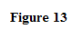
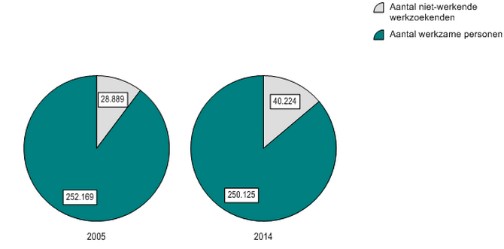

Despite the fact that the economic situation is not ideal, the Dutch government still invests around a billion euros a year into the sport sector. The sport sector contributes 1% of the Dutch economy. The CPB estimates the Dutch average gross income in 2015 on €2734. This is the income which most people have, according to the CPB. The average income in 2014 was €2695, which is €39 less than the current year. The average income is expected to grow to €2811 in 2016. That is €77 more than 2015 (GemiddeldInkomen). These numbers are all estimations of the CPB.
The consequences of the economic developments on the fitness industry can be seen in figure 14. A comparison is made between 2012 and 2014 regarding the number of locations of the different health clubs. A trend can be seen in the rocket increase of low budget and a dramatic decrease of premium health clubs.
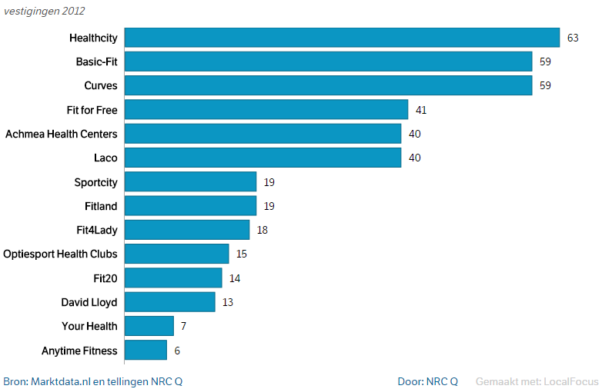

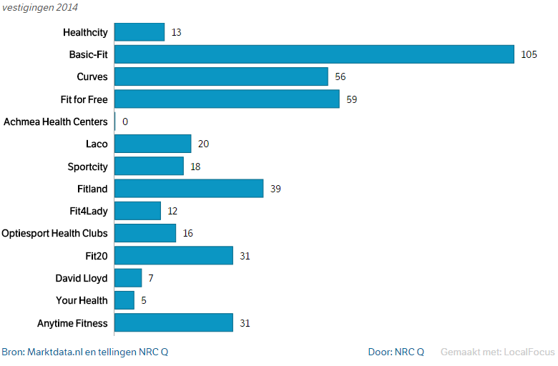

It is estimated by the CBS that one of the richest quarters of The Netherlands is located in The Hague. This quarter is called Scheveningen. The quarter called Haagse Hout also takes a high place in the ranking of richest quarters of The Netherlands. However, one of the poorest quarters of The Netherlands is also located in The Hague. This is the quarter Centrum. In other words, The Hague is the city with the highest contrast of rich and poor (Novum, 2007). HealthCity is also located in the quarter Centrum. To give a clear view of the layout of the Hague, a map of The Hague can be found below.

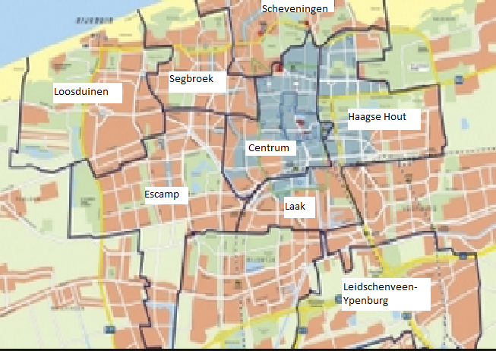

Social/Cultural Dimension

A lot of interesting developments can be noticed when the social/cultural dimension are studied. Fitness has become the most popular sport in The Netherlads and a healthy lifestyle has become a very popular lifestyle as well (Driessen, 2014). Via different social media channels such as Instagram and Facebook, the most common aspects of a healthy lifestyle are being emphasized, such as clean eating and fitness.

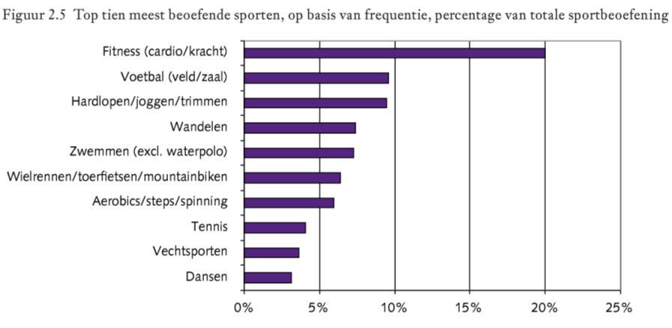
Figure 16 shows that fitness has become the most practiced sport in The Hague.
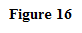
Since the rise of the internet, the society has become more individualized. People want to plan activities, such as sports on their own time. This means that fitness clubs should have long opening hours so people can come anytime that is comfortable to them. This is also the reason why people tend to do less team sports nowadays, because it causes a lack of freedom (Raaphorst, 2015).

Social Media
The rise of social media has created a fitness community. People have become individualized in terms of time and get motivated by their social media community (Fit!Magazine, 2012). They follow people who strive for the same goals and it is to say that these people, from all around the world, have become their fitness partners.
Figure 17 shows the usage of social media by the Dutch population. Social media has become a great tool for marketers to market their product or brand. Most social media channels are growing rapidly compared to the year previously, except Twitter, which is decreasing. Facebook remains the same with 6.6 million users. Remarkable are the growths of LinkedIn, Instagram and Pinterest.
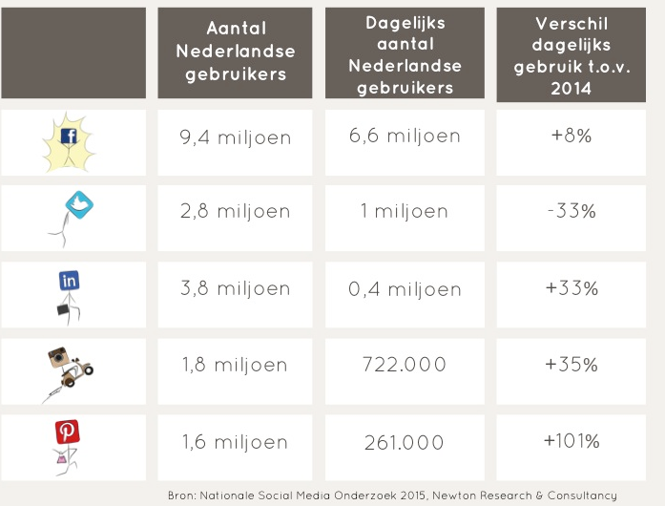

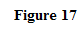

Appearance
Another important aspect of the social/cultural macro environment is appearance. A research conducted by the university of Texas asserts that people who look better tend to achieve more in life than the people who do not (Kraaijvanger, 2011). People nowadays are aware of this fact and go to the gym more often to work on their appearance. The people who look good are often better educated and easier to cope with. This is because of their high self-confidence, which they get from their appearance. Good looking people are also happier than people who do not look good. This is because people who looks good earn more money than others do. This research was held between 1971 and 2009 among 25.000 people from The United States, Canada, Germany and The United Kingdom.

Breeding

Annet Tiessen, from the SCP ( Sociaal Cultureel Planbureau) states that people should get the used to sports at a young age. ‘’When people get used to sports at a young age, it becomes a part of their life and they will tend to exercise forever (Raaphorst, 2015). ‘’They should learn that sports are fun and that it is important to exercise’’.
According to the SCP, two – third of the population exercises sufficiently.
People with a lower education level, people with a bad health and people who live in bad environment tend to do fewer sports. Most people are satisfied with the supply of sport facilities.

4.1.4 Technological dimension

Recently, there has been a congress of the IHRSA (The International Health, Racquet & Sportsclub Association). Their mission is to grow, protect and promote the health and fitness industry, and to provide its members with benefits that will help them to be more successful (Heel, 2014). The members of the IHRSA include health clubs and fitness facilities, gyms, spas, sports clubs, and industry suppliers.
During their latest congress, 570 companies from 35 European countries were present. Dave Right, CEO of ‘’Myzone’’, stated that wearable technology will be the future friend or enemy of fitness clubs (Heel, 2014). Many speakers said during the congress that the fitness industry should embrace this innovative technology as soon as possible. ‘’Everybody nowadays measures’’, Right stated. ‘’Especially low budget fitness clubs are likely to embrace this new technology because they are not able to offer personal attention (Heel, 2014).
‘’Wearables give feedback about the performance during the exercise. It motivates members to be and to remain active. Also, it takes the member’s experience to a higher level’’.
Most common wearables are smart watches, apps, and shoes.
The technology came over from the US. People tend to increasingly integrate technology into their lives, with the purpose of gathering information about themselves and to learn from it and if necessary, improve their lifestyle. This development is called ‘’Quantified Self’’, according to Gary Wolf and Kevin Kelly from the magazine ‘’Wired’’, in the US.
Another new technology in the fitness industry is machines that count repetitions. This means that the member is free from counting. The machine does that. These are so called: ‘’Smart machines’’.

4.1.5 Ecologic
Ecologic developments in the fitness industry are fitness machines that use kinaesthetic energy from exercising that is converted into electric energy (Overstappen, 2013).This energy can provide the club of lightening and air-conditioning. This development benefits the environment and reduces electricity costs for the sports club. Several fitness clubs in The Netherlands are already facilitated with this technology.
Another development is CSR (Corporate Social Responsibility). A couple of years ago, the CSR policy of many companies were about giving charity and reducing greenhouse effects. This has become an old fashioned approach of CSR. Nowadays, it goes a little further than that. Companies have to integrate CSR into their strategy, instead of approaching it as a project. When companies do so, a situation will occur where the environment, the society, and the company will profit from. In this type of CSR, this is the goal. Financial profits are a tool to accomplish that with(Fit!Magazine, 2013).When this happens, companies will return to why they actually started up: To meet a certain societal need.
A report of the Rabobank states that fitness clubs and health care need each other. Fitness clubs need to cooperate with national health care institutions. This is because the costs for national health care are increasing (Heijden, 2015). The purpose of this report of the Rabobank is to raise awareness that the emphasis should be on preventing disease, instead of curing it. The advice for fitness clubs is to join powers with general practitioners, health care, physiotherapists, and health care insurance companies and to cooperate closely with each other. A good example of this development is fitness club ‘’Body Sports’’. They integrated prevention courses into their product range.

4.1.6 Political
Minister Schippers from Sport has announced that there is a growing number of sport injuries. This is in conflict with the Dutch policy that everybody should be able to participate in sports safely. The minister was worried about the numbers (E.I.Schippers, 2015).
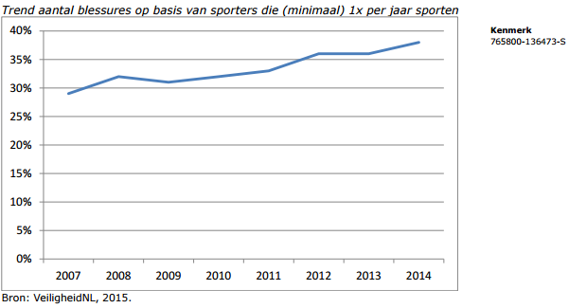
Figure 18 shows an increase in injuries during sports:
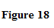

This figure shows that in 2007, 28% of the people who did sports got an injury and that the number jumped to 36% in 2014. In 2014, the number of people that got injured while doing sports is estimated on 4,7 million. The ministry wants to focus on the sports that are practiced by the majority. These include soccer, running, and fitness.
Injuries cause costs and absenteeism (E.I.Schippers, 2015). The ministry has set up two programs to fight this negative trend:
- Firstly, interventions have to be developed. This has to lead to measurements which will lead to fewer injuries.
- Secondly, executing the interventions nationally. Cooperations will be set up between sport organisations and research institutions.
Cooperations between the sports, science institutions, and the business will be supported.
The minister has reserved €675.000 euros for this program.

Meso environment

In this paragraph, an analysis of the industry will be made. In the previous chapter, an analysis of the macro environment was made. Now, it is time to narrow down to the meso environment. The meso environment will be made with the support of the Five Forces of Porter model. This model outlines to what extent suppliers, competitors, buyers, and potential new entrants can affect the organization.
Also, an analysis of the competitors in the market will be described. The elements that are key for this analysis are price, facilities, personal training, medical service, reachability and which target groups are served.
The industry is a large industry which contributes 1% of the economy of The Netherlands. The revenues are about one billion euros a year. The Netherlands counts around 1650 gyms in total, of which about a half are recording losses. Fitness was a really booming business in the recent years, but now the market has stabilized and the weak players in the market are closing their doors (Driessen, 2014).
According to Philip Pijpers, director of consulting office ‘’Kentrium’’, the majority of the gyms are becoming part of a chain. The individual gyms are suffering. About half of the individual gyms are recording losses (Bouma, 2014).
Fitness is, with a majority of 3 million members, still the biggest sport. ‘’Fitness can still be profitable’’, Martijn Rol from the Rabobank states. ‘’It is important that you can distinguish yourself from the rest’’. He also states that because of the economic recession, people’s attitude towards luxurious expenses, like a gym, has become more critical. ’’That is why cheap low budget gyms are doing well. Also the premium gyms are still doing well, but the mid segment gyms are suffering’’ (Heijden, 2015).
The fitness industry in The Netherlands can be categorized as monopolistic competition. This means that there are a lot of players in the market with a lot of customers. This means that one has to be creative in order to distinguish himself from the competition.

Competition analysis

In order to make the differences in the market visible, a competitor analyses in made. The elements that are used for this analysis are price, facilities, personal training, medical service, reachability, and which target groups are served. You can find the analysis in figure 19.
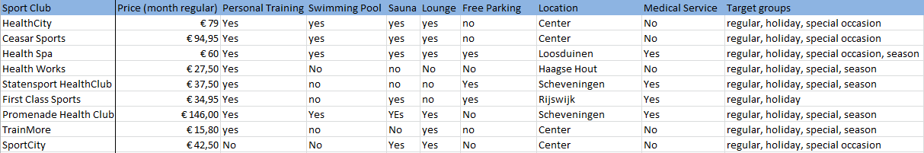
Based upon the facilities, services, location, price, reachability, and membership offers, an analysis is made. This analysis will later be of importance, when to current position of HealthCity will be determined. This is important to see how HealthCity can distinguish itself from the competitors.

Five Forces Of Porter

The next step in the meso analysis is to determine the effects that the industry has on the organization. Every force will be assessed apart from each other. The assessment will lead to a final conclusion to what extent the forces affect the industry. At the end, a final conclusion will be provided. A minus means that the situation is not so favourable. A plus means that the situation favourable is and a plus minus means neutral. The clarifications of the outcomes are described in the model.

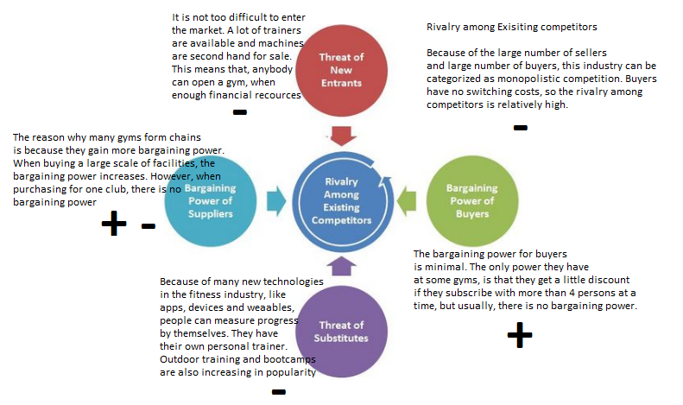

The total outcome of the Five Forces of Porter model is
This outcome means that the industry is a hard industry to be successful in. This is because the threat of new entrants is high, the threats of substitutes are increasing, as knowledge and technology are developing, and that there are a lot of competitors. This means that in this industry, a lot of competitors are present, so you have to be good to distinguish yourself to survive and to be successful.

Swot Analysis

In order to set up the strategy for HealthCity, a SWOT analysis has to be made. This model showcases the strengths and the weakness of the organization and the opportunities and the threats from the meso and macro environment. The SWOT analysis can be found below.
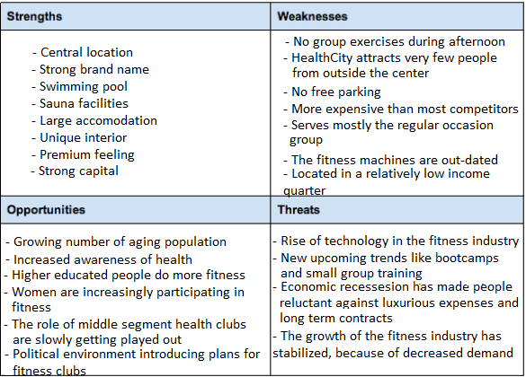

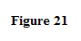

With the support of the confrontation matrix, the findings of the SWOT analysis are used to form different strategies. These strategies are formulated as: attacking strategy (S-O),
defence strategy (W-O), improvement strategy (S-T), and retreat strategy (W-T). The attacking strategy is the most favourable strategy. The question is: How can the organization’s strong points be applied, in order to adapt to the opportunities from the macro environment? The defence strategy is about how the organization’s strong point can fight the threats from the macro environment. The improvement strategy looks at opportunities and the organization’s weak points. The organization tries to improve the weaknesses so it can still profit from external opportunities. At last, a retreat strategy has to be thought of. This strategy links the macro environment’s threats with the organization’s weaknesses. The main question in the retreat strategy is: How can a weakness be improved, so the threat can be eliminated? The most important findings of the confrontation matrix are outlined on the next page.

Confrontation Matrix

Based upon the SWOT analysis, a confrontation matrix is designed. The numbers and colours used in the matrix indicate whether it belongs to a short term strategy, a middle term strategy or a long term strategy.
- The number 1 (green) is short term strategy
- The number 3 (orange) is a middle term strategy
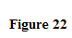
- The number 5 (purple) indicates that it is a long term strategy

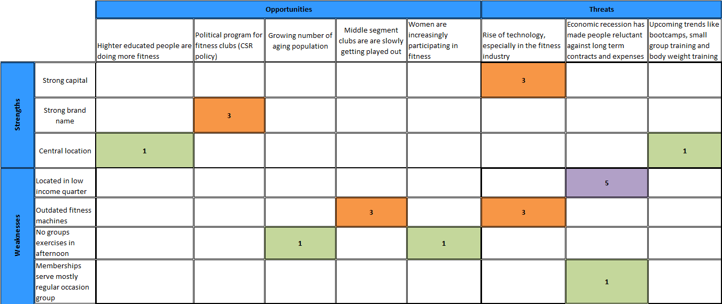
The main results from the confrontation matrix are:
- HealthCity should focus on CSR because the political environment provides the opportunity. This will help increase brand awareness and it will be profitable because of public relations.
- HealthCity should make contact with businesses which are located in the centre to offer team outings and workshops. HealthCity should start creating awareness among the business. Through this way, the businesses will continue in the user readiness stage.
- In order to attract people, HealthCity should be up-to-date with fitness facilities.
- HealthCity could organize bootcamps in the city centre, since that is becoming a threat.
- HealthCity could design a seasonal membership for people who are seasonal sporters. The current long term membership prevents them from subscribing. Also the people who suffer from economic recession will be better served.
- HealthCity can expand the opening hours for childcare, so housewives can sport as well. Women are increasingly participating.
- HealthCity can provide group exercises in the afternoon to serve women who want to sport, since it has become a trend among women. Also older people are served with this.

Goals and Objectives

The goals of HealthCity for this year are:
- HealthCity wants to grow with four members
- HealthCity wants to have a profit margin of €11.000
- HealthCity wants to sell 700 personal training sessions this year
On a monthly base, HealthCity wants to subscribe as many members as it loses monthly. So, if 20 people are unsubscribing, HealthCity wants to subscribe at least 20 new members.
On a daily base, HealthCity wants to make five appointments a day with prospects.

Segmentation

In this chapter, the segmentation will be explained. Segmentation is important because it is driven by the notion that people can be put into groups with similar needs that differ from other groups. This is also called the homogeneous and heterogeneous requirements for segmentation.
The other requirements for segmentation are:
- Measurable
- Substantial
- Accessible
- Actionable
- responsive.
This means that every segment has to consist of people with similar needs, each segment has to differ from one another, availability of data which measures the size of the segment, it has to be large enough, the market has to be reachable, a specific marketing mix should be possible to apply, and the segment has to respond to the marketing mix.
In order to segment the market as accurately as possible, the demographics from the survey are used. Also geographical and behavioural results that the survey provided are used for market segmentation.
The segmentation strategies used for the marketingplan are based on:
- Behaviour
- Geography
- Demography
- Psychographic
The reasons for using these variables are to be explained:
Behaviour:
Examples of the behaviour variable are benefits, rate of usage, user status, loyalty status, attitude towards product, and technological orientation.
The most applicable ones to be used are loyalty status, rate of usage, and benefits.
Why?
People are looking for a specific benefit or benefits when they go to a health club. Some people go to the health club to hang out, while others have a specific goal they want to achieve, like losing weight, or become muscular. The benefits sought are often in line with the rate of usage.
Geography:
Geographic segmentation can take place on different scales. It can take place for example on a national scale, by region, neighbourhood, state, and city. The best solution and most applicable scale for HealthCity is to conduct segmentation on the basis of neighbourhood.
Why?
Health clubs are a convenience business, says the International Health, Racquet, and Sportsclub Association. Most members live within a very close proximity to the health clubs they attend. This is also the case for HealthCity The Hague. Slightly 60% of the respondents that were surveyed live in the same quarter where HealthCity is located. The geographical segmentation is often in line with the loyalty status of the customers.
Demography:
Demographic segmentation takes place on the basis of, for example, age, race, gender, income, religion, social class, or household size. The most applicable demographic factors to be used for this marketingplan are: age and level of education.
Why?
What benefits people are looking for in a health club are often determined by age. It is likely that someone between the ages of 18-25 is looking for something else in a health club, than someone who is 55+. This all has consequences for how the marketing mix is going to be designed. Income is important because people have the choice of going to a low budget facility. In previous times, there were no low budget gyms, so only the wealthy people were going to the gym. Now people have a choice based on income: low budget or premium facility.
Psychographic:
Psychographics explain why people buy your product, in contrast to, for example, demographics, what tells who is buying your products. Segmentation on the basis of psychography is important because interests tend to cross geographics and demographics. Examples of psychographics are lifestyle, activities, and interests. It is advisable for HealthCity to use lifestyle and interests.
Why?
Lifestyle is a variable that offers characteristics of people. Some lifestyles have to do with health and appearance while other lifestyles include an unhealthy lifestyle. Some lifestyles are about creating the best version of you, while another lifestyle can mean that you accept the things the way they are.
Examples of lifestyles are the succeeder, the struggler, the mainstream, the aspirer, the explorer and the reformer.
Interest is also an important feature of psychographics. This is because interests tend to cross demographics. For example football. Football is loved by many people from all kind of ages.
Business markets also have to be segmented. HealthCity is located somewhere where many businesses can be found, so this requires also business market segmentation.
Businesses can be segmented in three ways:
- Geographically
- Demographically
- Behavioural
HealthCity is advised to segment businesses on a geographical basis and a demographic basis.
Why?
HealthCity is located in the centre of The Hague. This is also where many shops, companies, institutions and businesses are located. This is the reason for applying the geographical variable.
The reason for the demographic variable is because it is about the industry. Some industries are more attractive to target because of income and labour working conditions.

Main results of the survey:
One hundred people were registered a questionnaire. After the data of the survey was analysed, important findings were made. These are the most important findings of the survey that determine segmentation:
Demographics:
- 84% of the respondents have a high level of education. High level means at least a bachelor degree.
- People between the ages of 26-35 represent 34% of the club. This group is followed by the ages of 36-45 and 46-65 which both represent 28% of the club. On the third place are surprisingly the people of 18-25 years old. This group represents 9% of the club.

Geography:
- Slightly 60% of the people who train at HealthCity live in the centre. That means that they live nearby HealthCity.
- Eighty percent of the respondents responded that they train at HealthCity because of the geographical location. This indicates that there are complementary factors involved, like work or maybe the centre.
Behavioural:
- When it comes down to loyalty status, 54% of the respondents have been training longer than two years at HealthCity.
- When it comes down to user rates, 35% of the respondents state that they visit HealthCity four times or more weekly. HealthCity is visited three times a week by 38% of the respondents.
All the information gathered from analyzing is connected with each other. Through this way, it is possible to form several segments of people with similar demographics, geography, and behaviour.
The following figure shows how the segments are made and what names are allocated to them.
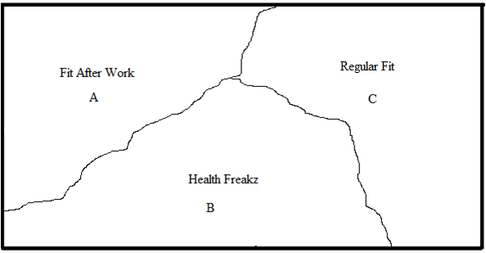

These segments are based on the survey that was held during a whole week with 100 respondents. All the responses are processed and analysed intensively. This has led to the following segments.
Regular Fit:
This is the group of people between the ages of 26 – 45. This group significantly consists of medium users. These people live or work in the neighbourhood of HealthCity because it only takes them less than 20 minutes to get to HealthCity. This group consists of high educated people.
Fit after work:
This is business market segmentation. The business is segmented on the basis of location and industry. The employees working for these organizations do not have to live in The Hague, but they work nearby.
This segment is created by rate of usage, geography and income.
HealthFreakz:
This segment trains at least four times a week. Their health and appearance are very important to them and often they are seeking for challenges, like running a marathon. They seek social contact, and good sporting facilities in a gym. They are heavy users. They live or work near the centre of The Hague, because it takes them less than 20 minutes to get to HealthCity Their lifestyle can be categorized as Succeerders. Their ages are between 26 – 45. This segment is created by geography, rate of usage, age, and an interview.

Targeting

This chapter outlines the targeting strategy. Now the segments are designed, the next thing is to determine which one to target.
Firstly, it is to say that the survey states that 80% trains at HealthCity because of the location. This is an important fact, because it means that HealthCity should look for customers in their own neighbourhood.
In order to see which segment(s) provide the best chances to target successfully, segment ranking will be applied. The ranking will take place by the method of The Marketing Plan hand book, by Marian Burke Wood.
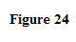
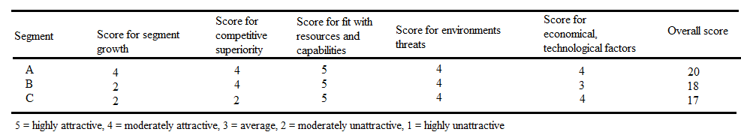

Figure 24 shows that segment A has the best chances to target successfully. Segment A is the business market segment. These include governmental organizations and businesses that are located in the centre. These show the most constant variables. This is because HealthCity does not depend on population estimations when it targets businesses, because businesses employ people from anywhere. For example, if there is a vacancy and the best candidate to fill the vacancy lives in Norway, the company will let him come over and the person is going to live and work here. This is why HealthCity does not depend on population estimations when it wants to target businesses.
Because HealthCity is located very closely from the business centre, it has some competitive advantages. Many businesses do have cooperation with health clubs that include that employees can train for a reduced tariff. It is favourable for HealthCity to contact the businesses with good offers.
HealthCity does have the resources and capabilities to serve the business market. HealthCity is a health club that is bigger than the competitors and contains all the facilities and services that one may expect.
The score for economic factors is 4 because businesses can profit from cooperations with health clubs. Despite the fact that most businesses also suffer from the economic recession, cooperations can profit from cooperations with health clubs to fight expenses due to absence. Cooperations with health clubs will contribute to the health of organizations’ employees.
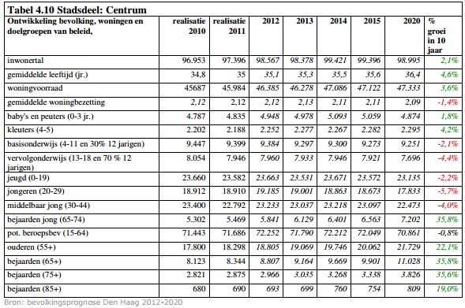
On the second place, segment B, with 18 points. The Health Freakz score for segment growth is low because estimations show negative numbers concerning population growth in those age groups. The estimations are made by the municipality of the Hague. Until the year 2020, the age groups between 26 – 45 are decreasing. Figure 25 shows the numbers (Gemeente Den Haag, 2012).
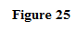
Because of the amount of competitors, the score for competition superiority is average. This is because of the rise of low budget gyms. The fact that 84% of HealthCity is high educated makes it assumable to say that HealthCity will attract these people, rather than low budget facilities. Anyhow, it will be important for HealthCity to get and stay ahead of the competitors when it comes down to attracting health freaks.
When we take a look at the resources and capabilities HealthCity has, it matches the needs of the Health Freakz perfectly. An interview with a Health Freak resulted in positive words how HealthCity serves the Health Freakz. The interview will be of importance when designing the marketing mix.
Economically, the recession is negative for attracting the segment. However, Health Freakz expect more from a health club than low budget gyms are offering. Low budget gyms are often too crowded for a Health Freak to workout properly.
The third segment includes medium users from the ages of 26-35. The population growth in this segment is also negative.
Competition rank is ranked with a 3, because of the low budget solutions. On the other hand, HealthCity offers more than the cheap solutions do, so this needs attention for the marketing mix.
HealthCity is a gym with free drinks, a lounge, many training machines, and relaxing facilities. This is important for older people. However, when it comes down to group exercising, HealthCity does not really serve older people. The group exercises are mostly for young and fit people who can handle the heavy workouts. This is why this is ranked with a 3.
The economic situation is also ranked with a 4. This is because the people in this segment are well – educated. This brings up the idea that they earn above the average.
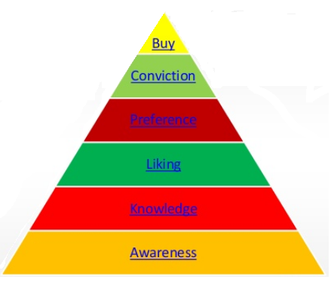
The overall score is that the business market is most attractive to target. However, HealthCity is advised to target HealthFreakz and older people, for the simple reason that it is easier.
HealthCity can target business to raise awareness about the advantages that HealthCity can offer for businesses.

Figure 26 shows the order of user readiness of people and organizations. The organizations that HealthCity could target, are not yet in the buying mode. First, HealthCity has to create awareness, where after it will provide knowledge, liking, preference, conviction and then it will buy.
In contrast to businesses, HealthFreakz are already familiar with fitness. It is better to attract them if results in the short term are desired.
HealthCity is advised to target Health Freakz because this target group fits best with what HealthCity has to offer. HealthCity is advised to attract people whose interests are in sports, who are Succeeders and for who appearance is important. These people go to the gym at least four times a week and are loyal.
HealthCity is advised to apply concentrated marketing, which means that they focus on one target group only.

Positioning

Now that the target group is determined, HealthCity needs to position itself to differentiate its services from the competitors.
An interview with someone from the target group, which are the Health Freakz, is subscribed at both HealthCity and HealthCity’s main competitor Ceasar Sports. He said: ‘’ When I want to work out really well, then I prefer HealthCity above Ceasar Sports. However, whenever I seek relaxation, I go to Ceasar Sports’’. This is a good thing to use for the positioning strategy. Currently, HealthCity’s slogan is: ‘’Fitness and more’’. By saying ‘’and more’’ HealthCity refers to the swimming pool and sauna facilities. However, since Health Freakz are to be targeted and the interview resulted that HealthCity is better for ‘’working your ass off’’, the slogan of HealthCity can be doubted.
Gary Barnes, the Health Freak that was interviewed, also said that HealthCity has a better audience that Ceasar Sports. When he visits HealthCity, he has better social interactions with people. This is also a very important aspect for him.
The interview is very important to determine the desired position. The interview gave in- depth information about how HealthCity is thought of in comparison with the competitor.
The following sentence is designed in order to help HealthCity get to the desired positioning:
‘’ HealthCity, become who you want to be’’
This sentence implies that HealthCity can offer anything that you want to become who you want to be. It indirectly implies that HealthCity can help you make your dreams come true. It also activates. The verb ‘’become’’ is used, which means that you have to do something for it. You have to work for it. In contrast to the current slogan of HealthCity, ‘’Fitness and more’’, the ‘’more’’ is emphasized. It is expected that this will not attract Health Freakz.
The current position of HealthCity is described in the following figure. The figure is based on the competition analysis.
Current position.

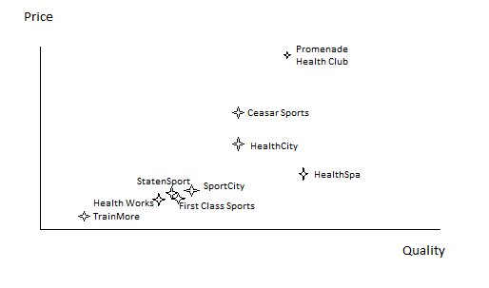

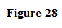

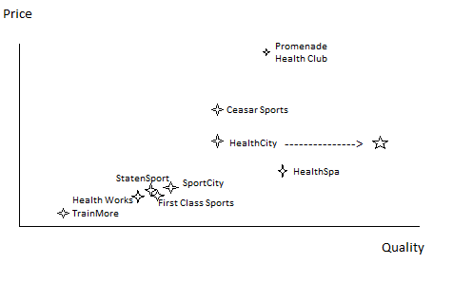
When HealthCity will improve it will get to the desired position.

It would be recommendable for HealthCity to get to the desired position. This has to do with the trend that middle segment gyms are slowly getting played out of the market. This concretely means that the members of SportCity, StatenSport, Health Works and First Class Sports sooner or later are going to decide which gym they should go to. The desired position offers major opportunities to expand the number of members. In order to get to the desired position in the market, a marketing mix is designed.

Strategy

In this chapter the general strategy will be discussed. The strategy will be based upon growth. In the chapter with goals and objectives, it is already stated that HealthCity wants to grow with at least four members this year. Monthly, around 70 people are unsubscribing because of several reasons. Jamal Badre, club manager of HealthCity said that there are two reasons why people unsubscribe:
- The first one is because expats are leaving. There is nothing that HealthCity could do to keep the expats, because they simply have to go home
- The second reason is that people find the price they pay too expensive in relation to the quality they get. This is something HealthCity can do something about.
This brings us to the first strategy that will be applied: Retention strategy.
HealthCity has to improve aspects what people are unsatisfied about.
The second strategy is a growth strategy. With help of the Ansoff Matrix, the growth strategy will be designed. This is because HealthCity’s objective is to grow with 4 members.
The growth strategies that will be used are market penetration and product development.
Market penetration:
Market penetration means that HealthCity will use it current products to gain more customers from the desired target group.
Product development means that HealthCity is going to adapt the current products to the needs of its desired target groups.
It is already mentioned in the DESTEP analysis that there is room for societal objectives. These need to be implemented as well. The government stated that too many people are getting injured when exercising. This is in contrast to the Dutch policy that people should be able to participate in sports safely.
The factors are the basis for the 3 following strategies.
- Growth strategy (by market penetration and product development)
- Retention strategy
- Fulfilling societal objectives (participating in sports safely)
The societal objectives can be put into three objectives:
- Donate money for charity ( spieren voor spieren, for example)
- Give workshops within the health club
- Giving presentations at universities about the importance of sports and safety)

Marketing Mix

Now that segmentation, targeting, positioning and the strategies are determined, the chosen direction is going to be put into more concrete measurements. This is with help of the marketing mix. The marketing mix showcases how HealthCity can adapt to the chosen target group to be successful. The marketing mix is designed for the Fitness Freakz.
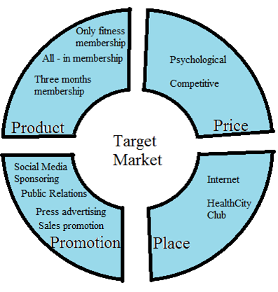

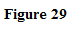

  - Product
The Only-Fitness membership is for people who do not want to make use of extra facilities that HealthCity offers. Because Health Freakz initially visit Health City to train only, they do not have to pay for extra facilities. The normal price for a 1 year membership is €79 and includes all the facilities that HealthCity offers. HealthCity should serve the Health Freakz by offering them the facilities which they only use. So, The Only Fitness Membership includes only fitness.
The All-In membership includes all the facilities. The target group can make use of the swimming pool, sauna facilities, group exercises and the fitness area.
The three months membership is a tool to attract the Health Freakz who do not want to commit for a long term contract. Because of the current recession, people have become reluctant to commit for long term contracts. Through this way, HealthCity can offer flexibility and is more likely to penetrate the market to attract Health Freakz.

13.2 Price
The price is going to be psychological and competitive based.
Psychological pricing is for example €49,95. Actually it is €50 but €49,95 looks less expensive. This is what HealthCity already applies.
The second strategy is competitive based pricing. The competitors’ prices influence HealthCity’s price.
Current prices for the one year and two year contract will remain the same. These are currently €79 for the one year contract and €69 for the two year contract. The Only Fitness Membership is going to be €59,00 for one year and €49,00 for two years on a monthly base.
HealthCity can additionally also serve seasonal sporters by offering three months contracts. This price is going to be €89,00. That means that the current price of the one month membership has to increase to €99,00.

13.3 Promotion
Promotion via social media means that HealthCity has to get followers on, for example, Facebook, Instagram, and Youtube. If HealthCity gets enough followers, it can provide HealthFreakz with interesting feed on new fitness methods etc. A tool that HealthCity can use is sponsoring. For example a famous athlete with many followers. If he is going to make videos on social media when he is working out in HealthCity, it will reach a lot of people.
Public relation promotion is important because it will reach a lot of people. HealthCity should be aware of what is happening in the societal environment and adapt to it. For example the problems concerning safe sporting. HealthCity is a strong brand name and can gain a lot of attention if it participates actively in the new policy. It will also help improve the reputation.
Since the majority of the audience of HealthCity are higher educated people, HealthCity can use advertorial promotion in newspapers and magazines. It is to say that people who are higher educated read those media.
Sales promotion is important when quick results are desired. Since HealthCity is advised to use market penetration as strategy, it is highly recommended to use sales promotions. For example, because many people like it better to work out together, HealthCity should adapt and create a sales promotion when, for example, three people subscribe at a time. When three people subscribe, they will get an All-In membership for the price of the Only Fitness membership.
In order to improve the image HealthCity, the political environment provides chances to improve the image. HealthCity should use these opportunities in order to gain more brand awareness.

13.4 Place
The memberships can only be purchased in the HealthCity club or on the HealthCity website.

13.5 Personell
HealthCity personnel should give every member personal attention. This is stated in the mission of HealthCity, but it is not executed well, the survey indicates. The telephonic interview with HealthCity Belgium resulted in a conclusion that in Belgium, the personnel is more focused on giving personal attention. In order to prevent people from dropping out, it is highly required that people are given attention by the employees.

13.6 Presentation
HealthCity is advised to improve the presentation. Currently, HealthCity has old-fashioned machines. HealthCity should position itself towards a place where you can best work towards your goals. Therefore, it needs the latest fitness machines.

International comparative examination with HealthCity Belgium

This chapter outlines the benchmark that is made between the HealthCity The Hague Premium and HealthCity Zuidpool Belgium.
This benchmark aims at finding out how comparable health clubs abroad operate in the field of marketing and what HealthCity The Hague Premium can learn from that. The method of research is interviewing. This interview took place on the phone with Luc Cuypers, who has been working for five years in the sales department of HealthCity Zuidpool Belgium.
The number of HealthCity clubs in Belgium decreased dramatically from 60 HealthCity clubs of which only one is left. This decrease took place in a time period of three years. ‘’All the HealthCity’s have become Basic Fit nowadays. We are the only HealthCity left. ‘’Basic Fit locations have increased to a number of about 120 locations’’.
When Luc Cuijpers was asked what his operation tasks are he stated: ‘’ The way I approach my job is to create a good vibe in the club so I become friends with the members. I make sure I give honest information about the memberships. Through this way, people like to visit the club and they promote the club by word of mouth.’’
Luc Cuijpers cannot remember when the last time that HealthCity set up a marketing campaign was. He thought it was about a half year ago. So, the way that the sales department of HealthCity Belgium works, is providing service and by making friends with the members, to create a friendly atmosphere.
Still, HealthCity Belgium counts around almost 2000 members. How long this location of HealthCity will remain is unsure, given the fact that it is the only one left.
It is assumable to say that the way the sales department of HealthCity Belgium operates, stands in line with the dramatic decrease of the number of HealthCity clubs in Belgium.
What HealthCity can learn from this trend in Belgium, is that marketing should be taken seriously. If you do not do research and market your product, you risk that you will have to close your doors, just like the 159 clubs in Belgium did. It seems a matter of time that HealthCity Zuidpool Belgium will close their doors soon as well.
The consequence of changing HealthCity into Basic Fit is that the pools, sauna facilities and free drinks will disappear. People can only visit the gym to train. People will pay less.

Figure 30 shows that The Netherlands is on the fourth place of Europe when it comes to participation in fitness. Belgium, however, does not do very well, with only 7% that is participating in fitness. (Hover, 2012)
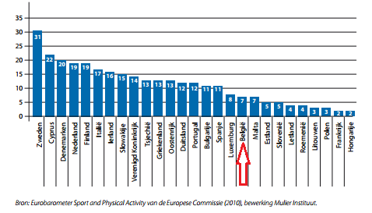

Recommendations
HealthCity gained a lot of brand awareness during the last years. It took over fitness chain Fitness First and it is the parent company of low budget facility Basic Fit. However, the fitness market has become a displacement market. This means that the market is saturated. This has resulted in a dramatic decrease of HealthCity locations throughout the European continent. HealthCity locations in the Netherlands are also increasingly closing their doors or are converting into low budget facility Basic Fit.
In order to prevent this from happening with location of The Hague, it has to target concentrated. This means that they should target one segment specifically. This target group is called the Health Freakz.
HealthCity already has all the facilities that are required in order to satisfy the Health Freakz. This is proven by the interview that was conducted.
On the other hand, HealthCity should not forget about the other segments.
Eighty four percent of the respondents of the questionnaire state that they are member of HealthCity because of the convenient location, while only slightly 60% lives nearby HealthCity. People who live outside of The Hague, state that the time they need to get to HealthCity is less than 15 minutes. It is assumable to say that these people visit HealthCity after their work in The Hague.
This means that HealthCity has to create awareness among the governmental institutions and businesses that are located in the city centre. HealthCity does not have to target them yet, because they do not have the right ‘’readiness stage’’ to buy yet. First, HealthCity has to create awareness, then invite them to have a team outing or to provide a workshop, and then, it can think about targeting the businesses and governmental institutions.

Conclusion
In this final chapter, the main research questions will be answered with the help the sub questions:
- What are the target groups that HealthCity should focus on?
An intensive research among members of HealthCity indicates that HealthCity should concentratedly target people between the ages of 25-45, who are highly educated with at least a bachelor degree and who live in the same quarter as where HealthCity is located at. Their lifestyle can psychographically be categorized as ‘’Succeeders’’. They are constantly looking for opportunities to improve themselves and to learn. Their appearance is important to them, regardless of what relationship status they are in. They seek social interaction, go to the movies and are going out to have a drink with friends. They are also performance oriented. They work out because they do not only want to be healthy, or be in shape, but they challenge themselves to deliver good performances. This means that they participate in events such as marathons. They are also aware of current events.
- How can HealthCity attract the target groups to become member?
HealthCity can attract the target group by re-position itself firstly. The image that HealthCity now has, is not what Health Freakz are looking for. The current slogan of HealthCity is: ‘’HealthCity, fitness and more’’. This emphasizes the ‘’more’’, while performance should be the basis for positioning. This is what attracts the target group. Every aspect of the club has to be in line with this new positioning. This means that HealthCity should innovate somewhat. New fitness machines are required. Fitness wearables are required. HealthCity has to be up-to-date when it comes down to fitness facilities. After this, HealthCity should be active on Social Media. Many Health Freaks are active on social media like Facebook and Instagram to follow athletes. HealthCity can hire such an athlete with many followers to workout in HealthCity. Through this way, HealthCity is going to attract a lot of people from the target group.
- Why do most people unsubscribe their membership at HealthCity?
Two main reasons why people unsubscribe their membership at HealthCity.
1: These people are expats. There is nothing HealthCity can do about this. Expats are not living here forever, so when they have to leave, they have to leave.
2: The price and quality relationship is not in balance, according to these people. The survey also indicates that HealthCity should improve several aspects. HealthCity does not value customers and HealthCity does not give enough personal attention. These are the two most negative things that came out of the survey. This should really be improved.
- What are external factors that affect the joiner leaver rate at HealthCity?
HealthCity is highly affected by external factors. It is mostly affected by demographic factors and economic factors.
- Demographic factors because age and income are very important for the joiner/leaver rate at HealthCity. Because the existence of cheaper solutions, such as low budget fitness and bootcamps. Also, income and level of education are affective, since HealthCity mostly consists of people who are employed and have at least a bachelor degree.
- Economic factors also affect the joiner/leaver rate. Because HealthCity is more expensive than most competitors, HealthCity should really distinguish itself from the competition in order to attract the target group. The current recession demands a lot of creativity from HealthCity to attract customers.

- How do comparable international health clubs abroad increase their membership sales and what can HealthCity learn from that?

Several health clubs abroad were assessed how they attract the potential members. They work at the same way that HealthCity does. People apply for a day trial. Then they make an appointment to visit they club and after the trail, the potential member can decide whether to subscribe or not. The only thing that HealthCity Belgium does, what HealthCity The Hague does not, is that they really become friends with their members and build up a personal relationship. They do that with all the members. In return, the members are acquiring new members for the club, by the use of word – of – mouth.
Summarized, HealthCity can increase the membership sales if it innovates the club, adapt the memberships to the target group’s needs , and to target concentratedly, according to the marketing mix. The main target group requires flexibility regarding memberships. That means that they should be able to pay for what they use.

List of References

(sd).
Bloomberg. (2015, Juni 21). http://www.bloomberg.com/research/stocks/private/snapshot.asp?privcapId=23353464. Opgeroepen op Juni 1, 2015, van Bloomberg Business : www.bloomberg.com
Bouma, K. (2014, July 29). http://www.nrcq.nl/2014/07/03/naar-de-sportschool-je-moet-kiezen-luxe-of-budget. Opgeroepen op June 1, 2015, van de Volkskrant: www.volkskrant.nl
Company Overview Of HealthCity International B.V. (2015, May 15).
Driessen, C. (2014, July 3). http://www.nrcq.nl/2014/07/03/naar-de-sportschool-je-moet-kiezen-luxe-of-budget. Opgeroepen op June 1, 2015, van NRCQ: www.nrcq.nl
E.I.Schippers, m. (2015). Nieuw progrmamma sportblessurepreventie. Den Haag: Ministerie van Volksgezondheid, Welzijn en Sport.
Fit!Magazine. (2012, May 4). http://www.fitmagazine.nu/hoe-actief-is-de-fitnessbranche-op-social-media/. Opgeroepen op June 1, 2015, van Fit!Magazine: www.fitmagazine.nu
Fit!Magazine. (2013, October 2). http://www.fitmagazine.nu/maatschappelijke-betrokkenheid-door-fitnesscentra-betaalt-zich-uit/. Opgeroepen op June 1, 2015, van Fit!Magazine: www.fitmagazine.nu
Gemeente Den Haag. (2012). Bevolkingsprognose Den Haag 2012-2020. Den Haag: Gemeente Den Haag.
Gemeente Den Haag. (2013, April 2). http://www.denhaag.nl/home/bewoners/actueel/to/Den-Haag-in-cijfers-1.htm. Opgeroepen op June 1, 2015, van Den Haag: www.denhaag.nl
Groothengel, P. (2012, December 10). http://managementscope.nl/magazine/artikel/693-rene-moos-healthcity. Opgeroepen op June 1, 2015, van Management Scope: mangementscope.nl
HealthCity. (sd). http://www.healthcity.nl/over-ons/visie-missie. Opgeroepen op June 1, 2014, van HealthCity: www.healthcity.nl
Heel, J. v. (2014). De toekomst van fitness - technologische ontwikkelingen en kennis. Amsterdam, Noord- Holland, The Netherlands.
Heijden, G. v. (2015, February). https://www.rabobank.nl/bedrijven/kennis/nieuw/tu_fitness_en_zorg. Opgeroepen op June 1, 2015, van www.rabobank.nl: www.rabobank.nl
Hover, P. (2012). Fitness in Cijfers. Sportsmedia.
http://www.bloomberg.com/research/stocks/private/snapshot.asp?privcapId=23353464. (2015, May 15). Opgeroepen op Juni 1, 2015, van Bloomberg Business: www.bloomberg.com
Kraaijvanger, C. (2011, April 1). http://www.scientias.nl/knappe-mensen-zijn-gelukkiger-en-rijker/. Opgeroepen op June 1, 2015, van Scientas: www.scientas.nl
Muilwijk, E. (sd). http://www.intemarketing.nl/marketing/modellen/behoeftepiramide-maslow. Opgeroepen op June 1, 2015, van Intemarketing: www.intemarketing.nl
Novum. (2007, April 2016). http://www.nu.nl/economie/1044483/wassenaar-heeft-meeste-rijke-wijken.html. Opgeroepen op June 1, 2015, van NU: www.nu.nl
Overstappen. (2013, July 25). http://www.degroeneenergievergelijker.nl/energie-opwekken-door-te-sporten/. Opgeroepen op June 1, 2015, van de Groene Energievergelijker: www.degroeneenergievergelijker.nl
Raaphorst, A. T. (2015, January 23). http://www.scp.nl/Publicaties/Alle_publicaties/Publicaties_2015/Rapportage_Sport_2014. Opgeroepen op June 1, 2015, van SCP: www.scp.nl

Appendices

Transcript interview 1

Gary, bedankt voor je tijd alvast. Jij valt dus in een categorie van mensen die dusdanig interessant is om verder uit te diepen, want je sport tamelijk veel en je valt ook binnen de leeftijdscategorie die het grootste deel vertegenwoordigt van HealthCity. Ik wil dus op basis van dit interview wat diepte krijgen over bepaalde interesses en lifestyle van jou. Dus als we gewoon beginnen met super algemeen, zou je kunnen zeggen wie je bent?
Gary: Ik ben Gary Barnes. Ik ben een allochtoon hier in Nederland, maar ik woon eigenlijk het grootste gedeelte van mijn leven al hier, sinds mijn eerste vanuit Engeland hiernaartoe geëmigreerd. Lagere school, middelbare school, universiteit in Nederland doorgemaakt en ook mijn werkzame leven altijd hier gezeten. Vrijgezel, fanatiek sporter, inderdaad zoals je zei, geïnteresseerd in vrijwel alles, dus ik lees veel, ik zie mezelf als redelijk sociaal, ik vind het altijd interessant om te horen wat mensen beweegt en waar ze gelukkig van worden. That is me. Sociaal, sportief, geïnteresseerd.
Zou je kunnen vertellen wat voor opleiding je gevolgd hebt?
Ja, mijn hoogste opleiding is een wetenschappelijke opleiding wiskunde, bij universiteit Leiden. Daarna heb ik voor mijn werk een opleiding gedaan op post doctoraal niveau tot beleggingsanalist. Die heb ik van 1998 tot 2001 gedaan en dat is de basis voor mijn beroep als belegger. Ik heb bij ING gewerkt, bij PGGM gewerkt en zit nog steeds in de beleggingswereld.
Ok, dan heb je ook al gelijk over je werk verteld. Want welk bedrijf heb je laatst voor gewerkt zei je?
PGGM, maar daar ben ik gestopt omdat ik het niet eens was met de organisatie. Wel met de collega’s maar niet met de organisatie, dus daar ben ik gestopt omdat ik denk dat ik wel wat leukers kan vinden.
Woon je in de buurt van HealthCity?
Ja, ik woon in Bezuidenhout, dus effectief voor mij is twee haltes weg van HealthCity en het centrum. Er lopen overigens nog twee andere collega’s van PGGM rond bij HealthCity.
Wanneer ben je in aanraking gekomen met HealthCity?
Ik denk dat dat 2011 was. Ik sportte hiervoor bij een andere sportschool. Volgens mij heten ze nu Enjoy op de prinses beatrixlaan. Daar heb ik van 2009 tot 2011 gesport, omdat het lekker dicht in de buurt was, maar ik was er minder geïnspireerd door, want de openingstijden waren slecht en van een collega van mij kreeg ik te horen dat HealthCity een zwembad had, had veel meer mogelijkheden, dus ik heb me door haar eigenlijk laten overhalen om van Enjoy naar HealthCity over te stappen.
Ok dus het zwembad heeft jou in eerste instantie overtuigd?
Ja, niet alleen het zwembad, maar ook de sfeer, omdat je andere openingstijden hebt, en je zit ook niet in het centrum dus, het publiek dat erop afkomt. Ik denk dat ik meer gecharmeerd was door het publiek en de sfeer bij HealthCity dan bij Enjoy.
Had Enjoy overigens wel een lounge zoals HealthCity dat heeft?
Ja, het was te midden van de sportruimte zelf. En er was een keuken met wat drank en wat leesvoer.
Wat was de prijs bij Enjoy?
Dat is lastig om te zeggen, omdat ik gesponsord werd door ING, die had een contract met ze, maar ik zou schatten dat het tussen de 40 en 45 euro was. Het was wel een redelijke stap omhoog van Enjoy naar HealthCity.
Je bent ondertussen ook even naar Ceasar, de concurrent geweest he?
Ja, sterker nog, daar zit ik nog steeds. De sfeer en de faciliteiten bij Ceasar verschillen wel van HealthCity. Die zijn lichtelijk complementair. Maar ik zou zeggen dat Ceasar er mooier uitziet, het is wat verser, wat nieuwer, het zwembad is fantastisch mooi, ze hebben zeven verschillende sauna’s. Het is echt veel meer een wellness center, maar waar HealthCity met name echt op scoort vind ik is de sfeer, de groepslessen die veel gevarieerder zijn, de vriendelijkheid van beide sportscholen is hetzelfde, maar ik denk dat toch dat HealthCity daar beter op scoort. Dus als ik rustig aan wil doen en wil chillen en in de sauna wil hangen dan ga ik naar Ceasar toe en als ik mezelf flink wil vermoeien, even wil beuken dan ga ik naar HealthCity.
HealthCity lijkt een beetje alsof het achter loopt met apparatuur, wat vind je daarvan?
Ja, maar dat is puur als je erop wijst. Ik zou zelfs zeggen dat het absoluut niet een hinderlijke factor is dat ik denk van Ik ga niet meer naar HealthCity, want het apparatuur is oud. Eigenlijk zou ik juist complimenten moeten geven dat het apparatuur zo goed wordt onderhouden, dat het nu na vijf jaar dat ik hier sport, dat het nog steeds in goede staat is. Ik denk dat mensen vrij gedisciplineerd zijn met het schoonmaken van de apparaten na afloop, je ziet het personeel ook ermee bezig zijn. Het enige wat regelmatig kapot gaat is de koffieautomaat, maar dat is niet echt een drama. Ik zou dus zeggen ja, de apparatuur is redelijk oud geworden, maar ik zie dat niet als een drama of een groot probleem.

Hoe zou HealthCity volgens jou nog verder kunnen verbeteren?
Als ik denk aan de locatie, het is nou eenmaal een A locatie. Je zult niet kunnen concurreren met prijsvechters, die tegen een habbekras een sport abonnement aanbieden. Dus zodra dat onder segment gaat concurreren met HealthCity, dan ben je gewoon die mensen kwijt. Tenzij je een abonnement gaat aanbieden wat zo laag mogelijk is in prijs maar dat de toegang beperkt. De locatie van HealthCity is gewoon briljant, makkelijk bereikbaar met openbaar vervoer voor iedereen, die dichtbij het centrum woont. Je hebt een grote ruimte ter beschikking om veel dingen aan te bieden. De lessen zijn heel goed, dus je merkt ook dat er een grote groep aan mensen speciaal voor de groepslessen komt. Maar ik denk dat er misschien een markt zou zijn voor de crèche, waar de tijden nu erg beperkt zijn. Als die tijden nu ruimer zouden worden, dan zou dat denk ik meer mensen trekken.
Afhankelijk ook van de doelgroep die wil gaan scoren. Bij Ceasar heb je ook een aparte ruimte voor wat wellness en yoga achtige dingen, maar ik zie nadrukkelijk ook een verschil in doelgroep tussen Ceasar en HealthCity. Bij HealthCity zie ik de harde werkers en de mensen die zich in het zweet willen werken, terwijl ik die groep juist niet zie bij Ceasar.
Wat voor leeftijden zie je ongeveer bij Ceasar?
Meer oudere mensen en minder divers. HealthCity heeft een hele mooie dwarsdoorsnede van nationaliteiten die in Den Haag wonen, denk ik dat je Ceasar vrij blank en vrij middelbaar van leeftijd moet schatten. Meer mensen van rond de 60.
Zover over HealthCity. Waarom fitness jij überhaupt?
Ik denk vier factoren die belangrijk zijn. Het allerbelangrijkste is sowieso mijn gezondheid. Je doet het sporten voor je eigen gezondheid, om naarmate je ouder wordt toch dat lichaam, waar je er maar 1 van hebt, in vorm te houden. Ik heb weliswaar niet dezelfde conditie als toen ik 20 was, maar ik kan nog best wel meekomen. Ik ben best tevreden met wat ik allemaal kan. En dat probeer je eigenlijk door continu onderhoud, je conditie op peil te houden en je gezondheid. Ik merk dat ik goed slaap van het sporten, ik merk dat ik lekker in mijn vel zit, en als ik om me heen kijk naar mensen van mijn leeftijd in mijn vriendenkring, dan zitten daar nog wel eens mensen tussen die aan het kwakkelen zijn met hun gezondheid, die met redelijk wat overgewicht rondlopen, dan klop ik mezelf toch wel op mijn schouder dat ik dat heb kunnen vermijden. Gezondheid is 1. Ik denk dat op 2 zeker ijdelheid ook wel meespeelt. Ik had al gezegd, ik ben vrijgezel, dus je wilt er in ieder geval voor zorgen dat het oog ziet dat het de moeite waard is.
Zou dat veranderen als je straks 3 jaar in een relatie zit?
Nee, ik denk dat ik daar zelf ook gewoon te ijdel voor ben, dat ik het zelf ook wel belangrijk vind dat ik mezelf in de spiegel kan aankijken en denk, ja, je mag je aan de rand van het zwembad of aan het strand vertonen. Dan op 3 komt sociaal. Zeker sinds 2011 denk ik dat je op sociale vlak meer bij HealthCity dan bij Ceasar dat je met mensen in aanraking komt en eigenlijk dat je met elkaar vrienden wordt en met elkaar afspreekt van ‘’ben jij bij die les of bij die les?’’, dan is het gewoon een stukje sociaal. En nu ga ik eventjes denken of ik wel een vierde heb.
Je had het ook even over conditie gehad. Zijn er ook nog prestaties die je zou willen leveren of wat je zou willen bereiken met fitness?
1 van de dingen die ik wel goed vind en wat nog meer mee gedaan kan worden. Ik heb onlangs meegedaan met de ‘’Men of Steel Run’’ in Scheveningen. Dat werd door HealthCity gesponsord als je lid was van HealthCity, dan kon je tegen een gereduceerd tarief meedoen. Dat heb ik als erg positief ervaren. Ik ben zelf een redelijk fanatieke hardloper, ik heb volgens mij als iets van 14 marathons op mijn lijst staan. Iets met de lessen als Grit en Bodypump, die houden in ieder geval mijn conditie op peil dat ik die marathons gewoon kan blijven lopen. Maar die Men of Steel was voor mij even een nieuwtje, dat vond ik erg gaaf en als HealthCity komt met zoiets ga ik zeker meedoen.
Oké, dus het zijn er toch vier he? Want je houdt toch van marathon lopen en dit soort uitdagingen, en die vereisen natuurlijk een goede conditie. Zou je kunnen vertellen wat je hobby’s zijn?
Zoals gezegd, heel breed kwa hobby’s. Nu ik werkloos ben, ben ik zes uur per dag aan het lezen, waarvan de helft gewoon de actualiteiten. Ik ben geabonneerd op de Financial Times, op NRC, op The Economist, ik lees de New York Times, ik lees Moscow Times, en best wel veel wat er gebeurt in de wereld. De andere dingen hebben meer te maken met brede ontwikkeling op het gebied van ‘’Hoe zijn we hier gekomen als maatschappij’’, wat vormt een maatschappij en waardoor verandert het weer. Dingen zoals het Maya rijk. Ik lees heel veel over financiële crisis wat natuurlijk een verbinding heeft met mijn werk. Wat is er nou precies gebeurd. Ook wel romans die op de short list staan. Tegelijker tijd ook films, ik heb een Pathé pas, waar ik na afloop van het trainen bij HealthCity ook wel naartoe ga. Muziek, ik heb een spotify abonnement en mijn huis zit met een Xonos system verbonden. Ohja, ik heb ook vrienden! HAHA. Gaan we even een hapje eten, drinken, borrelen.
Drink je alcohol?
Ja.
En beperk je dat enigszins of hoe ga je daarmee om?
Jawel, als ik op een feestje ben of als ik uitga dan drink ik de hele avond alcohol, maar meestal duurt mijn avond niet zo lang dat ik het gevoel het dat ik mezelf helemaal lam heb gezopen. Maar 8 tot 10 alcoholische consumpties komt voor. Bij een filmpje drink ik ook wel. Alcohol is meer iets als lekker erbij, lekker bij een maaltijd, lekker bij een filmpje kijken en lekker als je met mensen aan het discussiëren bent.
En waar hang je uit? Hang je in de stad van Den Haag uit?
Ik ga vrijwel nooit meer stappen in de stad. Als dat zo is dat gaan we met een vriendengroep. Of als we een goed restaurant hebben gevonden, dat we daar blijven hangen, maar verschillende stap plekken die bezoek ik eigenlijk nooit meer.
Heeft het sporten nog invloed op je eetgewoontes?
Ja, zeker de afgelopen 4 5 maanden, ik heb nooit ongezond gegeten. Maar ik ben nog gefocusder gaan opletten wat er allemaal via de mond naar binnen gaat. Dus ik probeer er meer op te letten, ook kwa proteïnen, koolhydraten en vetten.
Ik denk dat ik nu genoeg weet over je om je goed te kunnen indelen. Ik wil je hartelijk bedanken voor het interview. Als er nog vragen zijn dat weet ik je te vinden.

Transcript Interview 2

Goedendag, mijn naam is Faraaz Abdoel. Momenteel ben ik bezig met een vergelijkend marktonderzoek tussen Nederland en België. Zou ik je wat vragen mogen stellen?
Ja, ga je gang.
Mag ik je vragen hoe jij je werk invult?
Ik zorg ervoor dat ik een goede vibe mee breng naar de club. Ik geef altijd eerlijke informatie wanneer ik een gesprek heb met een prospect.
Doen jullie ook nog iets aan promotie?
Nee, ik moet zeggen dat we ongeveer al een half jaar 0,0 aan promotie gedaan hebben.
Hoeveel leden telt de club?
De club telt ongeveer 1700 leden. Vanaf 1 juli zijn wij nog de enige HealthCity in België want alles wordt BasicFit.
Ok, dat klinkt wel rampzalig. Hoeveel HealthCity's waren er eerst in België dan?
Eerst waren er een stuk of 60. Sinds een aantal jaar zet zich er een trend voort dat alles BasicFit aan het worden is.
Wat doe jij om leden te werven?
Ik zorg ervoor dat ik een goede vibe heb en goede interactie met de leden. Ik zorg ervoor dat ik iedereen ken en dat we altijd een praatje maken. Zodoende gaat het balletje rollen en komen er vanzelf nieuwe mensen binnen, bij wie ik weer hetzelfde doe.
Oké, dat is duidelijk. Zou ik nog even je naam mogen weten ter informatie?
Ja, mijn naam is Luc Cuypers.
Luc, ik wil je hartelijk bedanken voor je tijd en voor je uitleg. Succes met je werk verder.
Dankjewel.

Questionnaire

Beste respondent(e), Dear Respondent,

NL: Mijn naam is Faraaz en ik ben student aan de Haagse Hogeschool aan de opleiding European Studies. Voor u ligt een tevredenheidsonderzoek voor leden van HealthCity. Ik zou u willen vragen de vragenlijst zo volledig mogelijk te willen invullen. Het onderzoek is erop gericht om te kijken wat wij kunnen doen om u tevreden te maken/houden. Het onderzoek vindt plaats in opdracht van HealthCity Den Haag Premium. Het invullen van deze enquête duurt ca. tien minuten en uw anonimiteit wordt gewaarborgd.
EN: My Name is Faraaz and I am a graduate European Studies student at The Hague University of Applied Sciences. This document is a satisfactory survey for HealthCity members. The goal of this survey is to find out what HealthCity can do to make/keep their members satisfied. I would like you to fill in this survey as complete as possible. This research takes place by order of HealthCity The Hague Premium. This survey takes approximately ten minutes and you will stay anonymous.

Alvast ontzettend bedankt!
Thank you in advance!

Selecteer het gekozen antwoord
Select your chosen answer

1. Wat is uw geslacht?
What is your gender?

- Man/ Male
- Vrouw/ Female

2. In welk stadsdeel woont u?
In which quarter do you live?
- Centrum
- Escamp
- Leidschenveen-Ypenburg
- Laak
- Loosduinen
- Haagse Hout
- Scheveningen
- Segbroek
- Anders/Other, namelijk/ Namely……………………………………….

3. Wat is uw maandelijkse bruto inkomen? (Bedragen zijn in Euro’s)
What is your gross monthly income? (Amounts are in Euros)

- Lager dan/ Below 1500
- 1501 – 2000
- 2001 – 2500
- 2501 – 3000
- 3001 – 3500
- 3501 – 4000
- Hoger dan/ Over 4000

4.Tot welke leeftijdscategorie behoort u?
Which age category do you belong to?

- Jonger dan/ Younger than 18
- 18 - 25
- 26 - 35
- 36 - 45
- 46 - 65
- Ouder dan/ Older than 66

5: Wat is uw nationaliteit?
What is your nationality?

…………………………………………………………………………………………..

6. Hoe vaak bezoekt u HealthCity Den Haag ongeveer
How often do you visit HealthCity approximately?

- Minder dan één keer per week/ Less than once week
- Één keer per week/ Once a week
- Twee keer per week/ Twice a week
- Drie keer per week / Three times a week
- Vier keer per week/ Four times a week
- Meer dan vier keer per week / More than four times a week

7: Wat is uw maandelijkse contributie? (Bedragen zijn in Euro’s)
How much is your monthly fee? (Amounts are in Euros)

- 30 – 40
- 41 – 50
- 51 – 60
- 61 – 70
- 71 – 80
- 81 – 90

8.Hoe komt u naar de sportschool?
How do you come to HealthCity?

- Lopend/ Walking
- Fietsend/ By bycicle
- Openbaar vervoer/ By public transportation
- Auto / By car
- Scooter/ By scooter
- Anders/ Other…………………………………………………………………………..

9: Hoelang bent u onderweg naar de sportschool?
How much time does it take you to get to HealthCity?

- Minder dan 5 minuten/ Less than 5 minutes
- 5 - 10 minuten/minutes
- 11 - 15 minuten/minutes
- 16 - 20 minuten/minutes
- 21 - 30 minuten/minutes
- Langer dan 30 minuten/ More than 30 minutes

10: Hoelang sport u al bij HealthCity?
How long have you been training at HealthCity?

- 0 - 3 maanden/months
- 4 - 6 maanden/months
- 7 - 12 maanden/months
- 1 - 2 jaar/years
- Langer dan 2 jaar/ More than 2 years

11: Wat is uw hoogst genoten opleiding?
What is your education level?
- Lagere school/ Primary School
- LBO, MAVO, VMBO, MBO-1, eerste drie jaren HAVO en VWO/ High School
- HAVO, VWO, MBO 2-4/ Bachelor degree
- HBO, WO/ Master degree
- Anders, namelijk/ Other, Namely………………………………………………..

12: Waarom traint u bij HealthCity Den Haag Grote Markt?
Why are you member of HealthCity?

Meerdere antwoorden zijn mogelijk
Multiple answers are possible

- Goede locatie/ Good location
- Goede sportfaciliteiten/ Good sporting facilities
- Hygiëne/ Hygienic
- Goede ontspanningsmogelijkheden/ Good relaxing facilities
- Leuke groepslessen/ Nice group excercises
- Deskundig personeel/ Professional staff
- Goede sfeer onder leden/ Good atmosphere among members
- Anders/Other………………………………………………………………………………………………………………………………………………………………………………………………………………………………………………………………………………………..

12: Zou u iets veranderen aan HealthCity?
Would you change anything about HealthCity?

Ja/Yes
Nee/No

13: Wat zou u veranderen aan HealthCity als dat kon?
If so, what would you change about HealthCity?

- Ontspanningsmogelijkheden/ Relaxing facilities
- Sportfaciliteiten/ Training facilities
- Personeel/ Staff
- Hygiëne/ Hygene
- Groepslessen/ Group workouts
- Anders/Other……………………………………………………………………………………………………………………………………………………………………………………………………………………………………………………………………………………….

14: Zou u een ander aanraden om bij HealthCity te komen sporten?
Would you recommend HealthCity?

- Ja/ Yes
Nee/ No

15a: Zo ja, waarom wel
If yes, why? .....................................................................................................................................................................................................................................................................................................................................................................................................................................................

15b: Zo nee, waarom niet
If no, why not?
……………………………………………………………………………………………………………………………………………………………………………………………………………………………………………………………………………………………………………………………………….

Omcirkel het juiste antwoord
Select your answer

1 = Sterk oneens 2 = Oneens 3 = Neutraal 4 = Eens 5 = Sterk eens
Strongly Disagree Disagree Neutral Agree Strongly Agree

16: HealthCity motiveert mij om een actieve levensstijl te bereiken.
HealthCity motivates me to achieve an active lifestyle

Oneens Eens
Disagree Agree
1 2 3 4 5

17: Ik voel mij gewaardeerd door HealthCity
I feel that HealthCity values me as a customer.
Oneens Eens
Disagree Agree
1 2 3 4 5

18: HealthCity heeft persoonlijke aandacht voor mij
HealthCity pays personal attention to me

Oneens Eens
Disagree Agree
1 2 3 4 5

19: HealthCity is een hygiënische sportschool
HealthCity is a clean facility
Oneens Eens
Disagree Agree
1 2 3 4 5

20: HealthCity heeft vriendelijk personeel
HealthCity has a friendly staff
Oneens Eens
Disagree Agree

1 2 3 4 5

21. Wat vindt u van de prijs-kwaliteitverhouding?
What do you think about the price/quality relationship?

- Slecht/ bad
- Matig/ below average
- Redelijk/ average
- Goed/ good
- Zeer goed/ excellent

Dit is het einde van de vragenlijst. Ontzettend bedankt voor het invullen!
Wilt u op de hoogte blijven van het resultaat van het onderzoek, dan kunt u hieronder uw e-mailadres invullen.

This is the end of the survey. Thank you so much for your time! Do you want an update about the result of the survey, please write down your email address and I will inform you.

…………………………………………………………………………………………………………

