Errata

Thesis title: Fiber numerical aperture characterization for the single fiber reflectance technique

Thesis author: G.B. Loozen

Page 2:

“All results show a $NA$ varying from 0.23 to 0.22 in a spectral range of 400-900 nm…..”

Correction:

All results show $NA$ values varying between 0.23 to 0.22 in a spectral range of 400-900 nm…..

Page 5:

“Additionally, optical fiber the $NA$ will also vary when a bend is induced on an.”

Correction:

Additionally, the $NA$ will also vary when a bend is induced on an optical fiber.

Page 13:

Equation 18: $n_{c}$ is meant to be $n_{co}$.

Page 14:

${NA}_{fib}$in the caption of figure 4 is meant to be $NA$.

Page 19

Paragraph number 4.2 is supposed to be 4.1

After the sentence,

“This chapter is meant to give a basic understanding of effects that occur when inducing a bend on the optical fiber and will be used later on to qualitatively describe results obtained from the bending measurement.”

The following sentence is included for clarity:

Equations introduced will not be used to analytically describe changes in ${NA}_{eff}$ caused by bending.

Page 21:

“Morgan et al., for example, have accurately described the observed oscillatory patterns as interference between light that is refracted out of the core, due to the induced bend…..”

Correction:

Morgan et al., for example, have accurately described the observed oscillatory patterns as interference between light that is decoupled from the core, due to the induced bend…..
Page 29:

“The profile radius will be determined for both sides of the profile and the values for the radii are summed and averaged to account for minor angular misalignments between…”

Correction:

The profile radius will be determined for both sides of the profile and the values for the radii are summed and averaged to account for minor angular and lateral misalignments between…

“An expression for the error in the calculated angle and ${NA}_{fib}$ is derived and the errors…”

${NA}_{fib}$ is meant to be $NA$.

Page 37:

Changes made in table 7

$$\#$$ | $$z\left({10}^{-3} m\right)$$  $$±{10}^{-5} m$$ | $$r_{left }\left({10}^{-3} m\right)$$  $$±{10}^{-5} m$$ | $$r_{right }\left({10}^{-3} m\right)$$  $$±{10}^{-5} m$$ | $$r_{average}\left({10}^{-3} m\right)$$  $$±{10}^{-5} m$$
1 | 0.00 | 3.90 | 3.90 | 3.90
2 | 0.50 | 4.03 | 4.03 | 4.03
3 | 1.00 | 4.14 | 4.17 | 4.16
4 | 1.50 | 4.24 | 4.32 | 4.28
5 | 2.00 | 4.38 | 4.42 | 4.40
6 | 2.50 | 4.47 | 4.56 | 4.515
7 | 3.00 | 4.59 | 4.68 | 4.64
8 | 3.50 | 4.66 | 4.85 | 4.76

Page 38

“The $NA$ is then calculated with equation 51 as follows:”

Equation 51 is meant to be equation 18

“The corresponding error in $NA$ is calculated is follows:”

Correction:

The corresponding error in $NA$ is calculated with equation 51 as follows:

Page 39:

“Circles that correspond to the manufacturer specified $NA$, the $NA$calculated from the fiber profile with pinhole and the $NA$ calculated from the fiber profile without pinhole are drawn CCD the images.”

Correction:

“Circles that correspond to the manufacturer specified $NA$, the $NA$calculated from the fiber profile with pinhole and the $NA$ calculated from the fiber profile without pinhole are drawn in the CCD images.”

Page 43:

“The different colored markers in Figures 26A-F indicate the different bend radii induced per fiber.”

Correction:

The different colored markers in figures 25A-C indicate the different bend radii induced per fiber.

“Moreover , a comparison of the experimental results shown in figure 25A with results shown in figure 25C show an increase…”

Correction:

“Moreover , a comparison of the experimental results shown in figure 25A with results shown in figure 25B show an increase…”

Page 46:

“The overall results for all measurement with pinhole show a slight decrease in the $NA$ of 0.23 to 0.22 in…”

Correction:

“The overall results for all measurements with pinhole show a slight decrease between $NA$ values of 0.23 to 0.22 in…”

Page 57:

Figure 28 is meant to be:

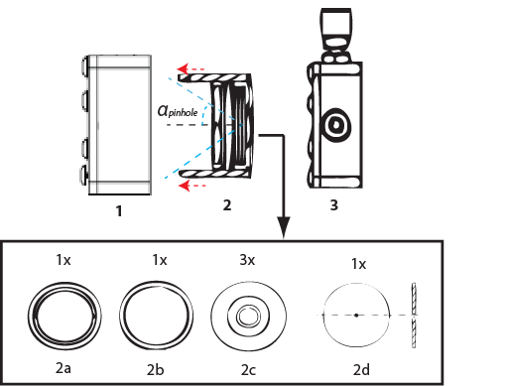

Changes in table 9

# | Components | Specifications
1 | Optic mount | $$-$$ | $-$
2 | Lens tube | $$-$$ | $-$
2a & b | Retaining ring | diameter | 18 mm
2c | Pinhole carrier | $$-$$ | $-$
2d | Pinhole | thickness | 0.013 mm
3 | x-y translational optic mount. | $$-$$ | $-$

