Errata

The reference in the first chapter of the introduction is: K. Ashton, *That ’Internet of Things’ thing, in the real world things matter more than ideas*, "http://www.rfidjournal.com/articles/view?4986" , June 2009.

The enumerations in the requirements section of the introduction are not the correct ones. This should be:

**Specifications of the AWSN**

• Modulation type: OOK

• Baseband of 50kHz

• Minimum transmitted power for energy harvesting:

-18.2±1.0dBm

• Maximum transmitted power for data transmission: ¡16dBm

**Requirements of the coil are:**

• As close as possible to the exact impedance of the IC, namely 9.5*µH* and 12Ω

• Should fit the size of a normal bandage or a 2 euro coin

• Maximum thickness of the coil must not exceed 2/3 coins stacked together

**Requirements of the receiver are:**

• Capable of receiving the signal at a distance of 10-20 cm.

• Only receive the signal of the AWSN

• Demodulate the signal

• At the output digital values of the modulated frequency

• Less as possible components

• Take into account future IC designs

• NF lower then 1dB

SYSTEM DESIGN

2.2 Data link, the reference should be 1.1 instead of 1.1.1

2.2.1 Reference for formula(2.16) is: C. Turner, *Backscatter modulation of Impedance Modulated RFID tags*

2.2.1 The explanation of the used parameters for formula 2.16 are stated at the top of page 10

2.2.1 Figure 2.3 is shown on page 10

2.2.1 The measurement setup and measurement of the link losses are stated in chapter 5.1

2.3 Figure 2.4 is shown on page 10

2.3.4 The abbreviation of bandpass filter should be BPF

CIRCUIT DESIGN

At the top of chapter 3, the reference is to chapter 2.3, figure 2.4

3.1.1 The second part of the open loop impedances of the LNA1 are imaginary. The impedance is then:

73,186- *j*102,052Ω and 101,492- *j*345,770Ω

3.1.1 In the line "With the program PASAN 3.2 the matching network" is with PASAN3.2 mentioned that the result of the program PASAN is shown in figure 3.2

CIRCUIT SIMULATION

In the paragraph of the SAWfilter, the missing reference is to figure 4.7

4.2.3 For the LF backend simulations we used a signal of 50kHz

4.2.3 The signal goes to 0V

4.2.4 The reference to the figure is missing. This should be figure 4.9

4.2.5 The filter characteristics are shown below:

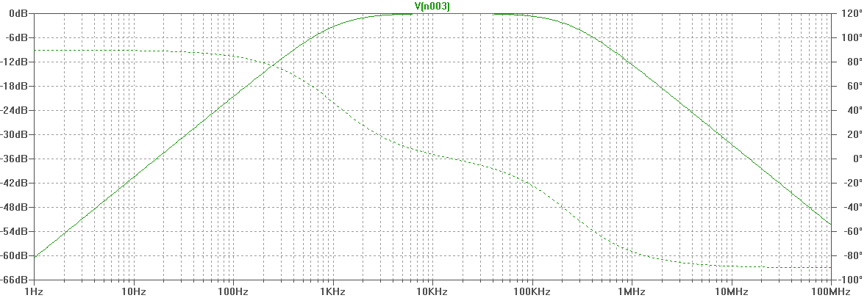

Filter characteristics of the LF filter

4.2.8 Figure 4.14 is missing, it is stated at the right of this page Comparator output of the LF-backend

MEASUREMENTS

In table 5.5 the results of LNA3 are:

S-parameter measured in dB

S11 -8.072 S21 19.518 S12 -38.391 S22 -5.616

In the measurement of LNA1, SAW filter, and LNA2 the captions of the graphs are not of the whole RF-frontend, but of the RF-frontend without LNA3.

Figure 5.12 can perhaps not be seen properly. Below these figures are shown more clear.

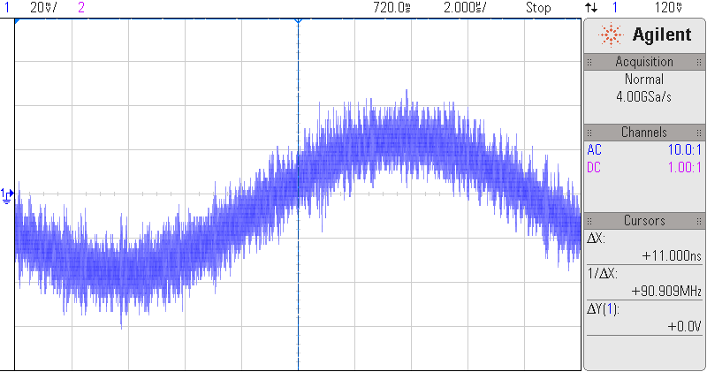

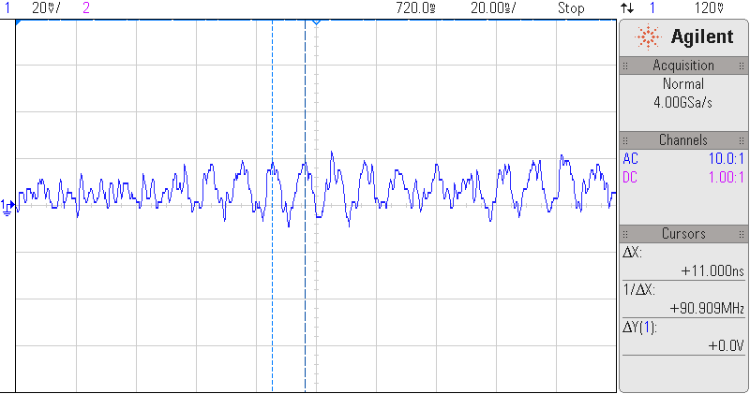

(a) LF backend input signal with lot of noise on it (b) Determined noise frequency on the input signal

Figure 1: Input signal for LF backend with noise and determined frequency of the noise

BIBLIOGRAPHY

The first paper, A 1.5µW 13.56\402 MHz autonomous wireless sensor node with temperature monitoring in

0.18 µm CMOS, is accepted for publishing in ESSCIRC instead of VLSI.