EU Naval Force Somalia – Operation Atalanta: fighting an elusive enemy

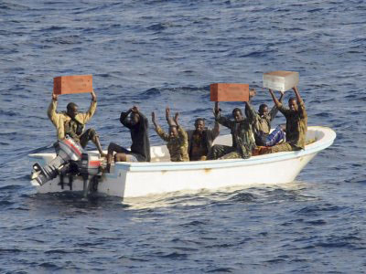
M.B.Braber
09042563
ES3-3A

Supervisor: M. van Munster
25-06-2012
The Hague, the Netherlands
School of European Studies
The Hague University of Applied Sciences
Table of Contents
1. Introduction 3
2. The pirates of Somalia 4
2.1 A background of Somalia 4
2.2 Who are the pirates 4
2.3 Somalia as the source of piracy 4
2.4 A slow response from the international community 6
3. Piracy a fundamental problem 7
4. EU NAVFOR Somalia – Operation Atalanta. 8
4.1 Mission 8
4.2 Objectives 9
4.3 Extension of mission and mandate 9
4.4 Structure of the mission 9
4.4.1 Contributing countries 9
4.4.2 Finance 10
4.4.3 Force size and area of operation 10
4.4.4 Command of EU NAVFOR Somalia 10
5. The objectives and success of the mission 11
5.1 Some statistics 11
5.2 Reduced number of hijackings 12
6. Measures to fight pirates 17
6.1 Vessel Protection Detachments 17
6.2 Private armed security guards 17
6.3 Coordination 18
6.4 Best Management Practices 19
7. EU NAVFOR Somalia is not the final solution to stopping piracy 20
8. Conclusion 21
Sources 23

Introduction
Maritime piracy is very old. One of the first acts of maritime piracy was registered during the first century BC (Paolo & Prohaska, 2012). Since then piracy has, on and off, been playing a major role during our world’s history. This paper is about the sea off the coast of Somalia, an area which has known an incredible growth of maritime piracy since the last decade. Together with the Gulf of Aden and the Indian Ocean this area forms on of the most important shipping lanes in the world. But during the last five years it became one of the most dangerous for ships passing through this vast area. Since 2005 maritime piracy has made a growing impact on international maritime security, on the economic activities and on the countries of this region. Because many ships pass through this area carrying flags of member states of The European Union (hereafter EU), the EU had to deal with this threat to international security. Therefore the EU launched the European Naval Force Somalia – operation Atalanta in December 2008 (EU NAVFOR Somalia, 2011). Today the mission continues into its fourth year.

The central question of this paper will be:

To what extent does operation Atalanta achieve its objectives?

The first chapter gives an insight into the background of Somalia, to see what has pushed the “sailors” and young Somali men to become pirates and how this problem became so important on the international agenda. The second chapter describes why this issue is so fundamental for the EU. This chapter is followed by a clear explanation of the mission of the operation. The fourth chapter deals with the objectives and the success of the mission. The fifth chapter deals with what the EU does and has to do to improve the situation. This will be followed with a chapter that deals with if the naval mission is the final solution to stopping piracy. It will end with a conclusion.

The used method for writing this paper is desk research. An institution like the EU makes all its information available via digital sources. It is a way of reaching the whole population of all the member states. As well it is definitely not that easy to travel to Somalia and conduct interviews. The area is still very dangerous and it is not recommended to go there. Therefore it was best in my opinion to use only desk research.

The pirates of Somalia

2.1 A background of Somalia
Somalia gained independence in the nineteen sixties, followed by elections in march 1969. The Somalia Youth League obtained a majority and, in the months that followed, became much more authoritarian in its rule of the country. The political situation deteriorated and in October of that same year the president was murdered by a policeman. In the following crisis the commander of the army, Mohamed Siad Barrem, took over power. He began a full totalitarian regime in which loyalty to the party and the nation was more important than loyalty to the many individual clans of Somalia. However, after the invasion of neighbouring Ethiopia in 1977, guerrilla groups were created, based on the different regions and clans, with the objective of destroying President Siad’s totalitarian and centralized regime. In 1988 this resulted in a country-wide civil war and, in 1991, Siad was overthrown. He returned to his clan to be one of the many warlords in the country (Gascoigne, n.d.). Since then the country has seen nothing but famine, militias on the warpath and interventions by the UN. However, the situation continues to deteriorate.

The population of Somalia has lived in extreme poverty for many decades now. Only the warlords, gang leaders, weapon smugglers, and now the ocean going pirates, are able to make a good living. The future for the population is slim and, according the index mundi, only a small percentage of the population lives to be 50 years old in Somalia (Somalia, 2012).

2.2 Who are the pirates
The piracy off the coast of Somalia is also known as “the great Somali make-work project” (Babineau, 2009). With an estimated unemployment rate of more than 50 %, Somalia belongs to the poorest countries in the world, although it is very difficult to find reliable sources for this percentage in this war torn country. While looking for a way to provide for their families, “young Somali men are taking up arms, riding out in the high sea in old, antiquated fishing boats and attacking the most modern yachts and shipping tankers that pass through on of the busiest shipping lanes in the world” (Babineau, 2009). Not only many men that try to provide their families with means of life, but also fighters of factions of the many different warlords that Somalia has are participating in the piracy business (Baldauf, 2008).

2.3 Somalia as the source of piracy
Since the start of the 1990’s the war torn country has seen more than a dozen of failed governments and poverty has grown out of proportion. Piracy off the coast of Somalia started to grow in the beginning of the 1990’s too. The sea off the coast of Somalia is full of fish. According to the United Nations, “high-seas trawlers from countries as far flung a South Korea, Japan and Spain have operated down the Somali coast, often illegally and without license, for the better part of two decades” (Tharoor, 2009). These high-seas trawlers were emptying the seas, destroying the very old fishing industry of Somalia. Fishermen, seeing no other option, started to organize themselves (in groups). These groups started to board ships passing by close to the coast. They did this as a way of protecting their fishing territory. While hijacking these ships, they started to ask for compensation money for their losses as fishermen. They stated that they were acting as a kind of “coast guard” for their waters. After the tsunami of 2004, drums washed up ashore on the beaches. After investigation, these drums proved to be full of toxic waste. This was also proof that nations used the coastal waters of Somalia for illegal dumping of toxic waste.
“illnesses and genetic mutations in new born infants have seen a huge rise in the coastline populations, skin disorders and cancers are becoming ever more common, and while health security has been severely afflicted, food security which once supported thousands of Somalis is also now decimated” (Kunertova, 2010).
Under the name of a “coast guard” more and more pirates started to attack ships to ask for compensation. Seeing that this could be very lucrative the piracy started to gain interest from and expand to the different clans of Somalia. This is why some people say that these pirates are “simple maritime criminals” (The Foreign Affairs Committee, 2012, p.13). These men have never been fishermen and are not interested in protecting their coastline. They were only attracted “by the lucrative illegal gains from piracy” (The Foreign Affairs Committee, 2012, p.13). These people have established a wide spreading criminal network in the country and are “actively harming development in Somalia” (The Foreign Affairs Committee, 2012, p.13).

In 2008, when the EU saw that something needed to be done, the piracy industry was the most important one of the country which, according to some sources, gave the pirates an income of $150 million dollars (Sherman, 2009, p.1). Because of the financial attractiveness in this extremely poor country, clans started to recruit among young Somali’s who had nothing to lose and so much to gain.

2.4 A slow response from the international community
About 28.000 ships pass through the Gulf of Aden each year, making it one of the busiest shipping lanes in the world. Only several hundreds of them are hijacked, which is only a small part. Making sure that they are not using excessive force, the pirates have more chance of obtaining the ransoms for the ships and their crew. Because more and more ships were hijacked and the pressure of the international community increased significantly, the EU finally decided that is was time to act. This culminated in the first ever EU Naval Mission.

Why was it necessary for the EU to initiate its own mission? The mission has been created as part of the Common Security and Defence policy of the EU. During the Balkan wars of the nineteen nineties it showed that EU member states needed to work together on Defence. This was showed by the necessary “intervention” of the US in the Balkan war, because the EU military was failing dramatically. The EU depends on the member states to make military resources available, but, in case of shortcomings, “the Berlin plus agreement of March 2003 allows the EU access to NATO planning and command structures and equipment during its operations to meet any shortfalls” (EU Common Security and Defence Policy, 2012). The USA always led NATO operations. Over the years the sentiment grew more and more that the EU needed “to pull its own weight” and “needed to pursue its own agenda, not the one laid on by the USA” (EU Common Security and Defence Policy, 2012). This is why the EU initiated its own mission.

Piracy a fundamental problem
For the first time in the history of the EU, the EU initiated a mission in which they directly try to protect EU citizens and ships. “Atalanta addresses pirate attacks in one of the most heavily-used maritime trade routes in the world, through which also large numbers of ships flying flags of EU member states and EU citizens pass” (Jarik, 2011, p.44). Next to protecting EU civilians, which is one of the main tasks of the EU, it has also a major impact on the world’s economy. “90% of the world’s traded materials moves by sea, and 40% of this (around 28.000 ships annually) passes through the Indian Ocean, Gulf of Aden and Arabian Sea” (The Foreign Affairs Committee, 2012, p.15). With all the measures taken to prevent being pirated and all the insurance costs for the ships, together with the costs for the missions and the ransom money, the annual cost of piracy has been estimated between “$7 and $12 billion” (The Foreign Affairs Committee, 2012, p.15). Piracy is a destabilizing factor in a region that is already volatile. And piracy is also said to pose a threat to international security with the suspected links to organized terrorism. Observers say that ransom money has been linked to an Al-Qaida linked militant terrorist group, who uses the funds in the fight against the Transitional Federal Government of Somalia, which is supported by the UN.
Tackling the piracy issue and taking the initiative, the EU tries to improve its status as a military actor.
“It shows that it is able to protect its citizens, its interests and to be an influential contributor in providing security. It is a change to show that the EU is pro-active, more coherent and more capable than ever before and that it is able to make an impact on a global scale” (Kunertova, 2010, p.9).

4. EU NAVFOR Somalia – Operation Atalanta.

4.1 Mission
Because of the growing concerns brought by the increase of piracy and the acts of armed robbery at sea, bringing a lot of danger to one of the busiest international maritime shipping lanes, the EU decided that action needed to be taken. Therefore the the EU initiated its first ever maritime operation by launching the European Naval Force Somalia – Operation Atalanta. This mission started in December 2008. It has been launched “within the framework of the European Common Security and Defence Policy (CSDP) and in accordance with relevant UN Security Council Resolutions (UNSCR) and International Law” (The European Union, 2012, EUNAVFOR Somalia). The mission is part of an EU policy that tries to deal with the instability, insecurity and poverty in the Somali area. This policy is called the comprehensive approach in the Horn of Africa. The EUNAVFOR Somalia refers to the following:
“The political objectives of the EU are to prevent and deter pirates from interrupting global maritime trade but also to contribute to a sustainable and long-term solution to piracy through building-up the capacity of the states in the region, including Somalia, to take ownership of the fight against piracy” (The European Union, 2012, Mission).
Originally the mission was supposed to last 12 months. However, at the end of 2009, the UN extended its resolutions, which extended the mission to December 2010 (McGivern, 2010). In 2010 the mission was extended for another two years to the end of 2012.

4.2 Objectives
The operation originally consisted of the following objectives (The European Union, 2012, Mission):
- The protection of vessels of the World Food Programme (WFP) delivering food aid to displaced persons in Somalia; the protection of African Union Mission on Somalia (Amisom) shipping;
- The deterrence, prevention and repression of acts of piracy and armed robbery off the Somali coast;
- The protection of vulnerable shipping off the Somali coast on a case by case basis;
- The EU NAVFOR – Atalanta shall also contribute to the monitoring of fishing activities off the coast of Somalia.

4.3 Extension of mission and mandate
The latest extension was discussed on the 23rd of March 2012. During an EU foreign ministers meeting in Brussels the council decided to extend the duration of the mission to December 2014. However, for the first time since its launch in 2008 the mission mandate was changed. The addition to the mandate of Atalanta “calls for the targeting of pirate onshore infrastructure, including moored boats, fuel tanks and communications equipment” (Bridger, 2012). This expansion has been called a “significant shift in strategy for a mission that has focused until now on stopping pirates at sea” (EU expands, 2012). In May 2012 the EU has launched its first raid on the Somali mainland under the new mandate. “Maritime aircraft and attack helicopters attacked the mainland of Somalia’s central coastline at dawn” (EU Forces, 2012).

4.4 Structure of the mission

4.4.1 Contributing countries
EU NAVFOR Somalia – Operation Atalanta receives help from countries that are not part of the EU. Norway was the first non-EU member that’s contributed in 2009. They sent a warship to the Indian Ocean. Furthermore Croatia and the Ukraine have sent staff officers to the operational head quarters in Northwood, England.
There are two ways of participating:
- Operational contribution
This means that a member state sends naval vessels or a maritime patrol aircraft or a Vessel Protection Detachment
- Providing military staff to the Operational Headquarters, or onboard units.
Additionally, there is a considerable military presence available in the Indian Ocean, with units from the Combined Maritime Force, NATO and marine ships from countries like China, India, Japan, Russia and many others. These ships are “all committed to counter piracy, but to some extent with different mandates and objectives” (The European Union, 2012, Mission).

4.4.2 Finance
The budget of the EU operation is shared for the common costs between all the EU member states. This is calculated on a country’s GDP and covers all the general costs made in the operation. Next to this each member state much pay for the deployment of its own naval vessels.

4.4.3 Force size and area of operation
The composition of the forces available constantly changes due to rotation of units. Every country should try and participate relatively equally to the means available. Also, depending on the monsoon season, there is a lower risk of possible pirate attacks. Usually there are around seven warships in the area and three maritime patrol aircraft. Together with land-based personnel the EU NAVFOR Somalia has about 1500 military personnel.
The mission area covers an area “from the south of the Red Sea, the Gulf of Aden and the Western part of the Indian Ocean including the Seychelles. The Area of Operation also include Somalia coastal territory and its territorial and international waters” (The European Union, 2012, Mission). This represents an area of almost 4.000.000 square kilometers. “In response to the geographical range in which pirates operate and changing pirate tactics, the EU has expanded the Area of Operations for EU NAVFOR and has adapted counter-piracy tactics” (The European Union, 2012, Mission).

4.4.4 Command of EU NAVFOR Somalia
Command of the mission changes every several months. The operations commander has its Headquarters in Northwood, England. The force commander commands the ships deployed for the piracy mission aboard his flagship. At this moment the operations commander is rear-admiral Duncan L. Potts, the force commander is rear-admiral Jean-Baptiste Dupuis.

5. The objectives and success of the mission
As stated earlier in this paper, the EUNAVFOR mission - operation Atalanta includes the following objectives:
- The protection of vessels of the World Food Program (WFP) delivering food aid to displaced persons in Somalia; the protection of African Union Mission on Somalia (Amisom) shipping;
- The deterrence, prevention and repression of acts of piracy and armed robbery off the Somali coast;
- The protection of vulnerable shipping off the Somali coast on a case by case basis;
- The EU NAVFOR – Atalanta shall also contribute to the monitoring of fishing activities of the coast of Somalia.
The most important objective is the protection of vessels of the WFP delivering food aid to displaced persons in Somalia, together with the protection of ships delivering food for the African Union Mission on Somalia (AMISOM). Since the EU NAVFOR began to provide escorts for these ships, not one WFP ship has been hijacked, “which allowed them to deliver 674.000 tons of food to the Somali people. Recently the EU announced the 100th successful AMISOM escort” (The Foreign Affairs Committee, 2012). This objective has been one of the leading issues since the start of the naval mission and this objective has a high priority among the commanders of the mission.
Before the start of the mission, many attacks were taking place in the Gulf of Aden. In the Gulf naval ships assigned to the mission established the Internationally Recognized Transit Corridor (IRTC). By several ships patrolling this corridor and by organizing commercial shipping into transit groups, it has been made almost impossible for the pirates to attack the valuable shipping here. Placing the ships in groups increases the possibility of detecting the pirate groups significantly.

5.1 Some statistics
Since 2006 hijacking attempt by pirates increased annually up till 2010, culminating in an astonishing 48 ships in 2010 who were captured and held for ransom by Somali pirates (ICC, 2011). Since the start of 2011 there has been a decline in pirate attacks on international shipping in the Indian Ocean. There were 97 attacks in the first quarter of 2011, with 19 hijackings. There were only six hijackings during the rest of the year (EU expands, 2012). According to the latest data of the ICC International Maritime bureau, up until the 18th of May 2012 there were 58 incidents, which ended up in 12 hijackings (Piracy, 2012). This means that the number of successful attacks are declined. But we should not forget that the pirates are still holding 13 vessels with a 197 hostages up to this date (Piracy, 2012).

5.2 Reduced number of hijackings
Has the EUNAVFOR been able to reduce the number of hijackings and maybe even the number of attempted hijackings? Yes and no. The success of the mission is only partial. Naval patrols have been one of the reasons that “the proportion of successful attacks has decreased dramatically” (The Foreign Affairs Committee, 2012, p.30). However, up till July 2011 the number of attempts made has been increasing significantly each year, as you can see in table 1.

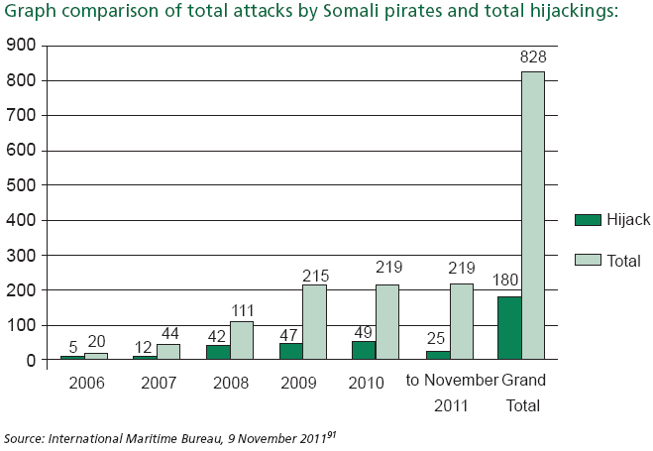
Table 1. Piracy off the coast of Somalia: Tenth report of session 2010-2012 (The Foreign Affairs Committee, 2012)
The reason for this increase in attempted hijackings has been the change in tactics of the pirates. While they were first concentrating on shipping closer to the coast, and in the Gulf of Aden, the creation of the IRTC and the presence of naval assets have made the pirates venture a lot further out to sea to hijack ships. An example was the hijacking of the Turkish vessel MV Frigia under Maltese flag on 23 March 2010 (Kunertova, 2010, p.16). This ship was hijacked 1.800 kilometers away from Somalia. This is closer to India than to Somalia.
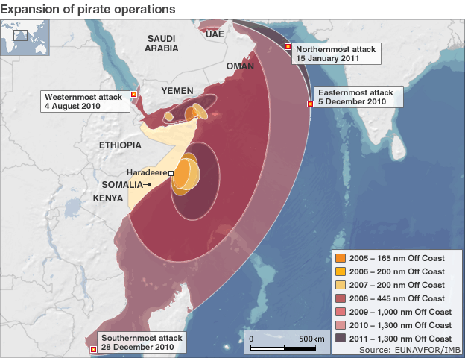
Figure 1. The losing battle against Somali Piracy (Illustration from the BBC News, 10 februari 2011, retrieved 24 June 2012 from the website http://www.bbc.co.uk/news/world-europe-12412565).
Figure 1 shows the expansion of piracy operations. It is really a gigantic area that is covered by only several marine ships.
Year after year pirates have developed their “skills”. They have already received huge sums of ransom money, which they use to buy more and modernized weaponry, faster boats and advanced technology. This has increased the operating area of the pirates to a huge part of the ocean. Pirates started to use mother ships from which they can launch their fast boats, the so called skiffs. This gives the pirates the option of taking more food and fuel with them, which immediately expands their action radius. On figure 2 and 3 you can see that the Somali pirates are spreading their area of operation from the Gulf of Aden and the coastline of Somalia far into the Indian Ocean. The first photo represents the first half of 2009, the year that pirates still capture ships close to the coastline and in the busy shipping lanes of the Gulf of Aden. However, in the second one, it is obvious that the pirates are venturing further out to sea on a regular basis and are spreading their hijack attempts.
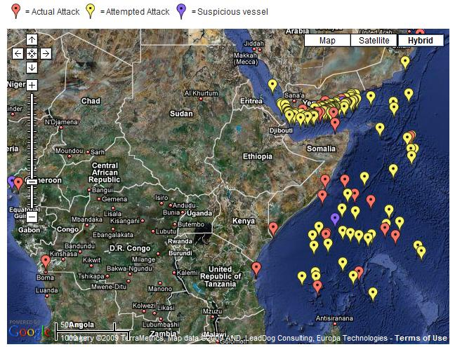
Figure 2. IMB Report: Maritime Piracy doubled in first half of 2009 (Illustration from the International Maritime Bureau, 16 Juli 2009, retrieved 24 June 2012 from the website http://www.maritimeterrorism.com/2009/07/16/imb-report-maritime-piracy-doubled-in-first-half-of-2009/).

Somali Pirates expanding their range, December 2010
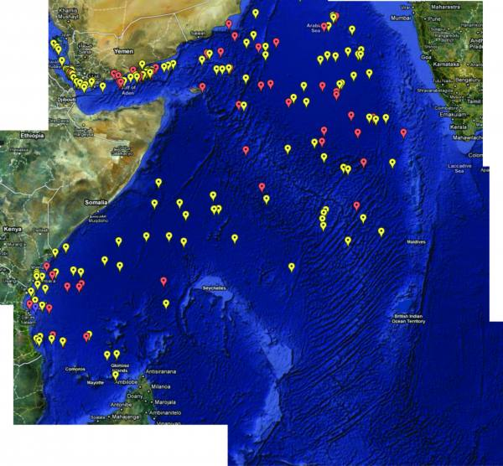
Figure 3. Somali pirates expanding their range (Illustration from the International Maritime Bureau, 8 December 2010, retrieved 24 June 2012 from the website http://americancommondefencereview.wordpress.com/2010/12/08/somali-pirates-expanding-their-range/
Pirates expanding their action radius makes combating piracy a lot more difficult for the EU Naval Forces. The operating radius of the EU consists of 5 million square kilometers (Kunertova, 2010, p.16), making it very difficult for the EU to deploy a successful naval policing mission with the limited amount of naval assets they can deploy. During a normal period there are on average 8-12 warships present for the EU naval mission. Together with the other naval assets from other missions this brings the total of warships an average around 30, depending on the monsoon season. However this is by far not sufficient enough to deal with the ever growing piracy threat across the Indian Ocean.
Several commanders of naval forces have stated their different opinions about the lack of naval vessels in the area. According to a US Vice-Admiral at least 63 warships would be needed to “get the situation under control” (Kunertova, 2010, p.16). However according to a major general Howes of the United Kingdom, “83 are needed to provide response conditions of half an hour, as they have been achieved in the IRTC” (The Foreign Affairs Committee, 2012, p.33). Is this likely to happen one day? I do not believe so. Gathering a fleet this size from all the different countries might be possible, but it will not be possible to keep a fleet that size in place, sufficiently supported, for several years. The world is too divided for that and there are too many countries that are only participating out of their own interests.

Measures to fight pirates

6.1 Vessel Protection Detachments
First of all, already several member states are doing more than just send their naval vessels to the Indian Ocean to police the ocean. They provide Vessel Protection Detachments (VPD’s) for ships passing through the danger area. These Detachments consists of a group of well-armed military protection teams, usually the size of one platoon. These troops are always well-trained marines. These marines are detached on a ship that has its flag in their homeland, because of the legal issues. They board the ship in a port that is entering the area of operations of the pirates. After leaving this area, the marines disembark the ship. Only the bigger and more vulnerable ships for hijacking can get one of these teams on board. After approval of the ministry of Defense the marines can enter the ship during its voyage. The Dutch ministry of Defense started putting these teams on board the ships from March 2011 (Beveiligingsteams Schepen, 2012). Anonymous Vessel Protection Detachments are similar platoons of marines, who sail on board the ships of the WFP. The bigger countries in Europe have already been providing them, and they have proven to be pretty successful in fighting off pirates during hijack attempts.

6.2 Private armed security guards
While these VPD’s are provided by the nation’s armed services, another kind of protection teams are getting more and more popular among owners of merchant vessels. These teams are similar to the VPD’s provided by militaries, however these teams are private sector security teams. There is, however, a lot of debate and discussion about these teams. These teams usually do not have enough legal bases, which can get them arrested in countries that do not accept them. And not every ship or ship owner is big and valuable enough that they can afford to hire a private armed security team and that it is worth the effort. This means that only the bigger ships will have these teams on board. Pirates will consequently move to smaller ships who maintain to be vulnerable.
However, several European countries are in the process of changing their policy about this. It has proven that these private teams have been an “undeniable success”, because “so far no ship with armed guards on board has ever been successfully pirated” (The Foreign Affairs Committee, 2012, p.22). Maybe it is worth the effort giving these private security companies enough legal bases to be able to place these teams on board ships. It could be a cheaper alternative as well.
The latest news on the private armed security guards comes from the Netherlands. The Dutch law is one of the countries that does not allow private security teams on boards ships carrying their flag. Instead the Dutch government prefers to place VPD’s on board. However insurance companies are pressing the government to change the law, or the Dutch navy need to increase their participation. Because the Dutch law does not allow ships to have private protection teams on board, many ship companies choose to carry a different flag, one of another country from the EU, which allows them to have a private team on board. This because there is a deficiency in protection. According to the insurance companies, since last year June the Dutch navy protected 20 ships with VPD’s, while there was a need for 250.

6.3 Coordination
One thing is clear that needs to be done: the coordination needs to be improved. Right now there are three different missions present in the Indian Ocean:. the EU NAVFOR Atalanta, Operation Ocean Shield from the NATO and Combined Task Force 151. These three are all related to combating piracy in the Gulf of Aden and the Indian Ocean and are all coordinated separately. Next to these groups, there are also marine assets from individual countries present in the Indian Ocean. Ships from Russia, Iran, China, India, Pakistan, South Korea and Japan have all been acting in the Indian Ocean. While all these international actors are present and have similar objectives, they sail under different mandates and under different commands. Although the protection of ships of the WFP has been very successful, the general problem of piracy has not been solved and it does not look like it will be solved any time soon.
What needs to be done here? Countries need to put aside their individual differences and the international community need to create one central command organization with one clearly recognizable common strategy. The time of countries saying that they only want to participate in a specific part of the operation, need to be brought to an end. The international community needs to show that they can work as one. As well it might be a good idea to coordinate the use of VPD teams. For example, now only marines from the Netherlands can be on board Dutch flagged ships. If the EU can coordinate the available VPD’s provided by the member states, maybe more ships can be protected, while making sure that the available teams are being used to the fullest. As well, as I said before, give more legal grounds to private security agencies. Make sure that these agencies can be used to its full potential. It does not hurt to let companies pay for their own protection, because many of them are already insured for this. Andrew Voke said: “as insurers, there is credit for using armed guards on your vessels” (The Foreign Affairs Committee, 2012, p.22). The companies should use it then.

6.4 Best Management Practices
In cooperation with the International Chamber of Shipping, other shipping industry organizations and military navies the Best Management Practices have been developed. This has been developed to
“assist companies and ships avoid becoming victims of piracy in the Gulf of Aden off the coast of Somalia and in the Western Indian Ocean. It offers specific, practical advice for companies in order to avoid, deter, or delay pirate attacks, and it is strongly supported by a broad coalition of industry and intergovernmental organizations” (Best Management Practices to deter Piracy in the Gulf of Aden and off the coast of Somalia, 2011).
The International Chamber of Shipping strongly recommends all ships passing through the area of operations of the pirates that they comply with the Best Management Practices. One of the measures stated in the BMP is the construction of a safe room, or citadel, where crew members can hide during a pirate attack and where they can control the ship. Another measure is the use of water cannons to deter pirates while they are attacking. This is a non-lethal way and is greatly promoted by the BMP. There are systems that can be automatically controlled from the citadel, which means that crew members can fight the pirates without running the risk of being shot.
The International Chamber of Shipping also recommends every ships to register with the EUNAVFOR Maritime Security Center - Horn of Africa. This center
“provides 24 hour manned monitoring of vessels transiting through the Gulf of Aden whilst the provision of an interactive website enables the Center to communicate the latest anti-piracy guidance to industry and for Shipping Companies and operators to register their movements through the region” (The Maritime Security Center – Horn of Africa, 2011).
By registering the coordination between ships and the monitoring by naval ships improves drastically, which is necessary to provide a quick response time on pirate incidents.

EU NAVFOR Somalia is not the final solution to stopping piracy
While only fighting pirates at sea, the international community cannot stop them. There are by far not enough naval assets in the area of operations to provide a relatively effective response time to a pirate hijack attempt, let alone capture them. The ocean is just way too big. As well the pirates are evolving their techniques and go out to sea further and longer than in the beginning. To effectively combat the piracy problem, the international community needs to address this problem by its roots: the situation in the country of Somalia. Fortunately this is already underway. Army units from the African Union (mainly Kenyan) have entered the country from the South as support for the Transitional Federal Government of Somalia. These units are moving their way up north and have brought stability back to larger parts of land. Even the capital, Mogadishu, has been liberated of the militia of AL-Shabab.
It finally looks like it is going in the right direction for Somalia. With the help from the land units of the African Union, the naval mission from the EU, NATO and other countries and the long lasting commitment these countries have given Somalia, maybe, in due time, stability will be guaranteed. For now, it looks like there is still a long way to go. Ships are still being attacked and troops of the African Union, together with soldiers from the Somali army, are continuing to fight militias. Besides this there is a political struggle that divides the Transitional Government and makes it very difficult for them to operate normally. And all this because of different clan backgrounds. It is time for the Somali people to overcome their difference and work together. It is time to bring an end to the famine destroying the country and the families of Somalia. It is time to bring hope back among the population.

Conclusion
Piracy off the coast of Somalia started to grow in the beginning of the 1990’s. The pirates called it protection of their shores against modern fishing fleets from other countries that came to empty the sea. They also wanted to protect the country against illegal dumping of radioactive waste. A war-torn country for many years, the “coast guard” started to notice that it is possible to provide for their families by hijacking a ship and asking for ransom. This started to attract more young Somali men that were trying to provide food for their families. Warlords saw it also as a very lucrative way of making money fast. It was reported that in 2008 a total ransom was paid of 150 million dollars.

In December 2008 the European Union started their first ever Naval Mission, called operation Atalanta. This mission was initiated, finding the legal basis in new UN resolutions, to provide protection to ships of the World Food Program delivering food to Somalia, and to police the ocean against any forms of piracy.

Not one ship delivering food was hijacked since the start of the mission, which has been a noteworthy accomplishment. However, the problem of piracy has not been solved. The IRTC in the Gulf of Aden has been a big success, but the pirates have just expanded the scope of operations further out onto the Indian Ocean, making it more and more difficult for the EU naval assets to control their activities. There are just not enough ships.

Other things are being done to fight piracy and make safe passage for the ships passing through the Indian Ocean. Several member states are placing VPD’s on board their flagged ships. These teams are very heavily armed platoons of marines. This has been proven to be a very effective measure of defense against the pirates. However not every ship can get a team like this onboard depending on the standards of the ship. Usually the teams are limited to the bigger, more vulnerable ships.

Private armed security teams are being used more and more also. This has been the reason of many discussions and debates, because these teams are not supported by any legal basis. The lack of security and support from their governments makes them vulnerable for arrest and prosecution. However, experience has shown that teams on board ships are a very successful measure. Not a ship has been hijacked that had a VPD or a private armed security team on board. The downside is that not every company can afford these teams.
A good step towards more effectiveness will be the increase of coordination between the three different operations. Make it one overall operation, with one mandate and one control center. Try to involve the countries that are fighting piracy individually, so that all the naval efforts from the whole international community can be organized and controlled and will diminish double tasks. This will increase the effectiveness of fighting piracy significantly.
Ships passing through the Gulf of Aden are strongly advised to follow the Best Management Practices and to register at the Maritime Security Center – Horn of Africa. Applying these measures can help maintain the safety on board the ship and even help deter pirates from an attack.
We saw recently that EU member states are expanding the mandate of the mission. Two months ago its members gave the operation the mandate of attacking the pirates’ bases on the coast line. Up till then the naval assets of the mission were supposed to stay away from the coast. This culminated in the first aerial attack on a base of the pirates, which has proven to be a big step towards fighting piracy, but as well a point of discussion, looking at the numbers of hostages still in captivity. Pirates have already made threats that with new attacks on their bases, they will not hesitate to retaliate on their prisoners.
Finally, to what extend does EU NAVFOR Somalia – operation Atalanta achieve its objectives? Escorting specific ships brings a 100% success rate. However with naval forces alone, the entire international community will not be able to combat piracy of the coast of Somalia and in the Indian Ocean effectively. The pirates will continue to be an elusive enemy.

Sources
Babineau, M. P. (2009, April 22). Somalia's clan system and piracy. In Helium, where knowledge rules. Retrieved May 9, 2012, from http://www.helium.com/items/1419477-somalias-clan-system-and-piracy

Baldauf, S. (2008, November 20). Who are Somalia's pirates? The Christian Science Monitor. Retrieved May 13, 2012, from http://www.csmonitor.com/World/Africa/2008/1120/p25s22-woaf.html

Best Management Practices to Deter Piracy in the Gulf of Aden and off the Coast of Somalia (2011, August). In International Chamber of Shipping. Retrieved June 25, 2012, from http://www.marisec.org/piracybmp.htm

Beveiligingsteams Schepen (2012, May). In Ministerie van Defensie. Retrieved May 23, 2012, from http://www.defensie.nl/missies/somalie/beveiligingsteams_schepen/

Bridger, J. (2012, May 11). The EU's misguided move to fight pirates onshore. In Academic Research on Contemporary Maritime Piracy. Retrieved May 16, 2012, from http://piracy-studies.org/

EU Common Security and Defence Policy. (2012, March 30). In CIVITAS EU facts. Retrieved May 28, 2012, from http://www.civitas.org.uk/eufacts/FSEXR/EX4.htm

EU expands Somali pirate mission to include attacks on landbases. (2012, March 23). The Guardian. Retrieved May 16, 2012, from http://www.guardian.co.uk/world/2012/mar/23/somalia-pirate-mission-expanded-eu

EU forces in anti-piracy raid on Somali mainland. (2012, May 15). The Guardian. Retrieved May 16, 2012, from http://www.guardian.co.uk/world/2012/may/15/eu-anti-piracy-raid-somalia?INTCMP=ILCNETTXT3487

EU NAVFOR Somalia. (2011). In The EU common security and Defence Policy. Retrieved May 9, 2012, from http://www.consilium.europa.eu/eeas/security-defence/eu-operations/eunavfor-somalia?lang=en

Gascoigne, B. (n.d.). History of Somalia. In History World. Retrieved May 9, 2012, from http://www.historyworld.net/wrldhis/PlainTextHistories.asp?historyid=ad20

ICC International Maritime Bureau issues 2010 Annual Report (2011, January 28). In Safety4Sea. Retrieved May 21, 2012, from http://www.safety4sea.com/page/2364/4/icc-international-maritime-bureau-issues-2010-annual-report-

Jarik, J. (2011). Operation Atalanta and the protection of EU citizens: Civis Europaeus Unheeded? Perspectives on Federalism, 3(2), 44. Retrieved May 22, 2012, from http://eui.academia.edu/JorisLarik/Papers/1105900/Operation_Atalanta_and_the_Protection_of_EU_Citizens_Civis_Europaeus_Unheeded

Kunertova, D., Patel, F., Richter, S., & Trept, L. (2010, April). European Anti-piracy Strategy: Somalian Piracy: Today’s Challenge Addressed by an EU Initiative. In tu-dresden.de. Retrieved May 22, 2012, from http://tu-dresden.de/die_tu_dresden/zentrale_einrichtungen/zis/newseceu/outcomes/papers_folder/MilSec_EU%20anti-piracy%20strategy.pdf

McGivern, L. (2010). The European Union as an international actor: Has operation Atalanta changed global perceptions of the EU as a military force? Retrieved May 16, 2012, from http://www.atlantic-community.org/app/webroot/files/articlepdf/McGivern-Operation%20Atalanta.pdf

Paolo, U., & Prohaska, A. (2012). Piracy Timeline. In The Way of the Pirates. Retrieved May 9, 2012, from http://www.thewayofthepirates.com/history-of-piracy/piracy-timeline.php
Piracy and armed robbery news & figures (2012, May 18). In ICC Commercial Crime Services. Retrieved May 21, 2012, from http://icc-ccs.org/piracy-reporting-centre/piracynewsafigures

Sherman, T. (2009, April 21). The history of piracy in Somalia. In Helium, where knowledge rules. Retrieved May 21, 2012, from http://www.helium.com/items/1424309-history-of-piracy-in-somalia

Somalia life expectancy at birth. (2012, January 9). In Index Mundi. Retrieved May 9, 2012, from http://www.indexmundi.com/somalia/life_expectancy_at_birth.html

Tharoor, I. (2009, April 18). How Somalia's fisherman became pirates. Time. Retrieved May 28, 2012, from http://www.time.com/time/world/article/0,8599,1892376,00.html

The European Union. (2012, April). EUNAVFOR Somalia. In European Union External Action. Retrieved May 14, 2012, from http://www.consilium.europa.eu/eeas/security-defence/eu-operations/eunavfor-somalia?lang=en

The European Union. (2012, April). Mission. In EU NAVFOR Somalia. Retrieved May 14, 2012, from http://www.eunavfor.eu/about-us/mission/

The Foreign Affairs Committee. (2012, January 5). Piracy of the coast of Somalia: Tenth Report of Session 2010-2012. InHouse of Commons Foreign Affairs Committee. Retrieved May 22, 2012, from
http://www.publications.parliament.uk/pa/cm201012/cmselect/cmfaff/1318/1318.pdf

The Maritime Security Center - Horn of Africa (2011). In EU NAVFOR Somalia. Retrieved June 25, 2012, from http://www.eunavfor.eu/about-us/mschoa/

