**Joyce Boekestijn**

**08005257**

**ES4-4C**

**The Hague University of Applied Sciences**

**School of European Studies**

**Mrs. Weijerman-Kerremans**

**15-05-2012**

15-05-2012

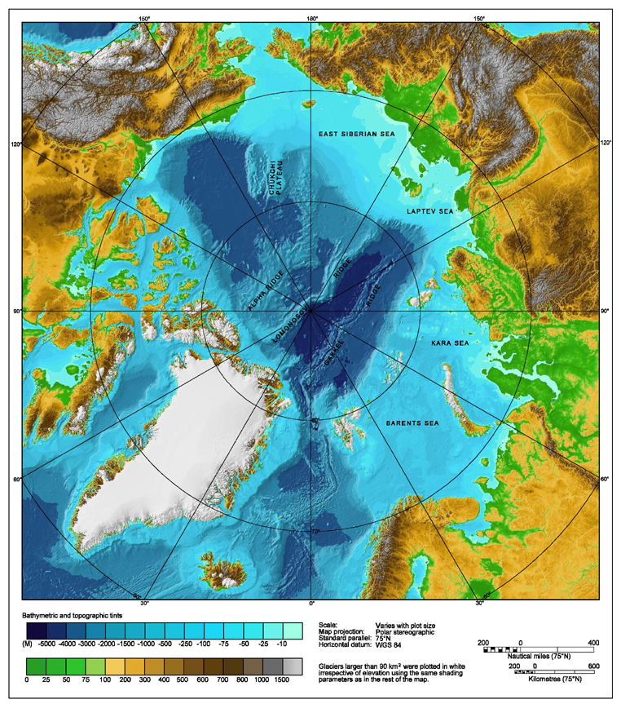

**Will UNCLOS last throughout the upcoming ‘Cold Rush’ in the Arctic?**

# EXECUTIVE SUMMARY

The Arctic Ocean stands at the threshold of significant changes. Climate change and the melting of ice have a potential impact on vulnerable ecosystems, the livelihoods of local inhabitants and indigenous communities, and the potential exploitation of natural resources. (Ilulissat Declaration, 2008, p.1)

Due to these changes, the Arctic region has increasingly become more valuable for the nations surrounding it: Russia, Canada, the United States, Norway and Denmark. Except for the United States, all of the Arctic coastal States are signatories to the United Nations Convention on the Law of the Sea. This entitles them to claim extension of the outer limits of their continental shelf at the Commission on the Limits of the Continental Shelf, as established in Annex II of the Convention. So far, Norway, Russia and Denmark have brought their submissions, although this does not mean that the other States have procrastinated in taking action.

Article 287 of the Convention sets out the different choices of procedure in the event of a dispute; one or more of the following means can be chosen to settle the dispute: Annex VI of the Convention for the International Tribunal for the Law of the Sea. This is an independent judicial body to adjudicate disputes arising out of the interpretation and application of UNCLOS. Then there is the International Court of Justice, which serves as the principal judicial organ of the United Nations. Its role is to settle legal disputes submitted to it in accordance with international law. Annex VII of the Convention provides for the Arbitral Tribunal, allowing each State party to submit arbitrators that are experienced in maritime affairs. The Arbitral Tribunal shall determine its own procedure, assuring each party a full opportunity to be heard and present its case. The last choice of procedure in conformance with Article 287 is Special Arbitration, as set out in Annex VIII of the legal framework. The Special Arbitral Tribunal shall consist of experts appointed by the State members and it shall carry out an inquiry and establish the facts giving rise to the dispute.

Apart from UNCLOS, numerous other institutions and programmes have been set up in order to protect and/or regulate the fragile ecosystems in the Arctic environment. One of them is the International Seabed Authority, which is the authorized organ in activity control and resource management in the so-called ‘Area’: the seabed and ocean floor and subsoil thereof beyond the limits of natural jurisdiction, i.e. the area that State parties can make a claim for. There is the International Union for the Conservation of Nature, which is the oldest and largest global environmental organization worldwide. The Arctic’s interest is represented in its Global Marine and Polar Programme.

The only Arctic body currently in existence is the Arctic Council. It acts as a high level intergovernmental forum to promote cooperation, coordination and interaction among the Arctic States. Worth mentioning is that the Arctic Council, in relation to the Arctic area, points out that ‘there is no Convention for this region as of yet’. The AC essentially acknowledges hereby that UNCLOS is not sufficient in regulating the situation in the Arctic.

There are many different positions on how geopolitics should be played in the Arctic. All offer a possible solution. The answer could be found in one or more historical theories, which have proven themselves in the past. To give an example, there is the Sector Theory, which would basically slice up the Arctic Ocean as a pizza, taking the North Pole as the centre. Each coastal State would be allocated a ‘slice’, based on its territorial claim. Another theory is that of *uti possidetis*. This theory allows territorial claims by the previous mother country. However, due to its ambiguity, this doctrine might only create more complications in the Arctic region, as the North West Passage (currently Canadian territory) has previously been under control of France as well as Great Britain. The International Court of Justice has contributed to the creation of the Straight Baseline Theory. Under this theory, States can claim that coastal waters are internal waters under certain provisions.

Some scholars share the opinion that the solution for the Arctic situation is to amend UNCLOS. What would require change is the ‘opt-out exception’ in Article 298 of the Convention. This allows States to abstain themselves from certain clauses. To better ensure efficient and effective resolution of Arctic territorial claims, UNCLOS signatories should not be able to opt out of arbitration.

Other observers claim that creating a new agreement similar to the Antarctic Treaty would be best. The striking point in this Treaty is Article IV, which denies a State’s rights in Antarctica, thereby rejecting all claims to territory. This indeed would take away the political problems rising in the Arctic region. But the matter of valuable resources will still not be solved. Moreover, the Antarctic Treaty is only in force until 2041. Applying a comparable treaty for the Arctic raises the question of what will happen afterwards. Will not the same situation arise when the treaty date expires?

Finally, the last possible solution in this research is to create a new Arctic Treaty. The greatest challenge here lies in convincing the eight Arctic States that it is in their collective benefit and long-term interest to have a regional and binding body. (Huebert, 2009, p.27) A potential Arctic Treaty should meet certain requirements: practical means to resolve differences need to be established, preferably in the form of a hard-law organ with binding decisions. Security of protection of the fragile environment and its resources is also key.

On the assumption that UNCLOS is not the answer, but merely the beginning of the search for the right solution, it does not matter in what form a solution will be found. What does matter is that a Cold Rush for the Arctic is approaching and that something needs to be done.

**TABLE OF CONTENTS**

EXECUTIVE SUMMARY 2

PREFACE 5

GLOSSARY 6

INTRODUCTION 8

CHAPTER 1: UNCLOS 10

*International Seabed Authority* 10

*Commission on the Limits of the Continental Shelf* 11

*Settlement of disputes* 12

*UNCLOS deficiencies* 14

*IUCN* 15

*UNEP* 16

*AEPS* 16

*Arctic Council* 17

*Ilulissat Declaration* 17

CHAPTER 2: INVOLVED PARTIES 18

Russia 18

United States 20

Canada 21

Norway 22

Denmark 24

CHAPTER 3: POSSIBLE SOLUTIONS 26

*Pick a theory* 26

*Amend UNCLOS* 28

*Follow Antarctic Treaty System* 29

*Create Arctic Treaty* 30

CONCLUSION 32

RECOMMENDATIONS 33

REFERENCES 35

APPENDICES 41

I. The Arctic 41

II. Outline of used terminology 42

III. Continental Shelf 42

IV. Extended Continental Shelf 43

V. EEZ 43

VI. Northwest Passage / Northern Sea Route 44

VII. Lomonosov Ridge / Mendeleev Ridge / Alpha Ridge / Gakkel Ridge 44

VIII. Norwegian claim: Loop Hole / Western Nansen Basin / Banana Hole 45

IX. Jan Mayen Island 45

# PREFACE

*By the author:*

International law has always had my special attention. During my exchange in Argentina I tried to get more engaged in the topic by choosing *‘Derecho Internacional’* as one of my subjects. Although classes were complicated and difficult as they were given in Spanish, I never lost interest. In fact, my preference for this field of law only augmented. The basics we were taught before during three years of European Studies in law were informative, but it was merely based on topics related to the EU. It was only in Argentina that my vision on international law changed; how much more was there to discover outside of the EU! It really broadened my view on things, seeing them in another perspective; the European and Latin-American vision on law and its basics differ significantly. From that point on I was very eager to gain more knowledge on international law, also approached from outside the European Union.

Once back in The Hague starting the final year, we were expected to choose a minor course. Among the possibilities was international law, which I enthusiastically signed up for. It is amazing how much one can learn in so little time and it was also during that minor that I found out my preferred field of international law: environmental law. The topic for my dissertation naturally stemmed from a combination of those two. Again I can say that I have learned incredibly much. For my research I quite often visited the Peace Palace. I could not have been in a better place; this building simply breathes international law. It worked very motivating and made me realize how fortunate I am studying and doing my research in The Hague with all the right sources available, right here in the world capital of peace and justice.

The last semester of one’s studies generally is considered the hardest part, having to finish all the last bits and writing a thesis at the same time. Fortunately, I can say that I have worked with the greatest pleasure on writing mine. It has even made me choose my Master programme in the same direction; Global Environmental Governance, which I will start after graduating.

To my readers: I hope you will enjoy reading this thesis as much as I did writing it.

# GLOSSARY

**AEPS** 🡪Arctic Environmental Protection Strategy

**CLCS** 🡪 is the abbreviation for the Commission on the Limits of the Continental Shelf. It consists of 21 experts in the field of geology, geophysics or hydrography, elected by States Parties to this Convention from among their nationals, having due regard to the need to ensure equitable geographical representation, who shall serve in their personal capacities. (UNCLOS, 1982, p.145)

**Continental shelf** 🡪 ‘’The continental shelf of a coastal State comprises the seabed and subsoil of the submarine areas that extend beyond its territorial sea throughout the natural prolongation of its land territory to the outer edge of the continental margin, or to a distance of 200 nautical miles from the baselines from which the breadth of the territorial sea is measured where the outer edge of the continental margin does not extend up to that distance.’’ (UNCLOS, 1982, p.53) i.e. it is the extended outer limits of each [continent](http://en.wikipedia.org/wiki/Continent) and associated [coastal plain](http://en.wikipedia.org/wiki/Coastal_plain).

**EEZ** 🡪 Exclusive Economic Zone is an area beyond and adjacent to the territorial sea, subject to the specific legal regime established in this Part, under which the rights and jurisdiction of the coastal State and the rights and freedoms of other States are governed by the relevant provisions of this Convention.

**Hard law** 🡪represents legal obligations, found either in treaties ore customary international law, that are binding in and of themselves. (Oxford, 2009)

**ICJ** 🡪 International Court of Justice

**ISA** 🡪 International Seabed Authority

**ITLOS** 🡪 International Tribunal for the Law of the Sea

**IUCN** 🡪 International Union for the Conservation of Nature

**Lomonosov Ridge** 🡪 The Lomonosov Ridge is an underwater ridge of [continental crust](http://en.wikipedia.org/wiki/Continental_crust) in the [Arctic Ocean](http://en.wikipedia.org/wiki/Arctic_Ocean). It spans 1800 km from the [New Siberian Islands](http://en.wikipedia.org/wiki/New_Siberian_Islands) over the central part of the ocean to [Ellesmere Island](http://en.wikipedia.org/wiki/Ellesmere_Island) of the [Canadian Arctic Archipelago](http://en.wikipedia.org/wiki/Canadian_Arctic_Archipelago). (CBC News, 2007)

**Mendeleev Ridge** 🡪  is a ridge centrally located in the Arctic Ocean, running underneath the surface. It is attached to the Lomonosov and the Alpha Ridge and extends for approximately 1,500 km, connecting the East Siberian Sea to central areas of the Arctic Ocean.

**North-west passage** 🡪 is a sea route through the [Arctic Ocean](http://en.wikipedia.org/wiki/Arctic_Ocean). It goes from the north coast of North-America via the Canadian Archipelago, connecting the Pacific and Atlantic Oceans.

**Seabed** 🡪 The seabed, or the seafloor, is the bottom of the [ocean](http://en.wikipedia.org/wiki/Ocean). In this work the seabed will be referred to as part of ‘the Area’, holding the seabed and ocean floor and subsoil thereof, beyond the limits of natural jurisdiction.

**Soft law** 🡪soft-law represents guidelines of behaviour that are not binding in themselves but are more than mere statements of political aspiration. (Oxford, 2009)

**Subsoil** 🡪is the layer or bed of earth beneath the topsoil or, in this work, beneath the ocean floor.

**Territorial Sea** 🡪the territorial waters of a State are comprised of its internal and archipelagic waters. This sovereignty extends to the air space over the territorial sea as well as to its bed and subsoil. Every State has the right to establish the breadth of its territorial sea up to a limit not exceeding 12 nautical miles. Within this area, i.e. its territorial sea, a State is free to set laws, regulate use and use all resources. (UNCLOS, 1982, p.27)

**UNCLOS** 🡪 is the abbreviation for the United Nations Convention for the Law of the Sea. It defines the rights and responsibilities of nations in their use of the world's oceans, establishing guidelines for businesses, the environment, and the management of marine [natural resources](http://en.wikipedia.org/wiki/Natural_resource). (UN, 1998, ‘’Oceans and Law of the Sea’’ section)

**Uti Possidetis** 🡪this is a principle used in international law to the delineation of borders. When a colony gains independence, the colonial boundaries are accepted as the boundaries of the newly independent State. (Oxford, 2009)

# INTRODUCTION

It is said to be ‘the product of the largest and most complex international negotiation ever held’. It is regarded as a ‘world order treaty’ and a ’primary pillar of international law’. As one of the most expansive international agreements, it is commonly referred to as ‘the constitution of the oceans’. (Wilder, 2010, pp. 520-522) On paper, it is called the United Nations Convention on the Law of the Sea.

In its preamble, the following statement can be read: *‘‘Recognizing the desirability of establishing through this Convention, with due regard for the sovereignty of all States, a legal order for the seas and oceans which will facilitate international communication, and will promote the peaceful uses of the seas and oceans, the equitable and efficient utilization of their resources, the conservation of their living resources, and the study, protection and preservation of the marine environment.’’* So far, so good; the Convention was established in 1982 and since then, over 160 States have signed it, without any outstanding issues having occurred.

However, a lot has changed since 1982, especially with respect to the Arctic region. A rush is currently underway to claim the last no man’s land in the world. The value of those claims only rises as the temperature does. (Jarashow, Runnels & Svenson, 2006, p.1588) The Arctic is virgin territory rich of natural resources, resulting in each nation bordering the Arctic Ocean, making a claim for its fair share in the Arctic Cold Rush.

Before, the Arctic was hardly considered important; it was known that the Arctic region was rich in resources, but it was impossible to exploit and transport them. The effort would not be worth the cost. This has changed in recent years. Since it was discovered in 2008 that twenty-two per cent of the world’s total of oil and gas reserves lie underneath the Arctic surface, (Fayette, 2009, p.64) attention has been raised among Arctic nations. Although there are eight countries within the Arctic Circle, there are only five that actually border the Arctic Ocean. They are the Russian Federation, Canada, the Kingdom of Norway, Canada, the Kingdom of Denmark and the United States of America. It will be those five States participating in the Cold Rush for the Arctic.

The preamble of UNCLOS further reads that *‘‘the area of the seabed and ocean floor and the subsoil thereof, beyond the limits of national jurisdiction, as well as its resources, are the common heritage of mankind, the exploration and exploitation of which shall be carried out for the benefit of mankind as a whole, irrespective of the geographical location of States.’’*

Although this beautifully puts forward the Convention’s exertion, it might also be viewed upon as too optimistic. UNCLOS is not a binding treaty, making it extremely difficult to use it as a decisive organ for the approaching Cold Rush. With so much wealth at stake, States can be tempted to throw overboard all their former good intentions as set out in the Treaty’s preamble. Are the Arctic coastal States capable of withholding themselves from trying to extend their continental shelf, only to respect ‘the common heritage of mankind?’ Additionally, as a non-binding agreement, there also are no means established that will impose legal or political consequences for the States that do not comply with the Treaty.

It is now the first time that the ‘constitution of the oceans’ has been called into question. As geopolitics are shifting, the issue is raised whether the UN Convention on the Law of the Sea is sufficient to regulate the changing situation in the Arctic region. Does this ‘world order treaty’ actually cover the means necessary to settle political disputes that rather sooner than later will commence?

By means of literature research, all aspects will be discussed in this work, eventually leading to drawing a conclusion for the following question:

*‘‘Will UNCLOS last throughout the upcoming Cold Rush in the Arctic?’’*

# CHAPTER 1: UNCLOS

*‘‘Prompted by the desire to settle, in a spirit of mutual understanding and cooperation, all issues relating to the law of the sea and aware of the historic significance of this Convention as an important contribution to the maintenance of peace, justice and progress for all peoples in the world’’* (UNCLOS, 1982, p.25)is read in the preamble of the United Nations Convention on the Law of the Sea. It is said to be ‘’the product of the ‘largest and most complex international negotiation ever held.’’ As one of the most expansive international agreements, it is commonly referred to as ‘’the constitution of the oceans’’. (Wilder, 2010, p.520)

The United Nations Convention on the Law of the Sea probably is the most important and recognized global agreement regarding oceanic governance. Hereinafter it is referred to as ‘the Convention’ or abbreviated to UNCLOS. Its basis came into existence in 1958 as the result of UN conferences on the Law of the Sea. UNCLOS as we know it today was established in 1982 and entered into force in 1994. Pursuant to the preamble of the Convention, a motive for its establishment was creating a legal order for the seas and the oceans which facilitates international communication and efficient utilization of their resources and preservation of the marine environment. (UNCLOS, 1982, p.25)

UNCLOS can be considered an international treaty that provides a regulatory framework for the use of the world’s seas and oceans to ensure, *inter alia* the conservation and fair use of resources and the marine environment. (PCA, 2009, ‘’UNCLOS’’ section) The Convention also addresses matters as sovereignty, rights of usage in maritime zones and navigational rights. Over 160 countries have ratified UNCLOS, including four of the five coastal States bordering the Arctic Ocean, which are Canada, Russia, Denmark and Norway. The United States is the only nation in the Arctic region that is yet to sign and ratify the Treaty.

## *International Seabed Authority*

Part VI of UNCLOS addresses the matter of ‘the Area’. As described in Article 1 of the Convention, this Area consists of the seabed and ocean floor and subsoil thereof beyond the limits of natural jurisdiction (UNCLOS, 1982, p.2); i.e. beyond the outer limits of the continental shelf. This Area is extremely relevant for the five coastal States bordering the Arctic, because it defines the extended area for which they can make a claim – provided that their claim is valid and scientifically supported. Section 4 of Part XI of the Convention refers to ‘the Authority’ regarding the Area, which is an established organization known as the International Seabed Authority:

*Article 156*

*Establishment of the Authority*

*1. There is hereby established the International Seabed Authority,*

*which shall function in accordance with this Part.*

*2. All States Parties are* ipso facto *members of the Authority.*

The International Seabed Authority, hereinafter referred to as ‘ISA’ or ‘the Authority’, is an autonomous international organization for the implementation of this part of the Convention. The Authority is to organize and control activities in the Area, particularly with a view to administering the resources herein. (ISA, 2012, ‘’About’’ section)

Part VII (*‘’Protection and preservation of the marine environment’’*), Section 8 of UNCLOS relates to Article 234 on ice-covered areas as regards to the Arctic. It allows coastal States to adopt and enforce non-discriminatory laws and regulations in ice-covered areas within the limits of the exclusive economic zone (EEZ). (UNCLOS, 1982, p.113) With this article, the Convention does provide the foundation for the first steps of international ocean governance in the Arctic, but it does not provide a complete system, nor does it deal with the specific features of the Arctic. (Huebert, 2009, p.33)

Nonetheless, due to recent environmental developments, more observers now start to see the significance of Part VI of UNCLOS (*‘’Continental Shelf’’*) for the Arctic. Article 76 herein describes the definition of the continental shelf: the seabed and subsoil of the submarine areas that extend beyond its territorial sea. This resulted in the most extensive scientific efforts on behalf of the coastal States to map the Arctic seabed (Huebert, 2009, p.34). If State parties, by means of this Article, can demonstrate their right to claim extension of their continental shelf supported by scientific proof, the State shall be entitled to practice its rights as described in Article 77. These rights, such as the sovereign right of a State to explore and exploit its natural resources, (UNCLOS, 1982, p.51) provide tremendous economic advantages. This explains the recent increased interest and considered importance in this part of the Convention.

## *Commission on the Limits of the Continental Shelf*

Also established in Part VI of the Convention on the continental shelf is the Commission on the Limits of the Continental shelf (hereinafter referred to as ‘the Commission’ or ‘CLCS’). It was established under Article 76 (8) in the Treaty and further elucidated in Annex II. The Commission is to make recommendations to coastal States on matters related to the establishment of the outer limits of their continental shelf. The limits of the shelf established by a coastal State on the basis of these recommendations shall be final and binding. (UNCLOS, 1982, p.49)

The purpose of the Commission on the Limits of the Continental Shelf is to facilitate the implementation of UNCLOS in respect of the establishment of the outer limits of the continental shelf beyond 200 nautical miles from the baselines from which the breadth of the territorial sea is measured; that is the part where to States have a right to make a claim for territory. (UN, 2011, ‘’Oceans and Law of the Sea’’ section) In Article 3 (1) of Annex II, the Commission’s functions are elucidated:

*Article 3*

*1. The functions of the Commission shall be:*

*(a) to consider the data and other material submitted by coastal*

*States concerning the outer limits of the continental shelf in*

*areas where those limits extend beyond 200 nautical miles, and*

*to make recommendations in accordance with article 76 and the*

*Statement of Understanding adopted on 29 August 1980 by the*

*Third United Nations Conference on the Law of the Sea;*

*(b) to provide scientific and technical advice, if requested by the*

*coastal State concerned during the preparation of the data*

*referred to in subparagraph (a).*

In order to bring a submission before the CLCS, it should contain the information on the proposed outer limits of the continental shelf of the State in question. To demonstrate these limits, a map is to be drawn and geographic coordinates of each point of the outer limit of the continental shelf are used. In addition, a method of construction in accordance with the criterion of Article 76 is submitted. Upon completion of the consideration of the submission, the Commission shall make recommendations in accordance with Article 76 of the Convention. The limits of the continental shelf established by the State party on the basis of these recommendations shall be final and binding. The Secretary-General of the UN then publicly announces the limits established through the procedure of the CLCS. (UN, 2009, ‘’Oceans and Law of the Sea’’ section)

Until present, two of the five coastal States have made a claim. The first was the Russian Federation, who made its claim on 20 December 2001. In its submission, Russia presented data indicating that the continental shelf of the Bering Sea shall be included in the continental shelf of the Russian Federation.

On 27 November 2006, the Kingdom of Norway made its claim. It was researched that in the area in the Western Nansen Basin in the Arctic Ocean comprises the Norwegian continental shelf beyond 200 nautical miles. Both submissions shall be further elucidated in the following chapter. (UN, 2006, ‘’Oceans and Law of the Sea’’ section, pp.14-16)

## *Settlement of disputes*

Part XV of UNCLOS is an extremely important part of the Convention as it sets out regulations on the settlement of disputes between State parties. Section 2, Article 287 (1) explains the ‘choice of procedure’ that State parties have in the event of a dispute. A State party is free to choose one or more of these means by a written declaration to be made under Article 287 of the Convention: (UNCLOS, 1982, p.131)

*Article 287*

*Choice of procedure*

*1. When signing, ratifying or acceding to this Convention or at any*

*time thereafter, a State shall be free to choose, by means of a written*

*declaration, one or more of the following means for the settlement of disputes*

*concerning the interpretation or application of this Convention:*

*(a) the International Tribunal for the Law of the Sea established in*

*accordance with Annex VI;*

*(b) the International Court of Justice;*

*(c) an arbitral tribunal constituted in accordance with Annex VII;*

*(d) a special arbitral tribunal constituted in accordance with*

*Annex VIII for one or more of the categories of disputes*

*specified therein.*

a. ITLOS (Annex VI)

At the time that UNCLOS was created, together with the Convention, a special tribunal was set up: the International Tribunal for the Law of the Sea. This is an independent judicial body to adjudicate disputes arising out of the interpretation and application of UNCLOS. The Tribunal has jurisdiction over any dispute concerning the interpretation or application of the Convention, and over all matters specifically provided for in any other agreement which confers jurisdiction on the Tribunal. (UNCLOS, 1982, p.181) Disputes relating to activities in the International Seabed Area are submitted to the [Seabed Disputes Chamber](http://www.itlos.org/index.php?id=19&L=0) of the Tribunal. The Seabed Disputes Chamber is competent to give [advisory opinions](http://www.itlos.org/index.php?id=44&L=0) on legal questions arising within the scope of the activities of the International Seabed Authority. (ITLOS, n.d., ‘’Home’’ section).

b. ICJ

The International Court of Justice serves as the principal judicial organ of the United Nations. The Court’s role is to settle, in accordance with international law, legal disputes submitted to it by States and to give advisory opinions on legal questions referred to it by authorized UN organs and specialized agencies. (ICJ, n.d., ‘’Home’’ section) Regarding the Arctic, it has never happened to the present day that the ICJ had to resolve a case that could not be settled by other means established in the Convention. However, this cannot be excluded in the future, due to the increased interest in the Arctic region and its undisclosed resources.

c. Arbitral Tribunal (Annex VII)

In the Convention, Article 1 of Annex VII on Arbitration states that *‘’…any party to a dispute may submit the dispute to the arbitral procedure…’’.* (UNCLOS, 1982, p.186) Every State party is entitled to submit arbitrators that are experienced in maritime affairs, but a list of arbitrators shall be drawn up and maintained by the Secretary-General of the United Nations. (UNCLOS, 1982, p.186) The Arbitral Tribunal shall determine its own procedure – unless the parties of the dispute have agreed otherwise – assuring each party a full opportunity to be heard and to present its case. (UNCLOS, 1982, p.187) The parties shall facilitate the work of the Arbitral Tribunal by providing it with relevant documents and call witnesses or experts when necessary. (UNCLOS, 1982, p.188) Decisions of the Arbitral Tribunal shall be taken by a majority vote of its members and its award shall be final and without appeal (unless the parties have agreed otherwise in advance). (UNCLOS, 1982, p.188) Any controversy may be submitted to another court or tribunal under Article 287 of all the parties to the dispute. (UNCLOS, 1982, p.189)

d. Special Arbitration (Annex VIII)

Annex VIII of UNCLOS deals with Special Arbitration as a means of settling disputes. As stated in Article 1: *‘’…any party to a dispute concerning the interpretation or application of the articles of the Convention (…) may submit the dispute to the special arbitral procedure provided for in this Annex.’’* (UNCLOS, 1982, p.189) The Annex further elucidates that the special arbitral tribunal shall consist of experts appointed by the State members. The special arbitral tribunal shall carry out an inquiry and establish the facts giving rise to the dispute. (UNCLOS, 1982, p.191) Unless the parties otherwise agree, the findings of fact of the special arbitral tribunal acting in accordance with paragraph 1, shall be considered as conclusive as between the parties. (UNCLOS, 1982, p.191)

If parties to a dispute fail to reach a settlement by peaceful means of their own choice, they are obliged to resort to the compulsory dispute settlement procedures entailing binding decisions, subject to limitations and exceptions contained in the Convention. (ITLOS, n.d., ‘’Home’’ section)

## 

## *UNCLOS deficiencies*

Initially, UNCLOS was not set up with the aim to regulate the Arctic, but rather all the world’s oceans and seas. It misses the focused regional attention that the Arctic needs in its current time of change.

Even more important is the abstinence of the United States in signing and ratifying the Convention. How can it be expected to settle all disputes that might occur through UNCLOS if the US has not even signed the Treaty? The American government has maintained that it accepts all sections of the Convention as customary law except for Part XI on the Area. (Huebert, 2009, pp.32-33) As mentioned before, the Area makes up the seabed and ocean floor and subsoil thereof beyond the outer limits of the continental shelf. The significance of the topic of the continental shelf has recently been recognized by competent observers (Huebert, 2009, p.34) because with the eye on the many potential resources in the Arctic, it has gradually become more interesting for State parties to make claims for extension of their shelf. A submission requires research to determine if the claim is valid geographically. While four out of five coastal States already have filed a claim or are working on their submission, the United States will not enjoy this right until it signs the agreement.

Although the possibility to make claims may seem a good system in theory, there are no political means that will ensure its practice as the Convention is not binding. Accordingly, it does not provide the political means of applying the conflict dispute system to the specific disputes of the Arctic. (Huebert, 2009, p.33) Moreover, with regard to the settlement of disputes, it is important to take notice of the UNCLOS preamble: *‘’Affirming that matters not regulated by this Convention continue to be Governed by the rules and principles of general international law’’*. (UNCLOS, 1982, p.25) This preamble statement amplifies the Convention’s lack in providing a legal order to be implemented when necessary. And considering the increasing climate changes in the Arctic region, it is expected that unpredictable political situations will occur in the face of claims that State parties have already made, or will make regarding their asserted sovereignty in the Arctic.

The problem in the Arctic is clear. Although UNCLOS may be seen as the logical organ to govern the Arctic, it is that same organ that lacks binding and political measures to ensure its implementation. Besides, it is not the only organ attempting to regulate and protect the world’s oceans and the north polar fragile marine environments. There are numerous other initiatives, some on a global level, others with a regional focus. Those most relevant in face of the Arctic will be mentioned in chronological order.

## 

## *IUCN*

The International Union for the Conservation of Nature (hereinafter referred to as ‘the Union’ or ‘IUCN’) is the world’s oldest and largest global environmental organization, established in 1958; notably even older than UNCLOS. With a great variety of work fields and programmes, the interest for the Arctic region is represented by IUCN under its Marine and Polar Programme.

The Union bases its strategy on knowledge, empowerment and governance. Under the assumption that knowledge, when available, and people and institutions empowered to use it, they can often participate more effectively in decision-making to improve laws, policies and institutions that define governance. (IUCN, 2010, ‘’Global Programme’’ section) In relation to the Arctic, IUCN holds the opinion that fragile polar ecosystems require urgent attention; particularly in the face of expanding human activities bringing these ecosystems out of balance. In case of the Arctic, this will only lead to more human activity as a result of the changing environment, creating opportunities for oil and gas development in that area. The Global Marine and Polar Programme, together with partners, is exploring new ways to preserve and protect the Arctic marine environment.

## *UNEP*

To continue on a global level, there is the United Nations Environment Programme (UNEP). It was founded in 1972 and has offices in many countries in the world. Its mission is to provide leadership and encourage partnership in caring for the environment and enabling nations and peoples to improve their quality of life without compromising that of future generations. UNEP has two governing bodies, which are the Governing Council and the Committee of Permanent Representatives. (UNEP, n.d., ‘’Environmental Governance’’ section) The UN Environment Programme is subdivided into six topics: climate change; disasters & conflicts; ecosystem management; environmental governance; harmful substances; and resource efficiency.

The current problem in the Arctic region would fall under the first topic; climate change.

Pursuant to this programme, UNEP has published a science compendium about the earth’s ice, significantly paying attention to the situation in the Arctic, stressing the drastically changing nature of the Arctic sea-ice over the last few decades. (UNEP, 2009, Climate change and science compendium)

## *AEPS*

In 1991, on initiative of the government of Finland, a declaration was agreed upon and signed by all eight Arctic nations: the Arctic Environmental Protection Strategy (hereinafter referred to as ‘the Strategy’ or ‘AEPS’). Uniform to what applies to UNCLOS, the Strategy is merely symbolic and has no political or legal means to enforce the measures it is alleged to take. Previous to its establishment, the eight Arctic countries gathered to discuss cooperative methods to protect the Arctic environment. It set out a cooperative plan of action, including assessment of potential environmental impacts in relation to developed activities. The gist hereof is cooperation in scientific research and sharing these data for the collective good. In addition, the Strategy instigated the Arctic Monitoring and Assessment Programme (AMAP). This measure was undertaken to monitor and assess the levels of anthropogenic pollutants (i.e. pollution caused by human activity) of all components of the Arctic environment. (AEPS, 1991, p.2) Although AEPS claims to have covered implementable measures on, for example, oil pollution, (AEPS, 1991, p.21) it also admits that *‘’certain issues with respect to oil pollution in the Arctic are insufficiently covered by the existing international agreements and conventions.’’* (AEPS, 1991, p.21)

## *Arctic Council*

The Arctic Council was formally established through the Ottawa Declaration in 1996. It has eight members that logically are the Arctic States. Currently, it is the only Arctic body in existence and it counts for a high level intergovernmental forum to promote cooperation, coordination and interaction among the Arctic States. Its particular focus is on sustainable development and environmental protection in the Arctic (Arctic Council, n.d., ‘’Home’’ section) in accordance with the aforementioned Arctic Environmental Protection Strategy. The Council aims to accomplish its mission via six working groups. They are: ACAP: Arctic Contaminants Action Program*;* AMAP: Arctic Monitoring and Assessment Programme*;* CAFF: Conservation of Arctic Flora and Fauna*;* EPPR: Emergency Prevention, Preparedness and Response*;* PAME: Protection of the Arctic Marine Environment; and SDWG: Sustainable Development Working Group.

Each working group is composed of representatives at expert level, government agencies and researchers. (Arctic Council, n.d., ‘’About us’’ section) As stated before, the Arctic Monitoring and Assessment Programme (AMAP) is also an important tool for the Arctic Environmental Protection Strategy in order to protect the Arctic by cooperative means.

## *Ilulissat Declaration*

The Ilulissat Declaration was held in Ilulissat, Greenland in May 2008 and is the most recent concluding gathering in face of the Arctic. It can be viewed as a conclusive statement after a meeting attended by the five coastal States of the Arctic: Canada, the United States, Russia, Norway and Denmark. All of these States are aware of the fact that ‘’the Arctic stands at the threshold of significant changes.’’ The Declaration further states that ‘’climate change and ice melting have significant impact on vulnerable ecosystems and the potential exploitation of natural resources.’’ (Ilulissat Declaration, p.1) The latter was the incentive for this meeting; it was a gathering initiated to discuss the development of the submissions of the coastal States about the extension of the continental shelf.

During the meeting, it was agreed upon by the five states that the Law of the Sea (UNCLOS) provides for significant rights and obligations concerning, *inter alia*, the delineation of the outer limits of the continental shelf. Their conclusion was that there is no need to develop a new comprehensive legal regime to govern the Arctic Ocean. (Huebert, 2009, p.31)

As one can conclude from this chapter it is obvious that significant initiatives have been taken on various levels to protect the Arctic. Unfortunately, none of them meet the special requirements related to the Arctic due to its unique environment and economic potential. In conclusion, the UN Convention on the Law of the Sea does not provide the solution for the Arctic; it is merely a first step in the right direction.

# CHAPTER 2: INVOLVED PARTIES

*‘’Shrinking ice, growing problems’’* is how author Thomas C. Farrens describes the situation in the Arctic area. The Arctic region is in political danger since discovery was made in 2009 that over thirty per cent of the currently undiscovered sources of natural gas and thirteen per cent of undiscovered oil exist in the Arctic. (Huebert, 2009, p.28) Also, the melting ice leads to potential sea passages becoming ice-free; creating new navigable sea routes. This means significant shortcuts for sea passages by which considerable amounts of money in transportation costs can be saved. These new discoveries with their potential resulted in strong economic incentives for the Arctic’s surrounding States to investigate how they can claim their fair share of promising prosperous Arctic territory.

## Russia

Russia ratified UNCLOS in 1997 and was the first nation to bring a submission before the UN Commission on the Limits of the Continental Shelf.(Mendez, 2010, p.536) Member States are given ten years after their ratification of the Convention to bring submissions before the Commission. In order to file a claim, a nation State should conduct scientific research and map its seabed floor in order to prove that the Arctic seafloor’s underwater ridges are a geological extension of the State its own continental shelf. (Gramling, C., 2007) Upon this information, the Commission shall make its recommendations.

In December 2001, Russia brought its submission for extension of its continental shelf, claiming 1.2 million square kilometers of Arctic territory, the North Pole included. It is worth mentioning that the North Pole nearly makes up half of the Arctic Ocean. Upon this information, the CLCS neither rejected nor accepted the Russian proposal, (Mendez, 2010, p.537) but after its review, the Commission requested more data on the claim in the Arctic. (Fayette, 2009, p.60) Following this request, Russia sent a team of scientists to start a research. Samples of the sea floor were taken, resulting into Russia arguing that the Mendeleev Ridge and the Lomonosov Ridge, the latter being an underwater mountain ridge that runs underneath the North Pole, are natural extensions of the Eurasian continent. (Mendez, 2010, p.537)

To present day, Russia has gathered substantial scientific evidence to put forward that the Lomonosov Ridge connects the North Pole to the Russian continental shelf on which Siberia is located. (Wilder, 2010, p.514) However, it is simultaneously said that Russia will postpone its revised submission while awaiting the claims of Denmark and Canada – that are also expected to claim the Lomonosov Ridge – who have the time to file a claim until 2012 and 2013 respectively. (Wilder, 2010, p.514)

*Lomonosov Ridge*

The Lomonosov Ridge is a central part of the Arctic Ocean between the Russian continental shelf and those of Canada and Greenland. Russia claims this Ridge as a natural prolongation of its shelf, but Canada and Greenland purportedly will also claim the ridge as part of their shelves. (Fayette, 2009, p.60) This concludes that this area will naturally become an area of dispute. According to Jim Cochran, a marine geophysicist, the ridge is a narrow band of continental crust stretching between Greenland and Siberia — and passing through the geographic North Pole — that rises above deep ocean basins on either side, and runs parallel to the nearby Gakkel Ridge, another mid-ocean ridge. (Gramling, C., 2007)

Apart from Russia’s claim based on geological samples, Denmark and Canada have also undertaken a collaborative programme to investigate the continental margins and possible connections of the Lomonosov Ridge extending from Ellesmere Island (Canada) and Greenland of Denmark.

*Motivation*

A variety of incentives can be evaluated as for Russia being the first to make its submission to the Commission on the Limits of the Continental Shelf. Evidently, it was one of the first nations to ratify UNCLOS hence acquiring the right to file a claim. Yet, this was not the only reason for Russia taking the role of ringleader. In the face of economic motivation, having its claim accepted would mean enormous economic prosperity for the Russian Federation. Of the estimated 90 billion barrels of oil and vast amounts of natural gas that lie in the Arctic Ocean, nearly two-thirds of these undiscovered natural gas resources can be found in two Russian provinces, the West Siberian Basin and the East Barents Basin. (Mendez, 2010, p.532) Although these areas once were considered impossible to explore, rapid melting of Arctic ice over the last years increases new economic opportunities. With such huge potential profits at stake, competition among Arctic States to gain land, and with that its resources, seems inevitable.

The majority of fuel resources are currently in possession of Middle-Eastern nations. As fuel prices become extremely high, due to, *inter alia,* political instability in that region, it is more than worth the effort for Russia trying to obtain a part of the world’s reserves located in the Arctic. Moreover, holding the right to exploit these resources can provide energy independence. (Mendez, 2010, p.532) Although this means independence for Russia, it would result in significant dependence for the rest of the world. The need for oil and gas will remain high as current resources become gradually exhausted.

With these future prospects in mind, political motivation for Russia to obtain its part of the Arctic is only likely to get stronger. Following this suggestion, in the summer of 2007, world’s largest country sent a team of scientists in one of its nuclear powered ice-breakers to survey the Arctic region and plant the Russian flag on the seabed beneath the North Pole. (Mendez, 2010, p.537) This indicates a strong political statement. In response, the Russian parliament submitted that ‘’the Arctic has always been Russian’’ and it the flag-planting was to ‘’stake the place for Russia’’. (Wilder, 2010, p.513)

## United States

The United States was a leading participant when shaping the UN Convention on the Law of the Sea. Regardless, it has never ratified nor signed the Treaty. The American government has maintained that it accepts all sections of the legal framework as customary international law, except for Part XI concerning the Area and accordingly regulations on mining in the area beyond state jurisdiction, i.e. beyond the continental shelf. (Huebert, 2009, p.32) As a non-signatory to UNCLOS, the United States cannot participate in the work of the Commission on the Limits of the Continental Shelf, putting at risk thousands of square kilometers of resource-richness of the US continental shelf. (Jarashow, Runnels & Svenson, 2006, p.1640)

*Obstacles*

Every Arctic coastal State is entitled to an outer continental shelf. UNCLOS provides legal means to determine the outer limit of the continental shelf, conforming to the provisions of Article 76. This specific article, allowing States to extend their Arctic territory, derives from Part XI of the Convention, the part that is withholding the US from signing the Treaty. The rejection initially comes from President Reagan in 1982, when he did not agree with the provisions of the Convention on deep seabed mining. When UNCLOS entered into force in 1994, however, attempts were made to amend the Convention as such that key articles would not be applied, including the one on limitation of seabed production. In addition, the United States would be guaranteed a seat on the Council of the International Seabed Authority. The agreement on these amendments was signed in 1994, resulting in the US recognizing UNCLOS (Rufe, R., 2003, pp.2-3) as customary international law. Notwithstanding, recognition is not a signature or ratification in the least.

Now, almost a decade later, the United States remains a non-signatory to the Convention. A group of Senators claim that signing UNCLOS will impinge on US sovereignty (Jarashow, Runnels & Svenson, 2006, p.1642) and, according to J. Kirkpatrick of the Senate Armed Service Committee, ‘’its ratification will diminish capacity for self-government, including, ultimately, the capacity for self-defense’’. (Kirkpatrick, J. J., 2004, p.12)

*Reasons to ratify*

Considering the situation from a different perspective, one could also state that the US will overlook great prosperity with its abstinence from UNCLOS. With nearly 12.500 miles of coastline, 360 major commercial ports, and the world’s largest exclusive economic zone, the United States has a lot to gain from signing the Convention, not to mention the right it will then be entitled to in bringing submissions before the CLCS. Also, it is the only legal framework that exists for managing international waters, and to present day, the only possibility to secure international recognition of a claim for extension of its continental shelf, ([Allen, Armitage & Hamre, 2011](http://cogitasia.com/odd-man-out-at-sea-the-united-states-and-unclos/)) which, in case of the United States, turned out to be greater than expected. In early 2008, US researches announced that they had determined that the US shelf extended 100 nautical miles further seawards than previously estimated. (Fayette, 2009, p.61) This research of 2008 can be considered a reaction to the demonstrative flag-planting by Russia in the summer of 2007. In order to preserve its position and to present its views on technical issues, the US has also sent letters to the CLCS commenting on various submissions, notably that of Russia. (Fayette, 2009, p.61)

This response, added to numerous other US Arctic actions, indicates legitimate interest of the abstinent nation in the Arctic region and shows that – whether or not as a reaction – the United States does not procrastinate in taking action.

## Canada

Canada ratified UNCLOS in 2003, which leaves it, considering the ten-year deadline, one more year to file a claim at the UN Commission on the Limits of the Continental Shelf. Although it officially never has brought a submission, Canada has undertaken various other actions to ensure its position in the upcoming ‘Cold Rush’ for the Arctic. Currently it is working on a program to track its developments for its future claim. The program is initiated by the government of Canada and its purpose is to achieve international recognition of the limits of Canada’s continental shelf beyond 200 nautical miles. This recognition is essential for offshore resource exploration and development. (Fisheries and Oceans Canada, 2009, ‘’Evaluations’’ section) Important to note is that the Canadian government fully supports the current efforts being made for data collection, as the Continental Shelf Program is aligned with the priorities of the Canadian government; it is committed to ‘’complete comprehensive mapping of Canada’s Arctic seabed.’’ (Fisheries and Oceans Canada, 2009, ‘’Evaluations’’ section)

*Collaborative initiatives*

In the past, Canada already made several attempts to claim the Northwest Passage in the Arctic. To strengthen its claim of control, in 1970, the Arctic Waters Pollution Prevention Act (AWPPA) was passed. This Act furthered Canada’s jurisdictional claim over the Arctic waters and it enabled Canada to prescribe standards for vessel construction and operation for ships traveling through its coastal waters. (Jarashow, Runnels & Svenson, 2006, pp.1617-1618) However, after UNCLOS ratification in 2003, Canada came to realize that it had to come up with more than just an action plan to claim its territorial right in the Arctic. Even more considering that Russia already had brought its submission to the CLCS. In response, Canada submitted the following: *‘’The Permanent Mission of Canada to the UN has the further honour to inform the Secretary-General that Canada is not in a position to determine whether it agrees with the Russian Federation’s Arctic continental shelf submission without the provision of further supporting data to analyse and that Canada’s inability to comment at this point should not be interpreted as either agreement or acquiescence by Canada to the Russian Federation’s submission.’’* (Permanent Mission of Canada to the UN, 2002, ‘’submissions’’ section)

Since then it has undertaken numerous steps, for example in 2007, when Canada added eight new ice-breakers to its fleet, built a new deep-water port, reopened a closed air force base, and started a ‘’cold weather’’ army training facility. (Mendez, 2010, p.538) In addition to tightening control over its territory, Canada also started to collaborate with other Arctic nations. In the same year that Russia planted its flag in the Arctic seabed, Canada, in cooperation with Denmark commenced an underwater survey to collect data supporting their claim for the Lomonosov Ridge. Both countries assert having proof that the ridge is a natural extension of the North American continent flowing into to Ellesmere Island in Canada and Greenland for Denmark. (Mendez, 2010, p.537)

In 2009, Canada also started to cooperate with the United States. A joint survey mission was set up to map the other ridge that is being claimed by Russia: the Mendeleev Ridge. The Canadian and the US Coast Guard icebreaker travelled from the Beaufort Sea to the Canada Archipelago, investigating the Mendeleev mountain ridge. As explained by Jacob Verhoef, science director for Natural Resources Canada’s Law of the Sea program, the purpose of that mission was to collect more data from the northern part of the Canadian basin. (Wilder, 2010, p.516)

Presumably, these actions initiated by Canada were a reaction to Russia’s rigorous acting as regards to claiming the Arctic. Reason why Canada has not yet officially brought its submission before the CLCS, is a lack of data. In 2008 it turned out that the then existing data was not sufficient to validate a submission to the CLCS. The majority of the collected data referred to the area within the 200 nautical miles Canadian territory. The Commission, however, requires information from outside 200 nautical miles.

To summarize, despite the fact that an official submission is missing, Canada has initiated various actions in order to protect its position in the Arctic area. It is recommended nonetheless that Canada should not wait much longer with filing its claim, as the ten-year deadline is leaving Canada less than one year to fight for its right in Arctic territory.

## Norway

Norway ratified the UNCLOS in 1996 and submitted a claim to the CLCS in 2006. The Commission has already reviewed Norway’s submission and in March 2009, it approved Norway’s 146.000 square mile claim. Although it was not the first coastal state to make a claim, it was the first nation to win control of extended Arctic territory. (Wilder, 2010, p.517) Only one small section, known as the Loophole, overlaps with a previous Russian claim. When the Commission approved Norway’s claim, it stated that it was up to Norway to resolve any disputed areas through negotiation. (Mendez, 2010, pp.536-537) The submission represented three separate areas in the North East Atlantic and the Arctic: (UN CLCS, 2009, p.9)

* *The Loop Hole in the Barents Sea*

The Loop Hole is a maritime area between Norway and the Russian Federation located in an area of shallow waters in the Barents Sea. It is the object of bilateral delimitation consultations. Norway observed that the area was part of the continental shelf of Norway as well as that of Russia, leaving it to the two rightful States to be delimited, as was already recommended by the Commission. (UN, 2006, ‘’Oceans and Law of the Sea’’ section, p.14)

* *The Western Nansen Basin in the Arctic Ocean*

The Nansen Basin is bounded to the north by the Gakkel Ridge, which is the only active oceanic spreading ridge in the Arctic Ocean. The southern area of the basin consists of parts of the continental slope of Norway (including Svalbard). It constitutes the submerged prolongation of the land mass of Norway in accordance with paragraph 3 of Article 76 of the Convention. (UN, 2006, ‘’Oceans and Law of the Sea’’ section, p.16) Because the Basin also naturally extends to Russia, an agreement was made between Norway and the Russian Federation that the easternmost fixed formula to point out the outer limit of the Norwegian continental shelf will be connected to a westernmost fixed formula point of the outer limit of the Russian Federation. The two States came to this conclusion based on the recommendations of the CLCS. (UN, 2006, ‘’Oceans and Law of the Sea’’ section, p.16)

* *The Banana Hole in the Norwegian/Greenland Seas*

The continental shelf of the Banana Hole covers the entire area beyond 200 nautical miles from the surrounding coasts. Outer limits of the continental shelf were established by subdividing two sub-areas of the Banana Hole. These are the Lofoten Basin and the Greenland Sea, and the Norway Basin. (UN, 2006, ‘’Oceans and Law of the Sea’’ section, p.18)

*Submission procedure*

Important to note is when Norway submitted documentation to the Commission, the other States informed the Secretary-General of the United Nations in accordance with the Commission’s rules of procedure that they did not object to the Commission considering the documentation and making recommendations on this basis. (UN, 2006, ‘’Oceans and Law of the Sea’’ section) Conforming to the Rules of Procedure of the CLCS, a communication was then circulated to all member States of the Convention, in order to make public the executive summary of the submission together with all charts and coordinates contained in that summary. (UN, 2009, ‘’Oceans and Law of the Sea’’ section)

Following, the Commission carried out its examination by means of several sessions, attended by various subcommissions to review the proposed submission. During these sessions, the Delegation of Norway was present to clarify details or respond to any question the Commission might have had. In that same occasion, the Delegation was given the opportunity to present its set of views and general conclusions covering the whole submission. (UN CLCS, 2009, p.9)

The Commission on the Limits of the Continental Shelf then conferred and brought forward its recommendations. Pursuant to Article 6, paragraph 3 of Annex II of the Convention, the adopted recommendations by the Commission are to be submitted to the coastal State and the Secretary-General. The recommendations of the Commission are based on the scientific and technical data and other material provided by Norway in respect of implementation of Article 76. (UN, 2009, ‘’Oceans and Law of the Sea’’ section) A last step in the submission of Norway is the final delimitation lines; they will have to be determined through bilateral agreements – as was done with the Nansen Basin. According to the procedure, these will be concluded after the Commission has made its recommendations. (UN, 2006, ‘’Oceans and Law of the Sea’’ section)

## Denmark

The Kingdom of Denmark signed the United Nations Convention on the Law of the Sea on the day it was opened for signature in 1982. The Treaty was ratified in Denmark in November 2004 and entered into force a month later. (Geological Survey of Denmark and Greenland, 2009, p.5) In 2009, Denmark submitted a claim to the Commission on the Limits of the Continental Shelf. It should be noted that this was a partial submission only applying to the Faroe Islands. Apart from this submission, Denmark has made other efforts, such as international collaboration, to gain notice of its presence in the Arctic.

Although the Convention was ratified in 2004, the Danish government initiated the Continental Shelf Project of the Kingdom of Denmark already in 2002. Danish ministries acted in close conjunction with the government of the Faroe Islands and the government of Greenland (Geological Survey of Denmark and Greenland, 2009, p.5) following that in April 2009 the submission could be presented.

The Faroe Islands consist of submerged landmass and are volcanic with an underlying deep-seated continental crust. (Geological Survey of Denmark and Greenland, 2009, p.10) The outer limits of the continental shelf north of the Faroe Islands extend to the distance of 350 nautical miles from the baselines of the territorial sea lines measured around the Islands. The outer limits of the continental shelf are delineated by the 200 nautical mile limits of Iceland in the west, the Norwegian island Jan Mayen in the north-west, and to the mainland of Norway in the south-east. (Geological Survey of Denmark and Greenland, 2009, p.12) In response of Denmark’s submission, the Secretary-General of the United Nations submitted a ‘receipt’, confirming that it had received the partial submission made by Denmark. It further stated that it would circulate the information to all State parties and make public the executive summary of the submission. A closing comment by the UN Secretary-General was that, ‘’upon completion of the consideration of the submission, the Commission shall make recommendation pursuant to Article 76 of the Convention.’’ (UN Headquarters, 2009)

Denmark’s submission can be considered a mere first step, as it only applies to the area north of the Faroe Islands. The Kingdom of Denmark intends to submit separate information on other maritime areas surrounding the Faroe Islands as well as the areas north, north-east, and south of Greenland. (Geological Survey of Denmark and Greenland, 2009, p.5)

In 2007, Denmark started a $25 million dollar project to establish that the North Pole is a natural extension of the continental shelf of Greenland.(Wilder, 2010, pp.516-517) Further, it launched a month-long mission to the Arctic, sending scientists to map the seabed north of Greenland.(Wilder, 2010, pp.516-517) As regards international collaboration, Denmark and Canada started to cooperate by initiating an investigation to the continental margins and possible connection of the Lomonosov Ridge extending from Ellesmere Island (Canada) and Greenland.(Jabour, Weber, 2008, p.30) This joint effort may be called extraordinary, taking notice that the two States are competing for the same territory off Greenland.(Wilder, 2010, pp.516-517)

# CHAPTER 3: POSSIBLE SOLUTIONS

This final chapter is divided into four subsections and will bring forward different positions on how geopolitics in the Arctic should be played. All represent a possible solution on how to solve and regulate the upcoming ‘Cold Rush’ in the Arctic. In the past, the Arctic States have often relied on certain theories to divide the last no-man’s-land in the world. They might decide to make use of one of those theories best suitable in the Arctic. Another quite often postulated solution is to amend UNCLOS. Some scholars share the opinion that if the ‘’opt-out’’ option in Article 298 will be deleted - thereby making the Convention binding - it will suffice in governing the Arctic. Others claim that the Antarctic Treaty System should be followed to create a similar Arctic version. There are two pole areas in the world, and it has worked for the Antarctic, so why should it not for the Arctic? The final possible solution discussed in this chapter is that of creating an entire new region-based Arctic Treaty, taking into account the special attention and requirements that the fragile ecosystem up north needs.

## *Pick a theory*

Nations often rely on historic doctrines when making claims over a territory. Problems may arise when multiple nations make a claim over a single territory, especially while utilizing different doctrines to support their claim. As is often the case, different doctrines can cause different results*.* (Farrens, 2010, p.667) Although there are numerous theories applicable to the Arctic situation, only a few will be mentioned.

* High Seas Doctrine

Freedom of the High Seas Doctrine is well established in customary international law. The term ‘’high seas’’ is commonly used to refer to the part of an ocean that extends beyond any national jurisdiction. Already in 1608, Hugo Grotius published a treatise declaring ‘’the world’s oceans constitute a common resource belonging to everyone.’’ Grotius’ premise rested on the idea that the oceans cannot be demarcated or occupied. (Wilder, 2010, p.518)

* Sector theory

The Sector Theory represents coastal proportionality and does not require geological evidence. (Mendez, 2010, p.543) To understand the theory, a very simple picture can be drawn: slicing up a pizza of which the North Pole is the middle, giving each coastal State their ‘slice’ based on the different territorial claims. Logically, both Russia and Canada strongly are in favour of the Sector Theory, arguing that the ocean within each nation’s sector becomes internal water subject to their exclusive control. The United States on the other hand, has always opposed this theory in respect of the Arctic, as Alaska only represents a narrow shoreline. (Mendez, 2010, p.543) Also Norway and Denmark have made it very clear that they do not support the Sector Theory when dealing with the Arctic. (Farrens, 2010, p.664)

* ‘’first in time, first in right’’ (theory of historic internal waters)

The principle of ‘’first in time, first in right’’ is an historical doctrine for internal waters. It requires a nation to show its possession and uncontested control of the land for a significant period of time. (Farrens, 2010, p.668) It does not necessarily apply to the first discoverer or inhabitant documented. A strong argument in favour of this theory is the population of a State living in a territory for centuries.

* Theory of historic consolidation of title

To make a claim under this doctrine, a nation must prove the following:

1. that it discovered the land or received transfer of title from the previous sovereign

2. that it maintains administrative control over the region

3. that there has been peaceful possession by the natural inhabitants of the region for a long period of time (Jarashow, Runnels & Svenson, 2006, p.1621)

* Doctrine of uti possidetis

*Uti Possidetis* in Latin literally means ‘’as you possess’’. Territory can be claimed by a land its previous mother country. This allows former colonies to claim sovereignty. (Jarashow, Runnels & Svenson, 2006, p.1623) This doctrine may be problematic due to ambiguous territorial control by other States. In case of the Arctic, this means Great-Britain as well as France holding previous control in the Northwest Passage during the colonial era, making it hard for Canada, for example, to make a claim on this basis. This concludes that the doctrine of *uti possidetis* might only create more complications in the race for the Arctic.

* Straight Baseline Theory

The straight baseline theory is a theory established by the ICJ whereby States can claim that coastal waters are internal waters under certain provisions: the baselines do not depart to any appreciable extent from the general direction of the coastline; the waters lying within the baselines are closely linked to the coastal State’s domain; the enclosed waters represent economic interests which are particular to the region and which have an importance evidenced by a long history of use. (Jarashow, Runnels & Svenson, 2006, p.1596)

This theory has already proven itself in practice and it derives from a decision made by the ICJ on the Norwegian baselines. The Court decided in favour of Norway, based on the straight baseline theory. By doing so the ICJ changed the idea of what qualifies territory as internal waters in a broader concept. (Jarashow, Runnels & Svenson, 2006, p.1598)

The example of the Northwest Passage shows how difficult it may be to prove a historical claim, and how easy it may be to defeat such a claim. For example, the United States entered the Northwest Passage more than once without the approval of the Canadian government. The objective of this undertaking was to prove that Canada lacks exclusive control over the region. Although this type of action may seem trivial, it is exactly the type of situation an international tribunal may consider when determining the exclusivity of a nation’s control over a piece of land or water. (Farrens, 2010, pp.668-669)

## *Amend UNCLOS*

UNCLOS in its current form allegedly provides one mechanism for governing territorial disputes in the Arctic. Member States resolve conflicting territorial claims through nonbinding dispute resolution, due to an ‘’opting out exception’’ in article 298 of the Convention. To better ensure a more efficient and effective resolution of Arctic territorial claims, UNCLOS signatories should not be able to opt out of territorial arbitration. Accordingly, some scholars hold the opinion that the opt-out exception in Article 298 must be deleted. (Wilder, 2010, p.536)

Important to note is that, the Arctic coastal States do not deem it necessary to make any changes in the current legal framework. As it is documented in the Ilulissat Declaration of 2008, the five States agreed that: ‘’*The Law of the Sea provides for important rights and obligations concerning the delineation of the outer limits of the continental shelf (…). We remain committed to this legal framework and to the orderly settlement of any possible overlapping claims. We therefore see no need to develop a new comprehensive international legal regime to govern the Arctic Ocean.’’* (Huebert, 2009, p.31)It is true that UNCLOS provides a solid basis for Arctic governance, but if it is all that needs to be done remains disputable.

Cooperation among Arctic nations regarding extended continental shelf claims has shown that nations can in fact cooperate with one another and agree upon a mutually acceptable forum in which to resolve conflicting territorial disputes. (Wilder, 2010, p.537) As can be read in the previous chapter ‘Involved Parties’, reference is being made here to the Loop Hole and the Western Nansen Basin that seems to be territory naturally extending from Russia as well as from Norway. Based on the recommendations of the CLCS, the two States were capable of sorting out their overlapping claims. A good example is set here and Arctic nations ought to be willing to negotiate and agree to submit their conflicting boundary disputes to a mutually accepted forum. If no results will be achieved, the CLCS should be empowered to automatically submit unresolved disputes to the ICJ to be resolved through binding arbitration. (Wilder, 2010, p.537)

Evidently, there are many potential advantages in reforming UNCLOS, as well as there are significant drawbacks. The fact that UNCLOS is not a region-based treaty is of utmost importance in situation of the Arctic. The Convention took over a decade to acquire the required number of signatories to become effective and was only successfully agreed upon during the third attempt to create the Law of the Sea. The reform that UNCLOS would need regarding the Arctic would likely involve member states to redraft significant parts of the Treaty. Then, nations around the world would subsequently have to comply with these changes. (Farrens, 2010, p.674)

Even if the international community would be prepared to make these required changes, there is always the risk that current member states will denounce the amended Treaty. In that case, not only would the Arctic remain unprotected, but so would the world’s other oceanic environments. Additionally, nations tend to ratify treaties only to claim reservations about provisions they do not like. This severely limits the potential of a treaty to create changes that are necessary to protect the Arctic. From this reasoning one can conclude that the risk may not be worth the potential cost. (Farrens, 2010, p.674)

## *Follow Antarctic Treaty System*

As the problems with the current framework continue to unfold, adopting a treaty similar to the successful Antarctic Treaty seems like a possible solution. (Farrens, 2010, p.675) The gist of the Antarctic Treaty with respect to the Arctic is that Article IV of the Treaty suspended the States’ rights in Antarctica, thereby rejecting all claims to territory. (Jarashow, Runnels & Svenson, 2006, p.1638) Neither does the Treaty allow States to make any new territorial claims as long as the Treaty is in force – which is until 2041. This enhanced allowing States to move past territorial disputes and focus on other important problems challenging the continent, e.g. pollution control, and natural resource- and scientific exploration. (Jarashow, Runnels & Svenson, 2006, p.1638) Considering similar environmental issues in the Arctic, and the impact that global warming has in both regions; it might lead to States wanting to form a comparable treaty for the Arctic region. (Jarashow, Runnels & Svenson, 2006, p.1638)

While there are undeniable differences between the Arctic and the Antarctic, they are alike in that both are fragile ecosystems needing protection. Moreover, the fact that the Arctic is closer to trade routes and continents means that it is even more disputable and territorial ownership holds more importance for the surrounding States. Undoubtedly, it will be difficult for the Arctic nations to compromise and it is possible that ‘soft law’ provisions may be the best way for achievement. Any decision made must not only balance the competing sovereignty claims, but it should also address long term environmental concerns. (Mendez, 2010, pp.544-545)

Article IV on suspending the right to make a claim has unquestionably been essential to the Antarctic Treaty, and if an Arctic Treaty were created, the decision to include a similar clause would be key and a controversial choice. While such an article may protect the Arctic environment, it is questionable whether the bordering nations will think alike, (Mendez, 2010, p.545) given the riches and future prosperity lying under the Arctic surface.

Some critics argue the differences between the Arctic and Antarctic outnumber the similarities, and thus the Antarctic Treaty is an imperfect guide. (Mendez, 2010, p.545) It is indeed simplistic to compare one region with the other and assume that what worked in the Antarctic will be equally effective in the Arctic. (Farrens, 2010, p.675)

First, Antarctica is a large, isolated landmass surrounded by water, whereas the Arctic is an ocean surrounded by land. Given the presence of eight territorial sovereigns eagerly protecting and trying to enlarge their jurisdictional domain, it seems not in the least optimistic to assume that the international community would be able to set up a comprehensive protection treaty, having only the Arctic’s best interest at heart.(Koivurova, 2008, p.21) Further, the desired uses of the Arctic are very different than those desired for Antarctica. Nations that border the Arctic are extremely interested in using the ocean for navigation, fishing, mining, and defence as recent discoveries promise readily accessible hydrocarbon resources in the area. (Mendez, 2010, p.545) Antarctica, on the other hand, is far removed from any other continent and/or valuable trade routes. (Mendez, 2010, p.545) The signatories of the Antarctic Treaty decided that Antarctica should be used for ‘’peaceful purposes’’ only, (Farrens, 2010, p.675) essentially meaning that its environment should not be interfered with and there must not be made use of economic advantages. Another important aspect to consider is the fact that the Arctic has a permanent human population whose interest must be taken into account. (Farrens, 2010, p.675) Unlike Antarctica, there are thousands, if not millions inhabitants that call the Arctic home. Logically, this extremely complicates the decision on how to govern the Arctic, as it is people’s future put at stake.

Finally, perhaps one of the most striking differences is the fact that the Antarctic Treaty is a temporary solution. The Treaty remains in force until 2041. Following this example, what would this mean for the Arctic? Is it not merely postponing the problem? If we avoid a Cold Rush today, will we not be dealing with the same issues in thirty years time?

## *Create Arctic Treaty*

The need for a new Arctic treaty is driven by the many changes that are making the Arctic region more accessible. Climate change is melting the Arctic sea ice at a rate faster than was predicted. The Arctic is a complex system which, even if not in the midst of such fundamental changes, requires new forms of governance and thinking. (Huebert, 2009, p.27) The greatest challenge in creating such an agreement lies in convincing the eight bordering Arctic States that it is in their collective benefit and long-term interests to have such an instrument. (Huebert, 2009, p.29) A new and comprehensive governance system, best represented by a binding regional treaty between the Arctic states, is required. (Huebert, 2009, p.27)

The only current Arctic body is the Arctic Council. It does a great job in defining and understanding the common environmental problems in the region, but it has made little progress in resolving them. (Huebert, 2009, p.30) Political will and the vision to understand what is at stake are needed to conduct the negotiations necessary. International meetings have been held to address the issue of future Arctic governance. However, the State participants ended these meetings stating that a new Arctic treaty is not required. They concluded that the law of the sea framework is sufficient. (Huebert, 2009, pp.30-31) However, the fact that the United States is not yet a member of the Convention should suffice to recognize that a new regional treaty is needed. UNCLOS is not the answer, but merely the beginning of the search for the right solution.

According to scholar Rob Huebert, a new Arctic treaty should focus on, but not be limited to, several requirements: firstly, practical means for all Arctic nations to resolve their differences needs to be established. Assuming that conflicts will arise, a hard-law organ whose decisions are binding, needs to be in place. Secondly, the Treaty needs to ensure that the resources in the Arctic are developed with the highest sensitivity to the environment. This should include all activities that may occur in areas of national jurisdiction. Human-made boundaries are irrelevant in the Arctic; pollution in one of the State’s EEZ will make its way to all of its neighbours. As a third necessity, the treaty needs to ensure that the Arctic members can respond jointly to accidents and disasters. In fourth place, the Treaty must place the needs of those who call the north home as the most important priority. The Arctic is not an empty wasteland; it has been home to people for thousands of years. As their home region is changing, they should be provided the tools to allow them to change with it, so they will not be forced to leave their home. And finally, a future Arctic treaty is required to do all that it can to encourage and support scientific research in the Arctic (Huebert, 2009, pp.36-37) as this concerns the interest of the whole international community (i.e. shift in economical power considering the riches in oils and minerals in the Arctic).

Ultimately, such a treaty may come in the form of a strengthened Arctic Council, it may be in the form of a series of small and specific agreements, or it may come as a new agreement. The form does not matter. What does matter is that the Arctic stands at the threshold of significant changes, (Ilulissat Declaration, 2008, p.1) and something needs to be done.

# CONCLUSION

Now, coming back to the gist of this research; Will UNCLOS last throughout the upcoming ‘Cold Rush’ in the Arctic? As pointed out in this paper, there is not one just answer to this question. Rather, there is a diverse range of possibilities to resolve the matter. The key, however, can be found in the shared opinion of the coastal States as to what they deem to be best. Whether this will be based on an historic theory or a new Arctic Treaty does not matter. What matters is cooperation among the five nations. The result of their collaboration will undoubtedly form the right solution to deal with the upcoming Cold Rush in the Arctic.

What already is certain on the other hand is that finding a way to resolve dispute resolution in a legally implementable way will be complicated and controversial. Fact is that UNCLOS provides a good basis for what needs to be established. With its Commission on the Limits of the Continental Shelf there is a decisive body to make recommendations on the outer limits of the continental shelf of a State; this is a good start. However, the Convention remains to be a soft-law agreement, meaning that the CLCS can make its recommendations, but the final outer limits need to be established by the State itself, based on those recommendations. This is problematic due to the fact that from the two submissions brought so far, both claims for extension overlapped with other nation’s alleged territory, leaving it to the States in question to resolve this; basically bringing them back to square one.

The alternative of amending UNCLOS as a potential solution needs realistic consideration. The Convention is signed by 162 nations in the world. Not only the Arctic States, but all of the Treaty’s signatories would have to agree to this revised version. This would be a highly time-consuming process, while the Arctic sea ice continues to melt. Consequently, political pressure will increase and thereby the need for an urgent solution. Besides, the suggestion that UNCLOS as a whole - applicable to all the world’s oceans and seas - might be redundant in case of the Arctic, needs to be taken into account. Hence, even if it were able to get all the Convention’s signatories to agree on the amended version of UNCLOS in respectable time, the Treaty would still miss the needed regional focus.

Perhaps what the Arctic region needs in its fragile state is a hard-law settlement, including legal and political means to ensure implementation. The Arctic is a complex system which, even if not in the midst of such fundamental changes, requires new forms of governance and thinking. A new and comprehensive governance system, best represented by a binding regional treaty between the Arctic states, is required. (Huebert, 2009, p.27)

# RECOMMENDATIONS

As the author is not an international competent person such as the head of State of one of the Arctic nations, or an expert in one of the relevant programmes mentioned in this paper, it cannot give recommendations that would truly make a difference. What the author can do, is give its opinion on the situation.

After having performed the necessary research, the matter has been clarified in many aspects. In view of the author, what will eventually turn the scale is cooperation among the Arctic States. To come back to the research question; ‘’Will UNCLOS last throughout the upcoming ‘Cold Rush’ in the Arctic?’’ the answer would be no. It would not last simply because too many parties would be involved that are not related to the Arctic region whatsoever. Arctic governance is a matter of the Arctic nations, of which only five actually border the Arctic Ocean, the area in question. Therefore, agreement must be made among those five coastal States. Considering all possible solutions before mentioned, it is the author’s belief that creating a new regional Arctic Treaty would offer the best workable solution. It is the quickest and most efficient way, in the economical as well as the legal spirit.

The United States still has not signed nor ratified UNCLOS, but it has realized the gain in territory and resources that the Arctic provides. Considering the action already taken to protect its Arctic interest, indicates that the United States will not miss out in participating for an Arctic Treaty. As the nation continues to abstain itself from signing UNCLOS and thereby withholding itself any legal right to territory, it will hardly be left a choice.

Opposed to what was concluded in the Ilulissat Declaration, UNCLOS is not sufficient and the time has come to establish new regional governance for the Arctic in the form of a treaty. Ice in the Arctic is shrinking, causing growing problems. It is time for the coastal States to face facts: the changing fragile polar environment is asking for action to be taken.

The author suggests taking the Arctic Council as starting point. It is the only Arctic body currently in existence; so why not benefit from this? At the moment it only provides for promoting and coordinating cooperation among Arctic States, but perhaps a binding legal organ should derive from it. A legal institution with the highest authority and binding decisions is needed. Making use of the Arctic Council is profitable in that all relevant parties already are a member. It was established by the eight Arctic States in order to achieve a common goal: sustainable development and environmental protection in the Arctic. These are important aspects that need to be respected in a potential Arctic Treaty likewise.

It is stressed that UNCLOS does provide a good basis for an Arctic Treaty.   
Accordingly, an organ similar to the CLCS to decide on territorial matters needs to be considered. Although the CLCS is a body of expertise, this applies for all the world’s oceans and seas. If an Arctic Treaty were to be established, its decision-making body should be even more explicit, consisting of only experts in the Arctic environment. Following, its decisions need to be final and binding, with legally implementable consequences for non-compliance.

The suggestions made here are the author’s assertion and only offer a simplistic view of what an Arctic Treaty should look like.

# REFERENCES

**Books - articles in periodicals**

Fayette, L.A. (2009). The consequences of climate change in the Arctic. *Ocean Yearbook, 23,* 39-79.

Farrens, T. C. (2010). Shrinking ice, growing problems: why we must act now to solve emerging problems posed by an ice-free Arctic*. Transnational Law & Contemprary Problems, 19*(655), 655-679.

Huebert, R. (2009). The need for an Arctic treaty: growing from the United Nations Convention on the Law of the Sea. *Ocean Yearbook, 23*, 27-37.

Jabour, J., Weber, M. (2008). Is it time to cut the Gordian knot of Polar sovereignty? *Review of European Community and International Environmental Law, 17,* 27-40.

Jarashow, M., Runnels, M.B., Svenson, T. (2006). UNCLOS and the Arctic: the path of least resistance. *Fordham International Law Journal, 30(*5), 1587-1652.

Koivurova, T. (2008). Alternatives fora n Arctic treaty – evaluation and a new proposal. *Review of European Community & International Environmental Law, 17,* 14-26.

Macnab, R., Neto, P., van de Poll, R. (2001). Cooperative preparations for determining the outer limit of the juridical continental shelf in the Arctic Ocean: a model for regional collaboration in other parts of the World? *IBRU Boundary and Security Bulletin, 9*, 86-96.

Mendez, T. (2010). Thin ice, shifting geopolitics: the Legal implications of Arctic ice melt. *Denver journal of International Law and Policy, 38*(3), 527-547.

Wilder, M. P. (2010). Who gets the oil?: Arctic energy exploration in uncertain waters and the need for universal ratification of the United Nations Convention on the Law of the Sea. *Houston Journal of International Law, 32*(2), 505-544.

**Other non-periodical documents**

*A dictionary of law* (7th ed.). (2009). Oxford University Press: Oxford.

*Declaration on the protection of Arctic environment: Arctic environmental protection strategy.* (1991, June 14). Rovaniemi, Finland.

*Ilulissat Declaration*. (2008, May 28). Arctic ocean conference Ilulissat, Greenland.

*The continental shelf North of the Faroe Islands. Executive Summary.* (2009, April). Copenhagen: Geological Survey of Denmark and Greenland, Ministry of Climate and Energy.

United Nations Secretary-General (2009, April 30). *Receipt of the submission made by the Kingdom of Denmark to the commission on the limits of the continental shelf* (CLCS.28.2009.LOS)*.* New York: UN Headquarters.

United Nations Commission on the Limits of the Continental Shelf. (2009, March). Summary of the recommendations of the commission on the limits of the continental shelf in regard to the submission made by Norway in respect of the areas in the Arctic Ocean, the Barents Sea and the Norwegian Sea. United Nations Convention on the Law of the Sea, Annex VI.

**Electronic sources**

Allen, T. W., Armitage, R. L. & Hamre, J. J. (2011, April 25). *Odd man out at sea: the United States and UNCLOS.* Retrieved March 18, 2012, from Center for Strategic & International Studies Web site: <http://cogitasia.com/odd-man-out-at-sea-the-united-states-and-unclos/>

Arctic Council. About us. (n.d.). *Working groups.* Retrieved March 11, 2012, from Arctic Council Web site: <http://www.arctic-council.org/index.php/en/about-us/working-groups>

Arctic Council. (n.d.). *About the Arctic council*. Retrieved March 11, 2012, from Arctic Council Web site: <http://www.arctic-council.org/index.php/en/about-us>

*Broken ship halts Russian expedition to claim Arctic seabed.* (2007, July 25). Retrieved May 15, 2012, from CBC News Web site: <http://www.cbc.ca/news/world/story/2007/07/25/russia-arctic.html>

Fisheries and Oceans Canada. Evaluations. (2009, September 22). *Canada’s submission to the commission on the limits of the continental shelf under the United Nations Convention on the Law of the Sea (the ‘’continental shelf program’’’).* (Project number 6B060, Final report). Retrieved April 1, 2012, from Fisheries and Oceans Canada Web site: <http://www.dfo-mpo.gc.ca/ae-ve/evaluations/09-10/6b060-eng.htm>

Gramling, C. (2007, August 1). *Cold wars: Russia claims Arctic land.* Retrieved March 11, 2012, from Geotimes website: <http://www.geotimes.org/aug07/article.html?id=WebExtra080107.html>

International Court of Justice. (n.d.). *The court.* Retrieved March 4, 2012, from ICJ Web site: <http://www.icj-cij.org/court/index.php?p1=1>

International Seabed Authority. (2012). *About us*. Retrieved February 26, 2012, from the ISA Web site: <http://www.isa.org.jm/en/about>

International Tribunal for the Law of the Sea. (n.d.). *The tribunal.* Retrieved March 11, 2012, from ITLOS Web site: <http://www.itlos.org/index.php?id=15> \

International Union for Conservation of Nature. About IUCN. Global Programme. (2010, September 15). *Our approach.* Retrieved March 18, 2012, from IUCN Web site: <http://www.iucn.org/about/work/global_programme/our_approach/>

Kirkpatrick, J. J. (2004, April 8). *Testimony before the senate armed services committee.* Retrieved April 8, 2012, from US Senate Armed Services Committee: <http://armed-services.senate.gov/statemnt/2004/April/Kirkpatrick.pdf>

Permanent Court of Arbitration. (2009). *Ad Hoc arbitration under annex VII of the United Nations Convention on the Law of the Sea.* Retrieved February 26, 2012, from the PCA Web site: <http://www.pca-cpa.org/showpage.asp?pag_id=1288>

Rufe, R. (2003, October 21). *Statement of Roger Rufe, president, the ocean concervancy before the senate committee on foreign relations.* Retrieved April 1, 2012, from US Senate Committee on Foreign Relations Web site: <http://www.foreign.senate.gov/imo/media/doc/RufeTestimony031021.pdf>

The Permanent Mission of Canada to the United Nations. (2002, January 18). *Note no. 0145.* Retrieved April 1, 2012 from UN Web site: <http://www.un.org/depts/los/clcs_new/submissions_files/rus01/CLCS_01_2001_LOS__CANtext.pdf>

United Nations Environment Programme. (2009). *Climate change science compendium. Earth’s ice.* Retrieved March 18, 2012, from UNEP Web site: <http://www.unep.org/pdf/ccScienceCompendium2009/cc_ScienceCompendium2009_ch2_en.pdf>

United Nations Environment Programme. Environmental Governance. (n.d.). *About UNEP: the organization*. Retrieved March 18, 2012, from UNEP Web site: <http://www.unep.org/Documents.Multilingual/Default.asp?DocumentID=43>

United Nations. Oceans and Law of the Sea. (1998). *A historical perspective.* Retrieved May 14, 2012, from UN Web site: <http://www.un.org/Depts/los/convention_agreements/convention_historical_perspective.htm#Historical%20Perspective>

United Nations. Oceans and Law of Sea. (2009, August 20). *Commission on the limits of the continental shelf (CLCS) outer limits of the continental shelf beyond 200 nautical miles from the baselines: submissions to the commission: Submission by the Kingdom of Norway.* Retrieved April 22, 2012, from UN Web site: <http://www.un.org/depts/los/clcs_new/submissions_files/submission_nor.htm>

United Nations. Oceans and Law of the Sea. (2009, June 30). *Commission on the limits of the continental shelf (CLCS) Outer limits of the continental shelf beyond 200 nautical miles from the baselines: Submissions to the commission: Submission by the Russian Federation.* Retrieved March 25, 2012, from the UN Web Site: <http://www.un.org/depts/los/clcs_new/submissions_files/submission_rus.htm>

United Nations. Oceans and Law of the Sea. (2006). *Continental shelf submission of Norway in respect of areas in the Arctic Ocean, the Barents Sea and the Norwegian Sea. Executive summary.* Retrieved April 22, 2012, from the UN Web site: <http://www.un.org/depts/los/clcs_new/submissions_files/nor06/nor_exec_sum.pdf>

United Nations. Oceans and Law of the Sea. (2011). *The commission, its purpose and functions.* Retrieved March 4, 2012, from the UN Web site: <http://www.un.org/Depts/los/clcs_new/commission_purpose.htm#Purpose>

**United Nations Convention on the Law of the Sea**

United Nations Convention on the Law of the Sea. (1982, December 10) *Annex II, article 2 Commission on the limits of the continental shelf,* p.145.

United Nations Convention on the Law of the Sea. (1982, December 10) *Annex VI, article 21 Jurisdiction,* p.181.

United Nations Convention on the Law of the Sea. (1982, December 10) *Annex VII, article 1 Institution of proceedings,* p.186.

United Nations Convention on the Law of the Sea. (1982, December 10) *Annex VII, article 2 List of arbitrators,* p.186.

United Nations Convention on the Law of the Sea. (1982, December 10) *Annex VII, article 5 Procedure,* p.187.

United Nations Convention on the Law of the Sea. (1982, December 10) *Annex VII, article 6 Duties of parties to a dispute,* p.188.

United Nations Convention on the Law of the Sea. (1982, December 10) *Annex VII, article 8 Required majority for decisions,* p.188.

United Nations Convention on the Law of the Sea. (1982, December 10) *Annex VII, article 11 Finality of award,* p.188.

United Nations Convention on the Law of the Sea. (1982, December 10) *Annex VII, article 12 Interpretation or implementation of award,* p.189.

United Nations Convention on the Law of the Sea. (1982, December 10) *Annex VIII, article 1 Institution of proceedings,* p.189.

United Nations Convention on the Law of the Sea. (1982, December 10) *Annex VIII, article 5 Fact finding,* p.191.

United Nations Convention on the Law of the Sea. (1982, December 10) *Article 1 Use of terms and scope,* p.22.

United Nations Convention on the Law of the Sea. (1982, December 10) *Article 2 Legal status of the territorial sea, of the air space over the territorial sea and of its bed and subsoil,* p.27.

United Nations Convention on the Law of the Sea. (1982, December 10) *Article 3 Breadth of the territorial sea,* p.27.

United Nations Convention on the Law of the Sea. (1982, December 10) *Article 76 Definition of the continental shelf,* p.53.

United Nations Convention on the Law of the Sea. (1982, December 10) *Article 77 Rights of the coastal state over the continental shelf,* p.51.

United Nations Convention on the Law of the Sea. (1982, December 10) *Article 234 Ice-covered areas,* p.113.

United Nations Convention on the Law of the Sea. (1982, December 10) *Article 287 Choice of procedure,* p.131.

# APPENDICES

## I. The Arctic



*Source:* Brian van Pay: national maritime claims in the Arctic

## II. Outline of used terminology

*Source:* Brian van Pay: national maritime claims in the Arctic

## III. Continental Shelf

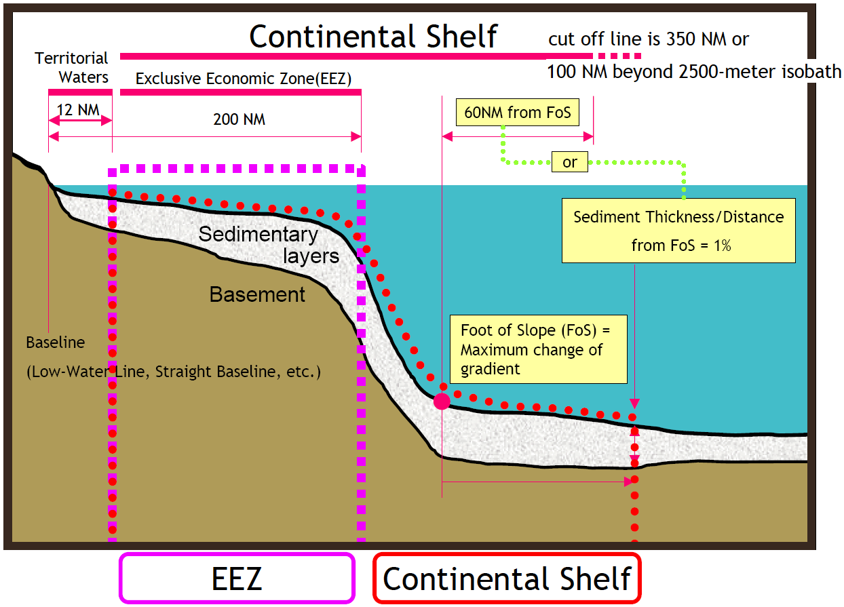

*Source:* Japan Oceanographic Data Center

## IV. Extended Continental Shelf

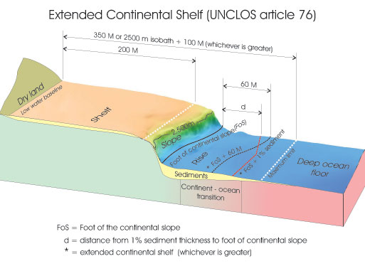

*Source:* GNS Science

## V. EEZ

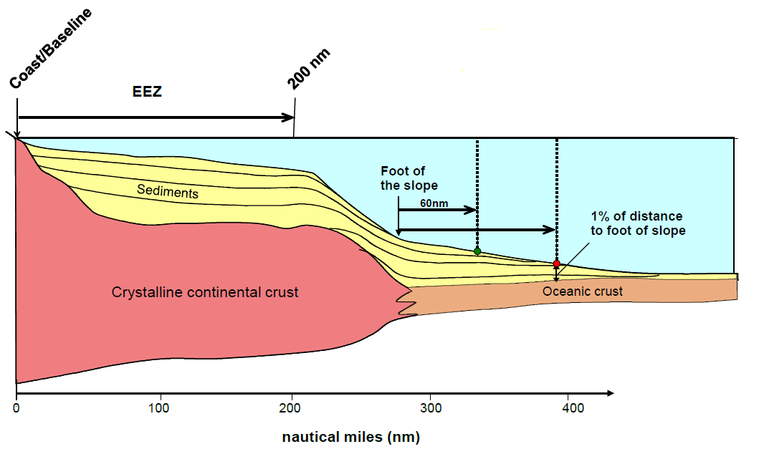

*Source:* Brian van Pay: national maritime claims in the Arctic

## VI. Northwest Passage / Northern Sea Route

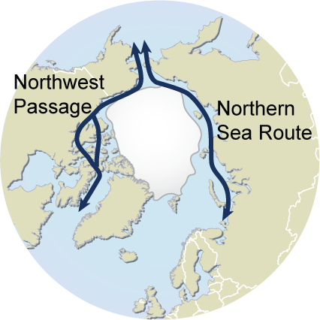

*Source:* Eating Jellyfish

## VII. Lomonosov Ridge / Mendeleev Ridge / Alpha Ridge / Gakkel Ridge

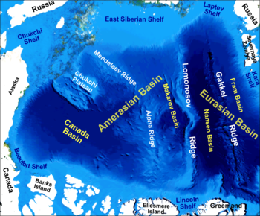

*Source:* Wikimedia Commons

## VIII. Norwegian claim: Loop Hole / Western Nansen Basin / Banana Hole

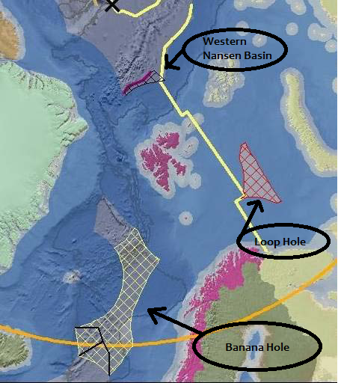

*Source:* Brian van Pay: national maritime claims in the Arctic

## IX. Jan Mayen Island

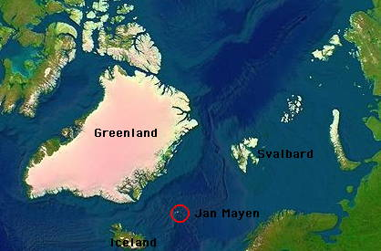

*Source:* My Opera: Ole Nielsen