Andrei Motoc
12025747
ES3-3C

Energy Security in Romania
What are the political and economic implications of the search for energy security in Romania?

-The Hague University of Applied Sciences-
-Academy of European Studies-

May- June 2015

Supervised by: Rebekah Tromble
Second Reader: MJ. Weijerman

Executive Summary

The role of the 21st century energy sector has developed into being essential for the drafting of the national security strategies of the world’s nations. Hence, the states develop particular approaches and strategies in order to attain energy security. Furthermore, those particular actions, undertaken by the states, have deep political and economic implications. Because of its unique mix of energy resources, and its status as a rising regional power, Romania served as the case study for this research. Consequently, the main research question of the paper was: “What are the political and economic implications of the search for energy security in Romania?”
Furthermore, a plethora of energy security classifications were analysed, with the aim of producing a standardized energy security definition. Hence, the concepts analysed in the research were delimited by clearly stated boundaries. Therefore, the definition advanced, regards energy security as: the availability associated with the continuous and sustainable accessibility of energy resources, used in an economically efficient manner. Moreover, the paper demonstrates that despite the EU’s best efforts, an EU-wide common approach in the area of energy security is still absent. That is mainly due to the Member States’ different patterns of energy consumption, production and needs, which ultimately, have to be addressed distinctively.
An assessment of the national energy sector in its entire complexity in Romania is given. Hence, the implications of the search for energy security in Romania were pointed out, answering the main research question. It was reiterated that the political and economic implications cannot be differentiated, as the two dimensions are inextricably linked in the area of energy and energy security. The implications observed, indicated that Romania, in its search for energy security, chooses to rely more intensely on TNCs and their investments, thus being more susceptible to foreign interests. Furthermore, the country is currently undergoing a political and economic reorientation towards the Caspian region, as a result of the high political risk and price volatility of the energy imports from Russia. Lastly, an implication of Romania’s search for energy security, indicates that the country is currently pushing towards the goal of becoming a regional energy exporter. On the basis of the observed implications, a concise list of recommendations was produced. Hence, in its search for energy security, Romania should be an advocate for the materialization of the EU energy union, should focus on addressing its urgent need for investments in the national energy sector and should focus its investments on renewable energy resources.

Table of Contents

1. Executive Summary ii
2. Table of Contents iii
3. Acronyms iv
4. Introduction 1
5. Literature Review 3
5.1 Conceptualizing energy security 3
5.2 Main energy resources 5
5.3 The prospects of an EU common approach to energy security 7
6. Methodology 11
7. Case Study: Romania 12
7.1 Assessment of the Romanian energy sector 12
7.1.1 Oil 12
7.1.2 Natural Gas 14
7.1.3 Coal 16
7.1.4 Nuclear Energy 17
7.1.5 Renewable Energy Resources 18
7.2 Assessment 20
8. Analysis 23
8.1 Non-state actors involved in Romania’s attempt of attaining energy security 23
8.2 Romania’s actions in the international community 25
9. Conclusion 30
10. Recommendations 32
11. References 34
Appendices i
1. Student Ethics Form
2. Informed Consent Form
3. Interview Transcript

Acronyms

AGRI Azerbaijan Georgia Romania interconnector
ARD Asociaţia România Dreaptă (Right Romania Association)
CEE Central and Eastern Europe
EC European Commission
EIA Energy Information Administration
EU European Union
EUR Euros (currency)
LNG Liquefied natural gas
MS Member State
NG Natural gas
NGO Non-governmental Organization
T Ton
TFEU Treaty on the Functioning of the European Union
TNC Transnational Corporation
Toe Tons of oil equivalent
TWh Terawatt hour
RO-BG-EL Romania-Bulgaria-Greece
US United States

Introduction

With every year that passes, the planetary energy resources are being depleted, while their significance increases drastically (Anderson, 2012). The role of the 21st century energy sector stretches far beyond its traditional economic realm, and grows into being an intrinsic part of the national security strategies of the world’s nations (Pacuraru, 2013). Hence, the pursuit of acquiring energy security has deep political and economic implications. The present paper aims to discover how the political and economic behavior of a particular state changes, in relation to the actions undertaken in order to achieve energy security. The effectiveness of those actions, policies or strategies and most importantly their political and economic implications will be analyzed in this paper. Because of its unique mix of energy resources, historical ties to both Western and Eastern sides of the world, and its status as a rising regional power, Romania will serve as the case study for this research.
The research commences with the literature review section, providing the background information necessary for answering the main research question, which is: “What are the political and economic implications of the search for energy security, in Romania?” The different concepts and definitions of energy security will be taken into account, and for the purpose of not getting diverted from the main research goal, the essay will settle on a single, standardized definition that will serve as a basis for the further analysis. Furthermore, an analysis of the different sources of energy used, together with their advantages and drawbacks will be provided. Perhaps the most important goal to be achieved in the literature review section is the need of demonstrating whether European Union Member States (MS) find themselves in the position of having an EU coordinated and common approach to energy security. Thereupon answering this preliminary fundamental question, the focus will be shifted back to the central issue of the research, namely, the Romania case study. Furthermore, the case study section will provide an analysis of the status of the Romanian energy sector, in all its complexity. Accordingly, the main research question will be then approached, with the aim of discovering the implications of Romania’s strategies, policies and actions, undertaken in its pursuit of achieving energy security. As expected, Romania being an EU MS, the strategies, policies and overall actions of the EU will be considered in the essay. However, this specific analysis will be a brief one, and will bear the sole purpose of emphasizing Romania’s own and particular responses in the quest to achieving energy security. The following section, the Analysis, will build upon the findings of the section dedicated to the case study of Romania, and will provide a more conclusive approach, by focusing entirely on the economic and political implications of Romania’s search for energy security. The paper will then aim to produce a concise list of Recommendations that normatively, should lead to an improvement of Romania’s energy security status, as well as its political and economic leverage power. Following, the last chapter, namely the Conclusion will summarize all the findings presented in the previous sections and will provide a definitive answer to the main research question,: “What are the political and economic implications of the search for energy security, in Romania?”

Literature Review

Conceptualizing energy security

As energy dependence increases, so does people’s expectations of having secure and continuous access to electricity for their homes, gas for heating and petrol at the pumps (European Commission A, 2014, p. 3). This brings into the discussion the concept of energy security, and perhaps more importantly how it should be defined. To begin with, it is of paramount importance to state that a standardized definition of the entire field of energy security would be neither feasible nor desirable. It would not be feasible, simply because depending on one’s specific needs, interests and empirical evidence, the concept of energy security can fluctuate. Hence, countries that rely heavily on imports will try to define the concept of energy security through the need of diversifying their supplies while keeping the prices low, whereas the exporter’s concept of security will reside in a constant demand for their resources, and upsurges in prices (Sovacool & Saunders, 2014, p. 645). Moreover, for a transit country, energy security will be defined merely through combating competition and ensuring a continuous flow of energy through the national distribution systems (Sovacool & Saunders, 2014, p. 645). Therefore, trying to produce a universal and standardized definition of energy security, would inevitably lead to the omission of characteristics or components that for some actors could be of utmost importance, thus making this endeavor not desirable.
The existing literature has the tendency of conceptualizing energy security mainly through either an economic lens, or a political one. From the economic point of view, energy security can only be defined through market terms, for it is in itself a result of the liberalization of energy markets; thus an outcome of the market (Chester, 2010, p. 889). Accordingly, it is defined primarily in relation to demand, supply (availability) and price (Chester, 2010, p. 889). Moreover, the market-centric definitions place energy security as one of the most important factors in the overall stability and wellbeing of the economy. Hence, the definition proposed by Bohi and Toman posits that energy insecurity is “the loss of economic welfare that may occur as a result of a change in the price or availability of energy” (Bohi & Toman, 1996, p. 1). Furthermore, the market-centric definitions emphasize the idea of energy security by means of a continued physical supply. The rationale behind this emphasis suggests that if the security of supply is being threatened, the organic response will be an increase in prices (Scheepers & Seebregts, 2006, p. 19). Consequently, this situation will lead to a loss of economic welfare, and ultimately back to Bohi and Toman’s aforementioned definition of energy insecurity. Similarly, Le Coq and Paltseva see supply security as “continuous availability of energy at affordable prices” (Coq & Paltseva, 2009, p. 2).
However, given its strategic perspective, the political standpoint regarding energy security builds upon the market-centric definitions, adding an emphasis on the actual struggle of ensuring security of supply. Therefore, security of supply represents the delivery of a stable supply of energy needs, ‘’regardless of the circumstances’’ (Mulder, Cate, & Zwart, 2007, p. 39). In this context, the locution: “regardless of the circumstance” is simply an attempt to bring forward the idea of risks. A security of supply risk is any shortage or mismatch in the actual supply and demand of a market (Scheepers & Seebregts, 2006, p. 19). So, from a political perspective, energy security is perceived just as the effort to mitigate any risk, be it through a reduction of energy dependence to other states, or through diversifying and improving the internal energy mix. Likewise, Lieb-Dóczy posits: “security of supply is fundamentally about risk. More secure systems are those with lower risk of interruption” (Lieb-Dóczy, Börner, & MacKerron, 2003, p. 11). This translates into the obligation of the political sphere (governments or other political executive bodies) of achieving a system as secure as possible, and to provide a “continuous uninterrupted availability of energy at the consumer’s site” (Scheepers & Seebregts, 2006, p. 19)
As expressed earlier in this paper, the attempt of drafting a single definition for the entire field of energy security, simply is undesirable. However, when the focus is shifted to specific environments and circumstances, a single definition is not only required, but fundamental. This way, all the concepts that are to be analyzed further in this research will be delimited by clearly stated boundaries and as such aiding the process of answering the main research question as accurately as possible. Consequently, energy security will be conceptualized into a single definition that will be regarded as the standard throughout the rest of the paper.
To begin with, the concept of availability will be at the heart of this definition. Availability takes into account not only the existence, but also the need of having a diversified pool of energy resources. Naturally, the more and diversified the resources are, the smaller will be the risks of experiencing shortages of energy and ultimately energy insecurity. However, a rich and diversified pool of resource will become largely redundant if the state does not hold the proper financial and technological resources of exploiting them. This is where the principle of accessibility is applicable. Furthermore, if the state benefits from the capacity of exploiting those energy resources, it is essential to do it in a continuous, environmentally sustainable, and efficient manner. Finally, the absolute goal of any energy security strategy will be the achievement of energy independence. If a state manages to attain that level of energy security, massive benefits will be brought to the wellbeing of the economy.
Therefore, for the rest of this paper energy security will be regarded as the: availability associated with the continuous and sustainable accessibility of energy resources, used in an economically efficient manner.

Main energy resources

As presented earlier, perhaps the most important characteristic of the proposed energy security definition, is the concept of availability of energy resources. The following section will build upon that by providing a brief overview of the relevant energy resources, which are to be considered in this paper. Furthermore, this section will provide the necessary theoretical foundation for the assessment of Romania’s energy sector, which will be undertaken later in this research. The energy resources to be analyzed are: oil, natural gas (NG), coal, nuclear, and renewable energy.
Oil has been, since the beginning of the 20th century and to this day, the global primary energy resource (Chester, 2010, p. 888). The reasons behind its importance, have been its widespread availability and its characteristics that make it easily transportable. Furthermore, from a historical perspective, is was relatively cheap, the price of a barrel ranging anywhere from 25 to 35 US dollars (Sovacool & Saunders, 2014, p. 643). However, much of this has changed. Being a finite resource that is heavily exploited, its supplies face imminent depletion. Moreover, the rich supplies whose depletion are not that immediate, are located in regions of notorious political and economic instability (Sovacool & Saunders, 2014, p. 643). Oil’s many uses (ranging from the production of electricity to transport), have led to the existence of a well-organized and extensive infrastructure (Sovacool & Saunders, 2014, p. 643). Consequently, oil is sustainable from an economic point of view, as the preliminary costs of initiating the system have been already amortized. However, from an environmental point of view, the sustainability of oil is one of its prime weaknesses. Oil has been scientifically linked to the greenhouse effect, and oil spills have been recurring disasters in the last decades (Sovacool & Saunders, 2014, p. 643). Returning to the prices aspect, oil has faced a price volatility never witnessed before. If in 2008 a barrel of oil was priced at a historic record of 135 US dollars, in April 2015 it was valued at 51 US dollars (NASDAQ, 2015). As unnatural as this drop in price might seem (considering that it is a finite resource and logically its value should increase), there is a quite simple explanation to this phenomenon. Namely, oil is losing its importance and its share of the global fuels consumption. Its loss is in the favor of new emerging energy resources such as: shale gas, biomass and other renewable resources. To be more specific, in 2010 oil held a global fuel share of 31.9 percent, but it is expected to decrease to 24.3 in 2040 (OPEC, 2014, p. 8)
Moving on, Natural Gas accounts for approximately 25 percent of the total global energy consumption (Chester, 2010, p. 888). Thus, making it (together with oil) one of the energy resources that holds the most strategic importance. It has a wide availability across the globe and it is relatively cheap. Furthermore, the many uses of NG, from electricity to heating (40% of consumption in the EU is represented by the residential sector) increase its importance (European Commission B, 2014). However, the majority of resources are concentrated only in a small number of states. Similarly to oil, those regions are, unfortunately, some of the most politically unstable in the world (Sovacool & Saunders, 2014, p. 643). Moreover, where oil trade routes or partners can be more volatile and easier to change, gas distribution systems are fixed. Therefore, in the case of NG, transport routes are almost entirely determined by the existing pipeline network (European Commission B, 2014). This way, the exporting countries have a much greater leverage power on those who are buying the NG. Regarding the environmental side of the problem, NG is an important source of greenhouse gas emissions (Sovacool & Saunders, 2014, p. 643). Moreover, the exploitation of particular types of NG, such as shale gas is believed to be responsible for heavy negative impacts on the environment.
Coal remains one of the most important energy resources used for producing electricity. The main motives behind its widespread use are its large global reserves and consequently, its relatively low price. However, even if coal resources are amongst the largest energy resources in the world, coal faces a rapid depletion rate. To be more precise, the coal proved reserves witnessed a decline of approximately 10 percent every decade, since 1993 (BP, 2014, p. 31). Historically, coal and the entire industry revolving around it were amongst the largest sector of employment (Sovacool & Saunders, 2014, p. 643). Nowadays, its use and status face a constant decline, mainly due to the most significant disadvantage of coal; namely, the devastating environmental impact that coal produces. It has been scientifically linked to severe health problems, air pollution and it is seen as a key threat to global warming (Sovacool & Saunders, 2014, p. 643).
Nuclear power is perhaps the most controversial means of producing energy. It has undergone a fascinating history, from being a symbol of power in its inception years, to a sustainable alternative to traditional energy resources for the better part of the last decades, and more recently, being perceived as a security concern. Even though nuclear power is the result of a series of high end technological processes, its foundation is represented by natural resources. Specifically, the presence of a very heavy metal, called Uranium is essential to producing nuclear energy. Nowadays, there are currently over 435 nuclear power reactors in the world, producing approximately 11% of the global electricity production (World Nuclear Association, 2015). Normatively speaking, nuclear energy is the most cost efficient means of producing energy; even though the initial costs of constructing a power plant are considerable, once it is functioning and producing energy, it becomes exceptionally profitable (Sovacool & Saunders, 2014, p. 643). However, nuclear power plants are quite prone to cost overruns due to frequent complications (Sovacool & Saunders, 2014, p. 643). This leads to another disadvantage, namely, its constant need for a high level technical expertise (Sovacool & Saunders, 2014, p. 643). During the last years’ discussions regarding climate change issues and environmental sustainability, nuclear energy has made its comeback as a prospective alternative to the heavily polluting resources, such as coal and oil. However, its promise of low-carbon emissions can be trampled by the risk of disasters such as the most recent one, of Fukushima, which can scar the environment for centuries. Nonetheless, environmental disasters have been a trademark of other energy resources, such as oil, with its more frequent oil spills. In the long run, nuclear power is the most potent method of producing energy, bearing the promise of an easier path towards energy independency.
Renewable energy is a wider term used to refer to a series of alternative energy resources such as: hydropower, biomass, biofuels, wind power, solar energy and geothermal energy. Having the prospective of avoiding the environmental disadvantages brought by other conventional resources, as well as benefiting from the support of new emerging technologies, renewable energy is gaining more and more importance (REN 21, 2014). As a key advantage, the renewable energy sector encompasses a wide variety of potential energy resources, that any nation has, and can exploit (Sovacool & Saunders, 2014, p. 643). However, a full reliance on renewable energy might be problematic. That is due to the fact that a constant supply can often be uncertain (when it comes to wind power for example). Nonetheless, the renewable energy sector has seen a rapid increase, accounting to almost 19 percent of the global final energy consumption (REN 21, 2014). Furthermore, renewable energy resources are seen as the way forward, and their use has been already integrated in many policy packages around the world.

The prospects of an EU common approach to energy security

The absolute aim of the present paper is to offer answers to the central research question, specifically: “what are the economic and political implications of the search for energy security in Romania”. However, in order to reach this goal, several issues must be addressed beforehand. Given the fact that the paper concentrates on the particular efforts of Romania to achieve energy security, it is of the highest relevance to analyse to what extent the country acts in accordance with an EU guideline or with its own, individual interests. The European Union has made tremendous progress throughout its history, in converging unalike MS interests into one overarching approach. As a result, the EU benefits nowadays from an internal market, common legislation (acquis communautaire) and for the majority of the MS, a common currency. This chapter will analyse whether this type of EU-wide common approach is applicable in the area of energy and energy security. Moreover, the feasibility and potential benefits of this approach will be studied.
The Treaty on the Functioning of the European Union (TFEU), clearly sets out the three different categories of Union competence. These directly correspond to the degree of the Union’s power to unilaterally legislate and adopt legally binding acts. Therefore, the three areas of Union competence are: exclusive competences (only the Union has the power to legislate), shared competences, and the support and coordination competences. Whether the EU exercises an exclusive competence in areas such as: customs union or competition rules, and only a role of support in domains such as: culture or tourism, the area of energy policy is part of the shared competences category (TFEU, 2012). This means that in the shared competences area, the MS have the liberty of acting to their liking, only as long as the EU clearly expresses its intent of not intervening (EU, 2015). If the EU decides to intervene, the particular area turns into a de facto exclusive competence. Moreover, Article 194 of the TFEU noticeably requires that:
“… Union policy on energy shall aim, in a spirit of solidarity between Member States, to: Ensure the functioning of the energy market; Ensure security of energy supply in the Union; Promote energy efficiency and energy saving and the development of new and renewable forms of energy; and Promote the interconnection of energy networks. (TFEU, 2012)”
Consequently, the inclusion of the area of energy policy in the category of shared competences, might be seen as a clear attempt of expanding Union’s prerogatives, and reserving a strong choice for a common response to energy issues. Hence, this inclusion, corroborated with the framework expressed in Article 194, could make one think that, at least in a theoretical manner, the Union does have a common approach in the area on energy and energy security. Even though, the Union does have shared competences in the area of energy, and moreover, if it decides to act on it, transforming it into an exclusive competence, it faces a massive limitation. To be precise, the fact that the European Commission’s (EC) role mostly resumes to the capability of proposing legislation (Pakalkaite, 2014, p. 3). Consequently, the legislation must go past the European Parliament and the Council, where the MS hold the power. This means that even if the Union (through the EC) would want to pursue a homogenous approach to energy security, and the MS would chose to do the contrary (and follow the national interest first), any such attempts of having a common approach would come to a halt. The before mentioned rationale could be one of the precise reasons explaining the lack of an EU-wide common approach to energy security so far.
Furthermore, as the map below indicates, EU MS have different degrees of energy dependence to foreign imports. Likewise, MS have different energy mixes. Whether, for example, France produces almost entirely nuclear (80.9%) and renewable energy (17.1%), the Netherlands’ energy production is dominated by natural gas (88.7%) (EUROSTAT, 2015).
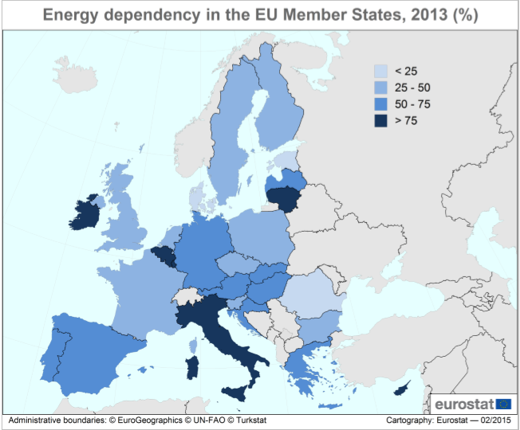

(EUROSTAT, 2015)
In other words, MS have specific patterns of energy consumption and production, and ultimately different needs. Consequently, these different needs have to be addressed through different approaches. At the present moment, the EU MS chose to address their issues, in almost every situation, through following their own national interests. On rare occasions, regional groupings form and choose to collaborate, and almost never they decide to unite on an EU-wide level. Accordingly, since the beginning of the Crimean crisis, a surge in MS’ divergent behaviour was observed. This way, despite the EU sanctions imposed on Russia, Greece renewed its natural gas deal with the Russian Federation, pursuing their own national interests (Chrysopoulos, 2015). Similarly, Hungary concluded its negotiations with Russia concerning a massive investment from the latter in two nuclear reactors that are to be built in the proximity of Budapest (InCont B, 2015). Worryingly, Hungary also passed a series of national laws that allows it to indulge in different energy security related infrastructure plans without the need of even consulting the EU and the other MS (Mediafax, 2014). Additionally, the Russian Federation made strong partnerships with Germany in the North Stream project and with Italy in the South Stream project (Pacuraru, 2013). What all the aforementioned cases have in common, is a strong self-centredness demonstrated by the MS, and their tendencies of pursuing only their own interests. Hence, these differences between MS, and their unalike strategies, can be seen as prime causes in the lack of an EU common approach in the area of energy security.
However, the last two years have seen an intensification of the EU’s efforts of developing such a common approach. It started with president Barroso’s statement, positing that “on energy security, Europe must speak and act as one” (EC, 2014). The President of the European Council, Donald Tusk and the new EC president, Jean-Claude Junker have managed to put forward a comprehensive plan for an energy union. The plan takes into account the fact that the EU is the world’s largest energy importer, and a big part of its MS are fully dependent on energy imports. The rationale offered, suggests that as long as a MS is weak in the face of energy security threats, the entire Union will become weak. This way, a better interconnectivity between MS, an emphasis on energy efficiency and renewable resources, and most importantly a bigger political leverage power, are seen as the only way forward for the EU. The idea of an energy Union seems to be the natural move towards a more secure European Union. Even though the MS show a strong support for this plan, the biggest test will be the moment when they actually have to give up some of their prerogatives. For example, the negotiation of prices for natural gas or oil will be done only at a Union level (Pătru, 2015). As Bogdan Pătru suggests, it is an ambitious plan that certainly will strengthen EU’s status in the area of energy security (Pătru, 2015).
This section has shown that despite the existing legislative framework laid out in the TFEU, the EU lacks the capacity of having a common approach in the area of common security. This is mainly because of the different needs of the MS and their tendency of pursuing strictly their national interests. However, the future promises an EU common energy approach and energy market. As long as the national needs, and energy mixes will be taken into account will full respect (as the President of Romania, Klaus Iohannis desired during the negotiations), the plan should prove a success (EVZ, 2015). However, for the moment the MS still find themselves in the impossibility of having a common approach. This will serve as a premise, for analysing Romania’s individual political and economic behaviours and implications resulted from its search for energy security.

Methodology

The objective of the present paper was to answer the central research question, namely: “what are the economic and political implications of the search for energy security of Romania?”, together with all its afferent sub-questions. In the pursuit of achieving this objective the use of both primary and secondary research has been made.
The dynamic character of the interview research method, enabled the extraction of information, directly from the people with a great expertise in the area of energy and energy security. It has also offered the opportunity of discovering information which otherwise would not be accessible through the more common methods, such as desk research. The interviewee chosen for this research was Mr. Bogdan Pătru. His career background as both an energy market consultant, and as an adviser to the Administration of the President of Romania, was highly compatible with the needs of the research. Specifically, the need of emphasizing the implications derived from Romania’s effort of achieving energy security. Hence, Mr. Pătru’s professional experience in the area of energy policy and government affairs has proved to be of utmost relevance to the outcomes of the research.
Complementary to the primary research, the desk research method was employed extensively. By using this method, general information concerning all the sub-questions of the paper was obtained. An effort was undertaken to use citations as recent as possible, yet, without making any compromises in regard to their reliability. This strategy was most dominant in the Analysis section, thus conferring the paper the topicality needed to approach the issue of energy security. Nonetheless, in certain sections of the paper (such as the one dedicated to the conceptualization of energy security) the most acclaimed and relevant references, happened to be dated before the year 2000. The main research resources used in this paper were the academic journals, for their well-established core information and their reliability, and news articles, given the fact that the answer to the central question is dependent on the outcomes of the global events in the area of energy security. Moreover, books, reports, memos, news releases and conferences recordings were further used in this paper.
Furthermore, the present paper has placed the utmost importance on fully respecting the research ethics. Consequently the interviewees were informed that their interventions were to be included in this research. Moreover, the interviewees expressed their willingness of associating their names with their interventions, through the inform consent form.

Case Study: Romania

The purpose of the present research is to discover and analyze the political and economic implications derived from Romania’s search for energy security. Whether the previous chapters have offered an insight into the theoretical foundations of energy security, this particular section will be precisely aimed at providing, an overview and assessment of the Romanian energy sector. This way, Romania’s genuine capacity, needs and leverage power in the international sphere will be better understood.

Assessment of the Romanian energy sector

Oil
Romania is one of the global pioneers in the area of extractive industries (PROTV A, 2015). In 1857 it managed to be the first country in the world that officially registered an oil production, extracting 275 tons of oil (PROTV A, 2015). It was seconded by the US in 1859 with a production of 274 tons (PROTV A, 2015). Moreover, Romania was the first country in the world to ever build a refinery, and the first country that was home to a completely oil-lamp illuminated city (Bucharest) (PROTV A, 2015).
Nowadays, Romania’s oil reserves are rather limited, accounting to approximately 2 billion tones (Government of Romania, 2015, p. 9). Worryingly, the last decades’ resource discoveries have only shown small reserves with no real prospects of drastically improving Romania’s oil production.
Romanian national consumption, production and import of oil
Year | 2005 | 2006 | 2007 | 2008 | 2009 | 2010 | 2011 | 2012 | 2013
Consumption | 14 088 | 13 467 | 13 072 | 12 917 | 11 294 | 10 021 | 9 527 | 9 119 | 9 283
Production | 5 215 | 4 791 | 4 541 | 4 500 | 4 400 | 4 200 | 4 075 | 3 991 | 3 984
Import | 8 873 | 8 676 | 8 531 | 8 417 | 6 894 | 5 821 | 5 452 | 5 128 | 5 299
*Units: Thousands of Tones
Data retrieved from the National Institute of Statistics of Romania (INS, 2015)

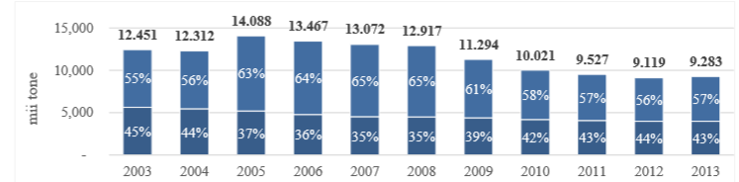
Ratio national production- imports of Oil
-National Production
-Imports
(Government of Romania, 2015, p. 10)

What can be observed from the preceding charts is that Romania’s oil production is slowly, but surely declining. That is mainly due to the fact that the resource basins are rapidly maturing. As the CEO of Petrom, Ms. Mariana Gheorghe stated, the country can expect drops in production up to 10 percent yearly, in the near future (PROTV A, 2015). Petrom is one of Europe’s largest companies operating in the energy sectors, and of utmost strategic importance for Romania (the government holds approximately 20 percent of the total shares (PROTV A, 2015). At the same time, one could argue that a decrease in oil production is still healthy, given the fact that the national oil consumption dropped as well. However, there is still a considerable gap between the amount of oil consumed and the amount of oil Romania internally produces. The rest has to be filled in by oil imports. Furthermore, as long as imports are necessary, energy security is still only an ambition for Romania. Moreover, another great issue regarding the decrease of consumption, is that it is strongly linked to a decrease in the industrial activity (Pătru, 2015). In other words, the consumption did not decrease as a result of energy efficiency, but as a result of poor economic outcomes.
Nonetheless, Romania still is EU’s 4th largest oil producer, accounting for more than 6% of its total production (Government of Romania, 2015, p. 10). Moreover, regarding the infrastructure, Romania, in theory, has the greatest refinery capacity in the entire Central and East Europe Region (CEE) (Government of Romania, 2015, p. 10). Despite its impressive infrastructure, Romania suffers a constant decline when it comes to its oil production. Part of this problem is caused by natural factors, namely the aging of the resource pools, and part because of the lack of investments in this specific sector. Nonetheless, all the problems can be addressed, even the resources replenished with the use of modern technologies.

Natural Gas

Romania benefits from one of the largest NG reserves in the CEE, having an excess of 615 billion cubic meters of NG geological resources at its disposal (Government of Romania, 2015, p. 16). Despite its large resource basins, Romania does not manage to have a sufficiently high level of annual production. This means that, as the charts below presents, Romania is not able to fulfil its yearly consumption levels. Part of this problem, similar to the case of Oil, is represented by the lack of investments in adequate technologies (Government of Romania, 2015, p. 16). What is even more problematic, is that at the current rate of extraction, which is approximately 11 billion cubic meters of NG per year, Romania’s existing NG reserves could be completely depleted in less than 14 years (Government of Romania, 2015, p. 16). The annual decline as well as replenishing rates of the existing reserves have been taken into account for the before mentioned forecast.
Year | 2009 | 2010 | 2011 | 2012 | 2013
Consumption | 140,1 | 146,8 | 150,6 | 144,7 | 132,5
Production | 119 | 121,84 | 112,95 | 109,97 | 112,71
Import | 21,1 | 24,95 | 37,65 | 34,73 | 19,89
Romanian national consumption, production and import of NG
*Units: Terawatt-hour (TWh)
Data retrieved from the National Institute of Statistics of Romania (INS, 2015)

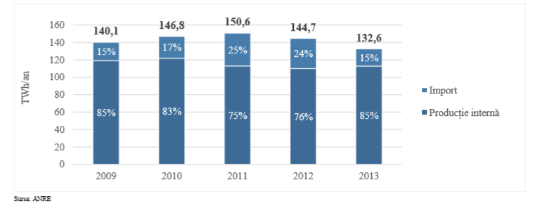
Ratio NG Import-Internal Production
Imports
Internal Production
(Government of Romania, 2015, p. 19)
Nonetheless, heavy investments aimed towards replenishing the already existing basins, and explorations towards finding new ones, could drastically improve Romania’s situation. In this respect, 2012 was a year of great hope for Romania. Exploratory missions intensified in Romania’s territorial seas of the Black Sea. In the Neptun perimeter (SE of Romania) a new NG basin was discovered, containing anywhere between 446-893 TWh (Government of Romania, 2015, p. 17). This could mean an increase of between 40% and 80% of Romania’s NG reserves, and a 60% increase in the country’s annual production (Government of Romania, 2015, p. 17). However, due to the complexity of the exploration procedure, extraction will not start until the beginning of 2019 (Government of Romania, 2015, p. 17). Even more promising, this is just one out of the many resource basins proved to exist in Romania’s territory of the Black Sea. It is estimated that the overall Black Sea reserves could allow Romania to extract up to 6.5 billion cubic meters of NG per year (PROTV, 2013). This means that the resources from the Black Sea alone, would cover half of annual the internal consumption. Furthermore, as mentioned earlier in the charts, the internal consumption is covered in a proportion of 85% from the existing onshore reserves. Consequently, the Black Sea reserves alone, once they will be extracted (from 2019 onwards), will transform Romania in a NG exporting power.
More recently, in January 2015, Romgaz (Romanian NG Company that is 70% controlled by the government) made another discovery. Yearly, up to 1.6 TWh will be extracted from this particular reserve, found in the Eastern part of Romania (InCont C, 2015). Even though the basin is not massive, it furthermore emphasizes the idea that investments in the area of exploratory technologies could decisively aid Romania.
Moreover, Romania holds a massive advantage in the area of alternative NG, namely shale gas. According to the Energy Information Administration’s 2013 report, it is assumed that Romania’s territory is home to Europe’s third largest shale gas reserves (EIA, 2013). The estimated potential amounts to 14.882 TWh of exploitable resources (Government of Romania, 2015, p. 17). In other words, this alone could cover Romania’s consumption (at the 2013 level) for over 100 years. However, popular unrest and intense NGO activity have already hindered the prospects of intense exploitation of shale gas on Romanian territories, which is to be discussed later in this paper.
Hence, NG is Romania’s key energy subsector. With further investments in exploratory technologies and infrastructure, it will certainly become Romania’s most profitable industry. As presented in this subsection, Romania needs only a small upsurge in energy production to become independent to its predominantly Russian imports, when it comes to NG. Taking into consideration that from 2019 onwards massive new basins will become available for exploitation, Romania’s future as a NG exporter seems certain.

Coal

Romania has immense amounts of coal at its disposal. Annual production reaches values of 33 million tons/year (Government of Romania, 2015, p. 31). At the same time, the internal consumption does not exceed the 23 million tons per year value (Government of Romania, 2015, p. 31). In other words, Romania has an overproduction of approximately 10 t per year (Government of Romania, 2015, p. 31). This overproduction is happening despite a massive decrease of production that started from the year 2012 onwards (Government of Romania, 2015, p. 31). Nonetheless, Romania would not be able to export its overproduction, mainly because of the extremely poor quality of the resources found within its borders (Government of Romania, 2015, p. 35).
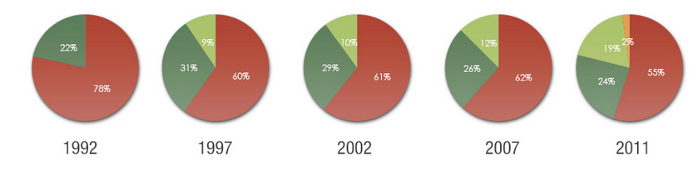
Breakdown of the electricity production of Romania
Thermo-electric power station electricity (SmartLink, 2014)
Aeolian-electric power station electricity
Nuclear power plant electricity
Hydro-electric power station electricity

As the chart above presents, since 1992, the use of Thermo-electric produced electricity, whose primary resource is coal, has plummeted. The poor caloric value of the reserves, combined with the immense cost of exploiting them with the existing out-dated technologies, have been prime motives in its decline. Moreover, the EU policies have played an important role in the demise of the heavily polluting resources such as coal, and in the promotion of renewable energy resources.

Nuclear Energy

Romania benefits from being one of the relatively few countries in the world that are able to undertake a full nuclear fuel cycle (Government of Romania, 2015, p. 37). Meaning, that from the stage of extracting the uranium ore, to the stage of producing electricity out of nuclear fuel, Romania does not have to involve any external factors. Romania currently has two entirely functional nuclear reactors, accounting for approximately 19% of the total energy produced (SmartLink, 2014). Romania is also well on the way of finalizing reactor 3 and 4 of the Cernavoda Nuclear Plant. However, the existing uranium ore reserves would not be sufficient for running all the four reactors concomitantly (Government of Romania, 2015, p. 37). Moreover, the existing resource basin has been heavily exploited in the past 26 years, and it is close to being depleted (Government of Romania, 2015, p. 37). Hence, this is why Romania is not an exporter of uranium ore. Correspondingly, Romania does not import uranium (Government of Romania, 2015, p. 38).
Therefore, Romania affords to find itself in this sort of equilibrium. The existing resources provide a sufficient amount of uranium to ensure a large share of the electricity production, alone. At the same time, given the fact the uranium ore is close to depletion, export is not an option, as well as it is not an option to start the two new reactors. Furthermore, nuclear-produced electricity can be regarded as a “bonus”. That is because Romania would be able to ensure its electricity independence from other resources (such as coal) even if nuclear energy ceases to be an option.

Renewable Energy Resources

Renewable resources are currently quite underdeveloped in Romania, although the country holds a significant energy potential in this area (Government of Romania, 2015, p. 42). Even though, out of the renewable resources presented in this sub section, Aeolian energy is perhaps already the most developed, Biomass holds alone more than 50% of the total energy potential (Government of Romania, 2015, p. 42).
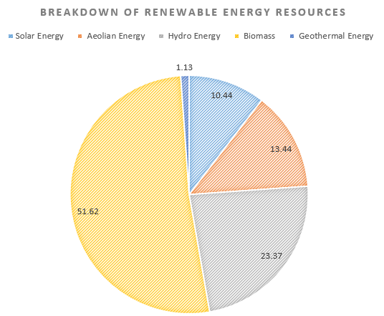

Data retrieved from: (Government of Romania, 2015, p. 42)
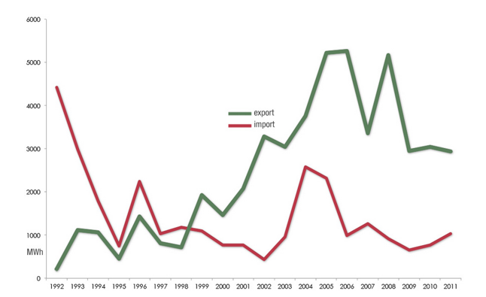
Romanian national import and export of electricity
(SmartLink, 2014)

As the graph above presents, Romania has been since 1999, an electricity net exporter (SmartLink, 2014). This means that it has produced and exported more electricity than it has imported and consumed. What is certain is that the potential of the renewable resources will further stabilize Romania in this status, of an energy exporter. Still, renewable energy resources in Romania, face the same major limitation, coming as a recurring theme; namely, the lack of investments in modern technologies, which sabotage the immense potential they hold. Nonetheless, this area of the energy sector is certain to expand in the future, as the EU heavily advocates for the use of renewable energy, through its 20-20-20 plan, which will be discussed later in this paper.

Assessment

As presented in the sections above, Romania is truly blessed with an abundance of resources. It has at its disposal resources that range from oil, natural gas, uranium ore, coal, and renewable resources. Despite its privileged positon, the country continues to be an overall net energy importer.

Total value of national energy consumption and production
Year | 2008 | 2009 | 2010 | 2011 | 2012 | 2013
Consumption | 39.799 | 34.328 | 34.817 | 35.648 | 34.851 | 32.634
Production | 28.861 | 28.034 | 27.428 | 27.478 | 27.112 | 25.853

*Units: Tons of oil equivalent (Toe)
Data retrieved from the National Institute of Statistics of Romania (INS, 2015)

Total value of energy imports and exports
Year | 2008 | 2009 | 2010 | 2011 | 2012 | 2013
Imports | 16.234 | 11.235 | 11.239 | 11.570 | 11.616 | 9.993
Exports | 5.565 | 4.600 | 3.992 | 4.124 | 3.620 | 4.203
*Units: Tons of oil equivalent (Toe)
Data retrieved from the National Institute of Statistics of Romania (INS, 2015)
As determined beforehand, the most important factor for Romania’s dependence status, is its constant incapacity of channelling investments into its energy sector. Although the past five years have seen a constant increase in investments, especially in renewable energy resources (where more than six billion euros were attracted), this is simply not enough (Government of Romania, 2015, p. 77). The latest draft version of the Romanian energy strategy report, estimated that investments of more than 100 billion EUR are needed (Government of Romania, 2015, p. 80). On one hand, investments aimed at improving the exploratory and exploitation technologies are needed. This way, newer resources basins can be discovered, and the already existing ones’ life can be prolonged. On the other hand, investment aimed at the consumption section of the energy efficiency continuum must not be neglected. Romania has struggled since 2007 to reduce its energy intensity, by introducing this objective in its national energy strategies. Energy intensity is the unit of measure, used in assessing the overall energy efficiency. Consequently, Romania has dropped its energy intensity with more than 42% since 2007, through an ample modernisation of its energy production systems (Government of Romania, 2015, p. 86). As impressive as it might seem, the country still is above the EU average, and amongst the worst performing countries (Government of Romania, 2015, p. 87). Nonetheless, the effort must be saluted with the trust that the country will continue on the same track.
Besides its national specific strategies, Romania is also committed to fulfilling the EU 2020 plan (Pătru, 2015). The 2020 climate and energy package, as its full name stands, is a legally binding set of targets aimed at integrating climate change issues into energy policies (European Commission, 2015). Hence, by the year 2020, a 20% reduction in greenhouse gas emissions from the levels registered in 1990 must be done, as well as a 20% improvement in the energy efficiency of the EU MS must be achieved (European Commission, 2015). Additionally, the share of use of renewable energy resources must be raised to the value of 20% (European Commission, 2015). Being a legally binding set of legislation, it means that each MS, including Romania, is obliged to fulfil them, by the designated deadline. Still, the package did not seem to be too much of a struggle for Romania, as the country is currently on track to meeting all the aforementioned objectives imposed by the EU. This 2020 package can be regarded as the single method through which the EU manages to impose limitations in the MS’ behaviour in the area of energy and energy security. Nonetheless, in the case of Romania, the package proved to be more of an opportunity than a limitation; in order to achieve the goal regarding the increased use of renewable resources, Romania benefited from large sums of money, coming as EU aid.
In short, Romania is currently passing through a massive transition period. Its national production is increasing, it is becoming less and less dependent on energy imports, while its recent NG resource discoveries promise to put Romania in the position of a net energy exporter.
Earlier in this report, an energy security definition was proposed. Thus, energy security was defined as the availability associated with the continuous and sustainable accessibility of energy resources, used in an economically efficient manner. Analyzing through the lens of energy resource availability, Romania has, within its territories, one of Europe’s richest pool of resources. However, the country access to these resources seems to be limited to no more than 30 years, in the case of oil, NG and uranium ore. That is due to their fast depletion rate. Evidently, this takes into account only the already exploited resource basins. Even though numerous other resource basins have been discovered, until the actual process of exploitation commences, there can be no discussion about continuous accessibility. Furthermore, regarding the aspect of using the resources in an economically efficient manner, Romania is already on the path of financially benefiting from some of its energy resources surplus. Moreover, the prospect of Romania as one of Europe’s most important NG exporters, is only years away from being fulfilled.
Nonetheless, Romania could not be granted the title of energy secure country. That is solely because of its dependence on foreign imports. As long as imports are necessary, political leverage is diminished and situations of risk are more present. However, that is not to be confused with the title of energy stable country. Romania, manages to have a constant access to energy and to deliver it to the final consumers at relatively constant prices, thus making it an extremely energy stable country. In conclusion, energy security could go from being merely a desire, to becoming a reality, should Romania continue its last years’ trend of exporting more energy, evidently corroborated with the exploitation of the new Black Sea reserves.

Analysis

The assessment of Romania’s energy sector, presented in the section above, was an essential requisite for understanding the energy capacity and needs of Romania. Only after understanding those needs and capacities, Romania’s behaviour in the international community can be analysed. Likewise, only after Romania’s efforts of achieving energy security are studied, the implications resulted from this behaviour can be comprehended. Hence, the Analysis section will be precisely aimed at answering the main research question of the present paper, namely: “what are the economic and political implications of the search for energy security in Romania?”

Non-state actors involved in Romania’s attempt of attaining energy security

A significant part of Romania’s attitudes towards achieving energy security is dictated by the influence spread by non-state actors. Specifically, the civil society, and much more extensively by the massive energy TNCs.
Historically, civil society had little to no presence in Romania. That was due to the previous communist regime, under which any form of free speech, thought or association was strictly forbidden. Nonetheless, close to three decades have passed since democracy was established in Romania, and since civil society began to gather strengths. In the area of energy, the most notable involvement of the civil society, regarded the exploitation of shale gas in Romania (Pătru, 2015). In 2010, Chevron, one of the largest energy companies in the world, leased from the Romanian Government, territories with the purpose of fracking for shale gas (Varlan, 2015). This action was immediately met with large scale protests organized by Romanian NGOs such as: ARD, as well as international NGOs such as Greenpeace (Ivan & Blanaru, 2012), The main issue raised by those NGOs, was the environmental impact that such fracking procedures will leave behind. After years of public debates and protests, Chevron decided to cancel all its plans of extracting shale gas in Romania (Varlan, 2015). This was an unprecedented case for Romania, and it was often called the first NGO victory in Romania. Besides this particular case, the civil society had no other notable involvement in the area of energy and energy security (Pătru, 2015).
A controversial topic, such as the one discussed beforehand, managed to divide the country’s population and to interrupt Romania and Chevron’s actions of exploiting energy resources. In this case, Romania was trying, through its collaboration with Chevron, to exploit its still untapped shale gas natural resources, and ensure progress in its target of attaining energy security. However, the civil society proved to be barrier in this plan. Thus, obliging the country to shift its focus to alternative methods of exploiting this particular energy resource, and reaching its overall goal. Therefore, changes in Romania’s approach to ensuring energy security, can be triggered even from within the country, by means of the population’s desires.
Besides Chevron, Exxon and Lukoil are involved in large scale energy projects on Romanian territories. However, in their case, the actions undertaken by them proved to be considerable more successful for their interests. Exxon and Lukoil are the two largest companies operating in the perimeter of the Black Sea. Hence, they have the access to Romania’s potentially largest resource basin. Moreover, the problem relies in the fact that companies with Romanian shareholding are basically inexistent in that exact perimeter. The only one being Romgaz, with a participation of only 10 percent (PROTV, 2015). The contrast between the importance of the Black Sea reserves and the actual implication of the Romanian Government for its own benefit, is simply inexplicable. Moreover, this seems to be a recurring theme in Romania’s policies. Sterling, a Canadian company, realized the true potential of the Black Sea reserves, long before Exxon and Lukoil. The company managed to be the largest energy actor in the area, as early as 1997 (PROTV, 2015). Furthermore, in a rather dubious move, most of its concession rights were sold to Midia Resources, a recently founded company that had no previous experiences in the area of energy exploitation (PROTV, 2015). Additionally, the company had a joint stock of approximately 50 EUR, an annual turnover of 0 EUR and no employees (PROTV, 2015).However, this did not stop the company from having access to some of Romania’s most vital resources (PROTV, 2015). The vicious cycle did not stop here. In the end, Midia Resources was assimilated by Sterling, which in turn was bought in 2014 by the Carlyle Investment Fund (PROTV, 2015). Carlyle was no stranger to controversies. Its executive board is compromised largely of former Pentagon military officers and directors (PROTV, 2015).
This link between Romania’s natural resources and foreign companies should be seen as one of the largest threats against Romania’s goal of achieving energy security. TNCs in collaboration with highly corrupted officials, locked Romania into contractual obligations that vastly hindrance the latter. Romania certainly benefits from the availability of enough natural resources to ensure its energy security. Nonetheless, as presented earlier in this paper, Romania needs urgent investments in its exploratory and exploitation technologies. Instead of engaging national resources, Romania chooses to slip into a rather lethargic state, which leaves the door open for the TNCs. This way, Romania has to rely on foreign companies and their immense investments budgets, for the exploitation of its own natural resources; reliance that “does not makes us proud in any manner”, as the current Minister of Energy stated (PROTV, 2015). Consequently, one of Romania’s signature strategies in its goal of achieving energy security, is the involvement of foreign energy companies. Therefore, a first implication observed in this paper is, that through this involvement and reliance on TNCs, Romania’s energy potential dilutes. Subsequently, its political leverage in the international community dilutes as well, leaving the country more vulnerable to foreign interests.

Romania’s actions in the international community

In the previous subsection, a first implication of Romania’s search for energy security was indicated. What can be denoted from that implication is that, a clear distinction between political and economic implications cannot be made nowadays. All the more, in a country such as Romania, where politics command the economic sphere (Pătru, 2015). Moreover, the political and economic actions and outcomes are heavily intertwined. A political action meant as a step forward in the progress of achieving energy security, evidently, will result in economic benefits as well. Likewise, that initial political action is born and guided out of economic desires. Therefore, in the end, the line between political and economic implications is rather inexistent. However, the political implications of the search for energy security could be regarded strictly as the political interactions that Romania undertakes in the international community, with the aim of enhancing its energy security status. On a same train of thought, the economic implications can be seen as the rather technical, planned actions that require a monetary contribution from Romania to enhance its energy security. This would include the efforts of developing the country’s energy infrastructure or investing in technologies, all in order to attain the goal of energy security.
The search of energy security through international relations is perhaps the best illustration of the Zero Sum Game. Whenever a state manages to negotiate a better path towards the achievement of energy security, another loses a proportional amount of security. This is what drives the states into indulging in rather aggressive behaviors, in order to achieve their energy targets.
Unfortunately, Romania, despite its rich energy reserves, still finds itself in the position of needing to be part of that Zero Sum Game, and fight for its energy security. As discussed in the previously advanced implication, Romania turns to TNCs for enhancing its energy security. However, that is not enough, as the genuinely significant energy exchanges happen at state level. In line with the entire EU’s issue regarding the dependence on NG, Romania mainly focuses on acquiring natural gas in order to fulfill its energy security needs. Moreover, as in the case of the other EU MS, the most important actor with whom Romania interacts is Russia, and its de facto state-owned Gazprom. Almost all of Gazprom’s actions can be confounded with the Russian Government’s desires and plans; this being the reason for why the company was not discussed in the subsection dedicated to the non-state actors. Fortunately enough, Romania is one of the EU MS with the lowest level of dependence to Russian NG exports. Nonetheless, recent political tensions have made the front pages, as Gazprom, unilaterally decided to reduce its NG deliveries to Romania over a period of three days (InCont A, 2014). Most of the political analysts saw Russia’s action as a warning sent to Romania; a warning for the country’s vehement condemning of the Russian interventions in Crimea (InCont A, 2014). Nevertheless, due to the previously Ukrainian crisis, (where Russia stopped NG deliveries to Ukraine on two separate occasions) Romania was fairly prepared for an interruption of the Russian gas. This preparation involved the temporary use of the NG strategic reserves, established precisely as an outcome of the aforementioned Ukrainian crisis. As stated beforehand, Romania has a relatively good leverage power, in its relation with Russia, as it does not depend on its energy exports. Even though that small percentage of dependence can be covered from national strategic reserves, it would be only a temporary measure. On a long term, Romania’s perspectives would have to change. To rephrase what was just been said above, Romania’s effort for achieving energy security means, at this moment, filling in the production gap with foreign energy supply. Naturally, the initial interaction on this matter was with Russia, the world’s largest exporter of energy and the country’s just about neighbor. However, the high degree of political risk, price volatility and encroaching behavior of Russia made Romania realize the need to shift its focus to other political actors. Hence, the second implication of Romania’s search for energy security, observed throughout this paper, is its political and economic reorientation, especially towards the Caspian Region, in its search for energy security. The political part involved Romania’s negotiations with countries such as Turkmenistan, Azerbaijan or Georgia, while the economic side of this implication refers to the construction of new infrastructure needed to support Romania’s reorientation. Regarding the economic aspect, Romania’s reorientations is fairly in line with the overall goal of all the EU MS to diversify the energy supply actors and routes. The last years have been the witnesses of an increasingly harsh pipeline war, as numerous plans have been announced, abandoned or redesigned in strict concordance with volatile political interests. The most notable plan was the construction of the Nabucco pipeline which was to bring gas from Azerbaijan to the EU, having Romania as an important hub in the delivery process.
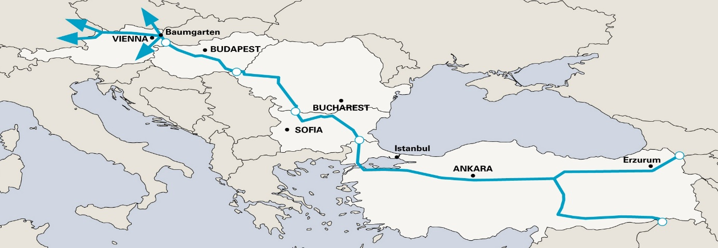
Nabucco pipeline
(Focus Energetic, 2015)
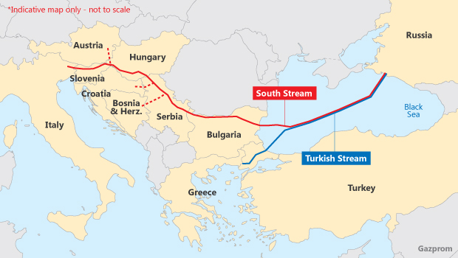
Evidently, Nabucco would have led to a diversification of the EU MS energy supply that in turn would have led to a decrease on their dependence on Gazprom. As imagined, Russia never agreed with the plan, and their continuous efforts to undermine the Nabucco project were finally realized, as the project was declared dead (Kardas, 2011, p. 41). Furthermore, Russia proposed the South Stream pipeline project, as an alternative to Nabucco (Kardas, 2011, p. 41). However, the South Stream pipeline could not have been an alternative, as the energy was to be imported from Russia. This would have defeated the entire purpose of diversifying and decreasing the reliance on Russian energy. The plan was interrupted in late 2014, when Bulgaria (under EU instructions) blocked the construction of the pipeline (Dumitrescu, 2015). Consequently, Russia proposed the plans of another pipeline. The Turkish Stream would now rely primarily on the involvement of Turkey, and in a characteristic retaliatory move from Russia, excluded entirely Bulgaria (InCont D, 2015). The pipeline is thought to be operational starting December 2016 (InCont E, 2015).
South Stream and Turkish Stream pipelines (Interfax Energy, 2015)

Coming back to the idea of the Zero Sum Game, it is clear that Romania is still not regarded as a prime actor in the area of energy. As a testament to this idea, out of all the pipeline plans discussed above, Romania was included only in the design of the Nabucco project. Therefore, Romania had to develop its own strategies and plans for achieving energy security. As mentioned before, Romania chose to shift the focus towards the Caspian Region. Subsequently, it developed the AGRI plan, in collaboration with Azerbaijan and Georgia. The project involves the transport of NG from Azerbaijan to Georgia, through the regular pipelines. The NG is then transformed into liquefied natural gas (LNG) and shipped over the Black Sea to Romania (MAE, n.d.). However, the basic rules of NG trade have to be understood in order to comprehend the actual importance of the AGRI plan. Thus, the most advantageous situation to trade NG, happens at a local level (Brussels Forum, 2012). If this is not the case, the NG will be sold at an international level, through a pipeline system (Brussels Forum, 2012). Only after this was settled as not being an option, the NG is turned into LNG and exported. This basic rationale is also a hierarchy of costs (Brussels Forum, 2012). Therefore, the Romanian AGRI plan proves to be only of marginal help, as the high costs would impede a full scale import situation. Nonetheless, the first steps in this reorientation towards the Caspian region have been made, leaving the option for more intensive future cooperation.
Besides challenging the status quo of the energy arena, through its reorientation towards the Caspian region, Romania also approaches a rather distinctive and surprising behavior in the regional context. Specifically, Romania is trying to profit from its superior energy status (in relation to its neighbors) by acting as a regional leader in the area of energy security. As discussed earlier in this paper, each country has a different approach to energy security. Whether for Russia, energy security would mean the continuation of massive exports at high prices, for Greece, the concept would mean an uninterrupted supply of energy at low costs, and for Hungary it would mean staying on the path of being a transit country. For Romania, energy security would mean achieving a bit of everything. Nonetheless, its greatest challenge and potential, would be to transform into an exporting country. And the country seems to be doing exactly this. What qualifies Romania for the position of energy exporter (especially in the area of NG) are its massive untapped Black Sea reserves, and its low dependence on Russian NG (Pătru, 2015). As a matter of fact, in April 2015 Romania managed the performance of importing 0% of Russia NG for internal consumption (Pătru, 2015). Hence, Romania, in its search for achieving energy security, realized its genuine potential and started to push towards the goal of becoming a regional energy exporter and leader; the before mentioned theory being the third implication of the search for energy security of Romania, advanced in this paper. This shift in attitudes was subtly announced in one of Andrei Gerea’s (Minister of Energy of Romania) speeches by saying that Romania: “has to think more about the possibility of offering security to its neighbors; not military, but energy security” (InCont F, 2015).
Consequently, Romania announced the possibility of building a new pipeline that would stretch from Romania to Slovakia (InCont G, 2015). This new pipeline would potentially link Slovakia to Russia, through Romania, although this would not be its objective. More exactly, because Romania, through this plan, seeks to build the infrastructure that will propagate its Black Sea NG reserves, once they are available. Similarly, Romania signed together with Bulgaria and Greece, an agreement regarding the interconnection of the countries’ NG transmission grids. This way, the RO-BG-EL Vertical Corridor would bring to the Balkan countries a much needed reduction in risk, regarding the supply of energy (InCont H, 2015). Additionally, Romania invested heavily, both politically and economically, in its distribution system towards the Republic of Moldova. However, this particular plan is suspected as being more of a political agenda item than an actual plan for exporting energy to Moldova (Pătru, 2015). Nonetheless, it is certain that Romania accelerated all its infrastructure projects that might be used as an energy export distribution system. Moreover, it is becoming clearer that Romania takes a serious option in challenging Russia’s monopoly in the Balkans. Whether this will materialize, and Romania will attain the status of regional power together with its much wanted energy security, remains to be validated by the political interactions throughout a more prolonged period of time, and evidently by further research.

9. Conclusion

The present research has advanced the idea that a difference between the economic and political implications of the search for energy security, cannot be made. The political and economic dimensions are inextricably linked in the area of energy and energy security. To be precise, a political implication always has an economic drive, as well as an economic outcome. Likewise, an economic desire can never be achieved, in the area of energy security, without involving the political factor. Therefore, the mentioning of the two dimensions, even in the central research question, should not be seen as an attempt of differentiating them into distinct categories of implications. It has to be understood rather as an opportunity of emphasising the dual characteristic, political and economic, of every implication resulted from the search of energy security in Romania.
Hence, the main research question of the present paper was answered by putting forward three distinctive but interconnected implications, observed throughout the research process. The first implication concerns Romania’s involvement of massive energy TNCs in its energy sector. The country’s search for energy security is impeded to some degree by the lack of proper technologies and infrastructure. Out of that struggle of achieving energy security, the opportunity of attracting investments from Transnational Corporations arises. However, the implication of this reliance on TNCs is that Romania’s energy potential dilutes. Subsequently, its political leverage in the international community dilutes as well, leaving the country more vulnerable to foreign interests.
The second concept advanced by the paper, is that Romania is currently under a process of shifting its geographical focus regarding its energy imports. The rationale behind this idea articulates that in its search for energy security, Romania was confronted with a high degree of political risk and price volatility from its main exporter of energy, Russia. The implication of this interaction, has been the realization of the need to focus on other, more reliable political actors. Consequently, Romania is currently undertaking a political and economic reorientation especially towards the Caspian Region, in its search for energy security.
Lastly, besides its new focus on the Caspian Region, Romania also realized its capacity of offering energy security to its neighbors. In its search for attaining energy security, and more importantly in light of the recent discovery of the Black Sea energy resource basins, Romania understood its true potential. Therefore, the country shifted its strategy, giving up on the Russian energy imports, and starting to push towards the goal of becoming a regional energy exporter. Naturally, this will also lead to achieving the status of regional power.
As the battle over energy resources intensifies, Romania has the obligation of finally realizing its genuine potential. The country is now closer than ever to achieving its objective of reaching energy security. Besides the realisation of its internal interests, Romania also will have to bear the responsibility of acting as a regional leader, while propagating energy security in the area. Hence, the future might be the witness of a situation where the entire CEE will worship Bucharest instead of Moscow (Korolciuk, 2015).

Recommendations

Based on the definition advanced by this paper, Romania still cannot be granted the title of an energy secure country. Nonetheless, it must be reiterated that this should not be confused with the idea of an energy stable country, which Romania is. That is because of its capacity of having a constant access to energy, and delivering it to the final consumers at stable prices. Therefore, this section is aimed at offering a concise list of recommendations that normatively should lead Romania to the path of achieving the status of energy secure country, as well. In turn, this should lead to an increase in Romania’s political and economic leverage and independence in the area of energy.

Romania should be an advocate for the materialization of the EU energy union. At a first glance, one would be tempted to state that an energy union would be in the disadvantage of Romania, and its desires of becoming a regional energy exporter and leader. This rationale would be founded on the idea that EU MS would have to give up some of their prerogatives, in favor of an EU-wide common approach. Nonetheless, this would simply not be the case. An energy union would automatically imply an easier path for the MS, Romania implicitly, to export their energy resources within the EU. Furthermore, this union would aid Romania in its attempts of importing energy resources on which it is more dependent, such as oil. That is because the negotiations regarding the prices and volumes of energy resources would be negotiated at a Union level, offering much more leverage power for all the MS. Nevertheless, Romania would have to adopt a nimble strategy in negotiating and furthering its interest in the design of such an EU energy union. Romania could certainly benefit from its upper hand in the area of energy and energy security and should advocate for the realization of national objectives such as attracting investments that would transform the country into a regional energy hub.

Romania should focus on addressing its urgent need for investments in the national energy sector. As presented throughout the paper, the prime factor in Romania’s energy insecurity lies in the lack of approximately 100 billion euros, needed as investments. Romania should focus intensively on channeling most of that much needed sum, from its internal capacities. Similarly, EU structural funds could prove to be a viable alternative as well. This way, the involvement of massive TNCs would not be necessary anymore. Consequently, Romania would be less susceptible to foreign interests, and the country’s political and economic leverage power in the international community would improve drastically.

Romania should focus its investments in the renewable energy resources sector. Romania has a massive potential in this specific energy subsector. Investing intensively in the renewable energy resources would, again, improve the country’s influence in the international community. The rationale is simple; the more resources you develop and have, the closer you are to solving your energy security dilemma. Similarly, the country’s capacity of exporting those energy resources, increases. Consequently, Romania would achieve both, its need to attain energy security, and its desire of becoming a regional power.

References

Anderson, R. (2012, June 12). Resource depletion: Opportunity or looming catastrophe? Retrieved March 3, 2015, from BBC: http://www.bbc.com/news/business-16391040
Bohi, D., & Toman, M. (1996). The Economics of Energy Security. Boston: Kluwer Academic Publishers.
BP. (2014). BP Statistical Review of World Energy June 2014. London: BP. Retrieved May 3, 2015, from bp.com/statisticalreview
Brussels Forum. (2012, April 4). Energy Security: Politics, Policy, and Geopolitics. Brussels, belgium. Retrieved May 14, 2015, from https://www.youtube.com/watch?v=S55aQ0q-52I
Chester, L. (2010, 11 November). Conceptualising energy security and making explicit its polysemic nature. Energy policy(38), 887-895. Retrieved September 14, 2014, from http://www.academia.edu/4645811/Conceptualising_energy_security_and_making_explicit_its_polysemic_nature
Chrysopoulos, P. (2015, April 8). Tsipras-Putin Sign New Trade Deal and Renew Greece-Russia Relations. Retrieved April 25, 2015, from Greek Reporter: http://greece.greekreporter.com/2015/04/08/tsipras-putin-sign-new-trade-deal-and-renew-greece-russia-relations/
Coq, C. L., & Paltseva, E. (2009, November). Measuring the security of external energy supply in the European Union. Energy Policy, 37(11), 4474-4481.
Dumitrescu, A. (2015, March 4). Bulgaria şi Azerbaidjanul vor relansarea proiectului Nabucco. Retrieved May 13, 2015, from Mediafax: http://www.mediafax.ro/economic/bulgaria-si-azerbaidjanul-vor-relansarea-proiectului-nabucco-13932295
EC. (2014). Energy security: Commission puts forward comprehensive strategy to strengthen security of supply. Brussels: European Union.
EIA. (2013). EIA/ARI World Shale Gas and Shale Oil Resource Assessment . Arlington, USA: EIA.
EU. (2015, March 12). FAQ on the EU competences and the European Commission powers. Retrieved from The European Citizens' Initiative: http://ec.europa.eu/citizens-initiative/public/competences/faq?lg=en
European Commission. (2015, April 8). The 2020 Climate and Energy Package. Retrieved May 10, 2015, from Climate Action: ec.europa.eu/clima/policies/package/index_en.htm
European Commission A. (2014). In-depth study of European Energy Security. European Union. Brussels: European Union.
European Commission B. (2014). MEMO- Questions and answers on security of energy supply in the EU. European Union, European Commission. Brussels: European Commission.
EUROSTAT. (2015). Energy production and consumption in 2013. Brussels: European Union.
EVZ. (2015, March 20). Iohannis: România sprijină uniunea energetică și speră ca ea să asigure protecția consumatorilor vulnerabili. Retrieved April 25, 2015, from EVZ.ro: http://www.evz.ro/corespondenta-de-la-bruxelles-iohannis-romania-sprijina-uniunea-energetica-si-spera-ca-ea-sa-asigure-protectia-consumatorilor-vulnerabili.html
Focus Energetic. (2015, March 5). Bulgaria si Azerbaijanul vor relansarea proiectului Nabucco (Bulgaria and Azerbaijan want the relaunch of the Nabucco project). Retrieved May 13, 2015, from Focus Energetic: http://www.focus-energetic.ro/bulgaria-si-azerbaidjanul-vor-relansarea-proiectului-nabucco-24455.html
Government of Romania. (2015). Strategia Energetica a Romaniei- Draft (Energy Strategy of Romania- Draft). Bucharest: Government of Romania.
InCont A. (2014, September 12). Gazprom reduce livrarile de gaze catre Romania.(Gazprom reduces gas deliveries for Romania) . Retrieved May 13, 2015, from InCont: http://www.incont.ro/international/rusia-se-razbuna-pe-tarile-care-ajuta-ucraina-gazprom-a-redus-livrarile-de-gaze-catre-statele-care-alimenteaza.html?utm_source=stirileprotv.ro&utm_medium=email&utm_campaign=Newsletter+StirileProtv.ro+12all09%2F11%2F2014+
InCont B. (2015, April 21). Ungaria a primit aprobarea UE pentru livrarea de combustibil nuclear din Rusia la centrala Paks, care va fi modernizata cu 12 mld. de euro de la Moscova. Retrieved April 25, 2015, from Incont Magazine: http://www.incont.ro/international/ungaria-a-primit-aprobarea-ue-pentru-livrarea-de-combustibil-nuclear-din-rusia-la-centrala-paks-care-va.html?utm_source=incont.ro&utm_medium=email&utm_campaign=12all+newsletter+Incont.ro04%2F21%2F2015+13%3A29&utm_content
InCont C. (2015, March 30). INcont Magazine. Retrieved May 10, 2015, from Inca o descoperire de gaze in Romania. Exploatarea va asigura 3% din productia Romgaz (Another gas discovery in Romania. The exploitation will ensure 3% of Romgaz production: http://www.incont.ro/industrie/inca-o-descoperire-de-gaze-in-romania-in-perimetrul-moldova-nord-care-asigura-3-din-productia-companiei.html?utm_source=incont.ro&utm_medium=email&utm_campaign=12all+newsletter+Incont.ro03%2F30%2F2015+13%3A40&utm_content=cla
InCont D. (2015, January 15). Rusii anunta Turkish Stream, conducta care va inlocui South Stream (Russians announce Turkish Stream, the pipeline taht will replace South Stream). Retrieved from InCont: http://www.incont.ro/international/rusii-anunta-turkish-stream-conducta-care-va-inlocui-south-stream-gazprom-este-treaba-partenerilor-europeni.html?utm_source=incont.ro&utm_medium=email&utm_campaign=12all+newsletter+Incont.ro01%2F15%2F2015+13%3A37&utm_con
InCont E. (2015, May 7). Gazprom a batut palma cu Turcia, gazoductul devine operational din decembrie 2016 (Gazprom signed the deal with Turkey, the pipeline will become operational from December 2016). Retrieved May 13, 2015, from InCont: http://www.incont.ro/international/gazoductul-turkish-stream-devine-operational-din-decembrie-2016.html?utm_source=incont.ro&utm_medium=email&utm_campaign=12all+newsletter+Incont.ro05%2F08%2F2015+13%3A26&utm_content=claudiu.motoc10%40gmail.com
InCont F. (2015, February 23). Strategia energetica va fi finalizata pana in octombrie. (The Energy Strategy will be finished in October). Retrieved May 14, 2015, from InCont: http://www.incont.ro/industrie/gerea-strategia-energetica-va-fi-finalizata-pana-in-octombrie-principalele-obiective-securitatea-alimentarii.html
InCont G. (2015, January 29). Reuters: Romania, Bulgaria si Slovacia ar putea construi un gazoduct catre Balcani ( Reuters: Romania, Bulgaria and Slovakia might build a pipeline to the Balkans). Retrieved May 14, 2015, from InCont: http://www.incont.ro/industrie/romania-bulgaria-si-slovacia-vor-sa-construiasca-un-gazoduct-catre-balcani-pentru-a-reduce-dependenta.html?utm_source=incont.ro&utm_medium=email&utm_campaign=12all+newsletter+Incont.ro01%2F29%2F2015+13%3A33&utm_content=claud
InCont H. (2015, April 23). Romania, Bulgaria si Grecia isi leaga retelele de gaze naturale (Romania, Bulgaria and Greece are connecting theot natural gas distribution systems). Retrieved May 14, 2015, from InCont: http://www.incont.ro/international/romania-bulgaria-si-grecia-au-semnat-un-acord-pentru-interconectarea-retelelor-de-gaze-naturale-pentru.html
INS. (2015, April). Energy Resources. Retrieved May 5, 2015, from Institutul National de Statistica: http://www.insse.ro/cms/ro/content/resurse-de-energie
Interfax Energy. (2015, February 10). Securing the future of Turkish Stream. Retrieved May 13, 2015, from Interfax Global Energy: http://interfaxenergy.com/gasdaily/article/15215/securing-the-future-of-turkish-stream
Ivan, D., & Blanaru, V. (2012, May 30). Gazele de şist, drenate spre justiţie: Societatea civilă a cerut Guvernului revocarea acordurilor petroliere cu Chevron (Shale Gas brought to Justice. Civil Society has requested the Government to revoke all agreements with Chevron). Retrieved May 12, 2015, from Jurnalul National: http://jurnalul.ro/bani-afaceri/economia/gazele-de-sist-drenate-spre-justitie-societatea-civila-a-cerut-guvernului-revocarea-acordurilor-petroliere-cu-chevron-614220.html
Kardas, S. (2011, March). Geo-strategic position as leverage in EU accession: the case of Turkish–EU negotiations on the Nabucco pipeline. Southeast European and Black Sea Studies, 11(1), 35-52.
Korolciuk, I. (2015, April 27). Romanian reverse flow as instrument of geopolitics. Retrieved May 15, 2015, from MIG News: http://mignews.com.ua/avtor/blogs/5500520.html
Lieb-Dóczy, E., Börner, A.-R., & MacKerron, G. (2003). Who Secures the Security of Supply? European perspectives on security, competition, and liability. The Electricity Journal, 16(10), 10-19.
MAE. (n.d.). Securitate energetică (Energy Security). Retrieved May 14, 2015, from MAE (Ministry of Foreign Affairs of Romania): http://mae.ro/node/1602?page=4
Mediafax. (2014, October 23). Lovitura pregatita de Ungaria in Europa. E de asteptat sa provoace furia Uniunii Europene si a Statelor Unite. Retrieved April 25, 2015, from PRO TV NEWS: http://stirileprotv.ro/stiri/financiar/lovitura-pregatita-de-ungaria-in-europa-e-de-asteptat-sa-provoace-furia-uniunii-europene-si-a-statelor-unite.html?utm_source=stirileprotv.ro&utm_medium=email&utm_campaign=Newsletter+StirileProtv.ro+12all10%2F23%2F201
Mulder, M., Cate, A. t., & Zwart, G. (2007). The economics of promoting security of energy. EIB Papers, 12(2), 38-61. Retrieved from http://hdl.handle.net/10419/44878
NASDAQ. (2015, April 4). Crude Oil Prices. Retrieved from NASDAQ: http://www.nasdaq.com/markets/crude-oil.aspx?timeframe=10y
O'Leary, Z. (2014). The Essential Guide to Doing Your Research Project. London, United Kingdom: Sage Publications.
OPEC. (2014). World Oil Outlook 2014. Vienna, Austria: OPEC Secretariat.
Pacuraru, C. (2013). Europa si imposibilitatea managemenutului securitatii energetice. Bucharest.
Pakalkaite, V. (2014). Competence Creep Through the Backdoor: EU Energy Regulation and Competition Policy . 5th Biennial ECPR Standing Group for Regulatory Governance Conference (pp. 2-20). Barcelona: 5th Biennial ECPR Standing Group for Regulatory Governance Conference.
Pătru, B. (2015, April 20). Energy Security. (A. Motoc, Interviewer)
PROTV. (2013, April 5). Rezervele din Marea Neagra pot acoperi jumatate din consumul anual de gaze al Romaniei (The Black Sea reserves could cover half of the annual gas consumption of Romania(. Retrieved May 10, 2015, from PROTV: http://stirileprotv.ro/stiri/financiar/rezervele-din-marea-neagra-pot-acoperi-jumatate-din-consumul-anual-de-gaze-al-romaniei.html
PROTV. (2015, May 6). Cum se lupta rusii si americanii pentru resursele romanesti din Marea Neagra. "In aceste vremuri energia inseamna securitate" (The Americans and the Russians are fighting for Romania's Black Sea resoures. In our times energy equals security). Retrieved May 12, 2015, from PROTV: http://romaniateiubesc.stirileprotv.ro/emisiuni/2015/sezonul-1/cum-se-lupta-rusii-si-americanii-pentru-resursele-romanesti-din-marea-neagra-in-aceste-vremuri-energia-inseamna-securitate.html
PROTV A. (2015, May 4). Romania, Europe's resource basin is getting depleted with every year that passes. Retrieved May 6, 2015, from PROTV- Romania I Love You: http://romaniateiubesc.stirileprotv.ro/emisiuni/2015/sezonul-1/romania-depozitul-de-carburanti-al-europei-care-se-goleste-in-fiecare-an-cat-din-petrolul-romanesc-vine-din-mare.html
REN 21. (2014). Renewables 2014 Global Status Report. Paris: REN21.
Scheepers, M., & Seebregts, A. (2006). EU Standards for Energy Security of Supply. The Hague: Clingendael International Energy Programme.
SmartLink. (2014). Securitatea Energetica a Romaniei (Energy Security of Romania). Bucharest: SmartLink. Retrieved from http://thesmartlink.org/securitateenergetica-2/
Sovacool, B., & Saunders, H. (2014, February 13). Completing policy packages and the complexity of energy security. Energy(67), 641-641. Retrieved September 20, 2014
Sovacool, B., & Saunders, H. (2014, February 13). Completing policy packages and the complexity of energy security. Energy, 641-641. Retrieved September 20, 2014
TFEU. (2012, October 26). Consolidated version of Treaty on the Functioning of the European Union. Brussels, Belgium: Official Journal of the European Union.
The Administration of the President of Romania. (2007). National Security Strategy. The Administration of the President of Romania. Bucharest: The Administration of the President of Romania. Retrieved from http://www.presidency.ro/static/ordine/SSNR/SSNR.pdf
Varlan, C. (2015, February 21). Chevron renunţă la gazele de şist din România (Chevron abandons Romanian shale gas). Retrieved May 12, 2015, from Ziarul Gandul: http://www.gandul.info/financiar/chevron-renunta-la-gazele-de-sist-din-romania-13865624
World Nuclear Association. (2015, February). Nuclear Power in the World Today. Retrieved from World Nuclear Association: http://www.world-nuclear.org/info/Current-and-Future-Generation/Nuclear-Power-in-the-World-Today/

Appendices:

Student Ethics Form
- Informed Consent Form
- Interview Transcript

Student Ethics Form

Your name: Andrei Motoc
Supervisor: Rebekah Tromble

Section 1. Project Outline

- Title of Project:
Energy security in Romania – What are the political and economic implications of the search for energy security, in Romania?

- Aims of project:
To underline how the political and economic behaviours of Romania are altered by the country’s attempt of attaining energy security

- Will you involve other people in your project – e.g. via formal or informal interviews, group discussions, questionnaires, internet surveys etc.

YES / N0

Section 2: Complete this section only if you answered YES to question (iii) above.

- What will the participants have to do? (v. brief outline of procedure):

Take part in an interview process and answer a set of questions.

- What sort of people will the participants be and how will they be recruited?

Professionals who work in the area of energy security. They have been recruited through personal connections.

- What sort stimuli or materials will your participants be exposed to, tick the appropriate boxes and then state what they are in the space below?

Questionnaires [ ]; Pictures [ ]; Sounds [ ]; Words[X]; Other [ ].

- Consent: Informed consent must be obtained for all participants before they take part in your project. Either verbally or by means of an informed consent form you should state what participants will be doing, drawing attention to anything they could conceivably object to subsequently. You should also state how they can withdraw from the study at any time and the measures you are taking to ensure the confidentiality of data. A standard informed consent form is available in the Dissertation Manual.

- What procedures will you follow in order to guarantee the confidentiality of participants' data?

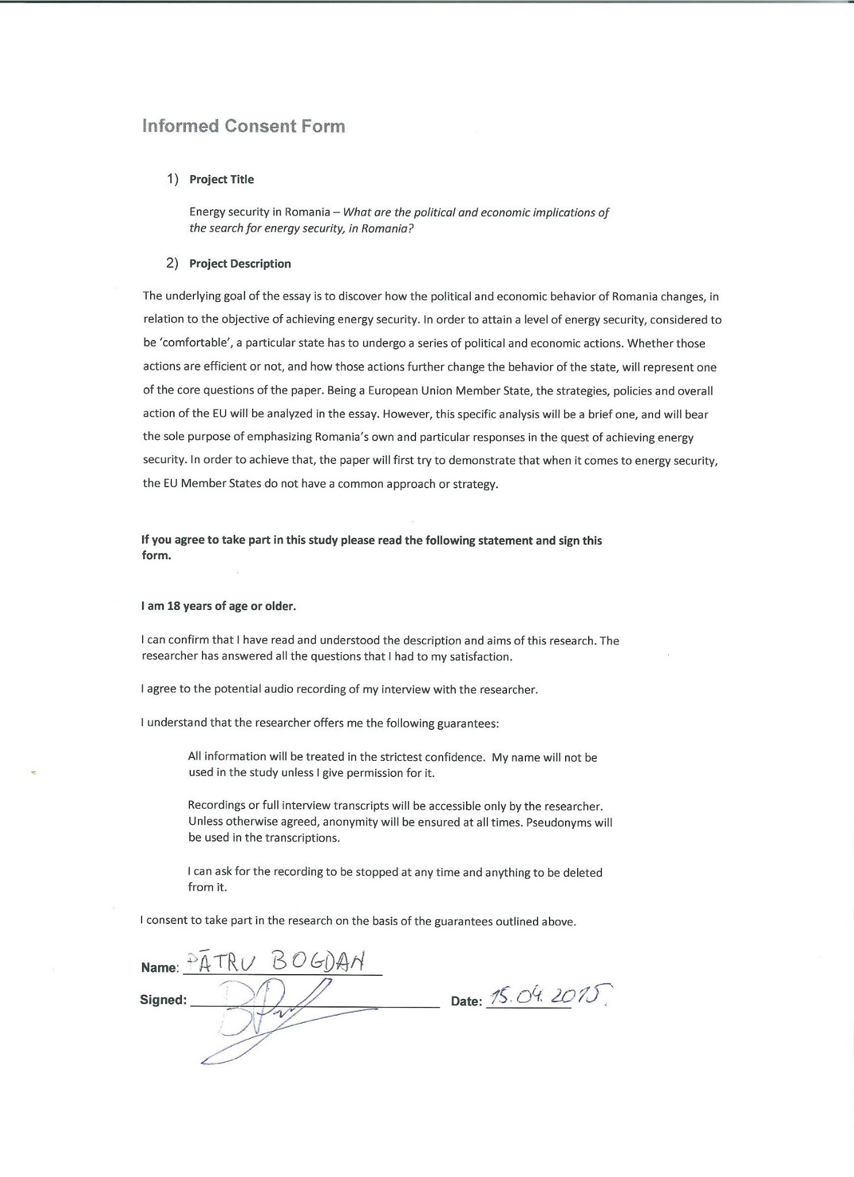
Informed Consent Form

Interview Transcript

Interviewee: Bogdan Pătru
Interviewer: Andrei Motoc

To what extent can the EU strategies and policies constrain the Romanian energy security agenda? (Can it impose limits in the country’s struggle of achieving energy security?

The objective of the Romanian energy sector, namely, to provide security of supply of electric and thermic energy to all of its consumers at an adequate level of quality, must be achieved with the lowest costs possible for the final consumers. Furthermore, it must respect all the environmental requirements, and the objectives set in the energy and environment policy framework of 2020-2030 (designed by the European Commission) and the European energy security strategy. Hence, the security of energy supply will be maintained, as well as the industry competitively and the protection of workplaces.

How do you assess Romania’s energy security position, in relation to the regional context?
In relation to its neighbours, and European Union Member States, Romania has an advantageous position when it comes to its energy security status because:

- Romania is one of the main natural gas and electricity producers in its region

- Romania has a relatively low level of dependency to Russian natural gas. That is a direct result of the ration between internal production and consumption. Nonetheless, it must be understood that Romania has a low level of energy consumption because the heavy energy consuming industry is underdeveloped and the population is extremely concerned with how they consume, as a result of the high costs of natural gas to end consumers.

- Besides the aforementioned facts, Romania also benefits from the capacity of storing high quantities of energy

- Romania benefits from immense natural resource basins that are still untapped such as the Black Sea Reserves

Therefore, with the appropriate investments (in transport infrastructure, storage, increasing the production capacity and interconnecting with the neighbouring countries) we can position ourselves as an important regional hub.

Can the EU achieve a comprehensive and common energy security strategy? Would that benefit all MS?
In theory, yes. And this is the role of the European Energy Union, initiated by the European Commission and supported by Romania. In practice, however, only time will tell how this project will end up and what it will achieve. It is somehow difficult. In regard to some issues, European Union Member States will have to give up some of their internal prerogatives, in the favour of a common approach for all Member States. For example, the negotiation of the acquisition price for natural gas from exporters outside the European Union-mainly Gazprom)

There is no doubt that this is an ambitious project. Still, from my point of view, I am certain that such a Union will further strengthen the European Union Member States. Meaning, that I am supportive of the ideas, plans, directions of the European Commission in this regard. For Romania, there is still to be observed how it will negotiate its upper hand, so that it will obtain a maximum of advantages on a national level, evidently in a European context.

Can there be made a clear distinction between the political and economic implications of the search for energy security in Romania?

There cannot be done a clear distinction between the two. In Romania, unfortunately, politics dictate over the economic sphere. Being a country that is not that well developed from an economic point of view, the economic factor is somehow absent in this debate. It is rather a discussion about small interests or cartel type of “games”. That is because the main energy producers are controlled by the state (Romgaz, Nuclear Electrica, etc.) as well as the transportation system (Transgaz and Transelectrica).

Does the civil society have any saying in the area of national energy security? Specifically in Romania.

Civil society, in Romania, was quite vehement regarding the shale gas exploitation. There have also been some debates regarding the liberalisation of the energy prices (agenda furthered by the European Commission). Otherwise there is not much implication on the civil society’s side, regarding the energy sector.

How can Romania afford to export natural gas, especially to the Republic of Moldova, as long as the country is still dependent on Russian gas?
The question can be analysed through two lenses:
- Politically: Romania exporting, all the more to Moldova, certainly sheds a good light on the country and its efforts of helping its brothers.
- Economically: Romanian authorities are putting enormous effort into the possibility of the Romania-Moldova pipeline of becoming a European Union community interest project. Without any success so far, as a project has to aid at least two Member States, in order to be put on the list of community projects.
Now, the reasons for why Romania exports natural gas:
- Even though the internal production has decreased, so did the internal consumption – we do not have a large sector of consuming industry and the household consumption has plummeted due to the high prices.
- In the context of the Ukrainian crisis and the last year’s energy crisis (provoked by Russia), Romania reduced its natural gas imports from Russia and started to consume from its stored energy resources. Consequently, in April 2015, we imported 0% of Russian natural gas for our internal consumption
- In relation to the low internal consumption, the internal production manages to fulfil all the needs. The problem is whether we could export or not, and in my opinion once the market is liberalised, we will export massively. Internal production will be achieved at low prices and the energy will be sold at high, EU prices, resulting massive profits for the producing companies.

In my opinion, the Romania-Moldova pipeline has no economic stake at all, for it is simply a political move.

