IMPORT OF CROATIAN WINE

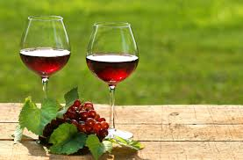

Name: Davor Simic
Student number: 20061782
Name supervisor: Mrs. N.A. Ariëns
Name second reader: W.M.J. van Leeuwen

22 June 2015

Source front page: (Food and Wine, 2015)
Student name: Davor Simic
Supervisor: N.A. Ariëns
Second Marker: W.M.J. van Leeuwen
The Hague University of Applied Sciences
European Studies Private (Business Management)
Research Proposal Registration number: ES4-1415sem2pr-059
Data Student
Name: Davor Simic
Student number: 20061782
Phone number: 0657584210
Data Supervisor and second reader
Name: N.A. Ariëns
Email: N.A.Ariens@hhs.nl
Name: W.M.J. van Leeuwen
Email: W.M.J.vanLeeuwen@hhs.nl

Executive Summary

This report is written as an import policy plan. First the Croatian wine sector is investigated. Croatia is a country with a booming tourism industry and especially the last years Croatia has become more popular amongst Dutch people. Croatia is also a country with a long history in producing wine. The country is divided into four wine regions: two regions on the coastal area and two in the inlands. Croatian wine producers are mainly focused on the domestic market. However, since the full membership in the European Union this phenomenon can change because of the lower export restrictions, which makes it easier to start exporting the wine abroad. On the other hand, the Dutch wine consumption is increasing, and beer is still the most popular beverage in the Netherlands, its consumption is decreasing whereas the consumption of wine is increasing.
In order to have a better insight into the Dutch wine market a DESTEP analysis has been made. As already mentioned, wine is becoming more popular. The Dutch prefer to drink wine in restaurants. According to the Rabobank, the largest group of customers in restaurants are elderly people. A demographic phenomenon of aging is visible in the Netherlands. These two facts could be positive for the wine industry and the increase of wine consumption..
Wine is a product that will always be consumed. Its place in the product life cycle is in the revitalization phase. This means that only small changes or adaptations can distinguish a producer from its competitors. Three segments that are the best option for the Croatian wine producers are supermarkets, liquor stores and Internet stores. These three segments distinguish themselves in the price and quality range.
Using the five forces of Porter the level of competition within an industry is being discussed. Wine is a unique product that can be replaced by two other beverages, beer and spirits. Although the level of beer consumption is still higher compared to wine, it is decreasing. The wine that is being consumed in the Netherlands is imported from the following countries: France, Italy, Germany, Spain, Chile, South Africa and Australia. Their wines can be found in every of the three segments already mentioned. The three segments differ from each other. Supermarkets are focused on the price of wine where as liquor stores and Internet stores are focused on the quality of wine.
Producers that purchase wine from Croatia to the Netherlands do not need to pay any import tariffs, because of the full membership of Croatia in the EU, however, excise duties and the VAT need to be paid. Because every member state of the EU has its own amount of excise duties, the European Union developed a new system that determines automatically which amount of excise needs to be paid. This system is called EMCS.
One of the most important recommendations for Croatian wine producers is marketing. Croatian producers should organise tastings and events for Dutch experts and sommeliers. The Croatian embassy in the Hague could be contacted to achieve this and organize such an event in the Netherlands.

Tabel of Contents
A. Executive Summary i
Preface v
1. Introduction 1
2. Theoretical Framework 3
3. Croatian Wine Sector 5
4. Dutch Wine Sector 8
5. DESTEP Analysis 11
5.1 Demographic analysis 11
5.2 Economic analysis 12
5.3 Social analysis 13
5.4 Technological analysis 14
5.5 Political analysis 15
5.6 Conclusion 16
6. Product Life Cycle and Market Segmentation 18
6.1 Product Life Cycle 18
6.2 Market Segmentation 19
6.3 Conclusion 19
7. Industry- Competitive Analysis 21
7.1 Threat of substitute products 21
7.2 Threat of new entrants 22
7.3 Bargaining power of customers 23
7.4 Bargaining power of suppliers 24
7.5 Intensity of competitive rivalry 25
7.6 Conclusion 25
8. SWOT Analysis + Confrontation matrix 26
8.1 SWOT Analysis 26
8.2 Confrontation matrix 26
8.3 Conclusion 27
9. Import Marketing Mix 28
9.1 Price 28
9.2 Product 29
9.3 Place 29
9.4 Promotion 30
9.5 Distribution policy 30
9.5.1 Distribution 30
9.5.2 Conditions of delivery 30
9.6 Conclusion 31
10. Conclusion 32
11. Recommendation 33
12. References 34
13. Appendix 1
13.1 Appendix 1: Wine import in hectoliters 1
13.2 Appendix 2: Wine consumption per capita 4

Preface

My final thesis was written as part of the European Studies Program at the Hague University. Because my parents are from Croatia I wanted to do my thesis about a Croatian product. Every year I go to Croatia in the summer and ask myself: Why do we have such good wines and I cannot purchase them in the Netherlands. I always thought that wine is a product that would make Croatia famous in the world. That is why I selected this subject to write my final thesis about.
I would like to thank my supervisor Mrs. N.A. Ariëns for her support during the process of my thesis. She gave me some good insights how to proceed when I did not know how to continue with my thesis.
I would like to thank my mother as well who supported me to be optimistic and for being always with me despite the difficult last six months. Despite the fact that he is not among us anymore, I would like to thank my father as well whose dream it was that his son would finally finish his university.

Introduction

Domestic wine production is a very important segment of Croatian agriculture and also plays an important role in tourism, which is an important sector of the Croatian economy. There is a long tradition of grape-growing and wine production, spread throughout most parts of the country, and viniculture is a traditional way of life. The country has a high potential for the export of wine, but why is this not being realised? The first reason is that due to the booming tourism in the last years, the producers of wine offer their product on the domestic market for tourists. After the summer season, a small amount of wine is left for export and this is not enough to compete on the markets abroad. The local wineries see the domestic market as a higher potential in comparison with the markets abroad. Another reason is that the local wineries are too small to compete on the world wine market. They harvest a small amount and set a high price for the wine, too high to compete on the world market. The last reason is the regulations in Croatia. Especially before the membership in the European Union importers were not keen on purchasing Croatian wine due to bureaucracy and regulations that are time-consuming. After joining the European Union, the competition for local wine producers increased. More foreign wine producers enter the Croatian market due to lower restrictions, which leads to a higher competition for local wine producers. This phenomenon could lead to a change of thinking for the Croatian wine producers to export more wine to foreign markets.

Also, the wine consumption of the Dutch increases every year. Several types of wine from different countries around the world presented themselves on the Dutch market. Therefore, the main focus of this Import Policy Plan is to investigate how to place wine from a local farmer in Croatia on the Dutch market. The result will answer the following central question: Which Import Policy Plan, could be used for Croatian wine to enter the Dutch market in 2016? In order to do this successfully, the following sub-questions will be answered:

- What does the Croatian wine sector look like?
- What does the DESTEP analysis of the Netherlands look like?
- Who are the main competitors in the Netherlands?
- What are the strong and the weak points of the Croatian wine producers?
- Which strategy is the best option derived from the confrontation matrix?
- Which marketing tools should be implemented to import the product in the Netherlands?
- What is the conclusion/recommendation of the report?

This report is written as an Import policy plan. This means that there is a certain structure that is been followed through the report. First, the product and an overview of the Croatian wine market will be explained. Next, the Dutch market will be investigated to determine what this market looks like and how it can be segmented into several potential market segments. Furthermore, a more descriptive research of the Dutch wine market will be discussed in the DESTEP and external analysis. A SWOT analysis will mention the strengths, weaknesses, opportunities and threats of the product on the market. The marketing mix will discuss what the best way is to launch and promote the product on the Dutch market. Furthermore, the conclusion will answer the central question of this report.
This research project will mainly consist of desk research. Both quantitative as qualitative research methods will be used. The main focus is on the relevancy and the applicability of the information in relation to the topic. Qualitative data will mainly be collected from various Internet sources: journals, articles, government/company publications and reports. Library databases as well textbooks will be relevant for the various theories mentioned in this report. Quantitative data will consist of figures and content analysis to describe variation in a situation. Both of these research methods will be gathered by the use of secondary data; data collected by others that are discussed in a reliable matter and applicable for the topic. As mentioned above, Internet will be the number one source to be used. Sources like Google, CIA, Google Scholar, CBS, HHS digital library are examples of this. The sources that are being used will be checked on reliability. No interviews were used because of the good information desk research provided. For example the Hofstede Centre provided relevant information about the social/cultural aspects of the Dutch and Croatians.
This report consists of a logical research structure that will finally lead to the answer of the central question. In this introduction the central question and it sub-questions have been defined. In the first two chapters the wine industry of Croatia and the Netherlands will be discussed. The DESTEP analysis is made to give a more clear view of the Dutch wine market. This enables potential market entries a better view on what the Dutch wine market as well consumer market looks like. In the next chapter, Product life cycle and market definition, a more theoretical view is given on the product and market. The SWOT analysis will describe the strengths, weaknesses, opportunities and threats for an organisation. This analysis will finally lead to the confrontation matrix where the strategy of a Croatian wine producer can be developed. In the next chapter the import marketing mix will be discussed. In this analysis price, place, positioning and product will be the key factors that are being researched. In the last chapter a conclusion/recommendation will be given to answer the central question of the report.

Theoretical Framework

The structure of this report is written as an Import Policy Plan. In this report several theories are implemented to answer the central question. The first theory that will be discussed is the DESTEP analysis. The DESTEP analysis is a tool that helps organisations to get an overview of the external environment. Each organisation is faced with factors that they cannot influence. These factors may directly or indirectly influence the operations of an organisation. With this analysis a company can adjust their strategy to gain a positive effect or gain more market share (Veldman, 2009). The DESTEP analysis consist of several parts:
- D: Demographic factors. For an organisation it is important to be aware of possible changes and effects of income, gender, population and age. Companies should be aware of their environment so they can adapt their product/service to the environment.
- E: Economic factors. The economic factors may change in an environment. Especially in the last years during the financial crisis that affected the world economy. Factors like income, inflation and purchasing power need to be researched to adapt the strategy of an organisation.
- S: Social/Cultural factors. To research the behaviour of customers and analyse their lifestyles, and social norms.
- T: Technological factors. To keep up with the changing world, companies need to react with innovative products and new production procedures to distinguish themselves from the competition.
- E: Ecological factors. New environmental regulations could be implemented in an environment. For example, sustainable products and climate regulations. Organisations need to anticipate on this phenomenon to distinguish them selves.
- P: Political factors. Laws, trade regulations and policies are of a great importance to organisations. They need to be aware of the latest regulations to avoid fines.

The second theory that is implemented in the report is the SWOT analysis. This analysis describes the strengths, weaknesses, opportunities and threats and it helps to determine the strategy of an organisation. After determining the SWOT, a Confrontation Matrix is used to further analyse the output of the SWOT analysis. The matrix allows an organisation to analyse each different combination between the strengths, weaknesses, opportunities and threats. The aim of the matrix is to identify the most important strategic option.
The third theory that will be discussed in this report is Porter’s Five Forces Model. This is a tool that determines where the level of competition is in an industry. To answer this question the following five forces need to be discussed:
- Supplier power: how easy is it for suppliers to increase the price of a product?
- Buyer power: how easy is it for buyers to decrease the price of a product?
- Competitive rivalry: the number and capability of the competition in comparison with the organisation.
- Threat of substitution: the ability for customers to switch to alternative products/services
- Threat of new entry: the ability of new organisations/products to enter the market.

Finally, the entrance strategy is formulated. This strategy will be used to decide upon the marketing instruments.

Croatian Wine Sector

Croatia has a long history of wine making. It started 2200 B.C. when the Illyrian tribe made wine in the area that nowadays is known as Dalmatia. Greek colonization 390 B.C. and the Roman Empire (4th century) helped spread the craft. For centuries wine making was a popular craft to do. After events like the Ottoman invasions, world wars, communism and the latest war in former Yugoslavia the craft disappeared from the country. Nowadays winemaking is becoming more popular. (Croatian Fine Wines, 2015)
In 2010, the Croatian Chamber of commerce established the Association of Croatian Wineries and the wine production in the country was divided in two parts: coastal and continental. In 2012 the wine production was divided into four regions by a group of sommeliers and wine experts. The two coastal regions are Dalmatia and Istria & Kvarner. The two continental regions are the Uplands and Slavonia & Danube. These four regions are divided in 12 sub regions. Although Croatia is a small country (1,5 times larger than the Netherlands) it has 17000 registered wine growers with vineyards over 59000 acres. 60% of the production includes white wine. (Croatian Fine Wines, 2015)
Figure 3.1: Wine regions in Croatia.

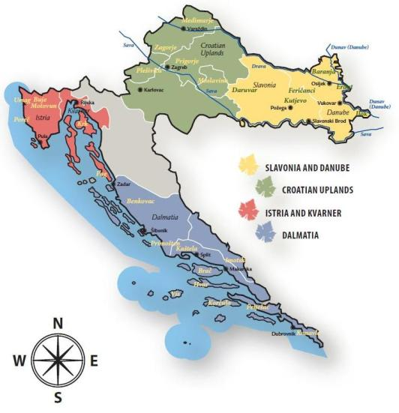
(Croatian Fine Wines, 2015)
Dalmatia is the southern region of Croatia. It is bordered by the Adriatic Sea on the west, Bosnia and Herzegovina on the east and Montenegro on the south. The warm and sunny climate of Dalmatia makes the region ideal for wine production. Although the region is situated at the sea and normally white wine would be produced more in these areas, the red wine is more popular for producing and consumption in Dalmatia. The varieties that are best known are Babić and Plavac. Notable wine producers in Dalmatia are Grgić Vina Winery, Korta Katarina Winery and Saints Hills Winery.
Istria & Kvarner is the second coastal region of Croatia and is situated in the northwest part bordered by the North with Italy and Slovenia and on the west by the Adriatic Sea. Since centuries Istria is strongly influenced by Italy. It has been part of the Venetian Empire where wine making is done for centuries. Nowadays the Italian influence is still visible in Istria. Italian is being taught at school, the cuisine is similar to the Italian with seafoods, olive oil and truffles. Istria is best known for its refreshing white wines Malvasia. Notable wine producers in this region are Wine Station Trapan, Franc Arman Wineyards and Vina Matošević.
The Croatian uplands are situated in the centre of the country, around the capital Zagreb. Bordered to the north by Slovenia and Hungary and on the south by Bosnia and Herzegovina. This area is known for its aromatic and refreshing white wines made from Sauvignon Blanc, Riesling and Chardonnay. Most notable wine producers in this region are Korak Winery, Tomac Winery and Bolfan Winery.
Slavonia & Danube are situated in the eastern part of the country, bordered on the north by Hungary on the east by Serbia and on the south by Bosnia & Herzegovina. This part is highly regarded for white wine made from Graševina which is better known as Welschriesling and Riesling. Wine is also made from other wine varieties like Chardonnay, Sauvignon Blanc and Pinot Gris. One of the best known wine producers in this region is the Krauthaker Vineyards and Winery which includes 70 acres. Iločki Podrumi is another winery that is situated on the banks of the Danube River and it is the second-oldest winery in Europe. (Jenssen, 2014)
In the figure below it can be seen that in 2012 Croatian farmers cultivated 29,000 hectares of vineyards, produced 187,550 MT of grapes and 1.3 million hectolitres of wine.

Figure 3.2 Vineyards, Wine and Grape production.

 |  | 2009 | 2010 | 2011 | 2012
Vineyards | ha | 34.000 | 33.000 | 32.000 | 29.000
Grapes | MT | 206.437 | 207.743 | 204.373 | 187.550
Wine | hl | 1.424.000 | 1.433.000 | 1.409.000 | 1.293.000
(Misir, 2014)
The Croatian consumption of wine is mainly orientated on the domestic wines. After the independence and the full membership to the European Union this started to change. More wines from abroad are taking their position on the Croatian market.
This could be a positive trend for local wine producers to start exporting their product on foreign markets.
(Misir, 2014)

Dutch Wine Sector

The Netherlands is developing more as a wine country. Although it is known as a country with its famous beers like Heineken and Amstel, the consumption of beer and spirits declined in comparison with wine. Wine courses and establishments for wine tasting are becoming more popular. Even wine production increased the last couple of years. This has something to do with the climate change. On the other hand, the tax increase of 2013 made a decline in the wine consumption in comparison with the years before. (Driessen & Morren, 2015)
Figure 4.1: consumption of wine, beer and spirits

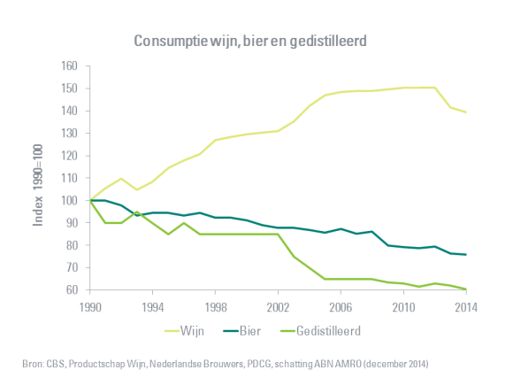
(Driessen & Morren, 2015)
After years of increase the wine consumption remain steady during the financial crisis at 21,8 Litres per capita. In 2013 it decreased to 20.5 litres as a result of the tax increase for alcoholic beverages. According to the ABN AMRO Bank the consumption will decline to 20 litres in 2014 en for this year it will remain at the same amount. After that, there will be a slight increase although that depends on the consumer purchasing power. In comparison with other countries, the Dutch are average in wine consumption. The Dutch consumer has a wide variety of wine to choose from. The best known European wine producing countries like France, Spain and Italy are most popular on the Dutch market, with France as the leader with a market share of 31%. Wine from outside Europe is increasing their market share every year. These so called “new wine countries” are Chile, Australia and South Africa. South Africa has the highest market share: 20% of countries outside of Europe and even higher than countries like Spain and Italy.
Figure 4.2 origins of wine according to the Dutch wine consumption
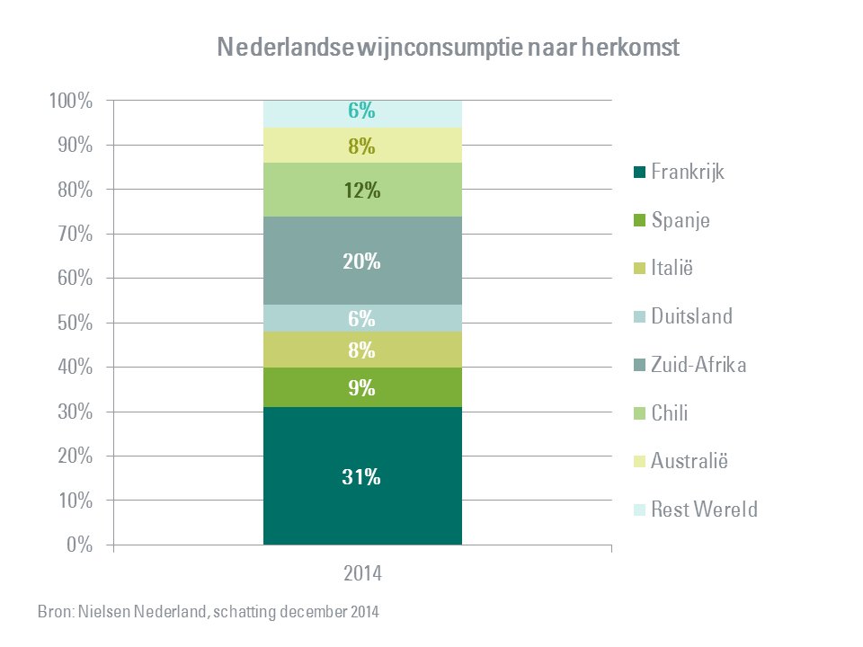
(Driessen & Morren, 2015)
In the figure below the consumption of Dutch consumers is shown. The Dutch prefer to consume wine that is of a lower price range. White, red and rosé wine, of a lower price range, has a market share of 66% combined. Red wine is the most popular wine with a market share of 44%, white wine has a market share of 29% and rosé 11%. White wine is less popular because it is consumed more in the summer and with fish dishes.

Figure 4.3 wine consumption by origin
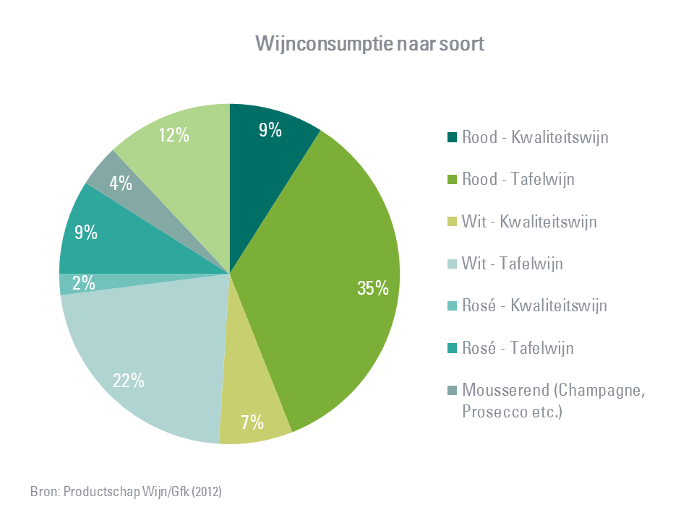
(Driessen & Morren, 2015)
66% of the wine is purchased in the supermarket and 22% in the liquor stores. This is corresponding with the previous fact that wine of a lower price range is more popular. This wine is more positioned in the supermarkets than in the liquor stores where wine of a higher quality value is positioned. Internet sales are becoming more popular as well, although they still have a low market share of 5%. (Driessen & Morren, 2015)

According to Nielsen consumers in the Netherlands drink 2-3 glasses of wine every two weeks. The consumption moments that are most common are dinner with friends or family and holidays. The most rare moment to consume wine is home alone. It was already mentioned earlier that the supermarket is the most popular segment to purchase wine. There is a difference between male and female. Females prefer the supermarket to buy their wine and men prefer the liquor store, wholesale, the Internet and the wine shop more in comparison to females. This fact can conclude that men are keener to spend more for quality wine than females. (Heiser, 2011)

DESTEP Analysis

The purpose of the DESTEP analysis is to give an overview of the demographic, economic, social, technological, ecological and political/legal factors of a landscape. This analysis is part of the external analysis of a report like an import policy plan. The research of the external environment of an organisation provides an organisation useful information about the threats and opportunities. Because the ecological environment is not relevant in the area of wine, it will not be discussed in this analysis.

5.1 Demographic analysis

Nowadays the Dutch try to take care of their health. Wine is being associated as a more healthy drink than other alcoholic beverages. This is a possible result of the increasing demand of wine in the last years, compared to beer or other alcoholic beverages. The growing popularity of wine can be seen below in figure 5.1. The last 20 years the wine consumption per capita increased 1,5 times. In comparison, the popularity of beer consumption slightly decreased and the popularity of spirits decreased with more than 50%.
Figure 5.1 alcohol consumption per capita.
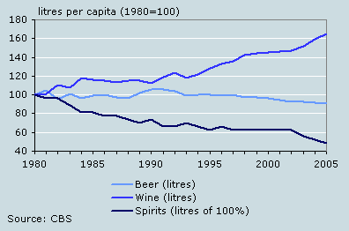
(Duimelaar, 2007)
There is a large difference in the kind of places where wine is consummated. According to a research of the ABN AMRO Bank, the least popular occasions for wine consumption are festivals, clubs and bars. Almost half of the interviewed participants declared never to drink wine in these places. On the other hand, more than 80% of the interviewed participants drink wine in restaurants. (Driessen & Morren, 2015)
In the Netherlands there is a demographic development where the larger part of the population will consist of elderly people. According to a research by the Rabobank, 40% of the restaurant guests are people between 50-64 years old. (Rabobank, 2015). This is positive for the wine industry/consumption in the Netherlands. The reason for this is that in the upcoming years the larger part of the inhabitants of the Netherlands will consist of elderly people. This demographic development can be seen in the figure below where the median age of the inhabitants is 42 years old.
Figure 5.2 demographic age structure Netherlands
0-14 years | 16.9% (male 1,460,234/female 1,393,766)
15-24 years | 12.2% (male 1,046,323/female 1,006,114)
25-54 years | 40.4% (male 3,423,777/female 3,399,378)
55-64 years | 12.9% (male 1,088,860/female 1,094,574)
65 years and over | 17.6% (male 1,331,258/female 1,633,067) (2014 est.)
Median age | total: 42.1 years  male: 41.2 years  female: 42.9 years (2014 est.)
(CIA, 2015)

5.2 Economic analysis

The Netherlands, the sixth largest economy in the euro-zone, is an open economy which is mainly relying on its foreign trade. This is due to the fact of its geographical location as a transportation hub. The port of Rotterdam serves as a primary entry point for goods to Europe. The Dutch economy rests on strong foundations of economic freedom. The property rights and investments regimes are the second freest in the world. The most developed industrial sectors are the machinery and equipment industry, chemicals, fuels and food processing industry. However, the service industry accounts for 74.8% of the national income.
The Dutch economy is recovering after the economic crisis. After a growth of 0,75% in 2014, the outlook in 2015 is a growth of 1,5%. The result of the growth is the increasing household consumptions and company investments. For the first time in years the Dutch household consumption increased above the average level of European household consumption. In the figure below the consumer confidence in the last years is displayed. During the crisis the consumer confidence in relation with the consumption decreased. Since mid-2013 this phenomenon changed and the consumer confidence increased.

Figure 5.3 consumer confidence
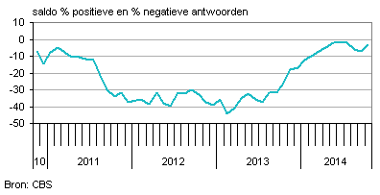
(CBS, 2014)

5.3 Social analysis

The Hofstede Centre is used as a tool to compare the Dutch with the Croatians on six key factors related to social/cultural environment. These six key factors are power distance, individualism, masculinity, uncertainty avoidance, long term orientation and indulgence. (The Hofstede Centre, 2015)
Power distance is defined as the extent to which the less powerful members of institutions and organisations within a country expect and accept that power is distributed unequally. The Netherlands score low on this factor (38) which means that the Dutch are: independent, stand for equal rights, superior accessibility, hierarchy for convenience only. Power is decentralized and managers count on the abilities of their employees. Attitude towards managers are informal. Contrary to the Dutch, Croatians have a score of 73 which means that there is a high hierarchic level and power is centralized. The attitude towards managers is formal.
Individualism is the degree of interdependence a society maintains among its members. It has to do with whether people define their self-image as “I” or “We”. In individualistic societies people are supposed to look after themselves. In collectivist societies people belong to “groups”. The Netherlands is a very individualistic country (score 80) and Croatia a collectivistic country (score 33).
Masculinity is the fundamental issue here is what motivates people, wanting to be the best (masculine) or liking what you do (feminine). A masculine society means that people are driven by success and competition. Success means in this way being the best/winner in a certain field. A feminine society means that people are caring for the other and the quality of life. The Netherlands is a feminine society (score 14), which means that decision making is made through involvement, managers strive for consensus and conflicts are being resolved through compromise and negotiation. Croatia is a more masculine society with a score of 40.
Uncertainty avoidance is the extent to which the members of a culture feel threatened by ambiguous or unknown situations and have created beliefs and institutions that try to avoid these. This term has to do with the way a society deals with the fact that the future can never be known. The Netherlands has a slight preference for avoiding uncertainty (score 53). This means that in the Dutch society there is a need of rules, people are precise and punctual and security is an important fact in individual motivation. Croatia has a high preference for avoiding uncertainty (score 80)
Long term orientation describes how every society has to maintain some links with its own past while dealing with the challenges of the present and future. The Netherlands (score 67) and Croatia (score 58) score similar on this factor. This means that these two societies believe that truth depends on the situation and time. They can easily adapt to changed conditions and have perseverance in achieving results.
Indulgence is the extent to which people try to control their desires and impulses. The Dutch society (score 68) exhibit a willingness to realise their desires with regard of enjoying life. They have a positive attitude and are optimistic. In contrary to the Dutch, the Croatian society (score 33) is not very optimistic and do not have the willingness to realise their desires. (The Hofstede Centre, 2015)

5.4 Technological analysis

Technology is changing. New technological trends could be positive for companies. A technological trend that affected the world in the last decades is the Internet. The Netherlands has one the highest percentage of Internet users in the European Union. A total of 14.872.000 people have access to the Internet. This is 90% of the total inhabitants of the Netherlands. (CIA, 2015)
99% of the users in between 12-25 years have access to the Internet. 80%-90% of these users are on the Internet daily. The daily use of Internet declines in the older categories. 86% of the people in between 35-45 years use the Internet daily and in the category 45-65 years old the daily Internet use is 77%. (de Bruijn & van den Wildenberg, 2011)

5.5 Political analysis

As part of the European Union, the Netherlands implemented European rules and laws for wine. Laws concerning labelling, and packaging are described below.
Compulsory labelling rules
- wines with a protected designation of origin or geographical indication
- alcoholic strength by volume
- the provenance
- identity of the bottler or producer
- identity of the importer ( for imported wines )
- sugar content
- allergenic ingredients
- lot number
optional labelling rules
- the vintage year
- name of one or several grape varieties
- terms referring to certain production methods
(EUR-Lex, 2011)
Processed wine from organic grapes must be produced in accordance with Regulation (EC) No 834. Label references for such wine must be indicated in terms of ingredients – e.g., “Wine from grapes from organic cultivation” and may not be referred to simply as “organic wine”. Wine labels may also include claims (such as “bio-dynamic”) as long as such a term does not mislead consumers.
The Netherlands is a member of the European Union and shares the Common External Tariff regime. EU duties are charged by Customs on the CIF (cost, insurance and freight) value of the product imported into the Netherlands.
Value Added Tax (VAT) is an indirect tax on goods and services that is borne by the end consumer and applied to the value added at each stage of the supply chain. (Alcohol and Tobacco Tax and Trade Bureau, 2010)
In the table below, Productschap Wijn published the excise duties for 2014 for each type of wine.
 | 1st February 2010 (in hl) | 1st January 2013 (in hl) | 1st January 2014 (in hl)
Group A (1,2% t/m 8,5% vol)
a) still wines / other fermented beverages | € 35,28 | € 41,78 | € 44,18
b) sparkling wine / other sparkling fermented beverages | € 45,63 | € 45,63 | € 48,25
Group B (8,6% t/m 15% vol)
a) still wines / other fermented beverages containing added spirit | € 70,56 | € 83,56 | € 88,36
b) sparkling wine / other sparkling fermented beverages ( alcohol up to 13% vol.) | € 240,58 | € 240,58 | € 254,41
Group C (8,6% t/m 10% vol)
Other fermented beverages containing added spirit | € 70,56 | € 83,56 | € 88,36
Group D (10,1% t/m 15% vol)
Intermediates (including other fermented beverages with added alcohol) | € 87,14 | € 100,22 | € 105,98
Group E (above 15% vol)
a) intermediates ( Vermouth, Port, Sherry) | € 122,75 | € 141,17 | € 149,29
b) sparkling wine | € 240,58 | € 240,58 | € 254,41
(De wijnwebsite van Nederland, 2014)

5.6 Conclusion
Wine consumption in the Netherlands increased the last years in comparison with beer and spirits. The Dutch society is becoming older. Elderly people consume more wine than younger consumers. Elderly people are also more seen guest in restaurants. Guests between 50-64 years are considered 40% of the guests in restaurants. The Netherlands is the sixth largest economy in the euro-zone that mainly concentrates on its foreign trade. Main ports like the Port of Rotterdam and Schiphol airport are considered entry points for goods distributed across Europe. The Dutch economy is recovering from the financial crisis. The prediction for 2015 is a growth of 1,5%. The Dutch are considered direct and open. They are independent and stand for equality. The society is considered feministic which means that decision-making is done through involvement and consensus, where everyone is invited to give its opinion. The Netherlands has regulations implemented by European law. Regulations concerning the labelling of wine are divided into compulsory and optional rules.

Product Life Cycle and Market Segmentation

6.1 Product Life Cycle

Figure 6.1 Product Life Cycle
Turnover
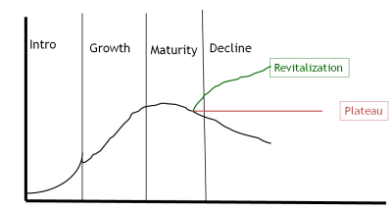Time
(Assignmentpoint, 2015)
Products often go through a life cycle. Initially, a product is introduced. Since the product is not well known and is usually expensive, sales are usually limited. However, many products reach a growth phase where sales increase dramatically. Frequently, the product will reach a maturity stage where little growth will be seen, for example with the LCD or LED televisions. Some products may also reach a decline stage, usually because the product category is being replaced by something better. For example, typewriters experienced declining sales as more consumers switched to computers or other word processing equipment. The product life cycle is tied to the phenomenon of diffusion of innovation. When a new product comes out, it is likely to first be adopted by consumers who are more innovative than others. Consumers are willing to pay a premium price for the new product and to take a risk on unproven technology. Wine is a product that is in between the maturity and decline phase of the product life cycle. This phase is called revitalization. In this phase companies need to distinguish their product from the competition. Examples of this are extra information on labels, cork cap instead of a twist cap. (Perner, 2015)

6.2 Market Segmentation
The supermarket segment is a price sensitive segment. The companies operating in this segment order large quantities and reduce logistics and delivery costs. Supermarkets have contracts with wholesalers who deliver the products to them. The supply of products to the supermarkets is done in large numbers due to the fact of lower costs. The products that are being supplied are well known in the market and they will sell themselves. Therefore, supermarket chains will not experiment with products that are unknown in the market due to higher risks. On the other hand, not every supermarket has a wide supply of wine. Albert Heijn has a wider supply of wines in comparison to Lidl. This is because Albert Heijn is focused on the wide and deep range of not only wines, but on their whole supply. It has several different options for every product, varying from the lower segment to the high segment. Chardonnay, Merlot and Riesling are wines that are common to be seen in Albert Heijn. On the other hand, Lidl is more focused on the lower segment of the products. Supermarkets sell their products in the cheapest matter but with a high quality range. Most of the wine product range in supermarkets is with twist caps instead of cork caps. Twist cap wine is less expensive than cork cap wine.

Liquor stores are a different segment than supermarkets. Liquor stores have a wider range of wines in several price classes. Unlike supermarkets, liquor stores do not have a main goal to sell as cheap as possible. The supply of liquor stores is done by importers and is at a much lower level than supermarkets. This is due to the fact that the storage capacity of liquor stores is much lower. That is why they have their focus on the quality of wine instead of the price. For example, in liquor stores the offer of cork caps is much higher. The decision-making is done by the owner of the liquor store. The owner decides how many of which wine will be offered in the store. The goal is to offer a wide range of wines that have a high quality and distinctiveness.

Although Internet wine stores are similar to the liquor stores, they differentiate themselves in their product range. The Internet wine stores offer wine that is unknown and cannot be purchased in supermarkets or liquor stores. Like in the previous two segments the decision-making is centralized and done by the owner. The delivery is done by importers that are in close range of the owner. This is due to the fact that the owners do not have a large storage. Because the Internet wine stores offer wine of high quality and wine that is unknown and hard to purchase, the prices are higher than in the supermarkets and slightly higher than in the liquor stores.

6.3 Conclusion
Wine is a product that is in the maturity phase of the product life cycle. To be more specific, it is in the revitalization phase. This means that slight innovations can make the difference for the product. Because wine is not a product that will not be out of stock or disappear from the market, it will not end up in the decline phase of the product life cycle. Supermarkets, liquor stores and Internet wine stores are the three most important segments for Croatian wine. The goal of the supermarkets is to purchase wine as cheap as possible whereas liquor stores and Internet wine stores purchase wine of a high quality.

Industry- Competitive Analysis
Porter’s five forces analysis is a framework that analyzes the level of competition within an industry and business strategy development. The five forces that are being discussed below are: Threat of substitute products, Threat of new entrants, Intensity of competitive rivalry, Bargaining power of suppliers and Bargaining power of buyers. In this report the new entrants, existing, firms and buyers can be identified in a particular case. The supermarkets, liquor stores and Internet stores are the retailers in the business. They are also the distributors of wine to the customers. In this analysis the retailers will be described as the buyers and the existing firms in the market.

7.1 Threat of substitute products
Porter’s threat of substitute products is the availability of a product that the consumer can purchase instead of the industry’s product. A substitute product is a product from another industry that offers similar benefits to the consumer as the product produced by the firms within the industry. The substitutes for wine in the Dutch market are beer and spirits. As already mentioned before in this report, wine is becoming more popular in the Netherlands. Although beer is still the most popular beverage, its consumption is declining which can be seen in the figure below. A reason for this trend could be the factor of aging in the Netherlands. The median age of the Dutch is increasing. As already mentioned before in this report, elderly people drink more wine in comparison to younger people. They go out more to have dinner and during dinner wine is often consumed. On the other hand, the Dutch tend to have a healthy lifestyle. In this context, wine is healthier than beer.
Figure 7.1 Consumption of beverages
Year | Beer | Wine | Spirits(litres pure alcohol) | Total(liters pure alcohol)
1990 | 87,7 | 14,5 | 1,98 | 8,1
1991 | 88,5 | 15,3 | 2,02 | 8,2
1992 | 90,2 | 15,9 | 1,90 | 8,2
1993 | 85,2 | 15,2 | 1,88 | 7,9
1994 | 86,0 | 15,7 | 1,77 | 7,9
1995 | 85,8 | 16,6 | 1,74 | 8,0
1996 | 85,5 | 17,1 | 1,76 | 8,1
1997 | 86,3 | 17,5 | 1,72 | 8,2
1998 | 84,2 | 18,4 | 1,66 | 8,1
1999 | 84,2 | 18,6 | 1,68 | 8,2
2000 | 82,4 | 18,8 | 1,68 | 8,2
2001 | 80,5 | 18,9 | 1,71 | 8,1
2002 | 79,8 | 19,0 | 1,66 | 8,0
2003 | 79,5 | 19,6 | 1,50 | 7,9
2004 | 79,4 | 20,6 | 1,37 | 7,9
2005 | 78,1 | 21,3 | 1,29 | 7,9
2006 | 79,4 | 21,5 | 1,28 | 7,9
2007 | 77,5 | 21,6 | 1,29 | 7,8
2008 | 78,5 | 21,6 | 1,29 | 7,9
2009 | 72,8 | 21,7 | 1,27 | 7,5
2010 | 72,0 | 21,8 | 1,26 | 7,5
2011 | 71,7 | 21,8 | 1,23 | 7,4
2012 | 72,3 | 21,8 | 1,26 | 7,5
2013 | 69,6 | 20,5 | 1,22 | 7,2
(Nederlands Instituut voor Alcoholbeleid, 2015)

7.2 Threat of new entrants
The threat of new entrants in the wine market is at a low level. There are several reasons for that. The first reason is the climate. Wine production is only suitable for a typical climate. This climate includes a high level of sunshine and a certain amount of rainfall. In order to make good wines, grapes should be grown in moderate, temperate climates. Winters must be mild enough to avoid damaging grapes, and summers must be warm enough in order to ripen them sufficiently. At the same time, if summers are too hot grapes will over ripe as well as be unable to retain their acidity. Wine grapes need at least 1400 hours of annual sunlight during the growing season. On the other hand, grapes need no less than 22 annual inches of precipitation to survive. Another reason that there is no threat of new entrants in the wine market is the economic and technological innovations in the production of wine. To be competitive on the Dutch wine market, the amount of production needs to be at a high
level. Only certain countries have the production and natural resources to produce wine for other countries, in this case for the Netherlands. (Calwineries, 2015)

Figure 7.2 Imported wine by country
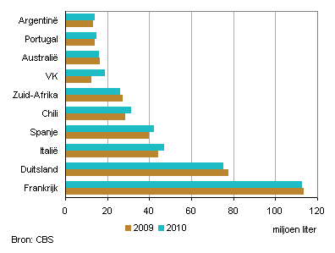
(Packbier & Ghianni, 2011)

7.3 Bargaining power of customers
In this part the bargaining power of customers will be explained. This will be done according to the three segments that have been chosen earlier in this report: supermarkets, liquor stores and Internet stores. The bargaining power of supermarkets is high. There are two reasons for this phenomenon. Supermarkets order large quantities from their suppliers to reduce costs. They can do this because they have enough storage. Because they order large amount of products, the suppliers depend on them. Suppliers need to keep satisfying the supermarkets in order not to lose them as their customer. This trend gives the supermarkets a high bargaining power. Liquor stores have a smaller bargaining power in comparison to the supermarkets. The main reason for this is that liquor stores offer wine that is from a high quality and thus more expensive. Liquor stores order smaller quantities of wine from their suppliers. This decreases their bargaining power towards suppliers because suppliers tend to switch easier to other customers that will order larger quantities. The combination of quality and price is important for liquor stores. Internet stores that offer wine have a low bargaining power. The first reason for this is that the Internet stores need to differentiate themselves more from liquor stores and supermarkets. They do that by offering unique wines. Unique in this matter could be a high quality wine that is in a higher price segment or wine that is rare in the market. That is why online stores order their wines on demand and that means in small quantities. Another reason that makes the bargaining power of online stores low is the fact that they seek to have suppliers that are in their geographical region to ensure a fast delivery and suppress the costs.

7.4 Bargaining power of suppliers
Suppliers in the Dutch wine market can be divided in two parts: importers and wholesalers. The importers are mainly focused on the liquor stores and the online stores. The wholesalers are focused on the supermarkets.
According to the KNVW (Royal Association of Dutch Wine Traders) there are more than 100 importers in the Dutch wine market. They have a high bargaining power towards liquor stores and Internet stores. The reason for this is the unique selling product and the small amount of orders of these two segments. On the other hand, there are a lot of importers active in the market. If the liquor stores/Internet stores do not agree with the price of a certain supplier, they can easily switch to another supplier. This makes the bargaining power of the supplier low. Wholesalers have to deal with a certain amount of supermarket chains in the Netherlands. In the figure below their market share is displayed.
Figure 7.3 Market share of supermarket chains
2007 | 2008 | 2009 | 2010 | 2011 | 2012 | 2013 | 2014
Albert Heijn | 29.5 | 31.3 | 32.8 | 33.6 | 33.5 | 33.7 | 34.0 | 34.1
C1000 | 14.3 | 13.2 | 11.7 | 11.5 | 12.1 | 12.0 | 9.5 | 5.8
Jumbo | 4.4 | 4.8 | 4.9 | 5.5 | 7.4 | 9.6 | 11.2 | 14.0
Jumbo Groep | – | – | – | – | 21.8 | 21.7 | 20.7 | 19.8
Superunie | 30.0 | 30.7 | 29.6 | 29.6 | 29.2 | 29.0 | 28.8 | 29.0
Coop | 2.4 | 2.5 | 2.4 | 2.5 | 2.6 | 2.7 | 2.8 | 2.9
Deen | 1.9 | 1.9 | 1.9 | 2.0 | 2.0 | 2.0 | 2.0 | 2.1
Detailconsult | – | – | – | 4.2 | 3.9 | 3.7 | 3.7 | 3.8
Dekamarkt | – | – | – | – | – | 1.9 | 1.9 | 1.9
Hoogvliet | 1.9 | 1.9 | 1.9 | 2.0 | 2.0 | 2.1 | 2.1 | 2.1
Jan Linders | 1.0 | 1.0 | 1.0 | 1.0 | 1.0 | 1.0 | 1.0 | 1.0
Plus | 6.0 | 6.1 | 6.0 | 6.0 | 5.9 | 5.8 | 5.8 | 5.9
Poiesz | 0.9 | 0.9 | 0.9 | 1.0 | 1.0 | 1.0 | 1.0 | 1.0
Spar | 1.9 | 2.2 | 2.3 | 2.2 | 2.1 | 1.9 | 1.8 | 1.7
Vomar | – | 1.6 | 1.7 | 1.7 | 1.6 | 1.6 | 1.6 | –
Aldi | 8.9 | 8.5 | 8.3 | 7.9 | 7.9 | 7.6 | 7.4 | 7.4
Lidl | 4.0 | 4.8 | 5.4 | 5.6 | 6.7 | 7.5 | 9.0 | 9.7
Overig | 1.5 | 0.7 | 0.8 | 0.8 | 10.6 | 0.6 | 0,5 | –
(Distrifood)
Wholesalers have to compete for their market share to supply the main supermarkets. This makes the wholesalers very dependent. Supermarkets rely on cheaper and standard wines instead of unique and more expensive wines. They order large amounts and this makes the bargaining power of wholesalers low.

7.5 Intensity of competitive rivalry
The intensity of competitive rivalry of the three segments is at a different level. As already mentioned, supermarkets are focused on the price of wine. Although they sell wines at a cheaper price range, they compete with each other on several ways. For example, Albert Heijn has a wide price range with a lot of different wines. On the other hand, Lidl has their focus on the lowest price and even sells wine that is not packaged in bottles. The liquor stores and online stores are focused on the quality of the wine. They offer wine on the market that cannot be found in supermarkets.
(Koninklijke Vereniging van Nederlandse Wijnhandelaren, 2015)

7.6 Conclusion
The substitutes for wine are beer and spirits. The consumption of beer is decreasing last years, whereas the consumption of wine is increasing. A possible fact for this is the aging of the Dutch population. Elderly people prefer to drink more wine than other alcoholic beverages. The threat of new entrants in the Dutch wine market is at a low level. Wine can only be produced due to a certain climate with at least 1400 hours of sunshine and annually 22 inches of precipitation. Supermarkets have a larger bargaining power towards suppliers than liquor stores and online stores. This is because of the larger amounts supermarkets purchase. Liquor stores and online stores need to differentiate themselves from the supermarkets. They offer wine of a higher quality and wine that is unknown on the market.

SWOT Analysis + Confrontation matrix

A SWOT analysis is being made to determine the strength and weaknesses of an organisation. The opportunities and threats illustrate the environment where the organisation is operating in or will be operating in.

8.1 SWOT Analysis
Internal | External
Strengths | Opportunities
S1 Climate Conditions | O1 booming tourism in Croatia
S2 Production of quality wine | O2 Membership in International Organisations
S3 High quality indigenous varieties of grapes | O3 Possibility of using financial EU resources
S4 Favourable geographical locations for viticulture | O4 Dutch wine market
Weaknesses | Threats
W1 International experience | T1 Competition
W2 Weak institutional basis (no cooperation with food producers) | T2 low scale of production capacity
W3 More reliant on domestic markets | T3 lack of designed governmental programs for encouragement of wine export

8.2 Confrontation matrix

 | O1 | O2 | O3 | O4 | T1 | T2 | T3 | + | - | Total
S1 | + | + | + | 0 | 0 | 0 | 0 | 3 | - | 3
S2 | + | + | + | 0 | - | 0 | 0 | 3 | 1 | 2
S3 | + | 0 | 0 | 0 | + | - | 0 | 2 | 1 | 1
S4 | + | 0 | + | 0 | 0 | - | 0 | 2 | 1 | 1
W1 | - | 0 | 0 | - | - | - | 0 | - | 4 | -4
W2 | 0 | 0 | 0 | 0 | - | - | 0 | - | 2 | -2
W3 | 0 | 0 | 0 | - | 0 | 0 | 0 | - | - | -
+ | 4 | 2 | 3 | 0 | - | - | -
- | 1 | - | - | 2 | 3 | 4 | -
Total | 3 | 2 | 3 | -2 | -3 | -4

S1/O1 Invest: The climate conditions in combination with the annually growing tourism makes the Croatian wine more popular. Tourists prefer to drink Croatian local wine on their vacation. The combination of a high amount of sunshine hours and a low percentage of rainfall makes the climate suitable for the production of wine.
S3/T1 Defend: Croatia produces good quality red (coastal area) and white (inland area) wine. Hereby it can distinguish itself from the competition. Most of the competitors are specialised on red or white wine.
O1/W3 Develop: The annually growing tourism could change the view of the Croatian producers to start think more internationally and take the risks to export their wine abroad.
T2/W1 Avoid: The production of wine in Croatia is at a much lower level than the production of the competitors. The annual production of local wine producers has to grow to compete on the Dutch wine market.

8.3 Conclusion
The strategic option Croatian producers need to use to enter the Dutch market is market penetration. Wine is an existing product which will be penetrated into a existing wine market, which is the Dutch wine market. To ensure this marketing has to have a leading role in the process. Croatian wine producers need to organise events for Dutch wineries, wine experts and sommeliers and for the representatives of the three market segments to make the Croatian wine known.

Import Marketing Mix

9.1 Price

To determine the price of the imported wine the costs need to be known. Because Croatia is part of the European Union, there are no import tariffs that need to be calculated into the price. Below a calculation is made for a famous Croatian red wine named Plavac mali Bonaparte.
Plavac Mali Bonaparte
- price of a 1 litre bottle in Croatia is 66,64 Kuna (Croatian currency)
- alcohol volume 14%
- the excise duty for this wine is 88,36 Euro in hectolitre.
(Bonaparte Plavac Mali, 2015)
Group B (8,6% t/m 15% vol)
a) still wines / other fermented beverages containing added spirit | € 70,56 | € 83,56 | € 88,36
(De wijnwebsite van Nederland, 2014)
The price of one bottle Plavac mali is 66.64 Kuna. According to the latest currency, one bottle is €8.79. To determine the profit of one bottle a financial analysis is made below. This financial analysis is made by the experience and knowledge of a Dutch wine importer named Ramon de Koning. The excise duty, together with the VAT are the only numbers that are known for know. The other numbers are determined by the knowledge of Mr. De Koning. The costs of the bottle includes the bottle, labelling and the filling of the bottle and will be set at €0,60. The transport costs and the margin of the supermarket/liquor store/Internet store will be set at a minimal value. The margin will be 30% and the transport costs will be €0,20.
Gross: €8,79
VAT 21%: €1.85 €6,94
margin stores: €2,64 €4,3
excise duty: €0,88 €3,42
transport: €0,20 €3,22
bottle costs: €0,60
Total costs: €6.17
Net profit: €2,62
The wine producer will earn €2,62 euro for one litre bottle of Plavac mali.
(de Koning, 2014)
Figure 9.1 Currency
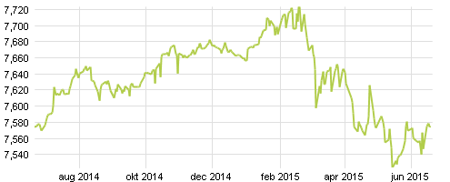
(Valuta, 2015)

9.2 Product
As already mentioned, there is a difference in the Dutch wine market between supermarkets, liquor stores and Internet stores. Liquor stores and Internet stores demand wine from a high quality and unique wines. For supermarkets the price is more important. The product should be attractive. The information on the labels should be in English and need to have a story about the origin of the wine. Attractive labelling is desired because this is the first contact of the customer with the wine. For the Dutch market it is not necessary to change any specification on the label of the Croatian bottle due to the Croatian membership in the European Union.

9.3 Place
It is hard for an unknown wine to enter the three segments on the Dutch market. The supermarket is the most difficult segment to enter. Liquor stores and Internet stores are more keen to purchase unknown wine that is of an high quality and unique for the Dutch market. Croatian producers should make a connection with agents in the Netherlands. These Dutch import agents should start visiting liquor stores in the main cities of the Netherlands, such as Amsterdam, Rotterdam and the Hague. During their visits the import agents should explain what the added value of the Croatian wine can be in relation to the product range of the liquor store. To achieve this, promotional strategies should be implemented to make the Croatian wine more recognizable for the Dutch market. The different channels could also be convinced with brochures that outline the quality of the Croatian wine.

9.4 Promotion
Croatia is becoming more popular as a tourist country. Every year more Dutch are spending their vacation on the Croatian coast and are getting to know the Croatian wine. This is a kind of promotion that needs to expand. Croatian wine producers have to organize tasting events for Dutch sommeliers and import agents not only in Croatia but also in the Netherlands.

9.5 Distribution policy

9.5.1 Distribution
The first stage of distributing wine is at the start of the producer. After producing, the wine goes via the importer/wholesaler to the retail business. The retailer finally delivers the wine to the end consumers. In certain cases, some of the distribution channels are being selected. For example, when a wine producer directly offers the wine to a retailer or when an end consumer directly purchases its wine at the wholesaler. According to the Royal Association of Wine Traders there are more than hundred wine wholesalers and import agents. As already mentioned, there is a difference between supermarkets on one side and liquor stores/online stores on the other side. Supermarkets purchase their wine from wholesalers. Because supermarkets order their quantities in large amounts they have contracts with wholesalers to deliver the product within a certain timeframe. Price policy is another important aspect why supermarkets have contracts with wholesalers. Because of the large quantities supermarkets gain discounts from the wholesalers. On the other hand, liquor stores/Internet stores distinguish themselves through unique and unknown products. Therefore they innovate through wines that are of a high quality and unknown to the market. For this reason they do business with several import agents. There are no contracts made between the liquor stores/Internet stores and import agents because of the changing product range of the segment group and the lower quantity of orders that are being made. (Melchior & Mosselman, 2003)

9.5.2 Conditions of delivery
EMCS
To import wine from Croatia to the Netherlands the EMCS system is developed. It is an automated system for the transport of excisable goods with community status within the European Union. The excise tariffs are different in member states of the European Union. The excise duty must be paid according to the excise tariff of the member state where the excise goods will be consumed and to the member state where the goods will be consumed. Therefore, Customs of the member states must be informed of the transit of excise goods between the member states of the European Union. The European Union developed the Excise Movement and Control System (EMCS) to monitor the transport of excise goods between the member states by using a computerised system. (Belastingdienst, 2015)
Bill of Lading
Bill of lading is a document between the shipper of a particular good and the carrier detailing the type, quantity and destination of the good being carried. This document must accompany the shipped goods, no matter the form of transportation. It must be signed by an authorized representative. This representative must be from the carrier, shipper and the receiver. (Investopedia, 2015)

9.6 Conclusion

Because Croatia is member of the European Union, no changes on the specifications on labelling are necessary. To enter the Dutch market, Croatian producers should have agents that investigate the market for them. These agents need to make contact with liquor stores to explain the added value of Croatian wine. In the Netherlands there are more than hundred wholesalers and import agents active for the wine market. Wholesalers are focused on the supermarkets and import agents on the liquor stores/online stores. This differentiation has to do with the amount of purchasing products. When exporting wine from Croatia to the Netherlands two major transport documents are needed: EMCS and Bill of Lading. EMCS is an automatic system designed by the EU to calculate the excise duty that needs to be paid.

Conclusion

The central question that is formulated for this final thesis was:
Which Import Policy Plan, for local Croatian wine, can be used to enter the Dutch market in 2016?
To answer this question an investigation about the Dutch wine consumer market is conducted. The wine consumption of the Dutch increased the last twenty years. Beer is still the most purchased beverage in the Netherlands, but its consumption is decreasing. 66% of the wine that is being purchased in the Netherlands is bought in the supermarkets. The supermarkets have a wide product range of wines for an affordable price. 22% is bought in the liquor stores. Liquor stores do not have a wide range like the supermarkets and the prices are higher. Also, online sales of several products are increasing in the Netherlands. 5% of the wine is purchased online.
Comparing the Dutch with the Croatian social/cultural environment it can be said that they differ from each other. A research conducted by the Hofstede Centre reveals that the two nations scored similar on the long-term orientation. This means that they can easily adapt to changed conditions.
Because Croatia is a member of the European Union and has already implemented EU rules for the production of wine, they do not have to change their production process. On the other hand, there are national rules that differ from the EU rules. An example of this is the excise duties and the VAT (Value Added Tax). Regulations concerning the labelling of wine are divided into compulsory and optional rules.
Wine is a product that is in the revitalization phase of the product life cycle. This means that slight innovations can make the difference for the product. An example of this is cork caps instead of twist caps. The supermarkets, liquor stores and online stores are the three key segments where Croatian producers need to be focussed on when entering the Dutch market. The supermarkets have a wide range of wines. They are focused to purchase their wine as cheap as possible. Liquor stores are more focused on the quality of wine, which makes the price of the wine more expensive. Online stores are focused on qualitative and unique wines.
Wholesalers and import agents are the distribution channels that should be used to enter the Dutch market. Wholesalers are focused on the supermarkets because they purchase large quantities. This is possible because of the large storage facilities supermarkets have. Liquor stores and online stores are focused on import agents. This is because of the distinguished product range the import agents have.

11. Recommendation

Croatia is a country with a booming tourism industry in the last decade. More Dutch are spending their vacation on the Croatian coast and tasting Croatian wine. Unfortunately, the Croatian producers are more focused on the domestic market. The reason for this is the production capacity. The production capacity is not at a high level to compete on the Dutch market. Since 2013 Croatia is a member of the European Union. This means that exporting wine to other countries inside the EU is easier and this could be an opportunity to increase the production capacity. Croatian wine has been awarded for having good quality and unique wine. One of the publications of Croatian wine was in the Wine Enthusiast Magazine, one of the leading magazines concerning wine. (Desimone & Jenssen, 2011)
Concerning the Croatian producers, the following recommendations are proposed: Increase the production capacity to compete on the Dutch market; organize tastings during the summer season for Dutch tourists; participate in European funding programs concerning the wine market; organize wine fairs and invite Dutch wine experts and sommeliers; make contact with the Croatian embassy in the Hague to organize a wine event in the Netherlands.
As already mentioned, three market segments dominate the Dutch wine market: Supermarkets, liquor stores and online stores. Online stores are focused on wine of good and unique quality. I recommend to first contact online stores with the help of import agents. Because Croatian wine is not available on the Dutch market the first step to enter the market needs to be a smart and reasonable choice. Online stores purchase small quantities. They avoid risks and want to have a better insight in the potential growth of the product. Does Croatian wine has a future in the Dutch market? Liquor stores are also a good option, because they purchase also small amounts of the product to determine if it can be a success.
Recommendations concerning the market segments are: To select local distributors in Amsterdam, Rotterdam and The Hague, who do not have a large customer list. This is due to the fact that a distributor with a large customer list can compete with the competitors very well., to organize tastings within the Netherlands at the liquor stores, to develop long term relationships with the Dutch distributors. Because Croatian producers are new in the Dutch market, it is better to have a long term strategy to establish Croatian wine in the Dutch market.
Finally a further research is recommended. The Croatian wine producers should conduct an other research on the question how to penetrate the Dutch wine market in the future. Which target group in Holland is specifically interested in the Croatian wine?

References

Alcohol and Tobacco Tax and Trade Bureau. (17th August 2010). International Affairs Division. Retrieved May 8, 2015, from the Netherlands website: http://www.ttb.gov/itd/netherlands.shtml
Assignmentpoint. (2015). Mc Donald's Strategic Marketing Mix. Retrieved June 2, 2015, from the Assignmentpoint website: http://www.assignmentpoint.com/business/mcdonalds-strategic-marketing-mix.html
Belastingdienst. (2015). Excise Movement and Control System. Retrieved June 19, 2015, from the Douane website: http://www.belastingdienst.nl/wps/wcm/connect/bldcontenten/belastingdienst/customs/excise_duty_and_consumer_tax/excise_movement_and_control_system_emcs/emcs_clusterpagina
Bonaparte Plavac Mali. (2015). Retrieved June 19, 2015, from the Vrutak website: http://www.vrutak.hr/product.aspx?c=0&p=411735
Calwineries. (2015). Climate. Retrieved June 14, 2015, from the Calwineries website: http://www.calwineries.com/learn/grape-growing/climate
CBS. (2014, October 20). Retrieved May 7, 2015, from the CBS website : http://www.cbs.nl/en-GB/menu/themas/inkomen-bestedingen/publicaties/artikelen/archief/2014/2014-10-20-m10.htm?Languageswitch=on
CIA. (2015, April 10). The World Factbook. Retrieved April 21, 2015, from the CIA website: https://www.cia.gov/library/publications/the-world-factbook/geos/nl.html
Croatian Fine Wines. (2015). Croatian Wine Regions. Retrieved April 19, 2015, from the Croatian Fine Wines website : http://www.croatianfinewines.com/index.php/croatian-wine-list/wine-regions-of-croatia.html
de Bruijn, D., & van den Wildenberg, E. (2011). De verkoop van alcohol via internet. Het Nederlands Instituut voor Alcoholbeleid. Utrecht: Ministerie van Volksgezondheid, Welzijn en Sport.
de Koning, R. (2014). Kosten van een fles wijn. Retrieved June 19, 2015, from the Wine2Buy website: http://www.wine2buy.nl/kosten-van-fles-wijn.html
De wijnwebsite van Nederland. (2014, January 1). Accijnstarieven. Retrieved May 10, 2015, from Wijn.nl website : http://wijn.nl/onderzoek-en-regelgeving/accijnstarieven/
Desimone, M., & Jenssen, J. (2011). Croatia in living color. Retrieved June 15, 2015, from the Wineenthusiast website : http://www.winemag.com/Web-2011/Croatia-in-Living-Color/
Distrifood. (n.d.). Marktaandelen. Retrieved June 15, 2015, from the Distrifood website: http://www.distrifood.nl/service/marktaandelen
Driessen, S., & Morren, R. (2015). De wijnmarkt in Nederland: trends en cijfers, kansen voor de horeca. ABN AMRO. ABN AMRO.
Duimelaar, P. (2007, June 28). Alcohol consumption youth and over-65s at the same level. Retrieved April 22, 2015, from the CBS website : http://www.cbs.nl/en-GB/menu/themas/gezondheid-welzijn/publicaties/artikelen/archief/2007/2007-2216-wm.htm
EUR-Lex. (2011, February 18). wines and wine sector products. Retrieved May 8, 2015, from the EUR-Lex website: http://eur-lex.europa.eu/legal-content/EN/TXT/?qid=1431536823008&uri=URISERV:sa0026
Food and Wine. (2015, February 20). Retrieved May 18, 2015, from the Chaniapost website: http://www.chaniapost.eu/2015/02/20/15th-international-wine-competition-in-thessaloniki/
Heiser, D. (2011, Maart). Inzicht in de Shopper van Wine. Retrieved April 13, 2015 from Productschap Wijn: http://wijn.nl/lmbinaries/presentatie_inzichten_in_de_wijn_shopper_dewy.pdf
Investopedia. (2015). Bill od Lading. Retrieved June 19, 2015, from the Investopedia website: http://www.investopedia.com/terms/b/billoflading.asp
Jenssen, J. (2014, April). Croatian Wine on the Rise. Retrieved May 8, 2015, from the Wine Enthusiast Magazine website: http://www.winemag.com/April-2014/Crazy-for-Croatia/
Koninklijke Vereniging van Nederlandse Wijnhandelaren. (2015). Ledenlijst. Retrieved June 16, 2015, from the Koninklijke Vereniging van Nederlandse Wijnhandelaren website: http://www.kvnw.nl/KVNW_de_organisatie/leden.php
Melchior, C., & Mosselman, M. (2003). de Slijters-Checklist. Hoofdbedrijfschap Detailhandel. Den Haag: Hoofdbedrijfschap Detailhandel.
Misir, A. (2014). Wine Report. American Embassy, Foreign Agricultural Service, Zagreb.
Nederlands Instituut voor Alcoholbeleid. (2015). Feiten en Cijfers. Retrieved June 14, 2015, from the STAP website: http://www.stap.nl/nl/home/feiten-en-cijfers.html#Alcoholconsumptie
Packbier, W., & Ghianni, R. (2011, September 29). Wine imports 4 percent up in 2010. Retrieved June 15, 2015, from the CBS website: http://www.cbs.nl/en-GB/menu/themas/internationale-handel/publicaties/artikelen/archief/2011/2011-3480-wm.htm?Languageswitch=on
Perner, L. (2015). Introduction to marketing. Retrieved June 2, 2015, from the USC Marshall website: http://www.consumerpsychologist.com/marketing_introduction.html
Rabobank. (2015). Restaurants. Retrieved April 21, 2015, from the Rabobank website: https://www.rabobankcijfersentrends.nl/index.cfm?action=branche&branche=Restaurants&p=8
The Hofstede Centre. (2015). Croatia in comparison with the Netherlands. Retrieved April 19, 2015, from The Hofstede Centre website: http://geert-hofstede.com/croatia.html
Valuta. (2015, June 19). Koers Kroatische Kune. Retrieved June 19, 2015, from the Valuta website: http://www.valuta.nl/kroatische_kuna
Veldman, H. (2009). Export Management. Groningen: Noordhoff Uitgevers B.V.

Appendix

13.1 Appendix 1: Wine import in hectoliters

EUROPESE UNIE | 2008 | 2009 | 2010 | 2011 | 2012
België | 99.611 | 119.425 | 138.792 | 149.126 | 151.103
Bulgarije | 1.817 | 400 | 579 | 253 | 1.088
Cyprus |  | 1 | 83 | 17 | 276
Denemarken | 398 | 333 | 473 | 362 | 1.023
Duitsland | 758.055 | 836.579 | 796.610 | 699.540 | 697.669
Estland |  | 20 | 0 | 0 | 18
Finland |  |  | 6.159 | 273 | 0
Frankrijk | 1.234.725 | 1.136.266 | 1.132.338 | 1.017.396 | 1.100.396
Griekenland | 5.831 | 3.447 | 2.875 | 3.239 | 4.081
Hongarije | 879 | 344 | 149 | 90 | 91
Ierland | 6.873 | 3.461 | 19.907 | 5.237 | 6.038
Italië | 425.877 | 471.073 | 497.947 | 420.793 | 454.881
Letland | 28 | 0 | 669 | 811 | 536
Litouwen |  |  | 0 |  | 0
Luxemburg | 1.810 | 1.861 | 728 | 369 | 1.075
Malta | 37 | 56 | 132 | 393 | 149
Oostenrijk | 5.731 | 83.826 | 8.879 | 8.696 | 11.542
Polen |  | 153 | 0 |  | 101
Portugal | 112.472 | 140.819 | 148.226 | 114.906 | 101.910
Roemenië | 1 | 6 | 6 | 37 | 2.861
Slovenië | 10 | 275 | 0 | 214 | 822
Slowakije |  |  | 0 |  | 215
Spanje | 443.568 | 400.586 | 425.926 | 342.409 | 385.579
Tsjechië | 78 | 60 | 29 | 322 | 684
Verenigd Koninkrijk | 145.581 | 141.675 | 215.486 | 125.982 | 191.386
Zweden | 5 | 26 | 284 | 604 | 1.065
Overige landen |  |  | 0 | 63 | 264
Totaal EU | 3.243.390 | 3.340.691 | 3.396.277 | 2.891.130 | 3.114.856
DERDE LANDEN
Argentinië | 136.896 | 131.376 | 140.365 | 92.437 | 112.127
Australië | 175.871 | 165.495 | 163.055 | 135.055 | 142.967
Brazilië | 1.887 | 571 | 0 | 655 | 835
Chili | 263.398 | 287.056 | 314.330 | 251.708 | 362.643
China | 2.142 | 1.551 | 1.263 | 1.419 | 874
Georgië | 265 |  | 0 | 0 | 463
Israël | 1.260 | 706 | 911 | 661 | 1.051
Macedonië |  |  | 0 | 0 | 0
Marokko | 90 | 38 | 0 | 180 | 83
Mexico |  |  | 0 | 222 | 141
Moldavië |  |  | 0 | 197 | 23
Nieuw-Zeeland | 8.474 | 15.436 | 21.412 | 26.681 | 28.862
Turkije | 318 | 44 | 182 | 172 | 124
Verenigde Staten | 13.882 | 15.389 | 24.174 | 26.121 | 33.749
Zuid-Afrika | 300.117 | 273.457 | 265.071 | 249.155 | 225.517
Zwitserland | 2.017 | 291 | 0 | 279 | 599
Overige landen | 6.637 | 3.130 | 3.592 | 4.388 | 4.658
Totaal derde landen | 909.040 | 894.540 | 934.355 | 789.330 | 914.716
Totaal EU | 3.243.390 | 3.340.691 | 3.396.277 | 2.891.130 | 3.114.856
TOTAAL | 4.152.429 | 4.235.231 | 4.330.632 | 3.680.460 | 4.029.571

13.2 Appendix 2: Wine consumption per capita

1990 | 14,54
1991 | 15,34
1992 | 15,91
1993 | 15,18
1994 | 15,69
1995 | 16,57
1996 | 17,1
1997 | 17,5
1998 | 18,4
1999 | 18,6
2000 | 18,8
2001 | 18,9
2002 | 19
2003 | 19,6
2004 | 20,6
2005 | 21,3
2006 | 21,5
2007 | 21,6
2008 | 21,6
2009 | 21,7
2010 | 21,8
2011 | 21,8
2012 | 21,8
2013 | 20,5
2014 | 20,3

