Executive Summary
Nowadays, companies are facing the problem of data overload. The Internet is an environment filled in with numbers that should indicate the path for business actions. The aim of this project is to generate Digital Marketing and Measurement Model for the company that needs a hand in achieving the success in the “digital World”, RAM-Infotechnology. The model helps to identify the source or success of failure of the company website, drawing a clear connection between company’s strategy and data available in web analytics tools.
To create the model, the central question is stated: What is the set of measures that helps to identify success of failure of RAM-Infotechnology website? The answer for research main question can be given by answering the following sub-questions: What are the business objectives that RAM Mobile Data has defined for RAM-Infotechnology website? What are the goals metrics for RAM-Infotechnology website? What are the RAM-Infotechnology website targets? What are the RAM-Infotechnology website segments? The mentioned model is inspired by the work of respected and well known online marketer, Avinash Kaushik. Digital Marketing and Measurement Model posted on Kaushik’s blog became a base for the following work. The research was conducted to find the set of measurements that indicates success or failure of RAM-Infotechnology website.
Various research methods were used during the investigation. Desk research included the study of the relevant literature as well as the use different Internet sources. A great help in the model creation provided the field research. Three interviews were conducted in order to find answers for research sub-questions. At the end, sub-answers that were found allowed to build up the final conclusion.
The research resulted in finding the company´s objectives, goals, Key Performance Indicators, targets and segments. Results of the conducted research leaded directly to the following conclusions about RAM-Infotechnology website. The website objectives are: to generate leads, to create brand awareness and to highlight events. The website generates leads by capturing leads and providing resources. What is more, the awareness of the brand is achieved through reinforcing the online/offline advertising. RAM-Infotechnology website launches events that are highlighted through engaging/creating the network. Regarding the KPIs, it was found that conversion is a metric illustrating capturing leads goal. When it comes to the providing resources goal, the identified indicator was a number of downloads. To find the information about online/offline advertising the marketer that works for RAM-Infotechnology should look on a branded traffic indicator. The last metric worth mentioning is a number of subscribes to an event which show the engagement of a network created by the website. The conducted research allowed finding targets for each website KPI. Finally, for each of the website goals were identified segments. It is recommended to RAM-Infotechnology to put greater emphasis on identification of website targets and segments.

Table of contents

Executive Summary 2
Introduction 7
“Data overload” 7
Research purpose 8
Research questions 8
Research methods 9
Research methods justification 10
Desk research 10
Field research 11
Chapter 1 – Internet, potential of marketing 12
Introduction 12
“Swimming in the Digital Sea” 12
Web impact on business 12
Sub-conclusion 13
Chapter 2 - Use of Internet by RAM-Infotechnology 14
Introduction 14
Briefly about the RAM Mobile Data 14
RAM-Infotechnology 14
Internet 14
Website 15
Web analytics tools 15
Topic selection 15
Sub-conclusion 16
Chapter 3 - Digital Marketing and Measurement Model 17
Introduction 17
The model design 17
Three key areas 17
Acquisition 17
Behaviour 18
Outcomes 18
5 steps 19
Business objectives 19
Business goals 19
Key Performance Indicators 20
Targets 20
Segments 20
Sub-conclusion 21
Chapter 4 - Business Objectives 22
Introduction 22
Objective 1 - Generate leads 23
Objective 2 - Creating Brand Awareness 23
Objective 3 - Highlight events 23
Sub-conclusion 24

Chapter 5 - Goals 25
Introduction 25
Identifying Goals for each Objective 25
Goal for Objective 1– Capture leads 26
Goal for Objective 1 – Provide resources 26
Goal for Objective 2 - Reinforce online/offline advertising 27
Goal for Objective 3 – Engage/create network 28
Sub-conclusion 29
Chapter 6 - Key Performance Indicators 30
Introduction 30
Identifying KPI for each goal 31
KPIs for ‘Capture leads’ - ‘# Conversions’ 32
KPI for ‘Provide resources’ - ‘# of downloads’ 32
KPI for ‘Reinforce online/offline advertising’ - ‘Branded traffic’ 33
KPI for ‘Engage/create network’ - ‘# of subscriptions to an event’ 33
Sub-conclusion 33
Chapter 7 - Targets 35
Introduction 35
Identifying targets for each KPI 35
Target for KPI ‘Conversions‘ 37
Target for KPI ‘# of downloads’ 37
Target for KPI ‘Branded traffic’ 37
Target for KPI ‘# of subscriptions to an event’ 37
Sub-conclusion 38
Chapter 8 – Segments 39
Introduction 39
Identifying segments for each goal 40
Segments for Goal ‘Capture leads’ 42
Segment for Goal ‘Provide resources’ 42
Segment for Goal ‘Reinforce online/offline advertising’ 42
Segment for Goal ‘Engage/create network’ 43
Sub-conclusion 43
Conclusions 44
Internet, potential of marketing 44
Use of Internet by RAM-Infotechnology 44
Digital Marketing and Measurement Model 44
Set of measures 45
Business Objectives 45
Goals 45
Key Performance Indicators 45
Targets 46
Segment 46
Recommendations 48
Objectives, goals, KPIs 48
Targets 48
Segments 48
Recommended segment selection 48
References 50
Internet sources 50
Books 51
Appendices 52
Appendix 1: 52
RAM Mobile Data Services 52
RAM Mobile Data Services 52
Appendix 2: Branded traffic – keywords 53
Appendix 3: Interview, goals and objectives 54
Interview questions 54
Transcript 55
Appendix 4: Interview, targets and segments 67
Interview questions 67
Appendix 5: Interview, segments 68
Interview questions 68

Introduction

“Data overload”
It is a known fact that nowadays people live in an environment overloaded with data. This problem exists not only for individuals, also organisations have been struggling with “mountains of data” for a long time. Already in early 60’s the term “information overload” was used in Bertram Gross’s book “The Managing of Organizations” referring to business.
Today every business exists in environment filled with information. The Internet is the main channel through which a company obtains and provides information. Additionally, a modern business cannot work successfully without Internet because of market demands. Potential customers search for products and services in the Internet, constantly comparing available offers that leads to a very competitive character of the Web. (Kaushik, 2010, Introduction).
At the same time, an environment filled in with numbers, data and analysis should be the foundation of decisions taken in businesses to adapt to customers’ needs and to understand them. (Kaushik, 2010, Introduction). There is so much raw information in the Internet that it is becoming difficult for businesses to sort out what is significant and what is not (Tonkin, Whitmore, & Cutroni, 2010, Introduction).
A website comes to be a central part of company’s existence, regardless of the size of the company or its location. It has a great significance from the marketing perspective because “it is the most measurable marketing channel ever created” (Tonkin, et al., 2010. Introduction, para.5). The main research of this project is conducted around metrics the company should take into consideration to measure the success or failure of the website.
Web analytics tools are created to measure actions that are taking place in the Internet. Currently, a great number of free analytics tools are available to monitor a website performance. One of the specialists that master web analytics tools is Avinash Kaushik. He works with the largest companies in the world. On his blog placed on www.kaushik.net, he calls himself the “Digital Marketing Evangelist for Google”. Moreover, he is an author of two best sellers “Web Analytics: An Hour a Day” and “Web Analytics 2.0”.
According to Kaushik, thanks to web analytics, the company has a possibility to track every single click of every visitor of its website. However, in the world filled with data it can be difficult to choose the information that is clearly showing success of failure of the company’s website (Kaushik, 2010, Introduction).
A web analytics tool provides the informational data and online feedback on a regular basis which is a great help in following the company’s actions. Nevertheless, the really important roles in web analysis play online marketers. A successful marketer tries to make sense in the sea of existing data. Kaushik found out that the marketer begins to work with analytics tool after thinking structurally about the real purpose of the website. It is the first of five steps that leads to establishing the set of measures that aids in identifying a success of failure of the website. (Kaushik, September 15, 2011).

Research purpose
In the world overloaded with data it becomes harder and harder for a company to monitor its website performance and to actually see whether the company achieves a success with its website. All contemporary companies are facing the problem with selection the most important data (Kaushik, 2010, Introduction).
The aim of this project is to define Digital Marketing and Measurement Model for the assignment provider, RAM-Infotechnology. This model will help to identify a system of measurement reflecting the source of success or failure of the RAM –Infotechnology online strategy. The model will also provide help to the company in sorting out the most significant data by maximizing the potential of using the web analytic tools. (Kaushik, September 15, 2011) .
In order to develop the model mentioned above five important steps will be followed. These steps are universal and can be applied to every business active online and can be fulfilled with support of every web analytics tool available on the market (Kaushik, September 15, 2011).

Research questions
To create Digital Marketing and Measurement Model several research questions need to be answered. The key question of the conducted research is:
What is the set of measures that helps to identify success of failure of RAM-Infotechnology website?
Sub-questions which are stated to help in model creation are the following:
- What are the business objectives that RAM Mobile Data has defined for RAM-Infotechnology website?
- What are the goals metrics for RAM-Infotechnology website?
- What are the RAM-Infotechnology website targets?
- What are the RAM-Infotechnology website segments?

Research methods
The direction of conducted research was derived from the Digital Marketing and Measurement Model developed by Kaushik, shared in his blog post form September 15, 2011. The main aim of this research was to provide the input for RAM-Infotechnology by developing the model. The model will formulate an answer to the main question of this research: What is the set of measures that helps to identify success of failure of RAM-Infotechnology website?
Finding the answers to the sub-questions formulated for this project was essential to create the set of measures. In the beginning objectives of the company were defined. It created the framework for the further steps in defining the Digital Marketing and Measurement Model. Secondly, the set of goals of the company’s website were identified. Based on the goals website’s Key Performance Indicators (KPI’s) could be formulated. The Key Performance Indicators narrowed down the sea of data that the company was struggling with to th valuable set of metrics. Having these metrics defined the following was identifying targets. These targets provided and will provide the company in the future the insights into the company’s online strategy performance. Finally, segments for the company’s website goals were specified to understand the company’s success or failure. Those five steps were necessary to be followed to identify RAM-Infotechnology website actions success or failure. Results of research conducted in such way lead us to the final conclusion. Answers that were found for sub-questions gave the answer for the key question. In order to answer those questions, different research methods were used for each of them. Research methods used to meet the goal of the project can be seen in Table 1.

RAM-Infotechnology website
Background information | - “Web Analysis 2.0” Kaushik  - ”Performance with Google Analytics” Tonkin
What are its business its objectives? | - 1st interview with Chantal Brouwers  - The Internet
What are its goals? | - 1st interview with Chantal Brouwers  - The Internet
What are its KPIs? | - Web analytics tools  - The Internet
What are its targets? | - 2nd interview with Chantal Brouwers  - The Internet
What are its segments? | - 2nd interview with Chantal Brouwers  - The Interview with Elias Crum  - Web analytics tools  - The Internet

Table 1. Research methods used for find answers for sub-questions

Research methods justification
As it is mapped out in the table above, in order to obtain needed information, various research methods were used. Desk and field researches were conducted to find answers to the key question and sub-questions.

Desk research
Due to the feature of the chosen topic, the Internet became an important source of the collected material. The desk research included deep investigation of existing information in the Internet. As it is the place where websites exists and web analysis can be conducted. One of the more important source of data was web analysis tool. It provided the measurements that reflect website’s marketing performance. In addition, the Internet is a great source of up-to-date information on online strategies, measurements models and internet data. The focus search were valuable articles, blogs posted by the industry professionals, Google itself and many others.
Another method of gathering the information was literature. The work of the online marketing professional and strategists provided a great base for the background information for this research.

Field research
Field research took place to obtain relevant material about company’s marketing plan. The person that provided the valuable details about the company’s website strategy was the RAM-Infotechnology product manager, Chantal Brouwers. Brouwers is currently involved in the company’s marketing actions and she knows the most about RAM-Infotechnology website strategy. First interview with Brouweres allowed collecting satisfying amount of material on the researched objectives and goals. The information obtained during the next interview seemed not to give answers for all stated questions.
For that reason, further research was conducted to deepen the knowledge about RAM-Infotechnology website segments. In acquiring the missing information aided a specialist in online marketing, Elias Crum. Crum used to work for the marketing department of one of RAM Mobile Data divisions. Currently, his company Margu Online Marketing is cooperating with RAM-Infotechnology. Margu Online Marketing is responsible for RAM-Infotechnology social media activities, online advertising and website optimisation. Therefore, Crum was able to provide valuable information about RAM-Infotechnology website segments.
The approach chosen to conduct the research have the effect in collecting all desired information to create Digital Marketing and Measurement Model. Selected research methods and the strategy allowed building up the final conclusion and giving some recommendations to RAM-Infotechnology.

Chapter 1 – Internet, potential of marketing

Introduction
This chapter provides the background information about importance of Internet to a business. It indicates challenges that a company faces nowadays. The significance of the website and the tools created to analyse online actions are emphasised in this part of the work.

“Swimming in the Digital Sea”
Nowadays, the Internet is inseparable part of a company’s existence. Due to its marketing measurability, the Internet is an instrument in hands of online marketers to stay competitive. The way the Internet is mastered can determine the company’s success or failure. Unfortunately, the Internet feature is being overloaded with data. Lots of information cause confusion and it is difficult for companies to separate the wheat from the chaff. Today, a great help supporting online marketing efforts of selecting the relevant data are web analytics tools (Kaushik, 2010, Introduction).

Web impact on business
The Web is having an enormous impact on business because it takes part in generating profit. Amount of time that people are spending online nowadays entails expenses. People are willing to spend more and more money on online purchases. This revolutionary situation leads to companies putting extra effort to gain customers through websites.
According to ComScore, in March 2011, Dutch visitors spent the highest amount of hours online in Europe which is 34.4 hours a month per visitor. What is more, the data shows that in 2009 1.4 billion Internet users spent over 300 billion hours online. A recent report by Forrester Research showed that the time Americans spent watching TV equals the time spent online (Tonkin, et al., 2010).
Marketers need to know their customers well to offer successful service or product. When it comes to online marketing, web analytics tools provide a great help in understanding customers. There is a variety of web analytics tools available on the market.
It needs to be specified what stands beyond the term "web analytics". As Kaushik writes in his book “Web Analytics 2.0”, web analytics is the “analysis of qualitative and quantitative data from your website and the competition” (Dubois, 2010, section 2, para. 2). Further on, the author states that web analytics drive the improvement of the online experience of company’s customers and prospects which increases the conversion rate.
As mentioned above, web analytics tools show statistics of web traffic, clicks and views of every visitor. The mastery of web analysis is sorting out the most relevant and valuable information form sea of data that every day floods the company. Thanks to the careful selection, the company could identify success or failure of its offering, product, service, campaign or website (Kaushik, 2010).
The Digital Marketing and Measurement Model is created to indicate the metrics that needs to be set to identify whether a company’s actions are successful or not. Narrowing the scope of the subject to the assignment given by RAM Mobile Data, the following steps are taken to create the structure that helps the company’s online marketers to identify the success or failure of RAM-Infotechnology website.

Sub-conclusion
The Internet is an important marketing channel nowadays due to its profit generation. Current market situation requires a company existence in the Internet. Due to the amount of available data, business faces lots of challenges related to the online performance. What is more, a website became a powerful tool in online existence. Web analytics tools help monitoring web activities. Unfortunately, it becomes harder and harder for the business to select the relevant information that would show the efforts put in creation of online marketing tools like websites. Digital Marketing and Measurement Model aims to find the key metrics that aid online marketers to identify success or failure of the website.

Chapter 2 - Use of Internet by RAM-Infotechnology

Introduction
In the following chapter you will find a brief description of the company, RAM Mobile Data and its division, RAM Infotechnology. Further section of the chapter elaborates on importance of Internet to RAM-Infotechnology. Finally, the significance of RAM-Infotechnology website and web analytics tools is explained. The sections are followed by the motivation of the topic chosen for the thesis.

Briefly about the RAM Mobile Data
RAM Mobile Data is working internationally providing mobile data communication solutions for businesses. The company with headquarter in The Netherlands has been established in early '90 of the XX century and it specialises in several fields. The company provides three main services; Track-and-Trace, Navara and Infotechnology (RAM Mobile Data, n.d.). More information regarding services can be found in Appendix 1.

RAM-Infotechnology
RAM- Infotechnology is the youngest division of RAM Mobile Data. However it is worth mentioning that RAM Mobile Data has been providing hosting service for more than twelve years under different names. In the beginning of company’s existence, the division was simply called Hosting followed by name, RAM Hosting. Due to company’s development, in March 2011, RAM Hosting took over the company Infotechnology and changed its name to RAM-Infotechnology. New name was not the only change implemented to hosting division at that time. The transformation has resulted in creation of new logo and new design and layout of the website.

Internet
RAM Mobile Data is present in the Internet form the beginning of the company’s existence. The company was established in 1993 when the Internet was way less advanced then now. Nevertheless, due to the type of services that company provided, its main marketing channel was and still is the Internet. RAM Mobile Data offers mobile data communication solutions approaching customers mostly online (RAM Mobile Data, n.d.).
According to the information gained during interviews with senior product manager, Chantal Brouwers, RAM-Infotechnology uses several online marketing tools to promote its activities. The efforts of Internet actions are put mainly in social media campaigns and RAM-Infotechnology website. The scope of the project includes the RAM-Infotechnology website. The company also intends to further improve and polish the lately changed hosting division website. Details regarding the interview can be found in Appendix 3.

Website
As RAM-Infotechtechology marketing employee says (Danielle Bronk), in the past, RAM Mobile Data had one main website for different services. As the company has been growing and developing, separate websites became a priority. At the end of 2009, hosting division of the company (then called RAM Hosting) has launched its first independent website.
As it is mentioned above, today the hosting division of RAM Mobile Data is called RAM- Infotechnology. RAM-Infotechnology website plays important role to RAM-Infotechnology as the RAM Mobile Data division. Hosting solutions provided by RAM-Infotechnology are taking place entirely online supported by latest digital technologies. One of the marketing channels created to promote RAM-Infotechnology in the Internet is RAM-Infotechnology website. In this project the main focus is on RAM-Infotechnology website, www.ram-it.nl because the company needs some help in developing its lately launched division (RAM-Infotechnology, n.d.).

Web analytics tools
RAM-Infotechnology website activities can be monitored and measured on a regular basis. It is a meaningful source of marketing information because every click made on the website leaves a footprint that can be seen and counted thanks to web analytics tools. Web analytics tool provides mass of information about visitors’ preferences. On one hand, it reveals interests; what they are reading, downloading, watching, what actions they are taking. On the other hand, the web analytics tool provides the valuable information about the potential or actual customers dislikes; what pages they click and leave right away (Kaushik, 2010).
On top of that, a website is a powerful information source for potential customers and business partners. They can gain the required information about the service or new technologies that the company provides. Moreover, they can obtain the information by downloading available brochures, reading newsletters or sending questions to RAM-IT desk service (RAM-Infotechnology, n.d.). Details about importance of actions taken on the website are shown in chapters dedicated to RAM-Infotechnology objectives and goals.

Topic selection
The idea to help RAM-Mobile Data in analysing one of their website came after independent discussions with senior marketing manager, Peter Groot and senior product manager, Chantal Brouwers. Marketers at RAM-Infotechnology use two of analytics tools; Google Analytics and Snoobi. The conclusion from the conversations with RAM-Infotechnology leaders was that the company gets analytics and available statistics from web analytics tools but finds it quite difficult to interpret given data and make conclusions based on it. For this reason the aim of the following project is to make the way of using web analytics tools more clear and easy for online marketers at RAM-Infotechnology by creating Digital Marketing and Measure Model. This model is described in the next chapter.

Sub-conclusion
RAM-Infotechnology is a hosting division of RAM Mobile Data. It existed under different names from 1993. Current name was introduced to the market last year.
Moreover, due to type of service provided by RAM-Infotechnology the company is mainly promoted in the Internet. RAM-Infotechnology is using different online marketing channels, social media and the company’s website. The RAM-Infotechnology website has a great importance to RAM-Infotechnology because hosting solutions provided by RAM-Infotechnology are taking place entirely online. Company’s website efforts are regularly monitored by webanalytics tools: Snoobi and Google Analytics.
What is more, RAM-Infotechnology is aiming to improve its website performance. The Final Project topic was chosen after the investigation of current company situation. Its result was to create Digital Marketing and Measurement Model that helps online marketers in searching indicators that signify success or failure of RAM-Infotechnology website.

Chapter 3 - Digital Marketing and Measurement Model

Introduction
The aim of this chapter is to present Digital Marketing and Measurement Model. The scope of DMMM is outlined. Additionally, five steps required in the model creation are explained in the last section of the chapter.

The model design
The DMMM aim is to find the set of measures that identifies success or failure of RAM-Infotechnology website. Thanks to this model RAM-Infotechnology will be able to use web analytics tools more efficient and better understand available data. As the result, marketers can improve the RAM-Infotechnology website performance by removing unsuccessful components. With the complete model RAM-Infotechnology will provide the guidelines for marketers helping to find out which metrics for web analytics tools are indicating success or failure of the website (Kaushik, September 15, 2011).
During the initial research conducted to find a solution for RAM-Infotechnology problem with data overload Kaushik’s name appeared. Kaushik as the authority specialised in online marketing is regularly updating his blog “Occam’s Razor”. It contains posts that help to define business problems in order to find effective solutions (Kaushik, 2012). The idea to create this model for RAM-Infotechnology was inspired by a section posted on the mentioned blog under the name, “Digital Marketing and Measurement Model”. The author provides guidelines that help in model creation in the post publicised on September 15, 2011.

Three key areas
The model is built thanks to information gained during the research at RAM-Infotechnology. To begin with, the general information is provided to define the scope of Digital Marketing and Measurement Model. It covers three key areas that guide the thought process of model creation. Areas of the main concentration are: acquisition, behaviour and outcomes (Kaushik, September 15, 2011).

Acquisition
At this point, basic vocabulary needs to be introduced. Every website needs visitors to fulfil its role. “The amount of visitors and visits a Web site receives is called website traffic” (Web Site Traffic, section 1). Getting a visitor on the website is termed online acquisition. A visitor can remain anonymous or the visit can result in knowing details about a visitor (2008, Perlstein). This happens by capturing e-mail address or name of the company which is called a “lead generation”.
The part of DMMM creation includes thinking about the website acquisition. This means that the website or video traffic has to be anticipated. What is more, three elements of successful acquisition should be covered: earned, owned and paid media. It is important to set the priorities for each component and to be aware on which element the company is spending the most efforts (Kaushik, September 15, 2011).

Behaviour
When visitors arrived on the company’s website they take certain actions. They click on standard website items; menu headers, links, pages and subpages to find the most relevant and interesting information. A website to be successful and to lure visitors back needs some attractive elements, so called “eye catchers”. Lately, it is popular to have on the website in addition to standard elements, downloads, videos or banners. The importance of named components is described in the next section (Kaushik, September 15, 2011).
Second area to focus on is website visitor’s behaviour. While creating DMMM it is helpful to specify the expected behaviour of website visitors. It also needs to be clarified what pages or videos are worth seeing as well as it is required to know if website is created to be visited recurrently and what actions should be taken during these visits. Moreover, it is necessary to know what the added value is that ties the customer to RAM-Infotechnology website. In other words, it needs to be said what is special on website that ties visitors to it (Kaushik, September 15, 2011).

Outcomes
The third area of interest that is analysed during the model creation is expected outcomes. It is very important to know what kind of outcome the company expects. It is possible that the outcome for the company is downloading a brochure with information about new services, events or other activities. It is profitable to the company because downloading the brochure generates a lead. The visitor that downloads any available documents form a website has to leave his/her e-mail address and the name of the company that he/she works for. Online lead generation is important for the company because it gives information about consumers’ preferences and allows the company to approach specific group of people (Kaushik, September 15, 2011).
As it is mentioned above, publishing videos is an attractive way to get visitors’ attention. Watching a stimulating video placed on a website can create the expected outcome for the company. The visitor that finds video material interesting can contact the company and becomes a potential customer (Kaushik, September 15, 2011).
Website banners are the main way to create awareness among visitors. Attractive banners sliding on a home page get the attention of potential customers. The information placed on banners can cause numerous outcomes such is increasing the brand perception, contacting the company, downloading a brochure or signing for e-mail promotion. This actions lead to buying company’s service or product. At the end, the business efforts should be profitable (Kaushik, September 15, 2011).

5 steps
Digital Marketing and Measurement Model is created with three focus areas - acquisition, behaviour and outcomes - kept in mind. However, the actual steps necessary to develop the model are deepened below (Kaushik, September 15, 2011).
Five steps are essential in DMMM creation. It is worth to mention that steps leading to model creation have a universal approach. They could be applied to any company. Moreover, any digital effort of a company could be processed in this model making no difference whether it considers a whole website or just one of the company’s campaigns. Finally, the data for the model could be obtained with support of any available web analytics tool connected with the website (Kaushik, September 15, 2011). Following model is a description adjusted to the provider of the assignment, RAM-Infotechnology.
As Kaushik states on his blog (September 15, 2011), Digital Marketing and Measurement Model created for RAM-Infotechnology website requires identifying:
- Business objectives
- Goals
- Key Performance Indicators
- Targets
- Segments

Business objectives
It is important for RAM-Infotechnology to set clear business objectives. Those objectives are a way for the business to define its efforts direction and goals (Chavis, n.d.). All activities that take place in the company should have defined objectives, this includes the company’s website. A clear set of objectives for the website shows the real reason of the website existence.
Well-set website objectives should fulfil several requirements. They should be doable, understandable, manageable and beneficial. Kaushik (September 15, 2011) points out that “If they are too vague, nothing will get done. If they are too lame, they’ll inspire no one. Go for (…) those (objectives) that deliver value to the company” (section 2, para. 5).

Business goals
Next step after setting RAM-Infotechnology website objectives is to identify goals for each of them. You need to approach this stage very carefully because goals are often confused with business objectives. While objectives state the question “what” business wants to achieve, aim of goals is to answer the question “how” business will achieve it. Kaushik writes a clear definition of goals on his blog: “Goals are specific strategies you’ll leverage to accomplish the business objectives.” (section 3, para. 2).
Goals for each business objective need to be identified with three focus areas kept in mind. A logical connection between the goal and each objective provides clarity to what needs to be done with the RAM-Infotechnology website to make it successful.

Key Performance Indicators
Third step that needs to be taken to create DMMM is identifying the Key Performance Indicators (KPIs) for RAM-Infotechnology website. The indicators are measurements with specific goals and targets that indicate the success or failure of the company’s website. KPIs should measure the progress towards website objectives with the consideration of targets set by the company (Thornton, n.d.). According to Kaushik, this model step requires finding the most relevant KPI for each goal (section 4, para. 4). At this point, web analytics tools are used to help in naming KPIs.
When the model is completed online marketers that work for RAM-Infotechnology should look for the data using KPIs mentioned in the model. The indicators and targets (next step) are the main guidelines for online marketers supporting the identification of the RAM-Infortechnology website success or failure (Kaushik, September 15, 2011).

Targets
The aim of step four of DMMM is identification of RAM-Infotechnology website targets. Targets are numbers set in advance as indicators of website success or failure (Kaushik, September 15, 2011). This step is critical in model creation. It gives the possibility to compare targets set by RAM-Infotechnology with data presented in web analytics tools, Key Performance Indicators numerical values.
Without specific targets, online marketers cannot know if the company’s website is successful or not. To show importance of targets identification the theoretical situation is given as an example; assuming that the RAM-Infotechnology website has ten clicks a week on a given banner it is not clear whether that is a good or bad result. To make it clear targets need to be specified (Kaushik, September 15, 2011).

Segments
The last step in model presented on Kaushik blog is segments identification, for each goal the segment of the main focus needs to be specified. A segment considers a group of people and the source of arrival to the website. This step specifies a group of people wanted on the RAM-Infotechnology website as well as what behaviour is expected from visitors. It is directly connected to business outcome that they are generating. Careful analysis of segments helps to understand the reason of success or failure of the website (Kaushik, September 15, 2011).

Sub-conclusion
A sample of Digital Marketing and Measurement Model created by marketing authority Kaushik is developed to identify success or failure of online activities of a company. The model posted on Kaushik’s blog became an inspiration to create DMMM for RAM-Infotechnology website. When completed, the model created for the company website would focus on three key areas; acquisition, behaviour and outcomes. Acquisition is connected with the website traffic. Visitors that appear on the website are expected to take certain actions during the visit. Moreover, those behaviours may create a profit for the company.
To create the model five steps need to be taken. First, business objectives need to be identified. Those objectives are a way for the business to define its efforts direction and goals. Secondly, goals for each objective are specified. Goals are the strategies that the company needs to take to meet business objectives. Third step in model creation is identifying Key Performance Indicators, metrics that would present the progress in achieving objectives. This step is followed by setting the Targets for each KPI. Targets are parameters of success or failure are set in advance. Finally, the last step, segments identification helps to understand why the website is a success or a failure. It takes into consideration a group of people that arrived on the website, their behaviour and outcomes that are result of those visits.

Chapter 4 - Business Objectives

Introduction
In this chapter business objectives of RAM-Infotechnology website are defined. Those objectives are identified to show the real purpose of the website “existence”. Setting parameters carefully in the first stage results in the robust base of whole model. Thanks to the interview the following business objectives for RAM-Infotechnology are identified; generate leads, create awareness and highlight events.
As it is recommended by Kaushik, business objectives need to be learned through the cooperation with the “senior-most leaders” in the company (Kaushik, September 15, 2011, section 2, para. 2). The process of gaining the information about objectives was supported by RAM-Infotechnology’s senior product manager, Chantal Brouwers. During one of the interviews she has provided needed information which became the core source of knowledge for this section.
After studying the sample DMMM posted on Kaushik’s blog Chantal Brouwers comes to a conclusion that the core objectives of RAM-IT are: creating awareness, generating leads and highlighting events. The following sections contain the description of RAM-Infotechnology website objectives. The graphic presentation of the website objectives can be found in Figure 1.
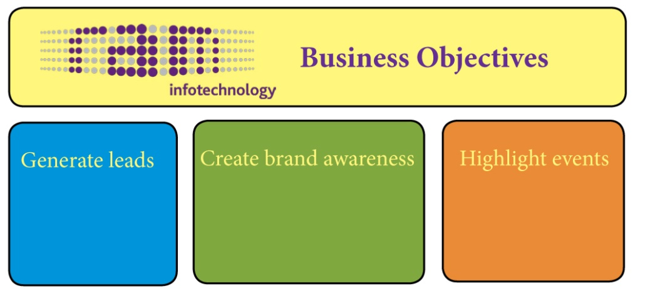

Figure 1. Business Objectives identified for RAM-Infotechnology website.

Objective 1 - Generate leads
Generally speaking, website cannot exist without visitors and visits, it needs the traffic. Visitors can remain anonyms or can leave their contact details. Contact details are required to be filled in on the company´s website when a visitor asks a specific question or downloads an available file. A visitor who leaves his/her contact details becomes the so called “online lead” of RAM-Infotechnology. Leads are saved in the company’s database for further marketing use; promotions of new services, events or other activities (RAM-Infotechnology, n.d.).
During the interview Chantal Brouwers admits that one of the most important objectives for RAM-IT website is generation of leads. The interviewee says that leads that company has can generate revenue. Thanks to obtained leads the company can get to the specific target group which is interested the most in the service that RAM-Infotechnogy offers. It is a way to promote the service successfully.

Objective 2 - Creating Brand Awareness
Creating brand awareness is one of the main ways to promote a company, service or product. When a customer is aware of a given brand, he/she is likely to recognise the company or to find the company in the Internet (Brand Awareness, n.d.).
The interviewee claims that for a business it is important to create the brand awareness among the customers to achieve a success. She adds that customers that are already familiar with RAM-Infotechnology should be able to find the company easily in the Internet.

Objective 3 - Highlight events
Another objective of RAM-Infotechnology defined during the interview is promotion of events. RAM-Infotechnology events are for example: business trades, conferences or discussions involving business associations or interests groups.
The company regularly launches events that may attract potential customers as well as current business partners. It makes the cooperation with RAM-Infotechology desirable and informative. What is more, a visitor that is attracted by the company’s activities is more likely to come back to the website again. Brouwers emphasise the importance of tying visitors to the website. The company’s website needs to have new visitors (objective: generate leads) but at the same time it is important to have recurrent visitors. She calls this “keeping house full”: the company website is generating new customers at the same time that it is building the bound with current customers.
Brouwers claims that RAM-Infotechnology is engaged this year in two main events: Zorg en ICT that took a place in March and Round Table that will be organised soon. To support the argument of importance of the highlighting events objective the example of upcoming event is presented. Currently, RAM-Infotechnology is working on organizing a new event that will take place at the beginning of June 2012. The company is going to organise Round Table that gathers psychology involved groups, the Mental Health Organisations (GGZ) which is RAM-Infotechnology target group. The aim of this event is to exchange information among mental health groups but it also plays an informative role for RAM-Infotechnology. This event will allow to obtain information about GGZ area of interest. Thanks to that RAM-Infotechnology will be able to understand better the preferences of its customers.

Sub-conclusion
The first step in creating Digital Marketing and Measurement Model is identifying business objectives. In the case of RAM-Infotechnology website these objectives are similar to those presented in the Kaushik’s model sample.
RAM-Infotechnology website needs to generate online leads that help in targeting a specific target group. On top of that, the company’s website has to create brand awareness among visitors. It needs to attract customers to make them come back to the website in the future. The third objective of RAM-Infotechnology website is to highlight the company’s events. It attracts visitors and encourages them to cooperate with RAM-Infotechnology.

Chapter 5 - Goals

Introduction
In the previous chapter the website objectives were specified. Based on that research goals for each objective are identified in this chapter. Primarily, the general business goal for RAM-Infotechnology is specified. Next sections of the chapter will explain the importance of the chosen goals.
As Brouwers says, the main goal stated in RAM-Infotechnology business plan for 2012 is to get in touch with care organisations: physiotherapists, general physicians and mental health organisations. Marketing actions for the year 2012 are driven by this goal. Taking marketing actions with a key focus on a specific area creates cohesion in the company strategy. This synergized plan includes short six weeks strategies to promote company’s events: Zorg en ICT and Round Table. The campaigns are taking place online in social media and on the company’s website.

Identifying Goals for each Objective
In this section of the chapter goals for each objective are identified. The graphic illustration of the goals is presented below, Figure 2.
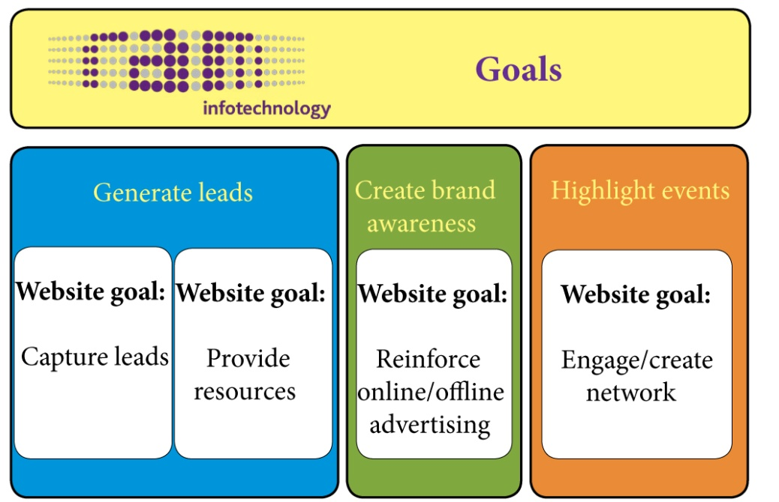

Figure 2.Goals identified for each of RAM-Infotechnology website objectives.

Goal for Objective 1– Capture leads
The main goal of Objective 1 is to capture leads. There are several methods to capture leads for RAM-IT: implementing the strategy “call to action”and providing resources.

Strategy to achieve Objective 1
During the interview with Chantal Brouwers it became clear that one of ways to generate leads on RAM-Infotechnology website is Call to Action (CTA). The “call to action” philosophy tries to encourage visitors to contact the company: call, leave a message or send an e-mail to RAM’s sales department. This approach allows to accomplish the important for RAM-IT objective which is the lead generation.
Lately, the website was rebuilt making sure it supports the efforts of leads generation though Call to Action. The new website version has an attractive layout. The web and texts are rewritten by specialized in website text writer to encourage customers to contact RAM-Infotechnology sales department. The website content is built according to the philosophy called “KISS” that stands for- keep it short and simple. As Brouwers claims, customers are simple in their actions, they need clear information and then they react through contacting RAM-Infotechnoogy.
For Brouwers it is important that visitors ‘land on’ the company home page. RAM-Infotechnology home page components help the company to capture leads from visitors. Banners published on the index page are designed in an attractive way to gain visitor’s attention and to encourage him/her for example to fill in a poll placed on it. What is more, a visitor can click on the special button on the right side of the home page to request needed information. Next to it a visitor can leave the lead by subscribing to receive the company’s e-newsletters. Finally, through the homepage a visitor can get to the company’s blog and social media accounts.
RAM-Infotechnology is present on Facebook, Tweeter and LinkedIn. A potential customer may make a registration and become a member of social media channels of RAM-Infotechnology. It generates valuable online leads for the company.

Goal for Objective 1 – Provide resources
On RAM-Infotechnology website there are files available for visitors to download. To proceed with download the visitor has to leave his/her contact details. Provided email address and/or a company name that the visitor is working for become a lead for the sales department to follow.

Strategy to achieve Objectives 1:
Every marketing action of RAM-Infotechonology, is supported by relevant software downloads available on the website. Visitors have a possibility to download white papers, case studies or brochures placed on the home page. On the index page a visitor is encouraged to get familiar with the available information and to leave their contact details. White papers are placed on the home page to help a visitor to solve a problem while case studies and brochures available on the home page have strictly informative function.

Goal for Objective 2 - Reinforce online/offline advertising
As mentioned before creating brand awareness has been formulated as one of the website objectives of RAM-Infotechnology. The awareness of RAM-Infotechnology brand is accomplished through promoting online and offline advertising.
Online advertising is a promotion that takes place through the Internet (Internet advertising, n.d.). Offline advertising is advertising a website through traditional media like magazines, radio or TV(Offline advertising, n.d.). The result of both types of advertising is visiting RAM-Infotechnology website.

Strategies to achieve Objectives 2:
Every company wants to ensure that its name is recognised among customers. A company that is present in several places in the Internet is more likely to be found by a visitor. This is why RAM-Infotechnology puts its effort in paid and unpaid advertisement. When a visitor types in the company name into a search engine two different kinds of results appear: paid and unpaid.

Paid traffic
Paid traffic is an outcome of clicking on results that appear on top of search engines: Google, Yahoo, Bling. RAM-IT cooperates with online advertising company to support brand awareness in the Internet, it is investing in paid media like advertisements on Google AdWords. People that type key words related to the company that provides hosting solutions can easily find RAM-Infotechnology in five first results showing up in search engines.
To give the example of paid traffic the social media campaign promoted on Google Adwords is presented. During the interview Chantal Brouwers mentions that hosting division of RAM Mobile Data took over the company Infotechnology and changed its name to RAM-Infotechnology. Additionally, one of RAM Mobile Data divisions has growen significantly which resulted in the new logo creation and changes in look and feel of the website.
Changes that the company applied were very complex. It took half a year before RAM-Infotechnology presented itself to the market. To launch the changes successfully the company invested in paid advertisements placed on Google AdWords. Brouwers comments that the effort and money invested in the marketing campaign have considerably increased amount of visits on RAM-Infotechnology website.

Unpaid traffic
Unpaid traffic, called as well ‘Organic search’ or ‘Natural search’ is one of the two search results showed in search engines (second - paid traffic). A company does not have to pay for visits generated by organic search (Organic search, n.d.). Natural search results appear in search engines like Google, Yahoo or Bing under paid search results.

Goal for Objective 3 – Engage/create network
Nowadays, an importance of a company’s network (stakeholders) is growing. Successful online marketers take into consideration their network as a group of people that wants to be informed about company’s events: upcoming business trades, conferences or other gatherings.

Strategy to achieve Objectives 3:
It is wise for RAM-Infotechnology to gather together its stakeholders by creating social media communities to keep interest groups up to date. Facebook, Tweeter and LinkedIn accounts of the company connect those people that share an interest in RAM-Infotechnology and its products. Members of RAM-Infotechnology social media community may obtain valuable information about events by subscribing to the social media group and read newest posts or watch videos.
One of the ways to promote RAM-Infotechnology events is social media campaigns. Social media campaigns are such campaigns that may gain traffic or attention through social media sites (What is social media marketing, n.d.). When campaign is running visitors may visit the company’s website to gain information about an event that is interesting for them. At RAM-Infotechnology, social media campaigns are prepared externally by the online marketing company, Margu B.V.
To give an example of RAM-Infotechnology event promoted via social media, business trade Zorg en ICT is presented. Zorg en ICT achieved a great success because of efforts put in social media. The event took place on 22 April 2012 in Utrecht and got a prize for the best social media campaign. It means that RAM-Infotechnology got the highest number of subscribes to the event through social media channels. RAM-IT is exceptionally proud to get this prize as competition was extremely taugh.. The company got better results than big market leaders like KPN or Vodafone. Due to the fact that the last event accomplished such a success, the upcoming event, Round Table, is planned be promoted in the same way.
Another example of successful social media campaign is promotion of the new RAM-Infotechnology website. RAM-Infotechnology introduced this website last year. Three social media channels were used to promote new look and feel: Tweeter, Face Book and LinkedIn. Efforts that the company invested into social media campaigns for RAM-Infotechnology have measurable effects. According to the interview, ten times more visitors go to the new website after proper promotional actions. Chantal Brouwers sees the transition as a big success of RAM-Infotechnology.

Sub-conclusion
RAM-Infotechnology website has following goals. Firstly, RAM-Infotechnology website is created to generate leads by capturing leads. Capturing leads at RAM-Infotechnology is a process based on “call to action” website feature and creating social media communities. Providing of resources is the second goal of lead generation. RAM-Infotechnolgy resources are provided in downloads.
Secondly, the website needs to create awareness. The goal for this objective is to reinforce online/offline advertising. The objective is achieved via paid traffic and organic search.
Finally, RAM-Infotechnology website objective is to highlight events. This should be achieved by engaging stakeholders via online advertising.

Chapter 6 - Key Performance Indicators

Introduction
Key Performance Indicator is an indicator that helps to realise how a company is performing torwards its business objectives. This step of model creation aims to identify metrics that represent RAM-Infotechnology website performance. Thanks to this part of Digital Marketing and Measurement Model creation RAM-Infotechnology online marketers will be able to identify success or failure of the website. Identifying KPI’s is a stage in the model where online marketers are working with data available in web analytics tools (Kaushik, September 15, 2011). For the purpose of the project web analytics tools were used to name specific metrics.
The following chapter is written to present Key Performance Indicators chosen for each Ram-Infotechnology goal. The choice of relevant KPI is guided by advises given in a Kaushik’s blog post from June 28, 2011“Your Web Metrics: Super Lame or Super Awesome”(June 28, 2011).

Identifying KPI for each goal
Several KPIs are selected to illustrate the most important metrics for the marketing department. The graphic presentation of RAM-Infotechnology website Key Performance Indicators can be found in the graphics, Figure 3.
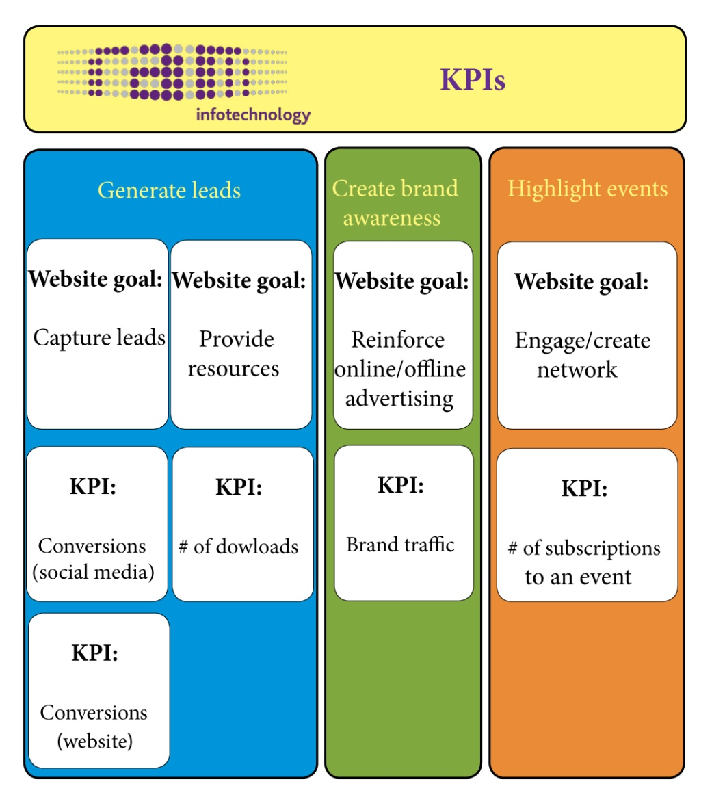

Figure 3. Key Performance Indicators identified for each of RAM-Infotechnology website goals.

KPIs for ‘Capture leads’ - ‘# Conversions’
As Brouwers claims, capturing leads is overall and the most important goal for RAM-Infotechnology. The best indicator of it is a number of conversions. Leads are generated through different channels. It is important for RAM-Infotechnology to make sure that leads are captured through social media, website and online newsletters.
This indicator is chosen to represent website performance. ‘Conversions’ (Conversion rate) metric is chosen to understand how RAM-Infotechnology website is performing in relation to ‘Generate leads’ objective. In online marketing conversion rate represents percentage of visitors who take on a website any desired action beyond simple page browsing.
Social media – # of followers
‘Conversions’ in social media is classified by Kaushik as a “Super awesome” indicator to measure efforts put in creation of online community (June 28, 2011). Monitoring of subscribers to social media channels may allow to capture leads about interested parties. RAM-Infotechnology captures leads tracking people who have subscribed to the company social media accounts.
Social media is an important channel to promote the company’s activities. During social media campaigns RAM-Infotechnology activities are increasing significantly, people are likely to subscribe to social media accounts: Facebook, LinkedIn and Tweeter.
Website leads
The company’s website is an important channel to capture information to approach visitors. For instance polls placed on the home page are generating valuable leads for a company. To complete the survey a visitor needs to provide his/her contact details. The poll placed currently on the home page of RAM-Infotechnology has a form of short survey that obtains information about visitors’ preferences.
What is more, visitors subscribing for RAM-Infotechnology newsletter available on the company’s website, also leave important leads for the company to follow. From that perspective it is wise for the online marketers to monitor personal details left by visitors interested in company news.

KPI for ‘Provide resources’ - ‘# of downloads’
The amount of downloaded documents reflects how the marketing department strategies perform against set goals. RAM-Infotechnology provides currently three sources of information: white papers, case studies and brochures. Detailed description of named downloads is presented in previous chapter. Online marketers that monitor the amount of downloaded files can capture leads of visitors. It can happen thanks to personal details required to be filled in before the actual software download.

KPI for ‘Reinforce online/offline advertising’ - ‘Branded traffic’
The company objective is to create brand awareness in order to reinforce online/offline advertising. Visitors aware of the company’s name should be able to easily find RAM-Infotechnology in a search engine. Therefore the most important metric is the number of visits to the website via brand keywords. Brand keywords are the keywords entered into a search engine where “RAM-Infotechnology” stands alone, in a combination with other words or as commonly used RAM- IT.
Branded traffic is the metric that allows RAM-Infotechnology to see the amount of visits that are the result of typing the company’s name into a search engine. Visitors who type in the company’s name in a search engine and click on links that differ from other results (yellow links on top of Google search engine) are becoming ‘Branded Paid traffic’. Every visit to the website obtained in such way cost RAM-Infotechnology some money. It is important for the company to know if the digital initiative generates outcomes.
At the same time the result of online/offline advertisement can be unpaid traffic. A visitor can type in the company’s name and click on unpaid search result. It is important for the company to distinguish the source of traffic. It is valuable information because if paid advertisements are bringing relatively fewer visitors to the website than unpaid advertisements, it may not be worth the finances put in the online/offline campaign.

KPI for ‘Engage/create network’ - ‘# of subscriptions to an event’
‘Highlight events’ objective is achieved through engaging stakeholders in the company activities. To illustrate the involvement of RAM-Infotechnology stakeholders online marketers may monitor ‘Visitor loyalty’ indicator. Such metric presents for example home page reoccurrence rate. Reoccurrence rate is the amount of people that came back to the website. The way to attract the visitors to browse RAM-Infotechnology pages again is presented in the previous chapter.

Sub-conclusion
To conclude, one of steps in creation of Digital Marketing and Measurement Model is identifying Key Performance Indicators for RAM-Infotechnology website goals. The metric for one of the website goals ‘Capture leads’ is ‘Conversions’. Conversions are all actions taken on a website beyond simple browsing. This includes social media followers and leads captured through the website. The company provides downloads: white papers, case studies and brochures. Therefore, the metrics for RAM-Infotechology goal, ‘Provide resources’ is number of downloads.
What is more, to reinforce online/offline awareness the company should take into consideration the ‘Branded traffic’ indicator. Finally, the research resulted in finding the metric for engaging/creating network which is the number of subscriptions to an event.

Chapter 7 - Targets

Introduction
In this chapter targets for each RAM-Infotechnology website are identified. Specific targets were defined during the second interview with RAM-Infotechnology product manager, Chantal Brouwers. Details regarding the interview can be found in Appendix 4.
According to Kaushik, targets are values in numbers determined in advance to indicate success of failure of the website. Setting targets helps to realise whether a number that is visible in a web analytics tool is reflecting a progress or regress of company’s actions. (Kaushik, September 15, 2011).
During the interview it became clear that RAM-Infotechnology is not setting exact targets for each of company’s goals in advance. Chantal Brouwers as a product manager monitors on a regular basis company performance using web analytics tools: Google Analytics and Snooby. As Brouwers states, she looks at the data shown in named web analytics tools and she can recognise whether the company’s actions are successful or not. Brouwers conclusions are based on comparison of current achievements with past records of the company’s activities which are available in web analytics tools.

Identifying targets for each KPI
As it is mentioned above, there are no exact numbers set in advance as indicators of the company’s actions including RAM-Infotechnology specific activities of the website. There is only one general target pre-determined for the whole RAM-Infotechnology website which is thousand visits per week. However, for the purpose of this project, some targets were identified in the cooperation with Brouwers. This approach was recommended by Kaushik in the blog post devoted to Digital Marketing and Measurement Model creation (Kaushik, September 15, 2011).
In this section numerical parameters are presented. These numbers represent number of visitors that took certain actions on the website. During the second interview with RAM-Infotechnology product manager following targets for RAM-Infotechnology website goals are specified. Targets are presented on the illustration placed below, Figure 4.
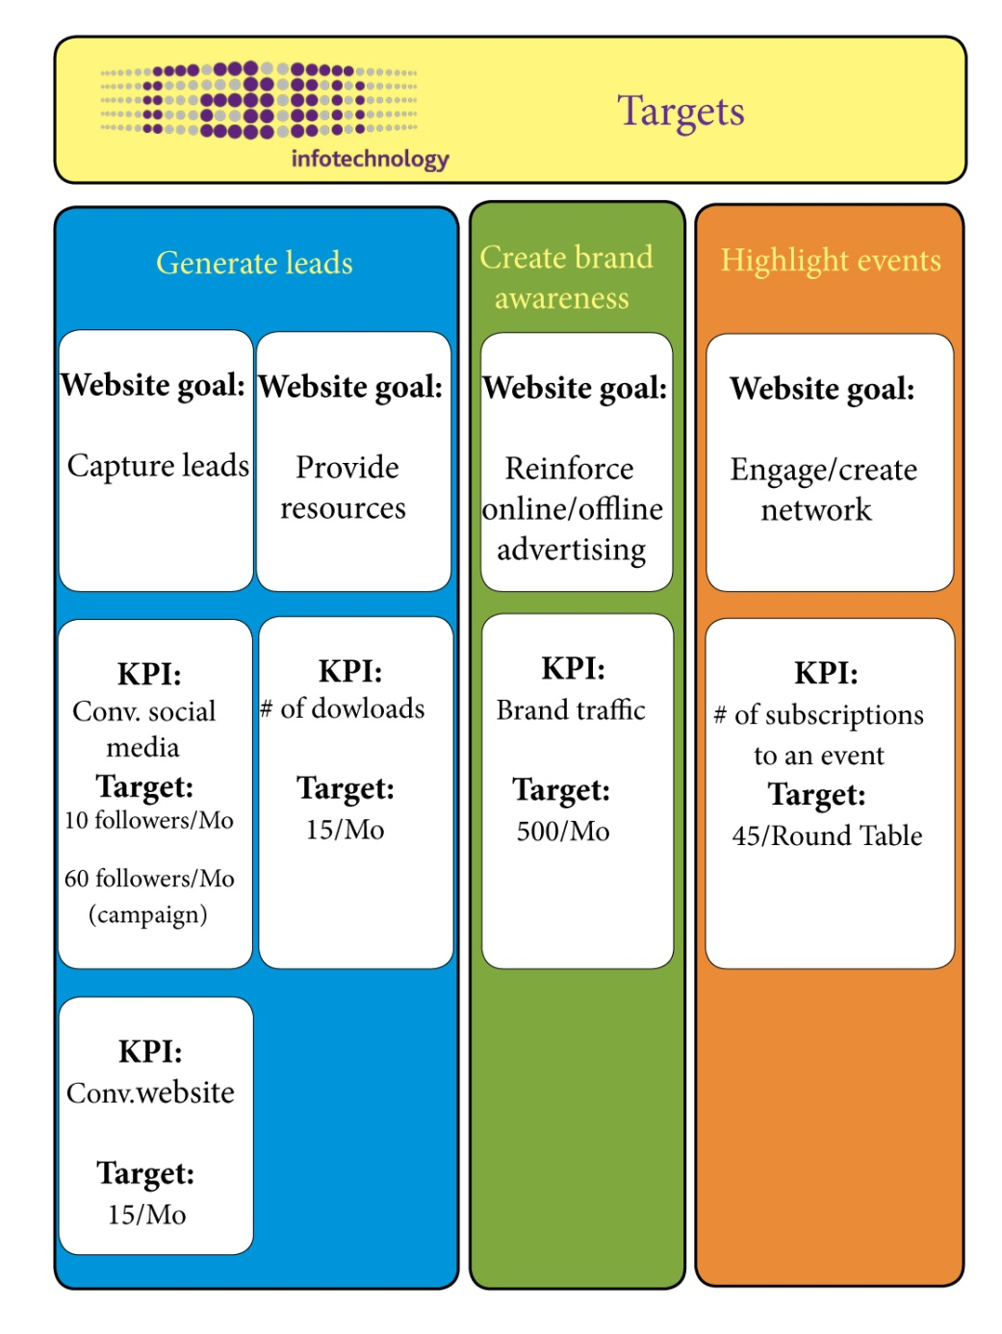

Figure 4. Targets identified for each of RAM-Infotechnolgy website Key Performance Indicators.

Target for KPI ‘Conversions‘

Social media – # of followers
RAM-Infotechnology launches several campaigns each year. Important channel to promote the company’s activities is social media. During the campaign RAM-Infotechnology activities are increasing significantly, more people subscribe to media channels: Facebook, LinkedIn and Tweeter.
The number of conversions which is the result of RAM-Infotechnology social media varies form 60 per month during campaign to 10 without an active promotion. Number of the social media conversions differs depending on a given campaign. During a campaign the average number of followers per month is 60. Additionally, to take a universal approach, the number of followers is also specified for the time when the company is not running any campaign. The estimated number of social media followers monthly is 10.

Website leads
The target for leads converted as a result of RAM-Infotechnology website visits is 15 per month. This includes leads created through information requests, home page polls and e-newsletter subscriptions.

Target for KPI ‘# of downloads’
The company expects to achieve the target of 15 downloads per month. The number covers downloads of white papers, case studies and brochures available on RAM-Infotechnology website.

Target for KPI ‘Branded traffic’
The number of expected traffic which is the result of typing the company’s name or related terms into search engines is 500 per month. This number is based on analyses of monthly results available on Google Analytics. To learn about specific keywords used by visitors in March 2012, see Appendix 2.

Target for KPI ‘# of subscriptions to an event’
According to Brouwers, the number of subscriptions to events depends from the given campaign. As it has been already mentioned the next event RAM-Infotechnology is going to organise is Round Table . The expected number of subscriptions to the event is 45. This figure is the result of Chantal Brouwers calculations. Brouwers expects 30 members of Round Table. Her experience shows that about 30 percent of subscribed people do not appear on an event. Brouwers says that fifteen extra subscriptions were a safe margin for the upcoming event.

Sub-conclusion
Concluding, RAM-Infotechnology website has only one general target and no pre-determined targets for specific indicators. The cooperation with the product manager has resulted in identifying numerical values for each of the website Key Performance Indicatiors.
The company’s website aims to have 10 social media followers per month. During a campaign this target increases to 60 followers monthly. Addionally, RAM-Infotechnology website is expecting to capture 15 new leads every month. The same amount of downloads is satisfactory for the product manager, Chantal Brouwers. What is more, high number of the branded traffic is set by interviewee. Brouwers set target of the traffic, resulting from searching in a search engine for the company’s name, 500 per month. Finally, the target for the metric ‘number of subscriptions to an event’ is identified. Finally, regarding the upcoming event, Brouwers hopes for 45 subscriptions.

Chapter 8 – Segments

Introduction
The last step of Digital Marketing and Measurement Model creation is identification of segments for each goal. Kaushik defines a segment as “A group of people, their sources, onsite behaviour, and outcomes” (September 15, 2011). To complete the model specific groups of people, their attributes and traffic sources need to be identified. Finally, behaviour of visitors and their interest needs to be clarified and the outcomes that they are interested in (Kaushik, September 15, 2011).
The purpose of segments identification is crucial part of understanding the reason a website achieved a success or failure. According to Kashik, the segment can be chosen from the list of default segments available in web analytics tools. The right section allows focusing on the important data segments; new website visitors or visitors that have come back to the website. (Kaushik, September 15, 2011). Figure 5, shows a sample table of a web analytics tool with default segments.

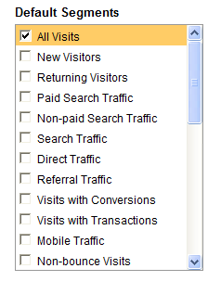
Figure 5. Default Segments (Kaushik, May 18, 2010).

To segment the most relevant data for RAM-Infotechnology website, first the marketing focus of the company’s website needs to be understood. Knowledge about website visitors; their behaviour and the desired outcome should allow choosing important segments form sea of data available in web analytics tools.
To learn about RAM-Inotechnology marketing focus, a second interview with Chantal Brouwers was conducted. During the interview Brouwers explains the concentration of the company’s marketing actions. RAM-Infotechnology marketers want to approach through the website two main target groups; direct and indirect customers. Direct customers or RAM-Infotechnology are healthcare organisations like GGZ (Mental Health Care Organisation) or Fyzo (Physiotherapeutic Institute). Brouwers claims that the company targets big healthcare organisations above 100 employees. Indirect customers are resellers or companies that cooperate with healthcare organisations for example ICT companies (Information and Communications Technology). During the interview Brouwers mentions that the most important sectors to focus on for specific goals depend on the given campaign. Unfortunately, the interviewee could not precise segments for each of RAM-Infotechnology goals. She adds that the behaviour that the company expects is contacting the company (“Call To Action”).
The aim of Marketing and Measurement Model is to pick the most relevant information form sea of data to identify success or failure of the company (Kaushik, September 15, 2011). The help in identifying the marketing segments provides as well Elias Crum. Crum, the owner of Margu Online Marketing working for years in social and mobile marketing field agrees to give the interview regarding the website marketing focus. Details about the interview can be found in Appendix 5.
According to Crum, RAM-Infotechnology website is created to attract two types of visitors; those that are looking for solutions to their problems and those who are searching for information about provided services. Sources of such visits may be for example paid advertisements, organic search or e-mail marketing (newsletters). Elias Crum says that the expected behaviour of a visitor depends on the target group that the potential buyer belongs to.
In the section Recommendations examples of segments are presented.

Identifying segments for each goal
In order to define the segment which will be used to obtain better and detailed insights on the goals that have been defined before the possibilities of web analytic tool have been investigated. The overall conclusion is that the tool can provide many possibilities to view the data (metrics). The data can be narrowed down to similar types of data, here called segments.
Based on the possibilities that the web analysis tools provide the following segments have been defined (Figure 6).
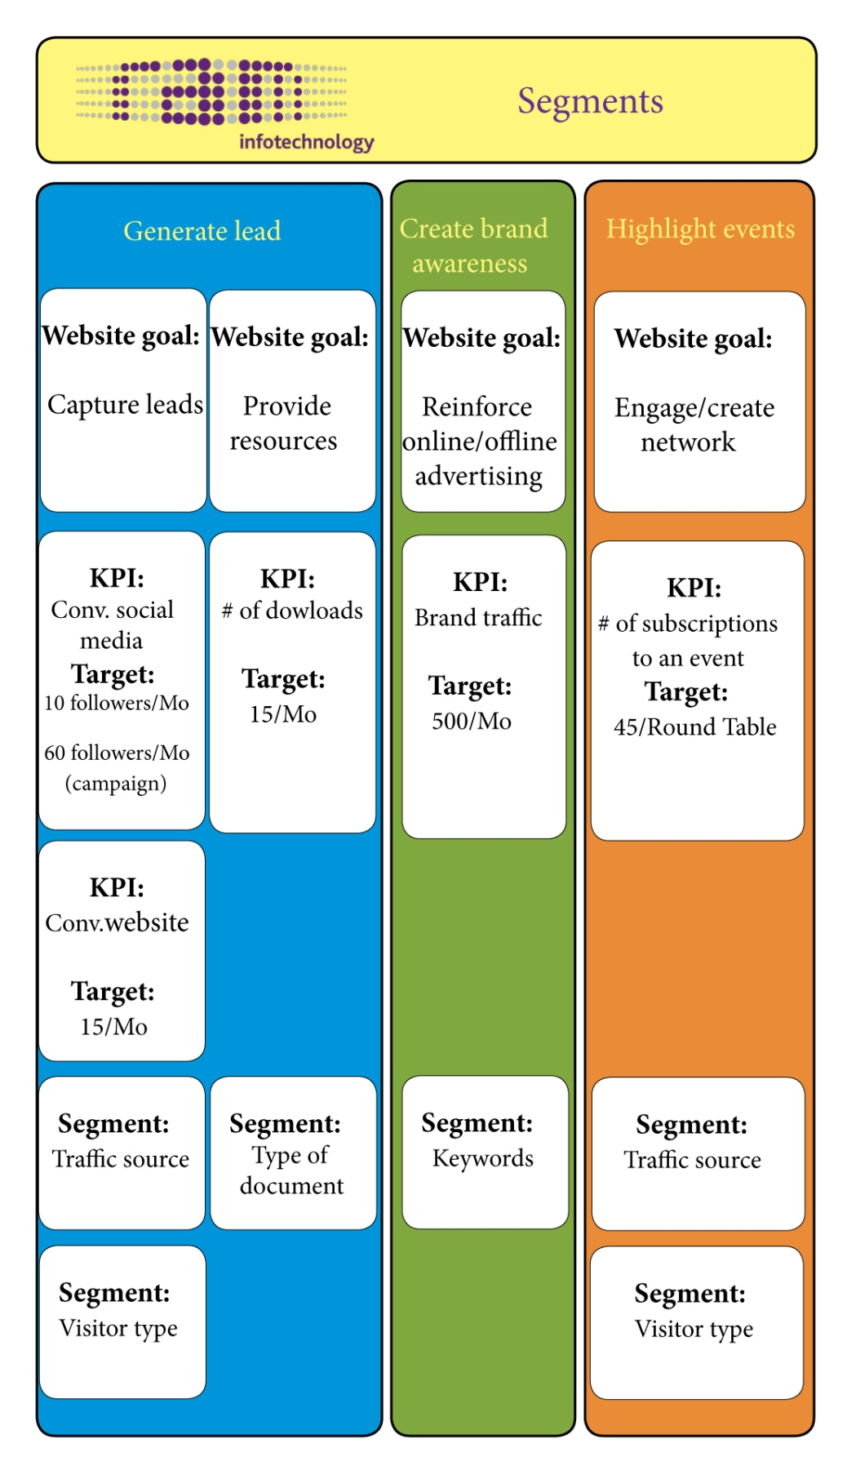
Figure 6. Segments identified for each of RAM-Infotechnology goals.

Segments for Goal ‘Capture leads’

Traffic source
There are several traffic sources of RAM-Infotechnology website; paid advertisements, organic search, social media and e-mail marketing (newsletters). It is important for RAM-Infotechnology to know if efforts that the company is putting in for example online advertising are bringing desired results.

Visitor type
In the model sample Kaushik proposes to segment a visitor type that has created a lead or that has enrolled to an event. Segmenting a visitor type may provide the knowledge for RAM-Infotechnology about a potential costumer. Thanks to that the company may learn more about those who browse RAM-Infotechnology website. Therefore, online marketers may recommend to sales department to follow leads (contact) created by big health care organisations which are the company’s target group and do not put efforts in organisations that are not interesting for RAM-Infotechnology. The information about a visitor allows taking further actions to fulfil the needs of the customers as well as approaching the most valuable leads.

Segment for Goal ‘Provide resources’

Type of document
The company is interested to knowing what types of documents are downloaded by its visitors: are these brochures or white papers. Thanks to such information the company may know if the information provided in the website resource is valuable for the potential customer. It also may indicate what information visitors are interested in. Based on this information the company can focus it marketing strategy and make strategic decision on the type of resources provided on the website.

Segment for Goal ‘Reinforce online/offline advertising’

Keywords
The company is interested if visits were the result of typing in the search engine keywords related to the company. Therefore it will need to be mounted if there source of visits to the website via brand traffic. By brand traffic it is understood the visit to the website by typing in the search engine tool a keyword including the company’s name in the search query. Since visits to the website by using such queries can be coming both from organic (for instance search engines) and paid (search engine advertising) these two channels may also be infresting segments for RAM-Infotechnology

Segment for Goal ‘Engage/create network’

Traffic source
RAM-Infotechnology is interested in source of visits to its website. Thanks to that the company can obtain the knowledge whether the efforts and finances put in advertising of events are bringing desirable outcomes.

Type of visitor
Infotemation about type of visitor that has subscribed to the event may provide valuable knowledge to the company. The company knows whether the run campaign is attracting the desired visitors.

Sub-conclusion
To fulfil the model creation segments for RAM-Infotechnology website needs to be identified. Basing on the marketing segmentation, the data segmentation in a web analytics tool can be made.
Two interviews were conducted to identify marketing segments for each of website goals. The information obtained during the interview with Chantal Brouwers shows the main RAM-Infotechnology focus. Two target groups are identified; direct (Health Care Organisations) and indirect customers (retailers, ICT companies). The desirable behaviour of visitors is to get in touch with RAM-Infotechnology.
Additional information regarding marketing segmentation provided Elias Crum. Thanks to the conducted interview website traffic sources are specified. Moreover, it is clarified that the expectations regarding a visitor behaviour depends on the specific target group.
The research resulted in finding segments for each of RAM-Infotechnology goal. Segments of data chosen as important in capturing leads are traffic sources and type of visitors. The type of document downloaded by the visitor may be interesting for RAM-Infotechology when it comes to provided resources. In obtaining the knowledge about reinforcing online/offline adverting may help segmentation of searched keywords. Finally, the efforts out in engaging/creating network may be monitored by segmenting the traffic sources and the visitor type in regard to subscriptions to an event.
Closing, in the section Recommendations examples of segments are presented.

Conclusions

Internet, potential of marketing
The Internet is an important marketing channel nowadays due to its profit generation. Current market situation requires a company existence in the Internet. Because of amount of available data, the business faces lots of challenges connected with the online performance. What is more, a website became a powerful tool in online performance. Web analytics tools help in monitoring web activities. Unfortunately, it becomes harder and harder for the business to select the relevant information that would show the efforts put in creation of online marketing tools like websites. Digital Marketing and Measurement Model aim is to find the key metrics that aid online marketers to identify success or failure of the website.

Use of Internet by RAM-Infotechnology
RAM-Infotechnology is a hosting division of RAM Mobile Data. It exists under different names from 1993. Current name was introduced to the market last year.
Moreover, due to type of service provided by RAM-Infotechnology the company is mainly promoted in the Internet. RAM-Infotechnology is using different online marketing channels; social media and the company’s website. The RAM-Infotechnology website has a great importance to RAM-Infotechnology because hosting solutions provided by RAM-Infotechnology are taking place entirely online. Company’s website efforts are regularly monitored by web analytics tools; Snoobi and Google Analytics.
What is more, RAM-Infotechnology desires improving its website performance. The Final Project topic was chosen after the investigation of current company situation. Its result was to create Digital Marketing and Measurement Model that helps online marketers in searching indicators that signify success or failure of RAM-Infotechnology website.

Digital Marketing and Measurement Model
A sample of Digital Marketing and Measurement Model created by marketing authority Kaushik is developed to identify success or failure of online activities of a company. The model posted on Kushik blog became an inspiration to create DMMM for RAM-Infotechnology website. When completed, the model created for the company website would focus on three key areas; acquisition, behaviour and outcomes. Acquisition is connected with the website traffic. Visitors that appear on the website are expected to take certain actions during the visit. Moreover, those behaviours may create a profit for the company.
To create the model five steps need to be taken. First business objectives need to be identified. Those objectives are a way for the business to define its efforts direction and goals. Secondly, goals for each objective are specified. Goals are the strategies that the company needs to take to meet business objectives. Third step in model creation is identifying Key Performance Indicators, metrics that would present the progress in achieving objectives. This step is followed by setting the Targets for each KPI. Targets are parameters of success or failure set in advance. Finally, the last step, segments identification helps in understanding why the website is a success or failure. It takes into consideration a group of people that arrived on the website, their behaviour and outcomes that are result of those visits.

Set of measures
The research central question was; what is the set of measures that helps to identify success of failure of RAM-Infotechnology website? The research resulted in finding following measures: objectives, goals, key performance indicators, targets and segments for RAM-Infotechnology website. Detailed conclusions regarding mentioned measurements can be in sections below.

Business Objectives
The research resulted in identifying business objectives of RAM-Infotechnology website. RAM-Infotechnology website needs to generate online leads that help in targeting a specific target group. What is more, the company’s website has to create brand awareness among visitors. It needs to attract customers to make them come back to the website in the future. The third objective of RAM-Infotechnology website is to highlight the company’s events. It attracts visitors and encourage them to cooperate with RAM-Infotechnology.

Goals
The answer for one of sub-questions is found by identification of RAM-Infotechnology website goals. Firstly, RAM-Infotechnology website is created to generate leads by capturing leads. Capturing leads at RAM-Infotechnology is a process of based on “Call To Action” website feature and creating social media communities. Providing of resources is the second goal of lead generation. RAM-Infotechnolgy resources are provided by downloads.
Secondly, the website needs to create awareness. The goal for this objective is to reinforce online/offline advertising. The objective is achieved via paid traffic and organic search. Finally, RAM-Infotechnology website objective is to highlight events. This should be achieved by engaging stakeholders via online advertising.

Key Performance Indicators
To conclude, one of steps in creation of Digital Marketing and Measurement Model is identifying Key Performance Indicators for RAM-Infotechnology website goals. The research results in fining the metric for one of the website goals ‘Capture leads’ is ‘Conversions’. Conversions are all actions taken on a website beyond simple browsing. This includes the number of social media followers and website leads. The company provides downloads; white papers, case studies and brochures. Therefore, the metrics for RAM-Infotechology goal, ‘Provide resources’ is number of downloads.
What is more, to reinforce online/offline awareness the company should take into consideration the ‘Branded traffic’ indicator. Finally, the research resulted in finding the metric for engaging/creating network which is the number of subscriptions to an event.

Targets
One of sub-questions considers identifying in advance targets to monitor the success of website actions. The research shows that RAM-Infotechnology website has no pre-determined targets that would help in identifying the company’s performance. However, conducting the field research has resulted in setting numerical values for each of the website Key Performance Indicatiors. The company’s website aims to have ten social media followers per month. During a campaign this targets increases to 60 followers monthly.
Addionally, RAM-Infotechnology website is expecting to capture 15 new leads every month. The same amount of downloads is satisfactory for the product manager, Chantal Brouwers. What is more, high number of the branded traffic is set by interviewee. Claimant set target of the traffic resulting from searching in a search engine for the company’s name, 500 per month. Finally, the target for the metric ‘number of subscriptions to an event’ is identified. Regarding the upcoming event, Brouwers hopes for 45 subscriptions.

Segment
To fulfil the model creation segments for RAM-Infotechnology website needs to be identified. Basing on the marketing segmentation, the data segmentation in a web analytics tool can be made.
Two interviews were conducted to identify marketing segments for each of website goals. The information obtained during the interview with Chantal Brouwers shows the main RAM-Infotechnology focus. Two target groups are identified; direct (Health Care Organisations) and indirect customers (retailers, ICT companies). The desirable behaviour of visitors is to get in touch with RAM-Infotechnology.
Additional information regarding marketing segmentation provided Elias Crum. Thanks to the conducted interview website traffic sources are specified. Moreover, it is clarified that the expectations regarding a visitor behaviour depends on the specific target group.
The research resulted in finding segments for each of RAM-Infotechnology goal. Segments of data chosen as important in capturing leads are traffic sources and type of visitors. Type of document downloaded by visitors may be interesting for RAM-Infotechology when it comes to provided resources. In obtaining the knowledge about reinforcing online/offline adverting may help segmentation of searched keywords. Finally, the efforts out in engaging/creating network may be monitored by segmenting the traffic sources and the visitor type in regard to subscriptions to an event.

Recommendations
The aim of this project was to generate Digital Marketing and Measurement Model for the assignment provider, RAM-Infotechnology. The model helps to identify the source of success of failure of the RAM –Infotechnology website, showing which indicators are important to the company. The structure was created to improve the usability of web analytics tools at RAM-Infotechonlogy. Additionally, the purpose of the conducted research was helping the company in sorting out the most significant data.

Objectives, goals, KPIs
After the research conducted for RAM-Infotechnology website it became clear that the company has a clear set of business objectives and goals. Thanks to this feature, it will be possible in to identify success or failure of the website. The strategy is well defined therefore it was possible to find Key Performance Indicators that the company’s online marketers should take into consideration while monitoring the website performance.

Targets
Some complications were faced during the model creation. It was hard to specify targets and segments for the website. Therefore, it is recommended for the RAM-Infotechnology to focus on those two aspects. To identify success or failure of the website targets needs to be set in advance. The company’s senior managers should specify expected numbers regarding the website actions. Thanks to this approach online marketers would know it the efforts put in order to build attractive website, bring desired results.

Segments
The company should find the way to segment the most important data from the information available in web analytics tools. RAM-Infotechnology lacks clearly selected segments to analyse. The company’s product manager is aware of the general target that RAM-Infotechnology would like to approach. However, when it comes to data selection the company does not have concrete segments chosen for website goals in order to monitor the performance. It is recommended to RAM-Infotechnology to identify segments for each website strategy in order to identify its success or failure.

Recommended segment selection
In this section data segmentation examples are provided.

Traffic source
During one of the interviews, Chantal Brouwers mentions that the company is focused at the moment on developing social media actions. The website visits that come from social media are the result of paid advertisements placed there. Because of the efforts that the company puts on social media actions and finances spend on advertisements on Facebook, LinkedIn or Twitter the company should select as a segment to monitor its performance.

Visitor type
During the interview Crum adds that there is a possibility to create a “persona”, a description of the potential customer of a company. The description is created to make a profile that includes information like a job position, age or interest of a person that the company would like to approach. Thanks to such analyse a company is able to fulfil exact needs of a potential customer by providing information that a prospect may be interested in. Unfortunately, currently RAM-Infotechnology does not create the “persona”. It would be highly recommended to conduct such analyse of a potential buyer to provide attractive for a visitor information and solutions.

Document type
In line to the interview with Elias Crum, that the document type downloaded from the company’s website depends on interests of a given target group. This information confirms RAM-Infotechnology product manager, Chantal Brouwers. She provides as well the complementary material regarding the importance of case studies, brochures and white papers. The biggest outcome for the company creates a case study. In case studies customers of RAM-Infotechnology refer to the cooperation with the company. Such recommendation is a power tool because it may attract potential buyers. Therefore, the company should monitor the leads that were created by downloading case studies.

Keywords
RAM-Infotechnology should segment those visits that were the result of typing the company keywords. Thanks to that the company can indicate whether the efforts put in the online/offline advertising are satisfactory. This approach allows sorting out the visits that were converted through typing related to the company keywords form the paid search.

References

Internet sources
About RAM Mobile Data (n.d.). Retrieved April 3, 2012, from RAM Mobile Data Web site: http://www.ram.nl/en/mobile_data_communication_solutions_provider
Brand awareness (n.d.). Retrieved April 25,2012, from Investopedia Web site: http://www.investopedia.com/terms/b/brandawareness.asp#axzz1t2TwfHCY
Conversion rate (n.d.). Retrieved April 27 from Marketing Terms Web site: http://www.marketingterms.com/dictionary/conversion_rate/
Chavis, J. (n.d.). What Is a Business Objective? Retrieved April 20, 2012, from eHow Money Web site: http://www.ehow.com/about_4710370_what-business-objective.html
Dubois, L. (2010, December 31). 11 Best Analytics Tools. Retrieved April 6, 2012 from INC Leadership Forum Web site: http://www.inc.com/guides/12/2010/11-best-web-analytics-tools.html
Gain insights that matter (n.d.). Google Analytics. Retrieved April 4, 2012, from Google Analytics site: http://www.google.com/analytics/features/index.html
Information overload (n.d.). Wikipedia, Free Encyclopaedia. Retrieved April 17, 2012, from Wikipedia Web site: http://en.wikipedia.org/wiki/Information_overload
Internet advertising (n.d.). Retrieved April 25, 2012, from The Free Dictionary by Farlex Web site: http://encyclopedia2.thefreedictionary.com/online+advertising
Kaushik, A. (2010, May 18). Web Analytics Segmentation: Do Or Die, There Is No Try! Retrieved May 11, 2012 from Occam’s Razor Web site: http://www.kaushik.net/avinash/web-analytics-segments-three-category-recommendations/
Kaushik, A. (2011, June 28). Your Web Metric: Super Lame or Super Awesome? Retrieved April 27, 2012 from Occam’s Razor Web site: http://www.kaushik.net/avinash/web-metrics-super-lame-super-awesome
Kaushik, A. (2011, September 15). Digital Marketing and Measurement Model. Retrieved April 3, 2012 from Occam’s Razor Web site: http://www.kaushik.net/avinash/digital-marketing-and-measurement-model
Kaushik, A. (2012, April 2). Multi-Channel attribution: Definitions, Models and a Reality Check. Retrieved April 18, 2012 from Occam’s Razor Web site: http://www.kaushik.net/avinash/multi-channel-attribution-definitions-models/
Mobile Software Solutions (n.d.). Retrieved April 3, 2012, from RAM Mobile Data Web site: http://www.ram.nl/en/mobile_applications_and_data_communication/mobile_applications_for_remote_employees
Offline advertising (n.d.). Retrieved April 25, 2012, from The Free Dictionary by Farlex Web site: http://encyclopedia2.thefreedictionary.com/offline+advertising
Organic search (n.d.). Retrieved April 25, 2012, from About.com Web site: http://webdesign.about.com/od/seo/g/bldeforganicsea.htm
Perlstein, J. (2008). Online Acquisition. Retrieved April 20, 2012, from Responsemedia Web site: http://www.responsemedia.com/RMWebSitePDFFiles/WhitePapers/OnlineAcquisition_08.pdf
RAM-Infotechnology (n.d.). Retrieved April 20, 2012, form RAM-Infotechnology Web site: http://www.ram-it.nl/
Thornton, S. (n.d.). What Is KPI? Retrieved April 22, 2012, from eHow Money Web site: http://www.ehow.com/about_5180751_kpi_.html
Visitors from The Netherlands show highest engagement online (2011, May 4). Retrieved April 4, 2012, from ComScore Web site: http://www.comscoredatamine.com/2011/05/visitors-from-the-netherlands-show-highest-engagement-online/
Web Site Traffic (n.d.). Retrieved April 20, 2012, from Marketing Terms Web site: http://www.marketingterms.com/dictionary/web_site_traffic/
What is social media marketing (n.d.). Retriever April 23, 2012 from Search Engine Land Web site: http://searchengineland.com/guide/what-is-social-media-marketing

Books
Kaushik, A. (2010). Web Analytics 2.0. The art of online accountability&science of customer centricity. Indianapolis (IN): Wiley Publishing.
Tonkin,S., Whitmore, C., & Cutroni J. (2010). Performance with Google Analytics. Strategies and techniques for maximizing online ROI. Indianapolis (IN): Wiley Publishing.

Appendices

Appendix 1:
The following section provides details about RAM Mobile Data. It is the appendix to Chapter 2 section ‘Briefly about the RAM Mobile Data’.

RAM Mobile Data Services
The following section provides details about RAM Mobile Data. It is the appendix to Chapter 2 section ‘Briefly about the RAM Mobile Data’.

RAM Mobile Data Services
RAM Mobile Data delivers various mobile data communication services supported by mobile networks like GPRS, UMTS or Mobitex. Solutions include Track-and-Trace vehicle tracking application.
Secondly, Navara - a division of RAM Mobile Data - provides customized software solutions for mobile applications. The software is created to ensure the safe digital information flow between companies or organizations and their employees.
Finally, RAM Mobile Data offers hosting applications infrastructure and supports access to mobile and fixed networks. The company division that is engaged with the application hosting and approaching different networks is RAM-Infotechnology.

Appendix 2: Branded traffic – keywords
This table presents the additional information for Chapter 6, section KPIs for ‘Reinforce online/offline advertising’ - ‘Branded traffic’. RAM-Infotechnology - Searched keywords, March 2012.
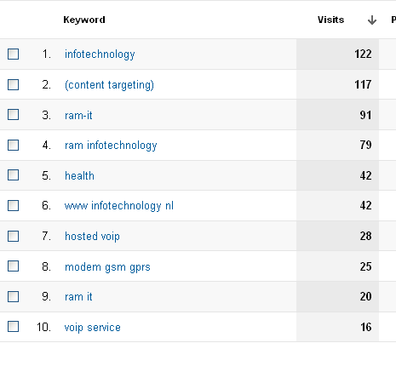

Appendix 3: Interview, goals and objectives
This is a transcript of the interview conducted on April 10, 2012 with RAM-Infotechnology product manager, Chantal Brouwers. The meeting took place at RAM Mobile Data and was recorded with the consent of interviewee. The questions were sent to Chantal in advance in order to get acquainted with the meeting topic. The interview is recorded and its duration is 49 minutes and 18 seconds.
Initials are used to refer to parties involved in the event. The interviewer Joanna Kurek further on appears as JK and the interviewee Chantal Brouwers is called CB. Additional comments and clarifications can be found in brackets.

Interview questions
- Why does the RAM-Infotechnology website exist?
(Examples of objectives: create awareness, generate leads, highlight events)
  - Acquisition
    - How are you anticipating acquiring traffic on the website/YT video/whatever else you are creating?
    - Did you cover all three components of successful acquisition: Earn, Owned, Paid media?
    - How would you prioritize each?
    - Where are you spending most of your efforts?

  - Behavior
    - What is the behavior you are expecting when people arrive?
    - What pages should they see?
    - What videos should they watch?
    - Should they visit repeatedly?
    - Are there certain actions they should take?
    - What is unique about your effort that is an optimal experience for a customer?

  - Outcomes
    - What outcomes define value delivered to the business bottom-line?
(Examples: a download, a phone call to your call center, a qualified online lead, signing up for e-mail promotions, people buying your product/ service, a 95%task competition rate, a 10 point lift brand perception)

- Identifying goals for each objective
Goals definition: specific strategies you will leverage to accomplish the business objectives.
Examples of goals for objectives:
Create awareness-> Reinforce offline/ online advertising
Generate leads-> Capture leads (e-mail/contact), provide customers information and resources
Highlight events-> Engage community via local events

Transcript
JK: Welcome, I will put the recorder next to you so that later on it is easier for me to write the transcript…
CB: OK
JK: We have not talked about my theses before, right?
CB: No, we haven’t.
JK: About what I am going to do and etc… So, I will tell you, more or less, what the plan is: I would like to create Digital Marketing and Measurement Model. The aim of this model is to help the online marketer to see in Google Analytics what is really important and what is not and to identify the success or failure of the website. The model consists of five steps: first of all I have to specify objectives of the website RAM-Infotechnology, I am going to focus on that, then for each objective I have to specify goals, then I am going to find in Google Analytics Key Performance Indicators for those goals and later on we will have to set the targets and find the segments for goals. This all, five steps, at the end will create, I will show you this kind of model (presenting the prepared material).When you have clearly heard, what are the objectives, where you have to search for numbers and what they (numbers)should be, then it is easier to actually look in Google Analytics…
CB: …to have a conclusive plan…
JK: …if it is good or not, because when you do not know, for example, what your targets are and you will see the figure “100”, you do not know If it is good or not.
CB: Exactly, you have to have a goal.
JK: So that is what I am doing and I need you…
CB: …to answer those questions
JK: Yes! First of all, as I said, we have to set company’s objectives. I have put here (on the sheet) sub-questions and examples of objectives. In this case it was a real estate company, they wanted to create awareness, generate leads and highlight events.
CB: : To be honest, I think that you’ve got the core for the website. Last year we’ve started with a new website because before the website was quite dramatic, to be honest. No one could find any information, there was no “call to action”. That is very different from the website now, instead of the website like before where the text was written by “sales”, they took a lot of efforts doing that but… well “sales”, they have a specific goal writing text, they are just like “this is what it does, now you can call me”. It is a bit like the customer of a potential customer will just look at it and “OK, right… so?”. We skipped the whole texts, we said “ we are going to start out new”. We hired a text writer, specialized in text for websites and the main thing was the “call to action”. It had to be short, it had to be simple. You have this word, it says KISS- Keep It Short and Simple. It is one of the phrases that they use within KPN (Chantal was working for KPN for 9 years), to be honest, KISS- Keep It Short and Simple. Why? Because, you need to call to action, that the only thing you want. If you have like big, big texts… people are not going to read that. They are not going to read 25 pages of how could you role at cloud computing solution or how could you role at hosting. What you could do, what kind of connection belongs to there and that and those… People are not very interested, they are just interested in…“OK-I want to have it, I am going to call you”. That is it. You have to have a different mind-set, you have to have generated “sense of urgency”. I do not know how to say that in English, to be honest.
So this are the three words: “create awareness”. It has to do with… that RAM-Infotechnology took over Infotechnology, as a company. You want to have a new name, new name we got lunched last March… but in October we lunched it to the market. From that moment on, we have got ten times more visitors in a week than before. Normally, we had 50-60 visitors on the website per week and now we have up to 500 and even 1000…
JK: Just because you have changed the name?
CB: Yes, we ‘ve changed the name and we’ve changed the text of the website.
JK: That is amazing.
CB: It is! I am so happy about it.
JK: Ten times more…
CB: Yes. It is of course because you have to create awareness. Mostly, by doing social media; LinkedIn, Tweeter and Facebook. They were quite hesitant about that, especially sales directors were quite hesitant about that but we convinced them. Many people think that Facebook is very private, it is a private not a company thing. But every private person works somewhere so you do a have cross reference. “Kruisbestuiving” we call it in Dutch. That is the first goal… I would not say the first goal because the first goal is to generate leads.

JK: So more important is to generate leads?
CB: Yes. That has to do with the fact that we are on the sales driven organisation , they (sales directors) want to make as much orders, they want to have as much orders as … (possible). I am working for sales and with sales so that is very important. We have various things organised for that; we’ve made five white papers and the downloads for white papers… (generate leads). Every week I get the list of people that download white papers for our website, that is one, from Kennisportal, it is again online, everything is online nowadays.
JK: Kennisportal? (www.kennisportal.com)
CB: Yes. Now, it has been taken over by heliview, it is called heliview online now (www.heliview.nl/online). What they do is, they put white papers in a “little basket” and put the ”little basket” it on the market square.
JK: So you are saying that heliview is a place where you can download white papers?
CB: Yes. They just put it central and anyone who would like to have some information can download it and leave their address… , name, address (e-mail ).
JK: …and it creates leads…
CB: Exactly. Every week I check the list and check companies which are on the list and then I send it to Niels (Niels van Peer) with an advise like ”I would advise you to have this followed up by XYZ by Stijn (Stijn van der Walle) or Marco (Marco Berkien- names of sale team members)”. ..“To have a look at in-between ”. Why? We do not want small consultancies, they can download, that is fine, but we are not going to call them. There are too “small potatoes” and it takes a lot of efforts. We do not think it is sales driven. It will not generate lots of leads and we will not get any money.
JK: So you are not busy with small companies?
CB: No, we do not work with small companies.
JK: You just want” big fishes”?
CB: Yes, we like “big care fishes”
…and the third, highlight events. We just had that for Zorg en ICT (last event). For the next event, I am talking to Elias (Elias Crum-business partner, responsible for social media) about this, to have a new social media campaign. We want to have Round Table organized for mental health organizations- GGZ. We want to do that in the beginning of June, after the holidays, just in between the May holiday and the big holiday.
I think that this is the three pointers for the website. You always have to have a certain sales drivenness, you always have to create the awareness for your name and for your company. If you do not have it, well then, people cannot find you. Especially, when you talk about Google Analytics or Google AdWords. If I draw in “RAM-IT” I will just get four-five where our name is preferred.
JK: That is increasing awareness via Google AdWords?
CB: Yes. For the rest, you try to create the awareness. Especially when you have a poll. It is not really working yet but it is just an idea we had. We have a new questionnaire, it is a questionnaire in the care market. You always try to get the contact with the certain groups. We are very big in the care market and we have a goal that we want to approach physiotherapists, GP’s and mental health organizations. This is our goal for 2012 and we are not going to divert on that. This is the goal, that is what I have to do. I have to make sure that we get in contact with those groups. Those three groups… Everything is in line with that. If you have a plan, you have to have a focus as well. No focus- there is no plan- you are just doing something, little fragments. You have to have certain cohesion. You have to have a plan: “I am going step by step”. For the Zorg en ICT we did that as well; the plan, six weeks, every week we had contact with our group that we wanted to approach. If you do that consistently, we call it a power of… repeat. Then you will be successful. It cannot be other ways that that, I think.
JK: To get in touch with your customers, is it like a separate goal or it is a part of all those…(three objectives)?
CB: …all those. It is an integrated plan. You need synergy, you need to make sure that you take to steps to approach the groups you want to approach.
JK: Let’s make sure about sub-questions…
CB: About the “i”- the first one (How are you anticipating acquiring traffic on the website/YT video/whatever else you are creating?), I think that I have answered it.
JK: Yes, I think so too.
CB: “… whatever else you are creating”. As much you can think of you want to create; questionnaires, polls, blogs, anything you can think of.
JK: Did you cover all three components of successful acquisition: Earn, Owned, Paid media?
CB: Paid media for sure. We have this online advertising agency that works for us. We give the money and they make sure that on Google AdWords… And then you see (Chantal shows the prepared Snoobi reports) , that is so funny about these reports, I do like these reports, and especially the recurrent of visitors. I am checking this every week. …And this is kind of low (number of visitors-503 ) because last week we were on 960 . This is kind of low but I think that it has to do with a fact that Zorg en ICT is finished. Then you have this peak and it is high and then it slowes down a bit. Recurrent- that is what I like, people come back to our website. New visitors- that is 53%. Then you have this indicator- “Search engines”… and you still see that people are really good in finding us. 54% finds us naturally. These are kind of KPI.
JK: If you would have to say what is more important; to get new customers or to keep the current customers?
CB: Both. It is like a little house; you have a front door and you have the back door. If you want to have as many people in your house, you have to close the back door and make sure the front door is open. You have to push your people in.
JK: That is a nice picture, I can really see it
CB: …but if the back door is open as well, the things that you push in just flow out. That is not what you want. You want to keep your house full and occupied. I always tell companies we are work for ”I do want the lead generation but keep the back door closed because lead generation costs lots of efforts”. You have the effort of doing it, you have to be in specific moment, you have to have specific offer for the specific client. You have to think “OK- that is what I need”. There are many indicators that needs to be in place so make sure that someone approaches you. But if your back door is closed (meaning open) it just flows out. The effort you take from lead generation is the effort non-taken. I refuse to do that.
JK: The next question: How would you prioritize each. I think you have already answered it as well. Where are you spending most of your efforts?
CB: I think social media but also…because you cannot use e-mail addresses anymore within the Dutch law, you can’t have the e-mail address and to approach anyone on the market or anyone… you have to put it in the envelope, and you have to…ahh… I think that it is so old school, I hate it. Honestly, I hate it. And why? Because sometimes we have those lists of potential customers, we have that “precalls”. That takes a lot of money but then you have email addresses and you can approach those people by email and not by putting it into the envelope. If you look on the results form Zorg en ICT-we had 204 people who subscribed through the website (RAM-IT) or the Zorg en ICT website, 17 came for the hand out…
JK: The invitation that I have sent?
CB: Yes. And the rest, whole came from the social media.
JK: That is unbelievable that social media have such power.
CB: Yes. So 190 came from social media.
JK: So, that is why the most effort is going there?
CB: Yes. You see though at the care market, because they are not early adapters, everything will have proven technology and then they will think about it more 10 years and then they are going to do it. Those 17 are quite big companies, big care companies, they are old school. They just like to have a letter and like to have things in their hands. It is very funny but it comes with the market. Do you have enough information on “a”?
JK: I think so.
CB: You can also ask me additional questions, if you want to know more about things you can always ask me. This is a first interview and you can have more if you want to.
JK: This is so nice of you. When I will process it later on, then I will see if I have enough information.
CB: Yes because when you are “on the job”, doing it so you can see that you need more of that or that information.
JK: Let’s move on to “b” Behavior.
CB: What is funny is that, if you make a briefing for the agency it is one of the key questions ”what kind of behaviour do you expect?”. I am going to look it up it is in in Dutch, there are four points… I am going to look it up: what are your goals in marketing, what are your goals in PR, what are your goals in communication, what do you expect. I am going to look it up for you because it may be interesting for you to just look through it. It is from KPN, it is good to be honest.
JK: Another source
CB: Yes. I was in the communication board and we made the briefing and we had one phrase ”shit in”, if you brief someone in a bad way, you should not be surprised that there is “shit out” and you will not get the behaviour you wished or you want.
JK: What is the behaviour you are expecting when people arrive (to your website)?
CB: When people just arrive on my website?
JK: Yes…
CB: I would love them to go of course to go to the home page because the home page has all the banners. If you go to WordPress, I would like to have weekly poll on it with one question. Just to be sure, when we are developing the products and developing services so I want to develop those products and services with the help from the market. If you have a market, then the market tells you-you have to develop XYZ. Sometimes technology companies develop something and they have to make a market, they have to make sure that people are going to buy it, that takes 5 to 10 years. Sometimes you do not have the breathing space to do that. After two years people are going to tell ”OK, how much money did we spent, how much money is going to get back?”. You need a right balance otherwise you will go bankrupt.
JK: To sum up: you are creating services for the market not the market for services.
CB: Exactly, this is very important. Many companies are not aware of that.
JK: Going back to the website…
CB: I would like them to go on the home page and then to brunches.
JK: Why branches?
CB: It has to do with that I am always working with the branches. I think that if you have specific offer for a specific client, he will recognise himself much easier in the offer you make.
JK: Then this is more custom?
CB: Yes, you can customize your offers. Everyone has this offer “solutions”;
-”I can provide you with the solution”…
- “OK, what can you do?”
-“I can make sure that your applications are in the clouds, I can make sure that you have the connection to the clouds”. If I was a customer I would still think “so what can I do with that?”. If you go to branches you can be more specific about it. You have to have more specific offer for the market. It will sell more easier.
JK: Let’s check if I understood this correctly: the home page is for the general awareness, that they (visitors) see what is going on in the company and branches are for the specific customer.
CB: Yes, to the specific solutions. I would like them to see that as well- branches…
JK: What videos should they watch?
CB: That is an interesting… (question). We have these little films and no one is watching them. Danielle (Danielle Bronk-marketing) has this calculator on the website and she can… (watch). You should watch that with her, you can look per item how many people have clicked on it, how many people has watched it.
JK: Is it a separate calculator or is it in Google Analytics?
CB: I think it is separated. We have those three clips, those little films and it is to create awareness. You are trying, sometimes you just try. Like a poll, we ask people about M2M- Machine to Machine and no one has filled in the poll yet on Face Book but you try. Sometimes you have to do new things to try and make sure that there is still awareness about your products and about the things you do. Sometimes they will not generate the things you want them to generate.
JK: This is just the test?
CB: Yes.
JK: Would you prioritize this? Is this on your list of priorities, the videos?
CB: Yes, it is a wise thing to have good film developed. Track-and-Trace has have a good film with I-man. I like that a lot.
JK: Yes, it is very simple.
CB: It is simple, simple lines and it tells the story. Maybe we should to something like that (for RAM- IT). But then again, the care market does not care. They are not going to look at the videos because it is too modern. The only one video, if you have physiotherapist explaining to people how they can do their exercises- that is kind of the movies they look at. On the other hand ,the rest of the will look at it differently. It is a bit difficult because we have two models; we have a model that we have direct customers and the care market and we have indirect model that we work through software partners and ICT resellers. It is a different approach and our website has to appeal to those groups. That’s sometimes difficult because the digital thinks are more for indirect channel and the direct things are more for care market. They want things in writing, they want a brochure in writing. For indirect channel I would never have a paper brochure I would send it by email.
JK: To sum up what videos should they see?
CB: The ones that are on the website.
JK: Should they visit repeatedly?
CB: Yes. That is what I like about these reports (Snoobi) the people recurrent, the people that come back to the website. That tells me that it is still very interesting what is on the website. If people just look on it for few seconds and then leaving and never come back I would not be happy about that.
JK: Are there certain actions they should take?
CB: “Please call me”. I need CTA- “Call To Action. “Please send me an e-mail or call me or leave a message”.
JK: By visiting the website, more or less, it has to encourage them to contact you.
CB: Exactly.
JK: What is unique about your effort that ties to an optimal experience for a customer?
CB: \it has to do with synergy and it has to do with the plan. We had this questionnaire during Zorg en ICT and I am not doing that for no purpose. I want those questions because I am looking on new subject for Round Table I want to organise. I want to approach the care market with a few questions like; how are you going to cut costs and still provide the quality care for patients, customers or clients. I have those questions and there is a goal behind it.
JK: For the future , for the other actions…
CB: Exactly. I am trying to work to a certain goal. We have those questions and I am going to do it on Face Book and Tweeter now. I want to have 80 more because I have got 20 from Zorg en ICT and then I will get 100 and that will show me what kind of the subject I have to have for my Round Table. Then I am going to organise that. Within 2-3 weeks I may know which subject I have to organise and then I am going to invite those people for the care market for my Round Table. It is all a big plan. You use your website, you use social media, you use anything; a consultancy or a direct mail. Really doesn’t matter what you use. You all use it for one purpose and it is to get a full Round Table. That I have 20 people in a little room and someone tell me what to do. I am approaching customers now within mental health organisations. I want then as a key note speaker. And maybe thanks to them people are going to subscribe to Round Table. It is all within the plan. I want people to be aware that there things that are happening at the care market.
JK: Let’s move on to the next point- outcomes. What outcomes signify value delivered to the business bottom-line?
CB: It’s “Call To Action” again. I want them to call me ,to send me an e-mail, to leave the message. Especially, I want a qualified online lead. I would love that. We have a few, that is so funny. Sometimes, people do approach our website because they have heard of us and then they leave the message and it is very valuable for sales. That is my whole thing; I am in service of sales, I have to make sure at the end of the year they have made the target. I have to enable them… but “Please call me”.
JK: That is the main. What about downloads?
CB: … downloads, people buying your product or service (reading).
JK: Going back to downloads… It is just to create the awareness again? If they download they have to leave their email and it is creating the leads as well.
CB: Yes. If you download a white paper then it is perfect as well because we know that you are interested in certain subject and we can call you.
JK: Phone call to your call centre?
CB: Yes, that is more phone call to sales department.
JK: Signing up for e-mail promotions?
CB: Yes, of course because if I have a newsletter I do want people to subscribe for that. The bigger the audience the bigger the chance that people will just get interested. It is all with the goal- people contact us, to sell to be honest. No one tells you that, but it is all about the money.
JK: We have identified objectives. The next step of the model requires identifying for each objective goals. I wrote here a definition of goals of that nice man- Kaushik (showing the book).Maybe you know him?
CB: No.
JK: Right now, the is like a mentor for me. He is an evangelist for Google, he is very important there. He is an author of this book (“Web Analytics 2.0”) which is a bestseller. He is a respected authority in this field. When you are starting with Google Analytics he is a guru.
CB: I am going to write it down because I’d like to read it.
JK:… and he has a blog which is very clear, well created. It is getting to your mind and actually you feel that you can do all this do by yourself , that you are going to be a master of Google Analytics. He is a smart guy. He is saying that the goal is a specific strategies you will leverage to accomplish the business objectives.
CB: The goals I have put them in order. It just came to me naturally. Generate the leads was one, create awareness was two, highlight events was three, and information and resources was four. You could discuss this because when you inform people in a good way and inform them about resources they will have a quicker “Call To Action”.
JK: Are we keeping the examples of goals?
CB: Yes. I have my target. To give you an idea I have to have 1000 visitors per week, that is one of my goals, I have to develop two new services in 2012. If you develop the service you always do that in line with a market. If you have developed it you have to bring it to the market as well. I am really focused on business development on business development at this moment. I am looking for two products …(Chantal describes new products- the information about them are confidential because products are not on the market yet).
JK: About the targets, I would like to talk to you in the second part of the interview. First I have to process this information (collected currently), go to Google Analytics(to make next steps) and then we can talk about targets and segments. For every goal we will have to set the targets, it is quite specific.
CB: For every product I have a target; for Round Table I have 20 people, I want it to last three hours max. I want to have a location, I want to have a lunch. I want to have 20 from mental health organisation in my Round Table. That is my goal, I have to work towards that.
JK: You said that you want to create awareness by advertising. Advertising… do you mean the banners? Or the whole page?
CB: The banners, all the things we do in social media channel; Tweeter, LinkedIn and Face Book. I am always trying to come up with something new, something different because you have to send the message and when it is normal it is not appealing anymore. You have to have some idiotic things like a blog. I want to make sure that people thing about it. The polls will always generate the traffic and they will always generate the people start to things about it.
JK: …and the third thing is to highlight events.
CB: Yes, my Round Table I want to organise for mental health organisations. That is after Zorg en ICT which was my first goal, the second goal for this year. If it doesn’t work-I’ve tried. You never know if someone shows up on it.
JK: How would you like to highlight Round Table because social media is impossible as you are saying.
CB: I do not want to make it commercial, I want to share the information with care market. That depends on the subject, that is why I do the questionnaire of 5-6 questions about the care market. One of six subject will be chosen and this is going to be my subject for Round Table.
JK: This is what you are going to highlight but how are you going to do it ?How they will know that you are organising Round Table?
CB: I’ve got the pre-calling applied. I went to GGZ Nederland, that is a website I made my own file, I gave that to the calling agency and I told them that they have to call all of them and ask them to give their e-mail addresses. I had them pre-called. That is the first step if you want to have a good campaign- you have to pre-call it. Make sure that you have all the information albout the group you want to approach. Ask the questions if they want us to organise the Round Table, 25 people said “yes”-we do want to have Round Table. That send me on idea organising Round Table. That is all about the synergy
JK: I thing that I all, thank you very much for your time. It was all I need.
CB: You’re welcome.

Appendix 4: Interview, targets and segments
The interview about RAM-Infotechnology website targets and segments was conducted on May 7, 2012 with RAM-Infotechnology product manager, Chantal Brouwers. The meeting took place at RAM Mobile Data and was recorded with the consent of interviewee. The questions were sent to Brouwers in advance in order to get acquainted with the meeting topic. The interview is recorded and its time duration is 56 minutes and 6 seconds.
The digital version of the interview is attached to the work dossier, Interview Brouwers 2.

Interview questions

- What are the targets for each KPI?
Conversion
- Social media – number of followers, paid advertisements
- Website leads
- E - newsletters

# Downloads
Brand traffic
# Subscribes to event

- What are the most important sectors to focus on for each goal?
Sector: A group of people, their sources, onsite behavior, and outcomes.

  - What groups of visitors are important?
  - What visitor behavior is desirable?
  - What a traffic source was marketing focus on?
  - Who are we trying to attract?
  - What on our site is important?

Objectives -> Goals:
Leads generation -> Capture leads, Provide resources
Create brand awareness -> Reinforce online/offline advertisements
Highlight events -> Engaging/create network

Appendix 5: Interview, segments
The interview about RAM-Infotechnology website targets and segments was conducted on May 15, 2012 with the owner of Margu Online Marketing, Elias Crum. The meeting took place at the Margu Online Marketing headquarter and was recorded with the consent of interviewee. The questions were sent to Crum in advance in order to get acquainted with the meeting topic. The interview is recorded and its total time duration is about 47 minutes.
The digital version of the interview is attached to the work dossier, Interview Crum part 1 and Interview Crum part 2.

Interview questions

- What are the most important segments to focus on for each goal?
- What traffic sources is marketing focus on (goals– capture leads, highlight events, online/offline advertising)?
- Which of the resources available on the website (case studies, brochures, whitepapers) are crucial for marketing focus?
- Additional questions:
  - What groups of visitors are important?
  - What visitor behavior is desirable?
  - What a traffic source was marketing focus on?
  - Who are we trying to attract?
  - What on our site is important?

