Navy Reforms and effective RDA in the Democratic Republic of the Congo: a Channel for National Development?
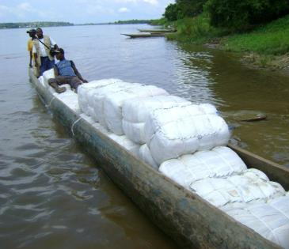
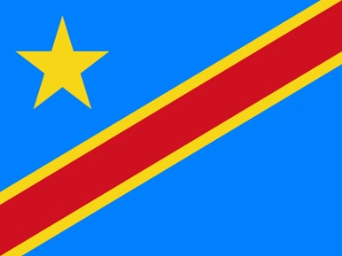
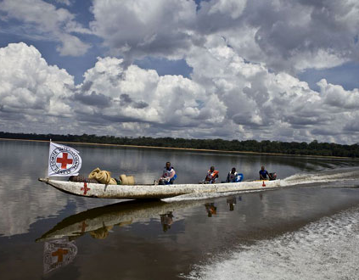

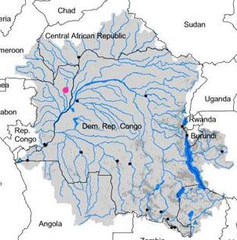
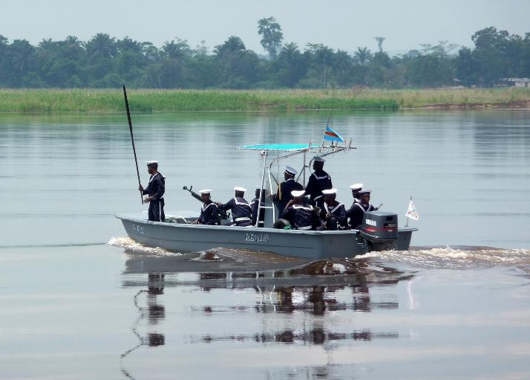

Name : Maria W. R. de Goeij
Student Number : 07009135
Dissertation Supervisor: M. van den Haspel (LLM)
Dissertation Mentor: M.J.M.S. Hekkens
Date of Completion: May 21st, 2013
School of European Studies, The Hague University of Applied Sciences

References front page:
(ICRC, 2012)(CrossedCrocodiles, 2011)(EduBlogs.org, 2012) (DefenceWeb, 2013) (Unicef, 2011)

Abbreviations
AFRICOM U.S. Africa Command
APS African Partnership Station
AU African Union
CCDP Centre on Conflict, Development and Peacebuilding
CJTF-HOA Combined Joint Task Force - Horn of Africa
COMESA Common Market for Eastern and Southern Africa
CRIMGO Critical Maritime Routes in the Gulf of Guinea Programme
DDR Disarmament, Demobilisation and Reintegration
DRC Democratic Republic of the Congo
ECF Extended Credit Facility
ECCAS Economic Community of Central African States
EITI Extractive Industries Transparency Initiative
EUSEC DR Congo European Union Security Mission in the DRC
FFP Fund For Peace
FN Force Navale
FSI Failed States Index
GoG Gulf of Guinea
GPI Global Peace Index
ICGLR International Conference on the Great Lakes Region
IMF International Monetary Fund
JAES Joint Africa-EU Strategy
MDA Maritime Domain Awareness
MNCs Multinational Companies
MONUSCO United Nations Organization Stabilisation Mission
NAVAF U.S. Naval Forces Africa
NBI Nile Basin Initiative
NRC National Resource Charter
PMAR Piracy, Maritime Awareness and Risks
RDA Riverine Domain Awareness
SAR Search And Rescue
SALW Small Arms Light Weapons
SSR Security Sector Reform

Executive Summary
In this dissertation, an answer is given to the following question: How can EU Naval Forces contribute to development in the DRC? By means of qualitative research, it has been found that EU naval forces could contribute to development in the DRC in various ways.
Firstly, by means of assisting on the establishment of Riverine Domain Awareness (RDA) in the DRC. Riverine Domain Awareness is the effective understanding of ‘what is going on’ in the riverine and Great Lake areas. The extensive network of rivers in the DRC holds development potential that has thus far has not been optimised. Effective RDA could lead to improved mobility and trade, especially in a local context, and could contribute to improving the DRC’s safety and security situation in riverine areas.
In order to establish RDA, the DRC’s naval force – the Force Navale (FN) – will need reforms throughout the whole organisation in order for them to become capable of achieving RDA. These reforms are not likely to come from within the organisation and will therefore require external assistance. EU naval forces could take on this task, in order to contribute to the development of the DRC.
RDA could also be applied on a regional level, by means of establishing a strategic framework of naval forces in parts of the Gulf of Guinea (GoG) region with a riverine focus. This would be contributing to development in the GoG, which would evidently enlarge the DRC’s potential on increasing its export quotas, and thereby economic growth. The process of forming such a framework will require external assistance. The EU naval forces could provide these naval forces to the naval forces of these countries in the GoG.
Private actors could prove valuable in the process of development and establishing effective RDA, taking on different roles. Private actors could position themselves as ‘field diplomats’ in order to make effective use of their comparative advantage over public actors. In this role, private actors could provide the FN – and the EU – with essential (local) information that could be used to operate more efficiently. The private sector could contribute to the establishment of RDA by means of donations, which could be either financial or in the form of practical assistance and consultancy.
EU naval forces could strive to enhance relationships with private actors and encouraging and ‘mobilising’ them to contribute in such a way, that it would effectively be contributing the development of the DRC.

Methodology
This dissertation is written around the question of how European Union naval forces can contribute to development in the DRC. The writer considered it important to use an integrative approach to answering this question, combining economics, law, and military studies. With regard to this dissertation, these fields should be seen interdependently: Development is being hold back by internal violence, Security Sector Reform (SSR) and economic growth tend to decrease the level of risk for a country to slide into civil war. Economic growth on itself also contributes to development but is also needed in order for a nation to be granted external assistance from the EU – under EU law – which in turn is needed in order to successfully reform the security sector, and so on.
This dissertation is based on qualitative research and was particularly inspired by the work of Paul Collier, Professor of Economics and Director of the Centre for the Study of African Economies at Oxford University. His view on nation building and conflict prevention was considered valuable because of the realistic (without hereby implying in any way that other views are unrealistic) and statistically backed nature of it, as well as the innovative approaches this could lead to.
Collier’s theory on the risk on civil war – as well as the outcome thereof and the proposed preventive measures – were known to the writer on beforehand. Collier’s theory proved valuable as a basis for this dissertation because it enabled the writer to explain the DRC’s risk on internal conflict – which greatly slows down the process of development – as well as an outcome would provide for measures that could be used in an integrative approach on development.
This dissertation focusses on the development of RDA – Riverine Domain Awareness – in the DRC rather than MDA – Maritime Domain Awareness - “the effective understanding of any activity associated with the maritime environment that could affect upon the security, safety, economy, or environment (Hekkens, Maritime and riverine security investments – A cure to avoid migration patterns of Black Swans towards the Central African lakes and waterways? Part I, 2012).
The DRC’s internal waterways have always been important to internal (legal and illegal) trade and could contribute to the development of the country. However, the value of RDA in Central Africa is something that has not been paid much attention to, as opposed to the value of MDA which is currently being officially researched and established, for example under project PMAR. Maritime Domain Awareness (MDA) also provides the DRC – especially in a regional view –with many opportunities, but falls outside the scope of this dissertation.
Because the writer does not have any fieldwork experience – nor a background in military studies – the experience, numbers, and theories of experts had to be relied on. These theories and experiences have been interpreted to the writer’s best ability, under the circumstances of not having visited the Democratic Republic of the Congo.
(Retired) Colonel Marco Hekkens – who has been stationed in the DRC as Chef Logistique to FARDC/SNR NLD for the EUSEC DR Congo mission in 2011– has been providing the writer with references that are considered reliable. Other references have been found through official websites of organisations, including the UN and the EU (or organisations related to the EU). Google has been used as a search engine, often in order to find references that had either been found in articles that had been sent to the writer.
Whilst the writer does not challenge the figures as presented in this dissertation – because it falls outside the content of this dissertation – it should be noted that there is always the possibility that the figures used, do not reflect reality. Information on the military equipment of naval forces in West and Central Africa are assumed to be correct as of date early 2012. Please note that due to maintenance and lack of spare parts – but also the level of training within naval forces – not all vessels as listed by the IISS or DefenceWeb are considered ‘operational’.
The legal framework, as presented in chapter seven, should not be seen as evidence that the EU must send military aid, but rather as an exploration of options, in order to define if it would be a possibility.

Table of Contents
Executive Summary 4
Methodology 5
Acknowledgements 10
1. Introduction 11
2. Risk Analysis 13
2.1 Economic Characteristics 13
2.2 Political Characteristics 14
2.3 Historical, Demographical, and Geographical Characteristics 15
2.4 Feasibility Hypothesis 16
2.5 FSI and GPI 17
2.6 Conclusion 19
3. Preventive Measures and Private Actors 21
3.1 Preventive Measures 21
3.2 Field Diplomats 22
3.2.1 Comparative Advantage of Private Actors 22
3.2.2 Requirements for Private Actors 23
3.2.3 Challenges for Private Actors 24
3.2.4 Motives for Private Actors to Engage in Private Diplomacy 24
3.2.5 Conclusion 25
3.3 Economic Reform and Private Sector Contributions 25
3.3.1 Public management and Congolese Minerals 26
3.3.2 Precepts of Mineral Resource Management 26
3.3.3 The Financing Role of the Private Sector: Investments in Investments 28
3.3.4 The Financing Role of the Private Sector: Non-Voluntary Donations 29
3.3.5 Conclusion 31
3.4 Security Sector Reform 31
3.5 conclusion 33
4. Riverine Domain Awareness 35
4.1 Value of RDA for Countering Armed Factions and Preventing Illegal Arms Trade 36
4.2 Value of RDA for Transport, Trade, and Aid 37
4.3 Value of RDA for Oil and Gas Exploration 37
4.4 Value of RDA for Ecology and the prevention of Shipping Accidents and Armed Robbery 38
4.5 What has to be achieved in order to establish effective RDA 38
4.5.1 Awareness at the Highest Level 39
4.5.2 External assistance 39
4.5.3 Infrastructure 39
4.5.4 Civil Shipping 39
4.5.5 Supporting Functions 40
4.5.6 Conclusion 40
4.6 Conclusion 41
5. Challenges That Face the DRC’s Force Navale (FN) 42
5.1 Infrastructure 42
5.2 Platform readiness 42
5.3 Personnel, Command and Control, and Combined-Joint operations 43
5.4 Conclusion 44
6. Strategic Framework of Naval Forces 46
6.1 Benefits of Regional Cooperation 46
6.2 Linking Naval Forces in the Gulf of Guinea 47
6.3 Overview of Naval Forces Within the Proposed Framework and Their Riverine Capabilities 48
6.4 A Strategic Framework of Naval Forces, How? 50
6.5 Conclusion 51
7. The EU and Africa: Assisting the DRC and the Strategic Value Thereof 52
7.1 Legal Framework: Agenda for Change 52
7.2 Legal Framework: Council Common Position 2005/304/CFSP 54
7.3 Legal Framework: Joint Africa-EU strategy 55
7.4 Strategic Value of the DRC to the EU 56
7.5 Conclusion 58
8. Conclusions 60
9. Recommendations: The Role of European Union Naval Forces in the DRC 62
References 63
Annexes and Appendices 71
1. Overview of Naval Forces in the GoG region, that are on the ‘short-list’ 72
1.1 Ghana 72
1.2 Nigeria 73
1.3 Niger 74
1.4 Cameroon 75
1.5 Equatorial Guinea 76
1.6 Republic of Congo (Brazzaville) 77
1.7 Democratic Republic of the Congo (DRC) 78
2. Overview of Naval Forces in the GoG region, that are not on the short-list 79
2.1 Côte d’Ivoire/Ivory Coast 79
2.2 Mali 80
2.3 Togo 81
2.4 Benin 82
2.5 Central African Republic (CAR) 83
2.6 Equatorial Guinea 84
2.7 Gabon 85
2.8 Angola 86
3. Existing International Initiatives 88
3.1 ECCAS/CEEAC 88
3.2 SADC 88
3.3 AFS/ASF 89
3.4 ICGLR 89
3.5 NBI 89
3.6 MONUSCO 90
3.8 EUSEC DR Congo 90
3.9 CRIMGO 90
3.10 AFRICOM, APS, NAVAF and CJTF-HOA 91

Acknowledgements
My interest in Africa started during my stay in Bloemfontein, South Africa, where I was on an exchange programme at the University of the Free State. With my own eyes I saw the great differences between home – The Netherlands, Europe – and Sub-Saharan Africa, in the knowledge that I had not even travelled to – and experienced – the less developed heart of Africa. Never having realised – ‘knowing’ and ‘realising’ is certainly not the exact same thing – this so clearly, I started to become eager to learn about the continent. I became particularly interested in subjects like nation building and peacebuilding after conflict. At that moment mainly focussing on marketing and economics, I ‘slightly modified’ my field of study.
One of the questions that kept lingering in my mind was – and still is – the following: “How could we really make it better?” Because frankly, what ‘we’ have been doing in the past has not always proven to be as effective as we had hoped it would be. One country that tragically reflects this rather blunt conclusion, is the Democratic Republic of the Congo. Africa’s broken heart – as it is sometimes referred to – has been torn apart by violence since what seems to be forever. Development is slow and made difficult by the constant threat of conflict. Although I knew it would be tremendously difficult to write on a country I had never been to – and unfortunately was not likely to visit in the near future – I was eager to learn and determined to take on this assignment.
Via the Hague University of Applied Sciences, I came into contact with Marco Hekkens. (Retired) Colonel Hekkens educated me on the valuable potential of riverine areas for development in the DRC, and pointed out to me the strategic importance of the Gulf of Guinea and its riverine backyards to Europe. He supervised my writing with great knowledge and patience, providing me with valuable information and sources. I want to express my sincere gratitude to Marco Hekkens, without whom I would have never been able to write this dissertation.
My sincere thanks also go to Marjo van den Haspel (LLM), who has been my supervisor from The Hague University of Applied Sciences. Marjo van den Haspel helped to greatly to maintain overview during the process of writing, and advised me on how to structure this document.
I would also like to thank Prof. dr. ir. Joris Voorhoeve, who has been a great mentor to me during the past year. Joris Voorhoeve taught me – partly through the internship that he offered me – many of the ‘basics’ of peacebuilding and conflict prevention, and encouraged me to think innovatively.
- Introduction
The DRC seems to be the forgotten broken heart of Africa: conflict has been lingering for such a long time, that the children that are currently growing up most probably do not even know what real peace is. Development has been stagnant for years, despite the numerous initiatives that have been established since the country’s independence in 1960.
Along the line of Security Sector Reform initiatives, the Congolese Force Navale (FN) has almost been ignored, whilst the DRC’s riverine and Great Lake area’s hold so much potential for development. This dissertation is written around the following question: How can European Union naval forces contribute to development in the DRC?
The sub questions that had to be answered in order to give an answer to this research question, focus on a variety of subjects ranging from economics to military studies, and from European law to political science. These sub questions will become clear in the below placed ‘road map’ through this dissertation, of which the content is as diverse, but at the same time as interconnected as the DRC’s riverine itself.
First, an overview is given of the proneness of the DRC to internal conflict, making use of the outcomes of the research of economist Paul Collier on the statistically backed causes of civil war. It is clear, that nations cannot show significant development whilst indulged in violence. This chapter is also used to give the reader a brief overview of the current situation in the DRC.
Out of the above noted analysis, three potential preventive measures follow: preventive diplomacy, economic reform and Security Sector Reform (SSR), these preventive measures will be elaborated on in the chapter that follows the risk analysis. In this chapter, the potential of the use of private actors in these preventive measures will be introduced as well, specifically in relation to assisting and financing development and security sector reforms.
Of these three preventive measures, reforms in the Congolese naval forces – which will in turn bring about some economic development as well – will be expanded on further, during the continuation of this dissertation. First, the potential contribution of Riverine Domain Awareness (RDA) to national development in the DRC will explored.
After this, the challenges that face the DRC’s Force Navale (FN) when establishing effective RDA, will be defined. The latter helps to determine to what extent SSR is needed for the FN to be able to contribute to long-term development. SSR cannot usually successfully be done from within the organisation itself, but requires external assistance. This assistance could be granted by EU naval forces in order to effectively contribute to long-term development in the DRC.
Subsequently, the possibility of a regional ‘strategic framework of naval forces’ is explored, which could have several positive effects on the development of the DRC. Similarly to what was stated above: EU naval forces could prove valuable in assisting to establish such a regional cooperation initiative.
Having given an overview of the degree of risk on civil war as well as the economic possibilities in the DRC, as well as having established what could be done – specifically in the riverine sector – in order to contribute to development in the DRC, as well as that EU naval forces would be valuable ‘mentors’ to the FN, it needs to be established if it would be – within the EU legal framework – an option to send military assistance to the DRC and why it would be valuable for the EU. This is being done in chapter seven.
The conclusion will summarise the most important findings, after which recommendations will be given on how European Union naval forces can contribute to long-term development in the Democratic Republic of the Congo.
In the appendices, the reader can find a more elaborate overview of the figures used in determining the capabilities of naval forces of countries on the long-list and the short-list of the strategic framework of naval forces in the Gulf of Guinea region.
- Risk Analysis
In his book ‘Wars, Guns, and Votes’, Paul Collier developed a statistical approach on this matter, in order to “try to predict whether a country has an outbreak of civil war on its characteristics prior to the war” (Collier, 2010). As was also mentioned by The Fund for Peace in the Failed States Index of 2011: “The reasons for state weakness and failure are complex but not unpredictable” (The Fund For Peace, 2011). Collier included economic and geographical characteristics, as well as aspects of the nation’s history, polity, and its social composition in measuring probabilities of the outbreak of civil war.
In the following chapter, these characteristics have been applied to the current situation in the Democratic Republic of the Congo (DRC), in order to explain the actual, statistically based risk on reoccurrence of internal conflict in the country and what could effectively be done in order to diminish this risk. Countries suffering from (civil) war are unlikely to show countrywide development, therefore it should be considered an important part of any development strategy to prevent the country concerned from slipping into (internal) conflict.
Without external help, the proposed initiatives and reforms will not be possible. In order for (military) intervention – also when in the form of assistance – to be sent by the EU, the nation’s current situation and risk on conflict must be indicated in order to decide whether or not the EU has mandate to do so. Also, this chapter is used to give the reader a brief overview of the situation in the DRC and some of the country’s characteristics.

2.1 Economic Characteristics
With regard to economic characteristics, it has been found that especially low-income countries are more at risk. This risk is increased when the annual growth-rate per capita of a country is low, or even in decline. The DRC’s economy is, according the CIA’s World Fact Book, slowly recovering from decades of decline. In spite of the DRC’s GDP remaining extremely low, the GDP real growth rate over 2011 has been 6.5%, indicating an improving trend over the past three years. However, taking into account that the economic development is uneven, these numbers do, under these circumstances, not necessarily imply that the risk on the outbreak of a new civil war slightly decreases by means of this economic growth. It is suggested that economic growth is the only long term effective peace building tool (Collier, Wars, Guns, and Votes, 2009). The problem here could be described as a very unfortunate paradox: it seems that long-lasting peace can only be achieved, in the event of significant economic growth, but economic growth is not all that likely to be achieved in areas that are subject to political instability and violent conflicts.
Another economic aspect Collier found to increase risk is a country’s dependence on natural resources. Valuable resources – and the mismanagement thereof – provide something to fight over. The latter applies to rebellion in such a way, that because the often high revenues of mineral trade, rebellion can be financed. Francesco Caselli of the London School of Economics predicted that some resources are highly likely to increase risks to internal conflict but that if there is a sufficient abundance of these resources it would be reducing these risks (Caselli, 2006). However, this can only apply if the revenues of these resources are being managed well, and accounted for.
The Democratic Republic of the Congo is endowed with enormous mineral wealth, and therefore a vast potential monetary wealth. The emphasis here – however – should unfortunately be on the word ‘potential’. In the history of the DRC – as well as in the current situation – its minerals have been feeding the war, rather than preventing it. The country doesn’t seem able to develop a stable exporting market, partly because the nation’s lack of visionary leaders and strong checks and balances, causing mismanagement of wealth.

2.2 Political Characteristics
The mineral question is closely related to the subject ‘corruption’. The DRC is ‘mineral-wonderland’ and political rulers, like for instance Mobutu, have been feeling “little need to create a strong administration”, nor did they “feel the pressure to build up strong armies” (Stearns, 2011). because one could easily rely on mercenaries that could be paid in cash or commodities. Enough revenues could be gained from the countries mineral wealth, which enabled Mobutu to inhibit bureaucracies that would be able to gather and administrate revenues (Stearns, 2011). The government could indeed function without taxing the income of citizens, indeed in turn detaching it from what citizens want. Over time, this phenomenon has not completely dissolved. As Jason K. Stearns also mentions in his book ‘Dancing in the Glory of Monsters’, the current president “Joseph Kabila has largely privatized the economy and has strengthened tax collection, but he is wary about creating a strong rule of law that could tie his hands” (Stearns, 2011). The latter issue is, and has been since the DRC’s independence, a distinctive characteristic for Congolese politics.
A large problem specifically in, but not limited to, post-conflict nations, is that there is too much money in politics. This causes the motives for wanting to be involved in governing the country having little to do with wanting to create strong checks and balances and improving the overall situation in the country, and all the more with accumulating personal financial wealth. The current political situation is being described as kleptocratic, with a venal political elite (Stearns, 2011). This specific political climate is highly likely to eventually cause friction, also keeping in mind the high level of ethnic diversity in the country.
As was suggested earlier, low-income societies are ‘dangerous’. Risk is increased even more when this low-income country is a democracy. When democracy is preceded by personal dictatorship, as has also been the case in the DRC, ethnic favouritism is likely to cause opposition. Since internal collapse has been what Congolese rulers have been fearing most, any form of suspected opposition is, often violently, suppressed.
No statistical evidence has nevertheless been found to prove that “violent internal conflict is the consequence of political repression” (Collier, Wars, Guns, and Votes, 2009). Repression is, under no circumstances, desirable, but it does not contribute to the risk of the outbreak of a civil war.

2.3 Historical, Demographical, and Geographical Characteristics
A historical characteristic that increases the risk on the occurrence of a violent conflict, is having had a civil war in the past. Countries that have a history of civil war, tend to be more likely to have another one in the future. However, the risk on further conflict declines with the passage of time, according to Collier. The DRC has had a history of decades of severe violence and conflict – and in fact still has in its Eastern provinces – and is therefore quite vulnerable with regard to reoccurrence, or aggravation and expansion of the conflict. The Fund for Peace’s Failed State Index 2012 indicates, in the DRC’s country profile, that it is a low capacity country, which signifies that it is not likely to be able to prevent a civil war in the future itself. (Fund For Peace, 2012)
In the Kivu provinces, the population, being mostly comprised out of ethnic Tutsis with strong ties to Rwandan and Ugandan Tutsis, are currently, and have been throughout the years, experiencing violence with a strong ethnic undertone.
Collier found that “diversity increases the risk of violence and that ethnic and religious diversity compound each other” (Collier, Wars, Guns, and Votes, 2009). The Democratic Republic of the Congo is one of the most ethnically diverse countries in the world. According to the CIA World Fact Book, the nation is composed of over 200 African ethnic groups. The population can roughly be divided into four main population groups. The majority of the people are Bantu (80%), other groups are Hamites, East Africans and a small percentage of Pygmies. The four largest tribes, Mongo, Luba, Kongo (all Bantu), and Mangbetu-Azande (Hamitic), make up about 45% of the total population (CIA, 2013) Hutus are of Bantu-, Tutsis to the Hamitic ethnicity.
The Religious division of the population looks as follows: 50% of all Congolese people is Roman Catholic, 20% is Protestant, 10% is Kimbanguist, 10% is Muslim, and 10% is defined as ‘other’, which includes West African Vodun (Voodoo) and other African indigenous beliefs (CIA, 2013).
The DRC has a very turbulent history when it comes to ethnic conflicts. The first and second African wars as well as the Ituri conflict were mostly the result of ethnical conflicts. Religion does not seem to impose serious risk on the outbreak of violence in the country, at the moment.
The DRC’s geographic features also slightly contribute to the country being at high risk of civil wars. It has been researched that mountainous landscapes create opportunities for rebels, and therefore increase risk (Collier, 2010) No evidence could be found for forests to increase risk, but obviously with regard to possible military interventions, this type of landscape, does create difficulties in securing the area, specifically logistically speaking. Whether it is a coincidence or not, the provinces that are the most mountainous, are also the ones where conflict has been the most severe over the past years, and in which the situation is still the considerably unstable, even when comparing it with other provinces. What probably does not directly increase the risk on political violence, but remains a continued threat for the population, is Africa’s most active volcano: the Nyiragongo volcano in North Kivu, near Goma. In 2002, 500.000 people got displaced due to eruption of the Nyiragongo (Seach, 2002)

2.4 Feasibility Hypothesis
The last characteristic Collier found to significantly contribute to the risk on internal conflict, is a weak military, not capable of opposing (potential) rebels. The latter is being illustrated by Collier’s feasibility hypothesis, which suggests that “the key to understanding civil war is to focus on how rebellion works, rather than on what motivates it” (Collier, Wars, Guns, and Votes, 2009). Two factors are, according to Collier, vital in order for rebellion to be feasible: money and military.
The first, money, is easily explained: rebellion can be extremely expensive. Some people opposing governments might be very much motivated to engage in rebellion because of their personal or political beliefs, but most of them would never be able to gather the financial means to actually start a large movement of rebellion. Also, as was previously explained, there is a lot of money in DRC politics, which could well be seen as an excellent motivation to engage in rebellion in order to try to overthrow the current government.
The second, military, is rather straightforward, but involves in the case of the DRC, a more complex explanation. As was mentioned before, a militarily weak government contributes to increased risk on civil war. Obviously, when the national army is able to stand up against organised rebels – and/or private armies – the likelihood of a successful rebellion is greatly reduced.
One could add one more factor to the hypothesis, namely: preventive diplomacy. Diplomacy – also on national, provincial level – can be very effective in preventing conflicts, or preventing disputes from spreading throughout the country leading to civil war. This is however, difficult to measure by means of statistics, because much tends to happen slightly behind the scenes.
The Democratic Republic of the Congo has not yet been able to build up a strong military power, notwithstanding international aid in the past and current advisory missions. The Failed State Index of 2012 also addresses the Congolese problem of poor ‘Security Apparatus’. This is also to be seen in the Fund For Peace’s capacity analysis of the DRC.
The weak state of the military, in the case of the DRC, has an extra bitter twist to it. Because of the low wages that soldiers earn working for the national army, some of these soldiers incline towards corruption. Weapons that were originally bought by the government – thus being imported into Africa the official way– in order to halt rebels, are being stolen by members of the national army and illegally sold to the highest bidder, wherever on the continent of Africa the demand is the highest (Collier, Wars, Guns, and Votes, 2009), via dubious channels. The highest bidders in the informal circuit in a part of Africa where demand is high, are most likely to be rebel movements. The smuggling of small arms and light weapons (SALW) throughout the continent of Africa is a major problem, because the continent’s internal borders are highly porous, as was also stated by Paul Collier. Much of the smuggling in the DRC, is facilitated by using the extensive network of rivers.

2.5 FSI and GPI
Interdependently of the above placed analysis, the DRC is ranked second in the annual Failed States Index (FSI) of 2012, and is being found to be a high-pressure, low-capacity state. Being ranked second in the FSI means that the state is the ‘second most failed state’, after Somalia. Thereafter follow respectively Sudan, South Sudan, Chad and Zimbabwe, as can be seen in the below placed table. The DRC is showing a slight deterioration – indicated by an increase in scores and rank – with reference to the 2011 edition of the FSI.

Total | Demographic Pressures | Refugees and IDPs | Group Grievance | Human Flight | Uneven Development | Poverty and Economic Decline | Legitimacy of the State | Public Services | Human Rights | Security Apparatus | Factionalized Elites | External Intervention
1) 114,9 | 9,8 | 10,0 | 9,6 | 8,6 | 8,1 | 9,7 | 9,9 | 9,8 | 9,9 | 10,0 | 9,8 | 9,8
2) 111,2 | 9,9 | 9,7 | 9,3 | 7,4 | 8,9 | 8,8 | 9,5 | 9,2 | 9,7 | 9,7 | 9,5 | 9,6
3) 109,4 | 8,4 | 9,9 | 10,0 | 8,3 | 8,8 | 7,3 | 9,5 | 8,5 | 9,4 | 9,7 | 9,9 | 9,5
N/R) 108,4 | 8,4 | 9,9 | 10,0 | 6,4 | 8,8 | 7,3 | 9,1 | 9,5 | 9,2 | 9,7 | 10,0 | 10,0
4) 107,6 | 9,3 | 9,5 | 9,1 | 7,7 | 8,6 | 8,3 | 9,8 | 9,5 | 9,3 | 8,9 | 9,8 | 7,8
5) 106,3 | 9,0 | 8,4 | 8,7 | 9,0 | 8,9 | 8,9 | 9,4 | 9,1 | 8,9 | 8,7 | 9,8 | 7,5

(Fund For Peace, 2012)

In the Global Peace Index (GPI), the DRC is ranked 154th of 158, meaning it is within the top 5 of least peaceful countries in the world. The illustration placed on the next page shows the nation’s rankings.
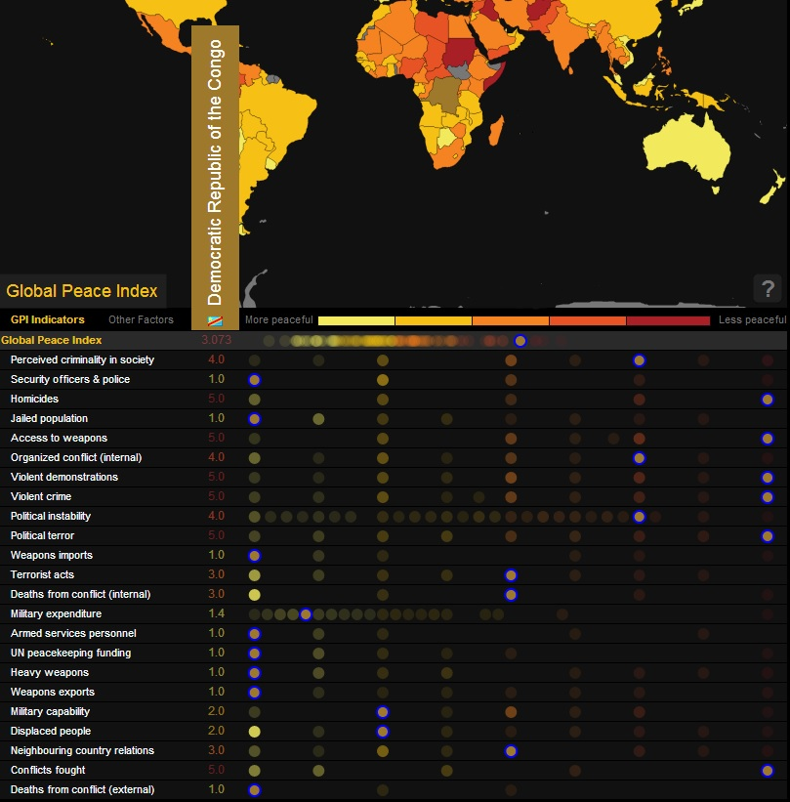 (Vision of Humanity, 2013)

2.6 Conclusion
It is clear, interpreting the above placed analysis as well as the outcomes of the FSI and GPI, that the DRC is extremely prone to internal violence. The country meets every single statistically backed characteristic found by Collier to increase the risk on the outbreak of a civil war and is classified as ‘alert’ by the FSI and ‘less peaceful’ by the GPI. Prevention of (the spreading of) conflict in the DRC is essential for national development and could be done by reforming the country’s security sector, preventive diplomacy and economic growth and stability. These three aspects will be elaborated on, in the following chapter. A nation’s proneness to violence is an important measure for the EU in the decision-making progress whether or not to send military assistance, which is needed in order for the country to undergo Security Sector Reform (SSR). It is now also established, that SSR contributes to preventing conflict, thereby in general contributing to development.
- Preventive Measures and Private Actors
Concluding from the analysis presented in chapter two, the risk of the DRC sliding back into civil war remains possible unless other mechanisms prevent such a disastrous happening. National development is unlikely to happen when conflict lingers, therefore it needs to be established what can be done in order to diminish te risk on internal conflict, in order to contribute to development.
This chapter exists of a ‘web’ of interconnected preventive measures that should also be seen as such – rather than as separate parts in the process towards development – because they would be most effective if these measures can complement each other. The different possible roles of private actors will also be introduced in this chapter, specifically with regard to information sharing, financing, consulting, and diplomacy.
These measures – which include SSR – are contemplated in order to interdependently prevent conflict, but will contribute to development directly as well. Economic growth – or stability – is an important measure for the EU in the decision-making progress on granting military assistance, which is needed in order for the Congolese security sector to undergo Security Sector Reform (SSR).

3.1 Preventive Measures
One could look at the following set of preventive measures that could together successfully contribute to the development of the DRC.
- Private actors could assist in preventive diplomacy, positioning themselves as ‘field diplomats’.
- Long-lasting peace can only be achieved in the event of significant economic growth, followed by economic stability. Economic reforms, increasing employment opportunities and education could be seen as a preventive measures as well as a means of creating a functioning, democratic government. Private actors could prove to be valuable here as well.
- Security Sector Reform (SSR) in the DRC is an important tool in trying to prevent the reoccurrence of internal violence. Within the process of SSR, the DRC’s Force Navale (FN) should not be neglected, because it has great potential to contribute to increased safety and security situation in the Democratic Republic of the Congo.
In this chapter, the above stated three interdependent preventive measures are explained in greater detail. Also, it is being described what its function could be in the process, as well as a brief overview of what should be done, or achieved, in order to work towards a more stable DRC. For the first two measures, the ‘journey’ will (for the most part) end after this chapter, due to the fact that a more in-depth analysis unfortunately falls outside the scope of this thesis. These aspect are however mentioned in this thesis to acknowledge that SSR cannot – in most cases – on its own prevent the outbreak of violence. This needs to be done in combination with preventive diplomacy – effective preventive diplomacy with the use of private actors will enable the military to operate more efficiently – and economic reforms, because economic growth – or clear potential thereon – plays a part in the EU decision-making process regarding whether or not to grant the nation with military assistance.

3.2 Field Diplomats
“Preventive diplomacy is action to prevent disputes from arising between parties, to prevent existing disputes from escalating into conflicts and to limit the spread of the latter when they occur” (UN Secretary General, 1992). Preventive and proactive approaches are advised by the Centre on Conflict, Development and Peacebuilding (CCDP), and welcomed by the UN, specifically because of its effectiveness and (cost) efficiency compared to reactive strategies. The costs, material as well as immaterial, of failed prevention are remarkably higher than those of preventive diplomacy and is therefore described as a cost-effective option for dealing with crises. (Eskandarpour & Wennmann, 2011)

3.2.1 Comparative Advantage of Private Actors
Private actors have a large comparative advantage in preventive diplomacy. According to Eskandarpour and Wennmann, private actors are more flexible and adaptable to changing situations and environments and are, moreover, better equipped to respond fast in case of an outbreak of violence. They are in a better position to analyse situations in a context sensitive way and monitor attitudinal shifts than governments and other non-private actors. Their demand driven approach increases efficiency. Also, “private actors are extremely well placed to provide entry points and facilitate the exchange of messages between parties that otherwise have no other channel of communication” (Eskandarpour & Wennmann, 2011), because of their informal character and personal commitment.
This personal commitment is likely to increase effectiveness: many private actors – and the people they care about – would benefit from an improved security situation and a more developed nation. These people are likely to experience the positive – as well as the negative – aspects of a changing situation, which enables them to detect these changes earlier and could motivate them respond to it in such a way, that it would be beneficial to them and their country. Private actors have large personal and institutional networks and because of their long term commitment, confidence is, and will be, built and dialogue is maintained, which is crucial for successful peacekeeping.
Civil society could – because of the above mentioned comparative advantage – be an important indicator on what would be effective in development and what things ‘they’ consider important to be changed. It could lead to a more people centred approach on development and military assistance.

3.2.2 Requirements for Private Actors
As was stated by Eskandarpour and Wennmann as well as by Hekkens and Brettle, not all private actors meet the requirements needed in order to engage in preventive diplomacy. Private actors need negotiation, interpersonal, and mediation skills that could make these companies, or persons, valuable as insider mediators. The largest opportunities lie in insider mediators analysing, communicating and negotiating, training, coaching, and assisting formal actors, thereby positioning themselves as ‘field diplomats’. “They can instil ‘strategic patience’, when rash ‘interventions’ and statements are assessed as counterproductive” (Hekkens & Brettle, Countering Unlawful Activities in the African Littoral: The Search for Coherency, primacy and Trust, 2012). These ‘field diplomats’ need to be willing to share intimate knowledge of the region they are working with formal actors in a discrete way, assuring confidentiality for their ‘sources of information’. At the same time, these organisations need to be proven reliable and trustworthy, transparent, and without hidden agendas. The risk on manipulation of private actors by unclean governments exists, and should be mitigated.
Confidentiality and information sharing remains an element that complicates cooperation between private and formal actors. A sensitive balance needs to be managed by insider mediators between sharing information and maintaining the promise of confidentiality (Eskandarpour & Wennmann, 2011). Without the promise of confidentiality, private actors lose all of their strategic value as field diplomats.
Improved networks of civil society groups could “link local, national, regional, and global levels of action” (GPPAC, 2013). It could for example be interesting to actively involve local leaders in preventive diplomacy, as field diplomats . One could implement initiatives such as GPPAC (Global Partnership for the Prevention of Armed Conflict) in the peace process, in order to create synergy between different grass-root organisations. An initiative such as GGPAC, has valuable knowledge on what actors would be reliable and trustworthy partners and could therefore be a crucial mediator when engaging in partnerships with private actors.

3.2.3 Challenges for Private Actors
Challenges for private actors include both human and financial constraints. Because of the project-based, country-specific, and limited duration financing, private actors find it challenging to build standing capacities that enable these organisations to respond adequately in times of crisis (Eskandarpour & Wennmann, 2011). Training and educating selected staff, existing and new, is extremely important in order for preventive diplomacy to be effective. However, it has been proven challenging to find funding especially for preventive measures, hence, in the current situation, the human and financial constraints remain in place. If a more permanent funding mechanism could be developed, the system would be quicker to set up in regions that are suffering from increasing risk on internal conflict, which is likely to contribute to adequate preparation of preventive diplomacy, which is key to the effectiveness and efficiency of the concept. These more permanent funding mechanisms, as well as successful human resources management, can only be provided for if formal actors modernise their state-centric view on preventive diplomacy, peace-making and peace-keeping (Eskandarpour & Wennmann, 2011).
The financing of private actors in preventive diplomacy depends on the situation and the types of organisations involved. Independent businesses could contribute, sponsor, actions, as it could well be in their own best interest for (geographical)areas to be, and remain, conflict-free. NGO’s usually have their own funds that could be used, provided that their preventive diplomacy activities and initiatives are in line with their core values. Other sources of financing could come from the UN network, or governments independently, depending on the severity and international, in some cases even global, consequences and scope of the threat. Most of the funding should come, however, from ‘goodwill’, as a result of common interests and values . Vital is, that in absolutely all cases, financing is completely and utterly transparent, in order to guarantee the neutral character of the funds that have been made available. It is absolutely crucial for the relationship between sponsoring organisations and operating organisations to remain completely neutral, without wielding authority (Eskandarpour & Wennmann, 2011).

3.2.4 Motives for Private Actors to Engage in Private Diplomacy
Funding and cost-effectiveness are largely contributing to the desire of formal actors to cooperate with private actors (Eskandarpour & Wennmann, 2011), but why would any private actor want to engage in preventive diplomacy? The latter depends on the nature of the different types of private actors. For example:
- NGOs will be able, and willing, to assist because it is written in their core values, but also because it will make their work much easier and more effective in the future.
- Local (tribal) leaders and village elders in the DRC are very keen to restore peace in the country. Within their tribes or villages they can be very influential and have their own way of practicing law. Some form of transitional justice, by the form of traditional justice, could be used specifically in the more remote region until the DRC is ready for a countrywide and effective rule of law.
- Local companies could profit largely from a more stable economy and society, it would be in their own interest to gain stability as fast as possible. In case ways of transport would be made possible and safe, they could enlarge their markets/number of customers.
It should be noted that the use of private actors in preventive diplomacy is not something that has been done on a large scale yet. It is therefore not possible to provide solid, statistical proof that an initiative such as the above mentioned, will be effective.

3.2.5 Conclusion
Private actors have comparative advantage in preventive diplomacy – compared to formal actors – because of their informal character, long-term commitment and personal network, in which a high degree of trust is involved. Private actors can detect (local) changes in an earlier stage compared to formal actors and are better equipped to react to these changes.
Not all private actors meet the requirements that are needed to be successful in preventive diplomacy, it is vital that they have adequate skills to position themselves successfully as insider mediators or ‘field diplomats’, as well as they need to be trustworthy and without hidden agenda. With regard to financing, it needs to be guaranteed that funds are completely transparent and neutral, again without hidden agenda.

3.3 Economic Reform and Private Sector Contributions
Management of the country’s vast mineral wealth could ameliorate the DRC’s GDP by large and is therefore a large opportunity to increase its economic potential and thereby their potential to decrease the country’s risk on civil war. This is possible by means of the growing economy itself but also because it would ameliorate the DRC’s chances on EU military assistance in order to successfully implement SSR, as well as contribute to create strong checks and balances in Congolese politics.

3.3.1 Public management and Congolese Minerals
Mismanagement of Congolese minerals cause internal and international 'frictions', especially in the eastern parts of the DRC, close to the Rwandan, Ugandan and Burundian borders. International agreements and appropriate control should prevent conflict from being financed by 'blood minerals'.
The DRC is a so called Extractive Industries Transparency Initiative (EITI) candidate country, working on implementing the ITIE but not meeting all requirements yet: currently, the country is even temporarily suspended (EITI, 2013). Becoming a member of the ITIE could largely contribute to creating strong checks and balances by gaining transparency in the nation’s income revenues, within Congolese public administration. This contributes to preventing those in power from abusing their position for their own personal (financial) benefit.
Public management remains a challenge in the DRC, not only with regard to the management of natural resources. Technical and financial assistance must be granted to the DRC public sector, as was also stated by the IMF country report of the DRC (International Monetary Fund, 2013). An independent and transparent ‘accountancy organisation’ could be established to take on the task to check the state’s finances and make these finances public. This is likely to contribute to tackling corruption by ‘taking the money out of politics’, making it an interesting career for only those that are genuinely committed to public administration and governing the country, as was also suggested by Paul Collier (Collier, New Rules for Rebuilding a Broken Nation, 2009). This is vital in the process of creating strong checks and balances within the DRC government.
A mechanism that could increase the income of the DRC, would be selling the rights to resource extraction by auction. This is both because rights to resource extraction tend to produce a considerable amount more than it is commonly calculated to be worth, and because with an auction, the possibilities of the abuse of power and/or position largely diminish, if not ruled out. As Paul Collier explained in March 2008:
“The British treasury estimated the rights to the 3G mobile spectrum to be worth $2 billion – it sold at auction for $20 billion. If the British treasury got it that wrong, imagine how the government of Sierra Leone will do. And so the government of Sierra Leone immediately asked for help with running resource auctions.” (Collier, The Bottom Billion, 2008)

3.3.2 Precepts of Mineral Resource Management
Another set of principles that could, in a later stage, contribute to the DRC’s development is the National Resource Charter (NRC): a set of 12 economic principles, for governments but also for private actors, organisations and companies, which could be used as applicable, straightforward guidelines on how to manage the vast development opportunities created by natural resources (NRC, 2013). The below placed table shows the 12 precepts – or ‘behavioural rules’ – that the National Resource Charter proposes to improve development by management of natural resources.
Figure 1. (NRC, 2013)
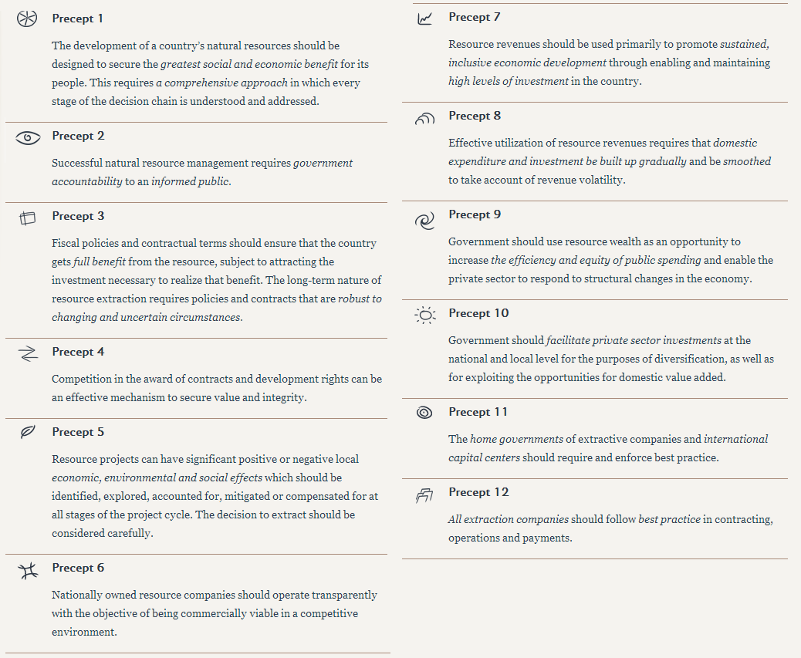
Obviously, these precepts will only be implemented successfully if the government (and its successive governments) is prepared to embrace such precepts to the best of their ability, with commensurate checks and balances; and possibly some sort of ‘mentorship’.
MNCs should take responsibility in the matter of fair trade and preventing internal conflict, engaging in regular checks in their production chain in order to not finance rebel movements. It should be made a priority to gain complete transparency within the full production chain, paying special attention to the origin of the minerals that were used in the process. The role of Congolese but ultimately also non-Congolese private actors could be considered with regard to contributing to financing development in the DRC. Which companies have been earning considerable amounts of money in the DRC? How could these companies contribute?

3.3.3 The Financing Role of the Private Sector: Investments in Investments
Not all companies will be enthusiastic to actively contribute to development of the DRC – their willingness possibly partly depending on their personal connection to the region – but their input could be crucial to success. In the long run, they will however be likely to profit from a more stable country, but ‘investments in their investments’ will be needed first.
The latter is meant as shown in the following (fictive/fictional) table describing four possible – though slightly exaggerated for visualisation purposes – scenarios for companies in the DRC (or any other country that is prone to internal conflict):

The blue line represents a possible scenario for the situation of a company – or group of companies – that started investing effectively in development and preventive initiatives. In this positive scenario, conflict is prevented and development is taking place. Growth rates start modest, but increase when time passes and the situation in the DRC – or more realistically: in that specific region of the DRC – improves.
The red line represents a possible scenario for the situation of a company – or group of companies – that started investing ineffectively in development and preventive initiatives. In this negative scenario, Investments have not lead to improvements in the DRC – for any number of reasons, including investments not being adequately allocated to effective initiatives – therefore the company’s growth rate is low, but steady. Conflict breaks out at T4, resulting in a decreased situation for the company.
The green line represents a possible scenario for the situation of a company – or group of companies – that did not invest in development and preventive initiatives. Growth rates start satisfactory, but conflict breaks out at T4, resulting in a decreased situation for the company.
The purple line represents a possible scenario for the situation of a company – or group of companies – that did not invest in development and preventive initiatives, in which neither conflict nor development take place. Growth rates are satisfactory, but do not increase over time.
The above placed scenarios are obviously not fully realistic: there are many factors that could affect a business, it is not said with certainty that these scenarios will come true exactly as predicted. What is important, is that ‘investing in investments’ could be in the benefit of the private sector as well as it would benefit development in the DRC.
One company on its own will not be likely to be able to singlehandedly generate enough means – financial or other – to improve the situation in regions in the DRC. However, as the Chinese proverb says: ‘every long walk begins with the first step’. Some companies have a large sphere of influence, and could have a disproportionally positive effect on development.
If companies would allocate substantial funds to development and conflict prevention initiatives, it would – over time – have a positive effect on the results of these companies. What is more, it is likely to improve the risk-return rate, making the company’s shares more attractive to shareholders. This might in the future not solely be noticed by shareholders in the DRC, but possibly also in ‘the western world’: investing in ‘emerging’ markets can be interesting – especially when offering an attractive risk-return rate – with regard to portfolio diversification because these markets tend not to correlate with European markets. The latter – however – falls outside the scope of this dissertation, but is something that should be kept in mind.
There could be sought to create some sort of ‘coalition of the willing’ in the private sector, or one could oblige companies to make donations that would benefit development in the DRC.

3.3.4 The Financing Role of the Private Sector: Non-Voluntary Donations
The private sector – especially multinational companies (MNCs) with large revenues – could be asked – or obliged – to make yearly donations to an independent authority that could divide the non-voluntary donations among small companies in a variety of sectors, of which examples are placed below. Not all donations need to be financial, it could also been given in the form of mentoring, training, educating, etcetera.
- The construction sector, working on – with relevance to this dissertation – rebuilding on-land and riverine infrastructure and build new ports, and renovate existing ports in order to improve internal and external trade and mobility. But also in a general sense, the construction sector could build facilities necessary in order for the people to get access to basic services, such as access to clean water – by means of building plumbing facilities – and healthcare. As was suggested by Paul Collier in 2009, the construction sector offers jobs and prospects for young men, who would otherwise form a large risk factor for internal conflict, whilst in the meantime effectively building up the country, literally. (Collier, New Rules for Rebuilding a Broken Nation, 2009).
- The (local) agricultural sector, in order to provide local people with food security and provide people with (small) revenues from farming. Products could for example be distributed and traded between different villages using the riverine network.
- The health sector – for obvious reasons – with small basic healthcare centres preferably also situated alongside waterways in order to promote ‘easy’ access.
- The educational sector, by making at available for as many people as possible, especially young people. It could also help to enhance tolerance among people with different backgrounds and create a new young generation of political leaders that could engage in a clear government in the future. Some schools could be situated close to waterways in order to promote ‘easy’ access.
- The private sector, with focus on small and local businesses. Experienced businessmen and -women could assist people of different age groups to start – or improve and maintain – their own businesses.
- The security sector, in order to contribute to (financing) Security Sector Reforms (SSR).
The abovementioned initiative would directly involve citizens with building up their country, at the same time providing these people with jobs and an income.
It is vital that appropriate balance is being found between attracting foreign business – which contributes to economic growth – and business contributing to reforms in the DRC. Imposing ‘contributions’ that are non-proportional in relation to potential revenues, is very likely to result in a decrease in foreign investment, rather that attracting it. This means that if companies have to invest too much compared to their estimated earnings.

3.3.5 Conclusion
Economic growth is essential for long term peace and development and could therefore be seen as a preventive measure, as well as a tool for development.
Poor financial management in the government sector hinder economic growth and should be included in economic reforms. It is important that (corrupt) money is taken out of politics and to create strong checks and balances within the DRC. This could be done by means of creating transparency about the government’s finances, which should be closely monitored by an independent organisation of accountants.
Auctioning the rights to resource extraction in the DRC also contributes to circumvent government corruption, as well as is increases the possible income for the state. Management of mineral resources – and allocating the revenues wisely – could provide the DRC with important development opportunities, which would increase its chances on external assistance of the EU. Transparency, with regard to the ITIE as well as in the chain of production of companies in the mining sector, is key here as well.
The Private sector could take its responsibility in contributing to development. This would bring about benefits to the development of the DRC, but would – in the long run – also be likely to benefit the companies involved. One could either attempt to create a ‘coalition of the willing’ – providing donations – within the private sector, or develop a system of non-voluntary donations – that are distributed via an independent authority – divided amongst companies in different sectors in order to build up the country, region by region. This initiative will create much needed jobs for the Congolese people, as well as an income and hopefully, the feeling of responsibility and ‘having something to lose’.
The perceptive reader might have filtered out already, the beginning of an introduction towards the importance of the riverine to the DRC’s (economic) development. This will be further elaborated on in the next chapter.

3.4 Security Sector Reform
According to Paul Collier’s feasibility hypothesis, a large part of the emphasis in preventing internal conflict in the DRC should be on whether the rebels have access to guns and money and whether the state is effective in opposing rebels.
Part of the first challenge could be tackled by appropriately managing the mining sector. Disarmament of rebels is essential, but extremely difficult because of the large numbers of small arms and light weapons that are being traded illegally. The process of DDR (Disarmament, Demobilisation and Reintegration) is difficult, because rebel groups tend to have strict military structures, in which leaving – and joining a DDR programme – is valued similarly to deserting (Small Arms Survey, 2013).
Security Sector Reform (SSR) can partly remedy the second part of the second challenge. Reforming the military in such a way, that it will become effective in opposing potential – and current – adversaries includes finding the challenges that the military is currently facing, which generally include a lack of discipline, a lack of respect for human rights, imbalances in the rank/age pyramid, inadequate training and skills, and material that is not operational.
In order to effectively reform the Congolese security sector, funds need to be made available. Part of the funding should come from the government, referring to – for example – the 12 precepts that were drawn up by the National Resource Charter. Another part of the funding could possibly be generated by the private sector, as was suggested previously. External assistance is needed for SSR to be successful, because change is not likely to come from within the Congolese forces not its government.
The EU would be valuable in assisting in reforming the FN: Europe has experience with SSR in the DRC, with EUSEC RD Congo and EUPOL RD Congo. These missions are largely land focused have not been able to bring about significant changes in the DRC, which could be explained by the following: change takes time and effort, especially when it concerns a country the size of Western Europe, and a security sector that has not been effective for decades. In order for SSR to be successful in the DRC, continuity and commitment have to be guaranteed.
According to Collier, it takes ten years for the risk on internal violence to decrease after civil war. Effectively, it would be logical if peacebuilding initiatives would remain in place for at least ten years, in order for the country to be able to show improvement and regain its chance on development. The reality shows however, that SSR missions generally do not exist for that long, not leading to real change. Possibly, the cost/effectiveness ratio could be improved by low-footprint missions that exist for a longer period of time, guaranteeing continuity and providing the Congolese people a real chance on peace.
The Force Navale (FN) – the DRC’s naval forces – should not be neglected in SSR. Once reformed and modernised, it can deliver important contributions to increase stability in the DRC by means of RDA: Riverine Domain Awareness. In the next chapter, this will be further expanded on.

3.5 conclusion
Above placed is a ‘web’ of interrelated preventive measures, that would be most effective if these measures can complement each other, because an integrated approach has been used.
Private actors, in the role of ‘field diplomats’ have a large advantage in preventive diplomacy, mostly because of their informal character, personal commitment and the level of trust. Also, ‘locals’ are more aware of the current situation as well as (slight) changes in their environment – that could for example indicate the start of civil disturbance – than any group of external experts will ever be. Also, they are better equipped to react adequately to the situation in order to prevent internal violence and conflict.
In case preventive diplomacy failed to prevent conflict, field diplomats could play an informative role in directing military forces to where they are needed. This can help a rapid response force to become more realistic in the future, contributing to being able to – in case conflict does break out in spite of preventive measures – ‘nip it in the bud’.
SSR is needed for the military to become successful in opposing rebel forces. Part of this could be financed by the private sector, part of this could be financed with government funds, generated – for example – from improved management of mineral resources. External assistance is needed in order for SSR to be effective. EU forces could prove to be valuable partners for the DRC in the process towards SSR, because of their experience and relatively transparent agenda with regard to development and military assistance.
The DRC does have potential to economic growth, but strong checks and balances will have to established in order for many of the opportunities to become real. Transparency in government finances and auctioning the rights to resource extraction could prove to be valuable tools in the process of ‘cleaning out’ politics and work towards economic potential. Economic potential is considered important in the decision making process to decide whether or not the EU will send military assistance.
Relations with private actors – or civil society – should be enhanced by the EU in order to strive towards an approach that would be contributing to Congolese society. The responsibility of private actors in development could be stimulated by EU forces, in order for action and assistance to be more effectively contributing than it has been in the past.
In the next chapter, a mechanism will be introduced that could reflect the integrated and society centred approach as was described above: Riverine Domain Awareness.

- Riverine Domain Awareness
The Democratic Republic of the Congo’s littoral, riverine, and lake environments could largely contribute to regional stability and economic growth, diversity, and prosperity, because of their potential to provide movement corridors. Riverine Domain Awareness (RDA), “the effective understanding of any activity associated with the riverine and lake environment that could affect upon the security, safety, economy, or environment” (Hekkens, Maritime and riverine security investments – A cure to avoid migration patterns of Black Swans towards the Central African lakes and waterways? Part I, 2012) can play an important part in Security Sector Reforms in the DRC.
Whilst the nation’s coastline is small, the network of rivers and lakes is extensive: 7838 kilometres of navigable rivers (Hekkens, Linking MDA to Security Sector Reform in the Democratic Republic of the Congo, 2011). The practical use of RDA has thus far not been optimised, but could very well provide the Congolese security sector – but also the security sector in other countries in the Gulf of Guinea (GoG) region with extensive riverine networks – with important opportunities.
RDA is about ‘knowing what is going on’ in the riverine and lake environment, not solely with regard to potential security threats. RDA can have positive effects on the safety of the people that are making use of these areas, with regard to their means of transportation as well as the condition of the rivers and lakes and their shores. Poor riverine conditions increase – for example – the risk on shipping accidents, that could in turn also affect economic activities as well as the environment. Other examples of activities that are associated with RDA could be – for example – illegal dumping, smuggling and armed robbery, but also fishing and oil and gas exploration. In this chapter, it will be explained how effective RDA – per ‘group of activities’ – could contribute to national development in the DRC and what should be done in order to achieve effective RDA.
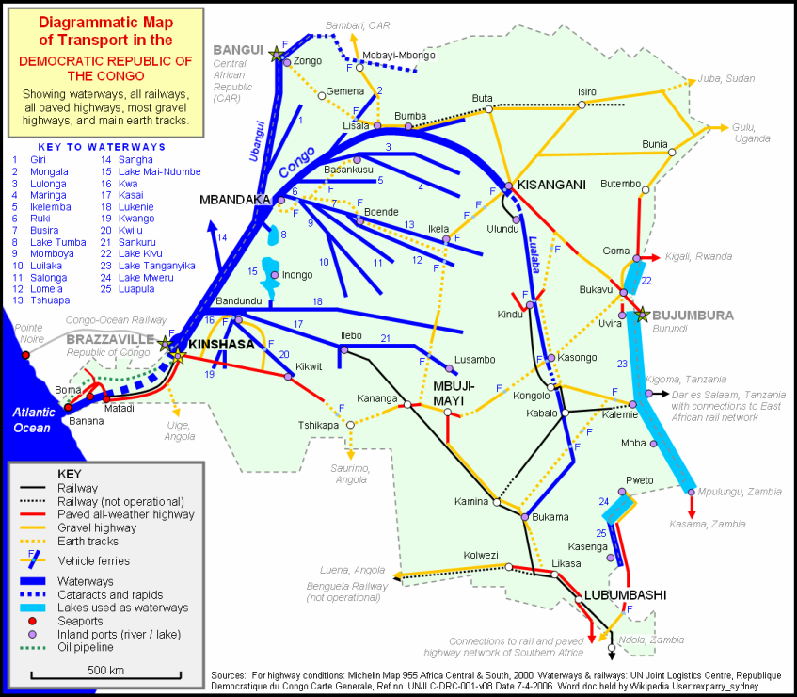
Map 1: (UN Joint Logistics Centre, 2006)

4.1 Value of RDA for Countering Armed Factions and Preventing Illegal Arms Trade
By means of RDA, especially when implemented internationally, illegal trade of small arms and light weapons ( SALW) could be reduced – contributing to a reduction of risk of the (re)occurrence of violent conflict – because part of the illegal distribution of small arms is being done via waterways. RDA could contribute to hinder armed factions to establish bases, or strategic hubs, in riverine corridors, which is for these rebel groups – from an ‘operational view’ – very attractive because of greater accessibility and mobility. Specifically for (illicit) cross-border smuggling operations, accessible transit corridors are of great importance to Armed Factions. Knowing ‘what is going on’ in riverine areas would largely contribute to enable the security sector to oppose these rebels (Hekkens, Maritime and riverine security investments – A cure to avoid migration patterns of Black Swans towards the Central African lakes and waterways? Part I, 2012)

4.2 Value of RDA for Transport, Trade, and Aid
Transport and infrastructure are needed for economic growth, which in turn is highly likely to reduce the risk on political instability. Because of the vast size of the Democratic Republic of the Congo and the poor condition of on-land infrastructure – or, in some areas, the complete lack thereof – the country’s waterways could offer affordable opportunities. As is to be seen on the above placed figure 2, the DRC’s riverine and Great Lake areas cover a large part of the country, offering the potential to transport goods and people to the country’s interior, as well as transport from the interior to the more populated areas and major cities.
From the west coast and the Great Lakes area, commodities, and in the future hopefully more manufactured goods, will be able to be transported to other parts of the world. If this process of transport were to be made safer, and therefore less risky, it would become more interesting for companies with a slightly lower margin than for example oil and mining companies, to establish factories in the region and attract foreign investment. One could hereby think of, for example, the textile industry. If risk during transport would be lowered enough, the mining industry could be industrialised more – because that would in that case be really interesting, weighing off risk and return rates – exporting not only raw commodities but also processed goods, generating a far greater profit for the DRC.
This amelioration of possibilities of safe transportation over water would not only be valuable to instigate economic growth, but also to aid workers and development projects. Material – for aid, education, construction, etcetera – could reach villages that would otherwise be extremely time-consuming and dangerous to reach, a lot faster and above all: safer.

4.3 Value of RDA for Oil and Gas Exploration
Oil and gas exploration close to the DRC’s west coast as well as in the Great Lakes area can give cause to tension between bordering states. Moreover, theft of oil and pipeline vandalisation could increase the risk on (local) disruption and are very likely to pose risk to tremendous damages to the environment, with all the negative health effects related to such pollution (Hekkens, Green Paper: Study Into Options to Modernize the DRC’s ‘Force Navale’ as a Tangible Contribution to a Comprehensive Security Sector Reform (SSR) Effort and to Stimulate Social and Economic Development, 2011). The risk on such damages could largely be mitigated by effective use of RDA.

4.4 Value of RDA for Ecology and the prevention of Shipping Accidents and Armed Robbery
As was briefly touched upon above, RDA also offers solutions from an ecological point of view. Heavy pollution and overfishing are, in the (nearby) future, likely to have disastrous consequences for the DRC, but also for neighbouring nations. Fish being a large source of nutrition for the Congolese population, scarcity will contribute to hunger, as well as poverty among small merchants, which will in turn be likely to contribute to the risk on civil disturbance. Due to lack of riverine surveillance, and therefore security, is the increasing chance that these small merchants might turn to piracy. Even military personnel tends to be prone to looting, around and on riverine corridors, where some of the largest villages lie. ‘Riverine piracy’ is already an issue in the Great Lakes area, where fishermen steal fish from other fishermen or having to “venture further afield, most of the time in other nations’ fishing grounds” (Hekkens, Green Paper: Study Into Options to Modernize the DRC’s ‘Force Navale’ as a Tangible Contribution to a Comprehensive Security Sector Reform (SSR) Effort and to Stimulate Social and Economic Development, 2011).
Furthermore, “there is no functioning ‘Search and Rescue’ organisation within the DRC; the FN is ill-equipped to assist in such circumstances, ‘if and when in range’ of the scene of the accident” (Hekkens, Green Paper: Study Into Options to Modernize the DRC’s ‘Force Navale’ as a Tangible Contribution to a Comprehensive Security Sector Reform (SSR) Effort and to Stimulate Social and Economic Development, 2011). Many lives could be saved if such an organisation would be established as part of the Force Navale (FN), quite possibly in cooperation with private actors.
The risk and effect of piracy would be mitigated by sufficient RDA, with regard to piracy in riverine and Great Lake areas. Regulating safety and pollution standards for (fishing) boats and establishing a search and rescue (SAR) organisation could provide for a larger degree of safety and security in Congolese waters and international borders, especially when collaborating with neighbouring states.

4.5 What has to be achieved in order to establish effective RDA
Effective Riverine Domain Awareness will not be achieved overnight and will not happen without putting a lot of effort in it. Within the current conditions of the DRC’s riverine and great lake area’s and the current capabilities of the FN, achieving effective RDA and making optimal use of it, would not be realistic. Below, one can find an overview of what essentially needs to be done – or achieved – in order to establish RDA and to maintain it.

4.5.1 Awareness at the Highest Level
In order to establish effective RDA, awareness has to be created at the highest level. The Congolese government then has to provide leadership support and allocate sufficient resources to RDA, first in order to establish it – which requires reforms within the DRC’s naval forces: the Force Navale (FN) with regard to policing and military capabilities – and later in a later stadium in order to maintain RDA.

4.5.2 External assistance
External assistance is needed in order to reform the DRC’s FN and to optimise the use of RDA ‘as best as possible given the local circumstances’. Continuity of this assistance it vital: Change is not likely to happen overnight. The specific challenges for the FN – thus where external forces can provide assistance – will be elaborated on in the next chapter.

4.5.3 Infrastructure
It would be contributing to the effectiveness of RDA – as well as to increase the degree of safety of the people making use of the riverine and increase the level and safety of trade and transport – rivers need to be dredged and buoys need to be placed in order to mark navigable channels and sandbanks. Also, ports have to be re-established. These ports could function as check-points for customs and excise and safety (vessels that are too heavily loaded, do not meet safety requirements, etcetera), could be the home base for Search and Rescue (SAR) organisations and could form ‘trade hubs’.
Technically, it would be the task of the state to provide infrastructure. However, process tends to be very slow – if not non-existent or even deteriorating – and it could therefore be useful to involve private actors – including the private sector – by means of the initiatives proposed in chapter 3.3.3 and 3.3.4: contributions of the private sector – and in the future possibly from citizens as a form of (transparent!) taxation – are transparently divided by an independent authority amongst small (local) companies in the form of either assistance, building materials or financial means, that can then together improve infrastructure themselves.

4.5.4 Civil Shipping
In order for the DRC to experience the optimal impact of RDA, civil shipping – and specifically the safety thereof – should be improved. Private actors could again assist in this. The ship-building industry is one of these industries – this has been discussed in chapter 3.3 – in which the effects of activities enjoy a broad sphere of influence. This sphere of influence could be seen as follows:
- The ship-building industry has influence on the safety of vessels, and therefore the safety of the people that are working with these vessels
- The ship-building industry has influence on what engines are being used – if an engine is used – and therefore how much these engines contribute to pollution.
- The ship-building industry has influence on ecology in various ways. For example: the building materials used to produce boats– wood, for example – need to come from somewhere. In the case of wood, this can contribute to deforestation and endangering the living environment of many different animals.
- The ship-building industry could have influence on maintenance of vessels.
- The ship-building industry could engage their clients – whether these clients are military of civil – in training to handle their products safely, with regard to safety on board but also concerning safety regulations on waterways.

4.5.5 Supporting Functions
RDA requires supporting functions that need to be established, which would consist of both military and civil personnel. These supporting functions include the following:
- A Search and rescue (SAR) organisation
- Custom and excise
- An illegal fishing patrol
- An environmental – or counter pollution – patrol

4.5.6 Conclusion
In order to establish effective RDA, there are a few things that need to be achieved. First, awareness needs to be created at government level and needs to be spread along the chain of command. Adequate budget needs to be allocated to RDA, which should be used to contribute to SSR, the improvement of infrastructure, and the establishment of functions that support RDA, such as SAR, and custom and excise, as well as an illegal fishing and counter pollution patrol. The latter could consist of both military and civil personnel.
External assistance is required in order to reform the FN, in order for them to be capable of achieving effective RDA. The specific challenges that face the FN – which therefore deserve special attention in SSR – will be elaborated on in the next chapter.
Actions that would complement RDA, are the amelioration of infrastructure, including (re)building ports, dredging rivers and placing buoys in order to indicate safe passages. Civil shipping should be improved especially in order to increase levels of safety for citizens that make use of the DRC’s waterways. Private actors could play a role in ameliorating (riverine) infrastructure and improve civil shipping.

4.6 Conclusion
Concluding from the above stated, effective RDA – being aware of ‘what is going on’ in the riverine domain – can contribute to national development in the DRC. It can lead to amelioration of the safety and security situation in the riverine and great lake areas – not only for citizens but also for aid workers – as well as it could largely contribute to improve trade and thereby contribute to economic development. RDA can play a role in preventing ecological imbalance and pollution, that are likely to bring about severe negative health effects for the Congolese population.
It reflects the integrative and society centred approach that was described in chapter 3, with regard to the establishment of RDA as well as maintaining it. Riverine Domain Awareness should be implemented in SSR within the FN, because the FN plays an important role in achieving effective RDA. External assistance is required to achieve RDA, particularly in relation to reforming the FN, but also quite possibly just to ‘make it happen’ and coordinate the process, also with regard to organising private actors to contribute. EU naval forces could take on these tasks, in order to contribute to development of the DRC.
In the following chapter, the challenges that face the DRC’s Force Navale in achieving Riverine Domain Awareness are described, in order to define in what areas EU naval forces could assist in order to establish and achieve effective RDA.

- Challenges That Face the DRC’s Force Navale (FN)
In order to achieve a comprehensive level of RDA in the DRC, the Force Navale’s (FN) operational capacity needs to be increased and special personnel needs to be trained to be able to adequately fulfil the tasks related to a search and rescue division. Many challenges within the FN itself as well as the physical state of their bases and vessels need to be met in order for the littoral and the riverine and great like areas to be able to be used in contribution to the welfare, stabilisation and rehabilitation of the DRC, and possibly its bordering nations.
In the following chapter, an overview of the FN’s existing ‘capability deltas’ is given, as well as what could be done in order to rectify some of the shortcomings that are holding back Congolese riverine safety and security, created by means of RDA. This will be put in context to the main research question by defining to what extent SSR is required in the FN, in order to determine how European Naval forces can assist in reforming the FN, thereby contributing to development.

5.1 Infrastructure
According to Hekkens, logistically and (on-shore) infrastructure wise, the Force Navale is to be considered extremely weak. Shore based infrastructures are either in disrepair or are not considered to be safe to operate by western standards, due to years of neglected maintenance. Moreover, according to Hekkens, “the logistic functions (i.e. supply, maintenance, ordnance etc.) suffer from years of neglect and lack of formal training. Stock levels are inadequate, often not ‘accounted for’, with insufficient visibility of asset location” (Hekkens, Green Paper: Study Into Options to Modernize the DRC’s ‘Force Navale’ as a Tangible Contribution to a Comprehensive Security Sector Reform (SSR) Effort and to Stimulate Social and Economic Development, 2011).These infrastructures must be made operational again, in order to for the FN to function adequately and establish RDA. Additionally, Congolese rivers need dredging, as was also mentioned in chapter 4.5.

5.2 Platform readiness
“All major platforms in the DRC are considered to be non-operational. The majority of smaller platforms lack functioning outboard engines, spare parts and fuel to conduct multiple day tasking’s. Mandatory safety equipment are in short supply and/or beyond their ‘do not use after date’” (Hekkens, Green Paper: Study Into Options to Modernize the DRC’s ‘Force Navale’ as a Tangible Contribution to a Comprehensive Security Sector Reform (SSR) Effort and to Stimulate Social and Economic Development, 2011). Platform readiness remains a large problem for the Force Navale. Although platform readiness is absolutely vital for the FN to effectively execute its tasks, not enough means have been made available in order to achieve this.
According to the Military Balance of 2012, The DRC FN has only 23 Patrol Boats (PB) in total:
- 3 Shanghai type II, of which two are non-operational
- 20 of various types, all under 50ft
This number is extremely low and does not allow the FN to adequately fulfil its tasks. In the past, the Force Navale has been donated second-hand platforms from western navies that have failed to be useful, due to lack of understanding of the mechanics when the vessel broke down or needed maintenance, or due to lack of the right fuel, or due to parts being stolen. The FN needs to get its hands on, either by foreign donation or own investment, platforms that are useful in riverine areas, which also have been suffering from years of neglect, with regard to i.e. dredging and placing buoys for marking the navigable channels and sandbanks. The latter could be ‘taken care of’ in collaboration with private actors in the construction and maintenance industry.
It is of utmost importance that whatever material is used, maintenance and guarding will not be neglected. It is not uncommon for arms, weapons and other material to disappear, get stolen and sold as a whole or in separate parts, often by military personnel, which causes the FN’s efficiency to decrease.
Innovative and cost-effective tactics and techniques could be used by the Force Navale to pose a challenge to potential adversaries and create effective Riverine Domain Awareness in the DRC.

5.3 Personnel, Command and Control, and Combined-Joint operations
As pointed out by Hekkens, there are important improvements to be met within the Force Navale, with regard to its personnel. Currently, according to the Military Balance 2012, the FN consists of approximately 6700 registered staff.
It would be wise to increase the number of personnel (civilian as well as military) of the Force Navale in order to contribute to countrywide RDA. It should be pointed out, however, that enlarging military forces should not on itself really form a strategy to reduce unemployment rates in the country, as it creates long-term liabilities for the state, but only as a mean of recreating balance and creating a force that is strong enough to oppose existing or foreseeable security threats.
An appropriate balance needs to be established between the number of men and women as well as the equal distribution of tasks between different racial groups working with and for the FN. It needs to start actively recruiting for younger employees, for the rank and age pyramid is not in balance. There is too many personnel that is too old, that still hold high military ranks (Hekkens, Green Paper: Study Into Options to Modernize the DRC’s ‘Force Navale’ as a Tangible Contribution to a Comprehensive Security Sector Reform (SSR) Effort and to Stimulate Social and Economic Development, 2011). Personnel has to be adequately educated and trained for their specific tasks. As stated earlier, personnel needs to either be trained to use and maintain the material that is ‘donated’ by them by foreign countries, or need to receive material that they are familiar working with.
A state of discipline – and understanding of human rights – needs to be achieved within the FN, in order for it to function effectively and in accordance with international humanitarian standards and, also with strong regard to the huge financial constraints, efficiently. “The ‘Command and Control’ functions are assessed as weak. It lacks robustness, responsiveness and the ability to create and maintain a sufficiently real-time ‘situational picture’ in order to effectively adjust and respond to changing circumstances” (Hekkens, Green Paper: Study Into Options to Modernize the DRC’s ‘Force Navale’ as a Tangible Contribution to a Comprehensive Security Sector Reform (SSR) Effort and to Stimulate Social and Economic Development, 2011).
Currently, the FN is, according to Hekkens, hardly capable of conducting combined operations. This lack of cooperation between the Force Navale and other naval forces in the region and/or the air and land forces, due to which the efficiency of the DRC armed forces is far from optimal, also from a regional point of view.

5.4 Conclusion
Concluding from the above stated, the FN requires SSR throughout the whole organisation. It needs modernisation regarding infrastructure, platforms, and other equipment. The rank and age pyramid should be brought in balance and personnel lacks the adequate training and discipline that is needed to successfully fulfil their tasks: this needs to be improved. In order to achieve effective RDA countrywide, the number of FN personnel will need to be increased. It would be valuable for the FN to be able to conduct combined operations.
As was stated before, SSR is not likely to be effective without external assistance. EU naval forces could coordinate the necessary reforms in order the FN to be able to achieve effective RDA, in order to contribute to development of the DRC.
In the next chapter it is described how a framework of naval forces – that focusses on RDA – in Western Central Africa could contribute to regional development and the development of the DRC.

Strategic Framework of Naval Forces

It is perhaps peculiar to note, that most African states do not have extensive naval forces, nor do they focus extensively on the region’s potential in the various riverine areas. Some of these states might not have a large long coastal area, but a considerable amount of African countries comprise large areas of water, like lakes and major navigable rivers. These waters, some territorial, some with international borders, form a large potential for the economies of these countries, as was stated above. Despite the many opportunities of safe and secure waters for African states, they currently merely remain a potential obstacle to development and unfit for trade due to being highly unsafe and deferred maintenance of ports and riverbanks.
In this chapter, the opportunities with regard to a strategic framework of naval forces – with riverine focus – in the Gulf of Guinea region – West Central Africa – are explored. A cooperation of this nature, could bring about development opportunities for the DRC as an international economic player, but also for the regional safety and security situation. The establishment of a strategic framework of naval forces in the GoG region, should receive external assistance in order for it to become reality. EU naval forces could take on this task in order to contribute to development in the DRC and the GoG region.

6.1 Benefits of Regional Cooperation
The DRC is not the only country in the region that is struggling to keep its internal and external waters safe and does not have an effective navy to participate in fulfilling this task, yet the FN’s ability to conduct cross-border collaborations is non-existent. The DRC should seek to enhance its in regional cooperation, especially in the field of Riverine Domain Awareness. A strategic framework of navies could be established in order for the riverine areas in west and central Africa to become safer and secure, and therefore of much more value for (international) economic purposes for different countries.
Trade between countries in the region would become easier, which could form the foundations on which the DRC could build its exporting sector, on a more continental level. If this could be achieved, and export quotas would be increased, this would benefit economic development in the DRC, which would in turn contribute to national, overall development. Search and rescue (SAR) could become more effective and efficient in bordering waters.
It could be mutually beneficial for countries to establish a framework of navies, with focus on the riverine. Together they could cooperate in a transparent and cost effective way and in a proactive manner, on the amelioration of RDA (and MDA). Thereby they would collectively be contributing to a safer and more secure region, helping to enable the region to reverse the negative economic circle they are currently in, to a positive one.
In the future, a system of pooling and sharing could be established within this framework, making the initiative even more cost-effective. However, this is a system that even the EU has not been able to master effectively: pooling and sharing involves a great amount of mutual trust, something that is – unfortunately – not abundantly ‘available’ in Africa.

6.2 Linking Naval Forces in the Gulf of Guinea
Such a framework could comprise the following countries in the Gulf of Guinea (GoG) region:
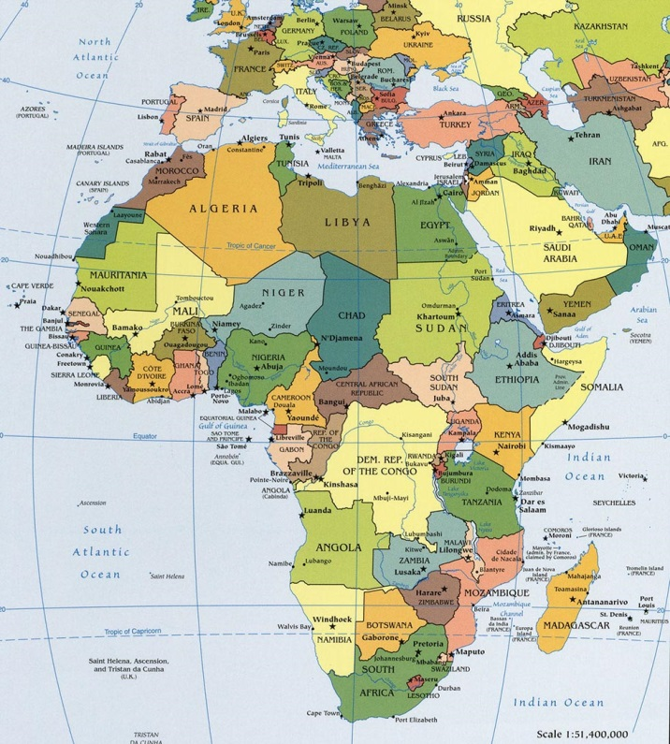
- Côte d’Ivoire
- Mali
- Ghana
- Togo
- Benin
- Nigeria
- Niger
- Cameroon
- Central African Republic (CAR)
- Equatorial Guinea
- Gabon
- Republic of Congo
- Democratic Republic of the Congo (DRC)
- Angola
Map 2: (Worldatlas, 2013)
These countries have in common that they mostly all have either large coastal areas or extensive riverine networks that connect those countries and that are important for economic activities. The latter is because of often poor over-land infrastructure networks, but is also influenced by ‘how things are being done for years’.
It is of utmost importance, that when establishing a framework of navies that’s focuses specifically on RDA, international relations are taken into account. Without analysing possible, and maybe even current, tensions between participating nations, a collaboration in this field would be destined to fail. Currently, there are no serious tensions between the abovementioned countries that could not be resolved in the not too distant future if the parties involved are prepared to cede some of their hard demands. Some of these countries there are, however, experiencing internal tensions and/or serious threats with regard to internal conflict, or are in the process of post-conflict recovery.
The abovementioned list would – looking at the various riverine areas within the GoG region – be optimal, but unfortunately also unrealistic, due to the vast geographical size of the area and the state of the various naval forces, as well as the large – political, legal, military – differences between the countries that would be involved. A collaboration between naval forces with riverine would be more plausible to narrow the previous list down to following countries:
- Ghana
- Nigeria
- Niger
- Cameroon
- Equatorial Guinea
- Republic of Congo
- Democratic Republic of the Congo (DRC)

6.3 Overview of Naval Forces Within the Proposed Framework and Their Riverine Capabilities
On the following pages, an overview is placed of the different naval forces that are on the above placed ‘shortlist’.
- The Ghanaian navy is relatively advanced, compared to most other navies in the GoG region. The focus lies mainly on maritime and coastal area, but it has riverine capacity and has been assisting private actors in riverine areas. The Navy’s two operational commands are in Sekondi (Western Naval Command) and Tema (Eastern Naval Command). It has two education centres, one with emphasis on naval trade and one that focusses on navy basics and leadership (Ghana Armed Forces, 2013).
- The Nigerian navy is the largest within the proposed strategic framework of navies and cooperated successfully with the Benin navy on joint anti-piracy patrols. In the past years, Nigeria has been putting a lot of effort in improving their maritime and riverine capabilities and are therefore rather modern (DefenceWeb, 2011).
- Niger has no naval forces, but does have riverine policing capability, according to Hekkens. Although much will need to be done in Niger in order to be able to achieve RDA, investments could – over time – show disproportionally good results. It would not be realistic to expect for RDA to be achievable throughout the whole country, but could possibly be limited to the western parts of the country.
- Cameroon’s navy is appropriately equipped for coastal and river patrol and its main naval bases are in Douala, Limbe, Kribi and Campo. Douala has a Naval Technical Training Centre and Centre for Training and Safety Application and will have an Officer Training School in the nearby future. In Issongo, there is a School of Diving and a Naval Riflemen Training and Professional Development Centre. (Hekkens, 2012)
- Equatorial Guinea has been heavily investing in, and increasing their navy in the past few years (Pravda, 2012), in order to protect its oil installations from piracy and robbery. Moreover, there are plans to establish a Naval School in the country (Equatorial Guinea Government, 2011). The latter is essential for future success, since the current state of the military is considered to be rather poor, with poorly trained personnel and nepotism determining ranking, leading to poor decision-making (DefenceWeb, 2013).
- Congo Brazzaville’s navy is rather poor equipped for maritime purposes, but has riverine capacity. Equipment has, however, been suffering from poor maintenance and morale is considered to be low within Brazzaville’s military forces. (DefenceWeb, 2013)
- The DRC’s Force Navale, as described previously, needs reforms. The navy does have riverine capacities.

All countries on the above placed ‘shortlist’ have a varying degree of capacity to operate on their rivers and lakes, which can be concluded based on the overview placed above. In the Appendix, the reader could find a more extensive list of figures. However, SSR – or at least modernisation of these forces – should not be considered to be a luxury. Also, it must be noted that an actual comparison between these nations with regard to their naval capabilities is extremely difficult. The numbers provided do not reflect – for instance – an accurate indication of serviceability and the level of training. Neither is it clear how the ‘Command and Control’ functions will be exercised under a variety of potential scenario’s.
Establishing a strategic framework of navies with riverine focus would however certainly not be impossible and could bring about a coordinated and persistent chain of ‘naval SSR’ that could ameliorate the safety and security situation in the region, as well as instigate long lasting economic development.

6.4 A Strategic Framework of Naval Forces, How?
It would be advisable to install an overarching organisation with a ‘High Representative’ for the GoG and its riverine backyards, possibly within the AU. In order to create an accountable organisation, the High Representative should be elected democratically. It would not be plausible that this would be successful if elections would take place region wide – most probably not even country wide – because currently, there might not be enough interest amongst civilians as well as it would – with regard to logistics – be terribly difficult to organise. More realistic would be, to elect the High Representative among the different representatives of the participating naval forces.
Roles and responsibilities of different naval forces – or the representatives thereof – should be fairly weighed against contributions (in deeds) towards development and should be rotating, in order to prevent representatives to stay in one position for too long. Ideally, these representatives would be elected democratically, within the Naval Forces in every country.
One could establish a ‘board of representatives’, led by the High Representative, who is democratically elected by the members of the board of representatives. An exact – and detailed – proposal on an organisational structure including a division of tasks, falls outside the scope of this thesis.
The forming the framework should be monitored and assistance should be granted in order to ‘run things smoothly’. EU naval forces could provide assistance in this process.
The EU has been supporting and working together with the AU successfully for years. Under JAES – the Joint African EU Strategy – the EU and the AU have established the APF, the African Peace Facility. Similar to the above proposed initiative, JAES focuses on regional cooperation
In the next chapter, the JAES and its goals will be elaborated on further.

6.5 Conclusion
In conclusion, many development opportunities exist in the establishment of a strategic framework of the selected naval forces in the GoG region, specifically if its focus would be on RDA. Among the selected naval forces, SSR would contribute to the effectiveness of the proposed collaboration. The strategic framework of naval forces could contribute to the international safety and security situation – which obviously includes the DRC – as well as it could ameliorate the international economic position of the Democratic Republic of the Congo, specifically within the GoG region.
The process of establishing the collaboration initiative, should be monitored by external partners. European naval forces could prove to be of value because of the good relationship between the EU and the AU and their current collaboration on the establishment of the APF – the African Peace Force – which focuses on regional cooperation and rapid response in different regions.
In the next chapter, the reader is provided with a legal framework, which indicates that it would be – according to EU law – a possibility to send military assistance to the DRC, in order to contribute to development of the DRC.

- The EU and Africa: Assisting the DRC and the Strategic Value Thereof

In order for the Force Navale to be able to undergo the required organisational reforms and engage in the proposed regional strategic framework of navies, it needs assistance. The European Union’s expertise and good relationship with the AU could prove valuable in achieving this. However, the EU does not grant assistance ‘just like that’: appropriate mandate needs to be found as well as it needs to be beneficial for the EU.
In this chapter, an overview of the relevant legal framework is given in order to determine if it would – under EU law – be possible to send EU naval forces to the DRC. After having established that the option to send military assistance to DRC exists, it is briefly described why the EU should consider to do so, apart from contributing to ameliorating the security situation in the country.

7.1 Legal Framework: Agenda for Change
The communication from the commission to the European Parliament, the Council, the European Economic and Social Committee and the Committee of the regions on increasing the impact of EU development policy: an Agenda for Change, states that “the mix and level of aid will depend on the country’s situation, including its ability to conduct reforms” (European Commission, 2011).
The Democratic Republic of the Congo has a high risk on re-occurrence of internal violence. The latter is proved by the Failed States Index (FSI), the Global Peace Index (GPI) and the analysis on the basis of Paul Collier’s statistically proven factors that contribute to the risk on the occurrence of internal violence. What’s more is that in the GPI as well as the FSI, an unfortunate overall deterioration of the country’s situation is seen. In the Failed States Index, the country is in the 2012 version, being assessed as ‘very high alert’ (Fund For Peace, 2012).
The ability of the nation to conduct sustainable reforms remains an issue for the DRC. Because of the enormous size of the country, the gap between the current situation is and what would be desirable, and the change that the security sector reform has to bring about, results will only be visible after a longer period of time. The impact of aid is slow and difficult to measure: significant changes in behavioural and thinking patterns require vast amounts of time.
Does that mean the European Union should turn its back on this highly vulnerable country? According to this same Agenda for Change, it should not. It states that “the EU should strive to help countries in situations of fragility to establish functioning and accountable institutions that deliver basic services and support poverty reduction” (European Commission, 2011). However, decisions on whether or not aid should be granted, and within what budget, are taken on a case-by-case basis. In the decision-making process, costs, risks and especially benefits are being weighed.
More precisely, as is stated in the Agenda for Change: “the EU must seek to target its resources where they are needed most and where they could have the greatest impact” (European Commission, 2011), and should specifically be allocated according to the country’s needs, financial capacities, commitments, performance, and the potential European Union impact on the situation.
The potential European Union Impact is, in the Agenda for Change, being assessed in two cross-cutting objectives, namely:
- “increasing the extent to which EU cooperation could promote and support political, economic, social and environmental policy reforms in partner countries”; (European Commission, 2011)
- “Increasing the leveraging effect that EU aid could have on other sources of finance for development, in particular private investment.” (European Commission, 2011)

Analysing the Democratic Republic of the Congo according to the above mentioned criteria, one could state that its needs are more than sufficient, as proved by the outcomes of the GPI, FSI and the analysis based on the statistical research of Collier. The DRC does have the potential to generate sufficient financial resources, provided for that its vast mineral wealth would be managed properly, and strong checks and balances would be established within the DRC government. Private actors could contribute to development as proposed in chapter three, of which was given an example in chapter six, in which the local private sector could be contributing to development by means of contributions from larger – possibly international – companies: leading to increased development of the private sector as well as the overall situation in areas of the DRC.
The country’s (political) commitment and performance are thus far debatable. The overall capacity, in this case with regard to the DRC’s capacity to tackle security issues of the DRC as described in de Failed Stats Index is low. However, this is exactly what could be increased by means of more effective advisory and trainings missions, as well as enhanced cooperation between nations in the Gulf of Guinea (GoG) region. Security Sector Reform is essential for the DRC to increase its performance on rule of law democracy and sound, non-corrupt, financial management and economic and fiscal policies. European Union impact will be great if the it would assist in SSR in the FN, working towards a collaboration within a strategic framework, and creating RDA.
According to Martinelli – with regard to the DRC’s commitment to reform, especially political reform – Congolese authorities are not actively participating in current reforming efforts, as the EU is assuming that the political will is there (Martinelli, 2013). Considering the motives for (most) Congolese authorities to be and remain in power as have been discussed in chapter two and three – money, and power over means to generate money – this should not come as a surprise. Effectively, thorough reforms – political reform, economic reform, legal reform and security sector reform – would most probably result in a separation of powers, current rulers losing their power and thereby their access to government money.
Although the full elaboration on the above stated falls outside the scope of this dissertation, it would be valuable to mention that it would be advisable to the EU to critically review their policies, in order to effectively work towards fulfilling the 21st century ‘needs of the world’.

7.2 Legal Framework: Council Common Position 2005/304/CFSP
Article 1.4 of the Council Common Position 2005/304/CFSP, concerning conflict prevention, management and resolution in Africa highlights once more the importance of the progress in the fields of conflict prevention and peace-building, describing it as a “necessary precondition also for African States to build and sustain capacity to deal effectively with terrorism”. It does not state that in those cases, visible progress is a necessary precondition for (military) aid.
Moreover, is it fair to expect a nation to be able to show progress and conduct reforms that meet up to the European standard, within a relatively short amount of time, when it has never been really at peace after previous severe conflicts? Would it then not be more realistic to look at a county’s potential and possible future capabilities, instead of looking at what not has been achieved yet? Besides, has ‘The West’ been sending the right kind of aid and assistance, that allowed the DRC to substantially improve its situation?
the Council Common Position 2005/304/CFSP, concerning conflict prevention, management and resolution in Africa, states in article 10 that the EU has to “reflect the need to maintain focus on a conflict even after it has become less acute, and to contribute to a more coherent and systematic approach to post-war situations in Africa, the EU shall:
- Develop and organise its own capacities in order to support security sector reform within the framework of democratic principles, respect for human rights, the rule of law, and good governance, in particular in countries in transition from violent conflict to sustainable peace.
- Continue and consolidate its support for tackling the problems of the destabilising accumulation and uncontrolled spread of small arms.

7.3 Legal Framework: Joint Africa-EU strategy
The European Union also has specific arrangements and partnerships with the African Union to specifically address the situation in the continent. One such partnership is the Joint Africa-EU Strategy (JAES). “The objective of the Joint Strategy is to cooperate in enhancing the capacity of Africa and EU to respond timely and adequately to security threats, and also to join efforts in addressing global challenges.” (Africa-EU Partnership, 2013)The four main objectives of the JAES are the following:
- Improving the Africa-EU political partnership
- Promoting:
- peace, security, democratic governance and human rights
- basic freedoms, gender equality
- sustainable economic development, including industrialisation
- regional and continental integration
- ensuring that all the Millennium Development Goals are met in all African countries by 2015
- Effective multilateralism
- A people-centred partnership.
(Africa-EU Partnership, 2013)
An example of a product of the Africa-EU partnership, is the African Standby Force (ASF): the African Union’s Peacekeeping force. The deadline for the peacekeeping force – that focuses on preventive action and rapid response – to become operational was originally set in 2008, but eventually – after being pushed to 2010 and after that to 2013 – delayed until 2015. (The East African, 2013)
The AFS should in 2015 be able to take on the following roles:
- Observer missions deployed alongside a UN mission – to be deployed in 30 days;
- A regional peacekeeping/building force – to be deployed in 30 days;
- Intervention for example in genocide situations – a robust military response in 14 days.
(Africa-EU Partnership, 2013)

The abovementioned initiative shows that the EU has previously been working on developing a force that is specialised in preventive action and rapid response – and regionally integrated – without all the countries involved having shown visible progress with regard to their ability to conduct reforms. However, deadlines for ASF to become operational have been delayed three times so far because forces are not ready yet – with regard to their capabilities – which might result in a little more resistance to engage in such an initiative – that shows similarities to an assistance mission in the DRC in order to assist in reforming the Force Navale and establish effective RDA, with a possibility of extending this to establishing a regional framework of naval forces in the GoG – in the future.

7.4 Strategic Value of the DRC to the EU
To start with: why should the EU, apart from preventing an outbreak of severe internal violence, invest in and assist the DRC? What is the strategic value of the DRC to the Europe? One could distinguish at least two main reasons, which will be elaborated on below.
Throughout the past years, two countries have been very present in the DRC: India and China. The nature of India’s relationship with the DRC and its government, differs significantly with China, however (Mthembu-Salter, 2012). Whilst India is largely involved in MONUSCO and operates rather independently, China seems to take advantage of the DRC’s corrupt government, engaging largely in favouritism.
Since a few years, Chinese state owned companies have been investing in the Congolese mining industry, in order to get their hands on valuable minerals, that they are prohibited from mining in the US due to the US' military-industrial complex (Mehta, 2012). China's own military-industrial complex, used heavily in their strategy to 'catch up' with developed economies, however, requires minerals; lots of them. Why bother with a country tremendously reducing poverty without assistance from 'the West'? The problem is not that it does not work, because it does, or that the EU should not desire independence from emerging economies, because obviously it should.
The problem is the Chinese military-industrial complex itself, the motives for the country to invest in developing nations. The military-industrial complex is a term developed by Dwight Eisenhower in 1961 and is used to describe a mechanism where policy and monetary relationships exist between a country’s armed forces, the military industrial sector, and legislators.
The motives for China to invest in the DRC are hardly philanthropic (Sleigh & Lewinski, 2006). In the book 'Economics of Killing', Vijay Mehta explains that it would not even slightly be in the interest of China's industrialisation to really develop the countries which they gain minerals from: If these countries would copy China's development strategy, minerals would be absorbed locally, leaving too little for China's growing demand. Therefore, in order for their industrialisation development strategy to be successful, "China must acquire puppet regimes and prevent them from being toppled by the agents of rival powers" (Mehta, 2012) as the nation is currently pursuing in the DRC.
Furthermore, because of the way companies like Sicomines, and Cosco, do business in the DRC, signing agreements with politicians and officials, this would slow down the process of 'getting money out of politics' in order to create clean governments, as has been explained in chapter 3.
The real danger for Europe, and effectively the rest of the world, would be the chance of China’s military-industrial complex that is fuelled by – inter alia – Congolese minerals, to ‘overshoot’ its goal of economic development by favouring the core interest of a military-industrial complex: war, and re-supply of military equipment. (Mehta, 2012)
Can the EU stop China from mining in the DRC, in order to prevent the military-industrial complex from being fuelled? No, it cannot. What it can do – however – to protect its economic and position and its perceived value in international relations, is to make sure that its strategic position in western Africa, including the Atlantic ocean, will not be challenged.
According to Hekkens, it is vital for the EU, and its economy, to maintain and strengthen its strategic position in the Atlantic Ocean and on the western African continent, thereby, though, not neglecting the Indian Ocean and the east coast (Hekkens, The Strategic Value of Africa and Maintaining Unchallenged Hegemony in the Atlantic Ocean, 2011).The reason why it is so important for the EU economy to remain its presence in the Atlantic Ocean and on the western seaboards, is the following: we cannot afford to lose the on-going race for strategic hubs in western Africa. The DRC's resources are vital for our/the European economy, and the future thereof.
As was mentioned above, China is heavily participating in this 'race', but also India and capable South American powers like Brazil could very well become large players in the DRC in the upcoming years. In case Europe fails to maintain its strategic position in the DRC, it might well be at the back of the line when the inevitable worldwide race for DRCs minerals really starts. Asia is recognising Africa’s growing strategic value, growing (working) population and economic potential, whilst the continent remains fairly underinvested especially by ‘the west’ (Sentse, 2011)
The EU losing its strategic positions might therefore have as unwelcome results that the EU economy will suffer from even greater economic uncertainty than it is already in, having to rely on the prices that were dictated by those that were willing to invest and will then dictate prices in their own interest, which will most likely not reflect the best interest of the EU, with regard to its economic needs. Also, an unfair trading mechanism that does not necessarily keeps the best interest of the DRC – as a politically unstable country as well as a developing economy – at heart. The latter applies specifically to the growing power of China in the region, as was explained in further detail above, but one can expect a similar future strategy from emerging Southern American countries. (Hekkens, The Strategic Value of Africa and Maintaining Unchallenged Hegemony in the Atlantic Ocean, 2011)
Notwithstanding, Congolese state and non-state actors could also jeopardise Europe's economy in the future, should relations between Europe and the DRC deteriorate and/or internal violence break out and rebels turn to taking over the mining industry in order to finance the conflict. In case of the latter, the EU will have a daunting task obtaining conflict-free minerals. In case of the outbreak of countrywide violence, cobalt would have to be classified as a conflict mineral, which would greatly affect western economies (Burns, 2011).

7.5 Conclusion
Concluding from the above placed legal framework, it would be an possibility for European Union naval forces assist the DRC in reforming specifically their Force Navale and creating a strategic framework of naval forces with riverine capacity. EU naval forces can only contribute to development in the DRC if the EU would grant permission to do so. It should be noted – however and unfortunately – that the current economic crisis and the ASF that is still not operational, could pose constraints to a mission such as the above stated. Possibly, the best chances lie in a long term small-footprint cooperation initiative with the AU, that fits within the current financial limits.
It is important for the EU to maintain – or expand – its strategic position in Western Africa. In case it fails to do so, Asian and possibly also South American countries might use this opportunity to their own advantage, which will not be likely to be in the best interest of neither the EU, nor the DRC. The latter is likely to bring about economic uncertainty – specifically to the EU – as well as a deceleration of development of the DRC.
In the next chapter, conclusions are written down, in order to – in the chapter thereafter – give recommendations on how EU naval forces could contribute to development in the DRC.

- Conclusions

Concluding from the above stated analysis, the DRC is very prone to internal violence and conflict must be prevented in order for development to take place. According to Collier, two processes should be considered important in order to reduce the risk on internal conflict: economic growth and security sector reform (SSR). One more preventive action could be added, which is not defined by Collier because it happens mostly ‘behind the scenes’ and cannot really be measured statistically: preventive diplomacy.
Private actors positioning themselves as ‘field diplomats’ could be of valuable use in the process of gathering information and mediating between different parties. These different parties could be varying from the private sector to the EU, from the AU to the Congolese government, from to civil society to rebel movements, and so on. The comparative advantage of ‘field diplomats’ could be valuable to determine ‘when, where and which’ action is required in order to either prevent conflict or to contribute to development most effectively and efficiently.
Economic reform could be valuable mean to – in time – encourage political reform by taking the corrupt money out of politics. At the same time, economic reform – leading to economic growth – would be in the direct interest of private actors, possibly making them more inclined to contribute. Private actors – which include the private sector – could also be involved in SSR, which would also be in their interest, although not always direct. Especially when RDA would be included in SSR, the role of private actors would become evident. Effective management of the mining of Congolese minerals could contribute to fund SSR if revenues resulting from if revenues would be allocated to reform and development initiatives.
Riverine Domain Awareness (RDA) – the effective understanding of all actions taking place in riverine and Great Lake areas – can be a useful mechanism to tackle some of the country’s security issues and at the same time contribute to economic growth. Effective RDA could have a positive effect on the safety and security situation in the DRC’s extensive riverine and Great Lake areas, but its effects could reach further. Trade, transport – which contributes to the mobility of aid workers and required materials, but also to the mobility of citizens, making it easier for (some of) them to reach hospitals, schools and marketplaces – and the environment. It could contribute to tackle issues such as armed robbery (‘riverine piracy’), pollution and illegal fishing.
Effective RDA would lead to a positive effect on development in the DRC, but requires – amongst other challenges – reforming the Force Navale (FN) – the DRC’s naval force – in order for the FN to become successful in achieving this awareness. Reforms are required throughout the whole organisation – on strategic and operational level, as well as on technical and tactical level – and should be coordinated and monitored by external forces. Also, support facilities have to be established – which include Search and Rescue (SAR) organisations, custom and excise, as well as illegal fishing and counter pollution patrols – which would consist of a military and civil collaboration. The EU could be valuable in this process, because of its experience in the DRC and the already established connections.
Additionally, in order to establish RDA, the involvement of private actors would be desirable to move citizens and the private sector to contribute – financially or by means of ‘action’ – to (re-)establish ports, place buoys in order to indicate safe channels through waterways, dredge rivers, build safer boats, and educate citizens on the importance of safety regulations and maintenance of material.
RDA could be lifted to a regional level, in order to increase development of countries in the Gulf of Guinea (GoG) region. This could have a positive effect on (especially) economic development in the DRC, increasing the country’s export quotas. In order to achieve regional RDA, a framework of naval forces could be established – possibly under the AU – that collaborate on increasing mobility – and thereby trade – between different states, as well as it would contribute to increasing the safety and security situation in the riverine backyards of the GoG.
Establishing a framework of naval forces in (part of) the GoG region, will require the assistance of external forces, possibly the EU. The EU has a stable relationship with the AU and is currently collaborating on establishing the African Peace Facility, the APF. Similar reforms will be needed in the participating countries in order to establish effective regional RDA in the GoG region.
EU assistance to the DRC could be mutually beneficial. Losing the strategic position the EU holds in the DRC would be likely to result in economic uncertainty for the EU due to Asian and possibly South American countries using this opportunity to their own best advantage. The best advantage of Asian and South American countries does reflect the best interest of the EU and the latter is likely to bring about economic uncertainty – specifically to the EU – as well as a deceleration of development of the DRC.
In the next chapter, Recommendations are being given on the role of EU naval forces in the process of development in the DRC.
- Recommendations: The Role of European Union Naval Forces in the DRC

The establishment of effective RDA in order to contribute to development in the DRC will require external assistance. European Union Naval Forces should assist in reforming the Congolese Force Navale on strategic, operational, tactical and technical level, as well as providing them with overall training. This would enable them to become an efficient naval and riverine force that is able to significantly contribute to tackling the country's security and development issues by means of effective RDA. The EU should strive towards small-footprint cooperation that fits within the limits of current financial constraints, rather than attempting to 'singlehandedly changing the nation, quickly'. To achieve long-lasting results, assistance must be granted over a longer period of time.
Another process where EU assistance could be highly valuable, is the during the process of establishing a regional RDA cooperation initiative between Ghana, Nigeria, Niger, Cameroon, Equatorial Guinea, Republic of the Congo (Brazzaville), and the Democratic Republic of the Congo. EU naval forces could – possibly in cooperation with the AU – take on an advising and monitoring role within the development of the exact organisational structure of such a framework, striving to achieve a fair distribution of tasks, and possible financial contributions, among the participants. Ultimately, if such a framework were to be established, reforms – or modernisations at the very least – would be required in the naval forces of the aforementioned African nations in the GoG region in order for these forces to be able to achieve effective RDA in ‘their’ countries.
Once a framework of naval forces has been established, the EU could take on a monitoring role to help ensure long-term effectiveness and efficiency. Once again, the approach should be efficient and ‘small-footprint’. All together the emphasis should lie on preventive action rather than attempting to pursue more reactive, less efficient, and possibly more expensive strategies.
EU naval forces could also be assisting in establishing and stimulating long-lasting and valuable, trustworthy relationships between private partners – such as the private sector, NGOs and civil society and ‘field diplomats’ – and the FN. Citizens could be motivated to be actively involved in the process of establishing RDA and could receive – whilst contributing on the establishment of RDA – basic training on how to safely use the Congolese riverine network for trade and transport.

References
Africa-EU Partnership. (2013, August 5). Training for African Standby Forces. Retrieved from Africa and Europe in Partnership: http://www.africa-eu-partnership.org/successstories/training-african-standby-forces
AFRICOM. (2013, April 29). Africa Partnership Station. Retrieved from United States Africa Command: http://www.africom.mil/what-we-do/security-cooperation-programs/aps
Ahere, J. (2012, December). The Peace Process in the DRC: A Transformational Quagmire. ACCORD.
Baker, M. L. (2011). Toward an African Maritime Economy: Empowering the African Union to Revolutionize the African Maritime Sector. Naval War College Review, 39-62.
BBC . (2001, August 1). Congo's Coltan Rush. Retrieved from BBC World: Africa: http://news.bbc.co.uk/2/hi/africa/1468772.stm
BSR. (2010). Conflict Minerals and the Democratic Republic of the Congo. www.BSR.org.
Burns, S. (2011, April 12). Conflict Minerals and Their Derivatives: Where Cobalt Fits In. Retrieved from MetalMiner: Sourcing & Trading Intelligence for Global Metals Markets: http://agmetalminer.com/2011/04/12/conflict-minerals-and-their-derivatives-where-cobalt-fits-in/
Butcher, T. (2007). Blood River: A Journey to Africa's Broken Heart. London: Vintage Books.
Caselli, F. (2006). Power Struggles and the Natural Resource Curse. London: London School of Economics.
CEEAC. (2013). Textes Officiels de la CEEAC. Retrieved from Communauté Economique des Etats de l'Afrique Centrale: http://www.ceeac-eccas.org/index.php?option=com_content&view=article&id=53&Itemid=77
Center for International Forestry Research. (2012). The Formalisation of Artisanal Mining in the Democratic Republic of the Congo and Rwanda. Bogor: CIFOR.
CFSP. (2008, September 11). EU Missions in the Democratic Republic of the Congo. Retrieved from Summaries of EU Legislation: http://europa.eu/legislation_summaries/foreign_and_security_policy/cfsp_and_esdp_implementation/ps0005_en.htm
CIA. (2013, May 7). Congo, Democratic Republic of the. Retrieved from The World Factbook: https://www.cia.gov/library/publications/the-world-factbook/geos/cg.html
Collier, P. (2008, March). The Bottom Billion. Retrieved from TED: http://www.ted.com/talks/paul_collier_shares_4_ways_to_help_the_bottom_billion.html
Collier, P. (2009, June 24). New Rules for Rebuilding a Broken Nation. Retrieved from TED: http://www.ted.com/talks/paul_collier_s_new_rules_for_rebuilding_a_broken_nation.html
Collier, P. (2009). Wars, Guns, and Votes. New York: HarperCollins Publishers.
Collier, P. (2010). The Plundered Planet: How to Reconcile Prosperity with Nature. London: Penguin Books.
CrossedCrocodiles. (2011, August). RiverineCongo3. Retrieved from CrossedCrocodiles: http://crossedcrocodiles.files.wordpress.com/2011/08/riverinecongo3.jpg
CSDP. (2013, April). EUSEC RD CONGO. Retrieved from Consilium Europa: http://www.consilium.europa.eu/eeas/security-defence/eu-operations/eusec-rd-congo
DefenceWeb. (2011, October 18). Nigeria-Benin Anti Piracy Patrols 'Succesful'. Retrieved from DefenceWeb: http://www.defenceweb.co.za/index.php?option=com_content&view=article&id=20172:nigeria-benin-anti-piracy-patrols-successful&catid=51:Sea&Itemid=106
DefenceWeb. (2013, February 5). Angola. Retrieved from DefenceWeb: http://www.defenceweb.co.za/index.php?option=com_content&view=article&id=29331:angola&catid=119:african-militaries&Itemid=255
DefenceWeb. (2013, February 6). Benin. Retrieved from DefenceWeb: http://www.defenceweb.co.za/index.php?option=com_content&view=article&id=29350:benin&catid=119:african-militaries&Itemid=255
DefenceWeb. (2013, February 14). Cameroon. Retrieved from DefenceWeb: http://www.defenceweb.co.za/index.php?option=com_content&view=article&id=29454:cameroon&catid=119:african-militaries&Itemid=255
DefenceWeb. (2013, March 13). Central African Republic. Retrieved from DefenceWeb: http://www.defenceweb.co.za/index.php?option=com_content&view=article&id=29835:central-african-republic&catid=119:african-militaries&Itemid=255
DefenceWeb. (2013, April 17). Cote d'Ivoire. Retrieved from DefenceWeb: http://www.defenceweb.co.za/index.php?option=com_content&view=article&id=30175:cote-divoire&catid=119:african-militaries&Itemid=255
DefenceWeb. (2013, April 23). Democratic Republic of the Congo. Retrieved from DefenceWeb: http://www.defenceweb.co.za/index.php?option=com_content&view=article&id=30241:democratic-republic-of-congo&catid=119:african-militaries&Itemid=255
DefenceWeb. (2013, April 30). Equatorial Guinea. Retrieved from DefenceWeb: http://www.defenceweb.co.za/index.php?option=com_content&view=article&id=30337:equatorial-guinea&catid=119:african-militaries&Itemid=255
DefenceWeb. (2013). Flag of DRC. Opgehaald van DefenceWeb: http://www.defenceweb.co.za/images/stories/JOINT/Flags/Flag_of_the_Democratic_Republic_of_the_Congo_400x300.jpg
DefenceWeb. (2013, April 16). Republic of Congo. Opgehaald van DefenceWeb: http://www.defenceweb.co.za/index.php?option=com_content&task=view&id=30164&Itemid=255
Doyle, M. (2012, June 29). How DR Congo Rebels Make Their Money. Retrieved from BBC News Africa: http://www.bbc.co.uk/news/world-africa-18630907
EduBlogs.org. (2012, January 30). The Congo River Drainage Map. Retrieved from MironMania.edublogs: http://mironmania.edublogs.org/files/2012/01/The-Congo-River-Drainage-Map-2ggwd5h.jpg
EITI. (2013, April 18). Democratic Republic of the Congo Temporarily 'Suspended'. Retrieved from Extractive industries Transparancy Initiative: http://eiti.org/news/democratic-republic-congo-temporarily-suspended
Equatorial Guinea Government. (2011, February 5). Equatorial Guinea will soon have a Naval School. Retrieved from Official Web Page of the Government of the Republic of Equatorial Guinea: http://www.guineaecuatorialpress.com/noticia.php?id=1299&lang=en
Eskandarpour, A., & Wennmann, A. (2011). Strengthening Preventive Diplomacy: the Role of Private Actors. Geneva: Centre on Conflict, Development and Peacebuilding. Retrieved from http://www.gpplatform.ch/sites/default/files/PP%2000%20%20Private%20Actors%20and%20Preventive%20Diplomacy%20-%20Nov%202011_0_0.pdf
European Commission. (2011, October 12). Increasing the impact of EU Development Policy: an Agenda for Change . Retrieved from Website of the European Commission: http://ec.europa.eu/europeaid/what/development-policies/documents/agenda_for_change_en.pdf
European Commission. (2013, March 18). The Critical Maritime Routes in the Gulf of Guinea (CRIMGO) Project. Retrieved from Develop[ment and Cooperation: EuropeAid: http://ec.europa.eu/europeaid/news/2013-01-10_crimgo_en.htm
Forces Armees Togolaises. (2013, May 5). Marine. Retrieved from Forces Armees Togolaises: http://forcesarmees.tg/index.php?option=com_content&task=view&id=22&Itemid=63
Fund For Peace. (2012). Failed States Index. Washington, D.C.: FFP.
Ghana Armed Forces. (2013, May 05). Navy. Retrieved from Ghana Armed Forces: http://www.gaf.mil.gh/index.php?option=com_content&view=category&layout=blog&id=43&Itemid=78
GPPAC. (2013, May 4). About Us. Retrieved from Global Partnership for the Prevention of Armed Conflict: http://www.gppac.net/nl
Ham, C. (2012). AFRICOM Posture Statement. US. Africa Command.
Hayes, K., & Burge, R. (2003). Coltan Mining in the Democratic Republic of the Congo: How Tantalum-Using Industries can Commit the the Reconstruction of the DRC. Camebridge: Fauna & Flora International Conservation Reports.
Hekkens, M. (2011). Green Paper: Study Into Options to Modernize the DRC’s ‘Force Navale’ as a Tangible Contribution to a Comprehensive Security Sector Reform (SSR) Effort and to Stimulate Social and Economic Development.
Hekkens, M. (2011, June 20-21). Linking MDA to Security Sector Reform in the Democratic Republic of the Congo. Opgehaald van SMi Conference: http://www.slideshare.net/MarcoHekkens/2011-06-20-smi-conference-mda-full-version-final
Hekkens, M. (2011). The Strategic Value of Africa and Maintaining Unchallenged Hegemony in the Atlantic Ocean. Carré, 26,27.
Hekkens, M. (2012, February 16). Maritime and riverine security investments – A cure to avoid migration patterns of Black Swans towards the Central African lakes and waterways? Part I. Opgehaald van Consultancy Africa Intelligence: http://www.consultancyafrica.com/index.php?option=com_content&view=article&id=951:maritime-and-riverine-security-investments-a-cure-to-avoid-migration-patterns-of-black-swans-towards-the-central-african-lakes-and-waterways-part-i-&catid=60:conflict-terror
Hekkens, M. (2012, February 16). Maritime and riverine security investments – A cure to avoid migration patterns of Black Swans towards the Central African lakes and waterways? Part II. Opgehaald van Consultancy Africa Intelligence: http://www.consultancyafrica.com/index.php?option=com_content&view=article&id=952:maritime-and-riverine-security-investments-a-cure-to-avoid-migration-patterns-of-black-swans-towards-the-central-african-lakes-and-waterways-part-ii-&catid=60:conflict-terro
Hekkens, M. (2012, February 28). Project Forward Operating Bases Part 3: Profile CAM Armed Forces.
Hekkens, M., & Brettle, A. (2012, June 18). Countering Unlawful Activities in the African Littoral: The Search for Coherency, primacy and Trust. Retrieved from Consultancy Africa Intelligence: http://www.consultancyafrica.com/index.php?option=com_content&view=article&id=1044:countering-unlawful-activities-in-the-african-littoral-the-search-for-coherency-primacy-and-trust-&catid=60:conflict-terrorism-discussion-papers&Itemid=265
ICGLR. (2010, November 25). Background ICGLR. Opgehaald van ICGLR: https://icglr.org/spip.php?article1
ICRC. (2012, April 16). ICRC. Retrieved from http://www.icrc.org/eng/assets/images/photos/gallery/2012-04-16-congo-bra-drc/congo-brazzaville-mombenzele-1.jpg
IISS. (2012). The Military Balance 2012. New York: Routledge.
International Monetary Fund. (2013). IMF Country Report No. 13/94. Washington, D.C.: International Monetary Fund.
IPIS. (2012). Mapping Conflict Motives: M23. Antwerp: IPIS.
Martinelli, M. (2013). Governance Assistance in the Democratic Republic of Congo: Options for European Engagement. Johannesburg: OSISA.
Mehta, V. (2012). The Economics of Killing: How the West Fuels War and Poverty in the Developing World. London: Pluto Press.
Mining Weekly. (2008, May 9). Chinese creating joint venture to gain access to DRC metals. Retrieved from Mining Weekly: http://www.miningweekly.com/print-version/chinese-creating-joint-venture-to-gain-access-to-drc-metals-2008-05-09
Mthembu-Salter, G. (2012). Goodwill and Hard Bargains: the DRC, China and India. Johannesburg: South African Institute of International Affairs.
Nationmaster. (2013, February 14). Nationamasters Africa. Retrieved from http://images.nationmaster.com/images/motw/africa
NBI. (2010). Nile Basin initiative. Retrieved from Nile Basin Initiative: http://www.nilebasin.org/newsite/
NOS. (2013, January 15). Conflict Mali: Wie, Wat, Waar? Retrieved from NOS op 3: http://nos.nl/op3/artikel/462176-conflict-mali-wie-wat-waar.html
Pravda. (2012, February 7). Africa's Richest Nation Ready For War. Retrieved from Pravda.ru: http://english.pravda.ru/hotspots/conflicts/07-02-2012/120436-equatorial_guinea-0/
SADC. (2012). About SADC. Retrieved from Southern African Development Community: http://www.sadc.int/about-sadc/
Seach, J. (2002, February 26). Nyiragongo Volcano Eruption 2002. Retrieved from Nyiragongo Volcano: http://nyiragongo.com/2002.html
Sentse, R. (2011). Things Are Not Always What They Seem. Carré, 28-31.
Sleigh, A., & Lewinski, H. v. (2006). China: Moving up the Value Chain. Accenture.
Small Arms Survey. (2013, April). Demobilization in the DRC: Armed Groups and the Role of Organizational Control. Retrieved from www.smallarmssurvey.org.
Stearns, J. K. (2011). Dancing in the Glory of Monsters: the Collapse of the Congo and the Great War of Africa. New York: PublicAffairs.
The Council of the European Union. (2005). Council Common Position 2005/304/CFSP. Retrieved from EUR-Lex : http://eur-lex.europa.eu/LexUriServ/LexUriServ.do?uri=OJ:L:2005:097:0057:0062:EN:PDF
The East African. (2013, January 26). Deadline for African Standby Force now 2015. Retrieved from The East African: http://www.theeastafrican.co.ke/news/Deadline-for-African-Standby-Force-now-2015/-/2558/1676156/-/3yiaih/-/index.html
The Economist Intelligence Unit Ltd. (2012). Into Africa: Emerging Opportunities for Business, a Special Report From the Economist Intelligence Unit. London: The Economist.
Think Security Africa. (2013). Security in Africa 2012. London: ThinkSecurityAfrica.org.
Tshibinda, B. W. (2013). ARMED FORCES OF THE REPUBLIC OF CONGO DEMOCRATIC ORGANIZATION STRUCTURE AND LEGAL BASIS. Lubumbashi: University of Lubumbashi.
UN. (2013, May 3). MONUSCO: United Nations Organization Stabilization Mission in the Democratic Republic of the Congo. Retrieved from UN: http://www.un.org/en/peacekeeping/missions/monusco/index.shtml
UN. (2013, March 28). Security Council approves intervention force to target armed groups in DR Congo. Retrieved from UN News Centre: http://www.un.org/apps/news/story.asp?NewsID=44523&Cr=democratic&Cr1=congo#.UZVK_rWeN8E
UN Group of Experts on the DRC. (2012, November 12). Letter dated 12 November 2012 from the Chair of the Security Council Committee established pursuant to resolution 1533 (2004) concerning the Democratic Republic of the Congo addressed to the President of the Security Council. United Nations Security Council.
UN Joint Logistics Centre. (2006, April 7). Transport in the Demoratic Republic of the Congo. Retrieved from Wikipedia: http://upload.wikimedia.org/wikipedia/commons/thumb/7/7f/Congo_Transport_Map.PNG/300px-Congo_Transport_Map.PNG
UN Secretary General. (1992). An Agenda for Peace: Preventive Diplomacy, Peacemaking and Peace-keeping . New York: UN.
UN Secretary General. (2011). Preventive Diplomacy: Delivering Results. New York: UN.
Unicef. (2011). Malaria1b_0. Retrieved from Unicef: http://www.unicef.ca/sites/default/files/imagecache/gallery_popup_420x400/gallery/photos/malaria1b_0.jpg
Vision of Humanity. (2013). Global Peace Index. Sydney: Vision of Humanity.
Voorhoeve, J. (2007). From War to the Rule of Law. Amsterdam: Amsterdam University Press.
Worldatlas. (2013, March 5). Africa Political Map. Retrieved from Worldatlas: http://www.worldatlas.com/webimage/countrys/africalargemap.jpg

Annexes and Appendices

1. Overview of Naval Forces in the GoG region, that are on the ‘short-list’

1.1 Ghana
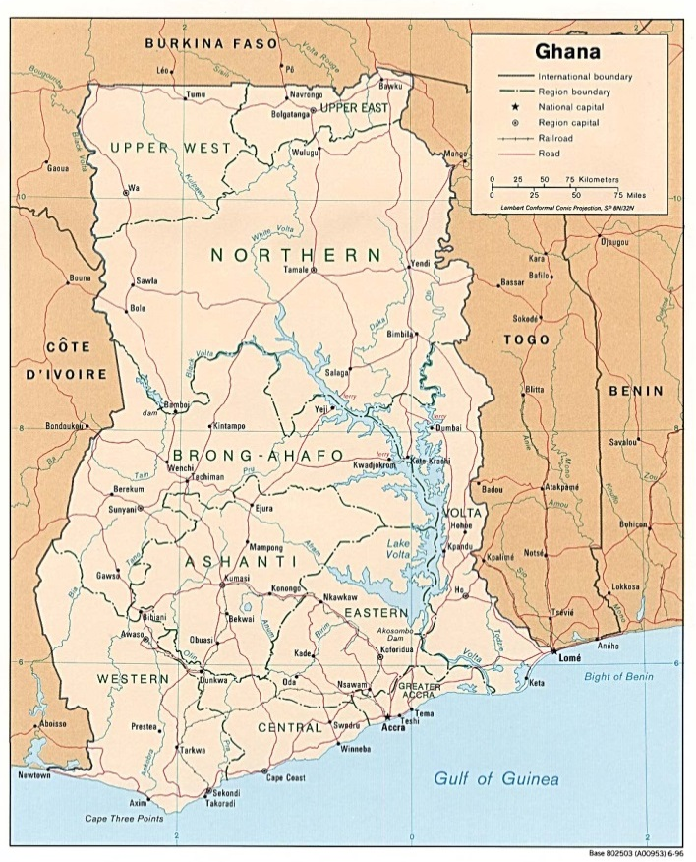 (Nationmaster, 2013)

Overview
The Ghanaian navy is relatively advanced, compared to most other navies in the GoG region. The focus lies mainly on maritime and coastal area, but it has riverine capacity and has been assisting private actors in riverine areas. The Navy’s two operational commands are in Sekondi (Western Naval Command) and Tema (Eastern Naval Command). It has two education centres, one with emphasis on naval trade and one that focusses on navy basics and leadership (Ghana Armed Forces, 2013).

Naval Capacity
Personnel (approximate): 2000 (IISS, 2012)

Equipment by type:

Navy
Patrol and Coastal Combattants | 1: Fast Attack Craft donated by South Korea  2: Warrior Class (GER)  4: Patrol Boat (Chinese)  1: Patrol Boat (US)  2: Control Submarine Chaser Achimota (GER Lurssen 57m)  2: Control Submarine Chaser Dzata (GER Lurssen 45m)  2: PCO Anzole (US)
(IISS, 2012)

1.2 Nigeria
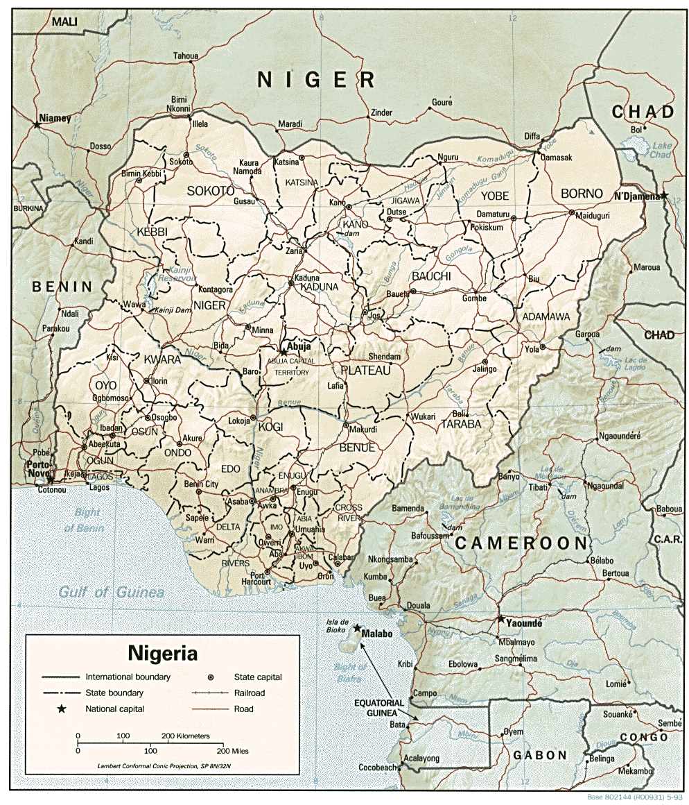 (Nationmaster, 2013)

Overview
The Nigerian navy is the largest within the proposed strategic framework of navies and cooperated successfully with the Benin navy on joint anti-piracy patrols. In the past years, Nigeria has been putting a lot of effort in improving their maritime and riverine capabilities and are therefore rather modern (DefenceWeb, 2011).
Naval Capacity
Personnel (approximate): 8000 (incl coast guard) (IISS, 2012)

Equipment by type:

Navy
Principal Surface Combatants: | 1: FFGHM Frigate Arardu (GER MEKO 360) with eight single lnchr with Otamat AShM, one octuplet Albatros lnchr with Aspide SAM, two triple STWS 1B 324mm ASTT with A244 LWT, one 127mm gun (capacity: 1 Lynx Mk hel)
Patrol and Coastal Combattants | 1: FSM Enymiri (UK Vosper Mk 9) with one triple lnchr with Seacat SAM, two triple STWS 1B 324mm A/S mor, one 76mm gun  1: PSOH Thunder (US Hamilton) with one 76mm gun  3: PCFG Ayam (FRA Combattante) each with two twin lnchr with MM-38 Exocet AShM, one 76mm gun (2 non-operative)  4: PCO Balsam (buoy tenders US)  2: Control Submarine Chaser Ekepe (GER Lurssen 57m) with one 76mm gun (2 non-operative)  4: Fast Patrol Boat Manta (Suncraft 17m)  1: Fast Patrol Boat Shaldag II  2: Patrol Boat Sea Eagle (4 additional vessels on order)  2: Patrol Boat Town  2: Patrol Boat Yola
Mine Warfare | 2: Ohue (mod ITA Lerici)
Amphibious | 1: Landing Ship Ambe (capacity 5 tanks; 220 troops)
Naval Aviation | 2: Anti-Submarine Warfare Helicopter Lynx Mk89 (non-operative)  2: Multi Role Helicopter AW139 (AB-139)  3: Light Transport Helicopter AW109E Power (non-operative)
Logistics and Support | 1: Patrol Combatant Support Ship  4: Small Harbour Tugs
(IISS, 2012)

1.3 Niger
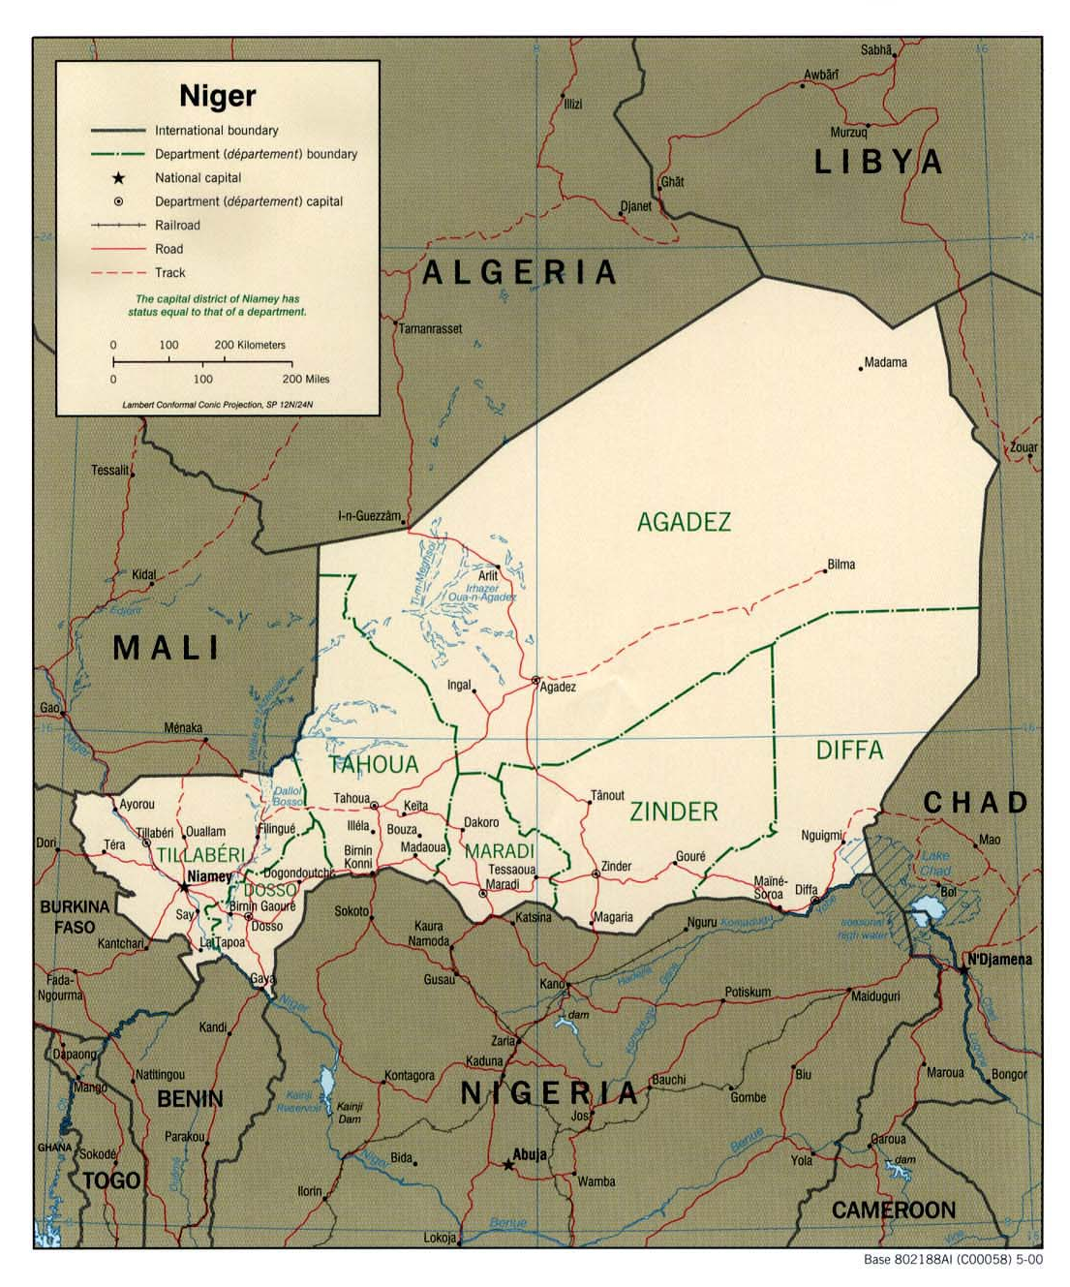 (Nationmaster, 2013)
Niger has no naval forces, but does have riverine policing capability, according to Hekkens. Although much will need to be done in Niger in order to be able to achieve RDA, investments could – over time – show disproportionally good results. It would not be realistic to expect for RDA to be achievable throughout the whole country, but could possibly be limited to the western parts of the country.

1.4 Cameroon
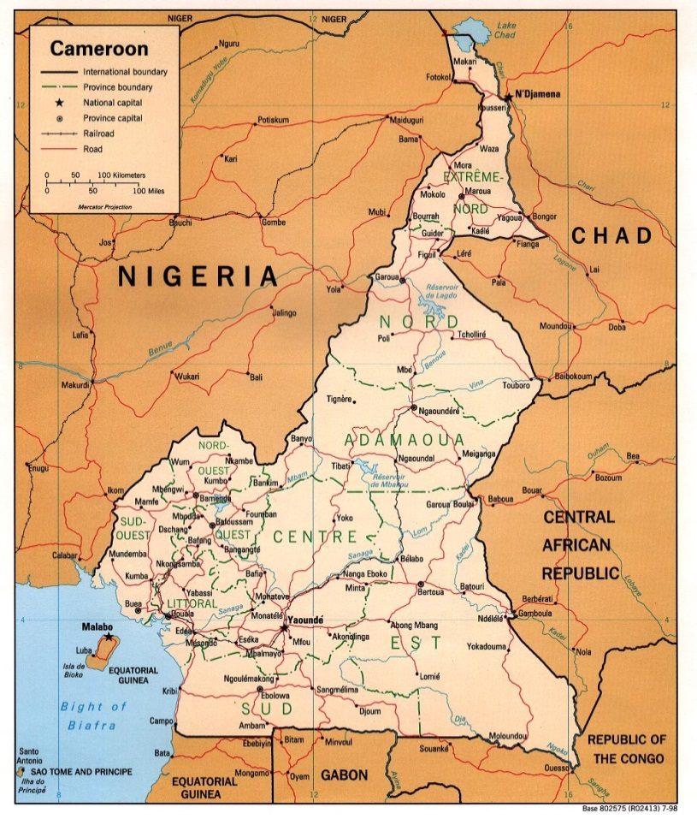 (Nationmaster, 2013)
Overview
Cameroon’s navy is appropriately equipped for coastal and river patrol and its main naval bases are in Douala, Limbe, Kribi and Campo. Douala has a Naval Technical Training Centre and Centre for Training and Safety Application and will have an Officer Training School in the nearby future. In Issongo, there is a School of Diving and a Naval Riflemen Training and Professional Development Centre (Hekkens, 2012).
Naval Capacity
Personnel (approximate): 1300

Equipment by type:

Navy (Marine Nationale Republique)
Patrol/Strike boat (Gun/Missile/OPV/IPV) | 2: FRA P-48 (Gun)  6: Rodman 101/46 (Gun)  1: Quartier class (Gun)  3: Boston Whalter patrol boats  1: Bakassi class patrol boat (P48S type)  1: L’Audacieux class missile FAC (P48 type)  1: Alfred Motto class patrol craft  20: Swiftship type river boats  2: Yunnan class landing craft  8: Simoneau
(DefenceWeb, 2013)

1.5 Equatorial Guinea
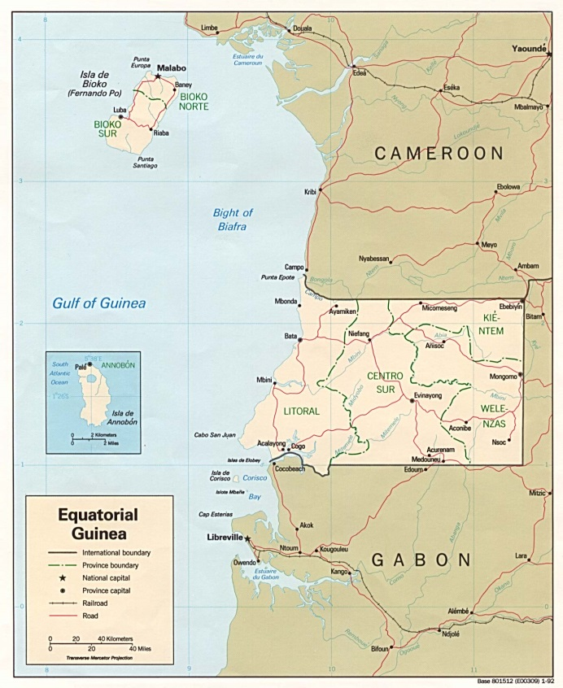 (Nationmaster, 2013)

Overview
Equatorial Guinea has been heavily investing in, and increasing their navy in the past few years (Pravda, 2012), in order to protect its oil installations from piracy and robbery. Moreover, there are plans to establish a Naval School in the country (Equatorial Guinea Government, 2011). The latter is essential for future success, since the current state of the military is considered to be rather poor, with poorly trained personnel and nepotism determining ranking, leading to poor decision-making (DefenceWeb, 2013).
Naval Capacity
Personnel (approximate): 120 (IISS, 2012)

Equipment by type:

Navy
Patrol/Strike boat (Gun/Missile/OPV/IPV) | 2: Shaldag II (IPV, designated Isla de Corisco and Isla de Annobon) (ISR)  2: Saar-4 patrol craft (delivered 2011)  1: OPV-88 Reklama (delivered 2012 and designated Bata)  1: Salamandra landing ship (delivered 2009 from China and designated Osa)  2: Kie Ntem class OPVs (delivered from Israel in February 2011)  2: TBC Estuario del Muni-class patrol vessel (UKR)  1: modified TBC Baroso-class corvette (On order from BRA)  3: TBC Pohang-class corvettes from (In order from KOR)
(DefenceWeb, 2013)

1.6 Republic of Congo (Brazzaville)
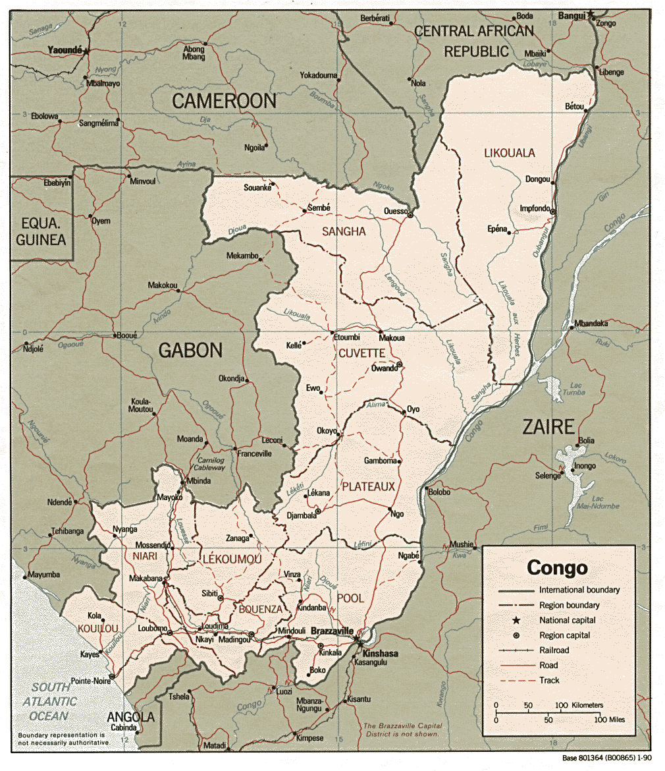 (Nationmaster, 2013)
Overview
Congo Brazzaville’s navy is rather poor equipped for maritime purposes, but has riverine capacity. Equipment has, however, been suffering from poor maintenance and morale is considered to be low within Brazzaville’s military forces (DefenceWeb, 2013).
Naval Capacity
Personnel (approximate): 800 (IISS, 2012)

Equipment by type:

Navy
Patrol | 3: Zhuk class harbour patrol (Non-operational)  3: Pirana class (Non-operational)  4: Arco class river patrol
Tug | 1: Hinda class
(DefenceWeb, 2013)

1.7 Democratic Republic of the Congo (DRC)
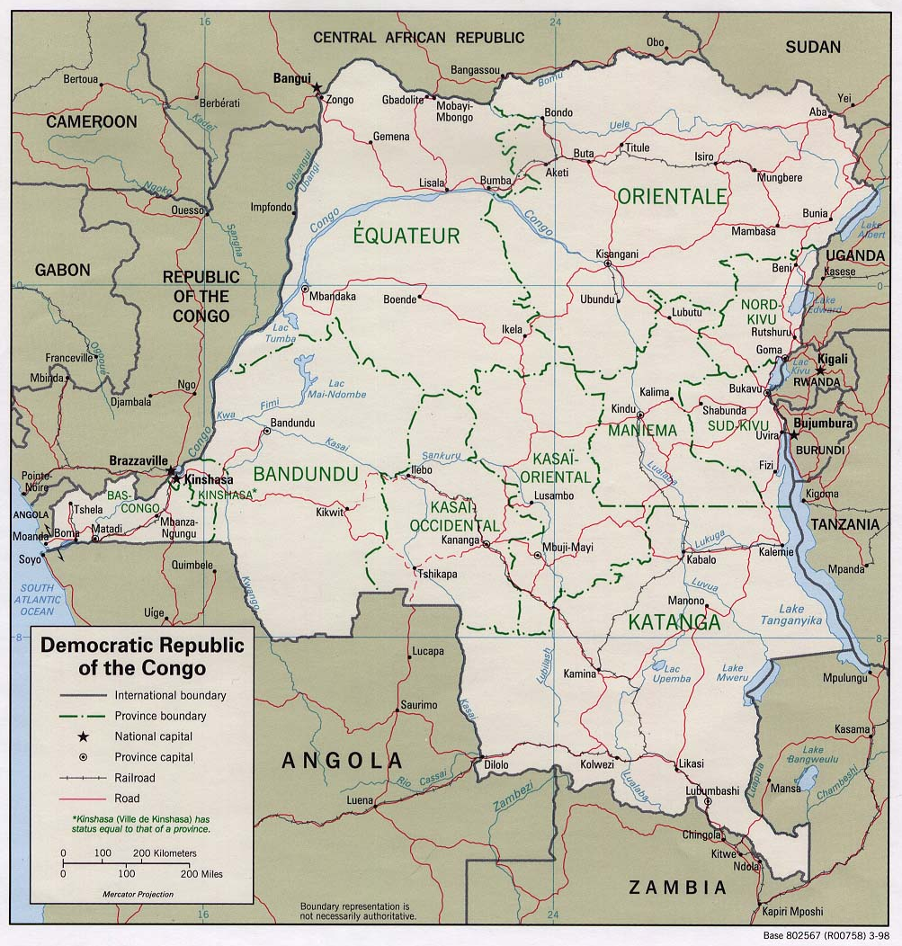 (Nationmaster, 2013)

Overview
The DRC’s Force Navale, as described previously, needs reforms. The navy does have riverine capacities.
Naval Capacity
Personnel (approximate): 6500-7000 (IISS, 2012)

Equipment by type:

Navy (Coast, River and Lake Guard)
Patrol/Strike boat (Gun/Missile/OPV/IPV) | 3: Shanghai II ( two non-operational)  $±$ 20: Harbour/River patrol Several river patrol boats
(DefenceWeb, 2013) (IISS, 2012)

- Overview of Naval Forces in the GoG region, that are not on the short-list

2.1 Côte d’Ivoire/Ivory Coast
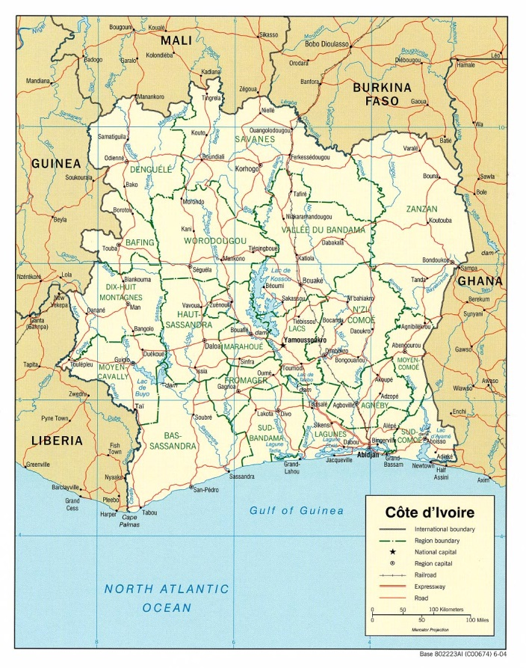 (Nationmaster, 2013)
Overview
The Ivory Coast navy focuses on the surveillance and security of the Ivory Coast’s coastline, but have capacity to conduct operations in the littoral and riverine areas. The exact status of the navy is unknown.

Naval Capacity
Personnel (approximate): unknown

Equipment by type:

Navy
Patrol/Strike boat (Gun/Missile/OPV/IPV) | 2: L’Ardent class missile fast attack craft (French Patra type)  2: Vigilant type patrol craft  1: Batral type landing ship  1: Intrepide class  2: Rodman class (Fishery protection only)
(DefenceWeb, 2013)

2.2 Mali
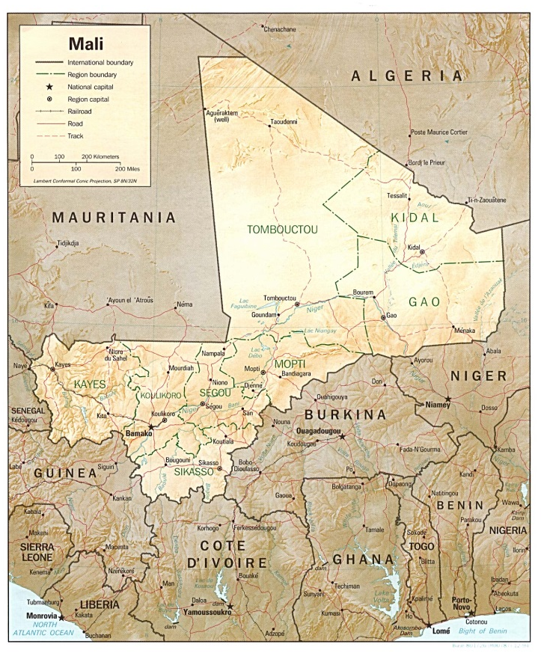 (Nationmaster, 2013)

Overview
Landlocked Mali’s navy is very small and their (all riverine)patrol boats are considered to be non-operative.

Naval Capacity
Personnel (approximate): 50 (IISS, 2012)

Equipment by type:

Navy
Patrol | 3: Riverine Patrol Boats (non-operative)
(IISS, 2012)

2.3 Togo
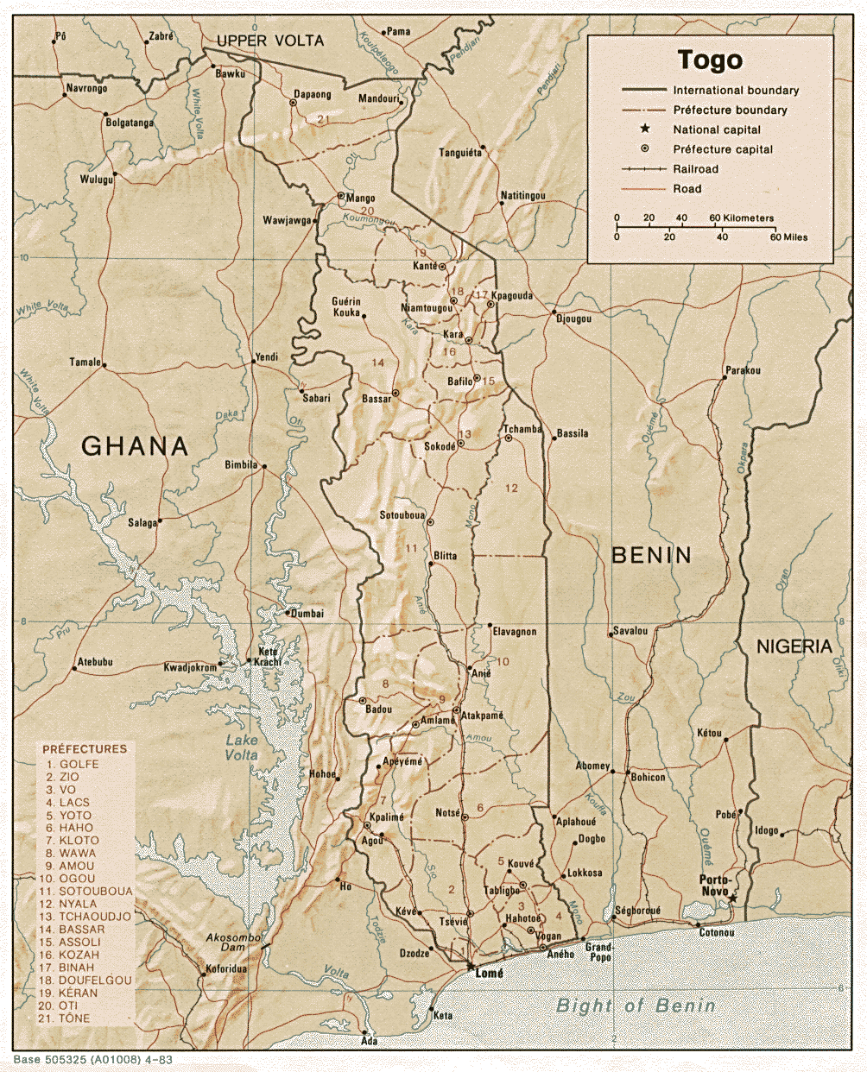 (Nationmaster, 2013)
Overview
The Togolese Navy – or Marine du Togo in French – is focussing mostly on defending its coastline but is capable of operating in inland waters. (Forces Armees Togolaises, 2013)

Naval Capacity
Personnel (approximate): 200 (IISS, 2012)

Equipment by type:

Navy
Patrol | 4: Kara (French Esterel)
(IISS, 2012)

2.4 Benin
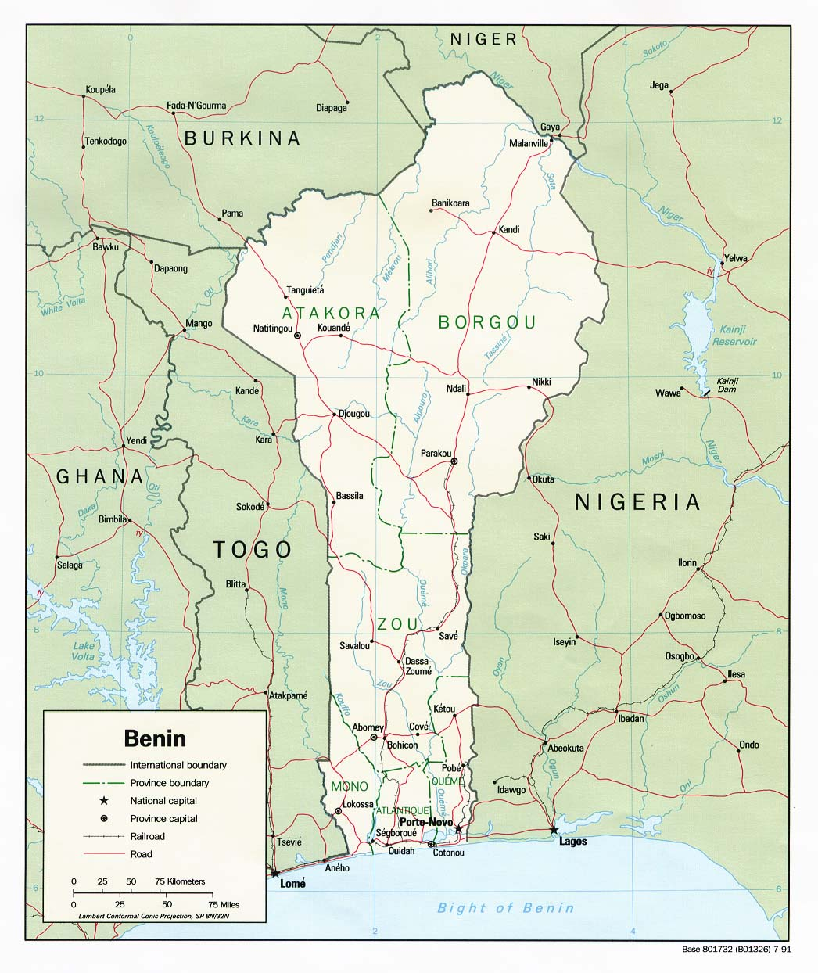 (Nationmaster, 2013)
Overview
The Benin navy cooperated successfully with the Nigerian navy on joint anti-piracy patrols (DefenceWeb, 2011). Benin is optimised for coastal patrolling.

Naval Capacity
Personnel (approximate): 200 (IISS, 2012)

Equipment by type:

Benin Navy (Forces Navales Beninois)
Patrol | 1: Patriote class  2: Zhuk class (ex-Soviet – allegedly sold for scrap)  3: 32 metre coastal patrol boats (Alibori, Oueme and Zou) delivered by Ocea in 2012.
Launches/speedboats | 3: Boston Whaler launches  4: Defender class speedboats (donated by US in 2008-2010. 4 delivered according to US government sources, although some sources claim only 2)
Tug | 1: Kondo coastal tug
Patrol/Strike boat (Gun/Missile/OPV/IPV) | 2: Matelot Brice Kpomasse class (Matelot Brice Kpomasse and La Sota -ex-Chinese; donated in 2000)
(DefenceWeb, 2013)

2.5 Central African Republic (CAR)
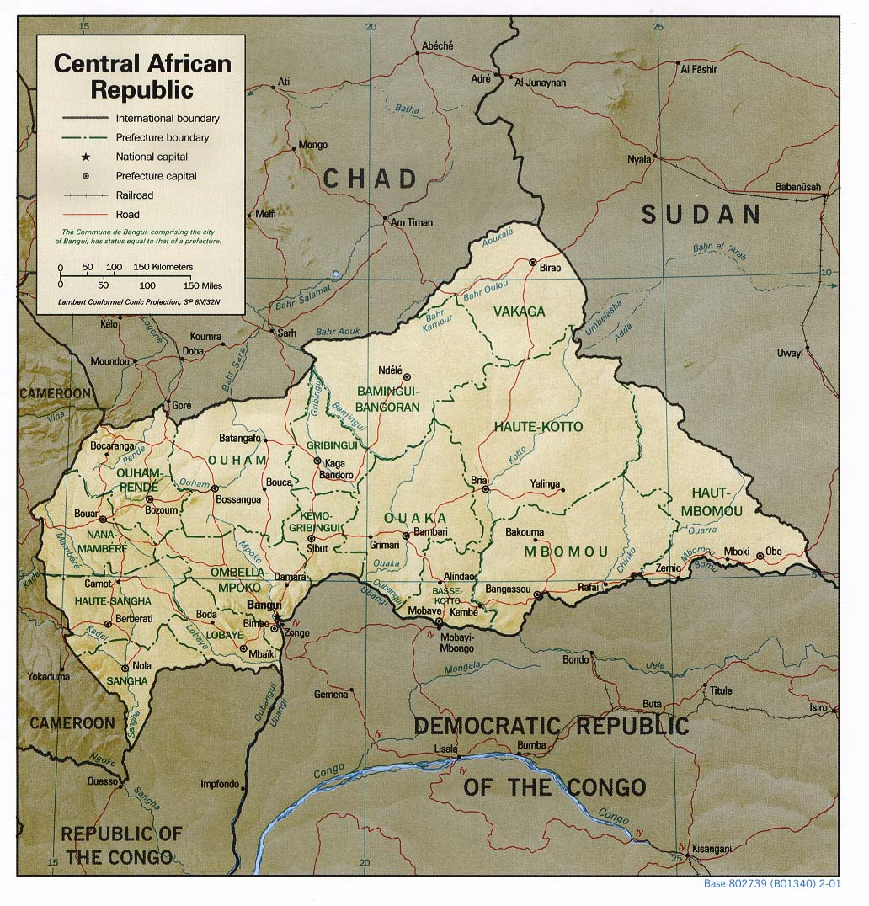 (Nationmaster, 2013)

Overview
Landlocked CAR has no naval forces, but does have riverine policing capability.

Naval Capacity
Equipment by type:

Navy
River/Lake patrol | 9: Patrol boats
(DefenceWeb, 2013)

2.6 Equatorial Guinea
(Nationmaster, 2013)

Overview
Equatorial Guinea has been heavily investing in, and increasing their navy in the past few years (Pravda, 2012), in order to protect its oil installations from piracy and robbery. Moreover, there are plans to establish a Naval School in the country (Equatorial Guinea Government, 2011). The latter is essential for future success, since the current state of the military is considered to be rather poor, with poorly trained personnel and nepotism determining ranking, leading to poor decision-making (DefenceWeb, 2013).

Naval Capacity
Personnel (approximate): 120 (IISS, 2012)

Equipment by type:

Navy (Coast Guard)
Patrol/Strike boat (Gun/Missile/OPV/IPV) | 2: Shaldag II (IPV, designated Isla de Corisco and Isla de Annobon) (ISR)  2: Saar-4 patrol craft (delivered 2011)  1: OPV-88 Reklama (delivered 2012 and designated Bata)  1: Salamandra landing ship (delivered 2009 from China and designated Osa)  2: Kie Ntem class OPVs (delivered from Israel in February 2011)  2: TBC Estuario del Muni-class patrol vessel (UKR)  1: modified TBC Baroso-class corvette (On order from BRA)  3: TBC Pohang-class corvettes from (In order from KOR)
(DefenceWeb, 2013)

2.7 Gabon
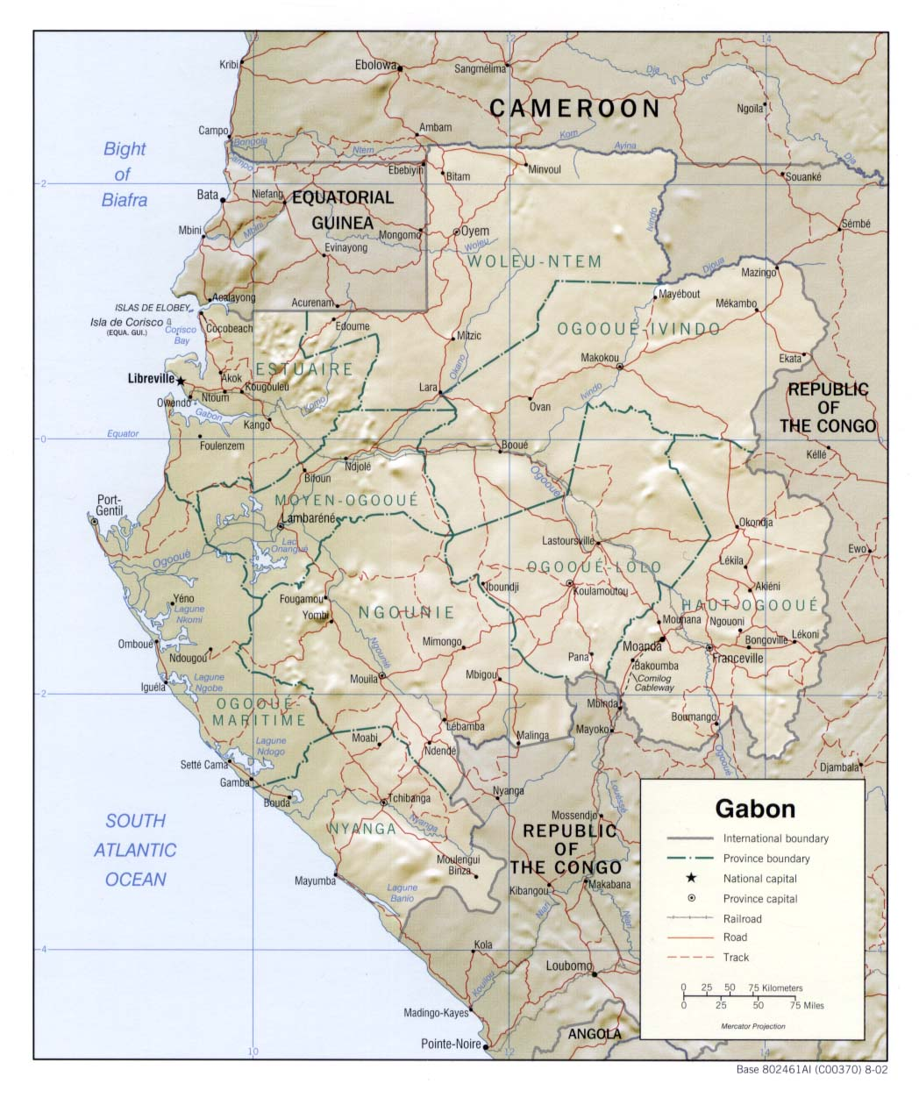 (Nationmaster, 2013)
Overview
Gabon’s navy is not large, but is relatively well equipped. Focus lies on maritime areas.

Naval Capacity
Personnel (approximate): 500 (IISS, 2012)

Equipment by type:

Navy
Patrol/Coastal Combattants | 2: PCC General Ba’Oumar (FRA P-400)  1: Fast Patrol Boat Patra with 4 SS 12M AShM  4: Patrol Boat Port Gentil (Vedettes côtières de surveillance maritime (VCSM) : coastal boats for sea surveillance)
Amphibious | 1: Landing Ship Tank President Omar Bongo (FRA Batral) (Capacity 1 LCVP; 7 MBT; 140 troops) 1 hel landing platform.  1: Landing Craft Vehicle Personnel
(IISS, 2012)

2.8 Angola
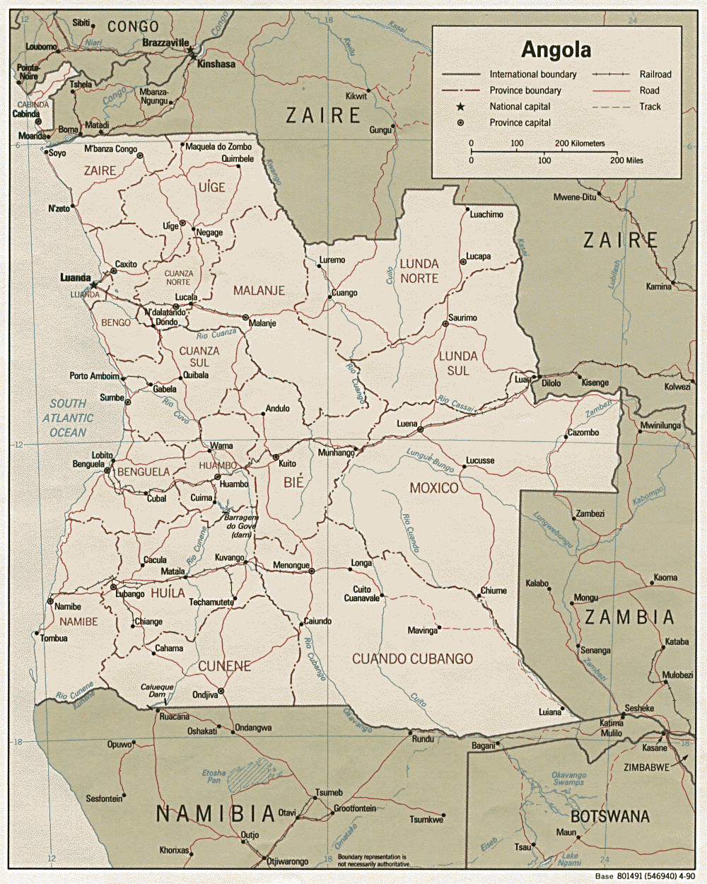 (Nationmaster, 2013)

Overview
The Angolan Navy – Marinha de Guerra (MGA) – has been suffering greatly from a lack of maintenance and inadequately schooled personnel. During the past few years, relatively large amounts have been made available in order to modernise the Angolan armed forces– including its navy – specifically by means of education, but there are still many improvements that have to be made (DefenceWeb, 2013). These improvements should also be made in riverine capacity.

Naval Capacity
Personnel (approximate): 1000 (IISS, 2012)

Equipment by type:

Navy
Fast Attack Craft | 4: Mandume class (Bazan Cormoran type, refurbished in 2009. The four boats are the Mandume, Polar, Atlantico and Golfinho)
Patrol boats | 3: Patrulheiro  5: ARESA PVC-170  2: Namacurra class (operated by the Navy and Fisheries Ministry)
Fisheries patrol | Ngola Kiluange and Nzinga Mbandi delivered from Damen Shipyards in September and October 2012, followed by a 28 metre FRV 2810 (Pensador). [These patrol boats are operated by Navy personnel under the Ministry of Agriculture, Rural Development and Fisheries]
Landing craft | 1-3: LDM-400 (often unserviceable)
Structure | Three Coastal surveillance companies (CRTOC) equipped with radars and mobile telecommunications  Naval War Institute (ISNG): provides training and advanced courses  Naval Academy  Naval Specialist School  Naval Infantry Unit: Angola’s Navy has a brigade sized unit of Marines capable of fielding a quick deployment Light Amphibious Battalion (BLD). The 700-strong brigade is made up of four Marine companies, 1 Naval Police unit and 1 Amphibious Operations unit. There are also Special Forces, heavy weapons, sniper and boarding units and an armoured section
(DefenceWeb, 2013)

Existing International Initiatives

Many initiatives that promote collaboration on different fields are currently existing among different African countries. A selection of initiatives is elaborated on below.

3.1 ECCAS/CEEAC
The Economic Community of Central African States (ECCAS) – in French : Communauté Économique des États de l'Afrique Centrale (CEEAC) – is an initiative from the African Union that promotes regional economic integration between ten Central African states: Angola, Burundi, Cameroon, CAR, Republic of Congo (Brazzaville), DRC, Gabon, Equatorial Guinea, Sao Tamé and Principe, and Chad (CEEAC, 2013). ECCAS – or CEEAC – additionally actively promotes peace and political stability in the region.

under ECCAS falls the following:
- COPAX, the Council for Peace and Security in Central Africa
  - FOMAC, the Council for Peace and Security in Central Africa
  - CDC, the Defence and Security Commission
  - MARAC, the Early Warning Mechanism of Central Africa

3.2 SADC
SADC (Southern African Development Community) is an inter-governmental organisation that complements the African Union. “Established in 1992, SADC is committed to Regional Integration and poverty eradication within Southern Africa through economic development and ensuring peace and security” (SADC, 2012).
The 15 members are Angola, Botswana, DRC, Lesotho, Malawi, Madagascar (Suspended since the 2009 coup d’état) Malawi, Mauritius, Mozambique, Namibia, Seychelles, South Africa, Swaziland, Tanzania, Zambia and Zimbabwe.
Other socio-economic (development)partnerships include the following:
- ECOWAS, the Economic Community of West African States
  - ECOMOG, the Economic Community of West African States Monitoring Group
- EAC, the East African Community
- COMESA, the Common Market for Eastern and Southern Africa
- NEPAD, the New Partnership For Africa’s Development

3.3 AFS/ASF
The African Standby Force (ASF) is the African Union’s Peacekeeping force, arising from the Africa-EU partnership. The deadline for the peacekeeping force – that focuses on preventive action and rapid response – to become operational was originally set in 2008, but eventually – after being pushed to 2010 and after that to 2013 – delayed until 2015. (The East African, 2013)

The AFS should in 2015 be able to take on the following roles:
- Observer missions deployed alongside a UN mission – to be deployed in 30 days;
- A regional peacekeeping/building force – to be deployed in 30 days;
- Intervention for example in genocide situations – a robust military response in 14 days.
(Africa-EU Partnership, 2013)

3.4 ICGLR
The International Conference on the Great Lakes Region has been established as an inter-governmental organisation in order to address issues such as conflict and political instability in the Great Lakes region, keeping in mind that these issues have a “considerable regional dimension and thus require a concerted effort in order to promote sustainable peace and development.” (ICGLR, 2010)

The ICGLR exists of four different main divisions:
- Peace and Security
- Democracy and Good Governance
- Economic Development and Regional Integration
- Humanitarian and Social Issues

Members of the ICGLR are: Angola, Burundi, Central African Republic, Republic of Congo, Democratic Republic of Congo, Kenya, Uganda, Rwanda, Sudan, Tanzania and Zambia.

3.5 NBI
The Nile Basin Initiative has been initiated in 1999, and forms a framework of countries that collaborates in developing (the economies) in regions surrounding the Nile basin, benefiting from and utilising what the Nile Basin water resources are offering. This largely includes the distribution of information and data. NBI is also protecting its citizens, by means of an early warning system in case of flooding.
The Nile Basin initiative comprises nine members: Burundi, DRC, Egypt, Kenya, Rwanda, South Sudan, Sudan, Tanzania, and Uganda (NBI, 2010).

3.6 MONUSCO
The United Nations Organization Stabilisation Mission (MONUSCO, previously MONUC) in the DR Congo – or in French: Mission de l'Organisation des Nations Unies pour la stabilisation en République Démocratique du Congo – is the longest mission the UN has ever established. Since 1999 the UN has been present in the DRC, first in order to monitor the peace process following the war. In 2010, mandate was given for MONUSCO, in order to stabilise the country and support its government’s consolidation efforts. (UN, 2013)

3.8 EUSEC DR Congo
Under the Foreign and security policy of the European Union, the EUSEC DR Congo mission has been initiated. This advisory and assistance mission has as its main aim to “provide practical support to the Congolese Government for the integration of the Congolese army and good governance in the field of security” (CFSP, 2008). Mandate for the EUSEC mission in the DRC has been extended to the 30th of September 2013 (CSDP, 2013).

3.9 CRIMGO
In January 2013, the EU initiated a project called CRIMGO: Critical Maritime Routes in the Gulf of Guinea Programme. The aim of this programme is to assist governments across West and Central Africa in improving safety of the main shipping routes along the following four pillars:
- “establishing a regional information sharing network;
- training related to coastguard functions;
- developing a framework for inter-agency cooperation;
- promoting operational inter-agency cooperation”
The participating countries within this initiative are “Benin, Cameroon, Equatorial Guinea, Gabon, Nigeria, São Tomé and Togo, with additional regional training programmes to be conducted in Côte d'Ivoire and Ghana. (European Commission, 2013)”

3.10 AFRICOM, APS, NAVAF and CJTF-HOA
The “Africa Partnership Station (APS) is U.S. Naval Forces Africa’s (NAVAF) flagship maritime security cooperation program. The focus of APS is to build maritime safety and security by increasing maritime awareness, response capabilities and infrastructure (AFRICOM, 2013)”. NAVAF is part of the US Africa Command (AFRICOM)
Within AFRICOM, the Combined Joint Task Force – Horn of Africa (CJTF-HOA) focusses specifically on the East Africa Region, building maritime capacity in order to establish peace and security in the region, but also to protect U.S. and coalition interests.
Riverine areas are within these operations not neglected, but do not have top priority either.

