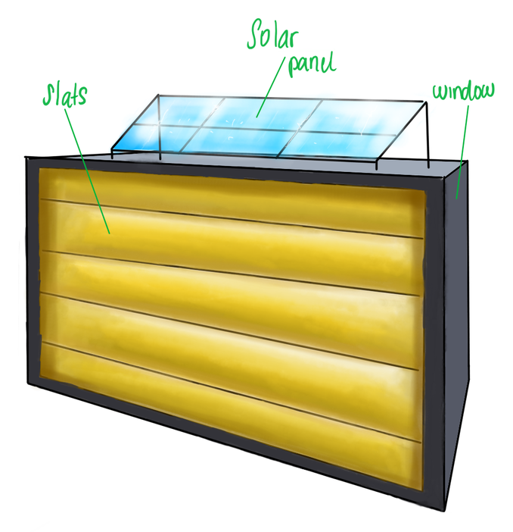

Revalorising Hatches
-
Semester 3 Project
Date: 06/01/2023
Authors:
Student name | Student number
Inês Guimarães (WTB) | 667556
Alexander Harper (WTB) | 671570
Ariana Walters (WTB) | 648953
Ruben de Jong (WTB) | 674030
Hady Alwattar (ELT) | 663666
Erickson Helder (ELT) | 666355
Ilkay Sayan (ELT) | 660230
Contents
Introduction 1
1 Research 3
1.1 Mechanical Research 3
1.1.1 Systems for sunlight-reduction 3
1.1.2 U- and R-factors for windows: 3
1.1.3 Different types of gears and chains: 3
1.1.4 Swing Hinge Mechanism: 3
1.2 Electrical Research 3
1.2.1 Mounting methods: 3
1.2.2 Different types of motors 3
1.2.3 Solar panel and battery varieties 3
2 Conceptual Design 4
2.1 Hamburger Model & Function Block Diagram 4
2.2 Morphological Table 5
2.3 Concept Sketches 6
2.3.1 Concept 1 6
2.3.2 Concept 2 7
2.3.3 Concept 3 7
2.3.4 Concept 4 8
2.5 Choosing Concept 8
2.6 Final Choice of Concept Design 14
2.6 System Acceptance Test Plan 15
3 Detailed Design 16
3.1 Function Block Diagram and System Description 16
3.2 Calculations 16
3.2.1 Mechanical Calculations 16
3.2.1 Electrical Calculations 17
Power Calculations 17
Power Formulas 17
3.3 Material Selection and Production 18
3.3.1 Material Selection 18
3.4 Component Selection and Parts List 20
3.4.1 Components List (electrical system) 20
3.4.2 Component Selection and Specifications 21
3.5 Drawings and Parts List 25
3.5.1 Final Design 3D Rendering 25
3.5.1 Final Design 2D Drawing 25
3.5.2 Final design Parts List (mechanical) 26
3.6 Electrical Schematic 26
4 Realisation 27
4.1 Production planning 27
4.2 System Test Plan 28
4.3 Test Results 29
Test 1; Solar Panel Results 29
Test 2; Motor Test Results 29
Test 3; Temperature and light sensor test results. 30
4.4 Reflection 31
References 33
Appendices 34
Appendix A: Plan of Approach 34
Appendix B: Research 45
B.1 Mechanical Research 45
B.1.1 Shutters and House Cooling 45
B.1.2 U- and R-factors for windows 48
B.1.3 Gear and Chain Mechanism 49
B.1.4 Swing Hinge Mechanism 57
B.1.5 Mounting Methods 59
B.2 Electrical Research 61
B.2.1 Sensors and Actuators 61
B.2.2 Solar Panels and Rechargeable Batteries 63
B.2.3 DC Motor Types 68
B.2.3 Battery Management Systems 73
Appendix C: Material Selection 77
Appendix D: Production Report 87
Appendix E: Code 90

Introduction
As part of the Evaluation for the Third semester, second year students of Electrical- and Mechanical Engineering at the HAN university of Applied Sciences must work on the development of a hatch that will control the climate inside the house depending on the light and weather outside the house. The project is called Coolheat.
Coolheat deals with the design, construction, and testing of a prototype of a hatch to monitor that temperature inside and outside the house automatically and acts accordingly. The prototype to be developed must meet the following requirements:
- The prototype is fully operational off the grid.
- The prototype responds automatically to the weather climate inside and outside the house.
- The prototype must be able to insulate the windows during wintry weather conditions.
- The prototype must be able to be mounted over a window.
Having the necessary knowledge of mechanics, electronics and programming is essential to finishing the project before the deadline, as well as research, problem solving skills and abilities to work as a team. Both the electrical- and mechanical engineering students need to complete their own parts as well as the mutual parts, to ensure satisfactory results before the deadline.
For the client, Electrical engineering students and the mechanical engineering students to be on the same page about Coolheat, a plan of approach was set up. The plan of approach can be seen in Appendix A
Layout of the report:
The report is laid out as follows:
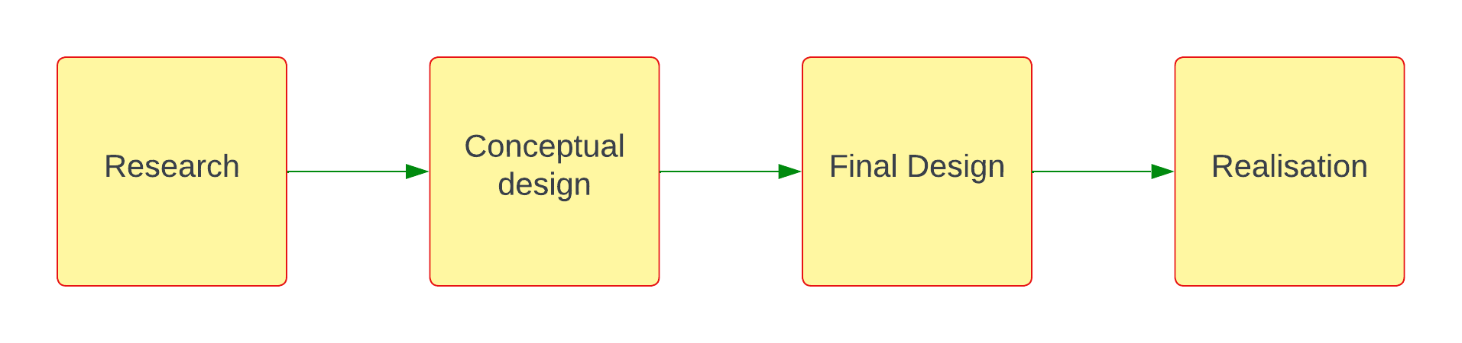
Chart 1 – Report Layout
V-Model
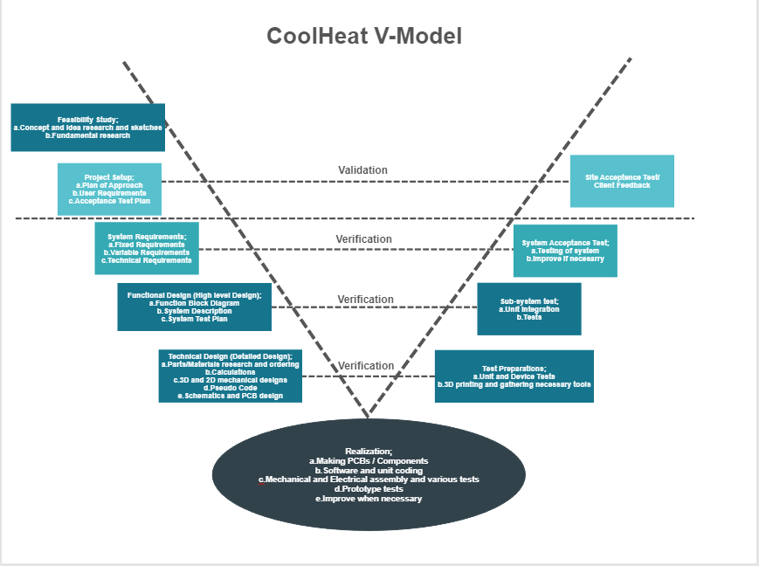
Chart 2 – V-Model

These however are interconnected to provide a smooth running format from the start of the design process to the completion of the building of the prototype.

Research

1.1 Mechanical Research

1.1.1 Systems for sunlight-reduction
Different systems that reduce the effect of the sun, systems that are fixed to the outside of windows like rolling-, vertical- and horizontal systems are mentioned. All these systems are compared in a table published by ‘European Roller Shutters,’ looking at properties like storm protection, temperature regulation and convenience. See appendix B1.1 for detailed research into Shutters and Cooling in, on and around buildings.

1.1.2 U- and R-factors for windows:
The U- and R- factor are reciprocals of each other: The R-value is a measure of heat resistance and is an assessment of material effectiveness. The U-value measures the heat transfer through the window. The total expected U factor for a double-paned window with vertical slats is 0,54. See appendix B.1.2 for detailed research into U- and R-factors for windows

1.1.3 Different types of gears and chains:
Multiple types of gears, chains and belts are mentioned. Their (dis)advantages and common uses are listed, as well as gear materials and the gear ratio. See appendix B.1.3 for detailed research into Gear and Chain mechanisms

1.1.4 Swing Hinge Mechanism:
An explanation about how the slats is moved is given. Slats can be moved by Gears and pneumatic cylinder, or gears and a CAM shaft. See B.1.4 for detailed research into Swing Hinge Mechanisms.

1.2 Electrical Research

1.2.1 Mounting methods:
Several types of mounting methods can be used, like Monkey hooks, Tap-in expanding, Drywall anchors and toggle anchors.

1.2.2 Different types of motors
Several types of DC motors and their function explained, comparison table for brushed and brushless motors also pros and cons table for servo and stepper motors included.

1.2.3 Solar panel and battery varieties
Various kinds of solar panels described their advantages and disadvantages listed. Various battery options for the project listed and explained. Comparison table for battery types created.

2 Conceptual Design

2.1 Hamburger Model & Function Block Diagram
The hamburger model establishes all the functions that the product must fulfil. The model also includes what part of the product fulfil the function. The function Block Diagram, on the other hand, only establishes what functions must be fulfilled
.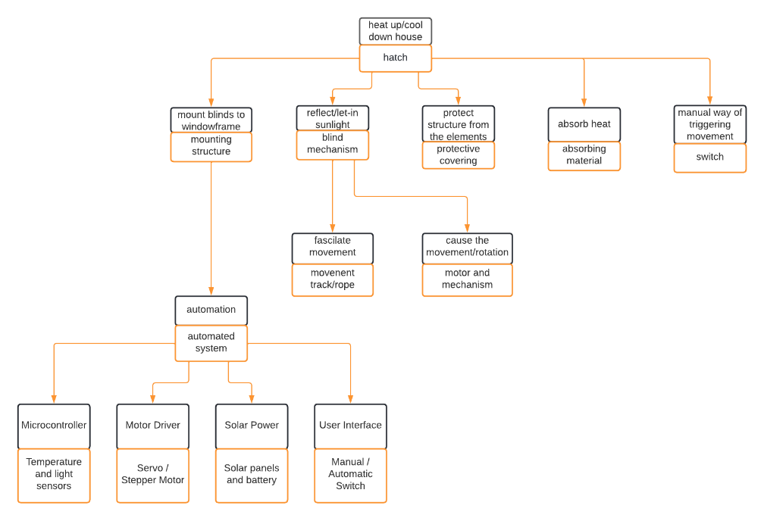
Figure 1: Hamburger Model
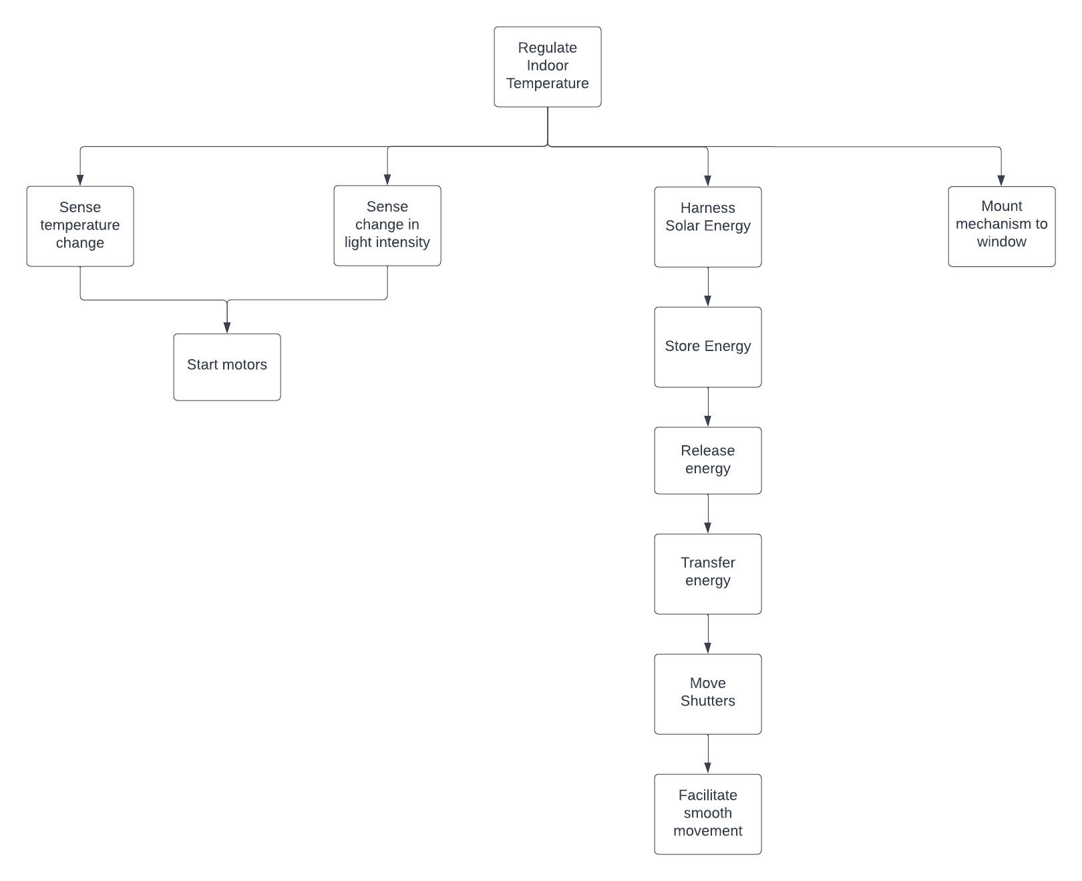
Figure 2: Function Block Diagram

2.2 Morphological Table
Using the research of various areas, decisions on several types of concepts could be conceived with the help of the functions from the function block diagram and using a Morphological table. This helps represent the different ideas for each function to produce multiple different concepts, using lines linking an idea of one function to an idea of another function. In this case, the red line represents the first concept, the yellow line the second concept, the green line the third concept, and the blue line the fourth concept. As shown, some functions were able to have more ideas than others.
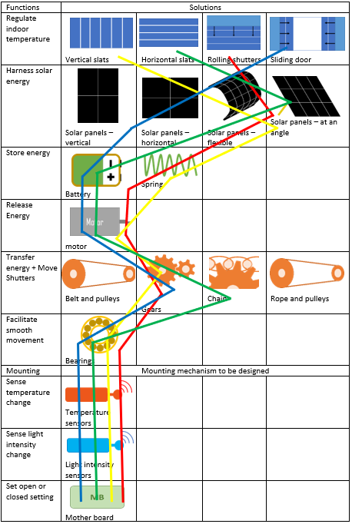
Table 1 - Morphological Table

2.3 Concept Sketches

2.3.1 Concept 1
Concept 1 is a roller system, where the panels or slats are connected in series and retract upwards into a housing above the window. To capture the energy from the sun, an angled solar panel is used on top of the window frame, with the panel being connected to a battery to store the energy. In this system a motor then converts the energy into mechanical energy to turn some connected gears that allow the system to rotate and therefore roll up and roll down.
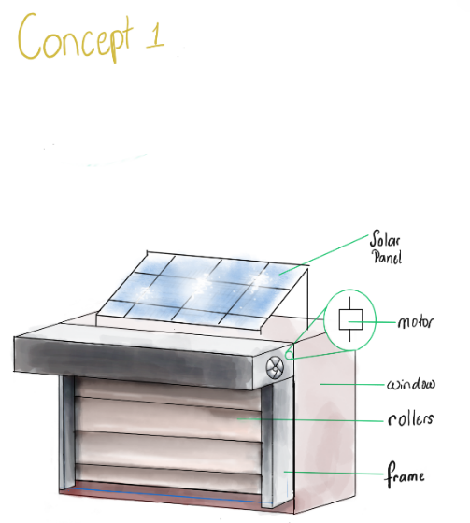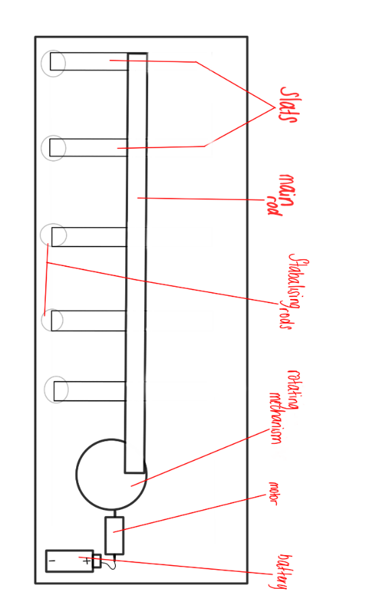
Figure 3,4,5 - Concept 1

2.3.2 Concept 2
The second concept uses vertically placed slats, that when closed are parallel to the windows, and rotate perpendicular to the windows. This is again powered by solar panels on an angle that are on an angle. The storage of energy this time is done through a spring system that compresses to store the energy and then releases it to rotate the slats back into the original position.
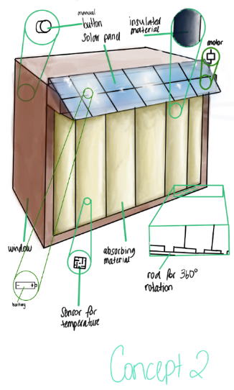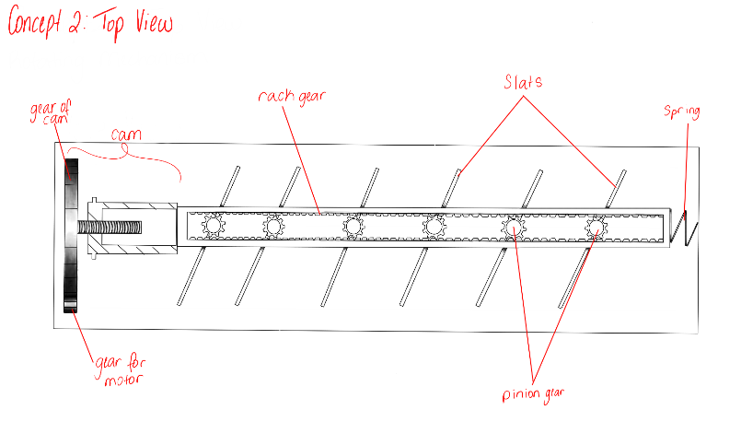
Figure 6,7 - Concept 2

2.3.3 Concept 3
The third concept is similar to the second in the way it has slats that rotate from being parallel to the window when closed into a perpendicular position when open. The main difference here is how the system works with the slats being placed horizontally. This works by using a chain connected to each slat and the motion powered overall by a motor and gearbox running from a battery and the solar panel on top. This is placed once again above the housing for the slats at an angle.
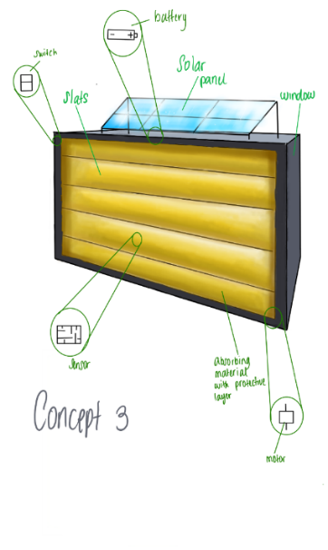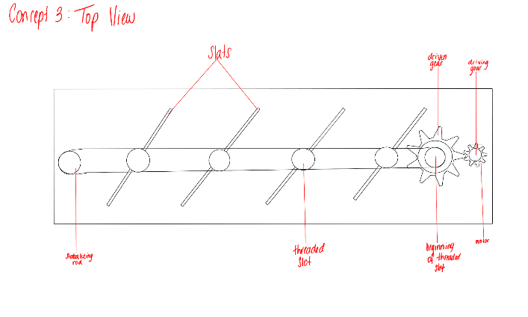
Figure 8,9 – Concept 3

2.3.4 Concept 4
The final concept is using sliding shutters. These open along the side of the wall and close in front of the window in a similar method to some traditional shutters on houses. In this case the solar panels would be applied directly to the front of the shutters.
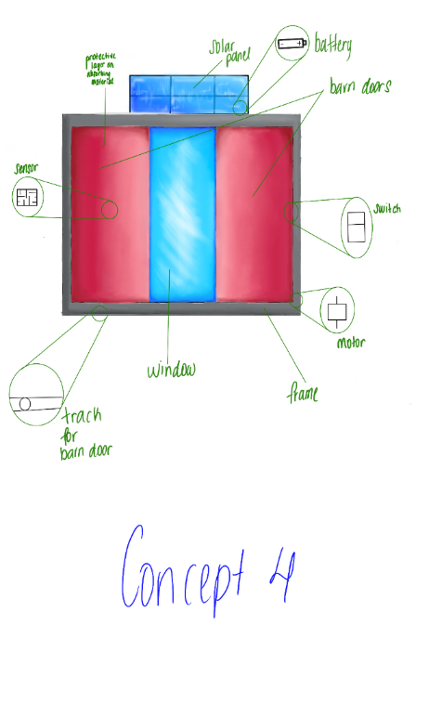
Figure 10 – Concept 4

2.5 Choosing Concept
After requirements were established, they were placed into two categories of requirements: variable and fixed requirements. These were determined by if the requirement was quantity or quality based. If the requirement required a desired quality, it was deemed a fixed requirement. Therefore, a variable requirement was determined by quantity.
Fixed Requirements
Requirement | Definition | Type | Verification | Stakeholder
Viability | The product must be tested at least in 5 different houses to check if it causes any damage to the integrity of the house. | Fixed requirement | Proper testing periods and professional verification method for mounting using laws and regulations, and developer’s standards | Government and/or Developer
User-friendly | Must contain a manual that was tested by at least 10 people, and at least 8 of them understood clearly how to mount it. | Fixed requirement | Survey to be done with an overall positive (above 8/10) response to the readability and explanation of the manual. | Developer
Safety | It must not have any sharp edges and it must not contain any chemical dangerous materials | Fixed requirement | Check the final concept design and the choice of materials to ensure the safety of the product | Government
Construction | The outside drywall can support the system | Fixed requirement | Strength calculation | Developer
 | The dimensions of the structure must be within the dimensions of the framework. | Fixed requirement | NEN2314 | Government
 | The construction must be able to cope with Dutch weather conditions (-10 degrees to 30 degrees, wind speed up to 10 on the Beaufort Wind scale, rain-water resistant) | Fixed requirement | Strength calculation + test set-up | Developer
 | The dimensions of the construction must meet the applicable NEN standards | Fixed requirement | EN 12412-2  EN ISO 12567-1 | Government
Autonomous | Generating energy by means of a PV panel | Fixed requirement | Test set-up | Developer
 | Storing energy by means of a chemical battery or a mechanical battery | Fixed requirement | Test set-up | Developer
Automation | While the device is working in automated it will run on one of 4 modes depending on the temperature (For info on modes look page X) | Fixed requirement | Reporting | Developers
 | Reading parameters using sensors | Fixed requirement | Test set-up | Developers
 | motor operation can be set to manual or automated | Fixed requirement | Test set-up | Developer
 | Manual overrule must be present | Fixed requirement | Expert rating | Developer
Movement | The panels can rotate to the desired degree according to the temperature and sunlight | Fixed  requirement | Testing of a prototype | Developers
Temperature | Sensors that detect temperature | Fixed requirement | Testing of a prototype | Developers
Budget | The price is below 300€ | Fixed requirement | Desk research comparison | Potential user
Table 2 – Fixed Requirements List
Fixed requirements are the most essential demands and therefore, need to be fulfilled. If a concept does not meet a requirement, it fails the selection. To be successful a concept needs to be able to fulfil all the fixed requirements.
Fixed Requirements
stakeholder: |  |  | Developer, Government, Potential User
 | Concept 1 | Concept 2 |  | Concept 3 | Concept 4
req 1 | yes | yes |  | yes | yes
req 2 | yes | yes |  | yes | yes
req 3 | yes | yes |  | yes | yes
req 4 | yes | yes |  | yes | yes
req 5 | yes | yes |  | yes | yes
req 6 | yes | yes |  | yes | yes
req 7 | yes | yes |  | yes | yes
req 8 | yes | yes |  | yes | yes
req 9 | yes | yes |  | yes | yes
req 10 | yes | yes |  | yes | yes
req 11 | yes | yes |  | yes | yes
req 12 | yes | yes |  | yes | yes
req 13 | yes | yes |  | yes | yes
req 14 | yes | yes |  | yes | yes
req 15 | yes | yes |  | yes | yes
req 16 | yes | yes |  | yes | yes
Table 3 – Fixed Requirements against Concepts
Variable Requirements
Requirement | Definition | Type | Verification | Stakeholder
Sustainability | Material of the product are recycled. | Variable requirement | Use Edupack to check the sustainability of the material | Developer
Insulation | It should have a R-Factor greater than R-5 | Variable Requirement | Test set-up | Developer
Noise-limitation | Movement should not exceed 30 decibels in loudness. | Variable Requirement | Expert Assessment + Test Setup | Developer
Aesthetics | Most parts of the product should be covered | Variable Requirement | Group assessment | Potential user
Maintenance | The interval between maintenance sessions should be 3 years. | Variable Requirement | Expert rating | Maintenance technician
 | Maintenance can be performed by a person with no information in the field. | Variable Requirement | Expert rating | Maintenance technician
Table 4 – Variable requirements List
Each requirement was weighted against the other, to achieve a judge but unbiased view of each requirement. In every column and row, one requirement “won” a comparison based on importance. When a requirement “won” it received a 1 and losing requirement got a 0. When totalled, each requirement was given a weighting factor. To do so, the results were grouped into four categories. The highest results received a higher weighting factor, and the lowest result received the lowest weighting factor. This was done to determine which requirement was the most important so that each concept was judged equally by each requirement.
stakeholder: maintenance technician, potential user, and developer
 | req 1 | req 2 | req 3 | req 4 | req 5 | req 6 | total | weight factor
req 1 |  | 0 | 1 | 1 | 0 | 0 | 2 | 5
req 2 | 1 |  | 1 | 1 | 1 | 0 | 4 | 10
req 3 | 0 | 0 |  | 1 | 0 | 1 | 2 | 5
req 4 | 0 | 0 | 0 |  | 0 | 1 | 1 | 1
req 5 | 1 | 0 | 1 | 1 |  | 1 | 4 | 10
req 6 | 1 | 1 | 0 | 0 | 0 |  | 2 | 5
Table 5 - Weight Factoring for Variable Requirements
Each concept was then judged based on how well it fulfilled the requirements. They were graded out of 10. The grading they received was then multiplied by the weighting factor to receive their result. In the table below, concept 2 receives the most points. In conclusion, concept 2 is deemed the best choice of a design based on the requirements and the recommended choice.
Variable Requirements
stakeholder: maintenance technician, potential user, and developer
 | Weight factor | Concept I | Concept II | Concept III | Concept IV | Expected Total
req 1 | 5 | 7 | 7 | 7 | 7 | 10
req 2 | 10 | 8 | 9 | 8 | 8 | 10
req 3 | 5 | 5 | 7 | 7 | 5 | 10
req 4 | 1 | 9 | 9 | 9 | 9 | 10
req 5 | 10 | 5 | 8 | 7 | 4 | 10
req 6 | 5 | 8 | 8 | 8 | 8 | 10
total | 36 | 239 | 289 | 269 | 229 | 360
Table 6 – Ranking of Variable Requirements
Requirements for Mechanism
To decide which mechanism was best to be used, a requirements table was created. It details what was felt to be necessary for a satisfactory mechanism and how these requirements would be verified.
Requirement | Definition | Verification | Stakeholder
Limited Complexity | Majority of the components can be 3D printed. | Components are simple for 3D machines at HAN university. | Developer
Reliable | The mechanism is durable and does not malfunction easily | Testing is done | Potential user
Inexpensive | The manufacturing of the components does not cost more than 50 Euros. | The costs of components are decided before they are bought. | Developer
Minimal maintenance | The mechanism does not require frequent repairs | Components are made of durable material. Components are also simple enough for someone without any knowledge to repair. | Potential user
Space | The mechanism has enough space to house electrical components. | The components take up less than 5.5cm | Developer
Efficiency | The efficiency exceeds 80% | Calculations (done at a later date) | Developer/ Potential user
Table 7 – Mechanism Requirements
A weight factor table was then created to determine which requirements were the most essential.
Weight Factoring for Mechanism Requirements
stakeholder: Developer, Potential user
 | req 1 | req 2 | req 3 | req 4 | req 5 | req 6 | total | Weight factor
req 1 |  | 0 | 1 | 0 | 0 | 0 | 1 | 1
req 2 | 1 |  | 1 | 1 | 0 | 1 | 4 | 10
req 3 | 0 | 0 |  | 1 | 1 | 1 | 3 | 5
req 4 | 1 | 0 | 0 |  | 0 | 0 | 1 | 1
req 5 | 1 | 1 | 0 | 1 |  | 1 | 4 | 10
req 6 | 1 | 0 | 0 | 1 | 0 |  | 2 | 5
Table 8 - Weight Factoring for Mechanism Requirements
Once the mechanism concepts were graded, the results demonstrate that concept 1 would be the best solution. Concept 1 involves a rod with hinges that turn the slats as it is pushed.
Mechanism Requirements
stakeholder: developer, potential user
 | Weight factor | Concept I | Concept II | Concept III | Expected Total
req 1 | 1 | 8 | 9 | 7 | 10
req 2 | 10 | 8 | 7 | 6 | 10
req 3 | 5 | 8 | 8 | 8 | 10
req 4 | 1 | 8 | 7 | 7 | 10
req 5 | 10 | 8 | 7 | 7 | 10
req 6 | 5 | 8 | 9 | 8 | 10
total | 32 | 256 | 241 | 224 | 320
Table 9 – Ranking of Mechanism Requirements
- Concept 1 = rod
- Concept 2= gear and cam
- Concept 3 = gear and pulley

Concept 1 is the concept that won the decision and therefore the suggested choice.
Circuit Requirements
To decide what kind of a system will be build and which components will be chosen a table of certain requirements created.
Requirement | Definition | Verification | Stakeholder
Complexity | Circuitry the product uses needs to be simple. | The production and assembly of the system requires basic tools. | Developer
Repairability and maintenance | The mechanism is durable and does not malfunction easily in case of malfunction parts are accessible in current market. | Testing and choosing appropriate parts. | Potential user
Cost | The ordering of components does not cost more than 50 Euros. | The costs of components are decided before they are bought. | Developer/Potential user
Autonomous | The circuit work off grid. | All components work with solar energy. | Potential user
Space | The components takes minimum amount of space. | The components take up less than 5.5cm | Developer
Precision | Precision of the sensor in the system is above %95 | Testing with external tools that more precise then %95. | Developer/ Potential user
Table 10 – Circuit Requirements

2.6 Final Choice of Concept Design
Overall Design
As seen above, the Kessel ring method proved that concept 2 would be the best concept to be used. This method demonstrated that concept 2 fulfilled the requirement the most and in the best way possible. In the fixed requirements category, concept two received 929 points out of the expected 1140 points. This means concept two was able to satisfy 81% percent of the requirements. Concept two also received majority of the points in the variable requirements category. The concept was able to get 289 points out of the expected 360 points. This is also 80% satisfaction of requirements.
To understand the reasoning behind the grading of concept two, justifications will be demonstrated. Below are the decided variable requirements and how concept two satisfied them.
- Sustainability: Based on the definition of the requirement, all concepts would be sustainable. They all will be made from the same sustainable materials, which can be easily recycled. These materials will include aluminium and foam.
- Noise-limitation: Research was done to investigate the amount of noise each concept would create. Wheels on tracks create a lot of noise even with lubrication. This rules both concept one and four. However, both concept 2 and 3 use gears and belts that limit more noise, although noise is still made.
- Aesthetics: In all concept’s aesthetics are easily achievable with minimal parts visible and desirable paint. Therefore, all concepts were graded the same.
- Maintenance: Once again, all the concepts are simple enough that they can be easily repaired by someone with no knowledge. Therefore, they are equally graded.
Mechanism
The reasoning to why concept one was the winning solution for the mechanism is detailed below.
- Limited Complexity: the components include a rod and hinges, which can all be 3D printed.
- Reliable: once built correctly, the hinges of the mechanism should work without issue.
- Inexpensive: all the parts can be 3D printed and will not cost a high amount as it can be printed at HAN university.
- Minimal maintenance: the other concepts involved a lot of parts that would require more maintenance than concept. Gears and chains require constant lubrication and surveillance.
- Space: the rod can be manufactured very narrowly and would take up less than 5.5 cm.

2.6 System Acceptance Test Plan
Table below describes the tests that will be performed and results that needed for a functioning system.
Task Name | Task Description | Expected Result
Testing of the user command override. | With help of a control panel or through user-interface hatches will be adjusted to desired state. | System overrides its current state and comply with the command.
Testing of the temperature sensors. | To test if the temperature levels are correct an external thermometer will be used to check internal and external temperature. | Thermometer results and system results matching.
Testing of the motor functions. | Either with user-interface or external element state will be adjusted. | Motor responds to the incoming command accordingly.
Testing of light sensors. | By pointing a flashlight to the light sensor sunlight will be simulated. | Hatches either closes or opens depending on the temperature sensor data. For example hatches closes when outside temperature higher then internal to prevent excess heating.
Table 11 – System Acceptance Plan

3 Detailed Design

3.1 Function Block Diagram and System Description
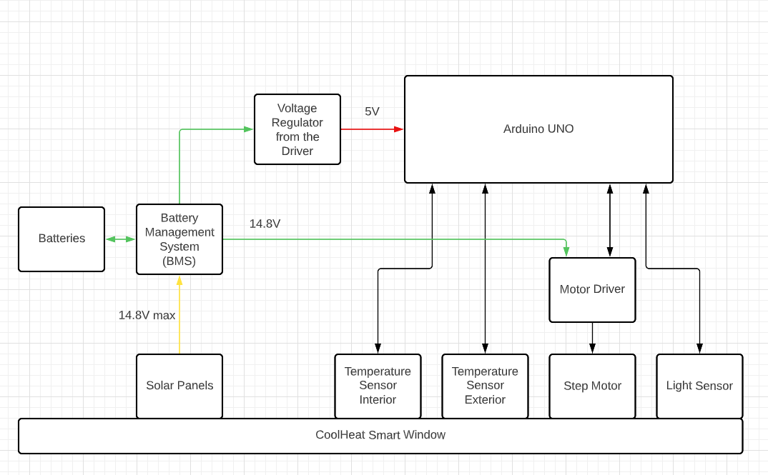
Figure 11: Function Block Diagram Electrical
The smart window uses four 18650 3,7V Li-ion batteries rated at 10A max to power up the entire system. 14.8V from the battery goes directly to driver that is controlling step motor then the driver regulates that voltage to 5V. Since Arduino also needs 5V to normally operate the same voltage regulator output used to power up the microcontroller as well.
This entire process has been powered by three small solar panels rated at 5V and 200mA connected in parallel. The system uses two temperature sensors to measure the temperature of both interior and exterior of the house. Additionally, a light sensor is also used to detect any sunlight hitting on the window itself. These sensors transmit data samples simultaneously to Arduino board. The main component of the system is the NEMA 17 stepper motor which controls the rotation of the hatches according to the environment. To control and drive the motor l293 driver is used.

3.2 Calculations

3.2.1 Mechanical Calculations
Calculations were done for the power needed for all the slats to turn. The electrical engineering students needed this information to choose the motor with the right power.
The formulas used were:
$$P=T⋅ω$$
- P = Power (W)
- T = Torque (Nm)
- ω = angular velocity (rad/s)
$$ω=\frac{n⋅2π}{60}$$
- n = revolutions per minute
- ω = angular velocity (rad/s)

3.2.1 Electrical Calculations

Power Calculations
Power calculations when system stationary.
Since we will not power up the motor while it is stationary, no significant amount of power will be consumed. While the shutter is in hold with the help of mechanical lock slides will be locked therefore there is no need to power the motor.

Power Formulas
Capacity of batteries formula
$$P_{battery}:\frac{\left(mAh*V\right)}{1000}$$
$P_{battery}=\frac{\left( 2500*3.6\right)}{1000}= 9 Wh$
$$P_{batteryJoules}=9*3600=32,400 Joules$$
OR
$Energy_{batteryJoules}=\left(Volts ⋅ Ah ⋅ 3600\right)$
$Energy_{batteryJoules}=\left(3.6 ⋅ 2500 ⋅ 3600\right)$
$Energy_{batteryJoules}=32,400 Joules$
Stepper motor power consumption per step
$$P_{step}=I_{max}*V$$
$$P_{step}=0.4*9.6=3.84 Watts per step$$
$$P_{perhour}=3,84*0,1=0,384 Wh$$
(We estimated that the motor will be operating 5 min a day with each rotation takes 5 seconds to complete)
It means $Time motor can operate with full charge=\frac{36}{0,384}=93,75 hours$
Sensors and Arduino combined
Component | Voltage | Current (A) | Time(hour) | Energy (Wh)
Arduino (ON) | 5 | 0.1 | 1 | 0.5
Arduino (OFF) | 5 | 2,00E-08 | 23 | 2,3E-06
Temperature Sensors | 5 | 0.01 | 0.1 | 5,00E-03
Light Sensors | 5 | 0.01 | 0.1 | 5,00E-03
Motor | 9.6 | 0.4 | 0.1 | 0,384
TOTAL | - | - | - | 0.894002
Table 12: Power Consumption
Formulas Used for the calculation above
$$P=V . I$$
$$P_{Wh}=Watts . Hour$$
This means $Time system can operate without charge=\frac{36}{0,894002}=40,26 hours.$
From the calculations above we have found that the system can operate around 40 hours when batteries fully charged. Reminder that these power consumption estimations are little exaggerated in reality we expect system to function at least 48 hours.

3.3 Material Selection and Production

3.3.1 Material Selection
With the help of Edupack, the group was able to set limits and requirements to design graphs where it indicates the best choice of materials as well as their properties.
Requirements
  - Recyclable
  - Stiff
  - Resist the typical Netherlands weather (rain/snow/wind)
  - High yield strength
  - Environmentally friendly
  - Resists erosion from atmospheric acids
  - Insulating
- Conclusion on what type of family of materials are the best
Despite having a high-density value and therefore being heavy, but also are bad insulators, metals/alloys, technical ceramics, and composites are the best choice for the family of materials because of all their properties.
Metals and alloys:
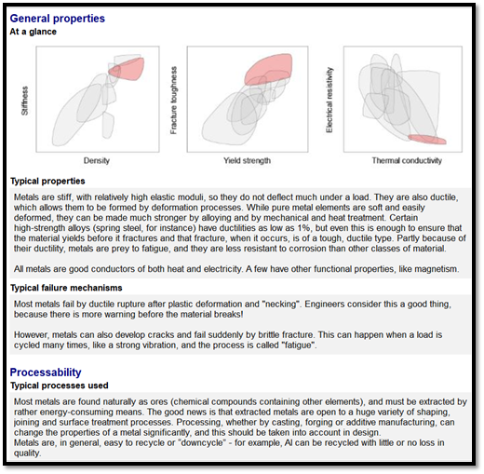
Figure 12 – General Properties of Metals and Alloys
Technical ceramics:
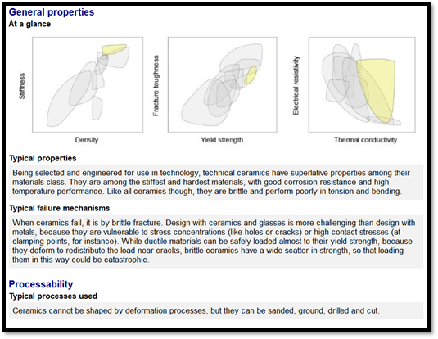
Figure 13 – General Properties of Technical Ceramics

Composites
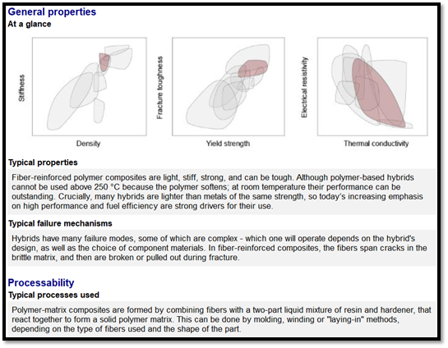
Figure 14 – General Properties of Composites
The Final choice
After several meetings and discussions, the group decided that the best material possible would-be aluminium filled with foam since it has every property that we are looking for, some examples would be:
- Sound absorption
- Non-flammable and form-stable at elevated temperature
- Aluminium foam is recyclable and thus environmentally friendly.
- Lightweight
- Durable
- High strength
- Maximum service temperature of 450ºC

3.4 Component Selection and Parts List

3.4.1 Components List (electrical system)
The list below show the components that has been chosen and used to build the system. The decision factor of the parts is explained later.
Part Name | Model | Quantity
Stepper Motor | NEMA17 | 1
Temperature Sensor | TMP36 | 2
Light Sensor | TSL2591 | 1
Driver | l293 | 1
Solar Panels | SOLAR SM2380 | 6
BMS | 4S 40A Battery Charger | 1
Batteries | INR18650-25R | 4
Microcontroller | Arduino UNO | 1
Table 13: Component List

3.4.2 Component Selection and Specifications
Solar Panels
Due to mechanical engineering specifications, it is necessary for the solar panels to be thin and narrow. The size must be small enough to fit the space above the window frame. Apart from the size the amount of power generated from the panel should be sufficient to both charge and power the system. These were the main criteria’s we had taken into consideration when choosing our solar panels. The table below shows different models of solar panels and prices.
Model No. | Voltage (V) | Current (mA) | Dimensions (L x W x H mm) | Price (€) | Seller
SOLAR SM2380 | 2 | 380 | 60 x 115 x ? | 6,30 | Reichelt.nl
SOLAR SM330 | 0.5 | 330 | 60 x 30 x 9 | 2,29 | Reichelt.nl
SOLAR SM850 | 0.5 | 850 | 60 x 60 x 9 | 4,06 | Reichelt.nl
SOLAR SM4200 | 4 | 200 | 120 x 60 x ? | 10,12 | Reichelt.nl
SOLAR SM6150 | 6 | 150 | 120 x 60 x ? | 8,74 | Reichelt.nl
Sygonix QUTQ6-15 | 6 | 150 | 120x82x3 | 8.58 | Conrad.nl
Sygonix QUTQ6-02 | 3 | 250 | 120x62x3 | 7.16 | Conrad.nl
Phaesun Sun Plus | 12 | 570 | 383x299x35 | 29.99 | Conrad.nl
Phaesun Sun Plus 5 | 12 | 300 | 270x270x45 | 23.99 | Conrad.nl
Velleman SOL4N | 2 | 200 | 72x46x2 | 4.99 per 1  4.7 per 5  4.58 per 10 | Conrad.nl
Table 14: Solar Panel Options
Out of all these options we have decided to choose SOLAR SM2380 for its both voltage and amperage rates.
Batteries
For system to be autonomous the energy generated from the solar panels must be stored. Only main choosing points for the batteries were its reasonable capacity and its rated voltage levels. After some thought, a choice was quickly made to use lithium cells. With a view to possibly use it in the prototype, the final decision has been made to use ICR186500 cells from Samsung due its low cost and easy accessibility. Power calculations has been made to find out how much energy the system will be consuming. These calculations have been made with wide margins and assumptions.
It has been assumed that the slats turn on average five times a day and that each turn would also last maximum five seconds.
This is added to the dormant consumption of the controller and weighed against the capacity of the battery cells. This showed that the daily consumption was around 1.6kJ and the amount of storage batteries has is around 32.4kJ which is well above its requirements.
INR18650-25R Specifications
Weight - g | 44
Brand | Samsung
Model | INR18650-25R
Format | 18650
Chemical | Li-ion
Voltage | 3.6V
Min. Capacity | 2.500,00
Performance | Flat top
Current(Amps) | 20,00
Protection Circuit | No
Height - mm | 64,90
Diameter - mm | 18,30
Table 15: Batteries
BMS
A simple type has been chosen for the BMS. Since the battery cells are not special or demanding types. We have mainly checked whether it has basic protection or not, if it is two-string or not, can it handle the correct voltages and whether it can regulate the voltages mutually.
Based on these criteria’s, the 4S 40A battery charger has been chosen. We really don’t know whether it has another name or model number since there is no markings on the board itself and we could not find any datasheet for it either. We choose this BMS Because it meets the requirements, and it is also compact. In addition, it also protects against any voltage peaks that are not desirable for the microcontroller and battery cells.
Microcontroller
When it comes to microcontroller, we did not made any decision for the reason that the Arduino was the only microcontroller we were able to program. Because the programming had to be done by ELT students since the ESE students decided to change their project.
Sensors
When it comes to temperature sensor TMP36 has been chose due to its both precise accuracy and its less power consumption. In the first stages of the project LM35 temperature sensor was going to be used but later on we have found out that the LM35 was too sensitive to voltage changes for that reason it quickly been disregarded, and an alternative solution has been found.
For a light sensor we decided to use TSL2591 for its precision and its programmability and its low power consumption.
TMP36 Specifications
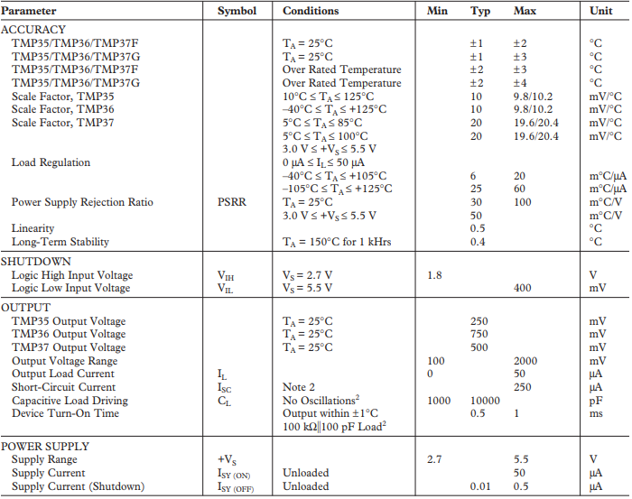
Table 16: Temp Sensor
TSL2591 Specifications
Symbol | Parameter | Conditions | Min | Typ | Max | Units
VDD | Supply Voltage |  | 2.7 | 3 |  | V
TA | Operating air temp. |  | -30 |  |  | °C
IDD | Supply Current | Active Sleep state - no I2C activity |  | 275  2.3 | 325  4 | µA
VOL | INT, SDA output low voltage | 3mA sink current 6mA sink current | 0  0 |  | 0.4  0.6 | V
ILeak | Leakage current, SDA, SCL, INT pins |  | -5 |  | 5 | µA
VIH | SCL, SDA input high voltage |  | 0.7 VDD |  |  | V
VIL | SCL, SDA input low voltage |  |  |  | 0.3 VDD | V
Table 17: Light Sensor
Motor
Possibly the most important part of the circuit is the motor. The slats must be controlled and that is only possible if a motor is present. Because a certain degree of precision is required, the choice for the type of motor is quickly made. A stepper motor has been selected. Since this type of motor rotates in small steps. When supported by software, the motor can be controlled to rotate in partial steps of a circle and to hold its position there.
This amount of precision and control was the main reason we have decided to use a stepper motor. Then we quickly searched the most common stepper motors. From our research we found out that NEMA 17 stepper motor fits perfectly to our requirements. It has enough torque (350mNm) nominally works at 2.8 volts and 1.7 amps and is therefore easy to control. The holding torque is 1.7 Nm, which is enough to handle the weight and friction of the mechanism.
NEMA 17 Specifications
Step Angle | 1.8°
Step Angle Accuracy: 5% (full step, no load) | 5% (full step, no load)
Resistance Accuracy: 10% | 10%
Inductance Accuracy: 20% | 20%
Temperature Rise: 80°C Max. (rated current,2 phase on) | 80°C Max. (rated current,2 phase on)
Ambient Temperature: -20°C~+50°C | -20°C~+50°C
Insulation Resistance: 100Ω Min. 500 VDC | 100Ω Min. 500 VDC
Dielectric Strength: 500 VAC for one minute | 500 VAC for one minute
Shaft Radial Play: 0.02 Max. (450 g-load) Shaft | 0.02 Max. (450 g-load) Shaft
Axial Play: 0.08 Max. (450 g-load) Max. | 0.08 Max. (450 g-load) Max.
Radial force: 220N (20mm from the flange) | 220N (20mm from the flange)
Max. axial force: 60N | 60N
Rated Voltage | 9.6 V
Current/Phase | 0,4 A
Inductance/Phase | 36 mH
Holding Torque | 166 mNm
Shaft | Single
Table 18: Stepper Motor

3.5 Drawings and Parts List

3.5.1 Final Design 3D Rendering
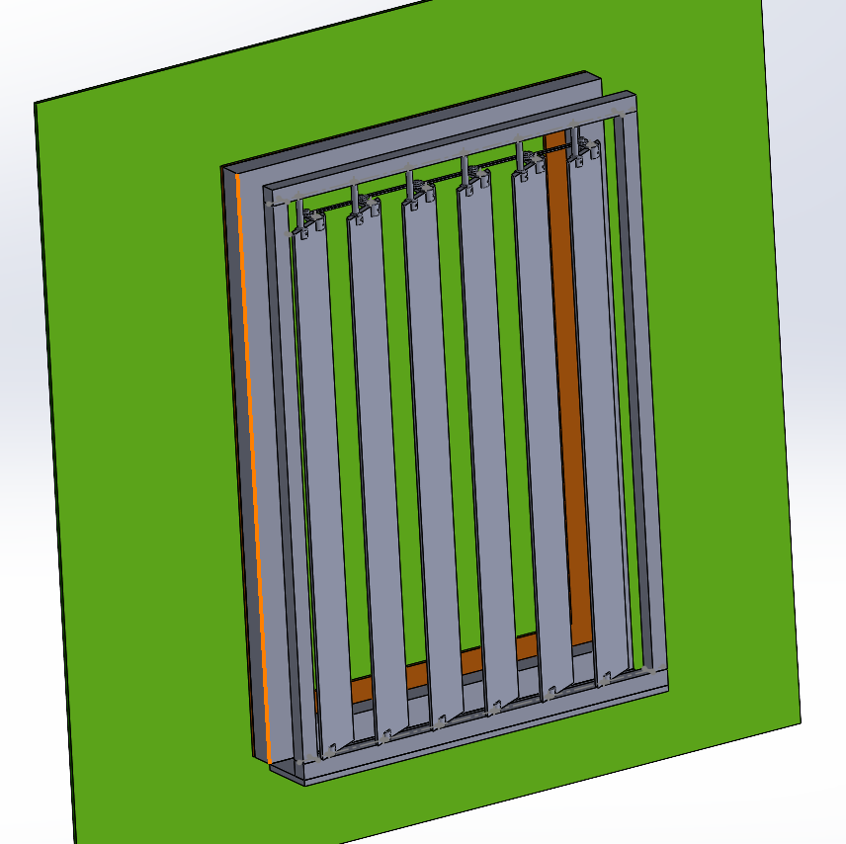
Figure - Final Design

3.5.1 Final Design 2D Drawing
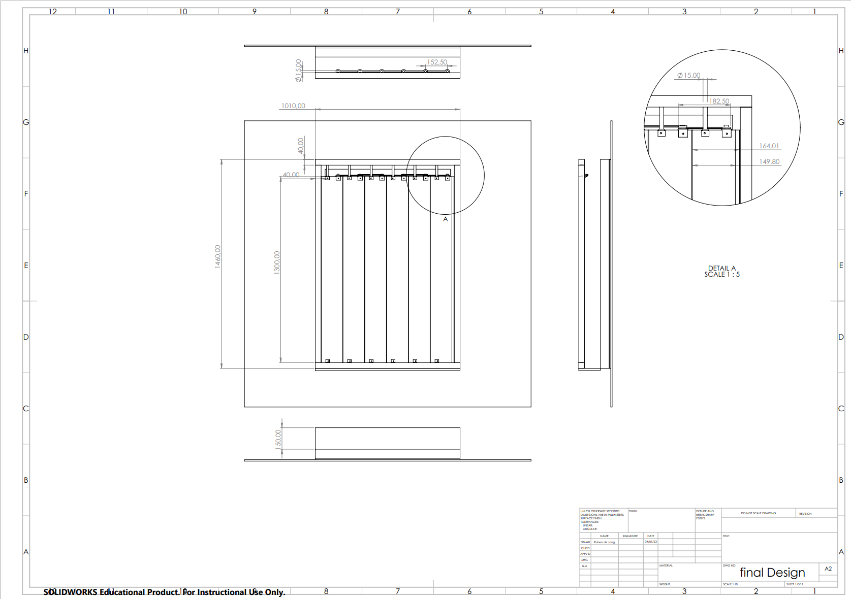
Figure - Final Design 2D

3.5.2 Final design Parts List (mechanical)
Component | Quantity
44*44 mm Wooden Beam
Closing cap (Brass) | 12
Steel square angles | 8
White Rigid PVC Foam Board | 6
3D Printed mechanism | 1
Weather Strips | 6
Table 19 - Final Design Parts list

3.6 Electrical Schematic
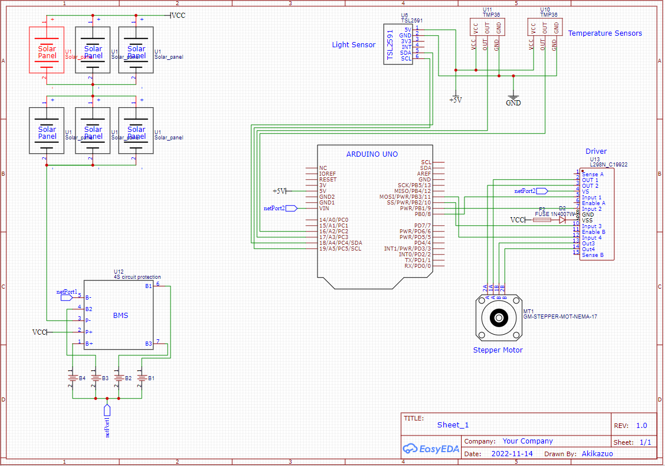
This is the system that has been assembled it consists of solar panels ,stepper motor ,temperature and light sensors. The system works with 5V DC mostly only exception is that the stepper motor which works with 12V DC on average.

4 Realisation

4.1 Production planning
Goal 1: Manufacturing of the mechanism
Key Action Steps | Tools used | Timeline | Expected Outcome
Step 1, Draw the several parts of the mechanism on CAD | Solidworks | 31/10- 1/11 | The drawings correspond to the mechanism desired
Step2, 3d print certain parts | 3D printer | 8/11-9/11 | The mechanism can be easily assembled and performs as expected
Goal 2: Manufacturing of the frame
Key Action Steps | Tools used | Timeline | Expected Outcome
Step 1, have the wood pillars of the correct length (a bit longer to allow mistakes to be corrected) and the same thickness. | Circular saw | 14/11 - 15/11 | The frame has a height of 1460mm, a width of 1010mm, and a thickness of 163mm
Step 3, Make the holes where the slats will be inserted |  |  | The holes have a diameter of 8mm
Step 2, Join the pillars together with the help of square steel angles Make the holes where the slats will be inserted |  |  | The frame is strong and stable
Step 4, Make the frame smooth |  |  | The frame is smooth to the touch
Goal 3: Manufacturing of the slats
Key Action Steps | Tools Used | Timeline | Expected Outcome
Step 1, Cut the slats in such a way that they have angled sides |  | 21/11 - 22/11 | The slats should have a height of 150mm and width 15 mm
Goal 4: Assembly
Step 1, Add the brass bearings to the frame |  | 28/11-29/11
Step 2, Add the slats to the frame
Step 3, Connect the moving mechanism to the slats
Table 20 – Manufacturing and Assembly steps
4.2 System Test Plan
The tables below show the test plans will be taken to ensure the circuit and components functions properly. Each test covers a different aspect of the system. Tools that had been used for testing are;
- Multimeter
- Arduino UNO
- Thermometer
- Flashlight
- Buttons
- Breadboard
- External power supply
Test 1; Solar power test plan
This test has been observing the different voltage levels during the day.
Test Name | Description | Expected Result
Solar power in a day | All three solar panels will be left outside for a day in November from 05:00 to 19:00 hooked to an Arduino board with a voltmeter to read and collect the data. | Power levels stay above 6 watts constant.
Table 21:Solar Test Plan
Test 2; Motor test plan
Test Name | Description | Expected Result
Basic motor functionality test | Basic motor functions will be tested with an external power supply. | Motor works properly.
Basic motor functionality test with batteries | Basic motor functions will be tested with batteries to check if the batteries are sufficient. | Motor works properly. The batteries provide 14,8V when fully charged.
Motor reaction to the temperature and light sensors. | Since the tests will be done in the lab there will be no difference between temperature sensors thus the temperature sensors replaced with buttons to trigger certain temperature values and test the motor functions. This triggering happens via changing the value of button1 from 0 to 1 therefore creating a difference between two sensors. | When button1 has a higher value than button2 the motor should rotate 45° clockwise. (50 steps)  When button2 has a higher value than button1 motor should turn 45° counterclockwise.
Table 22: Motor Test Plan
Test 3; Temperature and light sensor test plan
Test Name | Description | Expected Result
Light sensor functionality test. | Light sensor will be connected to Arduino and the different light levels will be tested. | Under shadow below 1.000/2.000 luminous  Under flashlight above 20.000 luminous.
Temperature sensor accuracy test. | One of the temperature sensors will be tested simultaneously with a thermometer with the difference between two, error rate will be calculated. | Temp sensor accuracy error rate +- 2 degrees
Table 23:Sensor Test Plan
4.3 Test Results

Test 1; Solar Panel Results
The table below shows the amount of sunlight and the voltage levels we have received during a day in November.
Time | Voltage (V) | Current (A) | Power (W)
05:00 | 0 | 0 | 0
06:00 | 7,2 | 0,523 | 5,44
07:00 | 9,5 | 0,687 | 6,53
08:00 | 9,9 | 0,781 | 7,518
09:00 | 10,2 | 0,806 | 8,23
10:00 | 10,5 | 0,830 | 8,72
11:00 | 11,00 | 0,812 | 8,95
12:00 | 11,2 | 0,802 | 8,996
13:00 | 11,7 | 0,768 | 8,602
14:00 | 11,6 | 0,713 | 8,272
15:00 | 11,3 | 0,645 | 7,293
16:00 | 10,7 | 0,610 | 6,53
17:00 | 9,9 | 0,625 | 6,19
18:00 | 8,2 | 0,540 | 4,43
19:00 | 6,9 | 0,009 | 0,0621
Table 24:Solar Test

Test 2; Motor Test Results
Test Name | Description | Expected Result | Result | Pass/Fail
Motor testing with a4988 driver. | Basic motor functions will be tested with an external power supply. | Motor to work with 12V from external power supply. | Motor did not work driver seems to be broken reason is still unknown further research needed to figure out why. | Fail
Motor testing with l293 driver. | Basic motor functions will be tested with an external power supply. | Motor to work with 12V from external power supply. | Motor works with 12V and 900mA. | Pass
Motor reactions to the sensor values. | Temperature sensors replaced with buttons to trigger certain temperature values and test the motor functions. This triggering happens via changing the value of button1 from 0 to 1 therefore creating a difference between button1 and 2. These differences normally would be created by the difference between two temperature sensors. | When button1 has a higher value than button2 the motor should rotate 45° clockwise. (50 steps)  When button2 has a higher value than button1 motor should turn 45° counterclockwise. | Failure in code needs further examination. Motor turns once then stop responding to the command. | Fail
Motor reactions to the sensor values. Number 2 | We found out that there is a delay when using buttons in the code itself we observed that the when button pressed the switching from value 0 to 1 is not instant instead it gives mix of both values while its changing that was the reason motor was only functioning once. We decided to use serial monitor to test the motor. | Same expected result. | Motor functions properly. | Pass
Table 25: Motor Test

Test 3; Temperature and light sensor test results.
Test Name | Description | Expected Result | Result | Pass/Fail
Light sensor functionality test | Light sensor will be connected to Arduino and the different light levels will be tested. | Under shadow below 1.000/2.000 luminous  Under flashlight above 20.000 luminous. | Under shadow ≈ 300 luminous  Under flashlight ≈ 52400 | Pass
Temperature sensor accuracy test | One of the temperature sensors will be tested simultaneously with a thermometer with the difference between two, error rate will be calculated. | Temp sensor accuracy error rate +- 2 degrees | Room Temperature Measured with thermometer = 23,4°  Room Temp. With sensor = 23,2°  Error rate = 0,854 % calculations below. | Pass
Table 26: Sensor Test
Error Rate
$$Error Rate=\frac{23,4-23,2}{23,4}*100=0,8547\%$$
4.4 Reflection
At the ending of the project the group, in reflection, the group has experienced many challenges and now have numerous ways some challenges could be prevented or improved.
- In the production stage, the mechanical engineering group experienced many issues with the connection rods that were designed. The first version of the rods fractured after 3D printing was finished. The rods were redesigned to have additional thickness. When connecting the second version of the rods to the slats, the group had noticed that the rods experienced bending when rotating in the slots. After a few moments, the rods fractured again.
To counteract this issue, the rods were redesigned to have better strength, so that they would be able to withstand torque, the cause of their fracture. This was done by thickening the base of the shaft were more torque occurred. Also, when 3D printing, there was additional thickness to the middle of the rods for further internal support.
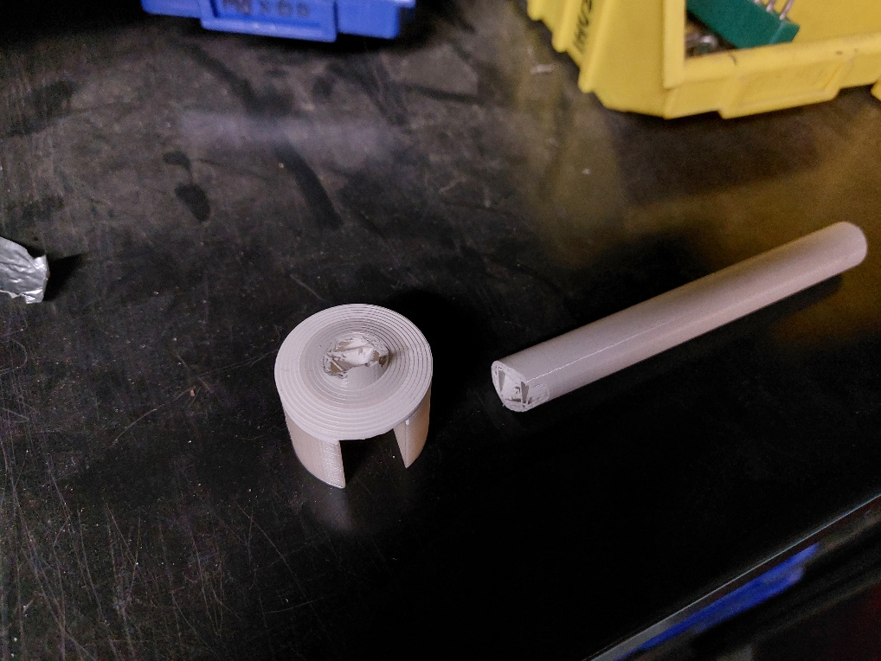
Figure 14 – Broken 3d printed components
- The group also noticed that the gear that was 3D printed might eventually wear down. This may be a result of the material that was used for the process. The gear may need to be manufactured from a different material or suitable size purchased to prevent wear.
- When the connection rods were being assembled to create the rotating mechanism, it was noticed that they unwind when the slats were rotated. To prevent this, they may require a stronger connection point.
- When the frame was initially assembled, the group carried the final frame to the window. This window would be where the group will attach the final product. In doing so, the group ensured that the final frame was the correct size for the window.
- After the slats were inserted into the frame and the rotation was tested, it was noticed that the slats had a difficulty rotating. The rods that connected the slats into the frame had a certain length so that the electrical components had room. However, this caused the rods to be too long, therefore, requiring more torque to turn. To counteract this problem, the rods would need to be shorter.
- In the beginning of the project, the group experienced a few issues with communication. There were instances of misunderstandings of clarity between the tutor and client. To avoid such instances, it would be best for the group to arrange a meeting with everyone present, so that expectations were clear. As a result, the plan of approach took the most time to perfect.
- To ensure that hinderances were avoided, the group created a method of planning. This method provided the group with tasks every week and adequate deadlines.

References

[1] | D. Suleman, B. de Haan, O. Schuit, G. Krist, J. Krawczak, M. Rijksen, T. van Mierlo and T. van Zagten, “Project Herwaardering van luiken,” HAN, Arnhem, 2021.
[2] | De Zonwering Fabriek, “Stel je screen samen,” [Online]. Available: https://www.zonwering-fabriek.nl/product/screens/screen/?productID=815&type=Nog%20te%20kiezen&placement=Nog%20te%20kiezen&finish=Nog%20te%20kiezen&width=750&height=500&housing_size=85(mm)&housing_color=antraciet&screen_color=grijs_-_zwart_108118&bediening. [Accessed September 2022].
[3] | OZ Shut, “Roller Shutters keep the heat in & the cold out,” [Online]. Available: https://www.ozshut.com.au/roller-shutters-keep-in-heat/. [Accessed September 2022].
[4] | Maple Sunscreening, “How does Brise Soleil work?,” Maple Sunscreening, [Online]. Available: https://www.maplesunscreening.co.uk/brise-soleil-explained. [Accessed September 2022].
[5] | Renson EU, “Architectural solar protection & Brise Soleil,” Renson EU, [Online]. Available: https://www.maplesunscreening.co.uk/brise-soleil-explained. [Accessed September 2022].
[6] | European Rolling Shutters, “The Ultimate Homeowners Guide to Choosing the Best Window Shutters,” European Rollling Shutters, 23 September 2019. [Online]. Available: https://www.ersshading.com/blog/the-ultimate-homeowners-shutter-guide/. [Accessed September 2022].
[7] | Lake Washington Windows and Doors, “Understanding R-Value and U-Value for Replacement Windows,” 03 January 2021. [Online]. Available: https://lakewashingtonwindows.com/understanding-r-value-and-u-value-for-replacement-windows/.
[8] | Glasherstelhermans, “Isolatiewaarde glas,” 2022. [Online]. Available: https://glasherstelhermans.nl/isolatiewaarde-glas/.
[9] | Allguard Roller Shutters, “How Outdoor roller Shutters Save You Money,” 2021. [Online]. Available: https://allguard.net.au/how-outdoor-roller-shutters-save-you-money/#:~:text=Regular%20secure%20shutters%20have%20an,money%20on%20higher%20R%20%E2%80%93%20values..
[10] | R. Ronquillo, “Understanding Gears,” 13 September 2022. [Online]. Available: https://www.thomasnet.com/articles/machinery-tools-supplies/understanding-gears/.
[11] | S. M, “CHAIN DRIVES AND TYPES OF CHAINS,” 17 August 2021. [Online]. Available: https://www.theengineerspost.com/chain-drives/.
[12] | ISC, “V-Belts,” 2022. [Online].
[13] | Mecholic, “Belt Drive - Types, Advantage And Disadvantage,” 2022. [Online].
[14] | Mecholic, “Timing Belt (Toothed belt) Advantages And Disadvantages,” 2022. [Online].

Appendices

Appendix A: Plan of Approach
Background Information
CoolHeat is the project commissioned by HAN, with Maarten van den Berg as the main sponsor. Maarten will evaluate the interim report as it progresses and the final report when it is done. CoolHeat is carried out by 7 second-year students from several HAN universities of sciences, bachelor's degrees. Two separate reports are done by the students from two different courses: Mechanical Engineering and Electrical Engineering.
The main sponsor of CoolHeat, Maarten van den Berg is employed by the HAN university of Applied sciences and works in the BES (Balanced Energy System) department. BES work to eliminate the imbalance in the Dutch Electrical Grid, which is caused by the difference in time of the peak renewable-energy-supply and the peak energy-demand. The main solution for this problem is to decrease the energy-demand at the peak times. That is one of the things that Coolheat seeks to do.
However, the main thing that Coolheat seeks to achieve is to regulate the indoor climate of a regular Dutch house that is built in the 90s. To increase the temperature in Winter and decrease it in Summer.
A previous team has worked on this problem. An idea of a revalorising hatch was thought of. Much research was done to create fertile soil for the idea to grow. However, this in-depth research resulted in a lack of time to build a proper working prototype even though a report was written. The research and report previously written will be referred to as a helpful tool for Coolheat.
As Coolheat progresses, Maarten will evaluate the progress and eventually the product. The team works in proximity to Maarten. This will keep the communication lines short, which is a plus. Plan of approach layout can be seen at table of contents.
Project´s Results
The objective of Coolheat is to reduce the energy usage of Dutch households, by relieving heating/cooling appliances. This can be divided in multiple objectives:
- Warming/keeping warm houses by adding an extra layer of insolation, or by letting in sunlight when available
- Keeping houses cool by adding an extra layer of insolation.
List of Requirements
The result can be well described by using the list of requirements completed with the aid of the stakeholder:
General Requirements
Demand in one word | Requirement (specific and measurable) | Type of requirements | Authentication method | Stakeholder
viability | The product must be tested at least in 5 different houses to check if it causes any damage to the integrity of the house. | Fixed Requirement | Proper testing periods and professional verification method for mounting using laws and regulations, and developer’s standards | Developer/Government
User-friendly | Must contain a manual that was tested by at least 10 people, and at least 8 of them understood clearly how to mount it. | Fixed requirement | Survey to be done with an overall positive (above 8/10) response to the readability and explanation of the manual. | Developer
Sustainability | Return of investment should be lower than 10 years. | Variable requirement | Use Edupack to check the sustainability of the material | Developer
Safety | It must not have any sharp edges and it must not contain any chemical dangerous materials | Fixed requirement | Check the final concept design and the choice of materials to ensure the safety of the product | Government

Functional Requirements
Demand in one word | Requirement (specific and measurable) | Type requirements | Authentication method | Stakeholder
Insulation | It should have a R-Factor greater than R-5 | Variable Requirement | Test set-up | Developer
Noise-limitation | Movement should not exceed 30 decibels in loudness. | Variable Requirement | Expert Assessment + Test Setup | Developer
Construction | The outside drywall can support the system | Fixed Requirement | Strength calculation | Developer
 | The dimensions of the structure must be within the dimensions of the framework. | Fixed Requirement | NEN2314 | Government
 | The construction must be able to cope with Dutch weather conditions (-10 degrees to 30 degrees, wind speed up to 10 on the Beaufort Wind scale, rain-water resistant) | Fixed Requirement | Strength calculation + test set-up | Developer
 | The dimensions of the construction must meet the applicable NEN standards | Fixed Requirement | EN 12412-2  EN ISO 12567-1 | Government
Autonomous | Generating energy by means of a PV panel | Fixed Requirement | Test set-up | Developer
 | Storing energy by means of a chemical battery or a mechanical battery | Fixed Requirement | Test set-up | Developer
Automation | While the device is working automated it will run on one of 3 modes depending on the temperature (For information on modes look to page 15) | Fixed Requirement | Reporting | Developers
 | Reading parameters using sensors | Fixed Requirement | Test set-up | Developers
 | motor operation can be set to manual or automated | Fixed Requirement | Test set-up | Developer
 | Manual overrule must be present | Fixed Requirement | Expert rating | Developer
Aesthetics | Most parts of the product should be covered | Variable Requirement | Group assessment | Potential user
Movement | The panels can rotate to the desired degree according to the temperature and sunlight | Fixed  Requirement | Testing of a prototype | Developers
Temperature | Sensors that detect temperature | Fixed  Requirement | Testing of a prototype | Developers
Budget | The price is below 300€ | Fixed Requirement | Desk research comparison | Potential user
Maintenance | The interval between maintenance sessions should be 3 years. | Variable Requirement | Expert rating | Maintenance technician
 | Maintenance can be performed by a person with no information in the field. | Variable Requirement | Expert rating | Maintenance technician

Mechanical part:
- Design of mechanism that ensures movement is smooth
- Design of connection between various parts of system
- Way of converting the kinetic energy from the motor to the rest of the system
- Design of protection of system from the elements like rain, snow, storms
- Design of mounting system to the window frame
Electrical part:
- A self-sufficient power supply that can make enough current to run a motor and be able to charge the battery and not running out in the winter for example
- A working program that opens and closes depending on temperature and light
- Have motor options working with the circuit
- Having a flexible circuit that can be change according to changes in the requirements (for example more powerful motors)
Final Results:
To describe the final results in detail, it is divided between the different functions
- Shutter that can shut out the sunlight and keep heat out by measuring the outside temperature and detecting the amount of light
- Mechanism that ensures movement is smooth by choosing the right motor with the right torque
- Components which ensure the mechanism is protected from the weather elements and the electronics must be hidden and protected from the outside environment
- Mechanism that can mount the structure to the window frame without damaging it
- Component that can transfer the kinetic energy from the motor the rest of the structure, wherever it is necessary.
- Position the solar panels in a direct sunlight and for it to collect the most sunlight possible

Function Description: Hamburger Model
A function description is necessary to ensure that the client and engineers are agreed on the functions of the end-product
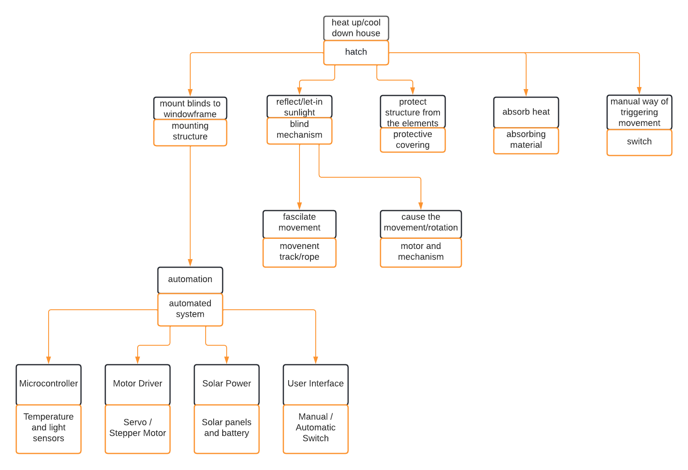
Project Activities:
To successfully achieve the results above mentioned several activities must be completed.
The activities can be separated into two groups:
- Mechanical Engineering activities
- Electrical Engineering activities
Mechanical Engineering Activities
- Research on different mechanisms
- Draw conceptual designs of the product
- Decision on the final concept design by using the Kessel ring
- CAD designs
- Order parts
- Manufacturing of the final prototype (which may include)
  - 3D printing and Laser cutting
  - Use of the machines in the workshop
Electrical Engineering Activities
- Choose the type and number of solar panels
- Placement of the sensors
- Make an automatic and manual switch
- Research and placement of the battery and driver
- Final circuit
- Coding
When these activities are completed and perfected, the group ensures that the prototype will match the client's expectations.

Project Limits
To make sure clear plan for the project can be made, it is important to set boundaries and limits. This means setting out the scope of the project and the conditions under which the project can run under. At a basic level there are two main questions that can be asked. The first is ‘When does the Project finish?’ The second is ‘What does the Project include?’ Using these two questions one can then start to make the limits of the project.
Questions:
Question 1 – When does the Project finish?
Creating the start and end of a timeline will create two limits for the project. In this case the start does not really depend on the completion of any other projects or tasks, meaning the project has started on August 29th, 2022. As we have been given a deadline for the completion of the project being the week before Christmas, this also gives us an end to the project.
Question 2 – What does the Project include?
With two boundaries set up, the other boundaries to complete a focused base that the project can be planned around. To set up these boundaries, one must work out the events, activities related to the project and then filter out the ones that are and are not important. Therefore, within the outer boundaries, one must have a different phase. There should be an Orientation and Research Phase, a Design Phase and then a Realisation Phase.
During the Orientation part one should set out a how the project will take place. The Plan of Approach comes under this area. In the research part one can break the research into Desk research and Field research. With the understanding of the project more important at this stage, the Desk research will be more important with any field research being closer to the boundaries.
During the design phase, any ideas that are not on the outside can be discounted and are therefore outside of the boundary.
The realisation phase is the last section and should be the point on which the prototype is completed. As this is the case, any kind of thing that is not related to the final design can also be removed from the boundaries at this point.
Methodology
The picture below demonstrates how the group decided to plan the project based on the courses in the group. This method was decided for the project to create an order for organization.
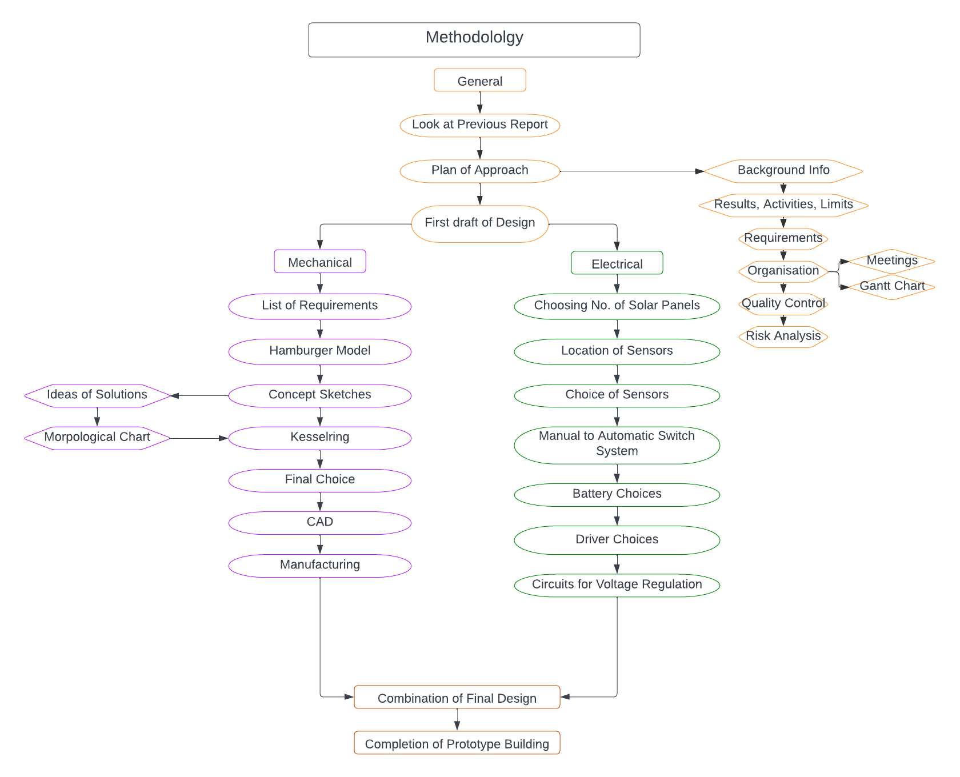
Group Members:
The table below displays the group members and the area they deem to be their expertise and specialty. This was decided so tasks could be better allocated based on someone’s best area.
Members | Expertise
Mechanical Engineering
Inês Guimarães | Planning management skills, Analytical/calculation skills, Project management skills
Alex Harper | Analytical skills, Project management skills, Writing skills
Ruben de Jong | Analytical skills, Project management skills, Writing skills
Ariana Walters | Planning and Project management skills, CAD skills, Workshop skills, Writing skills
Electrical Engineering
Hadi Alwattar | Coding/computer skills
Erickson Helder | Project management skills, communication skills, workshop skills, Computer skills
Ilkay Sayan | Analytical/calculations skills/Writing skills

Organisation:
The table below shows when each group member takes distinct roles during meetings.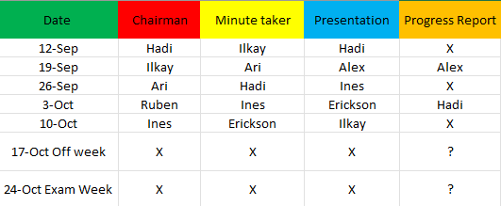
Gantt Chart:
The Gantt Chart below displays the plan schedule for the project. Each row has tasks that need to be completed at a certain date, shown in the columns. Each task is colour coded for each course in the project group.
Quality Control
The section on quality control in the project plan deals with the quality of the product. To guarantee its quality certain tasks will be executed with the reason behind it.
Tasks | Reason
When faced with an unsolvable problem external help from tutors will be used. | Ensure less time will be wasted on problem solving.
All documents about the project must be uploaded to Microsoft teams to reduce any risk of losing the work and increase the organization between team members. | Reducing the risk of losing any important document will be minimal.
Every week a meeting will be organized. | Bring each team member up to date on the latest developments and make certain decisions.
During the meeting there will be a division of tasks for everyone. | Make sure the team will work efficiently as possible.
All important safety precautions will be taken to protect the integrity of both electrical components and hatch mechanism. | Prevent any damage will be done to the prototype during testing.
When buying and producing parts alternative options will be taken into consideration. | Prevent any delay in case of a shipment problem or lack of components.
When needed feedback will be taken before moving onwards. | Make sure project requirements are met.
Any subsystem will be tested individually before combining with the other systems. | Make problem spotting during testing convenient as possible.
Each task will have a reasonable deadline. | Minimize the risk of any delays due to incomplete work.
Costs/Benefits:
We decided that the project is worth going through as the cost of the project is acceptable in reference to the budget. And the biggest benefit of this project is that it acts as a foundation for future projects and improvements.
Risk Analysis:
Within a project, there are many situations that may cause a project to fail. There are several pieces of the project that need to work cohesively and smoothly, otherwise the project may fall apart. Such situations can be categorised in to 5 sections. These include time, money, quality, communication, and organisation.
Categories and Table of Risks
Categories of Risks:
Categories of Risk | Examples | Solutions
Quality | - Members may produce under standard work, either from lack of information or time.  - Production may not be done well. This may cause failure in the prototype if not manufactured well.  - Parts that are ordered may be delayed, and certain parts of the prototype may not be completed in time.  - While assembly or manufacturing, mishaps may occur. | - Sufficiently inform all members during meetings and ensure everyone is clear and understands.  - Ensure that students with better expertise in production oversee others that lack experience.  - Order parts ahead of time to ensure early arrival.
Money | - The budget may be underestimated. Therefore, there may not be enough money to finish the project.  - Parts may be more expensive than thought; this may cause the budget to finish the project to be completed. | - Create a detailed, researched plan for a budget, and ensure there are funds left for emergencies and mishaps.
Time | - The project members might overestimate the necessary time needed to complete the project sufficiently. This may cause the project to fall behind on the final deadline or miss intermediate deadlines.  - Group members may spend a lot of time on a certain aspect of their task and delay the tasks in the project. | - Ensure all tasks have a weighted deadline. Tasks are given a longer time for completion if they have a higher priority or require a long time.  - All members are given a deadline and the project manager will be consulted on further action.
Organization | - Certain aspects of the plan for the project may be poorly planned and executed, causing delays.  - Parts of the methodology may be omitted or forgotten, therefore, also causing delays. | - Create a detailed plan with clear deadlines from the beginning of the project and ensure that the plan is checked, and tasks are on time. Ensure there is time allocated for mistakes.
Communication | - Members of the project may not communicate any problems they are having, therefore, causing under-standard work or delays.  - Information about the project may not be communicated properly through the correct channels. This may cause members not to be aware of updates or lack valuable information. This may cause delays in the project.  - There may be uncooperating members among the group that is not solved, which may cause group disruptions and delays. | - Ensure that there is a clear mode of communication within the project that all members have access to and check regularly.  - Ensure that all members are up to date before proceeding to the next milestone.  - Ensure that all members discuss their discomfort and disruptions are quickly solved in a calm manner.
Table of Risks:
Risk | Value | Factor | Weight | Total Risk
- Estimated duration of the project | 0-3 months  3-6 months  6+ months | 0  1  3 | 4 | 4
- Does the project have a definite deadline | No  Flexible  Yes | 0  2  4 | 4 | 16
- Is there sufficient time to complete the project within the set period | More than enough  Enough  Not enough | 0  1  3 | 4 | 4
- Is it a new project or has it been adapted | Minor adaptions  Major adaptions  New projects | 0  2  3 | 5 | 0
- Has the project been divided up into phases and is progress dependent on these phases | No  A little  strongly | 1  2  3 | 3 | 9
- Where is the project located | 1 location  1-3 locations  3+ locations | 0  1  2 | 2 | 0
- Does the project management team have any knowledge of the subject | A lot  A reasonable amount  Little | 0  2  4 | 3 | 0
- Does the project management team have any knowledge of how to plan a project | A lot  A reasonable amount  Little | 0  2  4 | 3 | 0
- Do the advisers have any knowledge of the field | A lot  A reasonable amount  Little | 0  1  3 | 5 | 0
- Is there a chance the project team will change during the project | Little chance  Some chance  Big chance | 0  2  5 | 5 | 10
- Is the project group using existing methods or creating its own | Only existing  Some methods existing  No existing methods | 0  2  4 | 4 | 0
- Are the project members sufficiently aware of the problems | Yes  Most of them  Not all of them | 0  1  5 | 5 | 0
- Is the field of research sufficiently demarcated | Yes  Reasonably  Not clearly | 0  2  5 | 5 | 10
- Has enough time been saved for coordination | Considerable  Reasonable  Insufficient | 0  1  3 | 4 | 4
- Are the boundaries clearly demarcated | Yes  Most are not  No | 0  1  3 | 4 | 4
- Are the boundaries limiting enough | Yes  Moderately  No | 0  2  5 | 5 | 10
Based on this table, the risk factors present in this project are 71/227. Therefore, this project has a 31% risk factor. This percentage is lower than the maximum of 50%. Therefore, the project is safe to proceed with and will be successful.
Automation explanation
The automation to open and close the hatches will be dependent on certain temperatures and light during the summer and will be only dependent on light during the winter.
Mode 1: (>=26) When its above or 26 degrees it would automatically be closed, you are able to open the hatches however manually if you desire to.
Mode 2: (25-17) Above 17 outside it will measure the difference between outside and inside and will open if there is light and will close back once the temperature inside is 5 degrees above the outside temperature.
Mode 3: (<17) When its below 17 degrees it will only work with light detection as soon as there is a high amount of light it will open if it detects no light after 1 minute it will close again.

Appendix B: Research

B.1 Mechanical Research

B.1.1 Shutters and House Cooling
Objective
To look at ways of controlling the radiation of the Sun passing into a house through the windows
Introduction
This document will look at several types of ways the radiation is reduced or removed from rooms inside buildings. This will be done to compare various methods that are used and how effective they might be. With the information obtained, one can make an informed decision on how best to approach the task of reducing energy usage of Dutch households, by relieving heating and cooling appliances that are traditionally used.
Background and Base
Background
With Climate change being an ever more relevant and present topic, it is important to look at ways to slow down its effects on the planet and even reverse some of the things that have happened. With countries trying to reduce the reliance on things like gas and oil, as well as using these methods to produce electricity, the reliance on electricity is becoming ever more important. The greater reliance means a higher usage of the electrical grid and in some places like the Netherlands it is reaching close to capacity. Therefore, designing ways that not only regulate the temperature of the room without the use of grid connected devices that heat and cool it internally, but also are not connected to the grid at all is a critical area to investigate.
Base
Prior to the start of this project, there was work done in another project to design a concept to solve the same issue. In that, similar research was done to look at the various methods of reducing the effects of the sun. During this, a very comprehensive list was compiled of many different approaches. [1] This research looked at methods that were both outside and inside the buildings however here methods that are outside the building will be looked at as it was said that the design should be fixed to the outside of the building. However, this does not mean one cannot investigate other means as they could also provide valid information.
Methods
There are a wide range of ways to control the temperature in a room. Here everything is separated into sections of ways that work on the outside of the building and then ways that work on the inside of the building. Methods on the outside of the building can also be broken down into those that are directly attached to or around the windows and those that are not.
Systems fixed to windows
For systems that are fixed to and around the windows, there would appear to be three distinctive styles. These are Rolling systems, Vertical systems, and Horizontal systems.
Rolling systems
Rolling systems work in the same principle of rolling up at the top and unwinding downwards to the bottom of the window. One rolling system is the rolling shutter that are made up of individual bars connected to each other in a chain like system allowing it to roll up. These tend to be made of materials such as Aluminium or PVC and can be controlled either wirelessly by electronics or work manually. Another system could be screens that will roll up. They tend to be made of a fabric that is either weather resistant or has been treated to make it so. Being on a roller, it allows them to be quite flexible with how high the screen or shutters are set. However, when they are lowered fully, both styles will have a much greater effect on blocking the heat from the sun out. For example, some screens have been able to filter the sun by 85% while still allowing a decent amount of natural light through [2], while rolling shutters will be able to work in a comparable way. In terms of creating an insulating system and keeping heat in when it is cool outside, they also increase the efficiency of this by some shutters reducing heat loss by up to 90% [3].
Vertical Systems
Alongside having a Rolling system, there is the possibility to also have a vertical system. An example of this is to just have slats hanging vertically. These could be in a fixed position acting in a similar method to that of the architectural ‘Brise Soleil’ or can be controlled to change the angle depending on how the sunlight and radiation is wanted to be filtered. While many of the vertical Slat style are extensively used in garden installations where there is seating, it has still been before.
Horizontal Systems
As well as a Roller system and a Vertical system, one could also use a Horizontal system. These can work in a variety of ways depending on how the system is wanted to operate. A blind style system would work by enabling the slats that block the sunlight and radiation to be removed from the view out of the window. Others include having slats that are fixed in one position, but the angle can be changed. These would work in a comparable way to the rotating ones that are hung in a vertical position by completely blocking as much light or heat intensity out or allowing most of it in depending on how the angle of the slats are arranged.
Traditional Styles
Along with this there are also more traditional methods which use a panelled design. These can come in a fixed manner whereby the panels fold away against the building or move away on sliders, which is seen on many traditional houses than on more modern ones. Alternatives to these have a louvered design with the slats being able to be moved depending on how much light or intensity of the heat is wanted to be allowed to enter the room. While these are usually fixed against the window frame, sometimes they can also be folded away or moved on sliders like the other ones. The slats on these panels can also be arranged in a vertical direction or horizontal direction.
Other outdoor systems
Alongside systems that are fixed to windows, there are others can reduce the temperature. An example of this is something like an awning that comes out of the building and creates an area of shade outside around the area of the window. When the awning is not pulled out then it is retracted away above the window, meaning that it would not provide any blocking of the view like shutters fixed to the window might. It is currently an immensely popular option on many Dutch houses, with different variants being a more classical style that curves over in a semicircle or a more modern version that is just a single panel that retracts upwards and back towards the building.
Similar to this is a permanent alternative by having an overhang built into the building. This would also provide shade over the building and will reduce the temperature around the area in front of the building and therefore possibly also keep the indoor temperature lower when it is warm outside. This method does have a drawback due to it being a permanent fixture. This means that when the outdoor temperature is cooler outside, it may also leave the indoor temperature as being cool due to being in the shade constantly. Designers of buildings have created alternatives to this by using a system known as ‘Brise Soleil,’ which translates from its French name into just ‘Sun breaker. While these are part of the architecture of the building. The idea behind it is they allow one to see out of the window and allow natural light in through the window but keep the glare and brightness from the sunlight as well as any of the solar radiation out of the building. [4] For example, a Horizontal system allows the higher sun to be radiated away from the building but then the lower sun can be let in during the winter to help heat the room. [5]
Indoor systems:
As mentioned previously, while the project is to be designed exclusively as a system to go on the outside of the building, one can also look at indoor solutions to help present ideas for a system and present what is out there
Summary of Methods
There is a vast variety in methods of keeping rooms cool without using power connected to the grid, however many of them still work in an equivalent way. Most will filter out the radiation by being able to reflect it in a different direction, therefore meaning it does not enter the building, while still letting some light in. Ones that can change the angle of the slats or shutter can not only do this, but almost completely remove the ability for radiation to get into the building. One advantage of this is that it could also create and insulating layer that reduces the amount of heat loss when it is required in the room due to it being cooler. A chart by the company European Roller Shutters [6] was able to show that having a Rolling shutter is probably the most effective in categories in being able to keep the room cool, but also in various other categories as well. This was in comparison to other types of systems being used on homes, albeit on homes in North America. Even when some of the methods were not directly fitted around the window, one can see that they can have a significant benefit to the cooling of the rooms in buildings. However, with this method, one would not be able to have any insulation, meaning there would still be heat loss and traditional methods to keep rooms warm would be required.
 | Storm Protection | UV Protection | Security | Durability | Versatility | Curb Appeal | Temp Regulation | Light Controls | Convenience | Privacy | Investment | Overall Score
Traditional | 1 | 1 | 1 | 8 | 1 | 9 | 1 | 1 | 1 | 1 | 1 | 2.4
Plantation | 1 | 8 | 3 | 6 | 8 | 2 | 7 | 8 | 7 | 8 | 3 | 5.5
Louvered | 2 | 2 | 3 | 8 | 2 | 8 | 7 | 4 | 2 | 2 | 2 | 3.8
Cafe | 1 | 4 | 2 | 2 | 4 | 3 | 4 | 4 | 4 | 4 | 4 | 3.6
Board & Batten | 2 | 2 | 2 | 9 | 2 | 9 | 2 | 1 | 2 | 2 | 5 | 3.5
French Door | 1 | 5 | 2 | 7 | 5 | 8 | 5 | 7 | 6 | 6 | 7 | 5.4
Multi-Tier | 1 | 6 | 2 | 7 | 8 | 5 | 5 | 6 | 7 | 7 | 5 | 5.4
Arched | 2 | 2 | 2 | 7 | 5 | 9 | 2 | 2 | 1 | 1 | 9 | 3.8
Raised Panel | 1 | 1 | 1 | 5 | 3 | 8 | 1 | 1 | 1 | 1 | 2 | 2.3
Barn Door | 4 | 5 | 4 | 8 | 9 | 9 | 5 | 6 | 6 | 6 | 8 | 6.4
Scandinavian | 2 | 1 | 1 | 9 | 2 | 9 | 2 | 1 | 1 | 1 | 9 | 3.5
Exterior Rolling | 8 | 8 | 8 | 9 | 7 | 7 | 7 | 9 | 9 | 9 | 7 | 8.0
Bahama Storm | 9 | 9 | 9 | 9 | 4 | 5 | 1 | 1 | 2 | 5 | 9 | 5.7
Shaker Storm | 9 | 9 | 9 | 9 | 4 | 1 | 1 | 1 | 1 | 5 | 7 | 5.1
Accordion Storm | 9 | 9 | 9 | 9 | 6 | 1 | 1 | 4 | 2 | 5 | 9 | 5.8
Figure – Table of rating various shutter and shading systems [6]
References
[1] D. Suleman, B. de Haan, O. Schuit, G. Krist, J. Krawczak, M. Rijksen, T. van Mierlo and T. van Zagten, “Project Herwaardering van luiken,” HAN, Arnhem, 2021.
[2] De Zonwering Fabriek, “Stel je screen samen,” [Online]. Available: https://www.zonwering-fabriek.nl/product/screens/screen/?productID=815&type=Nog%20te%20kiezen&placement=Nog%20te%20kiezen&finish=Nog%20te%20kiezen&width=750&height=500&housing_size=85(mm)&housing_color=antraciet&screen_color=grijs_-_zwart_108118&bediening. [Accessed September 2022].
[3] OZ Shut, “Roller Shutters keep the heat in & the cold out,” [Online]. Available: https://www.ozshut.com.au/roller-shutters-keep-in-heat/. [Accessed September 2022].
[4] Maple Sunscreening, “How does Brise Soleil work?,” Maple Sunscreening, [Online]. Available: https://www.maplesunscreening.co.uk/brise-soleil-explained. [Accessed September 2022].
[5] Renson EU, “Architectural solar protection & Brise Soleil,” Renson EU, [Online]. Available: https://www.maplesunscreening.co.uk/brise-soleil-explained. [Accessed September 2022].
[6] European Rolling Shutters, “The Ultimate Homeowners Guide to Choosing the Best Window Shutters,” European Rollling Shutters, 23 September 2019. [Online]. Available: https://www.ersshading.com/blog/the-ultimate-homeowners-shutter-guide/. [Accessed September 2022].

B.1.2 U- and R-factors for windows
One of the ways to find out the effectiveness of the design is to see how much it isolates when closed. In other words, to find out how much extra isolation it gives during winter, and thus how much energy usage is decreased.
R-value: “A measure of heat resistance and is an assessment of material effectiveness.”
U-value: “Measures heat transfer through the window.” “The U-value is a calculation of the conduction properties of various materials that make up the window.”
The relationship between the R- and U-value is that they are each other’s reciprocal. To find the U-value, divide 1 by the R-value, and vice versa.
 | U-value | R-Value
Indicates Energy Efficiency | Yes | Yes
Measure of Insulation | Yes | Yes
Based on specific | No | Yes
Based on multiple factors | Yes | No
Indicates Heat transfer | Yes | No
Indicates Heat Resistance | No | Yes
Measures Airflow | Yes | No
Measures Reflected Heat | Yes | No
Lower number is better | Yes | No
Higher number is Better | No | Yes
On NFRC* Label | Yes | No
Table 27: Similarities and Differences between U- & R-values
*National Fenestration Rating Council (American)
According to ‘Glasherstelhermans’ the U-factor for single paned windows is 5.8 and for standard double-paned windows is 2.8. Thus, the R-factor is R0,35.
The R factor of the average roller shutters is R3. The design of vertical slats is different. The chance of continual airflow is higher due to number of gaps that can occur if the slats are not fully closed. For these reasons it is prudent to decrease the R-Factor by half, for the estimation leading to R1,5
When adding the R-factors of double-paned glass and the newly estimated R-factor for vertical slats, this leads to R1,85.
Giving a final U-Factor of $\frac{1}{1,85}$ = 0.54
References:
[7]
[8]
[9]

B.1.3 Gear and Chain Mechanism
Gears
For this mechanism, as seen above, gears are needed. In this section, the several types of gears are explored, their disadvantages, advantages, and what are the most common uses for them are explored.
Types of gears and their characteristics

Type of Gear | Characteristics
Spur | - Most common type of gear  - Circular gear body  - Straight teeth cut or inserted parallel to the gear’s shaft  - Used for parallel axes configuration  - Mated with spur gears, internal gears, or gear racks  - High precision and efficiency (A)  - Easy to manufacture (A)  - Does not produce thrust force (A)  - Capable of handling high speed and high loads (A)  - Gear teeth experience high stress due to tooth design (D)  - Noise production during high speeds (D)
Helical | - Circular gear body  - Teeth twisted at an angle around gear body  - Used for parallel axes configuration  - Available in right-hand and left-hand designs  - Available in single and double helical designs  - Gradual tooth engagement and less impact loading (A)  - Quieter, smoother operation (A)  - Capable of handling greater loads (A)  - Lower efficiency (D)  - Higher design complexity, greater cost of manufacturing (D)  - Single helical design products thrust force (D), double helical does not (A)
Bevel | - Cone-shaped gear body  - Used for intersecting axes configuration  - Available in straight, spiral, and zero® bevel tooth designs  - Straight: simplest bevel gear design and easiest to manufacture (A); high impact, noise level, and stress (D)  - Spiral: gradual tooth engagement and less impact loading, noise, and vibration (A); higher design complexity and greater cost of manufacturing (D)  - Zero®: Quieter and smoother than straight bevel, able to rotate in both directions unlike spiral bevel (A)
Worm | - Pair comprised of a circular gear and a screw-shaped gear  - Used for non-parallel, non-intersecting axes configuration  - Large gear ratios and gear reduction (A)  - Quiet, smooth operation (A)  - Self-locking mechanism (A)  - Low transmission efficiency (D)  - Substantial amounts of friction (D)
Rack and Pinion | - Pair comprised of a gear rack and cylindrical gear  - Used for parallel axes configuration  - Rack mated with spur or helical gear  - Converts rotational motion to linear motion or vice versa  - Plain design, easy to manufacture (A)  - Capable of handling greater loads (A)  - Transmission cannot continue infinitely in one direction (D)  - Large amount of backlash between mated teeth (D)  - Gear teeth experience high friction and stress due to tooth design (D)

Types of gears and their common industries and applications
Type of Gear | Common Industries and Applications
Spur | - Clocks  - Pumps  - Watering systems  - Household appliances  - Clothes washing and drying machines  - Power plants  - Material handling systems  - Aerospace and aircrafts  - Railways and trains
Helical | - Same as spur gears but with greater loads and higher speeds (see above)  - Automobiles (transmission systems)
Bevel | - Pumps  - Power plants  - Material handling systems  - Aerospace and aircrafts  - Railways and trains  - Automobiles
Worm | - Instruments  - Lifts and elevators  - Material handling systems  - Automobiles (steering systems)
Rack and Pinion | - Weighing scales  - Material handling and transfer systems  - Railways and trains  - Automobiles (steering systems)
Types of materials
The gear material is also another essential aspect to look at since it can dictate the life period of the bearings.
- Cast iron is used for its ease of manufacturing and low cost, which make it suitable for high-volume or large-scale production applications which do not require high precision specifications.
- Steel, such as carbon and alloy steel, is used for its high hardness and tensile strength, which make it suitable for producing exceptionally durable gears.
- Nylon is a low-cost material with lightweight and non-corrosive properties, which make it suitable for large-scale production and light-load applications.
Change in speed or torque
When mated gears are of varied sizes, the resultant output torque and rotational speed are affected as the gear ratio is not equal to (i.e., greater, or less than) one. The term “gear ratio” refers to the ratio of the output to the input, and is illustrated by the following equation where output is typically expressed as the number of teeth on the driven gear and input is typically expressed as the number of teeth on the driving gear:
$$ⅈ=\frac{d_{out}}{d_{in}}$$

[10] Chain
For this mechanism to work, it needs a chain or a belt to transmit the mechanical energy efficiently. Both chains and belts are explored so the best option for the mechanism can be chosen. In this chapter, the advantages and disadvantages of chains are discussed as well as the type of chains.
Advantages and Disadvantages
Advantages | Disadvantages
Extremely high efficiency (up to 99%) | The driving and driven shaft should be accurately aligned so that their axes are exactly parallel
It can be used for the shaft at small or large centre distances (up to 3m) | Requires more lubrication
They permit a high-velocity ratio of up to 8:1 in one step. | High initial cost.
They can transmit higher power than belt drives. | Stretching of the chin makes it impossible for the operation to have periodic reversals.
Because the sprockets are lighter than the pulleys, they produce less stress on the shafts compared to the belt drives. | Velocity fluctuations are more.
Unlike the belt drives they can operate under adverse temperature and atmospheric conditions.

They occupy less space and are more compact than belt drives.
Maintenance is low.

Types of chain
- Roller Chain (Bush Roller Chain)
This type of chain is most used for transmission of mechanical power on many kinds of domestic, industrial, and agricultural machinery, including conveyors, wire- and tube-drawing machines, printing presses, cars, motorcycles, and bicycles.
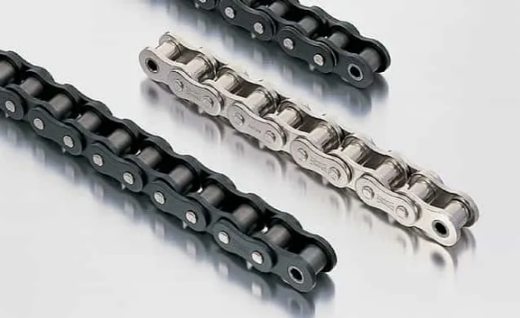
These chains are smaller in diameter than the height of the link plates of the chain. the link plates serve as guides when the chain engages the sprockets.
- The most used chain for drives is the single-strand standard series roller chain. The power rating capacities of these chains cover a wide range of drive load requirements.
- Multiple-strand roller chains are used to provide increased power capacity without the need for increasing the chain pitch or its linear speed.
- Silent Chain
The silent chain also called inverted tooth chain, consists of a series of toothed link plates assembled on joint components in a way that allows free flexing between each pitch.
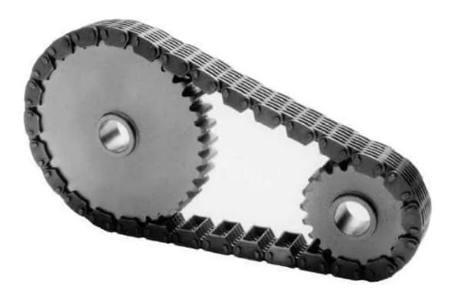
Silent chains from different manufacturers usually cannot be connected. Standard silent chains are used in a wide variety of industrial drives where a compact, high-speed, smooth, low-noise drive is required.
High-performance silent chains are available in a wide range of sizes with pitches and in widths and are used on very-high-speed drives where exceptional smoothness and quietness are required. These chains are commonly used in industrial equipment where ultimate smoothness is required.

- Engineering Steel Chain
Engineering steel chains were first developed in the 1880s and were designed for challenging conveying applications. Most engineering steel chains are used in conveyors, bucket elevators, and tension linkages.
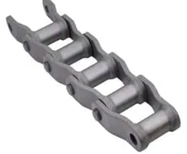
Only a few are used in drives. The main design considerations for these chains are tensile loads, several types of wear, lubrication, and the environment.
Wear the most important parameters while designing an engineering steel chain. Joint wear, roller and bushing wear, and sidebar and track wear all are of great concern for conveyor chains.
[11]
Belts
In this chapter, the advantages and disadvantages of belts are discussed as well as the type of belts.
Advantages and Disadvantages

Advantages | Disadvantages
They are simple and economical. | Limited Speed range.
They can transmit Power over a considerable distance. | They are not compact.
They can protect the machine from overloading by slipping the belt over a pulley. | Considerable power loss.
Belt drive can absorb shock and damp vibration. | Short service life compared to other modes of power transmission.
The operation is smooth and silent. | The velocity ratio may vary due to belt slip
They are durable and require extraordinarily little maintenance. | They inflict a heavy load on shafts and bearings.

Flat belt
It is the simplest form of belt drive. It is mostly used where a moderate amount of power transmission is required. They can transfer power up to 15m.
Some excellent features of flat belts are:
- A flat belt can deliver high power at high belt speeds
- Low noise operation
- High efficiency (up to 98%)
- Small bending loss due to small bending cross-section
- High flexibility
- No need for grooves
- Long service life as they handle dust and dirt well
- Can be reinforced for greater strength
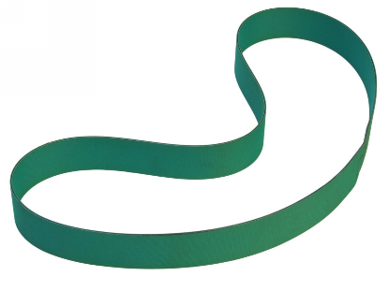
V belt
V belts are the most common belt type in use today. A V belt has a trapezoidal (V-shaped) cross-section that fits into a similar groove on pulleys and sheaves.
As V belt drives have a larger contact area between the pulley and the belt section (bottom + 2 sides), they can transmit greater power for the exact dimensions.
Types of v belts
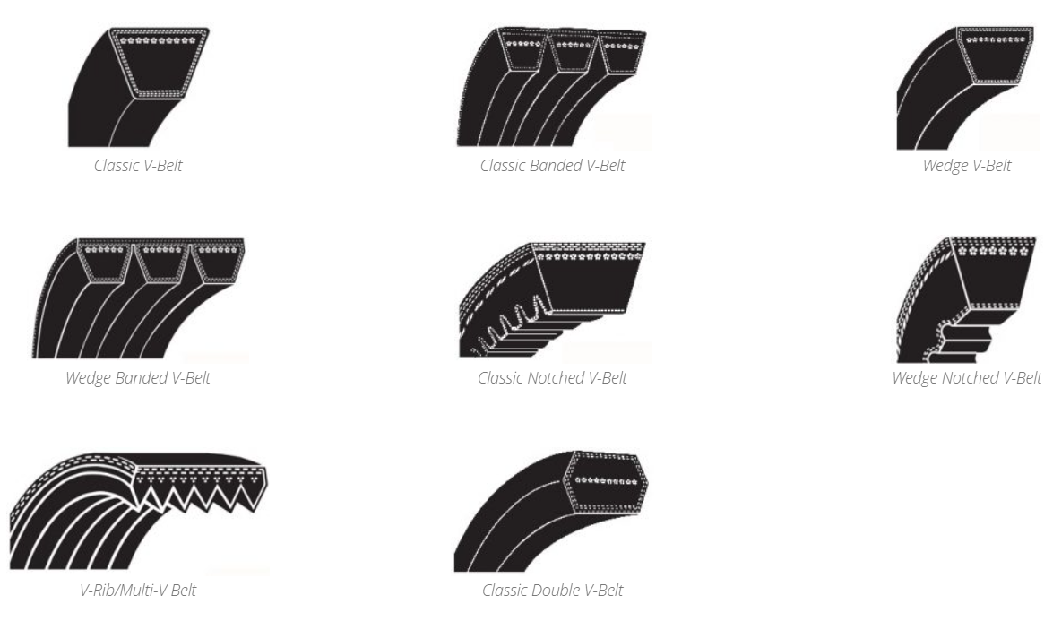
[12]
Some key features of V belts are as follows:
- Available in a wide range of sizes, strengths, and materials
- High power transmission capacity at high belt speeds
- Low cost
- Easy installation
- Compact arrangement
- Can combine with multi-grooved pulleys for many operational advantages
- Lower efficiency than flat belts due to the wedging effect with pulleys.
Timing belt
The timing belt (or toothed belt) is a positive transfer belt. They can transmit power at a constant speed with no slippage. They are used in synchronous power transmission. [13]
- High torque carrying capacity.
- No slipping between the belt and pulleys.
- Power transmission at a constant speed.
- No creep.
- Low noise and vibration.
- Lubrication not required.
- They are not economical.
- Need a sophisticated design of the belt as well as the pulley.
- Clutch action not possible.
- No protection against overloading.
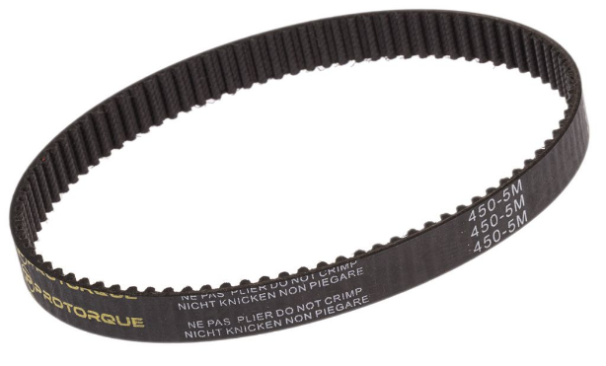

B.1.4 Swing Hinge Mechanism
Methods
- Gears and pneumatic cylinder
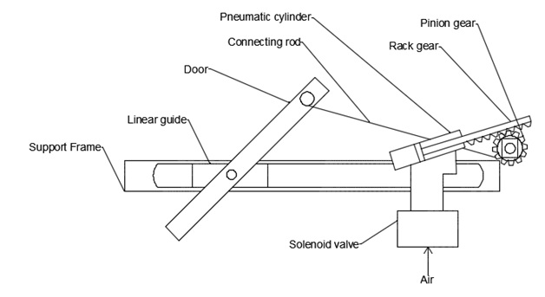
Pressurised air will enter through the solenoid valve, moving the pneumatic cylinder. This, in turn, will move the threaded rod, rotating the gear. The gear and the door are connected through a connecting rod. This rod in turn moves the door, caused by the gear rotating and pulling or pushing the rod.
However, this process requires several parts and may not be appropriate for the hatches because of the required space to perform this method. Rack-and-pinion drives have efficiencies as high as 97%.
A simpler version of this method could be used. The rack gear and the pinion gear could rotate the slats using another, smaller, cheaper mechanical battery. A slot could also be created within the slats so that it can rotate on an axis.
Terms
A rack and pinion are used when converting rotational movement to linear motion (or vice versa). A bar-shaped gear with an infinite (flat surface) radius of a cylindrical gear is called a rack, and a meshed spur gear is called a pinion.
A solenoid valve is an electromechanically operated valve. Solenoid valves differ in the characteristics of the electric current they use, the strength of the magnetic field they generate, the mechanism they use to regulate the fluid, and the type and characteristics of the fluid they control.
A pneumatic cylinder is a device that exerts a force and a reciprocating motion. Its three main components are:
Cylinder — a hollow piece that encloses the other two components.
Piston — the component directly subjected to the gas pressure by forming a seal.
Rod — the part attached to the piston that exerts the force over an external resistance.
Gears and cam

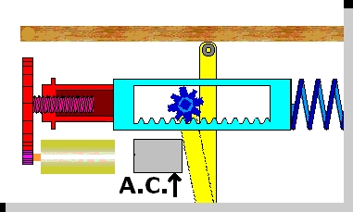
The motor will spin when charged and cause the purple gear to rotate. In turn, this will rotate the red gear. When this gear rotates, it causes the purple threaded rod to push the red box. This mechanism is one of a cam. The cam will push the light blue box. The blue gear inside this box will rotate when the box is pushed. The gear then performs as a lever, moving the door. The spring ensures that this mechanism works in the opposite direction.
The best spring for this mechanism would be … springs, as it would be able provide enough momentum and energy to push back the gear rack.
This method does not require a lot of space. However, it uses a lot of parts. This could reduce the efficiency of the system. Importantly, a camshaft has been proven to be very efficient.
Terms
- A camshaft is a rod that rotates and slides against a piece of machinery to turn rotational motion into linear motion. This change of motion is accomplished by the camshaft moving further and closer to the axis of rotation as the camshaft is pushed by the machinery.
- Rod: A simpler version using the mechanisms present in the first two methods could be using a cam to rotate a long rack and have gears rotate the slats at whatever necessary degree. These can be combined into one singular rod.
Calculations
- Torque
- Energy

  - $E=\frac{1}{2}k⋅x^{2}$ for springs
- Friction
  - gear friction is essential as it impacts
    - gear scuffing failures due to excessive heat generation and gear contact fatigue lives and associated failure modes of disintegration and micro-pitting
    - load-dependent (mechanical) gear mesh power losses
    - a class of gear vibrations along the direction of the relative sliding and the damping effects along the line of action
- Gear ratio
- Force
  - $F_{t}=P⋅A_{u}$
  - Where F_{t} – theoretical force. It is theoretical as it does not consider friction and spring forces.
  - P – the pressure inside the cylinder
  - A_{u} – useful area in contact with the gas

- Wear
- Efficiency
The consumed motor force, F_{c}, perpendicular in A on the vector r_{A}, is divided in two components: a) F_{m} which represents the useful force, or the motor force reduced to the follower, b) F_{ψ} which is the sliding force between the two profiles of cam and follower:
- $F_{m}=F_{c}\sin{t}$
- $v_{2}=v_{1}⋅\sin{t}$
- $P_{u}=F_{m}⋅v_{2}=F_{C}⋅v_{1}⋅\sin^{2}{τ}$
- $P_{C}=F_{c}⋅v_{1}$
- $η_{i}=\frac{P_{u}}{P_{c}}=\frac{F_{c}⋅v_{1}⋅\sin^{2}{τ}}{F_{C}⋅4}=\cos^{2}{δ}$

- $F_{Ψ}=F_{c}⋅\cos{τ}$
- $v_{12}=v⋅\cos{τ}$
- $ρ_{ψ}=F_{ψ}⋅v_{12}=F_{c}⋅v_{i}⋅\cos^{2}{τ}$
- $\sqrt{1^{ⅈ}}=\frac{P_{ψ}}{P_{C}}=\frac{F_{c}⋅v_{1}⋅\cos^{2}{τ}}{F_{2}⋅v_{1}}=\cos^{2}{τ}=\sin^{2}{δ}$

- The total efficiency of a pneumatic system is less than 20%.
- Springs are not very efficient

B.1.5 Mounting Methods
Ways to mount it to a dry wall
Note that the focus of the research of this group was what types of mechanisms there are. Therefore, this research contains only essential information. The next group should do in-depth research about this topic since several types of walls and windows exist as well as what is possible due to legislation.
Monkey Hooks
- Curved hooks
- Do not require anchors
- Leave tiny and easy-to-fill holes.
- They can hold up to 50 pounds
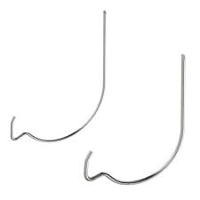
Tap-In Expanding Anchors
- Hanging items weighing less than 10 pounds.
- Quick and easy to use.
Drywall Anchors
- Large plastic screws (many sizes).
- Easily inserted into drywall using a screwdriver.
- Either expand or lock into the drywall
- Support up to 50 pounds. 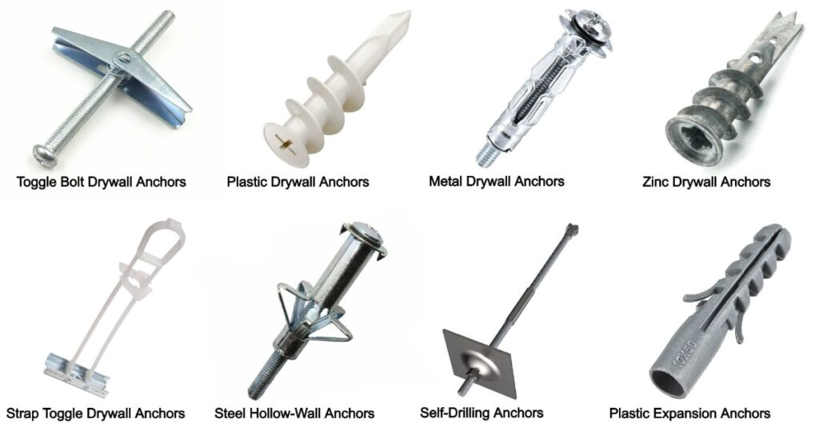
Toggle Anchors
- Complicated to install
- Work well for heavier items.
- When tightened, the toggle anchors securely to the inside of the drywall.
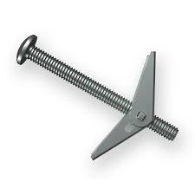

B.2 Electrical Research

B.2.1 Sensors and Actuators
Sensors and actuators (The prices are overly exaggerated)
- 2 Heat sensors
- 1 Light sensor
- 1 Servo/Stepper
- 1 Battery bank
- 1 BMS
- 1 Microcontroller
- X Solar panels
- 1 Motor Driver (only if stepper motor is used)
- 1 Schottky diode
- 1 Fuse
Product | Quantity | Price | Total Price
Heat sensors | 2 | 8€ | 16€
Light sensor | 1 | 8€ | 8€
Servo/Stepper | 1 | 10-20€ | 15€
Battery bank | 1 | 30-50€ | 40€
BMS | 1 | 6-10€ | 8€
Microcontroller | 1 | 6€ | 6€
Solar panels | X | ?? | ??
Motor Driver | 1 | 6-15€ | 10€
Schottky diode | 1 | 0.50€ | 0.50€
Fuse | 1 | 0.50€ | 0.50€
X | X | X | 104€

Heat Sensors
MCP9808
- Range of -40 to 125 degrees Celsius.
- Accuracy to within 0.25 degrees Celsius.
- Operates on a voltage range of 2.7 to 5.5 volts, making it suitable for almost any microcontroller or microcomputer.
LM35
- Operates on a voltage range of 4 to 30 volts, making it unsuitable for use with 3.3-volt microcontrollers.
- Temperature range of -55 to 150 degrees Celsius.
- Accuracy to within 0.5 degrees Celsius.
- This device requires a negative bias voltage to read negative temperature.
TMP36
- Operates on a voltage range of 2.7 to 5.5 volts. This makes the TMP36 and ideal companion for most microcontrollers.
- Temperature range of -40 to 125 degrees Celsius, usable to 150 Celsius.
- Accuracy to within 2 degrees Celsius
- Has a 500-mV offset to allow for the measurement of negative temperature.
DHT22
- Was rejected because it is mainly used as a humidity sensor but has a temperature sensor that has a low accuracy
Lm35
- Operates on a range of 4 to 30 volts which means that the sensor is overly sensitive to voltage change. If the motor pulls a bit more voltage the temperature reading would be inconsistent
TMP36 and MCP9808
- Both 2 operates on a range of 2.7 to 5.5 volts that means that it can be supplied from the Arduino directly which makes the reading more accurate and less dependent on voltage. The accuracy of the TMP36 is 2 degrees C and the accuracy of the MCP9808 is 0.25 degrees C which is more expensive (10 euros from amazon 6 from other websites) but more reliable.

B.2.2 Solar Panels and Rechargeable Batteries
Solar Panel Types
Monocrystalline solar panels
Monocrystalline solar panels are the most used residential solar panel to date because of their power capacity and efficiency. Monocrystalline solar panels can reach efficiencies higher than 20%, making them the most efficient panel on the market. While 20% may not sound impressive, there is a reason behind it. The sun’s rays span a broad spectrum of wavelengths and depending on the characteristics of the semiconductors and design of a solar cell, some of that light can be reflected, passed through, and eventually absorbed and converted into electricity.
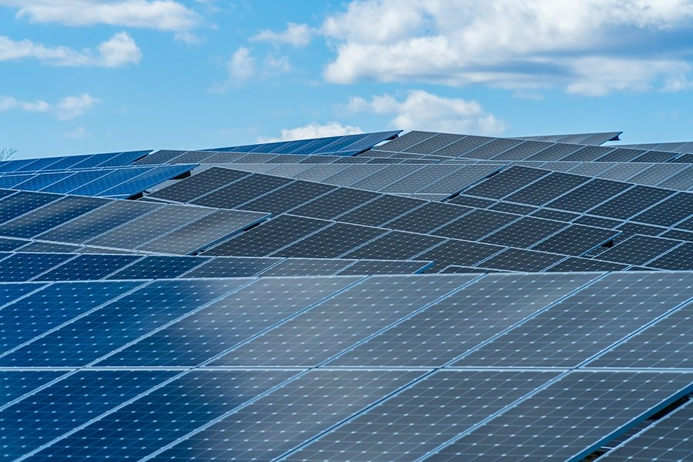
One of the easiest ways to identify a monocrystalline solar panel is by its colour. The cells on a module typically appear black to the eye because of how light interacts with its high-quality silicon, making it function well in low light conditions. For this reason, they are more efficient as black surfaces absorb light more easily. They also tend to generate more power than other types of panels, not only because of their efficiency but because they come in higher wattage modules with more than 300 watts of power capacity. Most individuals enjoy the sleeker aesthetics of monocrystalline solar panels on their roof for this factor, as they blend in well with black roof shingles. While efficiency and appearance make it a better selling point, they tend to be more expensive in part due to their manufacturing process.
Polycrystalline solar panels
Polycrystalline solar panels have been around for quite some time and are common among many individuals looking to go solar on a budget. These types of solar panels usually have efficiencies between 15% to 17%. While they are not as efficient as their counterpart monocrystalline, their advantage is their price point. The reason being is that the cells are produced from many silicon fragments, hence “poly,” rather than a single pure silicon crystal that is used in monocrystalline cells. This allows for a simpler cell manufacturing process, therefore making it more cost efficient to the end user.
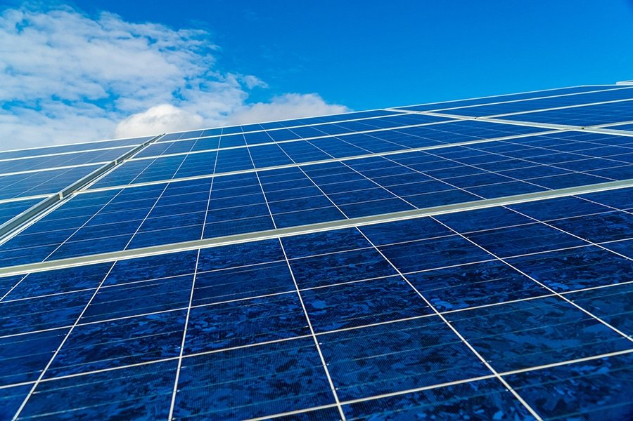
A polycrystalline panel’s blue hues come from the anti-reflective coating that helps improve the absorbed capacity and efficiency of the solar panel.
Thin film solar panels
Thin film solar panels tend to have lower efficiencies and power capacities than monocrystalline and polycrystalline panels. While efficiency can vary based on the certain material used in the solar cells, they usually lean more towards an efficiency of 11%. Lower efficiency ratings mean more thin film solar panels that would need to be installed to produce the same amount of electricity as a monocrystalline or polycrystalline solar system. For this reason, thin film solar panels might not be the best option for residential solar. On the other hand, they make the most sense in larger scale installations like utility-scale solar projects, as more panels can be installed to meet energy demands.
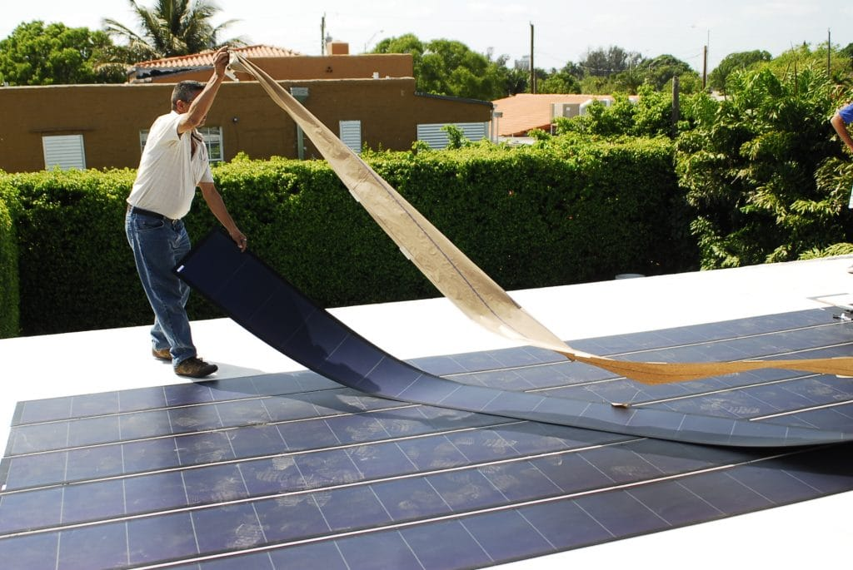
Thin film solar panels are made with solar cells that have light absorbing layers about 350 times smaller than the average silicon panel, making them very flexible. They come in both blue and black hues, depending on what they are made of. The most predominant type of thin film solar panel is made from cadmium telluride, but they can also be made from amorphous silicon, which is similar to the composition of mono and polycrystalline panels, and copper indium gallium selenide. As far as cost goes, what you pay for thin film panels will largely depend on what exactly they are made from, but overall, the cost of a thin film solar panel installation tends to be lower than installing a monocrystalline or polycrystalline system.

Comparison table of different solar panels
 | Monocrystalline solar panels | Polycrystalline solar panels | Thin film solar panels
Price per Watt | $1 – $1.50 | $0.70 – $1 | $0.60 – $0.70
Compatibility | Not flexible | Not flexible | More flexible
Efficiency | %20 | %15-17 | %11
Availability | - | - | -
Power Capacity | 300w | 240-300w (However, monocrystalline panels still beat polycrystalline in terms of power capacity per cell.) | Size dependent. (Conventional panels still produce more energy.)
Temperature coefficient (power loss per °C after 25 °C) | -0.3% /°C to -0.5% /°C | -0.3% /°C to -0.5% /°C | -0.2% / °C.
Temperature coefficient: A measure of the panel’s decrease in power output for every 1°C rise over 25°C (77°F).
Rechargeable Battery Types and Comparison Table
Rechargeable Battery Types
Lithium- ion Batteries
A lithium-ion (Li-ion) battery is an advanced battery technology that uses lithium ions as a key component of its electrochemistry. During a discharge cycle, lithium atoms in the anode are ionized and separated from their electrons. The lithium ions move from the anode and pass through the electrolyte until they reach the cathode, where they recombine with their electrons and electrically neutralize. The lithium ions are small enough to be able to move through a micro-permeable separator between the anode and cathode. In part because of lithium’s small size (third only to hydrogen and helium), Li-ion batteries are capable of having a remarkably high voltage and charge storage per unit mass and unit volume.
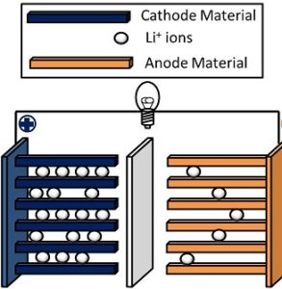
Li-ion batteries can use several varied materials as electrodes. The most common combination is that of lithium cobalt oxide (cathode) and graphite (anode), which is most found in portable electronic devices such as mobile phones and laptops. Other cathode materials include lithium manganese oxide (used in hybrid electric and electric automobiles) and lithium iron phosphate. Li-ion batteries typically use ether (a class of organic compounds) as an electrolyte.
Lithium polymer Batteries
A lithium-polymer (LiPo, LIP or Li-Poly) battery is a type of rechargeable battery that uses a soft polymer casing so that the lithium-ion battery inside it ‘rests’ in a soft external ‘pouch.’ It may also refer to a lithium-ion battery that uses a gelled polymer as an electrolyte. However, the term commonly refers to a type of lithium-ion battery in a pouch format. With this in mind, the more accurate name for this type of battery is lithium-ion polymer battery.
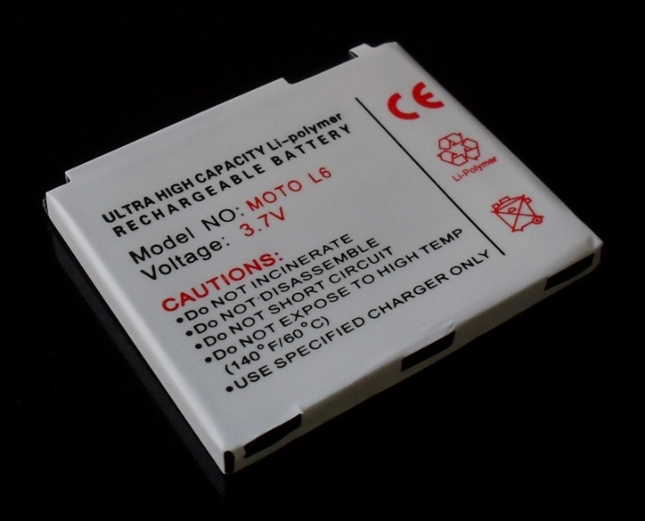
Nickel-cadmium Batteries
Nickel-cadmium batteries are usually shortened to simply NiCad batteries and they are a common option for kids’ toys, digital cameras, and flashlights due to the powerful, yet consistent voltage output. This means that when a flashlight is powered with a NiCad battery the light will remain constant until the battery dies, while an alkaline battery in the same flashlight will cause the light to dim when the battery power starts to run out. These rechargeable batteries charge quickly, but if they are not fully discharged before recharging the capacity of the battery can diminish over time. NiCad batteries are often used in high-drain electronic devices like flashlights, digital cameras, and some kids’ toys.
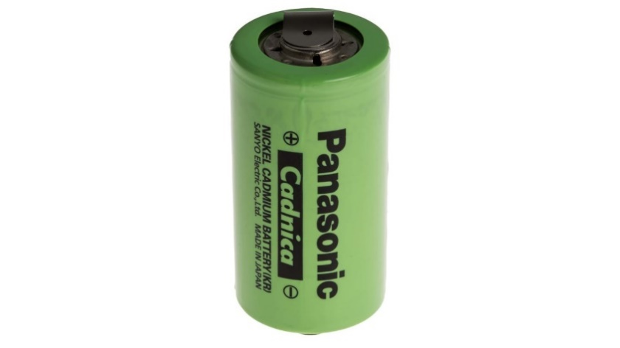
Nickel metal hydride Batteries
Nickel metal hydride batteries or NiMH batteries have a high energy density that makes them great for cameras, flashlights, and other high-power devices. In fact, they even outperform NiCad batteries, though they have a reduced cycle life that limits the number of times the battery can be recharged. Overcharging these batteries can result in a diminished energy capacity, so make sure they are not left on the charger for too long. Use NiMH rechargeable batteries for various household appliances and devices, like scales, flashlights, and digital cameras.
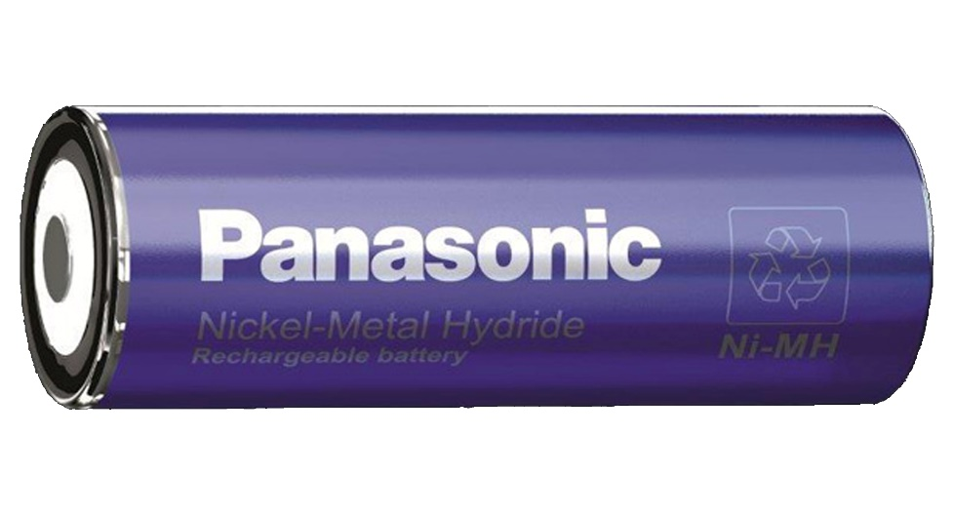
Comparison table of different battery types
 | Lithium- ion Batteries | Lithium polymer Batteries | Nickel-cadmium Batteries | Nickel metal hydride Batteries
Cost (Wh/$) | 0.47 | 0.75 | 1.50 | 0.99
Toxicity | Low | Low | Very High | Low
Specific power (W/kg) | 7-9000 | 5-700 | 150–200 | 250–1000
Energy density by mass (Wh/kg) | 150-200 | 107-175 | 30 | 100
Discharge rate at room temperature. | %2- %10 per month | %0.5 per day | %1.5 - %2 per day | %2 per day
Shelf life (years) | 5 | 5 | 5 | 5

References:
https://ecoenergyconsultants.co.uk/electricity-from-the-sun/types-of-solar-panel/
https://www.solarreviews.com/blog/pros-and-cons-of-monocrystalline-vs-polycrystalline-solar-panels
https://aurorasolar.com/blog/solar-panel-types-guide/
https://en.wikipedia.org/wiki/List_of_battery_types
https://en.wikipedia.org/wiki/Comparison_of_commercial_battery_types
https://www.epectec.com/batteries/cell-comparison.html

B.2.3 DC Motor Types
DC Motor Types and Comparison Table
- DC Motor Types
Brushed DC Motors
DC motors use wound coils of wire to create a magnetic field. In a brushed motor, these coils are free to rotate to drive a shaft – they are the part of the motor that is called the “rotor.” Usually, the coils are wound around an iron core, though there are also brushed motors that are “coreless,” where the winding is self-supported.
The fixed part of the motor is called the “stator.” Permanent magnets are used to provide a stationary magnetic field. Normally these magnets are positioned on the inner surface of the stator, outside of the rotor.
To create torque, which makes the rotor spin, the magnetic field of the rotor needs to continuously rotate, so that it is field attracts and repels the fixed field of the stator. To make the field rotate, a sliding electrical switch is used. The switch consists of the commutator, which is typically a segmented contact mounted to the rotor, and fixed brushes which are mounted to the stator.
As the rotor turns, different sets of rotor windings are constantly switched on and off by the commutator. This causes the coils of the rotor to be constantly attracted and repelled from the stator’s fixed magnets, which makes the rotor spin.
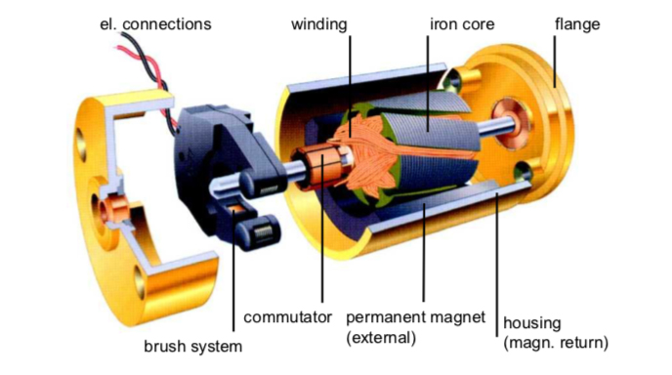
Since there is some mechanical friction between the brushes and commutator – and since it is an electrical contact, it cannot be lubricated – there is mechanical wear of the brushes and commutator over the lifetime of the motor. This wear will eventually reach a point where the motor no longer functions. Many brushed motors – especially large ones – have replaceable brushes, typically made of carbon, which are designed to maintain good contact as the wear. These motors require periodic maintenance. Even with replaceable brushes, eventually the commutator also wears to the point that the motor must be replaced.
In cases where rotation is only needed in one direction, and speed or torque does not need to be controlled, no drive electronics at all are required for a brushed motor. In applications like this, the DC voltage is simply switched on and off to make the motor run or stop. This is typical in low-cost applications like motorized toys. If reversal is needed, it can be accomplished by using a double pole switch.
To facilitate control of speed, torque, and direction, an “H-bridge” composed of electronic switches - transistors, IGBTs, or MOSFETs - is used to allow the motor to be driven in either direction. This allows the voltage to be applied to the motor in either polarity, which makes the motor rotate in opposite directions. The motor speed or torque can be controlled by pulse width modulating one of the switches.
Brushless DC Motors
Brushless DC motors operate on the same principle of magnetic attraction and repulsion as brush motors, but they are constructed differently. Instead of a mechanical commutator and brushes, the magnetic field of the stator is rotated by using electronic commutation. This requires the use of active control electronics.
In a brushless motor, the rotor has permanent magnets affixed to it, and the stator has windings. Brushless motors can be constructed with the rotor on the inside, as shown above, or with the rotor on the outside of the windings (sometimes called an “outrunner” motor).
The number of windings used in a brushless motor is called the number of phases. Though brushless motors can be constructed with different numbers of phases, three phase brushless motors are the most common. An exception is small cooling fans that may use only one or two phases.
The three windings of a brushless motor are connected in either a “star” or a “delta” configuration. In either case, there are three wires connecting to the motor, and the drive technique and waveform is identical.
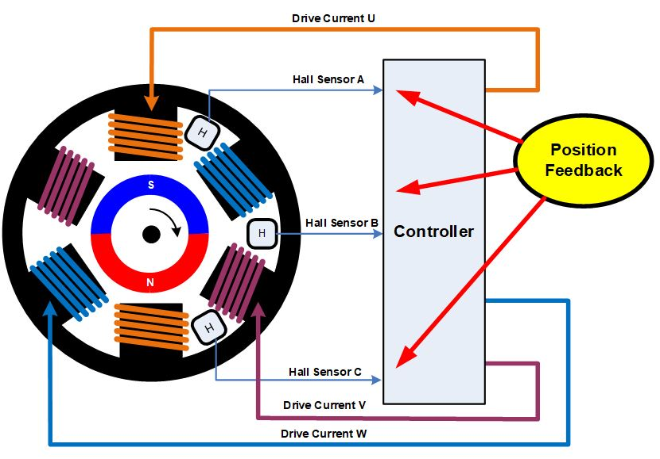
With three phases, motors can be constructed with different magnetic configurations, called poles. The simplest 3-phase motors have two poles: the rotor has only one pair of magnetic poles, one North and one South. Motors can also be built with more poles, which requires more magnetic sections in the rotor, and more windings in the stator. Higher pole counts can provide higher performance, though remarkably high speeds are better accomplished with lower pole counts.
To drive a three-phase brushless motor, each of the three phases needs to be able to be driven to either the input supply voltage or ground. To accomplish this, three “half bridge” drive circuits are used, each consisting of two switches. The switches can be bipolar transistors, IGBTs, or MOSFETs, depending on the voltage and current required.
There are several drive techniques that can be employed for three phase brushless motors. The simplest is called trapezoidal, block, or 120-degree commutation. Trapezoidal commutation is somewhat similar to the commutation method used in a DC brush motor. In this scheme, at any given time, one of the three phases is connected to ground, one is left open, and the other is driven to the supply voltage. If speed or torque control is needed, usually the phase connected to the supply is pulse width modulated. Since the phases are switched abruptly at each commutation point, while the rotor rotation is constant, there is some variation of torque (called torque ripple) as the motor rotates.
For higher performance, other commutation methods can be used. Sine, or 180-degree, commutation drives current thorough all three motor phases all the time. The drive electronics generates a sinusoidal current though each phase, each shifted 120 degrees from the other. This drive technique minimizes torque ripple, as well as acoustic noise and vibration, and is often used for high performance or high efficiency drives.
To properly rotate the field, the control electronics need to know the physical position of the magnets on the rotor relative to the stator. Often, the position information is obtained using Hall sensors that are mounted to the stator. As the magnetic rotor turns, the Hall sensors pick up the magnetic field of the rotor. This information is used by the drive electronics to pass current through the stator windings in a sequence that causes the rotor to spin.
Using three Hall sensors, trapezoidal commutation can be implemented with simple combinational logic, so no sophisticated control electronics are needed. Other commutation methods, like sine commutation, require a bit more sophisticated control electronics, and usually employ a microcontroller.
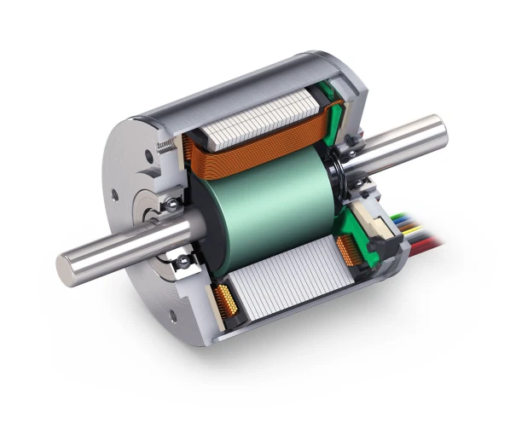
In addition to providing position feedback using Hall sensors, there are various methods that can be used to determine the rotor position without sensors. The simplest is to monitor the back EMF on an undriven phase to sense the magnetic field relative to the stator. A more sophisticated control algorithm, called Field Oriented Control or FOC, calculates the position based on rotor currents and other parameters. FOC typically requires a powerful processor, as there are many calculations that must be performed very quickly. This, of course, is costlier than a simple trapezoidal control method.

- Servo Motor
A servo motor is a rotational or translational motor to which power is supplied by a servo amplifier and serves to apply torque or force to a mechanical system, such as an actuator or brake. Servo motors allow for precise control in terms of angular position, acceleration, and velocity. This type of motor is associated with a closed-loop control system. A closed-loop control system considers the current output and alters it to the desired condition. The control action in these systems is based on the output of the motor. It uses a positive feedback system to control the motion and final position of the shaft.
There are two types of current flow in these motors – AC and DC. AC servo motors can handle higher current surges and are thus more commonly found in heavy industrial machinery.
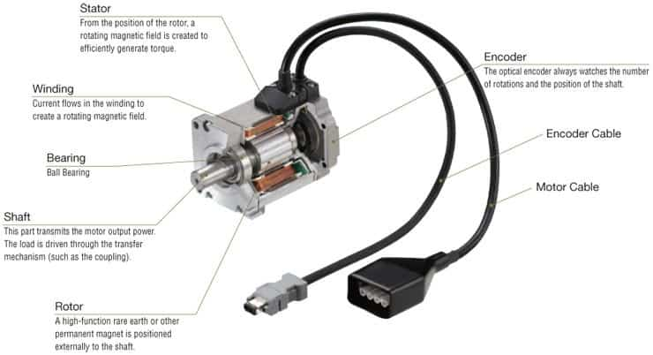
The servo motor consists of two winding stator and rotor windings. The stator winding is wound on the stationary part of the motor, and this winding is also called field winding of the motor. The rotor winding is wound on the rotating part of the motor and this winding is also called the armature winding of the motor. The motor consists of two bearings on the front and backside for the free movement of the shaft. The encoder has the approximate sensor for determining the rotational speed and revolution per minute of the motor.
- Stepper Motor
A stepper motor is a type of brushless DC electric motor that moves in precise angles, called steps, by converting a series of electrical pulses into rotational motion. They will not produce continuous motion from a continuous input voltage, and it will stay at a particular position if the power is “on.” Step motors are controlled with the use of discrete electrical pulse signals. Each pulse will rotate the step motor shaft by a fixed angle called a “step.”

If the pulses are carried out in a specified sequence, the motor will spin continuously; the speed can be controlled by the rate at which the pulses are sent. These natural step angles allow a step motor to be accurately positioned without the accumulation of error. The step motor produces output torque from the interaction between the magnetic field in the rotor and in the stator. The magnetic field strength is proportional to the amount of current applied to the windings as well as the amount of turns in the windings.
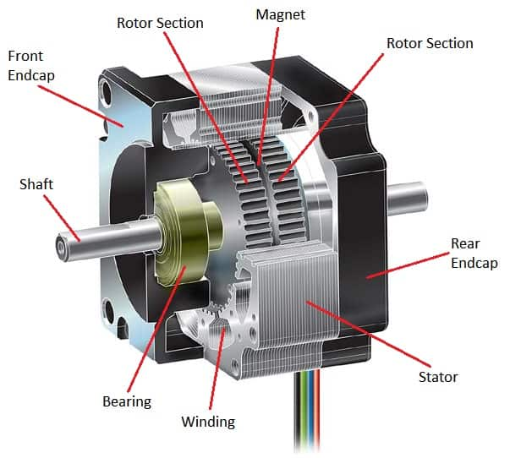
A stepper motor consists of a permanent magnet sandwiched between the two rotor halves (causing axial polarity), which make up the spinning part of the motor, placed into a stator housing where the stator coils of wire make up the different motor phases. With a 2-phase stepper motor, each phase has four coils. The phase is magnetized where the A and A- phases (or B and B-) are magnetized at the same time so that both A phases are magnetized as one pole, and both A- phases are magnetized as the opposite pole because the winding direction of the A-phase is opposite the winding direction of the A- phase.
The rotor is connected to the motor shaft, which gives the output rotation and torque of the motor when voltage and current pulses are applied to the motor windings. The bearings on either side of the rotor allow for smooth rotation with little friction and wearing. The bearings are placed into their designated spaces in the front and rear end caps, which allow for the concentricity of the rotor inside the stator.
Source:
https://instrumentationtools.com/difference-stepper-motor-servo-motor/
https://islproducts.com/design-note/stepper-motor-fundamentals/
https://islproducts.com/design-note/stepper-motors-vs-servo-motors/
https://islproducts.com/design-note/servo-motor-fundamentals/
https://www.monolithicpower.com/en/brushless-vs-brushed-dc-motors

B.2.3 Battery Management Systems
Battery Management System (BMS) is a system that monitors and manages a rechargeable battery (or group of batteries), such as those found in electric vehicles, UPS systems, and solar energy storage systems.
The BMS is responsible for protecting the battery from operating outside its safe limits, maximizing its lifespan, and providing accurate information about the battery's state of charge, state of health, and current capacity. In short, its primary functions can be narrowed down to ensuring the battery remains safe and reliable.
A BMS typically consists of a control unit, sensors, and connection wires. The control unit may be a separate device or integrated into the battery pack. The sensors monitor various parameters of the battery, such as voltage, current, temperature, and state of charge. The connection wires carry power and data between the battery and the BMS.
The control unit uses the information from the sensors to determine when to charge or discharge the battery, how much power to allow in or out, and whether the battery is operating within its safe limits. If the battery is operating outside its safe limits, the BMS will take action to protect the battery, such as disconnecting it from the load or shutting off power altogether.
The BMS may also provide information about the battery to a user or system, such as the current state of charge, state of health, and remaining capacity. This information can be used to optimize the performance of the system in which the battery is used.
A BMS typically includes safety features to protect the battery, such as overcharge and over discharge protection, short circuit protection, and thermal runaway protection. These safety features help to prevent damage to the battery and ensure that it operates safely.
The BMS may also include features to maximize the lifespan of the battery, such as balancing. Balancing equalizes the voltage of the cells in a battery pack, which helps to prevent capacity loss and extends the lifespan of the battery.
Battery management systems are used in a variety of applications, including electric vehicles, UPS systems, and solar energy storage systems. BMSs are an important part of these systems, as they help to protect the battery from damage, extend its lifespan, and provide accurate information about the battery's state. Mainly two types of BMS’s are in use and taken into consideration for this project.
- The first is a centralized BMS, which uses one control unit to manage all of the battery cells in the system.
- The second type of BMS is a decentralized (modular) BMS, which uses multiple control units to manage the battery cells in the system.
Centralized BMS
Centralized BMS is one central pack controller that monitors, balances, and controls all the cells. The entire unit is housed in a single assembly, from which, the wire harness (N + 1 wires for N cells in series and temperature sense wires ) goes to the cells of the battery. These wires are used for cell voltage, temperature measurements and balancing.
The board is commonly powered from the battery output and does not require an external power supply. It consists of multiple Analog to Digital Converters (ADC) channels as part of the cell monitoring circuitry. The voltage on each cell is referenced to the BMS ground and this voltage grows with the number of cells and provides high voltage at the ADC channels that are measuring the topmost cells in the stack.
The cell monitoring circuitry is also coupled with an intelligence circuitry. The intelligence circuitry is responsible for internal communication with the cell monitoring circuitry for data acquisition, computing the battery’s State of Charge (SoC) and State of Health (SoH), controlling the Power Distribution Unit (PDU) and for external communication.
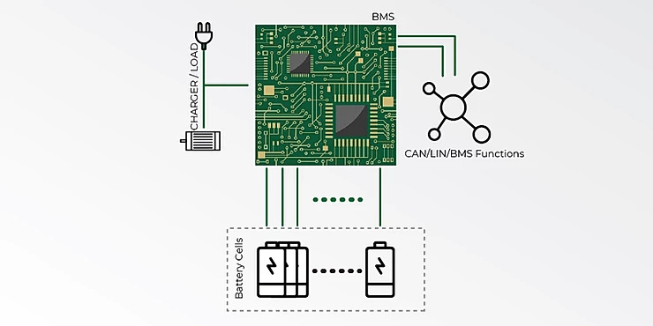

Decentralized BMS
A decentralized BMS, fundamentally, does not have the entire cell monitoring and intelligence circuitry on a single assembly. This architecture can be implemented through various topologies as explained below:
Modular: The battery management system is divided into multiple, identical modules, each with its bundle of wires going to one of the batteries in the pack. Typically, one of the modules is designated as a master, as it is the one that manages the entire pack and communicates with the rest of the system, while the other modules act as simple remote measuring devices. Readings from the other modules to the master module are transferred via a communication link.
Master-Slave: This architecture comprises of the Master and Slave BMS units. The slave unit monitors, balances, and controls a group of battery cells within the battery module. It communicates with the master unit through a communication interface. The Master unit is responsible for state estimation, control of Power Distribution Unit (PDU) and external communication. A master-slave BMS is similar to a modular system, in the sense that it uses multiple identical modules (the slaves), each measuring the voltage of a few cells.
However, the master is different from the modules and does not measure voltages. It only handles computation and communications.
Distributed: A distributed BMS is significantly different from the other topologies. While the electronics are grouped and housed separately from the cells in other topologies, a distributed BMS has the electronics contained on cell boards that are placed directly on the cells being measured.
Instead of many tap wires between cells and electronics, a distributed BMS uses just a few communication wires between the cell boards and a BMS controller, which handles computation and communications. 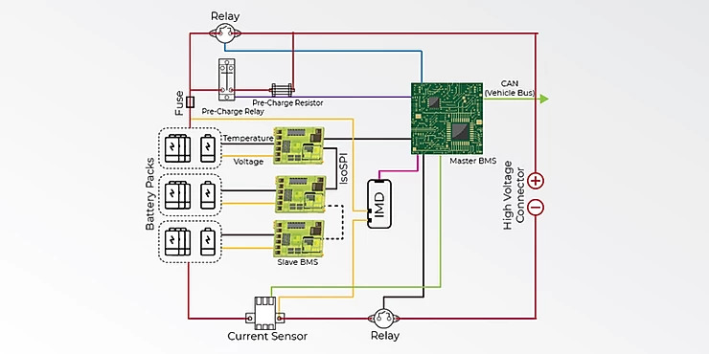

Advantages and Drawbacks of each solution
Solution | Pros | Cons
Centralised | - Less expensive than the modular solution | - The temperature of 8 cell groups cannot be acquired.  - Lots of wires.  - 3 different boards to design.  - The consumption of the acquisition/balancing board is not easy to predict.  - In James' configuration, the acquisition/balancing board cannot work without the Rpi. Can be a safety issue in case of Rpi crash.  - Complicated Rpi monitoring/balancing programme in James's configuration.
Decentralised (Modular) | - Wires are reduced to the maximum.  - Works autonomously.  - Perfect galvanic isolation.  - Easier test, troubleshooting and maintenance.  - Easily scalable solution  - BMS own consumption is easy to manage | - More hardware.  - A little more programming effort on the microcontroller side.  - Costs more than the centralized solution.
Source;
https://solidstudio.io/blog/battery-management-system-bms
https://hackaday.io/project/8876-universal-battery-module/log/34116-bms-design-centralized-architecture-vs-modular-architecture
https://www.ionenergy.co/resources/blogs/hv-battery-management-systems/#:~:text=Centralized%20BMS%20is%20one%20central,the%20cells%20of%20the%20battery.

Appendix C: Material Selection
With the help of Edu pack, the group was able to set limits and requirements to design graphs where it indicates the best choice of materials as well as their properties.
- Requirements
  - Recyclable
  - Stiff
  - Resist the typical Netherlands weather (rain)
  - High yield strength
  - Environmentally friendly
  - Resists erosion from atmospheric acids
  - Insulating
Limits chosen:
- A limit was set to make the material a good insulator
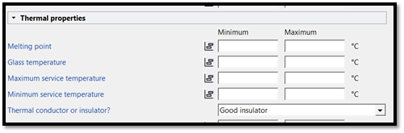
- A limit was set to make sure the material is durable against fresh water
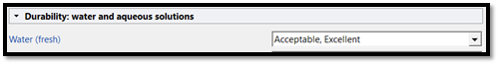
- A limit was set to make sure the material is durable against acids
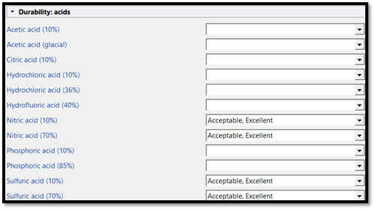
d. A limit was set to make sure the material comes from a renewable source, and it is recyclable
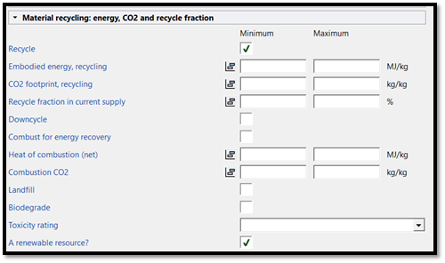
- Edupack Graphs
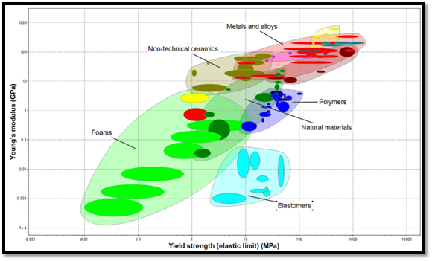
- The above graph compares Young’s modulus (stiffness) and Yield strength (elastic limit) of the family of materials available after the limits were placed. Both properties need to be maximized. The family of materials that have similar values for both includes Metals and alloys, technical ceramics, and Composites.
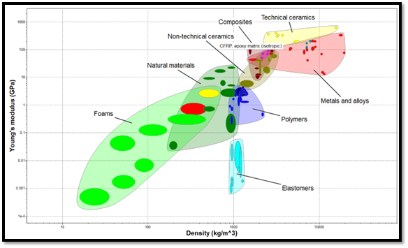
- The above graph compares Young´s modulus (stiffness) and the density of the family of the family of materials available after the limits were placed. Young´s modulus should be maximized while the density should be as lower as possible, so the final product is not heavy. The family of materials that complies with those measurements are Polymers and natural materials.
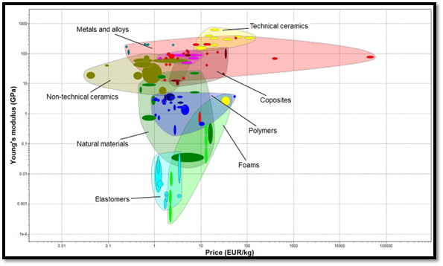
- The above graph compares Young´s modulus (stiffness) and the price of the family of the family of materials available after the limits were placed. Young´s modulus should be maximized while the price should be as low as possible. The family of materials that complies with those measurements are metals and alloys, technical ceramics, and composites.
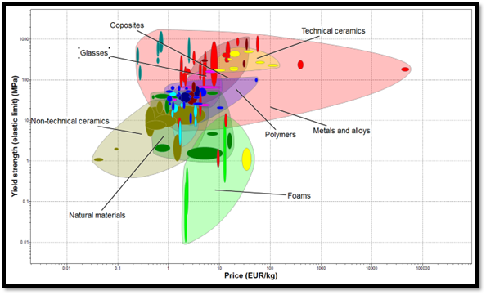
- The above graph compares the Yield strength (elastic limit) and the price of the family of materials available after the limits are placed. Yield strength should be maximized while the price should be as low as possible. The family of materials that complies with those measurements are metals and alloys, technical ceramics, composites, glasses, and polymers.

- Conclusion on what type of family of materials are the best
Despite having a high-density value and therefore being heavy, but also are bad insulators, metals/alloys, technical ceramics, and composites appear to be the best choice for the family of materials because of all their properties.

Edupack graph for Metals and Alloys
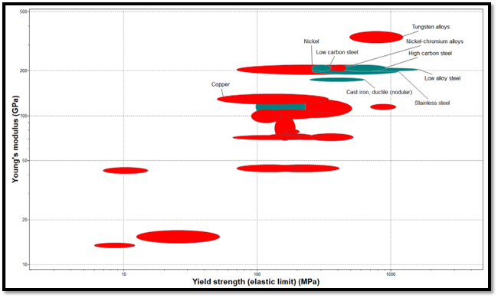
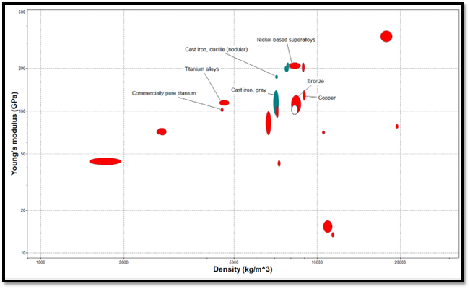
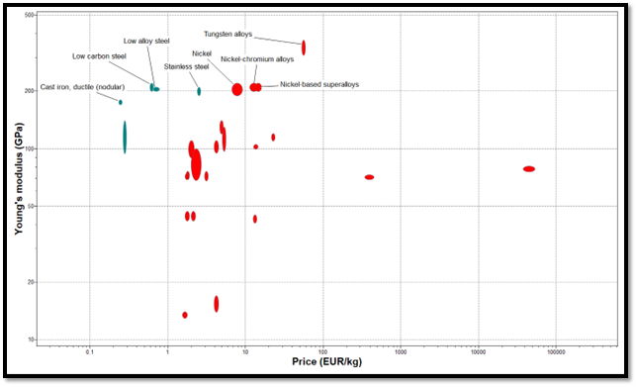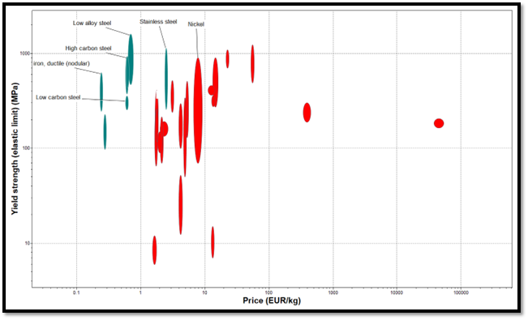

- Edupack graphs for technical ceramics
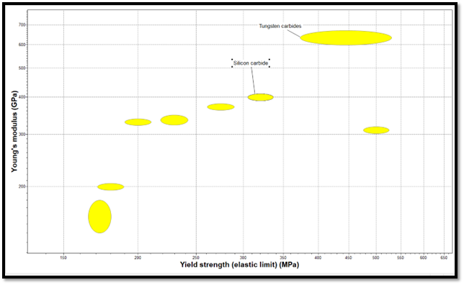
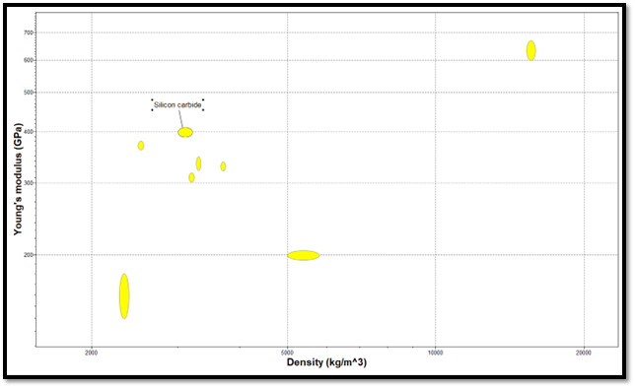
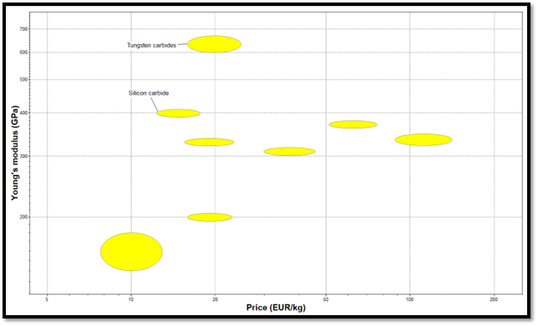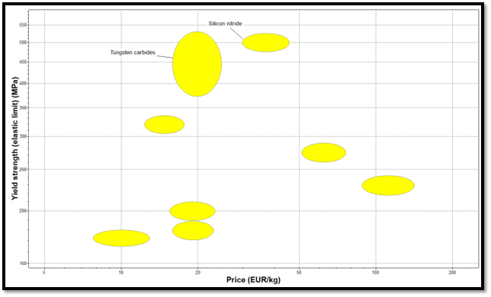
- Edupack graphs for composites

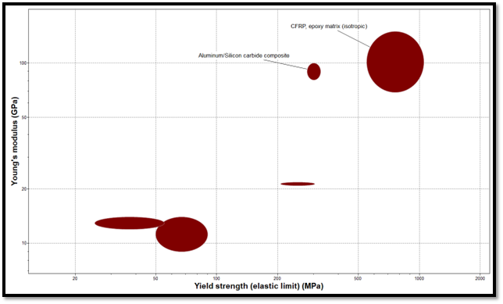
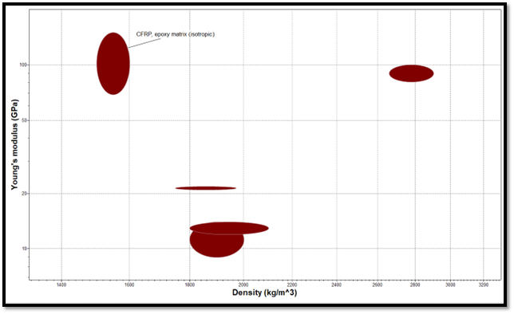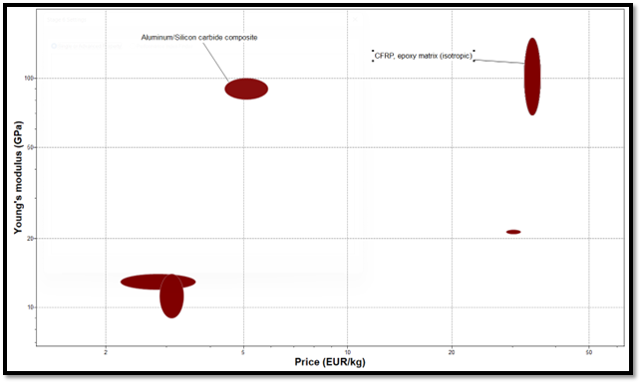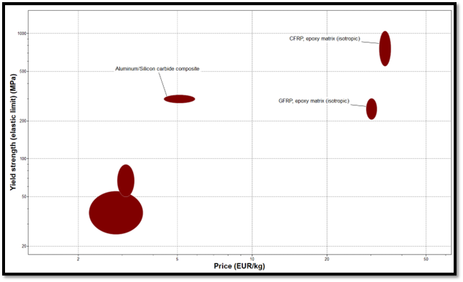

Appendix D: Production Report

Steps Completed
Goal 1: manufacturing of the mechanism
The parts of the mechanism were drawn on SolidWorks and 3D printed.
Goal 2: manufacturing of the frame
The wooden pillars were cut to the correct length, and each were cut to the same thickness. Holes were then created for the slats to be inserted. The pillars were connected with the help of square steel angles. Lastly, the assembled frame was spray painted.
Goal 3: manufacturing of the slats
The slats in were cut a 45-degree angle at length 150mm.
Goal 4: assembly
The brass bearings and the slats were inserted into the frame. The assembled mechanism was then attached to the slats.

Reflection
In the production stage, the mechanical engineering group experienced many issues with the connection rods that were designed. The first version of the rods fractured after 3D printing was finished. The rods were redesigned to have additional thickness. When connecting the second version of the rods to the slats, the group had noticed that the rods experienced bending when rotating in the slots. After a few moments, the rods fractured again.
To counteract this issue, the rods were redesigned to have better strength, so that they would be able to withstand torque, the cause of their fracture. This was done by thickening the base of the shaft were more torque occurred. Also, when 3D printing, there was additional thickness to the middle of the rods for further internal support.
Figure 14 – Broken 3d printed components
- The group also noticed that the gear that was 3D printed might eventually wear down. This may be a result of the material that was used for the process. The gear may need to be manufactured from a different material or suitable size purchased to prevent wear.
- When the connection rods were being assembled to create the rotating mechanism, it was noticed that they unwind when the slats were rotated. To prevent this, they may require a stronger connection point.
- After the slats were inserted into the frame and the rotation was tested, it was noticed that the slats had a difficulty rotating. The rods that connected the slats into the frame had a certain length so that the electrical components had room. However, this caused the rods to be too long, therefore, requiring more torque to turn. To counteract this problem, the rods would need to be shorter.

- When the frame was initially assembled, the group carried the final frame to the window. This window would be where the group will attach the final product. In doing so, the group ensured that the final frame was the correct size for the window.
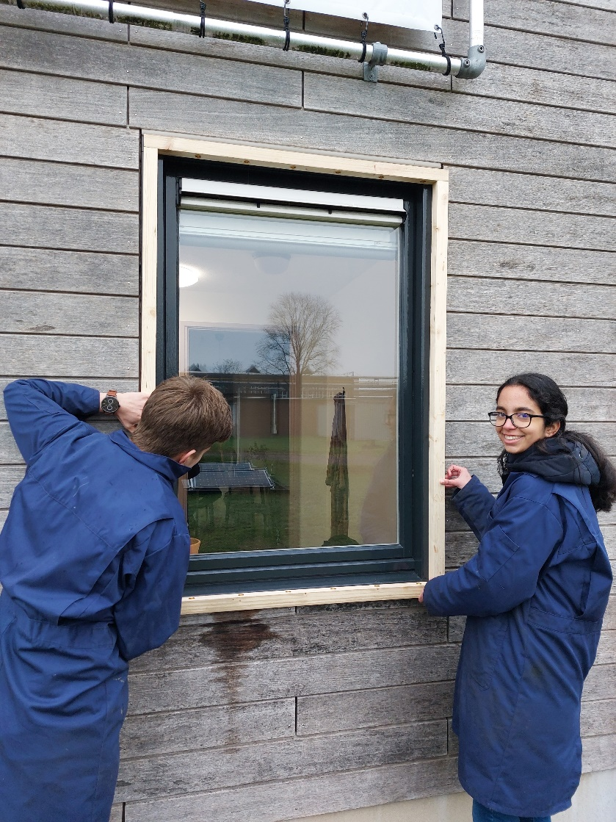
Figure 15 – Post assembly fit testing

Appendix E: Code
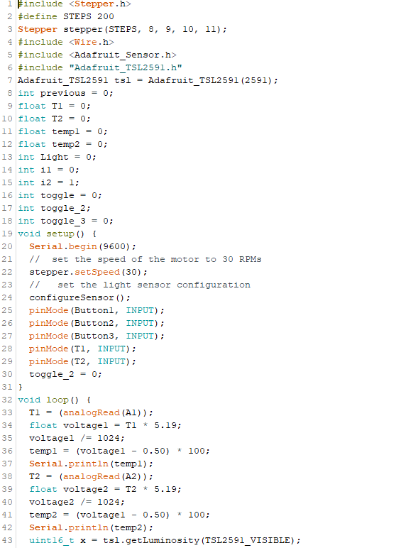
Figure
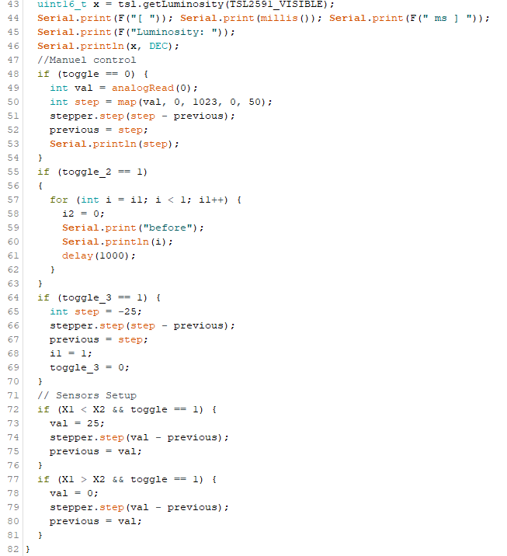
Code

