Adaptive Curricula, an answer to changing labour market requirements

Paper presented in track 7 at the

EAIR 41st Annual Forum in Leiden, The Netherlands
25 till 28 August 2019

Name of Author(s)
L.R. Buning, P.C. Schuur, F.J. de Vijlder

Contact Details
L.R. Buning
Hogeschool van Arnhem en Nijmegen (HAN University of Applied Sciences)
Ruitenberglaan 31
6826CC, ARNHEM
The Netherlands
E-mail: lejo.buning@han.nl

Key words

(1) Adaptive curriculum, (2) Institutional rationality, (3) Design rationale, (4) Co-creation and Professional Higher Education (5) adaptive learning triangle
Abstract
The automotive market shows rapid, sometimes disruptive innovations. Curriculum innovation in the professional higher education, such as the HAN Automotive Institute, could be an adequate response to changing labour market requirements.

Most research done on the cooperation between professional practice and professional higher education, carries an educational perspective. Enriching the curriculum design with state-of-the-art themes, and using insight in rationalities of professionals, opens a new perspective to align education and practice.

This paper elaborates on this alignment by addressing the design of an adaptive curriculum in the sixth out of eight semesters of the Automotive Institute bachelor curriculum, complying labour market requirements.

Introduction
Small enterprises and start-ups are the driving force for sometimes disruptive innovations not only in the national, but in the European automotive market as well. The professional higher education institutes, or universities of applied sciences (EURASHE, 2012, 2015), enables the professional practice to bring these innovations to the market. The decreasing time to market of innovations (Marx & Ramioul, 2004) shows dynamics comparable to Moore’s Law (Moore, 1998). This puts pressure upon the leading themes in professional higher education curricula to comply with the disruptive innovations (Schwab, 2015, 2016). Hence, research is required to understand and to align the dynamics of the cooperation between market and (professional) higher education.

Important work has been done to understand the cooperation market-(professional) higher education, through studies on hybrid learning configurations (Cremers, 2016; Cremers, Wals, Wesselink, & Mulder, 2016 Mulder, 2016; Wierenga & Cremers, 2017). In 2002, research groups entered the universities of applied sciences (van Gageldonk, 2017), to enable applied research in professional higher education institutes and to professionalise lecturers by involving them into their research. However, to be able to adapt to changing labour market requirements, caused by rapidly developing innovations in society, professional higher education must find an answer in adapting their curricula. In this paper the labour market requirements are interpreted as complying with 21ST century skills (Binkley et al., 2014) and state-of -the-art knowledge.

In line with earlier research (Camilleri, Delplace, Frankowicz, Hudak, & Tannhäuser, 2014), researchers of HAN Automotive Research, find it hard to mobilize their educational colleagues of the Institute Automotive, to participate in applied research on state-of-the-art themes. Conducted research emphasises the support of educational staff in adapting curricula of universities of applied sciences. Moreover, research is conducted on elaborating the social perspectives and design rationale of the learning environments (Bouw, Zitter, & de Bruijn, 2019; Cremers, 2016; Stappen & Zitter, 2016). Though social perspectives are important (Bouw et al., 2019), central in learning environments are the interacting professionals in the hybrid learning configuration. Therefore, understanding their institutional rationalities is essential.

The playing field around a higher education institute is populated by three communities of professionals: 1) education: the lecturers in the role of the teacher, 2) professional practice: the company employees or professional practitioner, in the role of problem owner and 3) research: the researchers in the enabling role towards applied science. We may visualize the conflict region in the form of an adaptive learning triangle (see Figure 1-1). The professional depicted within the triangle may belong to any of the three communities. Depending on the community he/she is in, his/her conflicts will be different.

This paper aims to clarify the conflicting rationalities that may emerge by a case study: Driving Innovation. Let us briefly introduce it. For the development of the sixth out of an eight-semester curriculum of the HAN University of Applied Sciences, the Automotive Institute, an innovative design rationale has been used. The sixth semester, called Driving Innovation comprises a 30EC study load and is divided in two parts: (i) 5EC focused on predefined themes and (ii) 25EC centralized in a project.

The central topic of the project is predominated by state-of-the-art, non-curricular themes in the increasingly complex environment of the professional community, embracing intelligent solutions. In this way an adaptive curriculum is created to meet labour market requirements. This approach is contradicting the prevailing educational paradigm in the Automotive Institute that the topic of a curriculum in all semesters, but the 5TH (internship) and 8TH (final thesis), is defined by curricular themes.

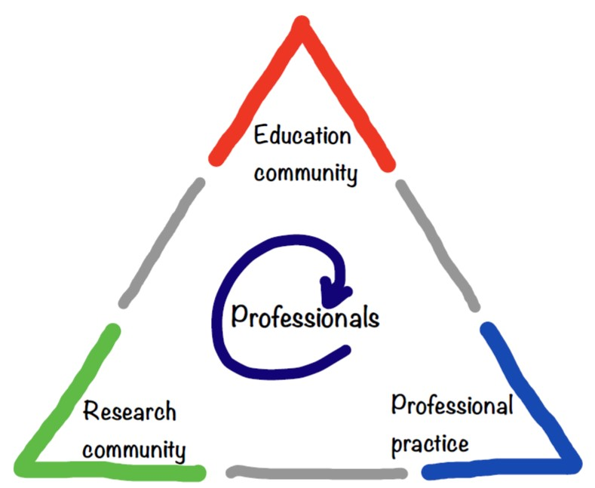
Figure 1-1 Adaptive learning triangle of the interacting education-, professional- and research community
This paper addresses the question: “How can curricula accommodate to and capitalize labour market requirements”, by elaborating on the curriculum design in an adaptive learning triangle. The paper is structured as follows. Section 2 provides background information. In Section 3 we discuss the method used. The first results of the curriculum development are presented in Section 4. Section 5 reflects on our findings in the form of a discussion. Finally, Section 6 gives concluding remarks.

Background
Most papers published on the topic of Professional Higher Education adapting to the changing professional domain, carry an educational perspective. Using for instance boundary crossing (Oonk, Gulikers, & Mulder, 2017), cross functional integration (Baunsgaard & Clegg, 2013), or absorptive capacity (Graaff, 2018) to enhance the educational organisation in cooperating with the professional practice. It was advised by Cremers (Cremers, 2016, pp. 124,125) to incorporate the professional practice in the hybrid learning configuration (Cremers, 2016; Wierenga & Cremers, 2017). Understanding rationalities of professionals in the adaptive learning triangle opens a new perspective to enhance cooperation between education, professional practice and research communities.

An important aspect of the educational process within the education community is the timetable of the curriculum; every semester is a study unit with a specific theme. Contrary to this, the daily dynamics of the research community complies with actual research interests. The consequence of this difference in dynamics is that both professional practice and research community experience a tendency to become worlds apart with respect to the education community (Adriaansen, 2005, p. 122; Griffioen, Visser-Wijnveen, & Willems, 2013, pp. 27-29).

This world apart tendency emerges at the Faculty of Technics of the HAN University of Applied Sciences within the professorship HAN Automotive Research (research community) operating next to the education community Institute Automotive. HAN Automotive Research is continuously focused on applied research on state-of-the-art topics in cooperation with the automotive professional community. The Institute Automotive is responsible for bachelor education for the automotive practice in an eight-semester bachelor curriculum on automotive engineering. Only semester six and semester eight offer the opportunity to cooperate in projects complying with state-of-the-art themes from the professional practice. The themes in the remaining semesters are dominated by educational topics.

A consequence of the two worlds tendency is that lecturers and researchers are scarcely involved in each other’s community and hardly or not at all involved in the applied research projects of the research community. Yet there is a good argument to involve professionals from the education community in applied research for the research community. The state-of-the-art knowledge is a necessity for education. It enables a better connection of the competences of an Institute Automotive graduate to the labour market or professional community.

For students in professional higher education it is virtually impossible to obtain all relevant knowledge about their future professional community and to be ready for applying it after they graduate. Not new, because it is inherent to learning that after knowledge development, knowledge transfer is a different chapter. For professional higher education institutes, it could be argued that knowledge transfer is based on or originates from applied knowledge (Marx & Ramioul, 2004, pp. 91, 92). A relevant parable is the curve in product development of computers regarding the increase in computing power and the size of the memory (Moore, 1998).

To enhance the interaction of the professionals in the triangle of the education, professional and research community (see Figure 1-1), and thereby bridging the two worlds, requires understanding of both worlds. An important step herein is to understand the rationalities of the professionals working together in this adaptive learning triangle.

As suggested by Figure 1-1, the professional must deal with different rationalities: institutional (organisations) and individual (professionals), and from the perspective of the three communities. Evidently, institutional and individual rationality affect each other: though there is always an exception to the rule, no individual has a totally different and separate rationality in two worlds. The concept of rationality goes back as far as Karl Mannheim (1893-1947) (Tromp, 2001, pp. 247-250) and Max Weber (1864-1920) (Kalberg, 1980, pp. 1151-1158; Tromp, 2001, pp. 241-247). Though developed in the late nineteenth, early twentieth century, the ideas of Mannheim and Weber are still actual and representative (Wilson, 2002).

The method of curriculum development and its analysis
In this section we describe: 1) the method used by the HAN to develop the curriculum for semester six, and 2) the compliance of our analysis of it with prevailing research methods.

Curriculum development
The curriculum is developed using a design group and a sound board group. The design group is an operational group of professionals from the education- and research community. And the sound board group consists of a group of stakeholders (see Table 3-1).

# | Description
1 | The members of the design group
2 | Professionals of the education and research community – not being a member of the design group
3 | Professionals from the professional practice
4 | Students from Institute Automotive from different cohorts
5 | And, invited, not always available, members of the research and education management teams
Table 3-1 Parties involved in the stakeholder group

Table 3-2, shows the subsequent steps of the design rationale for this semester.

# | Description
1 | Formulate the type of issues in terms of the nature and complexity of the task and the context
2 | Design the process of implementation, guidance and assessment with roles, tasks and responsibilities, including co-creation
3 | Process the cumulation of the practical knowledge gained in projects and the sharing of results
4 | Determine the learning environment and the necessary resources
Table 3-2 Steps of the design rationale
This design rationale is elaborated/assessed in round table discussions with the stakeholder group.

Compliance with prevailing research methods
In studies on human behaviour it is basically impossible to conduct research from a positivistic paradigm, since humans are creative, independent actors and thinkers (Saunders, Lewis, Thornhill, & Bristow, 2015). In this study, we use two qualitative tools: 1) observations and 2) round table discussions. The round table discussions were organised to get feedback on the design process and gain insights in stakeholder perspectives. Observations are used to enrich this data. This method is based on interpretivism in participatory action research (Akella, 2017; Gibson, 2004). Ethnographical approach is used describing and exploring the professional in his natural working environment/work situation (Have, 1985; Lindemann, 2014, pp. 96-98; Maso, 1984). The data acquired is focused on the rationalities of the professional in the three communities: Education, Professional Practice and Research. In the first steps of analysing the rationalities of professionals, we use Mannheim (Tromp, 2001, pp. 247-250) on institutional level:
- substantial: consciously acting from a holistic insight into the coherence of the events;
- functional: every action has a functional role in the realization of a given goal, with the help of consistent and objectively reducible means.

An important aspect of the research presented in this paper is the researcher being project leader of the curriculum development of the sixth semester. In two ways this is considered:
- triangulation is used to acquire data to gain insight in the behaviour of the professionals (Bryman, 2004; Hussein, 2009; Maso, 1984, pp. 77,78);
- the (unconscious) effect of a researcher on his research is considered to assure validity and reliability of the data collection (Hammersley, 2016), (Lindemann, 2014, pp. 110-113).

Results
As mentioned in the introduction, this paper addresses the accommodation of curricula to labour market requirements by elaborating/assessing the design rationale of an adaptive learning triangle. This section presents the highlights of the results of 4 round table discussions during the design process which must be finalized February 2020. The results presented in Table 4-1 - Table 4-3, originated from the participants of the round table discussions.

Round table one and two
In the first step in executing the design rationale five requirements were put forward by the design group to gain insight in the design rationale:
- To acquire the perspectives of each party involved, a win-win-win-win situation (for lecturers, researchers, practitioners, and students) has been elaborated
- The relevance of an upcoming research question has been discussed;
- Since it is de facto still a part of an educational curriculum, the method of implementation, the supervision and assessment, in terms of structure and responsibility, must be clear
- The hybrid learning configuration of the adaptive learning triangle, including time line for resources, must be clear to all participants
- Results and knowledge amongst the participating parties in the adaptive learning triangle should be shared

These requirements were developed in the design group and were iteratively discussed twice.
Both round table discussions were led by the researcher, not participating in the discussions. The first-round table discussion (February 4, 2019) was within the design group itself. And the second-round table discussion (March 11, 2019) was in a general meeting with the stakeholders, in 5 mixed groups. Table 4-1 shows the most striking results of both round table discussions.

Requirements | Findings
(1)  win-win-win-win situation | - Lecturers, researchers and professional practitioners, together with students learn from each other  - Lecturers get the opportunity to meet the State-of -the-Art  - Professional practice and professional higher education institute line up on competence development assessment  - Opportunity for new cooperative research
(2)  Relevance of a research question | - Direct from the professional community  - Students change from effort obligation to result recognition  - Projects are problem focussed, not solution oriented  - Students define the deliverables  - Project topic must be relevant, not time critical
(3)  Related to the curriculum | - Development in competences; how to monitor  - Role of each partner in the student assessment, tutoring, etc. More specifically with respect to the professional  - Is cocreation for all involved an option/possibility  - We strive for co-creation  - Student is in the lead
(4)  Adaptive learning triangle. | - Professional practice is responsible for resources (money, equipment, materials)  - Minimal 1 day a week at the client’s place  - The project topic defines the hybrid environment  - IP, secured network usage, becomes an issue.
(5)  Sharing of results and knowledge | - Symposium, colloquium, organised by?  - Peer review by students  - Sharing knowledge in multi project teams  - ‘Restricted’ open access results; lecturers, researchers company professionals are invited
Table 4-1 Results of the second-round table discussion of the design group
The results of the first-round are shown in blue. In the second meeting the results from the first meeting (blue) were acknowledged, the additional results are shown in red.

Round table discussion three
To gain more in-depth insight in the design path, a second meeting with the stakeholders was arranged. Table 4-2 shows the result of the third-round table discussion (May 6, 2019), where five uniform groups elaborated on the design path by discussing the following four topics:
- Specific research questions;
- Knowledge sharing;
- Co-creation;
- Mutual expectations.
Topics  Uniform groups | Specific research questions | Knowledge sharing | Co-creation | Mutual expectations
Students | Excessive workload expected | Time spent within HAN boundaries (grading). | A specialist / expert who has time and is interested | Less reports more verbal assessments, more feedback
SME 1 | Multi partner projects | Licences –solve by clear agreements | Roles must be clear | >1 day a week, strive for 50% at the company
SME 2 | Project on e-drive components in off-highway applications | Student involvement is a complicating factor | Depends on project goal | Cooperation! Frequent meetings, partly at HAN, partly at company
SME 3 | Turbocharger projects:  new, open topics | IP remains with the company | Role of lecturer more background: no accountability | Risk for company tutor management, strive for >1 day a week
SME 4 | Content over process.  Less focus on reports | NDA per project. Intellectual Property (IP) (e.g. Patents à company) | Necessary! Lecturer in limited role; sharing on meta level | Self-directing student teams, continuity is obligatory!
SME 5 | Projects availability is divers | Knowledge stays within the project group | Team: education + students + company | Self-directing student teams  selection process on project and students
Education | Short on concept, focus on analysis | Careful consideration on lecturer suitability | Frequent meetings to avoid lecturer to misalign the project focus. | Monitoring of lecturer deployment.
Design group | State-of-the-Art  None critical, or urgent | As much as possible, taking security into account | Must: clear on role fulfilment Working together in trust | Partly at HAN, partly at company.
Table 4-2 In-depth insights in the design rationale

Round table discussion four
To operationalise the design rationale the design group created a blue print for Driving Innovation. The blue print is subsided to a first assessment in the fourth-round table discussion with the stakeholders. The blue print has been discussed with the stakeholder group (see Table 3-1) on July 1, 2019. To enhance the support in both education and research communities, both management teams were invited and participated. In see Table 4-3, the most striking results are shown, given by professionals from the three involved communities.
Community | Remarks
Research | Good document in educational perspective, missing the project typing and activity time line. Clear how co-creation hours for teachers (education professionals) can be funded
Professional Practice | Do not yet see clearly what their role is.  Clear on IP and (again) discussion op costs.  Companies should have at least be consulted on student ratings.
Education - Lecturers | Good overview, however, practice is unruly; discuss and hold on to responsibility (not common at all).
Education - Students | You must be judged on those things that are indicated to be judged, so don't give yourself away for the group's sake if that means that your own work will be below the level. If you also do other things, this certainly works to your advantage.
Table 4-3 Results of blue print round table discussion (01.07.2019)

Discussion
In the daily practice of Professional Higher Education, professionals from the education community develop the curriculum. Generally, a less discussed subject herein is the perspective from the professional practice (Cremers, 2016, pp. 124,125). At the Automotive Institute an innovative step was taken to mend this shortcoming. In the development of semester six - Driving Innovation – three initiatives are leading:
- The semester curriculum theme will be defined by the state-of-the-art of the professional practice, contradicting the prevailing approach in curriculum development.
- The link with professional practice is monitored and evaluated on a regular basis in the sound board group on the curriculum development, and;
- Co-creation by all professionals involved in the adaptive learning triangle is stimulated effectively weekly based project meetings.

In this way Industry 4.0 (disruptive) innovations (Schwab, 2015, 2016) will find their way to the curriculum, despite short time to market constraints (Marx & Ramioul, 2004). These innovations will put pressure on the role of the professionals; all involved professionals will have to act in the perspective of a network professional (Vijlder, 2015). And roles of research-active professionals in universities of applied sciences can be enhanced (Schuiling et al., 2011; Winkel, Rijst, Poell, & Driel, 2017), to better comply with roles required when acting in the adaptive learning triangle.

The different world axioma
As discussed in the introduction and background, the worlds of ‘Education’ (education community) and ‘Research’ (research community) are different worlds (Adriaansen, 2005, p. 122; Griffioen et al., 2013, pp. 27-29). Table 4-1 is a consequence of the different world axioma. During the meeting with the design team (February 4, 2019) more educational driven themes were discussed (see Table 4-1, blue remarks). During the meeting with the stakeholders (March11, 2019), in which the professional practice was well represented, the focus shifted towards results and consequences (see Table 4-1, red remarks). For example, co-creation in the perception of the design team was an ‘option or possibility’, this changed to a goal (‘strive for’). Or on knowledge: the scholarly participants screamed for open access and open availability. Whilst the professional practice calls for IP and secured network usage. This ‘different world axioma’ is also illustrated by the students. They mentioned to expect an excessive workload, where the study load just complies with regulations, as before. Or ‘time spent to the project must comply the grading system’. On the other hand, ‘less reports, more verbal assessments’ does comply with current developments in the professional practice. In meeting 3 (May 6, 2019) the role of the professional practitioner is evaluated as valuable for the education community. However, when it comes to judging the development of the student there’s no consultancy foreseen in the RACI in student assessments.

The Hybrid Learning configuration
Various studies showed the importance of a hybrid learning configuration (Bouw et al., 2019; Cremers, 2016; Cremers et al., 2016; Stappen & Zitter, 2016; Wierenga & Cremers, 2017). In addition to this discourse on hybrid learning, this paper emphasizes the importance of an adaptive curriculum, meeting labour market requirements, i.e., the central theme of the curriculum is unknown prior to running the semester. The importance of the adaptive learning triangle was confirmed in all three round table meetings (see Table 4-1, 2 and 3) where stakeholders emphasized the importance of an adequately defined and set up hybrid learning configuration.

Discussions reflected in Table 4-1, 2 and 3, also showed that the physical location of the adaptive learning triangle is not important:
- The professional practice emphasises on minimal 1 day a week at the company;
- For the research community and education community, it is quite indifferent. Whilst both emphasises and comply with the at least one day a week” at the company.

Rationalities
As mentioned in footnote 5 (p. 3) this paper is part of a PhD research focused on rationalities of professionals. Understanding institutional rationalities and using an innovative design rationale can contribute to improve the professional interaction in an adaptive learning triangle. Thus it offers an opportunity to reduce the perceived discrepancy between the worlds of research and education, e.g. their themes in educational curriculum (Adriaansen, 2005, p. 122; Griffioen et al., 2013, pp. 27-29).

The round table meetings with the stakeholders offered a unique opportunity to observe rationalities as they emerged. Surprisingly, an interesting distinction has been observed in (i) the economic field, (ii) the research paradigm and (iii) the time perspective of the primary process.

The professional practice shows a clear focus on the costs (see Table 4-2 and Table 4-3). The return on investment is a prevailing attitude. These issues were not raised by the education- and research community. They considered the cost coverage aspect in terms of “Professional practice is responsible for resources (money, equipment, materials)” (see Table 4-1, item 4).

Similar effects show the attitude towards the research paradigm. For the SME, this calls for Intellectual property transfer: IP rights are for the SME (see Table 4-2 and Table 4-3). Education is focused on research attitude, and mainly thinks in terms of “design”, “produce”, and the research community is in this perspective focused on knowledge and knowledge development.

Rationality of Acting / Rationales | Education | Research | Professional practice
Economic perspective | Costs coverage  annual reports | Costs coverage  monthly reports | Shareholder value, Return on Investment
Research paradigm | Research attitude, designing, realization, services, … | Applied, Practical research | IP focused, USP-P
Primary process - Time perspective | A four-year curriculum, containing eight semesters | Continuously driven by state-of-the-art themes from the professional practice | Continuously driven by innovation and market
Table 5-1 Initial Frame Work on Institutional Rationalities
Table 5-1 shows a part of the initial framework of institutional rationalities originating from the referred PhD-research. This table shows a coherent compliance with the observed rationalities emerging throughout the stakeholder meetings.

Concluding remarks
This paper addresses the question: “How can curricula accommodate to and capitalize labour market requirements?”. We elaborate on this alignment by addressing the design of an adaptive curriculum in Driving Innovation, the sixth semester of the Automotive Institute bachelor curriculum of the HAN University of Applied Sciences. Central in this semester is compliance of the curriculum with state-of-the-art professional practice.

The curriculum is developed using a design group and a (broader) sound board group. The latter is a mix of lecturers, researchers, practitioners, and students. We closely followed 4 round table discussions of the sound board group. These round table meetings offered a unique opportunity to observe rationalities as they emerged. Our observation confirmed - once more - that the worlds of ‘Education’ and ‘Research’ are different worlds. Lecturers focus on educationally driven themes, whereas the professional practice focuses on results and consequences. For example, co-creation is for the lecturers an ‘option or possibility’, but it is a goal for practitioners.

Three guidelines - so far emerging from the above design process - may be of general value: (i) define the curriculum theme by state-of-the-art professional practice (ii) monitor and evaluate the link with professional practice on a regular basis (iii) stimulate co-creation of all professionals involved.

By doing so, we will create a better mutual understanding (and hence cooperation) between professionals in the adaptive learning triangle. This creates the opportunity to deal with the ‘two worlds’ axioma and to develop a curriculum complying with the actual research interests of the professional practice.

Further research will be carried out on understanding in more detail the individual and institutional rationalities of professionals operating in the adaptive learning triangle in order to enhance cooperation between education, professional practice and research communities.

Bibliography
Adriaansen, M. (2005). Kennis die werkt [Knowledge in Application]. Onderwijs en gezondheidszorg, 29(4), 121-125. doi:10.1007/bf03071478
Akella, D. (2017). "PALAR: The Action Research Model in Higher Education and Communities". The Learning Organization, 24(5), 381-384. doi:10.1108/Tlo-04-2017-0039
Baunsgaard, V. V., & Clegg, S. (2013). 'Walls or Boxes': The Effects of Professional Identity, Power and Rationality on Strategies for Cross-Functional Integration. Organization Studies, 34(9), 1299-1325. doi:10.1177/0170840612464756
Binkley, M., Erstad, O., Herman, J., Raizen, S., Ripley, M., Miller-Ricci, M., & Rumble, M. (2014). Defining twenty-first century skills. In Assessment and teaching of 21st century skills (pp. 17-66).
Bouw, E., Zitter, I., & de Bruijn, E. (2019). Characteristics of learning environments at the boundary between school and work – A literature review. Educational Research Review, 26, 1-15. doi:10.1016/j.edurev.2018.12.002
Bryman, A. (2004). Triangulation. In The SAGE Encyclopedia of Social Science Research Methods. Thousand Oaks (US): SAGE Publications, Inc.
Camilleri, A., Delplace, S., Frankowicz, M., Hudak, R., & Tannhäuser, A. (2014). Professional Higher Education in Europe - Characteristics, Practice examples and National differences. EURASHE - Knowledge Innovation Centre (Malta).
Cremers, P. H. M. (2016). Designing hybrid learning configurations at the interface between school and workplace. (Dr Docterate thesis), Wageningen University, Wageningen (NL).
Cremers, P. H. M., Wals, A. E. J., Wesselink, R., & Mulder, M. (2016). Design principles for hybrid learning configurations at the interface between school and workplace. Learning Environments Research, 19(3), 309-334. doi:10.1007/s10984-016-9209-6
EURASHE. (2012). Position paper on Research and Innovation. Brussels: EURASHE - European Association of Institutions in Higher Education
EURASHE. (2015). Making European Professional Higher Education a Key Player in the Development of a Fastly and Unpredictably Changing Society. Brussels: EURASHE - European Association of Institutions in Higher Education
Gibson, N. (2004). Action Research. In The SAGE Encyclopedia of Social Science Research Methods. Thousand Oaks: SAGE Publications, Inc.
Graaff, E. d. (2018). Absorptive capacity in het Hoger Onderwijs [Absorptive capacity in Higher Education]. Arnhem: Hogeschool van Arnhem en Njmegen; Faculteit Economie en Management.
Griffioen, D. M. E., Visser-Wijnveen, G. J., & Willems, J. (2013). Onderzoek in universiteit en hoger beroepsonderwijs: niet in de wortels [Research in Universities and Professional Higer Education; not in the Roots]: Noordhoff Uitgevers bv.
Hammersley, M. (2016). What's Wrong with Ethnography? The Myth of Theoretical Description. Sociology, 24(4), 597-615. doi:10.1177/0038038590024004003
Have, P. t. (1985). Een methode voor de etnomethodologie [A Method for the Etnhomothodology]. Sociologisch Tijdschrift, 12(2), 368-380.
Hussein, A. (2009). The use of Triangulation in Social Sciences Research: Can qualitative and quantitative methods be combined? Journal of Comparative Social Work, 1.
Kalberg, S. (1980). Max Weber's Types of Rationality: Cornerstones for the Analysis of Rationalization Processes in History. The American Journal of Sociology, 85(5), 1145-1179.
Lindemann, B. D. (2014). Lost in Translation - How public professional services reconfigure professional practices. Utrecht: Universiteit Utrecht.
Marx, S., & Ramioul, M. (2004). School en Samenleving; Mythe en realiteit van de kenniseconomie [Education and Environment; Myth and Relity of the Knowledge Economy]. School en Samenleving, 7(22), 89-110.
Maso, I. (1984). Verklaren in het dagelijks leven: Een inleiding in etnomethodologisch onderzoek. [Explaning in Daily Life: An Introducion to Ethnomethodologic Research]. Groningen: Wolters-Noordhoff.
Moore, G. (1998). Cramming More Components onto Integrated Circuits. Paper presented at the LIFE FELLOW, IEEE.
Oonk, C., Gulikers, J., & Mulder, M. (2017). Educating Boundary Crossing Planners: Evidence for Student Learning in the Multistakeholder Regional Learning Environment. Journal of Planning Education and Research. doi:10.1177/0739456x17737598
Saunders, M., Lewis, P., Thornhill, A., & Bristow, A. (2015). Understanding research philosophy and approaches to theory development. In Research Methods for Business Students (Mark Saunders, Philip Lewis, Adrian Thornhill & Alexandra Bristow ed., pp. 122–161). Harlow: Pearson Education.
Schuiling, G., Kengen, M., Mol, I., Okkerman, L., Winkel, M. v., Komduur, H., . . . Noij, L. (2011). Rolgerichte Competentieontwikkeling - Rollenportfolio’s in beroepsonderwijs, industrie en dienstverlening. Arnhem/Nijmegen: HAN Press.
Schwab, K. (2015). The Fourth Industrial Revolution. from https://www.foreignaffairs.com/articles/2015-12-12/fourth-industrial-revolution
Schwab, K. (2016). World Economic Forum. The Fourth Industrial Revolution: what it means, how to respond. Retrieved from https://www.weforum.org/agenda/2016/01/the-fourth-industrial-revolution-what-it-means-and-how-to-respond
Stappen, E. v. d., & Zitter, I. (2016). Exploring Design Principles for Technology-Enhanced Workplace Learning. Paper presented at the BLED 2016 Proceedings. 14. (http://aisel.aisnet.org/bled2016/14).
Tromp, G. H. M. (2001). Politiek door de Staten: doel- of waarderationeel handelen in het besloten overleg over de Wadden en het openbaar beraad over de ecologische hoofdstructuur. (PHD), Rijksuniversiteit Groningen,
van Gageldonk, C. (2017). Op zoek naar onderzoek: de totstandkoming van de onderzoekfunctie in het hoger beroepsonderwijs [In Search for Research: The Establishment of Research in Professional Higher Education]. Uitgeverij Eburon,
Vijlder, F. d. (2015). Professionals aan het roer. Goed bestuur door professionals. Kwaliteit van Onderwijs. Retrieved from https://www.scienceguide.nl/2015/05/professionals-aan-het-roer/
Wierenga, L., & Cremers, P. (2017). Zelfgestuurd leren in innovatiewerkplaatsen [Self-directed Learning in Innovation Workshops]. Onderwijsinnovatie (Open Universiteit), 03.2017, 17-24.
Wilson, H. T. (2002). Rationality and Capitalism in Max Weber’s Analysis of Western Modernity. Journal of Classical Sociology, Vol. 2(1), 93-106.
Winkel, M. v., Rijst, R. v. d., Poell, R., & Driel, J. v. (2017). Identities of research-active academics in new universities: towards a complete academic profession cross-cutting different worlds of practice. Journal of Further and Higher Education, 1-17. doi:10.1080/0309877x.2017.1301407

Appendix 1 Design Rationale from Project Management Plan
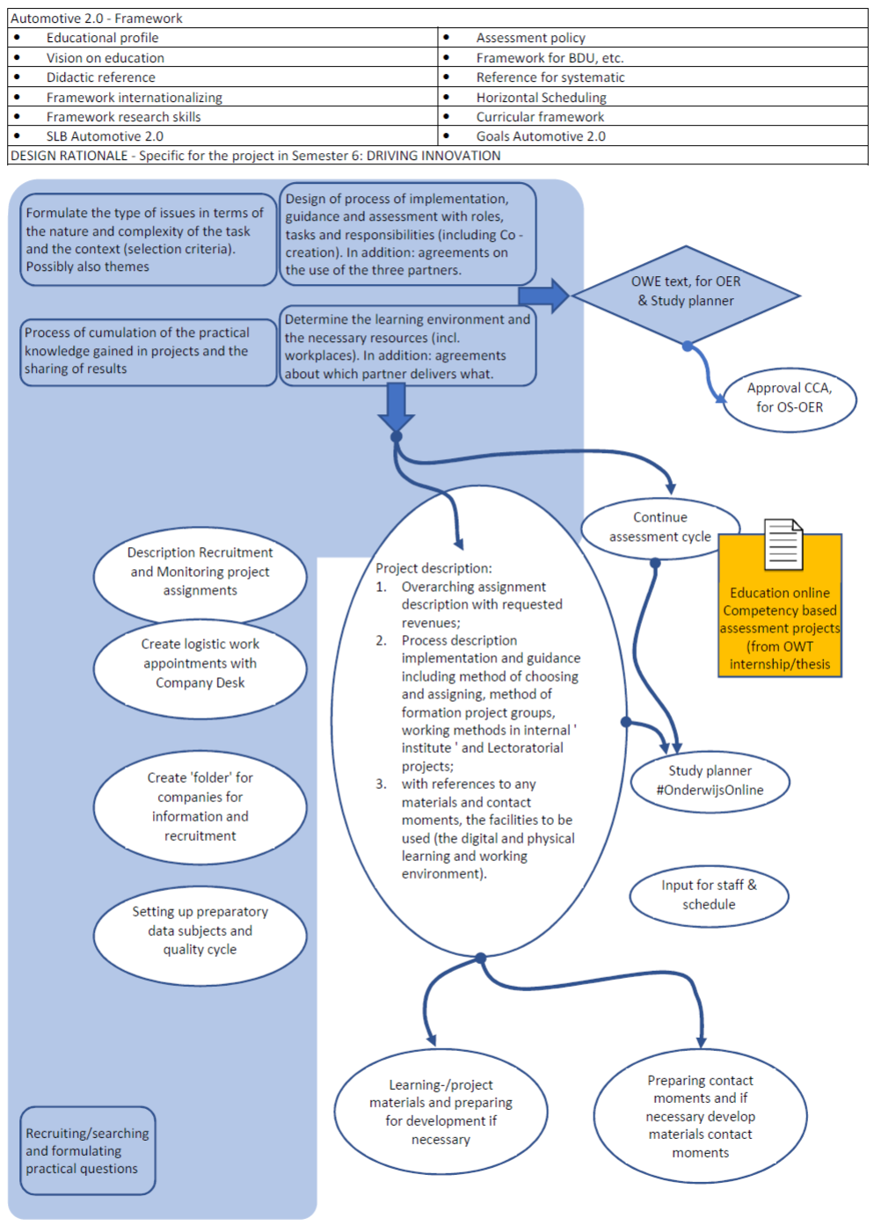

HAN – Hogeschool van Arnhem en Nijmegen, a professional higher education institute
Part of the Faculty of Technics of the HAN University of Applied Sciences (Hogeschool van Arnhem en Nijmegen)
Experience learned that from educational perspective, professorships set up a research program that does not comply with the subsequent professional practice.
A Professional Higher Education Institute, part of the Faculty of Technics of the HAN University of Applied Sciences
This paper is part of a PhD-research on rationalities enhancing applied research and innovation in universities of applied sciences by understanding rationalities of (involved) professionals
Hogeschool van Arnhem en Nijmegen
30EC, is equivalent with 840 hours study load for a student
In Dutch Lectoraat (van Gageldonk, 2017), in English Lectorate or Professorship
Semester six starts in February 2020 for first time. Semester five is an internship, which complies with the state-of-the-art in the professional practice. However, this semester is defined as an orientation on the professional practice and as such less preferable.
In this round table discussion, it is mutual agreed that co-creation must be part of the design rationale.
SME – Small Medium Enterprise, representing the community professional practice
Students are accounted for in the community education
Added by the author, based on the previous round table meetings
RACI – Responsibility matrix; Responsible, Accountable, Consulted, Informed. Info in Jacka, Mike; Keller, Paulette (2009). Business Process Mapping: Improving Customer Satisfaction. John Wiley and Sons. p. 257. ISBN 0-470-44458-4)

