  - CRISPR Applications in Curing Diabetes

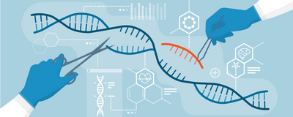
Figure 1: Genetic editing (Heidt, 2020)

Literature review
by Steffy Andreescu
7 February 2022

Abstract
This literature review will focus on how CRISPR/Cas can be used in curing diabetes. CRISPR is a newly discovered genetical engineering tool that was first found in bacteria and it has an important immune function, protecting them from viral infections by cutting the viral DNA, thereby disabling it. Researchers discovered that this tool can cut any DNA molecule as long as there is a guide RNA sequence that matches the gene of interest. One way this can be used in curing diabetes is to knockout the genes that lead to the disease. Another way which has more potential is to genetically modify animal DNA to make cells that don’t trigger immune responses in humans, and then transplanting the pancreas. A third and newer way is to modify human stem cells to stop expressing the molecules (MHC) that trigger the immune system to launch an attack on non-host cells, then differentiating these cells into insulin secreting cells and implanting them into diabetic patients.

Diabetes is a disease that affects how the body regulates its blood sugar levels, leading to 1.6 million deaths annually (El-Kenawy et al. 2019). There are two main types of this disease, type 1 diabetes, and type 2 diabetes. In type 1 diabetes, the beta cells of the pancreas that are responsible for secreting insulin are destroyed by a malfunction in the immune system that causes the body to make antibodies against these insulin-secreting cells, making type 1 diabetes an autoimmune disorder. In type 2 diabetes which is usually seen in overweight individuals, the beta cells secrete some insulin, but it is either not enough for how much of it the body needs, or the other cells in the body are not responding well to it as a result of a resistance developed to it (Diabetes.org, n.d.). In figure 2 below the similarities, but also the differences are highlighted. The treatment also differs based on the type and severity of the disease. The standard (and only) treatment for type 1 diabetes is insulin injections, which in some cases might be also given to type 2 diabetics, while type 2 diabetes can be managed more easily than type 1 and in more than one way, for example by taking medicine that lower glucose production or stimulate insulin production, by making changes in what to eat such as switching to a whole foods plant-based diet that is low in carbohydrates and high in fiber (Diabetes.org, n.d.), and by doing regular exercise(Lu & Zhao, 2020). However, there is no cure for this disease yet as only the symptoms are being treated by these standard practices, and not the underlying cause.
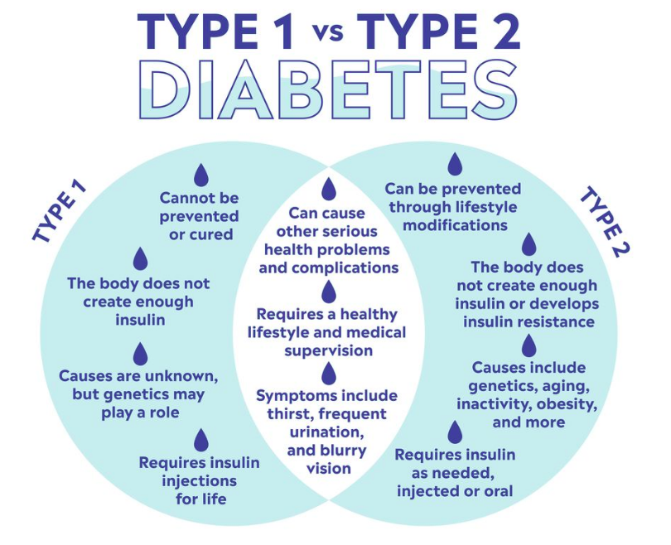
Figure 2: Differences and similarities between type 1 and type 2 diabetes. (Englert & Hamdy, 2021)
Bacteria are prokaryotic cells that are also vulnerable to viral infections. Throughout evolution they have developed a system to protect themselves against viral infections. The name of the tool they use is CRISPR which is a protein complex that works as an intracellular immune system looking for bacteriophage (virus that infects bacteria) DNA and cutting it when it is found. (Tetsch, 2017) This mechanism is very precise as a single RNA template can be used for a specific bacteriophage DNA sequence. When a virus infects a bacterial cell, the foreign DNA may insert itself in the region of the bacterial DNA which makes the Cas protein, and when this gets translated, the protein complex acts as a “find and cut” system which disables the virus from further replicating inside the cell. This immunity to specific viruses is also passed down to future generations when bacteria replicate.

Can bacteria be the answer for the cure to diabetes? Scientists figured out a way of using this tool to genetically engineer organisms by using this mechanism as a sort of “find, cut, and replace” system to change the genetic material of any eukaryotic cell as shown in figure 3. This tool has revolutionized the field of genetic engineering, having the potential to fix genetic disorders such as sickle cell disease, while also having applications in treating HIV infections and cancer.
Figure 3: Mechanism of CRISPR (Ball, 2016)

One way of using this tool is by doing a sort of “genetic surgery” by using CRISPR to alter the genes leading to diabetes. The genetic basis of this disease is very complex, and scientists are nowhere near understanding it, but it is thought that the onset of type 2 diabetes is caused by at least 124 genes that have mutations. One of these genes, HMGA1, which makes a protein that is located inside the nucleus and has many functions including in cell differentiation and inflammation, is also thought to play a role in the transcription of the insulin receptor. When this gene is mutated, the malfunctional protein that arises from it makes the body’s cells unable to keep a stable glucose homeostasis, leading to the development of type 2 diabetes. In the case of type 1 diabetes, the destruction of β cells, is thought to arise from down- or upregulation of specific genes, including insulin-like growth factor. Knocking out these genes with CRISPR can potentially eliminate the start of this disease, but more research is needed to know exactly how these genes interact with each other and the effect they have on the cells when they are mutated (El-Kenawy et al. 2019).

Another way of using this tool is by genetically engineering animals and then harvesting their organs, in this case the pancreas, that are then transplanted into diabetic patients (Kuscu et al., 2021). This procedure which has the name xenotransplantation and is not new, but dates back to the 1894 when doctors first tried to transplant sheep’s pancreas into a boy, however the procedure was not successful (Weaver, 2020). In today’s world, this is now possible, as more information is known about how transplantation and the immune system work. The greatest barrier in this is the difference in the cell surface between animals and humans as animals express different proteins and sugars on their cell membranes. Scientists have concluded that if these differences are eliminated then the immune system would not recognize the transplanted tissue as foreign and reject it. Figure 4 shows two ways that pigs’ DNA can be genetically modified to produce transgenic offspring. By eliminating specific receptors on the cell’s surface, such as those that bind to and activate NK cells, and increasing the receptors that inhibit NK cell activation may prevent the rejection of the transplanted tissue (Ryczek et al., 2021). In the near future, genetically edited pigs’ pancreases could replace defective human pancreases in diabetic patients, and produce comparable levels of insulin, thus eliminating the need of insulin injections and/or restrictive diet.
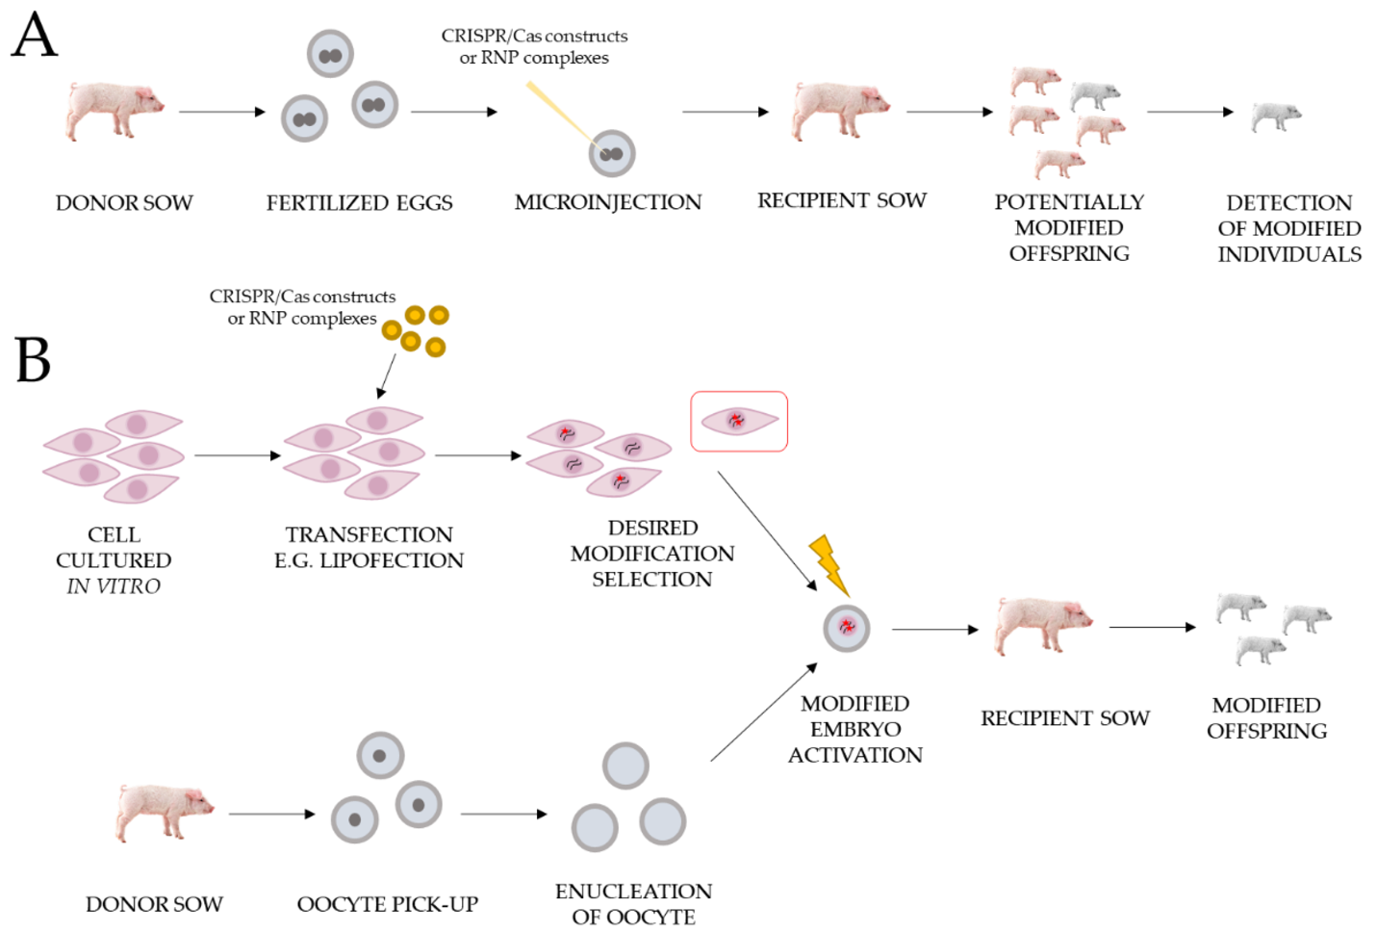
Figure 4: Two ways of genetically modifying pigs. (Ryczek et al., 2021)

In a newer approach, human stem cells were genetically engineered to stop expressing some of their receptors (MHC complexes) on the plasma membrane which act as a flag for the immune system. These cells can then differentiate into insulin producing cells which are later transplanted into diabetic patients, as shown in figure 5. This is done without the need of immunosuppressive therapy, which is normally used in allogenic transplants to prevent organ rejection. The newly transplanted cells would produce insulin thus curing the disease, without the need of additional treatments (ViaCyte, 2021). This is the first type of therapy of this kind and the company is now testing the safety and patient tolerance in a phase 1 clinical trial.
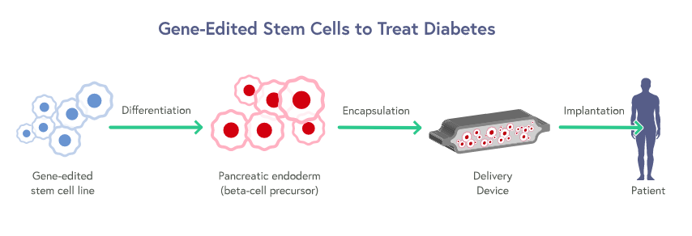
Figure 5: Schematic of how ViaCyte’s diabetes treatment works (CRISPRTX, 2022).

These methods hold great promise in bringing the cure to diabetes closer to people who need it, but there are many limitations to this technique of editing DNA. One of the worst dangers is that CRISPR, although highly specific to the gene of interest, has been shown to cause off target mutations. The guide RNA that CRISPR is using is usually 20 nucleotides long (Kuscu et al., 2021), and the human DNA is approximately 3 billion base pairs (Human Genome Project, n.d.), making it possible for CRISPR to mistake another part of the DNA for the one it is guided to modify. Also, since CRISPR is a protein that comes from bacteria, the immune system can detect it as a foreign body and make antibodies against it (Kim et al., 2018).

CRISPR is a very powerful that revolutionized the field of genetic engineering, but caution is very much needed when using it to eliminate these potential dangers. Besides being used to cure diabetes, this gene editing technique has many other applications in curing other diseases, mainly genetic disorders caused by mutations in DNA. The only thing diabetic patients have to do is wait because research and testing new treatments takes a long time, but there is hope because new discoveries are made every day, and more clinical trials will be announced. With all the available tools and the hard work of scientists, this can be a disease of the past.

Reference list
Note. From CRISPR Gene Editing Prompts Chaos in DNA of Human Embryos, by Heidt, A. (2020). The Scientist. Retrieved December 13, 2021, from https://www.the-scientist.com/news-opinion/crispr-gene-editing-prompts-chaos-in-dna-of-human-embryos-67668
El-Kenawy, A., Benarba, B., Neves, A.F., de Arujo, T.G., Tan, B.L., Gouri, A. (2019) Gene surgery: Potential applications for human diseases. EXCLI Journal, 2019 (18), 908–930.
http://dx.doi.org/10.17179/excli2019-1833
Diabetes.org, (n.d.) Differences between type 1 and type 2 diabetes. Diabetes UK. Retrieved December 13, 2021, from https://www.diabetes.org.uk/diabetes-the-basics/differences-between-type-1-and-type-2-diabetes
Diabetes.org, (n.d.) Veganism and diabetes. Diabetes UK. Retrieved December 13, 2021, from https://www.diabetes.org.uk/guide-to-diabetes/enjoy-food/eating-with-diabetes/veganism-and-diabetes
Lu, X., Zhao, C. (2020) Exercise and Type 1 Diabetes. NCBI. Retrieved December 13, 2021, from https://pubmed.ncbi.nlm.nih.gov/32342453/
Note. From Type 2 Diabetes: Every Important Fact to Know About Causes, Symptoms, and Treatments, by Englert, B.R., Hamdy, O. (2021). Prevention. Retrieved December 13, 2021, from https://www.prevention.com/health/health-conditions/a21764231/type-2-diabetes-definition/
Tetsch, L. (2017) The adaptive bacterial immune system CRISPR-Cas and its therapeutic potential. NCBI. Retrieved December 13, 2021, from https://pubmed.ncbi.nlm.nih.gov/29952526/
Note. From CRISPR: Implications for materials science, by Ball. F. Cambridge. Retrieved December 22, 2021, from https://www.cambridge.org/core/journals/mrs-bulletin/news/crispr-implications-for-materials-science#
Kuscu, C., Kuscu, C., Bajwa, A., Eason, J.D., Maluf, D., Mas, V.R. (2020) Applications of CRISPR Technologies in Transplantation. NCBI. Retrieved December 19, 2021, from https://www.ncbi.nlm.nih.gov/labs/pmc/articles/PMC8109183/
Weave, C. (2020) Xenotransplantation of the Pancreas: A Reality Check of Its Historical Emergence. International Journal of Diabetes and Clinical Research, 7(4) 7:131 https://doi.org/10.23937/2377-3634/1410131
Ryczek, N., Hryhorowicz, M., Zeyland, J., Lipiński, D., Słomski, R. (2021). CRISPR/Cas Technology in Pig-to-Human Xenotransplantation Research. Int. J. Mol. Sci. 2021, 22(6), 3196; https://doi.org/10.3390/ijms22063196
ViaCyte. (2021) CRISPR Therapeutics and ViaCyte, Inc. to Start Clinical Trial of the First Gene-Edited Cell Replacement Therapy for Treatment of Type 1 Diabetes. CRISPR Therapeutics. Retrieved December 13, 2021, from https://crisprtx.gcs-web.com/static-files/c7261dc7-481c-4057-88b1-69f7b2f07ea7
National Human Genome Research Institute (n.d.) Human Genome Project FAQ. Retrieved December 22, 2021, from https://www.genome.gov/human-genome-project/Completion-FAQ
Kim, S., Koo, T., Jee, H.G., Cho, H.Y., Lee, G., Lim, D.G., Shin, H.S., Kim, J.S. (2018) CRISPR RNAs trigger innate immune responses in human cells. NCBI. Retrieved December 22, 2021, from https://www.ncbi.nlm.nih.gov/labs/pmc/articles/PMC5848615/
CRISPRTX. (2022) CRISPR/Cas9 enables regenerative medicine 2.0. CRISPR Therapeutics. Retrieved February 7, 2022, from http://www.crisprtx.com/programs/regenerative-medicine

