Investigating the role of AMPK-mediated TET2 in diabetes-induced myelopoiesis and the effect of Vitamin C on restoring TET2 function.

Research report

Arina Kochetkova

2023

Table of Content

**Summary2**

**Introduction2**

Atherosclerosis: initiation and development3

Hematopoiesis and Myelopoiesis4

The influence of diabetes on myelopoiesis5

TET2 function and its role in myelopoiesis6

AMPK-TET2 axis as the link from diabetes to myelopoiesis6

The role of Vitamin C in TET2 function restoring7

**Materials and methods8**

Mice maintenance8

Experimental procedures in vivo 8

*Mice treatment* 8

*Blood samples preparation*9

*Bone marrow* *preparation*9

*Flow cytometry*9

cKit+ cell enrichment and sorting 10

5-hmC measurement for TET2 activity10

Experimental procedures in vitro10

*cKit+ cell culturing*10

*Bone marrow-derived macrophages (BMDM) culturing*11

Statistical analysis11

**Results11**

Vitamin C does not restore normal myelopoiesis in bone marrow 11

Vitamin C does not restore TET2 dysfunction in diabetes14

**Discussion16**

**Conclusion17**

**References17**

**Appendix19**

Supplementary table19

Supplementary figures20

## Summary

Diabetes remains a major risk for atherosclerotic-cardiovascular disease (CVD). While many mechanisms have been explored, the full extent of how diabetes promotes CVD remains unknown. An emerging area in diabetes is the influence of epigenetic regulation of gene expression. Diabetes has been shown to deactivate an important enzyme known as TET2 in hematopoietic stem cells (HSPCs), which is responsible for stabilizing gene expression through promoting 5‐cytosine hydroxymethylation (5-hmC). Our group has recently found in unpublished data that diabetes suppresses TET2 activity via the reduction of AMPK phosphorylation, subsequently decreasing 5-hmC in HSPCs in the bone marrow. This results in the skewing of hematopoiesis towards a myeloid lineage, known as myelopoiesis. This is significant as enhanced myelopoiesis has been shown to promote atherosclerosis. Vitamin C is a cofactor for TET2 activity and has been previously shown to further activate TET2 activity, thus increasing 5-hmC levels and restoring the balance of hematopoiesis. Here, we aimed to investigate if the effect of Vitamin C could restore diabetes-induced TET2 dysfunction and enhanced myelopoiesis. We render C57BL/6 mice diabetic via streptozotocin and after mice became diabetic (>15mM glucose), we placed them with or without Vitamin C in drinking water for 8 weeks. Using flow cytometry, we found that Vitamin C did not reduce myelopoiesis as there were no decrease in monocytes or neutrophils in the blood, or myeloid precursors in the bone marrow such as HSPCs, common-myeloid progenitors (CMPs) and granulocyte macrophage progenitors (GMPs). To further confirm that there was no effect of Vitamin C on 5-hmC levels in HSPCs, we isolated cKit+ cells (containing HSPCs, CMPs and GMPs) from C57BL/6 mice and cultured these cells for 72 hours in 25mM glucose with or without Vitamin C. Here we found that Vitamin C further reduced 5-hmC compared to non-treated cKit+ cells. Thus, this study revealed that Vitamin C fails to restore 5-hmC levels in hyperglycemia-affected cells and is not capable of suppressing diabetes-driven myelopoiesis. Although Vitamin C has been shown in other studies to activate and have beneficial effects in HSPCs and hematopoiesis, using Vitamin C in the setting of diabetes requires further investigation.

## Introduction

Diabetes mellitus (type 1 and type 2) is a complex metabolic syndrome underscored by elevated blood glucose levels and is frequently entailed by serious health complications1. The presence of diabetes has been established to double the risk of cardiovascular diseases (CVDs) incidence which accounts for almost 20 million deaths per year worldwide2. Atherosclerosis is the most prevalent cause of CVD, which is defined as a chronic inflammatory disorder that remains the primary reason for disability and death among patients with diabetes3. It manifests itself as the formation of lipid-enriched plaques in the innermost layer of vessel walls that, if ruptured, may launch a set of potentially lethal thrombotic events4. The inflammatory behaviour of atherosclerosis is accounted for elevated leukocyte levels, in particular to circulating monocytes and neutrophils that infiltrate atherosclerotic plaques and trigger the disease progression5.

As shown by previous studies, atherosclerosis is driven by excessive production of monocytes and neutrophils in bone marrow (BM) from their primary progenitor, hematopoietic stem cells (HSCs), in the process known as myelopoesis5. The differentiation of HSCs is regulated through the combination of transcription factors and epigenetic modifications and thus the HSCs proliferation pattern is rather susceptible to metabolic shifts6,7. Diabetic conditions such as hyperglycemia, chronic inflammation, and hypercholesterolemia were observed to promote a series of myelopoiesis-inducing events, however, the underlying molecular mechanisms that trigger the epigenetic changes specifically in HSCs are not yet clearly understood8.

#### Atherosclerosis: initiation and development

Atherosclerosis development is controlled by multiple factors such as disturbed lipid metabolism, elevated oxidative stress, and chronic inflammation9. The initiation of the disease starts with the disruption of endothelial function and the subsequent increase in endothelium permeability that allows the accumulation of low-density lipoprotein (LDL) particles inside the intima (innermost endothelial layer) of a blood vessel (**Figure 1**). Being protected from plasma antioxidants, LDL particles get subjected to oxidation by reactive oxygen species (ROS) and other modifications that result in the formation of pro-inflammatory oxidized LDL (oxLDL)9,10. Adhesion molecules and chemokines expressed by oxLDL-stimulated endothelial cells, facilitate the transmigration of circulating monocytes into the intima layer10. Inside the vessel wall, monocytes differentiate into macrophages and internalize oxLDL particles, resulting in the formation of foam cells. In response to the interaction of macrophages and T lymphocytes, smooth muscle cells (SMC) start migrating from the media into the intima layer and by secreting extracellular matrix (EMC) proteins establish the fibrous cap that protects the underlying atheroma. The accumulation of both apoptotic and living plaque resident cells together with cholesterol crystals forms the necrotic lipid core10,11. As inflammation sustains, leukocytes start secreting matrix metalloproteinases (MMPs) responsible for collagen degradation, thereby leading to fibrous cap destabilization and plaque rupture9,11. Eventually, the plaque content exposed to blood results in platelets recruitment, coagulation, and subsequent thrombus formation9.

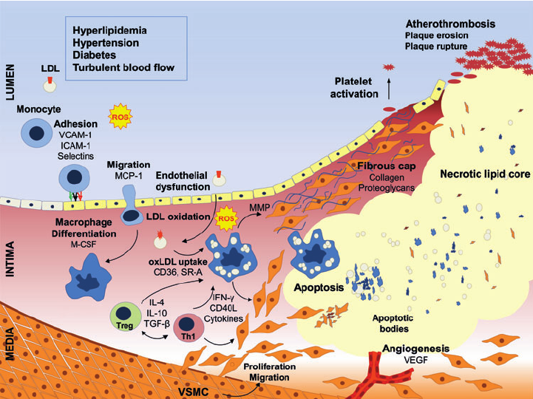

**Figure 1. The schematic overview of the events that occur during atherosclerosis development.** Being constantly exposed to the risk factors, disturbed endothelium starts infiltrating LDL particles into the intima layer of the vessel wall, where they are oxidized forming oxLDL. OxLDL stimulation of endothelial cells mediates the transmigration of circulating monocytes into the intima, where they differentiate into macrophages and after internalizing oxLDL particles, become foam cells. Onwards, the migration of smooth muscle cells occurs from the media to the intima layer, followed by the formation of a fibrous cup. The necrotic core is established by uncleared cell debris together with resident plaque cells and cholesterol crystals.

#### Hematopoiesis and Myelopoiesis

Hematopoiesis is the process of blood cell production from the hematopoietic stem cells (HSCs) to fully differentiated blood cells through multipotent progenitors. The establishment of HSCs fate occurs in bone marrow (BM) and is well balanced between self-renewal and differentiation12. In the homeostatic environment, the balance between specific lineages development is strictly controlled through intrinsic and extrinsic signalling systems that if altered, are capable to cause radical changes in the hematopoiesis process8,12.

Monocytes play a crucial role in atherosclerosis progression and are derived from HSCs in BM through a process termed myelopoiesis13. The process is initiated from HSC downstream multipotent progenitor (MPP) that is restricted in self-renewal potential and is committed to further differentiation (**Figure 2**)8. In literature, HSC and MPP are frequently referred to as one group of cells named hematopoietic and stem and progenitor cells (HSPCs). Next, HSPC differentiation continues in a lineage-confined manner from common myeloid progenitor (CMP) to granulocyte/macrophage progenitor (GMP) and then a number of intermediate immature cells before the final step to fully differentiated granulocytes and monocytes8,13. Once completely differentiated, myeloid cells are released into the bloodstream and perform their designated functions as innate immune cells. In contrast to normal hematopoiesis, the process of blood cell generation interfered by either chronic or acute conditions tends to result in lineage-skewing towards myeloid cell type8.

Monocytes constitute a heterogeneous population of cells that are classified regarding their surface-expressed receptors and thereby functions. In humans, three groups of monocytes are described: classical (CD14+CD16-), intermediate (CD14dimCD16+), and non-classical (CD14+CD16+; patrolling) when in mice only classical (Ly6Chi) and non-classical (Ly6Clow) categories are known15. When in humans all three subtypes have been reported to be associated with atherosclerosis development, in mice only classical monocytes have inflammatory functions and are suggested to be primarily involved in the disease progression16.

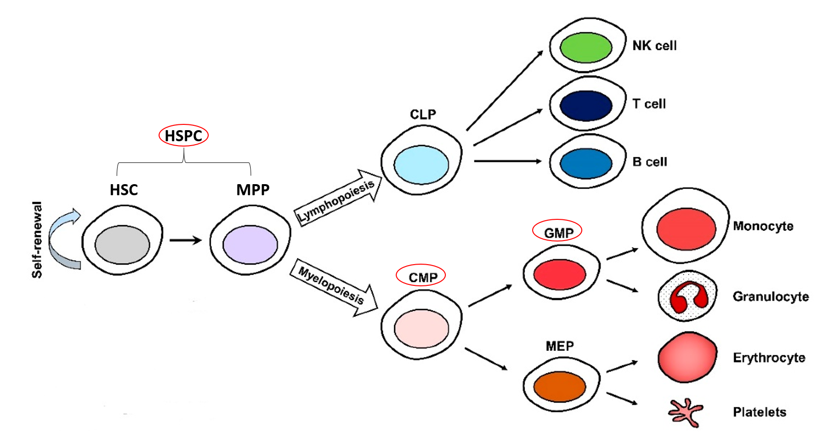

**Figure 2. Hematopoiesis and lineage specification.** Hematopoietic stem cell (HSC) undergoes self-renewal until the point when it differentiates into a multipotent progenitor (MPP). HSC and MPP together are called HSPCs Following either lymphopoiesis or myelopoiesis, MPP differentiates to either common lymphoid progenitor (CLP) or common lymphoid progenitor (CMP). CMP gives rise to granulocyte/macrophage precursor (GMP) which is responsible for monocytes and granulocytes production.

#### The influence of diabetes on myelopoiesis

As previously discussed, elevated levels of circulating leukocytes, especially monocytes and neutrophils, along with their inflammatory status are significant risk factors for CVD development. Type 1 and type 2 diabetes is a group of disorders described by altered carbohydrate metabolism and was seen to be associated with increased white blood cell count4,5. Diabetes entails a set of metabolic abnormalities, however, the exact mechanism how diabetes promotes myelopoiesis remains unclear5.

According to the latest studies exploring how hyperglycemia influence myelopoiesis, high blood glucose levels indeed promote myelopoiesis in BM thereby leading to excessive generation of circulating neutrophils and Ly6-Chi monocytes in diabetic mice5,8,13,17. Our laboratory discovered that an elevated release of monocytes is associated not with the enlargement of the HSCs pool but rather with shifting the proliferation axis towards the myeloid lineage5. Moreover, normalizing blood glucose was followed by slowing down of CMPs proliferation rate and restoring normal quantities of monocytes and neutrophils. Despite a few mechanisms that have been described in this context, the exact way how glucose skews progenitor cells towards enhanced myelopoiesis on the molecular level remains unknown.

#### TET2 function and its role in myelopoiesis

The continuous process of appropriate blood cell generation throughout the lifetime requires a flexible and at the same time strictly regulated system to have a balanced flux of HSCs into each lineage8. Since HSCs in BM are yet to become committed, they maintain an open chromatin state in order to facilitate gene expression and thereby an impetuous differentiation6. In this way, HSCs’ epigenetic profile is rather susceptible to any alterations and thereby to lineage drifts in response to metabolic changes such as diabetic conditions8.

DNA methylation and hydroxymethylation are considered crucial epigenetic modifications in HSCs that control HSCs proliferation pattern and in case if get disbalanced, result in hematological disorders18. The oxidation of DNA 5‐methylcytosine (5-mC) to 5-hydroxymethylcytosine (5-hmC) is catalyzed by the ten‐eleven translocation (TET) protein family and TET2, in particular, regulates this process in hematopoietic lineages19. 5-hmC is an intermediate state of DNA demethylation, involved in gene regulation through modulation of chromatin accessibility for transcription machinery. Normal 5-hmC levels were shown to be positively correlated with the increase of chromatin accessibility allowing successful transcription factors (TF) binding, that exhibits either activating or repressing behaviour20. Although the number of studies about 5-hmC in the context of hematopoiesis is quite limited, 5-hmC status was suggested to be important for the correct differentiation of HSCs21.

Functional loss of TET2 is associated with multiple hematological malignancies including myeloid lineage skewing22. According to previous research studies, TET2 was reported to be strongly enriched at DNA sites with enhancer features, that are located downstream of the promoters and facilitate the recruitment of transcription factors20,23. In MPPs, the depletion of TET2 resulted in the chromatin accessibility reduction at enhancers related to blood lineages determining genes23.

As was found by Han et al, during the transition from HSPCs to GMP and MEP, 5-hmC levels were gradually increasing at GMP and MEP enhancers respectively, meaning that the importance of 5-hmC presence was raised upon lineage specification. Interestingly, the enrichment of 5-hmC was reported to be higher at erythroid enhancers in MEPs than at the myeloid-specific enhancers in GMPs. Moreover, in MPPs, the DNA regions with increased 5-hmC were found to be overlapping with myeloid enhancers while the parts subjected to 5-hmC losses were associated with erythroid-specific enhancers. Taken together, these results suggested that the aberrant reduction of 5-hmC levels may greatly advantage the differentiation towards myeloid lineage20.

#### AMPK-TET2 axis as the link from diabetes to myelopoiesis

Hyperglycemia is known to destabilize TET2 and therefore leads to decreased 5-hmC levels in diabetic patients. The research group has revealed the functional pathway from glucose to TET2 via 5' adenosine monophosphate-activated protein kinase (AMPK), demonstrating that AMPK phosphorylates TET2 at serine 99 (S99) and in this way stabilizes TET2 configuration preventing it from degradation (**Figure 3**). The inhibition of AMPK function in diabetes correlates with decreased TET2 activity and reduced 5-hmC levels17. However, this has yet to be explored in HSPCs.

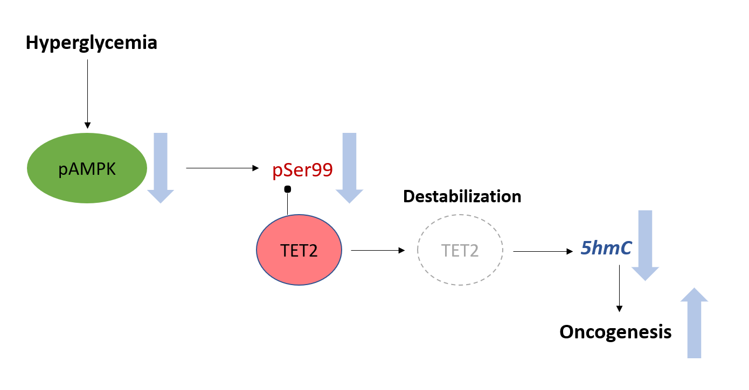

**Figure 3. The link between hyperglycemia and enhanced oncogenesis**. Hyperglycemia reduced the levels of phosphorylated AMPK leading to impaired AMPK functioning and thus decreased TET2 phosphorylation at S99. Unphosphorylated TET2 is not stable and thus cannot maintain the normal 5-hmC status of cells. The decrease of 5hmC levels results in oncogenesis promotion.

#### The role of Vitamin C in TET2 function restoring

Vitamin C is a co-factor of α-ketoglutarate and Fe2+ - dependent dioxygenases (α-KGDD), the family of enzymes that TET proteins belong to25. Vitamin C indeed promotes the catalytic activity of TET1 subsequently leading to a rapid increase in 5-hmC in stem cells such as embryonic stem cells (ESC) and induced pluripotent stem cells (iPSC)24. Moreover, high doses of introduced Vitamin C were potentially capable to improve the symptoms and overall prognosis for cancer patients, however, the underlying mechanisms of these positive effects remained unidentified25.

Earlier biochemical studies evidenced that Vitamin C acts as an electron donor for Fe2+ restoration during TET catalytical cycle, increasing the 5-mC oxidation rate which correlates with the findings from the Cimmino group. The research performed in HSCs showed the ability of Vitamin C to diminish an aberrant myeloid differentiation progression even in the complete absence of TET2 (*Tet2-/-*). However, in the combined TET2/TET3 deficiency the 5-hmC levels were more greatly depleted and no response of Vitamin C was detected. This suggests a compensatory role of TET3 in the absence of TET2. Based on these results, it was deduced that Vitamin C works primarily through TET proteins and is capable to restore normal 5-hmC status even at minimal TETs levels26.

Since the number of fatality cases caused by diabetes-induced atherosclerosis is annually raising, the importance of seeking innovative treatment ways is constantly increasing nowadays. In our laboratory, it was already discovered that diabetes indeed suppresses the AMPK-TET2 pathway functioning via reducing AMPK activity in HSPCs and thus promotes myelopoiesis. In addition to this, hyperglycemia was shown to be the condition that suppressed AMPK activity. Therefore, in the current study, the aim is to investigate, if normal TET2 activity could be restored with Vitamin C and result in normalizing the 5-hmC status of hematopoietic cells to prevent myeloid lineage skewing in the context of hyperglycemia.

Therefore, in this study, we aimed to determine if Vitamin C could increase TET2 catalytic rate and thus increase 5-hmC levels in HSPCs, CMPs and GMPs, resulting in the suppression of diabetes-driven exacerbated myelopoiesis. We hypothesized that Vitamin C can increase TET2 function and thus prevent myeloid skewing via restoring 5-hmC status in HSPCs, GMPs, and CMPs.

## Materials and methods

The current research was approached in two ways and thus was conducted in vivo and in vitro. With the in vivo experiment, we investigated if diabetes-induced TET2 dysfunction in HSPCs could be restored using Vitamin C to therefore reduce myeloid cell production in mice. To perform the experiment, C57BL/6 mice were subjected to two conditions: diabetic and diabetic with Vitamin C treatment. Briefly, mice were made diabetic via streptozotocin (STZ) injection. The blood leukocyte status was evaluated with flow cytometry after 4 weeks of diabetes. After 8 weeks, mice were humanely killed and the percentage of HSPCs, CMPs, and GMPs in BM was measured to determine myelopoiesis using flow cytometry. To assess TET2 activity, cKit+ cells containing HSPCs, CMPs and GMPs were isolated from BM via cKit+ cells enrichment procedure and subsequent cKit+ flow-activated cell sorting (FACS), and their 5hmC levels were measured via ELISA.

With in-vitro experiments, the effect of hyperglycemia was examined on the activity of TET2 in HSPCs and bone marrow derived macrophages. To achieve this goal, C57BL/6 mice were euthanized, and BM content was fully isolated. For TET2 activity assessment, the BM cells were first cKit+ enriched and sorted with FACS, and then cultured in three different conditions: with high glucose and with high glucose supplemented with Vitamin C.

#### Mice maintenance

The research was approved by the animal ethical committees (AEC) under the AEC-submitted approved project number P2039 at the Alfred Medical Research Education Precinct (AMREP). For both in vivo and in vitro experiments, male C57BL/6 mice aged 8-10 weeks old were used. Mice were housed at the AMREP animal facilities in a standard light/dark cycle and given access to food and water on an ad libitum basis. For in vitro study animals were euthanized immediately while for in vivo experiment mice were fed a standard chow diet purchased from Specialty Feeds (WA, Australia).

#### Experimental procedures in vivo

#### Mice treatment

C57BL/6 mice of experimental groups were made diabetic via intra-peritoneal (I.P.) streptozotocin (STZ, 50mg/kg) injections once per day for 5 consecutive days. After the last intervention, mice were given a period of 1 week to adapt to diabetes, and next, blood glucose levels were measured with a glucometer to confirm whether diabetes was successfully induced (blood glucose levels above 15mmol/L). After the adaptation period, one group was supplemented with Vitamin C orally (250 µM in drinking water). Water bottles were changed twice a week. After 4- and 8 weeks blood samples were collected and after 8 weeks mice were euthanized for bone marrow harvesting.

#### Blood samples preparation

Blood samples of 75µL were collected through the tail vein and bleed into a 0.5mL Epi-tube containing 5uL of 0.5M ethylenediaminetetraacetic acid (EDTA) to prevent blood clotting. Samples were mixed with 7mL of 1X RBC Lysis Buffer (BD pharm Lyse; BD biosciences) and incubated at RT for 15 minutes to lyse red blood cells. After 15 minutes, samples were centrifuged at 3000 rpm for 5 minutes at 4°C and cell pellets were resuspended in 200µL of FACS Buffer (containing 1x Hank’s Balanced Salt Solution without Ca2+ and Mg2+, with 0.1% w/v Bovine Serum Albumin and 5mM EDTA).

#### Bone marrow preparation

Following euthanasia, both tibias and femurs of each mouse were collected and cleaned by taking off muscles and connective tissues. All BM cells were flushed with phosphate-buffered saline (PBS) without Mg2+/Ca2+ through a 40µM filter. BM cells were lysed in 1mL of 1x RBC Lysis Buffer for 5 minutes. After 5 minutes, cells were centrifuged at 3000rpm for 5 minutes and resuspended in 200µL FACS buffer.

#### Flow cytometry

Blood samples were stained with a combination of antibodies against PB-CD45, PerCP/Cy5.5-Gr-1, BV605-CD115, PE-CD3, FITC-CD8, BUV469-CD4, APC-B220 at a dilution of 1:400 and then incubated for 30 minutes in the dark on ice. Flow antibody details can be found in **Table S1**. The stained samples were washed with 500µL of FACS Buffer, centrifuged at 3000rpm for 2.5 minutes, and resuspended in 200µL of FACS Buffer. After being transferred into FACS tubes, samples were acquired with BD LSR Fortessa (BD Biosciences) flow cytometer using the FACSDiva software. As shown in **Figure S1**, the cells for analysis were determined on the graph of side scatter area (SSC-A) vs. forward scatter area (FSC-A) and single cells were identified using SSC-A vs. SSC-height (SSC-H) to exclude doublets. From the myeloid population, monocytes were identified as CD45+CD115+ and later divided into Ly6-Chi (CD115+Gr-1hi) and Ly6-Clo (CD115+Gr-1hi) subsets. Neutrophils were distinguished as CD45+CD115-Gr-1+ and the non-myeloid population was identified as CD45+CD115-Gr-1-. From the non-myeloid cells, T cells and B cells were distinguished by CD3+B220- and CD3-B220+ markers respectively. Data were analyzed with FlowJo Software (TreeStar).

Bone marrow samples were stained against lineage committed lineage-committed cells (FITC-CD2, FITC-CD19, FITC-TER119, FITC-Gr-1, FITC-B220, FITC-CD3, FITC-CD4, FITC-CD11b) and stem cell surface markers (PB-Sca1, APC/Cy7-cKit, PerCP-Fcγ, and APC-CD34) for 30 minutes in the dark on ice. Stained cells were washed with 500μL FACS buffer and centrifuged at 3000 rpm for 5 minutes. Samples were then transferred into FACS tubes and immediately acquired using a BD LSR Fortessa (BD Biosciences) flow cytometer. As shown in **Figure S2**, HPCs were identified as Lin-Sca1-cKit+ while HSPCs were identified as Lin-Sca1+cKit+. From the HPC population, CMPs and GMPs were distinguished as Lin-Sca1+ckit+FcγintCD34int and Lin-Sca1+ckit+Fcγhi CD34hi respectively. Data were analyzed using FlowJo Software.

#### cKit+ cell enrichment and sorting

To assess the 5-hmC status in cKit+ cells, HSCs and HSPCs (containing CMPs and GMPs) were purified from BM content using cKit+ Enrichment Kit (BioLegend). Samples were stained with PE anti-mouse CD117 (c-Kit) antibody (BioLegend) for 15 minutes on ice and then washed with FACS buffer. After, samples were stained with mouse anti-PE nanobeads (BioLegend) for 15 minutes on ice. Then, samples were washed again and transferred into FACS tubes through a 40µM strainer. cKit+ cells were purified by magnetizing FACS tubes for 5 minutes in a Separation Magnet (BioLegend) and then the supernatant was discarded while FACS tubes were still inserted in the Separation Magnet. FACS tubes containing cKit+ cells were taken out from the Separation Magnet and the content was resuspended in 1mL FACS Buffer. Cells were centrifuged at 300g for 5 minutes, resuspended in 200µL of FACS buffer, and transferred into FACS tubes through a 40µM strainer.

For cKit+ flow-activated cell sorting (FACS), samples were stained against lineage-committed cells (FITC-CD2, FITC-CD19, FITC-TER119, FITC-Gr-1, FITC-B220, FITC-CD3, FITC-CD4, FITC-CD11b) and incubated for 30 minutes on ice in dark since the cKit+ enrichment yields only ~40% cKit+ cells. Next, cells were centrifuged at 300g for 5 minutes, resuspended in 500µL of FACS Buffer, and transferred in FACS tubes through a 40µM strainer. The sorting was performed using BD FACSMelody sorter and the obtained BM cKit+ Lin- cells were collected into 1.5mL DNA LoBind Eppendorf tubes (Epi-tubes) containing 200µL of FACS Buffer. The samples were then centrifuged at 1000g for 10 minutes at 4˚C and after discarding the supernatant, cell pellets containing cKit+Lin- cells were stored in a -80°C freezer until used for DNA extraction and 5-hmC measurement.

#### 5-hmC measurement for TET2 activity

To extract genomic DNA (gDNA) from cKit+ cells, a Monarch gDNA Purification Kit was used according to the manufacturer’s protocol (New England Biolabs). To estimate the concentration of obtained gDNA, 1x dsDNA HS Assay Kit (Thermo Fisher Scientific) was used and the measurements were performed with the Qubit 4 Fluorometer (Thermo Fisher Scientific). To determine 5-hmC levels in cKit+ cells, a MethyIFlash Hydroxymethylated DNA Fluorescence Quantification Kit was used according to the manufacturer’s protocol (Epigentek) and the fluorescent signal was detected with an EnsSpire 2300 Multimode Plate Reader (PerkinElmer).

#### Experimental procedures in vitro

#### cKit+ cell culturing

After cKit+ enrichment and FACS, cKit+ cells were cultured in 24-well cell culture plate was prepared with RPMI 1640 media supplemented with 2% heat-inactivated FBS, 1% penicillin-streptomycin, 6 ng/ml IL-3 and 0.001%SCF, and 25mM (high) glucose. BM cells then were seeded into a prepared cell culture plate at a concentration of 0.5 x 106 cells/mL. 250µM Vitamin C was added into the respective wells. Cells were incubated for 3 days in an incubator (Thermo Scientific) with a controlled temperature of 37°C, 5% CO2, and 95% humidity. After 3 days, cells were harvested for 5hmC measurement.

#### Bone marrow-derived macrophages (BMDM) culturing

C57Bl/6 mice 7-8 weeks old were euthanized and the bone marrow content was isolated from femurs and tibias. Two 48-well cell culture plates were prepared with RPMI 1640 media supplemented with 10% heat-inactivated FBS, 1% penicillin/streptomycin and 20ng/mL macrophage-colony stimulating factor (M-CSF; for monocyte to macrophage differentiation). BM cells were seeded into prepared plates at the concentration of 0.5 x 106 cells/mL. At day 6 when BM monocytes had differentiated into macrophages, media was adjusted to either 5mM or 25mM of glucose. Moreover, five dilutions of ascorbate of 0, 10, 50, 100, and 250 µM were prepared and added into the respective wells of both normal and high glucose groups. Cells were incubated for 3 days in an incubator (Thermo Scientific) with a controlled temperature of 37°C, 5% CO2, and 95% humidity. On day 9 the media were discarded and gently washed with PBS without Ca2+ and Mg2+ and discarded, before cell culture plates with attached cells were stored at -80°C ready for gDNA extraction for 5hmC measurement.

#### Statistical analysis

For the analysis of 2 experimental groups (STZ vs. STZ + Vitamin C, high glucose vs. high glucose + Vitamin C), a two-tailed unpaired Student’s t-test was performed. For comparison of the experimental 10 groups (BMDM experiment: normal glucose + Vitamin C (0 -250 µM) vs high glucose + Vitamin C (0 -250 µM) a two-way ANOVA test was conducted. The statistical analysis was performed using GraphPad Prism. A *p*-value of less than 0,05 was considered significant. Data were presented as mean ± SEM. *p* values were shown as \**p* < 0.05, \*\**p* < 0.01.

## Results

#### Vitamin C does not restore normal myelopoiesis in bone marrow

To study the effect of Vitamin C on diabetes-triggered myelopoiesis progression in vivo, C57BL/6 mice were rendered diabetic with STZ injections (50 mg/kg), and then one group of mice was left untreated whereas the second group was introduced with Vitamin C orally (250µM; in drinking water) for 8 weeks.

First, mice were bled after 4 weeks to check the changes in the circulating leukocyte profiles using flow cytometry. At this stage, no significant differences were observed in total monocytes and inflammation driving the Ly6-Chi monocytes between Vitamin C untreated and treated groups (**Figure 4**). Interestingly, the blood Ly6-Clo monocyte subset was reduced in Vitamin C treated mice, suggesting that Vitamin C affected myelopoiesis to some extent. Neutrophils, in contrast, were found to be increased in the Vitamin C treated group, which was consistent with the rest of the week 4 bleed data meaning that the introduction of Vitamin C did not suppress but rather facilitated further skewing of hematopoiesis towards myeloid cells production. Moreover, we quantified lymphoid cells, finding no effect on the abundance of T cells, but significantly reduced amount of B cells in Vitamin C treated mice. This data suggests that Vitamin C could potentially promote further disruption of hematopoiesis favoring myelopoiesis in expenses of lymphoid cell production in the bone marrow.



C

B

A

F

E

D

**Figure 4. Vitamin C isn’t observed to decrease the level of blood monocytes and neutrophils in diabetic mice after 4 weeks of ascorbate treatment.** C57BL6 mice were injected (i.p.) with STZ (50mg/kg) for 5 consecutive days to induce diabetes. Mice were allowed to develop the disease for 1 week and then were introduced with plain water or Vitamin C (250µM) supplemented water for 4 weeks. Flow cytometry was used to measure the abundance of (A) Ly6-Chimonocytes (B) Ly6-Clomonocytes (C) monocytes (D) neutrophils (E) B cells and (F) T cells. n=12 per group. Two-tailed unpaired Student’s t-test, data presented as mean ± SEM. *p<0.05, **p<0.01.

After 8 weeks, mice were bled for the second time and blood leukocyte levels were measured again. Although Vitamin C treatment was suggested to be more effective with time, no significant difference was observed between experimental groups in either myeloid or lymphoid leukocyte profiles (**Figure 5**).

  

F

E

D

C

B

A

 

**Figure 5. Vitamin C fails to alter the abundance of blood monocytes and neutrophils in diabetic mice after 8 weeks of Vitamin C treatment**. C57BL6 mice were injected (i.p.) with STZ (50mg/kg) for 5 consecutive days to induce diabetes. Mice were allowed to develop the disease for 1 week and then were introduced with plain water or Vitamin C (250µM) supplemented water for 8 weeks. Flow cytometry was used to measure the abundance of (A) Ly6-Chimonocytes (B) Ly6-Clomonocytes (C) monocytes (D) neutrophils (E) B cells and (F) T cells. n=12 per group. Two-tailed unpaired Student’s t-test, data presented as mean ± SEM.

Since blood leukocyte data was not considerably changing, mice were euthanized to verify if blood myeloid cell levels correlated with those of myeloid progenitors in BM. Here, BM was harvested and HSPCs, CMPs, and GMPs were analyzed using flow cytometry. (**Figure 6**). Consistent with the previous findings, no significant difference was observed in HSPCs and CMPs between Vitamin C and untreated groups. Despite this, a significant elevation in GMPs was observed in Vitamin C treated mice. Why there was a selective increase in GMPs at this point but no increase in blood monocytes requires further investigation.

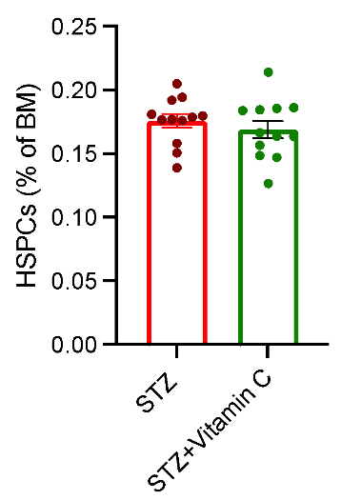 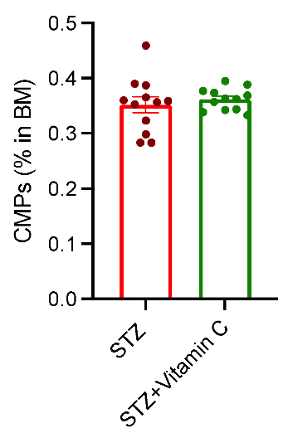 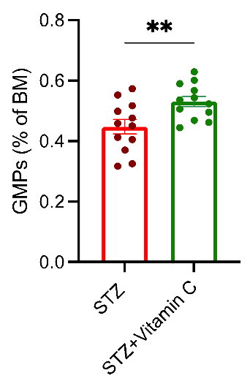

C

B

A

**Figure 6. Vitamin C doesn’t repress diabetes-triggered exacerbated myelopoiesis in the BM.** C57BL6 mice were injected (i.p.) with STZ (50mg/kg) for 5 consecutive days to induce diabetes. Mice were allowed to develop the disease for 1 week and then were introduced with plain water or Vitamin C (250µM) supplemented water for 8 weeks. Flow cytometry was used to measure the abundance of (A) LSK (HSPCs) (B) CMPs and (C) GMPs in diabetic and diabetic Vitamin C treated mice. n=12 per group. Two-tailed unpaired Student’s t-test, data presented as mean ± SEM. **p<0.01.

#### Vitamin C does not restore TET2 dysfunction in diabetes

To determine if TET2 activity was indeed altered by Vitamin C in HSPCs, cKit+ cells were isolated and 5-hmC levels were scheduled to be quantified. Unfortunately, the plate reader was malfunctioned and required fixing which was not possible to do within the time frame of this submission, and thus the results cannot be assessed yet.

Although being unable to assess the effect of Vitamin C on the 5-hmC profile in vivo, we decided to determine if isolating the effect of glucose in vitro could provide us with insights. Thus, we cultured isolated BM cKit+ cells, (consisting of HSPCs, CMPs, and GMPs) in high glucose in either absence or presence of Vitamin C. Concordant with in vivo flow cytometry data, Vitamin C significantly decreased 5-hmC levels in cells cultured with the addition of Vitamin C (**Figure 7**). This data suggests that Vitamin C is not capable to restore TET2 in hyperglycemic conditions but rather enhances the negative effect of high glucose on TET2 function.

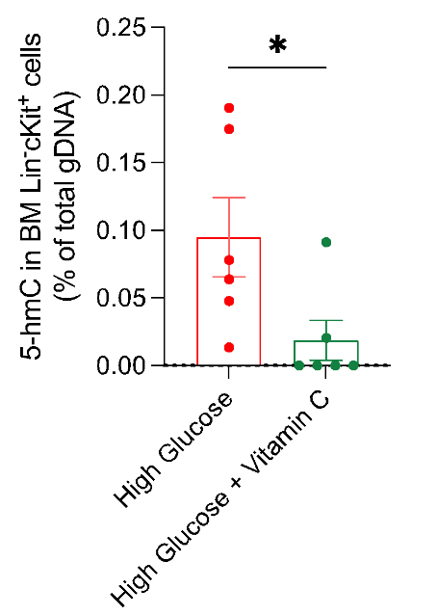

**Figure 7. Vitamin C decreases DNA hydroxymethylation, or 5hmC levels, in cKit+ cells cultured in high glucose conditions**. BM cells were harvested from C57BL/6 mice and sorted for the cKit+ subset using FACS. Sorted cells were cultured in high glucose (25mM) media either supplemented or not with Vitamin C (250µM) and 3 days after 5-hmC levels were measured. n=6 per group. Two-tailed unpaired Student’s t-test, data presented as mean ± SEM. *p<0.05.

To determine if the reduction of 5-hmC induced by Vitamin C was unique to HSPCs, we explored a number of concentrations of Vitamin C on bone marrow-derived macrophages (BMDM). We cultured BMDM in either normal or high glucose with Vitamin C added in the ascending series of concentrations 0, 10, 50, 100, and 250 µM for 7 days. After culturing, macrophages were harvested and 5-hmC levels were measured.

According to the obtained data, no strong relation was observed between 5-hmC levels and Vitamin C concentrations for both normal and high glucose conditions (**Figure 8**). Although no significant difference in hydroxymethylation status was detected between different glucose groups, DNA 5-hmC levels in the high glucose cultured cells were generally below the average line meaning that the overall impact of Vitamin C on 5-hmC status was detrimental in high glucose conditions. Consequently, Vitamin C was seen to be ineffective in restoring TET2 function in in-vitro-stimulated diabetic conditions regardless of its concentration and these findings are consistent with our in vivo data.

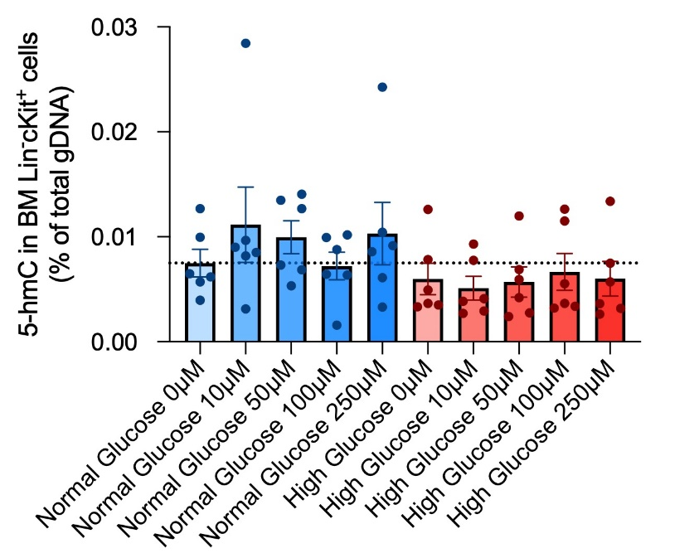

**Figure 8. Vitamin C doesn't facilitate restoring but rather negatively affects 5hmC levels in Lin- cKit+ cells in the condition of high glucose.** Bone marrow cells were harvested from C57BL/6 mice and cultured in BMDM stimulating media in high glucose (25mM) either supplemented or not with Vitamin C (250µM). After 7 days of culturing, cells were harvested and the 5-hmC levels were measured. n=6 per group. Two-way ANOVA test, data presented as mean ± SEM.

## Discussion

Exacerbated myelopoiesis promoted by diabetes is a crucial driver of atherosclerosis progression5. The underlying mechanisms of this process are partially understood; however, no successful therapies have been developed yet to suppress excessive myeloid cell production. As shown by previous studies, Vitamin C treatment imitates TET2 function recovery by increasing the TETs catalytic cycle rate and thus restores normal DNA demethylation profile in TET2 deficient cells. In this perspective, Vitamin C was proposed to be a potential targeted therapy to block an aberrant HSPCs self-renewal in pre-leukemic cells26. However, it was still unknown if this mechanism was relevant and similarly successful in the context of diabetes-triggered myelopoiesis.

Here, we discovered that Vitamin C is not able to restore diabetes-suppressed TET2 function and therefore normal 5-hmC levels in HSPCs, consequently, it cannot reduce an aberrant myelopoiesis. We observed that Vitamin C, besides being ineffective, is capable to promote further hematopoiesis disbalance towards myeloid generation meaning that the initial hypothesis is rejected. However, the data also showed that Vitamin C affected the 5-hmC profile positively when applied in normal glucose rather than in high glucose conditions meaning that in the high glucose microenvironment TET2 function cannot be restored independently on AMPK.

As previously shown, glucose has the potential to trigger epigenetic changes and thus initiate the development of cancer phenotype. In the AMPK-TET2 pathway, glucose impedes the phosphorylation of TET2 by AMPK, resulting in the instability of TET217. Unstable TET2 is subjected to time-dependent degradation by multiple pathways and therefore reduced AMPK levels entail the subsequent decrease in the number of functioning TET2 molecules27. Since Vitamin C does not promote TET2 phosphorylation but rather increases the enzymatic rate of already stabilized TETs, it is proposed that in the hyperglycemic environment, the effect of Vitamin C reduces with the decrease of functioning TETs. In this respect, in the future study, it is suggested to examine the effect of Vitamin C together with AMPK activators in the context of diabetes and if such a combination can provide positive results for restoring adequate 5-hmC levels.

Diabetes is a complex metabolic disorder that entails numerous pathogenetic alterations including chronic inflammation. Hyperglycemia is one of the major factors that drives and sustains the constant inflammatory state4. Glucose-driven AMPK dysfunction affects all AMPK-dependent pathways besides the AMPK-TET2 axis, and AMPK plays a crucial role in maintaining cellular metabolic homeostasis. The induction of antioxidant defense in response to oxidative stress, in particular, is AMPK-dependent. As shown by the Rabinovitch group, expression of antioxidant genes including catalase is rather reduced in AMPK knock-out cells, representing a direct role of AMPK in the regulation of cellular reactive oxygen species (ROS) levels28. Since this relation was not considered prior to conducting the current research, it could be the crucial reason for the inability of Vitamin C to effect TET2 levels and subsequently 5hmC. As mentioned in Cimmino’s study, the excess of Vitamin C can result in high ROS generation such as hydrogen peroxide, which is toxic for cells and normally decomposed by catalase26. In hyperglycemic conditions, suppressed AMPK activity entails reduced antioxidant gene expression and therefore accumulation of ROS, that stimulate premature cellular senescence and death28.Thus I postulate that supplementing Vitamin C treatment with the addition of catalase to ensure sufficient ROS elimination, may allow the restoration of TET2 and subsequently 5-hmC levels in the setting of diabetes.

## Conclusion

Our data clearly demonstrated that Vitamin C alone cannot restore TET2 function and therefore cannot suppress diabetes-driven myelopoiesis. Whether this occurred due to the lack of active TETs or catalase deficiency or deficiencies of other co-factors requires future research. In this perspective, since AMPK is known to be upstream of TET2 in the AMPK-TET2 pathway and responsible for the expression of antioxidant gene, perhaps the combined effect of Vitamin C with AMPK activation would be effective in the setting of diabetes.

# References

1. Rao Kondapally Seshasai, S. K. et al. (2011). Diabetes mellitus, fasting glucose, and risk of cause-specific death. *The New England journal of medicine, 364(9)*, 829–841.
2. Jiménez-Cortegana, C. et al. (2021). Nutrients and Dietary Approaches in Patients with Type 2 Diabetes Mellitus and Cardiovascular Disease: A Narrative Review. *Nutrients,* *13(11),* 4150.
3. Low Wang, C. C., Hess, C. N., Hiatt, W. R., & Goldfine, A. B. (2016). Clinical Update: Cardiovascular Disease in Diabetes Mellitus: Atherosclerotic Cardiovascular Disease and Heart Failure in Type 2 Diabetes Mellitus - Mechanisms, Management, and Clinical Considerations. *Circulation, 133(24),* 2459–2502.
4. Poznyak, A., Grechko, A. V., Poggio, P., Myasoedova, V. A., Alfieri, V., & Orekhov, A. N. (2020). The Diabetes Mellitus-Atherosclerosis Connection: The Role of Lipid and Glucose Metabolism and Chronic Inflammation. *International journal of molecular sciences, 21(5),* 1835.
5. Nagareddy, P. R. et al. (2013). Hyperglycemia promotes myelopoiesis and impairs the resolution of atherosclerosis. *Cell metabolism, 17(5),* 695–708.
6. Chambers, S. M. et al. (2007). Hematopoietic fingerprints: an expression database of stem cells and their progeny. *Cell stem cell, 1(5),* 578–591.
7. Sezaki, M., Hayashi, Y., Wang, Y., Johansson, A., Umemoto, T., & Takizawa, H. (2020). Immuno-Modulation of Hematopoietic Stem and Progenitor Cells in Inflammation. *Frontiers in immunology, 11*, 585367.
8. Xu, Y., Murphy, A. J., & Fleetwood, A. J. (2022). Hematopoietic Progenitors and the Bone Marrow Niche Shape the Inflammatory Response and Contribute to Chronic Disease. *International journal of molecular sciences, 23(4),* 2234.
9. Poznyak, A. V., Silaeva, Y. Y., Orekhov, A. N., & Deykin, A. V. (2020). Animal models of human atherosclerosis: current progress. *Brazilian journal of medical and biological research = Revista brasileira de pesquisas medicas e biologicas, 53(6),* e9557.
10. Libby, P. et al. (2019). Atherosclerosis. *Nature reviews. Disease primers, 5(1),* 56.
11. Wilck, N., & Ludwig, A. (2014). Targeting the ubiquitin-proteasome system in atherosclerosis: status quo, challenges, and perspectives*. Antioxidants & redox signaling, 21(17),* 2344–2363.
12. Murphy, A. J., Dragoljevic, D., Natarajan, P., & Wang, N. (2022). Hematopoiesis of Indeterminate Potential and Atherothrombotic Risk. *Thrombosis and haemostasis, 122(9)*, 1435–1442.
13. Barrett, T. J., Murphy, A. J., Goldberg, I. J., & Fisher, E. A. (2017). Diabetes-mediated myelopoiesis and the relationship to cardiovascular risk. *Annals of the New York Academy of Sciences, 1402(1)*, 31–42.
14. Ramaiah, L., Bounous, D. I., & Elmore, S. A. (2013). Hematopoietic System. Haschek and Rousseaux’s Handbook of Toxicologic Pathology, 1863–1933.
15. Kratofil, R. M., Kubes, P., & Deniset, J. F. (2017). Monocyte Conversion During Inflammation and Injury. *Arteriosclerosis, Thrombosis, and Vascular Biology, 37(1),* 35–42.
16. Kapellos, T. S. et al. (2019). Human Monocyte Subsets and Phenotypes in Major Chronic Inflammatory Diseases. *Frontiers in immunology, 10*, 2035.
17. Wu, D. et al. (2018). Glucose-regulated phosphorylation of TET2 by AMPK reveals a pathway linking diabetes to cancer. *Nature, 559(7715),* 637–641.
18. Murphy, A. J., Dragoljevic, D., Natarajan, P., & Wang, N. (2022). Hematopoiesis of Indeterminate Potential and Atherothrombotic Risk. *Thrombosis and haemostasis, 122(9),* 1435–1442.
19. Ito, K. et al. (2019). Non-catalytic Roles of Tet2 Are Essential to Regulate Hematopoietic Stem and Progenitor Cell Homeostasis. *Cell reports, 28(10),* 2480–2490.e4.
20. Han, D. et al (2016). A Highly Sensitive and Robust Method for Genome-wide 5hmC Profiling of Rare Cell Populations. *Molecular cell, 63(4*), 711–719.
21. Shi, D. Q., Ali, I., Tang, J., & Yang, W. C. (2017). New Insights into 5hmC DNA Modification: Generation, Distribution and Function*. Frontiers in genetics, 8,* 100.
22. Cai, Z. et al. (2021). Hyperglycemia cooperates with Tet2 heterozygosity to induce leukemia driven by proinflammatory cytokine-induced lncRNA Morrbid. *The Journal of clinical investigation, 131(1)*, e140707.
23. Rasmussen, K. D. et al (2019). TET2 binding to enhancers facilitates transcription factor recruitment in hematopoietic cells. *Genome research, 29(4),* 564–575.
24. Chung, T.-L. et al (2010). Vitamin C Promotes Widespread Yet Specific DNA Demethylation of the Epigenome in Human Embryonic Stem Cells. *Stem Cells, 28(10),* 1848–1855.
25. Fritz H. et al (2014). Intravenous Vitamin C and Cancer: A Systematic Review. *Integrative Cancer Therapies, 13(4),* 280-300.
26. Cimmino, L. et al (2017). Restoration of TET2 Function Blocks Aberrant Self-Renewal and Leukemia Progression. *Cell, 170(6),* 1079.
27. Zhang, T. et al (2019). Phosphorylation of TET2 by AMPK is indispensable in myogenic differentiation. *Epigenetics & chromatin, 12(1)*, 32.
28. Rabinovitch, R. C. et al (2017). AMPK Maintains Cellular Metabolic Homeostasis through Regulation of Mitochondrial Reactive Oxygen Species. *Cell reports, 21(1)*, 1–9.

# Appendix

#### Supplementary table

Table S1. Key Reagents Table

|  |  |  |
| --- | --- | --- |
| Reagent | Source | Identification code |
| *Mouse strain* | | |
| *C57BL/6* WT | SVI | N/A |
| *Chemicals* | | |
| Streptozotocin | AdipoGen | AG-CN2-0046-G001 |
| *Flow antibodies* |  |  |
| Pacific BlueTM anti-mouse CD45 Antibody  (clone: 30-F11) | BioLegend | Cat#103126 |
| PerCP-cytm 5.5 rat anti-mouse Ly-6G/Ly-6C (gr-1) Antibody  (clone: RB6-8C5) | BD Sciences | Cat#552093 |
| Brilliant Violet 605TM anti-mouse CD115 Antibody (clone: RB6-8C5) | BioLegend | Cat#135517 |
| PE anti-mouse CD3 Antibody  (clone 17A2) | BioLegend | Cat#100206 |
| FITC anti-mouse CD8a Antibody  (clone: 53-6.7) | Introvitrogen | Ref#11-0081-85 |
| BUV496 anti-mouse CD4 Antibody  (clone: GK1.5) | BD Sciences | Cat#612952 |
| APC anti-mouse/human CD45R/B220 Antibody (clone: RA3-6B2) | BioLegend | Cat#103212 |
| FITC anti-mouse CD3 Antibody  (clone: 500A2) | BioLegend | Cat#152304 |
| FITC anti-mouse/human CD11b Antibody  (clone: M1/70) | BioLegend | Cat#101206 |
| FITC anti-mouse Ly-6G/Ly-6C (Gr-1) Antibody  (clone: RB6-8C5) | BioLegend | Cat#108406 |
| FITC anti-mouse CD19 Antibody  (clone: MB19-1) | ThermoFisher | Ref#11-0191-85 |
| FITC anti-mouse CD4 Antibody  (clone: RM4-5) | BioLegend | Cat#100510 |
| FITC anti-mouse TER-119/Erythroid Cells Antibody  (clone: TER-119) | BioLegend | Cat#116206 |
| FITC anti-mouse/human CD45R/B220 Antibody  (clone: RA3-6B2) | Invitrogen | Ref#11-0452-85 |
| FITC anti-mouse CD2 Antibody  (clone: RM2-5) | BioLegend | Cat#100105 |
| APC/Cyanine7 anti-mouse CD117 (c-kit) Antibody  (clone: 2B8) | BioLegend | Cat#105826 |
| Pacific BlueTM anti-mouse Ly-6A/E (Sca-1) Antibody  (clone: D7) | BioLegend | Cat#108120 |
| PerCP/Cyanine5.5 anti-mouse CD64 (Fc𝛾RI) Antibody  (clone: X54-5/7.1) | BioLegend | Cat#139207 |
| APC anti-mouse CD34  (clone: HM34) | BioLegend | Cat#128611 |
| DAPI | Sigma | D9542-1MG |

#### Supplementary figures

C

B

A

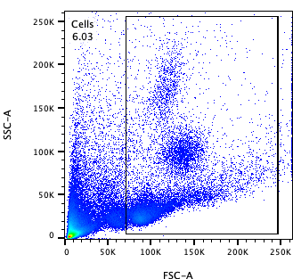 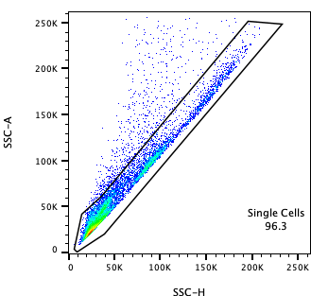 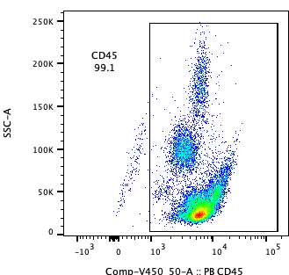

PB-CD45

SSC-A

SSC-A

SSC-A

FSC-A

SSC-H

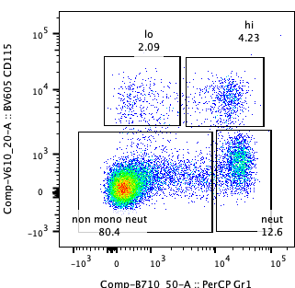 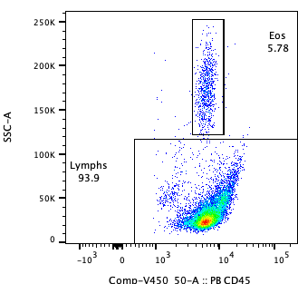 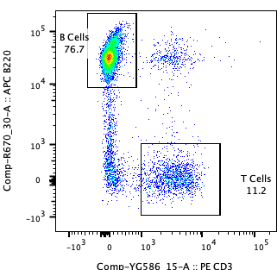

F

E

D

PerCp-Gr-1

BV605-CD115

PE-CD3

APC-B220

PB-CD45

SSC-A

**Figure S1. Gating strategy for mouse blood leukocytes.** (A) Side scatter area (SSC-A) vs. forward scatter area (FSC-A) graph was used to gate all living cells. (B) SSC-A vs. side scatter height (SSC-H) graph was used to gate single cells. (C) SSC-A vs. CD45graph was used to gate immune cells. (D) From the CD45+ population, CD115 vs. Gr-1 graph was used to gate Ly6-Chiand Ly6-Clomonocytes, neutrophils, and non-myeloid cells. (E) From non-myeloid cells, SSC-A vs. CD45 graph was used to gate lymphocytes. (F) From lymphocytes, B220 vs CD3 graph was used to gate B220+ B Cells and CD3+ T Cells

C

B

A

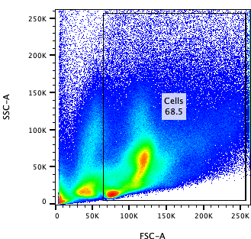 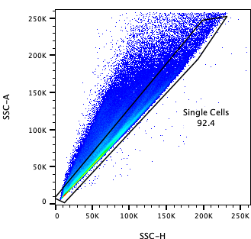 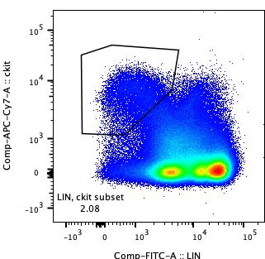

APC/Cγ7-cKit

FITC-Lineage

SSC-H

SSC-A

FSC-A

SSC-A

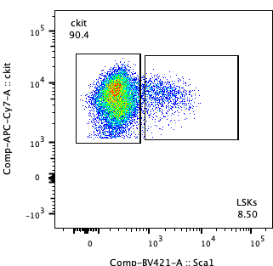 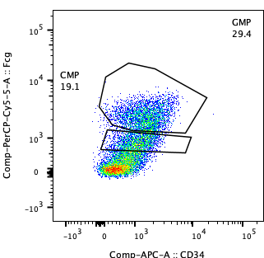

E

D

APC-CD34

PerCP-Fcγ

PB-Sca1

APC/Cγ7-cKit

**Figure S2. Gating strategy for mouse bone marrow cells.** (A) Side scatter area (SSC-A) vs. forward scatter area (FSC-A) graph was used to gate all living cells. (B) SSC-A vs. side scatter height (SSC-H) graph was used to gate single cells. (C) On cKit vs. lineage graph, Lin- cKit+ cells were gated. (D) From the Lin-cKit+ population, cKit vs. Sca1 graph was used to gate Sca1+ LSKs (HSPCs) from Sca1- cKit+ subset (HPCs). (E) From Sca1- cKit+ cells, Fcγ vs. CD34 graph was used to gate CMPs and GMPs.