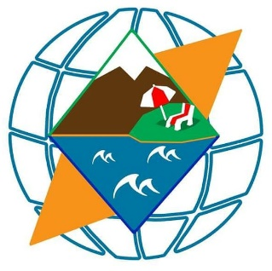

Strategic marketing communication plan

West Georgia LLC: Travel agency

*By Steven Assink*

Batumi, August 20, 2018

**Author Class**

Assink, Steven 1085254 CE5

**University Mentor**

University of Applied Sciences Roon van, Jolijn

Zernikedreef 11

2333 CK Leiden, Netherlands **Professor**

Feijen, Ed

**Degree Academic term**

Commercial Economy 2013-2017

**Phase of the study Academic year**

Academic graduation paper 2017-2018

**Status text Company**

Final II West Georgia LLC.

**Supervisor/director**

Zurab Meskhidze

# Preface

The aim of this report for travel agency West Georgia is to produce a marketing communication plan for the spring/summer touristic season 2018. The aim is to explore a new customer segment of EU residents, raise brand awareness and generate higher sales. Because tourism is a big industry based on many small businesses according to Ilia State university Georgia 2016 research report, Batumi market consists of diverse small tourism agencies offering similar services on different quality standards as well. West Georgia is one of these companies that offers services to incoming tourists and will need to explore its competitors, the behavior patterns of potential target segment and set its goals on expanding its communication channels. Role of tourism in the development of national economies, international trade, and the social and cultural life, makes it necessary to give high importance to tourism, thus making it a rapidly growing industry, specifically in Georgia and its second major destination-Batumi city. Due to the rising interest of tourism in Georgia country overall in the recent years, West Georgia is capable of making a strong entrance in the transformed market of international tourism from 2018, although it is a relatively new start-up of three years.

# Executive summary

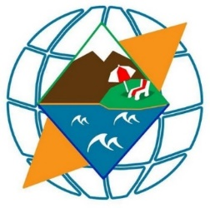West Georgia is a travel agency founded in 2016, in Batumi, Georgia. The main operating activity is offering across country tours to incoming tourists, majorly during summer season of May through October. West Georgia team consists of 10 staff members with the foreign representation of 50%. Its primary competition includes multiple large and experienced travel agencies and a 100s of small local founded tour firms. WG firm also offers services such as accommodation, food & drinks and tours in Georgian, Russian, English and Arabic languages.

West Georgia has hosted tourists from a few different countries such as Israel, Ukraine and Russia but not any English speakers until 2018. It is noteworthy that West Georgia has been competing with a big market of travel agencies offering services in Russian. It should be emphasized that the statistics of overall Batumi tourism market suggests that Russian speaking tourists have been more common compared to the past few years of new incoming Western European segment. On the other hand, because of optimistic data for more tourists arriving to Georgia by the year, with heightened percentage of West Europe countries, West Georgia has decided to differentiate and make West European incoming tourists who speak English, its target segment.

It needs to be emphasized that there has been no marketing department at all in WG until 2018 February when Steven Assink got hired for an internship, so this is the first marketing communication plan there has been written for West Georgia. More Precisely, this is the first marketing communication plan based on field and desk research done solely in 20 weeks of the internship period, 2018. There have been a few recommendations involved form the Director of the agency as well as colleagues, but the research and overall communication plan was created by Steven Assink. Although, it is also noteworthy that the company needs further research in order to make the marketing communication plan more extensive, precise and effective in the future.

The main target of West Georgia has been residents of neighboring countries around Georgia and Israel. It has already provided its services to over 200 tourists but overall its brand awareness is low. Research has determined that there is a window of opportunity for West Georgia to differentiate and use its strengths of English Language together with high quality service and target the new influx of West European tourists. Thus, the target group apart from the post-soviet country visitors, who are already aware of Georgia, its sights and can acquire services in Russian language without a challenge, will be new West European tourists. These incoming tourists have been actively getting interested and visiting Georgia since two years now.

The objectives of West Georgia for the 2018 season include raising brand awareness, successfully targeting the new West European segment and increasing sales respectively. Precisely, West Georgia travel agency expects to reach the goal of **20% sales increase** compared to **2017 numbers of serving 100 tourists**. In order to achieve its goals, West Georgia has allocated the budget of 5000 GEL-$2000 and will spend it on promotional tools discussed in detail in this communication plan. Additionally, the objectives will be reached through the creation of updated business cards, brochures in three languages, targeted public relations activities, being present on social media platforms commonly used by competitors and creating new features for the website. A strategic combination of these promotional elements will yield measurable positive results for West Georgia travel agency.

Table of contents

Preface

Executive summary

1. Introduction 7

1.1. Background 7

1.2. Context 9

1.3. Problem Formulation 9

1.4. Purpose 9

1.5. Structure and limitations 9

2. Research method and approach 11

2.1 Theoretical background 11

2.2 Method 14

3. Desk research 15

3.1. External analysis 15

3.1.1. Tourism sector Georgia 15

3.1.2. Industry 16

3.1.3. Economic trends 17

3.1.4. Competitors 18

3.2 Segment analysis 19

3.2.1 Incoming visitors by border type 19

3.2.2 Needs and Wishes 20

3.3 Background West Georgia LLC. 21

3.3.1 Mission 21

3.3.2 Vision 21

3.3.3 USP’s 21

3.3.4 Value proposition 21

4. Internal analysis 22

5. Field research 27

5.1. Primary Research 27

5.2. Research Objectives 28

5.3. Key Findings 28

6. Marketing Communication Plan 30

6.1. Communication target group 30

6.2. Marketing target group 30

6.2.1. Types of arrivals 31

6.2.2. Target group formulation 31

6.3. Communication 32

6.3.1. Message 32

6.3.2. Knowledge 33

6.3.3. Attitude 34

6.3.4. Behaviour 34

6.4. SMART Goals 35

6.5. Communication SMART goals 38

6.6. Marketing promotional Tools 39

6.6.1. Personal selling 39

6.6.2. Public Relations 40

6.6.3. (online) Advertising 40

6.6.4. Direct Marketing 41

6.6.5. Sales promotion 41

7. Budget and Schedule 42

7.1. Schedule 42

7.2. Budget 42

7.3. Expected revenue 43

8. Evaluation 44

Bibliography 45

Table of figures 47

Attachment

1. Tables and figures

2. Interview qualitative

3. Business Card

4. Brochure

5. Wrapped van

6. Company clothing

7. Website and Facebook

# Introduction

## Background

Georgia is a Caucasian country with almost 3,7 million residents and a climate zone range from hot subtropics to permanent snowy mountains. Tourism makes up a huge sum of country’s GDP and enables employment as well as business opportunities for its locals. The government’s pro-Western orientation has encouraged American and West European visitors and the numbers keep growing according to (GNTA, 2018). Because the Georgian government believes tourism has to be the priority for the country’s developmental benefits, infrastructure reconstructive works and international tourist campaigns are led. West European countries have not been informed about the country and its touristic attractions until past few years ago and specifically since 2016. In January – April 2018 the number of international arrivals in Georgia amounted to 2,060,264, showing an increase of 15.9% compared to the same period of previous year’. (GNTA, 2018).

**Europe Map** (University of Minnesota , 2016)

Because the new influx of West Europeans will be frequently discussed and used in this communication plan, it is important to define the term and take a look at the map for clarity.

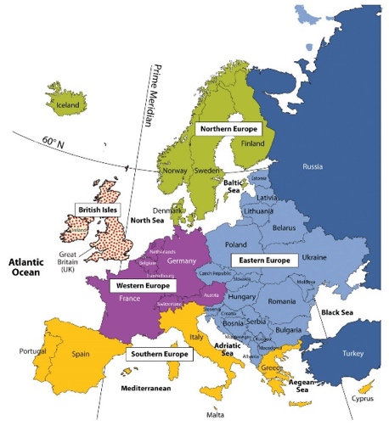Although Georgia is exactly in the middle of two continents-Europe and Asia, the country politically as well as racially identifies as European. Georgia is part of the free travel zone with the EU countries and is extremely Europe oriented. It is important to mention that some of the Eastern European countries will be referred to as Post-soviet countries in some cases in this plan, although the new targeted segment of West European tourists that speak English language covers all the countries that belong to West Europe. It should be emphasized that the map makes distinctions between West, South, Eastern and Norther European countries. The Western European countries with addition of the ‘British Isles’ is the major focus of the targeted audience in this marketing communication plan.

Figure 1 - Europe map

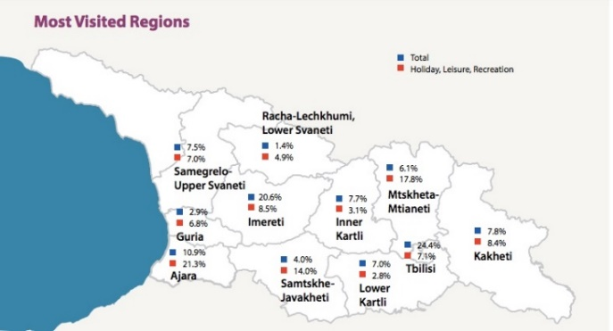Furthermore, the optimistic tourism growth in the country, Adjara region where WG offers most if its services, is the second most visited area according to (GNTA, 2018) most visited regions figure.

Figure 2 - Most visited regions Georgia

According to the (GNTA, 2018) map, Batumi is the second most visited city after the Capital Tbilisi by tourists. This allows the Batumi beach resort attractions to influence tourists into spending their vacations on the coast city. Batumi offers both mountain and the beach vacation opportunities for the season of 5 months- May through October. Georgian Tourism Department has shifted their focus from targeting mostly post-soviet, neighboring countries and Israel, towards Western European travelers who have sparked interest in the country. Residents of post-soviet have preliminary knowledge about Georgia due to shared historical background and convenience of Russian language. Therefore, Georgian travel agencies just like all the other service providers in all the regions have been heavily concentrated on creating standards that satisfied the needs and wishes of these new targeted consumers, who have different needs and wishes.

Yet, for the past few years, Georgia has been targeting the Western Europe through giving special treatment to the 6th millionth visitor who turned out to be a Dutch blogger (Georgia and Travel, 2017), supported the program “Wie is de Mol” after which the country has already received increased number of westerners as visitors and is expecting more this 2018 season. All in all, the government together with the tourism department are focused on raising awareness about Georgia, its beautiful nature, friendly and hospitable people and attractions not only in post-soviet countries but also in West Europe.

Since the exploration of competitors was done in person and in as much detail as possible together and with the recommendations of the director and founder of West Georgia agency, it turned out that the majority of competitor travel agencies concentrate on attracting Russian speaking tourists due to their Russian and Georgian language skills only. Further, because only young generation speaks English in Georgia, all the other services offered in Batumi specifically requires the tourists to speak Georgian/Russian to be able to order taxis, do groceries, where labels on foods are also not in English, order food etc. Therefore, the differentiation opportunity for west Georgia is to concentrate on hosting English speaking tourists who are already entering country borders and make them feel welcome and comfortable in the country.

It should be emphasized that (Investment, 2017) released an article recently, stating that ‘the flow from Western Europe increased by 27.8%. 104,575 people in 2017 compared to 81,813 in 2016. The most active countries were Austria, 5,750 in 2016, 7,779 in 2017, France - 15,044 in 2016 against 19,502 in 2017, the Netherlands - 10 081 in 2016 against 13,215 in 2017 and Switzerland - 4,702 in 2016 against 6,395 in 2017. Active growth was also shown by German and Belgium tourists.

This means larger opportunities and a bigger segment for West Georgia to attract and target starting this summer 2018 as the prognosis of more tourists entering Georgia in 2018 suggested by Georgian National Tourism Administration. (GNTA, 2018)

## Context

West Georgia is a travel agency in the seaside city, Batumi, Georgia which operates inside the country borders including services such as accommodation, food & drinks and tours. The firm offers its services in Georgian, Russian, English and Arabic languages. West Georgia has hosted tourists from a few different countries such as Israel, Ukraine and Russia. It is noteworthy that West Georgia has been competing with a big market of travel agencies offering services in Russian. GNTA releases optimistic data for more tourists arriving to Georgia by the year, with heightened percentage of West Europe countries especially. Consequently, West Georgia has decided to differentiate and adopt the Western European segment that matches the services WG can offer. Specifically, tours in English language, insured and modern transportation vans.

## Problem Formulation

West Georgia travel agency has one main question for its problem formulation, which is the following:

*“What marketing communication strategy channels can West Georgia agency implement, to target the incoming Western European segment in Georgia for 2018 season?”*

Thus, the core aim of this paper is to answer the problem formulation question.

## Purpose

This report answers the questions of what communication strategy channels West Georgia could potentially adopt for achieving a successful 2018 touristic season of May through October. Precisely, the plan will discuss the optimal marketing communication plan strategy chosen by WG, its tools, promotional tactics and channels of what type of content to deliver to the Western European segment this season. It should be noted that all the promotional tools or strategies discussed below are supported by desk researched business models and theories.

## Structure and limitations

The structure of this marketing communication plan for West Georgia travel agency is as follows:

The first Chapter of this report informs the reader about the country of Georgia, its touristic character and describes the city where West Georgia is based as well. Information of such type allows the audience of this report to understand the reasons why West Georgia operates, how it functions and why it is needed on the market.

As for the second chapter, it discusses the reasons and the methods how a small interview research was conducted with previous customers of West Georgia agency and discusses the qualitative interviews held with Western European Tourists that visited Georgia this 2018 summer season. The combination of the two allowed the content of this report to be valid and based on trustworthy data.

Further, the third chapter gives the crucial piece of information about the company WG’s mission classified within micro, meso and macro levels. Firstly, the micro level includes the company’s vision, its unique selling points and its proposition. Secondly, meso level discusses the Business model canvas elements as well as segment analysis. And lastly, macro level includes details for external analysis of tourism sector, industry, economic trends and competitors for West Georgia.

Moreover, fourth chapter has been dedicated to giving information about the further specifics about conducted field research interviews and the results.

Continuing, fifth chapter includes compatible data about marketing for WG, its tools and strategy.

Similarly, sixth chapter gives the reader knowledge of the data about communication, its strategy and tools for West Georgia agency.

Lastly, seventh and eights chapters involve budgeting and scheduling information as well as an overall valuation of the communication plan for West Georgia for 2018.

**Limitations**

It was necessary to have held qualitative interview research with future potential customers about their specific needs and wishes in Georgia whilst choosing travel agencies and reasons for it. Subsequently, two hotels were chosen with different price ranges, Hilton Batumi and Local Hotel Vakhtanguri. The potential clients from Western European countries were invited to the interviews by the hotels management team and offered a free beverage in case of participation. Because the interviews were held in the lobby/breakfast lounge area of these two hotels which are usually chaotic, there is a limitative chance that the answers were given hastily and not fully thought through by the interviewees. Therefore, not all the answers to the interview questions could have been deep and through enough.

# Research method and approach

The primary issue that has showed itself on the Batumi tourist services market is the lack of English language usage in all types of services as well as the poor knowledge of English language overall. Thus, West Georgia, being a young agency established by Zurab Meskhidze, Batumi State University alumni, in 2016, is striving to engage these English-speaking tourists from West Europe and give them high quality services.

The core focus of West Georgia is to research its new target segment which will be the English language speaking tourists who have entered the country and do not have pre-planned travel packages with tourist agencies already. West Georgia needs to know its audience well which is why, both desk and field researches were carried out in order to comprehend how to target the West European segment effectively. The desk research was completed according to online databases and in person conversations with West Georgia staff, tourist information centers in Batumi, as well as hotel staff. As for the field research, 5 past customers were interviewed, who were not English Speakers, but still valuable to collect the feedback from. Additionally, partnerships with two hotels were made, Hilton and Vakhtanguri, which helped WG agency arrange interview meetings with Western European visitors who spoke English. They were interviewed about their first impressions of the country and the city of Batumi especially, their future needs and wishes.

## Theoretical background

The Marketing communication plan is based on data collected from West Georgia team, Georgian national statistics agency statistics and qualitative interviews held with past customers of the firm as well as new Western European English-speaking tourists through two Batumi city hotels. Firstly, West Georgia decided to organize its missions, goals and strategies in a different way in 2018 than before. Precisely, the team has decided to focus more on the Western European potential consumers due to their growing interest in travelling to Georgia in 2018. Additionally, because the majority of Georgians in the tourism industry do not speak any western languages and can only offer their services in Georgian or Russian, West Georgia has the window of opportunity to use its expertise in high standard and safe tour organizing in English. Although the firm already had services available that directly match the needs of Western European tourists, West Georgia had not focused or put much effort into targeting the West European segment till this year.

It needs to be underlined that this research and the overall marketing communication plan has been focused on the service of guided tours only, specifically for new Western European segment. Although travel agencies offer more types of services and full packages than just guided tours such as plane tickets, hotels, transfers, food arrangements etc., the tours offered to tourists has been chosen as focus in order to deliver a better-quality result for the company.

**Objective**

What marketing communication strategy channels can West Georgia travel agency implement, to target the incoming Western European segment in Georgia for 2018 season?

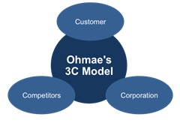**Theoretical framework**

3C model of Ohmae was used to create the theoretical framework for the communication plan for West Georgia. Because the model focuses on three main components of Corporation, customers and competitors, it is a perfect fit for West Georgia to base its business strategy on.

First of all, the customer link of the model keeps WG agency from distracting from its original target audience focus.

Figure 3 - Ohmae's 3C model

The main targeted audience is the newly chosen target group of English Speaking Western Europeans. It is important to mention that West Georgia will still be hosting the Russian speaking clients who were the main target before shifting the focus to English speaking Western European for the 2018 season. Although the segment is not a small group to focus on for a small newly created agency such as West Georgia, the company is putting its best efforts into keeping a clear focus on predicting what pleases its newly targeted customers.

Secondly, the competition is a link West Georgia has put considerable amount of time exploring. Positively, West Georgia does not have a large competition when it comes to hosting English speaking groups of tourists in Georgia. WG has focused on exploiting the weaknesses of its competitors as well, which are the inability to guide tours in the English language, high quality transportation and professional digital marketing set up, including a website and social media accounts.

Last but not the least, although the 3C’s of Ohmae is not a complex business framework for making strategic decisions, a small company as West Georgia has set out on relying on this framework to stay focused. Meaning, WG agency is making its touring service competitively priced and reliable, as well as comfortable and of high quality. For this given period, West Georgia is offering advice on accommodation units and breakfast/dinner arrangements if the clients request it with the addition of airport transfers. Yet the main service of the company stays the one or two-day tours across country during summer seasons only.

**Sub-questions:**

**Customer**

1. What attracts tourists in West Georgia services?
2. What channels do tourists use to get in touch with West Georgia?
3. Where are the customers located and what is their behavior like?
4. How do potential clients of West Georgia get in the country?
5. Through which channels did customers find out about the services of WG agency and decided to purchase them?
6. What are the most important aspects of the tour for the customer to be satisfied and happy with the purchase?
7. What are the perks and drawbacks customers experienced all throughout the trips?
8. Which benefits fit the Western European target group that West Georgia can offer and affect their behavior as well as choice of West Georgia services?
9. Which benefits is the target group not aware of?
10. Which faulty knowledge do they have?

**Competitors**

1. Who are the major competitors on the market?
2. Through which channels do competitors communicate with tourists in Georgia?
3. What are their main weaknesses?

**Corporation**

1. Which resources does West Georgia need to organise tours successfully?
2. What are the services offered by travel agencies in Georgia?
3. What feelings West Georgia evokes for its consumers?

Note that, the company needs further extensive research and careful strategizing in order to be able to differentiate successfully and reach all its goals for the long term.

## Method

The Marketing communication plan has been based on direct data about the company’s current and past activities collected from West Georgia team, Georgian national statistics agency data and qualitative interviews held with past as well as potential customers of the West Georgia firm.

(Grit, 2008) model was used to base the overall methodology of gathering information in terms of browsing the literature about all the necessary topics for the marketing communication plan. Further, trustworthy literature with the compatible content was read in meticulous detail and studied in order to gather supportive data for the plan.

Figure 4 - Grit model

After getting acquainted with the needed information closely, both academic theories and statistical data sets that represented the relevant information was selected to be included in the development of the communication plan. The final step, as depicted on the arrow with the naming of “compatible data focus’’, was to have all the supporting pieces of information included in order to produce the final plan for West Georgia travel company.

More precisely, Academic research reports and informative academic articles have been used as cited in the references from the EBSCO databases. Additionally, general country and city specific statistics have been introduced through Georgian National Statistics Agency online Portal. One of the major sources of collecting data about tourism including meticulous research details has been based on GNTA statistics which are updated every month. (GNTA, 2018). The GNTA statistics department posts every single updated detail and statistical information about tourism trends, incoming tourist numbers, mostly visited areas in Georgia etc. Moreover, Georgian Ilia State University reports were also used for determining necessary data for this marketing communication plan. Apart from these sources with valid information, compatible information from the books were included in the communication plan for West Georgia such as: Project Management by (Grit, 2008), Principles of Marketing by (Kotler, 2006), Marketing communication strategy (Ko floor, 2014).The core research data for determining the needs and wishes, experiences and interests of tourists who already visited Georgia was based on the field research in terms of qualitative interviews conducted with Western European English-speaking tourists who visited Georgia in 2018 summer season and were customers of two Hotels, Hilton Batumi and Hotel Vakhtanguri.

# Desk research

## External analysis

Desk research was based on data provided by Georgian National Tourism Administration and Georgian Ministry of foreign affairs. The retrieved information included supportive facts for successful potential of operating a travel agency in Adjara region and Batumi city, due to interest of tourists and increased influx of Western Europeans. External analysis also includes details about Batumi city, its potential for attracting visitors through beach and mountain resorts, cultural events and concerts as well as a vibrant atmosphere.

### Tourism sector Georgia

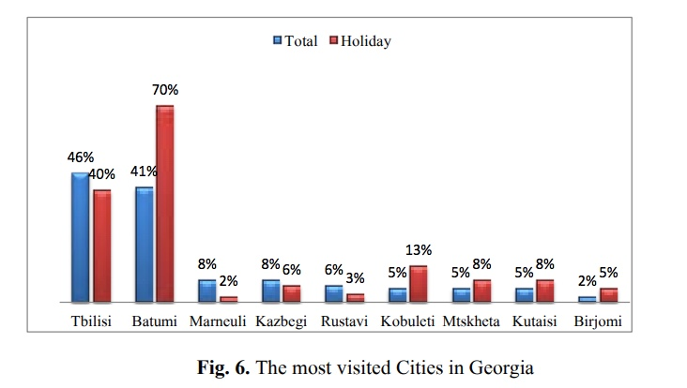“This small country at the crossroads of Europe and Asia recorded passenger traffic growth of 26 percent in 2016 and expects even faster growth of approximately 40 percent in 2017,” [says CAPA,](http://centreforaviation.com/analysis/georgia-aviation-market-part-1-tourism-drove-26pc-growth-in-2016-projected-40pc-growth-for-2017-339836) (CAPA, 2018), which offers independent aviation market intelligence, analysis and data services. The number of visitor arrivals by air increased by 40 percent compared to 2015, when visitors accounted for approximately 68 percent of total Georgia traffic. Additionally, Georgia has benefitted from instability in Turkey as tourists who would be planning holidays in Turkey look for other alternatives, said the report. In the most recent month, March 2017, Georgia reported a 68 percent increase in visitor arrivals by air, to 101,000

Figure 5 - The most visited Cities in Georgia 2016

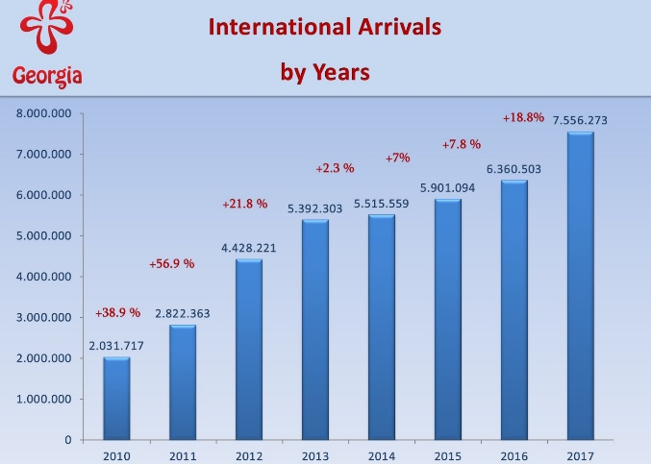In 2017, 7,6 million tourist visited Georgia, which is the increase of 18,8% compared to 2016. However, in 2013 the number of international arrivals grew by 22%, overstepping the five million mark for the first time and by 2017, reached its 6 million visitors. The data issued in 2016 by Georgian national statistics marks the growing amount of 16,8 % of all parts of Europe residents visiting Georgia, Batumi being the most visited destination for holidays. (70%). (GNTA, 2018) .

As a result, West Georgia is able to offer its customers the dazzling trips towards the most popular destinations while targeting its current post soviet segment as well as newly strategized English-speaking segment from Western Europe. The new segment has been encouraged by increasingly promising visitor statistics and growing number of western European as well as Northern American, Arabic and Asian countries’ residents.

Figure 6 - International visitors in Georgia

According to the World Tourism Organization report, "UNWTO World Tourism Barometer", (UNWTO World Tourism Oranization, December 2013) an increase in the number of international arrivals in Georgia was rated as the highest in Europe, considering the fact that Georgia is part of Europe as well, which is why it has been included in these statistics. Competitiveness of Georgian Tourism on the world market increased by seven positions ranking 66th among 140 nations in the Travel & Tourism Competitiveness index (Score: 4.10 in 2013) compared with 2011 (73th position). (Ministry of Internal Affairs of Georgia, 2013).

### Industry

**Batumi Tourism Profile**  
Batumi is located in the south-west part of Adjara region which is one of the most beautiful parts of Georgia, located near the border with Turkey. In Georgia, especially in Adjara, there are unique natural conditions for the development of all types of tourism. Adjara is famous for sun and beach tourism as well as for ecotourism (rural tourism) and entertainment. Today, Batumi is a fast-growing tourist region. Batumi has undergone serious changes and reforms, significantly improving its worldwide image and making its investment climate more attractive to foreign investors. The hospitality market in Batumi is developing as the inflow of foreign visitors, businessmen and delegations increases at a fast pace, which is attracting well-known international hotel chains.  
Currently a few international upscale brand hotels are present in Batumi: Radisson, Sheraton, Grand Rixos Hotel, Hilton and Holiday Inn.  
Today Batumi has become a distinguished tourist center on the Black Sea coast. Recent years have seen unprecedented measures taken to develop and encourage the development of the tourist market. The residential houses of Old Batumi have been reconstructed; water supply and drainage systems have been totally restored and renovated. Many tourist attractions have been created and international brand hotels have opened. Batumi has become a center of cultural events and international gatherings. Concerts attract the participation of world celebrities and the city hosts international festivals in art and sports. Batumi is distinguished by its abundance of diverse architectural buildings, which give the city a vibrant atmosphere.

See attachment 1.1: International arrivals 2016-2017 for specific numbers of incomers by country. Attachment shows that Western Europeans hold 1,8% share of the incoming tourists in Georgia during 2016 and 2017, occupying 31% increase. This data is significant to show that West Georgia travel agency has focused on the Western European English-speaking tourists on promising and realistic statistics.

See attachment 1.2: English speakers per EU country visiting Georgia.

In order to be able to define who of the Western European tourists is able to speak in English, a simple, yet effective tactic was used in order to determine a rough approximation of the number of tourists from West Europe that could potentially speak English.

### Economic trends

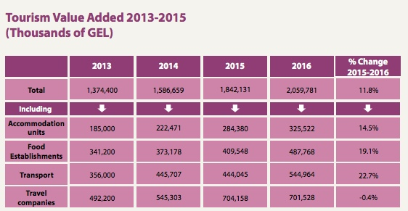Total expenditure by domestic visitors during the estimation period was 1.6 billion GEL- 652,583$ and average expenditure per visit was 125 GEL- 51$. The largest share of visitors’ expenditures, 28.6%, was registered on served food and drinks. (GNTA, 2018).

Figure 7 - Tourism Value Added

Revenues from tourism sector grow on annual basis in Georgia. Despite two regions of Georgia have been invaded, tourists consider Georgia to be an attractive country anyway. Over the past 10 years, tourism is an only sector in Georgian economy that grows on annual basis, despite global or regional crisis periods. It should be also noted that tourism sector has become one of the important sources for currency inflows to the country. According to the statistics of national tourism administration, the year of 2016 and the beginning of 2017 were especially successful in terms tourist and currency inflows from tourism sector. (GNTA, 2018).

According to National Tourism Administration, positive trend is maintained with EU countries too. In March inflow of tourists from Poland rose by 39%, France +38%, Germany +19%, Greece +18% and Lithuania +17%. Overall, these are positive indicators that tourism is a very important aspect of the Georgian economy.

According to Ministry of Finance of Georgia report in January 2018, (Ministry of Finance of Georgia, 2018). Tourism revenues have been growing over the past few years and have been contributing positively to the economic condition in Georgia, with the ratio of tourism revenues in total GDP marked between 7.1% and 11.8% from 2016.

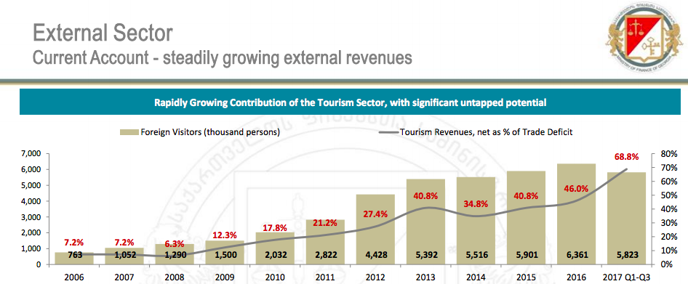

Figure 8 – Steadily growing external revenues, Georgia

### Competitors

The Georgian tourist branch counts hundreds of agencies which support tourists and their needs. On the other hand, there are only a few other agencies that operate in the same areas as West Georgia and offer services in English. **The rest of the agencies are quite small, do not have company logos, websites or services in English.** It should be noted that even the few travel companies written below that present competition to West Georgia, the URLs tend to be lacking information and include spelling mistakes for the English version of the webpages. (See attachment 1.3 for a list of competitors). Therefore, West Georgia can start working on its strengths and show a more professional, organized & trustworthy side of the brand to tourists.

According to the competitive behavior theory by (Kotler, 2006), West Georgia stands in the “niche’’ area of the four market places. To be more precise, West Georgia is able to provide satisfaction for the English-speaking tourists that other larger market leaders cannot really fulfil due to their lack of the language skills. The competitors table in the attachment 1.4 shows what channels the direct competitors of WG use.

Furthermore, online reviews were thoroughly read on Facebook, TripAdvisor, Yelp in order to gather more data about the competitor travel agencies of WG. In order to determine the price ranges for their offered services, websites were checked, and emails were sent when the prices were not mentioned either on brochures or anywhere online. Precisely, the emails were sent from the addressing name of Steven Assink, asking for prices and trips available during the summer season 2018.

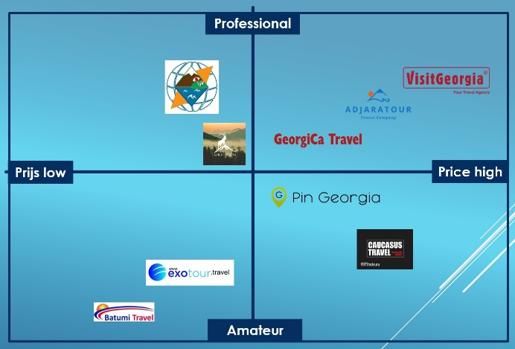Moreover, to be able to get an overview of how reachable competitor agencies were, the use of website, response rate and time on emails, presence on social media were evaluated.

The nonexistence of websites was counted towards the lack of communication channels and challenge of reach from potential customers compared to the agencies that had more channels available for customers and had obviously invested time and money into being findable through having set up informative websites and being present through different online channels.

Figure 9 - Perceptual map competitors

## Segment analysis

### Incoming visitors by border type

To know where the customers will be located and what their next behavior will be like, it’s important to analyze how they get into the country first. The answer to this question will help to determine which channels could be used for engaging with the customer. Subsequently, West Georgia will know what the first step is for determining the place where tourists need to find information about the existence of these comfortable and super interesting trips WG agency offers.

So, (GNTA, 2017) research shows that visitors arrive into the country by four border types.

|  |  |  |  |  |  |
| --- | --- | --- | --- | --- | --- |
| **Type** | **2016** | **2017** | **change** | **change %** | **Share %** |
| Land | 5.182.780 | 5.880.763 | 697.983 | 13,5% | 77,8% |
| Air | 1.066.597 | 1.565.305 | 498.708 | 46,8% | 20,7% |
| Railway | 60.389 | 73.392 | 13.003 | 21,5% | 1,0% |
| Sea | 50.737 | 36.813 | -13.924 | -27,4% | 0,5% |

Figure 10 - Arrivals by border type

There is an increase in the arrivals in three out of four categories. Arrivals by air have the biggest growth percentage, with an increase of 47%, but the arrivals by land are still responsible for the biggest share of 77%.

Secondly, the specific border types within the categories will help to understand more of the incoming tourist’s behavior.

|  |  |  |  |  |  |
| --- | --- | --- | --- | --- | --- |
| **Border** | **2016** | **2017** | **Change** | **Change %** | **Share %** |
| Sadakhlo | 1.164.810 | 1.349.455 | 184.645 | 15,9% | 17,9% |
| Sarpi | 1.262.799 | 1.288.993 | 26.194 | 2,1% | 17,1% |
| Airport Tbilisi | 845.874 | 1.247.638 | 401.764 | 47,5% | 16,5% |
| Tsiteli Khidi | 1.164.495 | 1.230.757 | 66.262 | 5,7% | 16,3% |
| Kazbegi | 931.924 | 1.184.080 | 252.156 | 27,1% | 15,7% |
| Tsodna | 198.558 | 224.165 | 25.607 | 12,9% | 3,0% |
| Ninotsminda | 193.544 | 214.239 | 20.695 | 10,7% | 2,8% |
| Airport Batumi | 129.718 | 208.845 | 79.127 | 61,0% | 2,8% |
| Vale | 108.561 | 159.022 | 50.461 | 46,5% | 2,1% |
| Airport Kutaisi | 91.005 | 108.822 | 17.817 | 19,6% | 1,4% |
| Vakhtangisi | 68.770 | 82.720 | 13.950 | 20,3% | 1,1% |
| Kartsakhi | 46.003 | 77.689 | 31.686 | 68,9% | 1,0% |
| Guguti | 42.494 | 68.753 | 26.259 | 61,8% | 0,9% |
| Railway Gardabani | 28.385 | 37.362 | 8.977 | 31,6% | 0,5% |
| Railway Sadakhlo | 32.004 | 36.030 | 4.026 | 12,6% | 0,5% |
| Port Poti | 25.786 | 19.219 | -6.567 | -25,5% | 0,3% |
| Port Batumi | 22.694 | 15.773 | -6.921 | -30,5% | 0,2% |
| Port Kulevi | 2.257 | 1.821 | -436 | -19,3% | 0,0% |
| Samtatskaro | 499 | 498 | -1 | -0,2% | 0,0% |
| Akhkerpi | 323 | 392 | 69 | 21,4% | 0,0% |

Figure 11 – Border type categories

### Needs and Wishes

Identifying the possible needs and wishes of the West Georgia company’s potential customers has been based on two different research outcomes. Firstly, as it will be discussed later in more detail, WG marketing team interviewed 5 previous customers of WG and asked them questions regarding their impressions and experiences with the company. See attachment 2.1: Interviews with past customers.

Secondly, a qualitative interview research was carried out in order to get acquainted with what the needs and wishes of English speaking Western European tourists visiting Georgia can be. The qualitative interviews with visiting English-Speaking tourists in 2018 were held with 25 hotel guests from Hilton Batumi and Vakhtanguri hotels located in different parts of the city Batumi-the old part and the New part of the city. See the interviews in attachment 2.2: Interviews with English speaking tourist. The interview results show two types of results. Firstly, the previous five customers of the West Georgia travel agency pointed out the positive and negative aspects of taking the tip with the company.

Positive Feedback included the organization of the tours, friendliness of the tour guides and the best efforts of the driver to make the guests comfortable. The informational tours and the comfortable vans were also highlighted by the past customers.

As for the negative aspects mentioned during interviews by the previous customers of West Georgia in connection with the company was mostly about preparing well for the trips to make sure WG chooses the most comfortable roads to drive on, fill in the gaps of long drives from one destination to another and provide information about visited places during and after the trips. Lastly, explaining the tourists that cash in Georgian currency is important in order to buy food and drinks while on trips out of the cities was mentioned a few times and has to be crucial to all visitors to know in advance.

These replies as the outcome of the field research, gathered altogether, suggest that West Georgia should follow the needs and wishes in connection with making tours informative, making tourists comfortable and welcome and let them feel that everything about the trip for them is fixed and organized. Additionally, in order to comprehend the needs and wishes better, it is important for WG to concentrate on improving the negative feedback given as well. Deriving the potential needs of the tourists who already experienced tours with the company, strongly suggest that giving the company customers a list of how to prepare for the trips is important to avoid discomfort and complaints.

As for the other part of the qualitative research where English-Speaking Western European visitors were interviewed, the results collected contribute to understanding the needs and wishes of Western European tourists. To begin with, 64% of the 25 interviewees preferred to be in contact with the company through social media, different from how the past customers found WG and got in touch with company representatives which was through tourist informational centers. The significant difference between the two, shows that Western Europeans have different behaviors and needs/wishes than what was shown by the past customers who were not from Western Europe.

Moreover, 48% of the guests said they visited Georgia with their family and 40% were traveling with their friends. This gives WG agency an incentive to design its marketing communication messages and overall trips adjusted to the family and friends’ environment.

Additionally, the interviewees have shared that they expect the value for their money when taking a trip with a travel agency. The majority also mentioned wanting to see a lot of places in a short amount of time with good food and entertainment. Visiting not only the beaches and common places, but also rare destinations which are not always included on online blogs or with every agency was highlighted by 20 out of 25 interview participants.

## Background West Georgia LLC.

A strategic planning is always required for a company to accomplish marketing effectively. (Baines, 2008). The strategic framework of West Georgia includes its mission, values and organizational goals.

Goals and objectives are important to be outlined for a company to be structured and track its achievements. Therefore, West Georgia’s overall objective is to attract English speaking tourists who are already inside the borders of Georgia rather than being in high competition with all the other competitor agencies in Batumi for Russian speakers. On the other hand, it needs to be mentioned that West Georgia is still a fresh start-up of a couple years and does not have enough resources to target those who are outside the borders of Georgia. Meaning, West Georgia travel agency does not have enough qualified staff and budget as well as a clear strategy so that it can target its segments on an international scale. Yet, West Georgia will continue working with its previous, current and upcoming potential Russian speaking tourists as well. Note, that all the internal data and decisions are supported by the founder and the director of West Georgia, Zurab Meskhidze (Meskhidze, 2018) for this marketing communication plan. Marketing Strategies of West Georgia travel agency have been traditional, in terms of using channels to raise awareness as well as attract clients through previously tried and tested strategies.

### Mission

West Georgia travel agency is determined to offer high quality travel packages that guarantee safety, comfort and adventures for those who are looking for visiting untouched areas of the country Georgia and wish to experience the hospitable culture.

We encourage a friendly working environment and hope that our team sets a good example for thinking out of the box, delivering high quality service and participating in continuous growth of the tourism industry in Georgia. (West Georgia, 2018).

### Vision

West Georgia believes the West European segment will become its main focus and its services will be known on an international scale. Additionally, West Georgia firm envisions to set an example to all the others in the industry by acquiring high quality, safe and high spectrum service standards. (West Georgia, 2018).

### USP’s

1. Safe trips with a comfortable means of transportation
2. Very interesting and informative as well as educating tours
3. Affordable prices
4. Flexible and a friendly approach
5. English speaking tour guides
6. Tours set up by native employees with specific knowledge of the untouched areas. (West Georgia, 2018).

### Value proposition

West Georgia travel agency offers local guided tours in multiple languages to the untouched areas of Georgia. We guarantee full safety, comfort and high standards for all our services.

# Internal analysis

**Business model canvas**

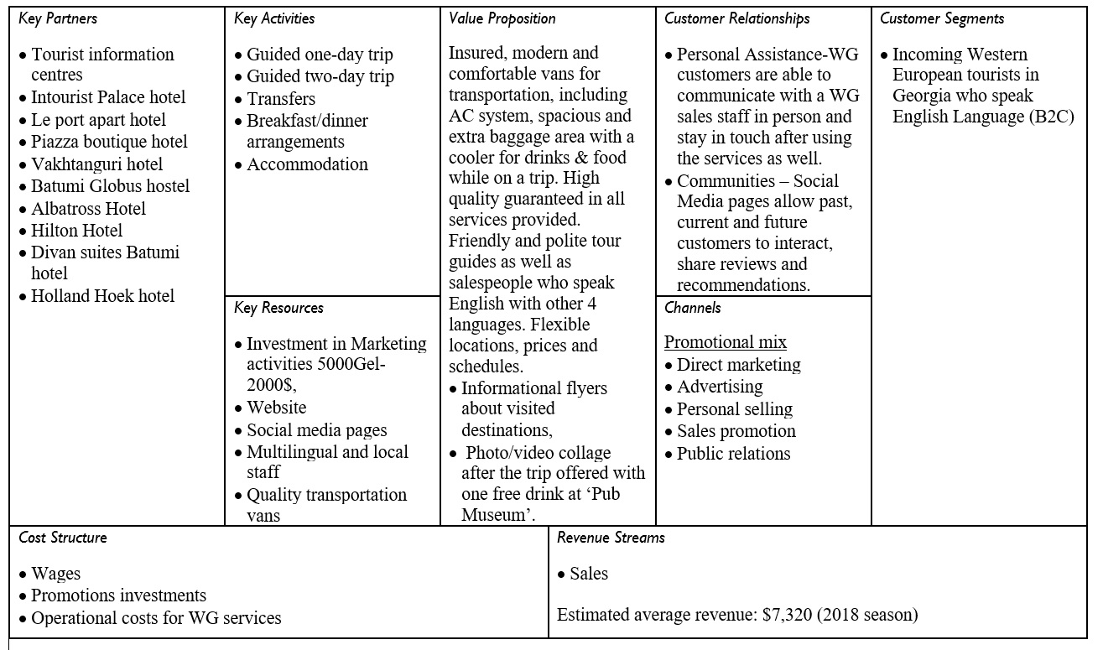

In order to analyze the current internal state of West Georgia, business model canvas was created. The agency needs to have full understanding of its internal elements of activities, partners, resources and operations, so it is able to develop a deep understanding of its need for a marketing strategy. After discussing the elements of the business canvas for West Georgia, the team will potentially be able to assess the roles of these elements inside the company and choose the most effective as well as efficient tactics for a new marketing strategy.

It needs to be noted that currently, WG does not have a clear marketing strategy, its channels and tactics written out to the fullest, so discussing the business canvas elements will allow a successful finalized plan and well-chosen tactics to implement it as well as a clear company overview. Later in the third chapter, the specific tactics, in this case promotional channels will be discussed. Moreover, it should be emphasized that West Georgia agency does not offer many different types of services as it is still a relatively new company that is building up its overall goals and strategies for the competitive market.

West Georgia product which is its service for tourists is the key element of its market positioning, satisfying needs as well as grabbing attention. (Kotler, 2006). A product can be represented in the form of a service as well, such is in WG case, which is designed to satisfy one of the 15 basic needs of a human- consumption. The satisfaction of needs to happen through matching the wishes of the customer. Because there are always others who can satisfy the needs and wishes in the same ways, brand name always allows companies to differentiate and be more recognizable to the customer.

West Georgia services include:

1. Guided One day trip
2. Guided Two-day trip
3. Transfers
4. Breakfast/dinner Arrangements
5. Accommodation

It is crucial for West Georgia to fully comprehend the long-term consequences and influence its brand name can have. Positioning and being able to compete on the market with its product with a progressive approach towards expanding and improving its services could be the key to successful positioning/differentiation on the market.

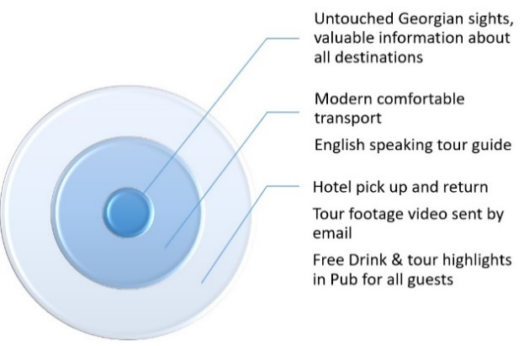In order to reach maximum customer value (Thorsten Wuest, 2015), “Three levels of a product’’ model is used to describe the main services and possible strengths the product of WG represents. The inner and the first level part of the model as shown on the figure, shows the core benefit of the product. Meaning, the product/service that customer really seeks and buys. For West Georgia, the first core benefit includes the distinguished service of being able to show tourists mainly untouched areas that are not on common internet tourism packages and the routes are not well known yet. Further, valuable historical and cultural information is given to the customers of West Georgia about each and every destination in multiple languages, one of which is English, both verbally and in a hard copy.

Secondly, the specific features of the WG agency service include the insured, modern and comfortable vans for transportation which are able to drive on diverse road types. Because not all roads are asphalt covered, most of the beautiful nature and heritage area destinations require driving in bumpy roads covered with rocks and potholes. The vans also have AC systems which is crucial in the sub-tropical climate temperatures, especially in summer time. Moreover, WG customers are able to go to the tours in groups of 8 in each van because they are so spacious with extra baggage area and a cooling fridge for the drinks. On the other hand, West Georgia is capable of conducting its tours in the English Language which is not common on the market yet. The guides are friendly, helpful and majorly locals who hold a massive amount of information about different areas.

Figure 12 - Product levels

Lastly but not the least, West Georgia offers pick up at the scheduled time for the tour and drives the customer back to the residential space after the tour has been completed. Although, it is possible to choose the option of spending the evening in a local pub in Batumi after the trip where tourists can get a free drink and share their impressions of the trip. Later on, photo collage and a video of the highlights of the tour is shown on the projector screen inside the pub for everyone to look back on and share the memorable moments.

There are internal and external factors that affect the pricing of a product, especially in a country like Georgia, the growing tourism and economic fluctuations. According to (Kotler, 2006) ‘internal factors include e.g. marketing mix strategy, costs and organizational considerations. In addition, external factors include market and demand nature, competition and other environmental elements.’

The prices for the most commonly offered and the most demanded tours are the following per person:

1. Zugdidi **-**Sightseeing in the ethnographical museum, Dadiani palace, Shroud of holy mother Cathedral- $60
2. Adjara coastline tour- Gonio city & Castle, Botanical Garden, Petra fortress- $35
3. Samtskhe-Javakheti **-** route through Vardzia Monasterial Complel, Rabati Castle, Green Monastery, Saint Giorgi’s Monastery of Chitakhevi - $90
4. Imereti tour including the capital Kutaisi city $70
5. Svaneti- Waterfalls and canyon of Martvili and Okatse, - $50

The payment methods have been through cash in Georgian national currency Lari and US dollars through local bank Transfer on West Georgia bank account. For 2018, the prices and the payment methods will stay the same as described.

Competitive pricing strategies can be discussed and applied for the current and future pricing tactic of West Georgia. The competitive strategies for market leadership include operational excellence, customer intimacy and product leadership. The first approach involves automating operational processes in order to reduce cost, the second includes an individual approach towards the customer and a personalized service, while the third strategy is about achieving premium market prices due to customer created experiences according to (Michael Treacy, 1997).

Out of the three strategies, West Georgia has been using the second approach of a personalized service and will continue to use this tactic for the upcoming season. To be more precise, WG agency is able to offer its potential customers a flexible tour, destinations and scheduling. Meaning, the trip hours, destination types and the agenda can be agreed upon from both sides and personalized to the needs and wishes of the consumer.

Because, the entrants by land are usually the residents of post-soviet countries, specifically the neighboring states, the new targeted segment of Western Europeans are documented to be using the airports as the entrance points to the country. The majority of the flights are directed towards Tbilisi according to (GNTA, 2017), and trains are the most common way of visiting the second most coveted city, Batumi. Since, it is already vivid that airports as well as railway stations are a common way of the targeted European segment gathering space, West Georgia has brochures spread in these two spaces. It is noteworthy that these brochures are included on official Georgian tourism information desks among all the other pamphlets targeted at tourists from diverse industry representatives as well. Apart from the information desks in the airport, the tourism informational centers are spread across the country, where West Georgia informational leaflets are presented among others.

Apart from the **brochures** that include the services offered by WG travel agency, another way of potential customers finding the services is the **official Facebook page** of WG which is linked to the **website**.

Precisely, potential customers can find all the necessary information and contact details both from the website and the Facebook page about the services West Georgia offers and the types of trips that can be arranged. Surely, this way of finding and purchasing the product is for the part of the segment that prefers to surf the internet for the information rather than pay attention to the informational desk brochures.

Promotion is an important factor for making West Georgia services known to customers. Previous and current strategies are inclined towards B2B and B2C since the start-up of the company. Hereafter the **promotional mix** (Rowley, 1998) has been used to clarify all promotional efforts.

1. Advertising.
2. Public relations or publicity.
3. Sales promotion.
4. Direct marketing.
5. Personal selling.

Out of the five approaches, West Georgia has been using the print advertising technique in terms of brochures and public relations strategies represented by videos and a website as described below.

To elaborate, brochures have been spread across tourist information centers in Adjara region (GNTA, 2018)->statistical portal->database->tourist information centers) and to border entry points. This in order to directly target the potential customers, which are the tourists entering Georgia. As for the public relations activities, West Georgia creates video tips for Batumi visits and sneak picks at beautiful places in the country. The Facebook page assists the company currently into attracting visitors and raising awareness. Although West Georgia has not been investing much in developing its public relations strategy, at this point, it is simply using the tactic of being positively present on social media.

As for the B2B, West Georgia has been in **tight relations with local hotels**, hostels, guesthouses, breakfast/dinner restaurants and bars. The leaflets spread across these places allow West Georgia to collaborate with them if they can share the responsibility of covering all needs of the tourists together. Meaning, if WG receives a request for a tour from a tourist, it automatically offers the client the hotel, restaurant and the bar it has ties with locally and vice versa. This way West Georgia is able to offer better customer care service and cover all needs rather than simply give tours and leave tourists with an empty feeling of dissatisfaction. Additionally, the ties with local hotels and restaurants allows WG assist its clients in saving up time in looking for food and sleeping space all on their own and is already eligible to offer the full package.

Traditional hierarchy structure, also referred to as line-organization (Grit, 2008) with the director on top as the main responsible person which manages and communicates to all the departments in his company, represented in the West Georgia travel agency. See the hierarchy within the company.

**West Georgia hierarchy**

Figure - West Georgia hierarchy

The firm exist of ten employees with at least a bachelor’s degree. The employees exist of 50% natives and 50% foreigners from multiple countries in Europe and Middle East.

English is the main language spoken within the company, although every person is bilingual which is especially important for the tour guides. The team of tour guides speaks besides English also Georgian, Russian and Arabic. This wide range of languages together with the high level of service and quality, enables West Georgia to offer their services to a wide range of tourists.

# 5. Field research

## Primary Research

West Georgia is a young travel agency that needs clear vision, goals and strategies. Because the company only has its staff devoted to operational departments, there is no marketing wing that can spend time and resources of gathering valuable data for sales contributions. As it has been mentioned multiple times, West Georgia has really high competition attracting sales from post-soviet country resident tourists visiting Georgia due to the fact that the majority of the segment can get all types of services in the Russian Language. To support the differentiation idea and willingness that West Georgia travel agency director Zurab Meskhidze has had since last season, qualitative research questionnaire was conducted with past and potential customers in order to figure out the experiences the future need and wishes of the tourists. This would give everybody the overall picture of how well West Georgia has been delivering its services and how satisfied its clients were. It should be emphasized that West Georgia agency had not gathered customer feedback ever before.

Qualitative research for West Georgia travel agency was conducted through interviews. The interview questions were created according to Erasmus+ project SMARTOUR, “Sustainable Manager in Tourism Sector’’ research questions, recommended by Jon Fairburn, Professor of Sustainable Development. (Erasmus+, 2017). The questionnaire questions were also adjusted according to the sub questions listed in chapter 2.1.

The interviews were held by the support of Russian speaking West Georgia employee over the skype call with previous customers of the company together with Steven Assink, who developed the questionnaires fitting West Georgia travel agency. The interviews consisted of 15 questions that were targeted at learning the impressions and experiences these customers had with WG during the trips. 60 % of participants were female, 40% were male and the average age was 35 years.

The results of these questionnaires enabled West Georgia to at least partially comprehend the possible needs and wishes of future potential clients of the company.

Furthermore, an additional research was conducted after having interviews with past customers. This time, the questions were more or less different from the initial questionnaire and were adjusted to holding interviews with potential clients, understanding their needs and wishes of Western European visitors. In order to conduct these qualitative interviews, two different hotels were chosen are located in two different parts of the city-Batumi. The Hilton Batumi is located in the New part of the city while Vakhtanguri is in the oldtown part. Overall, 25 participants participated in the research, knowing the purpose of the research in advance. 64% of the participants were Female and 36% male. The age range was from 29-51. The largest percent of the interviewees were represented by tourists from Germany, 44%, followed by 28% of Dutch tourists, 16% of guests visiting from Belgium, 8% from the UK and 4% from Switzerland. The diversity was asked as a preference to the management teams of both Hotels while recommending their guests to have this short interview with West Georgia.

## Research Objectives

The core research objectives concentrate on understanding the most common reason for West Georgia to operate as well as the channels how potential clients find and purchase its services. This lets the company work on its defining and strategizing on the specific channels it will use in order to target its audience during the season that is compatible for large sales share.

Additionally, it is crucial for West Georgia to know what type of tours and travelling experience previous tourists expected or needed in order to concentrate on creating a highly satisfactory tour package for the 2018 season. Secondly, understanding the needs, wishes and behavior patterns of Western European tourists who could be potential clients of WG is an important objective. The fact that the company is open to all types of developing ideas and feedback is helpful throughout the qualitative research/interview process and focuses on understanding what specific aspects of the trip the clients enjoyed or will enjoy in the future. Subsequently, better outcomes can be achieved, and real progress can happen for West Georgia, once the team extends the research and gathers highly important data.

* Determine what season West Georgia has customers requesting for the tours.
* Figure out through which channels customers found about the services of WG agency and decided to purchase them.
* What type of accommodation do the customers of WG stay at and prefer for the future?
* What are the most important aspects of the tour for the customer to be satisfied and happy with the purchase?
* Collect feedback about the perks and drawbacks customers experienced all throughout the trips in order to make improvement for the future.
* How interested are Western European tourists in using services from a Travel agency?
* What is the main reason, Western European tourists chose to have a holiday in Georgia?
* What services attracts tourists in a Travel agency?
* What are primary expectations of taking a trip organized by a travel agency?
* What are the most common activities most tourists prefer while on holiday?

## Key Findings

* Of those who participated in the interview research, absolute percentage out of five interviewees booked the holiday trips during the summer season.
* Additionally, it was interesting to see that all the previous customers interviewed had decided to book the tour of the regions once they were already in Georgia and not in advance before flying in.
* There is a commonality between where respondents heard about West Georgia services. The majority of respondents learned about the company by visiting the tourist information desks or centres inside the country borders.
* Research determined people prefer exploring the nature, the coastline and traditional cuisine and are more likely to pay attention to the safety of the trip as well as the hospitable atmosphere.
* Absolute percentage of the interviewees stayed at the budget friendly guesthouses and hotels.
* Having a busy trip schedule was an advantage for the majority of the interviewees a well as the friendly tour guide and the comfortable van. Yet, having hard copies with information about each destination and more places to visit in between main sights was a common request for future.

Based on the qualitative interview results through Western European visitors, a big percent of the participants, 64% was encouraged to go on a holiday in Georgia through information online, following by friends’ recommendations 24%, TV shows or commercials 4% and Travel Agencies in their home country recommending Georgia as a holiday destination by 8% of the interviewees.

80% suggested they would be interested in using services of a travel agency while on a holiday in Georgia. Out of 20 participants who said they were interested in using services of travel agencies, 25% said they have already searched for a local agency.

As for the services that attracts the interview participants the most, includes spoken common language mentioned by 40%, seeing rare places as destinations-32% and 16% prefer knowing that all aspects of their trip are fully organized and taken care of, together with 12% desiring time efficiency, through travel agency organizing everything for them.

Further, 48% of the interviewees choose to be in contact with a travel agency through social media, 11% selecting email as their preferred way of communication and only 8% being okay with using a mobile to stay in contact.

What is more, 48% of the participants were traveling with their family members, 40% with friends and 12% said they were on a holiday in Georgia alone. Hereafter, the range of the duration of the holiday for the interviewees ranged between 4 days and 2 weeks.

Backpacking, going to the beach, outdoor wellness, getting acquainted with the Georgian culture, exploring wildlife & nature and tasting the infamous Georgian cuisine were the main activities mentioned by the tourists in the qualitative interviews.

Last but not the least, the majority expected the trip to bring value for their money, be interesting while visiting a lot of places in a short amount of time, good food and entertainment, as well as comfort were mentioned by all the participants.

# Marketing Communication Plan

## Communication target group

Communication target group for West Georgia is much wider in terms of its scope and diverse age, interest and language scale compared to marketing target group. Precisely, communication target consists of tourists who are interested in travelling overall and specifically to the country of Georgia. They could be representatives of any country across globe and could be interested in taking guided tours. These potential tourists can be found outside of Georgia’s borders, planning their trips ahead of time, who need to be inspired to travel to Georgia first. After this, the divers’ regions of the country should interest them and only after these sparked attentions, they can be the close target audience for West Georgia services.

## Marketing target group

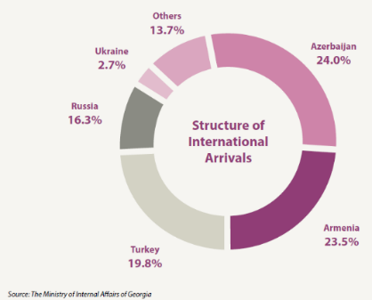The marketing target group of WG consists of a precise group of tourists who are already within the borders of Georgia and need a tour with the help of a guide and organized trips. These potential customers get the information about tours and West Georgia services through **free advice and recommendations of tourist information center workers, brochures spread in airports, train stations and different information desks/centers.** Further, the tourists who are in Georgia and take interest in exploring national landmarks, nature and informative trips, are English, Russian, Turkish and Arabic speakers.

Figure 14 - Structure of international arrivals

To supply all the relevant data to create a useful SWOT analysis, this paragraph will narrow down deeper in the incoming tourist’s specifications. In the years up to 2017, Georgia has been visited by 7,6 million tourists. Out of these 7,6 million tourists, West Georgia is especially interested in a rapidly increasing segment of Europeans with a large financial opportunity. This segment is part of the 13,7% described as others, which includes West European countries shown in the table below. (Attachment 1) Between 2016 and 2017, this specific segment grew exponentially with 31%. This numbers are worthy of attention and a solid foundation for WG to decide to adopt this target group specifically. Three main reasons for choosing the Western European target are:

1. EU residents have a higher spending power thus, they are capable to afford prices of services and travel in Georgia. Because the Euro is exchange at the rate of 1 to 3 Georgian GEL, the potential tourists can earn the ability to spend more.
2. It is an increasing segment as you can see in the table below (Attachment 1) according to the countries and the number of arrivals annually.
3. The competition for targeting and being able offer services to Western Europeans, as mentioned in the introduction, is low. Precisely, there are a few travel companies that can operate in English and the majority of the population in the country of Georgia do not speak English. Consequently, ordering a taxi, using transportation, ordering food in cafes/bars/restaurants and doing groceries etc. is a huge challenge in English language.

According to the United Nations Development reports (United Nations Development programme, 2016), these western European countries are part of the world’s top 25 most developed countries which are examined on various development fields. The Human Development Index (HDI), the Inequality-Adjusted Human Development Index (IHDI), the Gender Development Index (GDI), the Gender Inequality Index (GII), and the Multidimensional Poverty Index (MPI). Data used in these indices and other human development indicators included here are provided by a variety of public international sources and represent the best statistics available for those indicators.

### Types of arrivals

According to (GNTA, 2017), 46% of the arrivals, visit the country for 24 hours and more, which can be considered as holiday purposes. Furthermore 22,5% for transit purposes, as a short stop at the airport to wait for the next flight to take off and same-day visits, which take 31,5% for their account. These visits are overall business trips.

|  |  |  |  |  |  |
| --- | --- | --- | --- | --- | --- |
| **Types of Visit** | **2016** | **2017** | Change | Change % | Share % |
| **24 hour and more** | **2.720.970** | **3.479.507** | **758.537** | **27,9%** | **46,0%** |
| Transit | 1.321.344 | 1.700.170 | 378.826 | 28,7% | 22,5% |
| Same-day visit | 2.318.189 | 2.376.596 | 58.407 | 2,5% | 31,5% |
| Total | 6.360.503 | 7.556.273 | 1.195.770 | 18,8% | 100,0% |

Figure 15 - Types of arrivals

### Target group formulation

Because the targeted audience of Western Europeans who speak English language is quite large and is not possible to predict exactly, a basic system of probability was used to determine a rough approximation of how many western European English-speaking tourists could enter Georgia. First of all, the total amount of West European visitors from 2017 statistics (GNTA, 2017) was taken, who visited the country of Georgia. Out of these 135,137 visitors, a rough approximation of English speakers was calculated according to Attachment 1.2 (English speakers per EU country). After this step, roughly 89,977 visitors from Western European countries were expected to have been able to speak the English language, which made them eligible to use services offered by West Georgia. Finally, according to Figure 12 above, (GNTA, 2017), the number of visitors who would be a perfect target group for West Georgia was finalized by excluding the visitors that spent less than 24 hours in Georgia, as they would not have enough time to book and use WG services. Therefore, the final rough number of the potential clients West Georgia could have targeted according to 2017 statistics was estimated to 41,400 visitors. This probability estimate number is a way to predict how large the target audience for West Georgia could be in 2018 summer season, considering all the positive data about the increase of visitors form Western Europe.

|  |  |
| --- | --- |
| Target group West Georgia LLC: Travel agency | |
| Total number of West-European visitors | **135.137** |
| Potential English-speaking segment that enters the country on its own | 89.977 |
| Arrivals which spent 24hours or more in the country | 46% |
| West Georgia target group | 41.389 |

Figure 16 - Target group

## Communication

### Message

Two major aims of creating a marketing communications plan are developing brand values and directing the behaviors of the target groups for WG agency. West Georgia chose to set its brand values as Friendly, comfortable, approachable and Quality Guarantee. Meaning, WG travel agency wishes its brand to be recognized by past and future potential customers according to the chosen criteria. Friendliness and approachable is intended to be recognized according to the positive and supportive attitude of workers as well as tour guides. The Quality Guarantee is the most important brand value for West Georgia because it is concentrating all its energy on creating the European Standards of Quality and delivering all the services excellently I order to satisfy its customers. As for the Comfortable, this brand value is translated into the comfortable means of transport West Georgia company uses to serve the tours in all its destinations. It is important for customers to know that they will be given all the comfort they can use in the summer heat and bumpy roads that is commonly expected characteristics while traveling in Georgia.

Precisely, brand values are used by a firm to create feelings and then navigate them in order to perfect beliefs of consumers regarding the travel company WG. This is why West Georgia has chosen a two-sided positioning tactic which unifies the informational and transformational positioning characteristics. To begin with, West Georgia is building its positioning as the brand that can solve the challenge of finding services in high quality and in English Language for its target audience which is the English-speaking Western European tourists. Because West Georgia has both the Language skill and the high-quality services that are compatible to EU standards, the positioning tilts towards problem solving of the targeted group. Secondly, transformational positioning of WG uses the slogan of “Feel Georgia” and encourages exploring the country’s scenery and a certain tourist lifestyle with it. This is why, WG has focused its positioning strategy in the two-sided tactic based on (Ko floor, 2014).

As for the second aim of managing the behaviors, this strategy is used simply to influence targeted markets to use the service of tours offered across Georgia by West Georgia. (Baines, 2008). According to (Idman, 1993), marketing communication messages have to be easily understood by the audience and certain feelings, visions and patterns of behavior need to be evoked. Thus, West Georgia needs to target its segments with a carefully chosen message which is **English language skills, safety, comfortable trips and European standard tourism service package**. Although these are the needs that tourists have shown to need, the message that West Georgia is what they need, has to be sent in a simple, attention grabbing and memorable way. This is why, the marketing team together with the director have been working on a new design of brochures, **updated and more informative website** as well as a way **more active Facebook page**. Moreover, **the slogan developed** by West Georgia, **‘FeelGeorgia’** is intended to motivate tourists to develop a positive emotion and belief towards travelling in Georgia and order the WG services. The slogan will be used on the social media, the brochure and the transportation vans. It is important for West Georgia to distinguish itself with a slogan that will be easy remember and recognize. Although ‘FeelGeorgia’ does not directly communicate a traveling agency, it is intended to be easily noticeable and connected with experiences to explore and feel the real Georgian experience.

The high involvement hierarchy exists of 6 independent phases which could be divided in 3 groups, knowledge, attitude and behavior. (Raaij, 2010) West Georgia travel agency is discussed in detail according to the model.

### Knowledge

Which benefits fit the Western European target group that West Georgia can offer to its customers and affect their behavior as well as choice of WG services?

* Informative tours that do not include only famous and common touristic areas but less well-known landmarks as well.
* Insured vans for transportation and transfers
* Tours available in multiple languages including English.

Which benefits is the target group not aware of?

* Optimized routes of showing as many landmarks and local beautiful nature areas to the group as possible by local guides between the distance of main landmarks which are commonly suggested.
* Handing informational brochures in terms of historical and cultural significance, prepared by West Georgia guides in multiple languages, instead of just an oral representation on the spot. Subsequently, WG customers can look back on their trips and share information and impressions with others later on.

These assumptions are based upon unique selling points that were formed in accordance to the field research outcome as well as the data gathered from the desk research. Meaning, the discussions with the previous customers of West Georgia that were interviewed have singled out a few advantages and interesting facts about WG agency within their impressions.

Which faulty knowledge do they have?

* Potential clients lack the preliminary knowledge of the diverse nature, climate and landmarks across the Adjara region. Meaning, most of the tourists simply expect to visit the main city and a few modern buildings that are promoted on the internet.

**Strategy**

West Georgia travel agency wishes to differentiate on the market because the team believes they have solutions to the targeted audience’s problems, therefore, its brand positioning is focused on the informational strategy. Meaning, West Georgia approaches its targeted segments through offering pleasant and attractive options as solutions to their problems, which in this specific case are: lack of English Language among other agencies and in the country overall and the non-EU compatible quality of service delivery tendencies.

* Remove knowledge gaps: Does West Georgia have a good marketing team that communicates to the targeted markets effectively though compatible channels?

The answer is not yet, but the director of West Georgia has already hired a social media manager and asked for a consulting company for assistance. By May 10, new brochures with an updated design and content have been printed. Instagram and Facebook pages were created/linked with each other. Though, more social media presence will be the priority of the 2018 summer season and the use of promotional tools discussed in this marketing communication plan. However, it needs to be noted that West Georgia will need to adopt a more multichannel approach towards communicating with consumers and use advertising as well as social media more frequently.

* Change wrong beliefs

West Georgia should make sure that potential customers know Georgia is a safe place to be and that the company will take responsibility for their comfort and safety unless they step back in the airport. Secondly, as a travel company, West Georgia should make sure that it raises awareness about the country as the overall goal rather than promote only its services as a travel agency.

### Attitude

What feelings West Georgia evokes for its consumers?

West Georgia’s main goal is to evoke positive feelings among its potential consumers. To be precisely, the **feelings of safety, promise of beautiful memories with the tours and a friendly environment** are the targeted emotions the agency want the tourists to associate with the brand. In order to do so, collecting a database of previous customers (this data collecting started with motivation of this marketing communication plan recommendations to the director of West Georgia) and sending them a **feedback form**, thank you emails/video and request to sign up for **newsletters** for upcoming seasons, tours and events is s basic step to take from May 20, 2018. Further, ensuring the customer service and support leaves customers with positive impressions also make sure the associated feelings are encouraging.

On the other hand, the brand needs to start communicating its strength and brand image to potential customers which West Georgia struggles with right now but is planning on using a multichannel approach towards communicating clear messages to a larger target audience. It needs to be noted that West Georgia has decided to represent its brand as a way to truly **“FeelGeorgia”**, meaning the tours show the authentic part of the country and the Adjarian region. This way, WG will be focusing on its strengths of knowing every corner of the region and exactly what would interest the different groups, depending on their preferences.

### Behaviour

West Georgia potential customers have diverse expected behaviors. Meaning, the qualitative research conducted with past customers who were from Israel, Ukraine and Russia, showed slightly different behaviors than the English-Speaking Western Europeans. Western Europeans preferred to be contacted by Social media and Email, 48% and 44% correspondingly, while past customers of WG all got in touch with the company through tourist information centers. Furthermore, past customers mentioned being happy with early departures for the trips while the new wave of interviewees from Western European countries, specifically 92% think they would need to ask for flexible schedules. Interestingly, the past customers have not mentioned the early fixed time departures as a negative aspect of the WG agency or mentioned wanting to change it at all. On the other hand, seeing the nature in Georgia, doing backpacking trips and tasting Georgian cuisine is a common interest of all interviewed tourists.

West Georgia has been focusing on making the process of finding the services provided online and through tourist information center as easy as possible. Further, West Georgia will be implementing the online payment options such: Debit, Credit cards and iDeal or PayPal according to the availability. At this point, customers can only transfer money to the West Georgia Georgian Bank account and pay in cash. In order to make the Western European segment feel safe, West Georgia company abstains from using Wester Union and instead will rely on iDeal or PayPal. This way, the Brand will be recognized as safer to trust and the planning/payment process will be very time efficient. Also, having the flexible schedules and prices for each route available online would be both time effective and differentiated as well. Meaning, it was challenging to email competitors of WG and get exact dates, times and prices of tours, together with ignored and unanswered emails or vague price ranges. This is why, WG already has included all the information online and in its brochures and will puts its efforts into paying attention to what the tourists need from a travel agency.

## SMART Goals

SMART is a five-step process that can be used to guide anyone to their goal. (Rubin, 1981). This theory is used below for a clear objective range for West Georgia.

**Specific (simple, sensible, significant).**

* **What** do I want to accomplish?

***West Georgia wants to target a new Western European segment for the 2018 season and generate sales through selling tours in English to this segment.***

**Why** is this goal important?

* Because the competition is very high for the tourists who speak Russian language and come from the neighboring as well as post-soviet countries to visit Georgia, it is crucial for WG to differentiate and use its advantage of high quality services on the European standards compatibility and the availability of tours in the English language. Subsequently, WG stands a better chance of attracting tourists and having sales this 2018 summer season if it successfully targets English speaking Western Europeans rather than being in the high competition of targeting Russian speakers that other 100s of small travel agencies can do.

**Who** is involved?

* West Georgia team is involved completely into unanimously strategizing, designing all the necessary messages and targeting potential customers.

**Where** is it located?

* The goal of targeting Western European English-speaking tourists to purchase tour services /packages offered by West Georgia is within the borders of the country Georgia for the given period of 2018.

**Which** resources or limits are involved?

* Allocated budget is involved within the range of 5000 GEL for promotional activities that prepare WG for 2018 season. All departments are involved into developing strategies for carefully choosing the potential customer audience, the messages that are sent to the picked audience and through what channels. As for the limits, short amount of time for preparing all of these activities is the main limit together with the risk of failure with hastily targeting a whole new segment in one season.

**Measurable (meaningful, motivating).**

How much?

* In 2017, West Georgia hosted 4 tourist groups consisting of approximately 20-22 people each. Considering the positive prognosis of more tourists visiting Georgia this year according to (GNTA, 2018) and (Forbes, 2017), West Georgia team believes it is reasonable to have a 20% increase which is 16-18 people in 2018. Additionally, new segment will be targeted with newly adopted communication channels and strategies to increase sales as well as spread awareness.

How many?

* Have at least 1 group of Western European segment ordered tour in English for this 2018 summer season.

How will I know when it is accomplished?

* If the company notices the presence and interest of the newly targeted segment of Westerners who are in need of travel agency services in English.

**Achievable (agreed, attainable).**

How can I accomplish this goal?

* This goal of succeeding into attracting English speakers from Western European countries can be achieved through following the promotional plan and being actively present on social media.

How realistic is the goal, based on other constraints, such as financial factors?

* As mentioned in the communication plan, the competition for high quality standards and availability of the English language for the services is not high for this season of 2018. Because WG has strategized what messages it will send (quality, friendly atmosphere, good prices, English language etc.) and through what promotional tools, acquiring at least 1 group of the targeted audience is a high probable goal. More importantly, West Georgia has enough budget to send all the promotional and informative messages to the target group and has the standards/services that the targeted segment needs as well.

**Relevant (reasonable, realistic and resourced, results-based).**

Does this seem worthwhile?

* Differentiating is definitely worthwhile due to the fact that more and more travel agencies start operating by the day as registering business in Georgia is super cheap and easy. Further, the use of English Language strength together with the heightened interest of Western tourists in the country in 2018 is an advisable tactic.

Is this the right time?

* Timing is good, because as discussed earlier in the plan, the government of Georgia has been investing in promoting Georgia as a touristic destination to the Western Europe since 2016 and shows successful results. Due to the high influx of westerners, WG can be one of the first travel agencies that can attract customers due to its compatibility with the needs and wished of Western European tourists.

Is it applicable in the current socio-economic environment?

* Georgian economy is largely based on tourism. Especially Batumi because of its beach vacation attractions, great nigh life, traditional cuisine and beautiful sceneries has become a favorite destination for the incoming tourists. The demand is also increasing in accordance to the raising number of tourists incoming to the country and this region. This is why, West Georgia matches the environment and the demand created in the country.

**Time bound (time-based, time limited, time/cost limited, timely, time-sensitive).**

When?

* It will take the full May-October 2018 season to send the promotional targeted messages to potential clients inside the country borders. Specifically, week 21-30 will have allocated tasks which are all dedicated to earning WG its customers and managing to have services purchased. What is more, WG will need to keep researching the needs and wishes of its potential customers throughout the 2018 season and follow the socio-economic trends. Please view the attachment for task planning schedule.

(See Chapter 6.1 Calendar and 6.2 Budget)

## Communication SMART goals

|  |  |  |  |
| --- | --- | --- | --- |
| Communication SMART Goals | | | |
|  | **Influence behavior** | **Brand awareness** | **Track and shape attitude** |
| **S** | Boost sales by 20% compared with 2017 season. | Raise 20% brand awareness B2B and B2C within one year. | Implement, develop and maintain Customer relationship management. |
| **M** | Previous sales of 2017 = 100 sold tours x 120% = 120 sold tours in 2018 | Comparison of the direct website traffic from spring 2018 with spring 2019 through Google analytics software | Collection of the given feedback and written reviews. |
| **A** | B2C Promo team  B2B Account management (Hotel)  B2B Government tenders  B2C Tourist Info Centres  Brochures  Website  Social Media  Business card | B2C Promo team  B2B Account management hotel  B2C Tourist Info Centres  Promotion wrap on tour vans  Brochures  Social Media  Slogan: “Feel Georgia”  Company Clothing  Business card | B2C Newsletter  B2C Video of tour  B2C Promo team  Social Media content  Slogan: “Feel Georgia” |
| **R** | It is relevant according to the desk and field research results above. | It is relevant according to the desk and field research results above. | It is relevant according to the desk and field research results above. |
| **T** | All efforts will be done in the 2018 season, from week 20 to week 40. More time-bound details in the schedule, chapter 6.1 below. | All brand awareness efforts will be done in the 2018 season, from week 20 to week 40. More time-bound details in the schedule, chapter 6.1 below. | All efforts will be done in the 2018 season, from week 20 to week 40. More time-bound details in the schedule, chapter 6.1 below. |

Figure 17 - Communication SMART goals

* **Knowledge**

West Georgia wants to raise awareness about its existence and the services it offers to the targeted segment which added roughly up to approximately 41000 tourists in 2018. The goal is to spread the awareness to 30% of the target, which makes 12,300 potential clients. Different tools are being used as describes in the table above, section “brand awareness-achievable”. Further, out of the 12,300 consumers, at least 10%, 1,230 incoming tourists should have knowledge about What West Georgia is, and the services it offers.

* **Attitude**

This is the next step to establishing the knowledge about potential customers. After 6,150 will presumably hold information about WG travel agency, 15% would be expected to have a positive attitude towards the service package they are offered. This makes 922 tourists, who would presumably know what WG is, what services it offers, feels positive and interested in the services on a primary evaluation. Yet, only half of the 922 tourists should have the heightened interest and real tendency to purchase the services of WG in order for the firm to achieve its designated goals, which would be 461 potential clients becoming actual clients of WG.

* **Behavior**

West Georgia wants the behavior of its targeted groups to be inclined towards purchasing the trips and later on, sharing their positive experiences with other potential clients. For the specific 2018 season, 20% increase of sales, meaning 120 tour purchases are expected as an objective of 2018 overall.

## Marketing promotional Tools

Marketing tools are used in the aims of communication plan, in a specific aim of character, cost and consequence. West Georgia has not invested much in developing marketing tools for the given moment, yet the team put careful consideration into understanding these characteristics well and selected the following strategies according to promotional mix mentioned in Chapter 4, Internal Analysis by (Rowley, 1998):

### Personal selling

Personal Selling strategy relies heavily of experiences and impressions left on customers though individual conversations and interactions:

**Promo Team**

West Georgia should invest in hiring promo workers who share brochures about West Georgia in the streets, airports and train station while offering them the trips with WG. It needs to be noted that because there are competitor companies that spread their informational pamphlets from diverse industries who also target tourists in the same space, West Georgia has been trying to stand out and differentiate its tactic. Meaning, the **promo teams with the t-shirts** of the WG agency and **brochures** greet the incomers and offer the services in the airport. As for the railway stations, the official **Georgian Railway catalogue** has a page that includes an advertisement of West Georgia company’s services.

This strategy within direct marketing approach is a cost efficient and direct approach way of widening the scope of finding potential clients. Although it might not be the most differentiated and an innovative strategy, all the competitors within and outside of the travel agency market tend to have the same approach in Batumi. It should be emphasized that although the chances of finding a new booking is not high through this channel, as (Kotler, 2006) mentions, it helps build up one to one customer relation. On the other hand, it is noteworthy to see that (Idman, 1993) emphasizes the fact that direct marketing is often not used as a sole strategy. This is true for the case of WG as direct marketing represents only one of the marketing tools among others listed below.

### Public Relations

This promotional strategy relies on letting your previous customers share the information about the company according to the experiences and impressions they received.

**PR Goals**

* Create and maintain the reputation of high quality services for an affordable price among previous customer and a newly targeted segment
* Increase media coverage of West Georgia travel Agency
* Compile a database of customer email addresses and those who wish to sign up for newsletters

**PR Strategies**

* Participate in Government Tenders

Government organized incentives and tenders, help develop image and reputation through external promotion. These tools have influence on public awareness of WG and costs way less then ads. The aim is to grab attention, connect with interest groups that require tenders for their visitors/employees/participants and base long-term goals. Although West Georgia already uses this tactic, there is a new strategy it can adopt for future improvements.

* Create updated brochures to promote West Georgia and its services
* Develop announcements for the media
* Create monthly e-newsletter
* Collect recommendations from clients in terms of feedback

**Stories about WG spread through Word of Mouth**

This is a basic and an important aspect to the image of the company and its reputation, as well as potential for recurring and new customers. Because the information travels from customer to another potential customer, it is important to have high CRM and quality services to make sure the satisfied customer has a positive impact on the success of the firm in terms of its positive reputation leading to trustworthiness and increased sales. (NIMA, 2016).

Additionally, to be present and attract some attention of a larger segment, West Georgia will **wrap the company vans with West Georgia travel agency logos, phone number, Facebook page, top three common destinations.**

### (online) Advertising

West Georgia currently has little online presence and website needs an update in regards with a few additional features. The polished-up design and implementation of various social media platform accounts combined with search engine optimization, content management, and social media initiatives will maximize West Georgia company’s web presence. See chapter 6.1 for the exact social media updates according to time periods.

**Online Strategy**

* Design and develop website with new necessary features
* Set up an Instagram account linked to Facebook page to gain followers
* Link YouTube, Instagram, Facebook, Google+ and Pinterest pages to the website and each other.
* Design and develop a 90 second informational video to be posted on YouTube

### Direct Marketing

As it has been mentioned in the business model canvas above, WG has been working with multiple hotels for a mutually beneficial goal of suggesting full package services to tourists from both sides. For the 2018 season, a full list was gathered of hundreds of hotels and guesthouses/hostels in Batumi and whole Georgia by the marketing department representative Steven Assink. This enables West Georgia travel agency to contact these accommodation units who are also directly involved with tourist and offer them partnerships. This way, the range of WG B2B partners can definitely expand and presumably attract more customers. Emails and text messages will be sent with these offering to potential customers in the database as well as to customers who booked the hotel or a trip with West Georgia. Note, that the agreement involves the accommodation units receiving 10% of the profit from WG if their consumers order tours with WG. See the attachment 1.5: Accommodation units by region, for the full accommodation units lists.

Additionally, CRM will represent a core element of West Georgia’s brand image, its high-quality reputation in connection with choosing a new segment of first world country member country residents. It will be grounded on high-quality customer data and will be enabled by IT department. West Georgia will focus on organizing a training within its team, in order to unanimously define the strategies and behaviors connected to CRM for long term customer satisfaction goals that include recurring sales/other benefits further. Currently, these tactics are gathering feedback and responding to it and having presence through newsletters that will include simple throwbacks photos, new destination videos and photos. Because recurring sales is not a priority and a commonly expected phenomena in this business, improving CRM will be directed towards causing previous customers of WG to share encouraging emotions and photos/videos of their trips to future potential customers.

### Sales promotion

Short term sales promotion strategy for West Georgia currently is focused on spreading awareness about the company through an incentive. Precisely, the past customers of WG who have already booked the trips will be able to spread the incentive. Meaning, they will receive an email, which will contain a 10% discount coupon that they can send to different email recipients, may it be their family, friends etc. This way, West Georgia agency expects to make its brand name and services known outside the country borders of Georgia, while boosting its chances of attracting potential customers through involving current clients.

# Budget and Schedule

## Schedule

|  |  |  |  |  |  |  |  |  |  |  |
| --- | --- | --- | --- | --- | --- | --- | --- | --- | --- | --- |
| Week of 2018 | 21 | 22 | 23 | 24 | 25 | 26 | 27 | 28 | 29 | 30 |
| Create new business card |  |  |  |  |  |  |  |  |  |  |
| Government tender |  |  |  |  |  |  |  |  |  |  |
| Create new brochure |  |  |  |  |  |  |  |  |  |  |
| Create YouTube channel |  |  |  |  |  |  |  |  |  |  |
| Website Social Media update |  |  |  |  |  |  |  |  |  |  |
| Create Instagram |  |  |  |  |  |  |  |  |  |  |
| Create LinkedIn |  |  |  |  |  |  |  |  |  |  |
| Create Pinterest |  |  |  |  |  |  |  |  |  |  |
| Create Google+ |  |  |  |  |  |  |  |  |  |  |
| Appointment for Car wrap |  |  |  |  |  |  |  |  |  |  |
| Create & Print clothing |  |  |  |  |  |  |  |  |  |  |
| Informational video footage |  |  |  |  |  |  |  |  |  |  |
| Promo team activities |  |  |  |  |  |  |  |  |  |  |
| Customer feedback collection |  |  |  |  |  |  |  |  |  |  |
| Word of Mouth |  |  |  |  |  |  |  |  |  |  |
| Active role on Facebook |  |  |  |  |  |  |  |  |  |  |
| Active role on Instagram |  |  |  |  |  |  |  |  |  |  |
| Compile customer e-database |  |  |  |  |  |  |  |  |  |  |
|  |  |  |  |  |  |  |  |  |  |  |
|  |  |  |  |  |  |  |  |  |  |  |

Figure 18 - Schedule of activities

***Note: The light blue colors on the schedule represent the corresponding week of the implementation period of activities and the dark blue color means the operations are continuing to week 40 which is October 1, 2018 and the closing date of the tourist “summer season” for West Georgia travel agency.***

***>>>Week 21-May 14; Week 30-July 23; Week 40-October 1. <<<***

## Budget

West Georgia has the manpower, time and drive to achieve its set goals for 2018. Therefore, there is a newly allocated budget of 5000 Gel for promotional activities in the 2018 season.

Figure 19 - Cost of promotions

|  |  |  |
| --- | --- | --- |
| Costs for 2018 season | | |
| **Payment description** | **Amount** | **Total price in GEL** |
| Townhall fee | 1 | 200, - |
| Promo workers salary | 4 workers for 8weeks | 2400, - |
| Brochures | 5000 | 500, - |
| Promotion wrap on tour vans | 2 | 800, - |
| Company clothing/t-shirts | 14 | 210, - |
| Business cards | 1000 | 75, - |
| Website & Social Media modifications completed by WG director and IT specialist Zurab Meskhidze |  | Free |
| **Total cost in GEL**  **Total cost in USD** |  | **4185, -**  **$1697,90** (XE, 2018) |

## Expected revenue

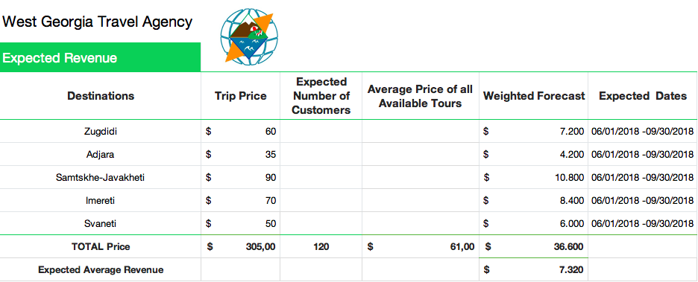

Figure 20 – Expected revenue

# Evaluation

The point of integrating IMC for West Georgia travel company is to help generate short-term financial strength and contribute to building brand value over time. Because West Georgia has diverse types of audiences of different age groups, nationalities, income etc. one characteristic they all have in common is being interested in exploring Georgia through guided tours. This is why IMC sending out different communicative message though different promotional tools that will fit multiple relevant audiences would be beneficial for WG. Further IMC requires the measurement of outcomes and because WG has been struggling with the lack of organization in its mission, goals etc., before this year, IMC will keep the West Georgia team on the right track. West Georgia needs its brand to be developed, shared and the reputation to be acquired and that is what IMC will play a major role as well.

Moreover, establishing a permanent connection with customers requires a multidisciplinary marketing strategy just like the IMC would suggest for West Georgia. In the case of a well-developed strategy, multi-channel interaction, as described promotional tools for WG travel agency above will strengthen the brand value and help build its reputation. A vivid example of how multichannel approach through an IMC strategy would work for WG is the strengthened impact and harmony different instruments in the orchestra create although each instrument sounds good on its own. (Stone, 2002). According to Experian Marketing Services, more than 80% of the marketers use three or more digital lines of successful campaigns successfully. Therefore, the current strategy for the successful operation of West Georgia is the Integrated Marketing Communication Strategy that puts together different promotional tools and plants a multichannel approach for the future.

# Bibliography

Adjaratour. (2018). *About us*. Retrieved from Adjaratour: www.adjaratour.com

Baines, P. F. (2008). Case Insight 1st edition. *Marketing*, 176.

Batumi Travel. (2018). *About us*. Retrieved from Batumi Travel: www.batumi-travel.ge

CAPA. (2018). *CAPA- Centre for Aviation*. Retrieved from centreforaviiation: centreforaviation.com

Caucasus travel. (2018). *about us*. Retrieved from Caucasus travel: http://www.caucasustravel.com

CBS. (2018). Statistics bureau. Amsterdam, The Netherlands.

Destatis. (2018). National statistics . Berlin, Germany.

Erasmus+. (2017, 08 31). SUSTAINABLE MANAGER IN TOURISM SECTOR. Shropshire and Staffordshire, UK. Retrieved from https://ec.europa.eu/programmes/erasmus-plus/projects/eplus-project-details/#project/2015-1-UK01-KA202-013499

European Commision. (2012). *Special Eurobarometer 386.* Brussel: TNS Opinion & Social.

Exotour travel. (2018). *about us*. Retrieved from Exotour travel: www.exotour.travel

Federal Statistical Office. (2018). Statistics office. Neuchatal, Switzerland.

Forbes, G. (2017, October 20). *The impact of Tourism*. Retrieved from http://forbes.ge/news/3311/The-impact-of-Tourism

Georgia and Travel. (2017, March 10). *6th million tourist in Georgia*. Retrieved from YouTube: https://www.youtube.com/watch?v=wj3v_UPRauY

GeorgiCaTravel. (2018). *About us*. Retrieved from GeorgiCa Travel: https://georgicatravel.ge

GNTA. (2017). *International Arrivals.* Tbilisi: Georgian National Tourism Agency.

GNTA, G. N. (2018). *Georgian National Tourism Administration*. Retrieved from https://gnta.ge/statistics/: https://gnta.ge/statistics/

Goi, C. (2009). A Review of Marketing Mix: 4Ps or More? *International Journal of Marketing Studies*.

Grit, R. (2008). *Project management.* Noordhoff .

Idman, R.-M. K. (1993). *Nykyaikainen markkinointiviestintä. 1. Painos.* Porvoo: Weiling+Göös .

Investment, I. (2017). *In 2017, Georgia was visited by 18.8% more tourists*. Retrieved from http://internationalinvestment.biz: http://internationalinvestment.biz/en/tourism/86-v-2017-godu-gruziyu-posetilo-na-188-bolshe-turistov.html

Ko floor, F. v. (2014). *Marketing communicatie strategy.* Noordhoff.

Kotler, P. &. (2006). *Principles of Marketing. 11th Edition.* New Jersey: Pearson.

Liechtenstein. (2018). Government. Vaduz, Liechtenstein.

Meskhidze, Z. (2018, February-June). West Georgia Travel Agency internal information. (S. Assink, Interviewer)

Michael Treacy, F. W. (1997). *The Discipline of Market Leaders.* Noordhoff.

Ministry of Finance of Georgia. (2018, January). *Georgia Economy Overview.* Retrieved from Georgia the outlook: https://mof.ge/images/File/Georgia-The%20Outlook_ENG_Jan-2018.pdf

Ministry of Internal Affairs of Georgia. (2013). Information Center. Tbilisi.

Monaco iq. (2018). Government. Monte Carlo, Monaco.

NIMA. (2016). Retrieved from https://www.nima.nl/alleen-marketeers-3-14-geschikt-b2b/

Office National Statistics. (2018). Government. London, United Kingdom.

Pin Georgia. (2018). *about us*. Retrieved from Pin Georgia: www.pingeorgia.ge

Raaij, F. e. (2010). *Marketingcommunicatiestrategie.* Noordhoff uitgevers.

Rowley, J. (1998). Promotion and marketing communications. *Library review*.

Rubin, R. S. (1981). The Society for Industrial and Organizational Psychology. *Saint Louis University journal*.

Stone, M. H. (2002). Multichannel customer management: The benefits and challenges . *Database Mark Cust Strategy Manag*, 10-39.

Thorsten Wuest, K. A.-D. (2015). Layers of an extended product . *Accessing servitisation potential of PLM data by applying the product avatar concept*.

United Nations Development programme. (2016). *Human Development Reports.* Brussel: United Nations.

University of Minnesota . (2016). *World Regional Geography: People, Places and Globalization.* Minnesota: Libraries Publishing edition.

UNWTO World Tourism Oranization. (December 2013). *UNWTO World Tourism Barometer and Statistical Annex.*

Visit Georgia. (2018). *About us*. Retrieved from Visit Georgia: www.visitgeorgia.ge

West Georgia. (2018). West Georgia Mission, Vission, USP's. Georgia: Zurab Meskhidze.

Wild Horn. (2018). *about us*. Retrieved from Wild Horn: www.wildhorn.ge

XE. (2018, June 14). *currencyconverter GEL to USD*. Retrieved from XE: https://www.xe.com/currencyconverter/

# Table of figures

Figure 1 - Europe map 8

Figure 2 - Most visited regions Georgia 9

Figure 3 - Ohmae's 3C model 13

Figure 4 - Grit model 15

Figure 5 - The most visited Cities in Georgia 2016 16

Figure 6 - International visitors in Georgia 16

Figure 7 - Tourism Value Added 18

Figure 8 – Steadily growing external revenues, Georgia 18

Figure 9 - Perceptual map competitors 19

Figure 10 - Arrivals by border type 20

Figure 11 – Border type categories 20

Figure 12 - Product levels 24

Figure 13 - West Georgia hierarchy 27

Figure 14 - Structure of international arrivals 31

Figure 15 - Types of arrivals 32

Figure 16 - Target group 32

Figure 17 - Communication SMART goals 39

Figure 18 - Schedule of activities 43

Figure 19 - Cost of promotions 43

Figure 20 – Expected revenue 44

# Attachment

## Tables and figures

***Attachment 1.1: International arrivals by country***

|  |  |  |  |  |  |
| --- | --- | --- | --- | --- | --- |
| **International arrivals 2016 - 2017 by country** (GNTA, 2018) | | | | | |
| Country | 2016 | 2017 | Change | Change % | Share % |
| Total | 6.360.503 | 7.556.273 | 1.195.770 | 19% | 100,0% |
| AMERICAS | 42.924 | 53.564 | 10.640 | 25% | 0,7% |
| MIDDLE EAST | 88.326 | 162.848 | 74.522 | 84% | 2,2% |
| AFRICA | 6.633 | 9.402 | 2.962 | 45% | 0,1% |
| EAST ASIA/PACIFIC | 239.970 | 464.740 | 224.770 | 94% | 6,2% |
| OTHER | 6.366 | 6.831 | 272 | 7% | 0,1% |
|  |  |  |  |  |  |
| EUROPE | 5.976.284 | 6.858.888 | 882.604 | 15% | 90,7% |
| Western Europe | 102.916 | 135.137 | 32.221 | 31% | 1,8% |
| Austria | 5.750 | 7.729 | 1.979 | 34% | 0,1% |
| Belgium | 5.061 | 5.999 | 938 | 19% | 0,1% |
| France | 15.044 | 19.502 | 4.458 | 30% | 0,3% |
| Germany | 40.915 | 51.447 | 10.532 | 26% | 0,7% |
| Ireland | 1.905 | 3.711 | 1.806 | 95% | 0,0% |
| Liechtenstein | 21 | 35 | 14 | 67% | 0,0% |
| Luxembourg | 233 | 242 | 9 | 4% | 0,0% |
| Monaco | 6 | 8 | 2 | 33% | 0,0% |
| Netherlands | 10.081 | 13.215 | 3.134 | 31% | 0,2% |
| Switzerland | 4.702 | 6.394 | 1.692 | 36% | 0,1% |
| United Kingdom | 19.198 | 26.855 | 7.657 | 40% | 0,4% |

***Attachment 1.2: English speakers per EU country***

|  |  |  |  |
| --- | --- | --- | --- |
| **Country** | **Total visitors 2017** | **English speakers %** | **Potential segment** |
| Austria | 7.729 | 73% (European Commision, 2012) | 5642 |
| Belgium | 5.999 | 38% (European Commision, 2012) | 2280 |
| France | 19.502 | 39% (European Commision, 2012) | 7606 |
| Germany | 51.447 | 56% (Destatis, 2018) | 28810 |
| Ireland | 3.711 | 98% (European Commision, 2012) | 3637 |
| Liechtenstein | 35 | 63% (Liechtenstein, 2018) | 22 |
| Luxembourg | 242 | 56% (European Commision, 2012) | 136 |
| Monaco | 8 | 9% (Monaco iq, 2018) | 1 |
| Netherlands | 13.215 | 90% (CBS, 2018) | 11894 |
| Switzerland | 6.394 | 61% (Federal Statistical Office, 2018) | 3900 |
| United Kingdom | 26.855 | 97% (Office National Statistics, 2018) | 26049 |
| **Total** | **135.137** | **-** | **89977** |

***Attachment 1.3: List of competitors***

|  |  |  |  |
| --- | --- | --- | --- |
| Tour operator | Office location | Field of expertise | Guided tour languages |
| (Adjaratour, 2018) | Batumi | Whole country | English, Georgian, Russian |
| (Batumi Travel, 2018) | Batumi | Adjara region | English, Georgian, Russian |
| (Caucasus travel, 2018) | Tbilisi | Whole country | English, French, German, Italian, Japanese, Russian. |
| (Exotour travel, 2018) | Tbilisi | Georgia, Armenia and Azerbaijan | English, Georgian, Russian, Polish |
| (GeorgiCaTravel, 2018) | Tbilisi | Georgia, Armenia, Azerbaijan | English, Georgian, Russian |
| (Pin Georgia, 2018) | Batumi | Whole country | English, Georgian, Russian |
| (Visit Georgia, 2018) | Tbilisi | Whole country | English, German, French, Italian, Spanish, Russian, Japanese |
| (Wild Horn, 2018) | Batumi | Adjara, Guria, Samegrelo, Samtskhe-Javakheti | English, Georgian, Russian |

***Attachment 1.4: Use of media by competitors.***

|  |  |  |  |  |  |  |  |  |  |
| --- | --- | --- | --- | --- | --- | --- | --- | --- | --- |
|  | Website | Social Media | Classic media | Newsletter | Posters | App | FAQ | Skype | Email Phone |
| Adjaratour |  |  |  |  |  |  |  |  |  |
| Batumi Travel |  |  |  |  |  |  |  |  |  |
| Caucasus travel |  |  |  |  |  |  |  |  |  |
| Exotour travel |  |  |  |  |  |  |  |  |  |
| GeorgiCa travel |  |  |  |  |  |  |  |  |  |
| Pin Georgia |  |  |  |  |  |  |  |  |  |
| Visit Georgia |  |  |  |  |  |  |  |  |  |
| West Georgia |  |  |  |  |  |  |  |  |  |
| Wild Horn |  |  |  |  |  |  |  |  |  |

|  |  |  |  |  |  |  |  |  |
| --- | --- | --- | --- | --- | --- | --- | --- | --- |
| Social Media | Facebook | Instagram | Snapchat | Twitter | YouTube | LinkedIn | Google+ | Pinterest |
| Adjaratour |  |  |  |  |  |  |  |  |
| Batumi Travel |  |  |  |  |  |  |  |  |
| Caucasus travel |  |  |  |  |  |  |  |  |
| Exotour travel |  |  |  |  |  |  |  |  |
| GeorgiCa travel |  |  |  |  |  |  |  |  |
| Pin Georgia |  |  |  |  |  |  |  |  |
| Visit Georgia |  |  |  |  |  |  |  |  |
| West Georgia |  |  |  |  |  |  |  |  |
| Wild Horn |  |  |  |  |  |  |  |  |

***Attachment 1.5: Accommodation units by region***

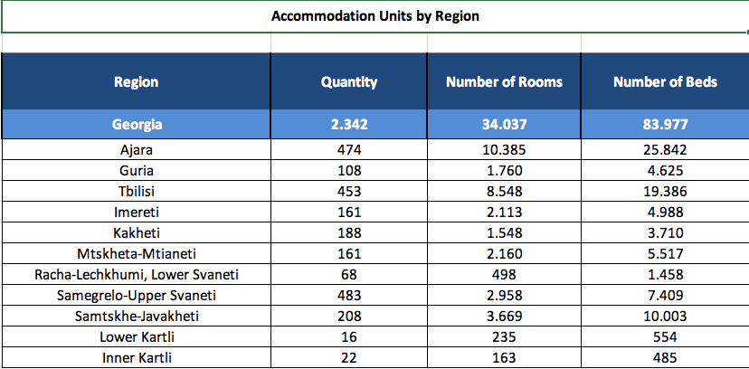

## Interview qualitative

***Attachment 2.1: Interviews with past customers***

**Qualitative research interview for wishes & needs - West Georgia**

1. Gender?

*Male*

1. What is your age?

*37*

1. Tell us how far and how you travelled to get to your destination - Georgia?

*From Israel by Plane*

1. During what season was your tour?

*Summer*

1. Was that your first visit to that destination?

*Yes*

1. Where, when and how did you book your holiday in Georgia?

*I bought the plane tickets for my family myself and booked the tour from Batumi at the information centre in the city.*

1. How did you find out about West Georgia travel agency?

*I saw a brochure with the colourful design among other brochures at tourist info centre.*

1. Who did you take West Georgia tour with?

*My family -wife, two sons and a couple friends.*

1. What was the duration of your holiday?

*Batumi holiday was 3 days, but I was in Georgia for a week overall.*

1. What kind of accommodation did you stay at and would you change it for the future? (OPEN)

* Apartment, hotel, hostel, camping, B&B, guesthouse.

*I stayed with my family in a small hotel in Batumi city, near the Sheraton Hotel and later on, we stayed at a private guesthouse.*

1. What was the most important aspect of your holiday destination? (OPEN)

* Culture, safety, food, infrastructure, transport, entertainment, nightlife more…

*We loved the food we tasted from Megrelian cuisine on the way to our Adjara tour.*

1. What activities did you like most during your holiday? (OPEN)

* Backpack, beach, wellness, culture, wildlife, nature.

*I loved looking down on the beach and the coastline form top of the mountain and the green nature with my family. The nature to us is just dazzling.*

1. What did you like about the tour overall? What did u not?

*I liked the comfortable drive to our destination places. Although we did take a good look at nice places, I would have preferred to see a little more rather than spend too much time on each attraction.*

1. How would you rate your overall experience during the trip with West Georgia travel agency and explain your rating?

I would rate it an 8. The trip was worth our time.

1. Do you take any interest in medical tours provided by west Georgia? (magnetic sand/mud bed etc.)

*It is not easy just to plan and go to Georgia on a whim again but my family and presumably friends as well would be interested in these type of tours.*









***Attachment 2.2: Interviews with English speaking tourists***

**Questionnaire**

1.     Gender?

2.     What is your age?

3.     Where are you from?

4.     What encouraged you to book your holiday in Georgia?

5.     Are you interested in using the services of travel agencies in Georgia? If no, go to question 7.

6.     Did you look for any agencies for your sightseeing?

7.     What services attracts you the most from travel companies in general?

8.     How would you prefer to communicate with your chosen travel agency for the booking?

9.     Do you think you would need to ask for flexibility about destinations and tour schedules?

10.  Who would you take the tour with while you are here in Georgia?

11.  What is the duration of your holiday in Georgia?

12.  What are your primary expectations of services if you decide to take the tour with WG or any other travel company in Georgia?

13.  What activities do you like most and plan on doing during your holiday? (OPEN)

**Interview analysis tables**

|  |  |  |  |
| --- | --- | --- | --- |
| **Respondent** | **Gender** | **Age** | **Country** |
|  | Male | 29 | Germany |
|  | Male | 36 | Germany |
|  | Female | 43 | Germany |
|  | Male | 32 | Germany |
|  | Female | 29 | Germany |
|  | Female | 43 | Germany |
|  | Female | 34 | Germany |
|  | Female | 30 | Germany |
|  | Female | 34 | Germany |
|  | Male | 45 | Germany |
|  | Female | 36 | Germany |
|  | Female | 51 | Netherlands |
|  | Female | 50 | Netherlands |
|  | Female | 37 | Netherlands |
|  | Male | 40 | Netherlands |
|  | Male | 34 | Netherlands |
|  | Female | 39 | Netherlands |
|  | Female | 32 | Netherlands |
|  | Female | 44 | Belgium |
|  | Male | 35 | Belgium |
|  | Female | 48 | Belgium |
|  | Male | 29 | Belgium |
|  | Female | 38 | UK |
|  | Female | 44 | UK |
|  | Male | 50 | Switzerland |

|  |  |  |
| --- | --- | --- |
| Question 4: What encouraged you to book your holiday in Georgia? | | |
| **Respondent** | **Summary** | **Full answer** |
|  | Social Media | I saw all types of different content on Social media, all the mountains and the modern buildings interested me. |
|  | Friends | Friends have visited Tbilisi before and could not make it to Batumi, that’s why we decided to make up for last year and now we are here |
|  | Friends | My friends visited, and I had already known about Georgia, so I decided to spend our anniversary here and we are very glad. |
|  | Social Media | I guess it was the friends but when I looked up all the videos and photos on YouTube, it looked very pretty. The country has very nice commercials made for promotion. |
|  | Social Media | It was definitely the pretty commercials I saw on YouTube. It looks amazing and very beautiful. |
|  | Travel Agency | I came to travel with my best friend. We checked a few destinations with the travel agency and decided to come to Georgia because it looked very beautiful on the photos |
|  | Social Media | There are a few Facebook travel pages that constantly post photos and videos and I saw a lot of them about Georgia. The usual, I got interested, looked up the blogs about travelling in Georgia and now I’m here. |
|  | Social Media | What encouraged me should have been the YouTube videos and all the content I looked up online but I also dd hear a lot about others travelling here. |
|  | Social Media | I watched a few documentaries on YouTube. |
|  | Social Media | I googled travel to Georgia and checked for the lonely planet book for here. I have been interested in finding more information about Georgia for a while, because I kept coming across content constantly online, so YouTube was a big help. |
|  | Social Media | Well, Facebook, YouTube, Vimeo are all full of videos and pictures. I saw the recent video about a tourist in Georgia, looked really nice to see such old culture and the modern buildings, the nature all together. |
|  | Friends | I am here with my friend who is also here with us. Our friend from Belgium told us about traveling to Georgia, he has been here a few times, so we just came over as well. |
|  | TV Show | Well, I am here with my friend because we came here together, but I was actually encouraged by waar is de mol, I think it is good that Georgia reached out through the TV. |
|  | Social Media | Mostly, it is the videos and photos I have seen. |
|  | Social Media | I did not know where Georgia was but I came across a few videos and then I started searching if it was close to Bulgaria, because I have been there a few years ago. |
|  | Social Media |  |
|  | Friends |  |
|  | Friends | My friends have been talking about it non-stop. We went to Turkey last year and it took us a lot of effort to arrange the trip together to Georgia. |
|  | Travel Agency | Travel agencies are usually how I do trips but when I work the whole year and only get three weeks off, I prefer to travel to a strange environment with some help. I cannot afford to waste time figuring everything out myself. |
|  | Social Media | I followed the Georgian travel Group on Facebook for a while and finally put the time to get here. |
|  | Social Media | I have seen videos about the nature and skiing here. I am off from work this August, so I could not really manage the skiing, but I still had to see what the country is like. |
|  | Friends | Friends have been wanting to visit Tbilisi for a few years and I am just a big fan of the beach and the sun. |
|  | Social Media | I saw a lot of videos on YouTube, there are a few short film documentaries about what happened to Georgia with Russia and how it started changing these years. |
|  | Social Media | YouTube is a good source to look up the traveling videos, vlogs of other travelers. It is comfortable to check how the nature looks like before I arrived here. |
|  | Social Media | I did my homework on Georgia and checked everything I could find online. |

|  |  |  |
| --- | --- | --- |
| Question 5: Are you interested in using the services of travel agencies in Georgia? If no, go to question 7. | | |
| **Respondent** | **Summary** | **Full answer** |
|  | Yes | Yes, depends on their prices and if it’s easy to use the services |
|  | No | No, we are doing well on our own |
|  | Yes | Yes, the agencies should have good offers, there is so much to see, it is good when an agency can organize all the sights into a trip. |
|  | Yes | Yes, I expect the prices to be pretty low here compared to Germany and the Euro so why say no to an organized trip? |
|  | Yes | Yeah, I actually have used them in Albania already and it was pretty comfortable. |
|  | Yes | Yes, we did not book the services with the German travel company because we though it is better to do it with local agencies |
|  | Yes | Yes, why not. |
|  | Yes | They should be able to help organizing the trip better although there is so much online, I would trust the locals to know better. |
|  | Yes | Yes, but I would prefer an agency here in Georgia rather booking it in Germany. |
|  | Yes | Yes, why not, if it’s easy to book everything and they offer interesting packages. |
|  | No | - |
|  | Yes | Yes, definitely but most likely I would check out the agencies here in Batumi because the prices from Dutch tourist agencies this summer were crazy expensive. |
|  | Yes | Yes, that would not be a bad idea I guess. |
|  | Yes | Yes, travel agencies should at least be able to direct me in a good direction to understand how things work here. |
|  | Yes | Yes, that is okay, I’m not sure I will do that now, but it is worth to consider. |
|  | Yes | Why not... |
|  | Yes | Definitely, it should have nice price offers here so why say no to a relaxed life? |
|  | No | - |
|  | No | - |
|  | Yes | Yes, that would be a good idea. |
|  | No | - |
|  | Yes | Yes, I would. |
|  | Yes | Yes, agency should be a bridge to get a good tour. |
|  | Yes | Yes, travel agencies work for the purpose to let tourists see all the famous and important places and that’s what I am here for. |
|  | Yes | Yes, travel agencies also differ, I would need to find an honest genuine agency that actually offers interesting tours. |

|  |  |  |
| --- | --- | --- |
| Question 6: Did you look for any agencies for your sightseeing? | | |
| **Respondent** | **Summary** | **Full answer** |
|  | No | Not really, thought about it but never got to it. |
|  | - | - |
|  | No | We saw a lot of brochures on the stand in the airport, but it was too chaotic to stop and check them. And I think there were many in Georgian or Russian writing, so it would take too much time to look for the versions I understand. |
|  | No | No. |
|  | No | No, but I saw the brochures on my nightstand. Didn’t look into it yet, I just arrived here in Georgia. |
|  | Yes | Yes, we did, and we are glad to be taking the trip with you tomorrow |
|  | No | - |
|  | No | - |
|  | Yes | I have searched when I was still home, but I didn’t really receive a reply to the online quote and then I never got back to it. |
|  | No | - |
|  | - | - |
|  | No | - |
|  | No | - |
|  | No | - |
|  | No | - |
|  | Yes | Yeah, I googled a few and then the main tourist information center in the boulevard had at least 10 different brochures to show me. |
|  | No | - |
|  | - | - |
|  | - | - |
|  | Yes | Yes, I tried to google travel agencies here and got a lot of results actually. |
|  | - | - |
|  | No | - |
|  | No | - |
|  | No | - |
|  | Yes | Yes, I checked the companies online but could not really find any dates or prices and I cannot really call here, so If I decide to take a guided tour I believe I will just drop by the office or the information center. |

|  |  |  |
| --- | --- | --- |
| Question 7: What services attracts you the most from travel companies in general? | | |
| **Respondent** | **Summary** | **Full answer** |
|  | Interesting rare places | Well, they need to have interesting places to visit which I don’t have to plan myself and put time in. |
|  | Language | Generally, the organization of the whole trip and food stuff. Of course, they have to be able to speak to me in English or German, what tourist understands that much Georgian to listen to a whole tour. |
|  | Time efficiency | The time efficiency. Going on a holiday is a lot of work actually. It is nice when others already prepare and let you rest. |
|  | Language | The language is important, so I understand all the information, I don’t want to just look at the sights, Georgia is an old country so I’m sure every place has a historic story |
|  | Language | I like that many people still try to find a common language here. I feel very welcome but still it’s just Georgian speaking all the time. So common language is the big motivator. |
|  | Value for the money | Receiving the value for the money due to the busy sightseeing schedule. I mean we are happy that we will be seeing a lot of places, I have read about most of them, but I was gladly surprised to find a few new names on the list |
|  | Interesting rare places | It is important to visit the places that will be memorable. I want to be able to take pictures and have enough time to really look around and see the real Georgia instead of a few modern buildings in the city. |
|  | Time Efficiency | For me, everything is about time, I cannot stay here for months and there is so much to see that I would want my agency to cram as many places to visit as possible. |
|  | Language | The language should be the most important aspect I guess. |
|  | Language | I’m sure the travel agencies should be able to have guides who speak a few languages, I would be so happy to hear it in German although I do not expect it of course. |
|  | Everything is taken care of | I need the travel agency to be able to organize everything to the last detail. I’m okay googling the places where to eat or get a drink but I would want the agency to have the recommendations ready. |
|  | Language | The agency should have tour guides who have good pronunciation for us to understand everything he describes well. |
|  | Everything is taken care of | Travel companies are there to organize the tours, the food and everything else. |
|  | Language | I believe that if not all travel agencies, at least the bigger ones should have tours available in different languages and at different times. |
|  | Interesting rare places | Although I understand that all travel companies have almost the same places they take tourists to, I’m looking for different places that are not crowded with the rest of the tourists. |
|  | Everything is taken care of | Travel salespeople should be responsible and have everything for the tour organized. |
|  | Interesting rare places | Generally, the most attractive part for me would be seeing the really interesting areas that I cannot google and visit myself. |
|  | Language | Generally, the travel companies should have different packages to offer in a few languages. |
|  | Interesting rare places | For me, the whole point of booking a tour with the agency is to see places that are not that commonly known to all the tourists themselves. |
|  | Interesting rare places | I think that the destinations where the company offers to take the tour to is the most important aspect. I would not want to take a boring tour and just see one place the whole day. |
|  | Language | Agencies should be polite, organized and have their tours ready in a few languages. |
|  | Language | Agencies should definitely hire tour guides who are fluent or really good at the languages they present the information in. It is disturbing sometimes to concentrate a lot on listening to guides who are obviously struggling to speak. |
|  | Everything is taken care of | Travel agencies should be in charge 100% and organize everything for their guests. |
|  | Interesting rare places | I would expect them to make their tours interesting and include rare places as destinations. |
|  | Time Efficiency | Travel companies in general should care about saving all the trouble and time for the customer, at least that is what I expect myself. |

|  |  |  |
| --- | --- | --- |
| Question 8: How would you prefer to communicate with your chosen travel agency for the booking? | | |
| **Respondent** | **Summary** | **Full answer** |
|  | Social Media | Social media pages are fine, especially Facebook is super easy. |
|  | Email | Emails are nice. It is easy to have a phone number here, we just got ours free at the airport and its super cheap to buy 4G. So, both phone and email are cool with me. |
|  | Email | Email, I guess |
|  | Social Media | Social media pages are okay, it’s the easiest way |
|  | Social Media | Through their Facebook page. A little box always pops up asking you to help, so I guess I would just send a text there that I want to book a trip. |
|  | Email | We did everything over email and it was comfortable that way |
|  | Email | Emails are good to communicate, I cannot always find time to open Facebook messages. |
|  | Social Media | Facebook is a good way. |
|  | Email | Emailing is the most professional and organized way to do it I think. |
|  | Social Media | Facebook is okay. |
|  | Social Media | Any Social media would be okay, I do not use a lot of them but I’m sure all companies would have Facebook and Instagram. |
|  | Mobile | It’s the easiest thing to get a phone number in Georgia so I would want to use my new phone number. |
|  | Social Media | Facebook is alright. |
|  | Email | I would prefer the email most likely, I like to be able to search for the information later on email, instead of going through all the messages on social media messages to find the price or the location. |
|  | Email | Emailing work for me. |
|  | Social Media | I would be cool with Facebook and Instagram messages if they reply to those quickly. |
|  | Social Media | Facebook is the fastest and the easiest. |
|  | Mobile | I would use my phone I guess, I’m not really sure about the tariffs yet. |
|  | Email | I use the email all the time. |
|  | Email | I would send an email, I’m not sure if they reply to the social media messages. |
|  | Social Media | Facebook or WhatsApp is the easiest I think. |
|  | Social Media | Social media is good for me. |
|  | Email | Emails of course. |
|  | Social Media | Anything would be okay with me honestly, but Facebook is super easy to check. |
|  | Email | I would send an email at first then I don’t know if it matters how we would stay in touch. |

|  |  |  |
| --- | --- | --- |
| Question 9: Do you think you would need to ask for flexibility about destinations and tour schedules? | | |
| **Respondent** | **Summary** | **Full answer** |
|  | Yes | Yeah of course |
|  | No | Not really, if they already have their routes planned, they have special times chosen at that time for a reason I think. |
|  | Yes | Yes, that would be nice. |
|  | Yes | Yes, for sure |
|  | Yes | Yes, that would be really nice because sometimes I want to catch the breakfast in the hotel in the morning and go to the beach first and then take the trip. |
|  | Yes | Yes, flexibility is important actually. We were told by another agency that they had a group tour available after a whole month. These companies should understand that we visit for a few days and it is not easy to book everything from Germany in advance |
|  | Yes | Yes, who would not want to have options. |
|  | Yes |  |
|  | Yes |  |
|  | Yes |  |
|  | Yes | Yes, if it’s worth it for the company to let everyone choose their times. |
|  | Yes |  |
|  | Yes | I think it’s comfortable to prepare and plan everything by hour so, yes, it would be good if the agency understood that we are trying to fit everything in. |
|  | Yes |  |
|  | Yes |  |
|  | Yes | Yes, I would be happy to plan my trip time. |
|  | Yes |  |
|  | Yes | Maybe I would not ask myself, but if I had the option, of course I prefer to choose my time. |
|  | Yes | If the company will not turn down all the times I suggest, yeah of course. |
|  | Yes |  |
|  | No | Not really, I like to stick to the schedule they give me if it’s not too crazy early. |
|  | Yes |  |
|  | Yes | Yes, why note. |
|  | Yes | I think we would love to ask for flexibility if it is possible because I really do not want to miss out on the beach in the morning. |
|  | Yes | Yes, I would prefer to choose between a few trip options at different times. |

|  |  |  |
| --- | --- | --- |
| Question 10: Who would you take the tour with while you are here in Georgia? | | |
| **Respondent** | **Summary** | **Full answer** |
|  | Alone | I’m here alone but I would definitely do the tour with my friends, or by myself is cool as well, I can meet new people at the trip anyway. |
|  | Friends | Well, my friends |
|  | Family | I’m here with my husband so we would take the trip together |
|  | Friends | With my friends, its handy to have others take photos of me and yeah of course we try to plan most of the things to do together |
|  | Alone | I would take the tour on my own. I’m pretty sure there are others who fall on the same tour schedule, I would not be the only one the travel company would take for the trip |
|  | Friends | My best friend. We are here together so we would definitely not miss out on the tour |
|  | Family | I would travel with my family. |
|  | Friends | I would have a lot of fun bringing my friends along. |
|  | Family | I think the tour should be more exciting with family, I would not do it alone. |
|  | Family | My Family! I need someone to take photos for me. |
|  | Family | My family, maybe friends but also depends on the duration of the trip. |
|  | Friends | I would love to share the experience with my friends. |
|  | Friends | Definitely with my friends or whoever I am traveling with. |
|  | Family | I travel with my family, so we would take the guided tours together. |
|  | Family | I love to travel and explore the new places with my family. |
|  | Family | I know that it would be a lot of fun taking the trip with my family members. |
|  | Friends | With my friends. |
|  | Family | Family, friends, it should be fun either way. Better than doing the whole day tour all on my own. |
|  | Friends | I would take the trips with my friends. Maybe the agencies have packages for groups especially. |
|  | Family | With my family for sure. |
|  | Family | I would love to take the trip with my family. The shorter trip most likely though. |
|  | Family | With my family. |
|  | Friends | I’m here with my friend so we would take the trip together. |
|  | Friends | With my friend. |
|  | Alone | I’m a sole traveler this year. |

|  |  |
| --- | --- |
| Question 11: What is the duration of your holiday in Georgia? | |
| **Respondent** | **Summary** |
|  | 7 days |
|  | 4 days |
|  | 7 days |
|  | 14 days |
|  | 10 days |
|  | 12 days |
|  | 9 days |
|  | 7 days |
|  | 14 days |
|  | 10 days |
|  | 5 days |
|  | 4 days |
|  | 7 days |
|  | 5 days |
|  | 14 days |
|  | 14 days |
|  | 4 days |
|  | 6 days |
|  | 4 days |
|  | 12 days |
|  | 5 days |
|  | 20 days |
|  | 5 days |
|  | 7 days |
|  | 7 days |

|  |  |  |
| --- | --- | --- |
| Question 12: What are your primary expectations of services if you decide to take the tour with WG or any other travel company in Georgia? | | |
| **Respondent** | **Summary** | **Full answer** |
|  |  | I expect everything to be planned and organized so I can just sit back and enjoy the views and feel that it’s really my holiday. |
|  |  | The tour should be interesting, so to show us a lot of places instead of driving an hour to see one destination. |
|  |  | The travel companies should have interesting tours organized with a lot of destinations for good price offers. I like when they include stops at the restaurants as well, everybody recommended me to taste the food here before we arrived. |
|  |  | I feel like all these companies will be overcharging with all these tourists coming from Europe but hey it is my holiday, so I expect them to make me feel completely relaxed and do all the work for my trip. |
|  |  | I really hope their quality is worth the money and they do not just include super famous 3 places or something like that. |
|  |  | I’m looking forward to seeing all the nature and the beautiful green mountains. It’s interesting to meet all the locals along the way |
|  |  | I expect that the tour guide is well prepared and knows all the ins and outs of the tour. |
|  |  | Well, when I go on a trip, it would be great if there is a certain harmony in the group that takes the tour because we have to get along for a whole day. |
|  |  | I just want to see pretty stuff like waterfalls and architecture with history. |
|  |  | Understanding and friendly staff. |
|  |  | It should be smooth and streamlined so I get value for the time on the tour. |
|  |  | I am taking tours as well to eat at places where I can otherwise never have this food, so I expect that those places are clean and checked on before we arrive. I don’t want to get sick. |
|  |  | Seeing places that are not on the internet, something rare. |
|  |  | I want attention and time from the tour guide to explain things if I ask for something. |
|  |  | When I take a tour, I never get my expectations high, so the result can be overwhelmingly good. From the service, I just expect friendly guides. |
|  |  | Knowhow about the tour and places. |
|  |  | Safety is important for me. This country is completely different then where I come from and it looks like I am back in time. |
|  |  | Entertainment during the different drives like explanation about things along the road of some games led by the guide. |
|  |  | I just want to get what I choose for. So If I choose to see a mountain, I don’t want to see a building. This was a problem in another tour I took in Greece. |
|  |  | I expect that the company thought about safety and comfort during the trip. |
|  |  | Nice food, memorable sights and helpful staff |
|  |  | I really hope to get the value for the trip. |
|  |  | I would expect the company to prepare me really well for the trip and show us all very interesting places with good background story. |
|  |  | I would expect good organization. |
|  |  | I would expect high quality trip overall. |

|  |  |  |
| --- | --- | --- |
| Question 13: What activities do you like most and plan on doing during your holiday? (OPEN) | | |
| Respondent | Summary | Full answer |
|  |  | I’m a hiking type of a guy. Just give me a backpack and I’ll see it all, the beaches, wildlife, especially the Georgian mountains. |
|  |  | I like a beer at the beach, but I guess with a travel agency I would go to the mountain Hike in the Mtirala and taste the food in the fountain restaurants. |
|  |  | The nature is just so beautiful, We like to get dinners in the evenings and we have been taking walks on the boardwalk after breakfast, the air is fresh and I love the smell of the sea. |
|  |  | I definitely want to take a hike in the Adjara mountain and of course go to the beach and nightlife is pretty active here as well as far as I know |
|  |  | I can’t wait to go to the beach, it’s so hot it’s impossible to walk around in the city. And then I will taste the food definitely and wine, the Georgian wine is a must! |
|  |  | We will be going to the beach for sure, taking the one-day trip in Adjara region with you and tasting all the cheesy Georgian food |
|  |  | I will be tasting all the food I can. And I will try to figure out how to take the cab to my destination without knowing Georgian. |
|  |  | I will be going to the beach, visiting the botanical garden and trying to walk the boulevard in the evening. |
|  |  | Food, Entertainment and nature. The whole point I came to Georgia. |
|  |  | I will go to the Adjara hike, I’m super interested in seeing as much as I can fit in my time. |
|  |  | I will go to the beach, it is so hot, either I will go up to the Kobuleti village to the fountain or I will see the city in the evenings, it’s just too hot to walk around now. |
|  |  | I will bike in the Mtirala mountain park and try the food here. |
|  |  | I will be spending my morning at the beach and then I will try the food for sure and see the city. |
|  |  | I will see everything I manage to in Batumi and then I’m going to Kazbegi mountains to sightsee. |
|  |  | In Batumi, I will spend time at the beach and sightsee around the city. |
|  |  | I keep looking up to the mountains, so I want to rent a car and see the fountains, how the locals live and not only stay in the city for the beach. |
|  |  | The beach, the mountain hike, what else, the food. |
|  |  | I already checked the city out and there are so many interesting buildings that are abandoned. I think Batumi has a lot of potential so I want to sightsee the whole city, not only the famous places. |
|  |  |  |
|  |  | I go to the beach in the morning and then we have lunch at different local places. I want to see the night city for sure. |
|  |  | The food, entertainment and exploring the beautiful Batumi. |
|  |  | I’m looking around the city. |
|  |  | The beach, the Georgian food, the nightlife. |
|  |  | We love the beach and the food, we have not planned how to travel to the mountainous part of Adjara yet, but we met a few friends here in the bar who might travel with us there. |
|  |  | I want to see the whole city, take the cabin car up the mountain and of course go to the beach. |

## Business Card

2017 version

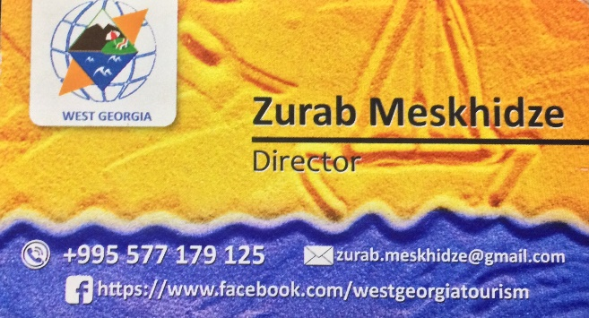

2018 version by Steven Assink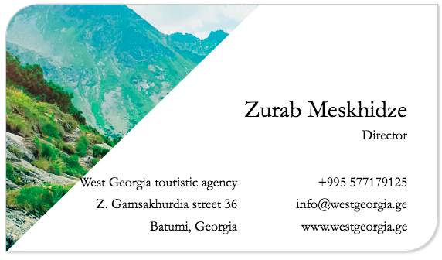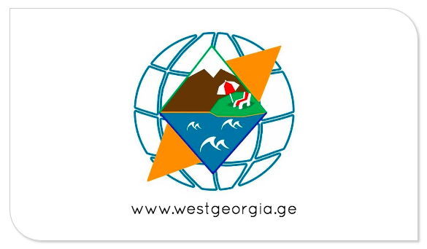

## Brochure

2017 version Outside Inside

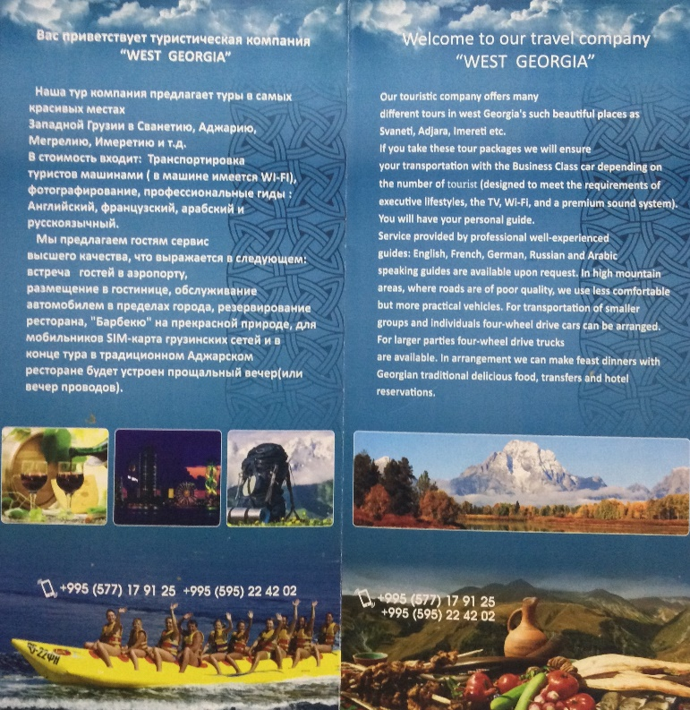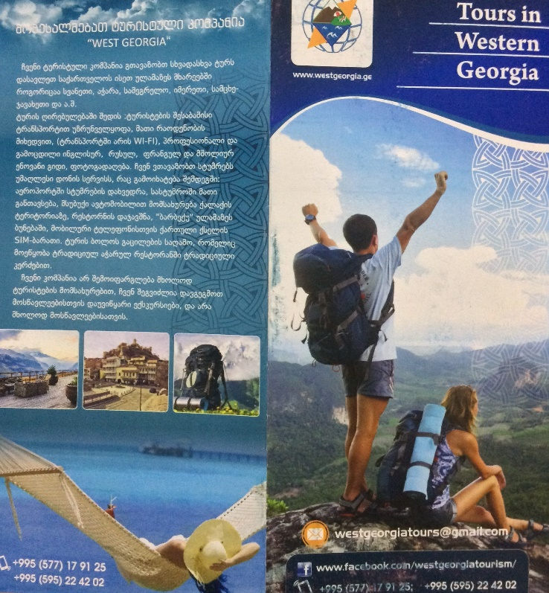

2018 version by Steven Assink Outside

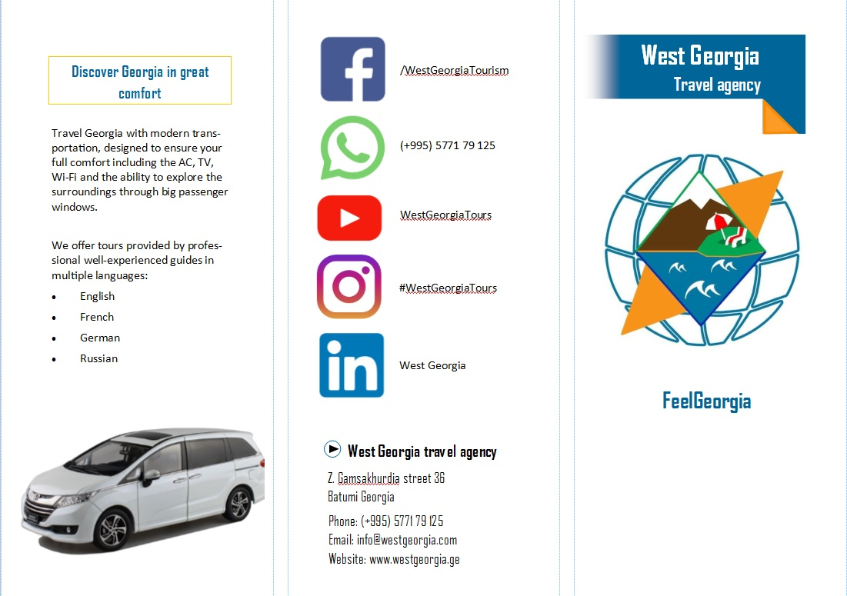

2018 version Inside

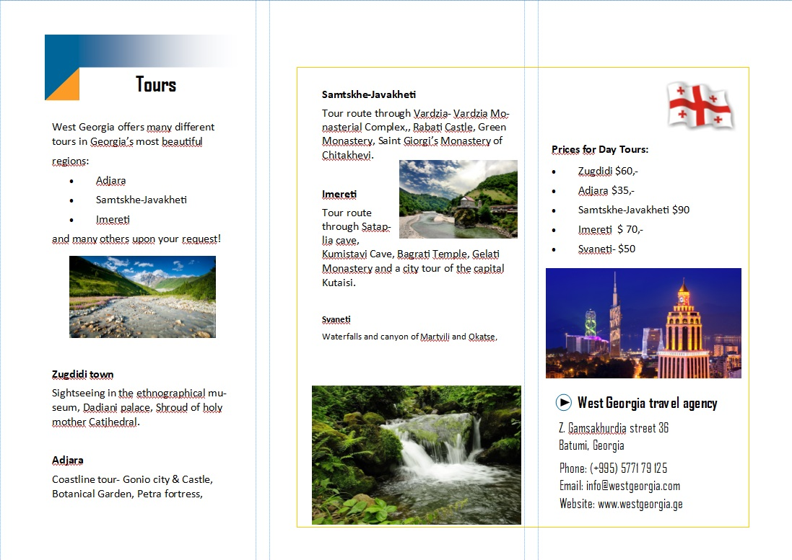

## Wrapped van

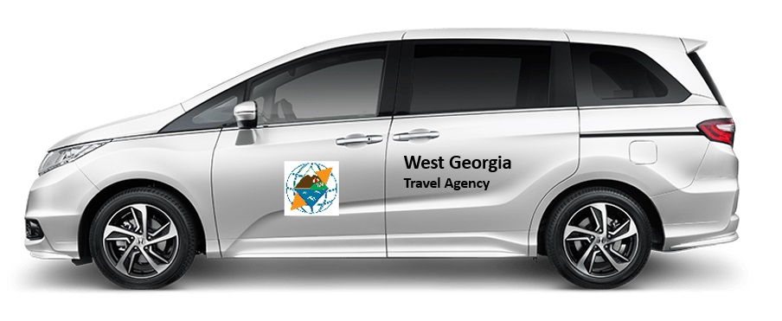

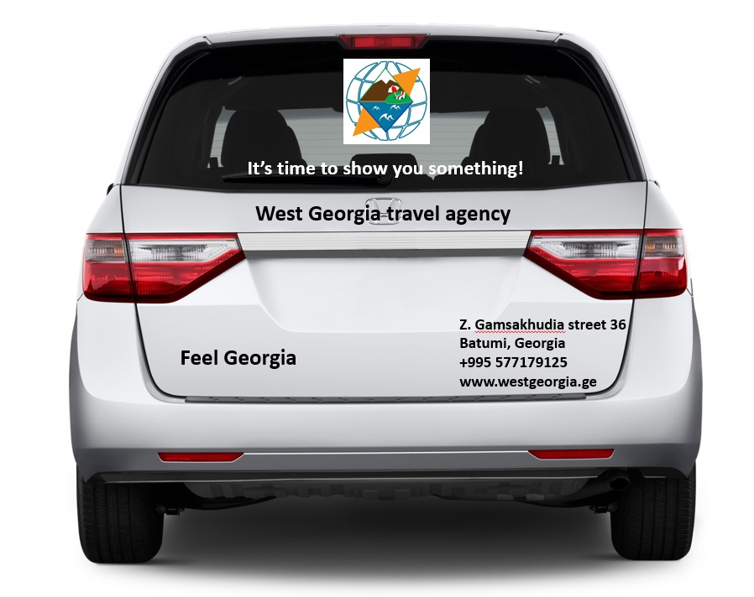

## Company clothing

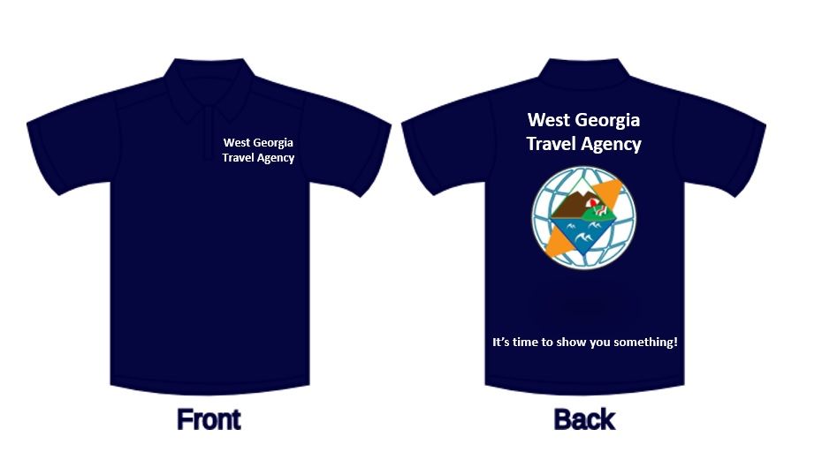

## Website and Facebook

Website

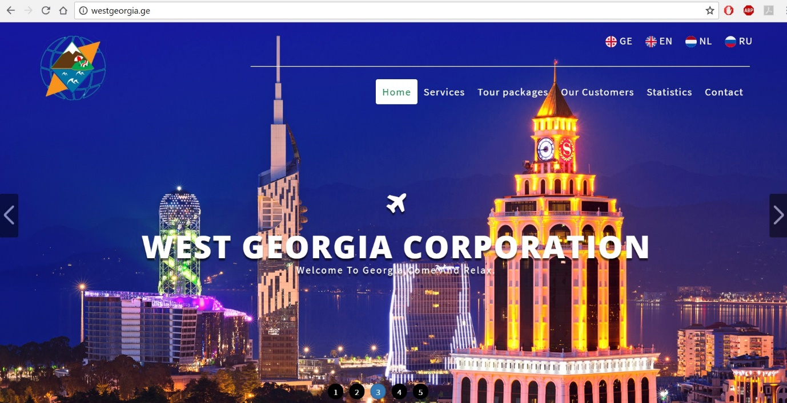

Facebook

