30-6-2016
Stefan Geisen – S.Geisen@nioo.knaw.nl

HOGESCHOOL LEIDEN, zernikedreef 11, 2333 CK leiden
b&m, microbiology, jan pieter van den berg
Presence of ecogeographic differences between range-expanding and related native plant species on microbial soil communities
NIOO-KNAW, Department of Terrestrial Ecology
Droevendaalsesteeg 10, 6708 PB Wageningen, T 0317 47 34 00, communicatie@nioo.knaw.nl
Mark Cnossen – s1071834

Inhoud
Abstract 2
Introduction 3
Climate change 3
Enemy release hypothesis 4
Plant associated organisms 4
Endophytes 4
Fungi 4
Oomycetes 5
Aim & experimental setup 5
Theoretic background of used techniques 7
Isolation and cultivation of fungi 7
Isolation and cultivation of oomycetes 7
DNA extraction 7
PCR 7
Materials & Methods 8
Seed collection and germination 8
Soil collection 8
Isolation of fungi and oomycetes from the seeds 9
Fungi 9
Oomycetes 9
Plant cultivation 9
Isolation of fungi & oomycetes from the roots 9
Molecular work 10
Results 10
Discussion 17
Conclusion 18
References 19
Appendix 21

Abstract
Climate change is a major contributor to the range shifts of several organisms such as plant species. A range is the geographical area where a species can be found and it is possible for plant species to undergo a range shift while still being present in their original one. These plants are called range-expanders. They interact with a huge range of organisms both above-and belowground, including a wide range of fungi and oomycetes which are often pathogens. Plant species are often suggested to have a faster expansion rate than their related belowground organisms and thereby outrun pathogens, which is called the enemy release hypothesis (ERH) and it is believed to attribute to the success of successful range-expanders.
The suggested main drivers of the ERH were cultivated, fungi and oomycetes, from the seeds of Centaurea stoebe and Centaurea jacea, commonly known as knapweeds, to see what potential pathogens they inherently carried with them and if root endophytes are seed derived. Similarly, those organisms were also cultivated from the roots to see if C. stoebe and C. jacea selected for different endophytes. To test whether the community of C. stoebe differed between ranges all plants were grown in both Slovenian and Dutch soil with a sterile soil as control. The DNA of all isolated cultures was extracted and sequenced to identify individual cultures. Three genera of fungi were identified to be dominantly present; Chaetomium spp., Fusarium spp. and Alternaria spp. These three genera were divided based on sequence information combined with morphological information of non-sequenced isolates that resembled sequenced cultures to look into their diversity. The abundance of the cultures was also distinguished to define infection rate.
From the results it would seem that C. jacea and C. stoebe select for different endophytes, since the diversity among C. jacea was significantly higher compared to C. stoebe (p<0.001). The infection rate is also significantly higher among C. jacea when compared to C. stoebe (p<0.001). The community of the range-expander C. stoebe does not seem to differ between ranges, suggesting that the enemy release hypothesis might not be involved in its successful range expansion. However, C. stoebe might be carrying Alternaria spp. within its seeds to gain a competitive advantage by accumilating local pathogens. This observation is based on the infection rate among the seeds of C. stoebe being significantly higher compared to C. jacea (p<0.01) while no Alternaria spp. cultures were isolated from its roots. The dominant presence of Chaetomium spp. in the roots of C. stoebe might play a role here because of its biological control properties, shielding it from the negative impact Alternaria spp. would have on it. Because of the similar morphogroups of Fusarium spp. and Alternaria spp. between the seeds and the roots, the fungi that the seeds of plants inherently carry with them might play a role after germination. Especially if the accumulation of pathogens does indeed drive the succes of C. stoebe as a range-expander.

Introduction

Climate change
Because of the global climate change temperatures worldwide are rising along with increased periods of drought in some regions, while in other regions there are higher precipitation rates^{[1]}. This is visualized in Figure 12 below.
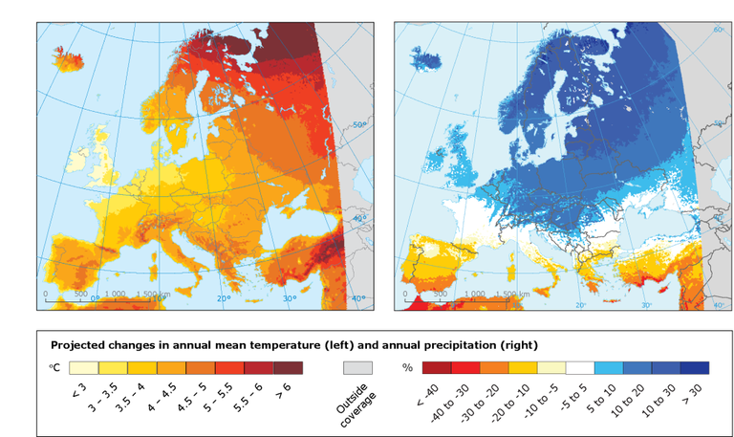
Figure 12 – Projected changes for 2071-2100, compared to 1971-2000 (European Environment Agency, 2015).

This change in climate enables plants and other organisms to shift their range towards higher latitudes^{[2]}. A range is the geographical area where a species can be found and is determined by several factors including climate, soil type and the interactions between species^{[3]}. When species shift their range they will therefore migrate towards a new geographical area. Climate change is but one of the factors that enables this range shift, another notable example being interference from humans by either introducing new species or through extensive land use. However, there are many reports that climate change is the major driving factor for the current massive range shift of species towards higher latitudes^{[3]}. Plant species are able to shift their range while still being present in their original one, these are called range-expanders since they expand their range rather than shifting it. These range-expanders can sometimes reach an enhanced dominance in their new range by altering above- and belowground interactions^{[3]}. This can turn the range-expander into an invasive species, decimating the local ecosystem. A species who has done this by expanding its range from Europe towards Northern America through the introduction of humans is Centaurea stoebe^{[16]}. Range-expanders like these, who expand their range across continents are called intracontinental range-expanders. Most studies focusing on range expansion and invasion have been about these intracontinental range-expanders while not much is known about range-expanders and their success at turning invasive when it comes to range expansion within in a continent^{[5]}. These are called intercontinental range-expanders and C. stoebe is also species who has done this within Europe itself^{[4]}. However, unlike its range expansion towards Northern America it is being driven by climate change and therefor it is unknown whether it will turn invasive^{[4]}. Some other examples of intercontinental range-expanders within Europe are Tragopogon dubius^{[14]} and Rorippa austriaca^{[15]}. The studies that have been done so far to determine if a range-expander will turn invasive have mostly focused on the difference in performance when compared to a related native plant species in the new range^{[6]}. However, it has been argued that studying the performance of the range-expander in their native range as well and comparing it to their performance in the new range increases the understanding of the above- and belowground effects that range-expanders have on native plant communities^{[7]}.

Enemy release hypothesis
A reason for why these plant species have been able to successfully expand their range is by expanding their range at a different rate than other organisms^{[10]}. An advantage of this is that detrimental organisms, such as pathogens or herbivores, which they are exposed to in their native range may not be able to keep up with their hosts and thus are absent in the new range^{[8]}. This process is what is known as the enemy release hypothesis. The concept of the enemy release hypothesis has been shown for intercontinental range-expanders but less so for their intracontinental counterparts. Because of this hypothesis the differences in the potential of range-expanders to expand their range and become invasive might in part be related to their phylogenetic relatedness to native plants. Plants without a close relative might be more successful range-expanders and have a higher chance of becoming invasive because of the absence of species specific pathogens. While host-switches of pathogens from the native plant to the range-expander might occur if they are a closely related, denying it the advantage it would get from being released from its enemies. So far the enemy release hypothesis has been shown for very few plant species but the focus has mostly been on fungal and oomycete pathogens. The main reason for this is that these pathogens are the most devastating when it comes to economically viable crops^{[8][35][37][38]}.

Plant associated organisms

Endophytes
An endophyte is an endosymbiont, which means it is an organism that lives within the cells of another organism. They are often a bacteria or fungi that lives within a plant for at least a part of its life cycle without being known to be pathogenic^{[12]}. However, some endophytic fungi may actually be latent pathogens that only become active under specific environmental conditions or when their host plants are under stress^{[12]}. Endophytes exist everywhere and have been found in all plant species studied to date. They can be transmitted both vertically (directly from parent to offspring) or horizontally (among individuals). Fungal endophytes that transmit vertically are typically considered clonal and do so by penetrating the host’s seeds with fungal hyphae^{[11]}.

Fungi
Most plant pathogenic fungi belong to the ascomycetes and the basidiomycetes. These two phyla form the subkingdom of Dikarya, often referred to as the “higher fungi”. An example of an ascomycete fungi that has been known to be pathogenic is Alternaria spp. Despite often being plant pathogenic they can live saprophytically in soils or on decaying plant tissues. It will frequently causes infections in which it enters the tissue and where it will remain inactive until changed conditions favour infection, hence why in many cases it is known as an opportunistic pathogen^{[25]}. They are foliar pathogens that can cause a range of diseases on a large variety of important economically viable crops^{[25]}. An infection leads to the formation of necrotic lesions that cause a slow destruction of host tissues by reducing photosynthetic potential. Alternaria spp. generally does not affect water or nutrient transport throughout the plant, because they do not specifically target roots or vessels^{[26]}. Another example of a fungi that belongs to the ascomycetes that has been known to be pathogenic is Fusarium spp. They are widely distributed in soils associated with plants and abundant members of the soil microbial community. While most species exist saprophytically, some are well known for inducing wilt or root rot. Fusarium oxysporum is one of these species, though there are a lot of different strains with not all of them being pathogenic^{[27]}. It is considered to be a normal member of the fungal communities^{[28]} in the rhizosphere of plants and in suppressive soils the interactions between pathogenic and non-pathogenic strains can actually result in the control of the disease^{[27]}. The reason for this is that non-pathogenic strains of F. oxysporum can compete for nutrients in the soil and also compete for infection sites on the root. Furthermore, it can trigger plant defence reactions which leads to inducing a systemic resistance. This means that the non-pathogenic strains can actually act as biological control agents^{[27]}. Another endophytic fungi that has been known to act as a biocontrol agent is Chaetomium spp. It is one of the largest genera of saprobic ascomycetes with more than 300 species worldwide and they are normally found in soil and organic compost^{[20]}. Chaetomium spp. are potential degraders of cellulosic and other organic material and have been known to act antagonistic against various soil micro-organisms in part because of their ability to act as a biocontrol agent^{[21]}. It has been found that by using specific strains of C. globosum it is possible to obtain good control over many plant pathogens such as Fusarium roseum, which has been known to cause seed blight^{[22]}, and Fusarium oxysporum^{[21]}. Some isolates also act antagonistic towards Alternaria spp.^{[23]} and can even produce antibiotics that suppress the ability of Pythium ultimum’s, an oomycete pathogen, to weaken or even outright kill seedlings before or after germination^{[24]}.
Some examples of pathogenic basidiomycete fungi are Rhizoctonia spp., most notable being Rhizoctonia solani since it causes a wide range of diseases in economically viable crops such as black scurf of potatoes, bare patch of cereals, root rot of sugar beet, belly rot of cucumber, sheath blight of rice and many other pathogenic conditions^{[37]}. Puccinia spp. is also worth noting, since it causes stripe rust in wheat (specifically caused by Puccinia striiformis) which one of the most important diseases of wheat worldwide^{[38]}.

Oomycetes
Oomycetes, such as the formerly mentioned P. ultimum, form a phylogenetic lineage of fungus-like eukaryotic micro-organisms. They contain both saprophytic and pathogenic lifecycles which include some of the most notorious plant pathogens. The saprophytic oomycetes inhabit primarily aquatic and moist soil habitats where they have a positive effect on nutrient cycling through their key role in the decomposition and recycling of organic matter. However, the pathogenic oomycetes cause devastating diseases in numerous economically viable crops as well as native plant species^{[35]}. One of the most distinguished characteristics of oomycetes is their production of zoospores. These are asexual and self-motile spores which are capable of chemotaxis (movement induced by a chemical signal). This allows them to swim in water films on leaf surfaces, soil water and in natural bodies of water^{[13]}. Eventually the zoospores have to settle on a surface because unlike most fungi they cannot survive for long without a host thanks to their trait of often being an obligate biothroph, meaning they can only live within living tissue. Oomycetes are also highly specialized, meaning that they need a specific host to survive^{[40]}. This is the reason behind why the different species infect such a high number of different crop and plant species^{[35]}. After settling on a surface they will start producing a sticky secretion which affixes them to the surface, which allows them to infect their host^{[13]}.
One of the most notorious oomycete pathogens is the infamous Phytophtora infestans, responsible for the Irish potato famine^{[30]}. It is a genus that is hemibiothroph, meaning that it lives inside living tissue for a while before continuing to live on in dead tissue. It includes more than 60 different species that infect not only potatoes but also other important crop species such as tomatoes, peppers, soybeans and alfalfa. Phytophthora spp. is also arguably the most devastating pathogen of dicotyledonous plants, or dicot, which is one of the two groups into which all the angiosperms (flowering plants) are divided in. Virtually every dicot is affected by one or more species of Phytophthora and several monocot species are infected as well making it a very damaging pathogen towards natural ecosystems as well on top of important crop species^{[35]}. Other important oomycete plant pathogens include the obligate biotrophs Plasmopara viticola, which causes downy mildew of grapevine, and Albugo, Bremia, and Peronospora species, which cause white rust and downy mildew on several crops. Another important pathogen is of course the genus Pythium which included more than a 100 species. They are abundantly present in water and soil habitats and cause a diversity of plant diseases, mainly in root tissue^{[35]}. However, some Pythium species, such as Pythium oligandrum, can be beneficial by reducing infections caused by more severe pathogenic microbes. This can occur directly through mycoparasitism^{[36]}, where the oomycete will use a fungi infecting its host as a source for nutrients, or indirectly by inducing a defence response in their host^{[35]}.

Aim & experimental setup
The goal of testing the enemy release hypothesis for intercontinental range-expanders would be impossible to do before doing some preliminary experiments to lay down a groundwork of sorts. To this end an inventarisation of the microbial community contained within the roots of two species of plants that co-occur in riverine habitats along the river Rhine-Waal in the Netherlands was done. The first species was the range-expanding (RE) plant species Centaurea stoebe, originating from southeastern Europe which has expanded its range towards the Netherlands only in the last 200 years. The second species was its closely related native species (common congener, or CC) within the Netherlands, Centaurea jacea, which is found along the entire expansion range from southeastern to northwestern Europe. For both plant species three populations were used from both ranges. The focus was on endophytic fungi and oomycetes to see if any trends could be observed. Endophytic fungi and oomycetes were therefore isolated from the roots of both C. stoebe and C. jacea to investigate whether closely related plant species selected for different endophytes and if any trends in the infection rate of these plants could be observed. Furthermore, both plants were grown in soils from both their respective ranges, the Netherlands and Slovenia, along with a sterile soil as control under greenhouse controlled conditions. The main focal point here was to evaluate whether the range-expander C. stoebe hosted a different community in their expanded range compared to its native range. The hypothesis was that they will harbour less pathogens in their expanded range than in their native range due to the enemy release hypothesis. All different treatment combinations that will be used are shown in Table 1. Finally, to test whether root endophytes were at least partly seed derived fungi and oomycetes were also cultivated from the seeds of both plants and origins. To identify all of the isolated cultures several molecular techniques were used. These included extracting the DNA, running a PCR targeting the ITS region and sequencing the PCR products. The received sequences were then subject to BLASTn searches against the NCBI database to determine the identities of all isolated cultures.

Table 1 – Treatment combinations including plant genus (numbers correspond with the population), seed origin (SE=southeastern, NW=northwestern), plant status (CC=common congener, RE=range-expander) and soil condition (S=Slovenian, NL=Dutch, C=sterile).
 | Plant genus | Seed origin | Plant status | Soil condition
1 | C. jacea 1 | SE | CC | S
2 | C. jacea 1 | SE | CC | NL
3 | C. jacea 1 | SE | CC | C
4 | C. jacea 1 | NW | CC | S
5 | C. jacea 1 | NW | CC | NL
6 | C. jacea 1 | NW | CC | C
7 | C. stoebe 1 | SE | RE | S
8 | C. stoebe 1 | SE | RE | NL
9 | C. stoebe 1 | SE | RE | C
10 | C. stoebe 1 | NW | RE | S
11 | C. stoebe 1 | NW | RE | NL
12 | C. stoebe 1 | NW | RE | C
13 | C. jacea 2 | SE | CC | S
14 | C. jacea 2 | SE | CC | NL
15 | C. jacea 2 | SE | CC | C
16 | C. jacea 2 | NW | CC | S
17 | C. jacea 2 | NW | CC | NL
18 | C. jacea 2 | NW | CC | C
19 | C. stoebe 2 | SE | RE | S
20 | C. stoebe 2 | SE | RE | NL
21 | C. stoebe 2 | SE | RE | C
22 | C. stoebe 2 | NW | RE | S
23 | C. stoebe 2 | NW | RE | NL
24 | C. stoebe 2 | NW | RE | C
25 | C. jacea 3 | SE | CC | S
26 | C. jacea 3 | SE | CC | NL
27 | C. jacea 3 | SE | CC | C
28 | C. jacea 3 | NW | CC | S
29 | C. jacea 3 | NW | CC | NL
30 | C. jacea 3 | NW | CC | C
31 | C. stoebe 3 | SE | RE | S
32 | C. stoebe 3 | SE | RE | NL
33 | C. stoebe 3 | SE | RE | C
34 | C. stoebe 3 | NW | RE | S
35 | C. stoebe 3 | NW | RE | NL
36 | C. stoebe 3 | NW | RE | C

Theoretic background of used techniques

Isolation and cultivation of fungi
Successful isolation of fungi can be achieved by the use of selective media that slow down the growth of the fungi. Most fungi and bacteria will grow on H₂O-agar, but at such a slow rate that it is relatively easy to isolate the target fungus. To inhibit the growth of bacteria an antibiotic, streptomycin for example, will often be added to the media. The simple formulation of the medium allows for easy observation of sporulation. For further determination potato dextrose agar (PDA) is usually used, since this media promotes luxuriant fungal growth making it easy to make a morphological distinction between the isolated fungi^{[34]}.

Isolation and cultivation of oomycetes
To bait the zoospores grass leaves are usually used. Using leaves to bait the zoospores is a standard technique that is commonly used to isolate oomycetes^{[18]}. For the cultivation the same principle applies for oomycetes as for fungi.

DNA extraction
For the DNA extraction the ZR Fungal/Bacterial DNA MiniPrep™ is commonly used. It is designed for the simple, rapid isolation of DNA from tough-to-lyse fungi. It uses bead beating without adding any organic denaturants or proteinases to break open the tough cellular wall of fungi. The DNA is isolated and purified with the use centrifugal force and several filters. The end product is ideal for downstream molecular-based applications including a PCR. A schematic of the ZR Fungal/Bacterial DNA MiniPrep™ procedure is shown below in Figure 1.

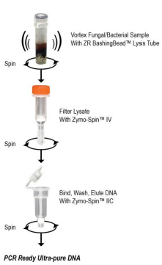
Figure 1 – ZR Fungal/Bacterial DNA MiniPrep™ procedure.

PCR
The purpose of a PCR (polymerase chain reaction) is to make a huge number of copies of DNA. This is necessary to have enough starting template for sequencing. It makes use of primers, which are single strands of DNA that are specifically made to bind to the DNA of interest, the template. The process is done in three steps. First the DNA is denaturated at a high temperature to melt open the double strands of the DNA and to stop all enzymatic reactions. Secondly the primers will be annealed, where the temperature will be lowered so ionic bonds can be formed between the now single stranded template and the primer. The primers that fit exactly form a more stable bond that lasts a little bit longer and on that new little piece of double stranded DNA (template and primer), polymerase can attach and it will start copying the template. Once there are a few bases built in the ionic bond will be so strong between the template and the primer that it does not break anymore. And finally the extension of this new piece of double stranded DNA, where the temperature will be adjusted for the ideal working conditions of polymerase so it can churn out a huge number of copies.
As for the target during this project, the internal transcribed region (ITS), it is currently the most widely sequenced DNA region in fungi^{[39]}. This is because among the regions of the ribosomal cistron, which is a sequence of genetic material in either DNA or RNA that contains the genetic code needed to make either RNA molecules or polypeptides, the ITS region has the highest probability of successful identification for the broadest range of fungi with the most clearly defined barcode gap between inter- and intraspecific variation^{[33]}. It has typically been most useful for molecular systematics at the species level. The standard primers that are used are ITS1 (5’->3’=TCCGTAGGTGAACCTGCGG) and ITS4 (5’->3’=TCCTCCGCTTATTGATATGC)^{[19]}.

Materials & Methods

Seed collection and germination
The seeds of three different populations for both C. jacea and C. stoebe were collected from varying locations in the Netherlands and Slovenia, see Table 2 for the details. 100 seeds from each population were sown to obtain at least 33 healthy seedlings of similar size and growth stage for the experiment. Before sowing the seed surfaces were sterilized with 10% household bleach solution for three minutes and then washed with sterile ddH₂O. The seeds were germinated on glass beads with sterile ddH₂O under controlled conditions (16:8hrs light:dark, 20:10ºC day:night temperature, 60% humidity).

Table 2 – Seed origins including the species of the plant along with their population, the country and area/town where the seeds were gathered along with the exact coordinates.
Species | Town/Region | Country | Site No. | Coordinates
C. jacea 1 | Millingerwaard | NL | NL1 | 51°52'45.8"; 6°00'16.9"
C. jacea 2 | Kekerdom | NL | Dijk | 51°51'55.68"; 6°0'44.37"
C. jacea 3 | Kaliwaal | NL | NL3 | 51°52'04.9"; 5°59'32.5"
C. jacea 1 | Domzale | SLO | L302/ AMF 2 | 46°08'13.54"; 014°36'58.32"
C. jacea 2 | Domzale | SLO | soil site 3.2/ AMF 3 | 46°09'91.62"; 014°45'33.90"
C. jacea 3 | Hrase | SLO | soil site 1/ AMF 1 | 46°22'37.64"; 014°10'06.62"
C. stoebe 1 | Schinveld (South Limburg) | NL | Bezoekerscentrum de Roode Beek | 50°58'19.2"; 5°59'16.8"
C. stoebe 2 | Hellevoetsluis | NL |  | 51°49'54.7"; 4°7'54.5"
C. stoebe 3 | Steenfabriek | NL |  | 51°51'60.3"; 5°53'33.6"
C. stoebe 1 | Zadovinek | SLO | litter 3/ AMF 3 | 45°55'58.10"; 015°29'78.10"
C. stoebe 2 | Zadovinek | SLO | L298/ litter 1/ AMF 1 | 45°55'73.46"; 015°30'50.88"
C. stoebe 3 | Zadovinek | SLO | L299/ litter 2/ AMF 2 | 45°55'82.28"; 015°29'74.02"

Soil collection
35kg of soil was collected from three different places in Slovenia (N46° 08' 08.124'' E014° 36' 34.992''; N46° 09' 54.972'' E014° 45' 20.340''; N45° 58' 08.544'' E014° 32' 44.592'') and 500kg of soil was collected from Millingerwaard in the Netherlands (N51° 51' 32.280'' E005° 53' 07.980''). All soil was sieved through a 1x1cm mesh to remove larger stones, macro-invertebrates and earthworms. After sieving, 5kg of the Slovenian soil and 450kg of the Dutch soil was sterilized by autoclavation for 20 min at 120 ºC while contained within two plastic bags. Due to differences in moisture calculated by using the dry weight of the soil the amount of soil mixed for each treatment differed. For the sterilized soil treatment, 36 1L pots were filled with a mix of 894.6 g sterilized Dutch soil and 55.4 g sterilized Slovenian soil (1:19). For the Dutch inoculum treatment, another 180 1L pots were filled with a mix of 859 g sterilized Dutch soil and 91 g inoculated Dutch soil (1:9). For the Slovenian inoculum treatment, 180 1L pots were filled with a mix of 844 g sterilized Dutch soil and 106 g inoculated Slovenian soil (1:9).

Isolation of fungi and oomycetes from the seeds
An experiment was performed to determine what type of fungi the seeds inherently carried with them. This was done for both fungi and oomycetes.

Fungi
For the cultivation of fungi three seeds of both origins (table 1) from both plant species were placed on a 10cm Petri dish filled with 1.6% H₂O-agar pH 6.7 containing 50µg/ml streptomycin. The seeds were first surface sterilized to increase the likelihood that only fungi from within the seeds were isolated. To this end two sterilization protocols were used; surface rinsed only with water for 5 min and thoroughly surface sterilized by first soaking the seeds in 10% household bleach solution for 5 min and then in 70% ethanol for 3 min. Five replicates for each plant genus with corresponding populations were used. The resulting cultures of endophytes were transferred to 0.5x potato-dextrose agar pH 6.7 (PDA; Oxoid). ^{[17]}

Oomycetes
For the cultivation of oomycetes five seeds of both origins (table 1) from both plant species were placed in 6cm petri dishes filled with a 1:1 mix of sterile pond water filtered through cheesecloth and sterile ddH₂O containing grass leaves (Agrostis capillaris, 2-3cm) for baiting zoospore forming oomycetes^{[18]}. After sterilization the petri dishes were incubated overnight at room temperature. Afterwards the grass leafs were transferred to a 1.6% H₂O-agar pH 6.7 containing 50µg/ml streptomycin plate. The resulting cultures of oomycetes were transferred to a 0.5x potato-dextrose agar pH 6.7 (PDA; Oxoid). To reduce the number of potentially duplicated isolates for both fungi and oomycetes, only one culture isolated from the same plant replicate was kept if they were morphologically indistinguishable.^{[17]}

Plant cultivation
Individual plant seedlings obtained from the germinating stage were transplanted into each pot after the mixing of the soil was done. Of each population, 15 seedlings were transplanted to pots with the Dutch inoculated soil treatment, 15 seedlings were transplanted to pots with the Slovenian inoculated soil treatment and three seedlings were transplanted to pots with the sterilized soil treatment. This resulted in a total of 396 plants. The plants were grown in the greenhouse under controlled conditions (16:8hrs light:dark, 25:15ºC day:night temperature, 60% humidity) and no additional nutrients were added. The pots were randomly assigned to the greenhouse space distributed across 27 carts. The carts were rearranged weekly to correct for environmental effects. During the whole experiment the pots were watered three times a week. The amount of water that the plants receive was calculated based on the soil moisture content weekly. This was done by weighing the pots and then adjusting the weight to 1kg with water. The pots were weeded when needed. At harvest, shoots of the plants were clipped and collected in paper bags, dried at 70ºC for three days and then weighed afterwards to determine plant dry biomass. ~5cm of the roots were carefully isolated from the soil and cut into pieces of ~0.5cm length before being stored in 2mL centrifuge tubes filled with sterile ddH₂O. The remaining roots were thoroughly washed, and after being dried on tissue paper, combined and dried at 70ºC for three days and weighed afterwards to determine plant dry biomass. The leftover soil was thoroughly mixed and a homogenized 2g subsample was stored in a 2mL centrifuge tube at -20ºC for further use.

Isolation of fungi & oomycetes from the roots
The root pieces stored in the centrifuge tubes were thoroughly washed under running water and were then transferred to new sterile centrifuge tubes filled with 70% ethanol and incubated for 7 min. Before the final transfer to a new centrifuge tube containing sterile ddH₂O the root pieces were once again washed under running water. The root pieces were placed on sterile tissue paper to surface dry under sterile conditions in a flow cabinet. Three individual root pieces were placed on distinct spots on a 10cm petri dish filled with 1.6% H₂O-agar pH 6.7 containing 50µg/ml streptomycin. Five replicates were used and the plates were stored at room temperature. The remaining roots were divided into three parts and each placed into a 6cm petri dish filled with a mix of pond water and ddH₂O (1:1) together with 3 grass leafs (Agrostis capillaris, 2-3cm). The petri dishes were placed at room temperature and incubated overnight. After incubation the grass leaves were transferred onto a 10 cm petri dish containing 1.6% H₂O-agar pH 6.7 containing 50µg/ml streptomycin. All H₂O-agar containing petri dishes were checked for the growth of fungi and oomycetes and newly formed colonies were transferred to petri dishes containing 0.5x potato-dextrose agar pH 6.7 (PDA; Oxoid). To reduce the number of potentially duplicated isolates, only one culture isolated from the same plant replicate was kept if they were morphologically indistinguishable.^{[17]}

Molecular work
To confirm the identity of all isolated cultures, DNA was extracted with the Zymo Research Fungal/Bacterial miniprep kit according to the manufacturer’s instructions. A PCR was then performed on the ITS region using the primers ITS1 and ITS4^{[19]}. The mastermix was prepared according to Supplementary Table 1 and the protocol used for the PCR is displayed in Supplementary Table 2 (see appendix). The sequence of the obtained PCR products was determined and potential taxonomic identities of the cultures were obtained by BLASTn searches against the NCBI database (http://www.ncbi.nlm.nih.gov/Blast.cgi). Obtained sequences were checked using Chromas and aligned with Seaview to build a phylogenetic tree.

Results
To determine whether or not C. stoebe and C. jacea selected for different endophytes and if C. stoebe hosted a different community between its native and expanded range the diversity of the cultures isolated from the roots for all different treatment combinations was determined. This was done by analysing part of the sequencing data alongside the morphological data to form several different morphogroups on the genera level. The result of this is shown below in Figure 2. This was only done for the isolated fungi because despite using a standard technique for the isolation of oomycetes along with an oomycete supporting medium, no oomycetes were isolated. When looking at just the plant species there is a significantly higher diversity among the cultures isolated from C. jacea compared with C. stoebe (F=13.98, p<0.001). However, there seems to be no significant difference in the diversity between C. stoebe grown in Dutch soil compared to Slovenian soil.

Figure 2 – The average diversity between isolated cultures from the roots across three populations is displayed on the Y-axis. On the X-axis from the bottom to the top the plant species, the soil they were grown in (NL = Netherlands, SLO = Slovenian, STERILE = control) and their seed origin is displayed. The error bars displayed show the standard deviation.

To get more insight as to where the higher diversity within the roots of C. jacea comes from a closer look was taken at the sequencing data for the roots. It was clear to see that the majority of isolated cultures were from the genus Chaetomium but there were also some cultures isolated from the genera Fusarium, Alternaria, Phoma and Gibberella, which are all potential pathogens. The isolation of these genera explains the higher diversity in C. jacea compared to C. stoebe since these genera were only isolated from the roots of C. jacea. Shown in Figure 3 is a phylogenetic tree of most of the isolated cultures from the roots. It was obtained by pairing the sequences of the isolated cultures with the two best matches in the NCBI database and aligning them to build a phylogenetic tree.

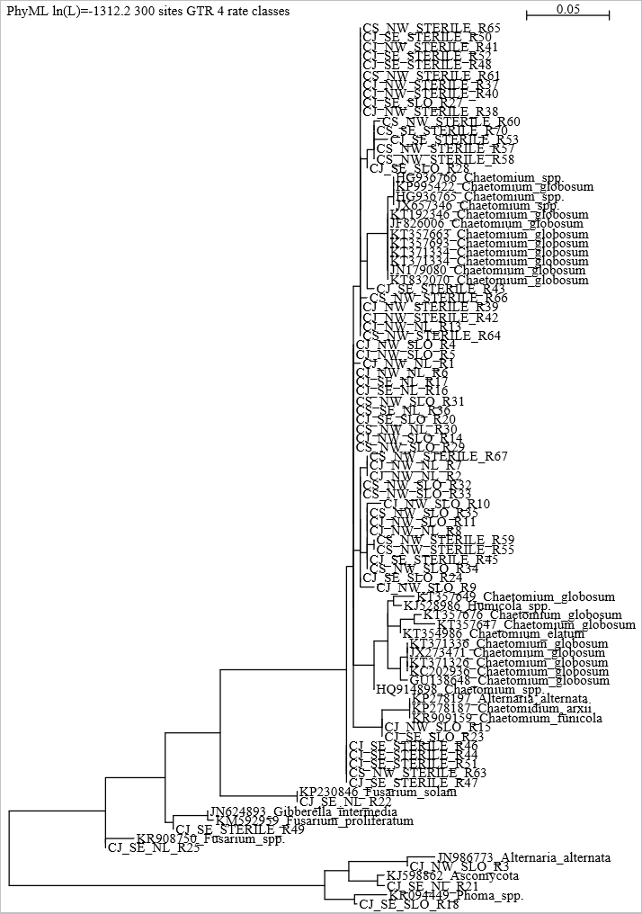
Figure 3 – Maximum likelihood phylogenetic tree of the available sequences from the cultures isolated from the roots with reference data. Displayed are the plant species (CJ=C. jacea, CS=C. stoebe), seed origin (NW=the Netherlands, SE=Slovenia), soil type (NL=Dutch, SLO=Slovenian, STERILE=sterile) along with the best matches obtained from running a BLASTn against the database of NCBI.
Not only the diversity of the isolated cultures was determined but also the abundance. This was done by tallying up all the isolated cultures from each treatment combination to give a bit more insight into the infection rate. The result of this is shown in Figure 4. Surprisingly, most cultures, especially of C. stoebe, were isolated from sterile soils since there are significantly more cultures in sterile soil compared with Slovenian (p<0.01) and Dutch (p<0.001) soils (F=10.97). In contrast, C. stoebe hosted significantly fewer cultures in Dutch and Slovenian soils than C. jacea (F=14.94, p<0.001). No cultures were isolated from the roots of C. stoebe with a Slovenian seed origin that had also been grown in Slovenian soil.

Figure 4 – The average abundance of isolated cultures from the roots across three populations is displayed on the Y-axis. On the X-axis from the bottom to the top the plant species, the soil they were grown in (NL = Netherlands, SLO = Slovenian, STERILE = control) and their seed origin is displayed. The error bars displayed show the standard deviation.

To make sure that there really were no differences between the communities of C. stoebe from its expanded range and its native range another analysis was performed on just Chaetomium spp. since it was the dominant genus present within the roots of C. stoebe. To do this the diversity for just Chaetomium spp. was determined, just as in Figure 2 was done for all the isolated cultures, by analyzing the sequencing data alongside the morphological data and dividing them into three different morphogroups. This is shown in Figure 5. However, even when looking specifically at just Chaetomium spp. there was no significant difference in diversity.

Figure 5 – The average diversity between isolated Chaetomium spp. cultures from the roots across three populations based on different morpogroups (Supplementary Figure 1) is displayed on the Y-axis. On the X-axis the plants species, the soil they were grown in (NL=Netherlands, SLO=Slovenia, STERILE=control) and their seed origin is displayed. The error bars displayed show the standard deviation.

Just like before in Figure 3 the abundance of Chaetomium spp. was also determined for all treatment combinations to see if the trend where the infection rate was higher for C. jacea compared to C. stoebe continued for the dominant genus. This is shown in Figure 6. However, no significant difference was found in the abundance between C. jacea and C. stoebe. Though again Chaetomium spp. was significantly more abundant in the cultures isolated from sterile soil compared to Dutch (p<0.001) and Slovenian (p<0.01) soils (F=12.71).

Figure 6 – The average abundance of isolated Chaetomium spp. cultures from the roots across three populations is displayed on the Y-axis. On the X-axis from the bottom to the top the plant species, the soil they were grown in (NL = Netherlands, SLO = Slovenian, STERILE = control) and their seed origin is displayed. The error bars displayed show the standard deviation.
To check whether or not root endophytes are at least partly seed derived both fungi and oomycetes were isolated from the seeds as well. Another phylogenetic tree was built in the same as the previous one, though with only just a small part of the sequence data. However, even with limited sequence data available it is still clear to see that the genera Fusarium and Alternaria are dominantly present within the seeds, which were also found within the roots of C. jacea. This is shown in Figure 7.
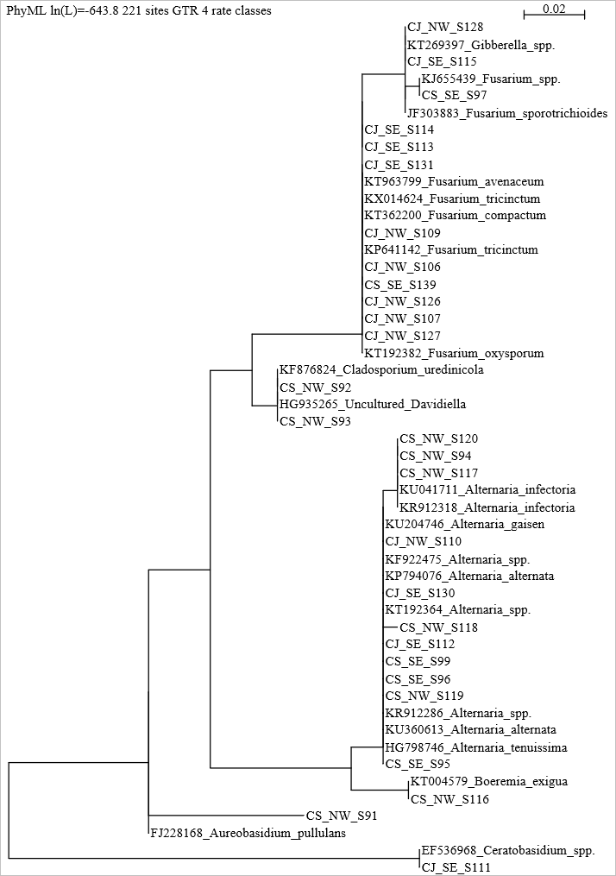
Figure 7 – Maximum likelihood tree of the available sequences from the cultures isolated from the seeds with reference data. Displayed are the plant species (CJ=C. jacea, CS=C. stoebe), seed origin (NW=the Netherlands, SE=Slovenia) along with the best matches obtained from running a BLASTn against the database of NCBI.
This dominance was further solidified after analyzing the sequencing data alongside the morphological data, again leading to the establishment of several different morphogroups to determine diversity. For Fusarium spp. this is shown in Figure 8 where there is a significantly higher diversity among the Fusarium spp. cultures isolated from the seeds of C. jacea compared to C. stoebe (F=29.14, p<0.001).

Figure 8 – The average diversity between isolated Fusarium spp. cultures from the seeds across three populations based on different morphogroups (Supplementary Figure 2) is displayed on the Y-axis. On the X-axis the plant species and their seed origin is displayed. The error bars displayed show the standard deviation.

When looking at the abundance that was determined in the same way as for Chaetomium spp. it is clear to see that the infection rate is significantly higher for the seeds of C. jacea when compared with C. stoebe (F=19.23, p<0.01), just as was observed for the roots. This is displayed in Figure 9 below.

Figure 9 – The average abundance of isolated Fusarium spp. cultures from the seeds across three populations is displayed on the Y-axis. On the X-axis from the bottom to the top the plant species and their seed origin is displayed. The error bars displayed show the standard deviation.

As was shown in Figure 7, Alternaria spp. was also one of the dominant genus found inside the seeds. However, as shown below in Figure 10, the trend so far where C. jacea has the higher infection rate seems to no longer holds true. For Alternaria spp. it is significantly higher abundant in the seeds of C. stoebe compared to C. jacea (F=10.29, p<0.01). As for the diversity of the isolated Alternaria spp. from the seeds, no significant difference was found between C. jacea and C. stoebe.

Figure 10 – The average abundance of isolated Alternaria spp. cultures from the seeds across three populations is displayed on the Y-axis. On the X-axis from the bottom to the top the plant species and their seed origin is displayed. The error bars displayed show the standard deviation.

Coming back to the original aim of finding out if root endophytes are actually at least in part derived from the seeds the different morpohgroups of the dominantly found genera within the roots and the seeds were used because of a lack of sequencing data for the seeds. Shown in Figure 11 are these different morphogroups and whether or not they were found in the roots or seeds from either C. stoebe or C. jacea. It is clear to see that there was a match between two of the morphogroups of Fusarium and one of Alternaria.

Figure 11 – The different morphogroups for the three dominantly found genera (shown in Supplementary Figure 1, 2, 3) is displayed here and whether they were isolated from the seeds or roots and from which plant species.

Discussion
During the isolation of fungi and oomycetes it became clear that no oomycetes were isolated from either the seeds of the roots, even though a standard method and medium was used precisely for that purpose. Though because of incomplete sequencing this cannot be said with certainty it would still seem unlikely that any were isolated. A reason for this failure might be because oomycetes are highly specialized pathogens that adapt to their host^{[40]}. Were this experiment to be repeated it would be a good idea to replace the used grass leaves with leaves of the host plants.
From the results it is clear to see that C. jacea and C. stoebe select for different endophytes. C. jacea has significantly more diversity (F=13.98, p<0.001) within its community thanks to the inclusion of several potential pathogens, most notibly Fusarium spp. and Alternaria spp. since these were also found within the seeds. Centaurea jacea also had a higher infection rate compared to C. stoebe (F=14.94, p<0.001). Meaning that C. stoebe might have better defenses against infection, especially since no potential pathogens were isolated from its roots. This lack of pathogens might also be explained by the dominance of Chaetomium spp. within the roots of C. stoebe. Chaetomium spp. have been known to act as a biological control agent towards many different pathogenic fungi which would make it inhibit the growth of the pathogens that were able to infect C. jacea^{[21]}. To test this a simple experiment could be performed placing the isolated Chaetomium spp. cultures on a plate together with the isolated pathogenic fungi cultures and seeing what interactions between them unfold.
Another point of interest is the high abundance of cultures isolated from the sterile soil compared to Slovenian (p<0.01) and Dutch (p<0.001) soils (F=10.97). An explanation for this might be that something went wrong during the sterilization process of the soil. An easy way to check this would be to see what is present in the soil after sterilization by isolating DNA, running a PCR and sequencing the results just as was done for the isolated cultures.
The diversity between the isolated cultures from C. stoebe does not seem to differ between ranges. Even when taking a more detailed look at just the Chaetomium spp. cultures, which was the dominant genus found within the roots, no significant difference was found. This would mean that C. stoebe attracts the same community in their expanded range as in their native range. However, since no pathogenic fungi were isolated from the roots of C. stoebe regardless of the soil it was grown it is unlikely that its success as a range expander is because of the enemy release hypothesis.
When looking at the cultures isolated from the seeds, two dominant genera were identified; Fusarium spp. and Alternaria spp. The trend of C. jacea having a higher infection rate comparet to C. stoebe is also present within the seeds when looking at Fusarium spp. (F=19.23, p<0.01). Furthermore, two of the Fusarium spp. morphogroups were present in the cultures isolated from both the seeds and the roots, which might suggest that the fungi the seeds inherently carry with them play a role after germination^{[29]}. These morphogroups of Fusarium spp. were present in the seeds of both C. stoebe and C. jacea. However, no Fusarium spp. was isolated from the roots of C. stoebe. Possibly thanks to the dominant presence of Chaetomium spp.^{[21]}.
However, Alternaria spp. cultures isolated from the seeds showed a different pattern, with C. stoebe having the higher infection rate instead of C. jacea (F=10.29, p<0.01). Though once again no Alternaria spp. is found in the roots of C. stoebe, further substantiating the idea that the ability of Chaetomium spp. to act as a biological control agent might be behind this^{[21]}. This would actually make it benificial for C. stoebe to carry Alternaria spp. with it in its seeds to negatively impact the competition, since C. jacea does seem to be susceptible to it. This concept has been termed before concerning invasive plants and therefore C. stoebe might be an example for the accumilation of local pathogens^{[32]}. An experiment should be performed to test this because the accumilation of local pathogens hypothesis might be behind its succes as a range expander. The first step would be to condition the soil through growing C. stoebe in it and then checking the community for the presence of pathogens, namely Alternaria spp., and their abundance. After this the conditioned soil could be used to grow C. stoebe alongside other plant species, for example Tragopogon dubius and Rorippa austriaca as these are also range-expanders within Europe^{[14][15]}, in it and through measuring the plant growth it should become clear whether or not C. stoebe gains a competetive advantage through the accumilation of local pathogens.

Conclusion
Taken together it would seem that C. jacea and C. stoebe select for different endophytes, since the diversity among C. jacea was significanlty higher compared to C. stoebe. This higher diversity is caused by the presence of several potential pathogenic genera, most notable being Fusarium spp. and Alternaria spp. since these were dominantly present within the seeds. The lack of presence of these potential pathogens within C. stoebe is most likely due to the biological control properties of Chaetomium spp. which is dominantly present within its roots and might inhibit infection with other potential pathogenic endophytes. When looking at the abundance of the isolated cultures it would seem that the infection rate is significantly higher among C. jacea when compared to C. stoebe. The community of the range-expander C. stoebe does not seem to differ between ranges, suggesting that the enemy release hypothesis might not be involved in its successful range expansion. However, C. stoebe might be carrying Alternaria spp. within its seeds to gain a competitive advantage by accumilating local pathogens^{[32]}. The reasoning behind is that while the infection rate among the seeds of C. stoebe was significantly higher compared to C. jacea no Alternaria spp. cultures were isolated from its roots thanks to the dominant presence of Chaetomium spp. Because of the similar morphogroups of Fusarium spp. and Alternaria spp. between the seeds and the roots, the fungi that the seeds of plants inherently carry with them might play a role after germination. Especially if the accumulation of pathogens is indeed the driving factor behind the succes of C. stoebe as a range-expander.

References
[1] Easterling, D. R., et al. (2000). "Climate Extremes: Observations, Modeling, and Impacts." Science 289(5487): 2068-2074.
[2] Parmesan, C. and G. Yohe (2003). "A globally coherent fingerprint of climate change impacts across natural systems." Nature 421(6918): 37-42.
[3] Van der Putten, W. H. (2012). Climate Change, Aboveground-Belowground Interactions, and Species' Range Shifts. Annual Review of Ecology, Evolution, and Systematics, Vol 43. D. J. Futuyma. 43: 365-383.
[4] Španiel, S., et al. (2008). "Diploid and Tetraploid Cytotypes of Centaurea stoebe (Asteraceae) in Central Europe: Morphological Differentiation and Cytotype Distribution Patterns." Folia Geobotanica 43(2): 131-158.
[5] Engelkes, T., et al. (2008). "Successful range-expanding plants experience less above-ground and below-ground enemy impact." Nature 456(7224): 946-948.
[6] Mitchell, C. E. and A. G. Power (2003). "Release of invasive plants from fungal and viral pathogens." Nature 421(6923): 625-627.
[7] Hierro, J. L., et al. (2005). "A biogeographical approach to plant invasions: the importance of studying exotics in their introduced and native range." Journal of Ecology 93(1): 5-15.
[8] Keane, R. M. and M. J. Crawley "Exotic plant invasions and the enemy release hypothesis." Trends in Ecology & Evolution 17(4): 164-170.
[9] Blossey, B. and R. Notzold (1995). "Evolution of Increased Competitive Ability in Invasive Nonindigenous Plants: A Hypothesis." Journal of Ecology 83(5): 887-889.
[10] Hickling, R., et al. (2006). "The distributions of a wide range of taxonomic groups are expanding polewards." Global Change Biology 12(3): 450-455.
[11] Stone, J. K., et al. (2004). "Endophytic fungi." Biodiversity of Fungi. Elsevier Academic Press, Burlington: 241-270.
[12] Petrini, O. (1991). Fungal Endophytes of Tree Leaves. Microbial Ecology of Leaves. J. H. Andrews and S. S. Hirano. New York, NY, Springer New York: 179-197.
[13] Grau, C. R., et al. (2004). "Fungal diseases." Soybeans: Improvement, production, and uses(soybeansimprove): 679-763.
[14] Tamis, W. L. M., et al. (2004). Standaardlijst van de Nederlandse flora 2003, Nationaal Herbarium Nederland.
[15] Dietz, H., et al. (2002). "Regeneration growth of the invasive clonal forb Rorippa austriaca (Brassicaceae) in relation to fertilization and interspecific competition." Plant Ecology 158(2): 171-182.
[16] Callaway, R. M., et al. (2004). "Soil biota and exotic plant invasion." Nature 427(6976): 731-733.
[17] Bosshard, P. P. (2011). "Incubation of fungal cultures: how long is long enough?" Mycoses 54(5): e539-e545.
[18] Pettitt, T., et al. (2002). "Comparison of serological, culture, and bait methods for detection of Pythium and Phytophthora zoospores in water." Plant Pathology 51(6): 720-727.
[19] White, T. J., et al. (1990). "Amplification and direct sequencing of fungal ribosomal RNA genes for phylogenetics." PCR protocols: a guide to methods and applications 18(1): 315-322.
[20] Von Arx, J. A. (1986). "Ascomycete Genus Chaetomium."
[21] Soytong, K., et al. (2001). "Application of Chaetomium species (Ketomium) as a new broad spectrum biological fungicide for plant disease control." Fungal 504(7): 1-15.
[22] Chang, I. and T. Kommedahl (1968). "Biological control of seedling of corn by coating kernels with antagonistic microorganisms." Phytopathology 77: 1470.
[23] Vannacci, G. and G. Harman (1987). "Biocontrol of seed-borne Alternaria raphani and A. brassicicola." Canadian Journal of Microbiology 33(10): 850-856.
[24] Di Pietro, A., et al. (1991). "Parameters influencing the efficacy of Chaetomium globosum in controlling Pythium ultimum damping-off of sugar beet/Einfluß verschiedener Parameter auf die Wirksamkeit von Chaetomium globosum bei der Bekämpfung von Pythium ultimum als Erreger der Auflaufkrankheit der Zuckerrübe." Zeitschrift für Pflanzenkrankheiten und Pflanzenschutz/Journal of Plant Diseases and Protection: 565-573.
[25] Thomma, B. P. H. J. (2003). "Alternaria spp.: from general saprophyte to specific parasite." Molecular Plant Pathology 4(4): 225-236.
[26] Rotem, J. (1994). The genus Alternaria: biology, epidemiology, and pathogenicity, APS press St. Paul.
[27] Fravel, D., et al. (2003). "Fusarium oxysporum and its biocontrol." New Phytologist 157(3): 493-502.
[28] Gordon, T. and R. Martyn (1997). "The evolutionary biology of Fusarium oxysporum." Annual review of phytopathology 35(1): 111-128.
[29] K F Baker, a. and S. H. Smith (1966). "Dynamics of Seed Transmission of Plant Pathogens." Annual review of phytopathology 4(1): 311-332.
[30] Haas, B. J., et al. (2009). "Genome sequence and analysis of the Irish potato famine pathogen Phytophthora infestans." Nature 461(7262): 393-398.
[31] Garcia-Jacas, N., et al. (2006). "Centaurea revisited: a molecular survey of the Jacea group." Annals of Botany 98(4): 741-753.
[32] Eppinga, M. B., et al. (2006). "Accumulation of local pathogens: a new hypothesis to explain exotic plant invasions." Oikos 114(1): 168-176.
[33] Schoch, C. L., et al. (2012). "Nuclear ribosomal internal transcribed spacer (ITS) region as a universal DNA barcode marker for Fungi." Proceedings of the National Academy of Sciences 109(16): 6241-6246.
[34] Atlas R. M., 1996, Handbook of Microbiological Media, 2nd Ed., CRC Press, New York.
[35] Kamoun, Sophien. "Molecular genetics of pathogenic oomycetes." Eukaryotic cell 2.2 (2003): 191-199.
[36] Jeffries, Peter. "Biology and ecology of mycoparasitism." Canadian journal of botany 73.S1 (1995): 1284-1290.
[37] Parmeter, J. R. Rhizoctonia solani, biology and pathology. Univ of California Press, 1970.
[38] Chen, X. M. "Epidemiology and control of stripe rust [Puccinia striiformis f. sp. tritici] on wheat." Canadian Journal of Plant Pathology 27.3 (2005): 314-337.
[39] Schoch, Conrad L., et al. "Nuclear ribosomal internal transcribed spacer (ITS) region as a universal DNA barcode marker for Fungi." Proceedings of the National Academy of Sciences 109.16 (2012): 6241-6246.
[40] Rouxel, Mélanie, et al. "Phylogenetic and experimental evidence for host‐specialized cryptic species in a biotrophic oomycete." New Phytologist 197.1 (2013): 251-263.

Appendix
Supplementary Table 1 – PCR mastermix
PCR mix 25µL | Volume (µL)
MQ | 15,25
DNTP | 3,125
MgCL2 | 1
10* buffer | 2,5
ITS1 | 1
ITS4 | 1
Fast start | 0,125
Total | 24

Supplementary Table 2 – PCR protocol
Temperature (⁰C) | Time
95 | 10 min
95 | 30 sec
56 | 30 sec | 39X
72 | 1 min
72 | 10 min
10 | ∞

