

**Method development and validation of imidacloprid and its metabolites in the snail Lymnaea stagnalis digestive gland with liquid chromatography and triple quadrupole mass spectrometry.**

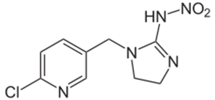

Student name: Leyla el Khamlichi

Company name: Sara Tufi

Supervisor: Karsten Kaspers

Student number: S1052486

Period: 13 January - 23 November 2015

Date: 27 November 2015

“Don’t ever let someone tell you that you can’t do something. You got a dream, you gotta protect it. When people can’t do something themselves, they’re gonna tell you that you can’t do it. You want something, go get it. Period. I’m a daughter from a strong man and women I’m proud to be me . This is why I dedicate this thesis to my parents:

Abeldelsalam el Khamlichi and Khadija el Khamlichi.

# ACKNOWLEDGEMENT

This thesis would not have been possible without the help, support and guidance of several individuals, whom in one way or another contributed and assisted in the preparation and completion of this study.

Firstly, I would like to express my gratitude to my supervisor Sara. I am deeply thankful for her encouragement, guidance and support. She supervised me throughout the course of my research and enabled me to develop an understanding of the subject. She always found time in her very busy schedule to give me useful advice and guide me in the right direction.

Furthermore, I like to thank my teacher Karsten Kaspers. Who had a lot of patience and compassion regarding the obstacles I had to overcome during the study.

I am also grateful for the support of Jacco Koekoek. I want to thank him for his help and advice during LC-MS support when Sara was not present at IVM. I also want to thank Martin Sicco, for providing me with good support and facilities to complete this project.

A special thanks to Khadija el Khamlichi-El Yahiaoui, Ali EL Yahiaoui, Tarik EL Khamlichi, Imane EL Khamlichi, Naima Benouari, Amal Nokro, Lucille van der Kust, Jose Semple, Ramiro Doorn, Nadifa Taous, Helci Deel, Wesimah Aib Ali, Nienke van Leverink, Veronick Nadeem, Hassan Rana, Mitchell Pengel, Rick Ramshai, and Shivanno Liesdek for their personal support during my research. Each and every one of them where very helpful and patient and I couldn’t have done this without their help.

Leyla el Khamlichi

Amsterdam 24 may 2015

# CONTENT

ACKNOWLEDGEMENT 3

CONTENT 4

ABBREVIATIONS 5

SAMENVATTING 6

1. INTRODUCTION 8

1.1 Imidacloprid 8

1.2 Exposure of imidacloprid on Lymnaea stagnalis 10

1.3 Metabolism of imidacloprid 11

1.4 Lymnaea stagnails 12

1.4 QueEChERS 13

1.5 Liquid chromatography 14

1.6 Mass spectrometry 14

1.7 The ion sources 14

1.8 Purpose, research question and hypotheses 17

1.9 Method validation 18

2. Experimental 20

2.1 Chemicals instrumentation 20

2.2. Equipment and materials 20

2.3 Recovery and sample preparation 21

2.4 Bradford protein assay 21

2.5 LC-MS 22

3. Results 23

3.1 System suitability test 23

3.2 Summary of Method 27

3.3 MS Optimization 27

3.4 Massa resolution 29

3.5 Sample Preparation 29

4. Validation 30

4. Conclusion 34

5. Recommendations for further analysis 35

6. Reference 36

7. Appendix 1 37

# ABBREVIATIONS

* DES-IMI Desnitro-imidacloprid hydrochloride
* CPC 6-Chloro-pyridine-3-carboxylic acid
* IMI-OL Imidacloprid-urea-olefin
* IMI-UR Imidacloprid-Urea
* IMI Imidacloprid
* ID4 Imidacloprid-D-4 analytical standard
* LC-MS Liquid chromatography- mass spectrometry
* MAC-KN Environmental quality standard (eqs)
* MAC-EQS Maximum Allowable Concentration Environmental Quality
* LC50 Lethal concentration
* LOD Lower Limit of Detection
* LOQ Lower Limit of Quantification
* M/ZMass charge number of ions
* IS Internal standard
* MRM Multiple Reaction Monitoring
* DG Digestive gland
* PSA 18 Primary Secondary amine
* Z-SEP(+) Zirconia
* A(+) Solution MeOH H2O 30/70
* MeOH Methanol
* R2 R square
* QuEChERS Quick, Easy, Cheap, Effective, Rugged
* LC-TQ-MS Liquid chromatography-Triple quad mass spectrometry
* N2 Nitrogen
* AR Argon

# SAMENVATTING

Imidacloprid (IMI) is een nieuwe neonicotinoïde insecticide die als belangrijke ongediertebestrijding steeds vaker wordt gebruikt voor vele gewassen. Afgelopen decennia heeft IMI de aandacht gekregen, vanwege haar dodelijke effecten op waterorganismen. De MAC-MKN waarden voor imidacloprid is 0,2 µg/ml. Sinds 2004 is de concentratie van IMI aan het Nederlandseoppervlaktewater constant overschreden. Het rapport van Van Dijk et al. (2012) bewijst dat niet-doelsoorten (insecten) diersoorten in het Nederlandse oppervlaktewater verontreinigd zijn met imidacloprid. Hierdoor moet er meer onderzoek gedaan worden naar de toxische effecten van imidacloprid op niet-doelsoorten die waarschijnlijk ongevoelig is voor IMI. Vanuit verschillende studies is gebleken dat IMI effect heeft op de doelsoorten en niet doel-soorten insecten. Lymnaea stagnails is een van organisme waarvan verwacht wordt dat het een lage gevoeligheid heeft voor imidacloprid. In een recente7 studie werden slakken blootgesteld aan verschillende concentraties IMI. Hieruit is gebleken dat de concentratie IMI gedurende de tijd afneemt. De hypothese bij deze studie is dat IMI gemetaboliseerd wordt naar zijn metabolieten.

De hypothese van de recente studie7 heeft geleid tot dit onderzoek. Het doel van dit onderzoek was het opzetten van een methode voor de kwantificering en validatie van imidacloprid en zijn bijbehorende metabolieten op de LC-TQ-MS. De onderzoeksvragen zijn:

* Kan de methode de metabolieten meten?
* Kan de methode de metabolieten in de dikke darm van een poedelslak na de blootstelling van imidacloprid bepalen?

De hypothese is dat imidacloprid wordt gemetaboliseerd tot zijn metabolieten. Doordat er geen bewezen methode was om IMI te detecteren in Lymnaea stagnalis, is de keuze van metabolieten gebaseerd op verschillende artikelen1,6 die IMI hebben onderzocht bij andere diersoorten (niet-diersoorten). De metabolieten die zijn gekwantificeerd en gevalideerd zijn:

* IMI-OL
* IMI-UR
* IMI-CPC
* DES-IMI
* IMI

De scheiding op de LC/-TQ-MS werd uitgevoerd op een C18 column 10 x 4.6 mm, 2.6-µM. De MS werd uitgevoerd in een positieve elektronspray ionisatie mode. Tijdens de methode is er gebruik gemaakt van een gradiënt analyse, de mobiele fase was (A)H2O:MeOH 95:5 v/v + 5mM ammonium formaat en 0,1% methaanzuur en (B) MeOH. De flow was 0,3 ml/min; de duur van de analyse bedroeg 22 minuten. De monsters en standaarden werden geanalyseerd met de gradiëntanalyse.

Tijdens de monstervoorbereiding is er gebruik gemaakt van de QuECHERS Z-SPE(+) en PSA (18). Uit de onderzoeksresultaten bleek dat de PSA(18) 20,95% minder respons gaf dan de Z-SPE(+). Vanuit deze resultaten kan geconcludeerd worden dat Z-SEP(+) een betere stap is voor de bewerking van het monster. De selectiviteit, precisie, lineariteit en Carry over voldoen aan de gestelde specificaties. De recovery van DES-IMI en CPC voldoen niet aan de gestelde eisen. Hierdoor is het essentieel een stap toe te voegen aan de monstervoorbereiding.

Een mogelijke verbetering voor de recovery is het gebruik van een andere QuEChERS ; namelijk de PSA (18). Uit de onderzoeksresultaten blijkt dat de gemiddelde matrixeffecten onder de 100% is. Een mogelijke oorzaak hiervan is dat er matrixeffecten aanwezig zijn in het monster die interfereren met de metabolieten. Om de matrixeffecten te elimineren zou er een standaardadditiemethode gebruikt kunnen worden. Vanuit deze resultaten kan geconcludeerd worden dat de methode die ontwikkeld is de metabolieten IMI, CPC, DES-IMI, IMI-UR, IMI-OL kan meten. De methode is niet gevalideerd op de gestelde eisen van de recovery; dit geldt alleen voor DES-IMI, CPC. Verder is de methode niet gevalideerd voor de matrixeffecten van de metabolieten IMI, CPC, DES-IMI, IMI-UR en IMI-OL.

De gestelde hypothese was dat imidacloprid zou worden gemetaboliseerd tot zijn metabolieten. De monsters die blootgesteld zijn aan imidacloprid bevatten een concentratie van 10 en 100 ng/l, welke zijn gekwantificeerd. De monsters die blootgesteld zijn aan een concentratie IMI onder de 100 ng/l zijn onder de detectielimiet gemeten. De resultaten van DG die zijn blootgesteld aan IMI met een concentratie van 100 ng/l, komen overeen met de gestelde hypothese. De onderzoeksresultaten geven aan dat IMI de hoogste concentratie heeft. Dit komt doordat IMI ook het Target Ion is. De andere metabolieten hebben een lagere concentratie dan IMI. Om een hogere concentratie van metabolieten te realiseren zullen de slakken langer moeten worden blootgesteld aan IMI.

# INTRODUCTION

### 1.1 Imidacloprid

Neonicotinoids are a relatively new type of insecticide, recently registered in the United States. Neonicotinoids means “new nicotine-like insecticides” and this type proves to be an effective pesticide against insects that are resistant to other classes of insecticides6. Insecticide 1-[(6-Chloro-3-pyridinyl)methyl]-N-nitro-4,5-dihydro-1H-imidazol-2-amine,commercially known as imidacloprid (IMI), was the first neonicotinoid that reached the market (see figure 1 for the chemical structure of imidacloprid). It has proven to be a good control against certain beetles, fleas, certain wood boring pests, flies, cockroaches and others members of the insect family. Imidacloprid has therefore become an important pest control for many crops.

However, the presence of manufactured chemical compounds in the environment has raised concerns. The compound has both lethal and sublethal effects on aquatic organisms. This can result in adverse effects on the functionality of our ecosystem. Over the past two decades, the compound gathered attention due to its general environmental presence and significant Eco toxicological effects. The international Maximum Allowable Concentration Environmental Quality Standard (MAC-EQS) was of help with that. The MAC-EQS is a guideline for the maximum allowed surface water concentration of chemical pollutants in surface water in the Netherlands. Since 2004, imidacloprid surface water concentrations have consistently exceeded the MAC-EQS (0.2 µg/ml). Especially in agricultural areas, here concentrations of 1 µg/l have been reported. Figure 2a shows an overview of the concentrations of imidacloprid in the Netherlands between 2003 and 2009 and Figure 2b shows the number of measuring points in the Netherlands exceeding the MAC-EQS set at 0,2 µg/L. Al in all saying imidacloprid is a concerning environmental pollutant.

Although the pesticide has proven to be highly effective on the neuronal cells of insects, recent reports indicate that non-target species are affected as well. Van Dijk et al reported a decline in non-target macro invertebrate species. Moreover, in cases where the Dutch surface water is contaminated with imidacloprid, serious effects in the aquatic ecosystem composition have been measured. The concentration that causes 50% of the population mortality (LC50), has been experimentally determined for imidacloprid in different organisms. But to further improve the base of evidence of imidacloprid toxicity, the effect of imidacloprid on non-target species should be more thoroughly investigated. Figure 1A shows an overview of the concentrations of Imidacloprid in the Netherlands between 2003 and 2009 and Figure 1 B shows the number of measuring points in the Netherlands exceeding the MAC-EQS set at 0,2 µg/L.

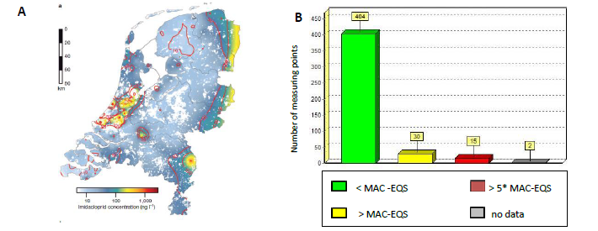

Figure 1a Interpolated mean logarithmic concentrations of Imidacloprid in the Netherlands (2003-2009) B, Frequency distribution of surface water measuring points in the Netherlands exceeding the Imidacloprid MAC-EQS( 0,2µg/L)

*:*

Imidacloprid is the most active neonicotinoid pesticides against insects. The neurotoxic consequences, of acute pesticide exposure are well known. Their exposure is associated with a range of symptoms as well as deficits in neurobehavior. Figure 2 show the chemical structure of imidacloprid. Neonicotinoids are related to nicotine in their structure and its action targets the nicotinic acetylcholine receptor. This means that normal nerve impulse become impaired. Imidacloprid shows selective toxicity for insects over vertebrates. Many studies proved the effects of neonicotinoid. The presence of imidacloprid in surface water is expected to lead to negative impact on the aquatic ecosystems. The highest sensitivity is found in insects, as was indicated by the LC50 value 12.94 µg/l afther 96-h exposure4 for the midge larvae Chirnonmus riparius4. It was observed in this study that the sub lethal phenotypic effect of ventilation and locomotion were affected at imidacloprid concentrations of respectively 0.55 and 1.20 µg/L afther 96-h exposure4. These findings suggest that imidacloprid might not only affect non-target species lethally, but also in a sublethal way. *Lymnaea stagnalis* is a model organism in environmental toxicology and neurobiology; this model organism is a non-target species for imidacloprid with a low expected sensitivity to this compound.

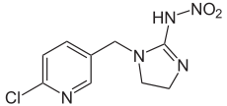

Figure 2: Imidacloprid

### 1.2 Exposure of imidacloprid on Lymnaea stagnalis

The result of the exposure of imidacloprid to the snails, show that the intended exposure concentration of imidacloprid is xx in comparison with the actual exposure concentration of imidacloprid (see figure 4). What's furthermore interesting, is that the average concentration of imidacloprid decreases after 24 hours. This might be the case because imidacloprid is metabolized to another component.5

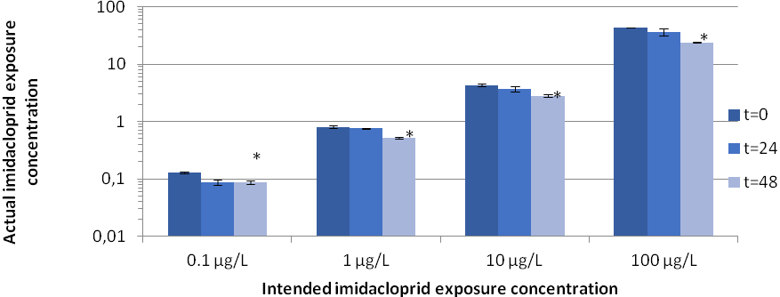

Figure 4: Exposure concentrations of Imidacloprid on Linnaean stagnalis

## 

### 1.3 Metabolism of imidacloprid

In order to better understand the metabolization of imidacloprid to another component, this research shows a schematic representation (see table 1) of the degradation products within the Lymnaea stagnalis tissues. It was quite difficult to describe the metabolic pathway of imidacloprid in Lymnaea stagnalis since there was no proven method to determine imidacloprid in Lymnaea stagnalis tissue. So the selected metabolites, which will be investigated in this research, were taken from many scientific research reports6,1 who investigated the metabolites of imidacloprid in different samples (non-target). From the metabolites in table 1 the commercial standards where available.

|  |  |  |
| --- | --- | --- |
| **Compound name** | **Elemental Composition** | **Chemical structure** |
| Imidacloprid | C18H19NO4 |  |
| (IMI) 1 |
| Imidacloprid-urea-olefin | C9H8CLN3O |  |
| (IMI-UR) |
|  |
| Imidacloprid-urea-olefin | C9H8ClN5O2 |  |
| (IMI-OL) |
|  |
| 6-chloro-pyridine-3-carboxylic acid | C6H4CLNO2 |  |
| (CPC) |
|  |
| Desnitro-​imidacloprid hydrochloride | C9H11ClN4 |  |
| (DES-IMI) |

Table: 1 Chemical Background information of imidacloprid and its metabolites

### 1.4 Lymnaea stagnails

The exposure of imidacloprid on Lymnaea stagnalis has been researched in a recent study7. Lymnaea stagnalis is also known as the great pond snail. The snail has a tall slender and pointed spire and shiny yellowish brown shell and pointed spire. The shells are breakable and transparent. The snail has a large head and a long flattened tentacles, the color of the snail is yellowish grey. This species inhabits slow or still waters, such as the edge of pools, streams, and reservoirs. Lymnaea stagnalis lives in muddy sand or crushed stone bottom. These species live in Asia (central, north and south and southeast), North America, North Africa, New Zealand and European Mediterranean area. The snail comes to the surface to take air into a respiratory cavity. The wide tentacles play a role in the intake of oxygen. The surface of the tentacles is covered by ‘cilia’. The function of the cilia is to increase the oxygen intake. Each snail individual has both female and male reproductive systems2 (see figure 3).

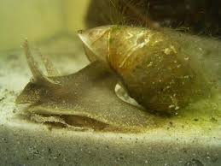

Figure 5: Lymaea stagnalis

### 1.4 QueEChERS

Research shows a few methods to analyze pesticide residue. For example: QuEChERS. QuEChERS stands for quick, easy, cheap, effective, rugged and safe. QuEChERS is a variety of a sample preparation and a cleanup technique for the analysis of multiple pesticide residues. The QuEChERS has a simple number of analytical steps; the method is fast and easy to perform. In different studies the method provides high recoveries for a very broad scope of pesticides. The QuEChERSmethodology is not only power for sample extraction and cleanup, but also for detecting a fast array of pesticides. QuEChERS has now become a generic technique with many modifications; each variation is designed to accom­plish one thing: quick sample extraction and cleanup.

QuEChERSin its basic form involves three steps:

1. Liquid micro-extraction

2. Solid-phase cleanup

3. LC/MS/MS or GC/MS analysis

The **QuEChERS** method has been introduced to increase sample material, while reducing costs, minimize degradation of susceptible compounds (e.g. base and acid labile pesticides) and expand the range of matrices.

### 1.5 Liquid chromatography

Chromatography is a technique for the separation of components, or solutes of a mixture. This separation occurs based on the interactions of the sample with the mobile and stationary phases. Many stationary/mobile phase combinations can be employed to separate a mixture with different types of compounds. The components within a mixture are separated in a column based on each component’s affinity for the mobile phase. Molecules of interest in the mobile phase are separated based on their differing interactions with the stationary and mobile phases. The mobile phase composition is changing during the separation run of the sample. The mobile phase continues to the flow through the column, the column effluent, or eluate, is typically collected in fractions while monitoring the concentrations of the compounds eluted from the column over time to yield an elution curve or chromatogram Liquid chromatography–mass spectrometry (LC/MS) is a technique that combines the physical separation capabilities of liquid chromatography with the mass spectrometric detection. LC-MS has a very high sensitivity and selectivity and is useful in many applications. Liquid chromatography (LC) separates the sample components and introduces them to the mass spectrometer (MS). The MS creates and detects charged ions. The LC-MS data may be used to provide information about the molecular weight, structure, identity and quantity of specific sample components5. The flow and gradient were optimized during the method.

### 1.6 Mass spectrometry

Mass spectrometry is a technique for studying the masses of atoms or molecules or fragments of molecules. Mass spectrometry can be used as a detector in chromatography to provide both qualitative and quantitative information. The mass spectrometry consists ionizing chemical compounds to generate charged molecules or molecule fragments and measurement of their mass-to-charge ratios. During the ion separation the mass spectrometry requires high vacuum to prevent molecular collisions during ion separation.

### 1.7 The ion sources

Electrospray is an also called ion spray. Liquid from the column enters the steel nebulizer capillary, which has a coaxial flow of N2 gas. If the machine is measuring the positive ions, the nebulizer held at 0 V and spray a chamber at -3500 V. For negative ion, the electric field at the nebulizer outlet is combined with the coaxial flow of N2 gas. It is creating a fine aerosol of charged particles. Positive ions from aerosol are leading in the mass spectrometer by an even more negative potential. Gas flowing from atmospheric pressure in the spray chamber transports ions to the right trough the capillary and to its exit where the pressure is reduced by a vacuum pump. Electrospray ionization (ESI) is mainly applied for polar compounds. Figure 5 shows an overview of an electrospray5.

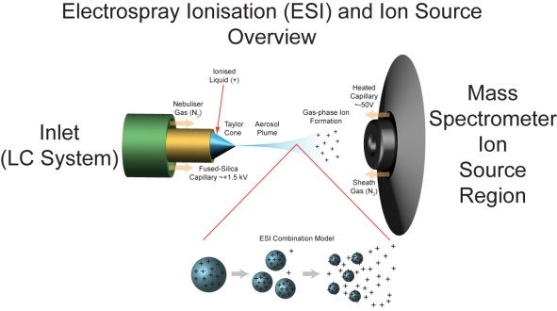

Figure 6: Overview of an electrospray

The transmission quadruple mass spectrometer, also known as quadruple mass analyzer (QMS), is a type of mass analyzer that is used in the mass spectrometry. The quadruple of the instrument is responsible for filtering samples ions, based on their mass-to-charge ratio (m/z). Ions are separated in a quadruple based on the stability of their trajectories in the oscillating electric fields that are applied to the rods. The quadruple has four loaded rods; these roads are arranged in a square and in between the molecular the ions are separated. Each rod has a DC voltage; the diagonal poles have an equal charge. Charged particles are guided in the middle between the rods. The voltage at the terminals of the charged particles keeps them between the poles. When there is an interaction between the poles, the charged particles develop a wave between the rods. The amplitude of this particular wave depends on the charge of the particle and alternating voltage. The greater the charge of the ion and the electric field, the greater the electrical power will be.

The quadruple mass spectrometry improves the sensitivity by decreasing the response of everything that decreases the background noise. The quadrople is using a selected ion monitoring that only looks at a few values of *m/z*.Themixture of ions finds place in the first quadruple (Q1); the precursor ion is selected in the Q1 and is adding to Q2 (the so called collision cell). The precursor ion collides with N2 or Ar. The molecules break into fragments and are called product ions. The Q3 selects only product ions of interest to the detector. This type of mass spectrometry is based up on selected ions.5 Figure 6 shows an overview of the quadrople.

Figure 7: Overview of the Quadrupole

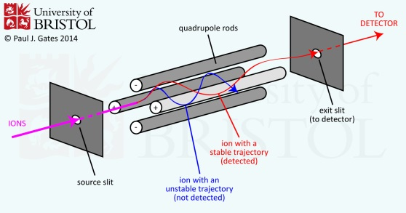

The mass sector is using a magnetic field, which allows ions of selected *m/z* to pass from the ion source to the detector. Gaseous molecules entering into the source are converted into ions, accelerated by an electric field and expelled into the analyzer tube. The tube is under high vacuum, so the ions cannot collide with the gas molecules. The magnet deflects ions toward the detector, which is situated at the far end of tube. Light ions are deflected and are able to touch the detector. Heavy ions on the other hand are not deflected enough. At the electron multiplier detector each arriving ion starts a cascade of electrons; this is equal to a photon, which starts a cascade of electrons in a photomultiplier tube. The detector shows a mass spectrum as a function of *m/z* that is selected by the magnetic field5. Figure 7 shows an overview of the mass spectroscopy. During the optimization of the MS the metabolites IMI-UR and IMI-OL were optimized. The metabolites DES-IMI, CPC and IMI already optimized. The flow and gradient were optimized during the LC method.

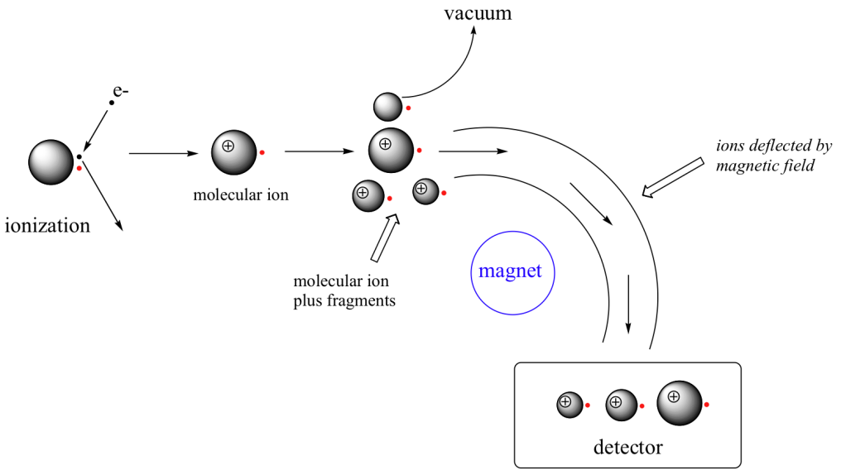

Figure 8:Overview of the mass spectroscopy

### 1.8 Purpose, research question and hypotheses

Result of the study on the exposure of imidacloprid on Lymnaea stagnails, have led to this study. The results indicate that imidacloprid might be metabolized to other components. Therefore the aim of the study was two folded:

1. To develop a method for the quantification of imidacloprid and its metabolites.
2. To validate the method.

The selected imidacloprid metabolites are: imidacloprid-olefin (IMI-OL), imidacloprid-urea (IMI-UR), 6-chloro-pyridine-3-carboxylic acid (CPC) and Desnitro-imidacloprid hydrochloride (DES-IMI).

The research questions for this paper are as follows:

1. Can the method (that has been developed and validated) measure the metabolites?
2. Can the method determine the different metabolites in digestive gland of *Lymnaea stagnalis* after imidacloprid exposure of different concentrations?

As figure 4 shows, the average concentration of imidacloprid decreases after 24 hours exposure imidacloprid on *Lymnaea stagnalis*. The hypothesis is that imidacloprid has been metabolized to its metabolites.

### 1.9 Method validation

Validation of an analytical method is the process by which it is established, by laboratory studies, that the performance characteristics of the method meet the requirements for the intended analytical application. Validation is required for any new or amended method to ensure that it is capable of giving reproducible and reliable results, when used by different operators employing the same equipment in the same or different laboratories.

The analytical parameters used in this validation study include the following:

* Selectivity
* Carry-over
* Lower limit of detection
* Lower limit of quantification
* Linearity
* Precision
* Matrix effect
* Recovery

***Selectivity***

An analytical method should be able to differentiate and quantify the analyte in the presence of other components in the sample. The absence of interfering components is accepted when the response is less than 20% of the lower limit of quantification for the analyte and 5% for the internal standard. Every blank sample should be tested for interference, and selectivity should be provided at the lower limit of quantification (LLOQ).

***Carry-over***

During the method development, the carry-over should be minimized. During the validation different blank samples must be measured after a sample or a high concentration of the calibration standard. The carry over in a high concentration standard should not be greater than 20% of the lower limit of quantification (LOD) and 5% for the internal standard.

***Lower limit of quantification***

The lower limit of quantification (LLOQ) is the lowest calibration point; this calibration point can be quantified with an acceptable accuracy and precision. The signal of this sample should be at least nine times higher than the signal of the blank sample. The signal to noise is determined by the program qualitative analysis.

***Lower limit of detection***

The detection limit (LOD) is the concentration that corresponds to the signal that is three times as high as the standard deviation of the blank signal. The program Qualitative Analysis determines the signal to noise.

***Linearity***

This is the method's ability to obtain results that are either directly, or after mathematical transformation proportional to the concentration of the analyte within a given range. Linearity is determined by calculating the regression line using a mathematical treatment of the results (versus analyte concentration). The R square represents the coefficient of the regression and the linearity of the method. A minimum of six calibration concentrations should be used. The calibration curve should be reported (slope and intercept). The R square must be greater than 0,99.

***Precision***

Precision is a measure of the reproducibility of the whole analytical method (including sampling, sample preparation and analysis) under normal operating circumstances. The precision is expressed as the relative standard deviation and it should be calculated in five samples at the same level of concentration. The precision must be equal to or below 15.

***Matrix effect***

If the method is be used with mass spectrometric method, the matrix effect should be investigated. For each metabolite, the matrix factor (MF) should be calculated. The MF is calculated by dividing the peak area of a blank matrix spiked with a standard; after the sample preparation and the peak area of the standard are at the same level of concentration. The area of the analyte is always normalized for the response of the internal standard (IS). The matrix effect should not be below 100%.

The formula used is:



***Recovery***

The recovery is used to determine whether there is any analytic loss during the sample preparation. The recovery percent (R%) of each analyte is calculated by dividing the concentration added by the concentration found multiplied by 100, as shown in the formula below. The recovery percentage must be within 80%-120%



# Experimental

### Chemicals instrumentation

Formic acid, Sigma-aldric (98,0%), Ammonium Formate, Fluka Bichmeica (99,0%), Acetonitrile, Sigma-aldrich (98,0%), Imidacloprid-olefin (IMI-OL), Dr-Ehrenstofer (99,0%), Imidacloprid-urea Dr-Ehrenstofer (99,0%), (IMI-UR), Dr-Ehrenstofer (99,0%), Dr-Ehrenstofer (99,0%), 6-chloro-pyridine-2-carboxylic acid (CPC) Dr-Ehrenstofer (99,0%), Desnitro-imidacloprid hydrochloride (DES-IMI), Dr-Ehrenstofer, Imidacloprid (IMI) Sigma Aldrich (99,0%), Magnesiumsulfate, Sigma-aldrich (99,0%), Sodiumchloride Sigma-aldrich (99,0%), Methanol Sigma aldrich (99,0%), Acetonitrile Sigma aldrich ( 99,5%).

**Instrumentation**

Liquid chromatography Agilent Technologies serie1200, massa spectrometer Agilent Technologies series 6410, C18 column (phenomena) 100 x 4.6 mm, 2.6- µm particle size (Kinetex 5u-XB-C18 100A column).

### 2.2. Equipment and materials

From each individual compound a stock solution was prepared of 10 µg/ml. The stock solutions were dissolved in MeOH:H2O 5:95 v/v. Of each stock solution, mixed calibration standards were prepared with different concentrations as described in table 2. The internal standard was prepared to take 100 µl in 10ml MeOH:H2O 5:95 v/v this solution was called (A+).From A+ 20µl was taken and added to 10 ml MeOH:H2O 5:95 v/v. From each calibration standard 50 µl and 50µl of internal standard was transmitted into an LC-MS vial.

Table 2: Calibration line

|  |
| --- |
| **Concentration µg/ml** |
| 1 ng/ml |
| 0,2 ng/ml |
| 0,1 ng/ml |

### 2.3 Recovery and sample preparation

***Sample homogenization***

The DG was weighted in a Precellys (Bertin technologies) 2ml vial with ceramic beads. There was 1.5 ml of MeCN added to the sample. 50µl of the internal standard was added to the sample. The sample was centrifuged by two cycles of 10 s at 65000 rpm with 15 s breaks between the cycles in a Precellys Dual tissue homogenator. The homogenate was transferred in an Eppendorf vial; this vial was put on ice for 5 min to allow the protein precipitation. The tube was centrifuged for 5 min at 4°C at 17000 rpm. The organic supernatant was transferred in an Eppendorf vial, 50 mg of anhydrous MgSO4 and 10 mg of NaCl was added to the vial. The vial was mixed directly for 1 min and centrifuged for another min at 6000 rpm. The organic supernatant was transferred to a new Eppendorf vial.

***Clean-up were based on the QuEChERS method and modified as follows:***

1 ml of the organic supernatant was transferred into a new Eppendorf vial and contained with 50 mg of the sorbent of QuE Z-sep+. The tube was mixed on a vortex for 30s and centrifuged for 1 min at 6000 rpm. The organic supernatant was transferred in a new Eppendorf vial. The sample was dried under a nitrogen flow. 100µl of the mobile phase was added to reconstitute the sample. The tube was centrifuged for 5 min at 4°C at 17000 rpm and transferred into an LC-MS vial.

## 

### 2.4 Bradford protein assay

In all samples the snail DG did not have the same tissue content. Therefore, the concentrations should have been normalized for the tissue content. Tissue content is directly related to protein content, which can be quantified using the Bradford protein assay (Bradford, 1976). Bovine Serum Albumin (BSA) was used as calibration standard and obtained from Sigma–Aldrich. The Protein Assay Dye Reagent was purchased from Bio-Rad Laboratories (Richmond, CA, USA). 10 µL of the DG homogenized sample was diluted with MilliQ water (1:100 v/v). Then, 160µL of these samples were added with 80uL of the Bradford reagent (diluted 1:1 with MilliQ water) in a 96-wells plate (Greiner Bio-One, Monroe, NC, USA) in triplicate. Next, the contents of the plate were mixed carefully and incubated for 10 minutes. Finally, wavelength absorbance at 595 nm was measured with a SPECTRAmax 340PC Spectrophotometer Plate Reader (Molecular Devices, Sunnyvale, CA, USA). The absorbance readings were performed using the software SoftmaxPro5.2 (Molecular Devices).

### 2.5 LC-MS

The LC separation took place on a C18 column 100 x 4.6 mm, 2.6- µm particle size (Kinetex 5u-XB-C18 100A column). The mass spectrometer was operated in the positive electrospray ionization mode. The LC was operated under gradient conditions with mobile phases of H2O:MeOH 95:5 v/v + 5mM ammonium formate and 0.1% formic acid (A) and MeOH (B). The flow rate was 0.3 ml/min. The run time was 30 minutes. Samples and calibration solutions were first analyzed by an initial gradient, as described in table 2. The MS source temperature was set at 350°C with a nitrogen flow of 40 PSI.

The mass spectrometer was operated in multiple reactions monitoring mode (MRM), by monitoring one precursor ion and two products ion for each analyte. The target ion transition with highest intensity (primary ion transition) was used for quantitation, whereas the second target ion transition was used for confirmation. The instrument uses mass hunter analyze version B0301 and B0400 for quantitative and qualitative calculations. The ion transitions, cone voltages, and collision energies for the analytes and collision energies for the analyzes are shown in table 3.

Table 4: The LC-MS gradient

|  |  |
| --- | --- |
| **Time** | **Gradient B%** |
| 0 | 5 |
| 10 | 60 |
| 17 | 95 |
| 22 | 95 |

# Results

## 3.1 System suitability test

Chromatography is a method by which a mixture is separated by distributing its components between two phases. A high efficiency between the separations (the peaks) is essential. This is motivated by the resolution equation, which shows that increases in column efficiency always result in improved resolution. Chromatographic efficiency is affected by a large number of experimental variables and its optimization can be achieved in many different ways, depending upon how many variables one is willing to adjust. These include pressure, temperature, particle size, column length and flow. The flow and gradient were optimized during the method.

***Column***

In a recent study of Kamel et al suggest the determination of neonicotinoids in honey bees6 was carried out with a C18 column 100 x 4.6 mm, 2.6µm particles. Therefore, there is decided to use a column with the same stationary phase as in the study of Kamel el A 6.

***Mobile phase and column***

Kamel et al 6 suggest the use of a mobile phase composed by H2O:MeOH(95:5) with 5mM ammonium formate and 0,1% of formic acid (A) and methanol (B). The pH of A was between 2 and 3. During this project, the same mobile phases, gradient and the same range of pH were used. The analysis started with the gradient that is described in table 3.

***Gradient***

The gradient, suggested by Kamel et al 6, was the starting point of the analysis. The gradient of the analysis is described in table 4. During the analysis, a gradient method has been used to separate the metabolites (IMI, DES-IMI, IMI-UR, IMI-OL, CPC). The gradient of the analysis is described in table 3. The gradient started with 10% of B, it was increased to 60% in 6 minutes and it was kept constant for 3 minutes. The percentage of B was increased to 90% from 9 till 15 minutes. From 15.1 till 25 minutes the gradient decreased to 10% of B. As can been in figure 8, the peak of IMI-OL and CPS shows double peaks. Furthermore: the peak of the metabolites IMI-OL shows overlap with DES-IMI. These findings suggest that the separation was not efficient for the metabolites and the gradient must be changed. Figure 8 shows the chromatogram of gradient 1.

Table 4: Gradient of method 1

|  |  |
| --- | --- |
| **Minutes** | **Percentage of B %** |
| 0 | 10 |
| 6.0 | 60 |
| 9.1 | 60 |
| 15.0 | 90 |
| 15.1 | 10 |
| 25.0 | 10 |

A standard was prepared for each metabolite and the standard was measured with the LC-MS. This way the peaks were designated in figure 8.

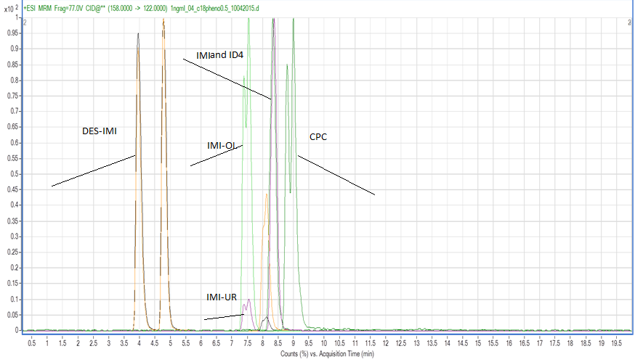

Figure 8: Chromatogram of the metabolites with gradient 1.

The separation of the metabolites with the gradient (table 3) of method 1 was not efficient. Based on the data, the gradient has changed. The gradient that has been used for method 2 as described in table 5. The gradient started with 5% of B and was increased to 60% in 10 minutes. The percentage of B has been increased to 95% from 17 till 22 minutes. As can be seen in figure 9, the peaks of IMI-OL, CPC and IMI are overlapping. To improve the separation between of the metabolites DES-IMI, CPC and ID4 the flow has been adjusted.

Table 5: Gradient of method 2

|  |  |
| --- | --- |
| **Minutes** | **Percentage of B** |
| 0 | 5 |
| 10 | 60 |
| 17 | 95 |
| 22 | 95 |



Figure 9: Chromatogram of the metabolites with Gradient 2

**Flow**

The flow is related to the internal diameter of the column. It is important to use the correct flow during the analysis. The gradient of method 2 was used with a flow of 0,25 mL/min; the separation with this flow was not efficient. The flow is adjusted from 0,25 mL/min to 0,40 mL/min. Figure 10 shows the separation between CPC and IMI. The metabolites are not separated; this also applies to the separation of CPC and ID4. According to the data, the flow has been changed.

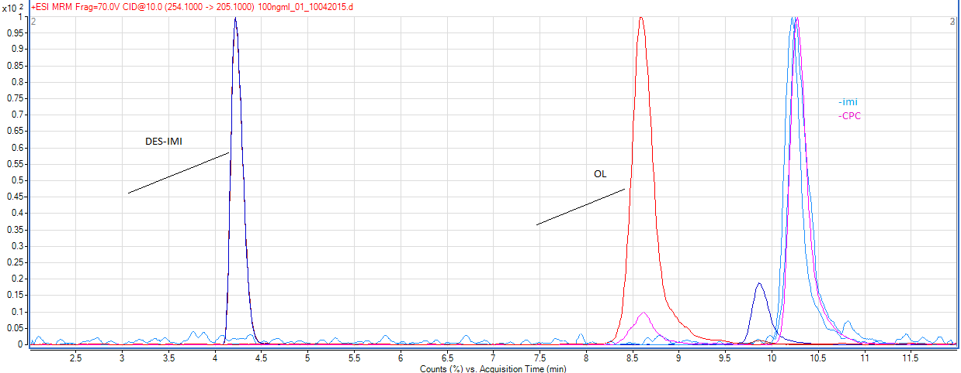

Figure 10: Chromatogram of the metabolites ( method 2 and flow of 0,25 ml/min)

The flow is adjusted from 0,4 mL/min to 0,30 mL/min. Figure 11, and two shows the separation of DES-IMI and ID4. The combination of the gradientof method 2 with the flow of 0.30 mL/min was efficient for all of the metabolites. Table 6 shows the retention time of the metabolites, which are shown in figure 11. The retention time is with the gradient of method 2 and a flow of 0.30 ml/min. Table 6 show the retention time of the metabolites.

|  |  |
| --- | --- |
| **Metabolites** | **R.T in min** |
| DES-IMI | 4,209 |
| IMI-UR | 10,245 |
| IMI | 10,745 |
| IMI-OL | 8,534 |
| CPC | 14,530 |

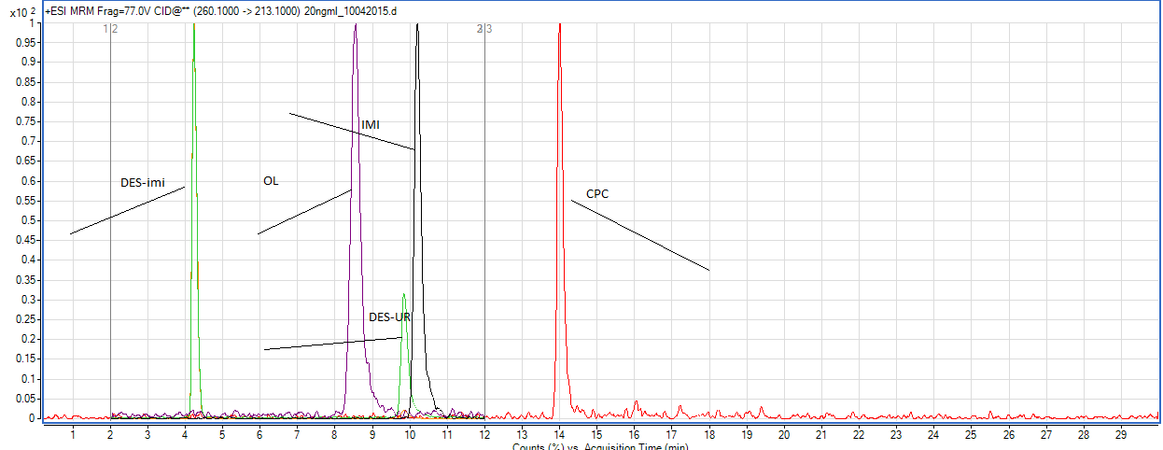

Figure 11: Chromatogram of the metabolites

Table 6: Retention time of the metabolites

### 3.2 Summary of Method

The results of the optimization leads to the following method that was used to separate the metabolites with the LC mms/ms. The LC was operated under gradient conditions with mobile phases of H2O:MeOH 95:5 v/v + 5mM ammonium formate and 0.1% formic acid (A) and MeOH (B). The flow rate was 0.3 ml/min. The run time was 30 minutes. Samples and calibration solutions were first analyzed by an initial gradient described in table 7.

Table 7: The LC-MS gradient

|  |  |
| --- | --- |
| **Time** | **Gradient B%** |
| 0 | 5 |
| 10 | 60 |
| 17 | 95 |
| 22 | 95 |

### 3.3 MS Optimization

Figure 12 shows the full scan from the metabolites IMI-OL. As can been observed the peak of 254.00 m/z the precursor ion is the mother ion. The Collision breaks the Target ion in fragments. Figure 13 shows that the transition of 171.1 m/z has the highest response. This also applies to the transition of 205.1m/z. The primary molecular (indent fine) ion is the 205.1 m/z. The qualifier ion is the value 171.7 m/z. The target and qualifier values in table 6 have been determined in the break down structure as shown in figure 12 and 13.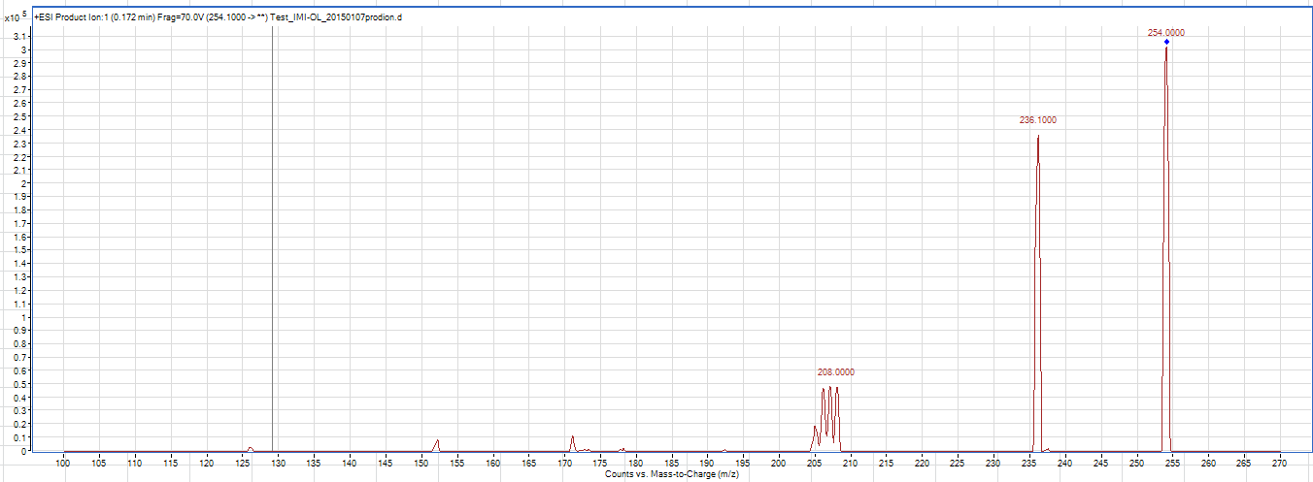

Figure 12: Full scan of IMI-OL

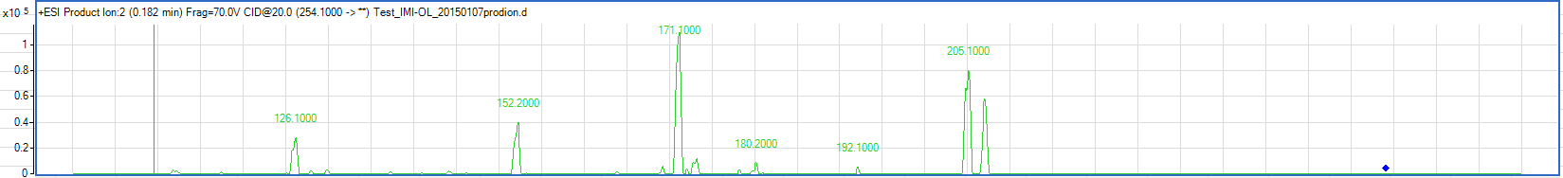

Figure 13: MS optimization of IMI-OL

The ion transitions, cone voltages, and collision energies for the metabolites and collision energies for the analyses are shown in table 8.

Table 8: MRM precursor/ product ion transition and instrument

|  |  |  |  |  |  |  |  |
| --- | --- | --- | --- | --- | --- | --- | --- |
| **Analyte** | **Molecular formula** | **Collision energy (eV)** | **Target Ion** | **Dwell time (ms)** | **Collision energy (eV)** | **Qualifier** | **Collision energy (eV)** |
| Imidacloprid-d4 |  | 30 | 260.1>179.2 | 50 | 77 | 260.1>213.1 | 35 |
| Imidacloprid | C9H10CIN5O2 | 18 | 256.1>175.0 | 50 | 77 | 256.1>209.0 | 30 |
| Imidacloprid olefin | C9H8CIN5O2 | 10 | 254.1>171.7 | 50 | 70 | 254.1>205.1 | 10 |
| Imidacloprid urea | C9H10CIN3O | 20 | 212.2>99.0 | 50 | 100 | 212.2>128.1 | 20 |
| Imidacloprid, Desnitro HCL | C9H11CIN4 | 22 | 211.1>90.1 | 50 | 77 | 211.1>126.0 | 38 |
| 6-chloronicotinic acid | C6H4CINO2 | 42 | 158>51.0 | 50 | 77 | 158>122 | 10 |

### 3.4 Massa resolution

Massa resolution is a scenario in which there are two MRMs with the same m/z fragment ions from different precursor ions. The collision cell (Q2) does not have enough time to clear the fragment ion from the first MRM before the second MRM fragmentation takes place. The product ion from the first MRM can appear in the second MRM chromatogram as a “ghost peak”. Between the separation of DES-IMI and IMI-UR there is a case of mass resolution. The transmission state of the DES-IMI is 211.1> 126.0 M/Z and for IMI-UR that is 212.2>128.0 M/Z. To eliminate the massa resolution, the MS Time of Flight (ToF) can been used or another column.

### 3.5 Sample Preparation

The QuECHERS stands for quick, easy, cheap, effective, rugged and safe and it eliminates matrix effect. Kamel et al suggests that a cleanup with the QuECHERS eliminated the matrix effect and the average of the recovery was increased. The TIC of sample 5 with the QuECHERS of PSA (18) and sample 5 with the QuECHERS of Z-Sep+ is shown in figure 14. Figure 14 shows that the QuECHERS of Z-Sep+ gives a better response than PSA (18). The percentage of the response of IMI-UR with the PSA (18) is 20,95% less than the one obtained with the Z-Sep+.

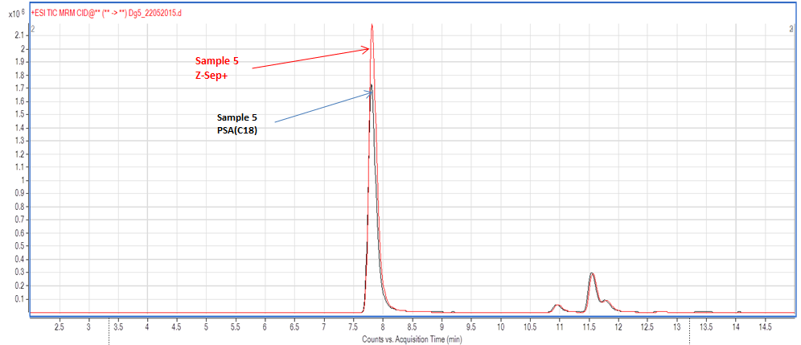

Figure 14: Overlay of DG3 (PSAC C18) and DG5(Z-Sep+)

### 

### 4. Validation

#### 4.1 Selectivity

The response of the interfering compounds in the processed blank was under 20% of the LOD. The chromatogram is shown in Appendix 1(figure 19).

#### 4.2 Carry-over

There was no carry over observed during the blank chromatographic run. The chromatogram of the blank is shown in Appendix 1 (figure 19).

#### 4.3 Precision

In table 9, the average, standards deviation (RSD) and coefficient of variation (CV %) percentage of the sample with the spiked concentration of 100 ng/ml are shown. Based on the results below in table 9, the conclusion can be drawn that the precision of the system is sufficient for this study. The raw data is shown in Appendix 1 (table 17).

Table 9: Average, STD and CV percentage of 100 ng/ml

|  |  |  |  |  |
| --- | --- | --- | --- | --- |
|  | **Des-imi** | **Imi-OL** | **Imi-UR** | **Imi- CPC** |
| **Average (*n*=5)** | 2,182 | 0,27 | 6,81 | 0,051 |
| **RSD** | 0,04 | 0,01 | 0,27 | 0,008 |
| **CV %** | 2,04 | 6,79 | 4,09 | 15,84 |

#### 4.4 Matrix effect

The average of the matrix effects are shown in table 10. The matrix effect is below 100%, which means that there is suppression from the matrix. To eliminate the matrix effect the method of standard addition to the matrix can be used.

Table 10: Matrix effect of the metabolites

|  |  |
| --- | --- |
| **Metabolites** | **Recovery percentage %** |
| DES-IMI % | 71,86 |
| IMI-OL % | 92,61 |
| IMI-UR % | 70,87 |
| CPC % | 71,28 |
| IMI % | 85,03 |

#### 

#### 4.5 Recovery

Based on the results below in table 11, the conclusion can be drawn that the recoveries for the metabolites of IMI-UR, IMI-OL and IMI are sufficient for this study. The recovery of DES-IMI, and CPC are not within the specified limit. As mentioned before, there were a cause of matrix effects, this might be the cause that the recovery of DES-IMI and CPC fall within the requirements. If the recovery is below the requirements, it means an improved sample preparation. To improve the sample preparation an addition of a step will might improve the recovery percentage.

Table 11: *Average Recovery percentages (± Standard deviation) of the samples*

|  |  |
| --- | --- |
| **Metabolites** | **Recovery %** |
| DES-IMI | 122,27± 2,03 |
| IMI-UR | 116,98 ±4,09 |
| IMI-OL | 84,61 ± 5,74 |
| CPC | 24,94 ± 7,20 |
| IMI | 98,47 ± 27,84 |

## 

#### 4.6 Linearity

Based on the results in table 12, the conclusion can be drawn that the linearity of the system is sufficient for this study. The linear range of the metabolites is shown in table 2. The R2 has been calculated from the different calibration lines of the metabolites (IMI, DES-IMI, IMI-UR, IMI-OL, CPC). The calibration curves from the metabolites are presented in appendix 1 (figure 15, 16, 17, 18, 19).

Table 12: The R2 and linear range of the metabolites

|  |  |  |
| --- | --- | --- |
| **Metabolite** | **Linear range** | **R2** |
| CPC | From 1 to 200 ng/ml | 0,999 |
| DES-IMI | From 1 to 200 ng/ml | 0,999 |
| IMI-UR | From 1 to 200 ng/ml | 0,999 |
| IMI-OL | From 1 to 200 ng/ml | 0,999 |
| IMI | From 1 to 200 ng/ml | 0,999 |

## 

#### 4.7 LOD and LOQ

Table 13 shows the LOD and LOQ of each metabolite.

Table 13: LOD and LOQ of the metabolites

|  |  |  |  |
| --- | --- | --- | --- |
| **Metabolite** | **Precursor ion (*m/z*)** | **LOD (ng/mL)** | **LOQ (ng/mL)** |
| CPC | 158,00 | 0,070 | 0,209 |
| DESIMI | 211,0 | 0,036 | 0,107 |
| IMI-UR | 212,0 | 0,017 | 0,050 |
| IMI-OL | 254,1 | 0,033 | 0,099 |
| IMI | 256,1 | 0,021 | 0,064 |

#### 4.8 Quantification of the exposed samples

The samples were exposed to different concentrations (0, 0.1, 1.0, 10 and 100 ug/l). The research question was to determine the different metabolites in the digestive gland of the *Lymnaea stagnalis*, after snails have been exposed to imidacloprid. As can been seen in figure 4, the average concentration of imidacloprid decreased after 25 hours. The hypotheses is that imidacloprid has been metabolized to other metabolites. The samples that are exposed at the concentration of imidacloprid and its metabolites less than 100 µg/ml were below the detection limit. The concentrations of imidacloprid were quantified at 10 and 100 ng. In table 12 the concentrations of the exposed samples at 10 ng/ml are shown. The concentration in table 13 shows the concentrations of the metabolite in the snails expose at the concentration of 100 µg/ml. The hypothesis that was made corresponds to the value that was found is the sample that is exposed to a concentration of 100 ng/ml. The concentration of IMI is the highest concentration since the sample has been exposed to IMI. The other metabolites showed lower concentrations than IMI. This indicates that IMI metabolism needs time to take place.

Table 14: *Concentration, average and STD of the exposed samples (10 ng/ml)*

|  |  |
| --- | --- |
| **Samples** | **Conc IMI ng/extract** |
| **Dg of snail A** | 0,173 |
| **Dg of snail B** | 0.015 |
| **Dg of snail C** | 0, 178 |
| **Dg of snail D** | 0.037 |
| **Dg of snail E** | 0,122 |
| **Dg of snail F** | 1,412 |
| **Dg of snail G** | 0,006 |
| **Dg of snail H** | 0,073 |
| **Dg of snail I** | 0,001 |
| **Dg of snail J** | 0,094 |
| **Average** | 0,211 |
| **STD** | 0,426 |

Table 15: *Concentration, average and STD of the exposed samples (100 ng/ml)*

|  |  |  |  |  |  |
| --- | --- | --- | --- | --- | --- |
| **Samples** | **Conc OL ng/extract** | **Conc UR ng/extract** | **Conc IMI ng/extract** | **Conc DES-IMI/ extract** | **Conc CPC/ extract** |
| **Dg of snail A** | 0,001 | 0,001 | 0,049 | 0,004 | 0,016 |
| **Dg of snail B** | 0,000 | 0,006 | 0,597 | 0,003 | 0,004 |
| **Dg of snail C** | 0,000 | 0,002 | 1,196 | 0,008 | 0,003 |
| **Dg of snail D** | 0,000 | 0,000 | 1,825 | 0,003 | 0,002 |
| **Dg of snail E** | 0,001 | 0,002 | 0,334 | 0,010 | 0,023 |
| **Dg of snail F** | 0,001 | 0,001 | 0,505 | 0,005 | 0,023 |
| **Dgof snail G** | 0,000 | 0,001 | 0,696 | 0,002 | 0,002 |
| **Dg of snail H** | 0,000 | 0,000 | 0,098 | 0,003 | 0,001 |
| **Dg of snail I** | 0,000 | 0,000 | 0,568 | 0,001 | 0,002 |
| **Dg of snail J** | 0,000 | 0,001 | 0,351 | 0,002 | 0,005 |
| **Average** | 0,000 | 0,001 | 0,622 | 0,004 | 0,008 |
| **STD** | 0,000 | 0,002 | 0,533 | 0,003 | 0,009 |

# Conclusion

The aim of the study was two folded:

1. To develop a method for the quantification of imidacloprid and its metabolites.

2. To validate the method.

In order to answer the purposes of this study, the method had been measured on the LC-MS triple quad. The method that was developed measured the metabolites IMI, DES-IMI, IMI-UR, IMI-OL and CPC. The mass spectrometer was operated in the positive electrospray ionization mode. The LC was operated under gradient conditions with mobile phases of H2O:MeOH 95:5 v/v + 5mM ammonium formate and 0.1% formic acid (A) and MeOH (B). The flow rate was 0.3 ml/min. The run time was 30 minutes. Samples and calibration solutions were first analyzed by an initial gradient described in table 2. Between the separation of DES-IMI and IMI-UR there is a case of mass resolution. The transmission state of the DES-IMI is 211.1> 126.0 m/z and for IMI-UR 212.2 m/z>128.0 m/z. To eliminate the massa resolution, the MS Time of Flight (ToF) can been used or another column. During the sample preparation two different QuECHERS have been used: the Z-Sep+ and PSA(18). The percentage of IMI-UR with PSA(18) is 20.95% less than the one obtained with the Z-Sep+. Based on those results the Z-Sep+ was used during the sample preparation. The selected imidacloprid metabolites are: imidacloprid- olefin (IMI-OL), imidacloprid-urea (IMI-UR), 6-chloro-pyridine-3-carboxylic acid (CPC) and Desnitro-imidacloprid hydrochloride (DES-IMI). Based on the results of the selectivity, carry over, linearity and precision the conclusion can be drawn that the conditions are sufficiently covered for the purpose of this study. The recovery of DES-IMI, and CPC were not within the specified limit. As mentioned before, there were a cause of matrix effect, this might be the cause of the result that the recovery of DES-IMI and CPC falls within the requirements. To improve the recovery of DES-IMI and CPC, another QuECHERS has to be used or a solid phase extraction. The matrix effect is below 100%; this means that there is signal suppression from the matrix. To eliminate the matrix effect, the method of standard addition to the matrix can be used. From those results it can be concluded that the method that has been developed can measure the metabolites DES-IMI, CPC, IMI-UR, IMI-OL and IMI. The method is not validated on the parameters of the recovery for the metabolites DES-IMI and CPC. Furthermore, the matrix effect of the metabolites IMI, CPC, DES-IMI, IMI-UR, IMI-OL is not validated.

As shown in figure 2, the average concentration of imidacloprid decreases after 24 hours exposure on the *Lymnaea stagnalis*. The hypothesis is that imidacloprid has been metabolized to its metabolites.

The research questions stated in this research were:

1. Or the method (that is been developed and validated) can measure the metabolites
2. Can the method determine the different metabolites in digestive gland of *Lymnaea stagnalis* after imidacloprid exposure of different concentrations?

From the results in figure 8, it can be concluded that the developed method can measure the metabolites IMI, DES-IMI, IMI-UR, IMI-OL, CPC. The established hypotheses corresponds to the value that was found in the sample that was exposed to a concentration of 100 ng/ml. Concentrations of Imidacloprid were quantified at 10 and 100 ng. The concentration of IMI is the highest concentration since IMI is the target ion. The other metabolites showed lower concentrations than IMI. This indicates that IMI metabolism needs time to take place.

# Recommendations for further analysis

* To eliminate mass resolution, the MS Time of Flight (ToF) can be used or another column.
* To improve the recovery of DES-IMI and CPC, another QuECHERS has to be used. Also recommended: a solid phase extraction.
* The matrix effect is below 100%, which means that there is signal suppression from the matrix. To eliminate the matrix effect, the method of standard addition to the matrix can be used.
* Other inter standard for CPC.

# Reference

1. Ashauer, R. *et al.*. Significance of xenobiotic metabolism for bioaccumulation kinetics of organic chemicals in Gammarus pulex. *Environ. Sci. Technol.* **46,** 3498–508

2. Orr, M. V, El-Bekai, M., Lui, M., Watson, K. & Lukowiak, K. Predator detection in Lymnaea stagnalis. *J. Exp. Biol.* **210,** 4150–4158 (2007).

3. Vijver, M. G. & Van Den Brink, P. J. Macro-invertebrate decline in surface water polluted with imidacloprid: A rebuttal and some new analyses. *PLoS One* **9,** (2014).

4. Mohr, S. *et al.* Macroinvertebrate community response to repeated short-term pulses of the insecticide imidacloprid. *Aquat. Toxicol.* **110-111,** 25–36 (2012).

5. Quantitative chemical analysis. *No Title*. (craig Bleyer, 2007).

6. Kamel, A. Refined methodology for the determination of neonicotinoid pesticides and their metabolites in honey bees and bee products by liquid chromatography-tandem mass spectrometry (LC-MS/MS). *J. Agric. Food Chem.* **58,** 5926–5931 (2010).

7. Exploring imidacloprid-induced effects on the central nervous system of Lymnaea stagnails. J. Stel. MSC environmental chemistry & Toxicology Reasearch thesis.

# Appendix 1



*Figure 15: Calibration curve of IMI-UR R2: 0.999*



*Figure 16: Calibration curve of IMI- R2: 0.999*

*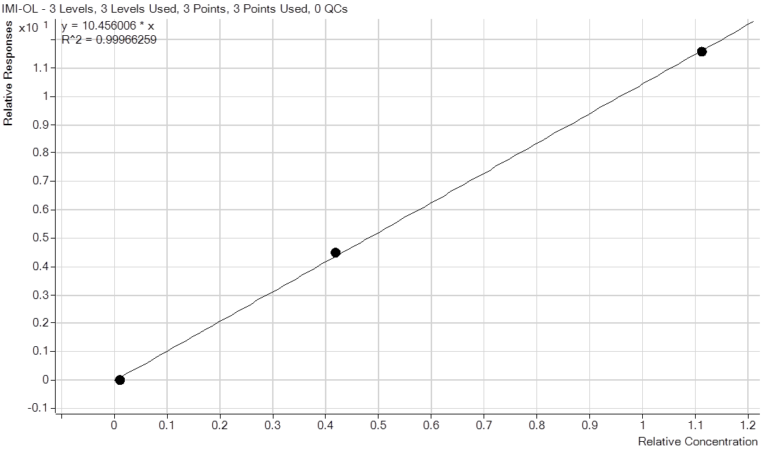Figure 17: Calibration curve of CPC R2: 0.999*

*Figure 18: Calibration curve of IMI-OL R2: 0.999*



*Figure 19: Calibration curve of DES-IMI R2: 0.999*

|  |  |  |  |  |  |
| --- | --- | --- | --- | --- | --- |
|  | **Control** | **0.1 µg/L** | **1.0 µg/L** | **10 µg/L** | **100 µg/L** |
| Protein content repl. A | 52.552 | 32.478 | 23.167 | 27.98018 | 30.82703 |
| Protein content repl. B | 25.053 | 30.106 | 40.088 | 45.63784 | 31.4036 |
| Protein content repl. C | 30.223 | 28.429 | 22.638 | 28.77297 | 26.53874 |
| Protein content repl. D | 28.141 | 30.245 | 25.607 | 42.97117 | 31.56577 |
| Protein content repl. E | 25.693 | 36.442 | 30.333 | 27.70991 | 35.69189 |
| Protein content repl. F | 33.405 | 23.136 | 26.793 |  | 51.65586 |
| Protein content repl. G | 26.931 | 36.499 | 43.082 | 28.17838 | 48.44865 |
| Protein content repl. H | 44.568 | 26.795 | 29.461 | 30.57477 |  |
| Protein content repl. I | 26.153 | 42.008 | 30.212 | 35.11532 | 44.3045 |
| Protein content repl. J | 33.275 | 28.039 | 33.215 | 30.53874 | 31.85405 |

*Table16: Appendix H. Bradford assay protein content in ten replicate samples per exposure group.*

|  |  |  |  |  |  |
| --- | --- | --- | --- | --- | --- |
| **Recovery** | **Des-imi** | **Correct with the weight** | **IS** | **Correct IS** | **Correct Both** |
| **Sample name** | **Area** | **Area** | **Area** | **Area** |  |
| 100 ng A 1 Dg 1 | 187197,371 | 699,2804294 | 84395,02227 | 2,218109148 | 0,008285802 |
| 100 ng A2 Dg 2 | 185566,2284 | 629,2513678 | 87428,60261 | 2,122488783 | 0,007197317 |
| 100 ng A3 Dg3 | 200072,0014 | 575,2501476 | 92829,37318 | 2,155266103 | 0,006196855 |
| 100 ng A4 Dg4 | 186890,7388 | 1027,436717 | 85492,09017 | 2,186058832 | 0,012017916 |
| 100 ng A5 Dg5 | 208578,9365 | 712,1165466 | 93511,80688 | 2,230509103 | 0,007615258 |
| **Recovery** | **Des-imi** | **Correct with the weight** | **IS** | **Correct IS** | **Correct Both** |
| **Sample name** | **Area** | **Area** | **Area** | **Area** |  |
| 100 ng A 1 Dg 1 | 25050,32345 | 93,57610551 | 84395,02227 | 0,296822286 | 0,001108787 |
| 100 ng A2 Dg 2 | 24738,89074 | 92,41274089 | 87428,60261 | 0,282961068 | 0,001057008 |
| 100 ng A3 Dg3 | 23871,55509 | 89,17278705 | 92829,37318 | 0,25715519 | 0,00096061 |
| 100 ng A4 Dg4 | 25036,67724 | 93,52512977 | 85492,09017 | 0,292853727 | 0,001093962 |
| 100 ng A5 Dg5 | 24149,3779 | 90,21060105 | 93511,80688 | 0,258249506 | 0,000964697 |
| **Recovery** | **Des-imi** | **Correct with the weight** | **IS** | **Correct IS** | **Correct Both** |
| **Sample name** | **Area** | **Area** | **Area** | **Area** |  |
| 100 ng A 1 Dg 1 | 591949,8074 | 2211,24321 | 84395,02227 | 7,014036983 | 0,026201109 |
| 100 ng A2 Dg 2 | 585115,3139 | 2185,71279 | 87428,60261 | 6,692493034 | 0,024999974 |
| 100 ng A3 Dg3 | 622614,2587 | 2325,79103 | 92829,37318 | 6,707082439 | 0,025054473 |
| 100 ng A4 Dg4 | 554467,8014 | 2071,228246 | 85492,09017 | 6,485603526 | 0,024227133 |
| 100 ng A5 Dg5 | 671921,1377 | 2509,978101 | 93511,80688 | 7,185414978 | 0,026841296 |
| **Recovery** | **Des-imi** | **Correct with the weight** | **IS** | **Correct IS** | **Correct Both** |
| **Sample name** | **Area** | **Area** | **Area** | **Area** |  |
| 100 ng A 1 Dg 1 | 4866,440645 | 18,17870992 | 84395,02227 | 0,05766265 | 0,0002154 |
| 100 ng A2 Dg 2 | 5339,394486 | 267,7 | 87428,60261 | 0,061071484 | 0,003061927 |
| 100 ng A3 Dg3 | 4081,996385 | 15,2483989 | 92829,37318 | 0,043973112 | 0,000164263 |
| 100 ng A4 Dg4 | 4512,749532 | 16,85748798 | 85492,09017 | 0,05278558 | 0,000197182 |
| 100 ng A5 Dg5 | 3981,304776 | 14,87226289 | 93511,80688 | 0,042575423 | 0,000159042 |
| **Recovery** | **Des-imi** | **Correct with the weight** | **IS** | **Correct IS** | **Correct Both** |
| **Sample name** | **Area** | **Area** | **Area** | **Area** |  |
| 100 ng A 1 Dg 1 | 207937,8171 | 776,7568811 | 84395,02227 | 2,463863525 | 0,009203823 |
| 100 ng A2 Dg 1 | 215641,8076 | 731,2370554 | 87428,60261 | 2,466490384 | 0,00836382 |
| 100 ng A3 Dg1 | 229823,5663 | 660,7923126 | 92829,37318 | 2,475763419 | 0,007118354 |
| 100 ng A4 Dg1 | 220659,1334 | 1213,079348 | 85492,09017 | 2,581047357 | 0,014189375 |
| 100 ng A5 Dg1 | 245762,9939 | 839,0679203 | 93511,80688 | 2,628149344 | 0,008972855 |

*Table 17: Data of spiked concentration of 100 ng/ml*