IMPROVING LABRITANNIQUE’S ONLINE MARKETING STRATEGY WITH A LIMITED BUDGET DURING AN ECONOMIC DOWNTURN

BY
Céline Renard
1545658

GRADUATION ASSIGNMENT SUBMITTED IN PARTIAL FULFILLMENT OF THE REQUIREMENTS FOR THE DEGREE OF BACHELOR OF COMMUNICATIONSYSTEMS OF THE INSTITUTE OF COMMUNICATION AT THE UTRECHT UNIVERSITY OF APPLIED SCIENCES

UTRECHT, 4 June 2012

Management Summary
This research was carried out for LaBritannique, a small business in the catering and event management industry in Brussels. The aim of this research is to advise on how to improve LaBritannique’s current online marketing strategy in order for the company to better reach its target audience.
Traditional advertising such as print advertising, television and radio adverts are too expensive for a small business, hence the decision to research how LaBritannique can improve its current online marketing strategy with its limited budget, during an economic downturn.
The first part of this research report outlines the current economic downturn and how it has affected businesses, and provides background information on the subject in order to better understand the context of the problem.
The theoretical framework of this research report is made up of two parts. The first part discusses and analyses the theory behind online marketing and the various tools available to companies to market themselves online. The second part of the theoretical framework discusses the various theories and models used and applied in order to answer the problem questions.
How the research for this report was carried out is described in the chapter on methodology. This chapter also defines and justifies the sample of respondents used for the questionnaire and which tools were used to analyse the results.
In conclusion, the report offers recommendations to LaBritannique on how it can put the research outlined in this report into practice.
Table of Contents
Management Summary 1
List of Figures 3
List of Illustrations 3
List of Graphs 4
List of Tables 4
Acknowledgements 5
1. Introduction and Background Information 6
1.1. The Economic Downturn and How it has Affected Businesses 6
2. Main Research Question and Sub Questions 8
2.1. Sub Questions 8
3. Theoretical Framework 9
3.1. Theory 9
3.1.1. Marketing a Brand 9
3.1.1.1. Definition of a Brand 9
3.1.2. LaBritannique’s Brand 10
3.1.3. Brand Positioning as part of the Marketing Effort 10
3.1.4. Traditional Marketing vs. Online Marketing 11
3.1.4.1. Definition of Marketing 11
3.1.4.2. Outbound vs. Inbound Marketing 12
3.1.5. Traditional Marketing 12
3.1.6. Online Marketing 12
3.1.6.1. Content Marketing 12
3.1.6.2. Permission Marketing 14
3.1.6.3. Email Marketing 15
3.1.6.4. Affiliate Marketing 16
Definition of Merchants 16
Definition of Affiliates 16
3.1.6.5. Search Engine Marketing (SEM) 17
Search Engine Optimisation (SEO) 18
Paid Search Marketing (or Pay per Click) 19
Advantages and Disadvantages of SEO and Paid Search Marketing 20
3.1.6.6. Social Media Marketing 21
Definition of Social Media 21
Types of Social Media 21
3.2. Theories and Models 23
3.2.1. The 5 Ps of Marketing for Social Media 23
3.2.1.1. The 5 Ps of Marketing for Social Media: Product 24
3.2.1.2. The 5 Ps of Marketing for Social Media: Price 24
3.2.1.3. The 5 Ps of Marketing for Social Media: Place 24
3.2.1.4. The 5 Ps of Marketing for Social Media: Promotion 24
3.2.1.5. The 5 Ps of Marketing for Social Media: People 25
3.2.1.6. The 4 Cs and the 4 As of Marketing 26
3.2.2. The SIVA Model 26
3.2.3. Brand Positioning 27
4. Methodology and Research Design 29
4.1. Research Design 29
4.2. Desk Research 29
4.3. Limitations to the Research 30
5. Discussion of Findings 31
6. Conclusion 33
7. Recommendations 34
Bibliography 38
Appendix 42
Full list of media tools available for content marketing (Internet Marketing Academy, 2011b) 42
Discussion of Findings - Graphs and Tables 43
Questionnaire 55

List of Figures
Figure 1. The Affiliate Marketing Model (Chaffey & Smith, 2008) 16
Figure 2. 4 Ps, 4 Cs and 4 As chart (Pringle & Field, 2008) 26
Figure 3. Basic principles of positioning (Franzen & Moriarty, 2009) 27
Figure 4. Positioning a brand (Kapferer, 2008) 28
Figure 5. Determinants of successful brands (Pelsmacker et al., 2004) 35

List of Illustrations
Illustration 1. LaBritannique's company logo 10
Illustration 2. Positioning of organic and paid for search results (Carrel, 2012) 18
Illustration 3. The basics of PPC and SEO (Tsai, 2009) 19

List of Graphs
Graph 1. Number of respondents active on social media 31
Graph 2. Percentage of male and female respondents 43
Graph 3. Social media use of respondents 45
Graph 4. Frequency of use among questionnaire respondents of Facebook 46
Graph 5. Frequency of use among questionnaire respondents of YouTube 47
Graph 6. Frequency of use among questionnaire respondents of LinkedIn 48
Graph 7. Frequency of use among questionnaire respondents of Twitter 49
Graph 8. Which social media channels respondents follow LaBritannique on 50
Graph 9. Legibility of LaBritannique's website 51
Graph 10. Ease of navigation of LaBritannique's website 52
Graph 11. Reasons why LaBritannique's website is not easy to read 53
Graph 12. Reasons why LaBritannique's website is not easy to navigate through 54

List of Tables
Table 1. The Benefits of Permission Marketing for Companies and Customers (Everitt, 2012) 15
Table 2. Advantages and Disadvantages of Affiliate Marketing (Chaffey & Smith, 2008; The Internet Marketing Academy, 2011a & 2011e) 17
Table 3. Advantages and Disadvantages of SEO and Paid Search Marketing (Chaffey et al., 2009) 20
Table 4. Country of origin of questionnaire respondents 44

Acknowledgements
I would like to take this opportunity to thank everyone who has helped me and supported me throughout the process of writing this research report, as well as the people who helped me get to this point in my studies.
Firstly, I’d like to thank everyone at LaBritannique, and in particular CEO, Alex Weston, for giving me the opportunity to do this research for them. I have enjoyed the process, although it has been tough at times, I found it to be extremely rewarding.
Secondly, I’d like to thank my tutor, Ivonne Louw, for the support and help throughout the process of writing this report. Your insights have been most valuable. At this point, I would also like to thank the members of my intervision group, Danine, Samantha and Pim, who have also been a great support and provided me with inspiration and motivation.
Lastly, and by no means least, I’d like to say a big thank you to my parents for their continuous support throughout my academic career. A special thank you to my Mum for spending the hours proof reading this report, but most of all for putting up with me during this, sometimes stressful, period of my studies.
Céline Renard

"Dreams come true. Without that possibility, nature
would not incite us to have them."
John Updike

1. Introduction and Background Information
LaBritannique is a small business, operating in the catering and event management industry in Brussels, Belgium. The company’s current online marketing strategy is not as effective as it could be. This research report aims to establish how LaBritannique’s online marketing strategy can be improved, and advise the company on how to put proposed changes into practice with a limited budget in order to better reach its target audience.
LaBritannique’s current target audience can be split into two groups: the company caters for the Business-to-Business (B2B) market as well as the Business-to-Consumer (B2C) market. Up until now, LaBritannique’s main target audience has been the B2B market, producing and organising lunches and dinners for corporate meetings and events. LaBritannique is seeking to expand its services to the B2C market and provide a full event management service, as well as a catering service for both the B2B and B2C target audiences.
Founded in 2009, during the middle of the economic downturn, the company and has adapted and learned to operate on a day-to-day basis within a limited budget. This did not come without its difficulties however, and the challenges of doing business in an economic downturn are outlined in the following sub chapter.

1.1. The Economic Downturn and How it has Affected Businesses
For the purpose of this research, the economic downturn mentioned in this report refers to the most recent the world has experienced, which started in the late stage of the year 2007. The economic downturn can also be referred to as an economic recession or simply a recession.
In an economic downturn, consumers tend to spend less money. With an economic downturn, comes a time of uncertainty, which affects both consumers and businesses. According to Şahin, Kitao, Cororaton and Laiu (2011), small businesses are hit harder by recessions, especially during the most recent recession. Şahin et al. (2011) claim that small businesses were affected more by the recession because of a considerable drop in consumer demand, which in turn produced poor sales figures.
As less money becomes available due to global debt, consumers’ concerns about their financial future grow. Businesses are directly affected by the economic downturn in many different ways, which can cause what is known as a snowball effect. These include the loss of loyal consumers, the loss of profit, as well as the loss of staff members.
Put simply, as consumers become more aware of their spending, and do everything they can to save money where they can, businesses need to work harder to convince consumers their product is worth buying, in an effort to keep profits up and avoid going into administration or filing for bankruptcy.
For a business to go into administration means that the business seeks outside help from administrators who determine whether or not the company can be rescued or whether it should be sold to pay off its debts to creditors.
Filing for bankruptcy is the process a business in financial trouble goes through to pay off all its debts at the same time (White, 2007).
The effects of the economic downturn on business can also be seen as destruction, as mentioned by the Economist (2012) and the destruction is plain to see – the economic downturn can destroy businesses, leaving empty shop windows on high streets worldwide. However, as stated by Bandyk (2009), an economic downturn can also present opportunities for other businesses as the larger businesses start making cut backs. Bandyk (2009) goes on to say that an economic downturn can be seen as beneficial as the tough financial situation can reduce the number of competitors on the marketplace.

2. Main Research Question and Sub Questions
Against the backdrop of the problem mentioned in the previous section, the main research question can be formulated as follows:
How can LaBritannique’s online marketing strategy be complemented to market itself more effectively with a limited budget during an economic downturn?

2.1. Sub Questions
To assist in answering the main research problem, the following sub questions have been formulated:
- What is the current economic downturn and how does it affect businesses in general?
- Which tools are available to companies to market themselves online?
- Which tools are suited for LaBritannique to market itself online with a limited budget?
- What elements are key for an online marketing strategy?

3. Theoretical Framework
This chapter consists of two distinctive parts. The first part deals with the theory of online marketing and gives an overview of online marketing versus traditional marketing and discusses various social media tools available for companies to market themselves. The second part deals with theories and models that apply to online marketing and to social media.

3.1. Theory
This first part of theoretical framework discusses the theory of marketing in general and marketing online. This section deals with how to market a brand and discusses LaBritannique’s brand. It also looks at how to position a brand through marketing and discusses in detail the various aspects of online marketing and social media.

3.1.1. Marketing a Brand
This sub chapter focuses on how to market a brand and looks at the various accepted definitions of the terms "brand", "brand positioning" and "marketing". A description of LaBritannique’s brand, as well as a brief overview of traditional marketing versus online marketing, is given with an emphasis on online marketing.

3.1.1.1. Definition of a Brand
Kapferer (2008) states that experts on branding are in continuous disagreement as to what the exact definition of a brand is. However, in his book "The New Strategic Brand Management", he does offer three definitions of a brand:
- Kapferer (2008) quotes a definition by Keller (1998) that is according to him, the traditional definition of a brand: “a brand is a set of mental associations, held by the consumer, which add to the perceived value of a product or service” (p. 10).
- From a legal perspective, Kapferer defines a brand as “a sign or set of signs certifying the origin of a product or service and differentiating them from the competition” (p. 10).
- “A brand is a name that influences buyers” (p. 11).
Rosenbaum-Elliott, Percy and Pervan (2011) define a brand as “[…] a label, designating ownership by a firm, which we experience, evaluate, have feeling towards, and build associations with to perceive value” (p. 4).
Yet another definition for the term "brand" is one given by Argenti and Druckenmiller (2004) who quote the American Marketing Association in their definition and say that a brand is a “name, term, sign, symbol, or design, or a combination of them, intended to identify the goods and services of one seller or group of sellers and to differentiate them from those of the competition.” (p. 368).
The above mentioned definitions of the term "brand" cannot be said to be incorrect, as they all revolve around the same idea. However, some of these definitions go into more depth than others. For the purpose of this research report, the following definition of the term "brand" will be used:
A brand is a name or label that designates ownership (Rosenbaum-Elliott et al., 2011), confirms the origin of a product (Kapferer, 2008) towards which consumers have feelings and build relations with (Rosenbaum-Elliott et al., 2011) which differentiates the owner of the brand from its direct competition (Argenti & Druckenmiller, 2004).

3.1.2. LaBritannique’s Brand
LaBritannique is a British-owned company based in Brussels, a multicultural city in the heart of Europe. The company is proud of its British roots and this aspect is represented in a subtle manner in its logo (see Illustration 1 below). The colours used in the logo are representations of the colours used in the three countries of Great Britain’s flags. Red represents England, green represents Wales, blue represents Scotland and purple is a combination of all three, complimenting each colour separately but also representing the cultural mix present in both Great Britain and Brussels where the company is situated.

Illustration 1. LaBritannique's company logo
LaBritannique has very strong values, some of which are exemplified in the company’s slogan: “globally inspired, locally sourced and prepared with passion”.
Other values the brand stands for include: fresh flavour, innovative and modern. These values are the basis of what the company stands for and part of their unique selling point (USP). As caterers, the company is always innovating with new recipes from around the globe, and can always produce something new and exciting for customers.
Another value that is essential to the business LaBritannique operates in is the way they do business. LaBritannique is very professional with a full team of dedicated staff, yet stays within the limits of an informal atmosphere, putting customers at ease. This value is what has made the company’s regularly organised Sunday brunches a great success.

3.1.3. Brand Positioning as part of the Marketing Effort
Marketing is much more than just advertising a product, service or a group of these, to the masses. Any product or service can be advertised and promoted to get more sales and increase profits and return on investment (ROI) for a company. To put it simply, “just getting the word out about your product isn't enough” (Crosby & Johnson, 2003).
Before a company can advertise its product or service, it needs to have a strong brand name and, most importantly, have strong brand values. These values are what consumers associate with the brand and determine how well a consumer can relate to the brand. As Desai and Waller (2010) state, “brands allow businesses to reach consumers directly with messages regarding emotion, identity; and self-worth, such that consumers are no longer buying a product but buying a brand” (p. 1425).
For a company to successfully market its brand, their brand needs to be clearly positioned in the market place and in minds of the consumers. The positioning of a brand in consumers’ minds is done through the use of effective marketing communication.
Kotler defined the meaning of brand positioning as “enabling a brand to occupy a "distinct and valued place" in the mind of the target consumer” (as cited in Rosenbaum-Elliott et al., 2011, p. 112). A similar definition, touching on the same concepts is given by Franzen and Moriarty (2009) who define positioning as “a location of a brand relative to its competitors in the mind of the consumer” (p. 165). Franzen and Moriarty (2009) go on to say that a brand’s positioning is what states its reason-for-being among its target audience against its competitors’ products and/or services. Positioning has one aim: to identify and claim a space in the market or as Kapferer (2008) puts it, “a strong purchasing rationale” (p. 178) that gives the brand an advantage, whether it is a real advantage or an apparent one (Kapferer, 2008).
When companies and brands seek to position themselves, they generally use what is known as a positioning statement. A positioning statement details the benefits the brand can offer, who its target audience is and how the brand can satisfy the consumers’ needs (Rosenbaum-Elliott et al., 2011).
There are two ways a brand can be positioned in the marketplace: centrally and differentially positioned.
Brands that are centrally positioned must deliver all the benefits that consumers associate with the product category, and are generally considered to be the category leaders (Rosenbaum-Elliott et al., 2011).
Differentially positioned brands are brands that position themselves based on one important benefit, which consumers believe the brand offers better than other brands (Rosenbaum-Elliott et al., 2011).
The theories and models of brand positioning are further discussed in the second part of the theoretical framework in sub chapter 3.2.3. Brand Positioning on p. 27

3.1.4. Traditional Marketing vs. Online Marketing
This sub chapter discusses the various forms of marketing tools available to companies for their use. The chapter analyses the term "marketing", discusses traditional marketing tools and online marketing tools and their advantages and disadvantages.

3.1.4.1. Definition of Marketing
The term "marketing" refers to the all the actions a company undertakes to ensure that the customers’ needs are met and fulfilled (The Internet Marketing Academy, 2011e). According to Whalley (2010), marketing “covers everything from company culture and positioning, thought market research, new business/product development, advertising and promotion, PR (public/press relations), and arguably all of the sales and customer service functions as well” (p. 11).

3.1.4.2. Outbound vs. Inbound Marketing
There are two types of marketing: outbound and inbound. Outbound marketing involves push communication towards current and potential customers, usually through television adverts, email marketing, billboards etc. (Pateman & Holt, 2011).
Inbound marketing is the exact opposite to outbound marketing in the sense that it involves pulling customers towards the company. This is done by making sure that the company is being active where the customers are active (Pateman & Holt, 2011). Inbound marketing is beneficial for companies as, if done correctly, customers will return several times, often bringing other potential customers with them (Pateman & Holt, 2011).

3.1.5. Traditional Marketing
For the purpose of this research, the idea of traditional marketing tools will be introduced but will only be touched on briefly as a means of comparison to online marketing tools. Conventionally, the marketing tools mentioned above tend to be the most expensive forms of marketing and advertising.
Traditional marketing tools refer to tools used for non-targeted advertising and are the tried and tested traditional way to communicate with the masses. These tools include television, radio, and direct mail (Scott, 2010). Other traditional marketing tools are categorised under print media and these include flyers, posters, billboards, magazines, newspapers, letters and the list goes on.
As mentioned above, traditional marketing tools can be expensive forms of marketing. Due to the costs of producing an advert for any of these mediums, these are not recommended for LaBritannique.
For example, flyers need to be designed, printed, and distributed. Each of these steps involves different people, therefore more cost. The designer needs to be briefed by the company, and then have the design approved by the company. If changes need to be made to the design, this is yet more time spent on the design and thus more money. Once the design is finished, the flyers need to be printed and the higher the number of flyers printed, the higher the costs. The company must also take into account the costs of paying people to hand the flyers out.

3.1.6. Online Marketing
Nowadays, the internet is widely considered as one of the most important communication tools, allowing businesses to reach a much larger segment of their target audiences, not possible with the use of traditional marketing (Yalçin & Köse, 2010).
When it comes to online marketing, there are various forms: content marketing, email marketing, permission marketing, affiliate marketing, search engine marketing (SEM) as well as social media marketing. All of these are interrelated in one way or another and are discussed in further detail below.

3.1.6.1. Content Marketing
Content marketing involves the publishing of content that “empowers, engages, educates and connects readers” (The Internet Marketing Academy, 2011b, p.10) and increases a company’s capacity to sway consumers’ opinions of their products (The Internet Marketing Academy, 2011c). Content marketing has always been around as part of a business’ marketing effort, yet with the introduction of the internet, as The Internet Marketing Academy (2011b) states, “a user’s voice is far more audible than it has ever been” (p.12).
Lieb (2012) agrees that content marketing involves publishing content that revolves around a company and its products and/or services, yet also underlines the fact that the content published as part of a content marketing strategy should not revolve solely around the company. Before good content can be created and published, a company will need to understand exactly who the content is aimed at. This is done by creating buyer personas. A buyer persona essentially represents the company’s target audience and describes the type of person that would have an interest in the product or service offered (Scott, 2010).
Pateman and Holt (2011) state that content marketing is all about publishing outstanding content, which should include a mixture of resources and entertainment for the target audience. Published content does not have to be exclusively limited to a company’s website. In fact, content can be published using a number of online media tools. Below is a selection of media tools on which companies can post their content (The Internet Marketing Academy 2011b) (for the full list provided by the Internet Marketing Academy, please refer to the appendix on p. 42):

Website
Blog
Social media
E-books
Press releases
White papers
Frequently Asked Questions (FAQs)
Podcasts
Videos
Online store

Clark (n.d.) offers a framework called the “5A Framework” which aims to help companies successful manage their content marketing. The 5A Framework consists of:
- Authenticity
- Attention
- Authority
- Action
- Acceleration
Each of these steps is discussed in further detail below:
- Authenticity
Authenticity in content marketing involves carrying out extensive research into the topics the target audience wants to read (Clark, n.d.). To make the topics authentic and appealing to the company’s target audience, the correct language needs to be used. This means using the same language that the target audience uses and avoiding using incomprehensible jargon (Clark, n.d.).
- Attention
The attention phase of the 5A Framework involves, as the name suggests, paying attention to the level of response the content published receives. This phase helps a marketer to establish what sort of content works and doesn’t work for their intended target audience and can help to establish which types of content can be useful to try subsequently (Clark, n.d). This phase is also the phrase during which a content writer can build relationships with other content writers, writing about similar subjects and obtain guest content from these (Clark, n.d.).
- Authority
Once the content writer has reached the authority phase of the framework, they will have already established a minimum number of people as their audience which will continue to grow as a result of these members passing your content on to others (Clark, n.d.). During this phase, the content writer will need to monitor the level of sharing their content receives through social media channels, for example, and identify, through the use of surveys what other topics the target audience wishes to read (Clark, n.d.). This phase is also the ideal time to build up a database of email addresses to use for upcoming promotions (Clark, n.d.).
- Action
The fourth phase of the framework is action, which entails sales and lead generation (Clark, n.d.). Lead generation is the process of directing people to a company’s main website and enticing them to purchase the product or service offered. It is during this fourth phase that a new product or service can be launched (Clark, n.d.). The way to do this successfully is to consistently allude to a new product (or service) launch well before the launch takes place. It is during this phase that taking note of any feedback received from customers on how the product (or service) can be improved is important (Clark, n.d.).
- Acceleration
The level of acceleration experienced will vary on the speed of growth of the target audience. It is during this stage that a company can expect to receive offers for affiliate marketing (further discussed in sub chapter 3.1.6.4. Affiliate Marketing, on p. 16) or even receive offers of further content from experts in similar industries (Clark, n.d.). What will most generally happen during this fifth and last phase is that companies will notice their content evolve in line with external factors affecting their industry and target audience.
Great content can form the basis of a great email marketing campaign (further discussed in sub chapter 3.1.6.3. Email Marketing on p. 15), as well as social media marketing (discussed in sub chapter 3.1.6.6. Social Media Marketing on p. 21).

3.1.6.2. Permission Marketing
According to Chaffey, Ellis-Chadwick, Mayer and Johnston (2009), permission marketing is when customers have agreed to receive marketing materials from a company prior to engaging in a relationship with the company. Everitt (2012) goes on to say that permission marketing usually happens because the consumer has an incentive to sign up (or opt-in) for information from the company. The majority of people who opt-in to receive marketing materials (usually by email) will be people who are part of the company’s target audience (Everitt, 2012).
According to Everitt (2012), there are several benefits to using permission marketing as part of a company’s overall marketing strategy and these benefits apply to both the customer and the company.
Company Benefits | Customer Benefits
- More targeted marketing, bringing higher sales  - Ability to use lower-cost methods (e.g., emails) effectively  - Easy testing and tracking  - Less wasted advertising  - Increased customer lifetime value  - More opportunities for additional sales, referrals and promotions  - Converting more qualified leads into customers | - Receiving useful or interesting information  - Receiving news of other products or services relevant to them  - Saving money with special offers and deals  - The initial incentive  - The benefits of your products or services
Table 1. The Benefits of Permission Marketing for Companies and Customers (Everitt, 2012)

There are various ways of obtaining permission from customers to contact them, both online and offline (Everitt, 2012). These include sign up forms on the company website or through social media (online) and through direct contact with the customer at a point of sale or exhibition (offline) (Everitt, 2012).
As Chaffey et al. (2009) state, email is a key tool in permission marketing as it allows the interaction between the company and the customer to be preserved. Email marketing is discussed in further detail in the following sub chapter.

3.1.6.3. Email Marketing
According to The Internet Marketing Academy (2011d), email marketing is in essence, “the act of sending out emails to customers, both current and prospective” (p. 9).
Email marketing is primarily a form of outbound marketing, yet can be seen as inbound marketing in some cases, when dealing with customers’ questions for example (Chaffey et al., 2009). Outbound email marketing is part of the company’s customer relationship management (CRM) and involves direct marketing in an attempt to get the reader to purchase a product (Chaffey et al., 2009). An effective email marketing campaign can help a company to form long-lasting relationships with its customers and thus develop online customer relationship management, or e-CRM (Chaffey & Smith, 2008).
Email marketing is an excellent marketing tool for companies to use as it permits them to use very specific targeting, using demographics for example, and allows a company to directly sell itself and its product and/or services to the recipient (The Internet Marketing Academy, 2011d). Email marketing is an important tool to use during an economic downturn, as it is both powerful and lucrative in the sense that it is a low-cost tactic to creating brand relationships, keeping loyal customers interested and create revenue (Westlund, 2009).
Georgieva (n.d.) states that although email marketing is very beneficial to a company’s marketing efforts, email marketing must be part of a comprehensive effort to educate customers about the company and advises that any email marketing campaign should also be enhanced by other marketing efforts such as search engine marketing (discussed in further detail in sub chapter 5.5.3.6), the creation of content (as discussed above) and social media marketing (discussed in sub chapter 5.5.3.7. below).

3.1.6.4. Affiliate Marketing
Affiliate marketing is a commission-based deal between two companies (Chaffey & Smith, 2008). The idea is to get other people and businesses (affiliates) to promote a company (merchant) and drive traffic to its website in return for a certain percentage of any sales made due to these extra visits (The Internet Marketing Academy, 2011c). In other words, a company only pays the commission, based on whether or not their advertisement received a good performance (The Internet Marketing Academy, 2011a), or generated a solid lead (Chaffey & Smith, 2008).

Definition of Merchants
The term "merchants", refers to “companies that sell a product and/or service, and they are the ones that pay affiliates for their marketing campaigns.” (The Internet Marketing Academy, 2011a, p. 9).

Definition of Affiliates
Affiliates are owners of websites that allocate space on their website for merchants to advertise their goods (The Internet Marketing Academy, 2011a).
Chaffey and Smith (2008) discuss a model for affiliate marketing (see Figure 1 below). This model illustrates how affiliate marketing works. An internet user is browsing the affiliate’s website and clicks on an advert (the merchant’s) and is then redirected to the merchant’s website. This activity is tracked and, depending on whether or not the internet user makes a purchase, (if that is the goal of the affiliate marketing campaign), the merchant then pays a commission fee to the affiliate. The advantages and disadvantages of affiliate marketing are illustrated in Table 2 on the following page.
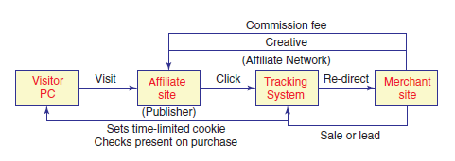
Figure 1. The Affiliate Marketing Model (Chaffey & Smith, 2008)

Advantages | Disadvantages
- Possibility of using numerous affiliates to reach different target audiences  - Allows the merchant to reach consumers using common phrases at a lower cost  - Increases the exposure of the brand as affiliates’ websites will be listed on third party websites  - Useful for generating awareness for a relatively unknown brand  - Affiliate marketing is on a “pay per performance” basis so costs can be easily controlled  - Ideal opportunity to form partnerships with others  - Affiliate marketing is a more effective use of the advertising budget  - Affiliate marketing is easily tracked, allowing for better overview of affiliate performance | - Affiliates may take advantage of brand name  - Can cause possible damage to the brand’s reputation if placed on websites with conflicting brand image and values  - Affiliate marketing can be time consuming  - Effective tracking software can be costly  - Using affiliate networks to manage campaigns can cost up to an extra 30% of agreed commission fees  - Affiliate marketing is best suited when the profit margin is high
Table 2. Advantages and Disadvantages of Affiliate Marketing (Chaffey & Smith, 2008; The Internet Marketing Academy, 2011a & 2011e)

Affiliate marketing is not recommended for LaBritannique as the company is still small and, although growing, its profit margins are not yet large enough to accommodate paying commission fees to others for the company’s advertising efforts.

3.1.6.5. Search Engine Marketing (SEM)
In today’s modern world, consumers are more often than not turning to the internet to search for information, which is why search engine marketing is ever more important for businesses.
Westlund (2010) defines search engine marketing (SEM) as the methods and tactics used in order to guide more internet users, or visitors, to websites. SEM involves the placement of advertisements on a search engine (such as Google or Yahoo) that encourage internet users who have entered keywords into the search engine to click on these links leading to another website (Chaffey & Smith, 2008). Keywords are words internet users type into a search box when researching topics online, these are also referred to as "search terms" (Taylor, 2004).
Westlund (2010) states that research into the topic has shown that SEM generates a high rate of return on investment in comparison to other forms of online marketing. This is mainly due to the technique’s close connection with the interests of individual internet users (Westlund, 2010). SEM is a vibrant marketing tool for companies as it allows them to reach potential buyers directly (Scott, 2010) and offers the possibility of boosting sales, raising brand awareness as well as increasing traffic to their websites (Westlund, 2010). All of this is done with the use of keywords, as mentioned and defined above.
Two main fields make up SEM activities. These are search engine optimisation (SEO) and Paid Search Marketing (Chaffey & Smith, 2008). The key difference between these two are that SEO is essentially free for companies to exploit through the use of keywords naturally, or organically appearing in search results, whereas paid search marketing is a service companies pay for in order to appear on the search results page an internet user sees. Companies do not pay for organic results, and these are listed in order of relevance to the keywords internet users input into the search box (Enge, Spencer, Fishkin & Stricchiola, 2009; Carrel, 2012). All internet search results display both SEO results and paid search marketing results, as shown below in Illustration 2. The topics of SEO and paid search marketing are discussed in further detail in the following sub chapters.
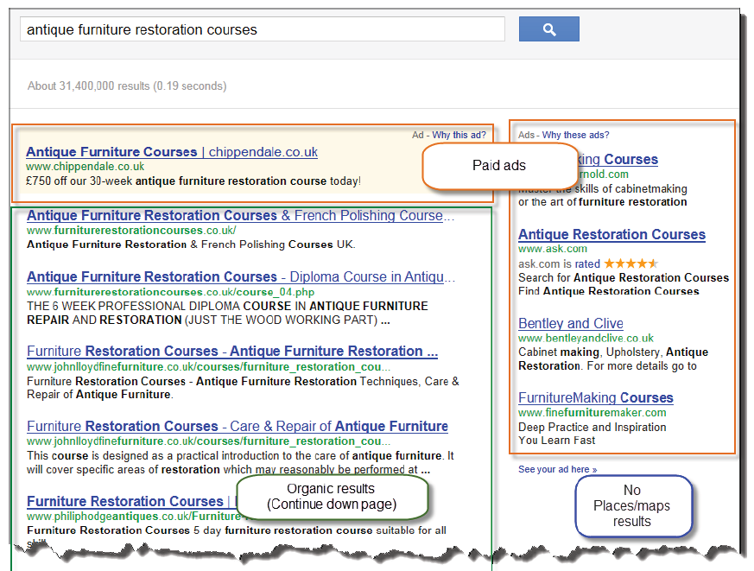
Illustration 2. Positioning of organic and paid for search results (Carrel, 2012)

Search Engine Optimisation (SEO)
Search engine optimisation (SEO) is a method that enables websites to rank higher in search results, making them more discernible to internet users when they search for particular products or services through the use of search engines, such as Google or Yahoo (HubSpot, n.d.).
As Carrel (2012) states, the higher up on the search results a company ranks, the better, as the vast majority of internet users tend to click on the first listing whilst lower listings receive fewer clicks, especially if users have to scroll down a page to see them. The key for a company to appear on the first page of a search query is to optimise its website. Search engines look for keywords matching a user’s query in various places on a website and Carrel (2012) lists the following as examples:
- Headers
- On-page text
- Page titles
- Inbound links and anchor text
- Internet links and anchor text
- Decryptions
- Alt tags
Optimising a website is done through associating specific keywords to it. Keywords can be short and consist of just one word, known as short tail keywords (Carrel, 2012) or they can be longer, known as long tail keywords (Carrel, 2012) which are typically made up of longer phrases or even questions. Scott (2010) claims that, “it is ineffective to try to reach buyers with broad, general search terms.” (p. 253). As well as this, keywords can also be geotargeted. This means that a geographical location is included as part of the keywords associated with a website and company (Carrel, 2012). Using geotargeted keywords can be highly beneficial for small businesses as the chances of being listed in a results page are significantly higher (Carrel, 2012).
To gain a better understanding and overview of both SEO and pay per click (PPC) advertising, the basics of these are shown in Illustration 3 below.
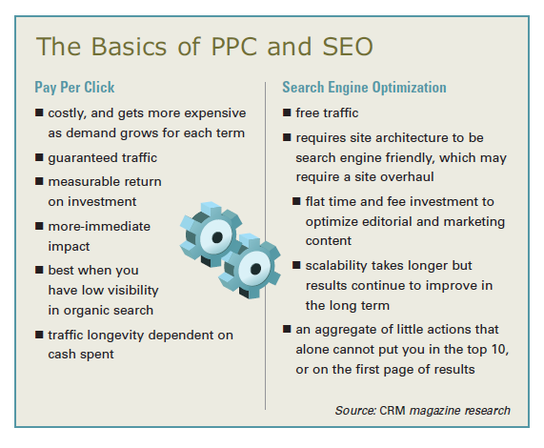
Illustration 3. The basics of PPC and SEO (Tsai, 2009)

Paid Search Marketing (or Pay per Click)
As previously mentioned, search engines have become an essential tool when looking for information on the internet (Laffey, 2007). As search engines are free for people to use, search engine providers, such as Google and Yahoo, have had to find a way to generate income (Laffey, 2007). Previously, search engine providers, as well as many other websites, have used basic online advertising, such as banners, to produce profits (Laffey, 2007). Nowadays, search engines make their profits from paid search marketing.
Paid search marketing is generally done on a pay per click (PPC) basis, meaning that companies only pay a nominal cost each time their link is clicked on by a user (Nabout & Skiera, in press). Prices companies pay are varied and are determined based on what they bid to pay for each click, for a specific keyword to be related to them (Nabout & Skiera, in press). For a small business aiming to improve its online marketing strategy, the bidding for keywords may not be the best option, as funding may not be as readily available as in larger companies.
An alternative to this, yet still in terms of PPC, is to use a service such as Google AdWords. This service allows advertisers with an AdWords account to set their daily and monthly budget (Google, n.d.). An advantage of using such a service is that there is no minimum cost (Google, n.d.), which allows businesses to spend as much, or as little, as they choose. For a small, and possibly relatively unknown, business, PPC may be of more value than simply using SEO, as if the company doesn’t appear on the first page of a person’s search query results, SEO has little to no value (Tsai, 2009).

Advantages and Disadvantages of SEO and Paid Search Marketing
As for every marketing tool, both SEO and paid search marketing have their advantages and disadvantages (Chaffey et al., 2009). These are summarised in Table 3 below.
Advantages |  | Disadvantages
SEO | Paid Search Marketing | SEO | Paid Search Marketing
- Highly targeted  - Potentially low cost visitors  - Dynamic | - Advertiser does not pay for the advertisement to be displayed; internet users searching for items determine which adverts appear  - Highly targeted  - Good accountability  - Predictable and fast  - Simpler than SEO | - Lack of predictability  - Time for results to be implemented  - Complexity and dynamic nature  - Ongoing investment  - Compared to other media channels, SEO is poor for creating awareness | - Competitive and expensive  - Not cost effective for companies with low budgets  - Requires specialist knowledge  - Time consuming
Table 3. Advantages and Disadvantages of SEO and Paid Search Marketing (Chaffey et al., 2009)

3.1.6.6. Social Media Marketing

Definition of Social Media
Social media is a term used to define an online network where people can connect and share ideas. Solis (2010) defines social media as “any tool or service that uses the internet to facilitate conversations.” (p. 37). Claxton and Woo (2008) define social media as being a magnet that “attracts hundreds of millions of people around the world, offering a place where people meet and connect through a network of friends.” (p. 178).
According to Shih (2011) the terms "social media" and "social networking" are often used interchangeably; these terms refer to two different things, yet are closely related. Shih (2011) states that social media is all about the content on a website, and can also be referred to as user-generated content. Examples of this include blogs, commenting, tagging, photos and videos. “Social networking often facilitates many forms of social media, but a lot of social media also exists outside of social networking sites.” (Shih, 2011, p. 17). The various types of social media are discussed in more detail further on in this chapter.
Social media is the new trend and companies are jumping, and many have already done so, on the bandwagon to use social media for their advertising efforts. However, it must be underlined that social media is only part of a company’s overall (online) marketing strategy (Solis, 2010), an argument supported by Claxton and Woo (2008) who state that social media sites are useful for businesses to share what they offer through the use of audio, videos, photos, etc. but stress that these tools should complement the businesses’ other online marketing efforts such as their website.
Social media is one of the least expensive tools available for companies to use when marketing online, as it allows them to connect with their target audience in a much more direct manner and on a much grander scale (Taprial & Kanwar, 2012b). Social media marketing is all about enhancing a company’s online presence, by being seen where consumers are looking; i.e. being present where consumers are congregating online (The Internet Marketing Academy, 2011c).

Types of Social Media
Kaplan and Haenlein (2010) identify six different types of social media. These are:
- Collaborative projects
- Blogs
- Content communities
- Social networking sites
- Virtual game worlds
- Virtual social worlds

- Collaborative Projects
Collaborative projects are online websites, or applications, that allow multiple users to create content to share with others (Kaplan & Haenlein, 2010). One example of a collaborative project is Wikipedia, the online encyclopaedia, which allows anyone with access to the internet to add, change or remove articles from its website. These changes are monitored by administrators who can accept or reject the changes made. A second example of a collaborative project is the social bookmarking service, Delicious. Delicious enables users to store and share their web bookmarks (Kaplan & Haenlein, 2010).
- Blogs and Micro Blogs
Blogs are one of the earliest forms of social media (Kaplan & Haenlein, 2010) and traditionally were the “equivalent of personal web pages” (Kaplan & Haenlein, 2010, p. 63) where one person shared their life story, or their thoughts on subjects that interest them. Typically, blogs are managed by one person but interaction is still possible as visitors to the site can leave comments on posts (Kaplan & Haenlein, 2010). Companies have also started using blogs to “update employees, customers and shareholders on developments they consider to be important” (Kaplan & Haenlein, 2010, p. 63). A company blog allows for a more informal tone of voice in comparison to a corporate website (Taprial & Kanwar, 2012a).
Micro blogs move away from the traditional personal webpage, to a more interactive webpage or what is known as a real-time live stream (Taprial & Kanwar, 20120b) where users can get information on what is happening at a specific moment in time. An example of a micro-blog is Twitter, which allows users to send out updates of up to 140 characters for all to read.
- Content Communities
Content communities have one main objective: to permit users to share media content between themselves (Kaplan & Haenlein, 2010). There are diverse types of content communities that use different forms of media and these include: text (e.g. BookCrossing, where users from around the world share books), photos (e.g. Flickr), videos (e.g. YouTube) and presentations (e.g. Slideshare) (Kaplan & Haenlein, 2010). The attraction of these content communities is that users are not necessarily required to create an account, but should they choose to do so, only limited information about the person is displayed for others to view.
- Social Networking Sites
Users on social networking sites create personal profile pages and can connect with friends, family and colleagues in order to view their profile pages (Kaplan & Haenlein, 2010). The content on these social networking sites includes photos, videos as well as audio files (Kaplan & Haenlein, 2010). Examples of social networking sites are Facebook and LinkedIn.
Companies actively use social networking sites to promote their products and brands and create brand communities – “a non-geographical community based on a set of structured relations between the admirers of a brand” (Muniz & O’Guinn, 2001, p. 412). Brand communities considerably influence the level of word-of-mouth advertising and consumer levels of purchase intentions (Algesheimer, Dholakia & Hermann, 2005). Rosenbaum-Elliott et al. (2011) state that with higher levels of participation in brand community, the likelihood of consumers repurchasing a brand’s product increases; and it also decreases the chance of consumers buying a competitor’s product.
- Virtual Game Worlds and Virtual Social Worlds
To quote Kaplan and Haenlein (2010), “virtual worlds are platforms that replicate a three-dimensional environment in which users can appear in the form of personalized avatars and interact with each other as they would in real life.” (p. 64).

Virtual game worlds allow users to join an online multiplayer game and compete with other users from around the world, and have strict rules.

Virtual social worlds allow users to live an online life, similar to their own, yet they are free to choose their actions as the rules are much more relaxed.
This research report will only discuss the following types of social media in more detail: blogs and micro blogs, content communities and social networking sites.
For companies, the aim of social media marketing (SMM) is to produce content that social media users will share with their connections on social networks, which enhances the level of exposure the company receives and increases customer reach (TechTarget, n.d.). The importance of creating compelling content is a subject previously touched upon on in sub chapter 3.1.6.1. Content Marketing on p. 12.
Part of SMM is social media optimisation (SMO). Similar to search engine optimisation (SEO), discussed above, in the sense that keywords can be associated with any content companies create on social media channels in order for users to find their content more easily when performing searches on social media channels as opposed to using search engines (Solis, 2010).

3.2. Theories and Models
The second part of the theoretical framework outlines the theories and models that can be applied to LaBritannique in order to solve the research problem. The theories and models discussed are the 5 Ps of Marketing for Social Media, the SIVA model, and brand positioning models.

3.2.1. The 5 Ps of Marketing for Social Media
The 5 Ps of marketing for social media are based on the traditional marketing mix of the 4 Ps of marketing, developed over 40 years ago (Pringle & Field, 2008). The traditional marketing mix consists of Product, Price, Place and Promotion. Hollensen (2007) describes the 4 Ps as “[…] a set of controllable variables or a "tool kit" at the disposal of marketing management which can be used to influence customers.” (p. 415). Kotler, Wong, Saunders and Armstrong (2005) highlight the concept of the 4 Ps as being a marketing mix used to influence consumers in the target market the way the company wants them to be influenced. This is to say that companies, if done so efficiently, can use the 4 Ps of marketing to convince consumers to buy their products and not those of their competitors.
According to Pringle & Field (2008), the 4 Ps may still be of use today, but the marketing mix is also struggling to keep up with the modernisation of today’s world where the focus is increasingly on people. With the focus on people comes the idea of interaction with people, the buyers of a company’s products. This is an argument backed up by Scott (2010) who states that for a company to succeed in today’s world of marketing, especially when using the internet, the company must think of its buyers first.
A fifth P needs to be added to the traditional marketing mix to create a newer concept applicable to online marketing and social media: that of People (Smith, Wollan & Zhou, 2011). People are what make interactions possible on social media and with online marketing campaigns. As Smith et al. (2011) state, “adding the "people" element recognises the new collaborative nature of the customer-company-relationship made possible by social media.” (p. 12).

3.2.1.1. The 5 Ps of Marketing for Social Media: Product
Product: “a tangible object or service” (Solis, 2010, p. 260).
The term "product" also refers to a service a company offers, not just a physical product. This section of the model mix helps marketers to define the extent to which their product (or service) is unique. It also helps marketers to define their product (or service) in order for them to better communicate and advertise to current and potential customers (Pringle & Field, 2008).

3.2.1.2. The 5 Ps of Marketing for Social Media: Price
Price: “The price that the customer pays as determined by market factors such as market share, competition, material costs, product identity and perceived value” (Solis, 2010, p.260).
Marketers do not often have an influence on the price of the product (or service) they are marketing. This P of the marketing mix is not about pricing as such but more about how to communicate to consumers why the price is such, in comparison with competitors’ prices for a possibly similar product (Pringle & Field, 2008). The pricing aspect of the marketing mix enables marketers to justify the price by positioning the product as any of the following: super-premium, premium, mainstream or value (Pringle & Field, 2008).

3.2.1.3. The 5 Ps of Marketing for Social Media: Place
Place: “Also referred to as the distribution channel, place is the location where a product can be purchased” (Solis, 2010, p. 260).
The third P of the marketing mix refers to where the product is distributed and made available to consumers. If the product is readily available to consumers, the chance of them buying the product is higher. However, as Pringle and Field (2008) state, there can be dangers associated with too much distribution. Companies risk losing consumer interest if their product is available everywhere a consumer looks. For this P of the marketing mix to be an efficient part of the overall mix, a careful blend distribution is needed in order for companies not to lose sight of their values (Pringle & Field, 2008).

3.2.1.4. The 5 Ps of Marketing for Social Media: Promotion
Promotion: “Communications employed to promote the product in the marketplace, ranging from advertising, public relations, word of mouth, point of sale, direct mail, events, marketing, and now, social media” (Solis, 2010, p. 260).
Promotion is a vague term (Pringle & Field, 2008) that covers all the different ways in which marketers can communicate with consumers. Kotler et al. (2005) define promotion as “activities that communicate the product or service and its merits to target consumers and persuade them to buy” (p. 34). These activities can include advertising, sales promotion, public relations (Kotler et al., 2005), direct mail, packaging, sponsorship, customer magazines, special events, websites, email and the list is ever growing (Pringle & Field, 2008).

3.2.1.5. The 5 Ps of Marketing for Social Media: People
Traditionally, marketing has always been focused on the product. Now, the focus has shifted to the relationship side of marketing (Berry, n.d.), and hence the need to add People to the traditional marketing mix.
The People element of the 5 Ps of marketing for social media has its own five elements that Smith et al. (2011) refer to as the 5 Rs: Reputation, Responsibility, Relationship, Reward and Rigor. These 5 Rs help to guide a company on how to reconnect with consumers in today’s market, where the focus is increasingly on interaction (Smith et al., 2011).
- Reputation
In today’s world, consumers are much more aware of what companies are doing and how they’re doing it, and thus reputation is of greater importance. Reputation refers to how well a company delivers on its promises to consumers as well as how it responds to negative comments in the media. Social media is a great tool for companies to use to stop the spreading of false claims that could damage the company’s reputation or to respond to unhappy customers publicly.
- Responsibility
Privacy concerns are a big issue, and responsibility refers to how a company gathers information about its customers and how it stores this information. It also refers to the extent to which a company is socially responsible, a perception on which consumers rank the companies they want to associate with.
- Relationship
Traditionally, the idea of marketing was to broadcast a message in a one-way manner. With the relationship facet of the 5 Rs, comes emotion. Companies need to show emotion in their communication with their customers to form relationships, and social media is an effective tool to engage in two-way communication, involving their customers, and thus creating an emotional connection.
- Reward
Reward refers to any added value that companies can gain from their activities on social media such as dialogues with individual customers. Social media allows companies to gather more detailed information about their customers and what they need, thus allowing them to better target their audiences.
- Rigor
Rigor deals with just how companies operate on social media and whether or not these operations are consistent and able to deliver the correct customer experience. Any inconsistencies with a company’s communications can lead to customers thinking they are insincere.
The effectiveness of this marketing mix depends on the extent to which a company has successfully blended all five elements of this marketing mix in order to reach its marketing objectives.
The idea of updating the traditional 4 Ps marketing mix is not new. Closely related to the 4 Ps of marketing are the concepts of the 4 Cs and 4 As. These are an adaptation of the 4 Ps in an attempt to modernise the original marketing mix and include the idea of people. These concepts are discussed in the following sub chapter.

3.2.1.6. The 4 Cs and the 4 As of Marketing
As discussed above, both the 4 Cs of marketing and the 4 As of marketing are based on, and similar to the 4 Ps of marketing as the principal is similar but the focus is on the customer. The 4Cs are Customer needs and wants, Cost to customer, Convenience and Communication. The 4 As are Acceptability, Affordability, Availability and Awareness.
The 4 Cs and 4 As of marketing are models that help marketers see the concept of the 4 Ps marketing mix from the view of the customer (Kotler et al., 2005). These newer models are one step closer to including the idea of “people” in the mix. As Kotler et al. (2005) state, customers are the key to marketing as every marketing campaign ends with customers.
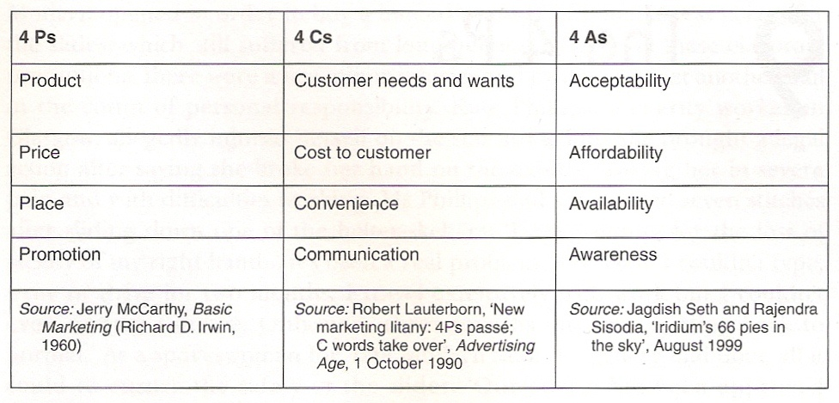
Figure 2. 4 Ps, 4 Cs and 4 As chart (Pringle & Field, 2008)

3.2.2. The SIVA Model
Pringle and Field (2008) discuss a newer model of marketing known as the SIVA model, developed by Dev and Schultz in their article dating from 2005, "Market Leader" (as cited in Pringle & Field, 2008). The SIVA model takes a different approach to marketing, centred on the customer. SIVA is an acronym for Solutions, Information, Value and Access (Pringle & Field, 2008).
The idea behind the SIVA model is that in a world where consumers are bombarded with messages everywhere they look, consumers have advanced from looking for products that simply meet their needs, to looking for products that provide solutions to their needs.
To find these solutions to their needs, consumers seek information to help direct them to said solutions.
Value is the next step consumers take in their search for products to meet their needs. Dev and Schultz are quick to point out that value in this context is not solely about the price of a product, but also about the added values that the product and its brand can bring to the consumer. It is these perceived values that will motivate the consumer to pay more for a product.
The last step of the SIVA model is access. Dev and Schultz state that consumers nowadays necessitate “what they want, when, where and how they want it” (as cited in Pringle & Field, 2008, p. 73).
Today’s world is very much a 24-hour world in the sense that there is always a shop open, and even more so now with the rise in popularity of the internet and online shopping.

3.2.3. Brand Positioning
Franzen and Moriarty (2009) discuss a basic model for brand positioning (see Figure 3 below). This model deals with three main questions: what is it?, what does it offer? and what or whom is it aimed at?. When a brand answers the first question, it is creating a link between the brand itself and the need it fulfils (Rosenbaum-Elliot et al., 2011). When answering the second question, brands create a link in the consumer’s mind between the brand and its offered benefit (Rosenbaum-Elliot et al, 2011). The third question, what or whom is it aimed at? is essential for a brand to answer in order to successfully form its positioning statement (as discussed in sub chapter 3.1.3. Brand Positioning as part of the Marketing Effort on p. 10)
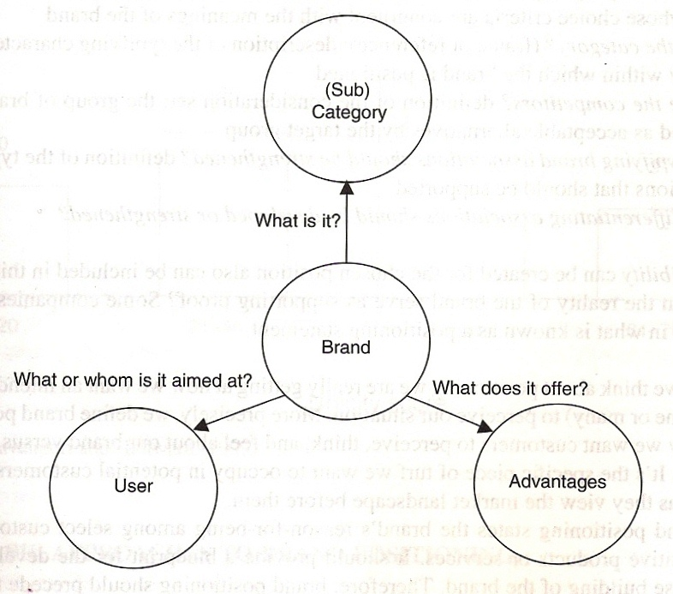
Figure 3. Basic principles of positioning (Franzen & Moriarty, 2009)
As Kapferer (2008) states, “positioning […] reminds us that all consumer choices are made on the basis of comparison” (p. 175). Kapferer offers another model (see Figure 4 below) for brand positioning that is based on four main questions: why?, when?, for whom? and against whom?.
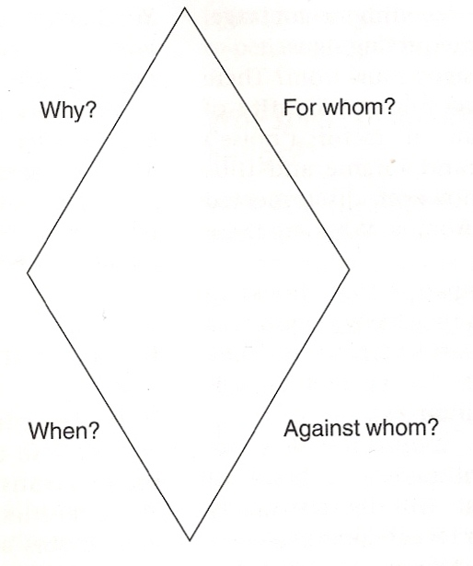
Figure 4. Positioning a brand (Kapferer, 2008)
Answering these four questions in its marketing communication will help a brand make its role in the market place instantly clear to consumers (Kapferer, 2008). Positioning has one aim: to identify and claim a space in the market or as Kapferer (2008) puts it, “a strong purchasing rationale” (p. 178) that gives the brand an advantage, whether it is a real advantage or an apparent one (Kapferer, 2008).
To summarise, to successfully position a brand, these main questions need to be answered:
- What is it? (Franzen & Moriarty, 2009; Rosenbaum-Elliott et al., 2011)
- Why do consumers need it and what does it offer? (Kapferer, 2008 & Franzen & Moriarty, 2009; Rosenbaum-Elliot et al., 2011)
- Who is it for? (Kapferer, 2008; Franzen & Moriarty, 2009)
- Who is it competing against? (Kapferer, 2008)
- When will consumers need it? (Kapferer, 2008)

4. Methodology and Research Design
This chapter looks at how the data needed for this research was collected, which sampling method was used, and outlines how the desk research was done. The chapter also discusses the limitations to the research.

4.1. Research Design
The data collected for this research report is quantitative data, retrieved through the use of an online questionnaire. The target group for the questionnaire included LaBritannique clients from 2011 and 2012 (up until the beginning of May) both male and female living in and around Brussels, as well as people that follow (or are fans of) the company on social networks, namely Facebook, Twitter and LinkedIn.
This sampling method for this research report used a non-probability approach as respondents were not selected at random (Denscombe, 2008). This non-probability approach included a combination of convenience sampling and purposive sampling. Convenience sampling is the method of selecting respondents who are easy to find and approach (Denscombe, 2008). This method was used on the social networks (mentioned above) to get people who follow the company on social networks to respond. These fans were already available and were therefore easy to find.
Purposive sampling is the method of selecting respondents based on the purpose of the research (Denscombe, 2008). In this case, part of the purpose of the research is to establish whether or not current clients of the company are active on social networks, and how they use these to interact with others. An email was sent to all the clients from 2011 and 2012 (up until the beginning of May) outlining the research and asking them to take part.
Neither of these sampling methods aim to produce a sample than can be used to represent the whole of the population in question, rather the rationale of using these sampling methods is to gain some knowledge of a smaller group of the overall population in order to draw conclusions.
This approach to sampling resulted in a final sample of 170 respondents. The answers given by the respondents were analysed with SPSS, a data analysis programme.

4.2. Desk Research
The desk research carried out for the purpose of this research report focussed on the following aspects: the economic downturn and how it has affected businesses; social media and how these can be used by small businesses to better market themselves; marketing and how to position a brand with effective marketing.
For the purpose of this research, books and articles on the subjects of marketing, social media, and the economic downturn were used. The sources referred to date back no more than 12 years, i.e. only literature dating back to 2000 was consulted.

4.3. Limitations to the Research
The results outlined in this research report cannot be generalised as the sample size is too small to correctly represent the whole of the population studied. The results gathered from this sample serve only to give a general overview, and thus any conclusions drawn are also general.
As well as this, the timeframe was limited, not allowing for more in-depth research into the topic or gathering a larger sample for more effective results.

5. Discussion of Findings
This chapter discusses and analyses the 170 responses received to the questionnaire (for full list of questions, please refer to the Appendix on p. 55).
LaBritannique operates in a multicultural environment, namely Brussels, in the heart of Europe. Although the majority of respondents are Anglophone (89 in total), from the United Kingdom, Ireland, the United States of America, Canada, Australia and Jamaica (see Table 4 in the Appendix on p. 44), other nationalities such as Swedish, Dutch and Italian are also represented. To be consistent in its communication and marketing activities online, on social media especially, LaBritannique should communicate with its target audience in English. This concept is elaborated on further in chapter 7. Recommendations on p. 34.
Of the 170 respondents to the questionnaire, 71 percent were female, 29 percent were male (see Graph 2 in the Appendix on p. 43), and of these respondents the vast majority are active on social media with just 19% saying they did not use social media of any sort (see Graph 2 below). Knowing the number of people among its clientele that don’t use social media is beneficial to LaBritannique in the sense that they can establish different ways to communicate with this smaller group of its clientele.
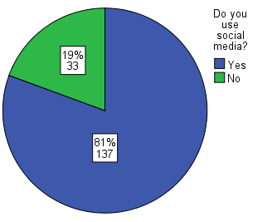
Graph 1. Number of respondents active on social media

Of the 137 respondents (81 percent) that use social media, 129 of them are active on Facebook, 89 on YouTube, 77 on LinkedIn and 47 on Twitter. These are the four most popular social media channels among the sample surveyed. The least popular social media channels include Delicious, Foursquare, and StumbleUpon (see Graph 3 in the Appendix on p. 45).
Out of the respondents who actively use Facebook, the majority use Facebook twice a day or more (51.94 percent) with close to 26 percent of respondents using Facebook once a day (see Graph 4 in the Appendix on p. 46).
The majority of respondents (just over 30 percent) use YouTube once a week (see Graph 5 on p. 47 of the Appendix), offering LaBritannique a great opportunity to start using this social media channel on a regular basis as part of its content marketing strategy (discussed further in chapter 7. Recommendations on p. 34).
Of the 77 respondents that use LinkedIn, the majority use this social media channel when they remember (nearly 26 percent) followed closely by nearly 25 percent of respondents using LinkedIn just once a month (see Graph 6 on p. 48 of the Appendix).
For Twitter, nearly 26 percent of respondents say they use the service when they remember. However, just under 43 percent say they use Twitter either once a day, or twice a day, or more (see Graph 7 in the Appendix on p. 49).
LaBritannique currently uses Facebook, Twitter and LinkedIn as part of its social media marketing strategy. Of the 170 respondents to the questionnaire, nearly 77 percent follow LaBritannique’s activity on Facebook, with just over 12 percent following on Twitter and just over 10 percent following on LinkedIn (see Graph 8 in the Appendix on p. 50).
These figures are indicative of which social media channels LaBritannique should be focussing on when redesigning its social media marketing strategy. This is further discussed in chapter 7. Recommendations on p. 34.
Respondents were also asked whether or not LaBritannique’s website was easy to read and navigate through. The majority of respondents answered yes to these two questions (see Graph 9 on p. 51 and Graph 10 on p. 52 of the Appendix) with just 9.17 percent of respondents not finding the website easy to read and 5.50% not finding it easy to navigate through.
For the respondents that answered no, the following reasons as to why the website is not easy to read were given (see Graph 11 on p. 53 of the Appendix):
- Too much text (71.34 percent)
- Too many animations (14.29 percent)
- Font too small (14.29 percent)
For the respondents that answered no, the following reasons as to why the website is not easy to navigate were given (see Graph 12 on p. 54 of the Appendix):
- Too much text (50 percent)
- Too many photos (25 percent)
- Takes too long to load (25 percent)
Although just a small percentage of respondents do not find the website easy to navigate or read, these figures are indicate possible reasons why LaBritannique’s online marketing strategy isn’t as efficient as it could be. This is a subject further discussed in chapter 7. Recommendations on p. 34.

6. Conclusion
As explained in the introduction, the economic downturn has affected businesses in such a way that they have needed to change their marketing strategies to align to consumers’ needs and consumers’ worries about spending. As a result of this, many businesses have turned to online marketing as a cost-effective solution.
Businesses seeking to start an online marketing strategy have a myriad of tools available to them. Probably the most important of these is search engine marketing (SEM), the act of using specific keywords related to their industry to help them achieve a higher ranking in search results provided by search engines such as Google. Depending on a company’s budget, they can either exploit the free form of search engine marketing, referred to as search engine optimisation (SEO), or use paid search marketing, a form of advertising for which companies pay only each time their link is clicked on. For LaBritannique, SEM is of extreme importance as, being a small business, the need to advertise their services to a large number of people, in a quick and easy manner, is essential to creating more leads and thus generating more customers.
This research has outlined the fact that other tools available for online marketing are all interrelated and, when used effectively, all help to achieve a higher ranking position in search results. All forms of online marketing revolve around the content used. Content marketing, is about creating compelling content for a company’s target audience. In order for the target audience to be able to locate this content, companies can tag the content with the keywords internet users are more likely to use when performing an internet search. Email marketing can only work for companies successfully if the content is of value to their readers, or companies run the risk of losing valuable connections. To avoid this, when companies create their content, they must be aware of the importance of not constantly singing their praises and promoting their products. Keeping readers interested involves the creation of content that is valid and interesting to them. This means creating content that is based around the subject and areas in which the company is operating, and that can be subtly linked back to the company. Linking back to the company is also done through affiliate marketing, but this form of online marketing is only beneficial for companies if they have the resources to pay for third-party advertising and still produce healthy profits, and is therefore not a suitable tool for LaBritannique as their profit margins are not yet large enough to afford to pay other people for their advertising efforts.
Due to the economic downturn, and the tough financial challenges that come with it, a greater number of businesses have turned to social media as a cheaper alternative to communicating with its target audience. Social media marketing provides businesses with the opportunity to reach a larger number of people within its target audience in almost half as much time as it would to reach the same number of people through traditional offline marketing. Social media marketing (SMM) is not free, as is often assumed. It may be free to create pages on social networks for example, but the cost of keeping these up to date also needs to be taken into account.
LaBritannique has also turned to social media as a means to market itself online. The company is currently active on Facebook, Twitter and LinkedIn. Just how its social media marketing can be improved, as well as its overall online marketing strategy, is discussed in the following 7. Recommendations on p. 34.

7. Recommendations
Marketing is about communicating with consumers and other businesses, making a statement in the marketplace. During an economic downturn when times are financially tough, is exactly when communication is at its most important and most useful for supporting a brand and to guarantee its strength in the market (Godfrey, 2009).
As previously mentioned, during an economic downturn, consumers tend to spend less as they are unsure of their financial future. Neff (2009) states that what consumers are searching for now is promotions and special deals and goes on to say that, should companies offer too many deals and promotions, it can have a damaging effect on the brand’s health, and that price promotions can reduce brand equity by encouraging consumers to be more price-sensitive. Ries (2009) states that “marketing is a long-term proposition. A company can get into trouble if it changes its marketing strategy to cope with a short-term problem.” (p. 14).
This is an argument that is backed up by Gallagher and Savard (2009) who state that a brand can steer growth at the best of times, and during an economic downturn, a brand can protect the value of a company.
Aaker (2009) mentions that an economic downturn is the opportunistic time to pay more attention to marketing and advertising campaigns, as competitors may be reducing their number of campaigns in a bid to save money, and thus there is less competition for consumer attention. For LaBritannique, this is where brand positioning is at its most important. When a brand is well positioned, the need for price promotions and special deals is almost superfluous. As Castaldo (2008) states, mistakes businesses make during an economic downturn, can be more costly than mistakes made in stable economic times.
LaBritannique’s main problem is the inefficiency of its current online marketing strategy. This is due to the brand not having been well enough positioned prior to commencing its online marketing efforts. Applying the brand positioning models proposed by Franzen and Moriarty (2009) and Kapferer (2008) to LaBritannique will help it to improve its current position and make it clearer to current and future customers.
The questions that need to be answered when positioning a brand are what is it?, who is it for?, what does it offer?, why and when do consumers need it?, and who is it competing against?. In LaBritannique’s case, it is clear that the service the brand offers is a full catering and event management service for any event, big or small, which answers the questions what is it?, what does it offer? and why and when do consumers need it?. As mentioned in the introduction, LaBritannique first started life as a business-to-business (B2B) service and it still is today, successfully. What the company now wants to do is expand further into the business-to-consumer (B2C) market, and this is why the company needs to slightly re-position itself and answer the questions who is it for? and who is it competing against?. There are many other catering companies in Brussels, and LaBritannique needs to differentiate itself from them in such a way that consumers are clear as to who the competition is and why LaBritannique offers a greater service. Doing so, will allow LaBritannique to ensure that consumers perceive the brand as having distinctive benefits unique to them. These benefits must be seen to add extra value to the brand, for example the quality of the product (Pelsmacker, Gueens & Bergh, 2004).
As Pelsmacker et al. (2004) state, a brand name is not enough for a company to be successful in today’s saturated market. Pelsmacker et al. (2004) discuss a model outlining the various criteria needed for a brand to be successful (see Figure 5 below).
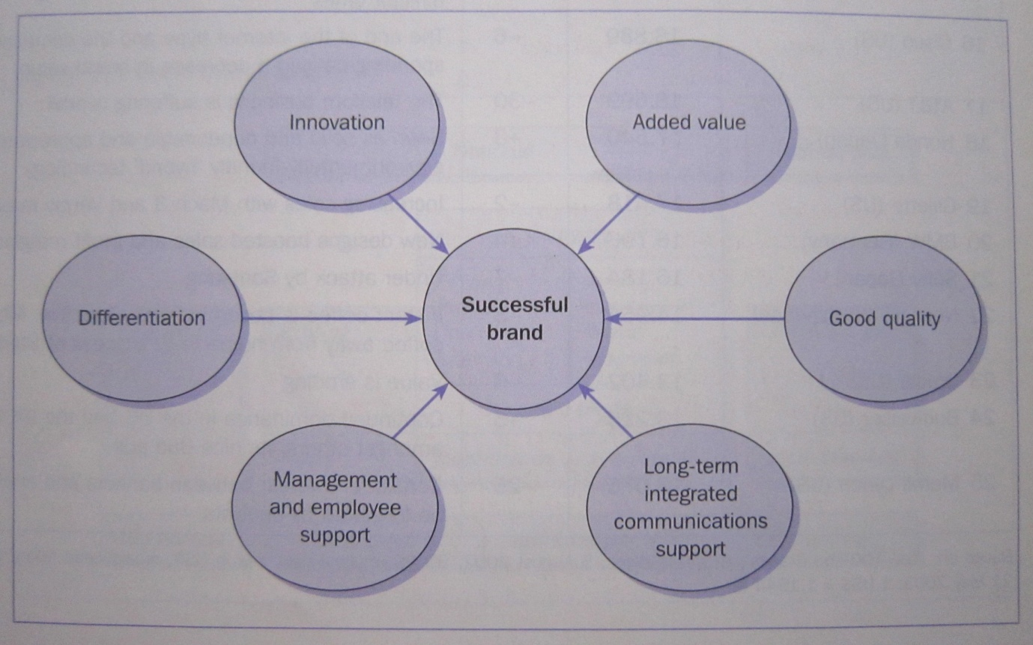
Figure 5. Determinants of successful brands (Pelsmacker et al., 2004)
These criteria include innovation and good quality, two values that LaBritannique already stands for (see sub chapter 3.1.2. LaBritannique’s Brand on p. 10 for a full list of the company’s brand values). The fact that one of LaBritannique’s values is innovation, is beneficial to them, as consumers can change their tastes and needs quite quickly, if given a valid reason to do so, and innovation is key to keeping consumers engaged with the brand, but also to keep the brand one step ahead of the competition (Pelsmacker et al., 2004).
LaBritannique’s staff is already a full team of dedicated people, working together to serve the company’s customers as best they can. As Pelsmacker et al. (2004) outline in their model, the support and dedication of staff within the company, both top level management and employees, is fundamental for a brand to hold a leading position in the marketplace. This is especially true for companies offering a service, such as catering (Pelsmacker et al., 2004).
In order for a brand to become a successful brand in the marketplace, the company behind the brand needs to have a clear marketing communication plan outlined. As Pelsmacker et al. (2004) state, “brands cannot become success stories without long-term, consistent, communications support, making customers aware of their uniqueness and keeping the brand's value trustworthy.” (p. 41). This is part of LaBritannique’s problem and using the SIVA model and the 5 Ps of marketing for social media can help to solve it.
The SIVA model focuses on consumers and how they search for products that provide solutions. SIVA is an acronym for Solutions, Information, Value and Access. Understanding this process will help LaBritannique to better reach its target audience. As outlined in sub chapter 3.1.6. Online Marketing on p. 12, consumers nowadays turn to the internet to find information. LaBritannique should make the most of online marketing tools such as search engine marketing (SEM) and content marketing to ensure consumers find the company when they search for solutions to their needs and information about products. Due to their the company’s limited budget, it is advisable for LaBritannique to use a service such as Google AdWords as part of its search engine marketing efforts as this allows the company to set a maximum budget. Search engine optimisation (SEO) is free, but used in combination with paid search marketing, can deliver better results (Tsai, 2009).
Using the concepts of content marketing will provide consumers with information on the value of the company and what it stands for and just how consumers can access this service.
The 5 Ps of marketing for social media are Product, Price, Place, Promotion and People. The main element of the 5 Ps is people. As LaBritannique is a company offering a service, the whole business revolves around people. As described in sub chapter 3.2.1.5. The 5 Ps of Marketing for Social Media: People on p. 25, the people element of the 5 Ps has its own five elements: Reputation, Responsibility, Relationship, Reward and Rigor. LaBritannique’s online marketing efforts should therefore focus on these five elements, and this can be done on the social media channels it is currently using (Facebook and Twitter) but can also be applied to other areas of its online marketing strategy such as its content marketing strategy.
Up until now, LaBritannique has been using LinkedIn as a third social media tool to communicate with consumers. As only just over 10 percent of respondents to the questionnaire carried out for this research report, actively follow LaBritannique on LinkedIn with just under 26 percent using LinkedIn when they remember and just under 25 percent of respondents using LinkedIn once a month (see Graph 6 on p. 48 of the Appendix), it would not be advisable for LaBritannique to continue using this social media tool as this would be a waste of resources.
The Rigor element of the 5 Ps of marketing for social media deals with the level of consistency delivered by companies on social media channels. As discussed in sub chapter 3.2.1.5. The 5 Ps of Marketing for Social Media: People on p. 25, inconsistencies in a company’s communication can lead to customers believing they are insincere. The majority of the respondents to the questionnaire are Anglophone (see Table 4 on p. 44 of the Appendix), in order to be consistent, all communication done by the company should be in English, at least on all communication channels used that are not its website. Having just one person in charge of content on social media is another way to keep communication consistent, as the style of writing will always be the same.
A number of the media tools listed by The Internet Marketing Academy (2011b) available for content marketing (see p. 42 of the Appendix for a full list) should be used by LaBritannique as part of its online marketing strategy. These include social media, e-books, videos and of course its website. The company’s website should always be included in any form of online marketing, in order for consumers to easily access the website and find further information they may need. As seen in chapter 5. Discussion of Findings on p. 31, a small number of respondents do not find the website easy to read or navigate through. The main reason given for this is the fact that LaBritannique’s website has too much text. This will need to be addressed as this could be a contributing factor as to why LaBritannique is not reaching as many members of its target audience as it could. With too much text on the website, consumers soon lose interest and navigate away from the webpage.
As content marketing is not just about the company promoting itself but also about providing readers with resources and entertainment, LaBritannique should consider the idea of using e-books and videos to communicate with consumers. LaBritannique can use e-books about cooking and recipes and offer tips on frequently asked cooking questions. Videos to compliment the e-books can also be used, possibly published online a few weeks after the e-books to keep consumers’ curiosity captivated. 89 out of the 170 respondents to the questionnaire use YouTube with just over 30 percent of these using the social media channel once a week (as discussed in chapter 5. Discussion of Findings on p. 31). This is certainly a motivating reason for LaBritannique to start using YouTube as part of its social media marketing strategy.
The costs involved in putting these recommendations into place and their upkeep will decrease over time. This is because the main investment will be in terms of training someone to learn how to use all these tools effectively, and once that person is confident with what they are doing, the time it takes to produce the work will reduce and in turn, so will the costs. The only considerable costs are those related to LaBritannique’s search engine marketing (SEM) efforts, but as discussed in chapter 3.1.6.5. Search Engine Marketing (SEM) on p. 17, these can be controlled if LaBritannique chooses to use Google Adwords, the company can set a maximum budget for each month and once the maximum is met, the paid search marketing adverts stop.
As with any marketing strategy the efforts LaBritannique puts in need to be evaluated over a certain time period to determine whether or not these have been successful. Online marketing involves attracting new consumers and keeping them interested and results for this will only be noticed after a period of time. The suggested time period for evaluation is six months. The aspects that can be evaluated to determine the level of success are whether or not the target audience has increased and whether this has led to more customers and more sales, and therefore more profits. The company’s search engine marketing efforts can be evaluated through the use of the Google AdWords application which gives insight into how many times certain keywords have been used by internet users and which of LaBritannique’s keywords have been more successful. Google AdWords also provides a list of suggested keywords to use and these can be used by LaBritannique.
With these recommendations taken into account, LaBritannique’s online marketing strategy can be considerably improved in order to better reach its target audience.

Bibliography
Algesheimer, R., Dholakia, U. M., & Herrmann, A. (2005). The Social Influence of Brand Community: Evidence from European Car Clubs. Journal of Marketing, 69(3), 19-34
Argenti, P. A. & Druckenmiller, B. (2004). Reputation and the Corporate Brand. Corporate Reputation Review. 6(4) 368-374
Bandyk, M. (2009). Getting off the Ground. U.S. News & World Report, 146(6), 72-74
Castaldo, J. (2008). Recession Management. Canadian Business, 81(3), 62-63
Carrel, J. (2012). Search Engine Optimisation. [eBook] Retrieved May 24, 2012, from http://bookboon.com/en/business-ebooks/marketing-ebooks/search-engine-optimisation
Chaffey, D. & Smith, PR. (2008) eMarketing eXcellence – Planning and optimizing your digital marketing (3rd ed.). Oxford: Butterworth-Heinemann
Chaffey, D., Ellis-Chadwick, F., Mayer, R. & Johnston, K. (2009). Internet Marketing – Strategy, Implementation and Practice. Harlow: Pearson Education Limited.
Clark, B. (n.d.) The “5 A” Framework for Content Marketing Success [Blog post] Retrieved May 24, 2012, from http://entreproducer.com/5a-content-marketing/
Claxton, L. & Woo, A. (2008). How to Say It: Marketing with New Media – a Guide to Promoting Your Small Business Using Websites, E-zines, Blogs and Podcasts. New York: Prentice Hall Press
Crosby, L. A., & Johnson, S. L. (2003). Beyond Brand Awareness. Marketing Management, 12(3), 10-11
Denscombe, M. (2008) The Good Research Guide – for small-scale social research projects (3rd ed.). Berkshire: McGraw-Hill Education
Desai, D. R., & Waller, S. (2010). Brands, Competition, and the Law. Brigham Young University Law Review, 2010(5), 1425-1499
Downturn, start up. (2012). Economist, 401(8766), 70
Enge, E., Spencer, S., Fishkin, R. & Stricchiola, J. C. (2009). The Art of SEO – Mastering Search Engine Optimisation. Sebastopol: O’Reilly Media, Inc.
Everitt, R. (2012) Permission Marketing. [eBook] Retrieved May 24, 2012, from http://bookboon.com/en/business-ebooks/marketing-ebooks/permission-marketing
Franzen, G. & Moriarty, S. (2009) The Science and Art of Branding. Armonk, New York: M.E. Sharpe, Inc.
Gallagher, M. and Savard, L. (2009). Brand Building in a Recession – Brand equity, the best defense in the face of declining consumer spend. Black Coffee brand expression. Retrieved February 26, 2012, from http://www.blackcoffee.com/brand-related/brand-articles/brand-building-in-a-recession
Georgieva, M. (n.d.) An Introduction to Email Marketing. [White paper] Retrieved, May 24, 2012, from HubSpot: http://www.hubspot.com/Portals/53/docs/ebooks/an_introduction_to_email_marketing_final.pdf
Godfrey. (2009). Why Branding Becomes More Important in Uncertain Times. [White paper]. Retrieved February, 26, 2012, from http://www.godfrey.com/~/media/Files/White%20Papers/Uncertain-Times-WP.pdf
Google. (n.d.) AdWords – Advertise your business on Google. Retrieved May 25, 2012, from https://accounts.google.com/ServiceLogin?service=adwords&cd=GB&hl=en_GB&ltmpl=jfk&passive=true&ifr=false&alwf=true&continue=https://adwords.google.co.uk/um/gaiaauth?apt%3DNone%26ltmpl%3Djfk&sacu=1&sarp=1
Hollensen, S. (2007). Global Marketing (4th ed.). Harlow: Pearson Education Limited.
HubSpot (n.d.) Introduction to Search Engine Optimization. [eBook] Retrieved, May 24, 2012, from HubSpot: http://www.hubspot.com/Portals/53/docs/Introduction-to-SEO-eBook.pdf
Kapferer, J. N. (2008). The New Strategic Brand Management – Creating and sustaining brand equity long term (4th ed.). London: Kogan Page Limited.
Kaplan, A. M. & Haenlein, M. (2010). Users of the world, unite! The challenges and opportunities of Social Media. Business Horizons, 53, 59-68
Kotler, P., Wong, V., Saunders, J. & Armstrong, G. (2005). Principles of Marketing (2nd ed.). Harlow: Pearson Education Limited.
Laffey, D. (2007). Paid search: The innovation that changed the Web. Business Horizons, 50, 211-218
Lieb, R. (2012) Content Marketing: What Kind of Content? [Blog post] Retrieved May 24, 2012, from http://marketingland.com/content-marketing-what-kind-of-content-11312
Muniz Jr., A. M. & O’Guinn, T. C. (2001). Brand Community. Journal of Consumer Research, 27, 412-432
Nabout, N. A. & Skiera, B. (in press). Return on Quality Improvements in Search Engine Marketing. Journal of Interactive Marketing. Retrieved, May 24, 2012, from http://www.sciencedirect.com.www.dbproxy.hu.nl/science/article/pii/S1094996811000764
Neff, J. (2009). Deal or no deal? Cheap prices can maim your brand. Advertising Age, 80(12), 1-25.
Pateman, N. & Holt, D. (2011). Inbound Marketing. [eBook] Retrieved May 24, 2012, from http://bookboon.com/en/business-ebooks/marketing-ebooks/inbound-marketing
Pelsmacker, De P., Gueens, M. & Bergh, van den J. (2004). Marketing communications. A European perspective. England: Pearson Prentice Hall.
Pringle, H. & Field, P. (2008) Brand Immortality – How brands can live long and prosper. Cornwall: MPG Books Ltd.
Ries, A. (2009). Don't Damage Your Brand for Short-Term Gains in a Recession. Advertising Age. 80(12) 14
Rosenbaum-Elliott, R., Percy, L & Pervan, S. (2011). Strategic Brand Management (2nd ed.). New York: Oxford University Press.
Şahin, A., Kitao, S., Cororaton, A., & Laiu, S. (2011). Why Small Businesses Were Hit Harder by the Recent Recession. Current Issues In Economics & Finance, 17(4), 1-7.
Scott, D. M. (2010) The New Rules of Marketing & PR – How to use Social Media, Blogs, News Releases, Online Video, and Viral Marketing to Reach Buyers Directly (2nd ed.). Hoboken, New Jersey: John Wiley & Sons, Inc.
Shih, C. (2011). The Facebook Era – Tapping Online Social Networks to Market, Sell, and Innovate (2nd ed.). Boston: Pearson Education, Inc.
Smith, N., Wollan, R. & Zhou, C. (2011). The Social Media Management Handbook – Everything you need to know to get social media working in your business. Hoboken, New Jersey: John Wiley & Sons, Inc.
Solis, B. (2010). Engage! – The Complete Guide for Brands and Businesses to Build, Cultivate and Measure Success in the New Web. Hoboken, New Jersey: John Wiley & Sons Ltd.
Taprial, V. & Kanwar, P. (2012a). Business Blogs – The Best Social Media Tool for Businesses. [eBook] Retrieved May 24, 2012, from
http://bookboon.com/en/business-ebooks/communication/business-blogs
Taprial, V. & Kanwar, P. (2012b). Understanding Social Media. [eBook] Retrieved May 24, 2012, from http://bookboon.com/en/business-ebooks/communication/understanding-social-media
Taylor, C. P. (2004). The Engine That Could. Mediaweek, 14(11), 18-22
TechTarget. (n.d.) Social Media Marketing (SMM) [Blog post] Retrieved May 24, 2012, from http://whatis.techtarget.com/definition/social-media-marketing-SMM
The Internet Marketing Academy. (2011a). Affiliate Marketing. [eBook] Retrieved May 24, 2012, from http://bookboon.com/en/business-ebooks/marketing-ebooks/affiliate-marketing
The Internet Marketing Academy. (2011b). Content Marketing. [eBook] Retrieved May 24, 2012, from http://bookboon.com/en/business-ebooks/marketing-ebooks/content-marketing
The Internet Marketing Academy (2011c). Developing an Internet Marketing Strategy. [eBook] Retrieved May 24, 2012 from http://bookboon.com/en/textbooks/marketing-media/developing-an-internet-marketing-strategy
The Internet Marketing Academy. (2011d). Email Marketing. [eBook] Retrieved May 24, 2012, from http://bookboon.com/en/textbooks/marketing-media/email-marketing
The Internet Marketing Academy. (2011e). Internet Marketing. [eBook] Retrieved May 24, 2012, from http://bookboon.com/en/textbooks/marketing-media/internet-marketing
Tsai, J. (2009). Search Engineering. CRM Magazine, 13(7), 37-42
Westlund, R. (2009). Best Practices for Em@il Marketing. Brandweek, 50(31), E2-E6.
Westlund, R. (2010). Search On. Mediaweek, 20(9), S1-S5.
Whalley, A. (2010). Strategic Marketing. [eBook] Retrieved May 24, 2012, from http://bookboon.com/en/textbooks/marketing-media/strategic-marketing
White, J. M. (2007). Chapter 14 Bankruptcy Law. Handbook of Law and Economics, 20, 1013-1072
Yalçin, N. & Köse, U. (2010). What is search engine optimization: SEO?. Procedia Social and Behavioral Sciences, 9, 487-493

Appendix

Full list of media tools available for content marketing (Internet Marketing Academy, 2011b)

Website
Blog
Social media (Facebook, Twitter, LinkedIn, etc.)
Articles
E-books
User Guides/Technical Manuscripts
Reference Materials
Press Releases
Product Descriptions
White Papers

Tutorials/Demonstrations
FAQs
Podcasts
Videos
Music
Printable Items
Downloadable Software
Commercials
Calendar
Coupons/Deals
Online Store
Help Desk

Discussion of Findings - Graphs and Tables
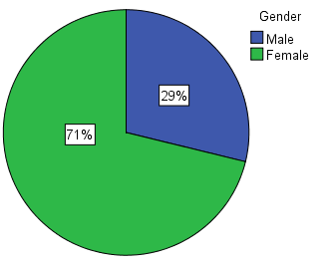
Graph 2. Percentage of male and female respondents

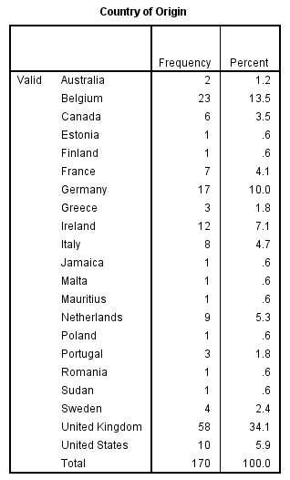
Table 4. Country of origin of questionnaire respondents

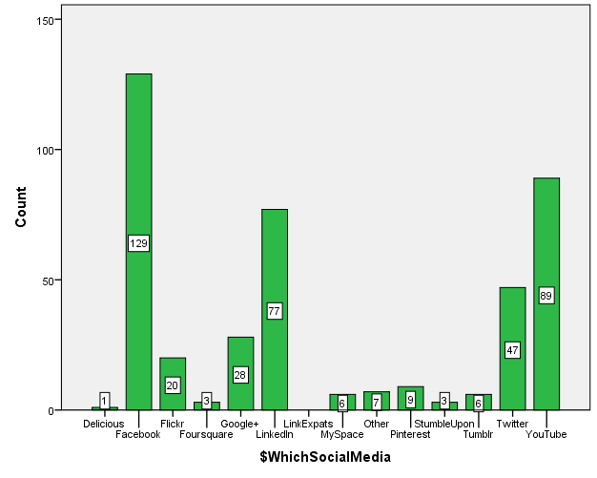
Graph 3. Social media use of respondents

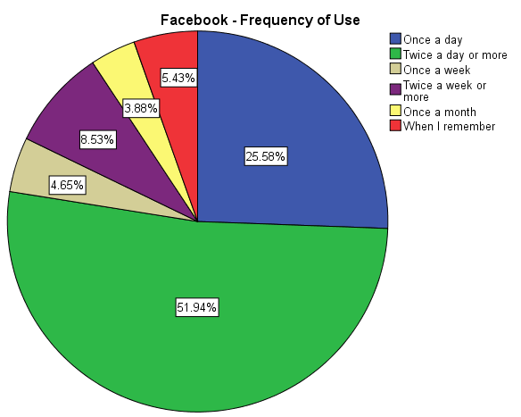
Graph 4. Frequency of use among questionnaire respondents of Facebook

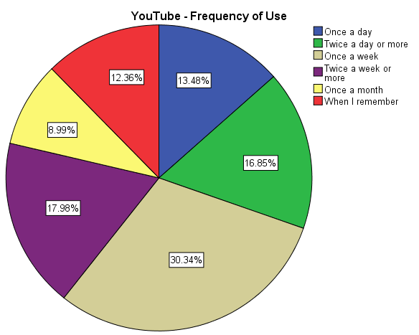
Graph 5. Frequency of use among questionnaire respondents of YouTube
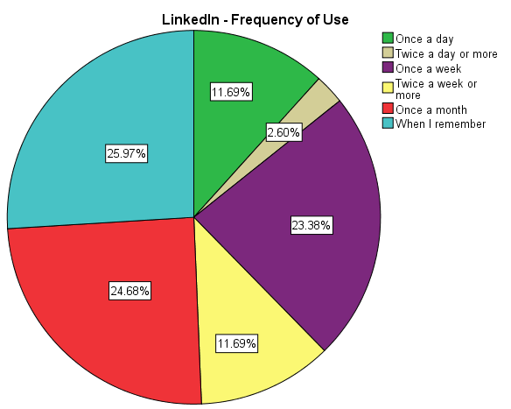
Graph 6. Frequency of use among questionnaire respondents of LinkedIn

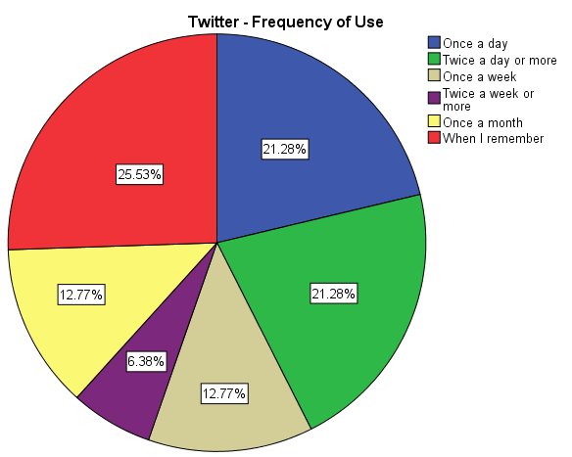
Graph 7. Frequency of use among questionnaire respondents of Twitter
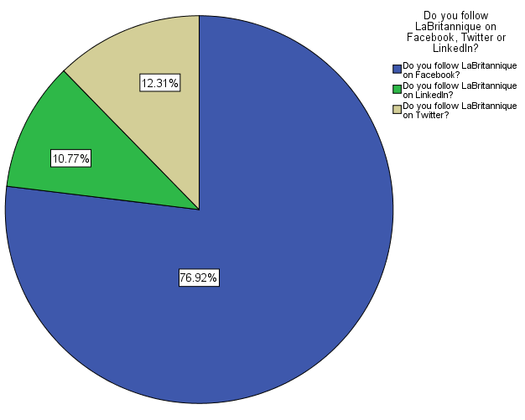
Graph 8. Which social media channels respondents follow LaBritannique on

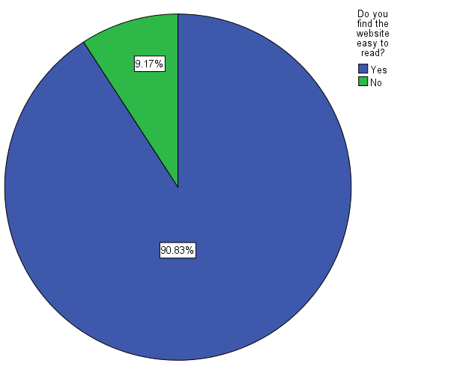
Graph 9. Legibility of LaBritannique's website
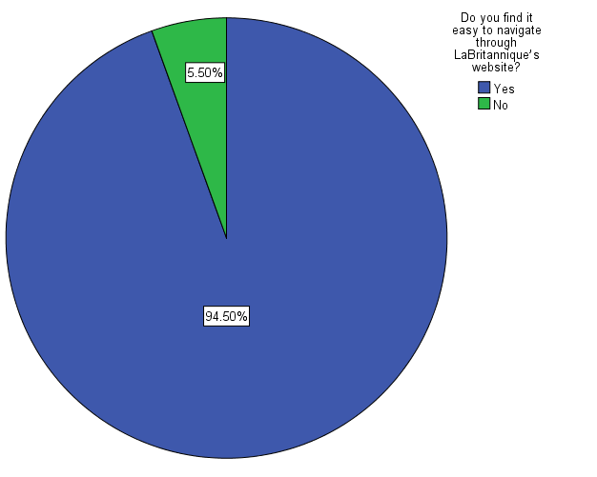
Graph 10. Ease of navigation of LaBritannique's website
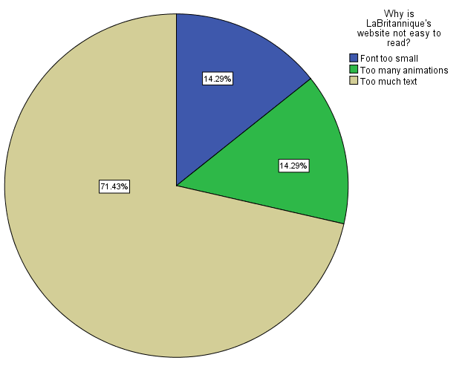
Graph 11. Reasons why LaBritannique's website is not easy to read
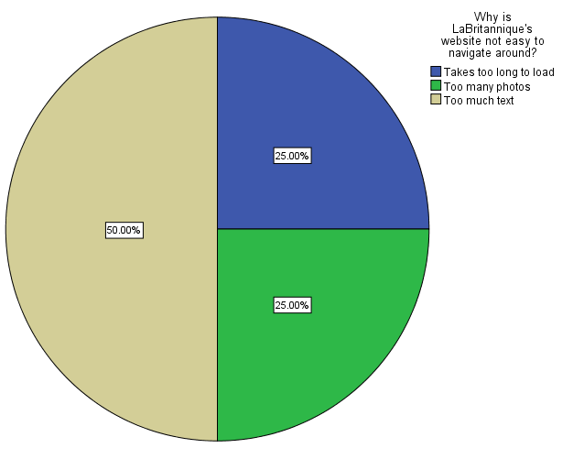
Graph 12. Reasons why LaBritannique's website is not easy to navigate through

Questionnaire
Dear respondent,
The following questionnaire is part of my dissertation. The subject is "how to brand a small company with a limited budget".
The questionnaire touches on the area of social media. More specifically, which social media is being used by whom, how these are being used and how often they are being used.
As part of my third year of studies, I did a 6 month internship in a British-owned catering and event management company, based in Brussels, called LaBritannique (www.labritannique.com) and my dissertation is based on this company and its needs.
I would be very grateful if you could take approximately 10 minutes of your time to answer the following questions to help me with my research. Your input is of great value and your participation is appreciated.
The information and answers you provide are 100% anonymous and the findings will be used only for the purpose of this research.
If you have any queries, please contact me by email: celine.renard@student.hu.nl
Céline Renard
4th year student at the University of Applied Sciences of Utrecht
These first questions are general questions about you, the respondent.
1. Gender: Male / Female
2. Age group:
<20
20 – 30
31 – 40
41 – 50
51 – 60
60+
3. Where are you from (originally?)
The following questions are about social media and how often you, the respondent, use them.
4. Do you use social media? Yes/No
5. Which social media do you currently use?

Delicious
Facebook
Flickr
Foursquare
Google+
LinkExpats
LinkedIn
MySpace
Pinterest
StumbleUpon
Tumblr
Twitter
YouTube
Other (please state):

6. How often do you use social media?
Please indicate how often you use the above mentioned social media. If your answer is not applicable (N/A), please indicate accordingly.
Once a day
Twice a day or more
Once a week
Twice a week or more
Once a month
When I remember
N/A

7. When in the day do you use social media?
Please indicate when you use the above mentioned social media. If your answer is not applicable (N/A), please indicate accordingly.
Early morning
Mid morning
Early afternoon
Mid Afternoon
Evening
Late at night
All day
N/A

8. Do you share posts from companies and businesses you like on your own wall/page for others to see? Yes / No
9. If yes, why? (multiple answers possible)
Relevant information
Funny
Useful
Interesting for a particular friend or group of friends
Other (please specify):
10. If no, why: (optional)
The following questions are about brands and branding in general.
11. Do you feel a strong brand for a product or company is important? Yes/No
12. What motivates you to buy a certain brand when shopping? (multiple answers possible)
Name
Price
Value
Service
Variety
Taste
Experience
Trustworthy
Reliable
Other:

13. Are you loyal to certain brands when shopping?
Yes, I stick to the same products.
Most of the time; sometimes I try new brands.
Never; I am always experimenting with new brands
Only for quality products; otherwise I choose the brand with the lowest price.
14. Do you consider yourself to be a price sensitive consumer? Yes/No/Depends (please specify)
15. Which, of the following, do you consider important to position a brand?
Quality
Communication strategies
Competitive pricing
Good value
Free offers and discounts
Other:
16. Does a brand’s country of origin influence your decision to buy a product?
Yes
No
Unsure
17. Do you think brands can reduce their prices and still maintain a good quality of product and image? Yes/No

The following questions refer to LaBritannique and its branding.
18. How did you first hear about LaBritannique?
Through Facebook
Through Twitter
Through LinkedIn
Through a friend
Through family
Through Google
Other Internet site (please state):
At a company event
At a friend’s event
By chance
Newspaper
Magazine
Other (please state):
21. How well do you feel you know the company?
I know the company very well.
I know a fair amount about the company.
I know just a little about the company.
I know almost nothing about the company.
Knowing about the company is not important to me

The following questions refer to LaBritannique’s activity on various social networking sites.
LaBritannique is active on Facebook, Twitter and LinkedIn
22. Do you follow LaBritannique on Facebook/Twitter/LinkedIn?
Facebook: Yes/No
Twitter: Yes/No
LinkedIn: Yes/No
23. How often do you read posts from LaBritannique on Facebook/Twitter/LinkedIn?
Everyday
Once a week
Once a month
When I remember
N/A
Other:
24. How engaging are posts from LaBritannique on Facebook/Twitter/LinkedIn?
(If your answer is not applicable (N/A), please indicate accordingly)
Below average
Average
Good
Very good
Excellent
N/A
25. How satisfied are you with the quality of posts from LaBritannique on Facebook/Twitter/LinkedIn?
(If your answer is not applicable (N/A), please indicate accordingly)
Not at all satisfied
Not very satisfied
Sufficiently satisfied
Extremely satisfied
N/A
26. Do you share posts made by LaBritannique on to your wall/page or a friend’s?
Yes/No
27. If yes, why:
Relevant information
Funny
Useful
Interesting for a particular friend or group of friends
Other:
28. If no, why? (optional)
29. Would you recommend that others follow LaBritannique on Facebook?
Yes/No/Maybe
30. If no, why? (optional)
(This question is optional, but I would be grateful if you could give one or two reasons why you would not recommend that others follow LaBritannique on Facebook)
31. Would you recommend that others follow LaBritannique on Twitter?
Yes/No/Maybe
32. If no, why? (optional)
33. Would you recommend that others follow LaBritannique on LinkedIn?
Yes/No/Maybe
34. If no, why? (optional)
The following questions refer to LaBritannique’s website.
35. Have you visited LaBritannique’s website?
Yes/No
36. Do you find the website easy to read?
Yes/No
37. If no, why?
Font too small
Too much text
Too many photos
Too many animations
Takes too long to load
Other:
38. Do you find it easy to navigate through LaBritannique’s website?
Yes/No
39. If no, why?
Font too small
Too much text
Too many photos
Too many animations
Takes too long to load
Other (please state):
LaBritannique will be revamping its website in the near future.
40. What would you like to see changed, if anything?
41. LaBritannique will be adding the following elements to its website: multi-lingual versions, e-commerce possibilities and lists of venues available to clients. What else would you like to see added, if anything?

Thank you for taking the time to respond to this questionnaire. Your input is much appreciated.
As mentioned, the information and answers you provide are 100% anonymous.
However, should I have any questions about your responses may I contact you?

