TURNING CUSTOMERS INTO PROMOTERS OF THE BRAND
BY
Rolf Tjalsma
1559859

GRADUATION ASSIGNMENT SUBMITTED IN PARTIAL FULFILLMENT OF THE REQUIREMENTS FOR THE DEGREE OF BACHELOR OF COMMUNICATIONSYSTEMS OF THE INSTITUTE OF COMMUNICATION AT THE UTRECHT UNIVERSITY OF APPLIED SCIENCES

UTRECHT, 10 June 2014

EXECUTIVE SUMMARY
eVision Industry Software develops applications for companies in the oil and gas industry that are used for the creation of permits-to-work, improvement of site safety, and control and analysis of health and environment issues. The business has grown fourfold over the last two years, due to global contract with such customers as Shell, BP, and Total, among others.
This report was commissioned to examine why it is important for eVision to improve its customer relations and how this can be done effectively. The research shows that for the last few years the company has focused solely on delivering and selling products, undermining the relation with the customer. While contracts often last for years, customers are only reactively supported. Further investigations reveal that up to now, no steps have been taken to quantify customer satisfaction.
The report concludes that a better service can turn customers into promoters of the brand. To achieve this, all departments within the company will have to change to a proactive work ethic.
It is recommended:
- that eVision organises a regular conference for the major customers, facilitating a debate during which talks about current issues and developing trends can be discussed;
- that more social media channels are utilised, to widen the possible audience; and
- that more regular news updates are published on the website, to enlarge the online footprint and increase the appeal of the website.
Contents
EXECUTIVE SUMMARY 2
1 INTRODUCTION 6
1.1 The company 6
1.2 Research question 6
1.3 Sub questions 6
1.4 Research problem 6
2 THEORETICAL FRAMEWORK 8
2.1.1 Inbound Methodology 9
2.1.2 Service-dominant logic 12
2.2 Grand combined Framework 14
3 METHOD 15
3.1 Case studies of impeccable customer service 15
3.1.1 Case study: Coolblue 15
3.1.2 Case study: L.L. Bean 16
3.2 Conclusion 17
4 SITUATIONAL ANALYSIS 19
4.1 Market Summary 19
4.1.1 Market Demographics 19
4.1.2 Market Needs 20
4.1.3 Market Trends 20
4.1.4 Market Growth 21
4.2 PESTLE Analysis (Opportunities vs Threats) 21
4.2.1 Political 21
4.2.2 Economic 21
4.2.3 Sociological 22
4.2.4 Technological 22
4.2.5 Legal 23
4.2.6 Environment 23
4.3 Competition 23
4.3.1 Identified competitors 23
4.3.2 Identified potential market entries 24
4.4 Key to Success 24
4.5 Critical Issues 24
4.6 SWOT Analysis 24
4.7 Current media utilised 25
5 DESIRED SITUATION 26
5.1 Turn customers into promoters of the brand 26
5.1.1 Facilitate a discussion group to increase cooperation on HSE efforts by Q3 2014 26
5.1.2 Improve efficiency of Search Engine Optimisation campaigns by Q4 2014 26
5.1.3 Post bi-weekly updates on social media by Q2 2015 26
5.1.4 Implementation of a Loyalty Program by Q4 2015 27
6 IMPLEMENTATION 28
6.1 PHASE 1: Attract 28
6.2 PHASE 2: Convert 28
6.3 PHASE 3: Close 29
6.4 PHASE 4: Delight 29
7 CONCLUSION 31
7.1 Sub questions 31
7.2 Research question 31
8 REFERENCES 34
APPENDIX A: Current media utilised 37
APPENDIX B: Future media utilised 39

Figures
Figure 2-1: Inbound Methodology by Halligan and Shah (HubSpot, 2014) 9
Figure 2-2: Attract phase 10
Figure 2-3: Convert phase 10
Figure 2-4: Close phase 11
Figure 2-5: Delight phase 11
Figure 2-6: Simplified version of S-D logic, original by Lusch and Vargo. 12
Figure 2-7: Phase 1 of S-D logic: Provision 13
Figure 2-8: Phase 2 of S-D logic: Co-production 13
Figure 2-9: Phase 3 of S-D logic: Co-creation 13
Figure 2-10: Grand combined framework of Inbound Methodology and S-D logic. 14
Figure 3-1: A Twitter user thanks L.L. Bean for their service. 17
Figure 6-1: Attract phase 28
Figure 6-2: Convert phase 28
Figure 6-3: Close phase 29
Figure 6-4: Delight phase 29

Tables
Table 3-1: Comparison between Coolblue and MediaMarkt's serviceability. 16
Table 4-1: SWOT analysis. 25

INTRODUCTION
Over the past six years, eVision has grown into a multinational software company providing software for the likes of Shell, BP, and Total. 2013 especially, was a remarkable year in which large contracts were signed allowing the business to boom and the company to grow professionally and expand with offices in the Middle East and North America.
The opportunities these contracts have brought economically at the same time pose an underlying threat. The growing pains that come with the tremendous success are starting to be felt and the time for taking back control is ticking away. Internal measures are being taken to keep the sustainability viable, though a clear vision on how to handle client satisfaction and new client acquisition seems to be missing.
Talking to clients and cooperating with them to identify best practices and better solutions than what is currently provided rarely happens, leaving the door wide open for competitors to tackle this and surprise eVision’s current and potential clients. If eVision can delight its customers in such a way that they become promoters of the brand, it might be more difficult for competitors to penetrate the market and, in the process, make the acquisition of new customers easier and more frequent.

The company
eVision Industry Software is a fast-growing software company with its headquarters in The Hague, that specialises in developing software for oil and gas companies that increases location-wide and employee specific safety, as well as making numerous procedures more time-efficient. Other offices are located in the Middle East, Australia, and the United States. Currently about 120 – 150 employees work for the company, but this is rapidly increasing as the demand for eVision’s product is rising. The customer base includes such companies as Shell, BP and Total, with whom eVision has global contracts.
The company’s focus is on high-end customers who meet certain criteria. The company has to:
- have a worldwide presence,
- work in the oil and gas sector, and
- be willing to change their own procedures to comply with the software.
The reason why eVision carefully selects and works with these customers is the large available market, the prestige and clout that these customers bring with them, and the currently congested workforce.

Research question
How can eVision turn its customers into promoters of the brand and utilise them for new acquisitions?

Sub questions
1.) In what kind of industry environment does eVision operate?
2.) How can the optimal marketing mix be developed?
3.) What is the best conduct to implement the marketing communication strategy?

Research problem
The growing demand for its products have forced eVision to grow fourfold in just two years. Due to this mandatory change the company has focused more on selling and delivering products than contemplating customer demands and providing service.
While the eVision sales team often encounters the same competitors bidding for the same projects, there is very little being done to persuade the potential customers other than sales pitches. The fact that the active clientele includes eight of the biggest oil and gas companies in the world is more or less neglected (Helman, 2012), save for the superficial summaries of completed projects on the website (www.evision-software.com/projects).
Experience provided by the eVision sales team concludes that most of the companies in the oil and gas industry do not compete with each other on health, safety and environment (HSE) efforts. They would rather work closely together, so as to improve HSE industry-wide. Stakeholders within the industry sometimes discuss issues during events and conferences where eVision is attending. They talk about current practices too, including the HSE software that is used at their oil rigs and plants.
eVision is catching up on many fronts such as development and management, but a well-defined structured service was not a part of this. The area of concern now is undervalued customer relations. Making it likely that the current customers step over to another provider, one that supports a better service. Losing only a few of the big customers could have devastating long-term results for the company.
Current or former customers can make or break a new acquisition. As long as very little is done about customer relations and in particular service, it is not unlikely to think that potential customers will not hear about eVision, or worse, they will hear only the bad stories.
If a world-class customer relationship is built, it can be expected that:
- current customers will appreciate working with eVision, and perhaps extent expiring contracts more easily;
- current customers will be more ready to buy more products from eVision; and
- potential customers are positively influenced by the current customers and be more easily prepared to buy products from eVision.
To make this happen a constructive marketing communication strategy can edify a stable customer relationship, making the choice easier to continue doing business with eVision, ensuring customer retention in the process, and make new acquisitions more easily conceivable.

THEORETICAL FRAMEWORK
Before the digital age communicating to customers was linear and simple. Advertising on TV, radio, and in the newspapers would guarantee a stable, large, and attentive audience. An audience that was predictable, mostly informed by established media companies, and - perhaps the biggest reason for the decades-long successful hegemony of these media - information did not travel at the speed of light yet.
Over time and largely due to technological advances, it has changed to a landscape in which audiences watch online TV shows to avoid commercials, listen to music on MP3-players instead of radio, and consult news articles on blogs and social media as opposed to buying newspapers. Besides the popularity issues this caused the established media, it has forced marketing communications (marcom) specialists to find new ways of reaching audiences.
Many researchers found that engaging the customer with a two-way conversation, asking about their opinion on and wishes for products and services, resulted in higher sales. This has initiated the new field of engagement marketing and is increasingly used by companies who engage with their audiences on the corporate website and social media (Goodman, 2012).
The World Wide Web was the incendiary reason that precipitated a revolutionary shift; from companies telling the people what they offer to the people telling the companies what they want to be offered. As intended by Tim Berners-Lee, inventor of the Web, the internet has allowed people to share information, low-cost and easily.
It is this open-nature of the internet medium and the human desire for two-way communication that a marcom specialist should embrace. Creating successful procedures that attract new customers and delights them to become promoters of the brand. Inbound methodology explains this in an almost childishly clear fashion. What it lacks in depth, service-dominant logic analyses at great lengths. Thus combining the two makes for a very powerful marketing communication tool.
Both theories are described and illustrated separately in chapters 2.1.1 and 2.1.2. The chapter ends with the theories combined into one single, powerful framework which will demonstrate their synergetic power this marketing communication strategy is applied to.

Inbound Methodology
All marketing related communication in which customers are involved, either through two-way communication or whereby the company listens to their customers, is called inbound marketing. It was successfully utilised by Barack Obama when he was vying for his first term in the oval office in 2008. His funding lacked behind John McCain’s, forcing Obama to find other methods of reaching his audience and make them vote for him. That is when he started using social media to talk to the people in the country. He listened to them and gave them answers. He had many times the amount of followers on all popular social media compared to McCain. Obama’s first stay in the oval office is thanks to inbound marketing (Halligan & Shah, 2010).
Brian Halligan has coined the term inbound marketing in 2005, when he was in the process of setting up HubSpot, his petri dish company for trying out marketing theories and in the process develop them (Pollitt, 2011; Halligan & Shah, 2010). The original inbound methodology model had three phases: Attract, Convert, and Close. It started with a stranger to the brand and ended with a customer. Trying this model left them with the question: What happens with the customer once they bought the product or service? They found that a customer is worth more than a serving hatch for products. The customer should be so incredibly happy and satisfied that he delightfully promotes the brand, becoming an intermediary between the company and a new stranger.
Figure 2-1 shows the most up-to-date version of the inbound methodology (HubSpot, 2014). It is divided into four phases: attract, convert, close, and delight. The status of the consumer is shown in the middle of the figure. A consumer can go through five steps: stranger, visitor, lead, customer, and promoter. Below the status of the consumer is the utilised media that is most important for the specific phase. The important media can differ greatly between companies and is therefore not static. To fit the purpose of this research paper appropriate media has been used in this figure. Lastly, an arrow from the promoter to the dotted lined circumference of the stranger status shows that a promoter influences the stranger.
This chapter introduces all phases and explains their function within the grand scheme. It gives examples of what media is used and why they are important for that particular phase.
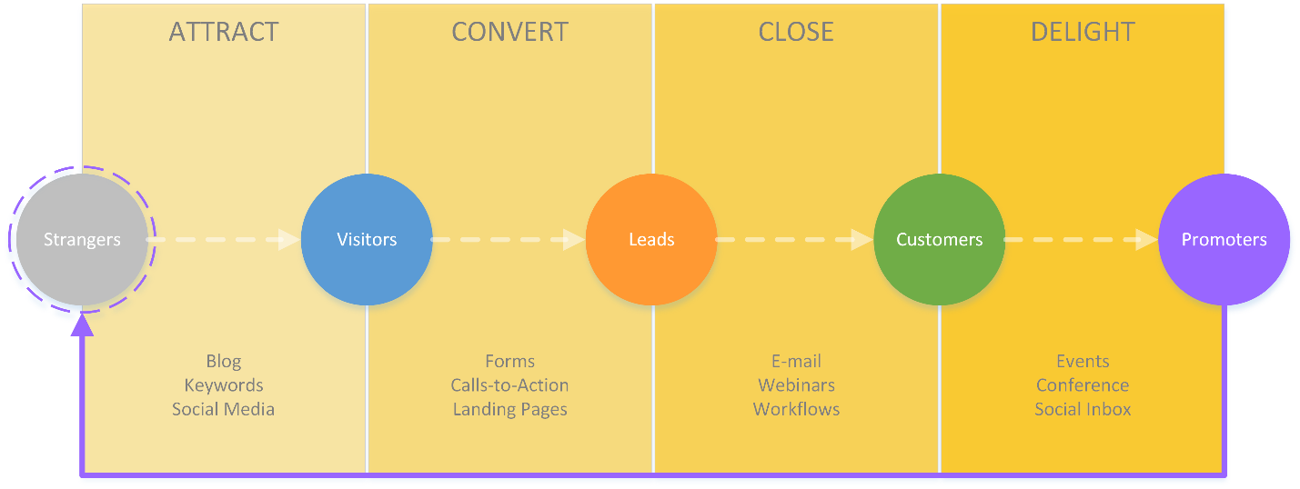
Figure 2-1: Inbound Methodology by Halligan and Shah (HubSpot, 2014)
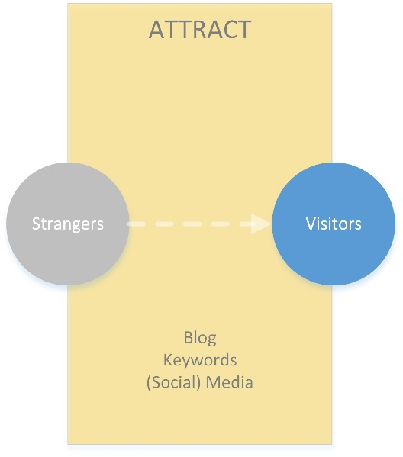
Figure 2-2: Attract phase
Phase 1: Attract
Before customers make a purchase they have to know about the existence of the company. The first phase of inbound marketing describes ways to attract a stranger to become a visitor (Figure 2-2). The device is not to attract as much visitors as possible, but as much right visitors.
The best way to achieve this is to describe the ideal customer, or buyer persona. A buyer persona defines in great detail what the ideal customer is like. It encompasses the people and companies that the business wants to work with.
Only after the buyer persona is known can the marketing be planned. The most important tools for this phase are blogging, SEO, and social media.

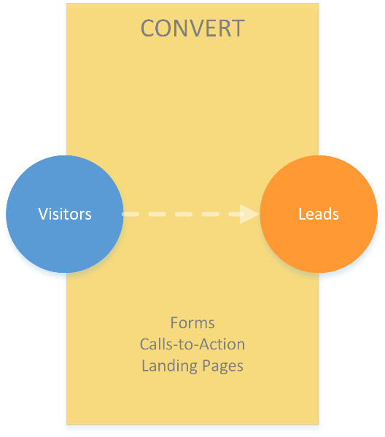
Phase 2: Convert
Figure 2-3: Convert phase
After attracting a visitor to the website, an attempt is made to acquire contact information. Converting a visitor into a lead means to convince them to become a potential customer by leaving contact details on the website or social media, at the very least an email address or phone number (Figure 2-3). For optimal conversion rates the website should appeal to the buyer persona, alluring those who the company would most likely sell to.
Contact details are the most important in this phase, to acquire that, Calls-to-Actions (CtA) can greatly help. CtA’s are buttons that lead to a landing page; that is where the visitor can submit a form and become a lead.
If visitors cannot find the right information on the website they will most likely not convert to a lead. The percentage closing the website after viewing only a single page is known as the bounce rate. Only the right content and ease-of-use can convert, this typically includes downloadable and informational content.

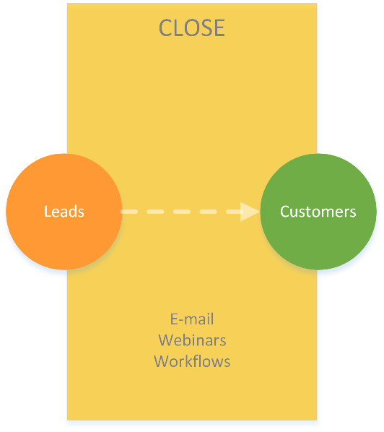
Phase 3: Close
Figure 2-4: Close phase
The phase in which a lead is closed to become a full-fledged customer is the Close phase (Figure 2-4). Personal attention is key, but not before scoring the lead. A lead score is given by the sales department and is a numerical representation based on standard metrics that determine the readiness of the lead.
If the lead is found ready, the company will be invited for webinars, receive newsletters, and contacted by e-mail or phone. This phase usually lasts much longer than phase 1 and 2 and might need extensive personal attention from a sales representative in conjunction with project managers and the development team.
Even if a lead is closed, it could run aground in the development or implementation phase. To prevent this the Delight phase is introduced.

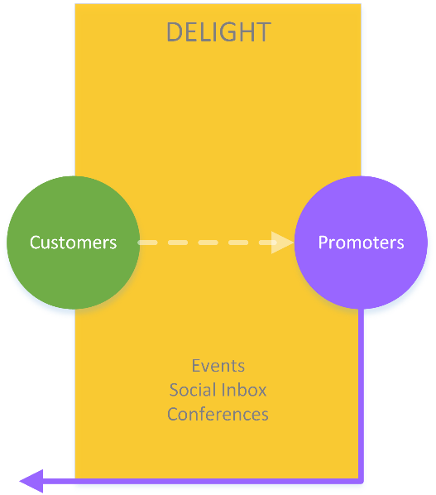
Phase 4: Delight
Figure 2-5: Delight phase
The last part of the Inbound Methodology lifecycle, the Delight phase, is perhaps as important as closing the sale itself (Figure 2-5). Every customer can become a promoter of the brand, though it is only the satisfied customers that promote the brand positively.
To convince customers, they will be invited to participate in events and conferences, as attendees and speakers. Special newsletters and varying personalised communication tools are used in this phase to keep the customers as involved as possible.
A promoter could introduce the company to a stranger, or coax a lead to become a customer. Also, every additional promoter increases the chance of increased sales.

The different media used during every stage are entirely dependent on what products and services the company provides and in what kind of environment it operates. Additionally, media are only mentioned once in the lifecycle, this means that where they do appear it is the first stage of appearance. Social media will still exist after the Attract phase and will not lose its function as an information carrier, however, those in a further stage do not need to be introduced to the company anew.

Service-dominant logic
In 2004, Robert F. Lusch and Stephen L. Vargo published an article that described the need for a departure from a product-centred view of markets to a service-oriented model. Subsequently, this service-dominant (S-D) logic caught flight and has been pondered upon in numerous publications and finally given a stable embodiment in their book Service-Dominant Logic: Premises, Perspectives, Possibilities (Lusch & Vargo, 2014).
S-D logic is a new way of thinking, rather than a workable theory. A simpler S-D logic framework and more recognizable terminology will be used for lucidity’s sake (Figure 2-6). An example of how S-D logic works and what it means to use is first given, after which the elementary version is broken down and elucidated in three phases.
Figure 2-6: Simplified version of S-D logic, original by Lusch and Vargo.
An example of service-dominant logic in everyday life
The implications S-D logic has on economics, marketing, communication, and society as a whole, is that it is a more logical view of the world than the current, prevailing model. This current model is heavily based on Adam Smith’s An Inquiry into the Nature and Causes of the Wealth of Nations (1776); written at the beginning of the Industrial Revolution and the fundamental basis for economics as it is taught today.
As opposed to S-D logic, Smith’s followers created, what Lusch and Vargo (2014) call, goods-dominant (G-D) logic. This logic conceptualises that value is created in the supply chain (sometimes referred to as the value chain), by suppliers of raw materials and producers of products. This value is destroyed through usage by a consumer, such as a new car that loses economic value from the moment it is bought. The flaw in this logic is that economic value is regarded as real value. But what is real value?
Lusch and Vargo (2014) explain that the problem with Smith’s observations are that he sought out to explain England’s wealth at the time, as opposed to creating a scientific interpretation of how economics work in general. They do observe that Smith’s (1776) initial view of economic exchange was true: Value is created upon usage of a good or service, rather than in the production process.
To determine real value, Lusch and Vargo (2014) ask the following: “If your house is burning down and you can take one thing (not another person) what would it be?” (Lusch & Vargo, 2014, p. 8). As unimaginable as this scenario might be for most, it serves as a good indicator to show what is valuable to people. Is a passport more valuable than a family photo album? Would you choose the guitar given by your best friends over expensive jewellery? Even when given the time to contemplate this dilemma, some constants pop up in most minds, such as: photos, gifts, old letters, and self-made items. In short, emotional items with predominantly low economic value (Huntington, 2012).
The value-added proposition of S-D logic is that cooperation between supplier and user always and constantly takes place. Whereas in G-D logic the supplier produces for the user, usually with very little feedback from the latter. Therefore, due to S-D logic’s cooperative nature, partnerships in the form of long-term contracts are often part of the deal. During the contract both parties consult each other and strive for better solutions than current existing ones. Working closely for a longer period means that practices will be more streamlined, while a mutual understanding of needs and wishes helps creating a better service overall (Freiling & Dressel, 2014).
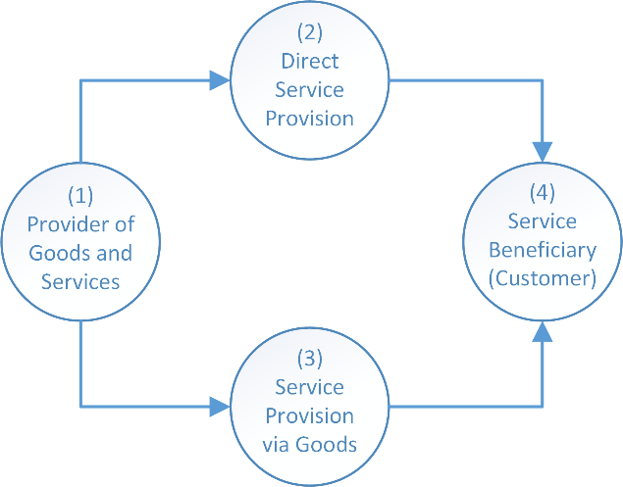
Phase 1: Provision
Figure 2-7: Phase 1 of S-D logic: Provision
The simplest, most straightforward phase of S-D logic (Figure 2-7):
- The provider is the company or individual that provides goods and services.
- Intangible service given is considered direct service provision.
- When the service is the provision of a tangible good is it called service provision via goods.
- The service beneficiary receives either goods or services from the provider.

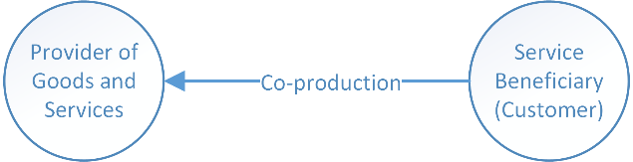
Phase 2: Co-production
Figure 2-8: Phase 2 of S-D logic: Co-production
One of the two pillars of S-D logic is co-production (Figure 2-8). This is optional for both parties, meaning that the provider can ask the beneficiary for opinions on and wishes for products and services, but the beneficiary can also provide their opinions and wishes unasked. In S-D logic providers are advised to always question their leads and customers for advice on current and future products and services. Gathering this information could benefit the output of the company, and, in addition, it will give the customer the feeling that the company listens to its opinion, potentially delighting the customer to become a promoter.

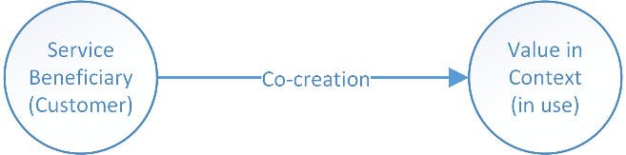
Phase 3: Co-creation
Figure 2-9: Phase 3 of S-D logic: Co-creation
The second pillar of S-D logic is co-creation and may as well be the defining phase in which the customer decides to continue co-operation with the provider or not (Figure 2-9). The value in context is determined through usage of the good or service, because only when a good or service is used can the beneficiary decide if the value that the provider promised to provide is worth the cost. Co-creation is therefore not optional and will always - even on an unconscious level - take place. This is especially important for companies that provide high-end goods and services, as the threshold for continuing business with such a provider is higher than one providing simple, generic products, such as toilet paper or a toothbrush.

Grand combined Framework
The Inbound Methodology provides a clear, visual framework, but little theory on exactly how to close a lead, and more particularly, turn customers into promoters. Additionally, S-D logic is still in its infant shoes and contains new, and sometimes vague terminology. This is why the lingo of the S-D logic model is changed to fit this research plan (Figure 2-10).
First and most important, the combined theory introduces a loop; taking into consideration that promoters are return customers. This does not necessarily need to be true, though for the industry eVision operates in and the products and services it provides it most likely is. The framework shows that all customers are co-creators, negatively or positively influenced by the value in context (in use).
When the value in context is positive, the customer could become a promoter of the brand and return to acquire more products. As the co-creation continues to be positive, the customer relationship will be able to endure more negativity up until the point of reaching a negative balance. This is when the company might lose its customer to a competitor and should approach this customer as a stranger again.
Though an estranged customer does not always go back to before the attract phase, the company has to presume this does happen and build its marketing with this in mind to build up a new level of trust again. The process that strangers, leads, and customers go through shows that every department is involved. It starts with sales, than it is picked up by project managers, after which a development team will personalise the software.
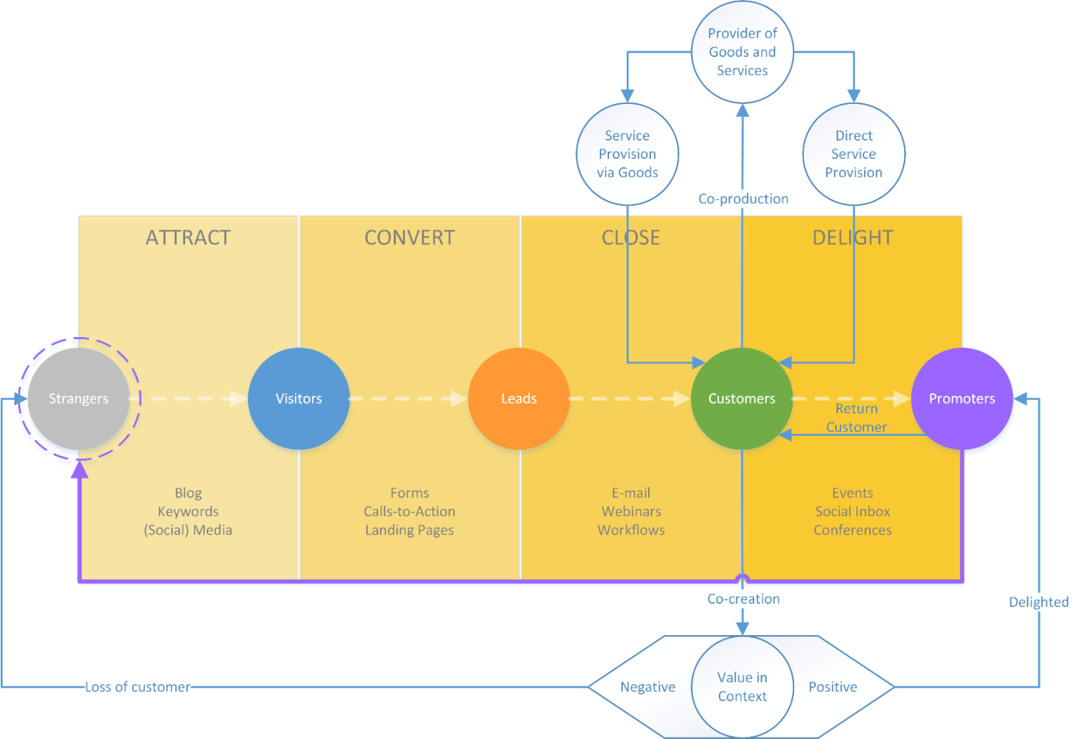
Figure 2-10: Grand combined framework of Inbound Methodology and S-D logic.

METHOD

Case studies of impeccable customer service
Today, customers expect a good service, fast response rate, and reachability through multiple channels, including phone and social media. But if they are served well, they will come back (Sage, 2014). Customer satisfaction can be very fragile, even after years of impeccable service, one bad experience can ruin the carefully built relationship (Tarantola, 2013).
As most products are not built to last, very few companies provide a lifetime warranty with their products (Barlow, 2011). The truth is that products often falter, especially after extensive usage, leaving customers floundered by the bad service they stumble upon when a company has so far neglected any focus on customer relations (Rick, 2014; Rampen, 2011).
Some companies focus their soul on treating every customer the way they would like to be treated as a person themselves. Companies like Coolblue and L.L. Bean fit this description, often receiving recognition from awards and customers. L.L. Bean’s remarkable customer service has been a part of the company for more than 100 years, while Coolblue seems to have found a way to give customers the same dedicated service a salesperson in a physical shop can provide and perhaps even more.
As 3.1.1 will explain, Coolblue focuses on incredibly fast response rates, regardless whether the customer calls them, or reaches out to them through social media. In 3.1.2, L.L. Bean’s customer service is highlighted. It shows that their response rate is fast too, and that they focus on making every dealing with them as easy and smooth as possible.

Case study: Coolblue
Historically, there are two types of companies when determining customer friendliness; those that perform well, and those that do not. Sometimes a new company introduces a new idea that shows the competition how things are supposed to be done.
The best way to describe Coolblue is simply looking at the lyrical ratings found all over the internet. Something quite unique because most people turn to the web to complain when something did not work out as promised by the delivering company (Trust Pilot Beoordelingen, 2014).
Founded by three graduate students in 1999, the company started selling MP3-players on Mp3man.nl, subsequently opening other specialist web stores such as Smartphoneshop.nl/be, and GPSshop.nl/be. It reported a revenue of almost € 250 million over 2013; an increase of 48% with respect to the year before. This annum Coolblue opened its 300th web store.
Since opening that first store they have won numerous customer service and marketing related awards, national, continental, and international. What makes them this efficient and successful and how do they manage to continue their growth while staying consistently attentive customer service (Coolblue, 2014)?
Pieter Zwart, one of the founders of Coolblue, sums up the key propositions the company lives by:
- Easy choices on a clear website.
- Clear information before, during and after the order.
- Experts who are available seven days a week via email and telephone.
- Physical shops in Rotterdam, Eindhoven, Groningen and Antwerp (e-Shop Expo, 2011).
Coolblue’s response rate to questions by email or social media is fast, with the intent to be faster than the competition will ever be. Whereas companies often hide their telephone number, Coolblue advertises with it on all their channels and website pages. On the pro-active informational side, they develop several YouTube films every week in which common technical questions are answered (e-Shop Expo, 2011).
“You can be an industry changer like Apple, a discounter like Aldi, focused on service and loyalty as Albert Heijn or a specialist such as a butcher.” According to Zwart, the explanation for the success of Coolblue is thanks to their obsessive focus on customer satisfaction.
Comparing Coolblue with MediaMarkt, one of Europe’s biggest electronic retailers, gives a clear impression on their approach to serviceability (Table 3-1).
Coolblue | MediaMarkt
E-mail is answered within four hours and only eight fields have to be filled in. | No e-mail response time is given and 16 fields have to be filled in.
Customer service is open seven days a week, from early morning until midnight. | Customer service is closed on Sunday; through weekdays open until 21 ‘o clock, and Saturday until 18 ‘o clock.
The phone number is a local number, with no additional charges. It is visible on every single page and it is always clear whether the service is open. | The phone number is a paid 0900 number, with a start rate of 4,5 cents and 10 cents per minute, plus additional mobile phone charges. The contact details are only visible on the customer service page, which is itself a little bit hidden. Whether the service is open or not is only made clear by reading the text.
A human being will always answer the phone. | A computer answers the phone, asking tedious questions. Before a real person is on the line a call could very well have taken a few minutes already.
Table 3-1: Comparison between Coolblue (Coolblue, 2014) and MediaMarkt's (MediaMarkt, 2014) serviceability.
Perhaps the most admirable feat is Coolblue’s honesty. Its website on vacuum cleaners can have negative reviews, written by Coolblue’s very own staff. Suppliers do not always appreciate this, but customers do. (Supply Chain Magazine, 2012) Even when a newly bought device is working sufficiently, the company will replace it without complaining and free of cost (Meyer, 2012).
Customers appreciate the honesty, openness and dedication, and gladly promote the brand on web forums. With their approach Coolblue intends to turn their customers into promoters of the brand and make them keep coming for more. And if it is not coming from the customers, it is the employees who praise their employer (Glassdoor, 2014).

Case study: L.L. Bean
L.L. Bean is another example of what a good customer service is worth. L.L. Bean is a privately held, family-owned mail order company specialised in clothing and outdoor equipment. They are based in Maine, United States, since it has been founded in 1912 by Leon Leonwood Bean (L.L. Bean, 2014a).
Selling products has never been their primary goal; it is customer service that tops their list of importance. Bean thought that offering a world class service would make the customers return for more and this philosophy does not seem to have wavered since the humble beginnings of the company, which in 2013 noted annual sales of $1.56 billion (L.L. Bean, 2014a).
The guiding principle of tirelessly putting customers first resonates through all L.L. Bean’s communication channels. What makes them special is that their toll-free telephone number, which can be seen on all L.L. Bean website pages; the special Twitter account called L.L. Bean Service; and email respondents are not only guaranteed human beings, their response rate is also incredibly fast (L.L. Bean, 2014b; Stella Service, 2014).
In December 2013, L.L. Beans average response rate by email was less than an hour. Compared to the average in the Apparel/Accessories industry of 16 hours it seems to be an incredible feat. L.L. Bean’s customer service staff is as big as it has to be on any given day, with over 2.000 representatives employed during the 2012 peak holiday season. On their busiest day that year more than 127.000 calls were handled (Stella Service, 2014).
Another remarkable service L.L. Bean provides is the lifetime guarantee on most of its products. Even after years of wearing a worn out jacket, it can be returned and a new one will be delivered free of charge. Even the delivery is faster than promised, as they say it will take five days, in reality it is always less (Post, 2013).
Remarkable service is not making hollow promises, it is keeping those promises and outperform them. L.L. Bean enjoys the sport of customer service and does it graciously. While Twitter users all over the world often thank the company’s approach in a Tweet, L.L. Bean turned yet another “customer 4 life” into a promoter of the brand Figure 3-1.
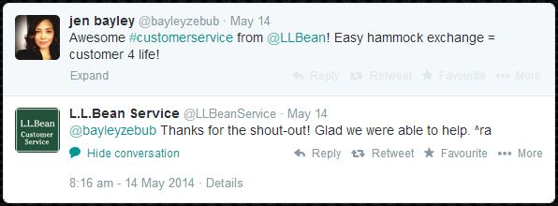
Figure 3-1: A Twitter user thanks L.L. Bean for their service.

Conclusion
In short, Coolblue and L.L. Bean seem to have found a way to uniquely satisfy their customers, turning them into promoters and seeing them return. Both companies were around before the Inbound Methodology and S-D logic were created, though their execution seems to be very alike with these models. The crux is in the continuous service provided to their customers; both follow that philosophy.
As is evident in the comparison in Table 3-1, Coolblue exerts more effort into online and phone reachability. There will always be a human being on the other end of the line when calling either Coolblue or L.L. Bean, as opposed to a voicemail. From any page on L.L. Bean’s website a visitor can find the telephone number, and with one click call the company, send an e-mail, or even chat with a real person instead of a computer robot (L.L. Bean, 2014b).
What may be noticed is that Coolblue and L.L. Bean are business-to-customer oriented, whereas eVision operates in a business-to-business environment. However, S-D logic introduces actor-to-actor, in which every business and every customer is an actor. According to S-D logic every transaction between a company and a customer is a transactions of service. In this sense the Coolblue and L.L. Bean cases serve as a good indication on how the actor who pays for the service, or customer, should be treated the same way, regardless of being a human or a company.
The final remarkable feat that both Coolblue and L.L. Bean possess is keeping their promises and performing better. Obviously the easiest way is not to make any promise at all, however, they have put the bar higher and higher. For example, Coolblue is always trying to deliver faster and respond faster to questions and enquiries. It is arguable that a company can ever be perfect, or even come close. Taste cannot be argued about and some people are just more critical than others. Though it is remarkable that many more reviews on the internet about Coolblue and L.L. Bean are positive than negative, as people are more inclined to go on the internet to leave a bad review than when they have had a good experience (TruReview Staff, 2013).

SITUATIONAL ANALYSIS
A company’s strategies are dependent on the current situation of different environments. These include, but are not limited to:
- The customers that use its products and services;
- other companies vying for the same customers; and
- the firm’s own internal environment.
Most situations do not allow a company to change its external environments, though they can be influenced as companies grow economically and politically stronger.
The company has more power over internal environments, such as its strengths and weaknesses, but these can still be influenced from the outside (e.g. new legislation, public pressure). This chapter analyses and draws conclusions on the current situation, it serves as an informational basis for the Implementation phase, and helps explain why a marcom strategy for eVision is needed.
Knowing and, more importantly, understanding these environments helps define (potential) situational risks and provides windows of opportunity. Knowing the environments helps push the boundaries in an attempt to astonish the market, presenting new and original ideas in ways that competitors have not yet thought of.
Without awareness of the current situation a company cannot definitively plan a desired situation, because it does not understand its place in the world. Awareness is therefore not only important, but ultimately necessary.

Market Summary
Summarising the market reveals difficulties and possibilities within the targeted segment. eVision aims its sales and marketing processes at other businesses, as opposed to individual persons. Yet, every business is ran by people. A few key differences exist between business-to-business (B2B) and business-to-customer (B2C) (a customer in this context is an individual person), whereby B2B deals are often much more rational than with B2C, and more people are usually involved with the deal. On the other hand does S-D logic suggest that all transactions are between actors, which can be either the buyer or receiver of a product. This is a part of S-D logic that is hard to follow, because it is indeed different dealing with a single individual or a monstrous machine of an organisation. The market summary chapter will look in the demographics of our (potential) customers, their needs, trends, and expected growth of the industry.

Market Demographics
eVision is currently targeting only companies in the oil and gas industry. The main reason for this is to become the market leader in this particular segment. It is also proof of dedication towards the industry, ensuring full attention is paid to optimise the software for this sector. The company has won bids over competitors because the customer felt that the other companies were not as dedicated to the oil and gas industry. This has been taken as a serious sign and thus improved the commitment towards this type of company.
On a weekly basis, about 20 requests for a software demo are placed through social media (LinkedIn), or the website. Only a few of these requests are usually granted after applying criteria points, such as the industry of the company, location, and job of the requestor.
At this moment, the demand for eVision’s software is higher than the company’s capabilities to provide. This gives it a unique position in which it can select its customers. However, the drawback is that promising potential customers are sometimes turned down due to necessity.

- Oil & gas industry
- High turnover (One billion plus)
- Purchase is driven by rationality, as contracts usually last years
- Customer relationships are important, regardless the geo-location of the company
- General areas are identified as follows:
  - Europe/Middle East/Africa (EMEA)
  - North and South America
  - Asia
  - Oceania

Market Needs
Traditionally, the oil and gas industry have relied on pen and paper for their administration of permit-to-work (PTW). This is not only tedious, it is also unreliable due to people not truthfully filling out the form because of lack of focus or seriousness, and there are no automated possibilities for safety checks.
According to the U.S. Bureau of Labor Statistics (2013), in the United States alone 138 died of fatal occupational injuries in the oil and gas industry in 2012. This was an all-time high and it continued as a trend since 2009 when 68 people were fatally injured. The fatality rate of 24.2 deaths per 100.000 workers is higher than the 21.2 in other industries, such as the agriculture, forestry, fishing, and hunting sectors (King, 2013).
Sadly, nonfatal injuries and occupational deaths will always occur whenever humans are involved and errors are made. Nevertheless, the amount of accidents can be minimized when applying the right safety regulations and systems. A company’s obligations and accountabilities differ greatly between countries, and a general industry standard is absent. The result is that every company will adhere to these minimum measures and requirements, but after which they are left to their own experiences and willingness to safeguard employee, facility, and environmental safety.
Using computer software, multiple automated safety checks can be implemented and it helps speed up administration tremendously, as some forms take up to 15 minutes to complete due to their size, allowing for a much more efficient way of work. The oil and gas industry is starting to embrace computer software that assists in increasing safety, though habitual use of pen and paper makes transition difficult at times. Accidents in the workplace are oftentimes a catalyst for change, making habits secondary to operational safety.

Market Trends
According to the U.S. Centers for Disease Control and Prevention (2012), “during 2003-2009, the majority [of oil and gas related fatalities] were either highway motor vehicle crashes (29%) or workers being struck by tools or equipment (20%). The next common fatal events were explosions (8%), workers caught or compressed in moving machinery or tools (7%), and falls to lower levels (6%).” The industry has recognized that many accidents could have been prevented if proper safety systems were in place (Centers for Disease Control and Prevention, 2012).
The major trend within the oil and gas industry is the shift from pen and paper permit administration to automated computer software. The possibilities to connect the permits to safety systems is already proving its worth on many of eVision customers’ locations, but there is a constant thrive to more innovative procedures for an ever-increasing safety level on the workplace. The competition between eVision and others is about providing the best software, with an end goal of accident prevention and permit-creation efficiency increase.

Market Growth
The market for electronic Permit-to-Work (ePTW) and HSE software in the oil and gas industry is currently booming as more companies become aware of the possibilities and results. The majority of the market is still untapped and companies go to great lengths before selecting the software of their preference. Also, due to the sheer size of many of the oil and gas companies it is entirely possible that separate locations may work with different providers. Obviously, it is every software company’s intention to provide every location of a customer’s platforms with its applications.

PESTLE Analysis (Opportunities vs Threats)
A PESTLE analysis is a framework that looks at a company’s external macro environment, from an opportunities and threats perspective.

Political
Public interest groups such as NGO’s like Greenpeace operate on different levels on a local and global scale. It sometimes happens that due to their protests consumer interest shifts and new rules and regulations are introduced. Those changes can cause disruptions in any type of industry forcing it to amend.
As Kotler puts it, “[B]eyond written laws and regulations, business is also governed by social codes and rules of professional ethics.” (Kotler, 1999, p. 168) Today’s business is incredibly scrutinized thanks to free speech and the invention of the internet.
Privacy related issues are also a threat. For optimal efficiency, some companies like to collect and save data such as fingerprints and other details. The employee could potentially log onto the system with his finger, saving the time of filling out forms manually. However, some employees and contractors might object to this, and the law might forbid it.
A current cultural sensitivity brought about by the distributed stickers of Dutch far-right politician Geert Wilders. The stickers used Saudi Arabia’s flag and had a degrading text about Islamic believes. Saudi Arabia has now threatened to ban Dutch companies of doing business in the kingdom, worth an estimated $2.7 billion (Critchlow, 2014). At this moment, eVision is in far advanced talks about a contract and instalment of software in the country. However, because of Geert Wilders’ actions this deal with Saudi Aramco, the world’s biggest state-owned company, is jeopardised.
eVision latest product follows employees who carry tags that connect to communication points using radio-frequency identification (RFID). A map in the control room monitors the position of all the employees, essentially following them. Though in a case of fire, little effort is needed to see if there are still people in dangerous areas. Finding the balance between local laws and company regulations, while trying to improve the overall safety of the people on-site is always a delicate subject.

Economic
Regardless the predictor, everyone agrees that oil and gas prices will continue to rise in the future (Walsh, 2013). As reserves dry out and populations grow the demand for these resources will not die out in the coming decades. Besides this, oil and gas companies are on a never-ending mission to discover new sources to drill for these minerals. New drilling places require new rigs at which location eVision can sell its software.
The trend within the oil and gas industry is going digital. It is cheaper on the long run, could potentially save lives, and in the process make it easier for employees and the company as a whole to work safely. Many of eVision’s current customers used pen and paper. The threat is that people often do not appreciate change. This means that proper change management is needed to introduce the ePTW.
An ePTW system takes only a few minutes to fill out. Upon confirming the ePTW, the system will automatically perform a safety and regulation check for the specific location. The old style is pen and paper, still used at many companies, and not only much more laborious, it does not have any additional automated safety checks. The time a company saves by digitizing and the funds it saves due to a decrease of accidents is an opportunistic driver for the company and end-user alike.

Sociological
A shift in cultural awareness can cause both positive and negative effects. In the unlikely event that whole populations stop using any product which involves oil or gas in the manufacturing or shipping process a change of course has to be made. A more likely occurrence is the already ignited change of culture within companies. Whereas in the past fatal occupational injuries were an accepted part of the job, as with the build of the Russian railway in the 20th century and even currently in Qatar where thousands of builders are expected to die due to incredibly harsh conditions while building the infrastructure and soccer stadiums for the World Cup in 2022 in the country (Richardson, 2001; Booth, 2014).
For a company, losing employees due to occupational accidents does not only cost money, it can, and perhaps should, cost a whole lot more when taking social responsibility towards the safety of their people into account.
A quick Google search on the BP oil spill in the Gulf of Mexico on April 20, 2010, currently shows more than 21 million results. The company itself says they have spent “more than $14 billion on…response activities” (BP, 2013), but other sources have calculated the total to be “$40 billion in fines, cleanup costs, and settlements as a result of the oil spill…with an additional $16 billion due to the Clean Water Act” (DoSomething.org, 2014). Strangely, according to post-accident articles the bad publicity will only have little or no effect at all on the revenues of the company. One would expect this to happen, but energy boycotts are proven to have little effect because of the demand for the product (Reuters, 2010).
Nevertheless, BP is a customer of eVision since 2013 and has become more committed to HSE measures, putting forth effort to minimize the chance of a similar type of disaster in the future. Whether this is economically or socially driven remains a topic of discussion, but corporate social responsibility is becoming a much bigger trend with the help of peer pressure through worldwide use of social media (Hall, 2010).
As populations grow and renewable technologies are not reaching maturity the demand for oil and gas will more likely increase than deteriorate. Also, with rising numbers of educated people from economies in Eastern Europe and Asia it can be expected that the amount of engineers and software developers will increase, allowing the company to delve from a bigger pool of employees with a wide variety of skills.
eVision’s customer attitude and opinion is often driven by health and safety consciousness, sometimes after an accident happened on-site. Again, the BP oil spill disaster is a fitting example (Guardian Research, 2010). Other opportunities and threats for eVision are oil and gas companies looking for good publicity, especially in the Middle East, where money is not the issue, but having the best and most beautiful product is.

Technological
Technology is a driving force behind change, perhaps even the most dramatic one. Trends in technology, even small ones, can change whole industries and ways of living. As Saylor.org puts it in their Principles of Marketing, “Understanding the technological environment can provide you with a greater understanding of a product’s life cycle and the direction the market is taking when it comes to newer technologies” (Saylor, 2014).
Technological threats are obviously other companies that surpass eVision in this field. A special research and development department in Portugal works together with the Universidade do Algarve to counter any threats and turn them into opportunities by building new and cutting-edge technologies (eVision, 2013).
Much of eVision’s profits go to research and development so as to stay creative. The biggest threat is market entry by bigger competitors who have much larger funds and more researchers. This is why specialising in the oil and gas industry is so important for now. Advancements in technology are an opportunity for the company, as long as these are ventured.

Legal
eVision’s headquarters is in The Hague, The Netherlands, so the company works under Dutch law. However, working in an international environment does pose threats, such as the difficulties that dispute settlements can bring about if an accident happens and liability is unclear (European Commission, 2013). Unrest in parts of the world can initiate sanctions and make it difficult for eVision to start or stay in such areas (Crooks, 2014).
Sometimes accidents happen in the oil and gas industry that catch the attention of the media, as with BP’s Gulf of Mexico disaster (Guardian Research, 2010). When that happens, often the company itself employs new safety measures, but countries most often follow (The Canadian Press, 2014). A regulatory change can be both an opportunity and a threat for eVision, depending on what changes. It may be the case that a new rule can be implemented in the software for automation, while on the other hand, if it is a rule that involves stricter human supervision, automation is in most cases not an option.

Environment
As mentioned in the economic forces, non-renewable resources are finite and will in the future be dried out. This means that eventually eVision will be forced to broaden its focus to other industries, though it could very well take decades before this threat is becomes reality. Peer pressure on oil and gas companies will possibly force them in the future to stop drilling for oil and gas, this is a threat for eVision.

Competition

Identified competitors
PetroTechnics
PetroTechnics is often a contender when potential customers are looking for HSE software. The company was a frontrunner in the industry for years, but lost many customers due to a lack of innovation. Quite a few former employees have joined eVision over the last few years. They are currently upgrading their software in a bid to return to become a global leader again.
Website www.petrotechnics.com
LinkedIn www.linkedin.com/company/petrotechnics
Twitter www.twitter.com/petrotechnics
iBanx
This company is often one of the finalists together with eVision for a bid to supply software to a company in the oil and gas industry, however, their customers operate in many different sectors. They frequently lose bids due to their lack of focus on the oil and gas industry.
Website www.ibanx-hse.com
LinkedIn www.linkedin.com/company/ibanx-hse
Twitter www.twitter.com/ibanxhse
YouTube www.youtube.com/user/HSESolutions
Other competitors are:
Cresent www.cresent.co.uk
Engica www.engica.com
GEMsoft7 www.gemsoft7.com
RAP www.rap-international.com
Sage www.sagesoftware.com
eVision occasionally meets these parties during bids for customers, though for most of them the focus is not on oil and gas companies, which is why they rarely proceed to final bid rounds. None of the companies seem to be listed on a stock exchange, suggesting that none of them is big enough to enlist. This makes it impossible to show in numbers how important they are because none shares their annual incomes and expenses.
The list consists of all the companies that eVision has run into during the last six years, but only PetroTechnics has been a steady contender for the same jobs in every continent. The other companies operate only locally, most of which in Europe, except for Sage, which operates in the United States and Australia as well.

Identified potential market entries
SAP
SAP is the global market leader in enterprise business applications and currently supports oil and gas companies with software regarding improved customer satisfaction, leveraging of new technologies, and lower capital development costs, among many other type of modules. So far they have not been successful with providing specialized software concerning operational safety.
Regardless, companies regularly give SAP a chance to come up with a model for software. Most of these companies already run SAP’s software and believe that it is easier and more cost-efficient to buy all programmes from the same company. Besides this, SAP is established all over the globe, naturally giving them an edge over less known software developers. Once they do sell a product similar to eVision’s software it will be difficult to push them out of the market again, making them a force to reckon with.
Website www.sap.com
LinkedIn www.linkedin.com/company/sap
Twitter www.twitter.com/sap

Key to Success
eVision’s key to success is its unique combination of software packages that maximises support in operational decision-making and use of tools to increase employee efficiency and overall work floor safety. Another major reason the company has become a global leader in its software segment is its recognition by companies such as Shell and BP, who are both using the software and are actively involved in the development of new modules and features as addition to the software.

Critical Issues
- Maturing the current technologies will enable an easier implementation of the software in the future;
- Development of new technologies is imminent to success;
- Competition of larger companies with bigger budgets investing in similar products;
- Convincing potential/current customers of investing in a new software module.

SWOT Analysis
 | Helpful to achieve the objective | Harmful to achieving the objective
Internal origin (attributes of the organisation) | Strengths  - Experienced staff in a wide diversity of fields  - Shell, BP, Total, and many other big companies are already customers.  - eVision is currently one of the market leaders (8 out of the 25 biggest oil and gas companies are already customer) (Helman, 2012).  - Unique software packages and full service.  - Revenue is tripled every year, forecast similar.  - Sustainable growth. | Weaknesses  - Most staff (out of 120) joined eVision less than a year ago.  - Company is relatively young (six years) and unknown.  - Growing very fast (Tripled yearly revenue).
External origin (attributes of the environment) | Opportunities  - Huge potential market.  - Strategic alliance with partners, such as Accenture (an outsourcing company).  - Little competition.  - Most competition has little or no experience in this particular industry. | Threats  - New technologies have to be researched on usability.  - High probability of increased competition.
Table 4-1: SWOT analysis.

Current media utilised
Many different media are used at this moment. Taking into consideration the model discussed in the theoretical framework, the Current media utilised list is divided in the four phases of the Marketing Methodology and further dissected into the categories of offline and online content. Appendix A gives an overview of all the media that is currently utilised.

DESIRED SITUATION
Establishing a desired situation for a company’s future is not always straightforward. Environments are always changing and people’s opinions with it. Chapter 3 has given insight into the current situation, helping to define a set of feasible goals.

Turn customers into promoters of the brand
Customers are rarely involved and used for content creation, save for the occasional news update on the eVision website. New visitors on the website and eVision’s social media channels should be welcomed by exciting news updates, with regular new additions to incentivise return visitors. Taking the customers’ own busy schedules and reluctance to cooperate into account, they cannot be bothered with laborious, time-consuming marketing activities. Appendix B gives an overview of current and future desired media utilised, the future media are highlighted in green.

Facilitate a discussion group to increase cooperation on HSE efforts by Q3 2014
There is no industry standard for health and safety in the oil and gas sector worldwide. During a conference in January 2014, organised by eVision for the biggest customers, some of the companies asked eVision to institute a platform where discussions about HSE would take place.
The first Oil and Gas Industry Standard (OGIS) Group conference will be held in the third quarter of 2014. The goal of the conference is to hold sessions during which attending companies introduce their own implemented HSE measures in an effort to standardise the best practices into industrywide guidelines.
The personal goal for eVision is to establish a better relationship with the industry leaders and become a hub to them for HSE software. If eVision successfully organises the OGIS Group events, it will be easier to upsell products and create better products that fit the customer’s wishes and specifications because of the discussion outcomes during the events.
From an economic perspective, arguably the best positive effect would be the bonding of eVision with these companies, making it increasingly difficult for competitors to get a foot in the door.

Improve efficiency of Search Engine Optimisation campaigns by Q4 2014
A third party is responsible for eVision’s Search Engine Optimisation (SEO), though there is much uncertainty on their conduct and a regular reconsideration and replenishment of search terms is non-existent. For this reason, this particular goal cannot be less vaguely described, but should be an integral part of future changes in the way SEO is handled.

Post bi-weekly updates on social media by Q2 2015
Social media should be utilised more intensely to attract more strangers to the homepage and convert more visitors to become leads. Weekly content would put eVision top of mind with social media followers and it will be more interesting to return to the website and follow the different media channels.
At this moment, only LinkedIn is utilized as a social communicational tool, while it is very easy to start using Twitter too. From a business-to-business perspective it does not make much sense to use Facebook, because the platform is mostly suited for friend-to-friend interaction and much less professional when comparing it with LinkedIn. Forbes contributor, Josh Bersin, says “LinkedIn has become the virtual rolodex for business people”, comparing the social network to the somewhat outdated business card holder (Bersin, 2012).
eVision will have to increase its media content output. This will not happen overnight, which is why the target will be to achieve this in Q2 2015.

Implementation of a Loyalty Program by Q4 2015
Monitoring customer satisfaction through a Loyalty Program will help to identify common issues and particular customer problems, hopefully before these become serious. Satisfaction can be measured through annual surveys and on-site visits. On-site visits are a good way to strengthen the relationships with a customer and cooperatively look at future possibilities, as well as looking at issues that are currently present.
Incorporating a Loyalty Program will ask effort from all departments. Certain processes will have to change, while others will need to be introduced and getting used to by the employees. It is therefore scheduled for full implementation late 2015.

IMPLEMENTATION
After analysing the current situation and building upon that to determine a desired situation comes the implementation; a detailed description of how the goals will be reached. The main goal is to delight our customers to become promoters, all the other aims work toward this general end-goal. Instead of putting the goals in a row and answer them piece by piece, the theoretical framework is applied to the implementation phase so that it is absolutely clear what is done during which phase in the process. At the end of every phase the respective goals are listed to illustrate how they will contribute in successfully reaching the end goal.

PHASE 1: Attract
To attract more strangers, eVision’s internet footprint has to be enlarged by using social media more extensively, as shown in Figure 6-1. Whereas currently LinkedIn is updated monthly at most, within a year this will have to increase to weekly. In addition, the reach of Twitter will be utilised.
Figure 6-1: Attract phase
At first, Twitter will mostly inform about news articles, product details, and vacancies on the eVision website. News articles are, for example, about successful implementations at customer sites, upcoming conferences or webinars, and management announcements such as the opening of a new office.
Starting in 2016, Twitter will also be used to communicate statistics derived from measurements the software has amassed at customer locations. These statistics will be anonymised as a standard rule, unless the customer gives permission to use their name.
Continuous resources will be spend on optimising SEO to attract strangers to the site. This will be monitored by measuring throughput more thoroughly to determine its effectiveness and where necessary adjust.
End goals:
- Improve efficiency of SEO campaigns by Q4 2014
- Post bi-weekly updates on social media by Q2 2015

PHASE 2: Convert
The bounce rate of eVision’s website will always be high, generally due to the unambiguous name of the company and the niche market that it operates in.
Figure 6-2: Convert phase
Attracting more strangers to the website will ultimately translate to more leads, and hopefully good leads. The Convert phase will not change much, only landing pages will be deployed more often because conferences and webinars will be organised more frequently (see Figure 6-2).
End goals:
- Improve efficiency of SEO campaigns by Q4 2014
- Post bi-weekly updates on social media by Q2 2015

PHASE 3: Close
Figure 6-3: Close phase
Closing a lead is already done effectively, even so right that sometimes too many leads are closed for the rest of the company to keep up. What will be continuously developed is the search for the best leads and enchant them with the best products and services using the media mentioned in Figure 6-3.
Workshops will be annually organized in the Middle East, Europe, and the United States. Online webinars are targeted at specific location for the following reasons:
- Localised speakers who have knowledge of the companies, people, and possibilities of the area;
- Products and services can be pushed for certain areas, making implementations easier and more cost-efficient for eVision.
Invitations to both workshops and webinars are sent to leads that are living and working in the respective area of the event. To reach outside current contacts, Google AdWords, Google AdSense, and LinkedIn campaigns will be utilised during the period that registration for workshops and webinars is open. Updates on Twitter, LinkedIn and the eVision website will ensure an even greater reach.
Finally, the workflows will continue to focus on finding the best leads. Thanks to the growing list of high-profile customers eVision’s conspicuousness will be noticed by other similar companies. Marketing will work closely together with the sales department to make sure both understand who and what the company is looking for.
End goals:
- Post bi-weekly updates on social media by Q2 2015
- Implementation of a Loyalty Program by Q4 2015

PHASE 4: Delight
Delighting the current clientele will, for the next few years at least, be the most important phase (Figure 6-4). eVision’s biggest contracts with even larger customers have been signed in 2013 and 2014; the difficult part will be to satisfy them and turn them into promoters. This can be done through service, on-time delivery, delivering the least that has been agreed upon and preferably more than that for the same price.
Figure 6-4: Delight phase
Companies such as BP and Shell have a legion of advisers, advocates, and experts. They demand the very best, also from their suppliers. It should be any supplier’s mission to deliver products and services that transcend the demand and this can be done by delighting customers with new and original ideas. In the future it can be more thoroughly achieved when the customers cooperate with eVision on better solutions.
Research and development (R&D) is incredibly important for any software company. eVision understands this and spends much of its earnings on R&D. One of its latest products is one that intelligently predicts accidents by input of past experiences. The more and longer this software is used, the more accurate it will become, ultimately helping to prevent accidents from happening. Oilrigs are dangerous enough as they are, eliminating human errors as much as possible can assist its employees in making better use of their working hours.
The next step is to make customers proud when using eVision’s products and services. The proposition for which these are sold is that they save time through simplicity, lives through analysis and prediction, and money through efficiency. The future proposition ought to be that customers have contributed to the greatness and effectiveness of the product, perhaps giving the people at the customer who worked on the project a feeling of camaraderie with the product itself, and therefore with eVision. These and other relevant values are but hollow marketing terms if they are not well-grounded.
Measuring the software using built-in tools may uncover undeniable facts that can be used to delight a current customer and intrigue a lead.
- The time saved by using ePTW can be measured easily by starting a digital stopwatch from the moment the permit-making process is initiated until it is processed. The results versus the time it took for an analogue PTW is the actual efficiency won per permit. The results can be measured overtime and update the customer on how fast they make back the initial payments for the software. Measuring for a year will give a steady statistic and allow it for using in marcom activities to attract new visitors to the request a demo. Therefore, two sides of the same coin are utilised with a single and easy effort.
- The same goes for saving lives and preventing minor accidents from happening. Current software already predicts when and where accidents are likely going to happen. It is important to know how many accidents happened before and after the implementation of the software so that the customer can be delighted with statistics that factually tell how much these are decreased of time. Just saying that the software saves lives is less an achievement for customers than be able to show that the software decreases injuries by 40% within three years.
- Both time-saving and injury-decreasing statistics help to substantiate how customers save money. This justification also works both sides of the same coin, as current customers can be delighted and new leads can be hauled in by adamant numbers as opposed to ambiguous buzzwords.
End goals:
- Facilitate a discussion group to increase cooperation on HSE efforts by Q3 2014
- Implementation of a Loyalty Program by Q4 2015

CONCLUSION

Sub questions
- In what kind of industry environment does eVision operate?
The sole focus on companies in the oil and gas industry gives eVision the opportunity to become specialised in the field and a household name in the industry. Focusing on a single market does pose threats, especially if a customer is so dissatisfied that they openly discuss eVision’s discourse. It would be wise for the company to think of how to introduce itself in other markets, while keeping the integrity high in the current one. This is beyond the scope of this thesis, but should be pointed out for the sake of a sustainable future.
All products and services that eVision provides for are sold to companies, with no in-between reseller or organisation. eVision is an end-to-end supplier; both software and hardware components and additional resources are provided as a single package. This allows for much freedom, though the company is actively looking for hardware companies to effectively work with on better hardware solutions. eVision is too much dependent on different hardware companies at this moment.
The need for ePTW systems in the industry is a great opportunity for eVision. It would appear that many companies at this moment still work with a paper based Permit system, and it will be eVision’s goal to provide products to as much of these companies as possible while retaining the current customers.
Another threat of the focus on oil and gas companies is the decline in availability of the natural resources, as well as political stability in oil and gas countries in the Middle East and Africa. These are more reasons to look for opportunities in other markets.
- How can the optimal marketing mix be developed?
Basing the marketing mix on the Inbound Methodology gives an easy and accessible view on how strangers, leads, and customers ought to be treated. The most important focus for the coming period should be on existing customers. With the help of S-D logic and the proposed Loyalty Program can the customer contentment be graded and suitably be adjusted and improved if necessary.
The OGIS Group conference will first be held in the third quarter of 2014. The outcomes of the discussions will help eVision create a better strategy regarding products, services, and communication. The companies will be directly asked what their current issues are and discussion tables will cooperatively look for best practices and answers to the issues. Also, future trends will perhaps be identified, helping eVision even further strengthen their relations.
Additional time will have to be spend on maximising the potential of the internet, social media in particular. More regular website updates and news articles can help increase eVision’s online footprint.
- What is the best conduct to implement the marketing communication strategy?
The best conduct to implement to strategy is to determine per existing and potential customer what the right components are to approach them, how to keep them informed, and with what kind of information should be provided. As mentioned before, the Inbound Methodology is an ideal overview to swiftly determine the right methods and media.
Once a company becomes a customer it is important to keep them and, as with the case studies, keep promises and perform better than expected.

Research question
How can eVision turn its customers into promoters of the brand and utilise them for new acquisitions?
The biggest challenge for eVision is not its competition, perhaps it is not even the difficulties that the steep growth is currently causing. The bigger challenge ought to be the relationship with current and future customers, some of the world’s biggest companies; often huge institutions that have tremendous economic and political power. eVision’s goal should not be to beat the competition, the focus has to lie on a world class service, the supplier-customer relation. A relation that will, if done correctly, make it increasingly difficult for competitors to beat.
The current lack of regular service could be a pitfall in the near-future, by creating a proactive attitude and trying to stay top of mind inside customers’ heads can overcome this. The effort to manage this is probably easier than what it looks like on the service. As seen during Barack Obama’s campaign, size does not matter and in business there is not such a thing as an underdog (Halligan & Shah, 2010, pp. 7-9). Unwavering focus and tenacity will be the determinants.
The inbound methodology is a very easy-to-understand method and it works together well with S-D logic, as both focus on service and complement each other. Whereas inbound methodology tells what to do, S-D logic says how. The added loop in the model that visualises return customers shows that the company, or any supplier of a good or service for that matter, needs to understand the importance of a satisfied customer. The unfulfilled customer will stop coming back and go to another supplier, even if their product or service is inferior.
A customer can basically have three statuses:
- New, upon using a product or service for the first time;
- Return, after coming back to purchase or get another product or service; and
- Runaway, when needs and wishes are not met and the customer looks for other suppliers.
The thrill and excitement a person can have using a product or service for the first time is a feeling that cannot be created twice, though treating every return customer with the same joy and excitement as the first time can make them feel special and give them a hint of positive past experience. The philosophy that a customer, especially in the technological sector, will always be a customer because they go for the technology and not the service is not true. In the end, everyone wants to be treated with respect and dignity.
To give this respect and dignity to customers such as Shell and BP, eVision should listen to their needs and help them analyse problems in search for better solutions. Solutions cannot be created for a customer without the help of a customer. Because eVision is not the end user of its own software, it must become a compulsory matter to cooperate.
A more frequent use of social media will enlarge eVision’s internet footprint. Regular updates are much more appealing to follow, than only one every so many months. The company currently involved in the LinkedIn campaigns and Google AdWords will be scrutinised to see whether this can be done better. eVision has to be found and linking more and more sites to the homepage will help.
The newly set up OGIS Group will hopefully create a debate among eVision and its customers on improving worker safety and efficiency. As a facilitator, eVision will be in the unique position to learn first-hand about current issues, possible betterments, and developing trends. Less than embracing this opportunity is not enough.
The most challenging task will be the successful implementation of the Loyalty Program. This is not yet fully outlined, but will get shape in the coming months. It will give eVision a way to determine how well the company is doing through questionnaires and statistics. In the future it will hopefully help to timely hit the alarm if a customer is dissatisfied. It will also enable the company to become much more proactive. I hope that customers will recognise this and reward the company with enduring relationships and mutual benefits. It is not a task solely for the communication department to achieve, it is a challenge for the company as a whole.
Internal engagement with projects and, more importantly, among departments and colleagues is vital to retaining a healthy growth and pleasant working conditions. But that is beyond the scope of this research. It strikes me odd that there are so few companies I have come across which provide a world class service. It should therefore be a pivotal drive for eVision going forth into the future, to implement such a service provision in an effort to turn the customers into promoters and beat the competition in a single stroke.

REFERENCES
Barlow, T. (2011, June 27). 15 Useful Items With A Lifetime Warranty. Retrieved May 27, 2014, from Forbes: http://www.forbes.com/sites/tombarlow/2011/06/27/useful-items-with-a-lifetime-warranty/
Berners-Lee, T. (2014). Biography: Tim Berners-Lee. Retrieved April 23, 2014, from The World Wide Web Consortium: http://www.w3.org/People/Berners-Lee/
Bersin, J. (2012, May 21). Facebook vs. LinkedIn - What's the Difference? Retrieved February 12, 2014, from Forbes: http://www.forbes.com/sites/joshbersin/2012/05/21/facebook-vs-linkedin-whats-the-difference/
Booth, R. (2014, September 26). Qatar World Cup construction 'will leave 4,000 migrant workers dead'. Retrieved February 12, 2014, from The Guardian: http://www.theguardian.com/global-development/2013/sep/26/qatar-world-cup-migrant-workers-dead
BP. (2013, December 31). Deepwater Horizon accident and response. Retrieved February 12, 2014, from BP: http://www.bp.com/en/global/corporate/gulf-of-mexico-restoration/deepwater-horizon-accident-and-response.html
Centers for Disease Control and Prevention. (2012, December 13). Oil and gas extraction. Retrieved February 10, 2014, from Centers for Disease Control and Prevention: http://www.cdc.gov/niosh/programs/oilgas/risks.html
Coolblue. (2014). Bereikbaarheid. Retrieved May 28, 2014, from CoolBlue: https://www.coolblue.nl/klantenservice/51/informatie-over/bereikbaarheid.html
Coolblue. (2014). Geschiedenis. Retrieved April 4, 2014, from Coolblue: http://www.coolblue.nl/geschiedenis
Critchlow, A. (2014, May 25). British business to win share of $400bn Saudi Arabian infrastructure bonanza. Retrieved May 30, 2014, from The Telegraph: http://www.telegraph.co.uk/finance/newsbysector/energy/10852860/British-business-to-win-share-of-400bn-Saudi-Arabian-infrastructure-bonanza.html
Crooks, E. (2014, May 14). Energy sanctions aim to hurt Russia more than the west. Retrieved May 16, 2014, from Financial Times: http://www.ft.com/cms/s/0/8ed5e8b2-dac2-11e3-8273-00144feabdc0.html#axzz32APU7V2e
DoSomething.org. (2014). 11 Facts About the BP Oil Spill. Retrieved February 12, 2014, from DoSomething.org: https://www.dosomething.org/facts/11-facts-about-bp-oil-spill
e-Shop Expo. (2011, May 18). e-Shop Expo. Retrieved April 4, 2014, from eshopexpo.eu: http://www.eshopexpo.eu/fr/nouvelles/5_BeCommerce_Awards_and_full_of_ambition_an_interview_with_Pieter_Zwart_Coolblue
European Commission. (2013, December 17). Dispute settlement. Retrieved May 30, 2014, from European Commission: http://ec.europa.eu/trade/policy/accessing-markets/dispute-settlement/
eVision. (2013, July 18). New R&D office in Faro, Portugal. Retrieved May 5, 2014, from eVision: http://www.evision-software.com/new-rd-office-in-faro-portugal/
Freiling, J., & Dressel, K. (2014). Exploring constrained rates of adoption of total cost of ownership models: A service-dominant logic analysis. International Small Business Journal, 4-6.
Glassdoor. (2014, May 28). Coolblue Reviews. Retrieved May 28, 2014, from Glassdoor: http://www.glassdoor.com/Reviews/Coolblue-Reviews-E735938.htm
Goodman, G. F. (2012). Engagement Marketing: How Small Business Wins in a Socially Connected World. In G. F. Goodman, Engagement Marketing: How Small Business Wins in a Socially Connected World. Hoboken, NY: John Wiley & Sons, Inc.
Guardian Research. (2010, June 29). BP oil spill timeline. Retrieved March 14, 2014, from The Guardian: http://www.theguardian.com/environment/2010/jun/29/bp-oil-spill-timeline-deepwater-horizon
Hall, L. (2010). Tying Together Social Media and Corporate Social Responsibility. Retrieved May 29, 2014, from Convince & Convert: http://www.convinceandconvert.com/guest-posts/tying-together-social-media-and-corporate-social-responsibility/
Halligan, B., & Shah, D. (2010). Inbound Marketing, get found using Google, Social Media, and Blogs. In B. Halligan, & D. Shah, Inbound Marketing, get found using Google, Social Media, and Blogs (pp. 11-19). Hoboken, New Jersey, United States: John Wiley & Sons, Inc.
Helman, C. (2012, July 16). The World's Biggest Oil Companies. Retrieved February 15, 2014, from Forbes: http://www.forbes.com/sites/christopherhelman/2012/07/16/the-worlds-25-biggest-oil-companies/
HubSpot. (2014). Inbound Methodology. Retrieved May 18, 2014, from HubSpot: http://www.hubspot.com/inbound-marketing
Huntington, F. (2012). The Burning House: What Would You Take? New York: It Books.
Investopedia. (2014). Investopedia: Best Practices. Retrieved April 22, 2014, from Investopedia: http://www.investopedia.com/terms/b/best_practices.asp
King, P. (2013, August 23). Oil and gas deaths reached record high in 2012. Retrieved February 10, 2014, from EE News: http://www.eenews.net/stories/1059986375
Kotler, P. (1999). Principles of Marketing. New Jersey: Prentice Hall Inc.
L.L. Bean. (2014a). Company Information. Retrieved May 17, 2014, from L.L. Bean: http://www.llbean.com/customerService/aboutLLBean/company_information.html?nav=ftlink
L.L. Bean. (2014b). Customer Service. Retrieved May 17, 2014, from L.L. Bean: http://www.llbean.com/llb/shop/510618?page=ask-and-answer-customer-service
Li, A. (2014, May 18). 3 Face Charges of Negligence, 25 Detained in Turkey Mine Disaster. Retrieved May 18, 2014, from Mashable: http://mashable.com/2014/05/18/18-arrested-turkey-mine-disaster/
Lusch, R. F., & Vargo, S. L. (2014). Service-dominant Logic. Cambridge: Cambridge University Press.
MediaMarkt. (2014). Contact. Retrieved May 28, 2014, from MediaMarkt: https://service.mediamarkt.nl/portal/public/service/contact
Meyer, B. D. (2012, April 3). Good service at Coolblue. Retrieved April 4, 2014, from Bart De Meyer - Blog: http://blog.bartdemeyer.be/2012/04/good-service-at-coolblue/
Pollitt, C. (2011, October 21). The New 5 Step Inbound Marketing Methodology. Retrieved May 18, 2014, from Business 2 Community: http://www.business2community.com/marketing/the-new-5-step-inbound-marketing-methodology-068639#!OuyRp
Post, T. (2013, June 4). The Best--And Worst--Customer Service. Retrieved May 17, 2014, from Forbes: http://www.forbes.com/sites/tompost/2013/06/04/the-best-and-worst-customer-service/
Rampen, W. (2011, February 7). Because it is time you take customer service seriously. Retrieved May 16, 2014, from Wim Rampen's Blog: http://wimrampen.com/2011/02/07/because-it-is-time-you-take-customer-service-seriously/
Reuters. (2010, June 4). BP's battered brand draws consumer opposition. Retrieved February 12, 2014, from CNET: http://www.cnet.com/news/bps-battered-brand-draws-consumer-opposition/
Richardson, P. E. (2001). Siberia's iron road. Retrieved February 12, 2014, from Paul E. Richardson: http://www.russianlife.com/paulerichardson/transsib.cfm
Rick, T. (2014, February 18). Infographic: Take customer experience seriously. Retrieved May 16, 2014, from Meliorate: http://www.torbenrick.eu/blog/business-improvement/take-customer-experience-seriously/
Sage. (2014). Improve Customer Service. Retrieved May 27, 2014, from Sage: http://www.sage.co.uk/ui_images/infographic-improve-customer-service.gif
Saylor. (2014). Principles of Marketing. Retrieved February 12, 2014, from Saylor: http://www.saylor.org/site/textbooks/Principles%20of%20Marketing.pdf
Stella Service. (2014, January 15). Stella Monthly Benchmarks: During the Challenging Holiday Season, LLBean.com Bests the Rest. Retrieved May 17, 2014, from Stella Service: http://happycustomer.stellaservice.com/2014/01/15/stella-monthly-benchmarks-during-the-challenging-holiday-season-llbean-com-bests-the-rest/
Supply Chain Magazine. (2012, November 11). Coolblue stuurt obsessief op customer service. Retrieved April 4, 2014, from Supply Chain Magazine: http://www.supplychainmagazine.nl/coolblue-stuurt-obsessief-op-customer-service/
Tarantola, A. (2013, December 27). Your Worst Customer Service Horror Stories. Retrieved May 27, 2014, from Gizmodo: http://gizmodo.com/your-worst-customer-service-horror-stories-1486478923
The Canadian Press. (2014, May 14). New Oil Spill Safety Rules Make Pipeline Companies Liable For Costs. Retrieved May 15, 2014, from Huffington Post: http://www.huffingtonpost.ca/2014/05/14/oil-spill-safety-rules-canada_n_5326780.html
TruReview Staff. (2013, October 24). Do Negative Reviews Have More Influence than Positive Ones? Retrieved May 28, 2014, from TruReview: http://www.trureview.com/blog/2013/10/do-negative-reviews-have-more-influence-than-positive-ones/
Trust Pilot Beoordelingen. (2014). Coolblue Beoordelingen. Retrieved April 4, 2014, from Trust Pilot: http://www.trustpilot.nl/review/www.coolblue.nl
Walsh, B. (2013, December 17). More Oil, More Gas and Less Driving: Predicting America’s Energy Future. Retrieved May 30, 2014, from Time: http://science.time.com/2013/12/17/more-oil-more-gas-and-less-driving-predicting-americas-energy-future/

APPENDIX A: Current media utilised
Phase 1 | Attract | Tool | Purpose
Offline | Brochures |  | To giveaway during conferences.
 | Business card |  | To giveaway during conferences.
Online | SEO | Google AdWords | Advertising on Google and Google affiliates.
 | Campaigns | LinkedIn | Paid campaigns on LinkedIn show up on users' pages.
 | PR Web (VocusM) |  | Release service that publishes single press releases on thousands of websites and blogs based on a selection of criteria.
 | Website | WordPress | SEO, campaigns, and PR Web direct to the website.

Phase 2 | Convert | Tool
Offline | Films |  | For posting on the website and show during conferences and workshops.
 | Roll-banners |  | For hanging in the office.
 | USBs |  | Giveaways to leads.
 | Wall installations |  | For hanging in the office.
Online | Calls-to-Action |  | “Demonstration” button on every page of the website for requesting live software demos.
 | Forms |  | To sign up for webinars, conferences, and workshops.
 | Landing pages |  | A landing page is a special page with information on events, and usually include before mentioned forms for signing up.
 | Online product brochures |  | To inform about products and services.
 | RSS feed |  | An RSS feed of news published on the eVision website.
 | Social media | LinkedIn | Professional visibility and a platform to look for new staff.
 |  | Vimeo | For posting on the website and show during conferences and workshops.
 |  | YouTube | For posting on the website and show during conferences and workshops.

Phase 3 | Close | Tool
Offline | Conferences |  | eVision organised conferences can take multiple days and clients as well as leads are invited.
 | Workflows |  | The essence of a successful workflow at this stage is to close a sale. The workflow itself may differ per lead. Sometimes a lead is talking with other parties than eVision, if so, more persuasion is required. After phone calls and email exchanges a project manager might become involved to talk to the lead about configuring and personalising the software to fit specific wishes and needs.
 | Workshops |  | In-dept demos on location in differect places of the world, specified for leads in those areas.
Online | Email |  | Leads (who left their email address) will receive invitations to webinars, workshops and conferences by email.
 | Webinars |  | Live demos of products and services, usually only explaining the surface and most important aspects.

Phase 4 | Delight | Tool
Offline | Events |  | For clients only. Occasionally held, though at this moment with no fixed frequency.

APPENDIX B: Future media utilised
Phase 1 | Attract | Tool | Purpose
Offline | Brochures |  | To giveaway during conferences.
 | Business card |  | To giveaway during conferences.
Online | SEO | Google AdSense | Cookie trackers post advertisements on websites.
 |  | Google AdWords | Advertising on Google and Google affiliates.
 | Campaigns | LinkedIn | Paid campaigns on LinkedIn show up on users' pages.
 | PR Web (VocusM) |  | Release service that publishes single press releases on thousands of websites and blogs based on a selection of criteria.
 | Website | WordPress | SEO, campaigns, and PR Web direct to the website.

Phase 2 | Convert | Tool
Offline | Films |  | For posting on the website and show during conferences and workshops.
 | Roll-banners |  | For hanging in the office.
 | USBs |  | Giveaways to leads.
 | Wall installations |  | For hanging in the office.
Online | Calls-to-Action |  | “Demonstration” button on every page of the website for requesting live software demos.
 | Forms |  | To sign up for webinars, conferences, and workshops.
 | Landing pages |  | A landing page is a special page with information on events, and usually include before mentioned forms for signing up.
 | Online product brochures |  | To inform about products and services.
 | RSS feed |  | An RSS feed of news published on the eVision website.
 | Social media | LinkedIn | Professional visibility and a platform to look for new staff.
 |  | Twitter | For generating a wider online footprint and initiate a following on social media.
 |  | Vimeo | For posting on the website and show during conferences and workshops.
 |  | YouTube | For posting on the website and show during conferences and workshops.

Phase 3 | Close | Tool
Offline | Conferences |  | eVision organised conferences can take multiple days and clients as well as leads are invited. These will be more frequently organised, directly targeting specific areas in the world.
 | Workflows |  | The essence of a successful workflow at this stage is to close a sale. The workflow itself may differ per lead. Sometimes a lead is talking with other parties than eVision, if so, more persuasion is required. After phone calls and email exchanges a project manager might become involved to talk to the lead about configuring and personalising the software to fit specific wishes and needs.
 | Workshops |  | In-dept demos on location in differect places of the world, specified for leads in those areas. These will be more frequently organised, directly targeting specific areas in the world.
Online | Email |  | Leads (who left their email address) will receive invitations to webinars, workshops and conferences by email.
 | Webinars |  | Live demos of products and services, usually only explaining the surface and most important aspects. These will be more frequently organised, directly targeting specific areas in the world.

Phase 4 | Delight | Tool
Offline | Events |  | For clients only. Occasionally held, though at this moment with no fixed frequency.
 | Measuring tools | Software | Measuring tools within eVision software can calculate and overtime predict the time it takes for PTW's to be filled out. Good numbers will delight clients and eVision can use anonymised data for marketing purposes.
Online | Social inbox |  | Newsletters, products updates, and other content, send by email.

