SOCIAL DIGITAL TRENDS: DUTCH POLITICS AND SOCIAL MEDIA

BY

Silvia Todorova

GRADUATION ASSIGNMENT SUBMITTED IN PARTIAL FULFILLMENT OF THE REQUIREMENTS FOR THE DEGREE OF BACHELOR OF COMMUNICATION OF THE INSTITUTE OF COMMUNICATION AT THE UTRECHT UNIVERSITY OF APPLIED SCIENCES

UTRECHT, 22nd April 2010

**Social Digital Trends**

## Dutch Politics and Social Media

**orange arrow**

**April 2010**

****

FH_Logo_white

**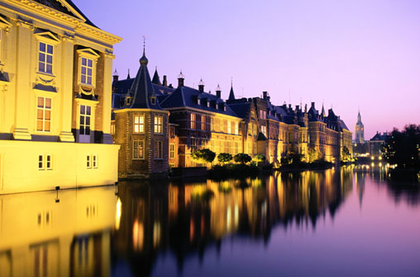**

Abstract

With powerful traditional media setting the political agenda in the Netherlands, the importance of strategic communication in politics is growing. Free online tools make it easier and faster for politicians to communicate with their voters. At the same time, the Dutch citizen demands more results from politicians as decision makers and remains sceptical about the importance of new media.

The stake of communication (via new media) for better interaction between citizen and politician is increasing.

As a professional communication consultancy, Fleishman-Hillard Amsterdam assigned this research in order to get a better understanding of the role of social media in political communication, as well as the interaction of social and traditional media in this process. The Public Affairs practice of Fleishman-Hillard needed this knowledge in order to be able to provide professional communications advice for digital media and public affairs to potential political clients. This research was aimed at answering the question: What is the role of social media in political communication? The second goal was to generate practical advice on how social media can be used effectively for this.

Research findings

The data findings are based on a quantitative part (questionnaire) and qualitative part (in-depth interviews).

During the first part of the research (online questionnaire among Dutch citizens), it has been established that the Dutch citizen is barely interested in communicating with Dutch politicians via social media. Even though the average Dutch is among the most active Europeans on social media channels (according to research by Forrester published in 2008), this research indicated that the activity on social media is not applicable when it comes to political communication.

The second part of this research was aimed at finding out why there is a discrepancy between the expectations of citizens and those of politicians who use social media. In the qualitative part of the research, an in-depth analysis has been made of the political message, channels, senders and receivers of information. Interviews with politicians, journalists and social media experts provided input for the advice on how to use social media effectively in politics.

Conclusion

The main conclusion of this research is that social media cannot be used as an independent medium in political communication, because it only reaches a small, very specific group of the Dutch population. The great influence of journalists as intermediaries in political reporting and communication creates a distorted and unreliable image of politicians in the eye of the voter. Social media have an important role in skipping these intermediaries when a politician wants to provide a more true and realistic image of himself to his potential voters. However, politicians in the Netherlands are still very inexperienced with social media and more often than not fail to reach their voters. At the same time, voters are hard to reach on social media because the political message is rarely relevant to them, and the fact that it is now communicated via social media does not make much difference to them. This has to do with the political system in the Netherlands and the fact that the voter is only interested in politics when certain negative changes take place in his environment. The Dutch voter appreciates the more genuine and direct communication style which politicians use in social media, and those who do it successfully have seen the benefits of reaching their target groups with more relevant messages. At the same time, social media helps to increase the publicity of a politician in traditional media. In this sense social media has proven to be a very effective tool for generating extra publicity and popularity in traditional media, which is something politicians look for during election time.

Recommendations

Politicians using social media need to have a powerful message that resonates with their target audience. Social media differs from traditional media because it gives politicians more control over what, where and how they can communicate. Not all politicians are good communicators, and when skipping journalists as intermediaries in the dialogue with the voter, politicians often fail to adjust their message to the style that the voter expects on social media. Politicians using social media therefore need to provide a mix of personal information and politics, so that they have a better chance at engaging their voters. At the same time, politicians need to be able to attract journalists on the social media platforms they communicate. Communication on social media is a challenging task for the politician, because he needs to reach two very different target groups with the same medium: both his potential voters, and journalists who use social media and can “spread” the politician’s message to traditional platforms. If politicians have a good understanding of what target groups they can reach on social media and what the effects that might be, they will be better positioned to shape their messages and deliver them successfully. At the same time, social media require participation, not only presence, which is still something new for politicians. They need to be more active, more persistent and be able to profile themselves as brands online. Social media provide many possibilities for a politician to become a brand, just like currently political parties and party leaders are brands, and social media are a powerful tool for brand management in the hands of a politician. The most important thing is to be aware that social media can only reach a wider audience and have an impact when it is used in combination with traditional media channels, and this research provides practical examples of how this can be done.

Dedication

This research has been conducted in assignment by the Public Affairs practice of Fleishman-Hillard, Amsterdam, an international communications consultancy. The director of the practice, Mr Werner van Bastelaar, assigned this research with the following purpose:

* External marketing of the practice (the research report, presentation and additional insights were used for the creation of a website and generation of publicity around the topic). The goal is to position Fleishman-Hillard as an expert firm providing advice in the field of digital Public Affairs
* Internal knowledge: the research is needed for the company internally, so that knowledge around the latest developments and practical application of digital tools for Public Affairs can be disseminated to the PR and Digital practices. The research results and recommendations have been presented during a “Knowledge Sharing” session of the company

The research has been planned already from November 2009 and preparations started in January 2010, because of the focus on the coming elections in March 2010.

I would like to express special thanks to Mr Werner van Bastelaar and Ms Hanneke Verhelst for their support and useful tips during the research process.

Contents

[Chapter 1 Introduction 9](#_Toc259609915)

[1.1. The Dutch elections 2010 9](#_Toc259609916)

[1.2. Why is this research interesting? 10](#_Toc259609917)

[1.3. Problem definition 12](#_Toc259609918)

[1.3.1. The changing democracy in the Netherlands. 12](#_Toc259609919)

[1.3.2. The challenged mainstream media. 13](#_Toc259609920)

[1.3.3. Policy question and research question. 13](#_Toc259609921)

[Chapter 2 Theoretical framework 16](#_Toc259609922)

[2.1 Political history 16](#_Toc259609923)

[2.1.1.The pillarised society. 16](#_Toc259609924)

[2.1.2. The depillarisation and the “birth” of the floating voter. 17](#_Toc259609925)

[2.1.3. Political system and voting behavior. 18](#_Toc259609926)

[2.2. Sociology and political science 19](#_Toc259609927)

[2.3 Political communication 20](#_Toc259609928)

[2.4 The communication process 24](#_Toc259609929)

[2.5 The democratic intermediaries 25](#_Toc259609930)

[2.6 Social media: some definitions 26](#_Toc259609931)

[Chapter 3 Methodology 28](#_Toc259609932)

[3.1 Quantitative research 28](#_Toc259609933)

[3.2 Qualitative research 31](#_Toc259609934)

[Chapter 4 Research findings 34](#_Toc259609935)

[4.1 Quantitative research results 34](#_Toc259609936)

[4. 2 Qualitative research results 35](#_Toc259609937)

[Chapter 5 Results analysis 68](#_Toc259609938)

[5.1 Limited reach 68](#_Toc259609939)

[5.2 The danger in Twitter 69](#_Toc259609940)

[5.3 Social media has its own rules and infrastructure 70](#_Toc259609941)

[5.4 Social media vs other media? 71](#_Toc259609942)

[Chapter 6 Conclusions 72](#_Toc259609943)

[6.1 Political involvement and participation 72](#_Toc259609944)

[6.2 The role of the media 72](#_Toc259609945)

[6.3 Communication matters 73](#_Toc259609946)

[6.4 Political determinism or the “maakbaarheidsidee” 73](#_Toc259609947)

[6.5 Political communication via social media: how, to whom and why 73](#_Toc259609948)

[6.6 Skipping the intermediary 75](#_Toc259609949)

[6.7 Providing information and advertising 76](#_Toc259609950)

[Chapter 7 Recommendations 77](#_Toc259609951)

[7.1 The power of the brand 77](#_Toc259609952)

[7.2 Simple and clear messages 78](#_Toc259609953)

[7.3 Confusing presence with participation 79](#_Toc259609954)

[7.4 “This is why it is social media, not political media” 81](#_Toc259609955)

[7.5 Dialogue and monologue 81](#_Toc259609956)

[7.6 “The ball is in the hands of politicians” 82](#_Toc259609957)

[7.7 The role of the opinion leaders 82](#_Toc259609958)

[7.8 Social and mainstream media 82](#_Toc259609959)

[7.9 Which social media? 83](#_Toc259609960)

[7.10 The lifecycle of social media 83](#_Toc259609961)

[Bibliography 84](#_Toc259609962)

[Appendices 86](#_Toc259609963)

[1. Questionnaire questions (in Dutch) 86](#_Toc259609964)

[2. Questionnaire results report (in Dutch) 94](#_Toc259609965)

[3. Jury report Beste Web Politicus (in Dutch) 105](#_Toc259609969)

[4. Interview questions social media experts and politicians 112](#_Toc259609983)

[4.1. Questions to politicians 112](#_Toc259609984)

[4.2. Questions to social media/PR experts 112](#_Toc259609985)

[List of footnotes 114](#_Toc259609986)

List of tables

[Table 1: *Previous research on social media and politics in the Netherlands and Europe* 9](#_Toc259549503)

[Table 2: *Voting activity for local and national elections, 1966-2010* 17](#_Toc259549504)

[Table 3: *Questionnaire respondents: Age* 27](#_Toc259549505)

[Table 4: *Questionnaire respondents: Location* 29](#_Toc259549506)

[Table 5: *Sample Validity test: Comparison of sample to data from CBS* 29](#_Toc259549507)

[Table 6 *Sample of interviewed social media and political experts* 31](#_Toc259549508)

[Table 7 *Sample of interviewed politicians* 32](#_Toc259549509)

[Table 8: *The communication process analysis* 42](#_Toc259549510)

[Table 9 SWOT *Analysis Social Media in political communication* 73](#_Toc259549511)

List of figures and illustrations

[Figure 1: *Target audiences in politics: The triage system* 21](#_Toc259552223)

[Figure 2: *The communication model* 23](#_Toc259552224)

[Figure 3: *Questionnaire respondents: Gender* 27](#_Toc259552225)

[Figure 4: *Questionnaire respondents: Age* 27](#_Toc259552226)

[Figure 5*: Questionnaire respondents: Education* 28](#_Toc259552227)

[Figure 6: *Questionnaire respondents: Location* 28](#_Toc259552228)

[Figure 7 *Jeroen Mirck’s famous tweet* 39](#_Toc259552229)

[Figure 8 *Article in Spitsnieuws about the “shooting”* 40](#_Toc259552230)

[Figure 9 *The infamous tweet by Jan Kees de Jager* 68](#_Toc259552231)

[Figure 10 *Two popular brands in The Netherlands* 76](#_Toc259552232)

[Figure 11: *Best Web politician's website: an example* 78](#_Toc259552233)

[Figure 12: *Twitter live feed in Google* 79](#_Toc259552234)

[Figure 13 *Femke Halsema: the Twitter queen: a good example of using Twitter and a blog* 79](#_Toc259552235)

Chapter 1 Introduction

Dutch politicians are trying hard to keep up with the speed with which the media landscape evolves. The traditional media covers political events faster and with more controversy, tending to present political news as infotainment, while politics stays the same and can barely keep up with this changed dynamics in the news. The way political news is being reported in the Dutch media puts politicians under pressure to catch up with the high expectations of the voter, something that they are not always able to, when trying to solve problems whose importance in the media is quickly shoved aside and replaced by other, more attractive topics. (Walgrave, as cited by Eenhoorn, 2004).

As the online media matured into the age of Web 2.0, and the voter is becoming more inquisitive and critical, politicians feel the pressure for a more open and transparent communication about their work. A dialogue with the voter and a good online presence are the key elements of political communication in the 21st century and politicians feel that they need to take part in this new reality, adjust to the new media infrastructure and turn a listening year to the citizen (Aalberts, 2006).

The problem arises when politicians try to do that. A clash of expectations, those of politicians, and those of the citizens, compromise the attempts to engage in dialogue through new media channels.

In 2010, openness, transparency and dialogue between politicians and citizens are still a challenge.

Political communication and marketing are challenged by the rapid spread of more and faster ways to communicate, and as citizens have become more critical and demanding, political reputation management becomes more challenging and the reach of political advertising dwindles. The fact that there are more ways to connect and initiate a dialogue with the citizen does not necessarily mean that this dialogue is successful. Politicians become entangled in a complicated race with innovation and a growing indifference with politics by the voter. Communication plays an important role in politics because in an audience democracy like the one in the Netherlands, the voter comes in contact with politics only through the media (Manin, as cited in Aalberts 2006). The stake of communication for providing the citizen with relevant information to make political choices is growing.

Therefore, the question that this research tries to answer is:

**What is the role of social media in political communication?**

1.1. The Dutch elections 2010

The local elections in the Netherlands on 3rd March 2010 presented a good opportunity to answer this question.

During the month prior to these elections the Dutch governing coalition of the leading parties PvdA, CDA and Christen Unie was disbanded, which caused a lot of speculation in the media about the disagreement between party leaders and their policies, that might have led to the breakup of this coalition. New government elections were scheduled for 9th June 2010, and for a while, national politics was shoved to the stage and became the centre of public attention and discussion. Twitter’s popularity (among other social media tools) rapidly increased as arguments between politicians in TV debates trickled through to this platform and the public directed its attention to the discussions on this new medium.

The looming government elections in the summer generated intensive interest in national politics, which also positively influenced the coverage of local politics, as the local elections were approaching. Leading national parties competing on local level exacerbated the race for votes with fiery debates on major Dutch talk shows. At the same time, the savvy internet user could follow the debate also on Twitter, from his computer or smart phone. The role of social media platforms such as Twitter to provide a new dimension in political communication was widely discussed in the media and this research aims at providing the most in-depth evaluation available to this moment.

1.2. Why is this research interesting?

Online media is too young a phenomenon to be considered a trend. At the same time, the effect it has on communication is too big to be dismissed as just a fad. With the advent of social networks such as My Space (USA), Hyves (the Netherlands) and Facebook (globally) and interactive ‘pull’ video channels such as YouTube, a lot of research has been done with the goal of measuring the use of online (social) media in political marketing and communication. All previous research focuses on one factor, and the results don’t provide enough insight for a complete understanding of the problem.

Table 1: *Previous research on social media and politics in the Netherlands and Europe*

|  |  |  |
| --- | --- | --- |
| **Research** | **Measuring** | **Conclusion** |
| 2007, By Burger@overheid: Do people want to vote online? | Social media and increasing political participation | 62% wants to vote online for the next elections. Many people want to be involved in politics on a local level, but the way it is happening now doesn’t meet their expectations. 2/3 of the surveyed choose the internet as the best medium for participation. The ones that are already using it are even more open for more online initiatives, such as online voting. |
| 24.11.2009, by Politiek Online: Use of social media among local politicians | Use of social media among local politicians | The use is mostly of “broadcast” or “push” nature and there is little contact with voters. |
| 05.2009, Use of party websites for the European Parliament elections, by Lipperhey (a website analysis expert company) | Analysis of political party websites | The websites of political parties are barely optimized for communicating their core standing points. Only the Socialists’ party (SP) scored well. |
| 05.2009, by CSNBlog/Thijs Sprangers: Use of social media among Euro parliamentarians | Use of social media among Euro parliamentarians | Parties and politicians have no social strategy: “Broadcasting instead of dialogue” |
| 10.2009, How do you mobilize your voters? By Adviesbureau DOUNYA | Ways to mobilize voters during campaigns | Email has (almost) no effect, but [www.stemhulp.nl](http://www.stemhulp.nl) is somewhat effective. The real effect of social media applications has not been studied yet. |
| 25.02.2009, iBalans by Berenschot | Analysis of political websites and social media activity of politicians | Even though local parties and politicians use social media actively, it barely reaches the citizen. Political parties forget about their most important communication platform: their website. |
| **International (Europe)** | | |
| 05.2009, by Fleishman-Hillard, Brussels: European Parliament Digital Trends Survey | Use of social media by EU parliamentarians | Members of the European Parliament (MEPs) realize that EU citizens go online and that they therefore need a web presence. However, the majority of MEPs do not currently take full advantage of social media tools as a means to engage with voters and drive them to their websites. |

**How is this research different?**

All researches are one sided: they either look at how voters use social media, or how politicians use it. They analyze websites and blogs and provide overall conclusions. They base their research findings on quantitative data. This research is different and more insightful, because:

* It combines the most up-to-date quantitative data (questionnaire for voters) with qualitative analysis
* The methodology: in-depth interviews with social media experts and politicians themselves provide insight in a variety of factors influencing political communication via social media
* It provides analysis of multiple factors: taking into account the Dutch political system and perceptions of politics in the Netherlands, the role of mainstream media, as well as the differentiation between local and national politics and how social media are applied by both local and national politicians
* This research provides a more in-depth and critical look at the motivations and expectations of both parties (politicians and citizens)
* The communication process will be analysed using the *sender-message-channel-receiver* model
* This research is aimed at providing practical advice (for politicians) for the implementation of social media in public affairs

1.3. Problem definition

1.3.1. The changing democracy in the Netherlands.

Dutch democracy has transformed into an “audience democracy”, which means that the citizen comes in contact with politics only through the media (Manin, as cited in Aalberts, 2006). The most important characteristic of this kind of democracy is that the media has the biggest influence on how the citizen will make political choices. According to De Beus (as cited in Aalberts, 2006), citizens in the audience democracy “watch” politics as spectators, because the media popularizes politics and represents is as infotainment, trying to keep their interest (Walgrave, as cited in Eenhoorn, 2004).

According to Manin (as cited in Aalberts, 2006) the biggest drawback of this democracy model is that the citizen is perceived to be passive, while this is not entirely true. In an audience democracy, the citizen is not constantly active, meaning, he becomes alerted by certain events that are communicated to him (by the media), and when these are relevant or threaten to change his situation, he becomes interested and possibly gets involved to acquire more information. At the same time, political parties are not so powerful anymore in communicating to the citizen. One important characteristic of the audience democracy is that the political parties have lost their ability to communicate standpoints successfully because:

* They have to change their standpoints more often because of the changing political and economic interests of the citizen, and especially in the Netherlands, with multiple parties competing in the political spectrum (after the depillarisation)
* The citizens are no longer interested in the stand points, but more in the politicians that express them. The influence of the media and most of all, television, has changed the way political information is presented. Television made it possible for party representatives, popular and attractive politicians, directly to communicate with the voter, which has shifted the focus of the audience from standing points to charisma and image.
* Developing standing points and party agendas has become a tactic for party leaders to attract voters, and not anymore a way to differentiate with ideologies. The increasing de-ideologisation has made parties less different from each other.

1.3.2. The challenged mainstream media.

Another factor that challenges the communication between citizens and politicians is that traditional media is not able to deliver all the information available from decision makers and parties, because it has only limited space and time to dedicate to political news. This results in a systematic omission of information that could be relevant to the citizen. At the same time, traditional media is not able to provide such information to all groups of society, because it is directed at a larger audience.

According to Graber (as cited in Aalberts, 2006), the role of the mainstream media to select relevant political information is becoming increasingly important, because of the growing amount of information available, and the speed with which it is made available to the citizen.

At the same time, Norris (as cited in Aalberts, 2006) states that citizens in the audience democracy need to be informed about practical issues that are directly relevant to their life, so that are able to evaluate the pros and cons of their political decisions. Schudson (as cited in Aalberts, 2006) claims that the citizens do not need to “have insight into all parts of the political process.”

1.3.3. Policy question and research question.

With these developments in mind and the fact that parties in the Netherland have to cope with decreasing memberships, which means, less money for campaigns, the imperative for free publicity is becoming crucial. (Van Praag, as cited in Aalberts, 2006). Therefore, internet and social media could play an important role for politicians to profile themselves to their target audiences, and for political parties to campaign effectively for less money. The impact of social media to facilitate a dialogue between consumers and profit organizations has been studied, and the benefits for both groups are well known: higher transparency, increased interaction, the possibility to provide feedback and a lot more targeted branding, reaching the right target audience (research by PR week, 2010). [[1]](#endnote-1)

However, this impact of social media on politics has not been measured yet. In theory it seems like social media can be the solution for a better targeted and relevant communication between politicians and their target audiences. Therefore the following policy question comes up:

*Can social media improve the communication between the citizen and politicians?*

In order for this question to be answered, this research will try to find out:

**What the role is of social media in political communication**. (research question)

The underlying problem is that even though social media are very popular, it is not known if it can be applied successfully for improving political communication between citizens and politicians in the Netherlands. This research will focus on finding out if this is true, and if yes, how it can be done.

1.4. Research sub-questions

To answer the above formulated question, the following sub-questions will be answered:

**Stage 1: Quantitative research**

A questionnaire was sent to a representative sample of the Dutch population, in order to measure the following:

1. How are voters keeping up-to-date with political topics? (both online and offline media)

2. Which social media are used passively or actively?

3. Is the social media activity of Dutch people also applicable to local politics?

4. Which social media are preferred by the citizens for communication with politicians?

5. Is there a certain type of citizens that are more interested in communicating via social media than others?

The survey results were analysed and based on the answers, questions were formulated for subsequent qualitative research. The qualitative research involved in-depth interviews with social media experts and politicians.

Monitoring of current news and new researches published about social media and politics was also an important part of this research. This was important to avoid doing qualitative research for a question that has already been answered.

**Stage2: Qualitative research**

**Literature overview**

Theories about political communication and campaigning in the Netherlands have been analyzed, as well as communication theories such as the message-sender-receiver-model. More recent theories about online channels and their influence on political communications have also taken into account. Relevant online marketing theories have been included. A review of the journalistic research on the role of the traditional and online media on political communication has been done. Finally, relevant research reports and publications by independent researchers on the topic of social media and political communications have been reviewed.

**Interviews**

In-depth interviews with social media-, political campaign experts and local politicians taking part in the elections have been organized. The interviews sought to answer the following questions:

**Politics and communication:**

* Why is local politics less relevant to the Dutch citizen than national politics?
* How can (social) media bring politics closer to the citizen?

**Social media:**

* How are politicians using social media and why do they fail to reach a wider audience?
* Which target group do politicians reach via social media?
* How can social media be used efficiently for political communication?
* How important is the interaction between social media and traditional media?

**Stage 3: Analysis, conclusions and recommendations**

At this point the data gathered has been be analyzed and conclusions and recommendations have been generated.

Chapter 2 Theoretical framework

The Dutch literature offers extensive discussions and theories about political marketing and communication. Some of these theories stem from political historical and sociological developments in the Dutch society, and others are derived from marketing and communication theories. A combination of these has be used a supporting basis and framework for the argumentation in this research.

2.1 Political history

2.1.1.The pillarised society.

The term depillarisation[[2]](#footnote-1) refers to a societal change in the Netherlands which took place in the 1960’s (Van Dooren, 2000). In this period, the existing pillars supporting the Dutch society began to break down. These pillars were the Dutch catholic, protestant and liberal parties, which had control over all government institutions (schools, hospitals, sports clubs, labour unions) and thus maintained influence on the way public life was organized in the country. These pillars were defined by the religious affiliation of the main three groups of which the Dutch population consisted: Catholics, Protestants, and non-religious, referred to as liberals. Every group had the right to maintain their religious affiliation and respect the one of the others. Throughout the recent political history of the country (second half of the19th century onwards), these three “streams” of worldview defined the socio-political identification of the citizens, and the way politics was organized. Unlike other countries, where social groups were divided into working class, middle class and intelligence (or higher middle class), in the Netherlands the citizen first identified himself as Catholic, Protestant, or Non-religious, and within these frameworks, he then identified himself as a part of one economic-social class (Van Dooren, 2000).

According to this division of societal groups, which nevertheless co-habited harmoniously and with respect to each other, political parties in the Netherlands were formulated. The protestants first organized themselves in a political party, (de ARP in 1879), then they were followed by the liberals (1881, The Social Democratic Union), and the Catholics were last with their RKSP in 1926 (Van Dooren, 2000). These parties and the later formed labour party (PvdA in 1946), became the basis for the three main movements in the political spectrum: Christian Democrats (Protestants and Catholics), Social Democrats (leftist parties/labour), and Liberals (right).

Before the depillarisation, each of these parties had a broadcast station linked to it and indirectly promoting its ideology, its “own” newspaper, and every other aspect of public life was organized based on these three main streams. There were the catholic schools, universities, work unions, hospitals and housing organizations. Catholics boys went to a Catholic football club in the weekend and the children of Protestants went to protestant universities. These pillars often defined social contacts and preferences. There was no discrimination, but because of the above divisions in public life, Catholics tended to marry Catholics, and Protestants married Protestants, while liberals were the less “bonded” of the three. The pillars thus further reinforced the division of society according to religion preferences. The labour party was the newest and it was formed with the objective of breaking the pillarisation, so they were not as organized as the Catholics and Protestants (Van Dooren, 2000).

2.1.2. The depillarisation and the “birth” of the floating voter.

In the beginning of the 1960’s , as a result of the increased welfare of the Dutch society, the appearance of TV as mass medium, the increased mobility and education level of the citizen, these socio-economic relations began to change. Citizens no longer felt that religion should be a decisive factor on which individuals should define themselves as citizens and on which organisations and societal structures should be based.

The Dutch citizen became more intelligent, inquisitive and critical. The existing pillars started to be seen as limitations and as a kind of patronizing attitude towards the citizen. The importance and influence of the pillars and the religious parties that supported them began to diminish. The socialists began to be better accepted in the Netherlands because of their now less radical Marxist principles, and especially after the war, they were gaining supporters from the working class groups that previously voted for one of the religious parties. With the decreasing influence of religious outlooks and ideologies, more progressive parties became to appear in the political domain. These parties placed themselves at the ends of the political spectrum and promoted a more explicit ideological profiling of progressive politics. New parties such as D66, GroenLinks, Boerenpartij, were a reflection of the depillarisation: practically oriented and accommodating a wider variety of principles (Van Dooren, 2000).

Voters that were no longer loyal to a religious party and switched to such parties joined the group of the “floating voter”, a new group that appeared as a result of the depillarisation. The floating voter was not loyal to any party and was changing his preferences before every election. With more parties competing for votes and the increasing group of floating voters, Dutch parties recognized the importance of this group for their campaigns. As the loyal voters became less and thus the chance of one religious party to gain enough votes decreased, political campaigning was becoming more and more focused on the floating voters and winning them over for the election. It was thus the floating voter who decided the outcome of the election, more than the minority of loyal voters. (Van Dooren, 2000).

Television became the most important medium for winning over the floating voter at the time. Parties found it important to present a likable and charismatic party leader, who would quickly become popular and attract the floating voters. Political standpoints and ideologies came on second place. This led the press to gradually lose respect to politicians, and journalists were becoming more obtrusive and gaining more control over the political message (Walgrave, as cited in Eenhoorn).

As the catholic and protestant pillars lost their influence, parties in the Netherlands also lost one very important function they had in the period of the pillarisation: their direct communication channels to their target audience. Politicians themselves were using these channels to keep informed about the issues that interest their voters and after the depillarisation they lost this opportunity. With the channels and newspapers no longer party-bound and the party unable to communicate to its supporters, the mainstream media took over the communication task. Journalists became the mouthpiece of political news, and political polls and researches delivered to politicians the facts that they previously got from the party-bound media (Van Dooren, 2000).

2.1.3. Political system and voting behavior.

The Dutch political system is a parliamentary democracy, meaning that the citizen indirectly delegates politicians to represent his interests in the parliament. In a system with proportional distribution of the votes as the one in the Netherlands, the votes during election that different parties obtain are proportionally represented within the available seats in the parliament. This means that if a party has gained 10% of the votes in an election, it will also get 10% of the seats in the parliament. The minimum number of votes required for a party to obtain seats in the parliament is determined by dividing the number of votes in the election to the number of available seats. Therefore, with 150 seats in the parliament the threshold is as low as approximately 0,7 %.This makes it possible for some very small parties to enter the parliament, and at the same time fewer parties have a majority. The system of party representation in the parliament (be it a majority, absolute of proportional), always aims at concentrating as few parties as possible in the parliament. However, because in the Netherlands the threshold of entering for smaller parties in the parliament is so small, the Dutch system is the least concentrative of all. This leads to the fact that more parties will represent the interests of more different groups of the population. In the Netherlands this is considered important for the democracy: a country where minorities are respected and is almost unthinkable that the system will change.

A drawback of this system is that the more parties in the parliament, the more difficult it will be to form a ruling coalition, and the more diluted the ideologies and principles have to be so that opposing or competitive parties can be joined in a ruling coalition.

According to Van Dooren (2000) this hasn’t had a direct effect on the voting behavior or the Dutch, if compared to a majority system in other countries. Voting behavior for the parliamentary elections is still above the 80%, which is considered quite a good number, provided that voting is optional in the Netherlands after 1970’s, when the voting obligation was removed. This means that the Dutch are inclined to vote even though they know that their political choice might have very little (if none) effect on the policy making in the coming four years.

However, when one looks at the voting activity for local elections, the situation is different. After removing the voting obligation in the 1970’s, the voting activity has begun to steadily decrease, while the one for parliamentary elections has recovered and now is just 13% lower than the one when voting was mandatory. However, voting for local elections has dropped by 25% after voting became optional, and it has continued sinking, until currently the percentage is 36 % lower than the years when voting was mandatory.

Table 2: *Voting activity for local and national elections, 1966-2010*



Source: Van Dooren (2000, p.86), Publiek-Politiek, L1NWS[[3]](#endnote-2)[[4]](#endnote-3)

According to Van Dooren, political participation in the form of voting has not been considered a problem, even after it dropped, and this is one reason why the mandatory voting was removed something that some countries, such as Belgium and Greece, are still afraid to do. This has to do with the fact that after the depillarisation and the loss of interest in ideologies, the Dutch citizen began to take advantage of other forms of political participation. Van Dooren (2005, p. 76), refers to these forms as “non-party related” political participation, such as action groups, petitions, lobbies and other organizations. Van Dooren (2000) explains this with the fact that a growing number of people do not trust the parties as good enough representatives of their interests, which also resulted in a decreasing party memberships, especially for the Catholic party who was the major one before the depillarisation.

Van Dooren (2000, p. 88-90) provides the following reasons for the decreased voting activity:

* The importance of how people feel about the parties: if they find parties as “left” or “right” as they find themselves
* The fact that the differences between party ideologies have decreased
* The role of the floating voter (changing his vote at every election)
* The issues on which parties profile themselves and the role of the party leader/ list topper[[5]](#footnote-2)
* The role of social class and religion for determining political choices has decreased

2.2. Sociology and political science

In the context of the audience democracy, Schudson (as cited in Aalberts, 2006), describes the Dutch citizen as “monitoring” (p. 33). “Monitorial citizenship” occurs when citizens become only interested in politics when they are alarmed about a certain issue that directly threatens to change their current situation, or when they want to find out more about a certain issue. According to Schudson (as cited in Aalberts, 2006), the monitoring citizens scan information and remain passive, until their interests are threatened and then they undertake action to avert the threat. Positive developments and political news are often skipped, because no reaction is required by the citizen.

The passive citizen can be induced to action if the media offers news that “is focused on things that can alarm the citizen” (Zaller, as cited in Aalberts, 2006).

This passivity is often interpreted as lack of interest in politics, but the “monitorial citizenship” model clearly explains that this is not entirely true and interest and involvement are more faceted. Moreover, the media has an important role in inducing higher activity, by selecting news content that will “alarm” the citizen and bring him into action. However, there are also groups of citizens who are not interested at all and systematically ignore political information. These are often those who feel that their interests are ignored in the political decision making. Van Dooren describes this group as, “Somebody under 30, with lower education, lives in the city or the suburbs and belongs to the working class” (p. 85).

According to Kleinnijenhuis (2007), the less involved and inactive citizens are the ones that are least exposed to political information, be it from the media or through discussions in their direct environment.

Thevissen (1994) claims that:

When there is low political involvement, knowledge and motivation, the voter will be less likely to make efforts to obtain information. The parties also contribute to the manipulation of the (available) information and will try to exploit as much as possible the lack of information of the voters. (p. 28)

According to Kleinnijenhuis (2007), these inactive and uninformed citizens are easier to manipulate than the ones that are informed and have formed an opinion about a certain party or are even a member of a party. During political campaigns, it is exactly these inactive and uninformed citizens that are able to swing the elections in one direction, **if** politicians succeed in influencing them to form a favorable opinion. He claims that the majority of political communication in the media during election campaigns is aimed at the uninformed, with the hope that their opinion can be swayed in a favorable direction.

The fact that there are even more uninvolved voters nowadays, actually makes political communication and efforts to reach the voters even more imperative than before.

As Thevissen (1994) explains it:

During political campaigns parties try to win over as much as possible the undecided voter, which explains that fact that even though politicians realize how limited the effect of election campaigns is, they still keep greedily investing in electoral propaganda. This is important: slight percentage shifts can be decisive for the winning or losing of a party or a candidate. (p. 43)

And:

The less stable the reaction of the voter is becoming to the political offer on the market, under the influence of the increasingly loosening bond with his party, the higher the need for applying electoral marketing communication techniques, which has offered possibilities for the professional communications sector to substantially improve its presence in the political process. (p. 44)

2.3 Political communication

Before continuing with reference to theories of political marketing communication, it is important to clearly define the types of political communication that exist as described by Kleinnijenhuis (2007) and Thevissen (1994).

Thevissen (1994) describes political communication as:

* Information distribution via the media (political news)
* Political advertisements (political marketing)
* Election debates (political debates)

Kleinnijenhuis (2007) breaks down political news during the election campaign into two kinds:

* News about political actors (politicians)
* News about political issues (matters, political products, policies, ideologies, agendas, goals, laws, social and economical variables)

In the news about standpoints on political issues the particular standpoints are referred to a politician or a political party. According to Kleinnijenhuis (2007, p. 18), “SP wil ook zoet voor armen” is a good example of news about standpoints.

In the news about factual developments around issues, the news is about what happens in reality with this issue. Example: “Economie draait op volle toeren” (Kleinnijenhuis, 2007, p. 18).

2.3.1. Sources of political information.

Before the research findings are presented, it is important to provide some definitions of sources of political information.

According to Edwards (2003, p. 131), they can be divided in the following groups:

1. The media system (print and broadcast)

2. The party-political system (parties and individual politicians)

3. The system of governmental organizations and state institutions (parliament)

4. The civil society: social movement organizations, stakeholder groups, other non-profit and non-party organizations

5. The social circle of the voter himself (friends and family)

This division applies to the physical as well as to the digital domain.

2.3.2. Political marketing communication.

Political marketing in Europe has been highly influenced by political marketing in the United States. Political marketing has its origins in the United States and it began as early as the 1930s. Even in a time when only radio existed as a mass medium, politicians were hiring independent communication advisers for the creation and execution of their campaigns (Thevissen, 1994).

Political marketing in the USA has been based on consumer marketing. The access to television and the growth in consumption and welfare of the American society facilitated the advertising industry, which made it possible to market anything to the citizens, from a bar of soap to a political candidate. In the 70’s political marketing developed into a parallel field of corporate marketing and applied the same management and marketing theories for its implementation as the ones applied by commercial marketers.

This means that just as in marketing of products or services, for political campaigns the market (constituency) was being segmented, studied and targeted according to demographic, ethnographic and psychological factors. The only difference was that political marketing was broken down into electoral and political marketing, where the latter meant a permanent activity, while the form referred to a short-term objective activity (elections).

In the segmentation of the constituency (the part of the population legally entitled to vote) political communication advisors applied the triage system: undecided, supportive and opposed voters. This system was derived from the established marketing segmentation of loyal customers, switchers (those who use both your products and the products of another company) and non-users (those only using your competitor’s products).

Figure 1: *Target audiences in politics: The triage system*

Source: Thevissen (1994), p. 38

This segmentation is still used today and is an important underpinning of any political strategy. It is used to determine on which part of the voters the party should focus its efforts. According to Thevissen (1994), the primary target group of most political campaigns is the large group of Undecided (including the floating voters, who change choice of party before every election), because the opinion of the Undecided (or lack of such) can be easily manipulated, since they are less interested and worse informed.

A secondary group is the one of the Supporters, who are very well informed and most of the times have already formed their opinion before the elections begin. The third group, the Opponents, are the ones least worth of investing time and money to reach them, because they, just as the Supporters, are very well informed but have already decided to choose for the other party. So this means that trying to swing their opinion in your favor will be a lot more difficult and unattainable within a short campaign, than targeting the Undecided group.

According Thevissen (1994), a research by Brants, Kok and Van Praag of the Dutch political parties in the Netherlands indicated that the main target group for the election campaigns is not the Undecided, but the Supporters. The most parties in the Netherlands claimed that the most important goal of their campaigns was to retain the loyal voters and further reinforce their choice. However, this research is done more than 16 years ago and the situation may have changed in the meantime (which is something that this research will aim to find out among other things).

Of course, this idiosyncrasy of the Dutch election campaigns can be easily explained with the proportional representation system of the Dutch parties in the government. When there are many parties with seats in the government, it is essential for a party not to win votes per se, but not to lose them, because this would mean losing seats. During elections, therefore, a party does not lose if another party gains more seats, as long as the party retains its own seats. A party only “loses” the election if it loses its current seats, meaning, some of its loyal voters become switchers and decide to vote for another party. So this explains why it is imperative for Dutch parties to retain their loyal voters and cater to their interests.

2.3.3. Dutch political communication in modern times.

According to research by Chris Aalberts on the last local elections in 2006, politicians have recognized the power of the floating voters and are no longer simply focused on retaining their loyal voters. At the same time, the media landscape has been enriched by the advent of the internet, and the opportunities to reach a wider audience for less time and money have grown. Dutch politicians have recognized that and have begun to utilize new media to reach a wider target group.

According to Aalberts (2008):

Over the last years internet has developed into a mass medium and is becoming increasingly relevant in the political domain. The possibilities of internet are interesting for politicians because they can directly communicate with their supporters. On the internet they don’t need to wait for journalistic attention and in this way they can also avoid critical questions by journalists. Furthermore, because of the internet, politicians are no longer dependent on their party for the leading of campaigns and they can now lead them themselves. In brief: in theory it has become easier for politicians to communicate directly with the voter: the gatekeepers who were preventing politicians from regularly communicating with the voter have disappeared on the internet. Because the internet attracts a larger audience, politicians can reach a majority of the population in a cheap way. (p. 2)

2.4 The communication process

The political communication process can be best described by using the sender-message-channel-receiver model. The politicians (government) are senders, the message contains information that helps the voters to choose their representative (standpoints and previous achievements of the governing parties), the channels are the media (newspapers, television, internet, radio, outdoor promotion tools), and the receiver is the (potential) voter or any citizen.

However, in a modern democratic society as the one in the Netherlands, the political decision-making cannot take place without the role of the political intermediaries. The intermediaries take control of both the message and the medium, in order to “shorten” the path of the communication to the citizen. According to Edwards (2003), citizens need intermediaries because in their search for information about how to make their political choice (for instance, voting), people are looking for “shortcuts” to information because they have only limited time and cannot possibly access all the information available in all media.

Figure 2: *The communication model*

Source: Foulger, D. (February 25, 2004). Models of the communication process. [[6]](#footnote-3)

2.5 The democratic intermediaries

According to Edwards (2003, p. 14), they have three roles:

1. Provision of information: In order for people to exert their democratic roles they need information. They can find this information via primary sources (other people, their previous experience, etc), or for instance by listening to the city council meetings on the radio. Main intermediaries for information provisioning are the media and stakeholder groups.

2. Promoting political choices: The essence of democratic politics is that citizens can make a choice of representatives based on their expressed values. Citizens communicate their needs and values not directly to the decision makers, but they delegate this task to “preference intermediaries”, or political parties. Main intermediaries for promoting political choices are political parties.

3. A third intermediary are the process-coordinators, account managers and moderators which make sure that interactions between groups of citizens, governmental organizations and decision makers proceed accordingly and that all groups are adequately connected. These intermediaries are not relevant to this research.

2.5.1. Eliminating or creating new intermediaries.

Edwards (2003) argues that the internet diminishes the role of the intermediaries and even makes them unnecessary (“disintermediation”), or changes their roles (“re-intermediation”) and facilitates the creation of new intermediaries (by combining their roles).

Edwards bases his statement on the changes in marketing that the internet has brought. E-commerce has shortened the distribution path of goods and services, and made it cheaper, faster and easier for a person to obtain a service, product, and for a company to distribute it. Thus internet has led to the extinction of many intermediaries (stores, distributors, sellers).

For political communication, the same effects are present. The media, as a major intermediary in providing information is not being necessarily threatened, but has been enhanced by other intermediaries (politicians and parties), who have taken up the role of **political information provision.** A political blog or a party website nowadays is a combination of both information in the form of news as well as promoting a certain political choice (the party standpoints, for instance).

In this way the internet has facilitated the combination of two intermediary roles in one: politicians become both providers of political information and promoters of political choices, and not only decision makers. This, however, doesn’t directly affect the role of the media (print and broadcast) as the main information provider in politics. The fact that politicians take up the role of informers has a marginal effect on the function and importance of mass media.

As Edwards (2003) puts it: “Practice shows that the old media, because of their deeply rooted reputation, are very good in sustaining the competition of the new intermediaries on the internet” (p. 23).

However, he also adds that:

Intermediaries have their own manner of action. They create their own bias. Intermediaries function inside the institutionalized conditions that limit the way differences in action, clash of interests and informational symmetries between intermediaries and citizens can occur. (p. 23)

With the perspective of the rapid development of internet technologies Edwards (2003) admits that: “The positions of some intermediaries may be put under pressure. New intermediaries appear and old intermediaries can use the internet to enforce their positions or to look for new intermediary positions”.

2.6 Social media: some definitions

In order to answer the research question this research has tried to find out how politicians use new media to reach their (potential) voters. Below follows a definition of new media, which in this paper is also referred to as social media.

As defined by Blom (2009):

Social media are content created by people using highly accessible and scalable publishing technologies. At its most basic sense, social media are a shift in how people discover, read and share news, information and content. It’s a set of technologies, tools and platforms facilitating the discovery, participation and sharing of content. It is transforming monologues (one to many) into dialogues (many to many) and the democratization of information, transforming people from content readers into publishers. Social media has become extremely popular because it allows people to connect in the online world to form relationships for personal and business. (p. 30)

For the purpose of this research, the most important characteristic from this definition is the ability of social media to “transform […] monologues (one to many) into dialogues (many to many) and the democratization of information” (Blom, 2009, p.30).

This characteristic of social media has important implications for political communication because this research aims to find out if by facilitating a dialogue social media can enhance the communication between citizens and politicians.

The two social media platforms most commonly discussed during this research are blogs and Twitter. Therefore it is necessary that a definition of both is provided. In the chapter Research Findings this definition will once more be referred to.

Twitter is:

A very popular instant messaging system that lets a person send brief text messages up to 140 characters in length to a list of followers. Launched in 2006, Twitter was designed as a social network to keep friends and colleagues informed throughout the day. However, it became widely used for commercial and political purposes to keep customers, constituents and fans up-to-date as well as to solicit feedback.

After establishing a Twitter account at www.twitter.com, individuals can import their e-mail addresses as well as use the Twitter search to locate and invite people. Twitter messages ("tweets") can be made public and sent to anyone requesting the feed, or they can be sent only to approved followers.

Messages can be sent and received via cell phone text messaging (SMS), the Twitter Web site or a third-party Twitter application. A MySpace account can also be updated. To follow a Twitter feed, the Twitter site and feed name become the URL; for example, [Microsoft's](http://www.pcmag.com/encyclopedia_term/0,2542,t=Twitter&i=57880,00.asp) Twitter feed is www.twitter.com/microsoft. Twitter expanded "mobile blogging," the process of updating a blog from a cell phone, into updating a short activities blog (the "microblog") and immediately sending the update to followers. [[7]](#endnote-4)

Twitter is a second-generation social media, compared to blogs. Even though it is called micro-blogging, Twitter is more of a network-creation tool than an online diary.

Here is a definition of a **blog:**

“A weblog is defined as a web page with minimal to no external editing, providing on-line commentary, periodically updated and presented in reverse chronological order, with hyperlinks to other online sources. Blogs can function as personal diaries, technical advice columns, sports chat, celebrity gossip, political commentary, or all of the above. Blogs can contain multi-media, such as videos, pictures or sounds, and a very important characteristic of blogs is that they contain links to other blogs and websites. This makes them literally “linked” to the rest of the content on the internet. “Blogosphere” is an often used term, which describes the collective community of all blogs on the internet. A blog’s rank (success) depends on how many times it’s visited, and how many times it was included in the blogroll (a list of other blogs’ links on a personal blog). So basically, blogs were the first online medium, whose popularity was determined not only by how much views they got by the audience, but also on how appreciated the content was by other bloggers, so that they included them on their blogs or websites. “[[8]](#endnote-5)

**Political websites**

Edwards (2003), defines them as the websites that provide information to the voters that will help them to decide whom to vote for. Political websites can be divided into:

* Sites of parties or their candidates
* Sites that are not party-related

Of course, the same definition can be applied to blogs: blogs of parties and candidates for the local elections and independent political blogs.

Chapter 3 Methodology

The following methods have been used for this research:

3.1 Quantitative research

A questionnaire consisting of 26 closed questions (with one option available), has been sent to a representative sample of the Dutch population. The sample was a panel of 529 respondents, who have volunteered to participate in such surveys. The personal data of these respondents is owned by the company Direct Research. The survey has been sent via email to 1300 people, of which 43%, 529 respondents filled it in between 3rd and 9th February 2010. The average time taking to fill in the survey is 6 min.

The demographic characteristics of the respondents are as follows:

3.1.1. Gender.

Figure 3: *Questionnaire respondents: Gender*

|  |  |
| --- | --- |
| Male | http://v2.directresearch.nl/images/bar.gif49,0% |
| Female | http://v2.directresearch.nl/images/bar.gif51,0% |

3.1.2. Age.

Figure 4: *Questionnaire respondents: Age*

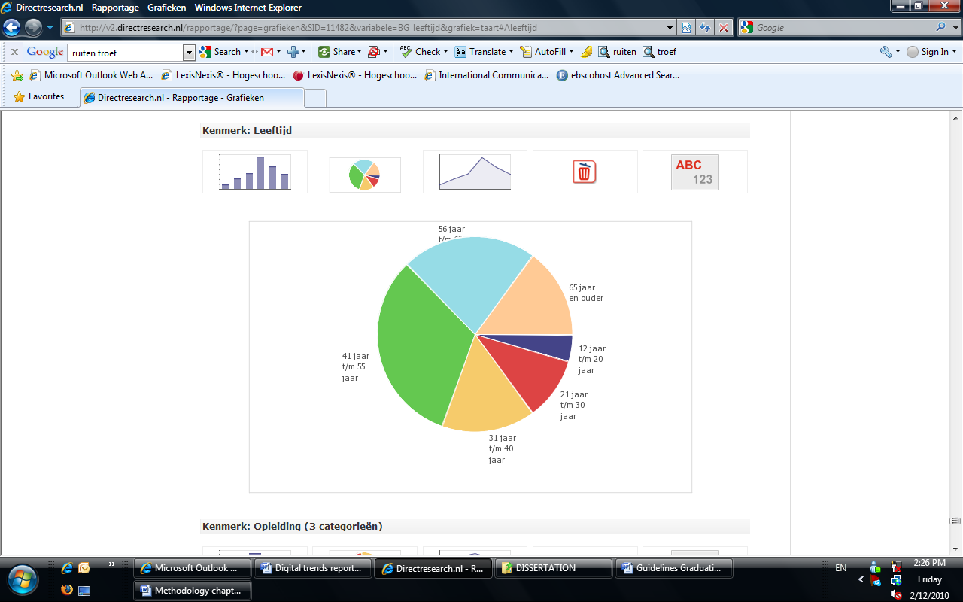

Table 3: *Questionnaire respondents: Age*

|  |  |  |
| --- | --- | --- |
| 12 jaar t/m 20 jaar | 24 | 4,5 % |
| 21 jaar t/m 30 jaar | 55 | 10,4 % |
| 31 jaar t/m 40 jaar | 82 | 15,5 % |
| 41 jaar t/m 55 jaar | 170 | 32,1 % |
| 56 jaar t/m 65 jaar | 118 | 22,3 % |
| 65 jaar en ouder | 80 | 15,1 % |
| **Totaal** | **529** | **100,0 %** |

3.1.3. Education.

Figure 5*: Questionnaire respondents: Education*

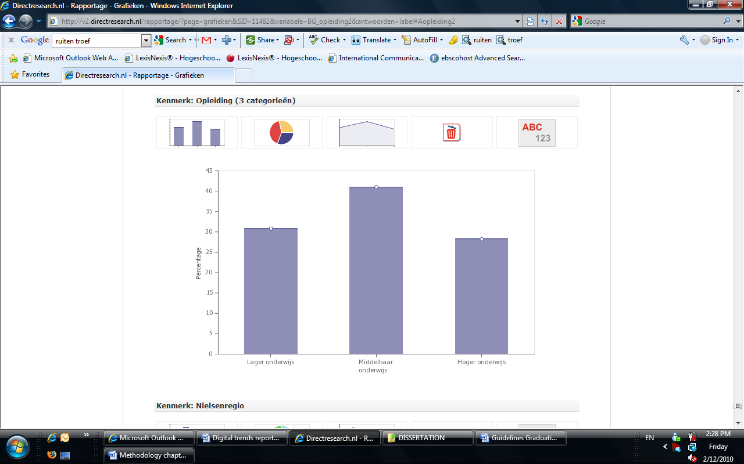

Legend: “Lager onderwijs” (lower education) is referred to as the lower forms of (vocational) education: “basisonderwijs” = primary education, “lbo” (incl. mavo)= lower vocational education and “vmbo”= preparatory vocational education. “Middelbaar onderwijs” (secondary education) refers to mbo = vocational education & training, and havo/vwo = preparational science education . “Hoger onderwijs” (higher education) refers to “hbo” (higher professional education) and “wo” (university degree).

3.1.4. Location.

Figure 6: *Questionnaire respondents: Location*

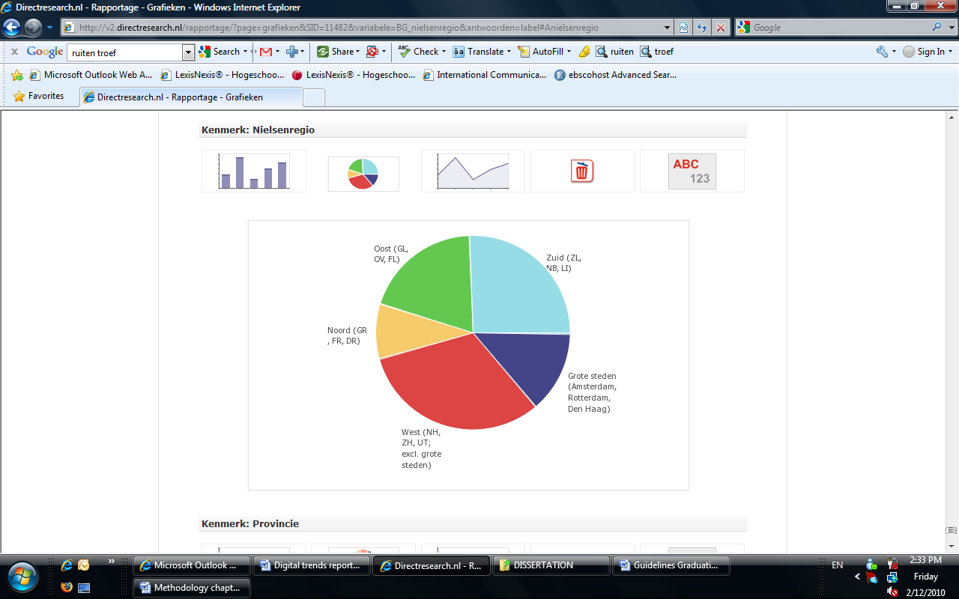

Table 4: *Questionnaire respondents: Location*

|  |  |  |
| --- | --- | --- |
| Grote steden (Amsterdam, Rotterdam, Den Haag) | 73 | 13,8 % |
| West (NH, ZH, UT; excl. grote steden) | 168 | 31,8 % |
| Noord (GR , FR, DR) | 48 | 9,1 % |
| Oost (GL, OV, FL) | 103 | 19,5 % |
| Zuid (ZL, NB, LI) | 137 | 25,9 % |
| **Totaal** | **529** | **100,0 %** |

Table 5: *Sample Validity test: Comparison of sample to data from CBS[[9]](#endnote-6)*



3.2 Qualitative research

3.2.1. Literature review.

* Books: recent literature about social media and its application in political campaigns and business marketing communications
* Business magazines: Dutch and International business magazines, with articles and research papers in the field of social media, politics and communications. (e.g. Elsevier, The Economist, Business week, Newsweek)
* Communication journals: (e.g. Communication and Mass Media Complete) and articles published in scientific journals, to be found in the database EBSOHOST (accessible from the HU mediatheek database)
* News articles in the national and international daily press (in print or online from Lexis Nexis)

3.2.2. Online research.

* Articles on Google scholar
* Relevant websites (politics, social media)
* Discussion forums (politics , social media)
* Blogs of specialists in the field of politics and/or social media
* Relevant information on social networks (LinkedIn, Twitter)

Data for the qualitative research has been gathered between 1st February and 31st March 2010. The fact that the local elections took place on 3rd March 2010 made it a convenient time to gather relevant information and organize interviews with experts and politicians. In the months February and March, social media and politics were major topic in Dutch the news, mainly because of the massive popularity of Twitter around the split of the government coalition on 20th February 2010. With new government elections scheduled for 9th June 2010, the public interest was directed at the leading national parties, represented also on a local level. Popular political figures such as Maxime Verhagen and Femke Halsema were shoved to the centre of attention with their social media activity on Twitter. This placed the magnifying lens on the social media presence of the local politicians too, with the local elections approaching. Therefore, the period between February and end of March was very beneficial for gathering of data for this research and the response of the sample was very high.

3.2.3. Interviews and field research.

The Meet and Tweet debate organized by communication consultancy PolitiekOnline from 23rd February in The Hague was an inspiration for selecting the specialists interviewed for the qualitative research. A representative mix of both social media experts and politicians provided a combination of insights that helped to answer the research question. Provided the circumstances (time and accessibility), it has been decided to conduct in-depth telephone interviews with the sample, between 30 and 40 minutes each.

Interviews with social media experts.

Dutch social media experts have been looked up on the internet, using social media networks such as LinkedIn, Twitter and search machines such as Google. Most importantly, however, these experts have been indicated via an advanced Google blog search on the topics of social media and politics, and by following political blogs such as Politiekonline.nl, Poliekedialoog.nl, as well as the Dutch national daily newspapers. In the end, five experts have been selected, using the following criteria:

* Experience with social media in public affairs
* Experience in PR and public affairs
* Journalistic experience and knowledge of politics

Table 6 *Sample of interviewed social media and political experts*

|  |  |
| --- | --- |
| **Name** | **Background** |
| Jeroen Mirck | ex-editor Adformatie, jury member of the Dutch Bloggies |
| Kay van der Linde | famous spindoctor (clients such as Pim Fortuyn and Rita Verdonk) |
| Camil Driessen | political scientist and journalist for De Pers, jury member of Beste Web Politicus |
| Jan Willem Alphenaar | social media expert, maker of the online film “DSB the movie” |
| Jaap Stronks | social media advisor, worked on the social media campaign of the PvdA |

Interviews with local politicians.

Nine politicians have been selected using the online tool Twittergids.nl, as well as based on an article in the Elsevier from 31st January 2010, ranking a top 5 of local politicians most active with social media channels on the internet. Twittergids.nl ranks politicians on Twitter, based on the number of followers they have. Politicians on top of the list, with the most followers (hence most popular and active) have been selected for this sample. The following criteria were also used:

* To be representative of the biggest political parties in the Netherlands participating in the elections (PvdA, CDA, VVD, D66, etc)
* To be representative of the biggest municipalities in the Netherlands (Amsterdam, den Haag, Eindhoven, etc)

Subsequently, some limitations of the selection criteria have influenced the sample. This is due to the fact that there are certain political parties from which more politicians are active on the internet (PvdA, D66), and are subsequently included higher up in the Twittergids.nl. Therefore parties like these are better represented in the sample.

Table 7 *Sample of interviewed politicians*

|  |  |  |
| --- | --- | --- |
| **Politician** | **Municipality** | **Party** |
| Michiel Mulder | Amsterdam | PvdA |
| David Rietveld | Den Haag | GroenLinks |
| Pepijn Zwanenberg | Utrecht | GroenLinks |
| Marc Dubach | Eindhoven | D66 |
| Stijn Verbruggen | Nijmegen | PvdA |
| Matthias Gijsbertsen | Groningen | GroenLinks |
| Jeroen Diepemaat | Enschede | VVD |
| Jeroen Fritz | Haarlem | PvdA |
| Martijn Vroom | Noordwijk | CDA |

Cross-selection.

A small part ( 3 persons) from the social media expert and politicians sample have been selected from the Bestewebpoliticus.nl, a competition for the best Dutch local politician using social media in his campaign. Two of the winning politicians from the competitions, Jeroen Fritz and Matthias Gijsbertsen, have been selected for an interview, and one person from the jury has been selected to be interviewed as a social media and political expert ( De Pers journalist Camil Driessen).

This selection has added extra validity to the sample, since at least two (Marc Dubach is the third, but he was selected previously and interviewed before Bestewebpoliticus.nl announced the winners) of the interviewed politicians have been accredited by a jury as expert users of the internet for public affairs.

Chapter 4 Research findings

*“I realize everyone is telling you social media are a unicorn, but maybe it's just a horse?"*

Jay Baer, social-media strategist, writing at [Convince & Convert](http://www.convinceandconvert.com/integrated-marketing-and-media/getting-serious-about-social-media/)

4.1 Quantitative research results

In the first part of this chapter the results of the quantitative research are presented.

Survey question: How do voters in the Netherlands use social media to keep up-to-date with political topics?

Sub questions:

1. General political interest and involvement of respondents.

2. What social media are preferred by the citizens for communication with politicians?

3. Is there a certain type of citizens that are more interested in communicating via social media than others?

4. How are voters keeping up-to-date with political topics? (both online and offline media)

5. Which social media are used passively and which actively?

6. Is the social media activity of Dutch people also applicable to local politics?

The complete research report of the questionnaire with graphics included can be found in the appendix of this report**.**

4.1.1. General political interest and involvement of respondents.

The overall conclusion of this survey is that the average Dutch citizen wants to be very passively involved in local politics. Even though 68% claim to be actively involved in political conversations and 71 % claim to be interested in political topics, only 53% thinks that they are up-to-date with the latest local political developments. When it comes to their interest to be involved in local politics via social media, 54% have absolutely no desire to communicate with politicians via social media.

4.1.2. Which social media are preferred by citizens for communication with politicians?

If they are to use social media for political communication, they would prefer on first place forums, on second, social networks, and on third, blogs, as a medium via which to keep informed about politics. However, when it comes to reacting and providing content for political discussions, only 1/3 is willing to both receive and comment on political topics. The other 2/3 prefers passive engagement (only read content, without posting or reacting).

4.1.3. Is there a certain type of citizens that is more interested in communicating via social media than others?

From demographic perspective, the younger the citizens, the more they use social media in general and the higher desire they express to be involved in politics via these media.

4.1.4. How are voters keeping up-to-date with political topics (both online and offline media)?

The results indicate that print media (newspapers and magazines) are the most preferred medium for keeping up-to-date with local politics. Online media performs quite poorly and there is no social media channel that stands out as the most popular about political discussions.

4.1.5. Which social media are used passively and which actively?

All social media are used rather passively. Social networks sites enjoy the higher percentage of passive use: 43%, however, when it applies to use for local politics the number shrinks to 8%. Active use of social networks (which enjoy the highest percentage of active use) in general is 36%, which however shrinks to 5% for active use in politics.

4.1.6. Is the social media activity of Dutch people also applicable to local politics?

No. The survey indicated that the social media activity is rather limited, although 66% state they use social media in general, for **political purposes** the use of social media is rather limited. For all types of social media listed in the questionnaire, almost 80% of the respondents stated that they never use it for political purposes.

4.1.7. Conclusion.

The overall conclusion from this survey is that social media are not as widely embraced as it is currently assumed, judging by data from a 2008 survey by Forrester. The survey measured the use of social media among European nations and the Dutch were one of the most active groups online with almost 20% of the adults being content creators.[[10]](#endnote-7) However, from this survey it has been established that the average Dutch person uses social media to a certain extent, but not that actively, and for political purposes the use is extremely limited.

A reason for this answer could be that 2/3 of the respondents are older than 40 years of age and 2/3 of them don’t have higher education, which is an age-group that is slower in adopting communication technology due to knowledge barriers. When it comes to politics, the use of social media is even lower, and in perspective it provides a challenge for politicians to connect with voters via social media. Even the younger age groups prefer to be only passively involved, and more than 80% of the population doesn’t want to receive any political updates online more than once a month.

When it comes to communicating directly with the city council via social media, the majority just doesn’t want to be bothered.

The results of this survey indicate that there is still a lot to be done in the field of social media in order to make it more accessible to certain age groups and certain audiences. At the same time, social media presents an opportunity for increasing the involvement of younger age groups, who have already embraced a certain social medium (Twitter and Hyves, for instance), as well as the involvement of more technically savvy age groups who are already familiar with social media.

In-depth qualitative research is needed to look at the way politicians use social media and with what strategies in mind. One possible reason for the lack of interest in social media and politics on behalf of citizens is that on these platforms they find little relevant information, and this implies that the senders (politicians) are not present or are using social media in the wrong way for their purposes. If this is the case then there is a typical asymmetry in communications and incongruence in the use of channels to deliver the message.Further research is needed to establish whether it is the channel (social media) that disturbs the communication flow, is it the message (politics) that is not relevant, or do senders (politicians) and receivers (voters) share different expectations about the communication process.

4. 2 Qualitative research results

The qualitative research consists of:

Part 1: A Meet & Tweet debate about social media and politics where the importance of social media (Twitter in specific) for the elections has been discussed

Part 2: In-depth interviews with social media experts and politicians

4.2.1. Debate about social media and politics where the importance of social media (Twitter in specific) for the elections has been discussed.

Below follow the most important statements from participants in Meet and Tweet: a discussion between social media experts, politicians and political clerks in different ministries. The meeting took place on 23rd February 2010 in The Hague, three days after the falling of the Dutch Balkenende cabinet. It was organized by PolitiekOnline.

The discussion was focused on three statements, aimed at testing the attitude of the audience towards social media and its role in political involvement. There were two specialists invited to the discussion to argue in favour or against the statements.

Meet and Tweet debate participants introduction.

|  |  |  |
| --- | --- | --- |
| C:\Users\Silviq\Desktop\Jaap Jansen.jpg |  | CA%20EUR%20(2).jpg |
| Jaap Jansen, journalist for the programme Een Vandaag. |  | Chris Aalberts, independent researcher and lecturer in political communication from the Erasmus University, author of the book “Aantrekkelijke politiek”[[11]](#footnote-4). |

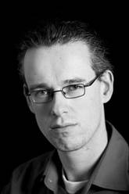**Chris Aalberts**

**Background**

Chris Aalberts has been doing research on the relation between citizens and politics for over five years now, and he has published multiple research papers on topics such as the use of different initiatives to involve younger people in politics. Since the last local elections in 2006, Chris Aalberts has been analysing the use of social media by some politicians to reach audiences that are less involved in politics. [[12]](#endnote-8)

As an independent researcher, Chris Aalberts maintains the view that the problem with political involvement of citizens can be solved by finding out what interests people so that politicians can make the content of their communication more relevant to the average Dutch person. Aalberts also claims that politics the way it is now is irrelevant for 90% of the people, and the rest 10% who are following political discussions are themselves politicians or in the immediate circle of politics: journalists, members of political organisations, etc. Therefore, Chris Aalberts’ view on the problem is that content is more relevant than form, which still remains a challenge for politicians: using social media such as Twitter as a channel is not helping to bridge the gap between politicians and citizens. [[13]](#endnote-9)

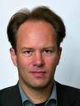 **Jaap Jansen:**

**Background**

Since November 2009 Jaap Jansen is a political editor for the current affairs programme Een Vandaag. Over the last year he has been working as a freelancer for KRO, AVRO, Het Gesprek, and TROS Kamerbreed (Dutch national TV channels and political shows). Until 2005 he was vice-chief of the parliamentary editorial of the Algemeen Dagblad, and from 1987 until 1997 editor at the Elsevier. He began as a political science student at the Haagse Post and the VPRO (a Dutch national TV channel). [[14]](#endnote-10)

Since the discussion was about using Twitter for political purposes, the guests were first asked to express their opinions about the medium.

|  |  |
| --- | --- |
| **Arguments Jaap Jansen** | **Arguments Chris Aalberts** |
| * The charm of Twitter is that everything is happening in real time and this results in a news addiction for the current affairs; * Twitter is very personal and it is customized for you because you create your own community by adding people you are interested in or have something in common with; * Speed of communication: everything happens quickly and everybody can participate in the debate. Even passively: look at how we followed the tweets of politicians about the fall of the cabinet and everyone was eagerly anticipating the next tweet with news. This couldn’t be possible in any other medium; | * All the information about the political sphere is totally irrelevant for 90% of the Dutch population; * Most of the Dutch people don’t know how Twitter works and never intend to use it; * Most people find it extremely difficult to orient themselves in the political domain, and tools like Twitter are not contributing at all, because they are still inaccessible for the majority of the Dutch population; * Information in 140 characters is not useful for these people if they are already ignorant about politics; * Social media are not going to help bridge the gap between citizen and politics, because the content of politics needs to adjust to the interests of the modern citizen; * Politics needs to become more relevant to the average citizen, and especially the younger generations; |

Summary Meet and Tweet discussion.

Statement 1:

*Is social media helping to bridge the gap between citizens and politics?*

Someone from the audience said that the more interested in politics citizens are using social media to obtain information about politics, but for a non-interested citizen, social media are not going to make politics more relevant.

A member of the city council in The Hague said that he finds social media an important tool to share his activities with the public. He stated that if he is not in the media, his constituency doesn’t know what he is doing. He referred to people who voted for him, but also for those who are considering to vote for him. He also said he regularly received reactions, but mostly from his political connections, and sometimes from citizens. He always replied to their comments/questions.

|  |  |
| --- | --- |
| **Social media: reach** | **Social media: reach** |
| C:\Users\Silviq\Desktop\Jaap Jansen.jpg | **CA%20EUR%20(2).jpg** |
| Jaap Jansen thinks that when it comes to reach in the new media, it cannot be compared to the print media (newspapers). He mentioned that only the followers of Femke Halsema on Twitter and Maxime Verhagen, together outnumber the circulation of the Groene Amsterdammer. So if you really want to be present in the media, it would be wise to aim at platforms like these, because so many people will be exposed to your messages. This is one step further to bridging the gap between politics and citizens.  **Social media: straightforward**  Jaap Jansen also thinks that the 140 signs (the limitation of a message sent on Twitter) actually help to deliver more straight-to-the-point and relevant content. People are scanning information nowadays and politicians who manage to deliver their message successfully in 140 signs are only benefitting from this restriction.  **Social media: different points of view**  Jaap mentioned that discussions in social communities such as Twitter offer a different perspective of what is written in the national press. This is a significant benefit for the citizen, because he has access to different points of view.  **Twitter: a source of news**  Twitter is a very good platform for direct connection between politicians and journalists, something that was impossible with the “old media”. Through Twitter journalists often have access to unofficial, but very useful information which they would otherwise not be able to obtain via other channels.[[15]](#endnote-11) | It doesn’t matter through which medium you send information, because it doesn’t change the fact who is receiving this information. All the people following politics on newspapers, TV, Hyves or Twitter are politically involved. This is a small clique of people, of which also a lot of journalists are members. This can be very exciting for these people but doesn’t mean anything for the other 90% of the population who have no political outlooks. Precisely the well informed people are those who will proactively seek information and platforms to express their opinions. The societal debate nowadays is about how to involve those who are not interested. You can’t outline a party’s ideology in 140 signs to people who can barely make any political decision.  The only way you can interest these people is through content: you have to make politics relevant to students, for instance (politics on MTV), you have to talk about things people find important, things that touch their daily lives. Unfortunately this doesn’t happen nowadays and what politicians tweet about is still irrelevant to those people.[[16]](#endnote-12) |

Statement 2:

*Politicians who use Twitter find form more important than content.*

**Form**

The audience thinks that it is exactly the form (140 characters) of the messages that makes Twitter so successful. This form helps you to bring out only the most important content and serves as a filter for irrelevant content. However, some think that in two years a lot of the politicians who currently use Twitter are going to quit.

**Content**

A politician says that she finds the added value in Twitter exactly in the content: the links that lead to videos on other sites, to interesting articles and blogs. She claimed that Twitter helped her to find and connect to younger audiences important to her campaign and now she is more up-to-date with discussions that happen among the youngest groups. This wouldn’t be possible without Twitter.

**Aggregation of information**

Someone from the audience says that social media sites are platforms where a lot of valuable content is discovered, which would otherwise not be found in the other media. A lot of user-generated content is to be found on these platforms, such as videos and pictures, which wouldn’t be accessible from other channels. Journalists take advantage of this and some of this content lands in the national newspapers exactly because it was popular on platforms like Twitter.

An example was provided with the notorious meeting of the D66 party at the Badhuistheater in East Amsterdam on 28th March 2009. During this meeting the candidates for European Parliament were presented. At the end of the meeting one guest was not allowed to leave the building, because someone had been shooting outside and the police had surrounded the premises and closed them off. Nobody could go out and get in. When he heard this, journalist Jeroen Mirck, who was also one of the guests, sent the following tweet from his smart phone:

Figure 7 *Jeroen Mirck’s famous tweet*

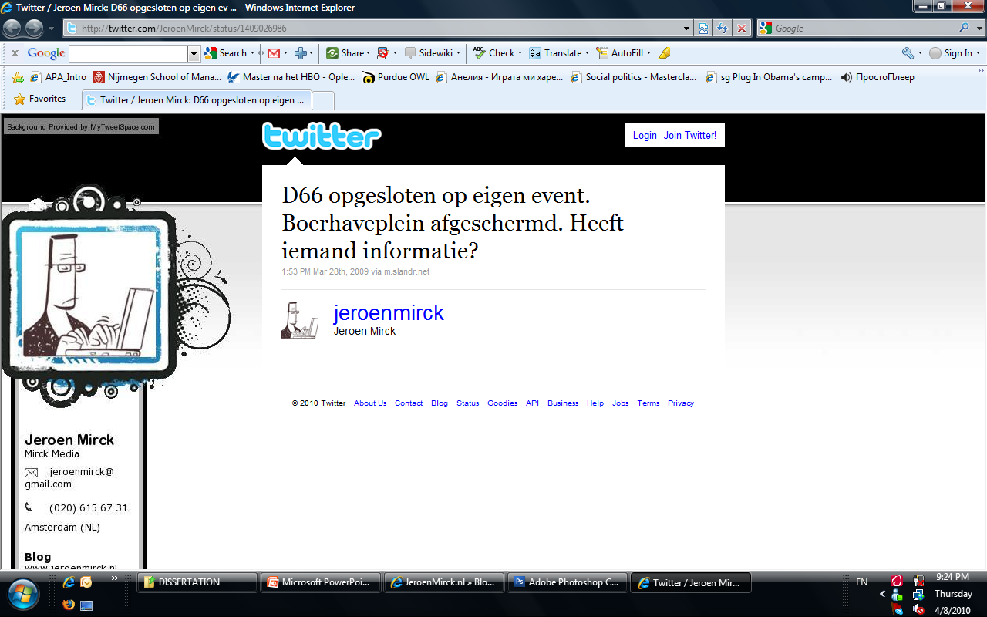.

After his tweet was retweeted by other twitterers in the network, the following article appeared in Spitsnieuws, stating that there has been a shooting at a congress of the D66 party, with a picture of the leader of the party, Alexander Pechtold.

Figure 8 *Article in Spitsnieuws about the “shooting”*

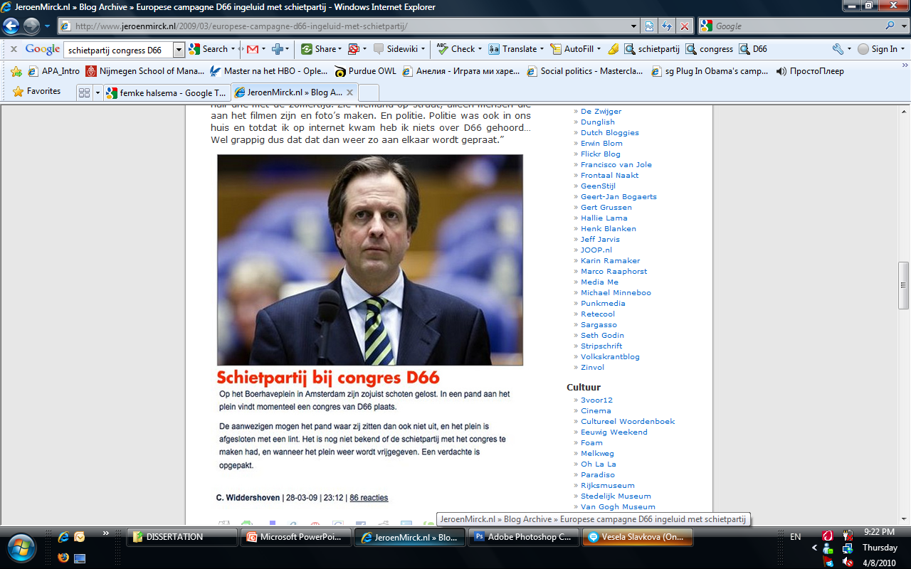

This is an example of the influence Twitter can have as a medium, if the sender of the message has a certain credibility (such as in this case was the situation of Jeroen Mirck, an ex-editor of Adformatie, a famous Dutch magazine for the advertising business). The role of Twitter for spreading information quickly also made it look as if the “news” was real, because it was cited (retweeted) by so many people.[[17]](#endnote-13) Obviously, the journalist who wrote the article should have checked the facts with the source, but he assumed it was true because so many people had retweeted it.

**Question: How can one bridge the gap between the citizens and politics?**

**Chris Aalberts:**

* You can do this by finding out what motivates people and acting upon it in your communication. Unfortunately mundane topics from the everyday life are nowadays no topic in political discussions;
* In a strange way, Geert Wilders (a controversial Dutch politician and leader of the Party for the Freedom, PVV) is successful in this communication because for a certain number of people in this country he really represents things that they come across or think about every single day and he is the only politician about whom some people can say that he understands their needs;

Statement 3:

*Does Twitter actually help to establish contact with politicians?*

**The audience:**

* Hard to define what is contact, if speaking with potential voters on the market is contact, is speaking with them via Twitter also contact?
* Not if politicians are using it as a push channel and only send out information about their political agenda, and if they don’t post personal content that would interest people;
* Femke Halsema formed a community of people interested in her through posting personal messages which make people think that she is just one of them, and so she created a loyal group of followers who are also willing to listen when she speaks about her political agenda;
* However, the number of followers doesn’t tell a lot about the quality of the content;
* Twitter can also be quite superficial: you never see the person on the other side, so in a way contact is limited;

|  |  |
| --- | --- |
| C:\Users\Silviq\Desktop\Jaap Jansen.jpg  Jaap Jansen | CA%20EUR%20(2).jpg  Chris Aalberts |
| In Twitter you can decide who you want to follow and you can always get rid of people who don’t bring any value to your network. | But then it means that Twitter is no open platform, but a platform where you create your own, closed communities. If politicians want to bridge the gap between themselves and citizens, they need to come up with resonating stories which are derived from personal contact with people, and for this Twitter cannot help you. |

4.2.2. In-depth interviews with social media experts and politicians.

In this part, the main findings from the interviews with social media experts are be provided. The questions used in each interview were similar and were only slightly adjusted to the personal background, knowledge and experience of the interviewees. The purpose of the qualitative research is to answer the following sub questions which arise as a result from the quantitative research findings[[18]](#footnote-5) and the Meet and Tweet discussion:

**Political communication:**

* Is lack of political interest in the Netherlands a problem and what is the role of communication for this?
* How can (social) media bring politics closer to the citizen?

**Social media:**

* How are politicians using social media and why do they fail to reach a wider audience?
* Which target group do politicians reach via social media?
* What are the mistakes politicians make when using social media?
* How can social media be used efficiently for political communication?
* How important is the interaction between social media and traditional media? As stated in the summary of the results of the questionnaire, the indicated lack of interest in social media among citizens can be explained with either one or all three of the following four factors. In this chapter, each of them will be analyzed individually as follows:

Table 8: *The communication process analysis*

|  |  |  |  |
| --- | --- | --- | --- |
| **Message** | **Medium** | **Sender** | **Receiver** |
| Is lack of interest in politics a problem in The Netherlands?   * National vs local politics * How can local politics become more interesting and relevant to the citizen? * Information about politics or politicians | How can social media be used efficiently for political communication?   * Low barrier to entry * Reputation management * Real time communication * Snowball effect * Open * Personal * A sea of information   What is the added value of social media as a campaign tool among other media? | How are politicians using social media and why do they fail to reach a wider audience?  What are the mistakes politicians make when using social media?   * Twitter * Blogs * Websites * The whole picture: Best web politician | Which target groups do politicians reach via social media?  What do citizens expect from communication via social media? |

Is lack of political interest in the Netherlands a problem?

The questionnaire implied that local politics is an issue with which the average Dutch citizen feels only remotely connected and does not want to be proactively involved. At the same time, the respondents of the questionnaire stated that they were taking part or at least listening during political discussions. This led to the conclusion that interest and involvement in politics are independent in the mind of the voter, and the following research attempted to clarify this.

The interviews with social media, political experts and local politicians showed a slightly different perspective to this phenomenon. The majority of them agreed that local politics is less relevant to the Dutch than national politics. According to most of them, the lack of interest in politics (in Dutch a common term used for this is “the gap”) is a given, and it’s based on the fundamentals of democracy, so it shouldn’t be considered as a negative trend.

The social media and political expert Jaap Stronks talks about “democratic deficit”, expressed by the lack of further participation on behalf of the Dutch citizens besides voting once a year. [[19]](#endnote-14)However, some of the interviewed politicians do not agree with this.

Camil Driessen, a political journalist at the daily newspaper De Pers pointed out that if one is looking at the voting participation figures, which are around the 50% for local and 80% for national elections in the Netherlands, the 50% participation in local elections is not a sign of lack of interest. He pointed out as an example other countries (USA), and claimed that 50% is a rather good figure, compared to the 60% voting activity for elections in the USA, given the multi-partisan system in the Netherlands and the difficulties in choosing a party to vote for. [[20]](#endnote-15)

A few of the interviewed politicians pointed out a distinction between interest and participation. According to Martijn Vroom from CDA in Noordwijk, “there is a difference between having no interest in politics and not voting.” He claims that there are a lot of people he has been in contact with that were interested in what he is doing in the city, but these were certainly not people who voted for his party, or bothered to vote for another party.[[21]](#endnote-16)

Jaap Stronks, a social media expert, specifies a distinction between “active” and “latent” interest. “Maybe you are not interested in politics, but when you hear that they’re cutting trees on your street you become involved.” [[22]](#endnote-17)

David Rietveld, a Groenlinks city council representative in The Hague, also thinks that interest in politics is foremost about issues that are closely related to the everyday life of the citizen. And when information about these issues is exchanged, then citizens become interested. “But when a council representative is blogging about what he is doing in the council on a daily basis, this is not appreciated by the people.” [[23]](#endnote-18)

When defining political interest it is thus important to be specific about the content of political communication. From the interviews with politicians it seems that they are not concerned with the fact that the average Dutch person shows little interest in politics (as in, higher level decision making that is far away from the everyday life of the citizen), even on the contrary: “If every citizen starts getting involved with politics, this would mean they don’t trust us as their representatives. People vote for us and delegate to us the ruling of their cities or the country, and they should trust us with the decision-making. Thus it is only natural that people don’t need to hear every day what I did in the city council, whom I met, and what decisions were made, “ according to David Rietveld. He also adds that earlier, before the internet came into play, politics was missing a human face and this was also making it less interesting to the average citizen.

Of course, when it comes to important issues, such as building projects or “tree cutting”, local politics becomes relevant and then “as soon as people say it, I will be outside at their door”, according to Martijn Vroom from CDA Noordwijk.

Just like David Rietveld, Martijn Vroom is actually content with the fact that people don’t bother to get involved in politics besides their showing up to vote once in four years. “There is sure lack of relevance, but this is not something to complain about. If people have chosen me as their representative they should be happy to lead their lives and don’t bother with politics, as I am there for that.” Martijn Vroom refers to the lack of relevance of his daily activities as a politician, which should not be dominating in his communication with the citizens. What should dominate are mostly practical and “mundane” decisions about a certain issue that has a direct impact on peoples’ lives. And when such an issue is the topic of discussion in the city council, then it should be communicated to the citizens, but one should be careful not to do that too much and too often.

Martijn Vroom also thinks that the gap (as in, distance through lack of interest) between politics and the citizen is actually made up by politicians themselves. He claims that there is a huge difference between being involved in politics and voting. One can vote without being involved and vice versa. Thus communication about politics has no direct effect on voting behaviour. Also, holding more referenda and requiring people to participate in decision making more often will actually make them more averse to politics, instead of bridge the gap.

“If people are not voting, this is because they have the feeling that whatever they vote doesn’t help to change their situation, and this has to do with the fact that politicians don’t keep their promises,” he claims.

David Rietveld expresses the view that “You have to find the balance between representative democracy and participative democracy. The citizen should not be involved in every decisions and this is why I think that voting more often or holding referenda for all kinds of questions is not the right way to make politics more relevant”. “People should participate through platforms such as Citizen participation (Burger Participatie 2.0) or Petitieonline (Online Petition), and this is a way to set up their own initiatives when they think it needs to happen“, continues David Rietveld.

However, experience has shown that such initiatives have had little success, mainly because of doubt about the following:

* Do people really want to be involved in governmental issues and decisions?
* Does the government (and administrative clerks) want to really involve citizens in its decisions? [[24]](#endnote-19)

**Conclusion**

From the interviews one can conclude that political communication plays a huge role in making politics less or more interesting to the citizen. However, interesting politics does not necessarily mean increased involvement. Politics will not change, according to the interviewed politicians, but communication can, and so can the citizen’s mindset. Apart from the fact that politicians should be careful what they communicate about, there is also the problem with lack of communication. Camil Driessen, a political journalist for the daily newspaper De Pers thinks that politics in The Hague does not have a “face” and is subsequently not interesting, for instance, during the mandate of Prime Minister Balkenende he never actually explained what he was doing in the government. “Whatever Balkanende says, he never says anything. And this creates an automatic indifference in politics.”

Even though this is an example on a national level, it depicts very well how also lack of communication or purposeful ambiguity can make politics less relevant and therefore less interesting for the citizens.

National vs. Local politics

The questionnaire failed to draw the distinction between local and national politics (even though structurally the difference was stated, from the answers of the respondents it can be concluded that there has been confusion). The answers of the respondents in the questionnaire clearly indicated that national politics interests them, but when it comes to using (social) media for receiving information about local politics, there seemed to be significantly less interest. The interviews with experts and politicians helped to clarify if indeed people in the Netherlands are more interested in national politics, and how does this affect their involvement in politics on a local level.

When discussing this issue, it is important to mention that the interviews with politicians took place after the local elections on 3rd March, which in a way is a good thing, because one could better evaluate the situation, but on the other, some of the answers received could be biased because of what was published in the press after the elections.

Public affairs in the Netherlands before the local elections this year was in quite of a turmoil: the coalition governing the country broke up two weeks before the local elections and national issues were shoved to the stage of public attention. Preoccupied with speculations about the scheduled elections for a new government in the summer, the media succeeded in streamlining public opinion into one direction: national politics.

Of course, there were the compulsory debates between party leaders of the national parties competing in the local elections, but how effective were these in helping the floating voters to make up their minds?

According to Jeroen Diepemaat, city council representative from the VVD in Enschede,”On the radio you would hear local party leaders arguing about national issues, and then you turn on the TV in the evening for an election debate and what you see is a 15-minute discussion of some local topics and during the remaining one and a half hour the debate goes on about Geert Wilders (a controversial Dutch politician and leader of the Party for the Freedom, PVV).” [[25]](#endnote-20)

From the interviews with politicians and social media specialists, one statement came to the foreground:

“The focus of national politics in the news is keeping people from being interested in local topics.”

However, there are other factors that together lead to the estrangement (or the “gap”) between local politics and the Dutch person.

Combined in one, these factors can have a significant impact on the interest of the Dutch citizen in local politics.

Where is that local newspaper?

It is an interesting phenomenon, but there are quite a few big municipalities in the Netherlands, where there are fewer local newspapers than in smaller municipalities in the province. If citizens wish to be informed about local matters, but the media infrastructure of their municipality is not well developed (an example is Utrecht with insufficient local newspapers, as Pepijn Zwanenberg from GroenLinks Utrecht mentioned), the information won’t be readily available to them. [[26]](#endnote-21)

The passive citizen.

Having in mind that the modern citizen is lazy, impatient and passive because of the increasing choice there is on the market for information, people would rather be “fed” than proactively seek information. They also expect news to be delivered quicker and their interest last shorter. Therefore, one could argue that the chance that someone would proactively seek information about what happens in the town they live in (even though this is more relevant to them) is very small. The average voter would wait to be served a “meal” of political news at his own convenience, and only occasionally get involved in local matters and only when this directly affects him (as all of the interviewed politicians stated).

The effect of losing interest and decreasing patience for keeping up with the slow decision making in politics was foreseen already in 2005.

Stefaan Walgrave, a political scientist (as cited in Eenhoorn, 2004) said:

Politics is a slow and tough process, while the media switches from one news piece to the other. I think that the viewer feels this effect. Sometimes it happens so that the attention of the media, and thus of politics is becoming shorter, while the policy making processes in politics are not becoming faster. As a result the public has overstrained expectations from the politics, and dissatisfaction arises because “nothing has yet happened” with a certain problem. (p. 6)

Harry Potter and the Dutch Queen.

As a matter of fact, the average Dutch person is not interested in national, neither in local politics. For the average citizen the word “politics” is associated with events happening in The Hague (breakup of the government coalition, news about the Royal family, national scandals) which receive a wide publicity in the national press. The fact that this information is being constantly “pushed” to the majority of the population though different channels ( such as national TV and daily press), leaves the impression among citizens that they are very well informed about politics. However, in reality this is not a sign of interest, but a sign of laxity and lack of initiative to seek information you are really interested in (or should be interested in, as for instance, what happens in your own community).

According to Judith De Glopper, who did graduation research for the University in Utrecht about the gap between citizens and politics, “Many citizens think that politicians explain too little about what they do. This causes the lack of trust in politicians and their policies” (De Glopper, as cited in Eenhoorn, 2004).

“Turning off” the radar.

Given that the modern Dutch citizen has access to multiple media channels (on and offline), as well as mobile, there is a number of ways one can seek information about issues that are relevant to him/her. In fact, very few people do this. The fact that a lot of people have now internet access on their mobile phone, doesn’t mean that they have more time to read the news about their home town on it. Because of the fear of information overflow, people put the “NO NO” stickers on their front door and thus become unwittingly excluded from the local events (reflected in the free local print media, for instance). The abundance of commercially attractive information on television makes local politics seem dull and unattractive to dedicate time to, even if one has access to local news channels.

Bring it on, Wilders!

National politics is represented as infotainment, with racial controversies and ideological disagreements between politicians represented as exciting battles before the camera, which is a lot more attractive to citizen than listening about the building of a new senior home in his neighbourhood.

According to political science expert Stefaan Walgrave (as cited in Eenhoorn, 2004),

Infotainment makes politics superficial and in this way it can never win the sustainable trust of the public. Issues and policies are supported by the identification of a sympathetic face and not any longer on the basis of content, whatever content it may be. (p. 5)

As Eenhoorn (2004) explains it, “Journalists mingle in debates, political accounts are replaced by soundbytes and difference of opinions is represented as a big public conflict. The medium has become faster but political decision making hasn’t” (p.1).

In her research, Eenhoorn (2004) has found that

The Council of Societal Development concludes that news media have become the set designers of the public interest: by selection, interpretation and framing they influence the space of politicians to bring out their standing points, to initiate debates and to promote interests. Media have thus influence on the rules of publicity.” (p.9)

“Als een zoutzak” in a YouTube video.[[27]](#endnote-22)

Local politics is a vague term that only obtains a meaning when a fire happens in the store next to your house. For the local politician, local politics means meetings in the municipal council, discussions about budget, policies and decision making. However, for him local politics is also when he is nominating his city to participate in the DJ Radio 3FM competition: Glass house (Glazenhuis), (Stijn Verbruggen PvdA, Nijmegen).

For the citizen, local politics is what member councils do behind the walls of the municipality, a place distant and unfamiliar. The local politician, if they are lucky to know him, is a person who is doing something they can’t explain with words. At the same time, people always have a lot to say about the government and how the country is ruled. However, how many can say which party has a majority in their own town?

According to De Glopper (as cited in Schrijver, 2006), “The policy of the government is so complicated, that the average citizen barely understands it” (p. 23).

From the interviews with politicians it was clear that they themselves recognized this phenomenon and try to rectify it by maintaining blogs. “Informing my voters about what I do” was stated as the number one reason of a politician to maintain a blog. Mixing political content with personal content is the recipe for success, if a politician wants to reach the citizen. All of the interviewed believed that nobody would read their blogs if they weren’t writing in an easy language and mixing the personal content with political.

This is an effect of estrangement of local politics which has to such an extent permeated the Dutch society, that the average Dutch person doesn’t even recognize it. The answers of the questionnaire showed that people feel they are informed about politics, while at the same time they refuse to engage in any way with their local representatives and local news barely reaches them. Two of the interviewed local politicians stated that there is no lack of interest in local politics, while the rest affirmed there is distance and lack of interest and blamed mostly the media infrastructure and national politics about it. It is clear that there is a large discrepancy between how the citizen perceives what local politics is and how politicians define it, but one thing is clear and this is that focus of national politics in the media is not the only factor that influences the lack of interest in local politics. Subsequently, if focus shifts and the local media infrastructure improves (which is not likely to happen with the budget deficit on a local level in the coming years), there is still the “human factor” and communication that play a very important role in this equation.

How can (social) media bring politics closer to the citizen?

There are many different and sometimes opposing views about this. One hand, we have the political system in the Netherlands (many parties, low threshold for a party to be included in the city council), as well as the needs of the modern citizens, their expectations of politics and more specifically, the influence of national parties on local parties, as well as the media infrastructure.

According to David Rietveld, a successful politician is one who is constantly looking contact with the voter. According to social media expert Jan Willem Alphenaar[[28]](#endnote-23) and Eindhoven city council representative Marc Dubach (D66), a politician should pro-actively search for groups in society that might be interested in his message. Politicians need to find those groups, attach to them, listen to what they talk about and subsequently communicate relevantly. Later in this chapter will be explained how social media can be used effectively for this purpose.[[29]](#endnote-24)

On the other hand, it’s not only about communication. As Camil Driessen from De Pers explains it, “Politicians tend to overpromise and under deliver. This is why people don’t trust them anymore. They need to stop promising that they can fix all the problems in society that can’t be fixed in the short term. There is some inherent perception among politicians that they always need to make promises. “

Kay van der Linde, a well known Dutch political spin doctor, who worked on the campaigns of famous American politicians in the USA in the 1980’s and early 1990’s, shares this vision, “Politicians need to promise less and keep their promises. They need to look at their credibility first and then communicate about it. Be good and tell it!”[[30]](#endnote-25)

What Camil Driessen, a political scientist and journalist from daily newspaper De Pers, implies is that if politicians become more realistic about the situation in the Netherlands people will be more willing to listen to what they have to say. However, the question is if that can ever change, given the fact that the politician’s role is exactly to “solve problems”. And especially in a system like the one in the Netherlands, party leaders can only differentiate by promising to solve problems relevant to their potential voters.

At the same time, there is the way the press (mainstream media) represents how politicians do their job. It always seems like politicians are too busy with saying what other politicians can’t do or do worse, and it looks more like a cat and mouse game in which citizens are not interested. What they want to hear is something that directly affects them. So if people get the impression that politicians are busy with policy making and getting things done in the municipality, they will be more interested in local politics (as in, decisions and processes that directly affect them).

All of the interviewed politicians said they were using social media exactly with this purpose: to show people what they are doing for them, how their actions in the municipality indirectly affect the citizen’s life and the community. As Martijn Vroom puts it, “If I’m receiving money from the taxpayer I consider it a duty to let people know what I am doing for it” (about why he started his blog eight years ago).

Social media are a great advantage for a politician who wants to provide an insightful (and alternative) view of what is said about him (or his party) in the press. This is one way how politicians can maintain their reputation and showcase what they are doing for the people who have chosen them. And in a way, this makes local politics more relevant because if people know what you do for them, they are more interested to listen to you when you have something to say. Later in this chapter more detailed will be provided on how social media can be used for such engagement.

Also, when there is a lack of good local media channels (as in some municipalities such as Utrecht, for instance) due to the weak local media infrastructure, politicians can make use of these free social media channels which offer many possibilities for direct engagement of the citizens.

The potential of social media can be streamlined into traditional media. All of the interviewed politicians claimed that influential blog posts they have written have been picked up and published in the local or national press, when the subject of discussion was important to the voters. Some even try to intentionally promote online content so that it lands in the local press, and in this way, reach a wider group of people and make their message more relevant to them.

As Martijn Vroom from CDA Noordwijk puts it:

When they publish a photo of me standing in the senior home with a bunch of flowers in my hands, people have no idea what I was doing there. But when I write about it in my blog and it gets published, then they get a real insight into the work I do for them.

According to Michiel Mulders from PvdA Amsterdam canvassing (going door to door) is a great way to bring local politics closer to the citizens. However, some politicians doubt about the effectiveness of this tactic having in mind the lack of enthusiasm among Dutch citizens for such initiatives.

Information about politics or politicians?

The questionnaire failed to draw a clear distinction between communication with politicians and political communication . The interviews with politicians were thus also focused on finding out what the difference is in the information received about politics and politicians, and information received by politicians

Some of the interviewed politicians were asked to define political communication in their own words. Most defined it as “trying to reach as many people as possible via as many channels as possible and initiating a dialogue with them”.

Martijn Vroom from CDA Noordwijk explained it as “Keeping people informed about what I do”. And according to Michiel Mulder from PvdA Amsterdam “Everything except pure household issues such as cat food is political communication. But it has to be symmetrical”.[[31]](#endnote-26)

The theoretical framework of this research defines political communication as a:[[32]](#footnote-6)

1. Political news (news about political actors and political issues)

2. Political advertisement (mainly during elections)

3. Political debates

It seems that an important aspect of political communication, namely, a dialogue between politicians and their voters, is omitted in the theory. When asked what political communications is, some politicians basically gave a definition of “communicating with the voters”.

One politician even defined politics as a “dialogue”, while another stated that it is “competition”, in the sense that the politician or party is competing with others for the vote of the citizen. However, neither one denied the importance of listening to what people say.

If political communication for politicians means communicating with their (potential) voters, or a broader group of people, this entails a wide choice of topics, platforms and audiences. For instance, communication via mass media (such as TV and newspapers) during the campaign will have a more commercial character; hence, it can be defined as political advertising. At the same time, these are channels where most of the political news is disseminated. Political debates are also something typical for the broadcast media.

So where and how does that direct dialogue with the voter take place? The answer is: online and on the phone. A majority of the politicians mentioned email and telephone as the primary way they keep in touch with their voters. They proudly admitted to receiving hundreds of emails about all kinds of issues related to what they do in the city, and not only during elections. However, on second place they mentioned social media platforms such as their blogs, Twitter, as well as local news websites or discussion forums. A majority referred to the “low barrier to entry” of social media that makes intermediaries such as the press redundant. People are now able to directly contact them by sending a message on a platform where everything is happening in real time. The fact that a politician makes his profile more open and visible, on his blog, Hyves or Twitter, for instance, makes him easily approachable and this means that more people will dare to contact him. And in this way, he attains easier his communication goal to reach as many people as possible by as many channels as possible.

It is remarkable that by using the internet more openly (social media), a politician is actually moving all other political communication from offline to online channels and vice versa. If email, blogs and Twitter facilitate a dialogue with more people and have the potential to reach more people, this means that these platforms can be used not only for communication with politicians (dialogue), but also for communication about politics (information provision).

In the following pages it will be discussed how and if social media are a suitable platform for both.

How can social media be used efficiently for political communication?

What are the distinctive characteristics of social media that make it suitable for political communication and as a tool to interact with voters?

In order to answer this question, it is necessary to return to the definition of social media provided in the theoretical framework of this report.

For the purpose of this research, the most important characteristic from this definition is the ability of social media to “Transform […] monologues (one to many) into dialogues (many to many) and the democratization of information” (Blom 2009, p. 30).

This specific quality of social media has a direct application to this case. In politics, and more specifically, during the recent local elections in the Netherlands, social media allowed for a democratization of information and a more open dialogue. The media platforms used by all interviewed politicians were blogs and Twitter.

How do blogs work?

Blogs arose in the late 1990’s as an easy alternative to websites, which were hard to create for less technically savvy internet user. Basically it meant easily setting up a web page where you can talk about anything, and without caring if one would read it. However, the key characteristic of a blog is that each blog is connected to another blog through a system of linking called “inter-linking”. Interlinking works as follows: most of the bloggers have a particular interest and read other people’s blogs who write about similar topics. When they like a blog, they add a link to it in their own blog. This is how gradually, all the blogs became connected and this caused the phenomenon called “the blogosphere”. Basically the blogosphere is one huge never ending network of millions of interlinked blogs. Something like a bubble within the internet. Of course, blogs can also link to websites, but the important thing here is that blogs are mainly linked to blogs, and one blog cannot exist long if it is not linked to other blogs. This is one of the key characteristics of blogs that make them so special.

The combination of a blog and Twitter that Dutch politicians used in the recent elections is an interesting choice of media, which can be explained only if one knows what blogs and Twitter represent. The main difference between blogs and Twitter is that blogs are one of the earliest Web 2.0 applications and Twitter is the latest Web 2.0 social media platform. In this context, a proper definition of Web 2.0 is necessary.

As described by Blom (2009), “Web 2.0 is a common term used to describe all the changes in the internet that resulted in more control in the hands of the individual user/consumer” (p. 30).

Very often social media are used as a replacement or a synonym, but there is a difference: Web 2.0 describes a trend, while social media refers to specific tools: Blogs, Twitter, Facebook, LinkedIn, Flickr, Digg, etc. Therefore in this report social media are used as a term to describe specific communication tools.

Van Vliet (2009) provides a more explicit definition of Web 2.0:

Web 2.0 is a common denominator for various forms of user activity on the internet, which did not exist before 1999 (the year when the free blogging service Blogger appeared). The main activities that Web 2.0 describes are: the participation of the user by publication of his own content through the internet (user generated content, or shortly, UGC), and sharing of each other’s time, knowledge and skills (sometimes referred to by terms such as “crowd-sourcing” and “the wisdom of crowds. (p. 32)

Content generation and participation.

Basically, the two main characteristics of the “new” online media are that the user is able to generate content that is subsequently accessible to anyone, anywhere in the world. One could set up a blog, and start writing. And those who were interested would find the blog and read it. As a consequence of that, people shared knowledge, because a lot of the bloggers were also specialists in a certain field and by reading each other’s post they kept up-to-date with the latest developments and sharing ideas. Blogs haven’t changed much since their inception in the late 1990’s and as it turned out from this research some of the interviewed politicians were using blogs since 2001. The ones that started so early tried it more out of curiosity and the desire to share their thoughts with other people, but this was not always connected to politics. The ones that started a blog later, for instance, just before the previous local elections in 2006, started the blogs mainly because they wanted to write about what they do in politics.

How does Twitter work?

Twitter, on the other hand, is a revolution for avid social media users. One of the interviewed politicians, David Rietveld from GroenLinks in The Hague, started using Twitter in 2007, one year after the medium became public, which in the Netherlands actually happened in 2007, before that barely anyone knew what Twitter is.

Twitter is a second-generation social medium which was originally invented as an “open” text messaging service: basically, sending a short message via your Twitter account, which could be seen by “friends”, people who were following your account. The revolutionary thing about Twitter that:

* Your messages are visible to anybody (if you “open” your profile), while you can also choose to see only messages that are interesting to you
* You can send and receive “tweets” (messages) online **and** on your smart phone (telephones with 3G coverage that enables them to display online content in browsers and online applications, such as Twitter).
* Twitter is connected to the live search on Google, which means that you can see a timeline of “tweets” sent within a certain timeframe, which is especially interesting if you are searching from information on the internet published literally one second ago. Blogs are not capable of that (yet).

These are the main differences that make Twitter such an exciting medium: not so much the fact that you can blog in 140 characters, or even the fact that you can set up a Twitter account in a minute, while a blog takes a longer and requires an attractive writing style and some creativity in layout choices. Even though Twitter became popular because it was easy to set up and get it going, it is a more complicated medium than blogs because of the abovementioned qualities and a range of features that make it a powerful tool, if, of course you know how to use it. Twitter is a new generation social media primary because of the fact that just like most new platforms and social networks, it requires minimum effort to sign up and get started, but its real value is revealed after you spend some time using it. Like any other social media, the value of Twitter is not preparation, but participation.

Twitter, blogs, and political communication.

This research is not concentrated on analyzing political blogs and Twitter accounts of Dutch politicians. There has been enough research that has done that. In the in-depth interviews with politicians actively using social media the qualities of social media platforms such as blogs and Twitter have been analyzed, and those that make them a suitable communication tool that can be used to facilitate a dialogue between politicians and citizens have been indicated.

Here are the most important qualities of political blogs and Twitter, also referred to as ‘social media’ that make them suitable for different types of political communication.

Low barrier to entry.

The majority of interviewed politicians defined social media as “laagdrempelig”[[33]](#footnote-7). Their main argument was that it (partially) eliminated the middle man: the so called intermediaries in political communication, such as the journalists (media). All politicians pointed out this as the main advantage that facilitates the dialogue with the citizen.

According to Jaap Stronks, a social media advisor, “Twitter is simple, fast and conversational and it offers the infrastructure that facilitates the conversation between the citizen and the politician.”

The fact that citizens can directly approach a politician without any prior contact and communication, or any introduction, (for instance, email communication norms are a digital version of the written letter) makes it more likely that a citizen would make the effort to do so. For instance, if a citizen was present at a political debate he/she would have to ask a question through the commentator or leader of the debate, who in that case is an intermediary. This creates a distance and every step needed to overcome it decreases the chance that the person would “dare” to do it. Even a single telephone call requires more “courage” than writing a few lines with your question and hitting “Enter” on the blog or Twitter account of the politician.

As Jaap Stronks, social media advisor explains it:

Twitter is indeed one of the instruments that make it possible for politician and citizen to interact with each other without the mediation of the press or that it is impeded by the fact that you can only ask one question during a public debate or at a meeting.

For politicians, the low barrier to entry allows them to reach people that are not necessarily interested in their party, but have questions about it. Nobody would give a politician a call asking them how their party is standing in terms of certain issue, but on Twitter people do that, because the barrier is so low and nobody can see them, judge them, and forbid them to ask.

Jeroen Diepemaat, a city council (ex) candidate, now elected for a representative, from VVD Enschede, explained how he was approached on Twitter:

A few people asked me about a several standpoints of my party and if their outlooks about these issues were the same as from our party. After I heard them I told them, if you think like that, VVD is not the party for you. You should definitely NOT vote for us.

So this helped people to make an informed choice and if Twitter wasn’t there, these people wouldn’t bother to send an email to Jeroen Diepemaat to ask him those questions.

Reputation management.

If used proactively, social media can help to forge opinions or respond to attacks online. Besides merely providing with information, social media can be used more strategically, if the circumstances require it. If you are Maxime Verhagen, reputation is very important. But so it is if you are a city council member from Nijmegen, running for the local elections and campaigning for “preferred votes” so you can become a council representative. Social media offers a very good opportunity for politicians to respond to certain discussions containing insinuations on their reputation related to their party or just an important issue on their agenda. The reach, of course, depends on how big your online social network is.

Jeroen Mirck provided an example when politicians used social media to respond to a heated discussion threatening their reputation:

Two weeks before the elections, when the government coalition broke up, Wouter Bos received a lot of criticism in the media blaming his party for causing the break of the coalition. Then he posted on his blog his explanation of the problem: “We had no choice but to intervene because CDA was heading for a disaster.” On the other hand you have Maxime Verhagen from the CDA twittering that it’s completely Wouter Bos’ party fault for the disintegration of the coalition.

In this case the politicians were able to “navigate” the public opinion because on Twitter they have (15 813 followers – Wouter Bos and 33 955 followers - Maxime Verhagen). Altogether, their reach was greater than the one of the famous Dutch political magazine, De Groene Amsterdammer (13.574).

In the case with local politicians this is even more important because they have little access to mainstream media. If Maxime Verhagen has something important to say he can call up a press conference and his commentary will appear in the press on the same evening. However, a local politician or party can make good use of a blog or a Twitter account when they have something important to share, and want to share it immediately. They can thus literally influence opinions online by responding to a discussion that can have a negative effect on their reputation. The local press can subsequently pick up the statement from the politician’s blog, without him having to contact them first.

As Martijn Vroom from CDA puts it, “Social media has an interaction effect”, “content from your website/blog is often picked up by the local and even national press, when it is very important, but the other way around happens too.”

Real time communication.

“Nowadays you don’t read news on the following morning, you read as it happens,” Jan Willem Alphenaar, social media specialist.

Online sources have gained reputation of being faster than the other channels. Some of the interviewed politicians even admitted to preferring following news online than in the newspaper, “Because before it appears in the newspaper, it has already happened and discussed hundreds of times online”, Jeroen Diepemaat VVD Enschede.

The speed of social media channels has made people less and less patient when it comes to keeping informed about current affairs. They want it now and aren’t willing to wait for the morning paper.

Social media channels like a blog or a Twitter account provide politicians with the advantage of responding to the need of the impatient citizen by updating them with news on the go.

“Why not do it?”, said Matthias Gijsbertsen from GroenLinks Groningen,”When I’m sitting at the city council and an important motion has been just accepted I tweet it immediately, and on the next day put it on my blog.”[[34]](#endnote-27)

A good example Matthias Gijsbertsen provided was the resignation of the PvdA leader Wouter Bos on 12th March 2010. Matthias Gijsbertsen said that the first thing he did was to go to the page of GroenLinks party leader Femke Halsema to see what she said about it, because that wouldn’t be on the news yet. There are many interesting insights that you would miss on the mainstream media, which due to time and other limitations can only provide one or two sides of the story, and that can happen hours after something has happened, while online you can see this immediately and participate in the discussion.

According to Kay van der Linde:

You get such a community-feeling when you follow the discussion on Twitter and react to others, like it happened when the cabinet fell apart last month. Twitter is the coffee machine of the internet. Things you would discuss on the following morning after you saw them on TV the evening before are now happening before you and you can take part in the debate immediately.

The snowball-effect.

Social media multiplies the reach of information on news websites or other social media platforms. The “retweet” function is the online equivalent of a quote, or mouth-to-mouth marketing. Someone from your followers likes what you wrote on your blog (and or Twitter) and by “retweeting” it he/she sends it to all the people that are following them, then some of them send it to their followers, etc. This has the following effect:

A politician can reach twice or three times as many people that normally don’t follow him and don’t know him. Journalists also follow politicians on Twitter and if there are many retweets the credibility of the source is increased. This will make it more likely for a journalist to look at the politician’s blog and eventually use some of the information for an article.

Potentially, a politician can involve many more people and instigate a discussion. Even though the retweeting is not writing a post yourself, but simply copying what another person said, this shortens the time for news to be spread to people that might want to talk about it and who will eventually do that.

Open.

Social media are by definition open because of the fact that anything posted on a social media platform can be seen by anybody. All the interviewed politicians stated that their social media account (Twitter, and Hyves, for instance) are open and everybody can follow them. But the openness of these channels is not so much in the fact that everybody can read the information on it, but more in the fact that you can see conversations between other people, in which you don’t participate.

For information purposes, the openness of new media makes it possible for any random person to see the “life behind the picture”.

Unlike newspaper articles, or content online, published with a certain purpose (blog post, videos, pictures and presentation), a conversation on Twitter reveals the person’s attitude and character more than anything else.

In this sense, social media tool such as Twitter create more transparency in political communication, something that has been missing in the Web 1.0 era when the most personal thing one could read online was an email.

Transparency generates more trust and trust makes people more approachable. For instance, if a politician is present on Twitter and a user is browsing the politician’s name or the political party, and if one of the first things he sees on the Google results is the politician’s Twitter account, this will help the person to learn more about the politician’s views than reading five articles about the politician in the newspaper or a magazine. There is a certain genuinity and frankness in the tweet posts that is not always present when a person is writing about something on his blog, or when he is being interviewed. The expression style, the language use and the frequency of the posts draw an impression of a politician, which makes him more “alive”.

The average citizen is attracted by this because it shows the person behind the politician or at least a part of him that the politician inadvertently lays open for people to see. And this kind of transparency plays a big role in helping to retain the impression of a certain politician or at least recall him when you read an article about him or see him standing on the market to promote his party.

Personal.

Social media are personal, because they help to eliminate the intermediaries (such as journalists, for instance). They are also personal because a politician can use it for sending information that would not be accepted in a public medium.

All of the interviewed politicians stated that they mix personal content with content about politics when they blog. Martijn Vroom from CDA Noordwijk even admitted that he was criticized about it by the jury of Best Web Politician:

They told me it was silly of me to post about personal matters, but I do it on purpose, I get many positive reactions from my readers about it. People want to know what is happening with the person behind the politician. They don’t like it if I write too much about politics.

According to Marc Dubach from D66 in Eindoven,

The best quality of Twitter is that you can see the person behind the politician. Politics is becoming more and more personal. People vote and will continue to vote more for the person than the party behind him. It’s important to show who you are and what you stand for.

Kay van der Linde agrees with these views:

Twitter is such a personal medium, in the sense that it makes you feel that people with whom you have contact are actually friends of yours because you follow them. And if politicians share a bit of their personal life, people like that.

“People don’t follow companies on Twitter, because no personality shows from the company account. When they have a question they want an answer from a person, not from a company,” adds Jan Willem Alphenaar, a social media specialist.

This point of view was supported by a majority of the interviewed politicians and social media experts.

A sea of information.

Participation and sharing have turned social media platforms like Twitter into abundant sources of information. The added value of Twitter is the fact that by posting a short message you can link to an article on another website or a blog. In terms of politics, the situation is the same as if you were a designer and were following the best designers in the world on Twitter. This would guarantee you an incessant flow of the newest, most interesting and in-depth content that would take ages to search for if you were doing it on your own.

With blogs and Twitter, if you know whom to follow you immediately get access to an infinite variety of information, “With social media I have the feeling that I get insights into so much information that I wouldn’t be able to find in the traditional media, “says Kay van der Linde.

It’s like organizing a party where each of the 20 guests brings one meal. You always end up with a better variety than if you were preparing the party on your own, even if you had unlimited budget. The same effect can be seen with information exchanged in social media channels.

What is the added value of social media as a campaign tool among other media?

Social media as a campaign tool can be used in several ways.

Politicians in the Netherlands mostly used it as a means to communicate to their target audiences (mostly supporters and undecided voters) and to profile themselves as a person, besides their political background.

Reach and engage.

In this sense social media are not used with a strategy in mind. Most of the interviewed politicians see the added value of social media in the low barrier to entry of the channel, in the sense that it makes it easier for people to contact them. All of the interviewed said they were asked questions on Twitter and approached by people who would not necessarily vote for them and their party, but just happened to see their profile and got interested in the person behind it. Marc Dubach, who was awarded the best Twitterer prize by the Best Web Politician initiative, finds the added value of Twitter in the fact that it makes it easier for people to share their irritations easier, and for a politician this is very valuable:

I proactively search for groups from Eindhoven to follow and issues that are hot via the Twitter search. It is so fascinating that in Twitter you can just “shout out” something and sooner or later it will be picked up.

He takes advantage of this and approaches the group or person to talk to them and see how the problem can be solved. Twitter is a sort of magnifying lens for things that happen in your community, and if you stay out of it, you will never find out, because people are not usually expressing their frustrations on the street, but in social media platforms like Twitter they do it because they feel a lot more comfortable.

According to Marc Dubach,

In an evening on Twitter I can reach a lot more people than if I spend the whole day on the streets of Eindhoven. This is because if you approach them on the street, you have to ask each one individually what is happening. While on Twitter you would do a research in society to find out what is happening in the neighbourhood. I am following a group of 250 people from Eindhoven, and this group is a golden mine for me as a politician.

Reputation and branding.

A lot of the interviewed politicians started blogging actively after they stepped into politics, or shortly before the previous elections. The main purpose of their blogs was to provide a platform for their standpoints and be more approachable to their potential voters. They said they found it important that people who voted for them in the previous elections knew what they were doing in the city council for the taxpayer, and for potential voters, what they stand for. The most common combination is a Twitter account and a blog/website and they are interlinked so the same information could be found on both.

Blogging politicians stated that they realize that social media by itself is not capable of making them more popular among their target group. However, it is a powerful tool because if you know how to use it you can generate publicity in the local or even national media channels such as newspapers or TV.

According to Stijn Verbruggen from the PvdA in Nijmegen,

It is an and-and situation. You need to have a talent as a writer, know when to approach journalists, you have to regularly write about what you do, be able to think of a nice PR stunt and to be active in social networks. All this things add up.

The most important things he mentioned are:

* The ability to be informed about what happens around you (in the community)
* The ability to communicate to as many people as possible about what you do and who you are.

In the case of PR, the effect of social media is only enhanced by intermediaries, such as journalists. All of the interviewed politicians stated that they are happy when a blog post generates publicity for them in the local newspaper, for instance, when there has been a huge discussion around it on their blog and many people link to it. However, very few write blogs in order to reach journalists; they simply do it because they “try to reach as many people via as many channels as possible”. What politicians want is to bring out their own statement, their own profile to the public and not the media to represent them as they wish.

If a journalist is interested in the blog of the politician it will mostly be because of the content and not because of the fact that it was on the blog.

Also, social media allows you to build a network of people following you, such as in Hyves and Twitter, and by profiling yourself and keeping these people close to what is happening with you you can use this network to spread your message across to other networks where you don’t have a reach.

Pepijn Zwanenberg from GroenLinks Utrecht mentioned that there were people coming to him because they found him online, and by getting to know him (also in person), they decided to vote for him and were eager to tell others to vote for him too. However, this is still too small of a group to have much effect for a successful campaign but it shows how social media complement and facilitate personal contact and help undecided voters to form an opinion.

Social media as a communication tool is mostly successful when you use it along with other tools. Being active with canvassing (Michiel Mulder from PvdA Amsterdam), speaking to people on the market and giving interviews for the local newspaper and TV.

According to Jan Willem Alphenaar:

A lot of politicians are followed on Twitter because they have been seen first in other media. My experience tells me that all channels are used to reach to one point: journalists are currently on any platform, and all these platforms are used to announce news.

Stijn Verbruggen (PvdA Nijmegen) was # 5 on the list with city council candidates for Nijmegen and he received quite a few preference votes. He claims that the use of social media played an important role for this. However, only with social media he wouldn’t be able to get all these votes, because visibility in the local traditional media also plays a role. Because of his publicity in the traditional media he became interesting to follow on social media sites and in this way he could gradually increase his followers. He is also active on online discussion forums.

Jeroen Fritz from PvdA Haarlem, who was announced the best Web politician during the elections did not manage to get enough preference votes compared to other candidates who were lower on the list and not so good with using social media.

As Martijn Vroom from CDA Noordwijk puts it, “You don’t win votes with social media. You win votes on the market. You can say on Twitter that you stand on the market and send a picture of yourself there, but you have to BE on the market.”

Organisational.

Social media are used as organisational tool when you want a group of people to achieve a certain political goal. A good example on an international level was when Barack Obama created the social network BarackObama.com, where people would sign up and follow news about Obama, comment and most importantly, donate money.

In this sense, social media was used to organise the crowd to achieve a higher goal: to spread the “Obama” mania, recruit more volunteers to the cause of the campaign, and get more money, so that Obama could compete on an equal level playing field in debates and with TV advertising. The Obama campaign is often used as an example of the perfect application of social media, but in the way Obama used it, social media was more of an organisational than a communication tool. It was only successful because the Obama social network had millions of members and his reach was great.[[35]](#endnote-28)

In the Dutch political reality, social media are used as an organisational tool for smaller projects that require more people to become a fan to a cause, however, this is not a very efficient way to use it for election campaigns.

As a few of the interviewed politicians pointed out, a politician can use social media as an organisational tool only if he has a reach of more than 10 000 followers. If you just have a few thousand followers you can’t expect anything substantial.

In addition, Kay van der Linde points out that if you are:

Unknown, you remain unknown even if you use social media. People can talk about brands online and look for brands, and political parties and famous politicians such as Maxime Verhagen and Femke Halsema are brands. This is why they have so many followers.

In this sense, it is logical that it might have taken Femke Halsema to send only one tweet to her followers on Twitter to get enough guests for her Twitter party on 27th February this year. Politicians like her can use their social networks as an organizational tool because they are already popular and have a wider reach.

“People will follow you because you are already famous or because of your charisma, or your powerful message,” says Kay van der Linde.

According to Kay van der Linde politicians need to work on their credibility and as soon as they have proven they are good enough, they can communicate about it. “Be good and tell it, this is the credo of PR”.

A good example of how a famous cause (thus good content) can become a success on social networks is a project that Stijn Verbruggen from PvdA in Nijmegen did on Hyves:

I started a lobby to propose Nijmegen as a city candidate for the Glass House (Glazenhuis), a project by Radio 3FM in which DJs close themselves in a glass room and don’t eat, so they can gather money for a good cause. Each year one city can participate and I want this year this to be Nijmegen. We set up a Hyves site and before I know it we had 3000 friends. The online petition for this cause received 5000 signatures. While if I post some political information on Hyves nobody will respond to it, let alone become a fan.

According to all interviewed politicians, television remains the most important medium for election campaigns. However, television, Twitter and blogs are the best combination.

Politicians pointed out examples of Twitter generating news coverage on the internet and vice versa. And yet again, as Kay van der Linde says, “When a Twitter discussion leads to a break up in the government, then you can say that social media has an impact.”

How are politicians using social media and why does it fail to reach a wider audience?

Before the local elections on 3rd March, a communications agency organised the initiative Best Web Politician. People could send in nominations of their favourite political blogs or Twitter accounts of politicians, or party websites. On 2nd March the jury of Best Web Politician announced the winners of the four categories.

1. Best party website

2. Best Twitterer

3. Best political blog

4. Best Web Politician (all of the above in one)[[36]](#endnote-29)

Camil Driessen,a political scientist, and journalist from De Pers, was in the jury. His impression of the quality of political blogs and social media accounts was the following:

The overall quality was quite bad. For a website of a politician, for instance, is very important to have your standpoints visible and this was hard to find with almost all of the websites we analyzed. With 80% of them it took us up to two minutes to find the standpoints and you know that as normal internet user that you would have given up by that time.

Another problem is that people can hardly find the blogs where politicians write about themselves. There are many good ones, where politicians write about what excites them and discussions arise with comments under the posts, and this is great. But it’s a pity that a lot of politicians have blogs for the sake of having one, just like Twitter nowadays, it’s very fashionable, so let’s use it.

Camil Driessen continues,”A lot of politicians copy-paste the party agendas in Twitter or keep writing about whom they had lunch with, thus the content is dry and boring. I have stopped following Twitterers like these.”

He continues, “You have to do it with sense of humor while you still provide good content and this is still difficult for a lot of people.”

“It irritates me when politicians use Twitter to write how great they are and how much better their party is than any other. This is so unemotional and superficial,” says Pepijn Zwanenberg from GroenLinks Utrecht. “Twitter has to present a mix between politics and private things”.

**What do specialists say?**

In the jury rapport[[37]](#footnote-8) of Best Web Politician, the jury describes how they reached the decision to select the winners. For each of the abovementioned category it is described what the overall impression of the jury was of the way the politicians used the particular platform. The criteria below indicate the pitfalls that make it so difficult for a politician to reach the reader and engage them with their communication.

Twitter.

Some of the Twitterers write too much about personal matters, and some focus too much on politics. There also quite a few Twitterers who barely have followers but twitter regularly. The jury found that too few politicians were twittering campaign-related content. They advise that when politicians tweet, their core standpoints have to always show through. This is something that the jury would like to see improve in the coming years.

The best Twitterer (Marc Dubach, D66 Eindhoven) was chosen because he matched the following criteria:

1. He tweeted regularly;

2. He tweeted about relevant political topics;

3. He combined personal with useful information in his tweets;

4. There are tweets that stood out because they were:

a) Funny

b) Original

c) Stimulating

d) Rich in content

e) Snappy

And also, the winning Twitterer March Dubach was using Twitter pro-actively not only to send information but to listen to what happens in his community.

**Impressions of the interviewed politicians of how other politicians use social media:**

* Politicians don’t post regularly on their blog or Twitter. If they don’t do that, they lose followers because people won’t come every time to check if you have posted something
* Politicians think that it is enough to be “there” (create a profile and not do anything more), while with social media you have to build up relationships, get in touch with people and answer their questions. You have to initiate a dialogue and listen to what people say, and not only send information
* Not using social media (apparently there are still many that don’t use it
* Use social media because others are using it, without being good at it
* Confusing the target audience: old politicians talking in YouTube videos “als een zoutzak” which barely get any views: this is not the way to involve the undecided voter, may be interesting for supporters of your party, but this is not the right way to do it
* Not following the right audiences on Twitter: for instance (local) politicians should follow groups in their cities, and involved citizens, instead of colleagues from the party. Politicians in The Hague need to follow target audiences depending on their subject area
* Not linking to other articles or their standpoints on their blogs, for instance
* Not showing enough personal “tone” in the tweets
* Blogs that are not written by politicians themselves
* Posting irrelevant content on the blogs, without critical opinion on issues, but just pasting party agendas

Blogs.

According to the jury of Best Web Politician, the blogs analyzed for the competitions proved that politicians take blogging seriously. However, there are no reactions to articles, even if they are long and comprehensive. So who reads the blogs? Maybe the texts are too long, so politicians need to shorten the message in order to attract readers. An important precondition for a successful blog is to generate comments and be fun to read. Two politicians with blogs were praised for their creativity: they exchanged blogs about their towns.

The criteria for a winning blog are the following:

1. Is the blog relevant and does it reflect current affairs?

2. Are the posts readable?

3. Is the political message clear?

4. Is the content newsworthy?

5. Are the texts/titles sharply formulated?

6. Can you leave a comment on the blog?

7. Does it happen often and does the politician reply to the comments?

The winning blog, the one of Matthias Gijsbertsen from GroenLinks Groningen was selected because of the balance of national and local political information. The posts were readable and the layout attractive.

Websites.

Websites by definition are not social media but they are closely linked to other platforms (such as Twitter, Hyves accounts and blogs), as the criteria of Best Web Politician showed. Therefore it is necessary to get an insight into the selection criteria for best website, in order to see why political sites fail to reach the reader:

The criteria for a good website are:

* Are the plans of the politician/party clear?
* Is the political message easy to differentiate?
* Are the standing points clear?
* What is the quality of the cross-media on the website?
* Does the site have Twitter widgets or links to other social media?
* Is there a blog and is it being updated?
* Does the site have a uniform style?
* How clear and readable is the site?
* How easily can one find the relevant information?
* Does the site make use of interactive media, such as videos and polls?
* Do all links work and do they link to the correct page?

The overall impression of the jury with websites was not very positive mostly because these websites don’t link to other social media platforms. Besides, there was hardly a site that combined both good layout and quality content.

The whole picture: best web politician.

The impression of the jury was that very few politicians stood out among the nominated. The biggest mistake politicians do is that they don’t design their site as a portal to other media: with widgets to display tweets, multimedia, possibilities to share content on other networks, etc. In this way a website can have an overview function and it can also be used as a platform to place the party standpoints on.

The criteria for best web politician were:

1. Does the politician have an active website with clear layout?
2. Does the website work as a portal to other social media such as YouTube and Twitter?
3. How does the politician formulate his ideas on the website/blog and profile? What does the politician want and does it show from his activities online?
4. Does the politician use social media such as Hyves efficiently?
5. How easy is to find the politician on search engines such as Google?
6. Do people talk about the politician on blogs, forums and communities?
7. Are the web activities of the politician also interesting for newspapers, radio and TV?

The selected winner, Jeroen Fritz from PvdA Haarlem used his website according to the criteria and the standpoints of his party were easy to find and clearly formulated. In Twitter he posts regularly and he has created a good network of followers (600). He links to content on his blog and other articles from his tweets. He makes YouTube videos and posts them on his website, blog and Hyves account, where he also posts texts. The posts are clear and easy to read.

Which target groups do politicians reach via social media?

According to the interviewed politicians and social media experts, politicians using social media reach only a small group of their party supporters, and a small group of the floating voters. However, people not interested in politics cannot be reached via social media.

Reason number one is that politicians using Twitter, for instance, predominantly follow other politicians, journalists and occasionally a small group of interested and politically active citizens in their community. (example is Marc Dubach, and his 250 Eindhoven “golden” group). All of the interviewed politicians stated that they follow other politicians from the same party or a competing party, journalists and experts in other fields, or so called “famous Twitterers”, and people or groups in their town. This leads to the formation of a “bubble” or a closed society of a certain “elite” of people using social media such as Twitter, where the ordinary citizen is left out.

As Chris Aalberts put it during the Meet and Tweet debate on The Hague, “Twitter is only used by a clique of people active in politics, be it politicians and journalists, and occasionally politically involved and intelligent citizens. But this is just a tiny percentage of the population.”

“The fact that politicians are too focused on themselves and journalists on social media, rather than the citizen, is only natural: their world was made up only of other politicians and journalists, these are the people they knew,” explains Jaap Stronks, social media specialist.

The Twitter “elite”.

As Jeroen Fritz from the PvdA explained it, “We know that younger, progressive, highly educated people hesitating between leftist parties such as D66 and GroenLinks are the most active on the internet and social media and we tried to approach this target group.”[[38]](#endnote-30)

“Twitter is still used by a certain elite. I don’t get any reactions on my Hyves page from ordinary people from the neighbourhood; these people usually send me emails,” Martijn Vroom from CDA Noordwijk.

Stijn Verbruggen from PvdA in Nijmegen also stated that nobody from his Hyves fans reacts on political content and places comments, while on Twitter the discussions easily roll out. “It’s the kind of people that are on these platforms. Maybe Hyves is still a more informal network, for average person next door.”

“Social media doesn’t help you reach people from the poorer neighborhoods, this is for sure,” Jeroen Fritz from PvdA Haarlem. “A great part of the important PvdA voters are not present on social media channels.”

Pepijn Zwanenberg from Groenlinks Utrecht explains that you can’t reach seniors and Moroccan women with social media, and they are still an important target group for him and his party in Utrecht.

As he adds, “A politician will follow (on Twitter) politicians from other parties or his own party, but he needs to communicate with other groups in society. Local politicians need to look for involved citizens.”

As Matthias Gijsbertsen from Groenlinks Groningen says about his blog, “I don’t write only for GroenLinks supporters, I write for the town. However, the content is often read by journalists and by people who find some things in the city council interesting and have googled them.”

He adds that

Of course, there are many people who are not at all interested in what is happening in the city council and the municipality, and that is not bad at all. I just need to make sure that the information is there, available to anyone and people need to be interested in order to look for that information.

“You shouldn’t see social media as some kind of wonder tool, because interest in politics is there or not, and if it’s not there, then social media doesn’t have any added value,” Camil Driessen, journalist from De Pers.

Floating, On the egde or Beyond?

There is also a differentiation between the kinds of voters politicians reach on social media. According to Jan Willem Alphenaar, “I think that with social media candidates for the city council reach more floating voters because people on these networks follow them for other reasons than the party they belong to.”

Camil Driessen from the Pers thinks that, “Twitter doesn’t help to reach the floating voter, who follows politicians on Twitter? I think Twitter gets overestimated in that.

It is obvious that the effect of social media and Twitter in specific depends on the kind of politicians you are following: a part-time candidate city council, like Marc Dubach, for instance, an alderman like Martijn Vroom, or a popular political figure such as Maxime Verhagen. In the case of a part-time politician, such as a candidate for a city council it will be more likely that this person has more fans and followers because of his other work, hobbies and connections, and not so much from the party he represents. So in that situation he is better positioned to reach more “floaters”.

What Martijn Vroom is trying to achieve with his blog is:

On one hand, you have to show to the people who always vote for your party and the members of the party that you are very active, while at the same time you have to show to the floating voter that you will work hard for them.

He continues:

When I visit an elderly people’s home, I reach a target audience that does not read my blog. Yet I write about the visit and post the pictures on my blog, so that other people who are interested in what I do can see that I also care about the elderly people. These are the children of these elderly people, or maybe their neighbors and they will read my blog. These people don’t necessarily vote for me, they just write on my blog that now they actually understand what I do in the city council and my job becomes more transparent to them.

Jeroen Fritz from PvdA Haarlem formulated his target audiences as follows:

1. People that usually vote for the PvdA but maybe won’t show up to vote. This is a very important group of voters especially in a few of the neighborhoods here. It is a big group which usually doesn’t show up to cast a vote. So this is our primary target audience.

2. Secondly, the floating voter, tending to vote for the PvdA, but hesitating between D66 and GroenLinks. This group is actually also very active on the internet.

Through the internet we reach these people more often than our regular supporters. Therefore social media are a very good instrument to reach this group.

He continues:

However, because Twitter is such an elite medium, you shouldn’t only apply social media in your campaign. But there is definitely a group in Twitter that you would never find in the neighborhood gatherings or the traditional meetings in the city council. Even if this is a small group of the society, it still matters.

What do citizens expect from communication via social media?

According to Edwards (2003, p. 15), when looking up information about politics and politicians, especially during elections, citizens make choices based on the following types of political information:

* Prospective: information about election promises and standing points of the party/politician
* Retrospective: information about achievements of the party/politician, performance-ratings of parties/politicians, voting advice (such as Stemwijzer.nl), or qualitative evaluations from third parties”

According to Edwards (2003), due to the structure of the political system in the Netherlands, voters make their choices primarily based on prospective information from parties or politicians. And the channels for this kind of information are predominantly the channels controlled by the parties and politicians themselves: the website with the standing points, the YouTube video with the promises, the blog of the candidate.

Usually the mass media would provide an overall estimation and evaluation of the success of a certain party and politician, but because in the Netherlands there are so many parties, there can be no definite “frontrunner”. Therefore, retrospective political information plays a secondary role in the decision making of the Dutch voter. In this sense, social media should be a very important tool, since it greatly facilitates the dissemination of prospective information.

However, Edwards (2003) wrote that

The use of internet will develop in the coming years, and so will the offer of political information and interactivity. Nevertheless, Norris predicts (as cited in Edwards, 2003), that this offer will appeal mainly to a limited group of politically active and interested citizens, and not so much the citizens with lower levels of political interest and self-confidence. This supports the reinforcement theses about the meaning of internet. (p. 153)

Chapter 5 Results analysis

**The “Yes, but” of social media**

The critical nature of this research manifests itself in the fact that during the in-depth interviews it has been sought to discover both strengths and weaknesses of social media as a tool for political communication. In order for the research question to be answered: “What is the role of social media in political communication?” certain key limitations of the medium have to be indicated and explained.

In the following paragraphs some of the limitations of social media that stood out during the research as possible weaknesses or setbacks for successful political communication will be highlighted.

5.1 Limited reach

As it has been indicated from the interviews with social media experts, politicians, the literature reviews and articles published in the Dutch press, as well as the questionnaire of this research, social media has a small reach in the Dutch society because there is only a group of higher educated people (among which many journalists and politicians), interested in politics that are currently using it. In this sense it is important to point out that the social media analyzed in this research are mainly blogs and Twitter accounts of politicians. The research also indicated that Hyves is not a medium where one can reach politically involved citizens, even on a local level. Therefore, this research counters arguments such as the ones David Nieborg, a social media specialist, uses on his CSN blog about the impact of social media on political communication:

And the reach of social media? I can be brief about that. It is bigger in the Netherlands than in the USA. More Dutch people are a member of and use social networks, and everyone has access to internet, people tweet all over the place and Linked is very popular, I can keep going. The reach is enormous. [[39]](#endnote-31)

David Nieborg obviously bases his arguments on research from third parties indicating the Dutch are one of the most avid users of social media in Europe, for instance a research published in 2008 by Forrester Research that “indicates” the Dutch as the most avid social media users online. However, research focused on the Dutch market such as iBalans by Berenschot from 25 February 2010 and the questionnaire from this research indicate that the average Dutch person is barely reading blogs and using Twitter. Obviously David Nieborg is making a generalization: drawing conclusions about the specific from the general.

There are two sides of the story: using social media, and using social media for politics. From the questionnaire of this research, as well as the Berenschot research it is clear that still a large number of the Dutch are not using social media for political purposes.

“Only 4% of the Dutch population is on Twitter so you miss out a large group that doesn’t use it,” according to Michiel Mulder from PvdA Amsterdam.

Research by InSite Consulting in Belgium on the worldwide social media users indicated that the most popular social networks, (including Twitter) are used for personal purposes. According to this research, strictly professional networks have a smaller number of friends.[[40]](#endnote-32)

According to Jaap Stronks, however, professional networks have an added value because:

The 4% of the Dutch population that use social media are the opinion leaders: journalists and politicians mostly, and they have their own networks, and this is why social media still has an impact, even this is such a small number of users.

As Kay van der Linde explained it, “We have social media already 10 years in The Netherlands and the distance between the citizen and politicians has only increased. This has to do with the way you use communication tools, not with the tools themselves.”

5.2 The danger in Twitter

The research findings described at the beginning of this chapter indicated that one of the best qualities of social media that make it so attractive is the speed of communication. However, there are certain risks to the fact that once you send your message out there in the open, you can become vulnerable to criticism and that might damage a politician’s reputation. An interesting example that spurred a discussion about the “danger” in Twitter was when the Minister of Finance, Jan Kees de Jager from the CDA, tweeted during a meeting with European ministers that if the crisis in Greece continues, it will influence European banks. Even though the politician later deleted the tweet from his blog and later from Twitter, he was starkly reprimanded by the government about this open speculation. [[41]](#endnote-33)

Figure 9 *The infamous tweet by Jan Kees de Jager*

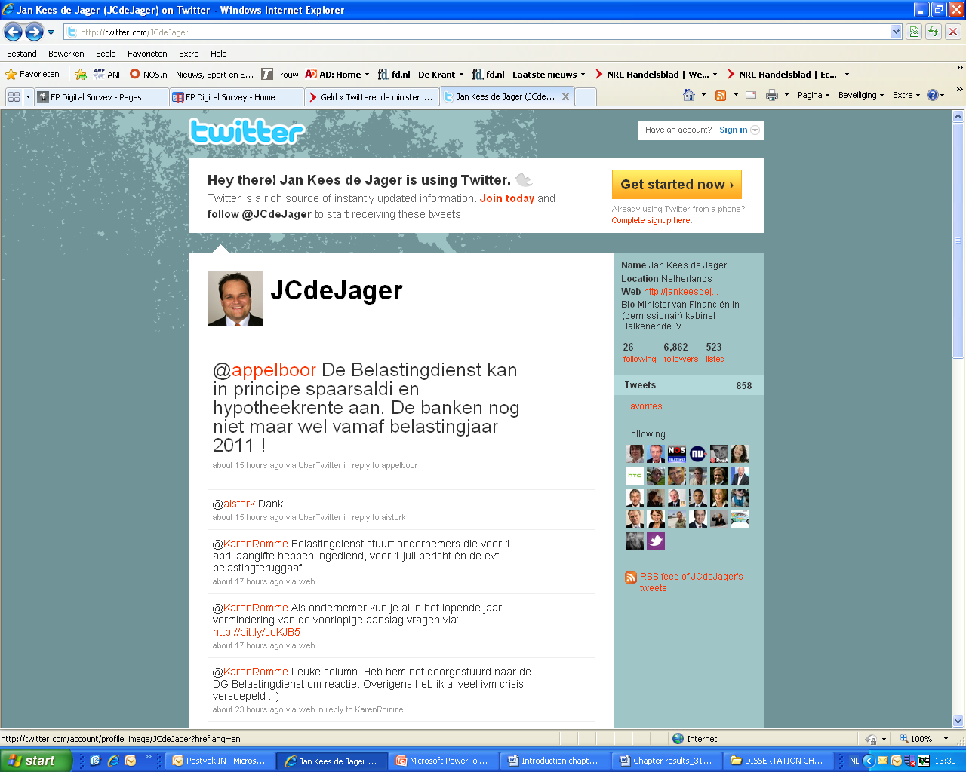

Ja, en als Griekenland heel veel Europese banken.

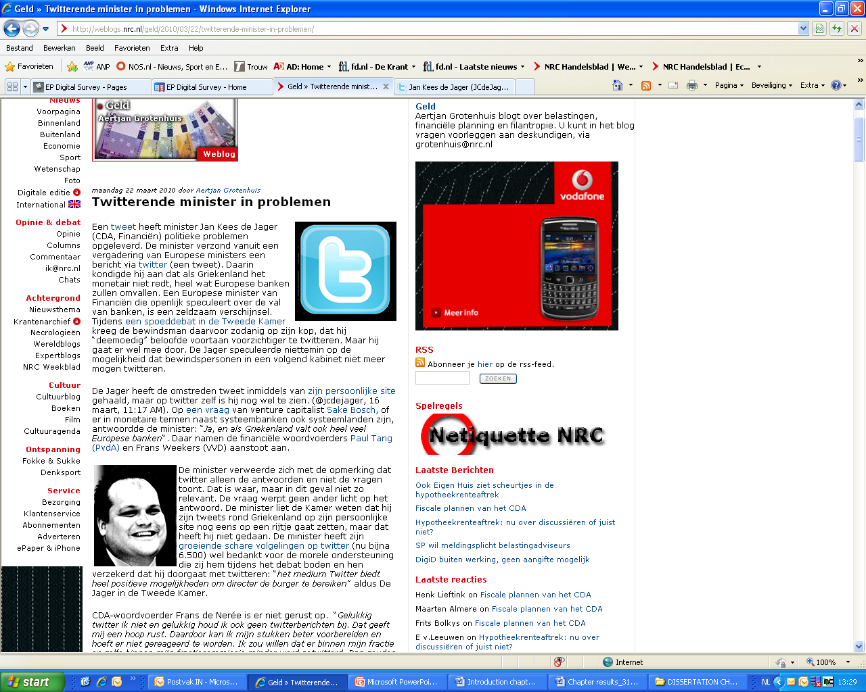

The core of the discussion was whether it was Twitter’s fault that such a hasty speculation was sent to the public without approval, or is it just the politicians fault for not knowing how to keep his mouth shut.

The article in the NRC.next received 27 reactions, indicating the following controversy of opinions:

* Twitter is just a medium and if the politician wanted to speculate, he could have blundered on another medium too
* The fact that many politicians twitter nowadays during “closed door” meetings, has an impact on the way they started to communicate publicly. Twitter is the main “culprit” for these kind of communication blunders, because the medium has no rules and regulations of its own

The crowd has been divided into two groups, one promoting the right of a politician to openly communicate with the citizens, stating that this kind of direct communication helps to bridge the gap between politics and the citizen.

On the other hand, a large group of people expressed disagreement with the current trend of Twittering politicians. They stated that politicians “Get paid to put things in order and not to play with gadgets.”

“Ministers and parliamentarians should get down to business and keep doing it instead of work on their profiling: we don’t pay them to tweet or text message.”

In this sense, it can be concluded that using social media in this way (leaking information via Twitter during meetings) is not appreciated by the citizen. This takes away from the credibility of social media tools such as Twitter and the politician himself and creates the impression that the tool in itself is dangerous, and not the person who uses it, the information sent and the way it has been used.

Politicians and social media experts interviewed for this research all shared the opinion that the impact of social media depends on how you use it and the information you communicate through it, and not so much on the medium itself.

As Kay van der Linde explains it, “Social media are just a tool. It’s the way you use it that brings its value.”

In an article on Communicatieonline.nl about social media and politics, the author Roland Kroes claims that:

Social media themselves have absolutely no norms and values. These are added by the users. Via social media the balance between sender and receiver is more proportionally divided than with traditional media.[[42]](#endnote-34)

This indicates that one could not blame political communication blunders on the social medium, however, the social medium tends to facilitate misuse and abuse of communication, for instance, by communicating information that is not meant to be communicated ( or at least it has to be “authorized”) , or communicating too often ( “politicians twittering too much nonsense and too often”) and thus irritating and antagonizing their target audience and creating indifference or even aversion towards politics.

Many of the interviewed politicians and social media experts complained of “politicians pasting the party agenda in their tweets, or boasting about how good they are,” and this kind of communicating is appreciated neither by other politicians nor by the citizen himself.

5.3 Social media has its own rules and infrastructure

It is still doubtful to what extent this is an entirely negative quality of social media, and if it only has to do with the fact that it is still new and people are judgmental of it because very few know how to use it well.

“Social media are a different infrastructure that requires a different approach, “according to Jaap Stronks, a social media expert.

He continues:

Politicians have just began using Twitter: most of them just about half an year ago, so it is a promise, a promise for a happy marriage. I think that a lot of politicians still have to learn to use the medium well and the ones that don’t use it need to overcome their prejudice. This will happen automatically because at some point you see what works and what doesn’t and in a few months the way you use social media changes. You have experimental use first and then it becomes your permanent communication tool.

5.4 Social media vs other media?

In his blog post on the CSM blog David Nieborg claims that social media are becoming as important, if not more important than television. Jaap Stronks provided the same outlook in his interview.

On his blog, David Nieborg talks about the impact of social media on the election campaign of the American President Barack Obama, “The power of YouTube, for instance, the way Obama used it, was that he eliminated the mass medium TV so that he could deliver his message directly to his supporters.”

Of course, David Nieborg admits that television has played an important role too, “Barack Obama owes a lot to the effective use of social media in his 2008 campaign, but without the use of traditional media he would have not succeeded. “

“Why would the Dutch voter be different?” asks David Nieborg, in his argumentation of the effect of social media in Dutch campaigns. Simply put: If social media are widely embraced in the Netherlands, then they should be as successful as they were in the USA.

Nevertheless, interviews with social media experts and politicians indicated that television in the Netherlands is still considered the most important medium for political communication. Additional research and literature review also indicated that TV is the # 1 medium for political communication during campaigns, in terms of reach and effectiveness.

So when it comes to campaigning, social media are only complementary, but when a politician wants to engage in a dialogue with the voter, social media alone ( and in combination with other media) have a lot more to offer than if a party or a politician was using only traditional media.

Chapter 6 Conclusions

Having put social media under a magnifying glass and analyzed all its characteristics and applications, it is clear that the medium, its users and target audiences are more complicated than it seems in the first place.

6.1 Political involvement and participation

The distance between the citizen and politics, which makes it less accessible to the average Dutch person is referred to as “the gap”. In this sense the gap means lack of interest and involvement in political issues, which results in decrease in political participation (as in voting).

One of the questions this research tried to answer is what the role of social media is in decreasing this gap.

The conclusion from the qualitative research of social media in politics is that its impact is too small to increase political involvement, and hence, participation of groups of people who are not interested in politics. At the same time, the gap was not considered a problem by politicians, and they were not using social media with the intention to decrease it. Politicians do not think that citizens have to be more interested in politics than they already are. Therefore it still remains an issue whether the lack of political interest is actually a negative occurrence.

Social media can only increase involvement of people who are already at least a bit interested in politics and of course, use social media often enough to be reached by politicians. Social media, just like other media, has no direct effect on political participation. Its effect stops at involvement and from there other factors play a more decisive role for political participation. This, however, was not a topic of this research.

6.2 The role of the media

One important conclusion was that the Dutch mainstream media played an important role in creating this “gap”. One of the main factors influencing the lack of interest in politics on a local level was that national political topics dominate the Dutch news landscape and very little attention is given to the local political leaders and parties. This shifts the little attention the citizen has for politics entirely to national topics and undermines the credibility of politicians. According to Jeroen Diepemaat from VVD in Enschede, people in his region were not motivated to vote and pointed out as the main reason the fact that the VVD party was performing bad on a national level, so why would they bother to vote for it locally? This image of the VVD is entirely forged by the mainstream media and is not always entirely correct, and not always refers to the local party.

The Dutch media trying to sell politics as infotainment leads to the commercialization of controversies between national political leaders or parties, while little time and space is left to discuss local political topics.

Local politics thus slowly loses its “face” and the citizen becomes more estranged from decision making processes that directly affect him. This has a direct effect on his trust in local politicians and their ability to represent his interests accordingly. Moreover, people nowadays tend to be more interested in individual politicians, more than parties, especially on a local level. This makes it imperative for politicians to make more effort to profile themselves better and show the person behind the politician.

6.3 Communication matters

Even though social media are accessible and widely spread in the Netherlands, they are not optimally used by politicians to try to communicate more personally and openly to citizens. The lack of experience with using online communication tools, unclear messages and insufficient knowledge of what citizens want to know about politics makes it even more challenging for politicians to communicate to their voters, even when they have access to a wide variety of (free) tools.

As accountable to the taxpayer, politicians are in a way obliged to provide transparency about their work in the local council, or the ministry, for instance. However, few have realized this is imperative, and those who have, don’t have the skills and experience with communication to be able to send relevant information, let alone engage in a dialogue with the interested citizen.

6.4 Political determinism or the “maakbaarheidsidee”[[43]](#footnote-9)

Another factor facilitating the growth of the “gap” between politics and the citizen is the nature of politics in the Netherlands and the way politicians behave. During election campaigns, politicians seek to leave the impression that they can solve grave social and economic problems within one mandate, and when they systematically fail to do so, citizens get disillusioned and gradually start ignoring (intentionally or not) political communication. Politicians expect to be able to solve problems in society which take years to be solved, and some of which can never be solved, and they try hardly to live up to their own expectations. This leads to the tendency to overpromise and under deliver, which takes away from their own credibility and the credibility of their parties as representatives of the public interest.

In a combination, these three factors: mainstream media, communication, and politics, have a massive effect on the way politics and citizens interact.

6.5 Political communication via social media: how, to whom and why

The subject of this research is to explore the role of social media in public affairs. Therefore, the focus here is on the sender (politicians), target audience (citizens), message (politics) and the medium (social media. In order to provide an answer it is important to analyze each of them in more detail.

The target audience of politicians using social media are the most important factor when evaluating its effectiveness. The second factor is the kind of political communication: information, advertising (campaigns) or debate. One has to look at the combination of both to determine the effectiveness of the medium.

For each of the purposes and communication needs, social media has a different effect. Therefore a SWOT analysis chart can best showcase the effectiveness of social media in public affairs.

The green field refers to the target group Supporters, as indicated in the triage model explained in the theoretical framework of this research report. The group Others (in blue) relates to Undecided voters and other stakeholders of the party.

As described in the theoretical framework, political communications is divided into three types:

* Information provision (news)
* Advertising (election campaigns)
* Debate (dialogue) between politicians and also politicians and citizens

These categories are taken up as pillars for the SWOT analysis below.

Table 9 SWOT *Analysis Social Media in political communication*

|  |  |  |  |  |  |  |
| --- | --- | --- | --- | --- | --- | --- |
| Supporters |  | | **S**trengths | **W**eaknesses | **O**pportunities | **T**hreats |
| Others |
| **Information (news)** |  |  | Skips the intermediary (journalists) | Less reach | To become an independent medium of its own | It is not taken seriously by other media |
|  |  | Fast | Sometimes too fast |  | Citizens demand for more speed in communication than politics can provide |
|  |  | Open | Sometimes too open | Increases transparency in politics | Can lead to loss of credibility |
|  |  | Immediacy (real-time) |  |  | Can lead to misuse of the tool: communicating more often than it is necessary |
|  |  | Personal | Sometimes too personal: does not interest everyone in the same way | Message retained longer when relevant to the reader |  |
|  |  | Provides different points of view (own points of view of politicians) |  | Can be used proactively, as a reputation management tool |  |
|  |  | Snowball effect of information reach |  | Can reach target groups larger then intended | Difficult to manage |
|  |  |  |  |  |  |  |
| **Advertising (campaigns)** |  |  | Cheap | Not used only by professionals | Will be widely accessible | To be used only because it's free |
|  |  | Personal | Tendency to conventionalize information to make it accessible to a wider group | Message retained longer when relevant to the audience |  |
|  |  | Ability to track reach online & monitor performance |  | Improvement of tactics based on evaluation |  |
|  |  | Influencing opinions |  | Can be used to promote own views and impact the public | Can become too polarized-> reach a smaller, alternative target group |
|  |  | Organisational tool (campaign causes) | Effective only with many followers > 10 000 | Can be used to organize people to act for a certain popular cause |  |
|  |  | Snowball effect of dissemination of message |  | Can reach target groups larger then intended | Difficult to manage |
|  |  |  |  |  |  |  |
| **Debate (dialogue)** |  |  | Low threshold |  | A wider target group can become involved |  |
|  |  | Immediacy (real-time) |  | Ability to respond immediately, also to protect reputation and preempt competition | Can lead to abuse/misuse of the tool: communicating more often than it is necessary |
|  |  | Feedback |  | Provides opportunity for politics to implement feedback into policy |  |
|  |  | Open | Sometimes too open | Increases transparency in politics | Can lead to loss of credibility |
|  |  | Personal | Sometimes too personal: does not interest everyone in the same way | Message is requested by the reader so it is well accepted | The medium can be seen as a gossip corner |
|  |  | Interactive (sender can become receiver and vice versa) |  | Places politicians on the same level as citizens | The intended "receiver” might take control |
|  |  |  |  |  |  |  |

6.6 Skipping the intermediary

As indicated at the beginning of the Research findings chapter, the mainstream media and journalists play the role of an intermediary between citizens and politics.

6.6.1. Engaging in a dialogue.

When used in political communication, social media can skip these intermediaries, and reach the citizen more directly. In some cases, as shown in the above SWOT table, this is highly desirable, such as when a politician wants to engage in a dialogue. In that sense, social media can be very effective within a certain target group, as indicated above. Usually these are not specifically voters of the party, but people who are active on social media, so they can also be from other parties or be floating voters. The key issue here is that by engaging in a dialogue with a certain group of citizens via social media, a politician cannot possibly convert them into supporters of the party. What can happen is exchange of information, opinions, and discussions, and depending on the target group, some will have more effect on involvement than others. Moreover, when using social media, Dutch politicians are predominantly focused on communicating to two target groups:

* The people who voted for them and members of the party ( if the politician has already been a council member)
* Supporters of the party who might vote for them because the politicians are candidates and are included on the preference votes list

Therefore, it can be concluded that at this stage, the Dutch politician is still focused mostly on his voters, and is not proactively seeking to engage in a dialogue with a broader target audience. Even though politicians say that they “try to reach as many people as possible” this is not about debate, but about information providing and advertising (the other two political communication purposes).

6.7 Providing information and advertising

However, when a politician wants to disseminate information and promote himself he is seeking to reach as wider group as possible and for this, intermediaries as the mainstream media are crucial. During the interviews all politicians and media experts stated that it was important for them to have their blog posts also published in the local/national press or that they get interviewed for the television. The selection criteria from the Best Web Politician competition also showed how important the cross-link is between social and traditional media for the promotion of a certain politician and his party during the elections. One of the criteria for selection of the Best Web Politician was “if his online activities were interesting for newspapers, radio and TV.”

Therefore, it can be concluded that for information providing and advertising, social media are only efficient when they work in a combination with the traditional media and not when they try to skip this intermediary.

Chapter 7 Recommendations

“Charisma, message and popularity,” Kay van der Linde

These are the three qualities that turned Barack Obama into role model for politicians worldwide. In the recent local elections Dutch politicians tried to replicate some of his tactics, but as this research proved, the effect was minimal.

This research outlined the key characteristics and bottlenecks that make it hard for Dutch politicians to interact with the citizen during and between campaigns. This final part of the research is dedicated to providing recommendations on how Dutch politicians can better utilize social media for information provision, advertising during campaigns and dialogue with the citizen.

7.1 The power of the brand

In online communications, visibility on search engines is crucial. According to Kay van der Linde, “Political parties are brands, and so are politicians”. You can engage in a dialogue about these brands, because people recognize them and proactively search for them online. But if you aren’t a brand, you are unknown by definition and people won’t look you up on Google, or on Twitter or Facebook.”

Figure 10 *Two popular brands in The Netherlands*

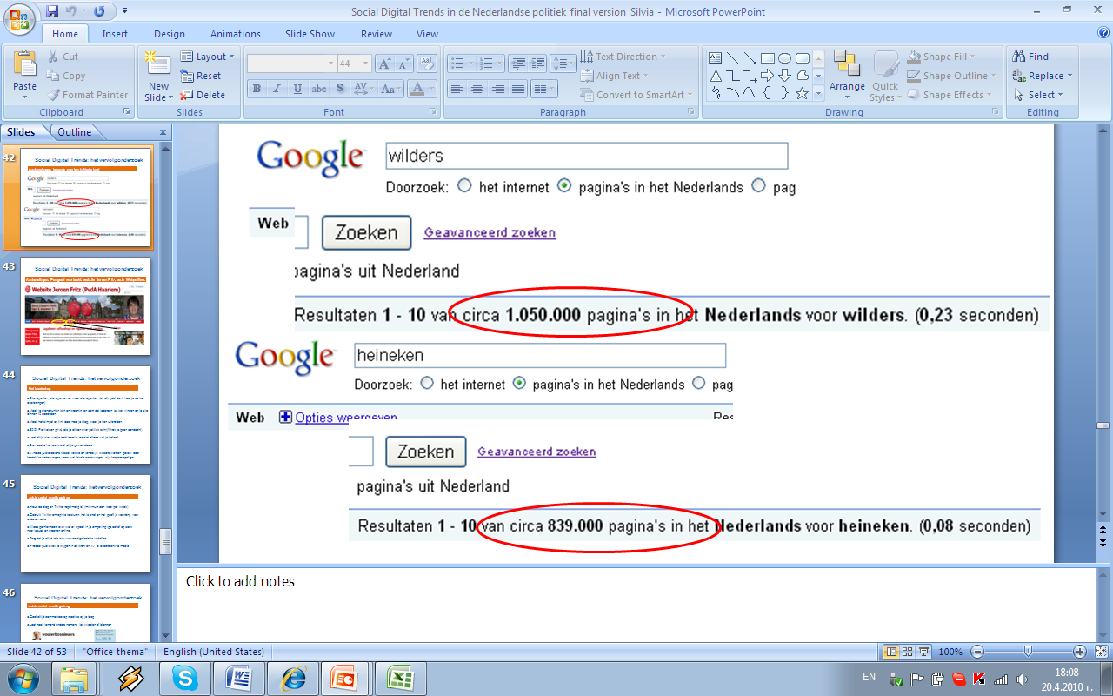

A simple experiment on Google shows what Kay van der Linde means with “brands”. The fact that a Google search on the surname of Geert Wilders generates more results than a search on the popular beer brand Heineken, is a proof for the fact that online popularity is generated by offline popularity, and not vice versa.

At the same time, with politics becoming more personal, people are interested in persons, not parties. When they have a question they want an answer from the politician, and not the party. Especially in the Netherlands, where the role of the individual politician for attracting votes for the party in local elections is so crucial, politicians are under a much bigger pressure to profile themselves online as brands.

Therefore, before politicians set out to profile themselves on the internet for a political campaign, they need to first think about their current popularity. “ Do people know me from other media already?”, “ Do people search for me on Google?”, “ Do they talk about me on other social media platforms?”, “Do articles about me in the online newspapers receive comments?”, these are examples of questions that politicians need to answer first before they start positioning themselves on the internet. Monitoring is the way to do it: there is a variety of free tools online that will help you to find out what your current reputation is at the moment.

Of course, if you are already popular, such as Femke Halsema from Groenlinks, Maxime Verhagen from CDA or Mei Li Vos from PvdA, it will take less effort to improve your visibility. However, popularity is not all it takes. Having a clear message and being a charismatic speaker (or a good writer) are also important. This is especially relevant for local politicians, who start out with almost zero popularity, but by bringing out memorable messages and being consistent in their communication, can achieve quite a lot of popularity on a local level. After all, in some municipalities it takes only a few hundred votes to enter the city council, and there are local politicians who can reach that threshold by streamlining the power of on- and offline media into an integrated communication strategy.

7.2 Simple and clear messages

Content is crucial in online communication. The fact that social media are used as a personal platform and are more directly targeted to the audience makes them a robust platform for powerful messages. However, if your message is superficial and has no value for your audience, it will turn into a feather that will be easily blown away by the surge of more interesting topics in other media. Without a powerful message, social media are just an empty placeholder. You need to have something important to say before you decide how you want to say it. The starting point for politicians on a local level are the standing points of their party, what they have achieved and what they want to achieve in the city council. This research showed it was the most important content that politicians need to provide before they seek any further engagement of the citizen and it is also the one point where politicians fail most.

According to Jeroen Fritz, winner of the prize for Best Web Politician:

Every politician needs to be able to deliver the main points of his argument in 140 characters (the limit of a message in Twitter). If these words are not enough, then you won’t be able to make your point even if you have 30 minutes in a room full of people.

As the research from Best Web Politician indicated, very few politicians succeeded in making their standpoints visible on their website or blog, let alone explaining them on social networks such as Twitter. A good example is the website of Jeroen Fritz, where standpoints and achievements are the first things one sees when opening his website.

Figure 11: *Best Web politician's website: an example*

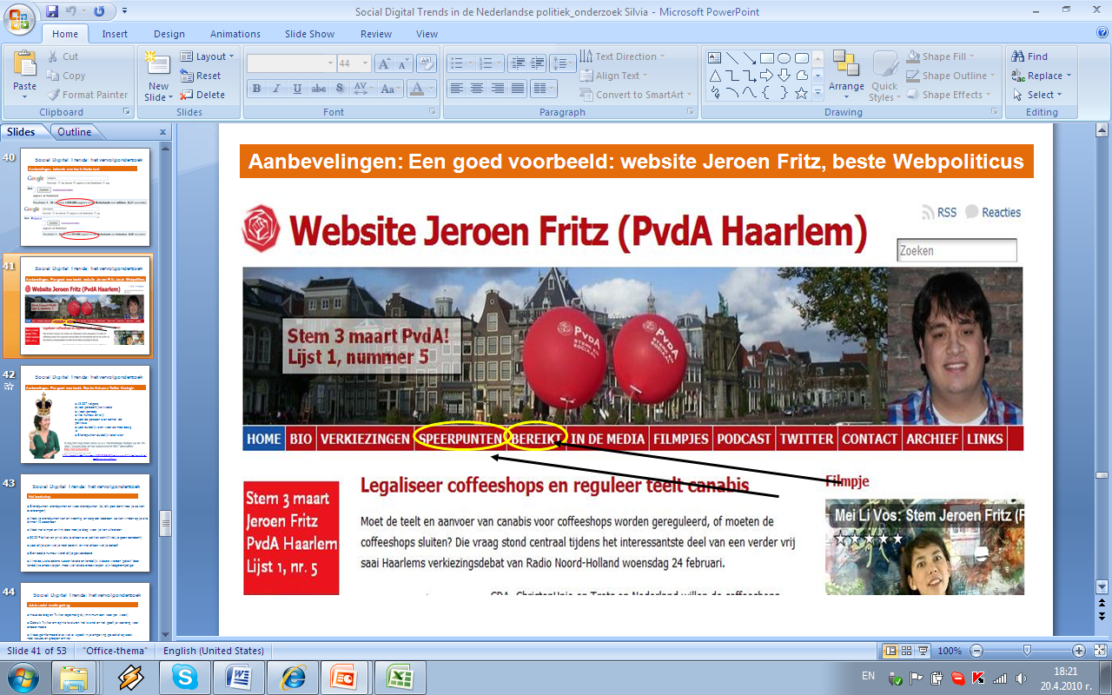

7.3 Confusing presence with participation

A key characteristic of social media are that it is interactive: sender and receiver switch positions constantly. Therefore it is not enough to simply be visible, but you need to be able to listen, provide feedback and answer questions. A common mistake politicians in the Netherlands make is confusing presence with participation in social media and this is what causes their failure in involving the citizen. If you are not updating your blog and Twitter account regularly, people will not go back every day to check it there is something new posted, and eventually, you will lose them as an audience forever.

In this sense content is not enough because even if you are the most talented blogger or Twitterer, you will lose your audience if you don’t keep up with the speed of events and the “thirst” of people for news. The modern citizen is spoiled by the increasing access to free news from a variety of channels, and the speed with which he receives updates about political affairs is increasing every year. Nowadays citizens won’t wait until the news is broadcast on RTL in the evening, but they will check their Twitter accounts or Google to follow discussions about breaking news. And smart politicians can take advantage of that, since now Google is also displaying live Twitter results from the most discussed topics. A politician who has mastered this skill is Femke Halsema, whose Twitter account with her 41 274 followers has become THE source of political news and commentary, even when it comes to other parties than Groenlinks.

Figure 12: *Twitter live feed in Google*

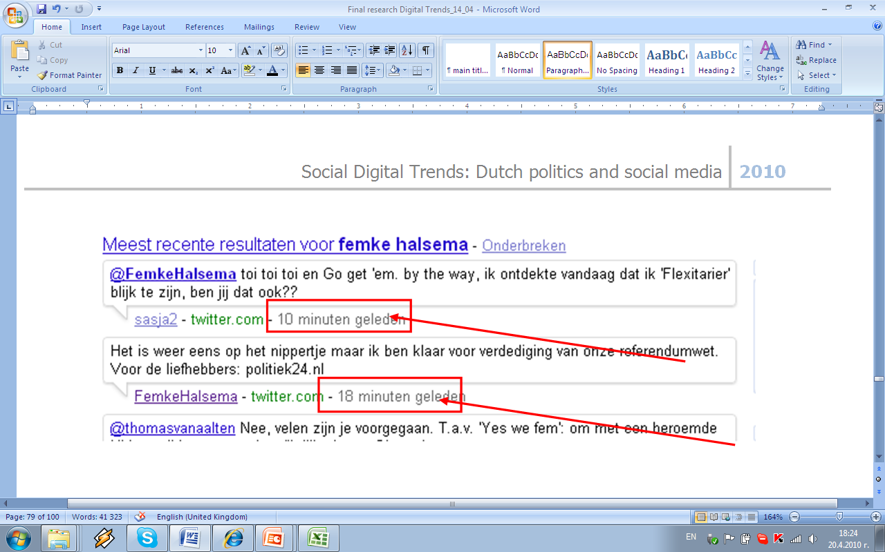

Figure 13 *Femke Halsema: the Twitter queen: a good example of using Twitter and a blog*

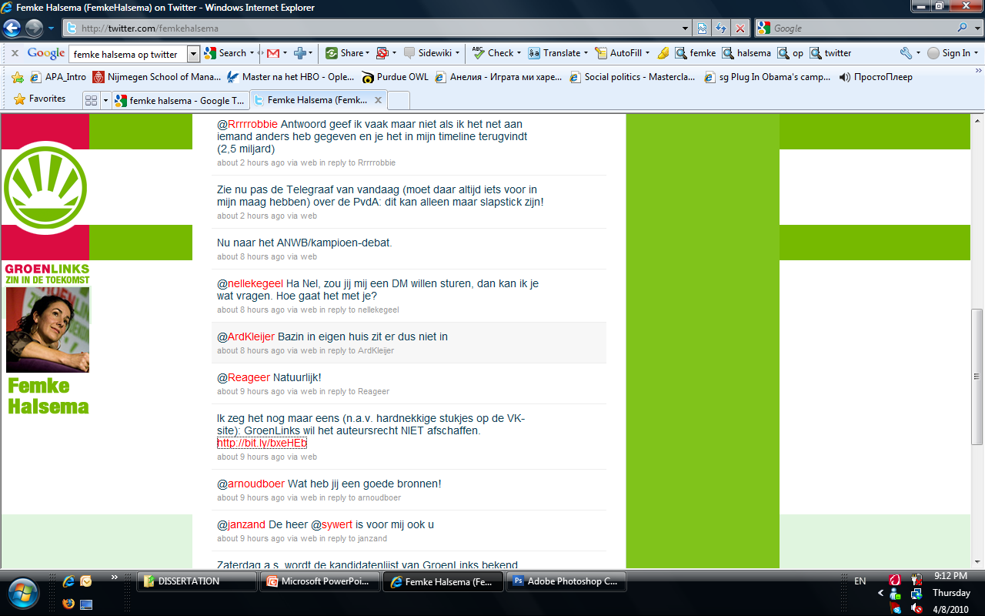

This tweet linked to a blog post that Femke Halsema wrote, in which she elaborates on the topic of copyrights for the music industry. It is a perfect example of how politicians should use Twitter to generate traffic to their blogs. . Twitter is very important since it displays a live feed of the results on Google, therefore when one is searching for a politician online, one gets the politician’s Twitter account on the search results page. Therefore, the best way to disseminate news (or promote the latest blog post) is to add a link with a short message on Twitter, so that people searching online can then click through to the politician’s blog to read the content in details. The same counts for other content, such as links to articles in news websites, or promotional YouTube films.

Femke Halsema received 48 comments on her blog post, and most of them were quite critical. She received so many comments because of the great number of Twitter followers she has, even though not all of them are following her blog. This example shows that Femke Halsema’s followers on Twitter are not only her party supporters, but also people from other parties or undecided voters, as it can be seen from the comments she received on her post.(available at: <http://www.femkehalsema.nl/2010/04/02/auteursrecht-is-aan-grondige-modernisering-toe/>)

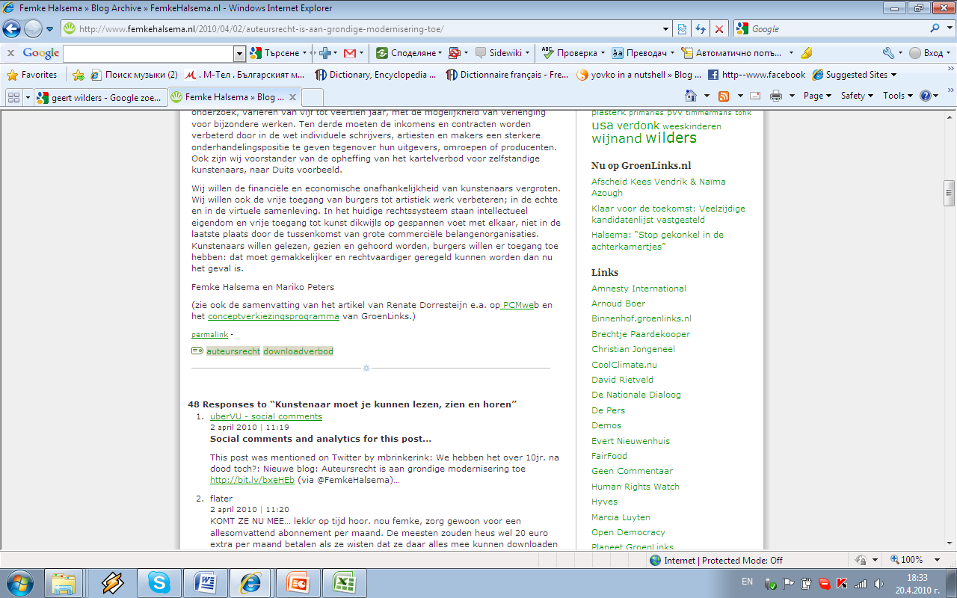

7.4 “This is why it is social media, not political media”[[44]](#footnote-10)

Social media provides the freedom for a politician to “show the person behind the politician” and engage in a more personal style of communication. The fact that people using Twitter and other social media platforms follow persons on them, not groups, is proof for one important characteristic of social media: it is personal.

Therefore, political parties and groups are not popular on social media (very few read the Groenlinks blog, but many more David Rietveld’s blog). For individuals (politicians) social media are THE number one choice channel to use. Therefore, pasting your party agenda in Twitter will not yield you more followers; there are other media where this information should be published. People expect to see personality on social media; they look for it there because they can’t find it in any other medium.

The right mix of political content and some background information about the politician’s personal activities related to it are the best recipe for gaining popularity on Twitter and blogs. Showing sense of humor and a tinge of sarcasm, being critical and honest, these are the qualities of a successful political blogger. With so many politicians using such platforms and so little attention from the reader, only the best and most talented will stand out from the mass. Marc Dubach from D66 Eindhoven won the prize for best Twitterer because of his funny, yet savvy and original tweets. Femke Halsema is also referred to as the “Twitter queen” for her humoristic and engaging yet objective reporting of the current events in the Dutch parliament.

7.5 Dialogue and monologue

Social media are ideally positioned as a platform for dialogue, promotion and information provision in politics. However, “Social media are a different infrastructure that requires a different approach,” as Jaap Stronks explains. An important quality of social media are that they are interlinked, as explained in beginning of the Research findings chapter of this report. Very often politicians forget that and use them independently, while the value of a blog, Twitter account and YouTube channel is exactly the fact that you can link between them and other media ( such as online news channels or newspapers).

According to social media experts, the main online platform of a politician should be his website/blog. It has to link to all his other social media accounts: Twitter, Hyves, YouTube channels, etc

As Jaap Stronks explains it:

Journalists are used to telling stories, while politics has always had a dialogue nature. This is only logical because these people are in the parliament or the city council because we have chosen them and we indirectly control the administration of the municipality or the government.

Therefore, an interaction with the mainstream media is crucial if a politician wants to have a good online presence and engage his (potential) voters. The more comments on your blog, the more journalists will be likely to see it and the more likely they will be interested in interviewing the politician and eventually writing an article about him in the local/national press or showing him on TV.

However, the most exciting feature of social media is that it facilitates dialogue between politicians and citizens. The Twitter accounts of politicians are open, and anyone can leave comments on their websites/blogs. The challenge here is to respond to comments and provide answers. Not every politician has mastered these skills. If a politician is only posting content without following responses and listening to feedback, his efforts in using social media are futile

7.6 “The ball is in the hands of politicians” [[45]](#footnote-11)

Marc Dubach from D66 Eindhoven won the Best Twittering politician prize by Best Web Politician, because he was actively searching for involved citizens in his town on Twitter. By joining these groups and following their conversations he gets an insight into what they talk about, what issues are important to them, what is happening in the community and as soon as he sees something that he is responsible for as city council member, he steps in.

When using social media, politicians need to embrace the idea that they have to proactively seek engagement with relevant groups of people, potential voters or citizens, where their intervention can make a difference and be appreciated. A common mistake of politicians using Twitter is following only journalists and other politicians. This is not helping them to engage in a dialogue with the citizen, it only estranges them from this primary audience. Politics cannot become more relevant for the average citizen if a politician in the city council is only talking to other politicians on Twitter or when only politicians leave comments on his blog.

7. 7 The role of the opinion leaders

The widespread presence of journalists and politicians on social media platforms has an indirect positive effect on the spreading of political information to other social or traditional media. These people usually have their own networks, which are made up mostly of very active internet users who help spread a relevant political message faster than the average citizen. The role of journalists, politicians and other active Twitterers online as opinion leaders is therefore important, and a politician needs to be able to split his attention between both groups that will help him spread the message to different target groups: on one hand, the involved citizen in the local community, and on the other, all others that would be interested in what he has to say but are not proactively looking for contact or are too far away (in the sense that they belong to another networks). The retweet function of Twitter has a major role in this, and politicians need to be able to send out succinct and impactful messages that require little editing, so that they can be easily retweeted. (retweeting mean “quoting” someone on Twitter, it is explained in the beginning of the Research Findings chapter).

7.8 Social and mainstream media

The collaboration between social media and traditional media is crucial, not only for disseminating information to a wider group (the snowball effect of social media), but also for positioning of the politician as a brand and raising awareness about his activities. The main challenge in the Dutch media system is the focus on national politics and representing politics as infotainment, as it was indicated in the theoretical framework and findings of this research.

Even though there is no direct solution for this challenge, “The local press has to pay more attention to local politics, but the local politicians need to make effort to make their statement more interesting so that the media can do something with it, “according to Stijn Verbruggen from PvdA Nijmegen.

“But this also means that local politicians need to produce more content, tell more stories, make more films, use social media and this still has a long way to go, “ according to Jaap Stronks, a social media expert.

7.9 Which social media?

This research showed that the most used tools for political communications during the recent election campaign were Twitter, blogs and websites (a website can be perceived as social media if it has widgets on it linking it to social media platforms). There is no coincidence in that: these tools proved to attract the most politically involved target group. Hyves and Facebook proved to be less effective because of the kind of people that are using it. Politicians felt they were not able to instigate a politically-laden dialogue on Hyves, because people there did not seem to respond positively to political content. Research by InSite, published in March 2010, also proved that social networks such as these are mostly used for entertainment purposes.

One of the most important tips of social media experts and politicians interviewed for this research was to “Know where your target group is.” This couldn’t be more relevant for social media. There is no point in being present on all social media platforms if the people you want to reach are not there, or if your message is not suitable for conversations taking place on that network.”

7.10 The lifecycle of social media

Finally, these recommendations need to be placed in the context of the state of social media in 2010. Social media are relatively new tools for politicians and a lot have just recently started experimenting with them. According to social media expert Jaap Stronks, social media always goes through an experimentation stage, where one tries to discover the added value of the tool before one starts using it as a permanent communication tool. This is a stage where the medium is often misused, because of lack of experience. The examples provided in this research indicated what the pitfalls can be for social media beginners, such as most of the politicians in the Netherlands nowadays.

However, this experimentation stage gradually moves to an implementation stage where the medium is used more professionally and a lot of the mistakes described in this research are avoided. However, there is also a stage where people give up on using social media, for instance, what happened to blogs, a few years after they became popular in 2001. Many politicians confided that they quit blogging for a while because they didn’t find it interesting but when Twitter became popular in 2008 they discovered the value of the combination of a blog and a Twitter account and became excited about blogging again.

This is a normal occurrence because “This is the way humans use innovation,” as Jaap Stronks explains it.

Bibliography

Books

Aalberts, C. (2006). [*Aantrekkelijke*](JavaScript:LinkToWord('aantrekkelijke','Index201'))[*politiek?*](JavaScript:LinkToWord('politiek','Index201')) *: een* [*onderzoek*](JavaScript:LinkToWord('onderzoek','Index201')) *naar* [*jongeren*](JavaScript:LinkToWord('jongeren','Index201'))[*en*](JavaScript:LinkToWord('en','Index201'))[*popularisering*](JavaScript:LinkToWord('popularisering','Index201'))[*van*](JavaScript:LinkToWord('van','Index201'))[*politiek*](JavaScript:LinkToWord('politiek','Index201'))*.* Apeldoorn: Het Spinhuis.

Blom, E. (2009). *Handboek communities: de kracht van sociale netwerken* (2nd ed). Utrecht: AW Bruna.

Edwards, A. (2003). *De gefaciliteerde democratie:internet, de burger en zijn intermediairen*. Utrecht: Lemma.

Kleinnijenhuis, J. & Scholten, O. (2007). *Nederland vijfstromenland*. Amsterdam: Bert Bakker.

Thevissen, F. (1994). [*Politieke*](JavaScript:LinkToWord('politieke','Index201'))[*marketing*](JavaScript:LinkToWord('marketing','Index201'))[*en*](JavaScript:LinkToWord('en','Index201'))[*communicatie*](JavaScript:LinkToWord('communicatie','Index201'))*:* [*politieke*](JavaScript:LinkToWord('politieke','Index201'))[*marketingstrategieën*](JavaScript:LinkToWord('marketingstrategieen','Index201'))[*en*](JavaScript:LinkToWord('en','Index201')) *de* [*impact*](JavaScript:LinkToWord('impact','Index201'))[*van*](JavaScript:LinkToWord('van','Index201'))[*electorale*](JavaScript:LinkToWord('electorale','Index201'))[*campagnes*](JavaScript:LinkToWord('campagnes','Index201')) *op het* [*kiesgedrag*](JavaScript:LinkToWord('kiesgedrag','Index201')). Brussel: VUBPRESS.

Van Dooren, R. (2000). *Traditie en Transformatie. Politiek en staatsinrichting in Nederland*. Amsterdam: Instituut voor Publiek en Politiek.

Van Vliet, H. (2008). *The zone of proximal media development*. Deventer: Plan B Publishers.

Reports

Aalberts, C. & Kreijveld, M.(2009). Knowledge exchange through online political networks (Research abstract).

Aalberts, C. (2008). Podcasts, blogs en YouTube: Nieuwe manieren voor politici om burgers te bereiken?.(Research report, Nederlandse Kring voor de Wetenschap der Politiek, 2008).

Berenschot.(2010). iBalans gemeenteraadsverkiezingen 2010. Amsterdam: Berenschot.

Drezner, D.W. & Farrell, H. (2004). *The power and politics of blogs*. Retrieved from <http://www.cs.duke.edu/courses/spring05/cps182s/readings/blogpowerpolitics.pdf>

Eenhoorn, M. (2004). Media versus politiek: politieke inhoud vervlakt. (Dissertation report, Hogeschool Utrecht, 2004). Retrieved from the Faculty of Communication and Journalism, Hogeschool Utrecht library catalogue.

Hendrikx van der Spek Communicatiebureau. (2010). *Juryrapport Beste lokale Webpoliticus 2010*. Bussum.

Insite Consulting.(2010). *Social networks around the world 2010* [PowerPoint slides]. Retrieved from <http://www.slideshare.net/stevenvanbelleghem/social-networks-around-the-world-2010>

Schrijver, J. (2006). Regionale omroepen zijn het medium bij uitstekom de kloof tussen politiek en burger te verkleinen. (Research report, Hogeschool Utrecht, 2004). Retrieved from the Faculty of Communication and Journalism, Hogeschool Utrecht library catalogue.

Magazines

Bouwman, B. (2010, January 30). Kwetterende kamerleden. *Elsevier*, 4, 28-29.

Online (newspaper) articles

Aalberts, C. (n.d.) Visie. Message posted to: <http://www.chrisaalberts.nl/visie-1.html>

Drees, M. (2008, December 17). *Sociale media: Nederland actief, Duitsland passief*. Retrieved from <http://recruitmentmatters.nl/2008/12/17/sociale-media-nederland-actief-duitsland-passief/#ixzz0aVsBXRWo>

[Grotenhuis](http://weblogs.nrc.nl/geld/author/aertjang/), A. (2010, March 22). Twitterende minister in problemen. *NRC Handelsblad*. Retrieved from <http://weblogs.nrc.nl/geld/2010/03/22/twitterende-minister-in-problemen/>

Instituut voor Publiek en Politiek. (n.d).*Verkiezingen/opkomstcijfers*. Retrieved from <http://www.publiek-politiek.nl/Info-over-politiek/Verkiezingen/Opkomstcijfers>

Kroes, R. (2010, January 28th). Social Media gaat Wilders niet per se stemmen kosten. *Communicatieonline.nl.* Retrieved from <http://www.communicatieonline.nl/opinie/bericht/social-media-gaat-wilders-niet-per-se-stemmen-kosten/>

Nieborg, D. (2009, June 2). [De waarde van Obama’s social media strategie voor Nederlandse politici](http://www.csnblog.nl/de-waarde-van-obamas-social-media-strategie-voor-nederlandse-politici/). Message posted to <http://www.csnblog.nl/de-waarde-van-obamas-social-media-strategie-voor-nederlandse-politici/>

Paternotte, B. (2009, April 2). [Een schietpartij op een D66-congres? Hoe nieuws ontstaat via Twitter](http://politiekonline.wordpress.com/2009/04/02/een-schietpartij-op-een-d66-congres-hoe-nieuws-ontstaat-via-twitter/). Message posted to <http://politiekonline.wordpress.com/2009/04/02/een-schietpartij-op-een-d66-congres-hoe-nieuws-ontstaat-via-twitter/>

Vlug, G. (2001, March 10). Waarom Burgerparticipatie 2.0 niet lukt. *Tijdschrift voor marketing: Molblog.* Retrieved from <http://www.molblog.nl/bericht/waarom-burgerparticipatie-2.0-niet-lukt/>

Villamedia. (2009, October 30). Jaap Jansen naar Een Vandaag. *Villamedia*. Retrieved from <http://www.villamedia.nl/personalia/bericht/jaap-jansen-naar-een-vandaag/>

Definitions

Floating voter. (.n.d.) In *The Free Dictionary*. Retrieved from: <http://www.thefreedictionary.com/floating+voter>

Twitter. (n.d.) In *PC Magazine Encyclopedia online*. Retrieved from <http://www.pcmag.com/encyclopedia_term/0,2542,t=Twitter&i=57880,00.asp>

Video podcast

Nieborg, D. (Speaker). (2009, July 7).Obama’s champagne: tussen hoop en hype. Podcast retrieved from <http://131.211.194.110/site1/Viewer/?peid=788fc79581b840dfb2b949bcbaf8ac2b>

Appendices

1. Questionnaire questions (in Dutch)

**Onderzoek gebruik sociale media**

Vragenlijst

**Vraag 1** belangstelling politiek **verplicht** , knop Vorige niet weergeven

Welkom in de vragenlijst!  
  
Er volgt nu eerst een aantal vragen over uw politieke betrokkenheid.  
  
Als er in gezelschap over binnenlandse politiek wordt gesproken, wat is dan uw houding? *(gesloten enkelvoudig)*

1. Ik doe meestal mee met het gesprek
2. Ik luister alleen met belangstelling
3. Ik heb geen belangstelling voor binnenlandse politiek

**Vraag 2** interesse politiek **verplicht** , knop Vorige niet weergeven

In hoeverre bent u geïnteresseerd in politieke onderwerpen? *(gesloten enkelvoudig)*

1. Ik ben zeer geïnteresseerd
2. Ik ben geïnteresseerd
3. Ik ben niet geïnteresseerd
4. Ik ben helemaal niet geïnteresseerd

**Vraag 3** hoogte politiek **verplicht** , knop Vorige niet weergeven

In hoeverre bent u op de hoogte van de lokale politiek? *(gesloten enkelvoudig)*

1. Ik ben zeer op de hoogte
2. Ik ben op de hoogte
3. Ik ben niet op de hoogte
4. Ik ben helemaal niet op de hoogte

**Vraag 4** kans stemmen **verplicht** , knop Vorige niet weergeven

Hoe groot acht u de kans dat u gaat stemmen bij de gemeenteraadsverkiezingen op 3 maart 2010? *(gesloten enkelvoudig)*

1. Ik ga zeker wel stemmen
2. Ik ga waarschijnlijk wel stemmen
3. Ik ga waarschijnlijk niet stemmen
4. Ik ga zeker niet stemmen

**Vraag 5** gebruik media **verplicht** , knop Vorige niet weergeven

Hoe vaak gebruikt u onderstaande media om op de hoogte te blijven van de lokale politiek? *(matrix enkelvoudig)*

|  |  |  |  |  |  |  |
| --- | --- | --- | --- | --- | --- | --- |
|  | Dagelijks | Vaak (3 tot 4 dagen in de week) | Af en toe (1 tot 2 dagen in de week) | Niet of nauwelijks (minder dan 1 keer per maand) | Nooit | Ik heb nog nooit van deze media gehoord |
| TV | 1 | 2 | 3 | 4 | 5 | 6 |
| Radio | 1 | 2 | 3 | 4 | 5 | 6 |
| Kranten/Magazines | 1 | 2 | 3 | 4 | 5 | 6 |
| Gemeentekrant/ folders | 1 | 2 | 3 | 4 | 5 | 6 |
| Brochures lokale politieke partijen | 1 | 2 | 3 | 4 | 5 | 6 |

**Vraag 6** gebruik media 2 **verplicht** , knop Vorige niet weergeven

Hoe vaak gebruikt u onderstaande media om op de hoogte te blijven van de lokale politiek? *(matrix enkelvoudig)*

|  |  |  |  |  |  |  |
| --- | --- | --- | --- | --- | --- | --- |
|  | Dagelijks | Vaak (3 tot 4 dagen in de week) | Af en toe (1 tot 2 dagen in de week) | Niet of nauwelijks (minder dan 1 keer per maand) | Nooit | Ik heb nog nooit van deze media gehoord |
| Bijeenkomsten | 1 | 2 | 3 | 4 | 5 | 6 |
| Het gemeenteloket zelf | 1 | 2 | 3 | 4 | 5 | 6 |
| Campagneteams op straat | 1 | 2 | 3 | 4 | 5 | 6 |
| Via persoonlijk contact met gemeenteraad/ ambtenaren | 1 | 2 | 3 | 4 | 5 | 6 |

**Vraag 7** gebruik internet **verplicht** , knop Vorige niet weergeven

Er volgt nu een aantal vragen over het gebruik van (sociale) media en lokale politiek.  
  
Hoe vaak gebruikt u het internet (waaronder e-mail)? *(gesloten enkelvoudig)*

1. Elke dag
2. Bijna alle dagen (5 tot 6 dagen in de week)
3. Vaak (3 tot 4 dagen in de week)
4. Af en toe (1 tot 2 dagen in de week)
5. Minder dan 1 keer per week
6. Minder dan 1 keer per maand

**Vraag 8** opkomst sociale media **verplicht** , knop Vorige niet weergeven

De laatste tijd is er veel in het nieuws over de opkomst van sociale media, zoals Twitter, Hyves, Facebook, SchoolBank e.a.  
  
Gebruikt u een van deze media? *(gesloten enkelvoudig)*

1. Ja
2. Nee

**Vraag 9** gebruik online media **verplicht** , knop Vorige niet weergeven

Hoe vaak gebruikt u onderstaande media om op de hoogte te blijven van de lokale politiek? *(matrix enkelvoudig)*

|  |  |  |  |  |  |  |
| --- | --- | --- | --- | --- | --- | --- |
|  | Dagelijks | Vaak (3 tot 4 dagen in de week) | Af en toe (1 tot 2 dagen in de week) | Niet of nauwelijks (minder dan 1 keer per maand) | Nooit | Ik heb nog nooit van deze media gehoord |
| Websites (bijvoorbeeld, van politieke partijen) | 1 | 2 | 3 | 4 | 5 | 6 |
| Blogs (bijvoorbeeld, van lijsttrekkers) | 1 | 2 | 3 | 4 | 5 | 6 |
| Social communities (zoals Facebook, Hyves) | 1 | 2 | 3 | 4 | 5 | 6 |
| Twitter (micro-blogging) | 1 | 2 | 3 | 4 | 5 | 6 |
| Video sites (Youtube) | 1 | 2 | 3 | 4 | 5 | 6 |
| Forums | 1 | 2 | 3 | 4 | 5 | 6 |

**Vraag 10** gebruik passief **verplicht** , knop Vorige niet weergeven

Welke van onderstaande sociale media gebruikt u zoal?  
  
Het gaat hier om passief gebruik (lezen, bron van informatie). *(matrix enkelvoudig)*

|  |  |  |  |  |  |  |
| --- | --- | --- | --- | --- | --- | --- |
|  | Dagelijks | Vaak (3 tot 4 dagen in de week) | Af en toe (1 tot 2 dagen in de week) | Niet of nauwelijks (minder dan 1 keer per maand) | Nooit | Ik heb nog nooit van deze sociale media gehoord |
| Blogs | 1 | 2 | 3 | 4 | 5 | 6 |
| Twitter (micro-blogging) | 1 | 2 | 3 | 4 | 5 | 6 |
| Sociale netwerken (zoals Facebook, Hyves) | 1 | 2 | 3 | 4 | 5 | 6 |
| Video sites (Youtube) | 1 | 2 | 3 | 4 | 5 | 6 |
| Forums | 1 | 2 | 3 | 4 | 5 | 6 |

**Vraag 11** gebruik actief **verplicht** , knop Vorige niet weergeven

Welke van onderstaande sociale media gebruikt u zoal?  
  
LET OP: Het gaat hier om actief gebruik (zelf content publiceren, commentaren plaatsen). *(matrix enkelvoudig)*

|  |  |  |  |  |  |  |
| --- | --- | --- | --- | --- | --- | --- |
|  | Dagelijks | Vaak (3 tot 4 dagen in de week) | Af en toe (1 tot 2 dagen in de week) | Niet of nauwelijks (minder dan 1 keer per maand) | Nooit | Ik heb nog nooit van deze sociale media gehoord |
| Blogs (uw eigen, of van anderen) | 1 | 2 | 3 | 4 | 5 | 6 |
| Twitter (micro-blogging) | 1 | 2 | 3 | 4 | 5 | 6 |
| Sociale netwerken (zoals Facebook, Hyves) | 1 | 2 | 3 | 4 | 5 | 6 |
| Video sites (Youtube) | 1 | 2 | 3 | 4 | 5 | 6 |
| Forums | 1 | 2 | 3 | 4 | 5 | 6 |

**Vraag 12** gebruik passief politiek **verplicht** , knop Vorige niet weergeven

Er zijn verschillende manieren waarop u zich met gemeentelijke politiek bezig kunt houden. U kunt bijvoorbeeld het nieuws over lokale politieke ontwikkelingen volgen, u informeren over gemeentelijke beslissingen, uw mening verkondigen over lokale politieke zaken, contact zoeken met lokale politici of gemeenteambtenaren, buurtbewoners activeren over lokale politieke issues, etc.   
  
Welke van onderstaande sociale media gebruikt u in die zin voor gemeentelijke politiek?  
  
Het gaat hier om passief gebruik (lezen, bron van informatie). *(matrix enkelvoudig)*

|  |  |  |  |  |  |  |
| --- | --- | --- | --- | --- | --- | --- |
|  | Dagelijks | Vaak (3 tot 4 dagen in de week) | Af en toe (1 tot 2 dagen in de week) | Niet of nauwelijks (minder dan 1 keer per maand) | Nooit | Ik heb nog nooit van deze sociale media gehoord |
| Blogs (bijvoorbeeld, van lijsttrekkers) | 1 | 2 | 3 | 4 | 5 | 6 |
| Twitter (micro-blogging) | 1 | 2 | 3 | 4 | 5 | 6 |
| Sociale netwerken (zoals Facebook, Hyves) | 1 | 2 | 3 | 4 | 5 | 6 |
| Video sites (Youtube) | 1 | 2 | 3 | 4 | 5 | 6 |
| Forums | 1 | 2 | 3 | 4 | 5 | 6 |

**Vraag 13** gebruik actief politiek **verplicht** , knop Vorige niet weergeven

Er zijn verschillende manieren waarop u zich met gemeentelijke politiek bezig kunt houden. U kunt bijvoorbeeld het nieuws over lokale politieke ontwikkelingen volgen, u informeren over gemeentelijke beslissingen, uw mening verkondigen over lokale politieke zaken, contact zoeken met lokale politici of gemeenteambtenaren, buurtbewoners activeren over lokale politieke issues, etc.  
  
Welke van onderstaande sociale media gebruikt u in die zin voor gemeentelijke politiek?  
  
LET OP: Het gaat hier om actief gebruik (zelf content publiceren, commentaren plaatsen). *(matrix enkelvoudig)*

|  |  |  |  |  |  |  |
| --- | --- | --- | --- | --- | --- | --- |
|  | Dagelijks | Vaak (3 tot 4 dagen in de week) | Af en toe (1 tot 2 dagen in de week) | Niet of nauwelijks (minder dan 1 keer per maand) | Nooit | Ik heb nog nooit van deze sociale media gehoord |
| Blogs (uw eigen, of van anderen) | 1 | 2 | 3 | 4 | 5 | 6 |
| Twitter (micro-blogging) | 1 | 2 | 3 | 4 | 5 | 6 |
| Sociale netwerken (zoals Facebook, Hyves) | 1 | 2 | 3 | 4 | 5 | 6 |
| Video sites (Youtube) | 1 | 2 | 3 | 4 | 5 | 6 |
| Forums | 1 | 2 | 3 | 4 | 5 | 6 |

**Vraag 14** communiceren politiek **verplicht** , knop Vorige niet weergeven

Heeft u behoefte om met lokale politici te communiceren via sociale media, zoals Twitter, Linkedin, online forums e.d.? *(gesloten enkelvoudig)*

1. Ja, heel veel
2. Ja, veel
3. Nee, weinig
4. Nee, helemaal geen behoefte

**Vraag 15** hoe vaak communiceren **verplicht** , knop Vorige niet weergeven

Hoe vaak wilt u communiceren (bijvoorbeeld, u informeren over gemeentelijke beslissingen, uw mening verkondigen) met lokale politici via sociale media? *(gesloten enkelvoudig)*

1. Dagelijks
2. Vaak (3 tot 4 dagen in de week)
3. Af en toe (1 tot 2 dagen in de week)
4. Niet of nauwelijks (minder dan 1 keer per maand)
5. Nooit

**Vraag 16** voorkeur media communiceren **verplicht** , knop Vorige niet weergeven

Welke van de onderstaande sociale media heeft uw voorkeur als het gaat om communiceren met lokale politici? *(gesloten enkelvoudig)*

1. Blogs
2. Twitter (micro-blogging)
3. Sociale netwerken (zoals Facebook, Hyves)
4. Video sites (Youtube)
5. Forums

**Vraag 17** manier sociale media **verplicht** , knop Vorige niet weergeven

Op welke manier zou u sociale media willen gebruiken met betrekking tot gemeentelijke politiek? *(matrix enkelvoudig)*

|  |  |  |  |
| --- | --- | --- | --- |
|  | Heel graag | Dat lijkt mij wel wat | Helemaal niet |
| Op de hoogte gehouden worden van relevante gemeentelijke ontwikkelingen | 1 | 2 | 3 |
| Nieuwe ideeën doorgeven aan de gemeente | 1 | 2 | 3 |
| Mijn mening geven over plannen van de gemeente | 1 | 2 | 3 |
| Een dialoog aangaan met wethouders en de burgemeester | 1 | 2 | 3 |
| Inwoners van de gemeente activeren voor een bepaald doel | 1 | 2 | 3 |

**Vraag 18** politicus social media **verplicht** , knop Vorige niet weergeven

Als een lokale politicus/ gemeentelijke ambtenaar sociale media zou gebruiken voor lokale politiek dan zou u die sociale media activiteit: *(gesloten enkelvoudig)*

1. Willen volgen en erop reageren
2. Willen volgen, maar er niet op reageren
3. Op geen enkele manier willen volgen

**Vraag 19** homeland **verplicht**

Tot slot volgt er nu een aantal achtergrond vragen.  
  
Bent u zelf en/of is een van uw ouders buiten Nederland geboren? *(gesloten meervoudig)*

* Ik zelf
* Mijn moeder
* Mijn vader
* Geen van bovenstaande

**Vraag 20** Homeland zelf **verplicht** , knop Vorige niet weergeven   
Skip vooraf: vraag wordt gesteld als 19 = Ik zelf;

Ik welk land bent u geboren? *(gesloten enkelvoudig)*

1. Turkije
2. Marokko
3. Suriname
4. Antillen
5. Aruba
6. Indonesië
7. Duitsland
8. België
9. China
10. Engeland
11. Anders, namelijk
12. Weet niet/geen antwoord

**Vraag 21** Homeland moeder **verplicht** , knop Vorige niet weergeven   
Skip vooraf: vraag wordt gesteld als 19 = Mijn moeder;

Waar is uw moeder geboren? *(gesloten enkelvoudig)*

1. Turkije
2. Marokko
3. Suriname
4. Antillen
5. Aruba
6. Indonesië
7. Duitsland
8. België
9. China
10. Engeland
11. Anders, namelijk
12. Weet niet/geen antwoord

**Vraag 22** Homeland vader **verplicht** , knop Vorige niet weergeven   
Skip vooraf: vraag wordt gesteld als 19 = Mijn vader;

Waar is uw vader geboren? *(gesloten enkelvoudig)*

1. Turkije
2. Marokko
3. Suriname
4. Antillen
5. Aruba
6. Indonesië
7. Duitsland
8. België
9. China
10. Engeland
11. Anders, namelijk
12. Weet niet/geen antwoord

**Vraag 23** woonomgeving **verplicht** , knop Vorige niet weergeven

In wat voor type gemeente woont u? *(gesloten enkelvoudig)*

1. Plattelandsgemeenten
2. Verstedelijke plattelandsgemeenten (minder dan 5.000 - 100.000 inwoners)
3. Grote stedelijke gemeenten (100.000 inwoners en meer)

**Vraag 24** wat stemmen **verplicht** , knop Vorige niet weergeven

Weet u al wat u gaat stemmen bij de gemeenteraadsverkiezingen op 3 maart 2010? *(gesloten enkelvoudig)*

1. Ja
2. Nee
3. Ik weet nog niet of ik ga stemmen

**Vraag 25** vorige verkiezing **verplicht** , knop Vorige niet weergeven

Op welke partij heeft u bij de vorige gemeenteraadsverkiezingen in 2006 gestemd? *(gesloten enkelvoudig)*

1. CDA
2. PvdA
3. VVD
4. ChristenUnie
5. SGP
6. GroenLinks
7. SP
8. Leefbaarpartijen
9. D66
10. LPF
11. Communistische Partij van Nederland
12. Nederlandse Volks Unie
13. Lokale partij
14. Anders, namelijk
15. Weet ik niet meer
16. Ik heb niet gestemd

**Vraag 26** stemgedrag **verplicht** , knop Vorige niet weergeven

Wat wilt u gaan stemmen voor de gemeenteraadsverkiezingen op 3 maart 2010? *(gesloten enkelvoudig)*

1. CDA
2. PvdA
3. VVD
4. GroenLinks
5. SP
6. D66
7. ChristenUnie
8. SGP
9. Partij voor de Dieren
10. Partij één NL (Marco Pastors)
11. Partij voor de Vrijheid (Geert Wilders)
12. Partij voor Nederland (Hilbrand Nawijn)
13. Trots Op Nederland (Rita Verdonk)
14. Communistische Partij van Nederland
15. Lokale partij
16. Anders, namelijk
17. Ik weet nog niet wat ik ga stemmen
18. Ik weet nog niet of ik ga stemmen

**Einde vragenlijst**

2. Questionnaire results report (in Dutch)

##### Politieke betrokkenheid

**Als er in een gezelschap over binnenlandse politiek wordt gesproken, wat is dan uw houding?**

|  |  |
| --- | --- |
| Ik doe meestal mee met het gesprek | http://v2.directresearch.nl/images/bar.gif68,1% |
| Ik luister alleen met belangstelling | http://v2.directresearch.nl/images/bar.gif23,4% |
| Ik heb geen belangstelling voor binnenlandse politiek | http://v2.directresearch.nl/images/bar.gif8,5% |

Deze vraag heeft als doel zicht te geven in de betrokkenheid (actief/passief) van Nederlanders in politiek .

**In hoeverre bent u geïnteresseerd in politieke onderwerpen?**

|  |  |
| --- | --- |
| Ik ben zeer geïnteresseerd | http://v2.directresearch.nl/images/bar.gif11,9% |
| Ik ben geïnteresseerd | http://v2.directresearch.nl/images/bar.gif70,5% |
| Ik ben niet geïnteresseerd | http://v2.directresearch.nl/images/bar.gif15,2% |
| Ik ben helemaal niet geïnteresseerd | http://v2.directresearch.nl/images/bar.gif2,5% |

Het grootste deel van de respondenten blijkt geïnteresseerd te zijn in politieke ontwerpen (71%). 12% is zeer geïnteresseerd en bijna net zoveel (15%) is niet geïnteresseerd. De overige 2,5% geeft aan helemaal niet geïnteresseerd in politiek te zijn.

**In hoeverre bent u op de hoogte van de lokale politiek?**

|  |  |
| --- | --- |
| Ik ben zeer op de hoogte | http://v2.directresearch.nl/images/bar.gif6,2% |
| Ik ben op de hoogte | http://v2.directresearch.nl/images/bar.gif52,9% |
| Ik ben niet op de hoogte | http://v2.directresearch.nl/images/bar.gif36,5% |
| Ik ben helemaal niet op de hoogte | http://v2.directresearch.nl/images/bar.gif4,3% |

Iets meer dan de helft van de ondervraagden (52,9%) zegt daadwerkelijk op de hoogte te zijn van de lokale politiek

##### Participatie in besluitvorming

**Hoe groot acht u de kans dat u gaat stemmen bij de gemeenteraadsverkiezingen op 3 maart 2010?**

|  |  |
| --- | --- |
| Ik ga zeker wel stemmen | http://v2.directresearch.nl/images/bar.gif59,4% |
| Ik ga waarschijnlijk wel stemmen | http://v2.directresearch.nl/images/bar.gif24,4% |
| Ik ga waarschijnlijk niet stemmen | http://v2.directresearch.nl/images/bar.gif8,9% |
| Ik ga zeker niet stemmen | http://v2.directresearch.nl/images/bar.gif7,4% |

Meer dan 80% van de ondervraagden is van plan te gaan stemmen.

##### Gebruik print en broadcast media

**Hoe vaak gebruikt u onderstaande media om op de hoogte te blijven van de lokale politiek?**

**TELEVISIE**

|  |  |
| --- | --- |
| Dagelijks | http://v2.directresearch.nl/images/bar.gif27,8% |
| Vaak (3 tot 4 dagen in de week) | http://v2.directresearch.nl/images/bar.gif9,5% |
| Af en toe (1 tot 2 dagen in de week) | http://v2.directresearch.nl/images/bar.gif15,3% |
| Niet of nauwelijks (minder dan 1 keer per maand) | http://v2.directresearch.nl/images/bar.gif18,7% |
| Nooit | http://v2.directresearch.nl/images/bar.gif27,8% |
| Ik heb nog nooit van deze media gehoord | http://v2.directresearch.nl/images/bar.gif 0,9 % |

Televisie is een weinig populair medium voor de lokale politiek. Bijna 1/3 van de ondervraagden gebruikt helemaal geen TV om op de hoogte te blijven. Welk medium wordt dan wel gebruikt?

**RADIO**

|  |  |
| --- | --- |
| Dagelijks | http://v2.directresearch.nl/images/bar.gif14,6% |
| Vaak (3 tot 4 dagen in de week) | http://v2.directresearch.nl/images/bar.gif8,7% |
| Af en toe (1 tot 2 dagen in de week) | http://v2.directresearch.nl/images/bar.gif13,2% |
| Niet of nauwelijks (minder dan 1 keer per maand) | http://v2.directresearch.nl/images/bar.gif18,3% |
| Nooit | http://v2.directresearch.nl/images/bar.gif44,4% |
| Ik heb nog nooit van deze media gehoord | http://v2.directresearch.nl/images/bar.gif0,8% |

Het grootste gedeelte van de respondenten (44%) ziet radio niet als een geschikt medium voor nieuws over de politiek. In vergelijking met het gebruik van televisie is het luistergedrag naar de radio significant lager.

**KRANTEN/MAGAZINES**

|  |  |
| --- | --- |
| Dagelijks | http://v2.directresearch.nl/images/bar.gif34,0% |
| Vaak (3 tot 4 dagen in de week) | http://v2.directresearch.nl/images/bar.gif12,5% |
| Af en toe (1 tot 2 dagen in de week) | http://v2.directresearch.nl/images/bar.gif28,0% |
| Niet of nauwelijks (minder dan 1 keer per maand) | http://v2.directresearch.nl/images/bar.gif11,7% |
| Nooit | http://v2.directresearch.nl/images/bar.gif13,4% |
| Ik heb nog nooit van deze media gehoord | http://v2.directresearch.nl/images/bar.gif0,4% |

Uit de antwoorden blijkt dat print media het populairste medium onder de respondenten is. Ongeveer een derde van de ondervraagden maakt dagelijks gebruik van kranten of tijdschriften. In totaal gebruikt 75% van de respondenten print media vaker dan 1 keer per week om op de hoogde te blijven van lokale politiek.

**GEMEENTEKRANT/FOLDERS**

|  |  |
| --- | --- |
| Dagelijks | http://v2.directresearch.nl/images/bar.gif5,5% |
| Vaak (3 tot 4 dagen in de week) | http://v2.directresearch.nl/images/bar.gif7,8% |
| Af en toe (1 tot 2 dagen in de week) | http://v2.directresearch.nl/images/bar.gif42,9% |
| Niet of nauwelijks (minder dan 1 keer per maand) | http://v2.directresearch.nl/images/bar.gif24,0% |
| Nooit | http://v2.directresearch.nl/images/bar.gif18,9% |
| Ik heb nog nooit van deze media gehoord | http://v2.directresearch.nl/images/bar.gif0,9% |

Uit de antwoorden blijkt dat er betrekkelijk veel gebruik wordt gemaakt van gratis gemeentekranten. 43% gebruikt het medium wekelijks en 13% zelfs meerdere keren per week.

**BROCHURES LOKALE POLITIEKE PARTIJEN**

|  |  |
| --- | --- |
| Dagelijks | http://v2.directresearch.nl/images/bar.gif2,1% |
| Vaak (3 tot 4 dagen in de week) | http://v2.directresearch.nl/images/bar.gif2,5% |
| Af en toe (1 tot 2 dagen in de week) | http://v2.directresearch.nl/images/bar.gif17,0% |
| Niet of nauwelijks (minder dan 1 keer per maand) | http://v2.directresearch.nl/images/bar.gif35,0% |
| Nooit | http://v2.directresearch.nl/images/bar.gif41,8% |
| Ik heb nog nooit van deze media gehoord | http://v2.directresearch.nl/images/bar.gif1,7% |

Bijna 80% maakt nauwelijks of helemaal geen gebruik van brochures van lokale politieke partijen. Een mogelijke reden hiervoor zou zijn dat brochures van partijen meer als reclamemateriaal worden beschouwd dan als bron van informatie.

##### Gebruik andere media

**Hoe vaak gebruikt u onderstaande media om op de hoogte te blijven van de lokale politiek?**

**BIJEENKOMSTEN**

|  |  |
| --- | --- |
| Dagelijks | http://v2.directresearch.nl/images/bar.gif0,2% |
| Vaak (3 tot 4 dagen in de week) | http://v2.directresearch.nl/images/bar.gif0,2% |
| Af en toe (1 tot 2 dagen in de week) | http://v2.directresearch.nl/images/bar.gif2,8% |
| Niet of nauwelijks (minder dan 1 keer per maand) | http://v2.directresearch.nl/images/bar.gif11,7% |
| Nooit | http://v2.directresearch.nl/images/bar.gif84,1% |
| Ik heb nog nooit van deze media gehoord | http://v2.directresearch.nl/images/bar.gif0,9% |

Nederlanders zijn weinig enthousiast over persoonlijk contact met lokale vertegenwoordigers. 84% neemt nooit deel aan bijeenkomsten met lokale politici.

**HET GEMEENTELOKET ZELF**

|  |  |
| --- | --- |
| Dagelijks | http://v2.directresearch.nl/images/bar.gif0,2% |
| Vaak (3 tot 4 dagen in de week) | http://v2.directresearch.nl/images/bar.gif0,6% |
| Af en toe (1 tot 2 dagen in de week) | http://v2.directresearch.nl/images/bar.gif2,3% |
| Niet of nauwelijks (minder dan 1 keer per maand) | http://v2.directresearch.nl/images/bar.gif13,8% |
| Nooit | http://v2.directresearch.nl/images/bar.gif81,5% |
| Ik heb nog nooit van deze media gehoord | http://v2.directresearch.nl/images/bar.gif1,7% |

Het gemeenteloket blijkt geen belangrijke aanspreekpunt te zijn voor vragen/opmerkingen over het lokale bestuur. 82% van de respondenten bezoekt het loket nooit.

**CAMPAGNETEAMS OP STRAAT**

|  |  |
| --- | --- |
| Dagelijks | http://v2.directresearch.nl/images/bar.gif0,2% |
| Vaak (3 tot 4 dagen in de week) | http://v2.directresearch.nl/images/bar.gif0,4% |
| Af en toe (1 tot 2 dagen in de week) | http://v2.directresearch.nl/images/bar.gif4,0% |
| Niet of nauwelijks (minder dan 1 keer per maand) | http://v2.directresearch.nl/images/bar.gif25,0% |
| Nooit | http://v2.directresearch.nl/images/bar.gif69,6% |
| Ik heb nog nooit van deze media gehoord | http://v2.directresearch.nl/images/bar.gif0,9% |

Er bestaat geen contact tussen de kiezers en de campagneteams. 95% van de respondenten heeft ze zelfs niet of nauwelijks gesproken.

**VIA PERSOONLIJK CONTACT MET GEMEENTERAAD**

|  |  |
| --- | --- |
| Dagelijks | http://v2.directresearch.nl/images/bar.gif0,8% |
| Vaak (3 tot 4 dagen in de week) | http://v2.directresearch.nl/images/bar.gif2,3% |
| Af en toe (1 tot 2 dagen in de week) | http://v2.directresearch.nl/images/bar.gif4,9% |
| Niet of nauwelijks (minder dan 1 keer per maand) | http://v2.directresearch.nl/images/bar.gif15,1% |
| Nooit | http://v2.directresearch.nl/images/bar.gif75,6% |
| Ik heb nog nooit van deze media gehoord | http://v2.directresearch.nl/images/bar.gif1,3% |

Nederlanders blijken veel afstand te nemen van de gemeenteraad. Meer dan 90% neemt niet of nauwelijks contact op met de gemeenteraad..

##### Gebruik internet

**Hoe vaak gebruikt u het internet (waaronder e-mail)?**

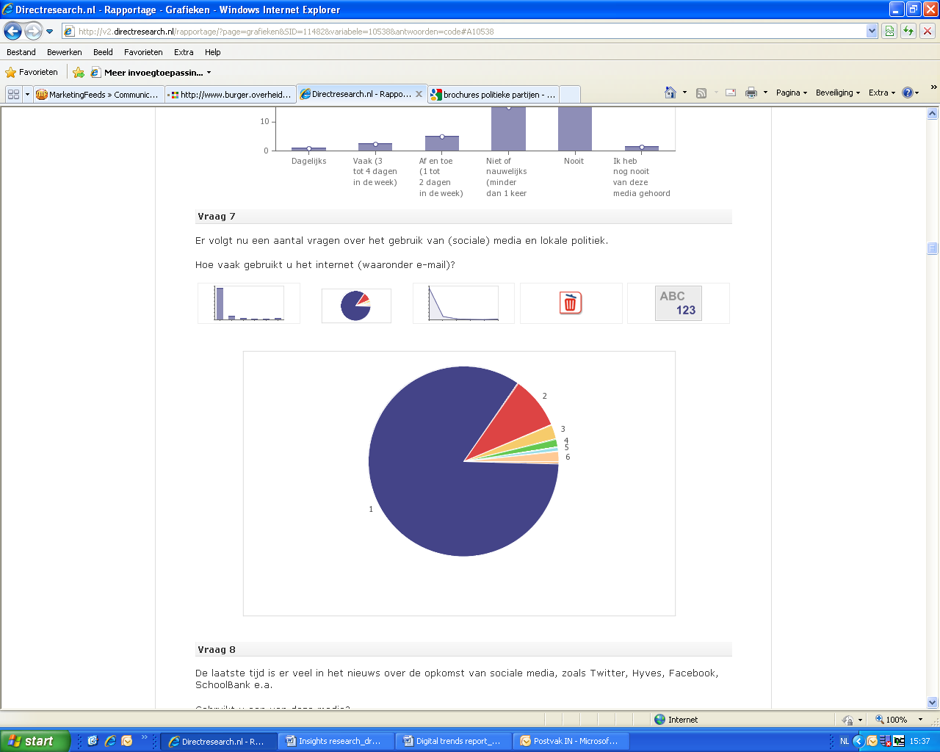

1. Elke dag: 84,7 %
2. 5-6 dagen in de week: 8,9%
3. 3-4 dagen in de week: 2,5 %
4. 1-2 dagen in de week 1,3 %
5. Minder dan 1 keer per week 0,6 %
6. Minder dan 1 keer per maand 2,1 %

Bijna 85% van de ondervraagden gebruikt het internet dagelijks.

##### Gebruik social media

De laatste tijd is er veel in het nieuws over de opkomst van social media, zoals Twitter, Hyves, Facebook, LinkedIn e.a.  
  
Gebruikt u een van deze media?

|  |  |
| --- | --- |
| Ja | http://v2.directresearch.nl/images/bar.gif66,0% |
| Nee | http://v2.directresearch.nl/images/bar.gif34,0% |

Bijna 2/3 van de respondenten maakt gebruik van social media sites.

Kijkend naar de leeftijd van de respondenten dan is te constateren dat de jongste deelnemers meer social media gebruiken dan de oudste. De 21-30 leeftijdsgroep is het meest actief.

**Gebruikt u een van deze media?**

|  |  |  |  |  |  |  |  |
| --- | --- | --- | --- | --- | --- | --- | --- |
| **Antwoord** | **12 jaar t/m 20 jaar** | **21 jaar t/m 30 jaar** | **31 jaar t/m 40 jaar** | **41 jaar t/m 55 jaar** | **56 jaar t/m 65 jaar** | **Totaal** | **Percentage** |
| Ja | 83,3 % 20 | **87,3 %** 48 | 79,3 % 65 | 67,6 % 115 | 58,5 % 69 | 349 | 66,0 % |
| Nee | 16,7 % 4 | 12,7 % 7 | 20,7 % 17 | 32,4 % 55 | 41,5 % 49 | 180 | 34,0 % |

## Gebruik online media voor politiek

**Hoe vaak gebruikt u onderstaande media om op de hoogte te blijven van de lokale politiek?**

**Websites (bijvoorbeeld, van politieke partijen)**

|  |  |
| --- | --- |
| Dagelijks | http://v2.directresearch.nl/images/bar.gif3,4% |
| Vaak (3 tot 4 dagen in de week) | http://v2.directresearch.nl/images/bar.gif2,6% |
| Af en toe (1 tot 2 dagen in de week) | http://v2.directresearch.nl/images/bar.gif8,5% |
| Niet of nauwelijks (minder dan 1 keer per maand) | http://v2.directresearch.nl/images/bar.gif28,5% |
| Nooit | http://v2.directresearch.nl/images/bar.gif56,3% |
| Ik heb nog nooit van deze media gehoord | http://v2.directresearch.nl/images/bar.gif0,6% |

Bijna 85% maakt nauwelijks of nooit gebruik van websites om op de hoogte te blijven van de lokale politiek.

**Blogs (bijvoorbeeld, van lijsttrekkers)**

|  |  |
| --- | --- |
| Dagelijks | http://v2.directresearch.nl/images/bar.gif0,9% |
| Vaak (3 tot 4 dagen in de week) | http://v2.directresearch.nl/images/bar.gif0,6% |
| Af en toe (1 tot 2 dagen in de week) | http://v2.directresearch.nl/images/bar.gif3,4% |
| Niet of nauwelijks (minder dan 1 keer per maand) | http://v2.directresearch.nl/images/bar.gif12,9% |
| Nooit | http://v2.directresearch.nl/images/bar.gif81,1% |
| Ik heb nog nooit van deze media gehoord | http://v2.directresearch.nl/images/bar.gif1,1% |

Het blijkt dat politieke blogs eveneens weinig aandacht van de Nederlanders krijgen. 94% van de ondervraagden heeft nauwelijks of nooit informatie over een partij of politicus op een blog gezocht.

**Social communities (zoals Facebook, Hyves)**

|  |  |
| --- | --- |
| Dagelijks | http://v2.directresearch.nl/images/bar.gif4,5% |
| Vaak (3 tot 4 dagen in de week) | http://v2.directresearch.nl/images/bar.gif3,2% |
| Af en toe (1 tot 2 dagen in de week) | http://v2.directresearch.nl/images/bar.gif10,8% |
| Niet of nauwelijks (minder dan 1 keer per maand) | http://v2.directresearch.nl/images/bar.gif10,0% |
| Nooit | http://v2.directresearch.nl/images/bar.gif70,9% |
| Ik heb nog nooit van deze media gehoord | http://v2.directresearch.nl/images/bar.gif0,6% |

Wanneer het gaat om social community sites dan blijkt de participatie iets te stijgen. Het verschil is echter niet significant. 81% heeft niet of nauwelijks gediscussieerd of gelezen over een politiek onderwerp op een social community site.

**Twitter (micro-blogging)**

|  |  |
| --- | --- |
| Dagelijks | http://v2.directresearch.nl/images/bar.gif1,3% |
| Vaak (3 tot 4 dagen in de week) | http://v2.directresearch.nl/images/bar.gif1,3% |
| Af en toe (1 tot 2 dagen in de week) | http://v2.directresearch.nl/images/bar.gif1,1% |
| Niet of nauwelijks (minder dan 1 keer per maand) | http://v2.directresearch.nl/images/bar.gif6,2% |
| Nooit | http://v2.directresearch.nl/images/bar.gif89,4% |
| Ik heb nog nooit van deze media gehoord | http://v2.directresearch.nl/images/bar.gif0,6% |

Twitter blijkt het minst populaire online medium te zijn. Bijna 96% volgt nauwelijks of nooit politieke tweets.

**VIDEO SITES (YOUTUBE)**

|  |  |
| --- | --- |
| Dagelijks | http://v2.directresearch.nl/images/bar.gif1,7% |
| Vaak (3 tot 4 dagen in de week) | http://v2.directresearch.nl/images/bar.gif2,3% |
| Af en toe (1 tot 2 dagen in de week) | http://v2.directresearch.nl/images/bar.gif5,5% |
| Niet of nauwelijks (minder dan 1 keer per maand) | http://v2.directresearch.nl/images/bar.gif16,6% |
| Nooit | http://v2.directresearch.nl/images/bar.gif73,3% |
| Ik heb nog nooit van deze media gehoord | http://v2.directresearch.nl/images/bar.gif0,6% |

Politieke video’s kijken op Youtube behoort niet tot de meest voorkomende activiteiten. 90% heeft niet of nauwelijks een politiek gerelateerd filmpje gezien op Youtube.

**FORUMS**

|  |  |
| --- | --- |
| Dagelijks | http://v2.directresearch.nl/images/bar.gif0,8% |
| Vaak (3 tot 4 dagen in de week) | http://v2.directresearch.nl/images/bar.gif2,3% |
| Af en toe (1 tot 2 dagen in de week) | http://v2.directresearch.nl/images/bar.gif7,4% |
| Niet of nauwelijks (minder dan 1 keer per maand) | http://v2.directresearch.nl/images/bar.gif16,4% |
| Nooit | http://v2.directresearch.nl/images/bar.gif72,4% |
| Ik heb nog nooit van deze media gehoord | http://v2.directresearch.nl/images/bar.gif0,8% |

De situatie met fora is vergelijkbaar met de andere social platforms: De meeste mensen (89%) hebben geen politieke discussies gevolgd op een of meerdere fora.

## Gebruik social media: actief of passief?

Gebruik social media: actief en passief

**Welke van onderstaande sociale media gebruikt u zoal?  
  
Het gaat hier om passief gebruik (lezen, bron van informatie).**

|  |  |
| --- | --- |
| **Blogs** | **16 %** gebruikt ze dagelijks of wekelijks, de rest nauwelijks of nooit |
| **Twitter** | **8 %** gebruikt het dagelijks of wekelijks, de rest nauwelijks of nooit |
| **Social netwerken (Hyves, Facebook, LinkedIn)** | **43%** gebruikt ze dagelijks of wekelijks, de rest nauwelijks of nooit |
| **Youtube** | **34%** gebruikt het dagelijks of wekelijks, de rest nauwelijks of nooit |
| **Forums** | **24 %** gebruikt ze dagelijks of wekelijks, de rest nauwelijks of nooit |

Het is duidelijk dat social netwerken en Youtube de favorieten zijn uit alle social media.

**Welke van onderstaande sociale media gebruikt u zoal?  
  
LET OP: Het gaat hier om actief gebruik (zelf content publiceren, commentaren plaatsen).**

|  |  |
| --- | --- |
| **Blogs** | **8%** gebruikt ze dagelijks of wekelijks, de rest nauwelijks of nooit |
| **Twitter** | **6 %** gebruikt het dagelijks of wekelijks, de rest nauwelijks of nooit |
| **Social netwerken (Hyves, Facebook, LinkedIn)** | **36 %** gebruikt ze dagelijks of wekelijks, de rest nauwelijks of nooit |
| **Youtube** | **9%** gebruikt het dagelijks of wekelijks, de rest nauwelijks of nooit |
| **Forums** | **12%** gebruikt ze dagelijks of wekelijks, de rest nauwelijks of nooit |

Nogmaals zijn social netwerken het populairste medium als het gaat om commentaren plaatsen en toevoegen van content.

## Gebruik social media voor gemeentelijke politiek: actief of passief?

**Welke van onderstaande sociale media gebruikt u in die zin voor gemeentelijke politiek?  
  
Het gaat hier om passief gebruik (lezen, bron van informatie).**

|  |  |
| --- | --- |
| **Blogs** | **5%** gebruikt ze dagelijks of wekelijks, de rest nauwelijks of nooit |
| **Twitter** | **3%** gebruikt het dagelijks of wekelijks, de rest nauwelijks of nooit |
| **Social netwerken (Hyves, Facebook, LinkedIn)** | **8%** gebruikt ze dagelijks of wekelijks, de rest nauwelijks of nooit |
| **Youtube** | **4%** gebruikt het dagelijks of wekelijks, de rest nauwelijks of nooit |
| **Forums** | **6%** gebruikt ze dagelijks of wekelijks, de rest nauwelijks of nooit |

Social netwerken zijn ook het populairste als het gaat om informatie opzoeken over politieke onderwerpen. In het algemeen worden social media weinig gebruikt als informatiebron voor lokale politiek.

**Welke van onderstaande sociale media gebruikt u in die zin voor gemeentelijke politiek?  
  
LET OP: Het gaat hier om actief gebruik (zelf content publiceren, commentaren plaatsen).**

|  |  |
| --- | --- |
| **Blogs** | **3%** gebruikt ze dagelijks of wekelijks, de rest nauwelijks of nooit |
| **Twitter** | **2 %** gebruikt het dagelijks of wekelijks, de rest nauwelijks of nooit |
| **Social netwerken (Hyves, Facebook, LinkedIn)** | **5%** gebruikt ze dagelijks of wekelijks, de rest nauwelijks of nooit |
| **Youtube** | **3%** gebruikt het dagelijks of wekelijks, de rest nauwelijks of nooit |
| **Forums** | **4%** gebruikt ze dagelijks of wekelijks, de rest nauwelijks of nooit |

Er wordt door burgers niet of nauwelijks actief gebruik gemaakt van social media met betrekking tot de lokale politiek.

##### Behoefte aan communiceren met politici

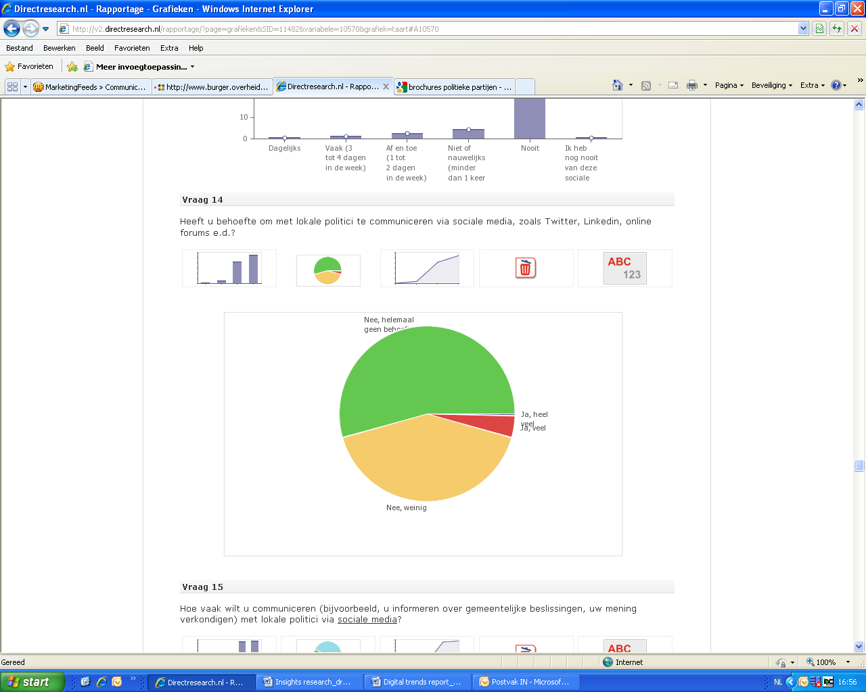

**54.4 %** heeft helemaal geen behoefte om te communiceren met lokale politici.

**41.2%** heeft weinig behoefte

**4.4 %** heeft veel behoefte

##### Voorkeur social media

**Welke van de onderstaande social media heeft uw voorkeur als het gaat om communiceren met lokale politici?**

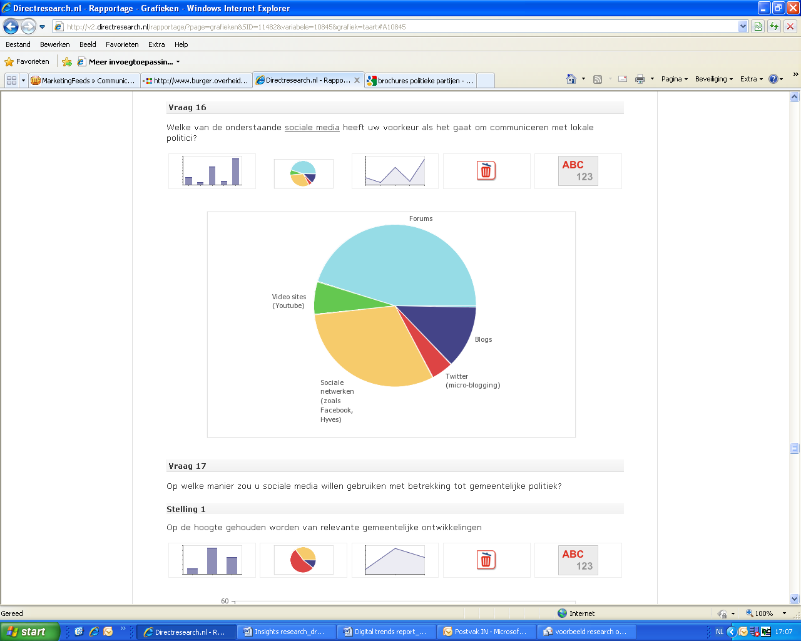

De definitieve voorkeuren zijn:

1. Forums (46%)
2. Social netwerken (31%)
3. Blogs (13%)

##### Gebruik social media: welke manier?

**Op welke manier zou u social media willen gebruiken met betrekking tot gemeentelijke politiek?**

**Op de hoogte gehouden worden van relevante gemeentelijke ontwikkelingen**

|  |  |
| --- | --- |
| Heel graag | http://v2.directresearch.nl/images/bar.gif10,8% |
| Dat lijkt mij wel wat | http://v2.directresearch.nl/images/bar.gif54,1% |
| Helemaal niet | http://v2.directresearch.nl/images/bar.gif35,2% |

**Nieuwe ideeën doorgeven aan de gemeente**

|  |  |
| --- | --- |
| Heel graag | http://v2.directresearch.nl/images/bar.gif6,4% |
| Dat lijkt mij wel wat | http://v2.directresearch.nl/images/bar.gif47,6% |
| Helemaal niet | http://v2.directresearch.nl/images/bar.gif45,9% |

**Mijn mening geven over plannen van de gemeente**

|  |  |
| --- | --- |
| Heel graag | http://v2.directresearch.nl/images/bar.gif8,5% |
| Dat lijkt mij wel wat | http://v2.directresearch.nl/images/bar.gif47,4% |
| Helemaal niet | http://v2.directresearch.nl/images/bar.gif44,0% |

**Een dialoog aangaan met wethouders en de burgemeester**

|  |  |
| --- | --- |
| Heel graag | http://v2.directresearch.nl/images/bar.gif5,1% |
| Dat lijkt mij wel wat | http://v2.directresearch.nl/images/bar.gif28,0% |
| Helemaal niet | http://v2.directresearch.nl/images/bar.gif66,9% |

**Inwoners van de gemeente activeren voor een bepaald doel**

|  |  |
| --- | --- |
| Heel graag | http://v2.directresearch.nl/images/bar.gif3,4% |
| Dat lijkt mij wel wat | http://v2.directresearch.nl/images/bar.gif34,0% |
| Helemaal niet | http://v2.directresearch.nl/images/bar.gif62,6% |

##### Social media: follow or react?

**Als een lokale politicus/ gemeentelijke ambtenaar social media zou gebruiken voor lokale politiek dan zou u die social media activiteit:**

|  |  |
| --- | --- |
| Willen volgen en erop reageren | http://v2.directresearch.nl/images/bar.gif27,6% |
| Willen volgen, maar er niet op reageren | http://v2.directresearch.nl/images/bar.gif38,2% |
| Op geen enkele manier willen volgen | http://v2.directresearch.nl/images/bar.gif34,2% |

Het is interessant hoe de meningen verdeeld zijn in 3 x 1/3. Bijna een derde wil reageren en volgen, een derde wil alleen volgen, en een derde wil helemaal niet volgen.

Als er naar de leeftijd wordt gekeken, zien we iets interessants:

|  |  |  |  |  |  |  |  |
| --- | --- | --- | --- | --- | --- | --- | --- |
| **Antwoord** | **12 jaar 12 t/m 20 jaar** | **21 jaar t/m 30 jaar** | **31 jaar t/m 40 jaar** | **41 jaar t/m 55 jaar** | **56 jaar t/m 65 jaar** | **Totaal** | **Percentage** |
| Willen volgen en erop reageren | 20,8 % 5 | 30,9 % 17 | 29,3 % 24 | 35,3 % 60 | 20,3 % 24 | 146 | 27,6 % |
| Willen volgen, maar er niet op reageren | 54,2 % 13 | 36,4 % 20 | 28,0 % 23 | 34,1 % 58 | 47,5 % 56 | 202 | 38,2 % |
| Op geen enkele manier willen volgen | 25,0 % 6 | 32,7 % 18 | 42,7 % 35 | 30,6 % 52 | 32,2 % 38 | 181 | 34,2 % |

Het blijkt dat de jongeren tussen 12 en 20 jaar en volwassenen tussen 56 en 65 jaar passief willen participeren.

##### Stemgedrag

**Weet u al wat u gaat stemmen bij de gemeenteraadsverkiezingen op 3 maart 2010?**

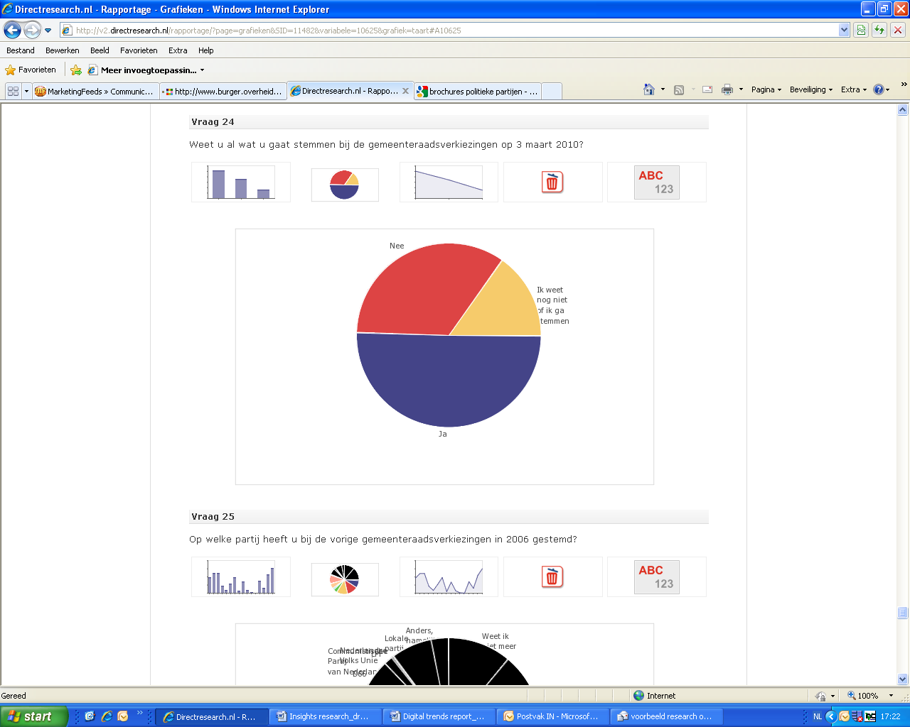

51% weet wat ze gaat stemmen, 34% niet en 15% weet nog niet of ze gaat stemmen

**Wat wilt u gaan stemmen voor de gemeenteraadsverkiezingen op 3 maart 2010?**

**25%** van de jongste respondenten die weet wat ze gaat stemmen, gaat stemmen voor D66 (deze partij heeft het grootste aantal voorkeuren in deze leeftijdsgroep)

**16%** van de 21-30 leeftijdscategorie gaat ook stemmen voor D66 (ook grootste aantal voorkeuren voor D66)

**14%** van de 56-65 leeftijdsgroep die weet wat ze gaat stemmen, gaat stemmen voor de huidige regeringspartij (CDA). De CDA is dus de top 1 voorkeur voor bejaarden.

3. Jury report Beste Web Politicus (in Dutch)

**1**. **Inleiding**

Met de opkomst van nieuwe media hebben politici een extra arena gekregen om te strijden om de gunsten van de kiezer: het internet. Sommige partijen hopen er zelfs extra zetels te verdienen. Nieuwe trends in online campagnevoeren zijn duidelijk zichtbaar. Steeds meer politici proberen met filmpjes via YouTube en tweets op Twitter de kiezer te verleiden. En weblogs blijken voor lokale politici ook een uitgewezen bron om zichzelf te presenteren.

Als politicus moet je tegenwoordig bijna overal zijn. En met zoveel kwantiteit is het moeilijk om de kwaliteit te bewaken, wordt al snel duidelijk als we alle online communicatiemiddelen van politici bekijken. Twitteraars die slechts één keer in de zoveel weken een bericht sturen, Hyvesvrienden die geen reactie krijgen, YouTubefilmpjes die nauwelijks kijkers halen: het lijkt soms kommer en kwel.

Gelukkig zijn er ook uitzonderingen tijdens deze verkiezingen: politici die de sociale media integreren in hun website, optimaal crossmediale mogelijkheden benutten en zorgen voor een constante stroom van content. Soms hebben ze een compleet campagneteam om te helpen, soms doen ze bijna alles alleen.

In dit rapport vindt u die uitzonderingen. Een vakjury heeft zich gebogen over de webfactor van lokale politici. Deze jury bestond uit:

* dr. Rens Vliegenthart - Universitair docent politieke communicatie
* Camil Driessen - politicoloog en journalist van Dagblad *De Pers*
* Josephine Zwaan – student Media & Cultuur, specialisatie Nieuwe Media

In vier categorieën hebben zij een winnaar bepaald: *Beste Webpoliticus*, *Beste Website, Beste Tweet* en *Beste Weblog*. Ieder jurylid heeft zijn eigen top 3 gegeven. Op basis daarvan zijn de winnaars bepaald. Bij iedere categorie en winnaar vindt u in dit juryrapport het oordeel.

**Namens de redactie van BesteWebpoliticus.nl,**

**Sophie Velthuizen**

**Karin Pijper**

**Tommy Hopstaken**

**Merel de Boer**

**Willem Hendrikx**

# 2. Beste Webpoliticus

Voor deze categorie golden de volgende uitgangspunten:

* Heeft de politicus een overzichtelijke en actieve website?
* Werkt de eigen website van de politicus als portaal naar andere internetmedia zoals Twitter en YouTube?
* Hoe formuleert de politicus zijn ideeën op de website, blog en/of profiel? M.a.w. wat wil de politicus en blijkt dat uit zijn webactiviteiten?
* Maakt de politicus gebruik van sociale media, zoals Hyves? Zo ja, maakt hij/zij er ook efficiënt gebruik van?
* Hoe vindbaar is de politicus op zoekpagina's, zoals Google?
* Wordt er veel over de politicus gepraat op fora, communities, weblogs, enzovoorts?
* Zijn de webactiviteiten van de politicus in kwestie ook interessant voor kranten, radio en televisie?

**Algemene indruk**

Op de nominatielijst stonden meerdere goede webpolitici. De juryleden vonden echter dat weinig politici boven de anderen uitstegen. Volgens de jury is het een groot gemis dat politici hun website niet meer inrichten als digitale portal naar andere internetmedia. Op die manier heeft een website een overzichtsfunctie. Bovendien kan deze dan eenvoudig gecombineerd worden met een korte en krachtige weergave van standpunten.

Een ander opvallend gegeven was het relatief geringe aantal vrouwen. De jury miste goede webpoliticae. ‘Waar zijn de vrouwen?’, vroegen de juryleden zich af.

**Winnaar**

De winnaar in deze categorie is Jeroen Fritz, PvdA Haarlem. Op de website van Jeroen is te zien hoe een ideale Webpoliticus zich gedraagt: Jeroen combineert de crossmediale functie met beknopte, duidelijke inhoud. Het is direct duidelijk waar hij en zijn partij voor staan. Met name het kopje 'Bereikt' viel bij de jury in de smaak. Zo kan het publiek snel vinden wat de PvdA in Haarlem voor elkaar heeft gekregen.

Jeroen gebruikt de overige internetmedia eveneens op de juiste manier. Op Twitter heeft hij zo'n 600 volgers, wat duidt op een langdurig en serieus gebruik van deze account. Hij plaatst regelmatig nieuwe tweets waarin hij vaak verwijst naar zijn weblog of andere media.

Ook zijn weblog blijft goed gevuld. Hij plaatst dagelijks blogs op zijn website en op zijn hyvespagina. YouTube-filmpjes of foto's staan er ter illustratie bij. Zijn teksten zijn leesbaar en overzichtelijk.

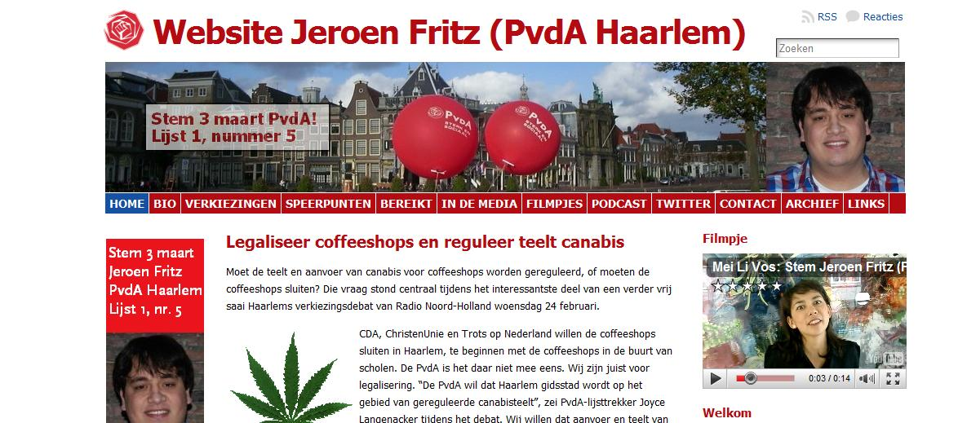

## NaamloosNaamloos

## Naamloos

## *3*. ***Beste Website***

Voor deze categorie golden de volgende uitgangspunten:

* Zijn de plannen van de politicus/partij duidelijk?
* Komt de politieke boodschap over?
* Zijn de standpunten helder?
* Hoe is de crossmediale kwaliteit? Heeft de site bijvoorbeeld twitter widgets of links met de sociale media?
* Is er een blog en is deze actueel?
* Heeft de site een uniforme stijl?
* Hoe duidelijk en overzichtelijk is de website?
* Hoe snel is relevante informatie te vinden?
* Wordt op de site gebruik gemaakt van interactieve media, zoals polls, filmpjes en gastenboeken?
* Werken alle links en linken ze naar de juiste pagina's?

**Algemene indruk**

De jury vond de algehele kwaliteit van websites niet optimaal. Omdat veel websites nauwelijks links leggen met andere media, was het aanbod eigenlijk teleurstellend. Volgens de jury was er geen website die heldere vormgeving combineerde met goede inhoud.

De kandidaten op de shortlist waren vooral duidelijke of inhoudelijke sites. *Westland Verstandig* had duidelijke agendapunten en een goede weergave van de inhoud. De site van *CDA Wierden* werd geprezen om de vormgeving, maar miste volgens de jury een degelijke inhoud.

**Winnaar**

De winnaar in deze categorie is de website van de ChristenUnie in Zwolle. Dit komt vooral door de duidelijkheid van de site. De site ziet er bovendien fris uit. De jury vond vooral de navigatie van de site een pluspunt: ‘je vindt snel wat je zoekt’. Ook de koppeling tussen kandidaten en inhoud oogstte lof bij de jury.

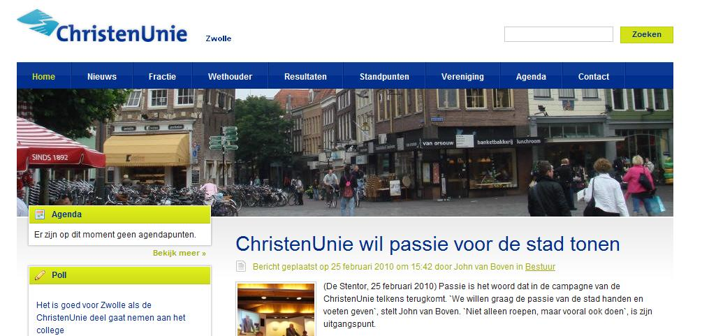

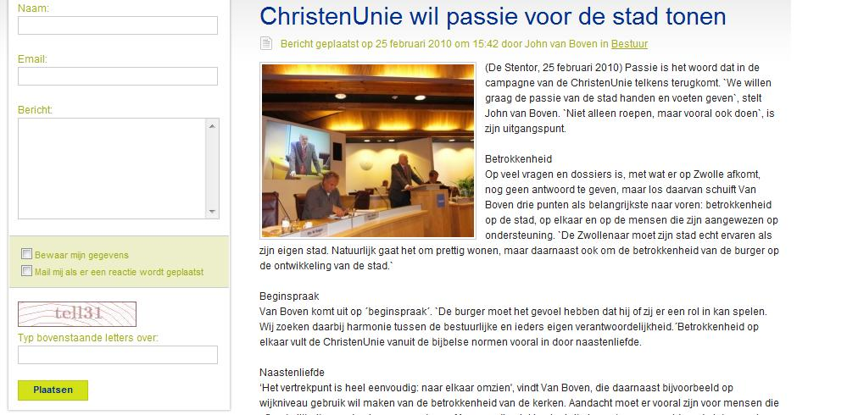

4. Beste Tweet

Voor deze categorie golden de volgende uitgangspunten:

* Twittert iemand regelmatig?
* Heeft iemand tweets over actuele, politieke onderwerpen?
* Is er voldoende afwisseling in de tweets: combineert de twitteraar persoonlijke noten met nuttige informatie?
* Is er een tweet die eruit springt? Deze is dan bijvoorbeeld:
  + - * Grappig
      * Origineel
      * Prikkelend
      * Inhoudelijk
      * Verfrissend

**Algemene indruk**

De jury zag veel onderscheid in twitteraars: sommige melden vooral persoonlijke informatie, andere vooral politieke informatie. Het is volgens de jury ook opvallend dat er twitteraars zijn die nauwelijks volgers hebben, maar toch heel veel twitteren of ‘voor eigen parochie preken’. De jury vond dat er weinig campagnegericht werd getwitterd. Daarvoor moeten tweets toch regelmatig je eigen boodschap laten zien. Dat kon volgens de jury beter.

**Winnaar**

De winnaar in deze categorie is Marc Dubach, D66 Eindhoven. Over hem zegt de jury: ‘Marc verdient de eerste prijs: hij is de ultieme twitterman. Hij gebruikt het als instrument om te weten wat er in de samenleving speelt. Hij zendt niet alleen, hij luistert ook via Twitter.’

**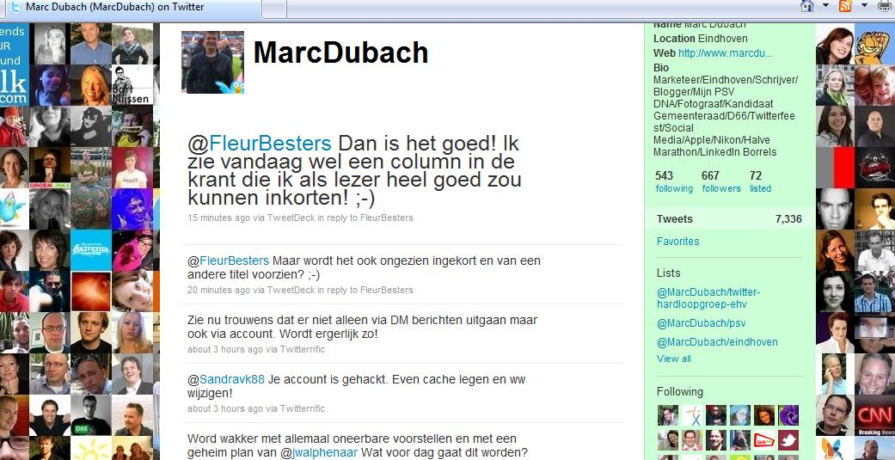**5. Beste Weblog

Voor deze categorie golden de volgende uitgangspunten:

* Is het weblog actueel?
* Hoe leesbaar zijn de stukjes?
* Is de politieke boodschap helder?
* Is de inhoud nieuwswaardig?
* Zijn de teksten/titels scherp geformuleerd?
* Kun je reageren op de weblog?
* Zo ja, gebeurt dat vaak?
* Beantwoordt de politicus de reacties?

**Algemene indruk**

De jury vindt dat de lokale politici de blogs serieus nemen: er wordt regelmatig geblogd en het gaat vaak over de inhoud. Wel vraagt de jury zich af: hoeveel mensen lezen een blog? Het aantal reacties is vaak laag en de teksten zijn regelmatig vrij lang. Een blogtekst hoort kort en bondig te zijn. Een weblog moet bovendien reacties oproepen en leuk zijn om te lezen.

Een speciale vermelding verdienen de blogs van Maarten Prinsen en Marc Hesp. Zij wisselen onderling blogs uit over hun steden. De jury vond dit een aantrekkelijk en leuk initiatief.

**Winnaar**

De winnaar in deze categorie is Mattias Gijsbertsen, GroenLinks in Groningen. Hij heeft een helder en overzichtelijk weblog, waarin hij een goede balans vindt tussen landelijke en lokale politiek. De blog nodigt uit tot lezen.

4. Interview questions social media experts and politicians

The questions for each interview were adjusted to the background and experience of the person interviewed. During the course of the interviews, additional questions have arisen or some of the questions have been added. The questions listed below are the questions that were used for the majority of the interviews. The questions in bold were also used in the interviews with social media experts.

4.1. Questions to politicians

* Wat is voor u politieke communicatie?
* Wat is uw strategie bij het gebruiken van sociale media?
* Als u sociale media gebruikt, op welk doelgroep is de communicatie op deze media gericht?
* Zijn er bepaalde media die beter geschikt zijn voor een bepaald doelgroep?
* Sinds wanneer gebruikt u Twitter? Waarom bent u begonnen?
* Wie volgt u op Twitter?
* Sinds wanneer heeft u een blog? Waarom bent u begonnen?
* Meet u het aantal unieke bezoekers op uw blog?
* Wat was de opkomst in uw gemeente dit jaar?
* Kunnen social media u voorkeur stemmen opleveren?
* **Kunnen social media helpen de kloof tussen de burger en de politiek verkleinen? Bestaat het zo’n kloof?**
* **Wordt lokale politiek beinvloed door landelijke onderwerpen?**
* **Wat zijn de grootste fouten die politici maken bij het gebruik van sociale media?**
* **Wat is een goed voorbeeld van een politicus die social media goed heeft ingezet?**
* **Wat is een succesvolle sociale media strategie waarmee politici de gemiddelde Nederlander beter kunnen bereiken?**
* Worden berichten op uw blog soms opgepikt door de (lokale) media?
* **Is er iets van de campagne van Barack Obama dat Nederlandse politici hier kunnen toepassen?**
* **Hoe kunnen social media helpen lokale politiek relevanter te maken voor de burger?**
* **Hoe ziet u sociale media bij de volgende verkiezingen (over 4 jaar)?**

4.2. Questions to social media/PR experts

* Op welk doelgroep moeten politici hun communicatie richten op sociale media?
* Hoe kunnen politici de zwevende kiezer beter bereiken op sociale media?
* Hoe kunnen politici een dialoog aangaan met de burger op sociale media?
* Welke zijn de belangrijkste eigenschappen van sociale media die ze geschikt maken voor politieke communicatie?
* Wordt politiek in Nederland persoonlijker?
* Hoe kan een politicus sociale media inzetten om populairder te worden als hij lager op de lijst staat?
* Hoe moeten politici communiceren om de politiek interessanter te maken voor de burger?
* Wat moet de verhouding zijn tussen prive en politiek-gerelateerde tweets?
* Hoe kunnen politici een bredere groep kiezers bereiken via sociale media?

List of footnotes

1. Sudhaman, A.(2010, 24th March). PRWeek/Diffusion Digital Integration Report: The digital divide. *PR Week.* Retrieved from <http://www.prweek.com/uk/news/992472/PRWeek-Diffusion-Digital-Integration-Report-digital-divide/> [↑](#endnote-ref-1)
2. “ontzuiling” in Dutch [↑](#footnote-ref-1)
3. *Verkiezingen/opkomstcijfers*. Retrieved from: <http://www.publiek-politiek.nl/Info-over-politiek/Verkiezingen/Opkomstcijfers> [↑](#endnote-ref-2)
4. *(2010, March 3rd).*Limburgse opkomst verkiezingen net geen 54 procent*. L1: Nieuws en sport uit Limburg.*Retrieved from <http://www.l1.nl/content/4481668/landelijke_opkomst_verkiezingen_op_535_procent> [↑](#endnote-ref-3)
5. Lijsttrekker, translated from Dutch [↑](#footnote-ref-2)
6. Retrieved from: http://davis.foulger.info/research/unifiedModelOfCommunication.htm [↑](#footnote-ref-3)
7. Twitter. (n.d.) In *PC Magazine Encyclopedia online*. Retrieved from <http://www.pcmag.com/encyclopedia_term/0,2542,t=Twitter&i=57880,00.asp> [↑](#endnote-ref-4)
8. Drezner, D.W. & Farrell, H. (2004). *The power and politics of blogs*. Retrieved from <http://www.cs.duke.edu/courses/spring05/cps182s/readings/blogpowerpolitics.pdf> [↑](#endnote-ref-5)
9. CBS Statline. *Bevolkingsontwikkeling; regio per maand*. [Data file]. Retrieved from <http://statline.cbs.nl/StatWeb/publication/?VW=T&DM=SLNL&PA=37230ned&LA=NL> [↑](#endnote-ref-6)
10. Drees, M. (2008, December 17). *Sociale media: Nederland actief, Duitsland passief*. Retrieved from: <http://recruitmentmatters.nl/2008/12/17/sociale-media-nederland-actief-duitsland-passief/#ixzz0aVsBXRWo> [↑](#endnote-ref-7)
11. Attractive politics, translated from Dutch [↑](#footnote-ref-4)
12. Aalberts, C. (n.d.) Visie. Message posted to: <http://www.chrisaalberts.nl/visie-1.html> [↑](#endnote-ref-8)
13. (C. Aalberts, Personal Communication, February 23rd, 2010) [↑](#endnote-ref-9)
14. (2009, October 30th). Jaap Jansen naar Een Vandaag. *Villamedia*. Retrieved from: <http://www.villamedia.nl/personalia/bericht/jaap-jansen-naar-een-vandaag/> [↑](#endnote-ref-10)
15. (J. Jansen, personal communication, February 23rd, 2010) [↑](#endnote-ref-11)
16. (C. Aalberts, personal communication, February 23rd, 2010) [↑](#endnote-ref-12)
17. Paternotte, B. (2009, April 2nd). [Een schietpartij op een D66-congres? Hoe nieuws ontstaat via Twitter](http://politiekonline.wordpress.com/2009/04/02/een-schietpartij-op-een-d66-congres-hoe-nieuws-ontstaat-via-twitter/). Message posted to <http://politiekonline.wordpress.com/2009/04/02/een-schietpartij-op-een-d66-congres-hoe-nieuws-ontstaat-via-twitter/> [↑](#endnote-ref-13)
18. See Chapter Research findings, Questionnaire conclusion [↑](#footnote-ref-5)
19. (J. Stronks, personal communication, February 25th, 2010) [↑](#endnote-ref-14)
20. (C. Driessen, personal communication, March 12th, 2010) [↑](#endnote-ref-15)
21. (M. Vroom, personal communication, March 17th, 2010) [↑](#endnote-ref-16)
22. (J. Stronks, personal communication, February 25th, 2010) [↑](#endnote-ref-17)
23. (D. Rietveld, personal communication, March 18th, 2010) [↑](#endnote-ref-18)
24. Vlug, G. (2001, March 10th). Waarom Burgerparticipatie 2.0 niet lukt. *Tijdschrift voor marketing: Molblog.* Retrieved from <http://www.molblog.nl/bericht/waarom-burgerparticipatie-2.0-niet-lukt/> [↑](#endnote-ref-19)
25. (J. Diepemaat, personal communication, March 19th, 2010) [↑](#endnote-ref-20)
26. (P. Zwanenberg, personal communication, March 9th, 2010) [↑](#endnote-ref-21)
27. (Stijn Verbruggen, personal communication, March 11th, 2010) [↑](#endnote-ref-22)
28. (J.W. Alphenaar, personal communication, March 2nd , 2010) [↑](#endnote-ref-23)
29. (M. Dubach, personal communication, March 1st, 2010) [↑](#endnote-ref-24)
30. (K. Van der Linde, personall communication, March 10th, 2010) [↑](#endnote-ref-25)
31. (M. Mulder, personal communication, March 17th, 2010) [↑](#endnote-ref-26)
32. See chapter Theoretical framework, p. 20 [↑](#footnote-ref-6)
33. With low threshold/barrier to entry, translated from Dutch [↑](#footnote-ref-7)
34. (M. Gijsbertsen, personal communication, March12th, 2010) [↑](#endnote-ref-27)
35. Nieborg, D. (Speaker). (2009, July 7).Obama’s champagne: tussen hoop en hype. Podcast retrieved from <http://131.211.194.110/site1/Viewer/?peid=788fc79581b840dfb2b949bcbaf8ac2b> [↑](#endnote-ref-28)
36. Hendrikx van der Spek Communicatiebureau. (2010). *Juryrapport Beste lokale Webpoliticus 2010*. Bussum. [↑](#endnote-ref-29)
37. The complete rapport can be found in the appendix of this dissertation [↑](#footnote-ref-8)
38. (J. Fritz, personal communication, March 12th, 2010) [↑](#endnote-ref-30)
39. Nieborg, D. (2009, June 2). [De waarde van Obama’s social media strategie voor Nederlandse politici](http://www.csnblog.nl/de-waarde-van-obamas-social-media-strategie-voor-nederlandse-politici/). Message posted to <http://www.csnblog.nl/de-waarde-van-obamas-social-media-strategie-voor-nederlandse-politici/> [↑](#endnote-ref-31)
40. Insite Consulting. (2010). *Social networks around the world 2010* [PowerPoint slides]. Retrieved from <http://www.slideshare.net/stevenvanbelleghem/social-networks-around-the-world-2010> [↑](#endnote-ref-32)
41. [Grotenhuis](http://weblogs.nrc.nl/geld/author/aertjang/), A. (2010, March 22). Twitterende minister in problemen. *NRC Handelsblad*. Retrieved from <http://weblogs.nrc.nl/geld/2010/03/22/twitterende-minister-in-problemen/> [↑](#endnote-ref-33)
42. Kroes, R. (2010, January 28). Social Media gaat Wilders niet per se stemmen kosten. *Communicatieonline.nl*. Retrieved from <http://www.communicatieonline.nl/opinie/bericht/social-media-gaat-wilders-niet-per-se-stemmen-kosten/> [↑](#endnote-ref-34)
43. Political determinism, in Dutch [↑](#footnote-ref-9)
44. David Rietveld, GroenLinks, The Hague [↑](#footnote-ref-10)
45. Jaap Stronks, social media expert [↑](#footnote-ref-11)