PRODUCTION OF UREA PHOSPHATE FERTILIZERS
  - AN INTERNSHIP REPORT

  - Submitted by

  - Michael Jeffrey Harskamp
Student number: 1563772

  - in partial fulfilment of the requirements of the degree
of
  - Bachelor of Applied Science
  - in
  - Chemistry – Research & Development
  - HU University of Applied Sciences Utrecht

Performed at
  - 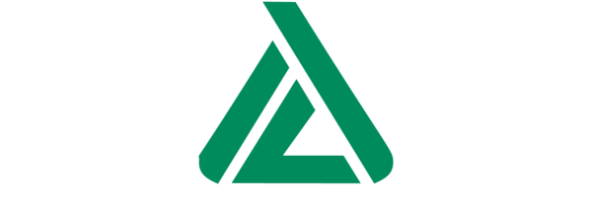
ICL Fertilizers Europe C.V.
  - Amsterdam

December 2013
Preface
The work outlined in this dissertation was carried out in the Department of Research & Development, ICL Fertilizers Europe C.V., over the period from August 2013 to December 2013. This dissertation is original, unpublished work by the author, M.J. Harskamp. The material included in this thesis has not been submitted for a degree or diploma or any other qualification at any other university. Furthermore, no part of my dissertation has already been or is currently submitted for any such degree, diploma or other qualification.

Acknowledgements
I am grateful to my supervisors, Kim ten Wolde and Anthony Zanelli, for their guidance and feedback during the research. I would like to thank them for the freedom in the research they granted to me during my work the lab.
I would also like to thank my colleagues at ICL Fertilizers Europe C.V. for creating a friendly and supportive environment. This includes Hermen Musch, Michiel Verspuij, Richard van der Sluis, Enzo Buscemi, Ola Gregorkiewicz and others.
I would also like to thank my educational supervisor, Richard van der Laan, for inspiring me to perform at my best and for his guidance during my studies.

Abstract
ICL Fertilizers Europe C.V. has been trying to substitute ammonium sulfate with urea as nitrogen source in the fertilizer granules because urea has a higher mass percentage of nitrogen and is relatively cheaper. Previous experiments resulted in granules with high caking tendencies due the reaction the urea undergoes with hydrated salts in the fertilizers.
Several methods have been tested, including methods from previous experiments. The most promising method is the USAC 3,6 method. This entails the dissolution of urea in sulfuric acid and water. This solution is then used to acidulate phosphate ore, similar to the current production process. Contrary to literature reports stating that this should then be dried at relatively low temperatures, the best product was acquired drying at higher temperatures. This would result in hard, free flowing granules with a low tendency towards caking and sufficient amounts of nutrients.

ICL Fertilizers Europe C.V. wil ammonium sulfaat vervangen met ureum als stikstof-bron in de kunstmest granules omdat ureum een hogere massapercentage aan stikstof heeft en relatief goedkoper is. Eerdere experimenten resulteerden in granules met de neiging om sterk te caken door de reactie die ureum aangaat met gehydrateerde zouten in de kunstmest.
Meerdere methoden zijn getest, waaronder al eerder gepoogde methoden. De meest veel belovende method is de USAC 3,6 methode. Hierbij word ureum opgelost in zwavelzuur en water. Vervolgens wordt deze oplossing gebruikt om het fosfaaterts te ontsluiten, vergelijkbaar met de huidige methode. In literaire veslagen word beschreven dat de granules dan op relatief lagere temperaturen moeten worden gedroogd. In tegenstelling daarvan worden de beste producten juist verkegen als er wordt gedroogd op hogere temperature. Deze granules zijn dan hard, vrij vloeiend, hebben weinig neiging tot caking en bevatten voldoende nutriënten.

Glossary
NAC: Neutral Ammonium Citrate
NPK: Nitrogen, Phosphorous, Potassium (Kalium)
ROP: Run Off Pile, intermediate of super phosphate fertilizers
MCP: Mono Calcium Phosphate
SSP: Single Super Phosphate
TSP: Triple Super Phosphate
UMCP: Urea Mono Calcium Phosphate
USAC: Urea Sulfuric Acid
USP: Urea Super Phosphate
USPG: Urea Super Phosphate Granular

Contents
Introduction 5
Theory 6
Current process 6
Urea 7
Methods 8
Addition during granulation 8
Addition after granulation 8
Urea-monocalcium phosphate 8
Urea sulfuric acid 9
Analytical methods 10
Results 11
Urea-monocalcium phosphate 11
Urea sulfuric acid 11
Elemental analysis 12
Urea value analysis 12
Cost estimation 12
Discussion 13
Conclusion 13
Appendices 14
Appendix 1: Flowchart of current production process 14
Appendix 2: Flowchart of altered production process with USAC 15
Bibliography 16

Introduction

During the agricultural revolution from the 17th up until the 19th century the understanding of plant growth increased rapidly, especially after the invention of crop rotation in the 18th century. This helped us understand the fact that every type of plant requires different amounts of nutrients. By cyclic switching between crops the nutrients required by one plant could recover in the field by planting a crop which wouldn’t need as much of the nutrient or by leaving the field fallow (Crop rotation, 2013).

Further improvements were made by Justus von Liebig’s findings; he realized that ammonia is a vital nutrient for plant growth and later the importance of other inorganic nutrients. He carried out experiments making fertilizers by treating bone meal with sulfuric acid. His studies of plant nutrition were continued by Sir John Bennet Lawes and Joseph Henry Gilbert. They experimented with various manures and set up the Rothamsted Experimental station, where the investigation of fertilizers is still happening. (Ongshaug & Hydro, 2012)

Nowadays it is known that the most needed nutrients, also known as macronutrients, are nitrogen (N), phosphorus (P), potassium (K), calcium (Ca), magnesium (Mg) and sulfur (S). Every crop needs a different amount of each of the nutrients, so fertilizer producers provide a wide array of compounds containing specific levels of nutrients. Most fertilizers contain nitrogen, phosphorus and potassium, some have added nutrients like MgO. Some of the most widely used methods to incorporate these nutrients are by the use of superphosphate and the so called Odda process.

ICL Fertilizers Europe CV has been producing fertilizers for over 100 years; starting off as a superphosphate production plant and growing its product spectrum to incorporate more nutrients into the fertilizers. Nowadays the plant uses ammonium sulfate as a nitrogen source, Israeli phosphate rock from the Negev desert for P to be acidulated to superphosphate (see Theory) and potassium chloride or potassium sulfate for K. Increasing costs of ammonium sulfate and relatively low nutrient content have driven fertilizer producers to search for alternative nitrogen sources.

One such source is urea. In comparison to ammonium sulfate it contains a higher weight percentage of nitrogen, 46% for urea and 21% for ammonium sulfate, is cheaper per unit of nitrogen and is much safer to handle than ammonium sulfate. Urea is not yet in use as there are some problems with using it in combination with superphosphates; urea reacts with the hydrated salts in superphosphate, causing bound water to be released. This primarily leads to lumping of granules and thus prevents them from flowing freely and from being spread evenly. The shelf life of the product also decreases due to the moisture. (Orphanides, 2002)

Theory

Current process
ICL Fertilizers Europe CV produces granulated fertilizers containing N, P and K. Most of the fertilizers are based on phosphate rock from Israel (around 31 weight % is P₂O₅), where the phosphorus is in the form of Apatite (Ca₅(PO₄)₃X; X being primarily F, Cl or OH). The phosphorus in this form isn’t useable as a fertilizer yet because of the insolubility of it in water. In order to be absorbed by plants it needs to be in Ca(H₂PO₄)₂ form, shortened as P₂O₅. This is done by acidulation of the rock with either sulfuric acid to form so called single superphosphate (SSP) or with phosphoric acid to form triple superphosphate (TSP). SSP is made by vigorously mixing 2,8 moles of sulfuric acid to 1 mole of P present in the rock. The reaction goes according to Equation 1-3 (Ongshaug & Hydro, 2012).
Equation (1) $2 {Ca}_{5}(PO_{4})_{3}F+7 H_{2}SO_{4} ⇄3 Ca(H_{2}PO_{4})_{2}+7 CaSO_{4}+2 HF$
Equation (2) ${Ca}_{5}(PO_{4})_{3}F+5 H_{2}SO_{4} ⇄5 CaSO_{4}+3 H_{3}PO_{4}+HF$
Equation (3) ${Ca}_{5}(PO_{4})_{3}F+3 H_{3}PO_{4}⇄5 Ca(H_{2}PO_{4})_{2}+HF$
For the production of TSP only Equation 3 is in order. In both cases of SSP and TSP there is also the reaction of acids with carbonated apatite, resulting in the formation of CO₂(g). This, together with the formed hydrogen fluoride, causes pockets of gas in the mixture, making it rise. As the acid reacts the mixture hardens in a broadfield curing den and becomes a vesicular solid. At the end of the cruing den the solid is scraped off and is then ready to be granulated using steam granulation, where the components are all added together in a rotating drum. The granulation is initiated by addition of steam and liquid water which wets the outside of the particles, allowing it to agglomerate. The compounds start to agglomerate into granules and these pick up more solids as they roll through the drum (Ongshaug & Hydro, 2012).The amount of water is critical as too much can cause over-granulation and using too little can cause no granulation to occur at all.
After granulation the granules are dried in another rotating drum with lifters which makes the granules fall through a hot air stream. This reduces the moisture content to 1-3%, resulting in dry, hard granules. These granules are then sieved to let the granules ranging from 2 to 5 mm through which are then cooled. Any granules bigger than 5mm are broken and recycled into the sieves, granules smaller than 2mm are returned to the granulation drum. The recycle ratio is around 1:1. This is quite high as the particles in the recycle flow that can pose as good starting granules. An overview of the production process can be found in appendix 1.
Products made in the plant each have their own grade, which is expressed as a number which corresponds to the weight percentage of certain nutrients in the granules. 15-10-15 for example for a NPK; the first number corresponds to the weight percentage of N, the second to the weight percentage of P₂O₅ and the third to the weight percentage of K₂O.

Urea
Currently, ammonium sulfate is added in the granulation phase as solid salt. The same can be done with solid urea in the granulator, but the granules then have the tendency to become moist as the urea reacts with hydrated salts in the super phosphate and releases water as described in Equation 4. Also blending the superphosphate-based granules with urea causes this water to be released. (Aasamäe, Arumeel, Einard, & Veiderma, 1993)
Equation (4) $CO{\left({NH}_{2}\right)}_{2 }+Ca{\left(H_{2}{PO}_{4}\right)}_{2}.H_{2}O→Ca{\left(H_{2}{PO}_{4}\right)}_{2}.CO{\left({NH}_{2}\right)}_{2}+H_{2}O$
Urea itself is hygroscopic above certain relative humidities. The graph of relative humidity against temperature is displayed in Figure 1.

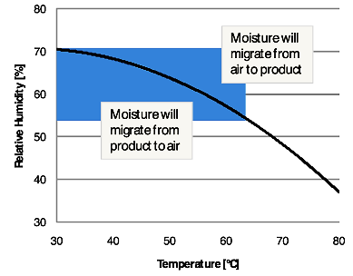
Figure 1: Relative humidity-Temperature graph of urea (http://www.solexthermal.com/images/en/articles/TheBulkSolidsCooler-2.png)

In the graph it is also visible that at higher temperature the urea will take up moisture at lower relative humidities. This poses a problem as the granules are heated with steam in the granulator and afterwards dried using a hot air flow. The surplus moisture build up in the granulator can cause over-granulation; the granules pick up too much material and become too large in size. This can be counteracted by simply using less steam or liquid. The moisture build-up in the dryer can be counteracted by the use of either cooler or dehumidified air.
The moisture build-up in and around the granules cause them to cake together and leaves it in lumps instead of free flowing granules. Therefore a solution has to be found in order to incorporate urea in the fertilizers without problems like caking. Several attempts have been made across the world but none have really proven successful, only resulting in granules of poor quality. On the European market such poor quality granules cannot be sold.

Methods

Some of the methods have been tested before at ICL Fertilizers Europe CV. They are still performed to give a whole image of the possible methods of incorporating urea in NPK’s and provide a good comparison for each other as they are performed with the same resources. All experiments are performed on mini-pilot plant scale and follow all steps of the production process except for the cooling step after size-screening.
Several processes which lead to a NPK fertilizer using urea have been recorded. In short, there are four methods of incorporating urea:
- The addition of prilled or ground urea during granulation (which leads to overgranulation and caked granules)
- Mixing urea prills with finished PK granules (this also leads to caking, but this could prevented by the use of coatings or additional compounds in the granules).
- Synthesis of urea-monocalcium phosphate, which can then be used in granulation.
- Solving the urea in a sulfuric acid and water mixture. This can then be used to acidulate the phosphate rock, leading to urea super phosphate (USP)
The preference goes to methods were the urea is incorporated in the granule as opposed to blends, as it will all be produced simultaneously. This saves time as opposed to producing several different granules after one another to form a specific blend afterwards.

Addition during granulation
Simply adding urea during the granulation like ammonium sulfate seems like the most straight forward method. As urea is usually produced in prilled form, it could provide a good starting point to form granules. Unfortunately the urea reacts with the hydrated superphosphate, releasing water and resulting in over-granulation and granules caking together. By adding acid neutralizers like gypsum and limestone this could be counteracted. another option is drying the SSP prior to granulation (Aasamäe et al., 1993).

Addition after granulation
The same problem arises as in addition during granulation. This could be prevented though by the use of specific additives or coatings. To this day there are none such components readily available. There are anti-caking and water resistant coatings available for either urea or NPK specifically and perhaps these could prove helpful in the production of urea NPK.

Urea-monocalcium phosphate
As described in Equation 5, urea forms complexes with calcium sulfate and monocalcium phosphate Ca(H₂PO₄)₂. In order to increase the amount of urea-monocalcium complexes, it can be made to react separately instead of in the blend of different calcium complexes found in superphosphate. This can be done by mixing the superphosphate in water causing Ca(H₂PO₄)₂ to dissolve in the water. It can also be done by reacting calcium carbonate CaCO₃ with phosphoric acid, which produces more MCP. It is then made to react by saturating the solution with urea. The resulting Ca(H₂PO₄)₂.4CO(NH₂ )₂ is still dissolved in the water and can be retrieved by slow evaporation of water or by addition of either phosphoric acid or a soluble calcium salt. The precipitating salt can then be filtered off and dried further if necessary. The resulting salt crystals are non-hygroscopic at relative humidities below 60% and can be used in the granulation process. (Frazier, Lehr, & Smith, 1967)

Urea sulfuric acid
Solving urea in the right ratio of sulfuric acid and water gives a liquid with a eutectic system, as shown in Figure 2. From here onward it will be referred to as USAC (Urea Sulfuric Acid). This is a liquid with a certain composition that has a melting point lower than the other compositions. For urea in sulfuric acid and water there are two of these eutectic points; E at 3,6 moles of urea to 1 mole of sulfuric acid to 1 mole of water and E’ at mole ratio 1,8:1:1. Both E and E’ are said to have a melting point around 10 °C while the melting point of urea is around 133 °C. These lower melting points are due to the complexes that urea forms with sulfuric acid, [CO(NH₂)₂.H₂SO₄] and [(CO(NH₂)₂)₂.H₂SO₄]. The formation of these complexes is an exothermic reaction; when making E’ the temperature can easily increase to over 100 °C. E on the other hand stays around 60-70 °C. (Limousin, Neveu, & Peudpiece, 1994)

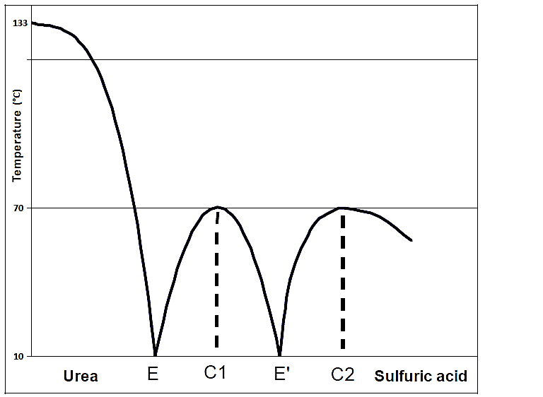
Figure 2: Eutectic system of urea and sulfuric acid (Limousin et al., 1994)

Dissolving urea in such a eutectic system leaves it in a stable liquid state along with sulfuric acid. This sulfuric acid can still be used to acidulate the phosphate rock. Using USAC for this allows two things to be done at the same time; the phosphorus in the rock is brought to the water-soluble form and urea is incorporated into the mixture. The reaction is similar to equations 1-3 with the addition of urea to it, as is described in Equation 5. (Granger, 2005)
Equation (5) ${Ca}_{3}(PO_{4})_{2}+ 2 H_{2}SO_{4}+(8a+2f) CO(NH_{2})_{2}+(e+2bx) H_{2}O→$
$$2a [CaSO_{4}. 4 CO(NH_{2})_{2}] + 2b[CaSO_{4}.xH_{2}O]+e [Ca\left(H_{2}PO_{4})_{2}.H_{2}O\right]+f[Ca(H_{2}PO_{4})_{2}.2CO\left(NH_{2})_{2}\right]$$
$(a+b=1 , e+f=1)$
After mixing the USAC with phosphate rock the mixture will harden like SSP and TSP and form a urea superphosphate (USP). This USP can be used like SSP and TSP in the regular process of granulation.
This method still has some problems; when dried at too high temperatures the granules tend to be more hygroscopic and take up moisture from the air. This leads to soft granules and may also cause caking due to salt bridges being formed between the granules.
In order to prevent this, neutralizing agents can be added to react with the free acids left in superphosphate. This agent can either be gypsum (Elaihu Di & Yuval, 2001) or limestone. The disadvantage of using either of these is that they can react with the acid and cause a decrease in the amount of water soluble P.

Analytical methods

An automatic analysis robot is present on the production plant to measure the values of various components including: % N (as NH₄ and NO₃), water soluble and total % P₂O₅, % K₂O, % CaO, % MgO, % SO₄, free acid %, pH and moisture %. The total nutrient values are measured by ion chromatography with sample dilution in HCl, free acid % and pH are measured by titration and moisture % is determined with gravimetric analysis.
There is also another value for P₂O₅, the NAC value. This entails the neutral ammonium citrate (C₆H₁₇N₃O₇) soluble amount of P₂O₅, which is a representation of the amount of P₂O₅ that can be absorbed into most types of soil. This value is not measured by the robot, but is measured separately after a curing period of at least a week.
The nitrogen value method used by the robot is designed for fertilizers produced with ammonium sulfate and nitrate. A new method has to be implemented in order to test the nitrogen value from urea and will require new equipment to do so. Therefore the actual nitrogen values of produced NP(K)’s will only be tested by a third party if the product has proved it could be produced in the current plant without any significant problems.
Produced granules are also tested for hardness and caking. Hardness is tested by measuring the weight needed to crush a single granule. Caking is tested by bringing a set volume of granules in a rubber container under 2 bar pressure for two days. This simulates the granules under pressure at the bottom of a mound. The whole is then pneumatically pressed together and the pressure at which the lump falls apart is measured.

Results

Urea-monocalcium phosphate
It was possible to retrieve crystals by slow evaporation of water saturated with urea and MCP. However, the crystals did not prove applicable in the granulation process as the entire mixture (10-50% UMCP, 90-50% SSP) liquefies after addition of only a marginal amount of steam. This could be due to the fact that they are both water soluble and the addition of water would cause the compound to dissolve in the water instead of allowing the particles to agglomerate.

Urea sulfuric acid
1,8 mol urea: 1 mol sulfuric acid: 1 mol water
By trial and error, the ratio of USAC to phosphate rock that gives the best ROP is at 80g USAC to 200g phosphate rock. This gives a fine powder which can be used immediately in granulation, but it is at a lower acid to rock ratio than what is required to properly acidulate the rock. This makes the ROP low in water soluble P₂O₅ in comparison to the total (around 25%). Various recipes were tried to improve the water soluble P₂O₅ levels, as shown in Table 1.
Table 1: Results of USAC 1,8
Recipe | Comment
USPG | Low on water soluble P₂O₅
USPG + KCl | Overgranulates easily
USPG + KCl (during acidulation) | Overgranulates easily
USPG + MgO | Granules increasingly harder, still low WS P₂O₅
USPG + MgO (during acidulation) | Improved WS P₂O_{5,} but not enough

3,6 mol urea: 1 mol sulfuric acid: 1 mol water
The solution has a density of 1,425g/ml and is a stable liquid from 10 °C to 100 °C. Also by trial and error the ratio proven to work best is 360g of USAC to 200g phosphate rock. At this ratio the mixture forms a suitable ROP, although slightly harder than SSP or TSP. The percentage of water soluble P₂O₅ against the total amount of P₂O₅ is sufficient (70-75%) to be sold commercially. The recipes in table 2 were either dried at temperatures not exceeding 60 °C (Cool Drying) or at temperatures higher than 100 °C (Hot Drying) (see Discussion).
Table 2: Results of USAC 3,6
Recipe | Drying | Comment
USP | CD | Round granules but quite soft
USP + KCl | CD | Overgranulates very easily
USP + MgO | CD | Granules are harder, but rather brittle, caking does occur
USP + MgO (during acidulation) | CD | ROP dries quicker but lower WS P₂O₅, caking does occur
USP + MgSO₄ | CD | No improvement on USPG
USP (cured for several days) | CD | Slightly harder granules, still not hard enough
USP | HD | Hard granules, low WS P₂O₅, NAC P₂O₅ is high enough, no caking
USP + KCl | HD | Overgranulates easily, difficult to control
USP + MgO | HD | No significant improvement from USPG
USP + KCl + MgO | HD | Possible, but difficult to control the (over)granulation
USP + Gypsum (CaSO₄) | HD | No improvement on USPG
USP + Limestone (CaCO₃) | HD | No improvement on USPG

Elemental analysis
Table 3 contains the average results of elemental analysis of the products obtained from the experiments (only the relevant values are shown).
Table 3: Elemental analysis of products
Compound | NH₄ % | P₂O₅ Total % | P₂O₅ WS % | WS Eff. % | P₂O₅ NAC % | NAC Eff. % | CaO % | SO₄ % | Moisture % | Free acid % | pH
USP 1,8 ROP | 0,1 | 20,4 | 4,7 | 23,0 | - | - | 33,2 | 15,2 | 2,1 | 1,4 | 3,2
USPG 1,8 | 0,4 | 21,6 | 3,7 | 17,1 | - | - | 33,1 | 14,7 | 5,9 | 0,2 | 4,1
USP 3,6 ROP | 0,1 | 11,1 | 7,5 | 67,6 | - | - | 19,3 | 20,5 | 3,1 | 5,5 | 2,5
USPG 3,6 CD | 0,1 | 11,6 | 7,6 | 65,5 | - | - | 18,5 | 19,3 | 6,2 | 4,6 | 2,6
USPG 3,6 HD | 2,1 | 11,6 | 3,0 | 25,9 | 8,9 | 76,7 | 20,2 | 21,5 | 1,7 | 1,2 | 3,6
UMCP crystals | 0,3 | 25,6 | 6,4 | 25,0 | - | - | 16,5 | 1,1 | 2,7 | - | -

Urea value analysis
The urea values of three batches of USAC 3,6 granules have been tested by external laboratory Everiss. The values are shown in table 4.
Table 4: Urea value of USAC 3,6 granules
Sample | N total % | N-Urea % | N- NH₄ % | P₂O₅ %
USPG 1/10/2013 | 19,6 | 18,3 | 1,3 | 12,0
USPG 31/10/2013 | 20,7 | 18,8 | 1,9 | 12,0
USPG + Recycle 31/10/2013 | 20,4 | 18,3 | 2,1 | 12,0
Average | 20,23 | 18,46 | 1,76 | 12,0

Cost estimation
A rough estimation has been done on the costs of the alterations required for the USAC 3,6 method. The quantities used to calculate the required storage space and other factors have been derived from the current process requirements. The average production is approximately 30 metric tonnes of granules per hour, which correlates to 20t of USAC solution required per hour. A run of USP granules would last continuously for 3 days, requiring 1440t of US. Taken with the density of the solution (1,425g/ml) this correlates to 1010m³ of USAC. As the solution needs to be made in batches to ensure the correct ratio, a 1000m³ storage tank (the remaining 10m³ can be compensated with the batch mixer) is required for the production to ensure a constant flow. The tank will need corrosion resistant coating due to the sulfuric acid. The costs are summed up in table 5.
Table 5: Cost estimation
Item | Cost (in k€)
Batch mixer | 75
Mixing controller | 10
1000m³ storage tank | 250
Corrosion resistant tank coating | 150
Foundation | 150
Pipelines + pump | 65
Appendages | 2
Electric feed | 7
Preliminary Total | 709
Engineering (15%) | 106,35
Unexpected costs (15%) | 122,30
Total | 937,65

Discussion
It has been stated in Methods that the USAC experiments should be dried at relatively low temperatures to ensure the urea in the granules does not decompose or melt. An experiment has been done drying the granules at high temperatures and it has been found that these granules become drier and harder than the granules dried at lower temperatures. Dry granules are less prone to caking and the hardness is required to ensure that the granule will stay intact when it is spread on the field using heavy machinery.
Therefore further experimenting with USAC 3,6 was done at high drying temperatures. The water soluble P₂O₅ value does lower from 70% to 10% of the total value, but the NAC value is still sufficient, around 75%, high enough to be sold as commercial fertilizer. This decrease in water soluble P₂O₅ goes along with an increase of the NH₄ value. This increase in NH₄ could be caused by the high temperature of the dryer breaking down the urea into ammonia, NH₃, and cyanic acid, HNCO_{(g)} (Schaber et al., 2004). This could require the exhaust fumes from the dryer to be scrubbed more intensive.
Tests have been done heating some granules of different USAC 3,6 method recipes over 250 °C. This causes gas development, which stops at a point. At this point all the urea in the granules will have most likely broken down into the before mentioned gases. The granules stay mostly intact, apart from becoming very brittle. This points out that the urea is important for the hardness of the granules.

Urea-monocalcium phosphate is not a viable way of incorporating urea in NPK fertilizers as the granulation of it is simply not possible in the current process. The synthesis of the crystals also requires more process steps which would require more equipment investments for the production plant in comparison to the USAC method. It also produces a lot more waste water which would require investments in a water treatment facility.

The USP 3,6 can be granulated in combination with other nutrients, but these seem to release more excess water than when granulated separately. When granulated in combination the water would get the granulation started, after that the water being released from the hydrated salts would keep the granulation going even during the drying stage. This excess water makes it hard to control the granulation process, causing multiple granules to coalesce and create (too) large granules. However, it is possible by using just a small amount of water. The granulation would be initiated in the granulator, leading to small granules. These would then increase in size in the dryer as water is released by the urea reacting with the hydrated salts. Therefore it is advised to granulate the USP separately to ensure an easily controlled granulation and blend these granules with others to reach the desired NPK value.

Conclusion
The most effective way of producing urea NP fertilizer granules is by the USAC 3,6:1:1 method, dried at high temperatures. This provides hard, free flowing granules which contain satisfactory amounts of nutrients. The USP granules can also be mixed with other granules to attain certain NPK values without any negative effects. The process does not need relatively major alterations to the production process besides a mixing vessel, storage tank and a heated pipeline from the storage tank to the ROP mixer, as shown in appendix 2, which is estimated to cost close to €950.000.

Appendices

Appendix 1: Flowchart of current production process
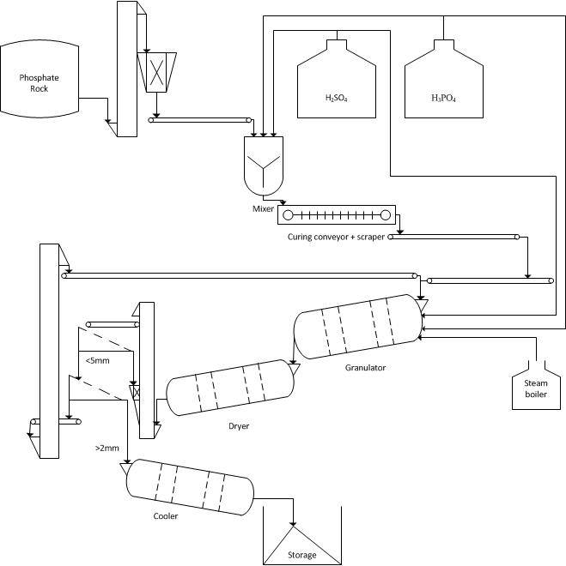

Appendix 2: Flowchart of altered production process with USAC

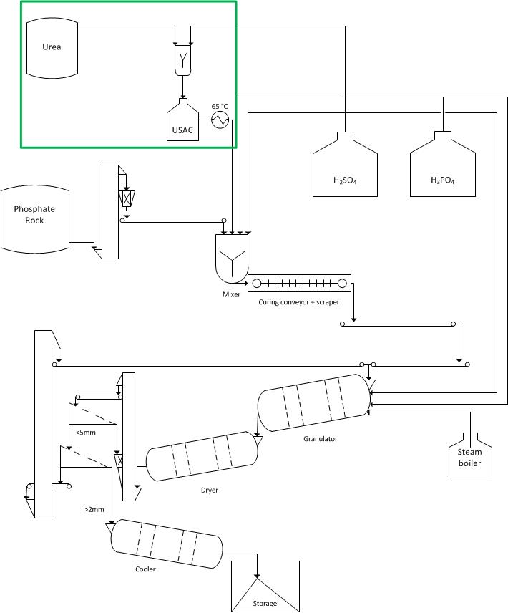

Bibliography
- Crop rotation. (2013). In Encyclopædia Britannica. Retrieved from http://www.britannica.com/EBchecked/topic/143973/crop-rotation

- Aasamäe, E., Arumeel, E., Einard, M., & Veiderma, M. (1993). Obtaining granular NPK fertilizers from single superphosphate and urea. Fertilizer Research, 35(2), 161–167.

- Elaihu Di, B.-J., & Yuval, S. (2001). Process for the preparation of urea superphosphate fertilizers. WO Patent App. PCT/IL2000/000,824. Retrieved from http://www.google.com/patents/WO2001042172A1

- Frazier, A. W., Lehr, J. R., & Smith, J. P. (1967). Urea-Monocalcium Phosphate , a Component of Mixed Fertilizers : z, 15(2), 345–347.

- Granger, J. P. (2005). AFA 18 th International Annual Technical Conference & Exhibition, (July).

- Limousin, L., Neveu, B., & Peudpiece, J. B. (1994). IFA Technical Conference. In A new way to produce urea-superphosphate fertilizers The AZF U.S.P. process.

- Ongshaug, G. U. K., & Hydro, N. (2012). Phosphate Fertilizers. In Ullmann’s encyclopedia of industrial chemistry. doi:10.1002/14356007.a19

- Orphanides, P. (2002). IFA Technical Conference. In Urea caking problems, how to avoid them (pp. 0–14).

- Schaber, P. M., Colson, J., Higgins, S., Thielen, D., Anspach, B., & Brauer, J. (2004). Thermal decomposition (pyrolysis) of urea in an open reaction vessel. Thermochima Acta, 424, 131–142. doi:10.1016/j.tca.2004.05.018

