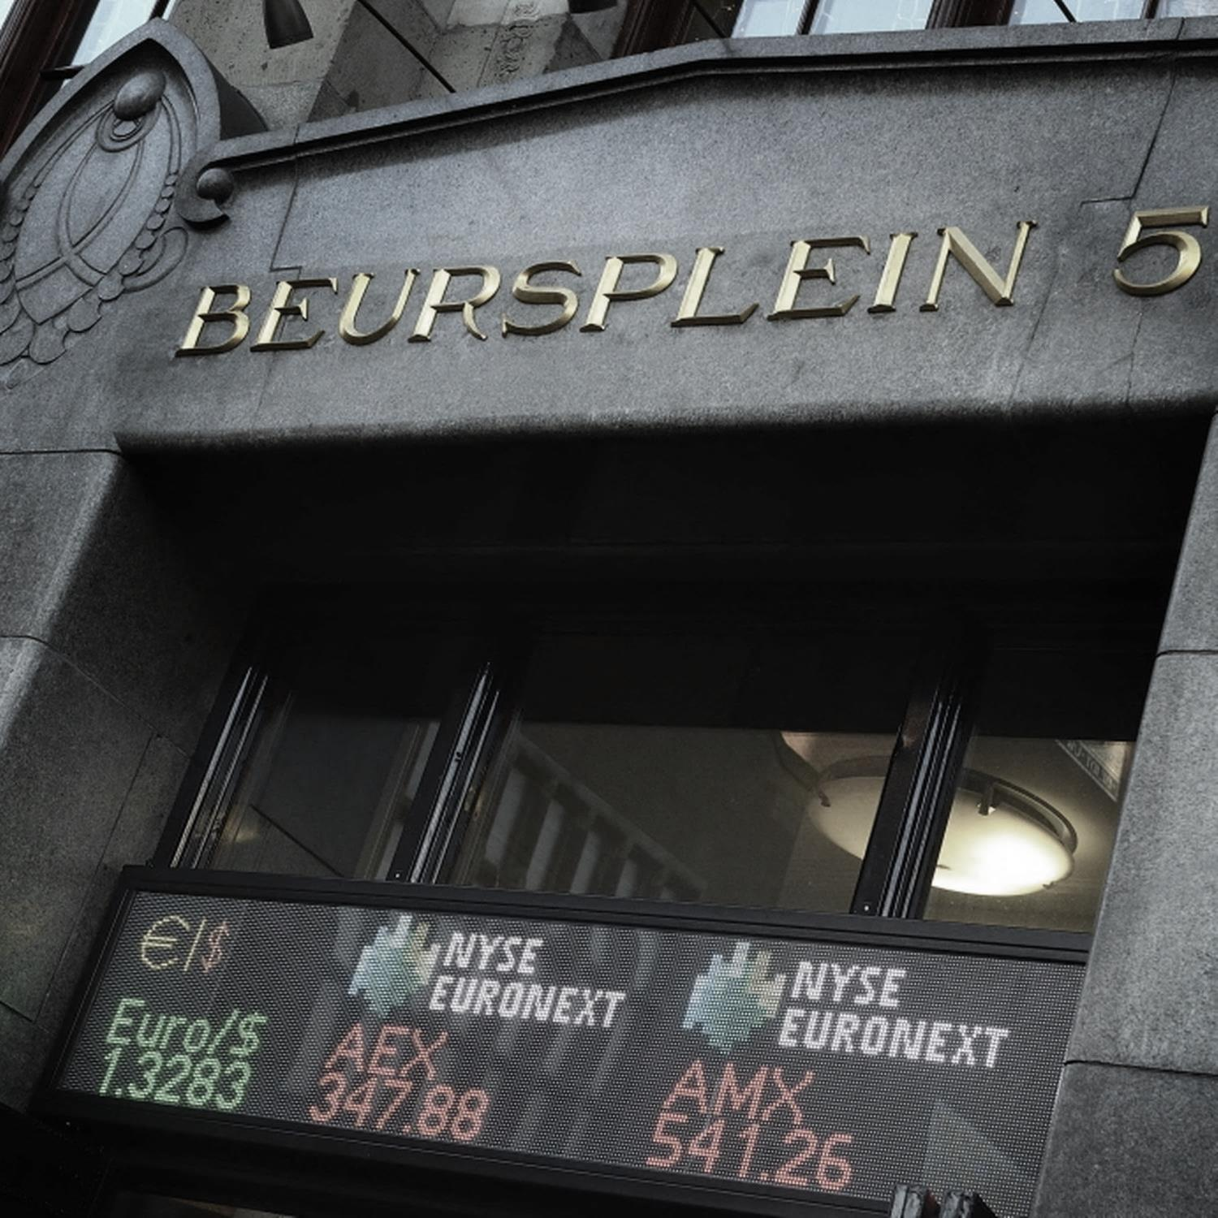

BACHELOR THESIS



Change-in-Control Provision and Shareholder Value in the Dutch Market

 By Luuk Kuiper

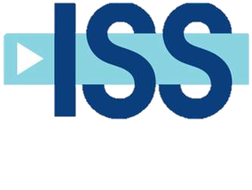

Change-in-control provision and shareholder value in the Dutch market

Student: Luuk Kuiper

Year 5, IBMS

Email: luuk.kuiper@student.hu.nl

Student number: 1578744

Hogeschool Utrecht, University of Applied Sciences

Supervising lecturer: Edwin Weesie

Second reader: Philip Dekker

Company supervisor: Robbert Gerritsen

Date: July, 2015

# C:\Users\kuipluu\Documents\Thesis\Miscellaneous\HU Logo.jpgForeword

This thesis is written for the completion of my bachelor International Business and Management Studies at the Hogeschool Utrecht, University of Applied Sciences. The bachelor program focuses on the international aspects of marketing, sales, management, finance and logistics. The subject of this thesis, the change-in-control provision of the Clawback Bonuses Act and shareholder value in the Dutch market, falls within the scope of this bachelor.

The subject of the thesis was selected in cooperation with Institutional Shareholder Services, Inc., where I did a six-month internship and assisted in the research and analysis of listed companies in the Benelux.

I would like to thank Robbert Gerritsen, head research analyst for the Benelux market at Institutional Shareholder Services, Inc., and my supervisor Edwin Weesie, from Hogeschool Utrecht University of Applied Sciences, for their valuable insights and direction in the completion of this thesis.

# Executive summary

The change-in-control provision of the Clawback of Bonuses Act limits the director’s ability to gain from a change-in-control by a deduction of the share value by the lowest increase in share value over a determined reference period. The provision therefore limits the effectiveness of share and option incentives. The intention of this research is to find what the effect of the change-in-control provision is on shareholder value and how ISS should advise its clients on the change-in-control provision.

The research method used is a case study. The cases that are selected for the case study are (i) ABN Amro Royal – Bank of Scotland, Banco Santader and Fortis Bank (2007), (ii) Numico – Danone Groupe (2007), (iii) Draka Holding – Prysmian (2011), (iv) Crucell – Johnson & Johnson (2011), and (v) Douwe Egberts – Reckitt Benckiser plc (2012). These cases are considered extreme cases and critical cases of change-in-control that can be especially problem-rich and encompassing and would allow for logical conclusions (Launso et al., 2006).

The outcome of the research suggests several problems with the change-in-control provision on shareholder value, namely: (I) the CEO is not incentivized for bargaining a higher premium in a takeover because the Provision eliminates the personal gain, (II) the Provision discourages CEOs to sell the company, (III) the change-in-control provision is limited to share or option incentives and could easily be diverted by awarding severance in cash, or other awards tied to share performance, (IV) the devaluation of equity-based incentives disconnects the principal and agent relation by removing the incentive for the CEO to negotiate a higher premium, (V) devaluating the equity-based incentives for Dutch companies makes it harder to attract talent. Advantages to the Provision are: (I) a reduction in possible public scrutiny in the case of excessive severance, and (II) the reduced incentive to sell the company increases the possibility of the implementation of a poison pill which has a positive effect on share value. However, the disadvantages clearly outweigh the advantages.

ISS should therefore take steps to; inform its customers of the implications of the change-in-control provision; encourage investors with a majority shareholding in companies to change the current remuneration policy; and advice positive on agenda items that include remuneration policies updates that change long-term incentive awards from shares or options to phantom stock, SARs, cash settled options, or conditional cash awards used for buying shares.

# Content

Foreword 2

Executive summary 3

Content 4

Glossary 6

1. Introduction 8

2. Literature review 10

3. Methodology 12

3.1 Orientation 12

3.2 Data Collection 13

3.3 Data analysis 13

3.4 Cases 14

3.5 Conceptual model 15

3.6 Limitations 16

3.7 Delimitations 16

3.8 Ethics 16

4. Findings 17

4.1 ABN AMRO Holding NV (2007) 17

4.1.1 Background 17

4.1.2 Sales process 18

4.1.3 Outcome 18

4.1.4 Hypothetical outcome 19

4.2 Numico NV (2007) 21

4.2.1 Background 21

4.2.2 Sales process 21

4.2.3 Outcome 21

4.2.4 Hypothetical outcome 22

4.3 Draka Holding NV (2011) 23

4.3.1 Background 23

4.3.2 Sales process 23

4.3.3 Outcome 24

4.3.4 Hypothetical outcome 24

4.4 Crucell NV (2011) 25

4.4.1 Background 25

4.4.2 Sales process 25

4.4.3 Outcome 25

4.4.4 Hypothetical outcome 25

4.5 DE Master Blenders 1753 NV (2013) 26

4.5.1 Background 26

4.5.2 Sales process 27

4.5.3 Outcome 27

4.5.4 Hypothetical outcome 27

4.6 Results of interview 28

5. Discussion 29

5.1 Outcome of findings 29

5.1.1 Decreased incentive to increase premium 29

5.1.2 Disruption of agency theory 29

5.1.3 Limited to shares and options 30

5.1.4 Severance approved by shareholders 30

5.1.5 Decreased fairness and ability to attract talent 30

5.1.6 Positive effects 31

5.1.7 Sub conclusion 31

5.2 Practical applications of findings 32

5.3 Market reaction 33

6. Recommendation 34

6.1 Practical recommendations 34

6.2 Implementation 35

7. Conclusion 37

Bibliography 38

Appendix 42

APPENDIX I: share price valuation in accordance to the Provision. 42

APPENDIX II: ABN Amro share price progression 43

APPENDIX III: Numico NV share price progression (source: Zephyr.com) 43

APPENDIX IV: Draka Holding NV share price progression (source: Zephyr.com) 43

APPENDIX V: Crucell NV share price progression (source: Zephyr.com) 44

APPENDIX VI: DE Master Blenders NV share price progression (source: Behr.nl) 44

APPENDIX VII: Severance calculations. Original situation vs. application of Provision. 44

APPENDIX VIII: Interview with Robert Gerritsen Analysist at ISS for the Benelux market 45

APPENDIX IX: Proposal of policy update in ISS format: discussion item 47

APPENDIX X: Proposal of policy update in ISS format: voting item 47

# Glossary

AEX Amsterdam Exchange Index

AGM Annual General Meeting

AMX Amsterdam Midcap Index (formerly knows as the ASE)

CEO Chief Executive Officer

Cash settled options An option for which the physical delivery of the security is not required

Change-in-control Occurs when a firm changes leadership, often times due to a takeover or acquisition

Change-in-control provision A provision included in an employment agreement that provides an employee with certain protections in the event of a change of ownership in a company

Clawback Money or benefits that are distributed and then taken back as a result of special circumstances

EGM Extraordinary General Meeting

ISS Institutional Shareholder Services

NV Dutch limited liability company (Naamloze Vennootschap)

Performance Stock Unit (PSU) Shares of company stock given to managers as a reward for certain performance criteria being met

Phantom stock An agreement to award bonus in the form of the equivalent of either the share value or the increase in share value over a period of time

Premium The amount of money exceeding the share price the acquiring company is offering for the shares of the target company

Proxy season The period in which many companies hold their annual general meeting. In the Netherlands from April and May

RBS Royal Bank of Scotland

RFS Royal Bank of Scotland, Fortis and Banco Santander; the consortium of banks that acquired ABN Amro

Stock Appreciation Rights (SARs) An agreement to provide the right to the monetary equivalent of the increase in the share value of a predetermined number of shares over a specific period of time

Target CEO The CEO of the acquired company

Target shareholder The shareholder of the acquired company

The Act The Clawback of Bonuses Act

The Provision The provision in the Clawback of Bonuses Act that limits that reduces the amount CEOs are able to sell their shares for in case of a change-in-control

VEB Vereniging Nederlandse Effectenbezitters (Dutch Investors’ Association)

Vesting To give someone control over their stock or stock options. Employee performance shares or options usually vest within an indicated vesting period, in order to incentives employees

White knight A friendly investor that acquires a corporation at a fair consideration with the support from the corporation's board of directors and management

# Introduction

In recent years executive compensation has transformed from a business issue into a political one (Vugt, 2013). As a response to the financial crisis the Dutch government came with measures to prevent repetition. One of these measures is the Clawback of Bonuses act.

The Clawback of Bonuses act ("the Act") has been taken into effect since January 1, 2014, in the Netherlands, and is a response to the social unrest regarding excessive bonuses (Allen & Overy, 2013). The purpose of the Act is to enable limited companies (NVs in Dutch) and financial undertakings to adjust or clawback excessive bonuses. In short, the Act will; (i) allow for the adjustment of a bonus awarded to a director to an appropriate amount if, under the given circumstances, payment of the bonus would be unacceptable, (ii) allow to clawback bonus paid to a director if it has been awarded on the basis of incorrect information, and (iii) in merger takeover situations, require public companies to withhold any increase in the value of shares[1] and options forming part of the directors remuneration (Clawback of Bonuses Act, 2014). For this research, the focus will be on the latter, the withholding of the increase in share value (premium) in the case of change-of-control.

In order to eliminate personal gain for directors as a driving force behind decisions in merger and takeover situations, companies are required to withhold any increase in the value of shares or options awarded to a director as remuneration if the value increases from a takeover, merger or division. The same goes for a value increase resulting from an important management decision that fundamentally changes the company's identity (BW 2:107a). Shares and options that the director has purchased himself or has inherited are not subject to the withholding obligation. The withholding occurs when the director sells his shares or ceases to be a director.

The change-in-control provision of the Act has been strongly criticized since it surpasses its goal and can be easily diverted by awarding bonuses in cash instead of shares or options (Commissie Vennootschapsrecht, 2010; Loyens & Loeff, 2014). Moreover, as both the director and the shareholders hold equity in the firm an increase in share price after change-in-control could result in personal gain for both the director and the shareholder of the firm.

Institutional Shareholder Services Inc. (ISS) is the world’s leading provider of corporate governance solutions for asset owners, investment managers, and asset service providers. ISS’ solutions include objective governance research and recommendations. As a proxy advisory firm, ISS needs to be aware of the changes in the corporate governance landscape it is analyzing. ISS bases its recommendations on its policy. At the moment, ISS does not have a policy on the change-in-control provision and therefore has to recommend on case-by-case basis, which costs time and money. The purpose of the research is to find if the change-in-control provision of the Act is in the interest of the shareholder and how ISS should advise its clients on this subject.

The proposed research question is therefore as follows: *“How should ISS advise its clients on the change-in-control provision of the new Clawback of Bonuses Act in the Netherlands?”* In order to answer this question, there are several other sub-questions that need to be answered:

1. How and to what extend are directors affected by the change-in-control section of the Clawback of Bonuses Act?
2. How and to what extend are shareholders and other stakeholders affected by the change-in-control section of the Clawback of Bonuses Act?
3. How are companies reacting to the change-in-control section of the Clawback of Bonuses Act?
4. What are the principles of ISS policy and how can it be utilized to form a recommendation for its clients in the Netherlands?
5. What corporate governance theory should be applied to the case studies in order to effectively measure the outcome of the change-in-control?

# Literature review

The intention of the Provision is to prevent that a director gains from the value appreciation of his/her shares in the case of a takeover of the firm. Therefore it is decided that a director should convey part of the profit to the firm. This is done with the intention to eliminate personal gain in case of a takeover (Ministry of Security and Justice, 2010). Moreover, the Provision intends to strengthen the position of the supervisory board with regard to severance (House of Representatives, 2010).

The change-in-control provision of the Clawback of Bonuses Act limits the director’s ability to gain from a change-in-control by a deduction of the share value by the lowest increase in share value over a determined reference period (further clarified in appendix I). The provision therefore limits the effectiveness of share and/or option incentives.

Research on acquisitions has found that target shareholders generally benefit if the takeover is successful (Elkinawy et al., 2013). Yet, directors of the target firm are able to lose their position or otherwise suffer substantial losses in compensation as a result of an acquisition of their firm. Therefore these directors will often times try to prevent the takeover, or in other cases, the directors will bargain with the acquiring firm to keep their position. These sorts of actions are naturally not in the best interests of the target shareholders. This leads many companies to implement compensation policies to provide the appropriate incentives for directors, which includes the accelerated vesting of restricted stock and stock options (Jensen, 1988). This is in line with the agency theory, since a consequence of the agency theory is that where CEO duality is preserved shareholder interests could be protected by aligning the interests of the CEO and the shareholders by a suitable incentive scheme for the CEO, i.e. by a system of long-term compensation additional to basic salary (Donaldson et al., 1985).

The effectiveness of such a manner of incentivizing directors is confirmed by Elkinawy et al. (2013), who have found a positive correlation between accelerated vesting and premiums. Their evidence suggests that accelerated vesting provides incentive for the CEO to negotiate the highest possible premium and thus increasing shareholder value. Moreover, Bettis et al. (2010) examined 983 equity-based awards and found that performance-vesting provisions are associated with subsequently better operating performance than firms without these provisions.

Hartzell et al. (2004) found that the gains from stock and options are the largest component of overall gains obtained by target CEOs in case of an acquisition. In combination with the accelerated vesting of shares therefore forms a strong alignment of interests between the shareholders and the CEO. Moreover, target directors negotiate a higher premium to compensate for lost salary in case the CEO is not retained (Lefanowicz et al., 2000). Signifying that managers who do not expect to be retained will bargain for a higher premium.

The Provision limits the ability for shareholders to incentivize the CEOs by equity-based awards. This makes room for other types of compensation schemes, like cash-based awards (e.g. golden parachutes) or post-merger special treatment. The decrease in effectiveness of share- and/or option-based incentives could have adverse effects for shareholders. Hartzell et al. (2002) foundthat golden parachutes diminish the incentive for target CEOs to negotiate larger gains for target shareholders.Moreover, it was found that premiums are lower in deals where the CEO negotiates a large, fixed cash payment (ie. golden parachute) as part of the merger agreement. The Provision would exclude the premium that the CEO would receive on equity-based incentives, therefore decreasing the personal gain for negotiating a higher premium for shareholders.

Fich et al. (2011)found that premiums are lower in deals in which the CEO is granted equity incentives after the deal is announced, but before it closes (ie. bribing). Meaning that the results for target shareholders are lower in cases were the CEO was bribed.Hartzell et al. (2004) add that target CEOs will accept a lower premium in exchange for special treatment after the acquisition, including golden parachutes or a position in the acquiring firm. Moreover, in a sample using 2198 completed M&A transactions between 1994 and 2010, Qiu et al. (2014) found a significant negative relation between target CEO retention and the premiums for target shareholders, suggesting that target CEOs bargain shareholder value for personal benefits during acquisitions. In order to increase the premium during a takeover, these incentives should therefore be avoided when possible.

In the case a CEO is nearing retirement, it was found that CEOs are more prone to selling the firm and receive a bonus in order tocash out at the end of their career (Elkinawy et al., 2013). A finding that confirms the importance of equity-based incentives for CEOs.

Another option for a target company is to avoid being acquired by means of a takeover defense. For shareholders there are also benefits to such a takeover defense. Executives produce wealth for shareholders when they actively pursue a corporate defense against a hostile takeover. Especially in cases where the poison pill provision is used to divert a hostile attack, the defense is likely to boost shareholder wealth (Pearce et al., 2004).

These studies confirm the importance for shareholders to pursue a remuneration policy with strong equity-based incentives for directors, so that in case a change-in-control occurs, the director will receive incentive to achieve a higher premium. The abundance of equity-based incentives can have negative effects for shareholders. Cash awards, personal benefits, or other incentives not tied to the equity value, do not incentivize directors to bargain a higher premium during a change-in-control.

# Methodology

## Orientation

The research question concerns the change-in-control provision of the clawback of bonuses act in the Netherlands. Furthermore, it relates to the clients of ISS in a way that the application of the findings of the research should be utilized in order to advise ISS clients how to use their voting right in companies that are affected by the change-in-control provision of the clawback bonuses act (from hereon: the Provision). The research question therefore asks for investigation of the Provision and the current manner of ISS client recommendation.

The case study method has been chosen because answering the research question requires deliberately isolating a small study group, the study group being companies that went through a change-in-control after 2007. Furthermore, case studies allow the researcher to become familiar with the data in its natural setting and fully appreciate the context (Punch, 1998), which is necessary in order to find the variables influencing change-in-control.

According to Yin (2003) a case study design should be considered when (I) the focus of the study is to answer how and why, and, (II) the behavior of those involved in the study cannot be manipulated. This is the case for this research. The type of research question asks for a profound analysis of particular cases in order to find what the effects are for shareholders and whether there are flaws to the Provision. Therefore it is most reasonable to use a case study research design.

The category of research design that is used for the case study is descriptive case study of multi-case studies. Which is defined a description of an intervention or phenomenon and the real-life context in which it occurs. Furthermore multi-case studies are used to explore the differences within and between cases (Yin, 2003).

Common difficulties connected with the case study design is that there is a inclination for researchers to attempt to answer a research question that is too broad (Baxter et al., 2008). In order to avoid this problem boundaries should be placed on a case to prevent this explosion from occurring (Yin, 2003).

Semi-structured interviews will be held with ISS experts in the second stage of the research to find how a client recommendation is formed and what factors would influence the recommendation in the case of change-in-control provision of the Act. The semi-structured interview technique has been chosen since it allows for new ideas to be brought up during the interview as a result of what the interviewee states, as well as keeping the interview within a predetermined framework (Drever, 1995). The results of the interview will be utilized to form a recommendation for ISS to implement the results of the research.

## Data Collection

Patton (1987) indicates that three steps are executed during analysis: data is organized, data is reduced through summarization and categorization, and patterns and themes in the data are identified and linked.

The data that will be used in the research is gray literature – information gathered about companies mainly in the form of annual reports, remuneration reports, takeover-prospects and memoranda, and media inquiries. The companies in question and media sources will supply this information.

We assume that the data supplied by the companies is valid. The information given in company reports is inspected by independent external auditors that assure the validity of the report. Moreover, the company will face reputation loss when found out that the data is incorrect.

Qualitative analysis usually involves engaging in the data to become familiar with it, then looking for patterns and themes, searching for various relationships between data that help the research to understand what they have, then visually displaying the information and writing it down (Kawulich, 2004). The data will be analyzed by summarizing the important issues and comparing it with other data, in order to later draw conclusions.

To ensure the validity of the interview data, the interviews will be simple and clearly structured so that the interviewee will understand the questions correct and the information is transferred unbiased.

## Data analysis

For our analysis we will be looking at the effects on the CEO, the shareholders, and other direct stakeholders. In order for the research to be equivalent in all cases, the variables of research need to be equal.

The goal of the analysis is to find what the effect of the Provision is on shareholders, and, to answer the sub-questions.

The ultimate goal of the Provision is to eliminate personal gain as an influence in the decision for the CEO to go through with the merger of acquisition of his company. Therefore, we will pay attention to the amount of income the CEO will receive as a result of the deal. We will do this by calculating the severance and the (vested) shares that the director has received due to the deal. This amount will be compared to the hypothetical situation if the Provision would have been in place. The share price for the CEO under the provision as follows:

1. The closing price of the shares and/or options 4 weeks before the announcement of the public offer, 4 weeks after end of the announcement, and the day on which the director sells his or her shares and/or options or director appointment ends.
2. Determine the increase in value in the relevant reference periods
3. The lesser increase in value of the two reference periods is to be deducted from the share price at the date that the director sells his/her shares or his/her employment is terminated.[2]

Appendix I clarifies the calculation with a detailed explanation of the determination of the share price under the Provision. In the calculation of the hypothetical outcome, reference will be made to this document.

Moreover, we want to know if the takeover was friendly or hostile. A friendly takeover is a takeover that is approved by the management of the target company, a hostile takeover is a takeover that the target company does not approve. In the case of a hostile takeover, the personal gain factor as an influencer over the merger of acquisition is diminished for we assume that the CEO does not agree with the takeover.

The last variable that will be considered is the effect on stakeholders, by looking at factors that would be changed in the case the Provision was implemented.

## Cases

The sample depends on the research question and the suggested research question is specifically focused on ISS and Dutch public companies. Non-probability sampling will be used in the first and second stage of the research. Random sampling of companies would not suffice as in case study research the sample is small and this makes randomization problematic (Gerring, 2006). The information-oriented sampling method has been chosen as the utilized sampling technique for the case study research in order to maximize the utility of information from small samples and single cases.

Cases are selected on the basis of expectations about their information content (Flyvbjerg, 2006). The cases that are selected for the case study are (i) ABN Amro Royal – Bank of Scotland, Banco Santader and Fortis Bank (2007), (ii) Numico – Danone Groupe (2007), (iii) Draka Holding – Prysmian (2011), (iv) Crucell – Johnson & Johnson (2011), and (v) Douwe Egberts – Reckitt Benckiser plc (2012). These cases are considered extreme cases and critical cases of change-in-control that can be especially problem-rich and encompassing and would allow for logical conclusions (Launso et al., 2006). In all cases the corporate governance policy of the companies are comparable with an average public company in the Netherlands, as in all cases the companies apply the Dutch Corporate Governance Code.

For the participant selection for the interview in the second stage of the research the purposive sampling technique has been chosen. The purposive sampling technique is the deliberate choice of participants because of the qualities the participant owns. It is a non-random technique in which the researcher decides what needs to be known and sets out to find people who can, and are willing, to provide the information by virtue of knowledge or experience (Bernard, 2002). The information that is gathered in the second stage of the research is specialized knowledge of ISS policy in the Dutch market.

## Conceptual model

The conceptual model for the research is as follows:

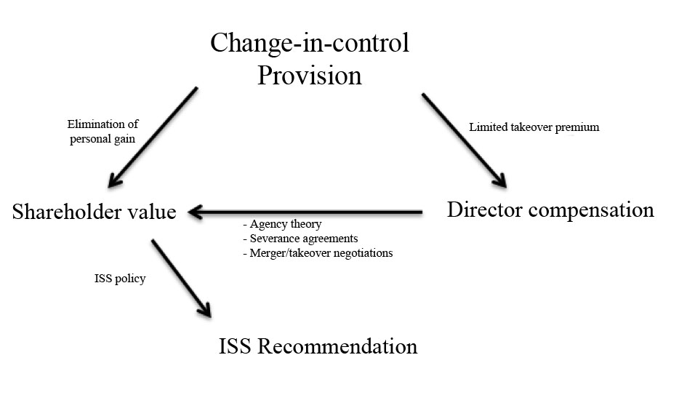

The change-in-control provision directly influences director compensation by limiting the director’s ability to gain from a change-in-control by a deduction of the premium over a reference period. At the same time the change-in-control provision intends to eliminate personal gain for directors in change-in-control, thereby intending to increase shareholder value.

The agency theory states that in order to align the interests of the shareholders and directors the directors need to be incentivized. These incentives often come in the form of shares and/or options since these align the share price with the level of reward for the director, hereby aligning the interest of the shareholders and directors.

Director compensation is determined by the remuneration committee of the supervisory board. The supervisory board is chosen or elected by the shareholders. The remuneration committee establishes the remuneration policy that includes the short- and long-term incentive scheme and the severance agreements for the director. In the Netherlands, these remuneration policies always need to be approved by the general meeting of shareholders.

Merger or takeover negotiations between the target CEO and the acquiring company are also of importance to shareholder value. In this process the takeover premium is determined, the higher the premium, the higher the gain for shareholders.

The Provision and the director compensation influence shareholder value. The case studies will be used to determine the effect of the Provision on shareholder value. The outcome of the case studies will be used to form a recommendation for ISS. The recommendation is influenced by ISS policy and the principles behind it.

## Limitations

The data used in the analysis is, inter alia, data supplied by the companies themselves. It is only the data that the company wishes to share or is required to share. A company does not always include a rationale for the decision.

The cases used for the research are considered historical and should also be viewed in historical perspective. The spirit of the age influences how people make decisions. An example of this is the way the public viewed remuneration before and after the 2008 financial crisis.

The research is limited to Dutch public companies only. These are the companies that openly publish their data concerning remuneration and which the Act is applicable to. The Provision applies to (I) cooperatives and private limited liability companies (BVs) qualifying as a bank, (II) mutual insurance companies qualifying as an insurance company, and (III) financial institutions, regardless of their legal form. However, since only cooperatives publish their financials to the public, the research will not apply to other types of companies to which the Provision applies.

## Delimitations

The analysis is limited to CEOs for Dutch public companies. Although the Provision applies to all directors of public companies, the focus of this research will be on the CEOs of these companies. This is chosen because the public criticism around remuneration arose due to the excessive severance several CEOs received upon the change-of-control.

## Ethics

To ensure that the research is done according to ethical standards, sensitive information will be handled with care. Moreover, the confidentiality of the people interviewed will be ensured if they indicate the need. Finally, all used ISS data will be kept confidential.

# Findings

In this part of the research we will look at how the directors are affected by the takeover of their firm and how the shareholders of that particular company are affected by the takeover. We will do this by looking at the historical takeover cases of (i) ABN Amro Royal – Bank of Scotland, Banco Santader and Fortis Bank (2007), (ii) Numico – Danone Groupe (2007), (iii) Draka Holding – Prysmian (2011), (iv) Crucell – Johnson & Johnson (2011), and (v) Douwe Egberts – Reckitt Benckiser plc (2012). For these cases we will evaluate the outcome for both the directors and the shareholders in the original case and the hypothetical case. The hypothetical case being that the provision of change-in-control would have been implemented at the time of the case study. This is of course done to find if the change-in-control provision has factors that influence the decision making of the CEO and thus the share value of the shareholder.

I want to stress the fact that the comparison of the original case to the case in which the provision of change-in-control is applied is a hypothetical situation. The fact that the change-in-control provision would have been applied to the cases *could* have meant that the stakeholders would have made different decisions, or that the takeover wouldn’t even have gone through. Therefore, we make the assumption that the stakeholders would have acted in the same manner in both the cases. This assumption makes the cases more fitting for the research.

The case studies will be ordered as follows: back ground, sales process, outcome, hypothetical outcome and conclusion.

## 4.1 ABN AMRO Holding NV (2007)

### 4.1.1 Background

In 2007, ABN AMRO Holding NV was acquired by RFS, a consortium of banks comprising Royal Bank of Scotland (RBS), Fortis Bank NV/SA, and Banco Santander. The acquisition talks were initiated after a minority shareholder (The Children Investment Fund, TCI) wrote a letter asking the CEO, Rijkman Groenink, and the supervisory board chairman, Arthur Martinez, to actively investigate a merger, acquisition or division of ABN AMRO. The motivation was that the share price did not reflect the true value of the underlying assets. On March 20, 2007, ABN AMRO announced the merger talks with Barclays.

On April 18, 2007, however, RBS contacted ABN AMRO to propose a deal in which the consortium RFS would bid for ABN AMRO and subsequently split the components of the firm. But five days later ABN AMRO and Barclays announced a proposed merger of ABN AMRO and Barclays. The deal had a value of €67 billion and included the sale of LaSalle Bank to Bank of America for €21 billion. One of the key interests of RFS was the LaSalle Bank; the deal with Barclays was therefore considered a poison-pill.

On April 25, 2007, the RBS-led consortium brought out its indicative offer of €72 billion, with the condition that ABN AMRO would have to abandon the sale of LaSalle Bank to Bank of America. At the shareholders' meeting the next day, approximately 70 percent of the shareholders voted in favor of the RFS deal and the breakup of ABN AMRO.

On July 23, 2007, Barclays raised its offer to €67.5 billion, but was still short of the RFS offer. The offer remained below the €72 billion offer made by RFS. RFS revised the offer to exclude the LaSalle Bank, since ABN AMRO proceeded with the sale of the subsidiary to Bank of America.

On 30 July 2007, ABN AMRO withdrew its support for Barclays’ offer which was lower than the offer from the group led by RBS. The board announced that the Barclays offer matched ABN AMRO’s strategic vision, but that from a financial point of view, the RFS bid was more lucrative to shareholders. The €72 billion bid from RBS, Fortis and Banco Santander was 9.8 percent higher than Barclays’ offer. Barclays pulled back the bid, making way for the RFS bid to go through and to start the process of dividing the parts of ABN AMRO.

On October 9, 2007, 86 percent of ABN AMRO’s shareholders accepted the RFS offer, thereby declaring the RFS consortium official. The CEO of ABN AMRO, Rijkman Groenink, greatly backed the Barclays offer and decided to step down.

In the aftermath, ABN AMRO and Groenink received a lot of criticism after it was announced that the CEO earned approximately €27 million on the takeover.

### 4.1.2 Sales process

ABN shareholders received €35.60 in cash and 0.296 RBS shares for each ABN share held. The offer was valued at €38.40 per ABN share, with a total value of €71.1 billion – 93.2 percent of the offer is provided in cash.[3]

### 4.1.3 Outcome

In the year 2007, Rijkman Groenink, CEO of ABN AMRO, received besides his salary of €778,000 and bonus of €1.4 million, a termination payment of €4.9 milion (including pension costs).

As part of the remuneration policy installed in 2001, Groenink owned 486,567 options and 28,822 matched shares of ABN AMRO. Moreover, Groenink privately held 77,012 shares of ABN AMRO.[4] As result of the takeover, the shares vested immediately and were sold to the consortium for €37.88 a share. This resulted in €22,440,149.88 in cash.

In total Groenink received €27,340,149.88[5] as a result of the takeover. The €27 million was highly criticized by the public and media, so highly even, it raised questions in the Dutch parliament.

From the background of the deal it becomes clear that the CEO preferred the deal with Barclays over the consortium. Because of the higher bid by the consortium, the deal with the consortium went through. It should be noted that the CEO would have earned less if the Barclays deal would have gone through.

### 4.1.4 Hypothetical outcome

Groenink owned a total of 592,401 shares and options that vested on the date of the takeover.

April 25, 2007, the first public offer was made by RFS, the share price four weeks prior to that date was €28.62 (appendix II).

On October 9, 2007, the RFS consortium formally declared victory after shareholders accepted the offer. The next day the deal was considered unconditional. Four weeks after this announcement of the share price was €36,88.

As of 1 November 2007, Groenink left ABN AMRO, the share price was €36,88.

The increase in value in both reference periods is therefore €8.26. This value will be deducted from the tender price on the day on which the director sells his shares or options, or when the appointed ends. According to the Provision, Groenink would have received €29.62 for his shares, instead of the original €37.88. The total share value is calculated below [6]

|  |  |  |  |  |  |  |
| --- | --- | --- | --- | --- | --- | --- |
| **Year** | **Options** | **Exercise price** | **Tender offer** | **Earnings** | **Provision value** | **Revised earning** |
| 2000 | 60,000 | €21.30 | €37.88 | €2,272,800 | €29.62 | €1,777,200 |
| 2001 | 55,000 | €23.14 | €37.88 | €2,083,400 | €29.62 | €1,629,100 |
| 2002 | 112,000 | €19.53 | €37.88 | €4,242,560 | €29.62 | €3,317,440 |
| 2003 | 133,000 | €14.45 | €37.88 | €5,038,040 | €29.62 | €3,939,460 |
| 2004 | 126,000 | €18.86 | €37.88 | €4,772,880 | €29.62 | €3,732,120 |
| AOR 2001 | 271 | €22.34 | €37.88 | €10,265 | €29.62 | €8,027 |
| AOR 2002 | 296 | €20.24 | €37.88 | €11,212 | €29.62 | €8,768 |
| Total | 486,567 |  |  | €18,431,158 |  | €14,412,115 |

This would mean that the CEO of ABN AMRO, would receive €14,412,115 for his options. The 28,822 matched shares and 77,012 private shares that the CEO owned would be worth €3,134,803.08. The total of the options, shares and termination payment would make €22,446,917.62. This amount is €4,893,232.26 less than the value Groenink received for his shares in the original case.

The CEO of ABN AMRO would have received approximately 5 million euro less as a result of the Provision. However, because the board preferred a merger with Barclays to the takeover of RFS, the takeover is considered hostile. The takeover was not initiated by the board of ABN, but by a shareholder of ABN. The favored the deal with Barclays and would earn less on that deal. Taking this into consideration, personal gain was not likely factor that had any influence on the decision for the takeover.

The Provision targets the directors of the company and does not directly influence the shareholders. However, due to the huge amount of severance that the CEO received, ABN AMRO received public criticism, an effect that harms company image and thereby possibly shareholder value. With the provision in place, the CEO would receive less severance, but it would still amount to €22,446,917.62. Even with the Provision in place, this does still amounts to a large sum of severance. It is unlikely that the Provision would justify the amount of severance for the public and thereby eliminating the threat of loss of image.

The difference of approximately €5 million between the original severance and severance under the Provision would have stayed in the company. This value would be transferred to the acquirer. Because ABN AMRO was sold partly in cash and partly in shares of RBS, part of this value would be transferred to RBS. However, this value would be divided by the three banks. The amount that would be left would be miniscule to the €7.7 billion profit that RBS made that year[7].

The original €27,340,149.88 that the CEO received was the gross amount received. The net value of this amount was €13,123,271.94, meaning that €14,216,877.94 was paid in taxes[8]. The gross total amount received under the Provision would be €22,446,917.62, the net amount would be €10,774,520.46, meaning that €11,672,397.16 would be paid in taxes. As a result of the Provision, the government would have received €2,544,480.78 less in taxes.

## 4.2 Numico NV (2007)

### 4.2.1 Background

July 9, 2007, Danone, a French rival of Numico offered €12.3 billion for the company by French rival Danone. The offer was valued at €55 per share, fully in cash, which was a 44 percent premium over the average share price over three months prior to the offer. The offer was accepted by the Numico board and was accepted on the same day.

Danone declared ownership of 90 percent of Numico's shares on October 31, 2007, declaring its offer for the remainder unconditional. Consequently, Numico was removed from the AEX (Amsterdam Exchange Index). Numico's shares were delisted from the AMX (Amsterdam Midcap Index) at the end of 2007 as Danone gained full control. On October 28, 2008, all remaining Numico shares were to be transferred to Danone as result of a squeeze out at the offer price of €55 per share.

The takeover has been highly criticized because the CEO of Numico (Jan Bennink) sold Numico to Danone (his previous employer) and earned a total of €82.7 million in doing so.

The takeover of Numico was seen as a poison pill for Danone. There were speculations that the takeover of Numico by Danone functioned as a poison pill against PepsiCo, especially after the sale Kraft by Danone. By buying Numico, Danone became less attractive for a takeover.

### 4.2.2 Sales process

The offer was valued at €55 per share, fully in cash, which was a 44 percent premium over the average share price over three months prior to the offer. The total value of the transaction was €12.3 billion. Danone financed the offer through fully committed credit facilities and took full control over Numico.

### 4.2.3 Outcome

After the takeover, Bennink resigned as a member of the management board. As a result of the change of control, Bennink was entitled to a compensation of €4,398,600 and a base salary of €1 million.

According to the offer document, Bennink held 270,027 shares and 425,660 performance shares, which vested at the moment of resignation. These had a total amount of €38,262,785. According to the remuneration report Bennink also had 1.5 million stock options outstanding. These stock options became exercisable upon change-of-control. The total value of the stock options represents an amount of €39,201,789. Total severance of Bennink, therefore, represents a value of about €82,863,174. [9]

### 4.2.4 Hypothetical outcome

Bennink owned a total of 695,687 shares and approximately 1.5 million stock options at the time of the takeover. These options were all vested at the moment of change-of-control.

July 9, 2007, the public offer was made by Danone, the share price four weeks prior to that date was €38.53 (appendix III).

The acceptance period for the tender offer began on August 21, 2007, and ended on October 31, 2007. The second reference date for the Provision is therefore November 30, 2007. A distinction should be made between the shares and the options however.

After the special meeting of November 30, 2007, the management board of Numico resigned. At the time, the share price was 54.35.

The increase in value in both reference periods is therefore €15,82. When this value is deducted from the tender offer of €55, only €39.18 remains. The new value for the 270,027 performance shares and 425,660 shares then becomes €27,257,016.66.

The stock option plan is detailed below [10]:

|  |  |  |  |  |  |  |
| --- | --- | --- | --- | --- | --- | --- |
| **Year** | **Options** | **Exercise price** | **Tender offer** | **Earnings** | **Provision value** | **Revised earning** |
| 2003 | 300,000 | €10.71 | €55 | €13,287,000 | €39.18 | €8,541,000 |
| 2004 | 277,500 | €25.86 | €55 | €8,086,350 | €39.18 | €3,696,300 |
| 2005 | 300,000 | €32.27 | €55 | €6,819,000 | €39.18 | €2,073,000 |
| 2006 | 300,000 | €35.02 | €55 | €5,994,000 | €39.18 | €1,248,000 |
| 2007 | 300,000 | €38.28 | €55 | €5,015,439 | €39.18 | €269,439 |
| Total |  |  |  | €39,201,789 |  | €15,827,739 |

In total Bennink would receive €26,804,802.11 for his shares in the company and €15,827,739 for his stock options, this totals €43,084,755.66. Including bonus and compensation this amount would rank up to €47,070,784.11.

The difference between the original amount and the amount under the provision is €34,379,818.34. In this case the Provision would have a significant impact. Would the deal still go through if the management of Numico would have received the amount according to the Provision? It probably would have. Danone was eager for an acquisition because it was in need for a poison pill due to the luring gaze of PepsiCo. Moreover, €41 million is still considerable amount for severance payment.

There would have been no direct effect to the shareholders. A benefit to the shareholders is however, the decrease in public criticism. The offer was purely in cash, all the shares were sold, and shareholders did not get any Danone shares in return for the deal, therefore shareholders would not have benefit from the € 34.4 million that the company would save form the Provision.

The government originally gained €43,088,850.48 tax from Bennink, this amount would be reduced to €24,476,807.74 in the case of the Provision.

## 4.3 Draka Holding NV (2011)

### 4.3.1 Background

On October 14, 2010, Draka’s major shareholder Flint Beheer hired Lazard to find a party to acquire its stake in Draka. According to Dutch law, a party acquiring 30 percent of the outstanding share capital is obliged to make an offer on all outstanding shares. On November 22, 2010, Draka presented its white knight Prysmian, with whom they entered earlier talks on a take-over. The same day, Xinmao also announced its interests and came with a bid price that was approximately 19 percent above the Prysmian offer. Although Draka and Xinmao knew each other from joint ventures in which they participated, the Draka management stated that it did not ask Xinmao to make an offer on Draka. As also shareholders requested, Draka entered into discussions with both Prysmian and Xinamo on the offers.

Prysmian acted promptly on its offer and filed the necessary documents with authorities in order to continue the official bid. Xinmao failed to issue the necessary documents and information to continue the bidding process.

On Jan. 5, 2011, Draka and Prysmian issued the offer memorandum and Draka reconfirmed its support for the Prysmian bid.

Due to the fact that both Prysmain and Xinmao made offer on all outstanding Draka shares, the case received considerable media attention, especially since the Chinese bid was considerably above the Italian bid.

### 4.3.2 Sales process

On November 22, 2010, Prysmian announced a public offer on all outstanding Draka shares for a price of €8.60 and 0.6595 Prysmian shares per Draka share, which represents an implied value of €17.20 per Draka share. On the same day, Xinmao made an all cash offer for a price of €20.50 per Draka share. Xinmao failed to provide additional details on its offer and the financing thereof. As such, the Draka board supports the Prysmian bid unanimously. On January 6, 2011, Xinmao announced it would not continue its bid for Draka, which paved the way for the Prysmian offer.

### 4.3.3 Outcome

At the time of the termination of the contract, Dorjee owned 9,940 ordinary shares of Draka, which had a value of €170,968 (€85,484 in cash plus 6,555.43 Prysmian shares at €13,04 a share).[11] Moreover, he owned a total of 95,267 conditionally granted performance shares, which were valued at €720,567.[12] Dorjee received a one-off bonus €991,500 for the completion of the take-over. Furthermore, he received €801,390 in compensation for the early closure of the long-term incentive plans of Draka following the takeover.[13] In Dorjee’s employment contract it was listed that in case of early termination of the contract he will receive one year base salary of €561,000, plus one year bonus of €518,666.67.[14],[15] In total Dorjee received €3,764,091.67 in severance.

### 4.3.4 Hypothetical outcome

Dorjee owned a total of 9,940 ordinary shares of Draka and 95,267 performance shares at the time of the takeover.

Although Prysmian announced its intention for a takeover in November 22, 2010, it was until January 5, 2011, that the offer was formally announced. In December 2010, the share price was €19.10 (appendix IV).

On February 8, 2011, Prysmian declared the offer unconditional, having then received acceptances from 44,064,798 shares, representing around 90.4% of Draka's ordinary share capital. The share price four weeks later - reference period 2 – was thus €17.82.

On March 1, 2011, the consolidation of Draka and Prysmian was set in motion, hereby ending the employment of Dorjee as CEO. The share price at the time was €17.82.

In both reference periods there is a decrease in value of €1.28. According to the Provision, only an increase in share price should be deducted to the share value. The director would therefore receive the exact same amount of severance. As the outcome would be the same, the effect on the director, shareholder and stakeholders would remain the same.

## 4.4 Crucell NV (2011)

### 4.4.1 Background

On September 17, 2010, Johnson & Johnson announced its intention to make a public offer on all outstanding Crucell shares for a price of €24.75 per share, which represents a total transaction value of approximately €1.75 billion. Although the bid was supported by Crucell, several shareholders announced their disagreement with the bid as they considered it poor and too early.

On October 6, 2010, Johnson & Johnson and Crucell announced they had reached agreement on the acquisition for an offer price of €24.75.

### 4.4.2 Sales process

The bid for all outstanding Crucell shares was €24.75 and fully in cash, which is a premium of 57.7 percent on the closing price of one day before the announcement.

### 4.4.3 Outcome

At the time of the takeover, R.H.P Brus, the CEO of Crucell NV, owned a total of 239,202 shares with a value of €5,920,249.50. Moreover, he owned a total of 646,057 stock options with a value of €9,738,402.63, that vested at the moment of takeover.[16]

He received a one-off cash bonus as a reward for the completion of successful negotiations with Johnson and Johnson with a value of €384,000. Crucell did not list any severance that the CEO would receive in case of a friendly takeover.

The total amount the CEO received for the completion of the takeover was €16,042,652.13.

### 4.4.4 Hypothetical outcome

The official press release for the merger agreement was made on October 6, 2011. The share price four weeks prior to this date was €15.69 (appendix V).

On February 22, 2011, the offer was declared unconditional.[17] The share price four weeks later was, again, €24.55.

On March 8, 2011, Johnson & Johnson acquired 98.89 percent of issued Crucell shares as of the end of the subsequent offering period.[18] The share price at the moment was €24.55.

There is no difference in the two reference periods since the share price is equal in reference period two and three.The amount to be deducted from the tender price is therefore €8.68 and the value per share that the CEO will receive under the provision will be €15.89.

The 239,202 shares that Brus owned would be valued at €3,800,919.78 instead of the original €5,920,249.50.

The revised option payout is listed below [19]:

|  |  |  |  |  |  |  |
| --- | --- | --- | --- | --- | --- | --- |
| **Year** | **Options** | **Exercise price** | **Tender offer** | **Earning** | **Provision value** | **Revised earning** |
| 2003 | 90,000 | €2.64 | €24.75 | €1,989,900 | €15.89 | €1,192,500 |
| 2003 | 125,000 | €5.94 | €24.75 | €2,351,250 | €15.89 | €1,243,750 |
| 2008 | 300,000 | €12.23 | €24.75 | €3,756,000 | €15.89 | €1,098,000 |
| 2009 | 72,340 | €10.82 | €24.75 | €1,007,696 | €15.89 | €366,764 |
| 2010 | 58,717 | €13.96 | €24.75 | €633,556 | €15.89 | €113,24 |
| Total |  |  |  | €9,738,403 |  | €4,014,338 |

For the options, Brus would receive €4,014,338, a difference of approximately €6 million.

The total amount of severance the CEO would receive under the Provision would be €8,199,257.59, a difference of approximately €8 million.

The application of the provision would have no real effect on the shareholders. The government however, would receive €4,263,613.95 less in taxes.

## 4.5 DE Master Blenders 1753 NV (2013)

### 4.5.1 Background

In April of 2013 Douwe Egberts Master Blenders (DEMB) received a public tender offer on all outstanding shares for €12.50 per share from Joh. A. Benckiser (JAB).

In the beginning of March 2012, DEMB announced a general meeting of shareholders where it was proposed to approve Bennink's compensation plan as CEO. This proposed compensation package remarkably did not consist of the common elements (i.e. base salary, short-term cash incentive, pension plan), but only an €4 million share grant per year. Although the EGM was cancelled and this compensation plan was not approved, it is remarkable because Bennink was aware of JABs interest in acquiring all outstanding DEMB shares. Despite this package's not being approved, it should be noted Bennink received a compensation package for Bennink of €10.4 million, of which €4.7 million results from share units that were previously granted and €5.7 million as a cash compensation. It is rather suspicious that Bennink would want to receive a compensation plan without the usual elements and, especially because JAB is Bennink’s old employer.[20] This could indicate prior knowledge of the takeover intentions and therefore anticipating the takeover by choosing to go for an annualized share grant, thereby indicating personal gain.

### 4.5.2 Sales process

JAB proposed to pay a consideration of €12.50 per share in cash. The acquisition was financed through €3 billion in fully committed debt and €4.9 billion in equity.

### 4.5.3 Outcome

At the time of the takeover Bennink owned a total of 619,376 shares of DEMB. These shares were acquired upon completion of the spin-off from Sara Lee Corporation from conversion of the Sara Lee shares, from the conversion of the Sara Lee incentive award plan, and by own purchase. As the purchase price was €12,50, these shares were worth €7,742,000. [21]

Moreover, as part of severance payment Bennink received Performance Stock Units (PSUs) and a cash payment. A total of 377,650 PSUs with a value of €4,720,625 and a cash payment of €5,697,350. Totaling in €10,417,975 as part of the severance agreement with JAB. A total of €18,160,175 for the takeover.[22]

### 4.5.4 Hypothetical outcome

Bennink owned a total of 997,026 of shares and PSUs at the moment the takeover was final.

The conditional announcement of agreement between the two parties was made on April 12, 2013. The share price four weeks prior to that date was €9.75 (appendix VI).

On September 18, 2013, the offer was made unconditional after Oak Leaf announced that all conditions been met or waived. Oak Leaf had tendered 456,812,887 shares, representing a 76.79 percent stake of DEMB's share capital, the share price four weeks later was €12.45.

Bennink and other executive members resigned per the settlement date, which was on September 23, 2013. The share price at the time was €12.49.

The increase in reference period 1 is therefore €2.70, the increase in reference period 2 is €2.74. That makes the share price under the Provision €9.80. This would mean that the 997,026 shares and PSUs Bennink owned would now be worth €9,770,854.80. In total, Bennink would receive €15,468,204.80, approximately €3 million less than the original case.

The application of the provision would have no real effect on the shareholders. The government however, would receive approximately €1.56 million less in taxes.

## 4.6 Results of interview

The interview was held in order to find how the conclusions of the research could be implemented so that ISS and its customers can benefit from the results. The interview was held with Robbert Gerritsen, head research analyst for the Benelux market at ISS. The complete interview can be found in appendix VIII.

In order to add the results of this research to ISS policy, the policy update needs to go through the policy development cycle. The policy development cycle contains of different stages of development in which the policy update is tested, discussed and evaluated.

The policy update is send to the customers by a policy survey to get the opinion of the customers on the topic. This is the moment that customers can give feedback on either the policy update and the current policy. The customer’s response is taken into account and, when necessary, policy update is amended. The policy update is then discussed in a European subcommittee. Senior analysts of ISS have annual meetings to discuss the current policy, policy updates and other relevant issues. In these committees the policy is assessment by a scenario and impact analysis. If the European subcommittee approves of the policy update it is assessed by the European Committee and later by the World Wide Policy Steering Committee. When approved by all the committees, the policy update is communicated to the customers by the pre-proxy season news update. The policy update is then a part of the ISS policy that will be used to analyze the following proxy season.

# Discussion

The five case studies give an indication of the implications of the Provision on shareholders, the companies, and its CEOs. While the intentions of the Provision is to limit personal gain in order to protect the shareholders, the case studies highlight other consequences of the Provision.

## 5.1 Outcome of findings

### 5.1.1 Decreased incentive to increase premium

In the case of Draka Holding NV, we have seen that the CEO would receive the exact same amount of severance in both cases. This captures an interesting problem with the Provision: there is no (monetary) incentive for the CEO to increase share price in the case of change-in-control. At Drake Holdings NV, the share price dropped due to the negotiations with two different parties. Due to the decrease in share price the value of the reference period turned into a decrease. Ultimately, this led to the fact that there was no deduction in share value for the CEO. This is completely contrary to the agency theory since, in this case, the Provision promotes a disruption of the principal agent connection in which the agent is rewarded for following the interests of the principal. Thus, the CEO is not incentivized to increase the share price.

### 5.1.2 Disruption of agency theory

While there are several leading theories in corporate governance, the Provision assumes the agency theory; it assumes agency problems arise due to the opportunistic self-interest of CEOs. The effects of the Provision are mainly focused on the severance itself and thus affect the CEO and the shareholder. However, in decreasing the personal gain, the Provision disrupts the principal and agent relation of the agency theory. This is illustrated in the case of Crucell. The initial value of the CEO’s options was €9,738,402.63, the value of his shares was €5,920,249.50, a total value of €15,658,652.13. This value is reduced to €8,199,257.59 under the provision. This decrease in value discourages a CEO to compy with a takeover. As was stated in the literature review, when a firm is acquired, managers of the target firm are able to lose their position or suffer sizable losses in compensation as a result of a tender offer. Thus, management of the target firm will frequently try to prevent the takeover or the CEO will bargain with the bidding firm to keep their job (Jensen, 1988). In order to prevent this, shareholders of the targeted firm implement compensation schemes to provide proper managerial incentives, which often includes the accelerated vesting of restricted stock and stock options (Elkinawy et al., 2013). However, the provision limits to target shareholders to pursue such an incentive plan, hereby limiting the options for shareholders to align the interests of the CEO with those of the shareholders, and therefore damaging shareholder value for target companies. The Provision therefore creates a discouragement for CEO’s to sell their companies. As target shareholders generally profit from an acquisition (Elkinawy et al., 2013), this could decrease shareholder value.

### 5.1.3 Limited to shares and options

Another flaw of the Provision is that it is limited to shares and options. The Provision could therefore easily be diverted by awarding the CEO with cash incentive awards instead of shares or options. This can be seen in the case of DEMB. Bennink received an excessive sum of cash as part of the takeover deal. As approximately 25 percent of the severance was paid in cash and the premium of the offer was 30 percent, the effect of the provision in this case is only a €3 million difference compared to the original situation. The decrease in value could easily be diverted by awarding the CEO with cash instead of shares or options. By awarding the severance in cash, the Provision had a smaller effect. Moreover, the severance would not be tied to equity-based incentives, therefore decreasing the principal-agent relation and possibly harm shareholder value.

### 5.1.4 Severance approved by shareholders

The severance that a CEO receives is predetermined. The remuneration policy for a CEO is created by the supervisory board of a company and approved by the shareholders of the company. This remuneration policy includes the severance agreements for the CEO and is often times in line with the Dutch Corporate Governance Code. This means that the shareholders ultimately approve the remuneration and the severance that the CEO will receive in the case of a takeover. It could be questioned whether the Provision should intervene in this process. The gain deducted from the directors share value will return to the company and shareholders. However, if the company and the shareholders already decided on the remuneration and severance it is not reasonable to subtract a part of the gain from this amount. Moreover, since the value deduction is laid upon by the government, shareholders could even decide to correct the deducted value to pre-provision standards in order to retain the positive effects of vesting on share premium, as was shown in the literature review.

### 5.1.5 Decreased fairness and ability to attract talent

Remuneration policies and targets within these policies are often based on so-called peer groups. These peer groups consist of companies that are similar in size and are often in the same industry. For example, a company like ABN AMRO had a peer group of medium-large banks in Europe.[23] Remuneration committees use these peer groups in order to establish a certain level of fairness (equal level of payment) to the executives, but even more important, in order to attract talent. If Dutch companies have a less attractive remuneration policy compared to other countries, it will be harder for Dutch companies to attract talent. By implementing this Provision, the Dutch government hereby restricts Dutch companies in its ability to attract talent.

Moreover, since the Provision only applies to Dutch companies this would decrease the overall value of the Dutch public companies on which the rules of the Provision apply, relative to public companies in foreign companies.

### 5.1.6 Positive effects

There are also positive effects to the Provision. The ABN AMRO case shows that the company received a lot of criticism because of the severance that Rijkman Groenink received upon leaving the company. The Provision would reduce the severance that a director would receive and therefore companies would be less likely to receive public scrutiny. Moreover, the share premium on the equity-based incentives is to be deducted from the salary and given back to the company. However, target shareholders would not profit from this.

Moreover, corporate action to pursue hostile takeover defenses generally benefits share price and therefore shareholder value (Pearson et al., 2004). This is however limited to hostile takeovers. Furthermore, not all executives are guaranteed to pursue a takeover defense in the case of a hostile takeover.

### 5.1.7 Sub conclusion

It is clear that the disadvantages outweigh the advantages. Therefore ISS should form a negative standpoint of the Provision and convey this to its customers.

Personal gain for CEOs is not necessarily a negative component in a takeover for shareholders, as was shown in the literature review. Moreover, in the end the shareholders decide whether to approve of the takeover. The severance the CEO is a part of the remuneration policy that often has been in place for several years. Recall that an implication of agency theory is that where CEO duality is retained, shareholder interests could be protected by aligning the interests of the CEO and the shareholders by a suitable incentive scheme for the CEO (Donaldson et al., 1991). This indicates that the Provision is counteractive. On one side it tries to increase shareholder value by eliminating personal gain, on the other side it reduces the alignment of interests that the agency theory establishes through the remuneration policy.

To summarize, the provision has a negative effect on the shareholder value due to the following issues:

1. The CEO is not incentivized to bargain a higher premium in a takeover because the Provision eliminates the personal gain (the premium) for the CEO.
2. In most cases, the Provision discourages CEOs to sell the company since the severance that the CEO would receive from the takeover is lower than the remuneration to be received.
3. The Provision is limited to share and option incentives and could easily be diverted by awarding severance in cash, or other awards tied to share performance.
4. The devaluation of these equity-based incentives disconnects the principal and agent relation by removing the incentive for the CEO to negotiate a higher premium.
5. The long-term incentives in remuneration policies are often based on international peer-groups. Devaluating the equity-based incentives for Dutch companies makes it harder to attract talent.

## 5.2 Practical applications of findings

It can be concluded that the overall effect of the Provision on shareholder value is negative. This is mainly the result of the fact that the Provision decreased the principal-agent relation and the effectiveness of incentives (i.e. shares and options). There are however some solutions to the negative effects that can be pursued to restore this.

*1. Extend the authority of the supervisory board to clawback excessive severance.*

The problem with excessive severance has its foundations in the remuneration policy and the accelerated vesting of shares. It would be an improvement to promote the supervisory board with the power to clawback the excessive severance. This way early in the compensation process, the determination of the performance targets and the development of the incentive scheme are being taken into account in order to reduce future excessiveness of severance.

*2. Award directors with equity-based incentives other than shares and/or options.*

Another solution is to award the director with phantom stock, stock appreciation rights (SARs), cash settled options or other kind of certificates that are based on the share value. The Provision is only limited to shares and options, not to other kind of certificates. It is normally preferred to award directors with shares, because in that case the director holds some ownership of the company. Since the Provision limits the effectiveness of incentivizing directors with shares and options, awarding the director with share-based certificates could restore the equity-based incentive scheme and strengthen the principal-agent relation.

*3. Conditional cash awards.*

Finally, the Provision does not apply to privately held shares held by the director. These are shares bought by the director and not awarded under an incentive plan. It is however possible to base the incentives of the director on the share price, but to award them in cash, under the condition that the director uses the cash award to buy shares in the company. This way the incentive will still be based on share value and the director is still incentivized to pursue a higher premium for shareholders in the case of a takeover.

## 5.3 Market reaction

The Provision applies to all takeovers since January 2014. In 2014, OCI N.V., BE Semiconductors Industries N.V., and Pharming Group N.V. amended its remuneration policy to include a segment that creates the possibility for directors to receive their vested performance shares and stock options fully in cash in the case of a public offer or takeover, in this way these companies bypass the Provision.

In 2015, Vastned Retail N.V., Telegraaf Media Groep N.V. and Batenburg Techniek N.V. have pursued similar actions. Moreover, upon request of its shareholders, Vastned Retail N.V., Telegraaf Media Groep N.V. and OCI N.V., have declared the Provision to voluntarily apply. [24]

The Provision has been applied by Nutreco N.V. and Philips N.V, in the spin-off of the light-division. Nutreco however, partly compensated its directors with a cash bonus, hereby compensating the directors for approximately 60 percent of the loss.

In the public offer for Exact N.V. the Provision was evaded by the decision of the supervisory board to remove the awarded performance shares (with a value of € 2.2 million) and to compensate the directors for the equivalent in cash.[25]

Moreover, the Provision was also not applied in the case of Roto Smeets Groep N.V. because the directors were not awarded in shares but in phantom stock.

# Recommendation

## 6.1 Practical recommendations

The Provision has a negative effect on shareholder value. ISS should therefore form a negative standpoint toward the Provision. Since the Provision is forced upon companies legislatively it will not be a voting item on a general shareholder meeting and therefore will not be possible for shareholders to vote against. However, it is possible for majority shareholders to request an EGM or to place an item on the agenda of a general meeting. It is therefore proposed that ISS should therefore take the following steps:

1. *Inform the customers of the implications of the Provision.*

In order to reduce the negative effects the Provision has on shareholder value ISS customers should be informed of the implications of the Provision. This way the customers can make better-informed judgments. The customers can be informed through the pre-proxy season news update that clients receive.

1. *Encourage institutional investors with a majority shareholding in companies to change the current remuneration policy.*

As previously stated, investors with a shareholding of over 10 percent – majority shareholders – are able to request an EGM or add an item to the agenda of an AGM. These shareholders should be encouraged to discuss or vote for a change to current remuneration policies. However, like any other advice, it remains a recommendation. The customer itself has to decide how to utilize its voting power. A proposal for a possible discussion agenda item in ISS layout can be found in appendix IX. This can be used by ISS in its research analyses.

1. *Advise FOR[26] agenda items that include remuneration policies updates that change long-term incentive awards from shares and/or options to phantom stock, SARs, cash settled options, or conditional cash awards used for buying shares.*

ISS should advice its clients to vote FOR agenda items that amend share and/or option awards in current remuneration policies into other share value based incentive awards. This agenda item can either be placed on the agenda by investors (as stated above) or by the company itself. It should be noted however that phantom stock, SARs and cash settled options are no full replacement of shares and awarding directors with shares (due to the conditional awards) should always be preferred over phantom stock, SARs or cash settled options.

## 6.2 Implementation

For ISS to implement the practical recommendations in an effective manner the following should be taken into account.

*Realization of recommendation*

There are two actions that ISS needs to undertake to apply these recommendations: (I) Inform customers of the consequences of the Provision using the pre-proxy season newsletter, and (II) to amend the policy in the ISS systems that create the research analyses. Before the policy update can be communicated to the customers the policy update has to go through the European subcommittee, the European committee, and the World Wide Policy Steering committee, where the policy update is discuss and defended. The outcome is then discussed with clients. Hence, the policy update can be used in the 2016 proxy season.

The research analysis product of ISS is generated by software. This software needs to be updated to include the policy update for the change-in-control provision. The first step is to enter two new codes in the ISS database for the Benelux market: a code for a discussion item of the clawback of bonuses act and a code for a voting item on the remuneration policy that includes updates that change long-term incentive awards from shares and/or options to phantom stock, SARs, cash settled options, or conditional cash awards used for buying shares. The next step is to update the software that generates the research analysis documents, so that when a code is entered for the previously named items, the software will generate the text for the research analyses. Draft proposals for the text for the items can be found in appendix IX and X.

*Timeline*

To assure an efficient implementation of the results of the research a timeline assists in establishing an successful realization.

**September***.* The policy survey is distributed amongst the customers. The policy survey includes the policy updates. Customers comment on the policy updates and share their opinion and expertise. In addition to the survey, September is also the month were the regional market roundtables and outreach are held in order to examine local market best practices. At the end of September the policy results will be distributed.

**October***.* After analysis and consideration of the survey responses, ISS will have a comment period for interested market participants on the final proposed amendments to the policy update for 2016.

**November**. The final policy update is released. Customers are able to find the update on ISS website or receive the update in the pre-proxy season newsletter. In November the ISS research system is adjusted to include the newly updated policy.

*Cost*

The additional costs for the implementation of the recommendation will be close to none. ISS already established the cycle of informing customers of new policy updates by their pre-proxy season newsletter. The same goes for the updates to the systems that create the research analyses. The policy in the system gets an update every beginning of the year, before the proxy season.

# Conclusion

The main research question is: How should ISS advise its clients on the change-in-control provision of the new Clawback of Bonuses Act in the Netherlands? The goal for ISS is to advise its clients on the negative implications of the Provision and to pursue an active strategy to motivate its clients to amend current remuneration policies to include incentives tied to the share value in order to restore the incentive for directors to bargain a higher share premium in case of a takeover.

The directors are affected by the change-in-control provision through their awarded performance shares and options. Directors that are awarded fully in shares or options are therefore more affected by the Provision than directors with other awards in case of a takeover. Literature research has shown that directors with equity-based incentives bargain a higher share premium in a takeover. Whereas directors that are awarded a golden parachute in a takeover tend to bargain a less favorable share premium for shareholders. Limiting the effectiveness of share and/or incentives could therefore possibly decrease the effectiveness of incentivizing directors to bargain a higher share premium and consequently harm shareholder value.

Companies are reacting differently to the Provision. In the last two years there were various occurrences of companies deciding to amend their remuneration policy in order to avert the effects of the Provision.

ISS Should inform its customers of the implications of the Provision on shareholder value. It should encourage institutional shareholders and majority shareholders to request companies to amend their remuneration policies in order to include share value based incentives, other than performance shares or options.

The most dominant corporate governance theory that can be connect to the intention of the Provision is agency theory; it assumes agency problems arise due to the opportunistic self-interest of CEOs. However, the Provision proves itself contradictory by diminishing the principal-agent relation due to the decreased effectiveness of shares and/or options incentives.

# Bibliography

Annual Report 2006, Numico N.V.

Annual Report 2007, ABN Amro Holding N.V.

Annual Report 2007, The Royal Bank of Scotland Group

Annual Report 2009, Crucell NV

Annual Report 2009, Draka Holding NV

Annual Report 2010, Draka Holding NV

Annual Report 2012 DE Master Blenders 1753 NV

Artikel 107a, Burgerlijk Wetboek 2, Rechtspersonen, Titel 4. Naamloze vennootschappen, Afdeling 4. De algemene vergadering

Baxter, P., Jack, S. (2008) The qualitative report, volume 13.4, McMaster Univeristy

Bettis, C., J. Bizjak, J. Coles, and S. Kalpathy (2010) Stock and option grants with performance- based vesting provisions. *Review of Financial Studies* 23, 3849-3888.

Bernard, H.R. (2002) *Research methods in anthropology: qualitative and quantitative methods*. 3rd edition. AltaMira Press ,Walnut Creek, California.

Memorie van toelichting [Explanatory Memorandum] 32.512 (2010), Eerste Kamer der Staten- Generaal [House of Representatives]

Claw-back Step-by-step process of calculating increases in value in the case of a public offer. (2014) De Blauw, Blackstone, Westbroek,

*Clawback of Bonuses Act 2014,* 32:512, Staatsblad Nr.563, Jaargang 2013.

De zoete verleiding bij overnames [The sweet temptation at takeovers] (February 5, 2015) Verenings Effecten Bezitters, Retrieved from: https://www.veb.net/artikel/05584/de-zoete-verleiding-bij- overnames

Devers, C. E., McNamara, G., Haleblian, J., Yoder, M. E. (2013) Do they walk the talk? Gauging acquiring CEO director confidence in the value creation potential of announced acquisitions, *Academy of Management Journal*, Vol. 56, No. 6, 1679-1702, doi:10.5465/amj.2011.0555.

Donaldson, L., Davis, J. H. (1991) Stewardship theory or agency theory: CEO governance and shareholder returns. *Australian Journal of Management*, 16, 1, June 1991, The University of New South Wales

Drever, E. (1995) *Using Semi-Structured Interviews in Small Scale Research,* University of Glasgow, Scottish Council for Research in Education

Elkinawy, S., Offenberg, D. (2013) Accelerated vesting in takeovers: the impact on shareholder wealth. *Financial Management (Wiley-Blackwell)*. Spring 2013, Vol. 42 Issue 1, p101-126. 26p. DOI: 10.1111/j.1755-053X.2012.01202.x.

Evaluatie van het AVA-seizoen 2015 [Evaluation AGM Season 2015] (July 9, 2015) Eumedion Corporate Governance

Fich, E.,Cai, J., Tran, A. (2011) Stock option grants to target CEOs during private merger negotiations. *Journal of Financial Economics* 101, 413-430.

Gerring, J. (2007) *Case study research: principles and practices*, Cambridge University Press, doi:10.1017/S0022381607080243

Hartzell, J.C., Ofek, E., and Yermack, D. (2004) What’s in it for Me? CEOs whose firms are acquired. *Review of Financial Studies 17*, 37-61.

Hoe Jan Bennink Miljoenen Verdiende Met Dubieuze Overname Douwe Egberts [How Jan Bennink Earned Million with Dubious Takeover of Douwe Egberts] (August 9 2014) Follow the Money

Jensen, M. C. (1988) Takeovers: Their Causes and Consequences, *Journal of Economic Perspectives* 2, 21-48.

Johnson & Johnson Acquires 98.89% of Issued Crucell Shares as of the End of the Subsequent Offering Period and Crucell Intends to Delist Crucell Ordinary Shares and ADSs (March 8, 2011) Investors Relations Johnson and Johnson. Retrieved from: http://www.investor.jnj.com/releasedetail.cfm?ReleaseID=555562

Johnson & Johnson Completes Tender Offer for Crucell and Declares Offer Unconditional, February 22, 2011, Investors Relations Johnson and Johnson. Retrieved from: http://www.investor.jnj.com/releasedetail.cfm?ReleaseID=551527

Kawulich, B. B. (2004) *Data analysis techniques in qualitative research.* State University of West Georgia.

Launso, L., Rieper, O. (2006) Qualitative research methods in complementary and alternative treatment*,* *Nafkam*, issue No. 3, The National Research Center in Complementary and AlternativeMedicine, University of Tromsø Norway

Lefanowicz, C.E., Robinson, J.R., Smith, R. (2000) Golden Parachutes and Managerial Incentives in Corporate Acquisitions: Evidence from the 1980s and 1990s. *Journal of Corporate Finance* 6, 215-239.

*Legislation on claw back of bonuses* (October 17,2013) Allen & Overy, Publications.

Offer Memorandum ABN Amro Holding N.V. by RFS Holding N.V. (July 20, 2007)

Offer Memorandum Crucell NV JJC Acquisition Company BV (December 8, 2010)

Offer Memorandum Numico N.V by Groupe Danone (August 20, 2007)

Offer Memorandum Oak Leaf BV (June 12, 2013)

Offer Memorandum Recommended Mixed Exchange and Cash Offer Prysmian (January 5, 2011)

Open letter of the Commission of Company Law to the Ministry of Security and Justice (April 15, 2010)

Patton, M. Q. (1987) How to use qualitative methods in evaluationLondon: Sage.

Pearce J. A., Robinson, R. B. (2004) Hostile takeover defenses that maximize shareholder wealth, *Business Horizons*, Volume 47, Issue 5, September–October 2004, Pages 15-24, ISSN 0007-6813, http://dx.doi.org/10.1016/j.bushor.2004.07.004.

Punch, K., (1998). *Introduction to Social Research: Quantitative and Qualitative Approaches.* London, England: Sage Publications Ltd.

Qiu B., Trapkov S., Yakoub F. (2014) Do target CEOs trade premiums for personal benefits?. *Journal of Banking & Finance*, Volume 42, May 2014, Pages 23-41, ISSN 0378- 4266, http://dx.doi.org/10.1016/j.jbankfin.2014.01.013.

Remuneration report (2011) Prysmian Group

Schneider, P. J. (2013) The managerial power theory of executive compensation, *Journal of Financial Service Professionals*. May 2013, Vol. 67 Issue 3, p17

Shleifer, Andrei and Robert W. Vishny (2001) Stock market driven acquisitions, Harvard University.

Vugt, F. (2013) Examining the Effects of a Global Crisis on CEO Compensation: Fortune 100 Evidence. University of Twente, Faculty of Management and Governance.

*Wet aanpassing en terugvordering van bonuses en winstdelingen [Clawback of bonuses Act]* (2014) Loyens & Loeff, No. 97

Yin, R. K. (2003) Case study research: Design and methods (3rd ed.), Thousand Oaks, CA: Sage.

# Appendix

### APPENDIX I: share price valuation in accordance to the Provision.

### Macintosh HD:Users:Luukkuiper:Pictures:Schermafbeeldingen:Captura de pantalla 2015-06-03 a las 8.56.54.png

### APPENDIX II: ABN Amro share price progression

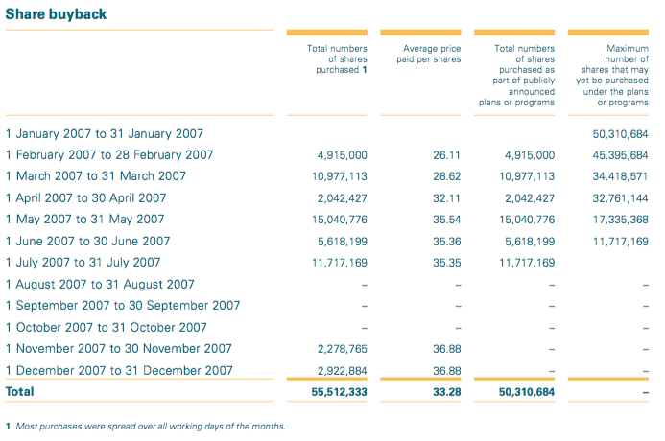

### APPENDIX III: Numico NV share price progression (source: Zephyr.com)

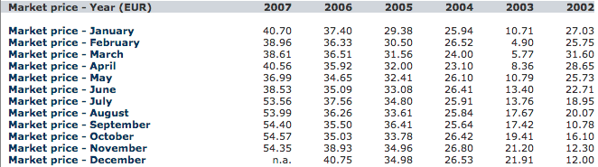

### APPENDIX IV: Draka Holding NV share price progression (source: Zephyr.com)

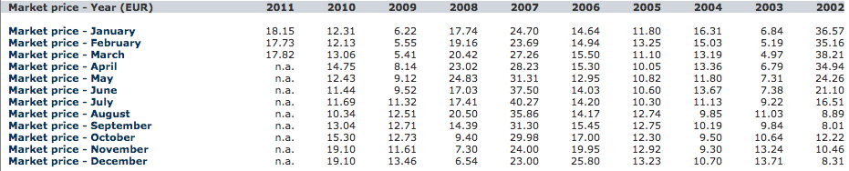

### APPENDIX V: Crucell NV share price progression (source: Zephyr.com)

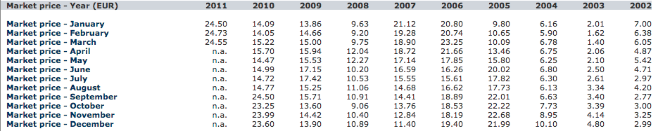

### APPENDIX VI: DE Master Blenders NV share price progression (source: Behr.nl)

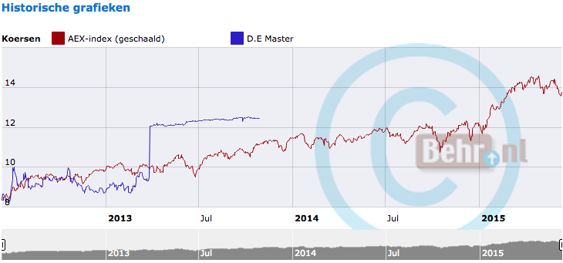

### APPENDIX VII: Severance calculations. Original situation vs. application of Provision.



### APPENDIX VIII: Interview with Robert Gerritsen Analysist at ISS for the Benelux market

Transcript interview Robert Gerritsen

Interviewer: *Luuk Kuiper*

Interviewee: Robert Gerritsen, Head Research Analyst for the Benelux market at ISS.

Topic: Implementation of policy recommendation.

The interview was held in Dutch and later translated into English

*Part of the policy development cycle at ISS can be found on the website. There are 5 factors that have to be taken into account for a policy update:*

1. *Industry group round table,*
2. *Ongoing feedback from investors/issuers,*
3. *Corporate issuer policy survey,*
4. *Institutional investor policy survey, and*
5. *ISS policy expertise*

***For this research the latter is most important, because ISS uses its expertise to reach new insights. Could you tell me some more about the process of the development of a policy update?***

There are a couple of things that are happening in developing a new policy update, so it might be best to see how that stands together chronologically.

What do we do after the proxy season, so the process we are working on now, is the drafting of a policy survey. This is a survey in which we try to find certain bottlenecks or problems in the market that analysts have seen. We submit these to the market in order to see what the market thinks. What we do is, we put a number of questions regarding the application of our standard policy, and ask what we need to take that into consideration and what they think of certain issues. For example, an issue which is now playing is gender diversity, there are more and more legislators in Europe to require gender diversity on boards of directors. And so it is a relevant question to then ask to investors and issuers of such should be included in our politics.

So in that way we receive feedback from the market. So what we see as certain developments. This is of course somewhat an allusion to the ISS policy expertise.

***So that basically means that the five elements of policy development go hand-in-hand with each other and should not necessarily be seen as five separate components.***

Indeed. Analysts see that the policy applies to certain aspects in a particular country, it is not as easy as they like it because it's not apparent to apply a certain policy always in the same manner. Then you should question how to apply it. That's the policy expertise of how we experience it, so, ‘does it make sense it has to apply it in a certain way?’

Okay, so we do the policy survey first. Then we get set responses from both the corporate issuers and our customers, as well as the broader range of institutional investors including investors who are not clients of us. They provide feedback on the expectations of the market, where you have to set certain limits, what should be included and what not include, or other comments.

Based on the results of this survey senior analysts, so analysts within ISS with some seniority, can make proposals to modify the policy. Those proposals will be then first treated in a subcommittee at European level in which the committee used 1 to 3 days to discuss specific proposals.

***Could you clarify how this process works within those subcommittees?***

The senior analysts make a proposal. Suppose the proposal is to bring gender diversity in a certain level in our politics. Is first introduced to a European subcommittee, which then discussed at a higher level to the European commission and then on to the World Wide Policy Steering Committee. That proposal will be discussed and defended on each level.

***So that means that there are so many people involved with a policy update.***

Yes, it is not only considered from Europe but also from the US. Every policy update has a clear impact on the customers and how they deal with corporate governance.

What we also do during this step is to make an assessment of the current policy, what will be the policy, and what is the impact of the policy update. We will make a scenario and impact analysis. So, how will the recommendations change and how it will evolve?

When we have taken all that into consideration and the update is approved by the World Wide Steering Committee, it can be concluded that it is a reasonable proposal. Then we make policy proposal and again present it to the market for issuers, investors and all other kinds of power-holders. For which they can again give feedback. Then we take the feedback and consider whether the policy proposal needs to be adjusted. Finally there is a decision whether we want to include that in our politics.

***Even if it is an update for the Dutch market, the proposal is going through the European subcommittee, the European committee, and the Worldwide Policy Steering Committee?***

Indeed.

***What factors are taken into account when writing an update?***

We take the internal expertise of how to apply a policy, how to make a certain policy work, and of how to get consistent recommendations. We have to set certain limits so that it is easier to apply a specific policy and to make it less open to interpretation. We take into account market developments, legislative developments, as well as feedback from our customers, institutional investors in the broadest sense, and also the issuers (companies themselves).

***As you know I'm doing my thesis on the change-in-control provision and the impact of shareholder value. How would something like that fit in the current policy for the Netherlands?***

First you should question, should the update only be applicable to the Netherlands? Why would the Netherlands be the exception? So then it would actually change a policy for continental Europe. We have different regional policies; a policy for language continent Europe, a UK politics, a politics of US, a separate policy for Russia, a separate policy for Israel. It concerns a general approach to change-in-control clauses that you would like to change.

***Are there existing policies that need to be adjusted if there is an addition to the current policy in the form of my recommendation?***

If you should update the policy, the continental European policy has to be updated. At the moment, we have no reference to the change in control clause in our European policy.

***Thank you, you answered all my questions. Many thanks for your time.***

### APPENDIX IX: Proposal of policy update in ISS format: discussion item

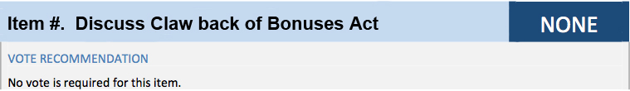

Discussion & Analysis

Under this item the implications of the Dutch Clawback of Bonuses Act are discussed, more specifically the change-in-control provision of the Clawback of Bonuses Act. Since January 2014, the change-in-control provision of the Clawback of Bonuses Act limits the director’s ability to gain from a change-in-control by a deduction of the share value by the lowest increase in share value over a determined reference period. Consequently, the provision therefore limits the effectiveness of equity-based incentives. This applies to (I) cooperatives and private limited liability companies (BVs) qualifying as a bank, (II) mutual insurance companies qualifying as an insurance company, and (III) financial institutions, regardless of their legal form. This is a non-voting item.

### APPENDIX X: Proposal of policy update in ISS format: voting item

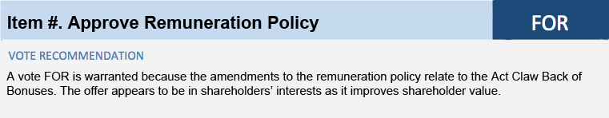

Discussion

Under this item, the management board proposes to amend the Remuneration Policy. The proposed amendments mainly concern the change of share and/or option award into phantom stocks, SARs, cash settled options, or conditional cash awards. These amendments are in line with the changes to equity-based incentives emerged from the change-in-control provision of the Clawback of Bonuses Act.

Analysis

Since January 2014, the change-in-control provision of the Dutch Clawback of Bonuses Act limits the director’s ability to gain from a change-in-control by a deduction of the share value by the lowest increase in share value over a determined reference period. Consequently, the provision therefore limits the effectiveness of equity-based incentives. The provision applies to (I) cooperatives and private limited liability companies (BVs) qualifying as a bank, (II) mutual insurance companies qualifying as an insurance company, and (III) financial institutions, regardless of their legal form.

The change-in-control provision limits the incentive for directors to negotiate a higher share premium in a takeover. Moreover, it discourages directors to agree with a takeover.

The remuneration policy amendments from share and/or option bases incentives to phantom stock, SARs, cash settled option, and/or conditional cash awards, are accepted to be a method of incentive that restore the effectiveness of share value based incentives to pre-provision standards. It should be noted however that phantom stock, SARs and cash settled options are no full replacement of shares and awarding directors with shares (by conditional cash awards) should always be preferred over phantom stock, SARs or cash settled options.

1. Including depository receipts
2. Claw-back Step-by-step process of calculating increases in value in the case of a public offer. (2014). De Blauw, Blackstone, Westbroek,
3. Offer Memorandum ABN Amro Holding N.V. by RFS Holding N.V., July 20, 2007
4. Annual Report 2007, ABN Amro Holding N.V.
5. Value of shares plus the termination payments.
6. Data retrieved from Annual Report ABN Amro Holding N.V. 2007 and Offer Memorandum ABN Holding N.V. by RFS Holding N.V. July 20, 2007
7. Annual Report 2007 The Royal Bank of Scotland Group
8. Assuming a tax rate of 52 percent
9. Annual Report Numico N.V. 2007
10. Data collected from Annual Report 2006, Numico N.V. and Offer Memorandum Numico N.V by Groupe Danone, August 20, 2007
11. Annual Report 2010 Draka Holding NV
12. Offer Memorandum Recommended Mixed Exchange and Cash Offer by Prysmian
13. Remuneration report 2011, Prysmian Group
14. Calculated over a three year average of yearly bonuses, €522,000, €294,000 and €740,000 respectively
15. Annual Report 2009/Annual Report 2010, Draka Holding NV
16. Offer Document Crucell NV JJC Acquisition Company BV, December 8, 2010
17. Johnson & Johnson Completes Tender Offer for Crucell and Declares Offer Unconditional, February 22, 2011, Investors Relations Johnson and Johnson. http://www.investor.jnj.com/releasedetail.cfm?ReleaseID=551527
18. Johnson & Johnson Acquires 98.89% of Issued Crucell Shares as of the End of the Subsequent Offering Period and Crucell Intends to Delist Crucell Ordinary Shares and ADSs, March 8, 2011 Investors Relations Johnson and Johnson. http://www.investor.jnj.com/releasedetail.cfm?ReleaseID=555562
19. Data collected from Crucell NV Annual Report 2009 and Offer Memorandum
20. Hoe Jan Bennink Miljoenen Verdiende Met Dubieuze Overname Douwe Egberts, August 9 2014, Follow the Money
21. Annual Report 2012 DE Master Blenders 1753 NV
22. Offer Memorandum by Oak Leaf BV
23. Annual report ABN AMRO Holding NV 2007
24. Evaluation AGM Season 2015, Eumedion Corporate Governance
25. De zoete verleiding bij overnames [The sweet temptation at takeovers], February 5, 2015, Verenings Effecten Bezitters, Retrieved from: https://www.veb.net/artikel/05584/de-zoete-verleiding-bij-overnames
26. In accordance with ISS standard. ISS uses FOR or AGAINST recommendations in its research analyses