Internship report (IBMS, HU)

Sensata Technologies, Marketing department

Expanding into Europe: “What strategic growth segments are of key interest for .Sensata Europe that could create a sustainable business in the Thermal .Management market”

Marina Boyko
ID 1550257, email: marina.boyko@student.nu.nl, Year 4

Publication date: January 2013
Contents
Executive summary 5
Glossary of terms 7
Who is Sensata 8
Literature review 9
Methodology 11
Hypothesis 11
Problem 11
Main question 11
Sub questions 12
Data collection 12
Findings 14
How thermal management works 14
What is important for purchasing decision 15
What are the main market trends and developments 16
Macro segmentations 17
Geographic 17
Applications 18
Micro segmentation 21
Function segmentation 21
Decision making 22
Price vs quality sensitivity 22
Volume 22
Electronic vs Mechanical engineering 23
High temperature applications vs low temperature applications 23
Competition 24
SWOT 26
Strengths 27
Weaknesses 27
Opportunities 27
Threats 28
Discussion and Conclusion 29
Portfolio 29
Customers 29
Distribution 30
Competition 30
Market trends 30
Geographic trends 32
Recommendation 34
Targeting 34
Eastern Europe 34
Applications which operate in aggressive environment 34
OEM 34
LED market 34
Ventilation 35
Strategies 35
Increase market share 35
Deploy distributors channels 35
Product development 35
Anticipate the threats 35
Appendix 1 “Penetration of inverted motors in applications” 37
Appendix 2”Lighting market” 38
Appendix 3 “Growth-share matrix - Major appliances and HVAC” 39
Appendix 4 “Growth-share matrix - Small appliances” 40
Appendix 5 “Growth-share matrix - Lighting” 41
Appendix 6 “Customer needs” 42
Appendix 6 “Questionnaire” 43
References 46

Executive summary

Sensata is major manufacture of sensors and controls, operates worldwide and has its production facilities in low cost areas such as China and Korea. The total revenue is 1.5 billion USD, with the major contribution of America’s market. The EMEA business unit is located in the Netherlands and employs around 300 people. Sensata’s products are mission critical products, for energy reducing and safety reasons. They sense and regulate temperature, performing thermal management funstion. In order to successfully compete on the market, it is very important to understand current market trends and developments, identify customer needs, decide where to focus in current and future market environment and what portfolio company needs in order to enter those markets.
The main trends and developments on the market of thermal management are decline in population and increasing of single households, slowdown in the economy which is heavily affecting retails’ performance, pressure from the government toward energy efficiency, EU targets in 2020 (20% energy from renewables and 20% increase in energy efficiency) and rapid development of electronic in electrical devises together with their miniaturization.
From geographic point of view, it is wise to separate market on Eastern and Western Europe, for cultural, economic and political reasons. Eastern Europe is showing major growth in almost all sectors, however the “must have” products are still the key drivers. Increasing disposable income is driving demands, however relatively high corruption level is “scarring off” invesrots. Standardization gap and trade barriers are also complicating business, however entering Russia WTO in 2013 might open opportunities. Generally speaking, Western European market is bigger than in the East, but the markets are in stagnation and in some cases in decline and mostly driven by renovation and replacement activities, purchasing power is much higher than in Eastern Europe therefore demands for expensive items are higher than in Eastern. Energy efficiency trends are the key.
Sensata current portfolio is quite limited, mostly consist of thermal switches (which are characterised as big, “rough” and suitable for aggressive environment), this fact is not aligned with market developments where fragile electronics require small and accurate devises.
The main company’s strength which differentiates it from its competitors is ability to handle high volume orders with tailor method. This helps Senata to work with OEM’s, however working with distributors is a challenge, since they require diverse portfolio.
According to the current situation on the market it is recommended to focus on penetration into the Eastern European market, especially Russia/CIS countries and Turkey. Applications which operate in aggressive environment and Ventilation segment suit Sensata’s current portfolio the best. For the further growth expansion into the LED market is very important, together with product development and deployment distribution channels. Anticipation threats such as penetration of VSM have to be part of Sensata strategies.

Glossary of terms

Thermal management - is a process of protecting and controlling equipment by sensing temperature and taking necessary actions
Major appliances - are large domestic appliances such as washing machines, dryers, dishwashers, refrigerators, ovens and cookers.
HVAC - industry sector which include following applications: heating, ventilation and air-conditioning
Small appliances - are small household appliances such as food preparation appliances, small cooking appliances, small kitchen appliances, vacuum cleaners, irons and personal care appliances
Variable speed driver (VSD) or inverted-based - is a motor whose speed depends upon the load that it carries. The main advantages are: increase efficiency, reduce noise and improve reliability.
OEM - original equipment manufacturer, companies which are making equipment
CM - components manufacture
LED - light-emitting diode, semiconductor light source

Who is Sensata

Sensata Technologies is a manufacture of mission-critical sensors and controls. Sensata manufactures around 20,000 different products and ships over 1 billion units a year under the brand names Klixon®, Airpax®, Dimensions™, Qinex™ and Sensor-NITE. The Klixon brand
became a synonym for thermostats and has very good perceived quality.
The company operates worldwide, it has business centres in Brazil, China, Japan, The Netherlands and USA. The manufacturing points are located in Asia (Korea, Malaysia and China) and South America (Dominican Republic and Mexico). Sensata employs 12,500 employees worldwide and in 2010 company has started trading on New York stock exchange under the name “ST”. The total revenue in 2010 is $1.5 billion and distributed in the following shares 5% Europe, 33% Asia and 42% Americas.
Sensata Technologies BV is EMEA unit which is located in Almelo, the Netherlands, it employs around 300 people and responsible for sales in Europe, Middle East and Africa’s markets.
The products are mission critical application for energy reducing, environment and safety as a result excellent quality is crucial factor for the organization. Engineer to engineer approach enables to understand customer needs and create sustainable value. Economy of scale allows producing high volume products at low cost. The market position is “high quality- high value products at competitive price”.
The European market contributes 25% to the total company’s revenue. Sensata market strategy is operational excellence which means providing customers with reliable products or services at competitive prices. To main tools are low cost production facilities, low transaction costs and efficient processes.

Literature review

Today’s competition level in the markets is highest than ever. In order to successfully compete in a market place companies have to gain a sustainable competitive advantage by delivering more value to the target customers than competitors do. Kotler (2008) defines competitive advantage as “an advantage over competitors gained by offering consumers greater value, either through lower price or by providing more benefits that justify higher prices”.
The well-known fundamental theories, for example Porter’s model (1998 and 2004) suggests that in order to gain a sustainable competitive advantage company can follow one of the following strategies: cost leadership, differentiation or focus (cost focus, differentiation focus or cost and differentiation focus). Moreover, the industry analysis helps companies to identify their strengths and weaknesses in relation to the existing competitors and assists in strategy evaluation. According to Porter there are 5 competitive forces which define the industry: threat of new entry, intensity of rivalry, availability of substitute products, bargaining power of buyers and bargaining power of suppliers (Ormanidhi & Siringa, 2008)
However, there are some doubts about role of market orientation, is it a source of competitive advantage or just the costs of competing? The study has shown, that the market orientation indeed leads to the performance improvements, such as increase in sales and profit, both in the short and long terms. However, only the earlier adaptation of market orientation in relation to direct competitors leads to the sustainable competitive advantage (Kumar, Jones, Venkatesan, & Leone, 2011)
Some studies suggest the sharper company differentiate its strategies, the more-lasting competitive advantage is. Research has shown that among high performed companies 80% are with clearly defined differential strategies (Zook & Allen, 2011). However, differentiation tends to diminish during the time. The reason is not only because the competitors are trying harder, but there are also internal issues. The growth followed by successful differentiation increases company inconsistency, eliminate company’s ability to learn and diluting economy of scale. The solution is continuously building up the differentiation from strength to strength, by delivering company’s value to the front line employees and learning how to sustain their competitive advantage through the market changes (Zook & Allen, 2011).
The service quality is an essential component of service competitive advantage.. The most well-known model to measure the quality of service is SERVQUAL. This model consists of following dimensions: reliability, responsiveness, assurance, empathy, and tangible. The customer satisfaction, according to the SERQUAL model has to be measured in terms of five dimensions which were mentioned above. The findings have to be compared between pre-purchase and post-purchased perception (Vinh, Patterson &s Styles 2009).
Selling product to business customer as well as to the consumer require answering following question: who are the buyers and what are their needs? How they make purchasing decision and what influence on their decision? What are the most important trends and development on the market? What are customer equity? Therefore it is important to conduct market research, find the main trends and developments, what are the customer needs and how company can fulfill these needs (Kotler 2008).
For many companies customer equity is the most important factor for the long term value or the firm. However, understanding how to manage and growth customer equity is a challenge. Ability to develop customer equity creates significant competitive advantage. There are three drivers of customer equity: value, brand and relationship. Value is the most important aspect in customer’s relationship with the firm. If product does not meet specific customer needs, the best marketing strategy will be inadequate. Three key factors are important: quality, price and convenience. Brand is a perception of image and meaning, it helps to attract, retain customer and strengthen emotional tie. Relationship equity helps to “glue” the customers to the brand (Lemon, Rust, & Zeithaml, 2001).
For marketing-oriented organization understanding customer needs is inspiration for their strategies. It requires gathering information about their consumers and clustering them in different group according to their similarities. Segmentation can be based in different factors, such as demographic, geographic, product attributes etc. The main advantage of segmentation is ability to target desired segment and precisely fulfill different customer needs (Kaleka, 2011).

Methodology

Hypothesis
Increasing functionality, power density and miniaturization of products boost the need for thermal technology and change the direction of traditional thermal management approach.
Heat generated by electronic devices and circuitry must be dissipated to improve reliability and prevent premature failure.
Why is it important?
- 55% of the electrical devises failures are due to high temperature
- Regulating temperature is increasing product life span
- In most cases it is mandatory by legislation
- Safety reason
Growth is determined how efficiently company understands and exploits its distinctive capabilities and how good it understands the market. A coherent marketing strategy is very important in development sustainable growth. It is vital to know who is buying and why. Company has to have a value proposition, products have to meet the real needs and solve real problems.
The desk and field research will be conducted in order to answer the research question. First of all, will be monitored market reports related to the industry, annual reports and websites of competitors, customers and other related companies.

Problem
For future growth it is essential for Sensata Europe to understand the new trends on the market and define new areas for development.

Main question
The goal of this research is to answer the following question “What strategic growth segments are of key interest for Sensata Europe that could create a sustainable business in the Thermal Management market?”
For the research the market for Thermal management is narrowed down in the following way:
- Automotive market is excluded

Sub questions
- What are the trends and developments in the market of “Thermal Management” and what is their potential impact on Sensata business
- What are the customer needs
- What key success factors Sensata needs in order to serve growth markets (portfolio, strategies etc.)

Data collection
The strategy of the research is based on both quantitative and qualitative data collection. Quantitative research includes survey, which was distributed during following events: Technological fair in Hannover and Lighting trade show in Frankfurt. The questionnaire was handed out to the company representatives, which are potential Sensata’s customers, since they are using similar products. Questionnaires were distributed equally between different industries. The amount of time at the fairs was limited, therefore the samples size was identified in relation to the available time. In addition, in depth interview was planned with some big market players.
For the Technological fair in Hannover was scheduled 2 days, survey was distributed among 40 companies and 4 in depth interviews was conducted.
For the Lighting show was scheduled 8 hours and survey was distributed among 15 companies and one in depth interview was conducted.
All participants were informed about the reason of the research and its topic and were asked if they would like to receive the results.
Quantitative research includes reviewing relevant literature, industry journals, articles, annual reports of the main players and also internal information within the company. To analyze Sensata internally were used presentation materials from different departments, such as Purchasing, Products Development, Finance and some materials regarding performance forecast which was prepared by the general management of European business unit.
The findings from different sources were summarized and analyzed by different models, such as BCG matrix and Kraljic matrix. The most important trends in the market were evaluated by industry.
Despite the fact, that this research was carefully prepared, I am still aware about the fact that it has limitations.
First of all, the sample size was relatively small, only 55 companies were interviewed at the trade show, which might not represent the whole population.
Second of all, was very difficult to access information due to very technological and specific nature of the topic.

Findings

How thermal management works
There are several steps in regulating and controlling temperature in electrical devices. First of all the temperature has to be sensed. The sensing device is being activated if the temperature rises (in some case drops) above or below desired level. The second step is control the temperature within the limit, the control function can be different and it highly depends on application and technologies used.
The table below represents overview of technologies which are used in temperature sensing.
x low -xxx high
Criteria | Thermal fuse | Bi metal switch | Thermistor
Description | Mounting on the surface where the temperature has to be sensed. In case of exceeding the certain level of temperature, thermal fuse is melting down and breaking the circuit off. There are also resetting thermal fuses, which are has to be manually reset. | Mounting on surface and consist of two bi metal discs, which are could be normally open or close. In case of exceeding the temperature limit bi metal discs are opening or closing which is breaking the circuit off. | Mounting on the surface and sensing the temperature. The main difference is that thermistors need a control unit to regulate the temperature. It has to transmit the signal in case the temperature is exceeding their limits. Thermistors operate together with electronic or electrical control units.
Temp range | xxx | xxx | xx
Accuracy | xx | x | xxx
Reaction | xx | xxx | x
Sensitivity | xx | xx | xxx
Price | x | xx | xxx
Advantages | •Provides the highest level of safety  • Easy to install | •Rough  •Doesn’t have to be reset  •Easy to install | • Does not break off the circuit,  but reduce the temperature gradually  • Easy integration with electronics
Disadvantages | • Operates once and need to be replaced or reset | • Break off the circuit  • Decrease in accuracy over the life time  •Relatively big size | • Cannot guarantee full safety, therefore in same case dual protection is installed  • More difficult to install  • Susceptible to the high temperature and aggressive environmental  •Requires additional installation (e.g. software)
Figure 1 “Thermal management technologies overview”

What is important for purchasing decision
The market environment Sensata operates in is B2B, the decision making process is complex and fragmented.
According to the Ktaljic model, from customer point of view Sensata products are “bottleneck items”, since they have a low financial impact on organization but still the supply risk is high. The purchasing strategy for these products based on continuity of supply and suppliers diversification, by investigating alterative products and suppliers.
During the trade show were interviewed Sensata’s potential and current customers. The main outcome of this survey has shown that quality and price play the most import role in the decision making process, both for technologies and suppliers .However, importance of relationship status with a supplier increases in supplier choosing (see figures below).

Figure 2 “Decision making criteria in choosing technology”

Figure 3 “Decision making criteria in choosing supplier”

What are the main market trends and developments
The table below shows the main trends and development which were identified in European market of Thermal management. The sign “+” represents positive effect on Sensata, “-/+”- could be either positive or negative and “-” is negative effect.
D | Increasing number of households | +
 | Decline in population | -
 | Large percentage of elderly population | -/+
 | Decline in working age population | -
E | Slowing down economic activities in Europe | -
 | Increasing unemployment rate | -
 | Cutting government expenditure | -
P | The industry is highly regulated by the Government (directives, safety specifications) | -/+
 | Pressure from the Government towards energy efficiency products, to reduce impact of product through their life cycle (Ecodesign, Energy Labeling, Ecolabel, green Public Procurement) | -
E | EU targets in 2020: | -
 | 20% of energy from renewable
 | 20% increase in energy efficiency
 | Global needs to reduce carbon emissions | -
 | Trends towards better recycled products | -
S | Unawareness among population about danger of using electrical equipment | -
 | Reducing gap in society between rich and poor | +
T | Rapid development of electronics in electrical devices | -
 | Technological progress in electrical equipment caused by increasing complexity and functionality of electrical devices | -
 | Components miniaturization | -
Figure 4 “Thermal management trends and developments in Europe, 2012”
Number of households is increasing despite of decrease in population, which means that nowadays people are living in smaller families. Another important trend is increasing of elderly population all over the Europe (MarketLine, 2011)
It is very important to mention that the industry is highly regulated by the Government, especially from safety point of view. In some cases thermal management is very explicitly defined in the directives and regulations
Second of all, the efficiency trend all over the Europe is becoming more and more vital. Part of the EU 2020 targets is aiming to achieve 20% of energy from renewable and increase in energy efficiency by 20%. The main instruments are:
- Ecodesign is aiming to reduce environmental impact of products (including energy consumption) through their entire life time.
- Ecolabel which promotes product with higher level environmental performance
- Low voltage directives make sure that the only safe electrical devises, which operates more than 50 volts equipment is introduced on the market (European Commission, 2011)
From economical point of view, financial crisis all over the EU is hitting all industries. Increase in unemployment and uncertainty are putting pressure on retail (MarketLine, 2011)

Macro segmentations
Geographically Sensata’s customers can be divided on Western and Eastern European. These two markets differ in many points, from economical to cultural.

Geographic
Eastern Europe |  | Western Europe
Rising incomes and increasing purchasing power (around 4% of GDP growth) | + | The main drivers are design, new housing renovation and replacement | -
Must have products are the key drivers | -/+ | Energy and water efficiency trends | -
Increasing the amount of disposable income | + | Aging population | -/+
Relatively high level of corruption | - | Relatively high average GDP per capita | +
Relatively low average GDP per capita | - | Increasing number of single households | +
Relatively high political risk in some countries ( e.g. Russia) | -
Income inequality | -
Reduction of VTA on home appliances (Turkey) | +
Trade barriers | -
Differences in standardization | -
Entering Russia WTO | +
Conducive FDI policies in Russia | +
Figure 5 "Trends in Eastern and Western Europe, 2012"
Eastern Europe
This segment is driving growth in Europe due to increased purchasing power. The average GDP per capita growth rate is 4% and the size of disposable income is gradually increasing. However, in compare to the Western countries it is still low and limiting consumer in pricing range. The incomes are distributed unequally, therefore the percentage of the population with a standard purchasing power is lower than in Western Europe.
The “must have” products are still the key drivers, many households are still experience their first purchase of “essential products”, such as cooking appliances, hoovers etc (Cruz, E. & Towers, M. (2011).
However, the political risk is relatively high, especially outside of EU in countries like Russia and Turkey. Other obstacles are trade barriers and variation between standardization norms. However, there are some positive factors such as reduction of VTA on Home Appliances in Turkey, Conducive FDI policies in Russia and entering Russia WTO (MarketLine 2011).
Western Europe
Western European market on the other hand is not showing significant growth and mostly driven by the replacement cycle. The average GDP per capita is quite high, which is increasing the purchasing power and the size of disposable income. People tend to buy more expensive items (MarketLine, 2011)
The number of “single” households is increasing and the population is becoming older.
The most important trend in Western Europe which is influencing almost all industries is Energy Efficiency (European Commission, 2011)

Applications

Major appliances
The main growth in Major appliances is driven by Eastern Europe, however the market size is bigger in Western Europe, except washing machines and cookers. Dryers, refrigerators and ovens/microwaves are expecting to boost in Eastern Europe with the CAGR 11%, 8% and 7% respectively (see appendix 3). ovens/microwaves are expecting to boost in Eastern Europe with respectively (see appendix 3) (Cruz, E. & Towers, M. (2011).

HVAC

Air-conditioning
The market of air-conditioning is highly depended on weather patterns, Western European market is slightly smaller than Eastern (see appendix 3). Penetration of VSM is the highest among other home appliances (see appendix 1) (Cruz, E. & Towers, M. (2011).

Ventilation
The main drivers of the ventilation market are construction activities in residential, industrial and commercial sectors. The factors such as awareness about importance of good air quality and energy efficiency are driving the renewing market demands (Bowman & Reese. 2010)
EU government has reviewed the directives aiming to reduce energy consumption in residential and non-residential constructions, and it covers 5 main end-users application(European Commission, 2011):
- Heating
- Cooling
- Ventilation
- Lighting
- Hot water
The forecast of units shipped in 2015 for the whole Europe is 61.73 mm which is representing 8% increase from 2006 (47.05 mm) (see appendix 3). 80% of fans are equipped with thermostats, the other 20% is not protected or self-protection (Bowman & Reese, 2011)

Heating
The new legislation form the EU government is aiming to increase the share of renewable heating technologies such as biomass boilers and solar thermal systems in Europe by providing additional incentives, such as subsidies to consumers to adopt the new technologies. The Energy Performance of Building directives have made a significant impact on increasing the share of renewable energy sources. In a short term, it is expected an increase in number of incentives which will be a challenge for the manufacturers to adjust their production process and technologies (DG Enterprise and Industry, 2010)

Small appliances
The market of small appliances is by far the biggest in terms of volume, the growth in Eastern Europe is slightly bigger than in Western Europe but the difference is not significant (see appendix 4) . Market is still driven by the “essential” products (Cruz, E. & Towers, M. (2011).

Lighting
Technologies overview
- Incandescent lamps – creating light by heating a metal wire
- Halogen lamps- bulbs filled with halogen gas
- Fluorescent- bulb filled with a mixture of argon and mercury vapor
- HID ( High-intensity discharge)- produces light be establishing an arc between two electrodes
- LED (Light emitting diodes)- semiconductor diode that converts applied voltage to light
Technologies | Luminous efficacy (lum./ watt) | Lifetime (hours) | Turn on time | Color quality (CRI)
Incandescent | 10—19 | 750-2500 | fast | 99
Halogen | 11—20 | 2000-3500 | fast | 99
Florescent | 40—70 | 7500-20000 | slow | 52-90
HID | 50—115 | 3000-2000 | slow | 65-70
LED | 60—120 | 12000-50000 | instant | 44-90
Figure 6"Lighting technologies comparison"
*Luminous efficacy-how well an energy source produces visible light.
*The color rendering index (CRI) is a quantitative measure of the ability of a light source to reproduce the colors of various objects faithfully in comparison with an ideal or natural light source

The most important drivers in the lighting market are incandescent ban (incandescent types of lighting is expected to be fully withdrawn by 2020), The Green paper (which is developed to accelerate the deployment of LED lighting within EU).
The LED penetration (value) is expected to be 30% by 2014, and 70% by 2020). The LED prices are significantly higher, than the other types of lighting, however the significant decrease in production costs is expecting due to economy of scale and government incentives. LED has the highest penetration of electronics, with high R&D investments by the lighting manufacturers
Fluorescent type of lighting counts for 28% (volume based) in 2010 and it is expected to growth to 45% by 2015. The growth is due to high luminous efficacy and long life time, but it has slow turn on time (McKinsey, 2010).

Micro segmentation

Function segmentation
The Thermal Management market is very fragmented and involved different participants and decision makers within different industries. However, it is possible roughly generalize the distribution chain in following chart. The 80% of Sensata’s products are distributed via direct channels.
Sensata
80%
Distributor

Components manufacturer
Original equipment manufacturer

Distributor
Distributors usually serve many small to medium companies, which are related to different industries. They require broad portfolio of products and volume flexibility, they have good geographical coverage, good network and knowledge of various industries. They are handling medium volumes and they are not the end user.

Components manufacture
Components manufactures are manufacturing and designing components which are later on will be assembled into the end product. They are designing products in house, however most of the time they follow specific requirements of their customers. They have deep technical knowledge of different, but more-less related industries (for examples motors but for different purposes, from washing machines to wind mills).

OEM
They manufacturing, designing and/or assembling electrical equipment under their own brand, have broad knowledge of industries they operate in, including technologies, the end user market trends and developments etc. They have influence on legislation authorities and invest heavily in R&D. Usually order high volume of several products, but have very broad suppliers’ portfolio.

Decision making
Companies have different approach in decision making from centralized versus decentralized. Centralized decision making companies have very bureaucratic way of working, whereas decentralized have more out of the control situations.

Centralized
Big global OEMs tend to have very centralized decision making units. They have suppliers both nationally and locally, on top of they have very diversified supplier portfolio to eliminate supplier’s dependence.

Decentralized
Smaller companies such as distributors have less centralized decision making process, they are more flexible and source locally.

Price vs quality sensitivity
Companies also vary in terms of price vs quality sensitivity, which mostly depends on company’s strategy. OEM more quality cautious, because of risk brand damage, whereas distributors are more price cautious.

Volume
Companies are different in terms of their order sizes, which is of course depends on their production capabilities and sales coverage.

The table below summarizes customer micro segmentation
Extend: (xxx-high, x-low) | OEM | CM | Distributors
Decision making centralization | xxx | xx | x
Geographic coverage | xxx | x | xx
Price sensitivity | X | xx | xxx
Quality sensitivity | xxx | xxx | xx
High volume orders | xxx | xx | x
Figure 7 "Customer micro segmentation"

Electronic vs Mechanical engineering
In some industries electronic penetration is much higher than in the others. This trend is defined by the factors, such as advanced level of technologies, power consumption and miniaturization.

High temperature applications vs low temperature applications
The operating temperature (temperature at which a device operates) varies from application to application. For example, LED applications operate in very low junction temperature app +40C, whereas in heating applications the temperature can be higher than +200C.

Competition
The table below represents main Sensata’s competitors which are active in Europe, their pricing strategies and main strengths and weaknesses.
Competitors | Revenue  (mln, €) | Pricing  (xxx-high, x-low) | Strengths | Weakness
Thermik | 15 | xxx | • Can handle small and high volume  • Flexible in customizing solution  • Strong presence in Germany | • Restructuration within the company  • Moving production facilities from Germany to Eastern Europe ( in transition stage)
Microtherm | 15 | xxx | • Customized product  • Strong presence in Germany  • Can accept low margin  • Can handle small and high volume | • Low presence in Eastern Europe
Limitor | 5 | xxx | • Customized products | • Enable to handle high volumes  • Selling mostly through distributors
TMC | 5 | xxx | • Flexible in customizing products | • Very small portfolio
Tomic | 2 | xx | • Strong presence in Eastern Europe | • Small volumes  • Small portfolio
DMP | 2 | xx | • Flexible in customizing  • Strong presence in Italy | • Small volumes
Pepi/EAW | 20 | xx | • Very successful in the US | • Small in Europe, trying to expand
Otter | 10 | x | • Strong presence in UK and Ireland | • Small portfolio
Honeywell | 35 | xxx | • High brand recognition  • Broad portfolio  • High volume  • Excellent technical expertise and innovative products | •Concentrating only on hi-tech industries
Figure 8 "Competition overview"
In compare to its main competitors, Sensata’s main competitive advantage is ability to handle high volumes orders with tailor method, another point is Sensata’s good perceived quality and recognizable brand. According to the in depth interview which was hold during the trade shows, first word which is coming to the mind when talking about thermostats is Sensata’s brand Klixton. Sensata also has quite advanced product development department, company is considered as innovator within their industry, many smaller companies are imitating Sensata’s products and taking advantage of its technologies. However, Sensata’s pricing strategy is not always competitive and considered as high.
The strongest point of many Sensata’a competitors is flexibility in customizing small volumes. As a result, many companies have broad portfolio and wide distribution channels which allows them to have good geographic coverage, especially in Eastern Europe.

SWOT

S | W
- High volume production with tailor method | - Inflexibility in low value production
- Good perceived quality | - Limited portfolio for distributors
- Recognizable brand, E.g. Klixton  became a synonym for thermostats | - Relatively long delivery time, logistical issues
- Wide portfolio for direct businesses,  80% of sales through direct channels | - Limited presence in Eastern Europe
- Long term relationship with the end users (OEMs) | - Higher pricing in compare to the main competitors
- Manufacturing sites in LCAs | - Fragmented geographical coverage
- European warehouse in Utrecht | - Limited distribution partnership
- Good engineering and product development capabilities | - High concentration on mechanical engineering  within the company
- Participation in standard comities in Europe | - Major outsourcing activities (loss of control)
- Stable processes, economy of scale | - Minor marketing activities ( short term thinking)
- Global presence
- Financially healthy company, good liquidity
- System solution business (design and manufacturing)
O | T
- Expansion into Eastern Europe | - Self-protected motors
- Increase sales and improve overall geographical coverage in Western Europe through distribution | - Brushless motors, sensor less protection
- Meet increasing demands for smaller thermostats | - Prices pressured and increasing competition from China
- Meet increasing demands for higher voltage thermostats | - Moving production from to LCAs (Asia, Eastern Europe)
- Alternative solution for PTC/NTC | - LED deployment in Europe
- Meet demands for smaller size/high temperature thermostats | - Electronics developments in electrical equipment
- Influence legislation in terms of safety in developing applications  (e.g. LED, Li-ion batteries) | - Economic instability within EU (influence on construction activities etc.)
Figure 9 "SWOT analysis"

Strengths
Sensata’s main strength is ability to manage high volume orders with customized solution. In addition, perceived product quality is quite high and Sensata’s brand Klixton became a synonym for thermostats. Therefore, company has very strong relationships with OEM’s where Sensata precisely meets customer needs – high volume and customized solutions.
Global presence, production facilities in LCA and European warehouse help to develop economy of scale, low production costs and efficient logistic services.
Participation in standard comities in Europe allows Sensata influence on regulations and standardization. In addition, company is financially very healthy, with a good liquidity which brings opportunity of acquisitions.

Weaknesses
Sensata is inflexible with low volume products which make it difficult to work with distributors. As a result, Sensata experiences fragmented geographical coverage in some areas (e.g. Eastern Europe), where access to the market is easier to make via distributors.
Company also has high concentration of mechanical engineering within their Product development department, which is limiting Sensata further development towards advanced technologies.
Sensata also outsources a lot of activities from production to customer support and logistic. This strategy is definitely benefit in cost reduction, however it also cause a lot of conflicts within company’s process and loss of control. It eventually lead to lack of efficiency within the organization.

Opportunities
The main focus for long term growth is expanding into Eastern Europe (especially CIS countries and Turkey). In addition it is important to improve overall geographic coverage via distributors.
As was mentioned earlier, the main trend on the thermal management market is miniaturization of electrical devices, which increase demand for smaller products. Sensata, can use this opportunity and came up with a solution in order to secure long term growth.

Threats
Energy efficiency trends which lead towards advanced technologies and development of electronics is the biggest threat for Senata.
Pricing pressure from competitors and financial crisis in EU is putting high pressure on the company.
However, if financial crisis affecting Sensata’s performance already now, advanced technologies and energy efficiency are more long term threats which do not make a big influence at this moment.

Discussion and Conclusion

Portfolio
Generally speaking Sensata’s portfolio is not too broad and mostly consists of bi-metallic switches and partially fuses.
Thermistors are more accurate in temperature sensing than fuses and bi metal switches. Therefore, they will be more suitable for applications where low tolerance is important, such as LED application.
Fuses and bi metal switches are the most suitable for the high temperature applications (e.g. heating), because they have highest temperature range and they are “rough”.
The cheapest version for the end user would be thermal fuse, but they operate in resettable/replaceable mode. The advantage is guaranteed safety, which is could be very important in application with the high temperature (e.g. heating).
As product, thermistors have the cheapest price, however they usually involve expensive electronics, which also requires specific knowledge and additional installation process. That means that the margin for Sensata will be very low and for the end user this solution will be very costly, which is more likely to be used in applications which already contain a lot of electronics or in applications where switching off the circuit is not desirable.

Customers
According to Kraljic model, Sensata products are “bottleneck products”, therefore delivery reliability and supplier’s diversification are very important for the customers.
The survey has shown that the price and quality are two the most important factors in choosing both technology and supplier (see figure 1). The third factor is changing, customization is an asset in technology choosing and good relationships are important in choosing a supplier (see figure 2). This means that maintaining good customer satisfaction and close relationship with the clients will benefit Sensata in a long term. Whereas, tailoring method more luckily will attract the new customers.
Sensata’s current Operational Excellence strategies is supporting customer needs, however it is becoming more and more difficult to compete on the market with increasing competition from Asia and pricing pressure.

Distribution
Since the company is excellent in producing customized products in high volume, working with OEMs and components manufactures will be the easiest way, whereas selling via distributers could be a challenge and requires more flexibility and portfolio differentiation. However, via distributors it is very easy to enter new markets, since they usually have good geographic coverage and network.

Competition
The main Sensata’s competitive advantage is ability to handle high volume production with customized approach, due to extensive product development department and good perceived quality. The main weakness in relation to its competitors is fragmented geographic coverage and relatively high pricing.
Many companies within thermal management industry are very flexible in handling small volume production with tailor method, which allow them to work with distributions and have good geographic coverage.

Market trends
During the desk research were identified several important for Sensata market trends (see figure 3). For example, increasing number of households will boost demands for the small/major household appliances, decline in population will affect turnover in a long term, together with large percentage of elderly population. Decline in working population is rather negative factor, since it puts obligations of insurance and pension payments on working population. In addition, financial crisis and rising unemployment in Europe are heavily affecting retails’ performance. Therefore, growth of cheaper appliances (e.g. small cooking appliances) is more likely than more expensive items (e.g. dish washers) (MarketLine, 2011)
Another important trend is EU 2020 targets (20% of energy from renewables and 20% increase in energy efficiency) together with increasing complexity and functionality of electrical devices will boost R&D expenditure and will increase demand for the new product solutions. One of the examples is variable speed motors. This trend is mostly affecting applications where energy consuming is fluctuating (e.g. air-conditioning), since variable speed motors adjusting rotation according to the needs, which is very energy efficient. The highest penetration of VSM is in air-conditioning, dishwashers and washing machines and it is growing drastically (see appendix1). The other advantage of VSM is reduced noise, which is affecting applications located in the living area (dishwashers). Penetration of VSM into different applications is a potential threat for Sensata, since thermal management is done purely with electronics, by calculating RPM (rotation per minute). However, the directives are not stating yet the requirements regarding thermal management. Therefore, there are still opportunities that extra protection will be necessary (Cruz, E. & Towers, M. (2011).
Another example is LED, which is expecting to penetrate rapidly into general lighting market and by 2020 count for 70% in terms of value and 60% in terms of volume (see appendix 2). The main reason is high efficiency of LED lamps and longest lifetime hour (see figure 5). Companies heavily spend on R&D within LED. During in-depth interview with one of the leaders in LED manufacturing, was found out that currently 70% of R&D spending are concentrated on LED deployment and that they expect booming of LED in the coming few years. During this interview was also found out that bi-metal switches and fuses are rarely used in LED applications for several reasons. First of all, the sizes are too big to fit in sometimes miniature fixture, second of all manufacturers do not really want to switch off and on the circuit which leads to decrease in energy and also reduce lamp life time. Instead, they prefer to use thermistors which gradually control the temperature and avoid circuit break off (McKinsey, 2010)
Thermal management is highly regulated by the government with different directives and standardization, this could be an opportunity for Sensata. Directives might not explicitly mention the way of thermal protection or regulation must be done, but they state curtain requirements. So, manufacturers are allowed to be flexible in designing they own applications and solutions, however they have to go alone with standard safety requirements. Sensata, as a large manufacture and company with extensive technical expertise has a certain influence within standardization authorities and able to lead regulation to the desirable directions.

Geographic trends
Eastern European market definitely has a potential, income inequity is shrinking and the amount of disposable income is increasing.
The average growth rate in Major Appliances and HVAC in Eastern Europe is 6% whereas in Western is around 2%. The market of washing machines is by far the biggest in Eastern Europe. Heating, cookers and microwaves are quite big as well. Ventilation segment is also booming with the CAGR around 18% (see appendix 3). The main driver for the ventilation market is construction activities and regulation of indoor air quality. Dryers are also booming with CAGR 12%, however the market size is still very small. In addition, several major European manufactures are planning their expansion to Eastern Europe and relocation of their manufacturing facilities to Poland and Turkey. The other trigger is entering Russia WTO in 2013, which will eliminate trade barriers and stimulate export into Russia (see figure 4).
Market of Small appliances is by far bigger than markets of Major Appliances, the market growth in the East is also higher than in the West, but in average lower that in Major appliances and HVAC (Cruz, E. & Towers, M. (2011).
Energy efficiency and advanced technologies are not affecting Eastern market yet, so there are not much product changes on the market. That means Sensata can enter the market with its current technologies.
However, operating in Eastern Europe has also disadvantages, such as differences in standardization, corruption and high political risk, especially for direct investments. These factors usually stop companies from the expansion into the Eastern European market (MarketLine, 2011).
Western Europe does not show major growth, however market sizes are generally much bigger than in Eastern Europe, except washing machines which is quite large in both region (see appendix 3) and Small appliances (see appendix 4) (Cruz, E. & Towers, M. (2011).
The Energy efficiency trend is affecting mostly Western European market, for the several reasons such as decreasing dependency on fossil fuels and ecological issues. As already was mentioned energy efficiency trend is increasing demand in advanced technologies which is considered as a potential threat for Sensata and requires major product development.
Sensata’s market share is higher in Major appliances and HVAC than in Small Appliances. Sensata shows strong presence in the markets of washing machines, refrigerators and dryers in the East and washing machines, dishwashers and dryers in the West. In small applicants, Sensata’s market share is quite low in both regions except Vacuum cleaners in Western Europe.

Recommendation

Targeting

Eastern Europe
First of all, it is important to focus on farther penetration into Eastern European market. Despite of smaller market size, Eastern Europe is strategically important geographic area, especially Russia /CIS countries and Turkey. The average growth rate is much higher than in the West. In addition, the energy efficiency trend which is very popular inside of EU and considering as a potential threat for Sensata is not too widespread in the East.

Applications which operate in aggressive environment
Since current Sensata’s portfolio consists mostly from bi-metal switches which are characterized as rough and easy to install products, it is wise to focus on application such as:
- Heating
- Small cooking appliance
- Cookers, Ovens
- Microwaves
- Freezers
The other reasons are:
- Low electronic penetration, since electronics are very fragile and not compatible with high temperature or aggressive elements
- Highly regulated industries, in terms of safety and thermal management, which can be a reason for dual protection requirement

OEM
Sensata’s ability to handle high volume product with tailor approach, precisely meeting OEMs’ demands.

LED market
LED market is booming and expected to penetrate the general lighting market in Europe with 60% market share (volume) by 2020. Standard products such as bi metal switch are not on demand in this application. Therefore, it is important to develop solution for this market, sort of substitute for thermistors. The product has to be:
- Small
- Does not involve expensive electronic installation, which can be cheaper solution for the customer and at the same time add margin for Sensata
- Does not switch off and on the circuit

Ventilation
This application has very good potential, the growth rate is quite high, in addition according to the in depth interview 80% of all ventilators are equipped with bi-metal switches.

Strategies

Increase market share
Sensata’s market share is quite low, especially in small appliances in both regions. It is lost opportunity, because this market is very big and has other advantages such as simplicity of the product design and low electronic penetration.

Deploy distributors channels
The other aspect is developing relationship with distributors, since they usually have good local knowledge. Therefore, it will be easier to enter new geographic area, for example Russia or Turkey. However, at this moment Sensata does not have suitable for distributor’s portfolio. So, the suggestion would be to work on production flexibility, in terms of customized solution in small volumes

Product development
Come up with a substitute to thermistors, which will be performing the same function but will add margin for Sensata. In other words make it more expensive and eliminate costly installation processes.

Anticipate the threats
Penetration of VSM is increasing and will become a threat, since it is heavily affecting market of washing machines, which is the biggest market in Major Appliances and one of strategic markets for Sensata. In general, penetration of electronics is considered as a threat for Sensata and has to be anticipated and taken into account.

Appendix 1 “Penetration of inverted motors in applications”

Appendix 2”Lighting market”

Appendix 3 “Growth-share matrix - Major appliances and HVAC”

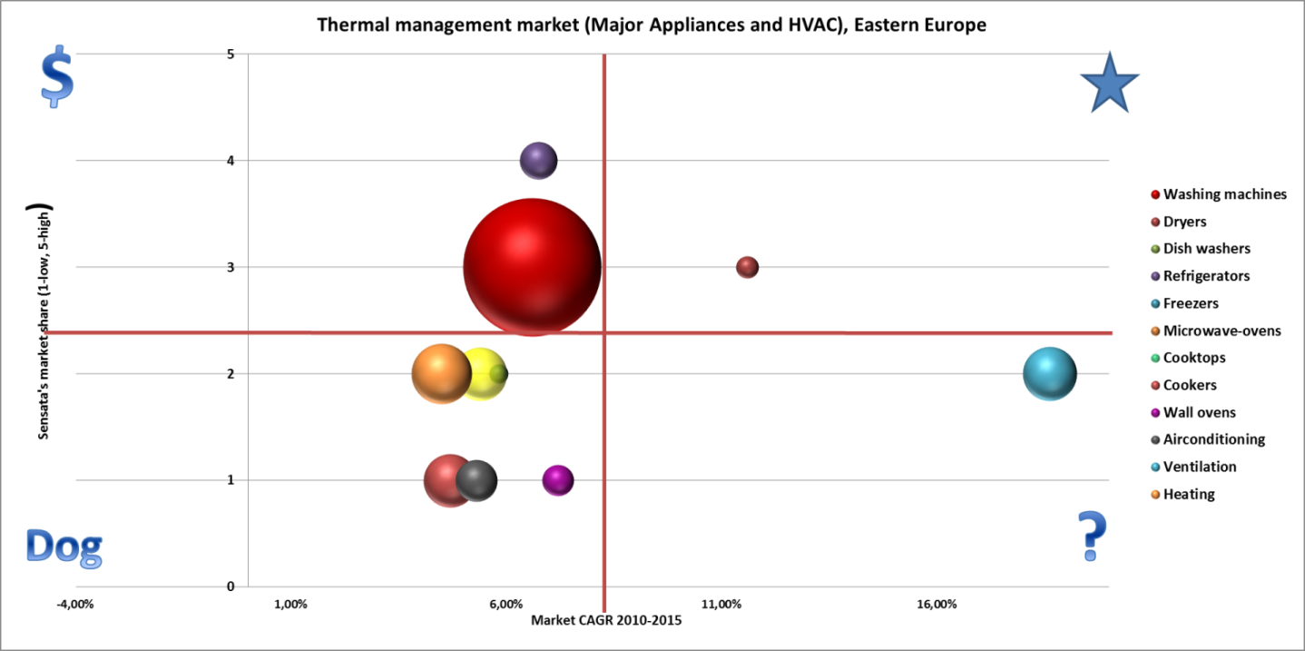

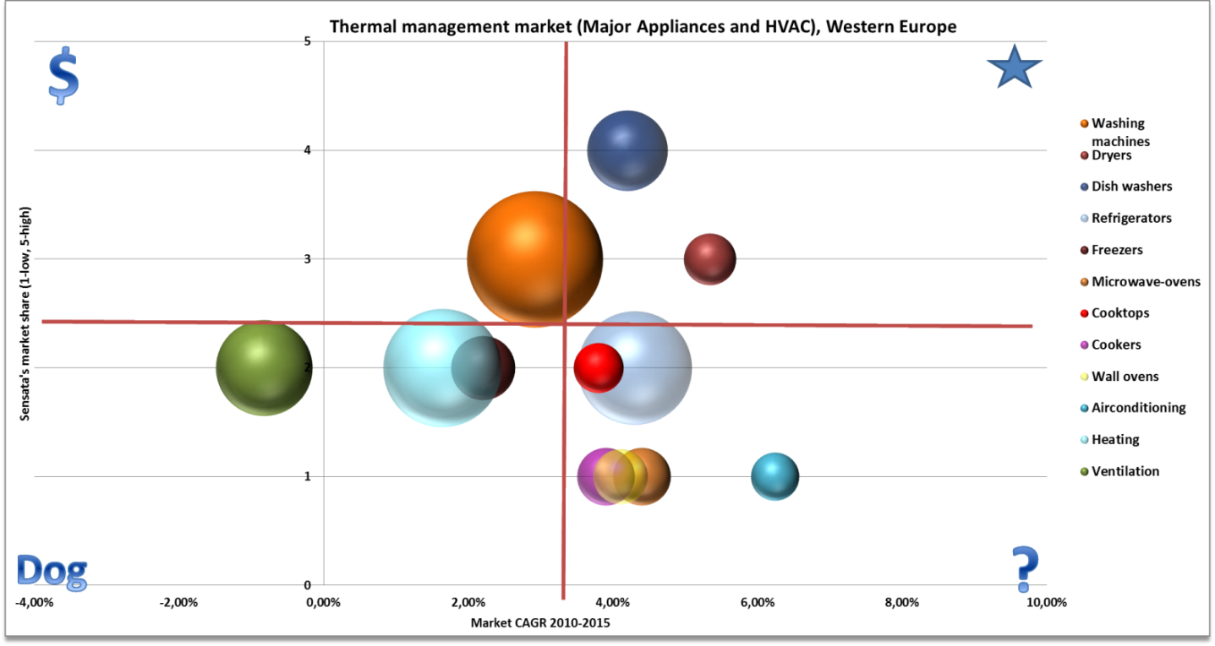

Appendix 4 “Growth-share matrix - Small appliances”

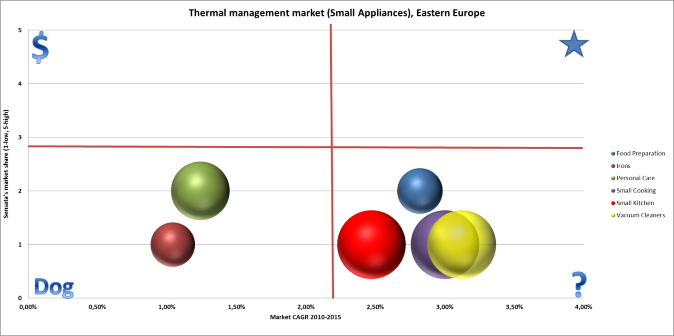

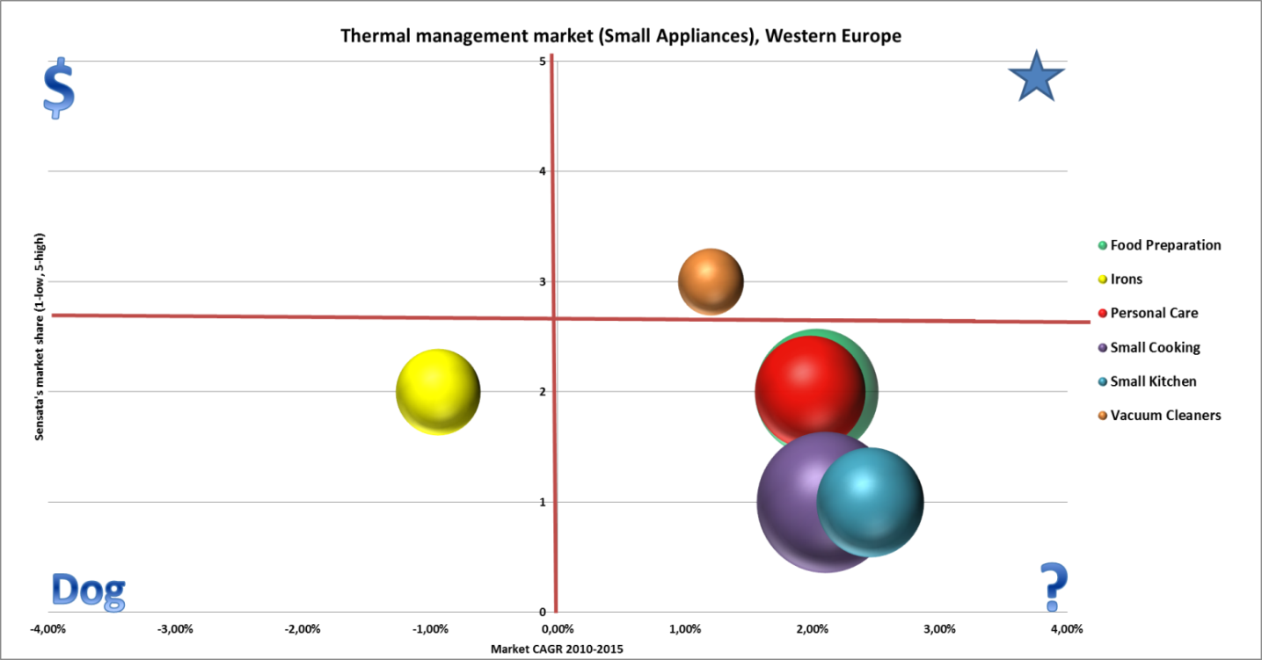

Appendix 5 “Growth-share matrix - Lighting”

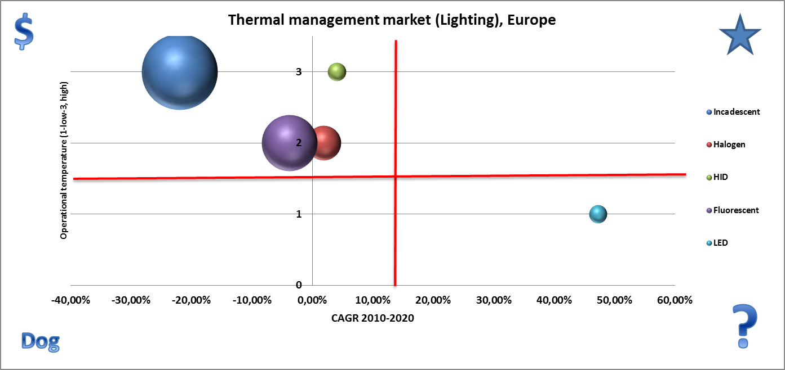

Appendix 6 “Customer needs”

Appendix 6 “Questionnaire”
- Is your company involved in the development of Thermal Management?
- Yes
- No

- Which industry your company operates in:

- Small appliances
- Major appliances
- Aerospace
- Defense
- Lightning
- Motors and equipment
- Medical equipment
- Heating, ventilation and conditioning
- Other (please specify)__________________________________________________

- Please rate the degree of your presence on the market (1-market leader and 5 market niche)

1 2 3 4 5

- What is your company’s geographic coverage?

- Western Europe
- Eastern Europe
- Middle East
- Asia
- Africa
- North America
- South America
- Oceania

- What is your position and role in the company

___________________________________________________________________
- Who is involved in decision making process within Thermal Management in your organization? Could you please grade the degree of involvement?

__________________________________________________________________

- What are the primary needs your company is fulfilling by using sensors and controls?

- Equipment control ( e.g. keeping it warm/cold)
- Temperature control ( regulating the
- Current control
- Extra safety
- Other (please specify)

- What other options do you have to fulfill those needs?

- Heat sink
- Fans
- Thermal shielding
- Thermal insulators
- Thermal compounds
- Thermal switches
- Thermostats
- Substrates for chips assembly in modules
- Heat pipes/Heat exchanges
- Water cooling systems
- Other (please specify)

- Please grade the following factors in term of importance in purchasing decision within thermal management.
- Price
- Quality
- Relationship with a supplier
- Lead time
- Extend of technical support
- Brand
- Ability to quickly place the order
- Possibilities for customized products
- Habit
- Other (please specify)

- What would be important for you in terms of product customization?
- specific size (please specify)
- specific features (please specify)
- specific form (please specify)
- other (please specify)

References

Bowman, J. & Reese, R.(2010), Industrial Ventilation Market Assessment, NEMI FMI Corporation.
Cruz, E. & Towers, M. (2011), The World Market for Major Home Appliances.
DG Enterprise and Industry. (2011), Voltage Limits Directives.
European Commission. (2011), Green Paper.
Kaleka, A. (2011). When exporting manufacturers compete on the basis of service: resources and marketing capabilities driving service advantage and performance, Journal of International Marketing, (19)1. 40-58.
Kotler, P., Armstrong G., Wong V., & Saunders J. (2008). Principles of marketing. England: Pearson Education Limited.
Kumar, V., Jones, E., Venkatesan, R., & Leone, R. (2011). Is Market orientation a source of sustainable competitive advantage or simply the cost of competing?, Journal of Marketing , (75), 16 –30.
Lemon, K., Rust,R.,& Zeithaml, V.(2001). What drives customer equity. Marketing Management, (10), 20-25.
MarketLine. (2011). Household Appliances in Eastern Europe. Industry report.
McKinsey &Company. (2011), Lighting the way: Perspectives on the global lighting market.
Ormanidhi, O., & Siringa, O. (2008). Porter's Model of generic competitive strategies, Business Economics, 55-63.
Vinh, L., Patterson, P.,& Styles C. (2009), Client perceived performance and value in professional B2B services: an International perspective, Journal of International Business Studies, 40 (2), 274–300.
Zook C., & Allen, J. (2011). The great repeatable business model, Harvard Business Review, 107-114.

