**Bachelor Thesis**



*Performance Management for Ahold European Sourcing*

C.Y. Meiling

Hogeschool Utrecht

International Finance and Control

June 27th 2011  
Student number: 1536886

Tutor: Gerrit-Jan Lanting

Principal: Erik Kleerebezem

# Title page

Company

Name: Koninklijke Ahold N.V.

Address: Provincialeweg 11

Postal code: 1506 MA

City: Zaandam

Telephone number: 075-6599111 (reception)

Website: www.ahold.com

Principal

Principal: Erik Kleerebezem

Email: erik.kleerebezem@ahold.com

Telephone number: 06-13630177

Tutor

Name: Gerrit-Jan Lanting

Address: Padualaan 101 (Hogeschool Utrecht)

Postal code: 3584 CH

City: Utrecht

Telephone number: 06-28764655

Email: gerrit-jan.lanting@hu.nl

Student

Name: Nina Meiling

Student number: 1536886

Adres: Laan van Vollenhove 500BIS

Postcode: 3706 AA

Plaats: Zeist

Telephone number: 06 251 642 52

Email: nina.meiling@gmail.com

# Preface

The final phase of the bachelor International Finance and Control consists of an internship and a research thesis in which theoretical knowledge should be applied to real life business.

From February 2011 until July 2011 I am an intern at Ahold European Sourcing in Zaandam. The department I have joined is called ‘Finance and Control’.

Ahold European Sourcing has two running projects that will soon provide a large quantity of spend data and contract information. This information can be used for the measurement of the performances of Ahold European Sourcing. My assignment is to find out if there is a Performance Management System that is suitable for Ahold European Sourcing and what things should and could be measured.

I hereby want to thank Gerrit-Jan Lanting and Erik Kleerebezem for supervising and guiding me through the whole process.

# 

# Management Summary

This research paper is written acting upon instructions from Ahold European Sourcing. This department within the international retail organization Ahold (Koninklijke Ahold N.V.) is responsible for the purchasing of private label, fresh, non food and not for resale goods in Europe.

Ahold European Sourcing wants a Performance Management System to measure its performances and to communicate these performances back to its employees.

The research question is the following:

*What is the Performance Management System that is best suitable for measuring Ahold European Sourcing?*

Several existing Performance Management Systems are analyzed. Based on the literature, a good Performance Management System for Purchasing should meet the following criteria:

1. Both Strategic and Operational measures
2. Both Lead (input measures) and Lag (outcome measures) indicators
3. All stakeholders should be considered (Suppliers, Internal customers and top management
4. Both Financial and Non-Financial measures
5. Both Effectiveness and Efficiency measures
6. Inclusion of sustainability
7. Applicable to retail

Because the strategy of Ahold European Sourcing includes increasing sustainability, the Performance Management System should include sustainability Key Performance Indicators.

There is no system that meets all the listed criteria, and therefore a tailor made Performance Management System (which is based on the Purchasing Performance Model of van Weele (2005)) is created based on the theory and on the Ahold European Sourcing strategy.

# Table of contents

Title page II

Preface III

Management summary IV

1. Introduction 6

2. Background literature 9

3. Research Strategy 12

3.1 Problem definition 12

3.2 Research questions 12

3.3 Methodology 13

4. Ahold 14

4.1 Highlights 16

4.2 Sourcing strategy 16

4.3 Organizational Structure 18

4.4 Definition six-step sourcing model 19

5. Analyzing the models 21

5.1 Balanced Scorecard 23

5.2 Performance Prism 25

5.3 Performance Pyramid System 26

5.4 Purchasing Performance Model 27

5.5 Tesco’s Corporate Steering Wheel 29

5.6 Conclusion 31

6. The Ahold European Sourcing Performance Management System 33

7. Data availability 36

8. Conclusions & recommendations 38

8.1 Conclusions 38

8.2 Recommendations 40

8.3 Areas for further research 41

References 42

Appendix 45

# 1. Introduction

Measurement of purchasing performances has been a hot topic for many years and it still is. It is not something that stands alone; it has tight links with measurement of the overall business performance (Monczka et al, 2005).

The functional level competences of an organization which consist of purchasing, manufacturing and marketing/sales can dramatically affect firm performance (Vickery, Droge, and Markland, 1993; Jayaram, Droge, and Vickery, 1999). While the focus used to be mainly on manufacturing and marketing/sales, purchasing is just as important. In recent years, the area of purchasing has been elevated to a strategic level and has become established as an important area of study (Gonzáles-Benito, 2007; Cox, 1996; Carter and Narasimhan, 1996).

Research of mcKinsey (1999) demonstrates that there is a clear relation between firm performance and purchasing professionalism. Organizations with high scores on purchasing professionalism realize an average EBITDA (Earnings before Interest, Taxes, Depreciation and Amortization) of 17.7% while the low performers did not get more than 12.7%. A significant difference (Reinecke et al, 2007). This tells us that one needs to look closely at how the firm is performing within the purchasing department and more important: lift the purchasing performance to a higher level of purchasing professionalism.

But purchasing professionalism is more than just measuring your purchasing performance. Some companies have the expectation that if you weigh yourself every morning, you will lose weight. This is not realistic of course, but often organizations are disappointed when a sophisticated Performance Measurement System does not deliver a significant boost in performance.

Besides the measuring of performance there is more that needs to be done. That’s why this research paper will not focus on Performance *Measurement* Systems but on Performance Management Systems. What is measured must depend on what management wants to manage.

This research paper is written acting upon instructions from Ahold European Sourcing. This department within the international retail organization Ahold (Koninklijke Ahold N.V.) is responsible for the purchasing of private label, fresh, non food and not for resale goods in Europe.

The focus lies on purchasing performance within the retail industry, and this paper tries to find the best fitting Performance Management System or create one that is most applicable to the Ahold European Sourcing.

Ahold decided to consider Ahold Europe and Ahold USA as different organizations that are managed separately, which is why the two organizations are not integrated. This research paper focuses on the Ahold European Sourcing department and the sourcing department of USA is therefore out of scope.

This research paper tries to answer the following research- and sub questions.

The main research question is:

*What Performance Management System is best suitable for assessing Ahold European Sourcing department?*

The sub question is:

*Where can Ahold find all information to measure Ahold European Sourcing?*

The structure of the paper is build up in the following way: Chapter 2 includes the background literature, where the terms Performance Measurement and Performance Management are defined, as well as the purchasing function and sourcing. Also the definition and evolution of the Performance Management Systems are described.

In chapter 3 the research strategy is presented, including the problem definition, research questions and methodology.

In chapter 4 the multinational Ahold is introduced and analyzed.

In chapter 5 five existing Performance Management Systems are explained and compared:

* the Balanced Scorecard (Kaplan, Norton, 1992)
* the Performance Prism (Neely and Adams, 2000)
* the Performance Pyramid (Lynch, Cross, 1991)
* the Purchasing Performance Model (van Weele, 2005)
* the Tesco Steering Wheel (Tesco, 2009)

The models are assessed on the basis of a set of criteria that are specifically developed for Performance Measurement in purchasing (Lardenoije, Van Raaij, & Van Weele, 2005).

These criteria include: strategic and operational measures, inclusion of all three stakeholders: suppliers, top management and internal customers, inclusion of ‘lead’ and ‘lag’ indicators, inclusion of both effectiveness and efficiency measures and financial and non-financial measures. Since Ahold European Sourcing also focuses heavily on sustainability, the models are also assessed on inclusion of indicators for sustainability.

It seems that most of the current performance models are not specifically designed for purchasing and definitely not for the retail industry. A retail organization has a different purchasing function than for instance a production organization. A retail organization purchases finished products and sells it again, while a production organization purchases raw materials, then adds value to these materials and then sells them again. The performance system therefore also has to be suitable for a retail organization.

Based on all these criteria, in chapter 6 some of the Performance Management Systems are combined and adjusted into a tailor made Performance Management System for the Ahold European Sourcing department.

In chapter 7 the data availability is discussed.

Chapter 8 presents the conclusions, recommendations and areas of further research.

# 2. Background Literature

**Performance Management**

Organizations with established performance measures for their procedures, processes, and plans experience lower customer dissatisfaction and employee turnover than those which do not have (Kakwezi & Nyeko, 2009).

Performance Measurement (PM) has many different definitions. One of these definitions is the one of Rouse and Putterill (2003), who defined Performance Measurement as “the comparison of results against expectations with the implied objective of learning to do better”. They state that the main reason for setting up a Performance Measurement System is to *improve* the performance. Dumond (1994) agrees with this in his research, since he considers “performance measures to be established to support the achievement of goals with the intent to motivate, guide and improve an individual’s decision making”.

Since Dumond’s definition also focuses on the *management* of performance instead of just on the *measurement* of performance, many authors refer to Performance Management Systems instead of Performance Measurement Systems. Results of Performance Measurement only tell you what happened but not why it happened or what to do about it. In order for an organization to make effective use of its Performance Measurement outcomes, it must be able to make the transition from measurement to management.

The term ‘Performance Management’ was first used in the 1970s, but it did not become a recognized process until the latter half of the 1980s (Armstrong & Baron, 1998).

**Performance Management System Criteria**

A good Performance Management System should meet the following criteria: Performance measures for purchasing (purchasing will be explained later) need to be balanced in terms of financial and non-financial measures, related to internal and external stakeholders (suppliers, internal customers and top management), and consisting of leading and lagging indicators (Evans, 2004).

It should have a mix of outcome measures (lag indicators) and performance drivers/input measures (lead indicators) (Norreklit, 2000). Financial and non financial measures are equally important in indicating the performance of the purchasing function (Lardenoije, Van Raaij, & Van Weele, 2005).

Measures need to be related directly to the organizations’ mission and objectives in order to reflect the company’s external competitive environment, customer requirements and internal objectives (Kennerley, Neely, 2002). It should include both effectiveness and efficiency measures and strategic and operational measures (Neely et al, 1995).

Overlooking the contributions in the purchasing area, Performance Measurement can mean a number of different things. A number of publications focus on the measurement of supplier performance (Trent & Monczka, 1998). Other contributions have a particular focus on the measurement of buyer performance (Hendrick & Ruch, 1988).

The success of the retail organization cannot be seen separately from the performance of the buyers since it is they who have the responsibility for providing optimal customer service through the purchasing of the right products that are available at the appropriate time, in appropriate quantities (McGoldrick, 2002).

**Sourcing**

This paper focuses on the Performance Management within a purchasing department.

A purchasing department is responsible for purchases, which can be raw materials, equipment, services etc.

A more advanced way of purchasing is sourcing. Sourcing is the acquisition of goods and services. Sourcing got its name from the practice: finding a source for materials. It is often called either ‘strategic sourcing’ or ‘global sourcing’.

‘Strategic sourcing is a cross functional process used to manage, develop and integrate supplier capabilities to achieve a competitive advantage, involving members from all functions of the organization’ (Monczka et al 2002). Slaight (1999) says that strategic sourcing is ‘a periodic event’ that includes the identification and selection of initial commercial agreements with a selected supplier that either creates or resets a relationship’.

He views strategic sourcing as a process whereby organizations divide their total spending into categories and then classify the categories on the basis of the importance of that product and service, and on the complexity of the supplier marketplace.

‘Global sourcing involves setting up production operations in different countries to serve various markets, or buying and assembling components, parts or finished products world-wide’. (Murray, Wildt and Kotabe; 1995b) Starting in the 1990s, firms have been advised to use global sourcing, by picking best-in-world external suppliers, as a means to improve competitiveness (Monczka & Trent, 1991; Quinn & Hilmer, 1994). Implementing these ideas has important consequences for the structure and strategy of multinational corporations.

# 

# 3. Research Strategy

In this chapter the problem definition, research questions, research methodology and collection of data is described.

## Problem definition

There is no balance in the amount of performance managements between the departments within Ahold, since some departments have very sophisticated Performance Management Systems with multiple Key Performance Indicators, while other departments do not have any Performance Management in place.

Ahold Europe has little insight in the performances of Ahold European Sourcing. Information like the number of suppliers, number of employees, supplier reliability, the number of different products per buyer and operational prices is not available. Especially with Aholds’ plans to increase its spend and therefore the whole department, this is an important area of focus.

Ahold wants to have a sourcing department that is transparent on both buyer performance and supplier performance. In addition to that Ahold wants to be able to communicate performance information back to its employees.

## Research questions

*What Performance Management System is best suitable for assessing Ahold European Sourcing department?*

*Where can Ahold find all information to measure Ahold European Sourcing?*

## Methodology

The approach to finding the ideal Performance Management System (from now on: PMS) for Ahold European Sourcing (from now on: AES) is to start by collecting existing PMSs used in different departments. Next the models are analyzed and the relevant pieces are put together to create a tailor made AES PMS. After the development of the theoretical frame, the Key Performance Indicators (from now on: KPIs) are created. The assignment is to create the PMS for AES as if AES has all the information and resources available to measure anything they want. This way AES can see where it ideally could be in a few years and what resources it needs to make available in order to be able to manage the departments’ performances.

AES is already busy creating a dashboard with the most important KPIs. If the PMS is found useful by AES, the next step might be that that the IT department will add the proposed KPIs to the current dashboard.

Right now AES does not have much information available to measure its performances, but with the data from the Spend Database and the contract management system, Ahold has a lot more information available that can be used to measure AES.

# 4. Ahold

Ahold (Koninklijke Ahold N.V.) is a major international supermarket operator. The industry it operates in is the retail industry. The parent company is founded in the Netherlands in 1887 by Albert Heijn (1865 – 1945), who opened its first grocer in Oostzaan.

Figure 1

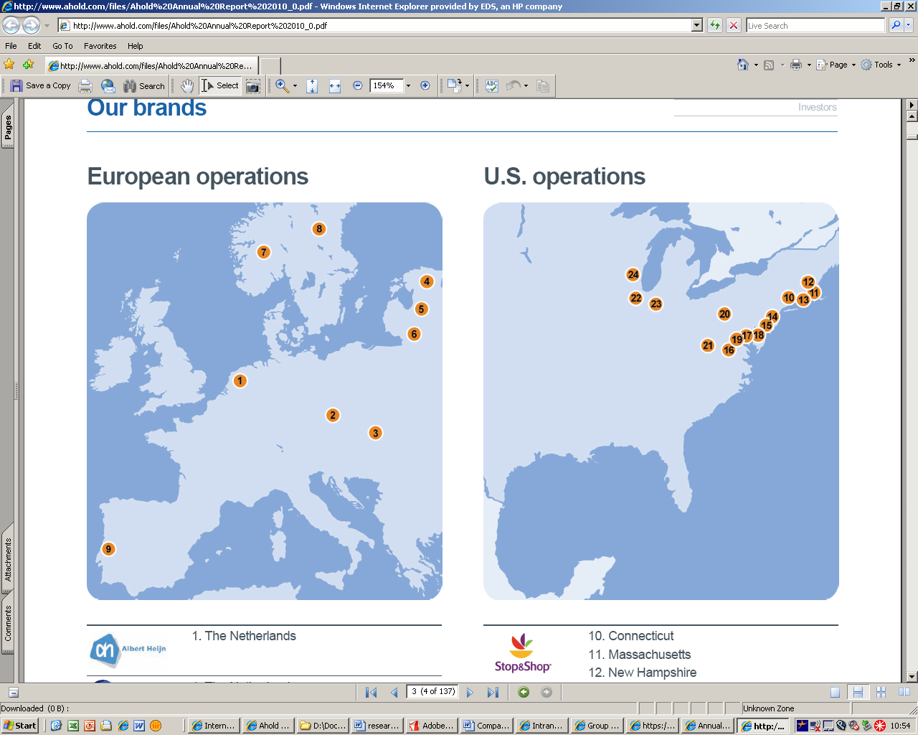

Ahold has shops in both Europe and the USA. In the Netherlands Ahold consists of the supermarket Albert Heijn, Ahold coffee company, the web shop Albert.nl, the drugstore Etos and the liquor store Gall & Gall. The Hypernova food-retail formula and Albert supermarkets are operated in Czech Republic and Slovakia. In Norway, Sweden and the Baltic States Ahold runs the ICA supermarkets in a joint venture, in which it holds a 60% stake. In addition, Ahold holds a 49% stake in JMR, a joint venture company shared with Jeronimo Martins Holding, which runs the Pingo Dolce supermarket chain in Portugal.

Ahold USA runs the Giant Landover, Stop & Shop, Giant Carlisle and Martin's supermarket chains, as well as the Peapod.com home shopping and grocery delivery service. Since Ahold USA is not in the scope of this research it will not be further discussed.

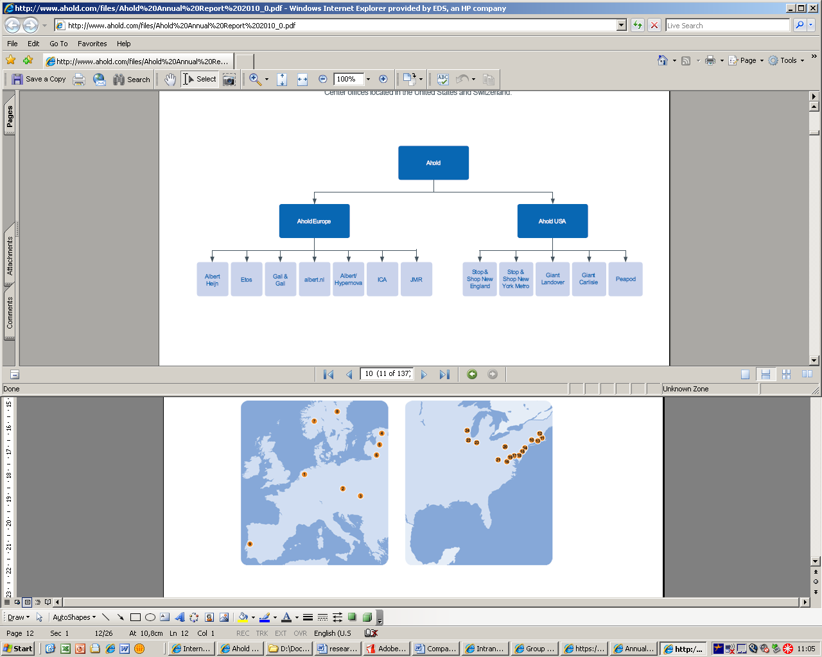

Figure 2a

In order to prepare for further growth, Ahold decided a year ago that it would take some of the departments that were then split up per operating company as one European department for all operating companies. Departments that are now operating on European basis instead of per operating company are Sourcing, Finance Group Control, IM, Franchise Account Man., Real Estate, and HR Expertise & Services (the blue group).

Figure 2b



For AES this means that it is now responsible for the sourcing of the operating companies Albert, Albert Heijn, Etos and Gall&Gall.

## 4.1 Highlights of Ahold

Net sales 2010: 29.5 billion

Net sales 2010 Europe: 11.7 billion

Operating income: 1.33 billion

Operating income Europe: 698 million

Retail operating income: 1.4 billion

Retail operating income Europe: 707 million

Retail operating margin: 4.9%

Retail operating margin Europe: 6.0%

Net income: 853 million

Total spend Europe: 10.5 billion

Total labor cost: 4.1 billion

Total labor cost Europe 1.4 billion

Employees: 213,000

Employees in Europe: 96,247

Store portfolio: 2,970

Store portfolio Europe: 2,219

## 4.2 Sourcing strategy

AES is a department within Ahold that is responsible for selecting and negotiating the best possible suppliers.

It is not AES’ goal to get the lowest price. Van Oppen (2008) says: ‘If you focus on costs your quality will go down. If you focus on quality your costs will go down.’

AES wants the best product for the best price, and wants to have strategic contracts with strategic suppliers, but also regular contracts with suppliers that deliver just once or twice. For both the strategic contracts and the regular contracts AES tries to select sustainable products.

The strategy of AES is:

Figure 3

We deliver

the **best relative purchase position**

by continuously improving

our **world class sourcing capability**

*through*



**Leverage**

**Professional organization**

**One way of working**

A professional organization means that Ahold wants to create an EU scalable organization, build capabilities to lead & support, create sourcing capabilities, and reward a challenging, reliable, attractive, professional and collaborative attitude.

By one way of working Ahold aims at using standardized analysis and KPIs, strategic models like Kraljic and Dutch Windmill, use standard tools like eSourcing Tool, eAuction tool and commodity tool, and standard (digital) contracts.

By leverage Ahold means that it wants to leverage scale by purchasing large quantities of products at the same time. Ahold also wants to leverage skills by using its skills for all operating companies.

## 4.3 Organizational structure

AES takes care of one third (3.3 billion of 10 billion) of all sourcing for the operating companies in all of Europe. The organizational structure of AES:

Figure 4

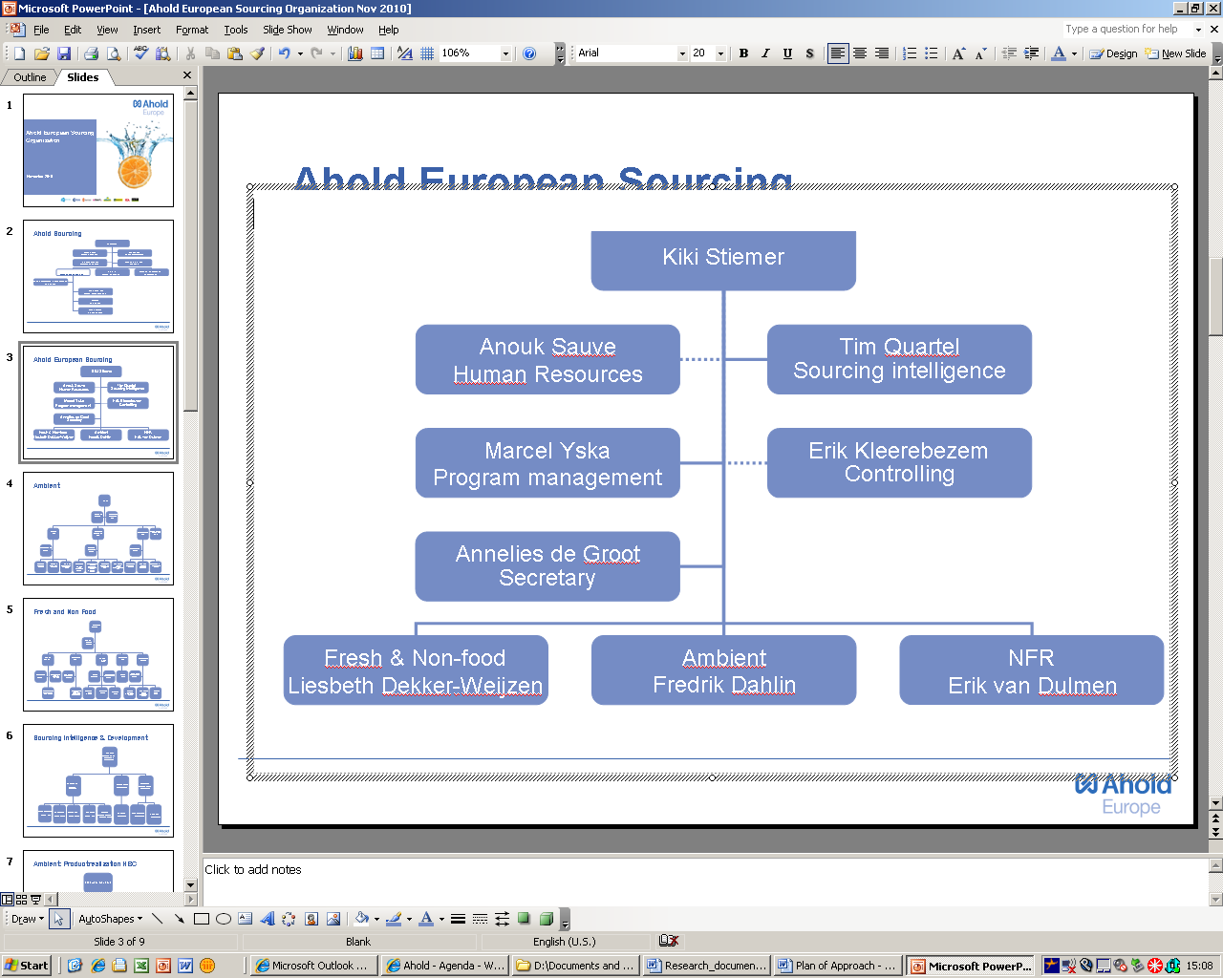

Within AES all private label goods are purchased by the European Sourcing Managers (ESM). The ESM’s are split up in several categories, which consist of Fresh (fruit, vegetables, meat, dairy, meals etc.), Ambient (all maintainable goods like juices, pasta, sauces, pet food, canned vegetables etc.) Non-food (clothes, kitchen equipment, detergents etc) and Not For Resale (power, store-shelves, uniforms, cash desks, insurances etc.)

The other departments (Human Resources, Sourcing Intelligence, Program Management, Secretary and Controlling) are the supporting departments.

## 4.4 Definition six-step sourcing model

AES uses a six-step sourcing model in its organization as a means to increase the quality of the whole purchasing process. It is therefore a very important model within AES, and can be used for the creation of the PMS.

AES’ Six-step sourcing model is a model that is developed to create a one way of working within AES.

Figure 5Purchasing Process Model and Six-Step Sourcing Model

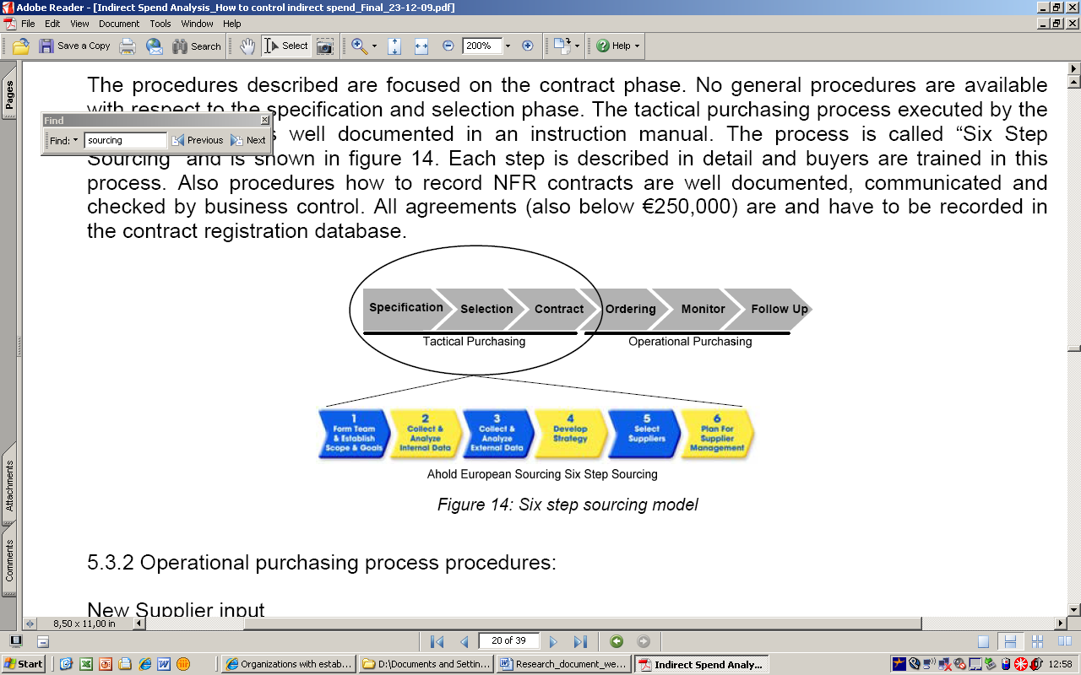

The six-step sourcing model can be seen as the tactical, more detailed and specified version of the purchasing process model of van Weele (2005), which consists of specification, selection and contract.

Figure 6 Six-Step Sourcing Model



The correct use in projects of the six-step sourcing process steps can help to give clear definitions of targets and expected outcomes, clear assignment of roles and responsibilities, clearly identified decision points in the process, and clear communication of issues and progress during the entire project. The process also stimulates thorough analysis and systematic approach for best sourcing strategy and negotiation tactics (and hence results) and continuous communication with stakeholders.

The process consists of seven steps, but because the business planning step is done at the operating companies and not at AES, it is not included in the six-step sourcing model. The steps are: (0: Business Planning)

1. Form team & Establish Scope & Goals

2. Collect & Analyze Internal Data

3. Collect & Analyze External Data

4. Develop Strategy

5. Select Suppliers

6. Plan for Supplier Management

The steps include mandatory deliverables, actions, and authorization.

Through the structured process sourcing becomes easier to manage, support with tools and methodologies, and easier to cooperate across various teams (common language, targets).

The six-step sourcing model can be used for the creation of KPIs for AES, by for instance measuring the amount of contracts that are created and took all the mandatory steps in the process as percentage of all contracts.

5. Analyzing the models

Multiple existing PMSs can be found that are build to measure the performances of firms. In this chapter, the different existing models are first explained and analyzed with the goal to find the one(s) that is (are) the best fit for AES. Next, the model(s) will be adjusted where needed and improved into Aholds’ tailor-made Sourcing PMS.

Lardenoije, van Raaij, and van Weele (2005) found six steps that can help a purchasing manager to develop a PMS to measure the performance of their own firm:

1. “Define the purpose(s) of the purchasing PMS. The purpose could be accountability to the board, motivation of individual purchasing employees, and/or a tool for continuous improvement.
2. Seek a close fit between the purchasing PMS and the organization-wide PMS (if there already is one). Pursue opportunities to adapt the organization-wide PMS to include suppliers and/or sourcing inputs as performance areas for total business Performance Measurement.
3. Purchasing performance indicators should be linked to the purchasing strategy, which in turn should be derived from overall organization goals and strategy. Innovation-related measures should feature prominently if the overall strategy is one of differentiation; cost efficiency measures if the strategy is one of cost leadership.
4. Ensure that the final list of performance indicators is balanced in terms of financial vs. non-financial indicators, lead vs. lag indicators, indicators of operational vs. strategic performance, and indicators related to effectiveness vs. indicators related to efficiency.
5. Involve purchasing personnel in developing the performance indicators and connect the performance indicators to the job descriptions of all employees.
6. Review the system and its purchasing performance indicators periodically to make sure it stays in line with changes in strategies and context in which the system operates.”

Using these steps, one can develop a purchasing PMS that is balanced in terms of measuring long-term and short-term performance, that is well-connected to the rest of the organization, and which helps motivate and guide purchasing employees.

The models that will be discussed and analyzed in this section are:

1. Balanced Scorecard (BSC)
2. The Performance Prism (PPR)
3. Performance Pyramid System (PPS)
4. Purchasing Performance Model (Van Weele)
5. Tesco Steering wheel

## 5.1 The Balanced Scorecard (BSC)

First the well known ‘Balanced Scorecard’ of Kaplan and Norton (1992) is discussed. Butler et al. (1997) state that the Balanced Scorecard has been implemented by many companies and its format and content appear to meet several management needs. Silk (1998) estimated that 60% of Fortune 1000 companies in the USA have had experience with Balanced Scorecards.

Figure 7: The Balanced Scorecard



Source: Kaplan and Norton (1996a)

Kaplan and Norton define the BSC as “a multidimensional framework for describing, implementing and managing strategy at all levels of an enterprise by linking, through a logical structure, objectives, initiatives, and measures to an organizations’ strategy”.

The BSC shows the organization’s overall performance. Its strength is that it does not only take the financial KPI’s into account, but also shows KPIs for the three non-financial measures, namely Learning and Growth, Internal business Processes and Customer.

The goal of the BSC is to translate the vision and strategy into objectives and measures in the four different areas:

* The financial measures are related to profitability with measures like Return on Investment (ROI) and Economic Value Added (EVA). This part tries to answer the question: ‘To succeed financially, how should we appear to our shareholders?’
* The customer measures include several core or generic measures of successful outcomes from the company like customer satisfaction and market share in targeted segments. This part tries to answer the question: ‘To achieve our vision, how should we appear to our customers?’
* The internal processes measures focus on the processes that are used for two of the other measures, namely the financial- and the customer measures, and if these processes contribute to achieving the financial and customer goals. This part tries to answer the question: ‘what business processes must we excel at to satisfy our shareholders and customers?’
* The Learning and Growth measures focus on the infrastructure that has to be built and managed in order to create long-term growth and improvement through people, systems and organizational procedures. This part tries to answer the question: ‘To achieve our vision, how will we sustain our ability to change and improve?’

Kaplan and Norton say that the most important area is the Learning and Growth area, since improvements in this area lead to improvements in the internal processes area, which precede improvements in the customer perspective, which then leads to improvements in the financial area.

A good BSC should have a mix of outcome measures (lag indicators) and performance drivers/input measures (lead indicators) (Norreklit, 2000). An outcome measure can be something like increased sales volume, while the time it takes for an order to be executed is a lead indicator. Financial, Learning and Growth, Internal business Processes and Customer should all include both lead and lag indicators.

## 5.2 The Performance Prism (PPR)

Neely and Adams (2000) developed the Performance Prism (PPR), which is a PMS that includes five areas of performance:

Figure 8: The Performance Prism



Source: Neely & Adams (2000)

1. Stakeholder Satisfaction is the one on top of the prism. This area of performance includes the key question: who are the key stakeholders and what do they want and need? This question includes not only shareholders and customers (balanced scorecard) but all stakeholders involved. (Neely et al., 2001).
2. The Strategies area of performance tries to answer the key question: what strategies do we have to put in place to satisfy the wants and needs of these key stakeholders? The strategy measures give an insight whether goals are being met and provide the data for informed executive decisions.
3. The Processes area of performance tries to answer the key question: What critical processes do we require if we are to execute these strategies?
4. The Capabilities area of performance tries to answer the key question: what capabilities do we need to operate and enhance these processes? Capabilities are the resources of an organization, the combination of practices, people, infrastructure and technology that enable the execution of the business processes of an organization (today and tomorrow).
5. The Stakeholder contribution area tries to answer the question: What contributions do we require from our stakeholders, if we are to maintain and develop these capabilities? This states that not only you have to deliver value to your stakeholders, but you also have to create a relationship with them, which means that the stakeholder has to contribute to you as well.

## 5.3 The Performance Pyramid System (PPS)

The Performance Pyramid System (PPS) created by Lynch and Cross (1991), was one of the first ‘new’ PMSs. The PPS is an interrelated system of different performance variables which are divided over and controlled by different levels of the organization which include the corporate vision, accountability of the business units, competitive dimensions for business operating systems, and specific operational criteria.

Figure 9: Performance Pyramid System (PPS)



Source: Lynch and Cross (1991)

According to Laitinen (2002), the purpose of the PPS is “to link an organization’s strategy to its operations by translating objectives from the top down (based on customer priorities) and measures from the bottom up”.

According to him, “the development of a firm’s performance pyramid starts with the definition of an overall corporate vision (the highest or first level of objectives), which is then translated into individual business unit objectives at the second level. At the second level of objectives key market and financial measures are identified as ways of monitoring performance in achieving the vision. In order to attain these market and financial objectives, key measures of customer satisfaction, flexibility and productivity are also derived. These key measures at the third level are further converted into specific operational measures, which form the base of the pyramid. These measures (quality, delivery, cycle time and waste) relate to individual departments”.

## 5.4 Purchasing Performance Model

Van Weele (2005) developed the Purchasing Performance Models. He divided purchasing performance into two elements: Effectiveness, which is the results actual / results planned (e.g. material cost, quality, logistics, innovation…) and Efficiency, which is the cost actual / cost planned (e.g. administrative lead times, orders per purchaser…)

Figure 11: Purchasing Performance Model

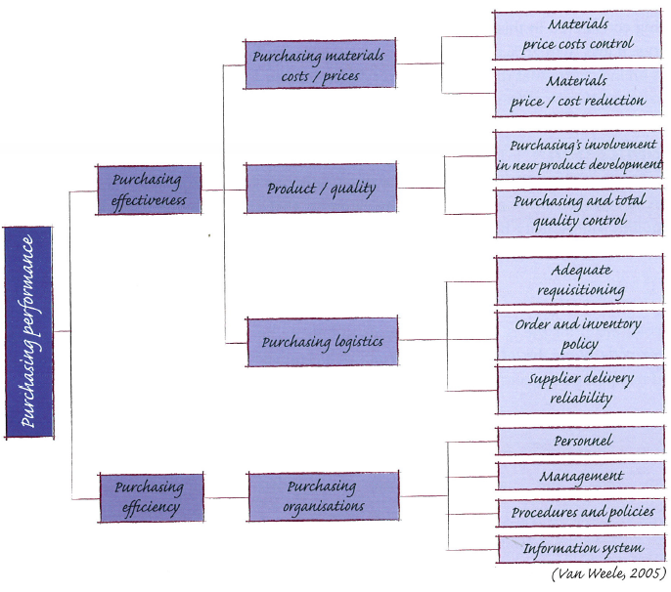

Source: van Weele (2005)

There are four dimensions on which measurement and evaluation of purchasing activities can be based that are strongly related with each other:

*Price / Cost dimensions*

This dimension refers to the relationship between standard and actual prices paid for materials and services. A distinction is made between:

* Price/cost control: continuous monitoring and evaluation of prices and price increases as they are announced by suppliers (e.g. ROI measures, materials budgets, price inflation reports, purchasing turnover)
* Price/cost reduction: continuous monitoring and evaluation of activities initiated to reduce costs in a structured way (e.g. searching new suppliers, value analysis, and substitute materials)

*Product / Quality dimensions*

This dimension refers to purchasing responsibility to secure that products and services are delivered by suppliers in conformance with specifications and requirements.

* Purchasing involvement in new product development: examples are the nr of man hours spend by purchasing on innovation projects, nr of technical change orders and initial sampling reject rate.
* Purchasing contribution to Total Quality Control: examples are reject rates on incoming goods, nr of approved / certified suppliers.

(E.g. time spent by purchasing on design and engineering projects, sampling reject rate (%) reject rate (%), line reject rate (%), quality costs per supplier)

*Logistics dimensions*:

This dimension refers to purchasing role to contribute to an efficient incoming flow of purchased materials and services. This includes the following major activities:

* Control of the timely and accurate handling of materials requisitions
* Control of timely delivery by suppliers
* Control of quantities delivered

(E.g. purchasing administration lead times, order backlog (per buyer), rush orders, delivery reliability index per supplier, materials shortages, inventory turnover ratio, JIT deliveries. Supplier evaluation and vendor rating are techniques used to monitor and improve supplier performance in terms of quality and delivery reliability).

*Organizational dimensions*:

This dimension includes the major resources that are used to achieve the goals and objectives of the purchasing function:

* Purchasing staff (training and motivation)
* Purchasing management (quality)
* Purchasing procedures and guidelines
* Purchasing information systems

(E.g. time and workload analysis of purchasing department, purchasing budget, purchasing and supply audit)

Each of the four dimensions can be measured and evaluated at different levels of aggregation, such as Line item level, individual supplier level, level of individual buyer, department level or overall company level.

## 5.5 Tesco’s Corporate Steering Wheel

The management tool of Tesco is called the Steering Wheel, and is divided into five quadrants – Customer, Community, Operations, People and Finance – which, in turn, are divided into several segments, each with a set of KPIs which are based on demanding but achievable targets (Tesco, 2007)

Figure 12: Tesco steering wheel

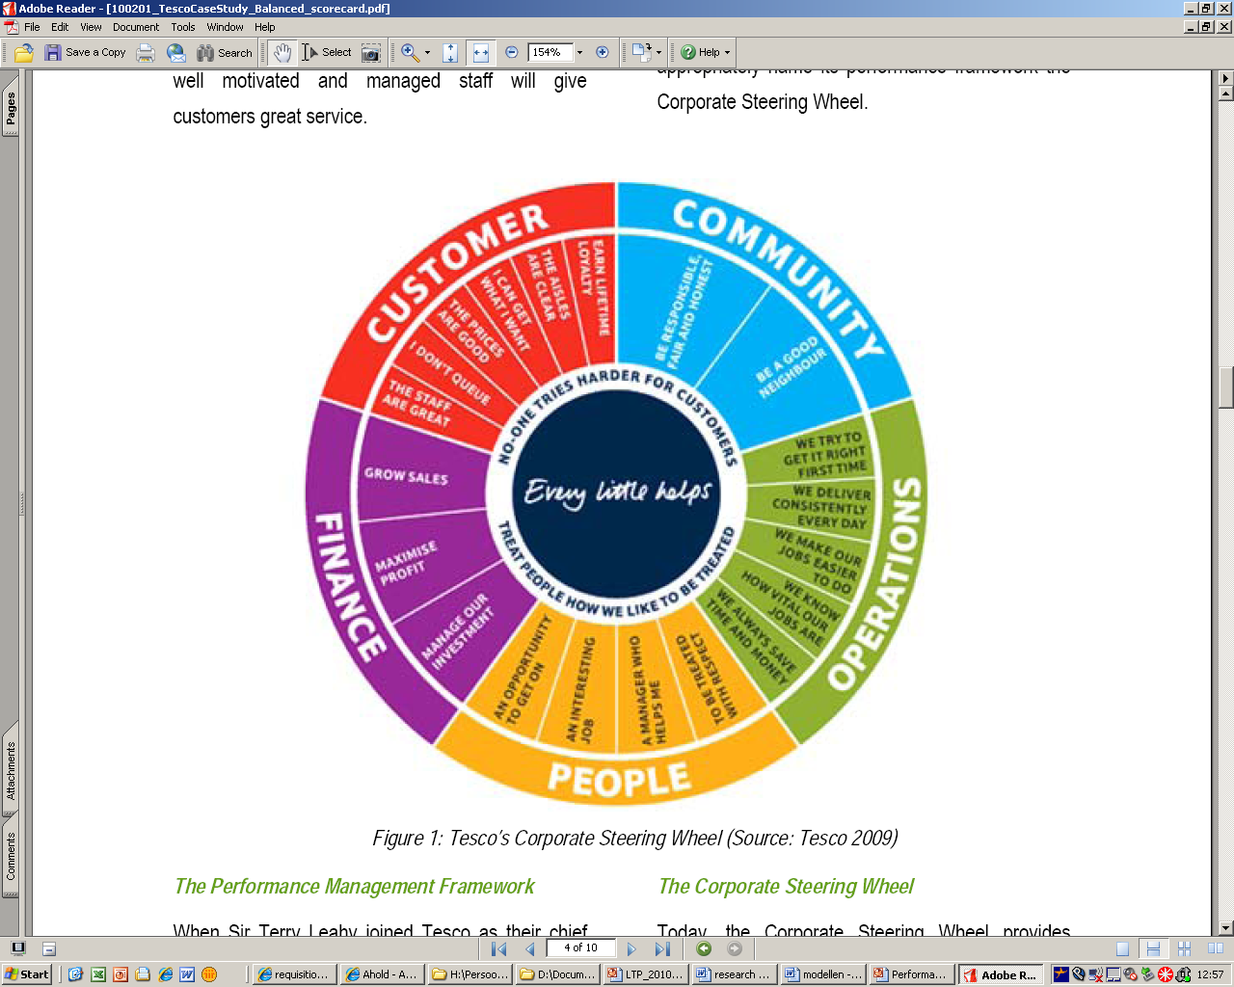

Source: Tesco (2007)

The Customer quadrant says: earn lifetime loyalty, the aisles are clear, I can get what I want, the prices are good, I don’t queue, the staff are great.

The Community quadrant says: responsible, fair and honest, and be a good neighbor.

The Operations quadrant says: we try to get it right the first time, we deliver consistently every day, we make our jobs easier to do, we know how vital our jobs are, we always safe money and time.

The People quadrant says: an opportunity to get on, an interesting job, a manager who helps me, to be treated with respect.

The Finance quadrant says: we grow sales, maximize profit and manage our investment.

The balanced scorecard or in Tesco’s case the steering wheel provides a base to the company for designing future strategies. It gives the current data and becomes a predictor which is important for predicting future trends and thus formulates strategies.

## 5.6 Conclusion

In table 1 (page 32) the results are plotted for all the discussed PMSs. The criteria that the models need to obtain in order to fit AES are:

1. Both Strategic and Operational measures
2. Both Lead and Lag indicators
3. All stakeholders should be considered (Suppliers, Internal customers and top management
4. Both Financial and Non-Financial measures
5. Both Effectiveness and Efficiency measures
6. Inclusion of sustainability
7. Applicable to retail

All five PMSs include performance measures at both strategic and operational level and they all include both financial and non-financial measures.

The *Balanced scorecard* has both lag and lead indicators, but it does not consider all stakeholders. Because the model does not include a supplier area it is not fully suitable for a purchasing department.

The BSC also does not provide any sustainability in its model. Therefore in order for the BSC to be suitable for AES, it has to add a fifth area ‘Supplier measures’.

The *Performance Prism* takes into account all its stakeholder, including its suppliers, which is essential for a purchasing PMS. The PPR does not include sustainability measures. A disadvantage of the PPR is that there are not many companies who have tried the PPR, and therefore there is not much known about its use in practice.

The *Performance Pyramid* does not sufficiently include stakeholders other than customers and shareholders. This model does take into account the sustainability (e.g. waste), but since suppliers are not included in the PPS, this model is not fully suitable as performance PMS for AES. It also does not make a clear distinction between efficiency and effectiveness measures.

The *Purchasing Performance Model (v Weele)* does not include the lead and lag indicators, and it does not include sustainability. It does make a very clear distinction between effectiveness and efficiency and it takes into account all stakeholders.

Since the *Tesco Steering Wheel* is a version of the balanced scorecard, but then completely focused on a retail organization, this PMS can be used for Ahold as well. The strong part is the inclusion of sustainability (community) There is, however, no sign of balance between efficiency and effectiveness, or lag and lead KPIs, and it does not take the suppliers into account.

|  |  |  |  |  |  |
| --- | --- | --- | --- | --- | --- |
| Table 1 | **BSC** | **PPR** | **PPS** | **v Weele** | **Tesco Wheel** |
| 1.      Both Strategic and Operational measures | + | +/- | ++ | + | + |
| 2.      Both Lead and Lag indicators | ++ | ++ | + | - | - |
| 3.      All stakeholders should be considered | - | + | - | + | - |
| 4.      Both Financial and Non-Financial measures | ++ | + | + | + | ++ |
| 5.     Both Effectiveness and Efficiency measures | +/- | +/- | - | ++ | - |
| 6.      Inclusion of sustainability | - | - | + | - | ++ |
| 7.      Applicable to retail | + | +/- | +/- | + | ++ |
| Total Score | ++++ | +++ | +++ | ++++ | ++++ |

Based on the advantages and disadvantages of all the PMS’s we see that the best scoring models are the Balanced Scorecard, The Purchasing Performance Model and Tesco steering Wheel. These systems will be combined to create a tailor made PMS for the purchasing department of Ahold Europe (see figure 13)

Because the Purchasing performance system of van Weele has the most appealing appearance and is conveniently arranged, this PMS will be transformed into the AES PMS (this choice is partly based on the preference of the author). The good elements of both the Balanced Scorecard (lead and lag indicators and financial and non-financial measures) and the Tesco Steering Wheel (sustainability) will be used and added to the Purchasing Performance Model of van Weele, which is shown in the next paragraph.

# 6. The Ahold Purchasing Performance Management System

**CONFIDENTIAL! CHAPTER IS NOT INCLUDED**

# Figure 13: PMS AES

# CONFIDENTIAL, NOT INCLUDED!! 7. Data availability

Finding the right data is the main problem in trying to measure firm performances. Where can you find the information and how can you be sure that it is the relevant information?

Since AES is a department that is responsible for the private label, fresh, non food, and not for resale sourcing of all the operating companies of Ahold, it has many customers at different locations. This leads to the problem that a lot of the data that is needed to measure the sourcing department is also split up over the operating companies. Think of the supplier information concerning time and accuracy of delivery, which is information that is not available for sourcing but is needed to measure the department.

The Employee satisfaction and skills development KPIs of the efficiency KPIs are measured based on the information from the Training Database.

**Spend Database**

Currently AES is developing a ‘Spend Database’ which consists of all spend information from the different operating companies together in one database.

AES decided to create the Spend Database because there is no periodic insight in spend and sourcing related information per AES Category. This is because all banners (operating companies) use own category structures, suppliers databases and IT systems. The goal of the Spend Database is to give periodic insight in spend and sourcing related information for all operating companies in scope through both local and harmonized ‘European’ hierarchies for Products, Brands and Suppliers. The Spend Database makes it possible for sourcing to be scalable for expansion. It also stimulates the one way of working by using the IM infrastructure to support the processes & scalability.

Within the Spend Database the time dimensions, currency, product hierarchy, brand (private label) hierarchy, supplier hierarchy, and measured values on SKU (Stock Keeping Unit) level are shown. The Spend Database also shows if the products are sourced by AES or not.

The information from the Spend Database will make it possible to measure the *effectiveness* KPIs in the PMS.

**Contract Database**

AES wants to create a Contract Registration Database (CRD) because it has no complete automatic workflow which causes a lot of manual work, not enough registration of management information, no progress information on the workflow, an obsolete invoicing system and the problem that IM cannot guarantee any service level of current system.

The information that will come from the Contract Database will provide information on all Ahold contracts, a fully automated workflow and Bill of Authority (BoA), a new invoicing vendor allowance invoice system, and an updating current system for management information (no more double key-inn). The outcome of the CRD will be contract templates per department, standard clauses for all departments, standard VA-clauses, standard special conditions (fixed purchase quantity etc), and internal comment clauses. The CRD will be directly linked to the six-step sourcing model.

The CRD will make it possible to measure the *efficiency* KPIs in the PMS.

**Purchasing Performance System**

The AES Purchasing Performance System (figure 13 on page 34) shows several KPIs in different colors. These colors represent the data availability of the KPIs. There are three categories:

For this KPI:

1. Data is currently available
2. Data will be available after the launch of the two projects (Spend Database, and Contract database within E Business suite).
3. Data is not available yet and needs to be developed.

The first category is highlighted in orange. This category makes a distinction between orange and striped-orange. The orange KPI data is already available. The striped-orange KPIs can only be measured partly with the available data, but it will only be possible to measure them in total once the Spend Database is released.

The second category is highlighted in blue. This category cannot be measured right now, but it will be possible to measure these KPIs once the Spend Database and the Contract Database are released.

The third category is highlighted in green. This category will not be possible to measure in the near future, and the means to measure this category still need to be developed.

# 8. Conclusions & Recommendations

## 8.1 Conclusions

The research question of this paper is:

*What Performance Management System is best suitable for assessing Ahold European Sourcing department?*

Having analyzed the existing PMSs’ suitability for the measurement of a purchasing department in a retail organization, none of the systems are perfectly suitable for AES. Each system has its advantages and its down-sides, but none possesses all the requirements to be the ideal Purchasing PMS for AES.

My conclusion therefore is that there is no existing Retail Purchasing PMS available off the shelf just yet.

|  |  |
| --- | --- |
| **Table 2** | **AES Purchasing Performance Management System** |
| 1.      Both Strategic and Operational measures | - |
| 2.      Both Lead and Lag indicators | + |
| 3.      All stakeholders should be considered | +/- |
| 4.      Both Financial and Non-Financial measures | + |
| 5.      Both Effectiveness and Efficiency measures | ++ |
| 6.      Inclusion of sustainability | ++ |
| 7.      Applicable to retail | + |
| Total Score | ++++++ |

Therefore a PMS is created exclusively for AES. The created system on page 35 (figure 13) is a combination of the Balanced Scorecard, the Tesco Steering Wheel and the Purchasing Performance Model of van Weele. The best parts of the three systems are integrated into this AES PMS.

Table 2 above shows the scores of the AES Purchasing PMS.

The strength of the system is that the suppliers are considered, it has both effectiveness and efficiency measures, it includes sustainability measures and it includes both financial and non-financial measures. The system also includes lead and lag indicators, and it is applicable to retail.

The system includes mainly operational measures and little to no strategic measures. This mainly has to do with AES’ preferences to not include strategic measures, so it could be included if AES decides to do so (AES could include a management performance in the efficiency category with KPIs like Quality of Management or the implementation speed of the strategies into practice). It also does not include the stakeholders ‘internal customers’ and ‘top management’. AES’ stakeholders are the category managers and the management of AES and Ahold Europe. The most important stakeholder for a purchasing department is included (suppliers), but the others should be included in the future as well.

The sub question is:

*Where can Ahold find all information to measure Ahold European Sourcing?*

As explained in the chapter ‘data availability’, the information to measure AES comes from many different places. The Purchasing Performance System consists of 30 KPIs.

Right now, AES is able to measure 27 percent of all its KPIs (8 out of 30) which are only efficiency measures. 2 effectiveness KPIs can partly be measured right now.

Once the Spend Database and the Contract Database are released, AES is able to measure 87 percent of its KPIs. This includes all KPIs except for the sustainability KPIs. AES has not find a way yet to measure these sustainability KPIs, but AES will be able to measure these as well in the future.

What will happen next is the following. After the release of both the Spend Database and the Contract Database (approximately 5 months from now), AES will start with the design of the AES Dashboard including the KPIs they decided to use. They will consider the tailor made PMS and select the KPIs that they think adds value to their Dashboard. Then in about 6 months the AES Dashboard will be released. At that moment AES will be able to measure about 90 percent of the KPIs. The only KPIs that are not measurable yet are the sustainability KPIs.

## 8.2 Recommendations

The next step in the process of Performance Management would be to implement the system and create a dashboard to be able to regularly report the performances. Bourne et al. (2000) show that PMSs requiring regular reporting are best automated. Bititci et al. (2000) point out that the main benefit of using an IT platform for managing the PMS within an organization is that the maintenance of the information contained within the systems becomes much simpler.

Effective PMS’s are linked to elements of human resource management, such as competence management, goal setting and sharing, feedback, and reward (Neely, 1999). Especially reward has been a hot topic recently and there is considerable debate as to whether performance measures should be linked to reward. According to Dumond (1994), providing feedback to individuals with regard to where they stand on the performance measures is essential. This can enhance performance by providing motivation or information about the correctness and adequacy of work behavior, and can also provide workers with a sense of accomplishment, competence and control.

AES receives feedback about its performances on the highest level (e.g. spend by AES), but not on department, sub-department or individual (buyer) basis. There is little communication about the performances and these performances are not linked to rewards. Therefore AES should consider the option to include the Human Resource Department to create a reward system for AES.

The internal customers of AES, which are the category managers of the operating companies, are not included in the Purchasing Performance System, so this has to be added later on.

Also some strategic KPIs should be added to the model. Of course it is up to AES if they choose to do so. AES also has to find a way to measure its sustainability KPIs.

## 8.3 Areas for further research

It might be possible that the sourcing strategies and Performance Management of purchasing used at Ahold USA are also very useful for Ahold Europe. Ahold USA is not discussed in this paper but this can be a good area for further research.

This paper focuses on the Performance Management internally. Previous and current results are compared to desired results within the internal organization. For further research it might be interesting to compare the sourcing department to other sourcing departments in large retail organizations, so check how they are doing compared to their competitors. Companies like AT Kearney can be hired to measure the external performances.

References

* Armstrong M and Baron A, 1998. *Performance Management – the new realities*. The Institute for Personnel Development, London.
* Bourne, M., Mills, J., Wilcox, M., Neely, A.D., 2000. *Designing, Implementing and updating Per-formance Measurement Systems,* International Journal of Operations & Productions Management 20(7), 754-771
* Bititci, U.S, Turner, T., Begemann, C., 2000. *Dynamics of Performance Measurement Systems*, Inter-national Journal of Operations & Production Management 20(6), 692-704.
* Butler, A. Letza, S. R., Neale, B., 1997. Linking *the Balanced Scorecard to Strategy,* Long Range Planning 30 (2), 242-253.
* Carter, J. R. and R. Narashimhan (1996), *“Is purchasing really strategic?”* International Journal of Purchasing and Materials Management, 32 (1), pp. 20-28.
* Cox, A. (1996), *“Relational competence and strategic procurement management: Towards an entrepreneurial and contractual theory of the firm*,” European Journal of Purchasing and Supply Management, 2 (1), pp 57-70.
* De Guerny, J., Guiriec, J.C., Lavergne, J., 1990. *Principes et mis en place du Tableau de Bord de Ges-tion*, 6th edition. Delmas, Paris.
* Dumond, E.J., 1994. *Making Best Use of Performance Measures and Information*. International Journal of Operations and Production Management 14(9), 16-31.
* Epstein, M.J., Manzoni, J.F., 1998. *Implementing Corporate Strategy: From Tableau de Bord to Balanced Scorecards*. European Management Journal 16(2), 190-203.
* Evans, J. R., 2004. *An exploratory study of performance measurement systems and relationships with performance results*. Journal of Operations Management 22, 219-232.
* Gonzáles-Benito, J. (2007*), “A theory of purchasing’s contribution to business performance,”* Journal of Operations management, 25, pp. 901-917.
* Hendrick, T.E., Ruch, W.A., 1988. *Determining Performance Appraisal Criteria for Buyers*. Journal of Purchasing and Materials Management 24(2), 18-26.
* Jayaram, J., C. Droge and S. K. Vickery (1999), *“The impact of human resource management practices on manufacturing performance,”* Journal of Operations management, 18(1), pp. 1-20.
* Kakwezi P & Nyeko S (2009) *procurement processes and performance efficiency and effectiveness of the procurement function.*
* Kaplan, R.S., Norton, D.P., 1992. *The Balanced Scorecard – Measures that drive Performance.* Harvard Business Review 70(1), 71-79.
* Kennerly, M., Neely, A., 2002. *A framework of the factors affecting the evolution of performance measurement systems*. International Journal of Operations & Production Management 22(11). 1222-1245.
* Laitinen, E.K., 2002. *A dynamic performance measurement system: evidence from small Finnish technology firms*. Scandinavian Journal of Management 18, 65-99.
* Lardenoije, E.J.H., Van Raaij, E.M. & Van Weele, A.J., 2005. ‘*Performance management models and purchasing: Relevance still lost’,* in: Researches in purchasing and supply management. Proceedings of the 14th IPSERA Conference, Archamps, France, March 20-23, pp. 687-97.
* Lynch, R.L., Cross, K.F., 1991. *Measure Up!: Yardsticks for continuous improvement.* Blackwell Publishers, Cambridge.
* McGoldrick P., *Retail Marketing,* 2nd Edition, McGraw Hill, 2002.
* McKinsey & Company, 1999. *The art of purchasing and supply chain management*
* Monczka, R. M., & Trent, R. J. (1991a). *Evolving sourcing strategies for the 1990s*. International Journal of Physical Distribution and Logistics Management, 21(5), 4-12.
* Monczka, R, M, Trent, R & Handfield, R. 2002. *Purchasing and supply chain management 2nd edition.* Mason, Oh: South Western.
* Monczka, R.M., Trent, R.J., Handfield, R.B., 2005*. Purchasing and Supply Chain Management,* third edition. Thomson South-Western, London.
* Murray, J. Y., Wildt, A. R., & Kotabe, M. (1995b). *Global sourcing strategies of U.S. subsidiaries of foreign multinationals.* Management International Review, 35(4), 307-324.
* Neely, A.D., Gregory, M., Plats, K., 1995*. Performance measurement system design: A literature review and research agenda*. International Journal of Operations & Production Management 15(4), 80-116.
* Neely, A.D., 1999. *The performance measurement revolution: why now and what next*? International Journal of Operations & Production Management 19(2), 205-228.
* Neely, A.D., Adams, C., 2000. *Perspectives on Performance: The Performance Prism*. Gee Publishing, London.
* Neely, A.D., Adams, C., Crowe, P., 2001. *The Performance Prism in Practice*. Measuring Business Excellence 5(2), 6-12.
* Norreklit, H., 2000. *The balance on the balanced scorecard: a critical analysis of some of its assumptions.* Management Accounting Research 11, 65-88.
* Oppen, Willem van, 2008. ‘*Collaborative key performance indicators’*, KPN business presentation.
* Quinn, J. B., & Hilmer, F. G. (1994). *Strategic outsourcing*. Sloan Management Review,35(4), 43-55.
* Reinecke, Nicolas en Spiller, Peter en Ungerman, Drew, 2007. *‘The talent factor in purchasing’*, The McKinsey Quarterly, February 2007
* Rietveld, G. (2009). *Inkoop; Een nieuw paradigma*. Den Haag: SDU Uitgevers.
* Rouse, P., Putterill, M., 2003. *An integral framework for performance measurement.* Management Decision 41(8), 791-805.
* Silk, S., 1998, *Automating the balanced scorecard,* Management Accounting, Vol. 11 No. 17, 38-44.
* Slaight, TH. 1999. *The future of purchasing and supply: strategic sourcing*. Purchasing today, October.
* Tesco (2007) *Tesco steering wheel* pg 9 2007 CR Report
* Trent, R.J., Monczka, R.M., 1998*. Purchasing and supply management: Trends and changes throughout the 1990s.* International Journal of Purchasing and Materials Management 34(4), 2-11.
* Van Weele, A.J., 2005. *Purchasing and Supply Chain Management: Analysis, Planning and Practice, fourth edition.* Thomson International, London.
* Vickery, S., C. Droge and R. Markland (1993), *“Production competence and business strategy; Do they affect business performance?,”* Decisions Sciences, 24(2), pp. 435-356.

Appendix: Other tasks at Ahold

During my internship at the AES department I also worked on other tasks. The tasks are listed below.

1. **Manuals and procedures of Finance and Control department**

The one way of working can be improved by collecting all manuals and procedures for controlling department, create manuals and procedures that are not there yet, and store them at a convenient location, so that they can be consulted when needed. This assignment meant that I had to collect all manuals and procedures of the Finance and Control department that were located at the control hard drive of Ahold. Then I had to find out which manuals and procedures were still up to date and which needed revision or could be thrown away. The documents were assigned to the controllers, and they had to examine and improve them. The corrected and updated documents that were also relevant to the buyers were put on the AES portal, an intranet site that was developed by the sourcing intelligence team and me, where I was responsible for the input from Finance and Control. The documents (+/- 10 documents) are now available for all buyers and can be found on the portal (the portal went life 2 weeks before the end of the internship).

For the portal I also was responsible for writing a description of what the department consists of and who are part of Finance and Control. I created a year planning (see task 3) that is also available on the portal. This assignment took the most time of the four tasks. All the meetings and trainings about the portal, the plan of approach, dozens of versions and improvements which resulted in approximately 1.5 month work.

1. **What to do and by who: Spend Database project**

The Spend Database is a database that provides AES with all spend data from the operating companies of Ahold (see appendix 2). For this project I created a planning with all the different parties involved (IT, Finance and Control, Operating companies).

The planning had to be adjusted many times because the project deviated from the original planning. The different parties still use this planning and adjust it when needed. This assignment took me about 3 days.

1. **Year Planning**

The time management for controlling is not what is should be yet. Often, deadlines are not met, and bottlenecks create problems that could have been foreseen with a clear year planning. By creating a correct year planning and sticking to it, the professionalism of the department will be increased. This will lead to reduction of time needed for the contract process, and increase the speed of the creation of year booklets, vendor checks, progress reports etc.

This year planning involves all the repeating activities of the Finance and Control department like forecasts and budgets, invoices, end of year reporting, closings and progress reports. The document can now be found on the portal as well, and provides an overview of the busiest weeks, which makes it possible for Finance and Control to plan its special activities around it. This assignment took a lot of time. Around 3 weeks to collect data, design the excel file, update and improve it, have meetings etc.

1. **Help with daily activities at ETGB.**

For the ETGB department I helped with the invoicing. I also helped with the presentation the department had to give to the different operating opco’s. This involved the bonuses that the operating opco’s could gain if they ordered above a certain quantity of products from its suppliers. I made the calculations that showed which companies obtained their bonuses and which did not. This assignment took me about 10 days.

1. **Other activities.**

I organized lunches for the interns every week; I organized a guided tour through the test shop inside the head quarters of Ahold; I organized two drinks with the interns at both Zaandam and Amsterdam; I joined a guided tour to the distribution center of Albert Heijn Zaandam, the Albert Heijn Museum, the Ahold Coffee company factory, the distribution center of Etos; I joined the introduction day for Ahold including presentations of the Jan Willem Koch (general director of Etos), where I won the first price for ‘most creative presentation’; I joined the drinks with other interns; I joined the AES spring breakfast with the whole department; I joined the AES summer drink including the presentation of Sander van der Laan (COO of Ahold Europe); I followed the editor training for google sites.

I had meetings with Mieke Swart (controller), Frank Mallens (controller), Zen Khan (controller), Watte de Wit (controller), Rob van der Pol (Manager Sourcing Intelligence), Marianne Soons (internship coordinator), Onno Perlot (Sourcing Intelligence, sourcing portal), Ajda Ayaz (assistant buyer Fresh), Jort Scholten (Financial trainee AES), Joost Claessens (category manager deep frozen food Albert Heijn), Jean-Marc Jansse (Sourcing manager European A-brands), Mariel Kollau (Project manager sourcing development), Manuela Speets (specialist tools and methodologies), Martijn Suurd (IT specialist), Frank Posdijk (Cap Gemini IT, team leader Spend Database),

I joined a LOT of meetings on a regular basis (every week). Some of them are:

- Team meeting Finance and Control AES

- Sourcing portal meetings (approximately twice a week)

- Progress meeting Spend Database project

- Once or twice a week a meeting with Erik Kleerebezem

- Meetings with internship coordinator about traineeships, internships and in-house days.