Optimizing Regeneration Parameters of Ion Exchange Resin

ADJUSTING CONCENTRATION OF REGENERANT, FLOW RATE AND CONTACT TIME TO IMPROVE TOC REMOVAL EFFICIENCY

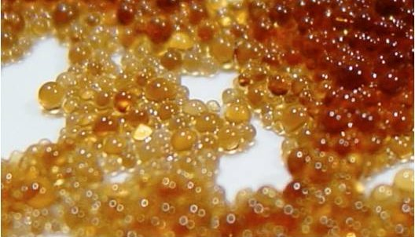

Author: *Tian Peng*

Version number: Final

Institution: *Evides waterbedrijf and* HZ University of Applied Sciences

Supervisors: *Peter van Hartingsveldt, Hans Cappon and Jouke Heringa*

Publication date: 05, June 2017

Publication location: Vlissingen

Optimizing Regeneration Parameters of Ion Exchange Resin

ADJUSTING CONCENTRATION OF REGENERANT, FLOW RATE AND CONTACT TIME TO IMPROVE TOC REMOVAL EFFICIENCY

*Author: Tian Peng*

*Publication location: Vlissingen*

*Publication date: 2017*

*Published by: HZ University of Applied Sciences - Water Technology*

*Student number: 00072469*

*Semester and study year: 2, 2016-2017*

*Date of completion: 05-06-2017*

*Study course: Water Management Final Thesis*

*Company supervisor: Peter van Hartingsveldt, Hans Cappon*

*Study lector: Jouke Heringa*

*Version number: Final*

**Abstract**

Total organic carbon (TOC) is often found in natural water sources, and also may come from (chemical) water treatment processes or from sewage. It may react with disinfectants to produce DBPs (disinfection by-products), which are harmful to water systems and public health. Besides, in industrial systems applying high pressures and temperatures, TOC may convert to acids, which causes corrosion and damage to the plants. Thus, reducing the concentration of TOC is essential in practice. In addition to the traditional chemical treatment technology, IX (ion exchange) resins have become widely accepted and feasible in recent decades. It has the positive ability to remove organic matter with charge (ions).

In order to apply this method and achieve maximum efficiency, it is necessary to know what factors influence the behavior of the IX treatment process. IX is a batch process including operation and regeneration. Ions will be exhausted by unwanted ions, in this case TOC, then it need to be regenerated. This research concentrated on how regenerant concentration (NaOH), contact time and flow rate affect the regeneration part through performing TOC removal experiments. The purpose of the research was to find the optimized regeneration parameters of the resins offered by Evides.

A strong basic anion resin in OH- form and a strong acid cation resin in H+ were used in this research to compare the performance under several experimental conditions. An initial set of experiments with standard regeneration settings determined the baseline settings and residual TOC concentration indicated removal efficiency of resins. After experiments, a response surface model was set up to analyze the relationship among the mass of removed TOC, NaOH concentration and flow rate, and further to find optimal parameters.

The conclusion of this study is that practically, the optimal flow rate is 4 m/h and regenerant (NaOH) concentration is 4% at 20℃.While the theoretical optimal flow rate is 4 m/h, regenerant (NaOH) concentration is 3.5% at 20℃ from response surface model in regeneration phase to achieve the best TOC removal efficiency.

**Preface**

Thisreport is my final thesis of Water Management at the Delta Academy. I would like to thank all the people who gave help to me during the project, especially Peter van Hartingsveldt, Hans Cappon and Jouke Heringa.

The project is a cooperated item between Evides and HZ University of Applied Science, which helps to offer references to Evides in their practical productions.

Although many things out of imagine happened, it finally finished successfully. I hope the experience could leave an unforgettable impression to me and my supervisors.

Tian Peng

Vlissingen, Netherlands.

2017, 05, June

Table of contents

1. Introduction 1

2. Theoretical framework 3

2.1. Ion exchange resin 3

2.2. Ion exchange capacity 4

2.3. Ion exchange regeneration 5

2.4. Ion exchange regeneration ability 6

2.5. TOC analyzer 6

3. Materials and methods 8

3.1 Experimental setup 8

3.2 Main experiment 9

3.2.1 Different concentration of regenerant 9

3.2.2 Different flow rate 10

3.3 Other Experiment 11

3.3.1 Ion exchange regeneration ability experiments 11

3.3.2 Ion exchange capacity experiments 11

3.3.3 Extra experiments 12

3.4 Data Analysis 13

3.4.1 Mass of removed TOC 13

3.4.2 Response surface model 14

4. Results 16

4.1 Main experiments 16

4.2 Response surface model 17

4.3 Other results 19

5. Discussion 21

5.1 Main experiment 21

5.2 Other experiment 21

5.3 Data analysis 22

6. Conclusion 23

7. Recommendation 24

7.1 Optimize experimental process 24

7.2 Optimize formulating model 25

Bibliography 26

Appendix 1 28

Three types of resins 28

Resin loading 29

Resin operating 29

Resin regenerating 29

TOC analyzer working principle 29

COD measuring 30

Appendix 2 32

Results (Main experiment) 32

Results (Regeneration Ability Experiments) 40

Appendix 3 41

Information from CADIX 41

# 1. Introduction

Natural water contains many types of organic matter, of which more than half of total mass is organic carbon, causing negative impact on human use. In addition to the effects on taste, color, odor and biological growth in drinking water in water distribution systems, organic matter also plays a detrimental role in industry such as failure of filtration systems and fouling of storage (Boyer, 2008). Generally, producing demineralized water for power production and cracking furnaces requires very low levels of TOC in the makeup water. TOC typically converts into organic acid, such as acetic, propionic, and other acids, under high pressure and high temperature in industrial system, resulting in lower pH and corrosion in treatment plants or boiler system (Hill Publishing Company, 1998). Thus, adopting appropriate measures to remove TOC has become an important issue also for economic and efficient benefit reasons. To solve the problem of high TOC levels, many methods have been invented. According to a case study, water pre-treatment with ion exchange technology had better removal of organics than those without ion exchange technology in water treatment (Drikas, 2010). Compared with common approaches like flocculation, coagulation and filtration, ion exchange is a more feasible and efficient treatment for the removal of TOC (Drikas, 2010).

Organic carbon components are complex and various, including suspended, colloidal and dissolved organic carbon (Anderson, 2013). Thus, the types and amounts of organic carbon group are unlimited, which results in the removal of this sum-parameter not being predicted accurately. Ion exchange is a batch process with two phases: operation phase in which functional ions are exhausted by TOC, and subsequently regeneration phase in which ions release TOC in a controlled way to create spaces for new functional ions. Operation and regeneration phases are separated in space and time. However, what happens in one phase affects the other, and vice versa. In this case, Evides specifically wants to focus on the regeneration part to analyze how regeneration parameters affect ion exchange treating efficiency. Evides is one of the Dutch water companies, which provides drinking water to around 2.5 million people and business per day, 36 cubic meters of DI water (deionized water), and 289 million cubic meters of wastewater in 2013 (Evides Waterbedrijf, 2013).

The information was offered by Evides that the way how ions regenerated has impact on ion exchange operation phase, in the sense that resins can remove more unwanted ions if regeneration condition is better. In fact, several parameters including temperature, types of regenerant and composition of the exhausted bed have influence on the regeneration phase (Nachod & Schubert, 1956). But analyzing the three main factors: concentration of regenerant, flow rate and contact time were required by Evides. By performing TOC removal experiments, more knowledge can be gained about what optimal regeneration conditions are when TOC removal efficiency is the best. Thus, the goal of the research was to achieve the best possible TOC removal efficiency under variable conditions: concentration of regenerant, flow rate and contact time.

Therefore, the main question of this research is:

How can the regeneration process in TOC removal with ion exchange be optimized with respect to concentration of regenerant, flow rate and contact time?

Sub-questions derived from this main question are:

1. How do these parameters affect ion exchange removal efficiency?
2. Which parameter is expected to influence TOC removal efficiency most in ion exchange?
3. How should the operational parameters of ion exchange regeneration be compared with respect to TOC removal?
4. What is the influence on regeneration ability of ion exchange in different parameters condition?
5. What is the optimal efficiency to remove TOC by ion exchange?

# 2. Theoretical framework



## Ion exchange resin

Ion exchange is a special chemical process commonly used for water softening or demineralization in water treatment, to remove unwanted dissolved ions by exchanging other similarly charged ions (Paulson, 2016). There are many appearances of ion exchange, natural substances like wood, sand, even living organisms and more artificial substances like functional resins (Vasileva, 2014). The first ion exchange example made use of zeolites, using synthetic aluminosilicate materials to soften water by Gans, a German chemist, in 1905 (Scholarly, 2013). Ion exchange technology was not widely used until 1930 and after the synthetic anion exchange resins being invented, natural anion exchangers were known to all (Zagorodni, 2007).

Ion exchange is a stoichiometric and reversible process. When ions being removed, the ion exchanger is left to make up the charge, resulting in the amount of counter ions staying constant (Helfferich, 1995). For instance, if H+ is exchanged by unwanted ions, R+ will be left in the resins to make up the charge (R means cation).

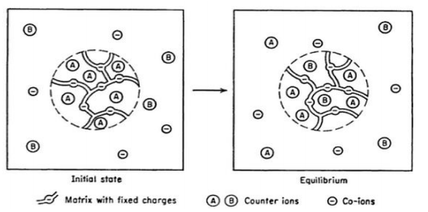

Figure 1 The explanation of ion exchange in a solution (Helfferich, Ion Exchange, 1995)

Ion exchange resin contains either cations with positive charge or anions with negative charge (Paulson, 2016). Ionized groups attached to the resin bed determines its functional ability, and ion exchange resins could be classified into four basic categories, SAC (strong acid cation), WAC (weak acid cation), SBA (strong base anion) and WBA (weak base anion) (Paulson, 2016).

Cation exchange may be used to exchange all cations in water by hydrogen ions, and be regenerated by dilute acid, generally sulfuric acid (H2SO4) or hydrochloric acid (HCl). The reaction is:

Operation: Ca·+ 2H+R– Ca2+R–2 + H2·

Mg· + 2H+R– Mg2+R–2 + H2·

Regeneration: 2HCl + Ca2+R–2 2H+R– + CaCl2

Or H2SO4 + Ca2+R–2  2H+R– + CaSO4

where R = cation exchange resin

Thereinto, bicarbonate is easily converted into carbon dioxide. Thus, cation exchange is usually followed by a degasser to remove CO2.

Anion exchange has the ability to remove anions present in water, such as SO42-, HCO3-, Cl-, by hydroxide ions. The reaction is:

Operation: 2R+OH– + H2SO4  R+2SO42– + 2H2O

R+OH– + HCl R+Cl– + H2O

Regeneration: R+Cl– + NaOH R+OH– + NaCl

where R = anion exchange resin

TOC is the typical substance with negative charge and removed by SBA (American Water Works Association, 2011). Although there are two types of resins in this research, SAC and SBA, what matters is SBA (because SAC resins are used to maximum remove inorganic ions), resulting in only analyzing the different performances caused by SBA. But SAC will be regenerated at the same time to make sure all the condition is the same in operation phase. Theoretically, cation resins are easier regenerated than anion resins, because cation resins have greater capacity and regeneration efficiency, and SAC is more stable than SBA (Howe, Hand, Crittenden, Trussell, & Tchobanoglous, 2012). Thus, if the two types of resins are regenerated at the same time and the time is sufficient for anion resins, the cation resins will be regenerated fully.

Frequently, bed volume (BV) is used to refer to the volume of resins. Because the different size of resin column may be applied, it is more direct to describe how much regenerant used to be related to the volume of resins (Harland, 1994). For instance, if 0.5L resins are used, 2BV of wastewater to be treated is 1L.

## Ion exchange capacity

Ion exchange is a cyclic process: unwanted ions are displaced to resins, leading to resins being exhausted gradually, and when there is no more room for unwanted ions to be loaded, the operation phase will stop and resins need to be regenerated by functional ions (Helfferich , 1962). Different from ion exchange removal efficiency which means the quantity of TOC removed by ion exchange, the number of exchangeable ions that resin is holding is called ion exchange capacity (Helfferich , 1962). In general, operation and regeneration capacity is different. Regeneration capacity means the number of ions from loss of function to exchangeable, however, operation capacity means the number of ions from exchangeable to loss of function, which is normally lower than regeneration capacity. What measured in this research was operation capacity.

Ion exchange capacity is expressed as eq/L (equivalents per liter of resin) and can be calculated as the mean of conductivity in the water.

$$\frac{conductivity\left(\frac{μS}{cm}\right)}{100}=capacity(\frac{meq}{L})$$

## Ion exchange regeneration

The basic purpose of regenerating resins is to restore the exhausted resin back to its functional form for next treating (DESILVA, 2006). Although operation and regeneration phases are separated, how ions regenerated will affect the performance of next operation. The relation is shown below.

operation

Regeneration

operation

Regeneration

operation

Figure 2 The relation between operation and regeneration phase.

During regeneration process, the retained ions are repelled by an excess of original ions, forcing the equilibrium back to original state (Scholarly, 2013). Generally, the regeneration procedures of ion exchange are:

* Compaction - pushing the resin bed up with high flow
* Injection - Cl- and TOC are removed from the functional group on the resin by excess hydroxide (OH-) and typically, the volume needed of DI water (deionized water) is 1-2 times BV (bed volume).
* Displacement/rinse - with DI water to remove chemicals of regeneration. Typically, the water volume needed to rinse is 3-5 BV.

There are two ways to regenerate resins: Co-Flow which the flow direction is the same in operation and regeneration phase and Counter-Flow which the flow direction is opposite in operation and regeneration phase. In Co-Flow regeneration, it has the weakness that regenerant cannot be completely converted into H+ or OH-, while in Counter-Flow regeneration, it improves the regeneration quality and reduces chemical consumption (Drbal, Westra, & Boston, 2012). The latter method is selected in this research.

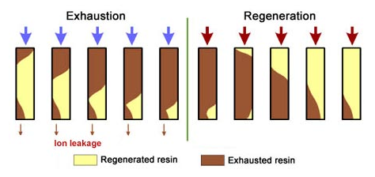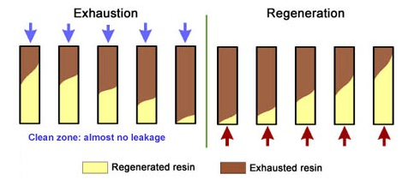

Figure 3 Two different regenerating method: Co-Flow and Counter-Flow.

As mentioned previously, flow rate, concentration of regenerant and contact time influences regeneration phase and the three factors are in a triangle relation. There are two methods to reach high concentration or loads: increasing the mass of regenerant while the volume remains stable, decreasing the volume of solution while the mass of regenerant remains stable. The former method is able to inject more regenerant into resin, thus higher concentration is beneficial to regeneration. Whereas the later method means injecting the same amount of regenerant but decreasing the contact time (contact time is equal to volume divided by flow rate), which has a negative effect on regeneration. The former method was selected to change the concentration of regenerant in this research. In precondition of meeting required contact time, higher concentration will regenerate the resin more completely because the desired ions have more possibility to complete the functional sites (K. SenGupta, 1995). Lower concentration or loads will lead to insufficient regeneration and decreasing the lifetime because of accumulation of impurities (K. SenGupta, 1995). In addition, if regeneration flow rate is extremely high, the contact time will be too short for resins to react with chemicals, and high pressure in the column may even increase the possibility of explosion, however, if the flow rate is too low, it will result in poor regenerated efficiency and channeling (J. Zaganiaris, 2016). In addition, regenerant may also contain other anions that have higher affinity to the active sites, thus, contact time must be sufficient because regenerant has to overcome the selectivity ratios and force the sites with hydroxide ion (Nachod & Schubert, 1956).

## Ion exchange regeneration ability

The difference between the mass of TOC retained in the resin and the mass of TOC released during regeneration defines the regeneration ability. In fact, it is hard to fully regenerate the ions with regenerant, because the resins will accumulate TOC a little in some degree. Some of the TOC remaining in the resin after regeneration will eventually exhaust the resin. Thus, by measuring the TOC concentration of effluent [1] in operation phase, the mass of TOC remained in the resins is calculated as formula 1. In the same way, the TOC concentration of wastewater [2] in regeneration phase is measured to calculate the mass of TOC out of resins as the formula 2. By comparing these two values, how much TOC remained in the resins is analyzed. It is to check whether resins regenerated well, and theoretically, the two values are similar. It could be expressed as:

➀Uptake by resin: TOC1=[TOC]in*V-[TOC]out*

➁Released by resin: TOC2=[TOC]out*Vregeneration

Ability= TOC1 - TOC2

**[2]**

**[1]**

resin

feed water

product

regenerant

waste

Figure 4 The explanation of ion exchange regeneration ability

## TOC analyzer

The basic principle of TOC analyzer is measuring TC (total carbon) and TIC (total inorganic carbon) present in sample, which the detailed inner process is explained in the appendix 1. TOC is then calculated by the difference between TC and TIC.

There are two different modes in TOC analyzer used in this research to measure TOC concentration: online mode and grab mode as shown in figure 5. Online mode is more direct and accurate because water is fed to TOC analyzer. While grab mode is indirect because it is measured by taking samples. TOC concentration is measured every 4 minutes under online mode, and 25 minutes under grab mode.

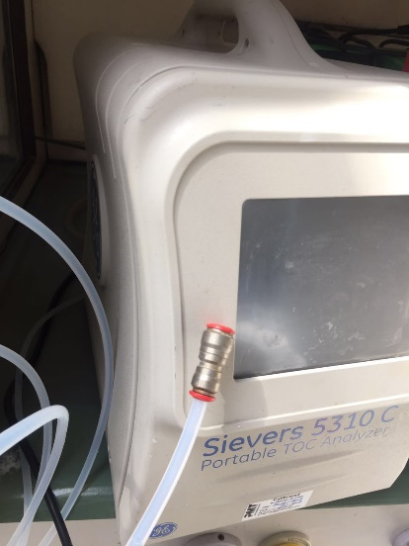 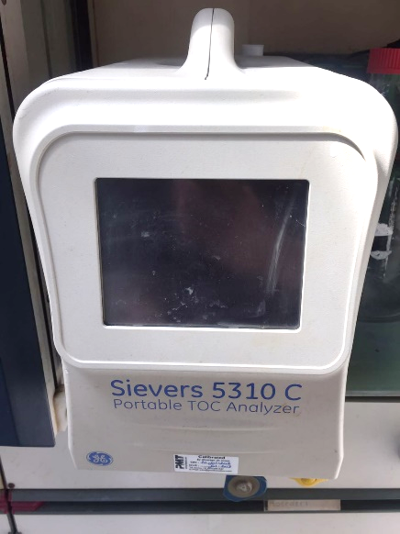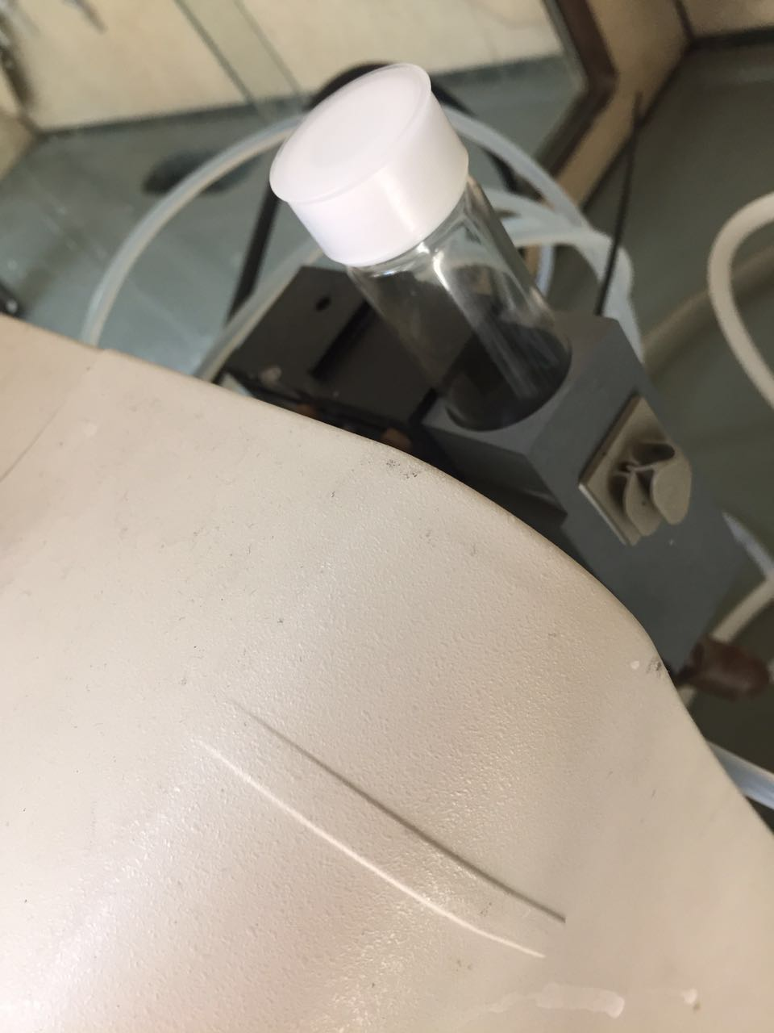

Figure 5 Online Mode and Grab Mode of TOC analyzer

All the TOC concentration in operation phase is measured in online mode for more exact results. However, the waste ([2] in figure 4) is full of strong base (NaOH), it will corrode the TOC analyzer if connected directly. Thus, grab mode is selected to measure the TOC concentration in the waste.

# Materials and methods

The research questions are partly answered by means of controlled experiments in a small-scale ion exchanger.

## Experimental setup

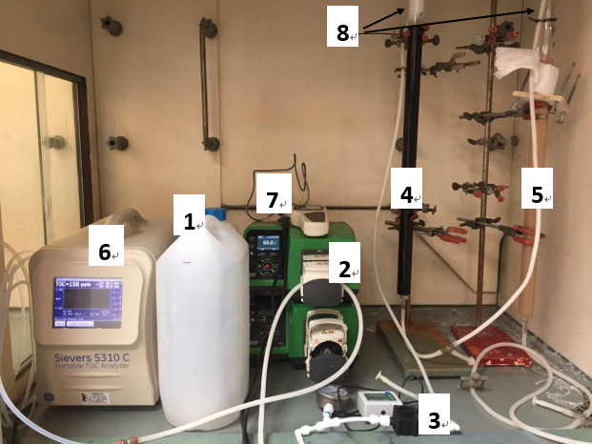The research aimed to find optimal parameter setting of ion exchange in regeneration phase. Figure 6 shows the setup used in the research. It shows [1] a big bucket to contain feed water (water source), [2] pumps to pump feed water into resin columns, [3] flow meter to check flow rate, [4] DOWEX™ UPCORE™ Mono MA-600 (SAC) to remove cations, [5] Lewatit® MonoPlus S 200 KR (SBA) to remove anions, [6] TOC analyzer to measure TOC concentration, [7] conductivity meter to measure conductivity and [8] DOWEX™ UPCORE™ IF-62 (inert) to prevent resins coming out because of its density and size. Inert resins are usually made of polyethylene, which floats in the top layer when the column is full of water and falls when there is air (Columns with freeboard, 2016).

Figure 6 The setup used in this project

The water source (feed water) was the reject of the reactor originated from the soften water system in the chemical lab of HZ. Because the TOC concentration and salt (NaCl) contents of this kind of water was higher than drinking water, it exhausted resins faster and the time for experiment decreased.

The flow chart in figure 7 gives an overview of operation and regeneration process. In the operation phase, feed water flowed through a flow meter, two columns and a conductivity meter, by means of a pump, and was then fed to the TOC analyzer to measure the TOC concentration. While in the regeneration phase, the two columns were separated because the SAC was regenerated by 38% concentrated hydrochloric acid, and the SBA was regenerated by NaOH at different concentrations and flow rates.

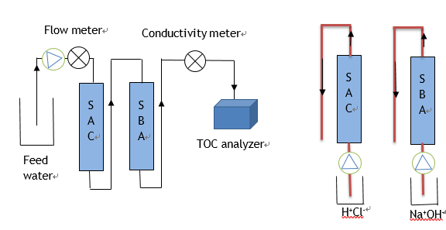

Operation phase Regeneration phase

Figure 7 A flow chart displaying the movement of the solution throughout the resin

All the settings were the same in operation phase, and the differences only existed in regeneration phase because of different regeneration parameters. However, there was no evident visual change in regeneration phase. The difference was therefore analyzed by the performance in operation phase.

## Main experiment

Before analyzing the influence by resins, the original TOC concentration of feed water was measured by feeding the feed water through the TOC analyzer directly.

Then, in the test phase, the resins were loaded by the method described in the appendix 1 to the column. The dimensions of the system were:

Table 1 The dimensions of the system.



After loading the resins, the resins were exhausted by the TOC in feed water and regenerated by regenerant. The flow rate in operation phase was set up as 11 m/h because suggested flow rate of resins was 5 to 50 m/h as shown in appendix 1. Different settings in regeneration phase were described individually below.



### Different concentration of regenerant

NaOH concentration experiments were divided into 4 groups as shown in table 2 because NaOH concentration for the SBA was suggested 2-4% (mass percentage) by the SBA handbook (shown in appendix 1). Contact time here meant the time for regenerant injected.

Table 2 Settings for different NaOH concentration.



The continuous process was explained as figure 8: each loading experiment was performed to regenerate the resins after each cycle and used these newly regenerated resins for the next operational phase. The TOC concentration was measured in the operational phase to analyze how much TOC was removed during the last regeneration condition.

O

R

O

R

O

R

O

R

O

R

2%NaOH 4m/h

C[TOC]

3%NaOH 4m/h

C[TOC]

4%NaOH 4m/h

C[TOC]

5%NaOH 4m/h

C[TOC]

O= operation phase R= regeneration phase C[TOC]= TOC concentration

Figure 8 Experimental process in testing different NaOH concentration for regeneration in ion exchange.

### Different flow rate

After NaOH regenerant concentration experiments, the maximum mass of removed TOC determined the optimal NaOH concentration, and this optimal NaOH concentration was then used to perform experiments at different flow rates. Flow rate experiments were divided into 4 groups as shown in table 3 because flow rate for the SBA was suggested 6-12 m/h by the SBA handbook (shown in appendix 1).

Table 3 Settings for different flow rate.



Similarly, the experimental process of different flow rates was described as figure 9. Thereinto, the experiment with 4%NaOH, 4m/h was not executed since it was already performed before.

O

R

O

R

O

R

O

R

O

R

4%NaOH 4m/h

C[TOC]

4%NaOH 6m/h

C[TOC]

4%NaOH 8m/h

C[TOC]

4%NaOH 10m/h

C[TOC]

Figure 9 Experimental process in testing different flow rate for regeneration in ion exchange

TOC concentration data was collected and then exported to excel.

## Other Experiment



### Ion exchange regeneration ability experiments

Ion exchange regeneration ability experiments aimed to answer the sub-question: What is the influence on regeneration ability of ion exchange in different parameters condition?

As mentioned previously, TOC concentration of the waste was measured by TOC analyzer in grab mode. The experimental process was described as figure 10: after each regeneration as designed, TOC concentration in the waste was measured.

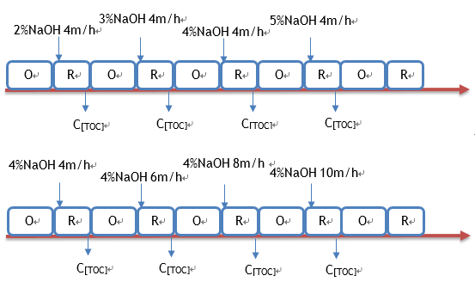

Figure 10 Experimental process of ion exchange regeneration ability.

### Ion exchange capacity experiments

As to practical capacity, the conductivity of feed water was measured by conductivity meter and then calculated.

As to theoretical capacity, it was obtained by means of the CADIX program. CADIX (Computer Assisted Design for Ion eXchange) is an integrated engineering tool to design system and modify the existing performance (CADIX Software). One example of user interfaces is listed in figure 11. The green blocks are where designed parameters imported, and the outcomes were calculated automatically.

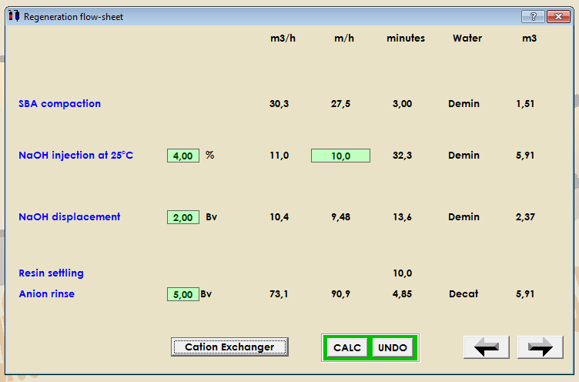

Figure 11 The interface of importing parameters in CADIX.

### Extra experiments

This group of experiments were not directly related to the main purpose of the research, but it could better analyze the performance of the resins during experiments. The process was described in figure 12: pH of the effluent was measured at the same time while measuring the TOC concentration at each cycle in operation phase.

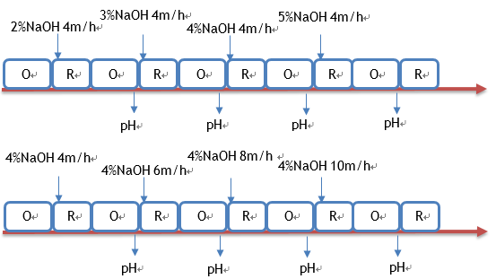

Figure 12 Experimental process of measuring pH

## Data Analysis



### Mass of removed TOC

The mass of removed TOC was equal to the difference of the mass of TOC in influent (feed water) and effluent, in other words, it was the actual treated water volume multiplied the difference of TOC concentration in influent and effluent. Thus, the definition of actual treated water volume affected results. When pumping feed water into columns, there was a short period before really exchanging. The start point was therefore defined at the first point when IC concentration was lower than 100 ppb, and breakthrough point was defined at the last point when IC concentration was lower than 100 ppb. The highlight part shown in table 4 was the really exchanging period.

Table 4 IC concentration of the effluent regenerated by 5% NaOH at 4m/h, 20℃



Actual treated water volume was equal to flow rate multiplied time, and expressed as BV (bed volume).

$$V=Q*\sum{T}$$

$$BV=V/0.5$$

$M=BV*\sum{(}$ [TOCin]-[TOCout])

Where: V = actual treated water volume / L

BV = treated water volume expressed as bed volume / L

M = mass of removed TOC / mg / 1 BV

### Response surface model

For a clear overview of the relation, a response surface model was needed to obtain insight into how the combined NaOH concentration and flow rate affected ion exchange regeneration efficiency. This contained an experimental approach to formulate data most.

The relationship graphs between NaOH concentration and the mass of removed TOC, flow rate and the mass of removed TOC were drawn individually to get an indication as to whether the relationship was likely to be linear ($f\left(x\right)=ax+b$), so first order, or parabolic, thus second order. It was impossible to formulate a higher order, because the number of experiments fell short.

Generally, a 2nd order model is expressed as (in this case):

$f\left(C,Q\right)=a_{0}+a_{1}C+a_{2}Q+a_{3}C^{2}+a_{4}Q^{2}+a_{5}CQ$

f(C, Q)= mass of removed TOC [mg/ 1BV]

Q = flow rate [M/h]

C = NaOH concentration [% mass percentage]

As independent factors were assumed, cross term was neglected, resulting in:

$f\left(C,Q\right)=a_{0}+a_{1}C+a_{2}Q+a_{3}C^{2}+a_{4}Q^{2}$

Therefore, the candidate formulas could be:



Figure 13 The candidate model formula

Each of these candidate models was fitted to the actual experimental data using least squares approximation. The sum of absolute differences between the experimental results (TOC) and the approximation for each model is the model error (ε). The FPE (final prediction error) is a method to calculate which model fits the data best and is therefore the most likely candidate to describe the unknown relationship. FPE is defined as the mean squared prediction error of a model plotted to formulate the present data (Lahiri, 2001). Thus, the parameters in each candidate model were estimated using a least square fit and the model which had the fewest parameters possible with the FPE which hardly decreased further when more parameters were added was selected.

Equation: 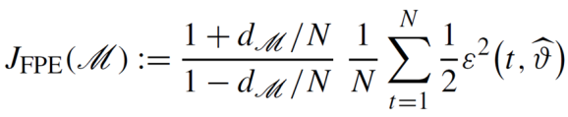

The model found could then be used to plot a full 3D response surface: TOC on the z-axis versus NaOH concentration and flow rate on the x- and y -axis. In addition, the model could be used to optimize the settings of the experiment. With the optimal settings of the model, a validation experiment must be performed to check whether the system actually operates better using these optimal settings.

Only the experimental ranges were chosen to plot the model towards this research. Because the limited experiments were performed, it was hardly to predict the outcomes out of this range.

# Results

## Main experiments

**TOC concentration**

Figure 14 The relationship between TOC concentration and BV (bed volume) at different NaOH concentration, 4m/h, 20℃

Based on TOC concentration data in table 11 to 14 in appendix 2, the relationship between TOC concentration and actual treated water volume (expressed as BV) at different NaOH concentration, 4m/h, 20℃ was described in figure 14. It shows how specific TOC concentration changed at different NaOH concentration. For instance, the point (38.475, 148) of the blue line means after injecting 38.475 BV of feed water (38.475 BV * 0.5L= 19.237 liters of feed water in fact), the TOC concentration of the effluent which was treated by resins regenerated by 2% NaOH, 4m/h, 20℃ was 148ppb.

Figure 15 The relationship between TOC concentration and BV (bed volume) at different flow rate, 4% NaOH, 20℃

Based on TOC concentration data in table 13, 15 to 17 in appendix 2, the relationship between TOC concentration and actual treated water volume (expressed as BV) at different flow rate, 4% NaOH, 20℃ was described in figure 15. It shows how specific TOC concentration changed at different flow rate. For instance, the point (24.075, 248) of the red line means after injecting 24.075 BV of feed water (24.075 BV * 0.5L = 12.037 liters of feed water in fact), the TOC concentration of the effluent which was treated by resins regenerated by 4% NaOH, 8m/h, 20℃ was 248ppb.

**Mass of removed TOC**

Table 5 Amount of removed TOC at different NaOH concentration, 4m/h, 20℃



Table 5 shows the results of the mass of TOC removed by resins which were regenerated at different NaOH concentration, 4m/h, 20℃. It was indicated that NaOH with 4% was the optimal concentration with maximum mass of removed TOC 134 mg/ 1L SBA resin. The calculated mass of removed TOC data was shown in table 11 to 14 in appendix 2, where the highlight was exchanging period.

Table 6 Amount of removed TOC at different flow rate, 4% NaOH, 20℃



Table 6 shows the results of the mass of TOC removed by resins which were regenerated at different flow rate, 4% NaOH, 20℃. It was indicated that 4m/h was the optimal flow rate with maximum mass of removed TOC 134 mg/ 1L SBA resin. The calculated mass of removed TOC data was shown in table 13, 15 to 17 in appendix 2, where the highlight was exchanging period.

## Response surface model

Based on the data in table 5, the relation between the mass of removed TOC and NaOH concentration at 4m/h, 20℃ was plotted to be parabolic, compared to be linear.

Figure 16 The relationship between mass of removed TOC and NaOH concentration at 4m/h, 20℃

Based on the data in table 6, the relation between the mass of removed TOC and flow rate with 4% NaOH, 20℃ was plotted linearly. The point at 6m/h was less convinced because the experiment was only performed once and there was the possibility of failure of the experiment.

Figure 17 The relationship between amount of removed TOC and flow rate at 4% NaOH, 20℃

In both cases the correlation R2 is low, so it is likely that a good model cannot be found.

Table 7 FPE and loss value for each candidate model



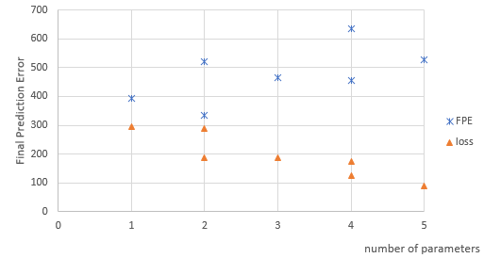

Figure 18 The final prediction error of models

Figure 18 shows the FPE of all candidate models, though it was not clearly visible. The FPE did not decrease with increasing model complexity (higher order), so no explicit optimal model might be found on the basis of this limited number of experiments. From the trendline (dash line in figure 18), the difference between 3 to 4 parameters changed least, implicating that FPE almost remained stable at 4 parameters. Although there were two FPE values at 4 parameters, the lower one was chosen comprehensively taking FPE and loss into consideration. It was expressed as: $f\left(C,Q\right)=a_{0}+a_{1}C+a_{2}Q+a_{3}C^{2}$, which means the regenerant concentration was quadratic and flow rate was linear related to the mass of removed TOC.

The equation: $f\left(C,Q\right)=-26.1+98.8C-9.24Q-14.14C^{2}$ showed the model that fitted data best. The response surface resulting from this equation is shown in figure 19.



Figure 19 The response surface generated by the formula

## Other results

**Regeneration ability**

The outcomes, shown in table 18 to 20 in appendix 2, of the TOC concentration in the waste were unreasonable because the mass was unbalanced. The TOC removed in operation phase and the TOC released in regeneration phase were supposed to be quite similar. However, there was a big difference.

**Ion exchange capacity**

Table 8 Theoretical and practical capacity at different regeneration parameters



The table 8 shows the outcomes of theoretical capacity in CADIX at different regeneration condition and practical capacity in experiments. Practical capacity of feed water was used to analyze how much feed water was needed in theoretical. The theoretical capacity kept unchanged, whereas the practical capacity was unstable because the volume of treated water for each experiment was different.

In theoretical, the quantity of functional ions that could be exchanged was:

SAC 1149meq/L * 0.5 L = 574.5meq

SBA 516meq/L * 0.5 L = 258meq

If exchanged TOC in feed water with capacity 7.76meq/L, theoretically,

for anion capacity, 574.5meq / 7.76meq/L = 74L of feed water was needed to exhausted SAC,

for cation capacity, 259meq / 7.76meq/L = 33L of feed water was needed to exhausted SBA.

The less of feed water needed demonstrated that the SAC was less affected and the SAC was still able to exchange when the SBA was exhausted.

**pH**

Table 9 pH in different solutions at different regeneration parameters



After the failure of performing regeneration ability experiments at different regenerant concentration, pH measuring was performed at different flow rates. It was evident that pH in effluent became lower after treating by the resins.

# Discussion



## Main experiment

The flow rate of pump was found quite inaccurate. A timer and measuring cylinder were used to achieve desired flow rate during experiments, which was still hard to make sure the accuracy of flow rate. Moreover, the original TOC concentration of feed water was measured once before main experiment, however it was not evident to recognize TOC concentration was always consistent. In addition, because of lack of degasser and connectors of column, the practical experiment devices were simplified, causing a problem that carbon dioxide produced by the SAC was not removed and entered into the SBA column. Therefore, for no decreasing of inorganic carbon, TOC concentration was not precise as it measured by TOC analyzer.

The whole setup was assumed to be practiced in a closed situation during operation and regeneration phase. However, water was sometimes overflowed, resulting in the measured concentration and mass of TOC decreasing. Theoretically, the time start to exchange TOC should be the same in operation phase. It was obvious that the start time was different from figure 14 and 15 where the lines dropped from different bed volume. The difference may come from the time for rinse is not sufficient in regeneration phase. Additionally, there were air bubbles in columns in some experiments, therefore the volume of resins exchanged with TOC was slightly different in operation phase. Each experiment was performed only once, which had the problem that it was unable to determine the accuracy of the results, such as the condition with 4% NaOH, 6m/h, 20℃.

Temperature is also a significant parameter in this research: in theory, higher temperature has a good influence on ion exchange efficiency because ions moving rate increases and pressure crossing the resin bed decreases, however, with the increasing temperature, the degradation of functional sites and loss of ion exchange capacity will happen (Nachod & Schubert, 1956). Therefore, there will be a limitation of temperature when regenerating.

## Other experiment

As to ion exchange capacity experiment, the water source imported in CADIX was default water which was simulated by CADIX itself and detailed parameters were shown in appendix 3, rather than the water used in practical experiment. Moreover, the safety coefficient, one of the imported parameter, of plants was set as 1 in CADIX, because the theoretical capacity here was in lab scale and was unable to achieve in practical production, causing the difference in theoretical and practical resin capacity. But it was still acceptable for theoretical approach. The theoretical capacity of the SAC and the SBA resins remained unchanged, which means treated volume of feed water should be the same in different regeneration parameters. However, the practical treated volume of feed water was different, which may due to air bubbles in columns, the unstable TOC concentration of feed water, or the operation errors in experiments.

As to regeneration ability experiment, TOC concentration of the waste was measured indirectly in grab mode. While TOC concentration of effluent was connected to TOC analyzer and measured directly in online mode, which might be the reason why mass unbalance of TOC in effluent and the waste.

As to extra experiments, pH measuring was not planned to do at first. It was the failure of regeneration ability experiment that led to changing another way to analyze the performance of resins. Thus, only a group of pH measuring was done.

## Data analysis

Due to only 4 different groups of experiments for each parameter, the relation between mass of removed TOC and NaOH concentration in figure 16, mass of removed TOC and flow rate in figure 17 was not obvious to formulate. In addition, the experiment which the SBA was regenerated by 4%NaOH at 6m/h was less convinced. Therefore, the response surface model was too weak to indicate the theoretical condition.

There exist 7 practical experiments in the model, however, the point where flow rate is 10m/h and NaOH concentration is 2% is far from the practical experiment, leading to the largest uncertainty whether practical situation is as the same as the model. Moreover, contact time is required minimum 45 minutes to regenerate anion resins, 60 minutes preferred (DESILVA, 2006). Whereas, the contact time for point where flow rate is 10m/h and NaOH concentration is 5% is 15 minutes, which results in less TOC removed in practical. Thus, whether the theoretical condition is consisted with the practical need to be analyzed.

# Conclusion

The main question in this research was how could the regeneration process in TOC removal with ion exchange be optimized with respect to concentration of regenerant, flow rate and contact time. However, contact time in this research is not evident to be answered, because there are no specific comparison experimental groups towards contact time. The sub-question: which parameter is expected to influence TOC removal efficiency most in ion exchange is therefore not answered as well. But it provides the information that longer contact time is, the better efficiency of ion exchange is. It can be concluded that the optimal parameters to achieve best TOC removal efficiency are 4% NaOH, 4m/h at 20℃ from experiments with the maximum mass of removed TOC 134mg per 1 BV SBA. Whereas, the optimal parameters are 3.5% NaOH, 4m/h at 20℃ from model with the maximum mass of removed TOC 109.53 mg per 1 BV SBA calculated by model.

For the case of quantity of removing TOC from water, enough contact time was desired. The relationship between the mass of removed TOC and flow rate is linear, with an increase flow rate resulting in lower removal efficiency because of shorter contact time. While the relationship is quadric between regenerant concentration and the mass of removed TOC, with a peak resulting in better removal efficiency. Therefore, regenerant concentration influences TOC removal efficiency more than flow rate. However, it is not considered wisely to be set at a low flow rate with the peak concentration, which is time consuming in practical. Increasing the flow rate of regeneration will surly negative affect the efficiency, but it will save time to deal with more water.

For the case of quality of removing TOC from water, although the best efficiency was reached by resins regenerated at 4% NaOH, 4m/h, 20℃ in experiments, it was more effective that TOC removed by resins regenerated at 2% NaOH, 4m/h, 20℃ with the minimum TOC concentration 148 ppb than that regenerated by 4%NaOH with minimum TOC concentration 176ppb from figure 14. Similarly, the most effective flow rate is 4m/h from figure 15. Thus, the better efficient parameters are not always the better effective ones. How to choose the effective or efficient regeneration parameters is determined by the requirement that more mass of removed TOC is needed or less TOC concentration is desired.

For a further conclusion, pH measuring was performed. It was evident that pH became lower in effluent after treating than that in feed water, which indicated that there existed much H+ and no (or a little) OH-. The results provide the information that the SAC is still exchangeable while the SBA is exhausted, and also prove that cation capacity is larger than anion capacity from experiments.

# Recommendation



## Optimize experimental process

**Optimal parameters experiment**

TOC concentration in feed water is supposed to be measured before each cycle to decrease the error whether original concentration is consistent. It was noted that the treatment process was simplified because of lack of experimental devices. Therefore, for closer to practical production and removing cation or carbon dioxide as much as possible, the combined WAC, SAC column, a degasser and the combined WBA, SBA column should be applied as shown below.

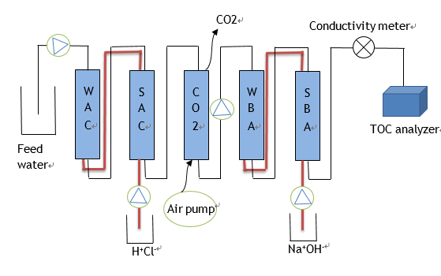

Operation phase Regeneration phase

Figure 20 Suggested system to perform the experiment

Because there is a way for gas to escape in the updated system, it reduces the possibility of explosion. During operation time, a flow meter can be used to measure the flow rate more accurate, while it cannot be applied in regeneration phase, otherwise the strong base or acid will corrode the flow meter. When regenerating the SBA, 38% concentrated hydrochloric acid should be diluted to around 5%. If water overflows in operation, take connectors out and dry it. It will increase friction to connect it tightly. It should check whether water overflows in regeneration before injecting HCl or NaOH, if overflows, stop for a while and resins will fall down instead of pushing the connectors out. Check pH of solution in the SBA after regeneration. If pH is still high, which means it remains NaOH, resins need to be rinsed more with DI water. Utilizing the clamps to control where solution come in and out rather than changing tubes from one bottle to another will make experiments much easier. A new set of parameter experiment about temperature and contact time should also be performed and analyzed.

**Regeneration ability experiment**

The failure of regeneration ability experiment may result from the method of measuring TOC concentration of the wastewater after regeneration. There is a more reasonable method by measuring COD concentration of the waste. It was concluded that there was a linear relationship between TOC and COD (COD=49.2+3*TOC) (Dubber & Gray, 2010). The specific method of measuring COD is described in appendix 1.

**Ion exchange capacity experiment**

To more accurately estimate theoretical capacity, the desired parameters in CADIX is supposed to be measured in practical water source, such as the equivalent of calcium per liter.

## Optimize formulating model

Each parameter experiment should be performed 2 to 3 times to check whether the results of the mass of removed TOC are the same under the regeneration condition. As to one parameter, more different group of experiments should be performed for better finding the relationship between the parameter and the mass of removed TOC.

After setting up the response surface model, testing the point where has the evident error, in this case is the point where flow rate is 10m/g and NaOH concentration is 5%, to check whether the is consistent with the model. In addition, a new set of experiments should be performed to check whether the best settings are in fact the optimal ones as concluded by model.

# Bibliography

American Water Works Association. (2011). *Water Treatment.*

Anderson, L. E. (2013). *Anion exchange resin technology for natural organic.* Dalhousie University Halifax, Nova Scotia, Canada.

Boyer, T. H. (2008). *Removal of Natural Organic Matter by Anion Exchange: Multiscale Experimentation and Mathematical Modeling.*

*CADIX Software.* (n.d.). Retrieved from DOW: http://www.dow.com/en-us/water-and-process-solutions/resources/design-software/cadix-software

Columns with freeboard. (2016, 8 28). *Ion exchange columns*.

DESILVA, F. (2006, 4 07). Resin Regeration Fundamentals.

Drbal, L., Westra, K., & Boston, P. (2012). *Power Plant Engineering.*

Drikas, M. (2010). *Long term case study of MIEX pre-treatment in drinking water.*

Dubber, D., & Gray, N. (2010). *Replacement of chemical oxygen demand (COD) with total organic carbon (TOC) for monitoring wastewater treatment performance to minimize disposal of toxic analytical waste.* J Environ Sci Health A Tox Hazard Subst Environ Eng.

Evides Waterbedrijf. (2013, 5 29). *Annual report 2013.*

Harland, C. E. (1994). *Ion Exchange: Theory and Practice.*

Helfferich , F. G. (1962). *Ion exchange: second edition.* Dover Publications, INC.

Helfferich, F. G. (1995). *Ion Exchange.* Dover Publications Inc.

Hill Publishing Company. (1998, 7 12). TOC in Industry. *Power*, p. 159.

Howe, K. J., Hand, D. W., Crittenden, J. C., Trussell, R. R., & Tchobanoglous, G. (2012). *Principles of Water Treatment.*

J. Zaganiaris, E. (2016). *Ion Exchange Resins and Adsorbents in Chemical Processing.* Books on Demand GmbH.

K. SenGupta, A. (1995). *Ion Exchange Technology: Advances in Pollution Control.*

Lahiri, P. (2001). *Model Selection.*

Nachod, F., & Schubert, J. (1956). *Ion Exchange Technology.* Academic Press INC.

Paulson, L. (2016, 1 27). What Is Ion Exchange. *RWL Water*. Retrieved from What Is Ion Exchange.

Scholarly, E. (2013). *Ion Exchange Resins—Advances in Research and Application.* Retrieved from ion exchange.

Vasileva, A. (2014). *Ion exchange for natural organic matter removal - Ion exchange resin comparison.* Helsinki Metropolia University of Applied Sciences.

Zagorodni, A. (2007). *Ion Exchange Materials: Properties and Applications.*

# Appendix 1

## Three types of resins

5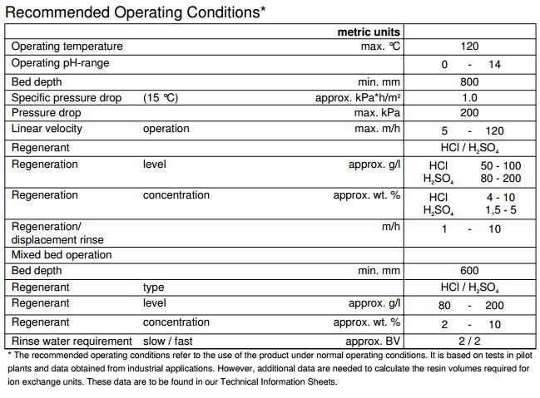

Figure 21 Suggested parameters of Lewatit® MonoPlus S 200 KR

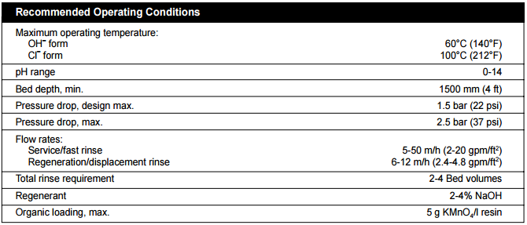

Figure 22 Suggested parameters of DOWEX™ UPCORE™ Mono MA-600

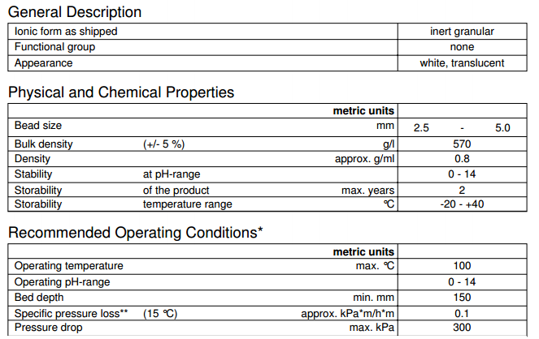

Figure 23 Suggested parameters of DOWEX™ UPCORE™ IF-62

## Resin loading

1. Fill vessel with sufficient water (~ 1/3 cylindrical height compartment) to allow settling and avoid resin damage.
2. Load the inert resin from the top of the compartment.
3. Load resin up to 80% of the total volume of resin required.
4. Close the vessel.
5. Backwash at 4 – 8 m/h for 30 minutes. The resin bed should not be pushed against the inert layer but only be in expansion.
6. Settle and push the bed down by draining.
7. Measure the bed height to determine the additional volume needed to establish the required bed height.
8. Fill the vessel to the resin level with water preferably from the bottom to top and load the additional needed resin volume.
9. Backwash at 2 – 4 m/h to level the resin bed for 30 minutes. The resin bed should preferably not be pushed against the inert layer.
10. Measure and report the resin bed height “as delivered” according to the resin bed height measurement procedure.
11. Fill the vessel with DI water; if possible leave the resins to wet overnight.
12. Proceed with the cleaning according to resin cleaning procedure.
13. Measure and report the bed height “as exhausted” and “as regenerated” after three regular service cycles according to the resin bed height measurement procedure.

## Resin operating

1. Build the device as shown in Figure 7 (black line).
2. Open pump and access to the resin vessel.
3. Drain the excess water in the vessel to resin level.
4. Allow the lower stopper to extend from the bottom.
5. Using a slow up-and-down motion, insert the device into the resin bed slowly. This must be done slowly to allow the resin level to equalize in the pipe. Inserting the device too fast will result in a sample of only the bottom portion of the bed.
6. Keep operation phase for hours. Once the conductivity rise rapidly, close access to resin vessel and pump.

## Resin regenerating

1. Build the device as shown in Figure 7 (red line).
2. Open pump and access to the resin vessel.
3. Inject DI water at fast flow rate to put resin from bottom to top.
4. Inject regenerant as designed condition from bottom to top.
5. Inject DI water (1-2 BV) to columns at slow flow rate until the conductivity is less than 1000 $μ$ S/cm.
6. Rinse DI water (3-5 BV) to columns at slow flow rate.

## TOC analyzer working principle

The analyzer is based on the oxidation of organic compounds to form carbon dioxide (CO2) using UV radiation and a chemical oxidizing agent (ammonium persulfate). Carbon dioxide is measured using a sensitive, selective membrane-based conductometric detection technique. For each TOC measurement, the concentration of inorganic carbon species (CO2, HCO3 -, and CO3 2-) is determined and, after oxidation of the organic compounds, the total carbon (TC) content of the sample is measured. The concentration of the organic compounds is then calculated from the difference between the concentrations of TC and total inorganic carbon (TIC). (TOC = TC - TIC)

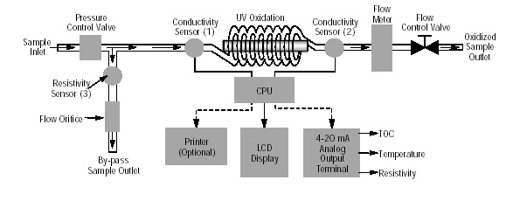

Figure 24 Inner process in TOC analyzer

## COD measuring

Experimental:

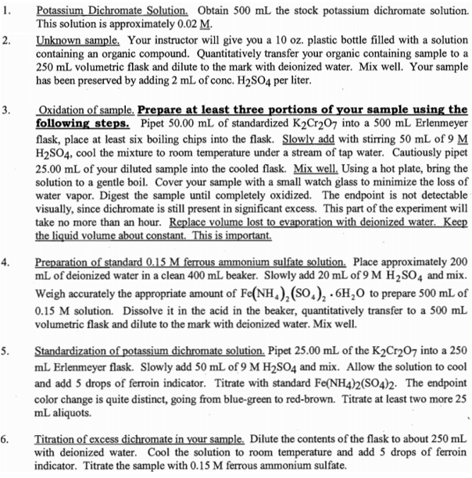

Calculation:

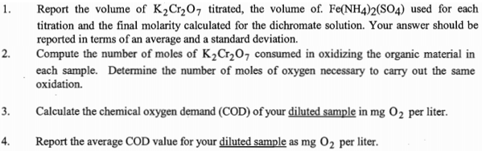

# Appendix 2

## Results (Main experiment)

Table 10 Data in this table shows the TOC concentration of feed water without treating



Table 11 Data in this table shows the TOC concentration treated by ion exchange being regenerated by 2% NaOH at 4 m/h, 20℃



Table 12 Data in this table shows the TOC concentration treated by ion exchange being regenerated by 3% NaOH at 4 m/h, 20℃



Table 13 Data in this table shows the TOC concentration treated by ion exchange being regenerated by 4% NaOH at 4 m/h, 20℃



Table 14 Data in this table shows the TOC concentration treated by ion exchange being regenerated by 5% NaOH at 4 m/h, 20℃



Table 15 Data in this table shows the TOC concentration treated by ion exchange being regenerated by 4% NaOH at 6 m/h, 20℃



Table 16 Data in this table shows the TOC concentration treated by ion exchange being regenerated by 4% NaOH at 8 m/h, 20℃



Table 17 Data in this table shows the TOC concentration treated by ion exchange being regenerated by 4% NaOH at 10 m/h, 20℃



## Results (Regeneration Ability Experiments)

Table 18 Data in this table shows the TOC concentration of regenerating wastewater of 2% NaOH at 4 m/h, 20℃



Table 19 Data in this table shows the TOC concentration of regenerating wastewater of 3% NaOH at 4 m/h, 20℃



Table 20 Data in this table shows the TOC concentration of regenerating wastewater of 4% NaOH at 4 m/h, 20℃



# Appendix 3

## Information from CADIX

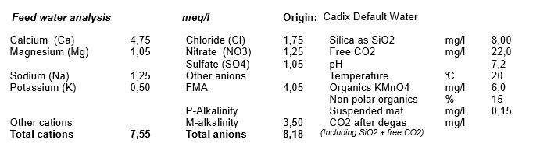

Figure 25 Default water parameters in CADIX

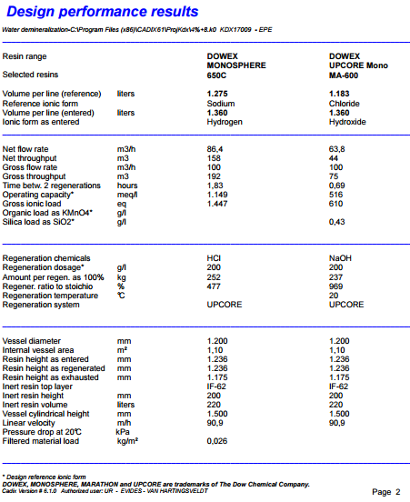

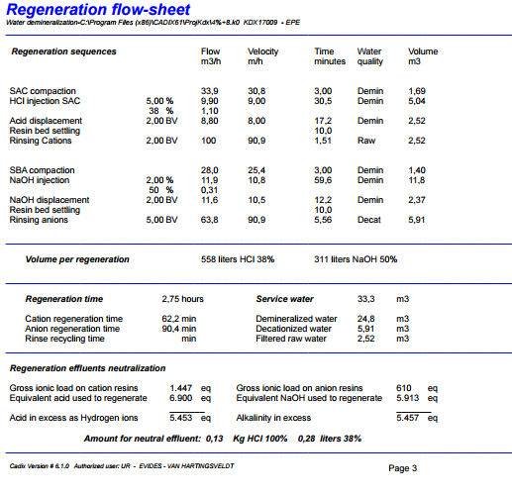

Figure 26 Detailed information of ion exchange regenerated by 2% NaOH at 10m/h, cold temperature in CADIX.

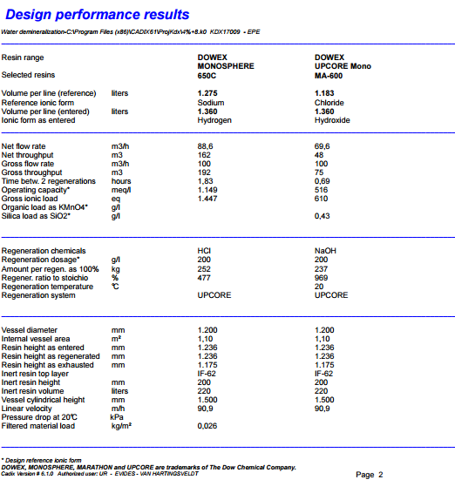

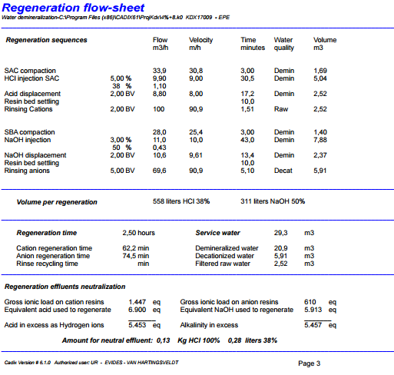

Figure 27 Detailed information of ion exchange regenerated by 3% NaOH at 10m/h, cold temperature in CADIX.

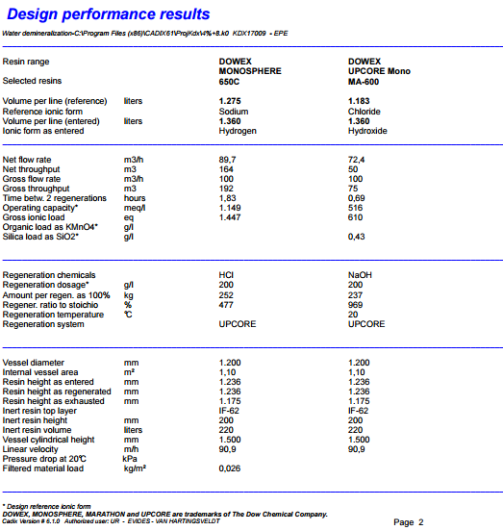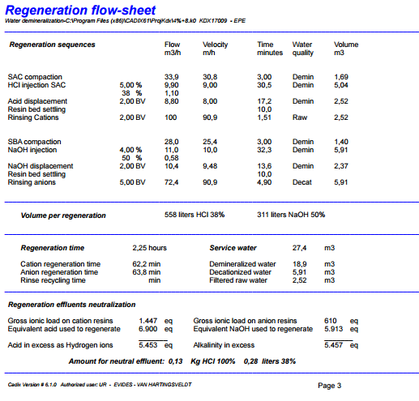

Figure 28 Detailed information of ion exchange regenerated by 4% NaOH at 10m/h, cold temperature in CADIX.

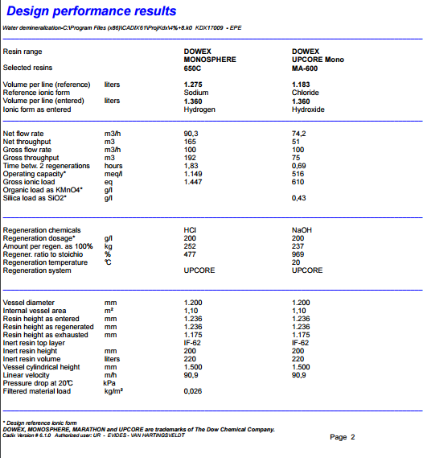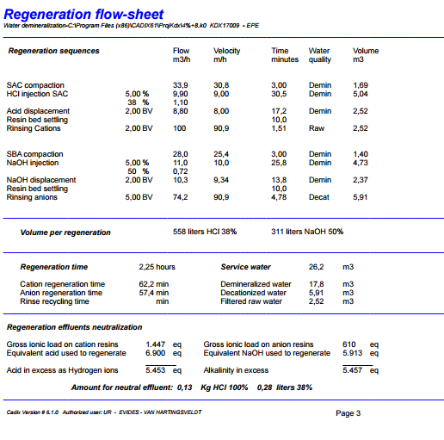

Figure 29 Detailed information of ion exchange regenerated by 5% NaOH at 10m/h, cold temperature in CADIX.

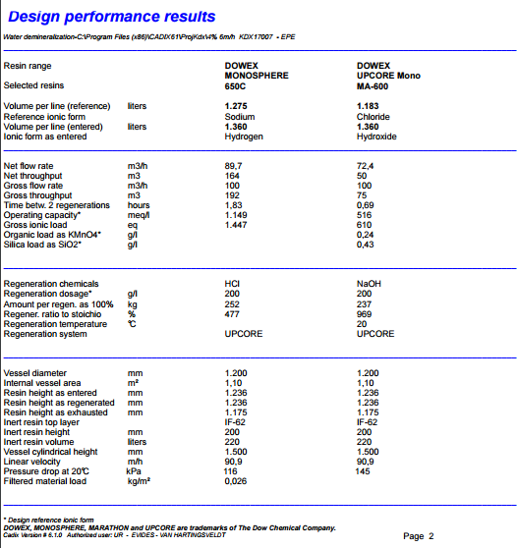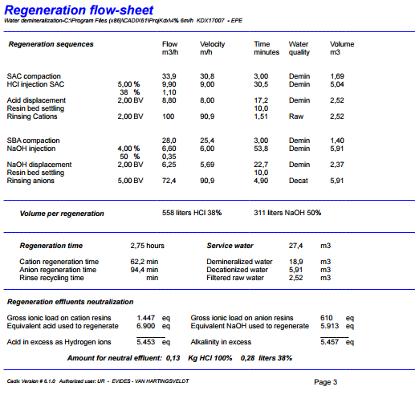

Figure 30 Detailed information of ion exchange regenerated by 4% NaOH at 6m/h, cold temperature in CADIX.

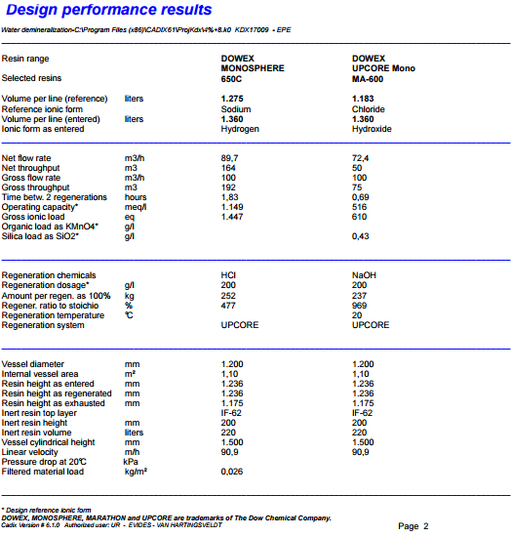

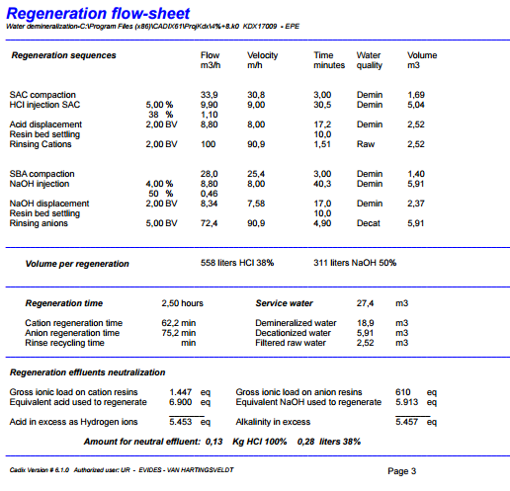

Figure 31 Detailed information of ion exchange regenerated by 4% NaOH at 8m/h, cold temperature in CADIX.

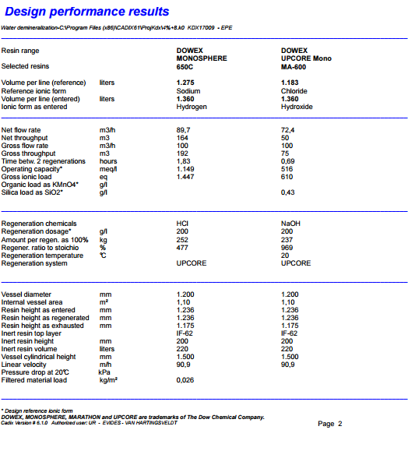

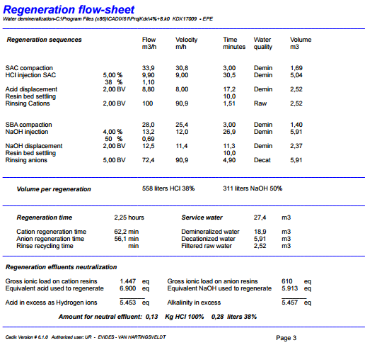

Figure 32 Detailed information of ion exchange regenerated by 4% NaOH at 12m/h, cold temperature in CADIX.