7 Readme file
- Data collection & management
Name of the person who saved the documents and/or files: Martijn Leenknecht and Ingrid Snijders
Data on which the manuscript was accepted:
Reference: Snijders, I., Rikers, R. M. M., Wijnia, L., and Loyens, S. M. M., “Relationship Quality Time: The validation of a relationship quality scale in higher education”. Manuscript submitted for publication on 5 November 2016 at the journal of Higher Education for Research and Development (HERD), and after revision accepted.

The article was included as a chapter in the doctoral thesis “Fostering student-faculty relationship in Higher Education. How relationship quality affects student involvement”, defended on March 10th 2021 at University Utrecht (online). See: https://doi.org/10.33540/460

Period on which the data was collected: start of 11 May 2015 (3 June 2015 reminder) till 24 June 2015
People who collected the data: Martijn Leenknecht and Ingrid Snijders

The documents and files can be found with the first author who is or was a researcher at the Faculty of Social and Behavioral Sciences at Utrecht University, Utrecht, Roosevelt Center of Excellence in Education, Middelburg, and employed by HZ University of Applied Sciences, Vlissingen, The Netherlands.
The files contain confidential (quantitative and qualitative) data, e.g., student numbers, names, and, information that can be traced down to individual persons such as by age, gender, study program, or, explicit remarks about persons from the specific educational institution. Therefore, the data package is only accessible through explicit permission by the first author. A request can be made by email: Ingrid.snijders@hz.nl
The files are stored at Surf Research Drive.
- Materials
The materials to collect the data for the survey were digitally distributed among the respondents such as the online questionnaire by campus mail, email invitations and reminder. In addition, a small scaled focus group discussion was held and supporting materials were handed manually.
Adjustments to the raw data file
Data was collected among students from a University of Applied Sciences. The survey study consisted of two parts. The focus of this study is on Relationship Quality dimensions. Next to quantitative survey data on relationship quality dimensions, we collected critical incidents to measure students' perceptions of relationship quality examples, however, they are not included in the data-analysis of this study (see datapackage “What’s in a student-faculty relationship”).
To conduct a confirmatory analysis on the quantitative data, we had to made some adjustments to the raw data file:
- variables that did not were included in the study were excluded from the analysis;
- All respondents that did not filled out the questionnaire completely and/or did not seriously filled out the questionnaire e.g., all had the same score on every item, were removed from the dataset;
- Negative formulated items were recoded if necessary for the analysis;
- Descriptive statistics- and frequencies were checked for irregularities;
- Difference analysis was conducted to confirm the A/B-version questionnaire influenced outcomes. Independent samples t-test was used. No significant differences were found. Information can be found with Martijn Leenknecht (co-researcher) at m.j.m.leenknecht@hz.nl

- Data files & information
Within this study’s data package, we included the files used for analysis such as:
- raw data file(s)
- syntax file(s) if present (for a PLS-SEM analysis no syntax files can be shown, however, we included the cvs-file used for PLS-Algorithms and Bootstrap analysis)
- output data from the (PLS)-SEM analysis such as from AMOS and/or SmartPLS
- qualitative data for the focus group discussion (Study 1) consists of film shoots and manually written feedback by students (scanned). For the focus group discussion, the main researcher (first author) and a student assistant were present to obverse. To lead the discussion, an experienced trainer from the educational institution was recruited, who did not know the students and did not have any concern with them.
- qualitative data for the critical incidents (Study 2) were collected through online written feedback by students and used in a separate study (see data package: What’s in a student-faculty relationship?)
- additional files including submission files and files for revision.
Additional information
This study (Study 1) was part of the research proposal that was granted by the Dutch Research Council (NWO) in the first round in 2015. The proposal is written in Dutch. The acknowledgement can be found at: https://www.nwo.nl/onderzoeksprogrammas/promotiebeurs-voor-leraren/toekenningen
General study design:
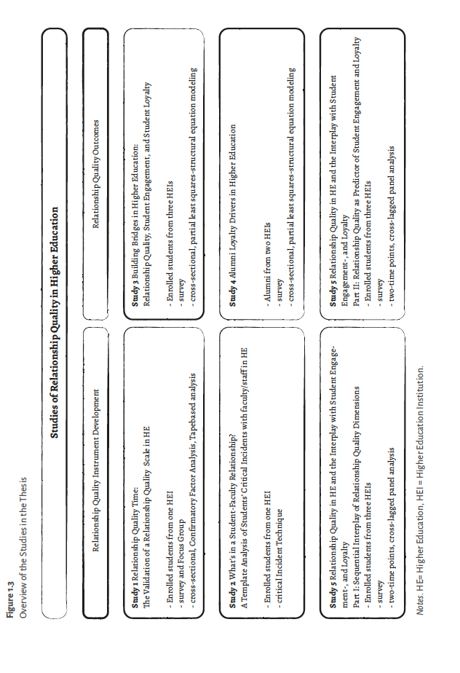
- Code book
Variables that were used for the study’s (1-5) analyses are:

Variable abbreviation | Variable name | Subdimensions | Subdimension name | Indicators abbr | Description item English
RQ | Relationship Quality ª | T_B | Trust in Benevolence | RQ_T_B01 | My university ^{d} is honest about my problems
 |  |  |  | RQ_T_B02 | My university has high integrity
 |  |  |  | RQ_T_B03 | My university is trustworthy
 |  | T_H | Trust in Honesty | RQ_T_H01 | My university is concerned about my welfare
 |  |  |  | RQ_T_H02 | When I confide my problems to my university, I know they will respond with understanding
 |  |  |  | RQ_T_H03 | I can count on my university considering how their actions affect me
 |  | SAT | Satisfaction | RQ_SAT01 | I am delighted with the performance of my university
 |  |  |  | RQ_SAT02 | I am happy with my university’s performance
 |  |  |  | RQ_SAT03 | I am content with my university’s performance
 |  | ACOMM | Affective Commitment | RQ_ACOMM01 | I feel emotionally attached to my university
 |  |  |  | RQ_ACOMM02 | I continue to deal with my university because I like being associated with them
 |  |  |  | RQ_ACOMM03 | I continue to deal with my university because I genuinely enjoy my relationship with them
 |  | ACON | Affective Conflict | RQ_ACON01 | I am angry with my university
 |  |  |  | RQ_ACON02 | I am frustrated with my university
 |  |  |  | RQ_ACON03 | I am annoyed with my university
SE | Student Engagement ^{b} | AB | Absorption | SE_AB01* | Time flies when I'm studying.
 |  |  |  | SE_AB02* | When I am Studying, I forget everything else around me.
 |  |  |  | SE_AB03 | I feel happy when I am studying intensely.
 |  |  |  | SE_AB04* | I am immersed in my studies.
 |  |  |  | SE_AB05 | I get carried away when I’m studying.
 |  |  |  | SE_AB06 | It is difficult to detach myself from my studies.
 |  | DE | Dedication | SE_DE01* | I find the studies that I do full of meaning and purpose.
 |  |  |  | SE_DE02 | I am enthusiastic about my studies.
 |  |  |  | SE_DE03* | My studies inspires me.
 |  |  |  | SE_DE04* | I am proud on the studies that I do.
 |  |  |  | SE_DE05 | To me, my studies are challenging.
 |  | VI | Vigor | SE_VI01* | At university, I feel bursting with energy.
 |  |  |  | SE_VI02* | At university, I feel strong and vigorous
 |  |  |  | SE_VI03* | When I get up in the morning, I feel like going to university.
 |  |  |  | SE_VI04 | I can continue studying for very long periods at a time.
 |  |  |  | SE_VI05 | At university, I am very resilient, mentally.
 |  |  |  | SE_VI06 | At my studies I always persevere, even when things do not go well.
SL | Student Loyalty ^{c} |  |  | SL01 | I would recommend my course of studies to someone else
 |  |  |  | SL02 | I would recommend my university to someone else
 |  |  |  | SL03 | I am very interested in keeping in touch with “my faculty”
 |  |  |  | SL04 | If I were faced with the same choice again, I would still choose the same course of studies
 |  |  |  | SL05 | If I were faced with the same choice again, I would still choose the same university
AL | Alumni Loyalty |  |  | AL01 | I found value in my education from…
 |  |  |  | AL02 | I am proud to be an alumnus/a of … | I am very interested in keeping in touch with “my faculty”
 |  |  |  | AL03 | I have positive feelings about … | If I were faced with the same choice again, I would still choose the same course of studies
 |  |  |  | AL04 | I want others to know I am a … alumnus/a. | If I were faced with the same choice again, I would still choose the same university
 |  |  |  | AL05 | My … education has improved my life.

a Adapted from Roberts et al. 2003. b Adopted from Schaufeli and Bakker 2003. c Adopted from Hennig-Thurau et al. 2001 (first five items) and partially from the survey by Newman and Petrosko 2011 (positive alumni feelings, last five items). d 'My university' is short for 'students’ educational faculty/staff''.

The UWES S 9 scale item was used for the analysis following the work from Schaufeli & Bakker (2003).

