21-3-2016
Optimization of the water production
On-board the M/S Maasdam
Yannick Van Aertselaer
HOGESCHOOL ZEELAND - DE RUYTER ACADEMY
Holland america line – m/s Maasdam
Optimization of the water production

Bachelor thesis

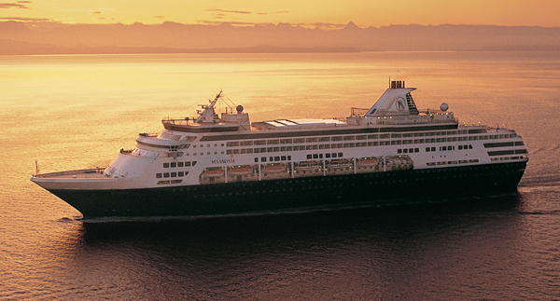

Place of issue: Vlissingen
Institution: HZ University of Applied Sciences
Education: Maritime Officer - Engineering
Date: 21-03-2016
Author: Yannick van Aertselaer

Year: 2015-2016
Semester: 2
Part of education: Bachelor research thesis
Mentor: A. De Groot
Version: 1

Abstract

This research has been conducted to analyze the current water production process and see if improvements in terms of energy efficiency is possible by using the optimal configuration for different sailing profiles. Water consumption on cruise vessel is higher than on non-passenger vessels. Freshwater can be obtained by means of 3 different methods. Bunkering of potable water from the shore side, distillation of seawater with the seawater evaporator and by using a reverse osmosis system.

Before this research, the method for producing water was selected randomly by the operator’s preference which resulted in inefficient production of potable water. Therefore, the following research question has been made up:

“Is it possible to optimize the potable water production on board the m/s Maasdam?”

To be able to answer this question, the current state of both systems was analyzed by filling in created log sheets on a daily base to learn more about the performance under different sailing profiles. The required energy sources for both plants were determined. All the data is collected in a database and analyzed which formed the results.

These results prove that an improvement of the current water production in terms of energy is possible.

From an early stage it was clear that the reverse osmosis system was the most energy efficient way of producing potable water. However, it is important to keep in mind the various advantages of the seawater evaporators. The most important advantages are utilizing excessive heat (and thereby cooling the main engines) and the ability to produce distilled and technical water. An estimation of the maintenance costs was made and analyzed. For both systems it was found that the maintenance costs don’t have a significant impact on the production cost and were considered irrelevant for the results of the research.

It is advised to use the reverse osmosis plant as much as possible to produce potable water. For the production of distilled and technical water, the seawater evaporators will be used. This is due to the higher salinity left in the water produced with the reverse osmosis system. The evaporators should only be used if more than 3 engines are running to prevent the need of starting up an additional oil fired boiler. In case the oil fired boiler has to start up, additional costs of 3,43$-10,12$ per m³ of potable water will be added by means of fuel consumption.

By following these guidelines and building up buffer capacity whenever possible it is possible to optimize the water production.

Contents
1. Introduction 1
1.1 Introduction Holland America Line 1
1.2 Introduction m/s Maasdam 2
1.2.1 Choices of water production 4
1.3 Research 5
1.4 Purpose of the research 6
2. Theoretical framework 7
2.1 Physical principles 7
2.1.1 Boiling point of water under a vacuum 7
2.2 Influencing parameters for total production 8
2.2.1 Total production Influencing factors and parameters for RO 8
2.2.2 Total production Influencing factors and parameters for evaporators 9
2.3 Energy sources reverse osmosis plant and sea water evaporators 9
3. Method 12
3.1 Introduction 12
3.2 Methodology 12
3.3 Prior conditions regarding the research 17
4. Results 18
4.1 Analyzing the daily average water consumption and production 18
4.2 Analysis of the reverse osmosis plant 19
4.3 Analysis of the seawater evaporators 21
4.3.1 Energy sources 21
4.4 Maintenance costs 26
4.4.1 Expected maintenance costs 27
5. Discussion 29
6. Conclusion & Recommendations 31
Bibliography 33
Attachments 34

1. Introduction

1.1 Introduction Holland America Line

Holland America Line was originally a Dutch shipping line from 1873 till 1989, and existed out of a cargo line and cruise line operating between North America and the Netherlands. The company had as homeport the port of Rotterdam. Nowadays the company is a British-American owned cruise line whereas the headquarters are based in Seattle. From 1989, Holland America Line moved to the company ‘Carnival Corporation’. The fleet consists of 14 vessels of different classes (S, R, Vista, Signature, Elegant Explorer and Pinnacle) and offers more than 500 cruises to 350 ports in more than 100 countries. (Holland America Line, 2014)

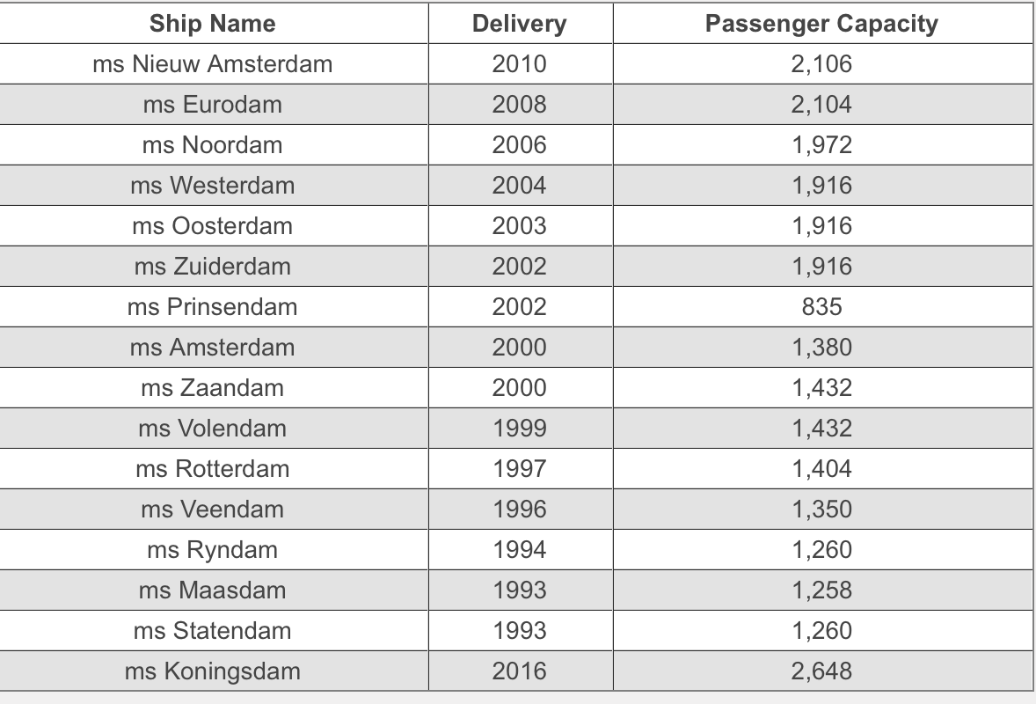
Image 1: Fleet Holland America Line (Holland America Line, 2014)

1.2 Introduction m/s Maasdam

The m/s Maasdam is one of the ‘S-Class’ vessels and has enough propulsion power to maintain a maximum speed of 22 knots. The vessel is 220-meter-long and has a beam of 31 meter with a maximal draught of 7.6 meter. Maasdam has a total capacity of 1258 passengers and 580 crewmembers. (Holland America Line, 2014)

The propulsion system consists out of a diesel-electric system and is driven by the following diesel engines:

- 2 Diesel generators: Sulzer 12ZAV40S
- 3 Diesel generators: Sulzer 8ZAL40

The diesel generators are feeding the following main consumers:

- 1 electrical system consisting of: 6,6kV grid, transformers and frequency drives
- 2 electrical propulsion motors (PEM) of 12 megawatts each.
To increase the maneuverability, the vessel is equipped with:

- 1 Stern thruster of 1720 kW
- 2 Bow thrusters of 1720 kW each

During wintertime the vessel is operating in the Caribbean and has a main turnaround port Fort Lauderdale. During the summer the vessel is operating in Alaska and making its way to Australia. (Holland America Line, 2014)

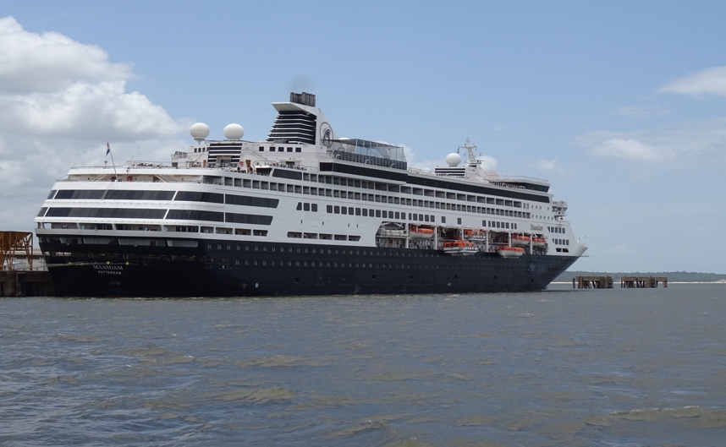
Image 2: MS Maasdam (Holland America Line, 2014)

Sulzer 12ZAV40S

On-board the m/s Maasdam, two twelve-cylinder diesel engines are installed by the manufacturer Wartsilä-Sulzer.

The most important characteristics of the diesel generators are the following:

Motor type: 12ZAV40S
Nominal power: 8640 kW @ 514 rpm
Stroke: 560 mm
Bore: 400 mm
Turbo chargers: 2x VTR 354-11
Frequency: 60 Hz
Phase: 3-phase
Produced voltage: 6600 V

The twelve cylinders are built up in a V-formation and the engine is not reversible. These engine specifics are based on the information of the engine manuals and sea trial reports. (Fincantieri, 1992)

Important note: All the twelve-cylinder engines have a common high temperature fresh water system, hereafter referred to as HTFW, that is going through the starboard seawater evaporating system. Incase none of the twelve-cylinder engines are running, the starboard seawater evaporator cannot be used as the heat of the cooling water is required for the evaporator to work. The HTFW circuit is cooled by the LTFW circuit but also by the seawater evaporator system which makes the seawater evaporator an important part of the whole engine cooling system. In case the seawater temperature is higher than usual, or all engines are running at high load, the cooling capacity of the HTFW heat exchangers alone is usually not enough and the evaporating system has to be used to get rid of excessive heat.

Sulzer 8ZAL40S

In addition, three eight-cylinder diesel generators are installed from the same manufacturer. These engines are not reversible and the cylinders are placed in line.

The most important characteristics of the diesel generators are the following:

Motor type: 8ZAL40S
Nominal power: 5760 kW @ 514 rpm
Stroke: 560 mm
Bore: 400 mm
Turbo chargers: 2x VTR 454-11
Frequency: 60 Hz
Phase: 3-phase
Produced voltage: 6600 V
This information is based on the diesel generator manuals and sea trial reports. (Fincantieri, 1992)

All the eight-cylinder engines have a common high temperature fresh water system, hereafter referred to as HTFW, that is going through the starboard seawater evaporating system. Incase none of the eight-cylinder engines are running, the starboard seawater evaporator cannot be used as the heat of the cooling water is required for the evaporator to work. The HTFW circuit is cooled by the LTFW circuit but also by the seawater evaporator system which makes the seawater evaporator an important part of the whole engine cooling system. In case the seawater temperature is higher than usual, or all engines are running at high load, the cooling capacity of the HTFW heat exchangers alone is usually not enough and the evaporating system has to be used to get rid of excessive heat.

1.2.1 Choices of water production

As for the water production onboard the m/s Maasdam, two options are available. The first method is by producing water with the installed reverse osmosis plant which can make up to 16,5m³ of potable water per hour (Case Marine inc., 2008). Secondly, two sea water evaporators are installed which, theoretically, can make up to 25m3/hour each. (Alfa Laval, 1999)

Reversed osmosis system installed on the m/s Maasdam

The reverse osmosis plant installed on the reference vessel is manufactured by Case Marine inc. and is a single pass R.O. plant with a theoretical production of up to 16,5m³/hr. Various factors such as seawater salinity, temperature, state of the membranes etc. will cause a change in the production rate. This plant is designed with the knowledge that the sea water temperature will range from 5^{O}C to 30^{O}C in normal application, seawater salinity will range between 28000 ppm – 38000 ppm. The high pressure pump is driven by an electromotor connected to a variable frequency drive. (Case Marine inc., 2008)

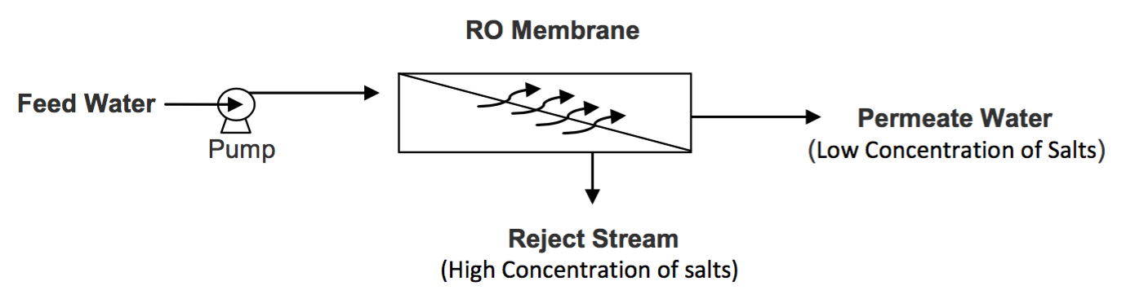
Image 3: Schematic of a basic RO plant (Harris, 2011)

Seawater evaporator system installed on the m/s Maasdam

Two identical seawater evaporator systems are installed on the reference vessel that are designed by Alfa Laval. The evaporators have a theoretical production of 600m³/day or 25m³/hour. The plant type is D-TU-4-1600 and is using jacket cooling water as the main heat source, required for evaporating the seawater. However, additional steam can be used to heat up the jacket cooling water if necessary. The plant is using the rising film principle in a tube heat exchanger at low evaporation temperatures. The system has 4 effects and is called a multi effect desalination. (Alfa Laval, 1999)

1.3 Research

Water consumption on cruise vessels is higher than on non-passenger vessels. Onboard the Maasdam water can be obtained by means of 3 different methods. Bunkering of potable water from a barge or shore-side is one option but is not enough to cover the water consumption and is usually more expensive. The other 2 options are producing potable water out of seawater by the use of either the 2 seawater evaporators or the reverse osmosis plant, installed on the m/s Maasdam.

The evaporators produce purified water by distillation (the process of evaporating and condensing a liquid) of seawater. The heat, used for evaporating the water is provided by the high temperature fresh water cooling system of the main engines. By using the heat, the waste heat is recovered and used efficiently. However, this heat is not always enough and additional steam can be used to heat up the process by use of a steam booster. The vacuum inside the evaporators is produced by a seawater driven ejector pump. After the water is evaporated, it will be condensed in the evaporator condenser. The impurities left behind in the evaporator is called brine which is removed by the brine pump. (McGeorge, 1995)

The reversed osmosis plant is essentially a membrane filter, capable of removing impurities of pretreated water. The RO membrane is designed to have a porosity which limits the passage of larger particles, but allows the smaller water molecules to pass through. The pretreated water is diffused through the membrane by having a higher hydraulic pressure on one side of the membrane. The concentrated brine containing filtered impurities is routed to waste, out of the membranes. (McGeorge, 1995)

The average amount of potable water consumed on a daily basis is 307 m³. Bunkering of potable water happens sporadically and only when it is necessary. Almost all the ports our vessel is visiting are facilitated with potable water bunkering in case it is necessary.

At the moment there is no standard procedure about when to use which method of water production in relation to the energy efficiency. During the years of service, the efficiency of evaporators will drop due to system leakages, formation of scaling etc. (Alfa Laval, 1999) (McGeorge, 1995)

The research question is as following:

“Is it possible to optimise the potable water production on board the m/s Maasdam?”

To properly answer the main research question, different sub-questions have been made:

- How are both evaporators performing under different engine configurations and loads?
- What is the current condition of the reverse osmosis plant?
- Are there significant maintenance costs to take in consideration that will increase the water production costs drastically?

1.4 Purpose of the research

This research will be conducted to analyse the current water production process and see if an improvement in terms of energy efficiency is possible by using the optimal configuration for different sailing profiles.

Factors such as waste heat recovery, different sailing conditions (and therefor engine configurations), maintenance costs, restrictions and the current condition of both systems will be taken into account.

The analysis of both systems’ current condition could be used as trend values to monitor the future condition.

2. Theoretical framework

In this chapter, all the relevant literature that will be used to develop a better knowledge of systems and definitions will be discussed. Basic working principles of both systems, design parameters of the systems, relevant physical principles, etc. are the main items that will be discussed next to previous case studies this research will be based on.

2.1 Physical principles

A few physical principles are necessary to explain the working principles of either the evaporating systems and reverse osmosis plant.

2.1.1 Boiling point of water under a vacuum

The boiling point of water is the temperature at which the vapor pressure of the liquid water equals the pressure surrounding the water and the water changes into a vapor. Water at a low pressure (vacuum) has a lower boiling point than water at atmospheric pressure. (Smit, 2003) This means that the boiling point of water is depending upon the surrounding environmental pressure. (Engineer edge, 2008)

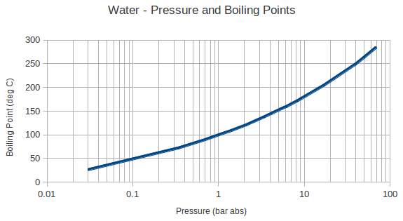
Image 4: Water - Pressure and boiling points (Engineer edge, 2008)

The heat of vaporization is the energy required to transform a given quantity of a substance from a liquid into a gas at a given pressure. This process, called evaporation is an endothermic process. During evaporation, heat is absorbed. According to (Silberberg, 2006) the following factors are of influence on the evaporation rate:

- Pressure: evaporation happens faster if there is less exertion on the surface keeping the molecules from launching themselves.
- Temperature of the substance: the higher the temperature of the substance the greater the kinetic energy of the molecules at its surface and therefore the faster the rate of their evaporation

These factors can be directly related to the seawater evaporation system where the pressure is lowered (vacuum) and the temperature is relative high in relation with the pressure. This is causing the seawater to evaporate quickly as the water is at a low pressure and the water temperature exceeds the boiling point. (Silberberg, 2006)

2.2 Influencing parameters for total production

2.2.1 Total production Influencing factors and parameters for RO

Seawater temperature: The decrease of seawater temperature will decrease the production quantity but will increase the water quality. (Harris, 2011)

System pressure: The decrease of system pressure will decrease the production of fresh water. (Harris, 2011)

Recovery %: “Recovery is the amount of water that is being ‘recovered’ as good permeate water. The higher the recovery % means that you are sending less water to drain as concentrate and saving more permeate water. However, if the recovery % is too high for the RO design then it can lead to larger problems due to scaling and fouling.

The % Recovery for an RO system is established with the help of design software taking into consideration numerous factors such as feed water chemistry and RO pre-treatment before the RO system. Therefore, the proper % Recovery at which an RO should operate depends on what it was designed for. By calculating the amount of recovery you can quickly determine if the system is operating outside of the intended design. (Harris, 2011) (McGeorge, 1995)”

Fouling: “Fouling refers to the irreversible changes that occur on the membrane and result in reduced flux over time. Many factors contribute to membrane fouling. Pore plugging and solute adsorption in the membrane pores can result in a decrease of the pore diameter and reduced flux. Solutes accumulated on the membrane surface due to concentration polarization may undergo irreversible changes over time and form a layer that will cause hydrodynamic resistance to flow. This layer formation depends on the membrane surface chemistry, solute–membrane and solute–solute interactions.

All the above make it clear that pretreatment of the feed stream is crucial in extending the useful membrane life. The objective of the pretreatment process would be to remove as many suspended solids and contaminants as possible before reverse osmosis. The pretreatment process may be a simple filtration or centrifugation step or it may be a much more thorough micro- or even ultrafiltration step. Pretreatment requirements will depend on the type of membrane used, the membrane configuration, and the composition and flow rate of the feed solution. (Lazarides, 2003)”

2.2.2 Total production Influencing factors and parameters for evaporators

Engines running and load: Because the evaporators are using waste heat from the HTFW it is safe to say that the amount of engines running and their load is an important factor for the production.

Heat resistive deposits: “The accumulation of heat resistive deposits inside evaporator tube bundles, deriving from scaling and fouling, significantly reduces plant thermal efficiency up to 25% and more, thus resulting in increased steam requirements to maintain the same distillate production rate. Furthermore, fouling contributes to tube corrosion and failure, badly affecting maintenance costs and overall plant life. (Ghiazza, 2008)”

Feed water flow: The amount of seawater added to the evaporator will change the production rate.

Vacuum: The pressure inside the evaporator system will change the production rate. (Engineer edge, 2008)

2.3 Energy sources reverse osmosis plant and sea water evaporators

Sea water desalination is an energy-intensive process (Gaparini, 1985; Carta, et. al 2003) and calculations can get complex when trying to find the energy consumed to make one m³ of fresh water as various factors are present.

“Reverse osmosis is a very efficient process, allowing for the simultaneous concentration, fractionation, and purification of the product and the accomplishment of multiple tasks in a single unit operation. It does not impart pH or chemical changes in the product and, since no significant heating is required, there is no heat degradation of the product. Thus, reverse osmosis has a minimal effect on the quality characteristics and nutritional value of the finished product, especially when compared to evaporative concentration where inevitably there is heat degradation, as well as flavor and nutritional losses.
Since reverse osmosis systems do not require steam, evaporators, and condensers, they require much less floor space and equipment than evaporative systems. Due to their relative simplicity, reverse osmosis systems have shorter come-up and shutdown time.
They are also more flexible and easier to modify or upgrade than conventional evaporative systems.

Reverse osmosis is very energy-efficient, because it typically operates at ambient temperature (no heating or cooling required) and, most importantly, there is no phase change requirement for water removal, as in evaporative processes. Overall, reverse osmosis systems require less energy than evaporative systems per unit of water removed from the product. Reverse osmosis systems require almost exclusively electric energy for pumping and recirculating, whereas evaporative systems require steam in addition to electric energy for pumping. (Lazarides, 2003)”

Professor (Kazmerski, 2009) states that “reverse osmosis (RO) is proved to be the most reliable, cost effective, and energy efficient in producing fresh water compared to other desalination technologies. The typical electricity consumption of seawater reverse osmosis plants is in the range of 4 to 7 kWh/m3.”

Various researches and manuals (Case Marine inc., 2008) (Harris, 2011) (Pirnie, 2005) are stating that the main energy source, required to run the reverse osmosis plant, is the electromotor that drives the high pressure pump. Additionally, the only other component that requires energy is the feed water pump which is also electrically driven.

(Kazmerski, 2009) (Gowin, 2000) says that electrical power, translated in watts, can be directly added up. This means that the total electrical consumption of the reverse osmosis plant can be found by adding the feed water supply pump electrical power with the electrical power of the electromotor that drives the high pressure pump. In another publication, (Parker Hannifin Corporation, 2010) states that the calculated power, required to produce one m³ of fresh water, can be found by dividing the total amount of power by the amount of fresh water that is produced in 1 hour time. This will give a value in kWh/m³ what can be used to make a comparison with other systems’ electrical consumption.

An example is given as following:

-16,5 m³ of fresh water produced in one hour
-82kW is the total power used by the two pumps

(82kW) / (16,5m³/hr) = 4,96 kWh/m³

As the electrical power consumption is constant for the reverse osmosis plant, the only varying factor to calculate the amount of kWh/m³ is the fresh water production. (Parker Hannifin Corporation, 2010)

The calculation for the seawater evaporators is more complex as different kinds of energy sources are added in order to make the process work. Multi effect sea water evaporators are requiring an external heat source in addition to the electrical power used to drive all the auxiliary pumps (Alfa Laval, 1999) (Lazarides, 2003). In the marine industry, the external heat source used to heat up the seawater in an evaporator is usually the jacket cooling water, also known as high temperature fresh water (Smit, 2003).

However, if the temperature of the HTFW is not high enough, or production needs to be increased, additional heat can be added by the use of a steam booster system. The jacket cooling water is guided through a heat exchanger that is heated up with additional steam, coming from the main steam system (Alfa Laval, 1999).

As for the electrical power consumption, the idea is the same as explained for the reverse osmosis system. All the electrical power consumed by the pumps can be added up. (Kazmerski, 2009) The required power in kWh to produce a m³ of water is calculated the same way. When no additional steam is added, the electrical power is the only cost effective energy source as the jacket cooling water is considered as waste heat recovery and is a free energy source (McGeorge, 1995). The addition of heat to your jacket cooling water in ways of steam makes the calculation more complex and information such as the amount of steam going through the heat exchangers, heat exchange rate etc. has to be available (Smit, Hulpwerktuigen deel 2, 1989).

3. Method

3.1 Introduction

The research consists of a main research question and several sub questions. To be able to answer the research questions, the research will be mainly based on active field research which will provide usable and reliable practical data to analyze the current situation regarding water production and see where improvements can be made.

3.2 Methodology

The following steps will be a guideline to answer the research question:

- Analyzing the current condition of both systems
- Defining waste heat recovery and which energy sources can be considered free of charge
- Determining the electrical power consumption for the RO plant and calculating the kWh/m³ produced water
- Determining the performance of the evaporators under different engine conditions and finding out when additional cost-effective energy has to be added to run the evaporators.
- Determine the cost of additional added non-waste heat recovery energy
- Analyzing the current average daily water consumption
- Analyzing the maintenance schedule and determining costs
- Analyze all the data and draw a conclusion

First step:

As for analyzing the current condition of both systems, the relevant design parameters have to be found in the operating manuals. The second part is the field research which will be performed over an extended period of time. Gathering practical values of both systems for two months will give a representative state of the current condition. A log sheet will be created which will be filled in as much as possible, stating all the relevant parameters.

For the reverse osmosis system, the relevant parameters to determine the condition are as following:

- Electrical power consumption
- Total system pressure before the membranes
- Total production in m³ / hour
- Recovery %

After gathering all the practical data over an extended time, the average will be taken which will indicate the current condition.

For the seawater evaporator systems, determining the current condition has to be done by analyzing the performance under different engine configurations. A comparison with the operators manual and practical values is not reliable anymore as according to the chief engineer of the m/s Maasdam, Martin Rohn, the pipe bundles in both evaporators are replaced a few years ago and are not original, which means the theoretical production rate and other parameters will vary for the original and no reliable reference can be made.

Second step:

Defining which energy sources are free of charge and which sources aren’t, is very important to make a proper judgement about the energy efficiency. The heat used to boil seawater in the evaporators is coming from the jacket cooling water system (HTFW) and can be considered as a free source of energy. Steam produced by the exhaust gas boilers can be considered as free energy until an additional oil fired boiler has to start to keep up the steam pressure.

Third step:

The reverse osmosis system is using electrical power as the main source of energy. This electrical power can be directly added up which gives a total amount of kW’s. The electrical power consumption for the reverse osmosis system is constant and will not be affected by the change of engine configurations. However, according to the formula below, the specific energy consumption per m³ produced water (kWh/m³) will vary slightly when the total production amount in m³ / hour changes.

The formula to calculate the specific energy consumption per m³ of produced water is as following:

$$\frac{\left(Total power consumption in kW\right)}{(Amount of water produced per hour in m3/h)}=(Specific energy consumption in kWh / m3 produced water)$$

Fourth step:

To analyze the energy efficiency of the evaporators during different sailing profiles, a log-sheet will be made which will be filled in as much as possible whenever the configuration is changing. Factors such as number of engines running (and therefore exhaust gas boilers), load of the engines, which evaporators are running, etc. will be included to make a practical analysis of the efficiency during different sailing conditions. This data will be collected as much as possible over a time of 2 months to make it a representative analysis.

The seawater evaporator system is requiring energy in forms of heat to boil seawater under a vacuum and electrical power to drive all the auxiliary pumps needed for the process to work. The electrical consumers are a constant factor throughout the whole process and a total amount of kW’s can be found. The same formula applies here to calculate the specific energy consumption, however, compared to the RO plant where the hourly production is almost constant, the hourly production of the evaporators will vary more due to various factors (vacuum, heat applied, feed water rate) and the specific energy consumption will change every time the hourly production changes according to the formula.

The heat used to boil the seawater is mainly coming from the high temperature cooling systems of the engines and can be seen as a free source of energy as it is recovery of waste heat. However, the heat given by the HTCW system is not always sufficient and compensation has to be made by heating up the HTCW with additional steam by means of a heat exchanger. If enough engines are running, over production of steam by the exhaust gas boilers will be present to heat up the HTCW, however, if there is not enough steam produced by the exhaust gas boilers, an additional auxiliary gas boiler will start up to cover the extra steam consumption. The startup of this additional oil fired boiler has to be considered as a loss of energy and has to be implemented in the cost calculation.

Fifth step:

Additional heat in forms of steam can be added to the jacket cooling water to increase the production of the evaporators. When the engine load is low or insufficient engines are running, the jacket cooling water temperature will be too low for the evaporator to run. As previously mentioned this additional steam can be considered as a free source of energy when there is no oil fired boiler running.

However, when insufficient engines are running, engine loads are too low or one of the exhaust gas boilers are isolated, the amount of produced steam will be lower and an additional oil fired boiler has to start up.

During sea voyage, when the vessel is in normal operation, the exhaust gas boilers are designed to produce enough steam for providing all the necessary consumers and still have an amount of steam left. The only time an additional oil fired boiler will start at this point is when insufficient engines are running and the steam produced by the exhaust gas boilers is not enough to cover the consumption of the HTFW steam boosters.

When the oil fired boilers are running during sea voyage it can be stated that the additional produced steam is not a free source of energy anymore and the fuel costs to run the oil fired boilers have to be implemented in the cost calculation to produce one m³ of potable water.

Whenever the oil fired boilers are running to compensate the steam, required for the steam boosters, the fuel rack position of the oil fired burner will be recorded.
For every fuel rack position of the burner, an amount of fuel will be burned which can be directed to an amount of fuel per hour. To find the amount of fuel burned in an hour for every position of the fuel rack, an additional analysis will be performed.

The oil fired burner will be started up in the “emergency operation” mode which makes it possible to disconnect the fuel rack from the automation and manually lock it in a chosen position. For all the recorded fuel rack positions during the analysis, a test will be performed and the fuel rack will be manually locked in these positions for one hour. The amount of fuel burned will be shown on the flow meter and will be recorded.
The amount of fuel burned per hour for every fuel rack position will be known, as well as the potable water production per hour for that specific configuration, which makes it possible to calculate the extra costs to produce one m3 of potable water when an additional oil fired boiler is running.

Sixth step:

To find an efficient configuration for water production under different sailing profiles it is necessary to analyze the current daily average water consumption. During two months, the daily water consumption will be recorded and an average will be made.

Seventh step:

For the last sub question, the maintenance schedules for both systems will be analyzed. Prices of expensive spare parts, cleaning, etc. will be included to see if there are significant maintenance costs, and at what interval the maintenance has to be performed. Because of different variable factors an exact amount cannot be found but an estimation has to be made.

All the costs will be calculated to a yearly amount so a grand total can be found. This total will be directed to additional costs per produced m³ of water by calculating the total amount of m³ water produced during a year.

An example is given in the following equation:

(Total maintenance costs) / (14m3/hr x 24 x 365) = Additional costs per m³

Final step:

Once all the data is collected and the current condition and its behavior under different sailing profiles of both plants is known, analyzing of the data will be performed.

A pattern in behavior should become visible and elements such as energy efficiency can be extracted from this data.

For different sailing profiles and engine loads, a conclusion can be made regarding the efficiency of both plants and the research question can be answered.

Requirements and conditions:

All the gathered data will be reviewed for its liability and data collected that is not useful will not be used during the research. However, an important note is that all the measured values are gathered with the current measuring instruments installed on both plants. It might be possible that instruments such as thermometers are not 100% accurate anymore. All the measurements will be done with the same equipment over the extended period of time to make sure all the values are representative and can be compared.

For the evaluation of the current performance of the evaporators under different sailing profiles, the following requirements have to be met before the checklist will be filled in:

- A quick check will be performed to see if the plant is running normal (e.g. amps of pumps)
- The engine configuration and load has to be the same for at least 1 hour to make sure temperatures are constant

As for the maintenance costs it is clear that only an estimation can be made because it is impossible to find exact lifespan data etc. This estimation will be used whether to see if there is a significant difference between the RO plant and seawater evaporators.

3.3 Prior conditions regarding the research

To make sure both parties are on the same page, this chapter will comprise all the condition and standard values that will be used throughout the whole research.

Data analyzing

Due to insufficient information available regarding the steam used in heat exchangers (amount, heat exchange rate, etc.) the proper energy calculation is not possible.

By analyzing whether an additional oil fired boiler is used for producing the steam added to the evaporators, a cost calculation can be made by monitoring the fuel used by the boiler. This way, the steam-cost calculation is simplified but still taken into account.

Pricing

Throughout the research, fuel prices may vary. The prices used in the research are the official fuel prices on 19/05/2016 (Bunker index, 2016) and are as following:

- Heavy fuel oil: 214 dollars/t (Rotterdam IFO380)
- Marine gas oil: 417 dollars/t (Rotterdam MGO)
- Potable water bunkering: 3,5 to 7 dollars/m³

Seawater temperature

The influence of seawater temperature will not be taken into account. For the reverse osmosis plant the production will be slightly affected but changes are small. For the seawater evaporator system, the seawater temperature will indirectly affect the high temperature cooling water as the seawater will cool down LTFTW and LTFW cools the HTFW. Changes due to variation of seawater are small and can be considered irrelevant for the research.

Occurring of unforeseen damage

For this research, the maintenance costs are only based on planned maintenance according to the systems’ manuals. Costs of randomly occurring damage will not be taken into account.

Waste heat recovery for the evaporators

The heat coming from the jacket cooling water (HTFW) will be considered as free energy.
When the steam is produced by the exhaust gas boilers, it will be considered as free energy. If steam is produced by an oil fired boiler, it will not be considered as free energy.

4. Results

This chapter is using the previously described method as a guideline and builds up by answering the sub research questions and eventually the main research question. All data used in shown graphs or pictures will be added as attachments for verification.

4.1 Analyzing the daily average water consumption and production

First of all, it is necessary to analyze the current situation onboard the m/s Maasdam regarding the water demand. Once the average demand is known, the required amount of water that has to be provided is known as well. Whether this water should be provided via bunkering or self-production will be discussed later on in this chapter.

Image 5 is showing the average daily water consumption. This graph is based on data gathered for 60 days during the month March and April 2016:

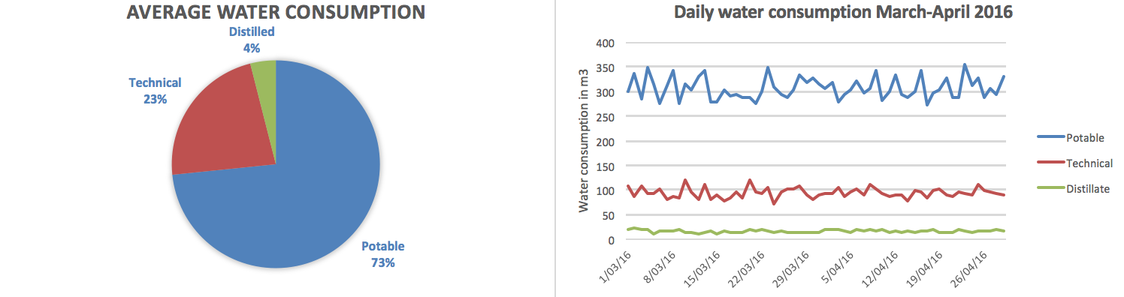
Image 5: Average daily water consumption during March-April 2016

It is clear that the demand of potable water (73%) is the highest due to the hotel department based on the cruise vessel. The water is used for showers, sinks, galley and personal consumption. The daily average consumption for potable water is 307m³.

An average consumption of 95m³ technical water forms 24% of the average daily water consumption. This water is used for deck-wash, laundry department, a part of the firefighting system and engine room auxiliary equipment.

The daily average consumption for distilled water is 16,6m³ which relates to 4% of the total consumption. Distilled water is mainly used onboard the vessel to fill up boiler feed water and engine cooling water.

Reference calculations can be found in attachment 1.

An important fact is that producing water is not possible while staying in a port and can only be produced while being on sea. This means having a buffer is necessary to cover the port consumption. The average daily potable water consumption is approximately 307m³ which means at least 13m³ per hour should be made to keep up with the consumption. If production is not possible for a certain amount of time, for example while being in a port, compensation has to be made to meet the daily requirement.

Proper managing of the total water storage is vital for the operation of the vessel and hotel department (passengers using drinking water, showers, galley, etc.) and helps when unforeseen circumstances are presenting themselves.

4.2 Analysis of the reverse osmosis plant

The reverse osmosis installation is installed in 2009 on the m/s Maasdam and can be considered relatively new. The plant is relatively small compared to the seawater evaporators and can be started up within three minutes without the requirement of external energy sources besides the electrical power supply, used to drive the pumps. The main disadvantage of the RO plant is that the water quality is worse than the evaporators and produced water cannot be used to fill up the distilled or technical tanks due to the relatively high salinity content left after processing. Another disadvantage that should be taken into consideration is that because of the higher salinity left in the produced water (300-500 ppm), pipelines and tanks of the potable water process are more vulnerable to corrosion.

According to the operators manual (Case Marine inc., 2008) of the reverse osmosis plant, the relevant operating parameters are the following:

- Hourly production of potable water: 16,6 m³/hour
- Recovery in %: Between 36% and 40%
- Total system pressure: 62 bar
- Nominal power “Fedco” pump: 68 kW

The current average values of the reverse osmosis plant are the following after examining the condition for two months (44 measurements):

- Hourly production of potable water: 14,6 m³/hour
- Recovery in %: 36,2 %
- Total system pressure: 60,4 bar
- Nominal power “Fedco” pump: 69,7 kW

The graph added in image 8 is showing the condition during the months March and April 2016. A screenshot of the reference calculations (excel file) is added in attachment 2.

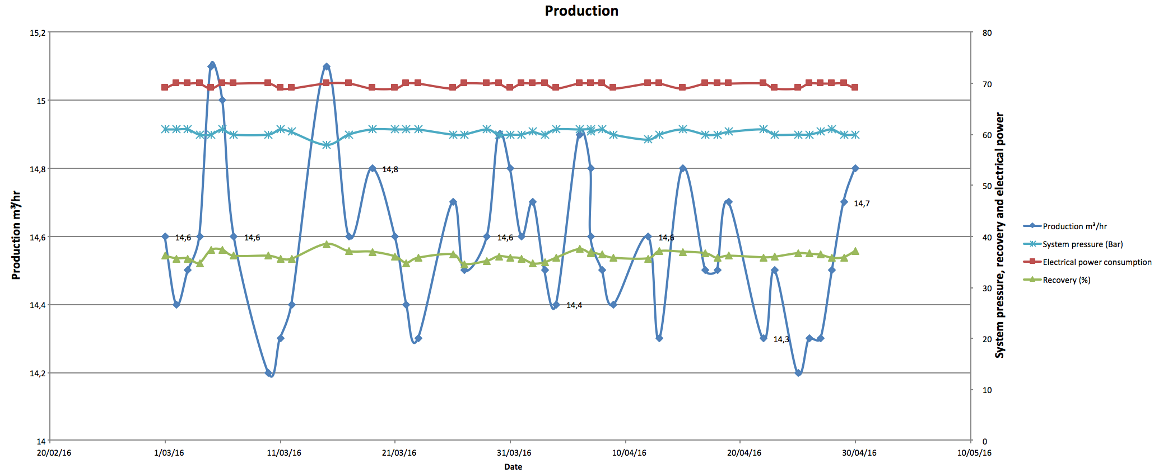
Image 6: Reverse osmosis plant condition overview of March-April 2016

As previously mentioned, the main power source to operate the reverse osmosis plant is the electrical power supply feeding the electro motors, which are driving the pumps.

The nominal power of the two pumps installed on the R.O. plant:

- Seawater feed pump: 12 kW
- High pressure Fedco pump: 70 kW

According to the measurements, these electrical power values are almost constant and small changes can be considered negligible. As for the hourly production, the average value is 14,7 m³/hour.

The specific energy consumption by the reverse osmosis plant to make one m³ potable water is the following:

(82kW) / (14,7m³/hr) = 5,58 kWh/m³

This value will be quasi constant and is not affected by the engine configuration and load.

4.3 Analysis of the seawater evaporators

The seawater evaporators on-board the m/s Maasdam are so-called multi effect evaporators are are consisting out of 4 stages. Each stage the temperature drops but the vacuum increases to compensate. The heat source, necessary to evaporate the seawater, is coming from the high temperature cooling water. Additional heat can be added by means of the steam booster heat exchangers.

4.3.1 Energy sources

The seawater evaporators are requiring an electrical power supply to drive the auxiliary pumps and energy in forms of heat to evaporate the seawater.

The evaporators are equipped with 6 auxiliary pumps with each their own function. The electrical power consumption of these pumps is based on the information tag attached to the electro motors and are as following:

Electrical consumer Nominal power in kW

- Seawater cooling pump 26 kW
- Recirculation pump 16 kW
- Seawater ejector pump 14 kW
- Feed water pump 13 kW
- Brine pump 11 kW
- Distillate pump 6 kW

Total nominal power 86 kW

The power consumption of these electrical consumers are constant and are not affected by engine configurations or load changes.

However, in contrary to the reverse osmosis system, the hourly production rate for the seawater evaporators is influenced by the engine configuration and engine loads, which makes it impossible, at this time, to apply the same formula for calculating the specific energy consumption. The average production rate has to be found for each different engine configuration before the formula can be used.

The second source of energy required to operate the evaporators is the heat used for evaporating seawater. As previously mentioned, the heat coming from the jacket cooling water is being utilized and waste heat is recovered. However, if insufficient engines are running or the engine load is too low, the heat will not be sufficient and an additional steam booster will be used. First of all, it is important to recognize in which configuration adding steam is necessary in order to operate the evaporators.

Steam necessary for production?

For an extended period of time the evaporator checklist, provided in attachment 3, is filled in on a daily basis and by analyzing the 51 measurements the following pattern is found:

Starboard evaporator (8 cylinder engines)

- 3 engines running with all exhaust gas boilers online: (60-82% load)

Steam is applied to increase the production but it is not necessary. If engine load is above 75% and the seawater temperature is high, the HTFW temperature might be too hot and the steam boosters have to be shut.

- 2 engines running with all exhaust gas boilers online: (60-82% load)

Steam is applied to increase the production but it is not necessary in order to produce water.

- 1 Engine running with the exhaust gas boiler online: (60-82% load)

Applying steam is necessary to produce water, the HTFW temperature will be too low and the water will not evaporate.

Portside evaporator (12 cylinder engines)

- 2 engines running with all exhaust gas boilers online: (60-82% load)

Steam is applied to increase the production but it is not necessary. If engine load is above 75% and the seawater temperature is high, the HTFW temperature might be too hot and the steam boosters have to be shut.

- 1 engine running with the exhaust gas boiler online: (60-82% load)

Applying steam is necessary to produce water, the HTFW temperature will be too low and the water will not evaporate.

Note: Out of 51 measurements the engines were always found equally sharing the load via the power management system and loads were ranging between 60% to 82%. All the exact data can be found in the excel database which can be showed at any given time.

Now it is clear in which configurations the evaporators are requiring steam to produce potable water, the next step is to determine in which configurations the exhaust gas boilers are not producing enough steam to cover the HTFW steam booster consumption in combination with the necessary consumers (heating coils, etc.) and the oil fired boiler has to be started up to compensate.

After analyzing the gathered data (51 measurements) about the seawater evaporators the following pattern is clearly visible:

- At least 3 engines with the exhaust gas boilers online are required to produce enough steam to provide the necessary consumers AND the HTFW steam boosters.

Following up on this statement it is safe to say that the heat, supplied by the HTFW in combination with adding steam is a free source of energy until less than 3 engines with 3 EGB’s are running.

It is the operators’ choice whether to add steam or not (to increase the production rate). This choice will have no economic impact until the oil fired boiler is started.

- The electrical power required to run the evaporators can be seen as the only cost-related energy source UNTIL an additional oil fired boiler is started to compensate the steam usage.

4.3.2 Additional costs for running the oil fired boiler

The next step is to determine the additional costs for running the oil fired boiler. The oil fired boiler was found to run 9 times out of 51 measurements (18% of the time). For every situation when the oil fired boiler was running (less than 3 engines online and only 1 engine on the portside or starboard evaporator), the fuel rack position was recorded. Positions 1 and 2 were found during the analysis.

During two manual tests, the fuel burned in one hour for each fuel rack position was recorded and shown in the following table:

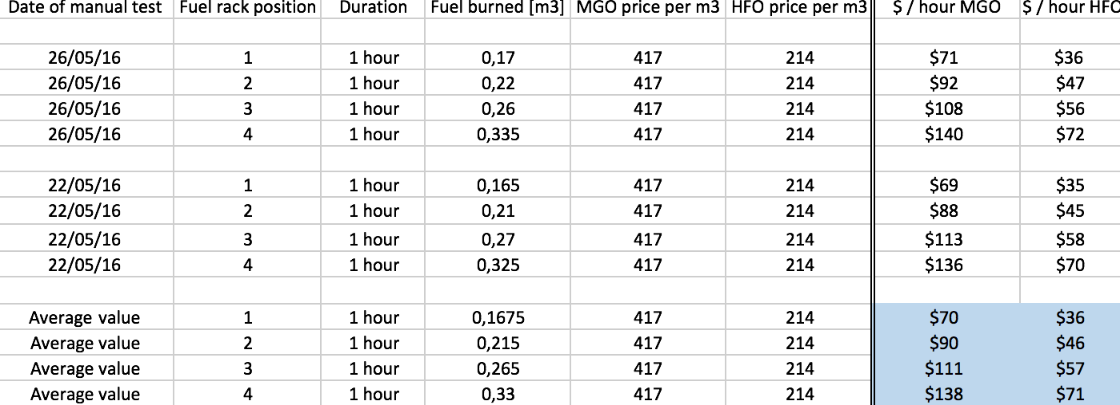
Image 7: $ per hour for different fuel rack positions on heavy fuel oil and marine gas oil.

The following graph (image 10) is showing the price to run the oil fired boiler for one hour in each different fuel rack position:

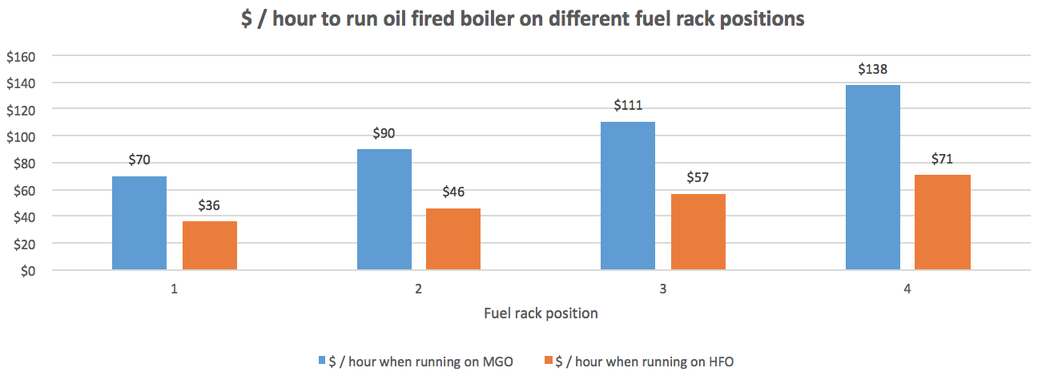
Image 8: $ / hour to run oil fired boiler on different fuel rack positions
Note: The fuel prices used for this calculation can be found in the prior conditions for this research. The calculation is made in an excel database which can be showed at any given time.

Once the price per hour is known for each fuel rack position and fuel type it is possible to calculate the extra costs for producing one m³ of H₂O while running the oil fired boiler:

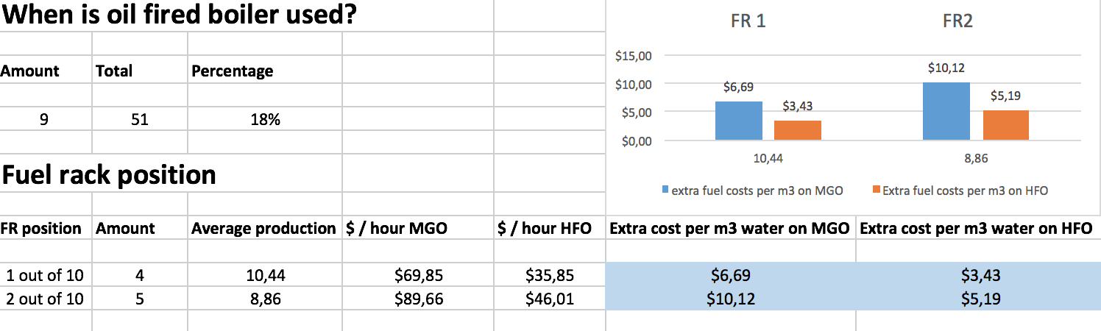
Image 9: Extra costs per m³ of H₂O on different fuel types

The main fuel type we are using is heavy fuel oil but whenever our vessel is sailing in the special ECA zones, a fuel changeover is performed switching from heavy fuel oil to marine gas oil to meet the environmental requirements. The extra costs per m3 of water while running an oil fired boiler is almost doubled when running on MGO.

Fuel rack position one is found 4 out of 4 times to relate to engine loads higher than 71%.
Fuel rack position two is found 5 out of 5 times to relate to engine loads lower than 71%.

Out of the 51 measurements the following frequencies of engine configurations have been recorded:

Engine configurations Amount Percentage

- Two 8 cylinders 0 0
- Three 8 cylinders 0 0
- Two 12 cylinders 1 1,96%
- One 8 one 12 cylinders 7 13,73%
- One 8 two 12 cylinders 8 15,69%
- Two 8 one 12 cylinders 9 17,65%
- Two 8 two 12 cylinders 11 21,57%
- Three 8 one 12 cylinders 10 19,61%
- Three 8 two 12 cylinders + 5 9,80%

Total measurements: 51 100%

The engine configurations and engine loads are depending on various factors such as speed to make, weather conditions and hotel load.

For both evaporators different sub categories were made, stating the total production rate in relation to different engine configurations and loads. The following two tables are showing the average production rate per hour and the specific electrical energy consumption for each different sub category:

Portside evaporator (12 cylinder engines)

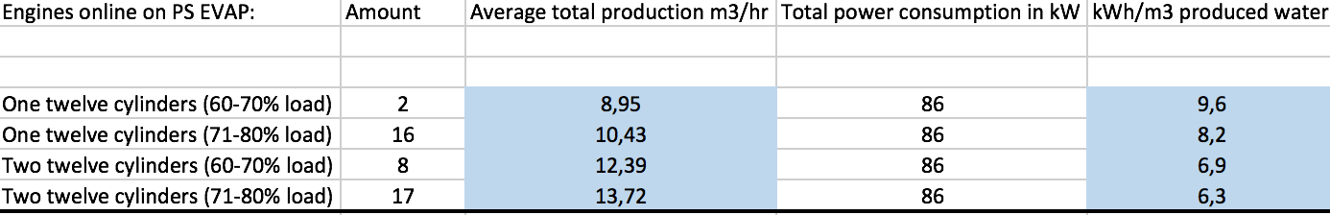
Image 10: Portside evaporator performance under different engine profiles

Starboard evaporator (8 cylinder engines)

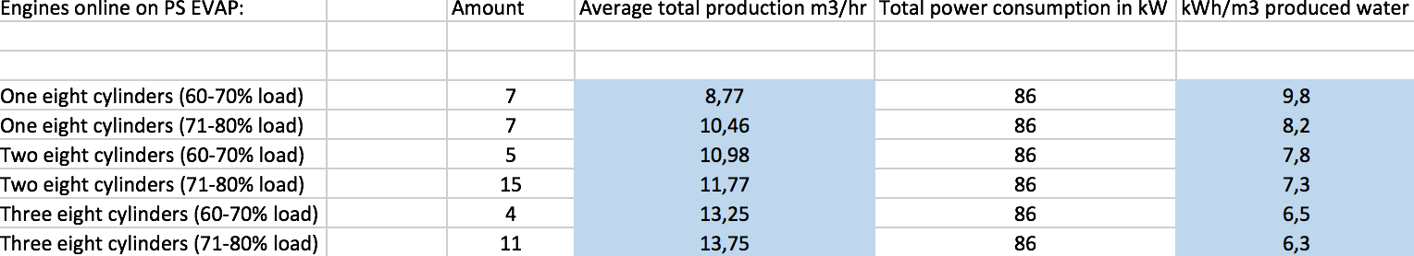
Image 11: Starboard evaporator performance under different engine profiles

The influencing factor for the specific energy consumption of the evaporators is the production rate. When the engine loads are increasing and more engines are running, the specific energy consumption will be lower because of the increase in production rate.

The following table is an overview of the specific electrical consumption of the evaporators and reverse osmosis plant under different engine configurations:

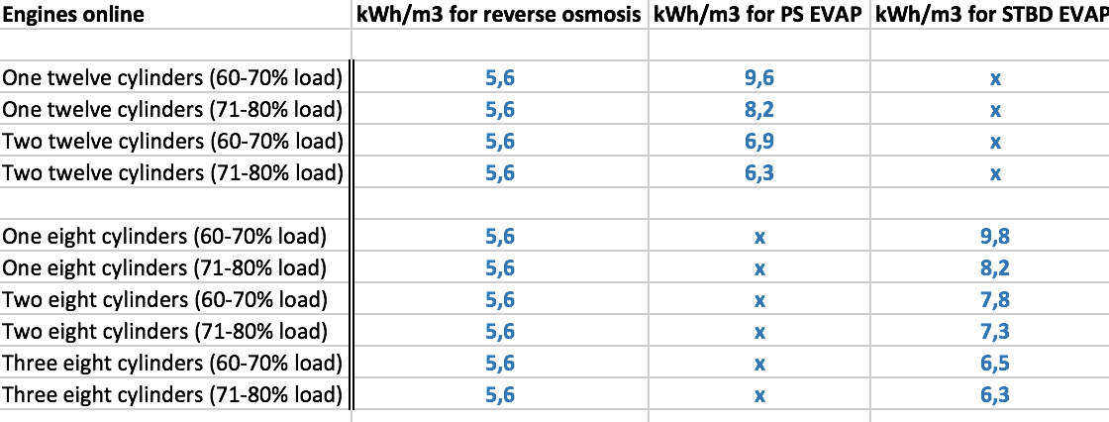
Image 12: Overview of specific electrical consumption for the evaporators and reverse osmosis plant.

This table can be used to compare the electrical consumption of the evaporators versus the reverse osmosis plant, until an additional oil fired boiler is used to produce water.

Although the reverse osmosis plant is consuming less energy in any situation, it is important to keep factors in mind such as maintenance costs (and therefor operational costs), specific advantages for each system (e.g. waste heat recovery, cooling capacity of the evaporators, water quality, etc.).

4.4 Maintenance costs

As for the maintenance costs an estimation model is built up by combining the theoretical maintenance schedule for both systems with the practical history available. The prices for spare parts or maintenance kits are related to our ships’ maintenance management system called “AMOS”.

It is not possible to calculate the exact costs regarding maintenance because of the following variable factors:

- Price from spare parts can change throughout the time
- Exact time of failure can only be estimated
- Unforeseen malfunctions of the equipment
- Operators influence

The purpose of this chapter is to estimate the maintenance costs, based on the information that was available, to see if there is a significant difference between the reverse osmosis plant and the seawater evaporators.

4.4.1 Expected maintenance costs

All the mentioned items in the maintenance schedules are listed in an excel database created for the research. The exact intervals of the maintenance or estimation based on history and operators’ experiences are mentioned together with the price of the spare part.

Because “Maintenance costs” can be a study on its own, the working hours and non-critical spare parts are neglected.

Reverse osmosis system

As for the reverse osmosis plant the most cost effective items are as following:

- Fedco pump overhaul kit and maintenance kit
- Replacement of micron filters for pre-treatment
- Replacement of the membranes

The Fedco centrifugal pump is the vital part for the reverse osmosis system and is because of its complexity the biggest maintenance cost on a year basis. The replacement of the micron filters (20 and 10 micron), required for pre-treatment of the supply water and protection of the membranes, is the second biggest cost and is performed every one to two weeks. (Case Marine inc., 2008)

Replacing of the membranes can never be estimated as the quality of supply water and efficiency of the pre-filtering are variable factors. The plant is installed for 7 years and membranes were never replaced, the expected lifespan of membranes are 5 – 10 years. (Case Marine inc., 2008)

- By adding up all the yearly costs for all the different items, a total of 23525 dollars is found. If we redirect this value to the additional costs per m3 produced water an addition of 0,1918 dollars per m³ is found.

The calculations are made in an excel database and can be used as a reference. The results are shown in attachment 4

Evaporator system

The most maintenance intensive items are the following for the seawater evaporators:

- Auxiliary pumps for seawater
- Auxiliary pumps for freshwater
- Salinity meter

The seawater pumps are by far causing the most expensive maintenance costs as seawater is aggressive on pump impellers, wear rings, housing etc. According to the history of the seawater evaporator plant it can be estimated that the seawater pumps require an overhaul kit +- every 2 year. For the freshwater pumps this estimation is set on every 6 years. (Alfa Laval, 1999)

Measuring the salinity of processed seawater is of high importance because the 3-way valve, deciding whether to dump the processed water overboard or fill up the tanks, is working in relation with the salinity meter. Based on the history, the replacement interval is estimated to every 2 years. (Alfa Laval, 1999)

- The total maintenance costs per year are estimated on 21939 dollars and if redirected to the additional costs per m3 produced water an addition of 0,22 dollars per m³ is found.

The calculations are made in an excel database and can be used as a reference. The results are shown in attachment 5

5. Discussion

By building up the theoretical framework, a method was created that proved to be successful to answer the research questions. Results prove the statement that the reverse osmosis plant is always the most efficient way of producing potable water. The reason for this is that there is no changing of phase required and therefore no adding of heat. The reverse osmosis system is working exclusively on electrical power. However, this doesn’t mean that the RO plant is always the best choice as the operator has to keep in mind the various advantages of the seawater evaporators. Based on previous cases, the average energy consumption per m³ of potable water produced for the reverse osmosis was found to be ranging between 4-7 kWh/m³, depending on the plant’s characteristics. The value for the installed RO plant is 5,6 kWh/m³ what can be considered reliable.

It was expected that the reverse osmosis would be more energy efficient but the energy consumption of the evaporators comes unexpectedly close to the RO plant when the majority of the main engines are running on a load of 70% or above. This is because the external heat provided by the engines is high and steam produced by the exhaust gas boilers is sufficient, making it possible to consider both as a free source of energy. This leaves the electrical power as the only cost-effective energy source. It is only on low loads or insufficient engines running that the reverse osmosis system is by far way more efficient.

The reader should keep in mind that the performance of the evaporators is highly influenced by the heat (and therefore additional steam) added. Another important note is that although the 2 evaporators are identical, the heat exchange coefficient of those evaporators are varying. Scaling built up during the years of service can explain the minor differences between the portside and starboard evaporators’ performance. During the research the starboard evaporator’s flowmeter broke down on may 5th 2016 and was replaced. After analyzing and comparing the results before and after this change of flowmeter it became clear that there are no significant changes in gathered values. The same type and brand of flowmeter was installed.

All the data gathered in the database was properly analyzed to determine the reliability. For the evaporators, values where exhaust gas boilers were switched off due to maintenance or values that were gathered when the situation was changed within the hour were neglected. A situation had to be constant for at least one hour so the temperatures could settle out properly.

Throughout the research the seawater temperature ranged between 25-30 degrees Celsius. Because the difference is so low, it was the only reason that this influencing factor for determining the performance of both plants was neglected, as this would add a lot of complexity to the research. If the seawater temperature was changing significantly it had to be implemented in the calculations.

Because accurately finding the maintenance costs can be a study on its own, it is beyond the scope of this thesis to find the exact maintenance costs for both plants. The calculations made regarding the maintenance and spare parts are estimations made as accurately as possible, based on the information of the prescribed maintenance schedule, operators experience and history of the plants. The purpose of making this estimation is mainly to find out whether there is a significant difference between both plants or not. The difference proved to be small and can be neglected for answering the research questions as they almost cancel each other out.

The method used to complete this research was clear and effective. The various log sheets made contained the required information and prevented that irrelevant information was gathered. In order to make the values representative, the time span for the research was stretched out as much as possible, given the time limitations. The communication and support between the researcher, the university and crew onboard was excellent.

6. Conclusion & Recommendations

The goal of this research is to improve the current water production onboard the m/s Maasdam. Currently the method being used to produce potable water was chosen randomly. Operators always choose the easiest and fastest way to top up potable water tanks without keeping in mind the economic aspect, which changes under different sailing conditions. This is mainly due to lack of effort and knowledge of the various factors influencing this efficiency.

For answering the research question whether it was possible to optimize the potable water production on board the m/s Maasdam or not, various sub questions were drawn up which were answered in chapter 4.

Yes, results proved that it is possible to optimize the water production by carefully picking the method of water production in relation to the different sailing conditions. In all cases of engine profiles and loads, the reverse osmosis plant is found to be the most energy efficient. Nevertheless, important advantages of the seawater evaporators should be kept in mind such as getting rid of excessive waste heat and thereby cooling the main engines. Another advantage is the ability to produce distilled and technical water which requires less salinity.

The reverse osmosis system cannot be used to produce distilled and technical water because the water quality of the reverse osmosis plant is lower. The salinity left in the RO plant ranges between 300-500 ppm, whereas the evaporators are operating between 5-200 ppm.

Therefore, it is advised to use the reverse osmosis plant as much as possible for the production of potable water. This is proven to be the most efficient way but due to the vessel’s itinerary, constant producing of potable water is not possible and the reverse osmosis plant on its own will not cover the daily demand. When the water production is not sufficient by the reverse osmosis plant it is highly advised to use the evaporators, only when there are at least three engines running with online exhaust gas boilers. The evaporators are requiring additional steam, and whenever less than three exhaust gas boilers are running there won’t be enough steam produced to cover the usage. This causes an additional oil fired boiler to start up, resulting in an addition of 3,43$-10,12$ per m³ of produced water, depending on the type of fuel and engine loads. It is an unnecessary cost that can be avoided by properly planning the production (and hereby building up a buffer) or only using the evaporators when the requirements are met.

For the production of technical and distilled water, the evaporators should only be used when more than three engines with online exhaust gas boilers are running. This way, adding steam will be a free source of energy and no additional oil fired boiler has to be started, preventing unnecessary fuel burning. The more engines are running and the higher the load, the better the efficiency of the evaporators.

Because the evaporators are part of the main engine cooling systems they might be needed for engine cooling. This will be clearly visible when the high temperature fresh water temperature rises. Various factors such as seawater temperature, engine loads and configurations and the amount of steam added to the heat exchangers, are influencing the HTFW temperature. Because of this, it is almost impossible to find a general configuration where the need of operating the evaporators is required. It remains the operator’s responsibility to act as necessary. At the point where operating the evaporators to get rid of excessive heat becomes necessary, the only cost effective energy source is the electrical power and the difference between the RO plant and evaporators becomes relatively small.

When adding the evaporators for engine cooling it is advised to top up the distilled and technical fresh water tanks first before producing potable water. This is because the hourly production will be high and the tanks will be filled in a relatively short time.

Because the time to gather field information was relatively short it might be good to add the checklists, that were made for the research, to the daily log sheet that is filled out by the 4th engineer, and expand the already created database. This will fine tune the results and shows the impact of the advised schedule to follow regarding the producing water. A good addition to this thesis would be a full research on maintenance and operational costs, and comparing the costs between the RO plant and evaporators.

Bibliography
Alfa Laval. (1999). Operation Manual: Evaporator. USA: Alfa Laval.
Bunker index. (2016, 05 19). Bunker index - Prices. Retrieved from Bunker index: http://www.bunkerindex.com
Case Marine inc. (2008). Operations Manual. Seattle: Case Marine.
Engineer edge. (2008, 2 23). H2O Boil pressure. Retrieved 3 29, 2016, from Engineers edge: http://www.engineersedge.com/h2o_boil_pressure.htm
Fincantieri. (1992). Trial report . Trieste: Lloyds register en Fincantieri.
Ghiazza, E. (2008, 02 15). Fisiait.com. Retrieved from THE SCALING OF TUBES IN MSF EVAPORATORS: THE HISTORY, THE WEAPONS AGAINST IT AND THE NEW TRENDS: http://www.fisiait.com/pubblicazioni/19/Ghiazza_06.pdf
Gowin, P. (2000). Examining the economics of seawater desalination using DEEP. Vienna: International Atomic Energy Agency.
Harris, J. (2011, 03 19). Basics of reverse osmosis. Retrieved 03 29, 2016, from Puretec water: http://puretecwater.com/resources/basics-of-reverse-osmosis.pdf
Holland America Line. (2014, 2 21). Holland America Line. Retrieved from HAL: http://nl.hollandamerica.com/ennl/
Kazmerski, L. (2009). Economic and Technical Analysis of a Reverse-Osmosis Water Desalination Plant using DEEP-3.2 Software. Colorado: National Renewable Energy Laboratory.
Lazarides, H. (2003). Principles of Reverse Osmosis. University of Thessaloniki. Greece: Elsevier Science Ltd.
McGeorge, H. (1995). Marine Auxiliary Machinery. In H. McGeorge, Marine Auxiliary Machinery (7 ed., pp. 101-104). Oxford: Butterworth - Heinemann.
Parker Hannifin Corporation. (2010). General Comparison of Reverse Osmosis to Vapor Compression Distillers. Parker, 3.
Pirnie, M. (2005). Membrane filtration guidance manual. United States 'Environmental protection agency'. USA: EPA.
Silberberg, M. A. (2006). Chemistry. In M. A. Silberberg, Chemistry (4th ed., pp. 431-434). New York: McGraw Hill.
Smit, J. (1989). Hulpwerktuigen deel 2. In J. Smit, Hulpwerktuigen deel 2 (pp. 1-30). Urk: Smit & Wytzes.
Smit, J. (2003). Hulpwerktuigen deel 1. In J. Smit, Hulpwerktuigen deel 1 (Vol. 1, pp. 87-98). Urk: Smit & Wytzes.

Attachments

Attachment 1

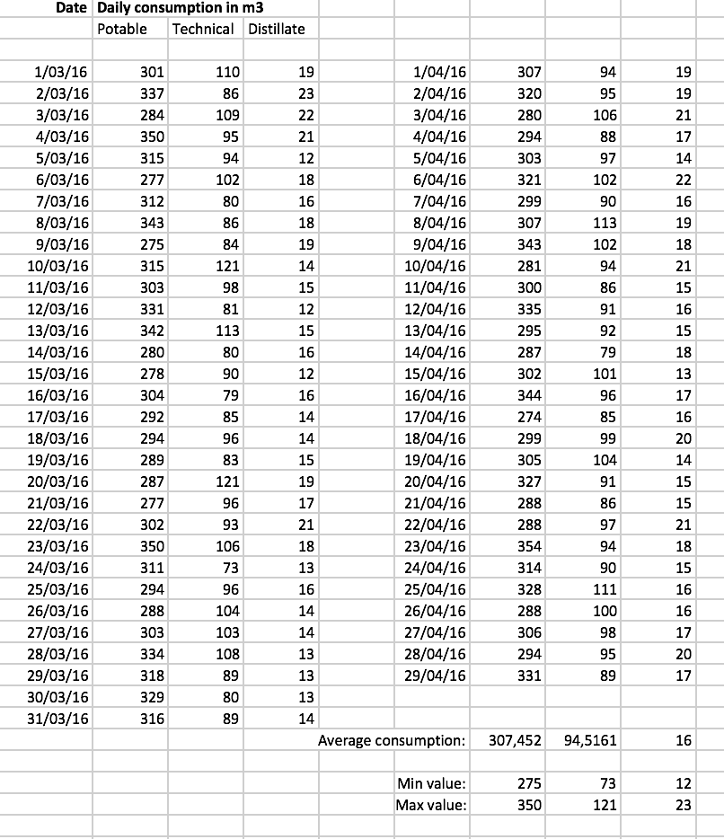
Attachment 1: Calculations average water consumption
This calculation of the average daily water consumption is based on values during the months March and April 2016. The big variation in potable consumption values is mainly due to the difference in consumption during sea days and port days.

Attachment 2

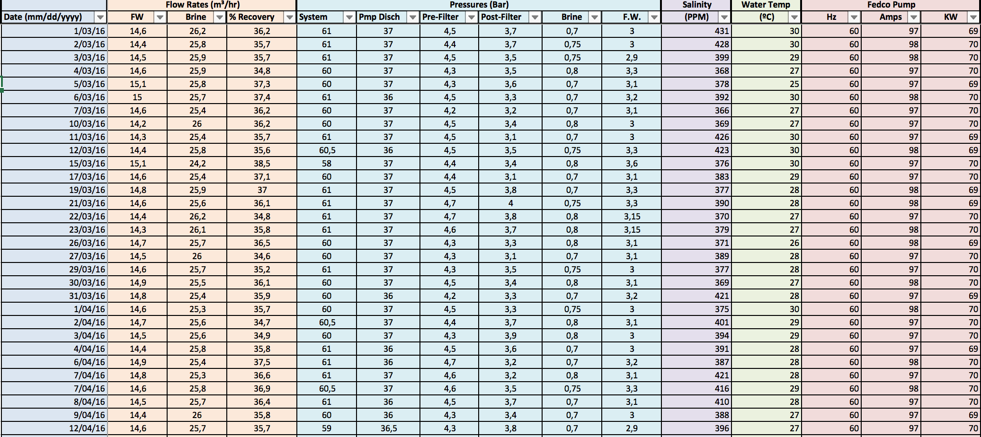

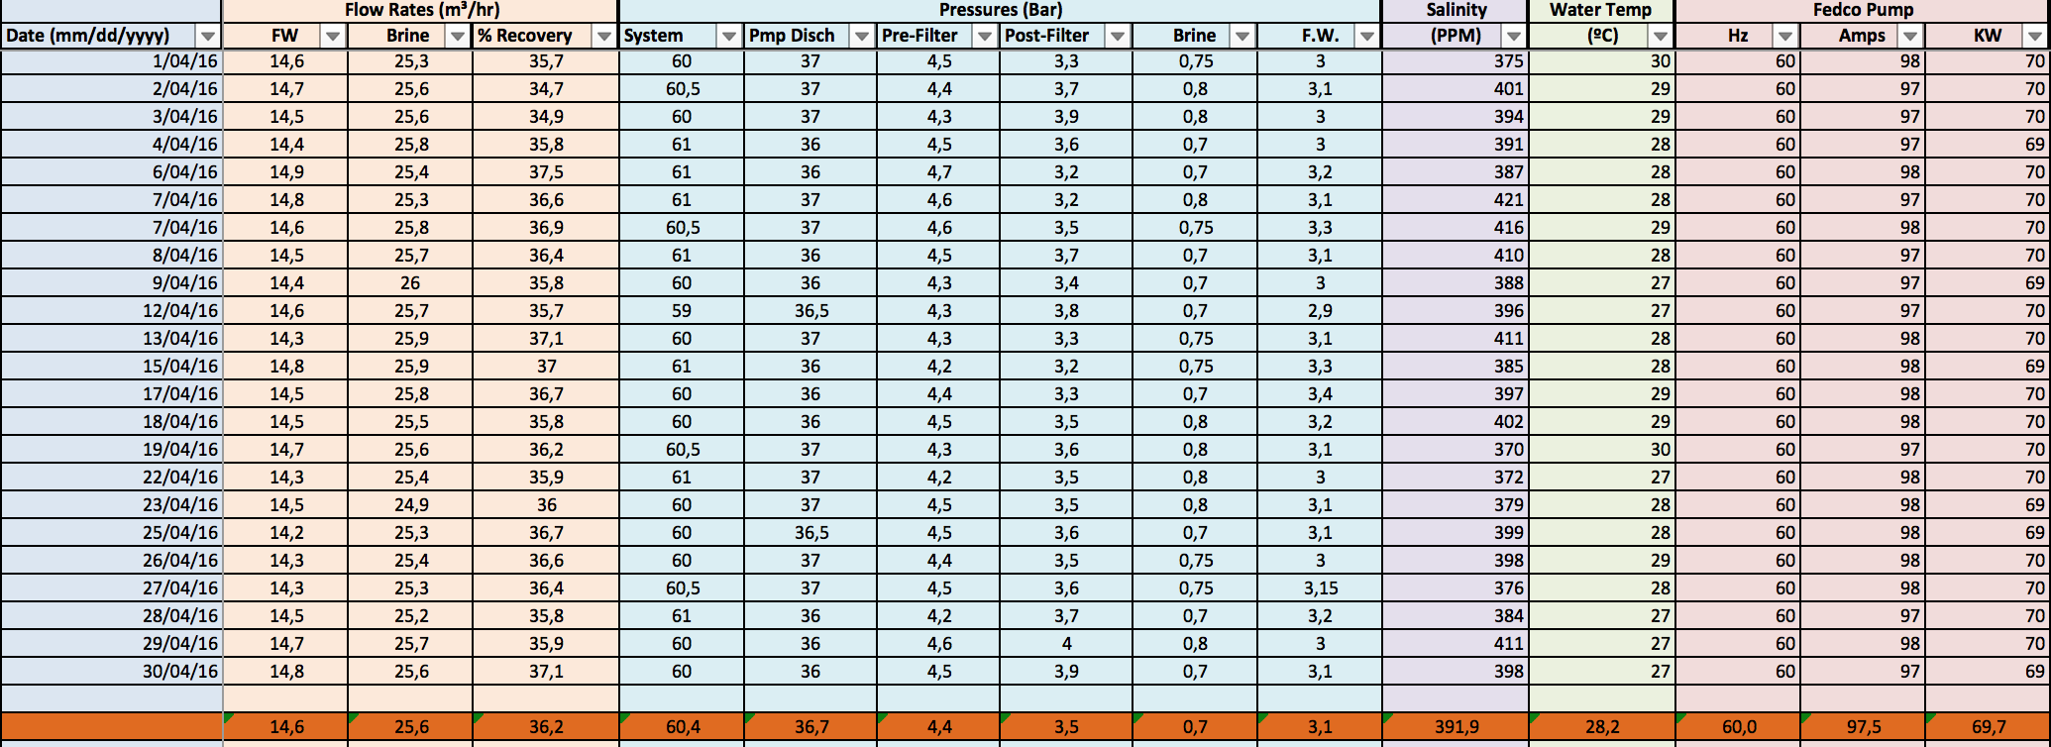

The values in the graph shown in image 9 are based on the daily gathered values during the months March-April 2016. As for a reference value, an average is taken to analyze the current condition of the reverse osmosis plant.

All these values together with the graphs are recorded in an excel database which can be shown at any given time.

Attachment 3

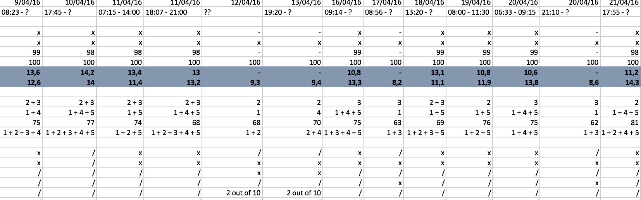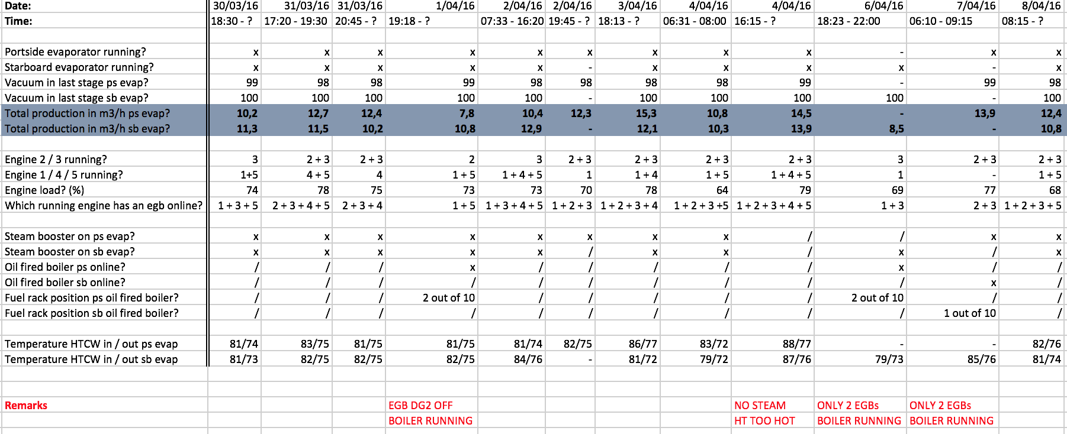

Example screenshot of the information collected about the evaporators’ performance over an extended period of time. All the data is stored in an excel file which can be showed at any given time. A total of 51 separate measurements were made.

Attachment 4

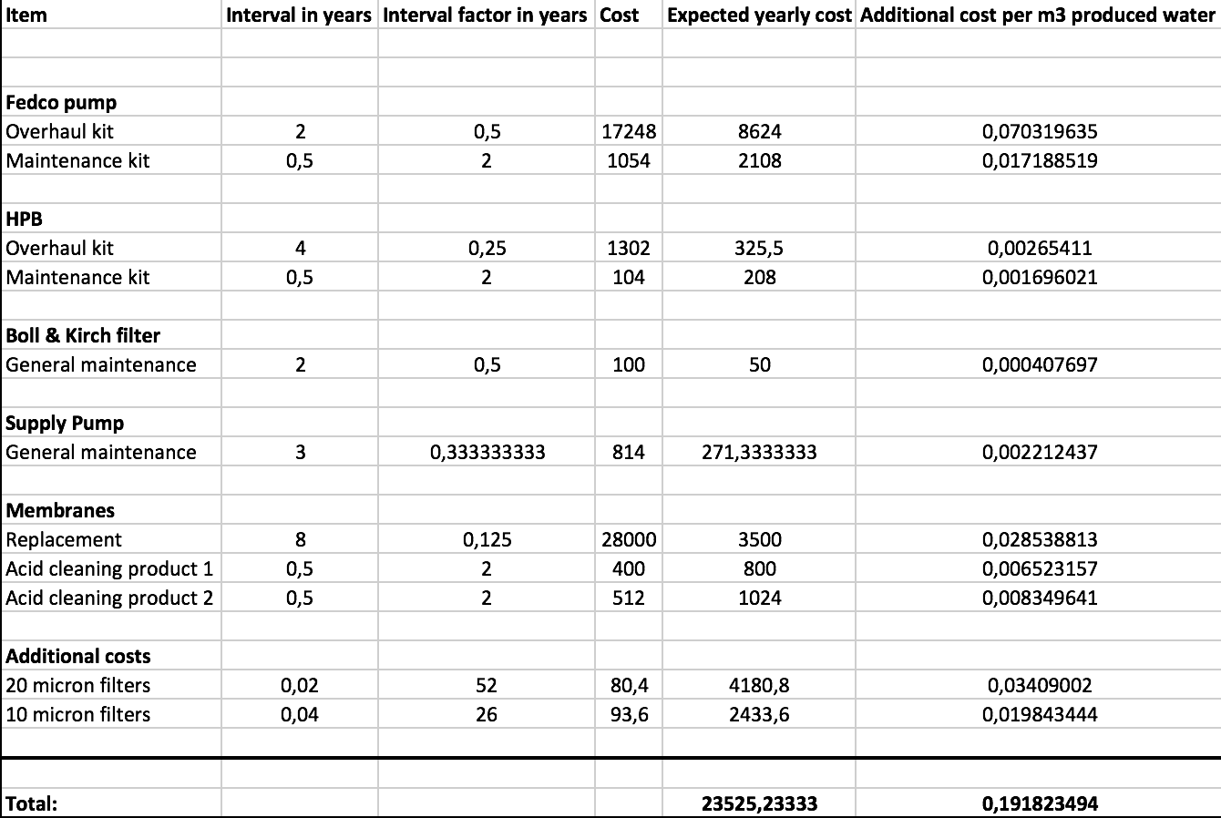

Calculations made in an excel database for the reverse osmosis maintenance costs. The excel file can always be shown as a reference.

Attachment 5

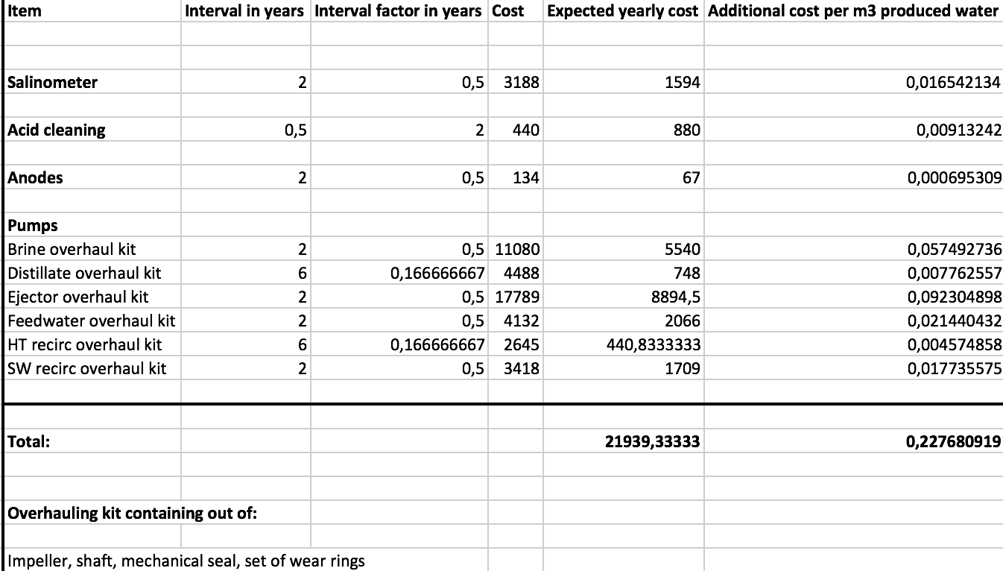

Calculations made in an excel database for the reverse osmosis maintenance costs. The excel
file can always be shown as a reference.

