The process of constructing a numerical simulation of the head difference around an artificial peninsula located in front of the coast of Zeeland
Final Report
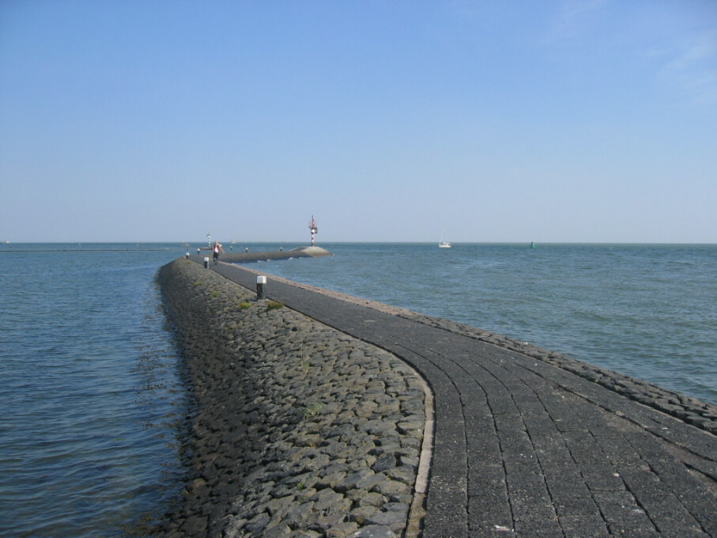

Wouter Kennis
Version 1.1
Graduation Research
HZ University of Applied Sciences
Supervisors: P. van der Heide, M. van der Linde
Vlissingen, January 16, 2017
The process of constructing a numerical simulation of the head difference around an artificial peninsula located in front of the coast of Zeeland
Final Report

Wouter Kennis
Version 1.1
Graduation Research
HZ University of Applied Sciences
Supervisors: P. van der Heide, M. van der Linde
Vlissingen, January 16, 2017
Contents
1. Introduction 1
2. Method 2
2.1 Construction of a static model of a Dynamic Tidal Power plant 2
2.1.1 Generating electricity 2
2.1.2 Inside the dam: flow through the turbines 2
2.1.3 Outside the dam: height difference due to tidal waves (static) 3
2.1.4 Assumptions on the value of parameters used in the static model 4
2.2 Influence of parameters of the static model on power generation 5
2.2.1 Length of the dam 5
2.2.2 Turbine area in relation to total available surface area 6
2.2.3 Internal resistance of the turbines 6
2.3 Translating static values to dynamic parameters 7
2.3.1 Incoming waves 7
2.3.2 Progression through the area 8
2.4 Software used to construct the model 9
2.4.1 Pre-selection of software packages 9
2.4.2 Choosing the desired software 11
3. Results 12
3.1 Examining functions in 2D 12
3.2 Lessons learned from 2D modelling 18
3.3 Combining functions in 3D 18
4. Conclusion and recommendation 20
5. References 21
6. Appendix 22

Introduction
A few years ago the Dutch government set goals for sustainability. These goals include switching to fully sustainable energy production by 2050. Using only conventional sustainable energy production methods like solar panels and wind turbines will not result in achieving the set goals, so alternative methods of energy production must be examined. One of these alternatives is Dynamic Tidal Power (DTP), this method uses a long dam perpendicular to the coastline creating a difference in water level on opposite sides of the dam that can be used for generating electricity. According to static models, such a dam stretching for around 50 km in an area with a tidal velocity of 1 m/s could potentially generate 11,5 GWe, roughly a third of the power used in the Netherlands in 2013.
However, some aspects involving such a DPT plant are still uncertain before the government can make a decision regarding construction. One of these aspects is the actual difference in water level around the dam which triggers the rotation of the turbines installed in the dam. Without an accurate model of the situation no concrete predictions on the amount of electricity generated by the dam can be made. This means no predictions can be made on how profitable the dam will be and how long it would take to earn back the investments. This could all ultimately lead to a decision not to build such a DPT plant and potentially not reaching the goals set for 2050.
This study means to create a way to gain an understanding of the potential electric yield of a DPT plant through the input of several key parameters. Since, generally speaking, electric power is derived from a pressure component and a flow component, this means that the behaviour of the water level around such a dam due to the influence of the tidal wave (the pressure component) is key in deriving the electric yield of the plant. Therefore the following research question has been proposed:
“How can the water level, influenced by changing tides, around a 50 km dam stretching off the coast of Zeeland be numerically simulated?”
The main question can be split up in several minor questions for the different aspects that need to be considered:
- How can a static model regarding Dynamic Tidal Power be constructed?
- What is the influence of input parameters on the power output of the dam?
- How can the static model be transformed into a dynamic model?
- What software can best be used to construct the dynamic model?
These questions will lead to a model which can simulate the varying water level around the dam at different times of the day depending on the nature of the tidal wave. When a year’s average amplitude is used as input for the simulation the results will represent the overall power production in that particular year, resulting in an indication of how profitable such a DTP-plant could be.

Method
This chapter will explain the steps taken in order to create the dynamic model for the DTP-plant. It will start by constructing a static model and explore the different aspects that influence the eventual power generation. This is followed up by an explanation of how several of the parameters in the static model behave in dynamic conditions. Finally, several software packages that could potentially be used to construct the model will be examined for their usefulness, eventually choosing one to construct the model in.

Construction of a static model of a Dynamic Tidal Power plant
This paragraph will explain how power is generated in a DTP-plant. The explanation will take a top-down approach, starting with the general equation for power from tidal difference and from there explain the different factors and their equations. The paragraph will present two main parameters that affect the total power production of the DTP-plant: Dam length and tidal velocity.

Generating electricity
The holes in the dam create a difference in water level in front and behind the turbines. The turbines use this to generate power according to the following equation:
$$P=φ_{v}*ρ*g*H*η$$
In this equation P represents the generated power (W) by multiplying ϕ_{v} (flow in m³/s), ρ (seawater density in kg/m³), g (gravitational constant in m/s²), H (height difference in m) and η (efficiency).
Factors like gravity, seawater density and efficiency will be constant after the dam has been built, meaning that factors influencing the amount of power generated will be the flow through the turbines and the height difference between the two sides of the dam.

Inside the dam: flow through the turbines
The flow through the turbines can be determined by multiplying the total surface area of the turbine pipelines with the velocity of the water through one of the turbines. This velocity will be determined using an adapted form of the Bernoulli law:
$$p_{out}+\frac{ρ*{v_{out}}^{2}}{2}+ρ*g*z_{out}+Δp_{w}=p_{in}+\frac{ρ*{v_{in}}^{2}}{2}+ρ*g*z_{in}$$
In this equation v_{out} equals the velocity of the fluid in the pipeline (m/s), v_{in} represents the velocity of the fluid before entering the pipeline, Δp_{w} represents the resistance in the pipeline (Pa), the pressure terms p represent the atmospheric pressure around the dam (Pa) and the z terms represent the water level in front and behind the dam (m).
The equation must be rearranged in a way that the desired parameter, the velocity in the pipeline, can be extracted. In this rearrangement the atmospheric pressures will be considered equal to each other, therefore cancelling each other out. Also, the height terms z_{in} and z_{out} can been combined to form a singular height difference. This means that the equation will have the following structure:
$$\frac{ρ*{v_{out}}^{2}}{2}+Δp_{w}=\frac{ρ*{v_{in}}^{2}}{2}+ρ*g*H$$
This rearrangement has kept the pressure drop by internal resistance on the left hand side of the equation. This has been done because the resistance in the pipeline is dependent on both the velocity of the water and the internal structure of the pipeline and turbine. This resistance takes the following form:
$$Δp_{w}=\sum{\frac{ξ*ρ*{v_{out}}^{2}}{2}}$$
In this equation ξ represents the resistance coefficients of the pipeline and the turbine, dependent on Reynold’s number, pipe length and diameter. Since the velocity and density of the fluid do not change over the length of the pipeline the equation can be rearranged to fit in Bernoulli’s law:
$$v_{out}=\sqrt{\frac{{v_{in}}^{2}+2*g*H}{\left(\sum{ξ}+1\right)}}$$
It is important to remember that the resistance coefficient ξ is a combined factor of both constant values due to the configuration of the turbine and variable values that change according to the velocity in the pipeline, creating an iterative process. However, computer simulations can account for this automatically.
Multiplying the final outcome of this equation with total area of all pipelines combined will lead to the total flow over the plant. This can be substituted into the original equation for power generation to take on the following form:
$$P=\sqrt{\frac{{v_{in}}^{2}+2*g*H}{\left(\sum{ξ}+1\right)}}*A_{turbines}*ρ*g*H*η$$
This equation shows that the total amount of generated power is dependent on a set of fixed values related to the configuration of the dam and the difference in water level between the two sides of the dam, as well as the velocity of the incoming tidal wave.

Outside the dam: height difference due to tidal waves (static)
According to the previously derived equation, the driving force behind the generation of power is the difference in height between both sides of the dam as well as the incoming velocity of the water. The difference in height, however, cannot be obtained the same way as in conventional tidal power using a basin. Instead, the difference in height will have some connection to the amount of water pushing against the dam.
This hypothesis can be proven using the analytical model made by Paul Kolkman from the Delft Hydraulics Laboratory (Deltares). He proposed the maximum difference in water level on both sides of the dam to have the following connection:
$$H_{max}=\frac{4*π*D*v_{max}}{g*T}$$
In this equation the maximum water level difference H_{max} is derived from several factors: D represents the length of the dam (m), v_{max} is the maximum undisturbed tidal velocity (m/s) and T represents the tidal wave period (s).

Assumptions on the value of parameters used in the static model
The equations used in the static model consist of several fixed parameters. These include water depth, tidal velocity, seawater density and internal resistance. Since, in this case, the location of the dam is off the coast of Zeeland, the topographical data can be derived from several sources:
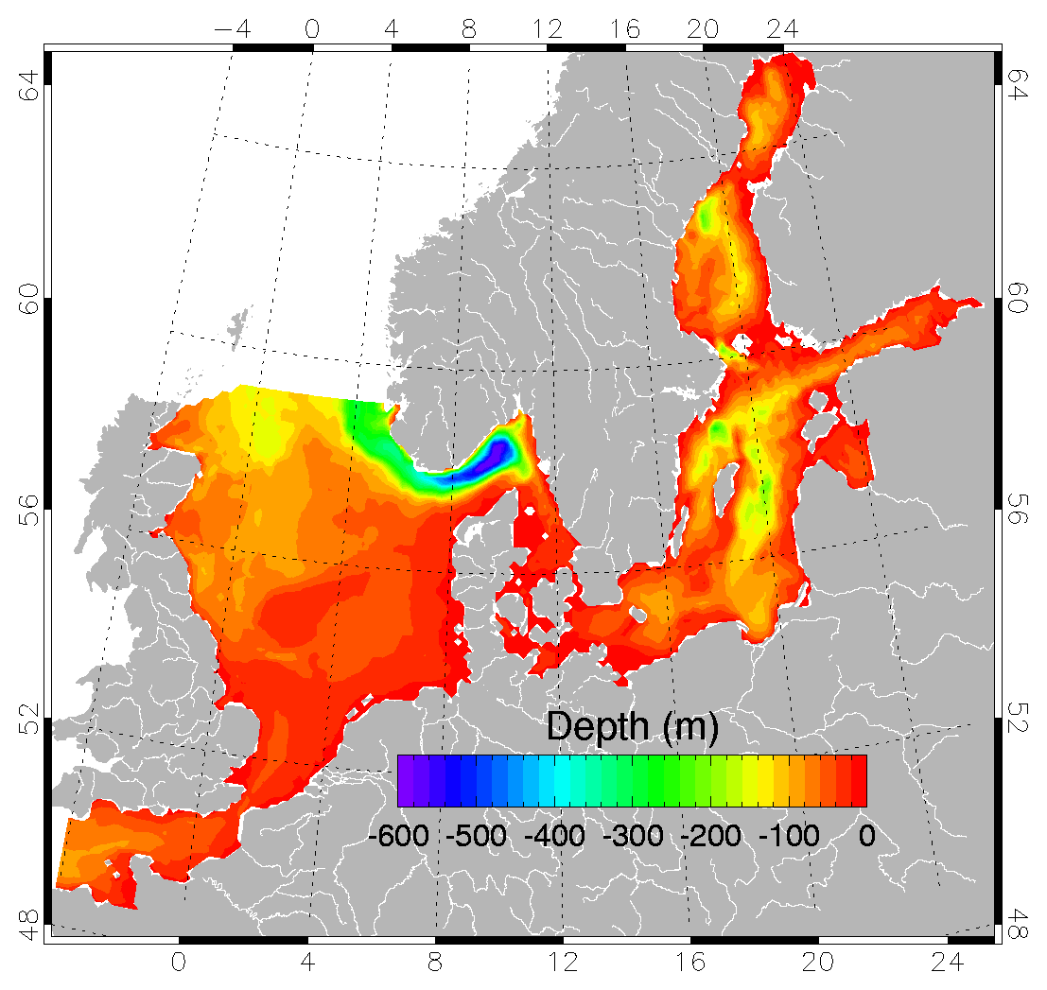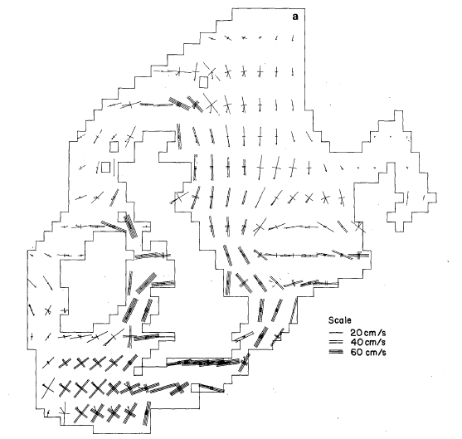
Figure 1: North Sea depth map Figure 2: Average tidal velocity in the North Sea area
In these figures the north sea area has been examined for both depth and tidal velocity. The maps show that in the area the dam will be built, water depth has been estimated to be 30 metres and tidal velocity has been estimated to be around 60 cm/s.
The resistance coefficient of the power equation will be set to one for the time being. Since the design of the turbine tube’s entrance and internal configuration largely decide this number no actual value can be given until detailed designs are available.
The static model is a simplification of the more complex dynamic variant. In reality increasing the amount of turbines in the dam will lead to a lower height difference over the dam due to water being able to flow through the dam rather than only around it. To compensate for this fact the model hypothetically shortens the dam to a closed variant with the same surface area as the actual dam as if the turbines would be present. The assumption is made that the height difference over the dam in the case of a long dam with turbines is the same as the height difference over a shorter dam without turbines.

Influence of parameters of the static model on power generation
Using the adapted Bernoulli equation and Kolkman’s analytical model a static model of the DTP-plant can be created. The model can then be used to analyse the influence of several parameters in these equations, other than water level around the dam, on power generation by altering only one of them at a time. In the analysis the following values for these parameters will be used as a base form:
Table 1: Parameters of the static DTP model
Parameter | Value | Unit
Velocity | 0.6 | m/s
Dam length | 50 | km
Effective dam length | 45 | km
Turbine efficiency | 0.8 | -
Water depth | 30 | m
Turbine area | 10 | % of dam area
Resistance coefficient | 1 | -
Tidal period | 43200 | s
Gravitational acceleration | 9.81 | m/s²
Density of sea water | 1025 | kg/m³
Using Kolkman’s equation first, the presence of a dam generates a height difference of around 0.8 metres. Using this height difference in the Bernoulli equation leads to a power generation of around 2.7 GW. These results can be used as a base line to compare against factors that could influence power production. This analysis will examine the effect of dam length, turbine area and internal resistance on power generation with the help of figures generated with MS Excel.

Length of the dam
The first parameter to be analysed is the dam’s length. As seen in the figure below, power generation increases exponentially due to the dam’s length having influence on the water height difference around the dam according to Kolkman’s equation. In a completely simplified form of the power equation, only dependent on the dam’s length, the relation between length (km) and power (GW) is as follows:
$$P=0,0002D^{2.4479}$$
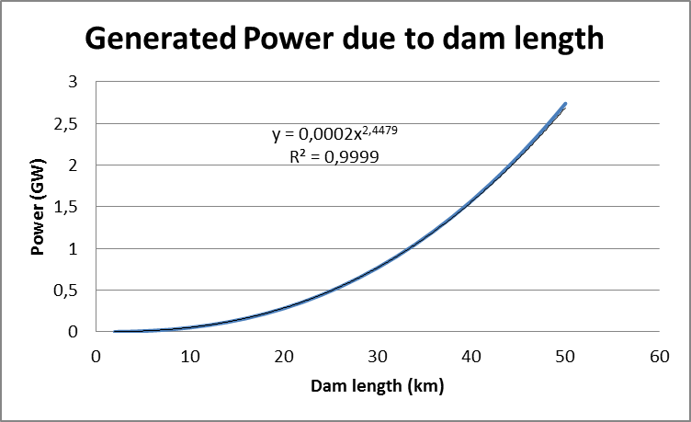
Figure 3: The relation between dam length (km) and power generation (GW)

Turbine area in relation to total available surface area
Another parameter affecting power generation is the total amount of turbines. An increase in turbines will in general increase the power output of the dam, but due to more water flowing through the dam the height difference on opposite sides of the dam will decrease. The figure below describes how increasing the turbine area will result in increasing the total power output as expected, but reach an optimum at a turbine area of around 40% of the total dam’s surface area.
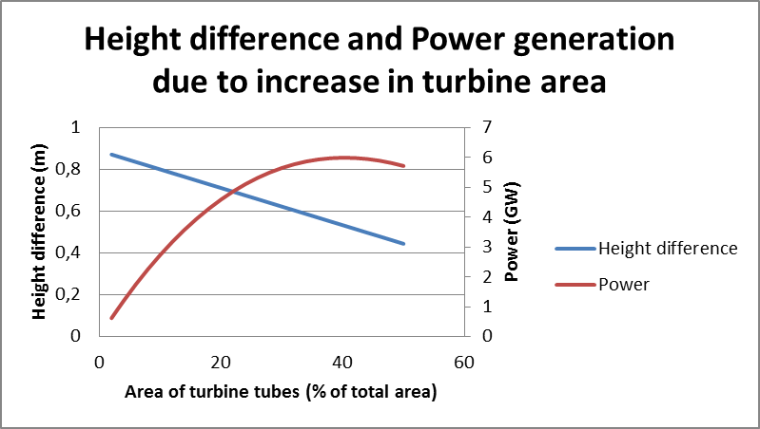
Figure 4: Changes in height difference (m) and power generation (GW) due to an increase in the total turbine area (%)

Internal resistance of the turbines
A third parameter influencing the total amount of power produced is the internal resistance inside the turbines. Increased resistance will reduce the flow through the turbines, resulting in a lower power production. However, the reduced flow will increase the height difference over the dam due to the restriction of the water’s movement. The figure below demonstrates the connection between power, height difference and internal resistance.
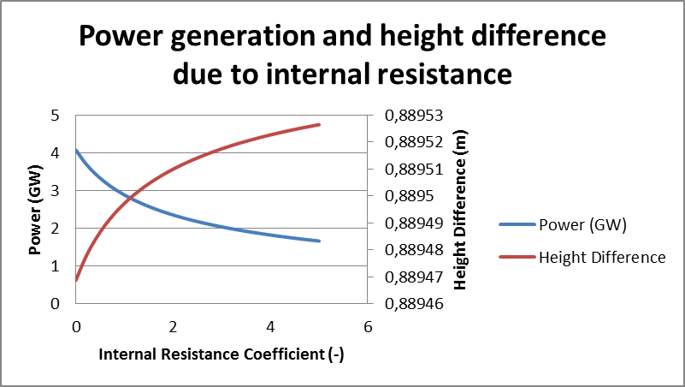
Figure 5: Generated Power (GW) and height difference over the dam (m) as a result of increased internal resistance (-)

Translating static values to dynamic parameters
The static model has produced an environment in which several factors can be tested for their influence on power generation. However, the DTP-plant will be placed in a dynamic environment. This paragraph will deal with the conversion of several factors from static to dynamic as to enable their use in the eventual model. Two factors described here are the incoming waves and the behaviour of water in the area around the dam.

Incoming waves
The amount of water approaching the dam changes over the course of a day, as seen near the coast in low and high tides. Tides move along the coast as time progresses, meaning that in this case more to the south measurements are taken, the earlier high tides show up in the data. This fact can be used to examine the wavelength and propagation speed of these tidal waves.
The wave propagation speed can be found by dividing the distance between two locations along the coastline by the time difference between the highest water levels. In this case the two locations chosen are Westkapelle and the Hartelhaven, roughly 65 km apart. The water level information derives from the tidal information of November 22nd 2016:
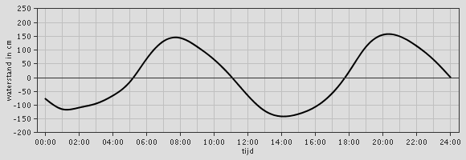
Figure 6: Tidal information of Westkapelle, November 22nd 2016
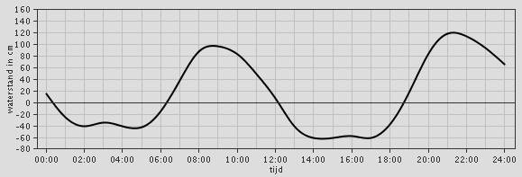
Figure 7: Tidal information of the Hartelhaven, November 22nd 2016
The graphs show that there is a peak in water level in Westkapelle at around 7:45 am and in the Hartelhaven at around 9:00 am. This means that the tidal wave travels roughly 65 km in 1.75 hours, meaning 37 km/h, therefore around 10 m/s in between the two locations. Since tides have a period of twelve hours the wavelength is 445 kilometres.
Another point of interest is the amount of water flowing through the area. A rough estimate can be made from the data used earlier. The figure above states that the maximum difference between high and low tide in Westkapelle is around 3 metres. At that point, the distance across the North Sea to the English coast is around 140 kilometres. Along with the velocity of the tidal wave of 10 m/s the amount of water flowing through the North Sea is 4.2 million cubic metres of water per second(around 4.3 billion kg/s when using a seawater density of 1025 kg/m³). The conclusion of the depth map used earlier was that the area of the North Sea used for the DTP-plant has an average depth of 30 metres, meaning that the mass flowing through the area is around 43 billion kg/s with a varying 2.15 billion kg/s due to the tides.
The flow through the North Sea must now be translated into a sinusoid function before it can be used as input for the model. The period for the tidal wave is 12 hours, therefore the equation used for the flow through the North Sea is as follows:
$$\dot{m}=43*{10}^{9}+2.15*{10}^{9}*sin⁡(\frac{2π}{43200}t)$$
The equation formulated above defines the flow across the entire distance of the North Sea between Westkapelle and the English coast spanning 140 km. This means that the flow per kilometre is as follows:
$$\dot{m}=0.31*{10}^{9}+0.015*{10}^{9}*sin⁡(\frac{2π}{43200}t)$$
This equation combined with the velocity of the tidal wave of 10 m/s can now be used as input for the model.

Progression through the area
The behaviour of water in a three-dimensional environment can be described using the shallow water equations. These equations take an average water depth in order to create an image of the movement of waves, with or without structures obstructing their path. The equations combine the conservation of mass and momentum with mass continuity in order to create the following result:
$$\frac{δ}{δt}u+u\frac{δ}{δx}u+v\frac{δ}{δy}u+w\frac{δ}{δz}u=1\frac{1}{ρ}\frac{δ}{δx}p$$
$$\frac{δ}{δt}v+u\frac{δ}{δx}v+v\frac{δ}{δy}v+w\frac{δ}{δz}v=1\frac{1}{ρ}\frac{δ}{δy}p$$
$$\frac{δ}{δt}w+u\frac{δ}{δx}w+v\frac{δ}{δy}w+w\frac{δ}{δz}w=1\frac{1}{ρ}\frac{δ}{δy}p-g$$
The shallow water equations use u, v and w to indicate the velocity in three dimensions (x, y and z). As per usual density, pressure and gravitational acceleration have been referred to as ρ, p and g. Given the boundary conditions these equations will be able to indicate the tidal velocity around the dam. The equations will also remove the need to compensate the dam’s length in the height equation, since they will account for water ‘leaking’ through the dam.

Software used to construct the model
This paragraph will explore several possible software packages that could be used to construct the numerical model. Following the introduction of several of these, a choice will be made which software package will be used to construct the model.

Pre-selection of software packages
Several software packages exist for numerical modelling. However, not every one of these will be suitable for this situation, since they specialise in data-analysis and statistics. Software that could be used for the model will therefore need the capability to solve time-dependent partial differential equations. A selection has been made by checking the most used applications of several software packages and only further explore those that seemed useful for the project. Four software packages that have passed this first selection will be discussed: MATLAB, GNU Octave, OpenFOAM and COMSOL Multiphysics.
MATLAB
MATLAB is a desktop application that offers a simple structure to solve complex (iterative) equations. It achieves this by keeping the algebraic code used similar to how one would find it in textbooks. Several of the features MATLAB offers are:
- Easy to understand code suitable for scientific and engineering computing
- Desktop environment tuned for iterative exploration, design, and problem-solving
- Graphics for visualizing data and tools for creating custom plots in 2D and 3D
- Functions for curve fitting, data classification, signal analysis, and many other domain-specific tasks
- Tools for building applications with custom user interfaces
- Options for sharing MATLAB programs for free with other users
MATLAB also offers several extensions such as FEATool. This is a toolbox that enables the user to solve engineering problems through its GUI, it is also customizable using the MATLAB code. FEATool offers the following features:
- Geometric modelling in one, two, and three dimensions
- Triangular, tetrahedral, quadrilateral, and hexahedral grid cells
- Pre-defined physics modes for heat transfer, fluid dynamics, mass transport, structural mechanics, electrostatics, and classic PDE equations
- Automatic grid generation with simplex grid cells
- Stationary, time-dependent, linear, and non-linear solvers
- Constant, 1st, and 2nd order conforming and non-conforming FEM shape functions
- Easy to use GUI and command line scripting functionality

GNU Octave
GNU Octave is a free alternative to MATLAB concerning numerical simulation software. It excels at solving equations for both linear and nonlinear experiments. As seen in the image below, coding is done with a simple top-to-bottom approach, making it simple to understand:
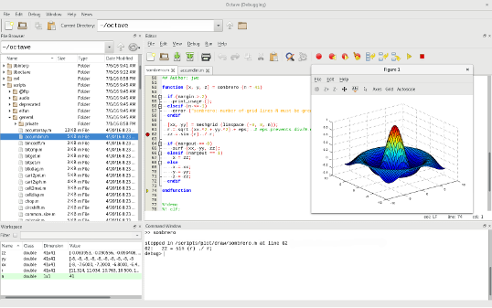
Figure 8: Screenshot of a GNU Octave worksheet
GNU software is constantly updating, its latest version, Octave 4.0.3, was released on July 2nd 2016.
OpenFOAM
OpenFOAM (Open source Field Operation And Manipulation) is a free simulation software. It focusses on the simulation of fluid dynamics. The image below gives an example of how OpenFOAM visualises the results of a mass of water being released and spilling over a dam:
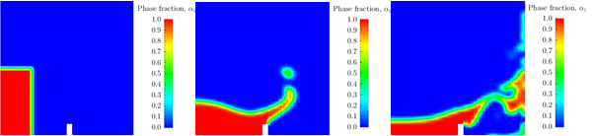
Figure 9: Water spilling over a dam
This example shows that OpenFOAM is capable of simulating the movement of fluids over time in a series of two dimensional images.
COMSOL Multiphysics
COMSOL Multiphysics is a multi-purpose simulation software. It enables the user to generate virtually any situation due to its ability to connect with CAD-like software and its ability to simulate the behaviour of heat transfer and fluid dynamics.
The COMSOL Multiphysics engine allows it to have the following features:
- Geometric modelling of simple shapes with options to import more complex CAD models
- Meshing of 3D and 2D models
- Equation based modelling through non-linear PDE’s, ODE’s and DAE’s
- Access to solvers such as MUMPS, PARADISO, SPOOLERS and several others
- Generate materials with both linear and nonlinear properties
- Physics-based modelling of heat transfer, laminar flow and pressure acoustics
- Visualising results in surface plots, streamline plots, contour plots and others
- Enables importing / exporting of data to other products

Choosing the desired software
After having examined several basic differences between the software packages the desired functions of the model are mostly included in COMSOL Multiphysics. Due to its graphic design capabilities and built-in physics simulator creating an environment to simulate a DTP-plant is made simpler than having to design the entire surroundings of the dam through an extensive code. COMSOL Multiphysics also has the most desired functions regarding the display of results due to its 3D graphic creator.

Results
Comparing the different possible software packages has resulted in the selection of COMSOL Multiphysics. The following chapter will explain the steps needed to reach a functional model of a DTP-plant, starting at a simple basis and adding complexion with every step taken. The different functions will first be examined in 2D, after which insights into COMSOL Multiphysics will enable the construction of a 3D model, of which the construction steps are globally described.

Steps taken to construct the models
Models constructed with COMSOL Multiphysics have a specific layout. The model in general is split into three categories: Model, Study and Results.
The Model section is in turn split up into: Definitions (to define constants and to add in ramps), Geometry (to construct the physical domain of the model), Materials (to assign materials to parts of the domain), Physics (contains all used equations, also used to define initial values and boundary conditions, name changes depending on what physics are selected) and Mesh (to construct the grid in which the solver runs the simulation).
The Study section contains the solver that will run the simulation. In here, the length of the simulation as well as the solving methods and tolerances can be defined.
The Results section contains the conclusions of the simulation which can be visualised in plots and tables.

Processing the results
After the model is configured, the compute button in the Study section will start the program’s calculations. The results of these calculations will be placed in the Results section in the form of a Plot Group, which in turn can be configured to visualise the desired result in several ways such as surface plots and contour plots.
COMSOL’s solver can be used to run a simulation for a set amount of time. However, the default plots generated in the Results section will only show the situation as is on the first second. Therefore, the need exists to change these plots into an animation that shows every point in the simulation. To achieve this, select the desired plot and use the “player” button on the toolbar. The animation can now be configured to the desired framerate and runtime after which it can be exported.

Examining functions in 2D
This section will examine the different functions COMSOL Multiphysics has to offer in 2D environments. First, the area of the DTP-plant will be simulated as if seen from above, demonstrating the flow in the area and the effect the dam has on the fluid’s trajectory and velocity. This is followed by a simulation of the area as if seen from the side, where a cross-section of the area is used to generate waves and height differences in the water.

Undisturbed steady flow of water
- In the model wizard, choose 2D for the dimensions, Laminar Flow (spf) in the add physics window and Time Dependent in the select study type window
- In the Definitions section, add a step function and enable smoothing with a transition zone of 0.1
- In the Geometry section, set the scale to km and add a rectangle with a width of 100 km and a length of 50 km at the location x = 0 km and y = 0 km
- In the Materials section, add water to the model and appoint it to domain 1
- In the Laminar Flow section, add an inlet to boundary 1, an outlet to boundary 4 and a second wall to boundary 3. Then, switch the inlet to mass flow and set the flow to 50/30*0.31*10^9 kg/s. In the second wall section, switch the boundary condition to slip
- In the Mesh section, select a Physics-controlled mesh with a normal element size
- In the Study section, set the time in the Step 1: Time Dependent section to range(0,432,86400) to represent a full day of simulation
- In the Study section, press the Compute button
The result of this model is a series of plots for the velocity and pressure of the water over time. These plots can be merged into an animation as instructed above.
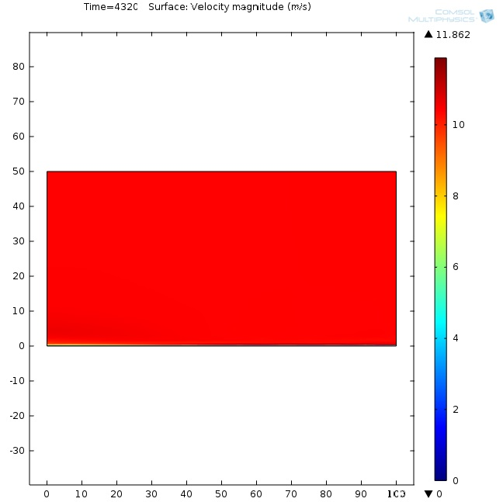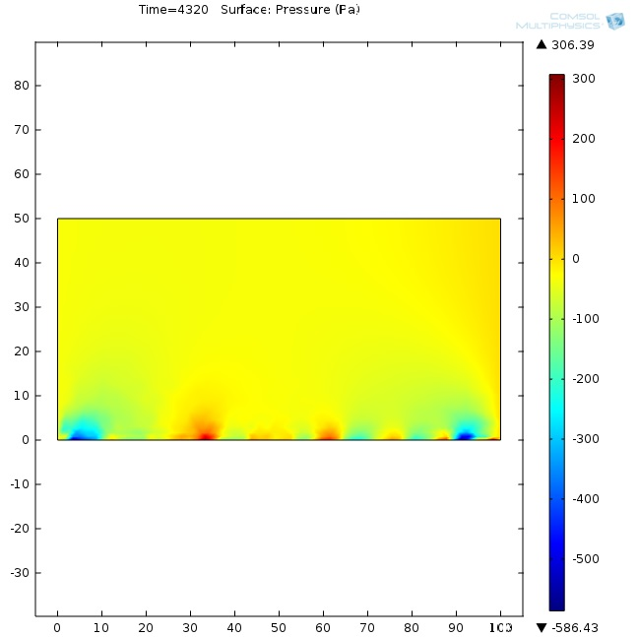
Figure 10: Water velocity and pressure plot of an undisturbed steady flow

Undisturbed periodic flow of water
- In the model wizard, choose 2D for the dimensions, Laminar Flow (spf) in the add physics window and Time Dependent in the select study type window
- In the Definitions section, add a step function and enable smoothing with a transition zone of 0.1
- In the Geometry section, set the scale to km and add a rectangle with a width of 100 km and a length of 50 km at the location x = 0 km and y = 0 km
- In the Materials section, add water to the model and appoint it to domain 1
- In the Laminar Flow section, add an inlet to boundary 1, an outlet to boundary 4 and a second wall to boundary 3. Then, switch the inlet to mass flow and set the flow to 50/30*(0.31*10^9+0.015*10^9*sin((2*pi)/43200*t)) kg/s. In the second wall section, switch the boundary condition to slip
- In the Mesh section, select a Physics-controlled mesh with a normal element size
- In the Study section, set the time in the Step 1: Time Dependent section to range(0,432,86400) to represent a full day of simulation
- In the Study section, press the Compute button
The result of this model is a series of plots for the velocity and pressure of the water over time. These plots can be merged into an animation as instructed above.
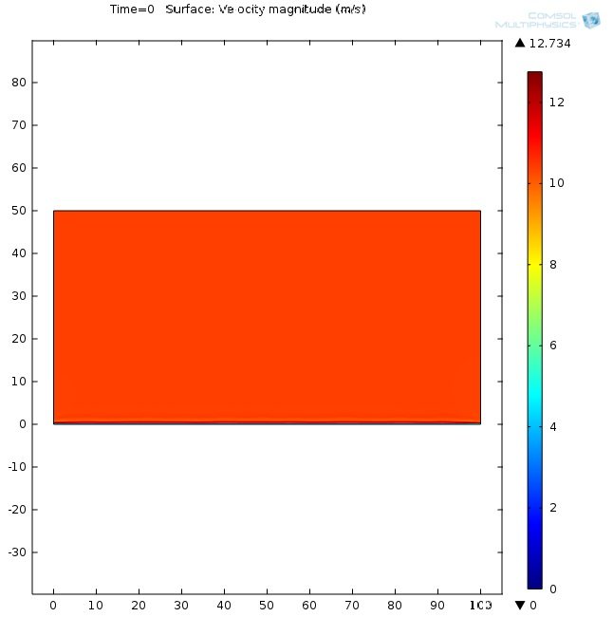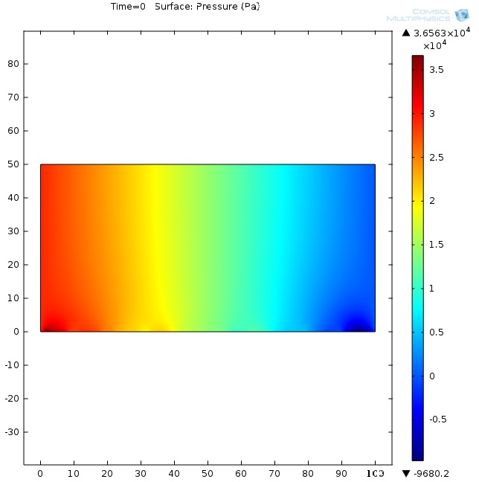
Figure 11: Water velocity and pressure plot of an undisturbed periodic flow

Periodic flow of water around a solid dam
- In the model wizard, choose 2D for the dimensions, Laminar Flow (spf) in the add physics window and Time Dependent in the select study type window
- In the Definitions section, add a step function and enable smoothing with a transition zone of 0.1
- In the Geometry section, set the scale to km and add a rectangle with a width of 100 km and a length of 50 km at the location x = 0 km and y = 0 km
- In the Geometry section, add a second rectangle with a width of 0.02 km and a height of 20 km at the location x = 30 km and y = 0 km. Then, add a difference section and subtract rectangle 2 from rectangle 1
- In the Materials section, add water to the model and appoint it to domain 1
- In the Laminar Flow section, add an inlet to boundary 1, an outlet to boundary 4 and a second wall to boundary 3. Then, switch the inlet to mass flow and set the flow to 50/30*(0.31*10^9+0.015*10^9*sin((2*pi)/43200*t)) kg/s. In the second wall section, switch the boundary condition to slip
- In the Mesh section, select a Physics-controlled mesh with a normal element size
- In the Study section, set the time in the Step 1: Time Dependent section to range(0,432,86400) to represent a full day of simulation
- In the Study section, open the Time-Dependent Solver and in the Time Stepping tab, switch the steps taken by solver to intermediate
- In the Study section, press the Compute button
The result of this model is a series of plots for the velocity and pressure of the water over time. These plots can be merged into an animation as instructed above.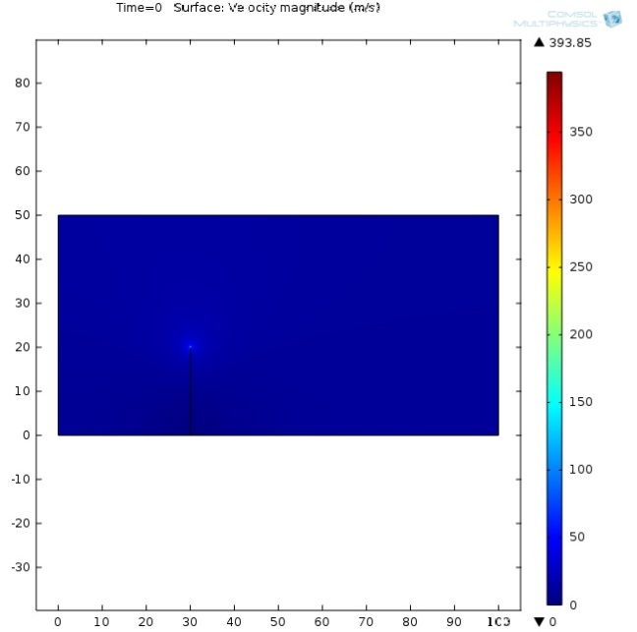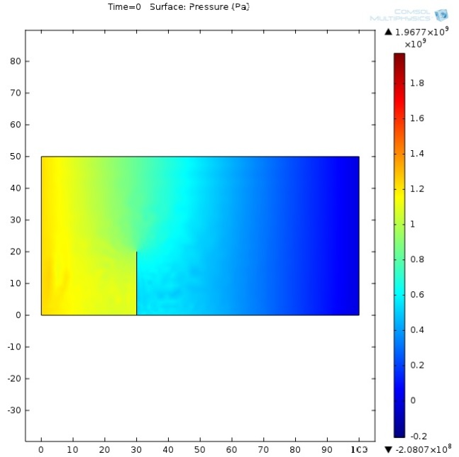
Figure 12: Water velocity and pressure plot of a periodic flow around a solid dam

Periodic flow of water around a dam with openings
- In the model wizard, choose 2D for the dimensions, Laminar Flow (spf) in the add physics window and Time Dependent in the select study type window
- In the Definitions section, add a step function and enable smoothing with a transition zone of 0.1
- In the Geometry section, set the scale to km and add a rectangle with a width of 100 km and a length of 50 km at the location x = 0 km and y = 0 km
- In the Geometry section, add five extra rectangles with a width of 0.02 km and a length of 4 km at the locations x = 0, 4.15, 8.30, 12.45 and 16.60 km and y = 30 km
- In the Materials section, add water to the model and appoint it to domain 1
- In the Laminar Flow section, add an inlet to boundary 1, an outlet to boundary 4 and a second wall to boundary 3. Then, switch the inlet to mass flow and set the flow to 50/30*(0.31*10^9+0.015*10^9*sin((2*pi)/43200*t)) kg/s. In the second wall section, switch the boundary condition to slip
- In the Mesh section, select a Physics-controlled mesh with a normal element size
- In the Study section, set the time in the Step 1: Time Dependent section to range(0,432,86400) to represent a full day of simulation
- In the Study section, set the Relative tolerance to 10
- In the Study section, open the Time-Dependent Solver and in the Time Stepping tab, switch the steps taken by solver to intermediate
- In the Study section, press the Compute button
The result of this model is a series of plots for the velocity and pressure of the water over time. These plots can be merged into an animation as instructed above.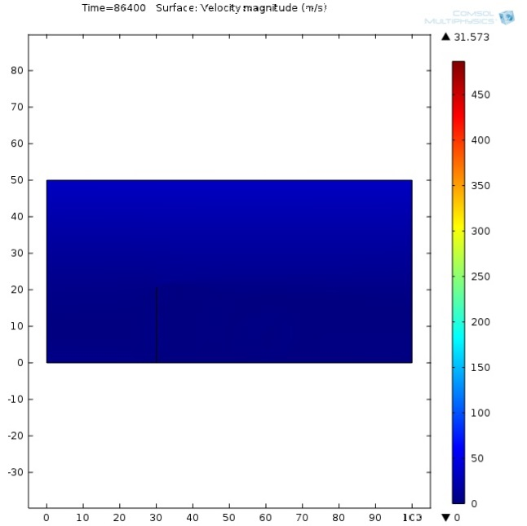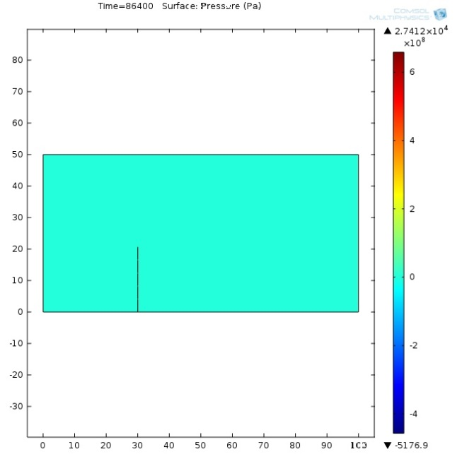
Figure 13: Water velocity and pressure plot of a periodic flow around a dam with slits

Wave-motion due to a steady flow of water
- In the Model Wizard, choose 2D for the dimensions, Laminar Two-Phase Flow, Moving Mesh (tpfmm) in the add physics window and Time Dependent in the select study type window
- In the Definitions section, add a variables tab and insert variable g = 9.81
- In the Definitions section, add a step function and enable smoothing with a transition zone of 0.5
- In the Geometry section, add a rectangle with a width of 2 m and a height of 0.5 m at location x = 0 and y = 0. Add a second rectangle with a width of 2 m and a height of 1 m at location x = 0 and y = 0.5
- In the Geometry section, add four points at locations x = 0 and y = 0.1, x = 0 and y = 0.4, x = 2 and y = 0.1 and x = 2 and y = 0.4
- In the Materials section, add water to domain 1 and air to domain 2
- In the Laminar Two-Phase Flow, Moving Mesh section, set Wall 1 to No slip. Add a second Initial values section and assign that to domain 2. Add an Inlet to boundary 3 with an inflow velocity of 0.2 m/s and an Outlet to boundary 9. Add a volume force for domain 1 with a y of –g*1000 and add a volume force for domain 2 with a y of –g. Finally add a Fluid-Fluid Interface to boundary 6 and switch the surface tension coefficient to a Library coefficient, liquid/gas interface of Water/Air
- In the Mesh section, select a Physics-controlled mesh with a normal element size
- In the Study section, set the time in the Step 1: Time Dependent section to range(0,0.1,1.1) with a Relative tolerance of 0.1
- In the Study section, open the Time-Dependent Solver and in the Time Stepping tab, switch the steps taken by solver to intermediate
- In the Study section, press the Compute button
The result of this model is a series of plots for the velocity and density of both domains over time. These plots can be merged into an animation as instructed above.
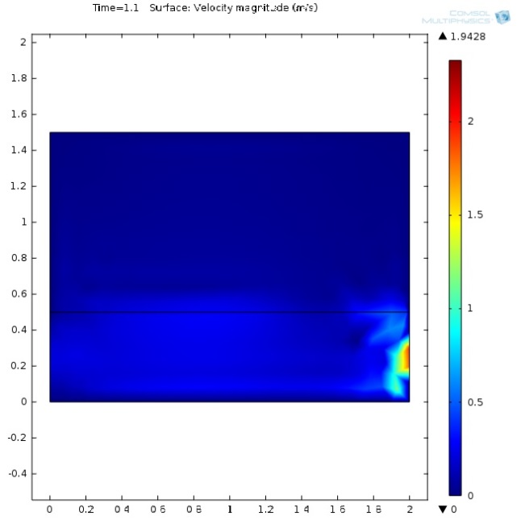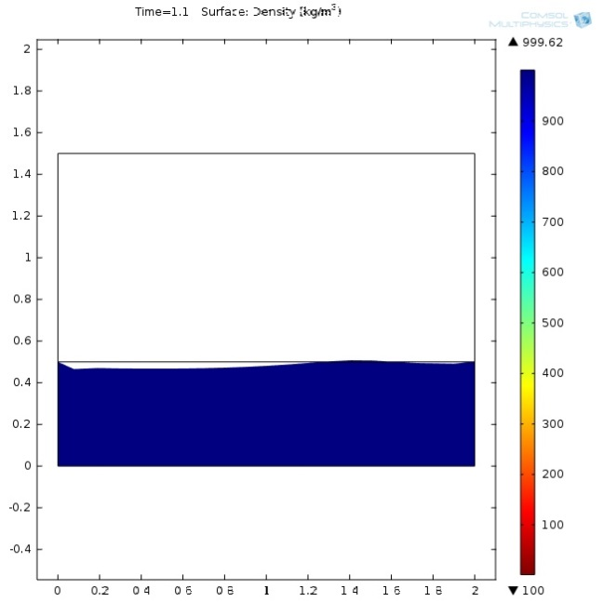
Figure 14: Velocity and Density plots of a sideways view of flowing water

Lessons learned from 2D modelling
By trying out the different functions COMSOL Multiphysics has to offer in two dimensional space, several insights have been gained:
- Creating an environment for a simulation can be achieved through the combination of simple shapes and by adding the right material to the desired domains.
- Every material needs a separate Initial Values and Volume Force section, even if their conditions are identical.
- The mesh used should be as fine as possible to generate the most accurate result. However, this is not always necessary and finer meshes lead to longer simulation times.
- The solver needs very close attention. Time ranges and steps taken for plots are located in a different tab than the time steps used in the simulation. Also, several options for improving the simulation exist but with no explanation whatsoever, choosing the wrong option will lead to failed simulations.
- Error messages are vague, leading to a lot of time loss unless instructions gathered from forums can point to the right direction.
- Results from a completed simulation can be reviewed in animations. These can be altered to the desired format and finally be exported into separate files. However, the exporting of these animations has not yet been successful.

Combining functions in 3D
The insights gained in the previous paragraph will be useful in combining the functions into a full 3D model. This section will describe the overall steps that need to be taken to combine the periodic flow around the dam and the wave-motion model from the 2D environment into a single model. Just as before the initial model will be a simple representation of the area, adding complexion after every step.
Undisturbed steady flow of water
- Select a 3D, Laminar Two-Phase Flow, Moving Mesh (tpfmm), Time Dependent model in the Model Wizard
- Use the same dimensions as the 2D undisturbed water flow model. Instead of a rectangle, use a block with a height of 30 metres
- Add a layer of air over the previous block with a height of 70 metres
- Add a fluid-fluid interface to the boundary between the two blocks
- Add an inlet to one end of the water block with a mass inflow of 0.31*10⁹*50 kg/s
- Add an outlet to the other end of the water block
- Add the necessary Initial Values and Volume Force sections and assign them to the correct domains
- Construct a mesh of appropriate size
- Set the runtime of the simulation to 86400 seconds (12 hours) and configure the solver in such a way that this runtime is possible (by altering time steps / solving methods / etc.)
- Start the simulation with the Compute button.

Undisturbed periodic flow of water
- Use the previous model as a base for this one
- Change the flow in the inlet to 50*(0.31*10^9+0.015*10^9*sin((2*pi)/43200*t)) kg/s
- Configure the mesh and solver in a way that the simulation can run for the desired 12 hours
Periodic flow of water around a solid dam
- Use the previous model as a base for this one
- Add a block to the model, around a third of the length in, with a width of 0.02 km, stretching about halfway into the stream of the water and a few metres out of the water. Use the Difference function to subtract it from the other two existing blocks
- Configure the mesh and solver in a way that the simulation can run for the desired 12 hours
Periodic flow of water around a dam with openings
- Use the previous model as a base for this one, double the length and width of the model to end up with a domain of 200 km long, 100 km wide and 100 m high (consisting of 30 m of water and 70 m of air)
- Temporarily delete the Difference function used in the previous model
- Use the block used to represent a dam to overlap several round holes with a diameter of 8 metres with their centre at a height of 25 metres (for realism, no holes should be placed in the two kilometres of the dam close to the edges)
- Use the Difference function to subtract the leftover dam from the other domains in the model
- Configure the mesh and solver in a way that the simulation can run for the desired 12 hours.

Conclusion and recommendation
At the start of the project, a research question was formed to find out how the dam in a Dynamic Tidal Power plant influences the water level around the dam. To aid in this question, it was split up into different questions dealing with a static model and which parameters affect the water level and power production of the dam. It also dealt with aspects that needed to be changed in order to allow the model to be converted into a dynamic version of the previous static model and what software should be used in order to correctly construct this model. Through research and experimentation with the software, the following can be concluded:
- A static model of a Dynamic Tidal Power plant can be constructed using Kolkman’s analytical model: $H_{max}=\frac{4*π*D*v_{max}}{g*T}$ and a combination of an equation for tidal power and an alteration of the Bernoulli law of fluid dynamics: $P=\sqrt{\frac{{v_{in}}^{2}+2*g*H}{\left(\sum{ξ}+1\right)}}*A_{turbines}*ρ*g*H*η$
- A longer dam will lead to an exponential increase in power production due to the dam’s length being represented multiple times in the power equation.
- Greater turbine surface area will initially increase the power output but greater flow through the dam will lead to lower height differences and therefore lower power output. This causes the power output to peak at around 40% when this static model is used.
- Increased internal resistance will lead to a reduction in power production due to lower flow rates through the turbines, but this results in an increase in the difference in water level around the dam.
- The constant initial velocity will be changed to a fluctuating mass flow of $\dot{m}=0.31*{10}^{9}+0.015*{10}^{9}*sin⁡(\frac{2π}{43200}t)$ per kilometre if distance is taken perpendicular to the coastline to represent a tidal wave of 12 hours flowing from the English Channel along the Dutch coastline.
- Kolkman’s analytical model will be exchanged for the shallow water equations to create a dynamic model.
- Due to its built in physics engine, the software package most suitable for creating the dynamic model is COMSOL Multiphysics.
The project has resulted in the construction of several models in COMSOL representing a 2D environment in which a top down view of the area surrounding the DTP dam has been simulated when exposed to a tidal wave and a sideways view of a water wave due to the influence of flowing water. These two models can now be combined in order to create a 3D full-scale model of a DTP dam.

Recommendation
Over the course of the project several setbacks have occurred regarding COMSOL. These setbacks range from problems with accessibility to problems with COMSOL’s layout and solver configurations. These problems were caused by a lack of experience with the program that could not be effectively overcome by consulting forums and tutorial models. Therefore, for a continuation of the project where the two 2D models will be combined into one full model it is recommended to assign the project to individuals with extensive experience with COMSOL to avoid these setbacks in the future.

References

CDF Direct Ltd. (2016). OpenFOAM User Guide: 2.3 Breaking of a dam. Opgeroepen op September 29, 2016, van CDF Direct: http://cfd.direct/openfoam/user-guide/damBreak/#x7-520002.3
Centraal Bureau voor de Statistiek. (2015). Elektriciteit in Nederland. Den Haag: Centraal Bureau voor de Statistiek.
COMSOL Inc. (2016). COMSOL Multiphysics. Opgeroepen op September 30, 2016, van COMSOL: https://www.comsol.com/comsol-multiphysics
COMSOL Inc. (2016). COMSOL Multiphysics Product Features. Opgeroepen op September 30, 2016, van COMSOL: https://www.comsol.com/comsol-multiphysics#specs
Danish Meteorological Institute. (2016, July 11). DMI Ocean Models. Opgeroepen op October 14, 2016, van Danish Meteorological Institute: http://ocean.dmi.dk/models/hbm.uk.php
Davies, A. M., & Furnes, G. K. (1979). Observed and Comptued M2 Tidal Currents in the North Sea.
GNU Octave. (2016). GNU Octave. Opgeroepen op September 28, 2016, van GNU Octave: https://www.gnu.org/software/octave/
Hulsbergen, K., Klopman, G., Steijn, R., van Banning, G., & Frölich, A. (2008). Dynamic Tidal Power (DTP) - A new approach to exploit tides. 2nd International Conference on Ocean Energy. Brest.
Kübacher, C. (2009, May 28). Shallow Water, Derivation and Application. Dortmund, Duitsland.
MathWorks. (2016). Matlab Features. Opgeroepen op September 26, 2016, van Mathworks: http://nl.mathworks.com/products/matlab/features.html
Ministerie van Economische Zaken. (2016). Energierapport - Transitie Naar Duurzaam. Den Haag: Xerox/OBT.
Ouwehand, J., Papa, T., Gilijamse, W., & de Geus, J. (2009). Toegepaste Energietechniek Deel 2: Duurzame Energie. Den Haag: Academic Service.
Precise Simulation Ltd. (2016). FEATool mulitphysics. Opgeroepen op September 27, 2016, van FEATool mulitphysics: https://www.featool.com/
Rijkswaterstaat. (2016, November 22). Getijresultaat Hartelhaven. Opgeroepen op November 2016, 2016, van getij.nl: http://getij.rws.nl/getij_resultaat.cfm?location=HARTHVN
Rijkswaterstaat. (2016, November 22). Getijresultaat Westkapelle. Opgeroepen op November 22, 2016, van getij.nl: http://getij.rws.nl/getij_resultaat.cfm?location=WESTKPLE
Taal, A. (2012). Toegepaste Energieleer, Warmte- en Stromingsleer. Den Haag: Sdu Uitgevers bv.

Appendix
All models used in the project will be listed below:
MS Excel
- Static Model DTP.xlsx
COMSOL Multiphysics
- DTP_2D_Undisturbed_flow_of_water.mph
- DTP_2D_Undisturbed_periodic_flow_of_water.mph
- DTP_2D_Periodic_flow_of_water_with_solid_dam.mph
- DTP_2D_Periodic_flow_of_water_with_dam_with_slits.mph
- DTP_2D_Steady_flow_wave_motion.mph

(Ministerie van Economische Zaken, 2016)
(Hulsbergen, Klopman, Steijn, van Banning, & Frölich, 2008)
(Centraal Bureau voor de Statistiek, 2015)
(Ouwehand, Papa, Gilijamse, & de Geus, 2009)
(Taal, 2012)
(Taal, 2012)
(Hulsbergen, Klopman, Steijn, van Banning, & Frölich, 2008)
(Danish Meteorological Institute, 2016)
(Davies & Furnes, 1979)
(Rijkswaterstaat, 2016)
(Rijkswaterstaat, 2016)
(Kübacher, 2009)
(MathWorks, 2016)
(Precise Simulation Ltd., 2016)
(GNU Octave, 2016)
(CDF Direct Ltd., 2016)
(COMSOL Inc., 2016)
(COMSOL Inc., 2016)

