Free Amino Acids & 5’-Nucleotide content of Seaweeds
  - A Chemical Assessment of Taste

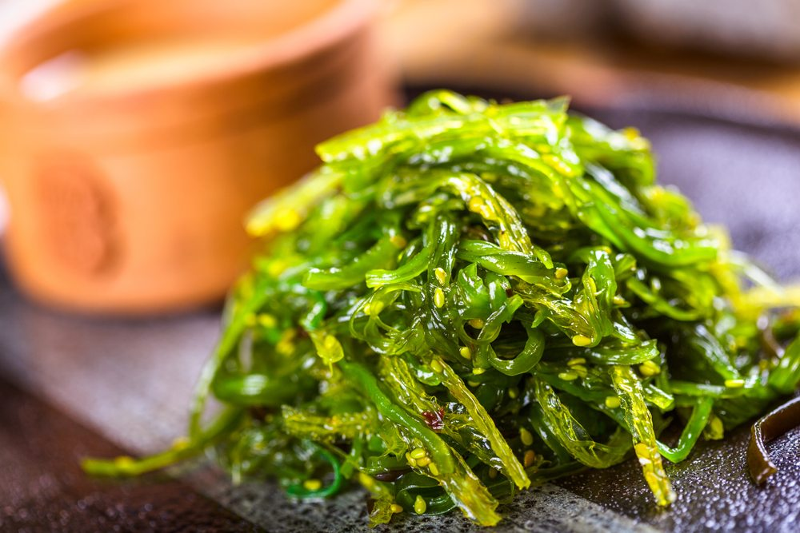
| Roy Fremouw
| CU06726 Final Thesis & Project
| Supervisors: Dr. T.C.W. Moerdijk-Poortvliet, Dr. G.C.H. Derksen
| Wednesday, 06 June 2018

This page intentionally left blank.

Free Amino Acids & 5’-Nucleotide content of Seaweeds
  - A Chemical Assessment of Taste

Institute: HZ University of Applied Sciences
Bachelor program: Chemistry
Group: HC8-AC
Course: CU06726 Final Thesis & Project
Supervisors: Dr. T.C.W. Moerdijk-Poortvliet
Dr. G.C.H. Derksen
Date: 06/06/2018
Deadline: 06/06/2018
Version: 1.0

This page intentionally left blank.

Abstract
In this study, various extraction methods were compared based on their ability to extract both free amino acids, and free 5’-monophosphate nucleotides from the seaweed Saccharina latissima.
Based on the results, extraction at room temperature with Milli-Q over 24 hours was chosen as the method of choice, as with it the highest concentration of nucleotides was obtained, and it most closely resembles the conditions of saliva, which consists of 99% water.
Milli-Q extracts of various species of seaweed were afterwards obtained using the Milli-Q extraction protocol and analysed on their free amino acids (FAAs) and 5’-monophosphate nucleotide composition.

Of the investigated species, L-Glutamic acid was the most abundantly available in the investigated samples of Gracilaria, suggesting umami taste. The sweet-tasting amino acid L-Alanine was the main free amino acid found in the two investigated Saccharina, with investigated Ulva sp. containing mainly L-Asparagine, indicating sour taste. 5’-monophosphate nucleotide composition was found to have both inter- and intra-species differences, despite this, umami enhancing 5’-nucleotides were found present in all of the analysed samples.

Predictions on the taste of the analysed species of seaweed were made based on their chemical composition, looking at the FAAs and 5’-monophosphate nucleotides. However, taste is complex, and it is therefore recommended to combine extensive quantitative data with physical evaluation of the seaweeds, that has been carried out by expert taste panels, so that palatability can be accurately quantified.

This page intentionally left blank.

Acknowledgements
First of all, there are various people I would like to express my gratitude to. I would like to thank Dr. G.C.H. Derksen, Dr. T.C.W. Moerdijk-Poortvliet, and Prof. dr. K.R. Timmermans for their trust and support, and for giving me the opportunity to perform my final thesis at the research group Marine Biobased Specialties and the Royal Netherlands Institute for Sea Research, allowing me to work on a challenging subject that is beneficial to the future. You are all very enthusiastic and involved in your work, something that I deeply admire.

Furthermore, I would like to thank J. Brasser and P. van Breugel for their assistance, support, and advice while performing my practical work at the laboratory at Royal NIOZ.
This page intentionally left blank.
Table of Contents
1. Introduction 1
2. Theoretical background 2
2.1. Amino Acids, Nucleotides & Taste 2
2.2. Overiew Amino Acid Composition Seaweeds 4
2.3. Extraction of Free- and Bound Amino Acids, and Nucleotides 6
2.4. Analysis of Amino Acids 7
3. Experimental 8
3.1. Chemicals & Reagents 8
3.2. Samples & Sample preparation 10
3.3. Test extractions 11
3.4. HPLC analysis of amino acids 11
3.5. HPLC-analysis of 5’-monophosphate nucleotides 12
3.6. Data analysis 13
4. Results 14
4.1. Assessment of the HPLC-method: Linearity, Limit of Detection, Limit of Quantitation 14
4.2. Comparison of various extraction methods 17
4.2.1. Free Amino Acids 17
4.2.2. 5’-Monophosphate Nucleotides 18
4.3. Investigation into the FAA and Nucleotide composition of various seaweeds 19
4.3.1. Free Amino Acids 19
4.3.2. 5’-Monophosphate Nucleotides 21
5. Discussion 25
6. Conclusion & Recommendations 27
Bibliography 29

Abbreviation | Meaning
AA(s) | Amino acid(s)
Ala | Alanine
Arg | Arginine
Asn | Asparagine
Asp | Aspartic acid
Cys | Cysteine
EtOH | Ethanol
FAA(s) | Free amino acid(s)
Glu | Glutamic acid
Gly | Glycine
HCl | Hydrochloric acid
His | Histidine
Hyp | Hydroxyproline
Ile | Isoleucine
Leu | Leucine
LOD | Limit of Detection
LOQ | Limit of Quantitation
Lys | Lysine
Met | Methionine
MQ | Milli-Q (Ultrapure water)
PCA | Perchloric acid
Phe | Phenylalanine
Pro | Proline
Ser | Serine
TAA(s) | Total amino acid(s)
Thr | Threonine
Trp | Tryptophan
Tyr | Tyrosine
Val | Valine

1. Introduction
With the global population expected to reach 9.8 billion individuals by 2050 (United Nations, 2017), the radical switch to a diet comprised mainly of plant-based foods is one of the viable routes that can be taken to ensure that the increased demand for food is met (Röös, et al., 2017). The use of seaweeds has already been suggested as a suitable protein source for animal feed (Kumar & Kaladharan, 2007). Seaweeds can also aid in the development of high value, functional foods (Hafting, et al., 2015). At the moment, seaweeds are consumed less readily in Europe in comparison to countries such as Japan (Taylor, et al., 2017). In regards to food acceptance, the palatability of food (taste, aroma, colour, texture), is an important factor (Narukawa, 2018), with free amino acids having been found important contributors to the taste of food (Kirimura, et al., 1969; Ito, et al., 2017), and free 5’-monophopshate nucleotides also contributing to the perceived end-taste (Mouritsen & Khandelia, 2012). As such, in order to be able to produce high quality seaweed products with a suitable palatability to be used and accepted as food, the Marine Biobased Specialties (MBBS) research group (part of Centre of Expertise Biobased Economy) and the Royal Netherlands Institute for Sea Research (NIOZ) have set up the joint project “Taste and Texture” with the aim of acquiring knowledge in regards to chemical composition of seaweeds related to their palatability.

The main goal of this study was to investigate suitable extraction methods for free amino acids and free 5’-monophosphate nucleotides from macro-algae, and to subsequently determine the free amino acid and 5’-monophosphate profiles of various seaweed species, so that conclusions can be draw regarding their palatability.

2. Theoretical background

2.1. Amino Acids, Nucleotides & Taste
In 1908, Ikeda identified the compound responsible for the distinct savoury taste of broth prepared from dried bonito and the seaweed Laminaria japonica as being glutamic acid (Glu), an amino acid, and subsequently called the savoury taste “Umami” (Ikeda, 1908).
Since the discovery of Ikeda in 1908, more research has been done in regards to the individual tastes of amino acids (AAs). The tastes of both D- and L-amino acids (D-AAs, L-AAs) has been investigated at three different concentration levels by Kawai, et al., (2012) and various AAs have been found to elicit either sweet, sour, bitter, or umami taste, or a combination thereof. Furthermore, they describe a difference in taste between the D- and L-isomeric form of some AAs. Generally, AAs which tasted bitter in their L-isomeric form were found to taste sweet or bitter-sweet as D-AAs.
An overview with the tastes of various FAAs can be seen in table 1 on the next page, adapted from Kawai, et al., (2012). The table depicts the three concentrations at which the amino acid solutions were prepared and tested, followed by the perceived taste for every amino acid; bitter, sour, sweet, or umami. It is important to note that the perceived taste of the AAs is apparently related to the concentration at which they occur. As an example, the taste of L-Alanine (L-Ala) is described by Kawai, et al., (2012) as changing from sweet at low concentrations (67 mM), to sweet & umami at high concentrations (1000 mM).

In addition to Glu, both Alanine (Ala) and Glycine (Gly) are mentioned as being contributors to the unique taste of seaweed (McHugh, 2003; Norziah & Ching, 2000).
In regards to umami, the presence of certain free 5’-monophosphate nucleotides (inosine-5’-monophosphate (IMP), guanosine-5’-monophosphate (GMP) and adenosine-5’-monophosphate (AMP) in combination with the AAs Asp and Glu, have been found to enhance the strength of perceived umami taste. Furthermore, the combination of IMP and sweet-tasting AAs, such as L-Ala, L-Ser, and Gly, has been shown to elicit umami as well (Kawai, et al., 2002; Mouritsen & Khandelia, 2012).

Table 1. Overview tastes of various D- and L-amino acids tested at 3 different concentrations, adapted from Kawai, et al., (2012).
 | L-Amino acids |  |  |  |  |  | D-Amino acids
 | Concentration |  |  | Taste |  |  | Concentration |  |  | Taste
Amino Acid | Low (mM) | Medium (mM) | High (mM) | Low | Medium | High | Low (mM) | Medium (mM) | High (mM) |  | Low | Medium | High
Alanine (Ala) | 67 | 200 | 600 | Sw | Sw | Sw, Um | 67 | 200 | 600 |  | Sw | Sw | Sw
Arginine (Arg) | 5.0 | 10 | 20 | Bi | Sw | Bi | 8.0 | 20 | 50 |  | Bi, Sw | Sw, Bi | Bi, Sw
Asparagine (Asn) | 16.7 | 50 | 150 | So | So | So, Um | 16.7 | 50 | 150 |  | So | So | So
Aspartic acid (Asp) | 1.5 | 3.0 | 6.0 | So | So | So | 0.67 | 2.0 | 6.0 |  | So | So | So
Cysteine (Cys) ¹ | 100 | 200 | 400 | Bi | Bi | Bi, Sw | - | - | - |  | -
Glutamic acid (Glu) | 0.63 | 2.5 | 10 | So | So | So, Um | 0.67 | 2.0 | 6.0 |  | So | So | So
Glutamine (Gln) | 62.5 | 125 | 250 | Sw | Sw | Sw, Um | 50 | 100 | 200 |  | Sw | Sw, So | Sw, So
Glycine (Gly) ² | 63 | 250 | 1000 | Sw | Sw | Sw, Um | - | - | - |  | - | - | -
Histidine (His) | 25 | 50 | 100 | Bi | Bi | Bi | 10 | 30 | 90 |  | Sw | Sw | Sw, Bi
Isoleucine (Ile) ³ | 16 | 40 | 100 | Bi | Bi | Bi | - | 90 | - |  | - | Sw, Bi | -
Leucine (Leu) | 16 | 40 | 100 | Bi | Bi | Bi | 30 | 60 | 120 |  | Sw, Bi | Sw, Bi | Sw, Bi
Lysine (Lys) ⁴ | 50 | 100 | 200 | Sw, Bi | Bi, Sw | Bi | - | - | - |  | - | - | -
Methionine (Met) | 12.5 | 50 | 200 | Bi | Bi, Sw | Bi, Sw | 50 | 100 | 200 |  | Sw Bi | Sw, Bi | Sw, Bi
Phenylalanine (Phe) | 8.3 | 25 | 75 | Bi | Bi | Bi | 8.0 | 20 | 50 |  | Sw Bi | Sw, Bi | Sw, Bi
Proline (Pro) | 63 | 250 | 1000 | Bi, Sw | Bi, Sw | Sw, Bi | 95 | 190 | 380 |  | Bi | Bi | Bi
Serine (Ser) | 63 | 250 | 1000 | Sw | Sw | Sw, Um, So | 250 | 500 | 1000 |  | Sw | Sw, So | Sw, So
Threonine (Thr) | 100 | 250 | 625 | Sw | Sw, So | Sw, So | 112 | 280 | 700 |  | Sw | Sw | Sw
Tryptophan (Trp) | 4 | 10 | 25 | Bi | Bi | Bi | 1.0 | 4.0 | 16 |  | Sw | Sw | Sw, Bi
Tyrosine (Tyr) ⁵ | - | - | - | - |  |  | - | - | - |  | -
Valine (Val) | 25 | 50 | 100 | Bi | Bi | Bi, Sw | 25 | 50 | 100 |  | Sw, Bi | Sw, Bi | Sw, Bi
1: D-Cysteine was not tested for unspecified reasons. 2: Glycine has no isomeric forms. 3: Isoleucine was only tested at one concentration for unspecified reasons.
4: D-Lysine was not tested for unspecified reasons. 5: Tyrosine was reportedly omitted because it was found to be barely soluble in water. Saturated solutions were found to contain no taste.
Abbreviations: Bi = Bitter; So = Sour; Sw = Sweet; Um = Umami

2.2. Seaweed Phycology
Seaweeds, or macro-algae, are aquatic plants capable of photosynthesis, and function as primary producers of macronutrients in their environments. Macro-algae are divided into three main groups based on the pigments involved in photosynthesis; green (Chlorophyta), brown (Phaeophyta), and red (Rhodophyta) (Diaz-Pulido & McCook, 2008; Kim, 2012). Examples of each group are given in figure 1.
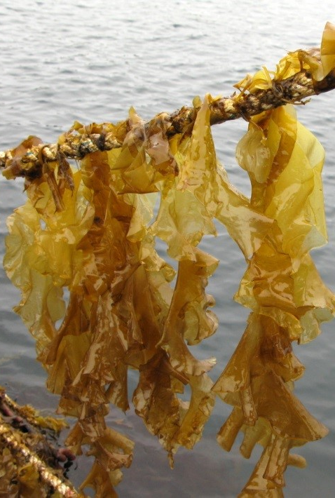
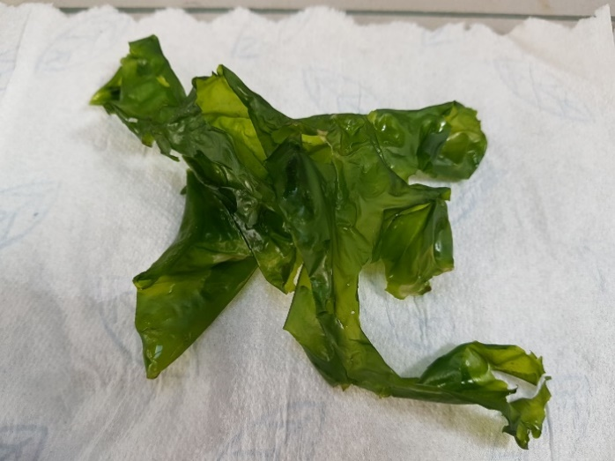
B
A

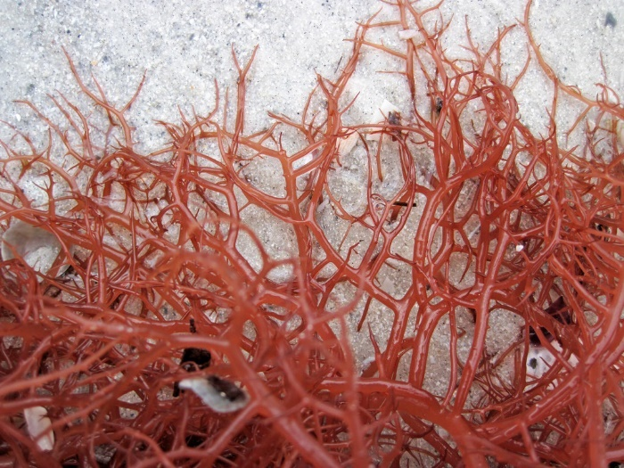
C
Figure 1. Collage of green, brown, and red macro-algae. A: The green macro-algae Ulva sp. B: The brown macro-algae Saccharina latissima, C: The red macro-algae Gracilaria sp.

2.3. Overview Amino Acid Composition Seaweeds
In regards to the amino acid composition of seaweeds, most literature seems to be approaching the subject from a nutritional perspective, investigating the total amino acid (TAA) composition of seaweeds, and generally less data is available regarding the FAA composition of seaweeds, which are found to be important contributors to taste (Kawai, et al., 2012).
In regards to the total amino acid (TAA) content, 16 of the 20 standard proteinogenic AAs were found in investigated red, brown, and green seaweeds. Asn, Cys, Gln, and Trp were not identified, their absence most likely explained due to the loss of these AAs as part of the used hydrolysis process to obtain AA monomers for analysis (Council of Europe, 2004). Of the 16 AAs identified, Asp and Glu were found to be the most prevalent AAs present (Astorga-Espana, et al., 2016; Biancarosa, et al., 2016).
In regards to the FAA composition of Nori (the red macro-algae Porphyra tenera and P. haitanensis), 10 of the 20 standard proteinogenic AAs (Asp, Thr, Ser, Asn, Glu, Gly, Ala, Val, Ile, and Leu) and 3 non-proteinogenic AAs (taurine, citrulline, γ-aminobutyric acid) were found in P. tenera, with Val and γ-aminobutyric acid not detected in P. haitanensis (Hwang, et al., 2013). Furthermore, several FAAs (Glu, Asp, Ala, Pro, Asn) were detected in five different species of brown seaweed (Peinado, et al., 2014).
In terms of concentration, the AA composition of seaweed differs per species (Astorga-Espana, et al., 2016; Biancarosa, et al., 2016; Hwang, et al., 2013; Penado, et al., 2014). The composition is further influenced by seasonal variation (Marinho, et al., 2015), and other growth conditions, such nutrient availability (Boderskov, et al., 2016).

2.4. Extraction of Free- and Bound Amino Acids, and Nucleotides
Before analysis of the AA composition is possible, extraction of the AAs from the sample material is necessary. In the case of the TAA composition, sample material is first freeze-dried and ground, after which it is hydrolysed over 22-24 hours at 110 ºC using 6 mol/L hydrochloric acid (HCl) (Astorga-Espana, et al., 2016; Biancarosa, et al., 2016). However, during this process, some AAs are lost, as mentioned earlier (Council of Europe, 2004).
In regards to the extraction of FAAs from seaweed material, the use of 70 – 75 % solutions of ethanol (EtOH) have been reported for various species, both performed at room- and elevated temperature (Hwang, et al., 2013; Smith & Young, 1955). However, use of high alcohol concentrations reportedly decreases the yield of some AAs (Fish, 2012). Other methods mentioned in literature use water for the extraction of AAs from plant material (Fish, 2012), and hydrophilic compounds from macro-algae (Godlewska, et al., 2016). As explained by Fish (2012), the usage of water as an extraction solvent allows for the quantitative extraction of all present psychological AAs (Fish, 2012).
The method as described by Peinado, et al. (2014), uses 0.005 M hydrochloric acid (HCl) as an extraction solvent combined with elevated temperature, for the extraction of both FAAs and free 5’-monophosphate nucleotides from seaweed samples. Furthermore, the use of 6% perchloric acid (PCA) also mentioned for the extraction of polar metabolites (from animal tissue) (Viant, 2007), and both FAAs and free nucleotides from algae (Jones & Lewin, 1961). The advantage of the usage of PCA is that it is capable of precipitating proteins, due to its large anion, and strong acidity (Hauschka, 1973). Furthermore, compared to use of organic solvents, extraction with PCA reportedly yields higher concentrations of the basic AAs (Saifer, 1971).
However, there are also limitations to the use of dilute acids, such as the conversion of Asn and Gln to their respective acids when working with dilute acids, resulting in an overestimation of both Asp and Glu (Fish, 2012).

2.5. Analysis of Amino Acids
Reversed-Phase High Performance Liquid Chromatography (RP-HPLC) is commonly used for the analysis of AAs from algae (Conde, et al., 2013). However, in regards to the analysis of AAs, derivatization of the AAs prior to analysis is necessary in order to increase the sensitivity of the AAs for detection (Yang, et al., 2006). AAs are frequently derivatized prior to analysis on RP-HPLC through use of pre-column derivatization with ortho-phtaldialdehyde (OPA) in combination with a thiol, to produce fluorescent derivates (Tanwar & Bhushan, 2015; Molnar-Perl & Bozor, 1998).
The general reaction of the derivatization of AAs with OPA and a thiol (in this case, N-isobutyryl-L-cysteine) is described as seen in figure 2 (Hess S., 2011). However, the exact mechanism behind the OPA derivatization is not completely understood, despite that several attempts have been made to elucidate its exact mechanics (Zuman, 2004; Zuman, et al., 2009).

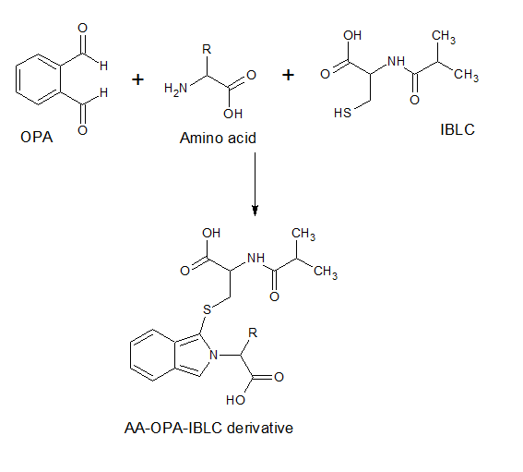
Figure 2. Reaction of amino acid with o-phthaldialdehyde and N-isobutyryl-L-cysteine. Adapted from Hess, et al., 2004.
As mentioned earlier, various thiols can be used for derivatization in combination with OPA. However, the use of chiral thiols, such as N-isobutyryl-L-cysteine (IBLC), allows the separation between the D- and L-isomers of an AA (Brückner & Westhauser, 2003), as a result, the concentration of the L-AAs in the samples can be determined more accurately, as distinction is made between de D- and L-isomers of the present AAs.

3. Experimental

3.1. Chemicals & Reagents
Combined amino acid standard (Catalogue# AAS18-10 x 1 mL), and separate amino acid standard (Catalogue# LAA21-1KT) were obtained from Sigma-Aldrich (Steinheim, Germany). Buffers of pH 4.00 (Catalogue# 1.09475) and pH 7.00 (Catalogue# 1.09477), sodium acetate trihydrate (CAS# 6131-90-4), glacial acetic acid (CAS# 64-19-7), HPLC-grade methanol (CAS# 67-56-1), HLC-grade ethanol (CAS# 64-17-5), fuming hydrochloric acid (Catalogue# 1.00317), ammonia solution (min. 25%), sodium hydroxide pellets (CAS# 1310-73-2), and boric acid (CAS# 10043-35-3) were all purchased from Merck KGaA (Darmstadt, Germany). N-isobutyryl-L-cysteine (CAS# 124526-02-8), ortho-Phthaldialdehyde (CAS# 643-79-8), and Dowex 50WX8, 50 – 100 mesh (CAS# 69011-20-7) were purchased from Sigma-Aldrich (Buchs, Switzerland). Perchloric acid (70%) was obtained from Fischer Scientific (Leicestershire, United Kingdom). Milli-Q (18.2 MΩ.cm) was obtained from a Merck Millipore MQ Gradient A10 system (Millipore, Bedford, USA). Cellulose-Nitrate filters (0.2 µm) were obtained from Sartorius (Goettingen, Germany).

Separate AA stock solutions were prepared for L-Asp, L-Gln, and L-Trp using the LAA21 AA kit obtained from Sigma-Aldrich, as described below. Molar mass data was obtained from the amino acid reference document from Sigma-Aldrich, which can be found in Appendix 1. Samples were dissolved in 9.90 mL of Milli-Q + 100 µL of 37 % HCl. After preparation the solutions were transferred into cleaned glass screw-cap vials and stored in the freezer at -20 ºC.

Table 2. Preparation L-Asparagine, L-Glutamine, and L-Tryptophan stocks solutions in 10 mL 0.1 M HCl.
L-AA | MW g/mol | m (AA) mg | V (total) mL | c(AA) µM
L-Asn | 132.12 | 3.85 | 10.0 | 2914
L-Gln | 146.15 | 3.76 | 10.0 | 2566
L-Trp | 204.23 | 5.10 | 10.0 | 2497

Volumes of the L-Asn, L-Gln, and L-Trp stock solutions were combined with a 400 µL aliquot of the AAS18 AA kit, diluted in a 25 mL flask using 30 % methanol (MeOH), to prepare a 40 µM intermediate stock solution. This solution was transferred into cleaned glass screw-cap vials and subsequently stored in the freezer at -20 ºC.

Table 3. Preparation of 40 µM combined L-AA standard solution in 30 % methanol.
L-AA | c(AA)stock µM | V(stock) µL | V (total) mL | c(AA) µM
L-Asn | 2914 | 343 | 25.0 | 39.98
L-Gln | 2566 | 390 |  | 40.04
L-Trp | 2497 | 400 |  | 39.95
AAS18 | 2500 | 400 |  | 40.00

From the 40 µM combined L-AA standard, a 1500 nM standard was prepared using a 0.2 M, pH 9.8 borate buffer, which was prepared from a pre-made 1.0 M stock.
Using the prepared combined stock solution of 1500 nM, various calibration standards of known concentration were prepared in the abovementioned borate buffer. Initially a 6-point calibration range was constructed ranging from 46.9 nM to 750 nM. However, in these standards the AA L-Arg was not found, and it was assumed that co-elution between L-Arg and L-Ala had occurred. Later a 4-point standard range, ranging from 46.9 to 750 nM, was found to contain separation between L-Arg and L-Ala, however, this time partial and complete co-elution was observed between L-His and Gly, at low and high concentrations respectively. As such, the initial 6-point calibration range was used for quantitation and calculation of the LOD- and LOQ-values for all AAs with the exception of L-Arg and L-Ala, with the 4-point calibration range being used for L-Arg and L-Ala.

A solution of ortho-Phthaldialdehyde (OPA) was prepared fresh every 24 hours, by dissolving 16 mg of OPA into 1 mL of MeOH, filled up to 20 mL with 0.2 M borate buffer of pH 9.8. After preparation the OPA-solutions was subsequently stored at 4 ºC. An aliquot of the solution was transferred into an HPLC-vial at the start of a run. Solutions of N-isobutyryl-L-cysteine (IBLC) were prepared on-demand by dissolving 10 mg of IBLC into 1 mL of MeOH. For runs over night, a new vial was filled with the OPA-solution stored at 4 ºC to be used by the samples that run overnight, and a fresh solution of IBLC was prepared as well. For runs over the weekend, a completely fresh solutions were prepared for both at the end of Friday afternoon, and placed in the autosampler.

Acetate-buffers of 25 mM of pH 7.0 and pH 5.3 (mobile phase A and B respectively), were prepared by dissolving approximately 3.40 g of sodium acetate trihydrate into 1000 mL of Milli-Q. A dilution of acetic acid was used to adjust the pH to the desired pH-value. Solutions were filtered over a 0.2 µm cellulose-nitrite filter and degassed using helium before use.

3.2. Samples & Sample preparation
Samples of the brown macro-algae Saccharina latissima were cultivated over six months in the coastal waters of Scheveningen, the Netherlands, and were collected on June 6th 2017, and subsequently stored in the freezer at -20 ºC. Before analysis, frozen S. latissima was thawed, washed in demi-water to remove salt and other adhering material. The samples were carefully patted dry on both sides with tissue paper, weighed, and subsequently freeze-dried. After freeze-drying the samples were weighed again to determine the water content, after which they were ground using a Fritsch pulverisette planetary ball-mill (FRITSCH GmbH, Germany). During this initial grinding step, the planetary ball-mill was operated in pulses of approximately 30 seconds with 1 minute intervals to prevent the degradation of the samples due to heat. Samples were ground until observed to be of homogenous size. After initial grinding, the material was ground again using a Retsch MM301 vibratory mill (Retsch GmbH, Germany), operated at a frequency of 30 hertz for 30 seconds. Ground seaweed was combined in glass screw-cap vials which were cleaned in the dishwasher beforehand, and subsequently stored at -20 ºC until further use.

Two samples of the red macro-algae Gracilaria sp. (a red coloured variant (Gracilaria sp. 1) and a black coloured variant (Gracilaria sp. 2), respectively), and the green macro-algae Ulva sp., were collected on February 4th 2018 from the Eastern Scheldt at the northern coastline of Yerseke, the Netherlands. Another sample of S. latissima was also collected from the same location. The S. latissima retrieved from Scheveningen will be referred to as S. latissima 1, with the sample from the Eastern Scheldt referred to as S. latissima 2, respectively.
After collection, the obtained specimens were washed using cold water and subsequently stored in the freezer at -20 ºC. The samples were freeze-dried and subsequently ground under liquid nitrogen by use of a mortar and pestle. Weights were recorded before and after freeze-drying to determine the moisture content.

3.3. Test extractions
Tests for the extraction of FAAs were carried out using the ground S. latissima 1. Test extractions were carried out with 70 % EtOH, 0.005 M HCl, and Milli-Q, at room temperature over 24 hours, and using ice-cold 6 % PCA. Extraction was also performed using 0.005 M HCl at 50 °C for 90 minutes, but no significant difference was found between the two HCl extracts.
After extraction, the samples were cleaned up using cation-exchange chromatography using Dowex 50WX8 adapted from (Veuger, et al. 2005), after which they were stored in the freezer at -20 ºC.
The protocol for each extraction method, as well as the sample clean-up procedure can be found in Appendix 2.

3.4. HPLC analysis of amino acids
The Dowex-treated extracts were thawed and subsequently diluted using the 0.2 M Borate buffer of pH 9.8. Before analysis, the AAs were derivatized using pre-column derivatization with OPA and IBLC. Automated derivatization of the AAs was carried out by the autosampler; 200 µL of an 80 % MeOH solution was first taken into the needle, followed by 80 µL of the OPA solution and 20 µL of IBLC solution. 100 µL of the needle’s contents were then subsequently injected into the sample vial, which was homogenized for 1 minute using the autosampler’s mixer compartment and left to incubate for 1 minute afterwards. After the minute an aliquot of 50 µL was injected onto the column for analysis.
Analysis of the derivatized AAs was carried out on an HPLC-system consisting of a Dionex P580 Series pump, a Thermo Electron Corporation SpectraSYSTEM AS3000 autosampler & column oven, fitted with a Waters Nova-Pak end-capped C₁₈ column (4 µm; 60 Å; 3.9 * 150 mm) and Allsphere ODS-1 All-Guard guard-column. Vial tray temperature was set to 19 ºC, and the column oven was maintained at 26 ºC. Derivatized AAs were detected using a Jasco FP-2020 programmable fluorescence detector, with excitation and emission wavelengths set at 330 nm and 445 nm, respectively. The following solutions were used as mobile phase, using the gradient program as described in table 4: 25 mM, pH 7.0 acetate-buffer (A), 25 mM, pH 5.3 acetate buffer (B), and HPLC-grade MeOH (C).

Table 4. Overview of the elution program used for the analysis of the ortho-Phthaldialdehyde / N-isobutyryl-L-cysteine derivatized amino acids. A: 25 mM, pH 7.0 acetate-buffer; B: 25 mM, pH 5.3 acetate-buffer; C: HPLC-grade methanol. Flowrate is given in millilitres per minute; eluent concentrations are given in percent.
Time (min) | Flowrate | Eluent A | Eluent B | Eluent C
0 – 3 | 0.800 | 92 | 3 | 5
3 - 46 |  | 92 -> 65 | 3 | 5 -> 32
46 - 65 |  | 65 -> 0 | 3 -> 45 | 32 -> 55
65 - 70 |  | 0 | 45 | 55
70 - 75 |  | 0 -> 17 | 45 -> 3 | 55 -> 80
75 - 85 |  | 17 -> 92 | 3 | 80 -> 5
85 - 90 |  | 92 | 3 | 5

3.5. HPLC-analysis of 5’-monophosphate nucleotides
Extracts treated and untreated with Dowex 50WX8 were sent to the HZ University of Applied Sciences to be analysed on their 5’-monophosphate nucleotide contents (AMP, dAMP, UMP, GMP, dGMP, IMP, dIMP). Analysis was performed by minor students D. Bakkers and S. Dieleman by use of a Dionex Ultimate 3000 HPLC system, equipped with VDW-3400 variable wavelength detector (set to 260 nm), TCC-3000 column compartment (kept at 26 ºC), WPS-3000SL autosampler (injection volume 10 µL), and an LPG-3400A pump with online degasser (0.500 mL/min). Isocratic elution of the separated nucleotides was achieved using 10 mM H₂SO₄ of pH 2 as the mobile phase, in combination with a PrimeSep D guard- & mixed-mode column (5 µm; 100 Å; 4.6 * 150 mm).

3.6. Data analysis
Data analysis of the obtained AA results was carried out in Microsoft Excel 2016, making use of the function LINEST(Y;X;False) to retrieve the slope of the regression line. Function STEYX(Y;X) was used to retrieve the residual deviation of the regression line of the analysed calibration range. LOD and LOQ were predicted for each AA through use of the following equations (Kothapalli, et al., 2012).
$$LOD=3.3*\frac{STEYX}{SLOPE}$$
Equation 1. Equation to predict the Limit of Detection (Kothapalli, et al., 2012)

$$LOQ=10* \frac{STEYX}{SLOPE}$$
Equation 2. Equation to predict the Limit of Quantitation (Kothapalli, et al., 2012)

4. Results
In order to investigate the FAA and 5’-monophosphate nucleotide composition of the various seaweeds mentioned in chapter 3, seaweed samples were initially collected and freeze-dried. Water percentages were determined by weighing the samples before and after freeze-drying. The water percentages in the samples ranged from 68% in Gracilaria sp. 2, to 89% in S. latissima 1. Values for dry- and wet-weight can be found in Appendix 3.
Using the freeze-dried S. latissima 1, test extractions were carried out to determine which extraction method was most suitable for the extraction of FAAs from seaweed, after which the other seaweed samples were treated using the chosen extraction method. Extracts were then analysed on both their AA content, and their nucleotide content, by use of High Performance Liquid Chromatography.

4.1. Assessment of the HPLC-method:
Linearity, Limit of Detection, Limit of Quantitation
The obtained quantitation data for each AA is described in table 6. In all, every AA, with the exception of L-Lys, have an R²-value of 0.99 and higher, indicating good linearity for analytical practice (Miller & Miller, 2010), up until the tested concentration of 750 nM. In terms of sensitivity, as denoted by the slope, L-Lys is the least sensitive of the compounds, with Gly being the most sensitive of the AAs. Calibration graphs of each L-AA can be found in Appendix 4.

Table 6. Overview of the Coefficient of Determination (R²), slope, Limit of Detection (LOD) and Limit of Quantitation (LOQ) for every amino acid contained in the calibration range. Injection volume 50 µL.
Amino acid | R² | Slope | LOD (nM) | LOQ (nM)
L-Asp | 0.9993 | 0.0485 | 10.0 | 30.4
L-Glu | 1.0000 | 0.0476 | 5.92 | 17.9
L-Asn | 1.0000 | 0.0374 | 4.01 | 12.2
L-Ser | 0.9970 | 0.0548 | 8.06 | 24.4
L-Gln | 1.0000 | 0.0431 | 4.97 | 15.1
L-Thr | 0.9999 | 0.0465 | 9.04 | 27.4
L-His | 0.9997 | 0.0242 | 14.9 | 45.3
Gly | 0.9986 | 0.0728 | 15.4 | 46.7
L-Arg | 0.9863 | 0.0217 | 100 | 304
L-Ala | 0.9992 | 0.0613 | 36.0 | 109
L-Tyr | 0.9996 | 0.0414 | 16.3 | 49.3
L-Val | 0.9999 | 0.0441 | 4.4 | 13.3
L-Met | 0.9982 | 0.0403 | 38.1 | 116
L-Trp | 0.9977 | 0.0373 | 36.6 | 111
L-Phe | 0.9998 | 0.0301 | 9.40 | 28.4
L-Ile | 0.9989 | 0.0444 | 22.6 | 68.3
L-Leu | 0.9995 | 0.0279 | 19.2 | 58.3
L-Lys | -1.9378 | 0.00301 | 280 | 847

Figure 3 on the next page shows two chromatograms of a 750 nM standard from both calibration lines each, showing co-elution between L-Arg and L-Ala in chromatogram A (peak 9; peak 8 & 9 respectively in B.), and co-elution between L-His and Gly in chromatogram B (peak 7; peak 7 & 8 respectively in A). Co-elution was observed to increase as cumulative runtime on the column increased (data not shown).
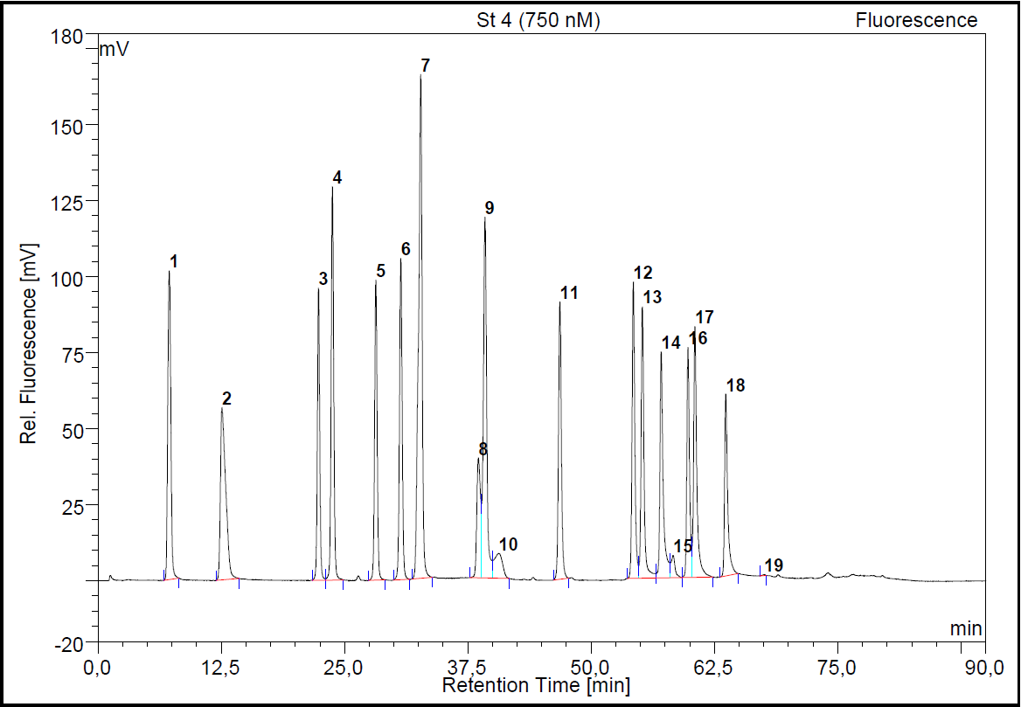
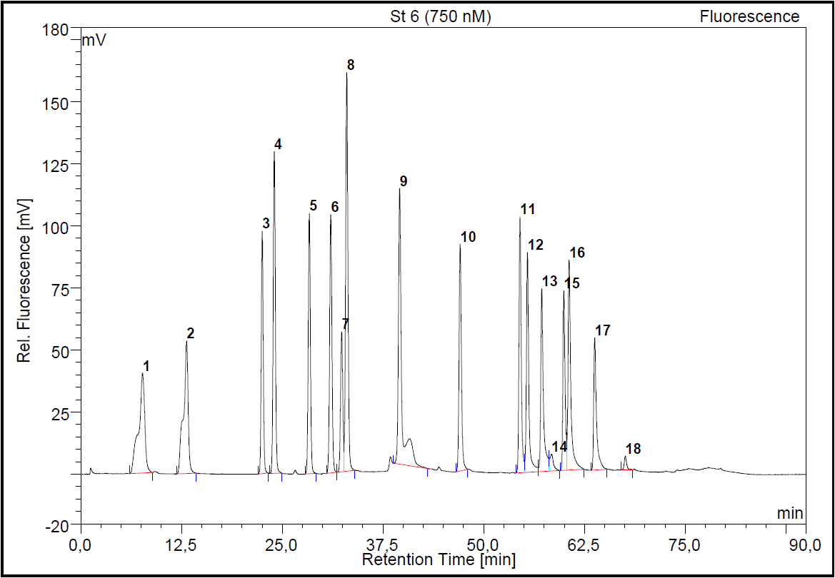
B
A
Figure 3. Examples of two typical chromatograms of a 750 nM standard containing L-Asp (A1, B1); L-Glu (A2, B2); L-Asn (A3, B3); L-Ser (A4; B4); L-Gln (A5, B5); L-Thr (A6; B6); L-His (A7, B7); Gly (A8; B7); L-Arg (A9, B8); L-Ala (A9, B9); L-Tyr (A10, B10) ; L-Val (A11, B12); L-Met (A12, B13), L-Trp (A13; B14), L-Phe (A15, B16); L-Ile (A16, B17); L-Leu (A17, B18); L-Lys (A18; B19). Chromatographic conditions: Waters Nova-Pak end-capped C₁₈ column (4 µm; 60 Å; 3.9 * 150 mm), Allsphere ODS-1 All-Guard guard-column; mobile phases: (A) 25 mM, pH 7.0 acetate-buffer, (B) 25 mM, pH 5.3 acetate buffer; (C) MeOH (see table 4. for used gradient). Injection volume: 50µL. Detector parameters: EX: 330 nm, EM: 445 nm.

4.2. Comparison of various extraction methods

4.2.1. Free Amino Acids
Figure 4 shows the absolute and relative FAAs composition of the various S. latissima 1 extracts, obtained as described in chapter 3. The highest total amount of FAA is obtained through use of the 6 % PCA extraction method. Furthermore, in regards to the other applied methods, the extracted amount of FAAs is more or less the same, with L-Ala being the most abundant AA present, followed by L-Asp. Tabular data describing the FAA concentration in μg/g can be found in Appendix 5.

Figure 4. Absolute and relative L-Amino acid composition of S. latissima 1, obtained through various extraction procedures. All presented results are based on triplicate measurements.

4.2.2. 5’-Monophosphate Nucleotides
Given the importance of the 5’-monophosphate nucleotides in relation to taste, all of the obtained S. latissima 1 extracts were analysed on their 5’-monophospate nucleotide contents (AMP, dAMP, UMP, GMP, dGMP, IMP, dIMP) at the HZ University of Applied Sciences, using the method as described in chapter 3. As indicated by the results in figure 5., the Milli-Q extracts contains both the highest total nucleotide concentration as well as the highest concentration of each of the detected nucleotides, amongst all of the investigated method. In each of the extracts, the following nucleotides were found: AMP, dAMP, UMP, GMP and dGMP, with IMP and dIMP not found in either.

Figure 5. Absolute and relative 5’-Nucleotide composition of S. latissima 1 extracts, obtained using various extraction methods. All presented results are based on triplicate measurements.
While the 6 % PCA extraction-method provides the highest total amount FAAs from S. latissima 1, it is important to note that PCA is a known carcinogenic (Sigma-Aldrich, 2018). This, combined with the fact that the Milli-Q extraction-method provided both the highest total concentration and highest concentration of each of the individual nucleotides in S. latissima 1, the choice to use this method for the combined extraction of AAs and nucleotides is warranted. Furthermore, from the tested extraction methods, Milli-Q as an extraction solvent most closely resembles the composition of saliva, which consists of 99 % water (Humphrey & Williamson, 2001).

4.3. Investigation into the FAA and Nucleotide composition of various seaweeds
Freeze-dried and pulverized samples of the collected Gracilaria sp. 1, Gracilaria sp 2., Ulva sp., and S. latissima 2 were extracted using the Milli-Q extraction protocol, with the extracts being subsequently analysed on their FAA, AMP, dAMP, UMP, GMP, dGMP, IMP, dIMP content. The data of the AA analysis is shown in figure 6 for the abovementioned species, as well as the Milli-Q extraction data of S. latissima 1 obtained earlier. The data of the 5’-nucleotide analyses is shown in figure 7.

4.3.1. Free Amino Acids
In terms of the total FAA composition, S. latissima 2 contains the highest amount of FAAs, with 3.43 ± 0.30 % of its dry weight (DW) consisting of FAAs, followed by Gracilaria sp. 1, Ulva sp., Gracilaria sp. 2, and finally S. latissima 1, which consist of 1.69 ± 0.27 % DW; 1.47 ± 0.29 % DW; 0.639 ± 0.039 % DW, and 0.123 ± 0.036 % DW FAAs, respectively.
In regards to the composition of FAAs, for both species of Gracilaria, the main contributors to the total FAA composition are L-Asp, L-Glu, and L-Gln, with them attributing for 14.8 ± 0.3 %, 41.0 ± 0.1 %, and 26.3 ± 1.2 %, respectively of the total FAA content in Gracilaria sp. 1, and 22.9 ± 0.9 %, 37.9 ± 2.6 %, and 6.91 ± 0.24 % in Gracilaria sp. 2.
L-Ala is by far the largest constituent of the FAA composition in both Saccharina samples, contributing for 65.7 ± 4.2 % of the total FAA composition in S. latissima 2, and for 39.9 ± 0.4 % in S. latissima 1. Other large contributors to the total FAA composition are L-Glu with 8.60 ± 0.64 % in S. latissima 1, and L-Gln with 10.2 ± 0.3 % in S. latissima 2.
L-Asn is the largest component of the FAA-composition in Ulva sp., with 38.7 ± 6.9 %, followed by 19.3 ± 3.3 % L-Gln.
Tabular data describing the FAA concentration in μg/g can be found in Appendix 6.

Figure 6. Absolute and relative L-Amino acid composition of five species of seaweed (Gracilaria sp. 1; Gracilaria sp. 2; S. latissima 2; Ulva sp., and S. latissima 1), extracted with Milli-Q over 24 hours at room temperature, while agitated. Reported data are the averages of triplicate measurements. Enlarged version showing the S. latissima 1 composition.

4.3.2. 5’-Monophosphate Nucleotides
The analysed species each contain all of the following 5’-monophosphate nucleotides; AMP, dAMP, UMP, and GMP, with dGMP only identified in S. latissima 1. IMP and dIMP have not been detected in any of the species.
The total concentration of 5’-monophosphate nucleotides is highest in S. latissima 2 with 0.820 ± 0.014 ‰ DW, followed by 0.683 ± 0.048 ‰ for Gracilaria sp. 1, and 0.506 ± 0.041 ‰ for S. latissima 1. The lowest concentrations are found in Ulva sp. and Gracilaria sp., having 0.376 ± 0.039 ‰ and 0.210 ± 0.011 ‰, respectively.
Overall, Gracilaria sp. 1 contains the highest amount of GMP at 0.683 ± 0.048 ‰ DW, making up the majority of its nucleotide composition. The concentrations of dAMP and UMP are comparable with one another, at 0.152 ± 0.004 ‰ and 0.148 ± 0.017 ‰, respectively for dAMP and UMP, with AMP being the lowest constituent, at 0.0849 ± 0.0167 ‰.
In Gracilaria sp. 2, the nucleotide composition consists mainly of UMP, with 0.132 ± 0.005 ‰, followed by AMP, GMP and dAMP at for 0.039± 0.003 ‰, 0.210 ± 0.011 ‰, and 0.0177± 0.0006 ‰, respectively.
AMP and UMP are the main contributors to the nucleotide composition of S. latissima 2, attributing for 0.408 ± 0.005 ‰, and 0.361± 0.006 ‰, respectively. The remaining amount is made up from 0.0111 ± 0.0007 ‰ dAMP and 0.0401 ± 0.0023 ‰ GMP. Nucleotide composition of S. latissima 1 is more uniform, albeit it a lower total amount of nucleotides; 0.156 ± 0.010 ‰ AMP, 0.149 ± 0.012 ‰ UMP, 0.0998 ± 0.0068 ‰ dAMP, 0.101 ± 0.012 ‰ GMP, and 0.0712 ± 0.003 ‰ dGMP.
Finally, Ulva sp. consists of 0.232 ± 0.017 ‰ AMP, 0.0790± 0.0116 ‰ dAMP, 0.041 ± 0.004 ‰ UMP, and 0.0242 ± 0.0066 ‰ GMP.

Figure 7. Absolute and relative nucleotide composition of five species of seaweed (Gracilaria sp. 1, Gracilaria sp. 2, S. latissima 2, Ulva sp., and S. latissima 1), extracted with Milli-Q over 24 hours at room temperature, while agitated. Reported data are the averages of triplicate measurements.

4.4 Column performance in time
Degradation of the column was observed during the project, so much so that the initial column had to be replaced. Degradation of the column can be seen from the two following chromatograms (fig. 8 and fig. 9, respectively), which depicts significant visual decrease in the peak shape of two 750 nM L-AA standards, with figure 8 showing the second injection on the newly installed column, and figure 9 showing the 68th injection on the same column. By comparing the two chromatograms, increase in tailing, loss of separation, and increase in base-line drift can be seen between the two figures.

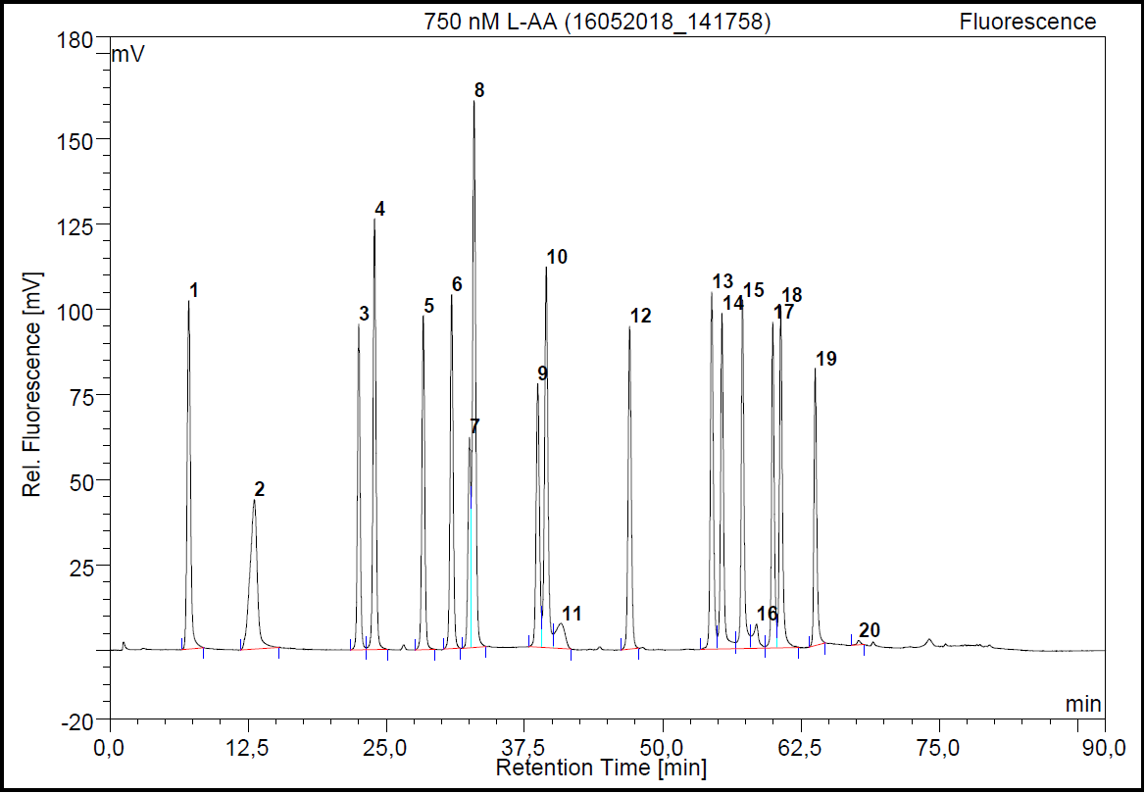
Figure 8. HPLC-FD chromatogram showing 750 nM L-AA standard after installation of a new Nova-Pak end-capped C₁₈ column. Second injection on column. Chromatographic conditions: Waters Nova-Pak end-capped C₁₈ column (4 µm; 60 Å; 3.9 * 150 mm), Allsphere ODS-1 All-Guard guard-column; mobile phases: (A) 25 mM, pH 7.0 acetate-buffer, (B) 25 mM, pH 5.3 acetate buffer; (C) MeOH (see table 4. for used gradient). Injection volume: 50µL. Detector parameters: EX: 330 nm, EM: 445 nm.
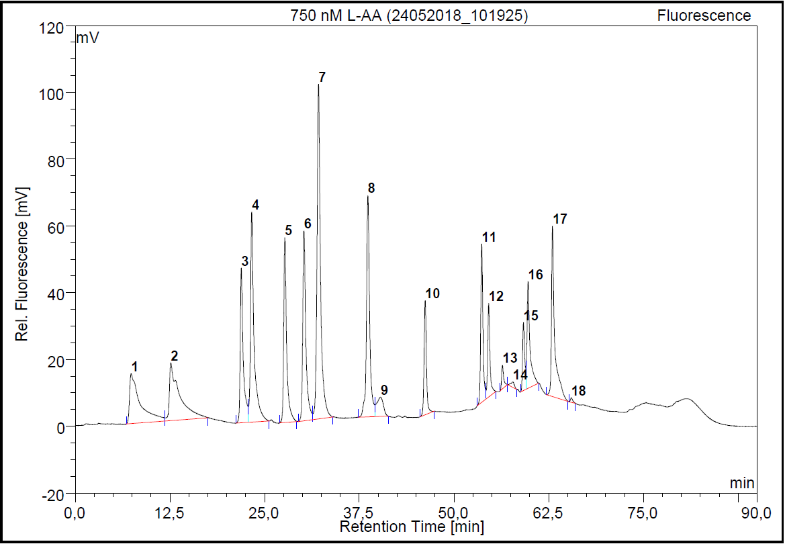
Figure 9. HPLC-FD Chromatogram showing a 750 nM L-AA standard, 68th injection on a new Nova-Pak end-capped C₁₈ column. Chromatographic conditions: Waters Nova-Pak end-capped C18 column (4 µm; 60 Å; 3.9 * 150 mm), Allsphere ODS-1 All-Guard guard-column; mobile phases: (A) 25 mM, pH 7.0 acetate-buffer, (B) 25 mM, pH 5.3 acetate buffer; (C) MeOH (see table 4. for used gradient). Injection volume: 50µL. Detector parameters: EX: 330 nm, EM: 445 nm.

5. Discussion
The FAA compositions of various species of seaweed were analysed by use of High Performance Liquid Chromatography coupled to fluorescence detection after pre-column derivatization of the AAs with use of OPA and IBLC. While analysis of AAs as OPA-derivates on reversed-phase columns (C₁₈) is described as a commonly used method (Escoubeyrou & Tremblay, 2014), degradation of the used C₁₈-column was observed over the course of the analyses. This is most likely caused by the matrix of the injected sample. Given that the exhibited fluorescence intensity of the OPA-thiol derivates is highly dependent on pH, with optimal fluorescence being obtained when the derivatization is performed at high pH (9.0 – 10.5) (Roth, 1971; Aminot & Kérouel, 2006). To maintain the pH of the reaction mixture stable, borate buffers are commonly applied (Aminot & Kérouel, 2006), with a borate buffer of pH 9.8 being used in the used method. Injection of this high pH reaction mixture has been known to degrade used C₁₈-columns (Mopper & Dawson, 1986), caused by dissolution of the silica supports as a result of the high pH (Kirkland, et al., 1997).
A suggested solution is to use an alternative column in place of C₁₈-based columns, such as the use of organo-silica columns, which reportedly have significantly longer lifetimes at high pH levels compared to regular silica-based columns (O'Gara & Wyndham, 2006).
Furthermore, literature describes other issues regarding the used analysis method for AAs. The used OPA and IBLC reagents are described as being unstable at room temperature, and as having limited stability at -4 °C (Dittmar, et al., 2009), in addition to this, OPA-derivatization reportedly yields multiple derivates when the compound contains multiple NH₂-CH₂-R moieties, as described by Mengerink, et al. (2002), such as Gly and His (Mengerink, et al., 2002). Furthermore, the reactivity of OPA is limited to primary amines (Benson & Hare, 1975), as such, AAs containing secondary amines, such as the Pro, cannot be derivatized using this method (Roth, 1971), making subsequent analysis of these compounds impossible. In addition, Cys is reported to show minimal to no fluorescence after derivatization (Escoubeyrou & Tremblay, 2014), inhibiting detection of this compound as well. Furthermore, the OPA-derivate of Gly and Lys are characterized by having a low stability (Aminot & Kérouel, 2006), as well is fluorescence response of Lys low, and variable (Mopper & Dawson, 1986).
Additional to the abovementioned drawbacks, it was noticed that the used autosampler could not maintain a lower temperature than 19 °C, given the fact that the reagents are unstable at room temperature makes it likely that they degraded over the course of their run. However, the analysed standards showed good linearity for all L-AAs, with the exception of Lys, despite being derivatized using the exact same reagent solutions, from the same HPLC-vial, and the cumulative standard run taking approximately 11.5 hours.

Milli-Q extractions were carried out on various seaweeds, and subsequently analysed on their AA and 5’-nucleotide contents by use of the HPLC-method.
Overall, the largest contributor to the FAA composition in both species of Gracilaria was L-Glu, followed by L-Gln in Gracilaria sp. 1, and L-Asp in Gracilaria sp. 2, which both have been described as sour, to sour-umami, sweet to sweet-umami, and sour-tasting by Kawai, et al. (2012). In both species, L-Glu was the main FAA constituent, which suggests that umami will be the main taste associated with both species. Furthermore, given that both the relative and absolute concentration of umami tasting AAs is higher in Gracilaria sp. 1, it can be predicted that the taste of Gracilaris sp. 1 will be more intensely umami than Gracilaria sp. 2, which is likely to be even more amplified by the presence of higher absolute concentrations of the 5’-monophosphate nucleotides AMP, dAMP, and GMP in Gracilaria sp. 1. Furthermore, both species of Gracilaria were found to contain a large peak not contained in the used standard mixture, which was identified as likely being β-Alanine, using the available data at NIOZ. However, it could not be quantified (data not shown).
S. latissima 1 and S. latissima 2 are both characterized by the presence of high relative concentrations of L-Ala, which is described as sweet-tasting by Kawai, et al. (2012). Presence of high concentrations of the FAA L-Ala has been reported for other species of Saccharina in literature (Cao, et al., 2014). Overall, the total absolute FAA content in S. latissima 1 is approximately 25 times lower when compared to S. latissima 2. Whether this difference is due to the different growth conditions (coastal waters of Scheveningen for S. latissima 1 vs. the Eastern Scheldt for S. latissima 2), or that S. latissima 1 has been stored in the freezer since June 2017 until February 2018 without being freeze-dried, cannot be determined. However, as a result the taste of S. latissima 2 will likely be sweeter than S. latissima 1, given that the absolute L-Ala concentration is approximately 40 times higher compared to S. latissima 1. The absolute total nucleotide composition is less different between the two species. However, where S. latissima 2 contains mainly AMP and UMP, S. latissima 1 contains both AMP, dAMP, UMP, GMP, and dGMP, all at comparable levels. Given that IMP has not been found in either of the species, which imparts an umami taste in the presence of L-Ala (Kawai, et al. (2002), the taste of both will most likely remain mainly sweet, with S. latissima 2 tasting more intensely sweet than S. latissima 1, due to the differences in absolute concentration of L-Ala. Furthermore, in regards to S. latissima 1, it was the only specie found to contain the nucleotide dGMP.

The major constituents of the FAA composition of Ulva sp. are L-Asn, followed by L-Gln, which both elicit umami taste at high concentrations. Of the tested 5’-nucleotides, AMP is the largest constituent. However, despite that these AAs elicit an umami taste (Kawai, et al., 2012), AMP has been reported to only increase the taste of umami in the presence of L-Asp and L-Glu (Mouritsen, et al., 2012), as such, the prediction is made that the umami taste will not be enhanced.

In regards to the determined FAAs compositions, concentrations of Cys and Pro could not be determined due to the limitations of the used analysis method, and as such, are not taken into account.
Generally, up to 50% of the FAA composition in macro-algae is made up out of Ala, Asp, and Glu (Scheuer, 1980). In general, the obtained results are in agreement with this, with the exception for Ulva sp., which was found to contain L-Asn as its major FAA constituent.
Additionally, given that co-elution between L-His and Gly, and L-Arg and L-Ala was observed in some of the standards, combined with the fact that separation between these AAs degraded over time, it is possible that in terms of quantification, Gly and L-Ala might be an overestimated.

Finally, predictions were made based on the FAA and 5’-nucleotide compositions. However, taste is complex, not only do the AAs have different tastes (Kawai, et al., 2012), they also have different taste thresholds (Schiffman & Sennewald, 1981), meaning that AAs present at lower concentrations might be sensed earlier than AAs present at higher concentrations. Furthermore, FAAs and 5’-monophosphate nucleotides are not the only compounds influencing taste, with peptides having been mentioned as well (Kirimura, et al., 1969), not forgetting more typical components such as sugar, or the present salt levels within the algae. What also needs to be considered is the influence of seasonal variation on the FAA composition (Scheuer, 1980), which can effectively also influence the perceived taste of seaweeds.

6. Conclusion & Recommendations
In this study four different extraction methods were carried out on S. latissima 2, and subsequently analysed on both their AA and 5’-monophosphate nucleotide composition, to determine which extraction method provided the highest amount of each.
It was shown that extraction with 6% PCA yields the highest amount of total FAAs from S. latissima 1, while the used Milli-Q extraction method yields the highest concentration total 5’-monophosphate nucleotides. However, due to PCA being a known carcinogenic, the Milli-Q extraction was ultimately chosen for the investigation of FAAs and 5’-monophosphate nucleotides in various species of seaweed, plus the fact that Milli-Q as an extraction solvent most closely resembles the composition of saliva, which consists of 99 % water (Humphrey & Williamson, 2001).
The two investigated Gracilaria both contained mainly L-Glu, suggesting umami taste. L-Ala was the main FAA found in the two investigated species of Saccharina, indicating sweet taste. Ulva sp. contained mainly L-Asn, indicating sour taste. 5’-monophosphate nucleotide composition was found to have both inter- and intra-species differences. AMP, dAMP, UMP and GMP were found in all of the investigated seaweed species. dGMP was only found in the S. latissima 1, and IMP and dIMP were not found in any of the investigated species.
It was furthermore discovered that the used column for the HPLC-analysis of AAs degrades rapidly over time, most likely due to the highly alkaline conditions that are required for the OPA-derivatization. If it is decided that extensive investigations are carried out on the FAA composition of seaweeds in the future, it is recommended to investigate possible alternatives to the currently used method, such as through adaption of the method towards the use of organo-silica columns, which reportedly have significantly longer lifetimes at high pH levels compared to regular silica-based columns, so that the used column does not need replacing as frequently. The use of a autosampler capable of maintaining low temperatures (4 °C) is also suggested, given that both OPA and IBLC have been reported to be unstable at room temperatures (Dittmar, et al., 2009).
In addition, it is also recommended to expand the scope of included AAs. While the focus during this study was on proteinogenic AAs, a non-proteinogenic AAs (presumably β-Alanine) was detected in samples of the species Gracilaria.

Despite the above, identification of the FAA and 5’-monophosphate nucleotides of the investigated species of seaweeds was achieved, and it was possible to make basic predictions on the taste of the seaweeds using the obtained FAA and nucleotide data. However, taste is complex, and to be able to draw a direct conclusion on the taste of any seaweed species, grown at whatever conditions, extensive quantitative data should be combined with physical evaluation of the seaweeds, so that factors such as taste-thresholds are accounted for, and the palatability can be accurately quantified.

Bibliography
Aminot, A., & Kérouel, R. (2006). The determination of total dissolved free primary amines in seawater: Critical factors, optimized procedure and artefact correction. Marine Chemistry, 223-240.
Astorga-Espana, M. S., Rodriguez-Galdon, B., Rodriguez-Rodriguez, E. M., & Diaz-Romero, C. (2016). Amino acid content in seaweeds from the Magellan Straits (Chile). Journal of Food Composition and Analysis, 77-84.
Benson, J. R., & Hare, P. E. (1975). o-Phthalaldehye: Fluorogenic Detectin of Primary Amines in the Picomole Range. Comparison with Fluorescamine and Ninhydrin. Proceedings of the National Academy of Sciences of the United States of America, 619-622.
Biancarosa, I., Espe, M., Bruckner, C. G., Heesch, S., Liland, N., Waagbo, R., . . . Lock, E. J. (2016). Amino acid composition, protein content, and nitrogen-to-protein conversion factors of 21 seaweed species from Norwegian waters. Journal of Applied Phycology.
Boderskov, T., Schmedes, P. S., Bruhn, A., Rasmussen, M. B., Nielsen, M. M., & Pedersen, M. F. (2016). The effect of light and nutrient availability on growth, nitrogen, and pigment contents of Saccharina latissima (Phaeophyceae) grown in outdoor tanks, under natural variatino of sunlight and temperature, during atumn and early winter in Denmark. Journal of Applied Phycology, 1153-1165.
Brückner, H., & Westhauser, T. (2003). Chromatographic determination of L- and D-amino acids in plants. Amino Acids, 43-55.
Cao, Y., Duan, J., Gua, J., Guo, S., & Zhao, J. (2014). Rapid determination of nucleosides, nucleobases and free amino acids in brown seaweed using ultra-performance liquid chromatography coupled with triple quadrupole mass spectrometery. Journal of Applied Phycology, 675-686.
Conde, E., Balboa, E. M., & Parada, M. (2013). Algal proteins, peptides and amino acids. In H. Dominguez, Function ingredients from algae for foods and nutraceuticals (pp. 135-169). Cambridge: Woodhead Publishing Limited.
Council of Europe. (2004). European Pharmacopoeia 5.0 (Vol. 5.0). Renouf Publishing Company Limited.
Diaz-Pulido, G., & McCook, L. J. (2008). Environmental Status: Macroalgae (Seaweeds).
Dittmar, T., Cherrier, J., & Ludwichowski, K.-U. (2009). The Analysis of Amino Acids in Seawater. In O. Wurl, Practical Guidelines for the Analysis of Seawater (pp. 67-77).
Escoubeyrou, K., & Tremblay, L. (2014). Quantification of free, dissolved combined, partculate, and total amino acid enantiomers using simple sample preparation and more robust chromatographic procedures. Limnology and Oceanography: Methods, 421-431.
Fish, W. W. (2012). A Reliable Methodology for Quantitative Extraction of Fruit and Vegetable Physiological Amino Acids and Their Subsequent Analysis with Commonly Available HPLC Systems. Food and Nutrition Sciences, 863-871.
Godlewska, K., Michalak, I., Tuhy, L., & Chojnacka, K. (2016). Plant Growth Biostimulants Based on Different Methods of Seaweed Extraction with Water. BioMed Research International.
Hafting, J. T., Craigie, J. S., Stengel, D. B., Loureiro, R. R., Buschmann, A. H., Yarish, C., . . . Critchley, A. T. (2015). Prospects and Challenges for Industrial Production of Seaweed Bioactives. Journal of Phycology, 821-837.
Hauschka, P. V. (1973). Analysis of Nucleotide Pools in Animal Cells. In Methods in Cell Biology (pp. 361-462).
Henkin, R. I., Gill, J. R., & Bartter, F. C. (1963). Studies on Taste Threshold in Normal Man and in Patietns with Adrenal Cortical Insuficiency: The Role of Adrenal Cortical Steriods and of Serum Sodium Concentration. Journal of Clinical Investigation, 727-735.
Hess, S. (2011). A Universal HPLC-MS Method to Determine the Stereochemistry of Common and Unusual Amino Acids. Methods in Molecular Biology, 63-75.
Hess, S., Gustafson, K. R., Milanowski, D. J., Alvira, E., Lipton, M. A., & Pannell, L. K. (2004). Chirality Determination of Unusual Amino Acids using Precolumn Derivatiation and HPLC-ESI-MS. Journal of Chromatography A, 211-219.
Humphrey, S. P., & Williamson, R. T. (2001). A review of saliva: Normal composition, flow, and function. The Journal of Prosthetic Dentistry, 162-169.
Hwang, E.-S., Ki, K.-N., & Chung, H.-Y. (2013). Proximate Composition, Amino Acid, Mineral, and Heavy Metal Content of Dried Laver. Preventive Nutrition and Food Science, 139-144.
Ikeda, K. (1908). New seasonings. Journal of Chemical Society of Tokyo, 820-836.
Ito, H., Ueno, H., & Kikuzaki, H. (2017). Construction of a free-form amino acid database for vegetables and mushrooms. Integrative Food, Nutrition and Metabolism.
Ito, K., & Hori, K. (1989). Seaweed: Chemical Composition and Potential Food Uses. Food Reviews International, 101-144.
Jones, R. F., & Lewin, R. A. (1961). Nucleotides, amino acids and peptides in perchloric acid extracts of Chlamydomonas moewusii. Experimental Cell Research, 86-92.
Kawai, M., Okiyama, A., & Ueda, Y. (2002). Taste Enhancements Between Various Amino Acids and IMP. Chemical Senses, 739-745.
Kawai, M., Sekine-Hayakawa, Y., Okiyama, A., & Ninomiya, Y. (2012). Gustatory sensatino of L- and D-amino acids in humans. Amino Acids, 27-33.
Kim, S.-K. (2012). Handbook of Marine Macroalgae. John Wiley & Sons, Ltd.
Kirimura, J., Shimizu, A., Kimizuka, A., Ninomiya, T., & Katsuya, N. (1969). The Contribution of Peptides and Amino Acids to the Taste of Foodstuffs. Journal of Agricultural and Food Chemistry, 689-695.
Kirkland, J. J., Henderson, J. W., DeStefano, J. J., van Straten, M. A., & Claessens, H. A. (1997). Stability of silica-based, endcapped columns with pH 7 and 11 mobile phases for reversed-phase high-performance liquid chromatography. Journal of Chromatography A, 97-112.
Kothapalli, P. K., Khagga, M., Mekala, N. R., Sigamani, J. P., Vundavilli, J. K., Masani, N. K., & Sharma, H. K. (2012). Simple and Sensitive Stability-Indicating Ion Chromatography Method for the Determination of Cyclopropylamine in Nevirapine and Moxifloxacin Hydrochloride Drug Substances. Scientia Pharmaceutica, 77-87.
Kumar, V., & Kaladharan, P. (2007). Amino acids in the seaweeds as an alternate source of protein for animal feed. Journal of the Marine Biological Association of India, 35-40.
Lindroth, P., & Mopper, K. (1979). High Performance Liquid Chromatographic Determination of Subpicomole Amounts of Amino Acids by Precolumn Fluorescence Derivatizatoin with o-Phthaldialdehyde. Analytical Chemistry.
Marinho, G. S., Holdt, S. L., & Angelidaki, I. (2015). Seasonal variations in the amino acid profile and protein nutritional value of Saccharina latissima cultivated in a commercial IMTA system. Journal of Applied Phycology.
McHugh, D. J. (2003). A Guide to the Seaweed Industry. Rome: Food and Agriculture Organization of the United Nations.
Mengerink, Y., Kutlan, D., Toth, F., Csampai, A., & Molnar-Perl, I. (2002). Advances in the evaluation of the stability and characteristics of the amino acid and amine derivates obtained with o-phthaldialdehyde/3-mercaptopropionic acid and o-phthaldialdehyde/N-acetyl-L-cystine reageants HPLC-MS study. Journal of Chromatography A, 99-124.
Miller, J. N., & Miller, J. C. (2010). Statistics and Chemometrics for Analytical Chemistry. England: Pearson Education Limited.
Molnar-Perl, I., & Bozor, I. (1998). Comparison of the stability and UV and fluorescence characteristics of the o-phthaldialdehyde/3-mercaptopropionic acid and o-phthaldialdehyde/N-acetyl-L-cysteine reagetns and those of their amino acid derivatives. Journal of Chromatography A, 37-46.
Mopper, K., & Dawson, R. (1986). Determination of amino acids in sea water - Recent chromatographic developments and future directions. The Science of the Total Environment, 115-131.
Mouritsen, O. G., & Khandelia, H. (2012). Molecular mechanism of the allosteric enhancement of the umami taste sensation. the FEBS Journal, 1-9.
Murray, J. E., Laurieri, N., & Delgoda, R. (2017). Proteins. Pharmacognosy, 477-494.
Narukawa, M. (2018). Physiological responses to taste signals of functional food components. Bioscience, Biotechnology, and Biochemistry.
Norziah, M. H., & Ching, C. Y. (2000). Nutritional composition of edible seaweed Gracilaria changgi. Food Chemistry, 69-76.
O'Gara, J. E., & Wyndham, K. D. (2006). Porous Hybrid Organic-Inorganic Particles in Reversed-Phase Liquid Chromatography. Journal of Liquid Chromatography & Related Technologies, 1025-1045.
Peinado, I., Giron, J., Koutsidis, G., & Ames, J. M. (2014). Chemical composition, antioxidant activity and sensory evaluation of five different species of brown edible seaweeds. Food Research International.
Reece, J. B., Urry, L. A., Cain, M. L., Wasserman, S. A., Minorsky, P. V., & Jackson, R. B. (2011). Campbell Biology. Pearson Education Incorporated.
Röös, E., Bajželj, B., Smith, P., Patel, M., Little, D., & Garnett, T. (2017). Greedy or needy? Land use and climate impact of food in 2050 under different livestock futures. Global Environmental Change, 1-12.
Roth, M. (1971). Fluorescence Reaction for Amino Acids. Analytical Chemistry, 880-882.
Saifer, A. (1971). Comparative Study of Various Extraction Methods for the Quantitative Determination of Free Amino Acids from Brain Tissue. Analytical Biochemistry, 412-423.
Scheuer, P. J. (1980). Amino Acids from Marine Algae. Academic Press.
Schiffman, S. S., & Sennewald, K. (1981). Comparison of Taste Qualities and Thresholds of D- and L-Amino Acids. Physiology & Behavior, 51-59.
Shimadzu. (2011, 07 03). Analytical Methods for Amino Acids. Retrieved from Shimadzu: https://www.shimadzu.com/an/hplc/support/lib/lctalk/53/53intro.html
Sigma-Aldrich. (2018). Amino Acids Reference Chart. Retrieved 03 19, 2018, from Sigma-Aldrich: https://www.sigmaaldrich.com/life-science/metabolomics/learning-center/amino-acid-reference-chart.html
Sigma-Aldrich. (2018, 05 26). MSDS - 311421. Retrieved from Sigma-Aldrich: https://www.sigmaaldrich.com/MSDS/MSDS/DisplayMSDSPage.do?country=NL&language=nl&productNumber=311421&brand=ALDRICH&PageToGoToURL=https%3A%2F%2Fwww.sigmaaldrich.com%2Fcatalog%2Fproduct%2Faldrich%2F311421%3Flang%3Den
Smith, D. G., & Young, G. (1955). The Combined Amino Acids in Several Species of Marine Algae. The Journal of Biological Chemistry, 845-853.
Tanwar, S., & Bhushan, R. (2015). Enantioresolution of Amino Acids: A Decade's Perspective, Prospects and Challenges. Chromatographia, 1113-1134.
Taylor, V. F., Li, Z., Sayarath, V., Palys, T. J., Morse, K. R., Scholz-Bright, R. A., & Karagas, M. R. (2017). Distinct arsenic metabolites following seaweed consumption in humans. Scientific Reports.
United Nations. (2017, 06 21). Wold population projected to reach 9.8 billion in 2050, and 11.2 billion in 2100. Retrieved 02 12, 2018, from United Nations: https://www.un.org/development/desa/en/news/population/world-population-prospects-2017.html
Veuger, B., Middelburg, J. J., Boschker, H. T., & Houtekamer, M. (2005). Analysis of 15N incorporation into D-alanine: A new method for tracing nitrogen uptake by bacteria. Limnology and Oceanography: Methods, 230-240.
Viant, M. R. (2007). Revealing the Metabolome of Animal Tissue using 1H Nuclear Magnetic Resonace Spectroscopy. In W. Weckwerth, Metabolomics Methods and Protocols (pp. 229-246). Totowa: Humana Press.
Yang, W.-C., Mirzaei, H., Liu, X., & Regnier, F. E. (2006). Enhancement of Amino Acid Detection and Quantification by Electrospray Ionization Mass Spectrometry. Analytical Chemistry, 4702-4708.
Zuman, P. (2004). Reactions of Orthophthaladehyde with Nucleophiles. Chemical Reviews, 3217-3237.
Zuman, P., Salem, N., & Kulla, E. (2009). What Do We Know about Determination of Amino Acids with Orthophthalaldehyde? Electroanalysis, 645-649.

Pictures and illustrations:
Cover: “Green seaweed salad”.
Adapted from Bembu.com. Retrieved February 14, 2018 from: https://bembu.com/health-benefits-of-seaweed/

Figure 1A: Material of MBBS research group

Figure 1B: “Drying of harvested Saccharina Latissima”.
Adapted from Promac.no. Retrieved June 05, 2018 from:
https://promac.no/drying-of-harvested-saccharina-latissima/

Figure 1C: “Gracilaria tikvahiae (graceful redweed)”
Adapted from hiveminer.com. Retrieved June 05, 2018 from:
https://hiveminer.com/Tags/gracilaria

Appendices

Appendix 1. Amino acid reference sheet
Table 1. Overview data (3-letter symbols, molecular weights, pKas, and isoelectric points) of amino acids, adapted from Sigma-Aldrich (2018).
Name | 3-Letter Symbol | Molecular weight (g/mol) | pKa1 | pKa2 | pKa3 | pI
Alanine | Ala | 89.1 | 2.34 | 9.69 | - | 6.00
Arginine | Arg | 174.2 | 2.17 | 9.04 | 12.48 | 10.76
Asparagine | Asn | 132.12 | 2.02 | 8.80 | - | 5.41
Aspartic acid | Asp | 133.11 | 1.88 | 3.65 | 9.60 | 2.77
Cysteine | Cys | 121.16 | 1.96 | 8.18 | 10.28 | 2.07
Glutamic acid | Glu | 147.13 | 2.19 | 4.25 | 9.67 | 3.22
Glutamine | Gln | 146.15 | 2.17 | 9.12 | - | 5.65
Glycine | Gly | 75.07 | 2.34 | 9.60 | - | 5.97
Histidine | His | 155.16 | 1.82 | 6.00 | 9.17 | 7.59
Isoleucine | Ile | 131.18 | 2.36 | 9.65 | - | 6.02
Leucine | Leu | 131.18 | 2.36 | 9.60 | - | 5.98
Lysine | Lys | 146.19 | 2.18 | 8.95 | 10.53 | 9.74
Methionine | Met | 149.21 | 2.28 | 9.21 | - | 5.74
Phenylalanine | Phe | 165.19 | 1.83 | 9.13 | - | 5.48
Proline | Pro | 115.13 | 1.99 | 10.60 | - | 6.30
Serine | Ser | 105.09 | 2.21 | 9.15 | - | 5.68
Threonine | Thr | 119.12 | 2.09 | 9.10 | - | 5.60
Tryptophan | Trp | 204.23 | 2.83 | 9.39 | - | 5.89
Tyrosine | Tyr | 181.19 | 2.20 | 9.11 | 10.07 | 5.66
Valine | Val | 117.15 | 2.32 | 9.62 | - | 5.96
pKa1 = -COOH group; pKa2 = -NH₃; pI = pH at Isoelectric point

Appendix 2. Extraction protocols

2.1 Extraction of free amino acids: 0.005 M HCl; room temp.; 24h

Chemicals & Materials
- 50 mL Centrifuge tube (TPP)
- 15 mL Centrifuge tube (TPP)
- Analytical balance (0.00000 g or 0.00 mg)
- 0.01 M HCl
  - 83 μL 37 % HCl diluted to 100 mL using Milli-Q
- Vortex mixer
- Benchtop rotary tube shaker (75 RPM)
- Centrifuge (2800 g)
- Glass Pasteur pipette

Procedure
- Take one centrifuge tube and mark it accordingly,
- Weigh in 100 mg of freeze-dried and ground algae sample using a weighing paper,
- Carefully transfer the weighed in material to the centrifuge tube,
- Pipet 5 mL of 0.01 M HCl to the tube,
- Pipet 5 mL of Milli-Q into the tube,
- Shake the tubes, and vortex the samples at the highest setting for 1 minute,
- Place the tubes horizontally into a benchtop tube shaker, set at 75 RPM,
- After 24 hours, vortex the samples, then centrifuge the tubes for 10 minutes at 2800 G,
- After centrifugation, transfer the supernatant to a new, labelled, 15 mL centrifuge tube,
- Store the new tubes in the freezer at -20 ºC, or continue with DOWEX.

2.2 Extraction of free amino acids: 6 % perchloric acid

Chemicals & Materials
- 15 mL Centrifuge tube (TPP)
- Analytical balance (0.00000 g or 0.00 mg)
- 6 % Perchloric acid – Ice-cold
  - 8.6 mL 70 % Perchloric diluted to 100 mL using Milli-Q
Transfer the 6 % Perchloric acid to a cleaned Duran bottle, and place it in the freezer
- Vortex mixer
- Ice-bath
- Centrifuge (3700 g)
- Glass Pasteur pipette

Procedure
- Take one centrifuge tube and mark it accordingly,
- Weigh in 100 mg of freeze-dried and ground algae sample using a weighing paper,
- Carefully transfer the weighed in material to the centrifuge tube,
- Pipet 5 mL of ice-cold 6 % perchloric acid into the tube,
- Vortex the sample at the highest setting for 30 seconds,
- Place the tube into an ice-bath, and leave it to incubate for 10 minutes,
- After 10 minutes, retrieve the tubes from the ice-bath,
- Centrifuge the tubes for 10 minutes at 3700 g,
- Transfer the supernatant into new 15 mL centrifuge tube using a glass Pasteur pipette,
Store the tubes in the freezer at -20 ºC, or continue with DOWEX.

2.3 Extraction of free amino acids: MQ; room temp.; 24h

Chemicals & Materials
- 50 mL Centrifuge tube (TPP)
- 15 mL Centrifuge tube (TPP)
- Analytical balance (0.00000 g or 0.00 mg)
- Ultrapure water
- Vortex mixer
- Benchtop rotary tube shaker (75 RPM)
- Centrifuge (2800 g)
- Glass Pasteur pipette

Procedure
- Take one centrifuge tube and mark it accordingly,
- Weigh in 100 mg of freeze-dried and ground algae sample using a weighing paper,
- Carefully transfer the weighed in material to the centrifuge tube,
- Pipet 10 mL of Milli-Q into the tube,
- Shake the tubes, and vortex the samples at the highest setting for 1 minute,
- Place the tubes horizontally into a benchtop tube shaker, set at 75 RPM,
- After 24 hours, vortex the samples, then centrifuge the tubes for 10 minutes at 2800 G,
- After centrifugation, transfer the supernatant to a new, labelled, 15 mL centrifuge tube,
- Store the new tubes in the freezer at -20 ºC, or continue with DOWEX.

2.4 Extraction of free amino acids: 70 % EtOH; room temp.; 24h

Chemicals & Materials
- 50 mL Centrifuge tube (TPP)
- 15 mL Centrifuge tube (TPP)
- Analytical balance (0.00000 g or 0.00 mg)
- 70 % Ethanol
- Vortex mixer
- Benchtop rotary tube shaker (75 RPM)
- Centrifuge (2800 g)
- Glass Pasteur pipette

Procedure
- Take one centrifuge tube and mark it accordingly,
- Weigh in 100 mg of freeze-dried and ground algae sample using a weighing paper,
- Carefully transfer the weighed in material to the centrifuge tube,
- Pipet 10 mL of 70 % Ethanol into the tube,
- Shake the tubes, and vortex the samples at the highest setting for 1 minute,
- Place the tubes horizontally into a benchtop tube shaker, set at 75 RPM,
- After 24 hours, vortex the samples, then centrifuge the tubes for 10 minutes at 2800 G,
- After centrifugation, transfer the supernatant to a new, labelled, 15 mL centrifuge tube,
- Store the new tubes in the freezer at -20 ºC, or continue with DOWEX.

2.5 Sample clean-up using DOWEX cation-exchange

Chemicals & Materials
- DOWEX 50WX8 (50 – 100 mesh)
- Glass columns (30 mL (10 mL columns also work, but elution is slower))
- Milli-Q
- 2 M NaOH
- 2 M HCl
- 2 M NH₄OH
- Quartz wool
- Beakers (100 mL)
- Duran flask

Methods
Before starting the sample clean-up, make sure the next step has been done:

2.1 Washing of glass columns, DOWEX resin, and quartz wool:
- To pre-wash the quartz wool;
- Take a dab of quartz wool and place it in a 100 mL glass beaker,
- Submerge the quartz wool in 0.1 M HCl,
- Take the wool out and move it to another beaker,
- Rinse the quartz wool using Milli-Q,
- Place the beaker containing the quartz wool in an oven to dry,
- Once dry, store the quartz wool in the oven, or in an exsiccator.

- To wash the DOWEX;
- Transfer an amount of DOWEX resin into a Duran flask,
- Submerge the DOWEX resin with Milli-Q,
- Shake the bottle vigorously,
- Allow the DOWEX to precipitate,
- Pour off the Milli-Q (be careful not the lose any / too much resin),
- Repeat all of the above steps until the top-layer of Milli-Q becomes clear.

- To prepare the DOWEX;
- Pour off the clear layer of Milli-Q,
- Submerge the layer of DOWEX in 2 M NaOH,
- Shake vigorously,
- Allow the DOWEX to precipitate,
- Pour off the NaOH (be careful not to lose any / too much resin),
- Repeat steps b – e, 2 additional times (thus a total of 3 times),
- Submerge the layer of DOWEX in 2 M HCl,
- Shake vigorously,
- Allow the DOWEX to precipitate,
- Pour off the HCl (be careful not to lose any / too much resin),
- Repeat steps g – j, 2 additional times (thus a total of 3 times),
- Submerge the layer of DOWEX in Milli-Q,
- Shake vigorously,
- Allow the DOWEX to precipitate,
- Pour off the Milli-Q (be careful not to lose any / too much resin),
- Repeat steps l – o, 2 additional times (thus a total of 3 times),
- Submerge the DOWEX in Milli-Q.
2.2 Carrying out DOWEX procedure
- Take a cleaned glass column and mount it vertically using clamps,
- Take a small piece of the cleaned and dried quartz wool and place this into the glass column,
- Compress the quartz wool to remove any air; However, be careful to compact it too tight, because this will significantly slow down the elution speed.
- Pipette 1 mL of washed and prepared DOWEX into the column (pipette very slowly, because otherwise air might get trapped inside the DOWEX layer, and the column is ruined),
- Place a ‘waste’ beaker underneath the glass column,
- Rinse down the DOWEX using approximately 10 mL of Milli-Q,
- Pipette 2 mL of sample supernatant onto the column,
- When the meniscus of the supernatant reaches the top of the DOWEX resin: Rinse the column with Milli-Q (approximately 10 – 15 mL),
- When the meniscus of the Milli-Q reaches the top of the resin: Quickly replace the ‘waste’ beaker with a beaker labelled with the sample’s code, and add 6 mL of 2 M NH4OH onto the column to elute the amino acids,
- Once the eluent has completely run through and the column has stopped dripping, cap the beaker with Parafilm.
- At the end of the day, place the beakers containing eluents on top of a heating plate,
- Set the heating plate to 30 - 40 ºC, remove the Parafilm from the beakers, and let the ammonia evaporated overnight.
- At the start of the next day, remove the beakers from the heating plate,
- Re-dissolve the dried sample in the solvent of choice,
- Carefully shake and swirl the beakers 3 times, with approximately 5 minutes interval,
- Pipette each of the beakers’ contents into 15 mL labelled polypropylene tubes,
- Store the PP-tubes containing the re-dissolved samples at -20 ºC until further use.

Appendix 3. Overview wet- and dry weights

Table 2. Overview of wet- and dry-weight content of analysed seaweed species. Wet and dry weight given in grams and percent, respectively.
Species | Wet weight | Dry weight | Wet content | Dry content
Gracilaria sp. 1 | 52.87 | 9.18 | 82.6 | 17.4
Gracilaria sp. 2 | 24.15 | 7.72 | 68.0 | 32.0
S. latissima 1 | 100.01 | 11.43 | 88.6 | 11.4
S. latissima 2 | 39.54 | 4.19 | 89.4 | 10.6
Ulva sp. | 25.58 | 7.98 | 70.0 | 30.0

Appendix 4. Overview calibration graphs of calibration range

Figure 10. Obtained calibration range of L-Asp. 46.9 – 750 nM. Chromatographic conditions: Waters Nova-Pak end-capped C₁₈ column (4 µm; 60 Å; 3.9 * 150 mm), Allsphere ODS-1 All-Guard guard-column; mobile phases: (A) 25 mM, pH 7.0 acetate-buffer, (B) 25 mM, pH 5.3 acetate buffer; (C) MeOH (see table 4. for used gradient). Injection volume: 50µL. Detector parameters: EX: 330 nm, EM: 445 nm.

Figure 11. Obtained calibration range of L-Glu. 46.9 – 750 nM. Chromatographic conditions: Waters Nova-Pak end-capped C₁₈ column (4 µm; 60 Å; 3.9 * 150 mm), Allsphere ODS-1 All-Guard guard-column; mobile phases: (A) 25 mM, pH 7.0 acetate-buffer, (B) 25 mM, pH 5.3 acetate buffer; (C) MeOH (see table 4. for used gradient). Injection volume: 50µL. Detector parameters: EX: 330 nm, EM: 445 nm.

Figure 12. Obtained calibration range of L-Asn. 46.9 – 750 nM. Chromatographic conditions: Waters Nova-Pak end-capped C₁₈ column (4 µm; 60 Å; 3.9 * 150 mm), Allsphere ODS-1 All-Guard guard-column; mobile phases: (A) 25 mM, pH 7.0 acetate-buffer, (B) 25 mM, pH 5.3 acetate buffer; (C) MeOH (see table 4. for used gradient). Injection volume: 50µL. Detector parameters: EX: 330 nm, EM: 445 nm.

Figure 13. Obtained calibration range of L-Ser. 46.9 – 750 nM. Chromatographic conditions: Waters Nova-Pak end-capped C₁₈ column (4 µm; 60 Å; 3.9 * 150 mm), Allsphere ODS-1 All-Guard guard-column; mobile phases: (A) 25 mM, pH 7.0 acetate-buffer, (B) 25 mM, pH 5.3 acetate buffer; (C) MeOH (see table 4. for used gradient). Injection volume: 50µL. Detector parameters: EX: 330 nm, EM: 445 nm.

Figure 14. Obtained calibration range of L-Gln. 46.9 – 750 nM. Chromatographic conditions: Waters Nova-Pak end-capped C₁₈ column (4 µm; 60 Å; 3.9 * 150 mm), Allsphere ODS-1 All-Guard guard-column; mobile phases: (A) 25 mM, pH 7.0 acetate-buffer, (B) 25 mM, pH 5.3 acetate buffer; (C) MeOH (see table 4. for used gradient). Injection volume: 50µL. Detector parameters: EX: 330 nm, EM: 445 nm.

Figure 15. Obtained calibration range of L-Thr. 46.9 – 750 nM. Chromatographic conditions: Waters Nova-Pak end-capped C₁₈ column (4 µm; 60 Å; 3.9 * 150 mm), Allsphere ODS-1 All-Guard guard-column; mobile phases: (A) 25 mM, pH 7.0 acetate-buffer, (B) 25 mM, pH 5.3 acetate buffer; (C) MeOH (see table 4. for used gradient). Injection volume: 50µL. Detector parameters: EX: 330 nm, EM: 445 nm.

Figure 16. Obtained calibration range of L-His. 46.9 – 750 nM. Chromatographic conditions: Waters Nova-Pak end-capped C₁₈ column (4 µm; 60 Å; 3.9 * 150 mm), Allsphere ODS-1 All-Guard guard-column; mobile phases: (A) 25 mM, pH 7.0 acetate-buffer, (B) 25 mM, pH 5.3 acetate buffer; (C) MeOH (see table 4. for used gradient). Injection volume: 50µL. Detector parameters: EX: 330 nm, EM: 445 nm.

Figure 17. Obtained calibration range of Gly. 46.9 – 750 nM. Chromatographic conditions: Waters Nova-Pak end-capped C₁₈ column (4 µm; 60 Å; 3.9 * 150 mm), Allsphere ODS-1 All-Guard guard-column; mobile phases: (A) 25 mM, pH 7.0 acetate-buffer, (B) 25 mM, pH 5.3 acetate buffer; (C) MeOH (see table 4. for used gradient). Injection volume: 50µL. Detector parameters: EX: 330 nm, EM: 445 nm.

Figure 18. Obtained calibration range of L-Arg. 46.9 – 750 nM. Chromatographic conditions: Waters Nova-Pak end-capped C₁₈ column (4 µm; 60 Å; 3.9 * 150 mm), Allsphere ODS-1 All-Guard guard-column; mobile phases: (A) 25 mM, pH 7.0 acetate-buffer, (B) 25 mM, pH 5.3 acetate buffer; (C) MeOH (see table 4. for used gradient). Injection volume: 50µL. Detector parameters: EX: 330 nm, EM: 445 nm.

Figure 19. Obtained calibration range of L-Ala. 46.9 – 750 nM. Chromatographic conditions: Waters Nova-Pak end-capped C₁₈ column (4 µm; 60 Å; 3.9 * 150 mm), Allsphere ODS-1 All-Guard guard-column; mobile phases: (A) 25 mM, pH 7.0 acetate-buffer, (B) 25 mM, pH 5.3 acetate buffer; (C) MeOH (see table 4. for used gradient). Injection volume: 50µL. Detector parameters: EX: 330 nm, EM: 445 nm.

Figure 20. Obtained calibration range of L-Tyr. 46.9 – 750 nM. Chromatographic conditions: Waters Nova-Pak end-capped C₁₈ column (4 µm; 60 Å; 3.9 * 150 mm), Allsphere ODS-1 All-Guard guard-column; mobile phases: (A) 25 mM, pH 7.0 acetate-buffer, (B) 25 mM, pH 5.3 acetate buffer; (C) MeOH (see table 4. for used gradient). Injection volume: 50µL. Detector parameters: EX: 330 nm, EM: 445 nm.

Figure 21. Obtained calibration range of L-Val. 46.9 – 750 nM. Chromatographic conditions: Waters Nova-Pak end-capped C₁₈ column (4 µm; 60 Å; 3.9 * 150 mm), Allsphere ODS-1 All-Guard guard-column; mobile phases: (A) 25 mM, pH 7.0 acetate-buffer, (B) 25 mM, pH 5.3 acetate buffer; (C) MeOH (see table 4. for used gradient). Injection volume: 50µL. Detector parameters: EX: 330 nm, EM: 445 nm.

Figure 22. Obtained calibration range of L-Met. 46.9 – 750 nM. Chromatographic conditions: Waters Nova-Pak end-capped C₁₈ column (4 µm; 60 Å; 3.9 * 150 mm), Allsphere ODS-1 All-Guard guard-column; mobile phases: (A) 25 mM, pH 7.0 acetate-buffer, (B) 25 mM, pH 5.3 acetate buffer; (C) MeOH (see table 4. for used gradient). Injection volume: 50µL. Detector parameters: EX: 330 nm, EM: 445 nm.

Figure 23. Obtained calibration range of L-Trp. 46.9 – 750 nM. Chromatographic conditions: Waters Nova-Pak end-capped C₁₈ column (4 µm; 60 Å; 3.9 * 150 mm), Allsphere ODS-1 All-Guard guard-column; mobile phases: (A) 25 mM, pH 7.0 acetate-buffer, (B) 25 mM, pH 5.3 acetate buffer; (C) MeOH (see table 4. for used gradient). Injection volume: 50µL. Detector parameters: EX: 330 nm, EM: 445 nm.

Figure 24. Obtained calibration range of L-Phe. 46.9 – 750 nM. Chromatographic conditions: Waters Nova-Pak end-capped C₁₈ column (4 µm; 60 Å; 3.9 * 150 mm), Allsphere ODS-1 All-Guard guard-column; mobile phases: (A) 25 mM, pH 7.0 acetate-buffer, (B) 25 mM, pH 5.3 acetate buffer; (C) MeOH (see table 4. for used gradient). Injection volume: 50µL. Detector parameters: EX: 330 nm, EM: 445 nm.

Figure 25. Obtained calibration range of L-Ile. 46.9 – 750 nM. Chromatographic conditions: Waters Nova-Pak end-capped C₁₈ column (4 µm; 60 Å; 3.9 * 150 mm), Allsphere ODS-1 All-Guard guard-column; mobile phases: (A) 25 mM, pH 7.0 acetate-buffer, (B) 25 mM, pH 5.3 acetate buffer; (C) MeOH (see table 4. for used gradient). Injection volume: 50µL. Detector parameters: EX: 330 nm, EM: 445 nm.

Figure 26. Obtained calibration range of L-Leu. 46.9 – 750 nM. Chromatographic conditions: Waters Nova-Pak end-capped C₁₈ column (4 µm; 60 Å; 3.9 * 150 mm), Allsphere ODS-1 All-Guard guard-column; mobile phases: (A) 25 mM, pH 7.0 acetate-buffer, (B) 25 mM, pH 5.3 acetate buffer; (C) MeOH (see table 4. for used gradient). Injection volume: 50µL. Detector parameters: EX: 330 nm, EM: 445 nm.

Figure 27. Obtained calibration range of L-Lys. 46.9 – 750 nM. Chromatographic conditions: Waters Nova-Pak end-capped C₁₈ column (4 µm; 60 Å; 3.9 * 150 mm), Allsphere ODS-1 All-Guard guard-column; mobile phases: (A) 25 mM, pH 7.0 acetate-buffer, (B) 25 mM, pH 5.3 acetate buffer; (C) MeOH (see table 4. for used gradient). Injection volume: 50µL. Detector parameters: EX: 330 nm, EM: 445 nm.

Appendix 5. Data various extraction methods S. latissima 1
Table 3. Overview of L-amino acid content of S. latissima 1 obtained through various extraction methods.
 | 70% EtOH  (ug/g dry weight) |  | 0.005 M HCl  (ug/g dry weight) |  | 6% PCA  (ug/g dry weight) |  | Milli-Q  (ug/g dry weight)
Amino acid | Average | St.dev | Average | St.dev | Average | St.dev | Average | St.dev
L-Asp | 184 | 42 | 200 | 23 | 246 | 16 | 210 | 23
L-Glu | 68.5 | 15.3 | 64.7 | 10.0 | 89.8 | 12.1 | 102 | 37
L-Asn | 39.4 | 10.6 | 50.7 | 1.2 | 76.7 | 6.6 | 49.3 | 17.1
L-Ser | 51.0 | 8.7 | 56.2 | 2.1 | 91.0 | 8.7 | 68.7 | 22.0
L-Gln | 120 | 31 | 130 | 3 | 194 | 20 | 146 | 54
L-Thr | 35.9 | 10.0 | 38.6 | 1.6 | 57.3 | 5.6 | 47.4 | 17.2
L-His | 3.45 | 1.50 | 2.84 | 2.86 | N.D. | - | 2.23 | 2.28
L-Gly | 37.7 | 8.20 | 40.9 | 3.1 | 79.2 | 6.8 | 49.5 | 19.3
L-Arg | N.D. | - | 5.90 | 0.58 | N.D. | - | N.D. | -
L-Ala | 615 | 162 | 583 | 23 | 1077 | 91 | 575 | 215
L-Tyr | 3.52 | 1.28 | 7.05 | 0.82 | 3.99 | 5.64 | 7.10 | 3.05
L-Val | 27.0 | 24.8 | 25.35 | 27.26 | 27.3 | 31.3 | 23.5 | 11.7
L-Met | 23.7 | 9.07 | 19.1 | 16.6 | 28.9 | 31.8 | 40.0 | 17.0
L-Trp | N.D. | - | 6.01 | 10.41 | N.D. | - | N.D. | -
L-Phe | 3.73 | 2.41 | 10.11 | 7.64 | 9.8 | 1.1 | 6.73 | 1.86
L-Ile | 5.97 | 3.07 | 19.22 | 19.00 | 15.0 | 0.3 | 9.51 | 2.78
L-Leu | 3.61 | 2.27 | 3.31 | 2.88 | 11.2 | 4.3 | 4.75 | 0.77
L-Lys | 27.4 | 38.1 | 3.62 | 3.70 | 26.4 | 2.6 | 11.9 | 8.2
N.D. = Not Detected

Appendix 6. Data Milli-Q extracts various species
Table 4. Overview of L-amino acid content of various species of tested seaweeds.
 | Gracilaria sp. 1  (ug/g dry weight) |  | Gracilaria sp. 2  (ug/g dry weight) |  | S. latissima 1  (ug/g dry weight) |  | S. latissima 2  (ug/g dry weight) |  | Ulva sp.  (ug/g dry weight)
Amino acid | Average | Std. Dev | Average | Std. Dev | Average | Std. Dev | Average | Std. Dev | Average | Std. Dev
L-Asp | 2497 | 351 | 1463 | 80 | 210 | 23 | 746 | 53 | 565 | 106
L-Glu | 6921 | 1083 | 2428 | 300 | 102 | 37 | 2956 | 400 | 1253 | 308
L-Asn | 179 | 23 | 116 | 2.14 | 49.3 | 17.1 | 1033 | 37 | 5578 | 627
L-Ser | 403 | 100 | 413 | 24.3 | 68.7 | 22.0 | 1179 | 31 | 564 | 55
L-Gln | 4437 | 599 | 442 | 41.5 | 146 | 53.7 | 1741 | 24.1 | 2785 | 396
L-Thr | 223 | 39 | 235 | 20.6 | 47.4 | 17.2 | 182 | 24 | 124 | 15
L-His | 72.5 | 11.9 | 19.6 | 34.0 | 2.23 | 2.28 | N.D. | - | N.D. | -
L-Gly | 321 | 60 | 311 | 30 | 49.5 | 19.3 | 1513 | 107 | 974 | 56
L-Arg | 486 | 208 | 328 | 168 | N.D. | - | N.D. | - | 146 | 136
L-Ala | 1094 | 504 | 226 | 47 | 575 | 215 | 22454 | 757 | 660 | 46
L-Tyr | 13.2 | 17.0 | 291 | 160 | 7.10 | 3.05 | 2260 | 1913 | 195 | 136
L-Val | 34.3 | 19.2 | 78.1 | 67.8 | 23.5 | 11.7 | 118 | 5.36 | 195 | 210
L-Met | 82.9 | 52.9 | 19.9 | 21.2 | 40.0 | 17.0 | 131 | 39 | 195 | 206
L-Trp | N.D. | - | N.D. | - | N.D. | - | N.D. | - | 295 | 375
L-Phe | 56.1 | 45.1 | 4.86 | 5.10 | 6.73 | 1.86 | N.D. | - | 295 | 357
L-Ile | 36.0 | 51.0 | 4.97 | 5.15 | 9.50 | 2.78 | N.D. | - | 295 | 511
L-Leu | 37.6 | 37.2 | 11.4 | 3.0 | 4.75 | 0.77 | N.D. | - | 295 | 564
L-Lys | 98.0 | 18.7 | 63.3 | 2.7 | 11.9 | 8.20 | N.D. | - | N.D. | -
N.D. = Not Detected

The 20 standard proteinogenic amino acids: Glycine, Alanine, Valine, Leucine, Methionine, Isoleucine, Phenylalanine, Tryptophan, Tyrosine, Serine, Threonine, Cysteine, Asparagine, Glutamine, Proline, Aspartate/aspartic acid, Glutamate/glutamic acid, Lysine, Histidine, Arginine (Murray, et al., 2017).
Basic amino acids: Lysine, Arginine, and Histidine (Reece, et al., 2011).
CAS-numbers are given where possible. Otherwise, catalogue-number of supplier is given.
Coordinates: 51.5031069465621,4.041778768587392
2’-Deoxyadenosine 5’-monophosphate
Uridine 5’-monophosphate
2’-Deoxyguanosine 5’-monophosphate
2’-Deoxyinosine 5’-monophosphate
Taste threshold: The minimum concentration at which a compound is found to elicit taste (Henkin, et al., 1963).
It is important that all the samples are heated for the same amount of time. Start the evaporation process at the same time each day and collect the samples at the same time the next morning. Additionally, if possible, the heater could be connected to a time clock, so that the heater can be automatically shut off at a set time.
For the HPLC-FD analysis this will be in 4 mL, 0.2 M borate buffer of pH 10; for the nucleotide analysis on HPLC (minor students) this will be 1 mL of Milli-Q; for the amino acid analysis on HPLC this will be 1 mL, 0.1 M HCl

